Implementing Australia’s TV prominence framework

Call for submissions and evidence

SEPTEMBER 2024

Canberra

Level 3  
40 Cameron Avenue   
Belconnen ACT

PO Box 78  
Belconnen ACT 2616

T +61 2 6219 5555  
F +61 2 6219 5353

Melbourne

Level 32   
Melbourne Central Tower  
360 Elizabeth Street   
Melbourne VIC

PO Box 13112  
Law Courts   
Melbourne VIC 8010

T +61 3 9963 6800  
F +61 3 9963 6899

Sydney

Level 5   
The Bay Centre  
65 Pirrama Road   
Pyrmont NSW

PO Box Q500  
Queen Victoria Building   
NSW 1230

T +61 2 9334 7700  
F +61 2 9334 7799

Copyright notice

[Creative Commons logo](http://i.creativecommons.org/l/by/3.0/88x31.png)

<https://creativecommons.org/licenses/by/4.0/>

Except for the Commonwealth Coat of Arms, logos, emblems, images, other third-party material or devices protected by a trademark, this content is made available under the terms of the Creative Commons Attribution 4.0 International (CC BY 4.0) licence.

All other rights are reserved.

The Australian Communications and Media Authority has undertaken reasonable enquiries to identify material owned by third parties and secure permission for its reproduction. Permission may need to be obtained from third parties to re-use their material.

We request attribution as © Commonwealth of Australia (Australian Communications and Media Authority) 2024.

Executive summary 1

1. Our approach 2

What the framework does 2

Relevant legislation 2

Minimum prominence requirements 2

The ACMA’s role 3

Timeline 3

2. Defining a regulated television device 5

Stakeholders’ views 5

Our preliminary view 6

3. Defining a primary user interface 9

Stakeholders’ views 9

Our preliminary view 10

4. When a regulated television service is offered 14

The difference between ‘must carry’ and ‘must offer’ 15

Our preliminary view 16

Invitation to comment 18

Making a submission 18

Appendix A: Primary user interface examples 19

Executive summary

Australia recently introduced laws establishing a prominence framework to support the availability of free-to-air television services on internet-connected television devices.[1] The Australian Communications and Media Authority (the ACMA) is responsible for the implementation of various aspects of the framework.

We are seeking submissions and evidence on matters that will inform our discretion to make determinations and guidelines that may impact the scope and application of the framework.

The ACMA has powers to:

* determine which devices must comply with the minimum prominence requirements
* determine where on the primary user interface (the home screen, landing page or similar) the prominence requirements must be fulfilled
* determine the circumstances in which certain television services will be taken to have been ‘offered’ to manufacturers for installation on device (and therefore subject to the minimum prominence requirements).

The framework will apply to devices manufactured and supplied in Australia on or after 10 January 2026.

To assist industry to meet its new obligations in a timely way, this paper presents our preliminary views and seeks comment on:

* implementing the framework (chapter 1)
* defining ‘regulated television devices’ (chapter 2)
* our understanding of a ‘primary user interface’ on devices (chapter 3)
* when a service is ‘offered’ (chapter 4).

In developing these preliminary views and questions for stakeholders, we have been informed by submissions from the following consultations undertaken during the development of the prominence framework:

* The [Prominence Framework for Connected Television Devices–Proposals Paper](https://www.infrastructure.gov.au/have-your-say/prominence-framework-connected-television-devices-proposals-paper) by the Department of Infrastructure, Transport, Regional Development, Communications and the Arts in December 2022.
* The [Inquiry into Communications Legislation Amendment (Prominence and Anti-Siphoning) Bill 2023](https://www.aph.gov.au/Parliamentary_Business/Committees/Senate/Environment_and_Communications/ProminenceAntiSiphoning/Submissions) by the Senate Environment and Communications Legislation Committee.

# Our approach

This chapter describes the TV prominence framework, the ACMA’s role, and how we propose to exercise relevant powers under the framework.

## What the framework does

The prominence framework, once implemented, will consist of requirements made under legislation, regulations, and any instruments or guidelines that the ACMA may make.

The framework establishes minimum requirements that manufacturers of internet-connected televisions and other devices must meet to ‘ensure that local free-to-air television services can easily be found on connected television devices in Australia’.[2] This is known as a ‘must-carry’ model, as distinct from the ‘must-promote’ model that was also considered. It will allow Australian audiences to continue to access ‘regulated television services’ by ensuring these services are prominent on device interfaces. The rules apply to linear, free-to-air broadcast services and BVOD (broadcasting video on demand) services of national broadcasters and commercial television broadcasting services. The Minister for Communications may specify further regulated television services.

Access to these services is achieved through an obligation on the manufacturers of ‘regulated television devices’ to comply with the ‘minimum prominence requirements’. These obligations will apply to devices manufactured and supplied on, or after, 10 January 2026. This sequence is illustrated in Figure 1 below.

Logic flowchart

## Relevant legislation

The prominence framework is given effect through Part 9E of the *Broadcasting Services Act 1992* (BSA), with minimum prominence requirements to be set out in upcoming regulations made under the BSA. The *Australian Communications and Media Authority Act 2005* has also been amended to support the ACMA’s administration of the framework.

## Minimum prominence requirements

The minimum prominence requirements will be set out in regulations. The exposure draft of the [Broadcasting Services (Minimum Prominence Requirements) Regulations 2024](https://www.infrastructure.gov.au/sites/default/files/documents/I23ZB246.v17.docx) provides some guidance on what could be included in the final regulations. Section 6 of the draft regulations specifies that all regulated television devices would need to meet requirements for Australian BVOD apps that enable access to a regulated television service. These requirements include that the application is:

* pre-installed or installed when the device first connects to the internet after it is supplied
* visible on the primary user interface of the device
* a similar size and shape, and in the same location, as other comparable applications such as those designed for the purposes of providing access to services like ad-supported or subscription video on demand (SVOD) services.

Section 7 of the draft regulations also specifies additional requirements for regulated television devices capable of receiving television broadcasting services using the broadcasting services bands that are subject to the prominence framework (that is, the linear broadcasting services of commercial, community and national television broadcasting services). These requirements include that:

* a user must be able to access each of those services by selecting a single icon or visual representation, and the icon or representation must be visible on the primary user interface of the device
* the single icon or visual representation is a similar size and shape to SVOD applications that are displayed on the primary user interface of the device.

Subsection 7(2) of the draft regulations provides additional minimum prominence requirements for devices with an electronic program guide (EPG). These requirements include that the EPG must be readily accessible on the device, that the user must be able to use the EPG to access particular television broadcasting services, and how those services are identified.

## The ACMA’s role

Under the BSA, the ACMA has the power to:

* make guidelines about regulated television devices, or determine that specified domestic reception equipment is, or is not, a regulated television device
* describe or determine requirements for a primary user interface on regulated television devices
* determine circumstances in which a regulated television service is offered and determine different circumstances for different regulated television services.

The ACMA may also:

* provide advice to the minister about determining that a specified service is or is not a regulated television service
* provide a report to the minister about matters relevant to the prominence framework.

The BSA also provides the ACMA with a range of information-gathering and enforcement functions and powers.

## Timeline

Minimum prominence requirements will apply to devices manufactured and supplied 18 months from the start of the relevant provisions of the BSA (January 2026). To meet this timeframe, we propose the approach shown in Figure 2. We may adapt this timeline in response to submissions to this consultation.

Indicative ACMA implementation timeline

**Issue for comment**

**Question 1:**  
Do you have any views on the ACMA’s proposed approach?

# Defining a regulated television device

Subsection 130ZZI(1) of the BSA defines a regulated television device as domestic reception equipment that:

(i) is capable of connecting to the internet and providing access to broadcasting video on demand services; and

(ii) is designed for the primary purpose of facilitating the viewing of audiovisual content.

‘Domestic reception equipment’ is not defined in the BSA. The term has previously been used to mean a domestic digital television receiver.[3] We have taken the term to mean equipment necessary to receive a service for home/residential use. The term does not include equipment manufactured exclusively for business or institutional use.

The BSA provides that the ACMA may determine that specified domestic reception equipment is, or is not, a regulated television device, if required.

The primary purposerequirement allows the regulatory framework to adapt to emerging technology.

The [revised explanatory memorandum](https://parlinfo.aph.gov.au/parlInfo/search/display/display.w3p;query=Id%3A%22legislation%2Fems%2Fr7132_ems_91a284af-591d-4063-95f5-e0ef6ed45e0e%22;rec=0) to the Communications Legislation Amendment (Prominence and Anti-siphoning) Bill 2024[4] (the Bill) adds that the intended scope of ‘regulated television device’ includes smart televisions, set top boxes and plug-in devices.[5] It indicates that mobile phones, tablets, video gaming consoles and laptops are unlikely to be captured by the primary purpose test.

## Stakeholders’ views

Some stakeholders argued that mobile phones, laptops and tablets ought to be included within the scope of regulated television devices.[6] Free TV Australia argued for a broad scope of devices in its response to the Prominence Framework for Connected Television Devices – Proposals Paper (2022 Proposals Paper) but did not contest the scope of regulated television devices in its submission to the Senate Committee.[7]

The Consumer Electronics Suppliers Association (CESA) argued that smart monitors and smart projectors are not regulated television devices and have sought clarity from the ACMA about these devices.[8]

RMIT University researchers supported the ‘primary purpose’ test for assessing whether a device is a regulated television device.[9] Some responses to the 2022 Proposals Paper raised objections to the subjective judgments required by the ‘primary purpose’ test. Our proposed approach to applying the test (described below) aims to address these concerns.

## Our preliminary view

### Applying the ‘primary purpose’ test

Regulated television devices are designed for the primary purpose of facilitating the viewing of audiovisual content. The revised explanatory memorandum to the Bill states:

This [test] is intended to exclude devices that are not, on balance, designed for viewing audiovisual content (that would include television programs). Such devices may have the capability of viewing such content, but that purpose would be ancillary or secondary to other intended purposes.[10]

This is reinforced in the minister’s second reading speech on the Bill:

This definition has been designed to include devices that are predominantly used for TV viewing, while excluding devices that may technically be used to do so but where this is a secondary function.[11]

Where a device is designed to meet multiple purposes, we propose the following matters would inform our consideration of a ‘primary purpose’ test:

* how the manufacturer describes the purpose of the device
* how the manufacturer has designed the user experience for the device (for example, how the device is controlled, the design of the primary interface and the ease of access to view audiovisual content)
* the type of software and apps pre-installed or promoted by the manufacturer as being accessible on the device
* other features and functions of the device (for example, the types of inputs, screen resolution and portability of the device).

Our analysis of available consumer devices suggest that these factors provide the most transparent and verifiable indication of a device’s primary purpose.

### Types of devices

While regulated television devices need to be considered on a case-by-case basis, we consider the types of devices identified in the [revised explanatory memorandum](https://parlinfo.aph.gov.au/parlInfo/search/display/display.w3p;query=Id%3A%22legislation%2Fems%2Fr7132_ems_91a284af-591d-4063-95f5-e0ef6ed45e0e%22;rec=0) serve as a basis for assessing what domestic reception equipment is likely to satisfy both elements of the definition at subsection 130ZZI(1)(a) of the BSA.

As such, our preliminary view is the following classes of device *are* considered ‘regulated television devices’ under the TV prominence framework:

* smart televisions
* smart media streaming devices (for example, Google Chromecast, Apple TV, Fetch TV, Hubbl and Amazon Fire TV Stick).

Consistent with the [revised explanatory memorandum](https://parlinfo.aph.gov.au/parlInfo/search/display/display.w3p;query=Id%3A%22legislation%2Fems%2Fr7132_ems_91a284af-591d-4063-95f5-e0ef6ed45e0e%22;rec=0), our preliminary view is that the following devices do not meet the ‘primary purpose’ of facilitating the viewing of audiovisual content, and are therefore *not* considered to be ‘regulated television devices’ under the TV prominence framework:

* mobile phones
* tablets
* laptop and desktop computers
* video game consoles.

Some devices will require greater consideration on a case-by-case basis. These ‘edge’ cases include smart monitors[12] and smart projectors.[13]

* **Smart monitors:** our initial scan of this market highlighted the general-purpose nature of these TV-like devices. Being ‘designed for multitasking’,[14] smart monitors often combine TV-viewing functionality with a variety of productivity-related tools commonly found on computers, including videoconferencing, office software and interface designs that support user interaction. Our preliminary view is that, while some manufacturers and suppliers market the functionality to display audiovisual content, the device’s design is unlikely to be for the primary purpose of facilitating the viewing of audiovisual content.
* **Smart projectors**: our initial scan of thismarket found many such devices came with built-in smart TV operating systems (for example, Android TV and VIDAA), coupled with pre-installed video on demand (VOD) apps, such as Netflix and YouTube. Our preliminary view is that smart projectors are likely to meet the primary purpose test of facilitating the viewing of audiovisual content, provided specific devices prioritise access to VOD (or other video content) services on the home screen.

As multipurpose devices grow in popularity and manufacturers respond to different customer use-cases, the design intentions of these devices may shift. As a result, our guidance about regulated television devices may change over time. This technology and user-interface evolution may also require us to reconsider what informs the ‘primary purpose’ test.

Table 1 below summarises our preliminary view of ‘regulated television devices’.

Summary of device types

|  |  |  |  |
| --- | --- | --- | --- |
| **In-scope** | **Likely in-scope** | **Likely out-of-scope** | **Out-of-scope** |
| * Smart TVs * Smart streaming devices | * Smart projectors | * Smart monitors | * Mobile phones * Tablets * Laptop and desktop computers * Video game consoles |

**Issues for comment**

**Question 2**

What are your views on the proposed considerations when applying the primary purpose test? Is there anything else the ACMA should consider?

**Question 3**

Is there a device the ACMA has not mentioned in this paper that you think should be considered?

**Question 4**

Do you consider there is a need for the ACMA to clarify whether certain specific domestic reception equipment is, or is not, a regulated television device?

# 3. Defining a primary user interface

Section 130ZZL of the BSA provides that the primary user interface of a regulated television device means the interface of the device that is either or both of:

1. *the home screen or main screen of the device*
2. *the main interface most commonly used to provide access to applications that make audiovisual content available on demand using a listed carriage service; and*

*meets the description or requirements (if any) determined by the ACMA.*

The ACMA may determine such description or requirements by way of a legislative instrument.

The ACMA may describe an interface or determine requirements relating to an interface differently for different regulated television devices or kinds of regulated television devices, or different kinds of things or circumstances.

Many devices make apps available to viewers via a strip of icons (or tiles) in a central position on the primary user interface.

Some devices present users with an aggregated view of content as well as a range of apps. For example, Fetch TV and Hubbl offer users a range of content to watch, reducing the need to search within each app for the desired content. In its submissions to the Senate Inquiry, Fetch supported the ‘must-carry model’ for regulated TV devices but raised concerns that strict rules may ‘compromise consumer experience’:[15]

The Fetch primary Ul [user interface] provides significant prominence in a manner that is logical and intuitive but does not involve literal "visibility" of BVOD apps on the first page (home page) that the viewer sees, nor does the UI provide a single row of apps anywhere. Navigation is based on the customer use case - search, continue watching, find new show, find movie, watch sport, frequently viewed, etc. In different places on the UI, sorting logic can vary - e.g. by recency of use, frequency of use, free and subscribe to only, FTA first, etc.

## Stakeholders’ views

Submissions to the Senate Standing Committees differed about the exact location and parameters of the ‘home screen’. Some submissions restricted the primary user interface to what a user sees without scrolling or taking any other action, while others argued that the primary user interface ought to extend to some horizontal or vertical scrolling.

For example, Free TV’s submission[16] on the exposure draft of the regulations suggested:

… if 100% of a primary user interface may not be viewed by a user of the device on first opening that interface without the user of the device scrolling or taking any other action, primary user interface means only that part of the interface that may be viewed on first opening that interface without the user of the device scrolling or taking any other action. If scrolling or any other action is required to view any part of an interface, that part will not be considered to be part of the primary user interface of the device on and from that date.

SBS’s submission[17] shared this position:

The outcome for users must be that the SBS On Demand app (and the apps of other FTA broadcasters) are present and visible at start up on the primary user interface, without the user having to scroll through pages, rails or subsections of the primary user interface.

However, evidence provided by CESA noted there may be insufficient screen space to accommodate all apps subject to prominence requirements without allowing for some scrolling:

For certain manufacturers it is not possible to fit the 5 BVOD applications (let alone an additional 4 applications if prominence is extended to also include community and the children’s television BVOD service applications) on a home screen menu due to the space constraints on the primary user interface and interference with contractual arrangements with non-regulated services.

In a response to a Question on Notice from the Senate Committee about the different technical layers and options involved in implementing prominence requirements, Free TV Australia submitted:

Each manufacturer may have their own philosophy, but there is always space to expand. One idea would be to add a second Ribbon. Alternatively, it may be possible to expand the number of tiles to the sides, typically to the right. Another alternative might be to alter the size and shapes of the tiles dynamically as the user move [sic] the cursor along the tiles.[18]

Reference to contractual arrangements for non-regulated services is relevant. The Government’s [Impact Analysis](https://oia.pmc.gov.au/sites/default/files/posts/2023/11/Impact%20Analysis_1.docx) that accompanied the Bill stated:

The potential revenue impacts of a prominence framework would be mitigated by the fact that the must-carry model proposed would not prevent manufacturers from continuing to sell the highest profile tile and app positions on the primary user interface to international streaming services such as Netflix and Disney+. Rather, the must-carry model would only require the services and apps of Australia free-to-air TV broadcasters to be available on the ‘home screen’ of the device and to be pre-installed. The highly valuable existing and future commercial arrangements with these international firms could remain in place … the must-carry prominence model would not require free-to-air services and apps to be promoted above or ahead of competitor services, including the larger international streaming services.[19]

Examples to illustrate submitters’ views of the position and definition of the primary user interface, at the time of the Committee hearing, are provided at Appendix A.

## Our preliminary view

A device displaying all regulated television services on its home screen without the user needing to scroll (i.e., the ‘initial view’ or screen presented to users) is likely to meet the minimum prominence requirements. However, there may be technical or contractual obstacles that prevent manufacturers doing this. We therefore propose to describethe primary user interface as a virtual space that may extend beyond the bounds of the screen.

We envision that scrolling may be required to reach all regulated television service apps, but not beyond a space that is double the initial view. This approach would provide a consistent outcome for users while also providing manufacturers with the flexibility to apply the prominence framework in differing ways, based on their existing user interfaces.

#### Horizontal interfaces

Some user interfaces display app icons in a horizontal ‘carousel’ or ‘ribbon’. Scrolling to the right shifts the icons, allowing a user to view and select apps that were not displayed on the initial view.

Figure 3 below illustrates a screen with 8 icons on the initial view. Requiring all regulated apps to appear within no more than double the initial view would mean that the first 16 tiles would be considered within the scope of the primary user interface for the prominence framework (shown bound by a pink rectangle in the figure).

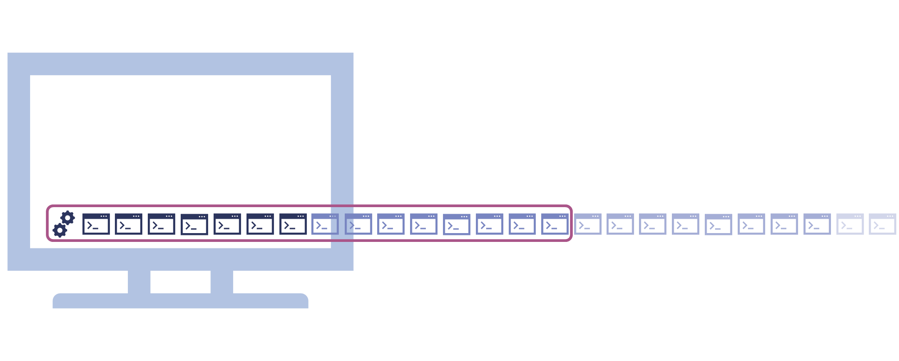Primary user interface with horizontal scrolling

#### Vertical interfaces

Some interfaces may take the form of multiple rows or stacked ribbons, which extend vertically beyond the bounds of the screen (‘below the fold’). We envision that these types of interfaces would need to display all regulated television service apps within the first 2 ribbons or rows, with no horizontal scrolling.

Figure 4 below illustrates a screen displaying 8 icons in a horizontal ribbon. Scrolling down shifts to a new ribbon or row of icons not displayed on the initial view. Based on this interface, the first 16 tiles would be considered within the scope of the primary user interface (shown bound by a pink rectangle in the figure).

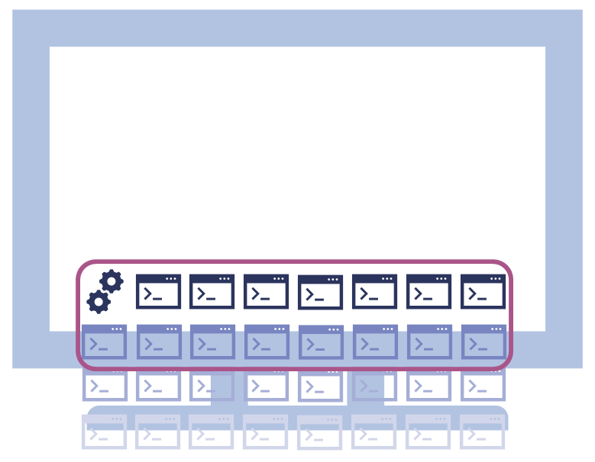Primary user interface with multiple ribbons

#### Grid interfaces

Some primary user interfaces may take the form of a grid, where scrolling has the effect of moving between different ‘pages’ of apps. We envision that these types of interfaces would be required to display all regulated television services within the first 2 pages.

Figure 5 below illustrates a screen displaying 9 icons in a grid without scrolling. The first 18 tiles would be considered within the scope of the primary user interface (shown bound by a pink rectangle in the figure).

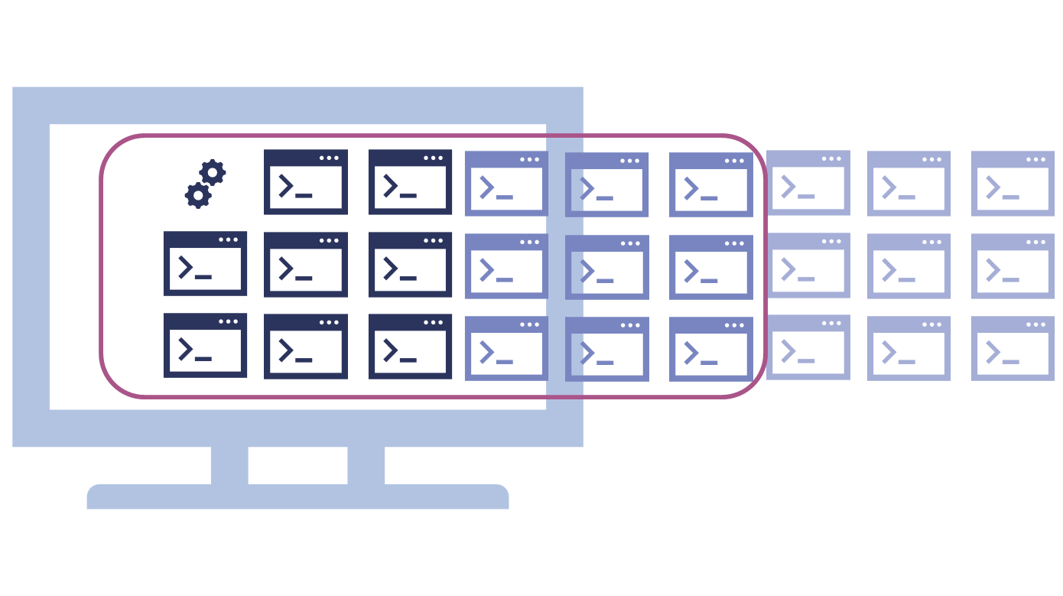Primary user interface with a grid

We understand that there may be disparities between the number of apps visible on the initial view of a home screen, based on both the size of the apps and the type of user interface chosen by manufacturers. Given this, it may also be appropriate to set a limit for the number of apps that can be displayed before regulated television services.

#### Content aggregating interfaces

As discussed above, some regulated television devices prioritise the discoverability of content, and do not display a scrollable list of apps on their home screens. Instead, these devices display tiles or icons of video content from across different subscription and broadcasting television services on the home screen, which may be personalised to the user (for example, displaying particular titles or genres). We understand that these content aggregating interfaces are growing in popularity among manufacturers, and that the TV prominence framework must be able to accommodate this.

Where a home screen primarily aggregates contentrather than apps, regulated television services will still need to be pre-installed and available for access on the ‘main interface most commonly used to provide access to applications’ (BSA s130ZZL). This could be a designated app page, screen, or pop-up, with a different layout and means of navigation. In these circumstances, the ACMA may need to set additional requirements for the ‘primary user interface’ (for example, requiring narrower scrolling tolerances when apps are being displayed on an interface other than the home screen).

In developing our preliminary view, we have taken care not to describe ‘primary user interface’ too narrowly or too broadly. For example:

* determining narrow descriptions or requirements would make it less likely that the approach will fit all regulated television devices and may make it impossible for manufacturers to comply with the minimum prominence requirements (for example, requiring 5 tiles be placed where only 4 tiles fit).
* determining broad descriptions or requirements may lead to interfaces that while compliant, may not deliver meaningful prominence to regulated television services.

The variety of devices and operating systems is also a relevant consideration. Specific requirements for some devices may reduce the user experience, interfere with existing contractual arrangements, or risk changing the market dynamics, as is the case when some devices prioritise content aggregation rather than apps on the primary user interface.

**Issues for comment**

**Question 5**

Should the ACMA exercise its discretion to make descriptions or requirements for a device’s primary user interface? Should the descriptions or requirements refer to the primary user interface extending beyond the static landing page for access to VOD apps, to include scrolling (horizontally or vertically)? Do ribbon or row layouts require different consideration to grid layouts?

**Question 6**

Do you support treating content aggregating interfaces differently from other regulated television devices when describing requirements for the primary user interface?

**Question 7**

To what extent do existing contractual arrangements between device manufacturers (or operating systems) and content services providers (such as SVOD providers) affect the ability to provide prominence to BVOD apps on the primary user interface?

**Call for evidence 1**

According to submissions to earlier government processes, 5 brands (Samsung, LG, Sony, Hisense, TCL) account for around 86% of the market for smart TVs in Australia. We are establishing a catalogue of images of ‘home screens’ and ‘main interface(s) most commonly used to provide access to applications’ from manufacturers of regulated television devices in Australia. This catalogue will assist with finalising our views on describing the primary user interface.

We request stakeholders provide images of home screens (where BVOD and SVOD apps are commonly located). This includes the home screens of all brands of TVs, streaming devices and other likely regulated television devices available in Australia.

# When a regulated television service is offered

A regulated television service provider may develop apps for the platforms and devices they want their regulated television service to appear on. The app must meet conditions for the successful integration into the operating system. Manufacturers provide guidance for app developers on their websites.[20] Once the ‘must-carry’ obligations come into effect, manufacturers must not supply a regulated television device in Australia if it does not comply with the minimum prominence requirements for a regulated television service that is ‘offered’ by a regulated television service provider.

After the device is supplied, manufacturers must take reasonable steps to ensure that the device continues to comply with the minimum prominence requirements until the earliest of the following times:

* when an action by a user of the device results in the device not complying with those requirements (for example, when a user deletes or moves an app for a regulated television service)
* when the software used on the device is no longer provided, updated or supported by, or on behalf of, the manufacturer (for example, when a manufacturer deems a device obsolete)[21]
* when the regulated television service is no longer offered by the regulated television service provider (for example, SBS decommissioned its On Demand Version 2 app from Sony Linux televisions in December 2021).[22]

The BSA does not define the conditions for when a regulated television service is offered or no longer offered. The ACMA may, by legislative instrument, determine circumstances in which a regulated television service is taken to be offered and determine different circumstances for different regulated television services or kinds of regulated television services.

The explanatory memorandum to the Bill notes:

… it is intended that any such determination by the ACMA would prescribe that, for a registered television service to be offered, it must meet minimum technical specifications for integration into the software used on a regulated television device.[23]

Where possible, we will rely on existing industry practices for determining the circumstances in which a regulated television service is taken to be offered.

## The difference between ‘must carry’ and ‘must offer’

The ability for manufacturers to comply with the minimum prominence requirements will depend on those regulated television services (such as BVOD apps) integrating with the specifications for each regulated device. Across the leading TV brands sold in Australia, operating systems, and therefore integration specifications, differ. In 2022, there were 4 different operating systems used across the 5 most common TV brands in Australia.[24] CESA submitted to the 2022 Proposals Paper consultation that 5 TV manufacturers supply more than 60% of consumers.[25] Software variation is also seen across other TV devices such as Hubbl, Apple TV and Fetch.

The government’s [[Impact Analysis](https://oia.pmc.gov.au/published-impact-analyses-and-reports/prominence-framework-connected-television-devices)](https://oia.pmc.gov.au/sites/default/files/posts/2023/11/Impact%20Analysis_1.docx) that accompanied the Bill identified that:

The framework may also impose compliance costs on free-to-air broadcasters, as they would need to develop and provide an app for each TV device that was compatible with the technical specification for the relevant operating system. These costs would include software development and maintenance costs, and resourcing costs for complaints handling. However, the costs would be avoidable, as free-to-air broadcasters would not be required to develop and provide device-compatible apps if they did not feel it was in their overall interests to do so. A free-to-air broadcaster may determine that the benefits of developing and maintaining an app for a particular regulated TV device do not exceed the costs. In this circumstance, they would incur no costs associated with the development and maintenance of the relevant app. (Page 25)

In determining the circumstances in which a regulated television service is taken to be offered, we must consider how and when manufacturers will be made aware of new applications for regulated television services, and the lead time required by manufacturers to incorporate these new applications into the primary user interface, either for pre-installation or installation during the device setup procedure.

Many regulated television services provide information on their service (and app) about availability by platform and operating system.[26] This information, while likely designed to assist audiences in accessing the desired service, provides a useful reference on how regulated television services make their applications available. The ACMA would support a standardised and centralised list of applications that are made available across platform and operating systems, providing release dates and contact information for technical difficulties.

A similar list of the minimum specifications for apps to be integrated into devices could be established and updated as needed. This list may also include reference to specific software development kits, an existing industry practice that makes the applications compatible with the minimum specifications for integration.

## Our preliminary view

To be ‘offered’, an app must meet any reasonable manufacturer’s specifications before the deadline for inclusion in the relevant device development timeline. The ACMA is considering the need for a legislative instrument determining circumstances when a regulated television service is taken to be ‘offered’.

### Defining what is offered

We propose that to be taken to be offered, an app must meet the technical specifications of a platform. This matches current practice: manufacturers cannot provide an app to users that is incompatible with their app store or operating system.

### Defining who gets offered

Regulated television service providers would not be required to provide an app to *all* manufacturers for that app to be taken to be ‘offered’. Regulated television service providers may make decisions about which manufacturers or platforms to produce apps for.

### Defining timelines

To be taken to be offered, an app must meet the manufacturer’s requirements in time for inclusion in their development timeline. Manufacturers should be transparent about these timelines.

### Defining how it is offered

Device manufacturers and operating system providers already publish processes for developers to submit apps for inclusion in their app store. We believe these existing channels should suffice for regulated television services to submit apps to manufacturers and operating system providers.

**Issues for comment**

**Question 8**

Should the ACMA determine circumstances in which a regulated television service is, or is not, taken to be ‘offered’? Is the ordinary meaning of ‘offered’ adequate?

**Question 9**

Is there sufficient transparency about which apps are currently offered to which manufacturers?

**Question 10**

What circumstances should the ACMA consider for a regulated television service to be, or not be, taken to be ‘offered’?

**Question 11**

Under what circumstances might a manufacturer ‘reject’ an app that meets its quality and timeliness criteria?

**Question 12**

Are there different circumstances that the ACMA needs to consider for different kinds of regulated television services?

**Call for evidence 2**

What platforms and operating systems are regulated television services available on?

**Call for evidence 3**

How do app developers provide assurance of an app’s compatibility with each device or operating system? For example, is there internal or external certification of apps?

**Call for evidence 4**

What lead times are required to incorporate additional regulated television service applications into a device if they are compatible and made available today? For a given model of device, what do manufacturers consider the deadline for an app to be pre-installed, or added to a setup procedure?

**Call for evidence 5**

Data on the likely costs of compliance would help the ACMA evaluate the efficiency of the regulatory framework. What costs do regulated television service providers incur when offering apps to manufacturers? What costs do manufacturers incur when assessing or accepting apps submitted to their app store? Noting this is commercially sensitive information, indicative figures are acceptable.

# Invitation to comment

## Making a submission

We invite comments on the issues set out in this consultation paper.

[Online submissions](https://www.acma.gov.au/have-your-say) are preferred and can be made by uploading a document. Submissions in PDF, Microsoft Word or Rich Text Format are preferred.

Submissions by post can be sent to:

The Manager  
Content and Media Reform Section  
Australian Communications and Media Authority  
PO Box 78  
Belconnen ACT 2616

The closing date for submissions is **5pm (AEDT), 15 October 2024**.

Consultation enquiries can be emailed to [CAMR@acma.gov.au](mailto:CAMR@acma.gov.au).

### Publication of submissions

We publish submissions on our website, including personal information (such as names and contact details), except for information that you have claimed (and we have accepted) is confidential.

Confidential information will not be published or otherwise released unless required or authorised by law.

### Privacy

View information about our policy on the [publication of submissions](https://www.acma.gov.au/publication-submissions), including collection of personal information during consultation and how we handle that information.

Information on the *Privacy Act 1988*, how to access or correct personal information, how to make a privacy complaint and how we will deal with any complaints, is available in our [privacy policy](https://www.acma.gov.au/privacy-policy).

# Appendix A: Primary user interface examples

The illustrations below are drawn from submissions to the Senate Committee and are labelled according to their submission number.

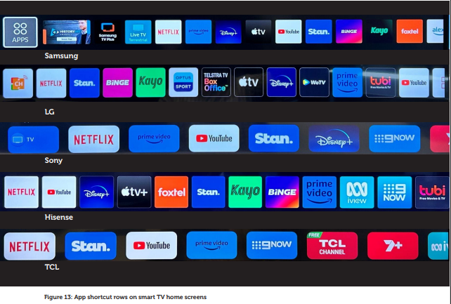‘App shortcut rows on smart TV home screens’ (source: RMIT University, submission 6)

In Figure 6 above, the number of app tiles that appear on different smart TV home screens without user scrolling is:

* Samsung: 12
* LG: 13
* Sony: 7
* Hisense: 12
* TCL: 7

‘Illustrated example of Terrestrial Live TV function prominence’ and ‘Illustrated example of BVOD app prominence’ (source: Free TV,   
submission 10)

Figure 7: ‘Illustrated example of Terrestrial Live TV function prominence’ and ‘Illustrated example of BVOD app prominence’ (source: Free TV, submission 10)


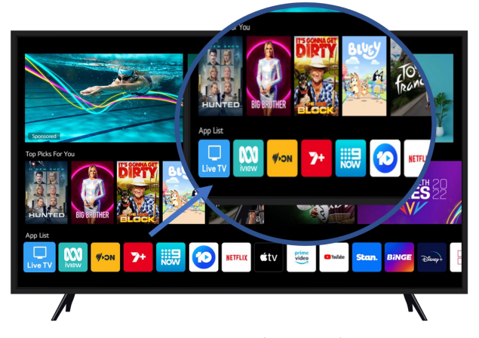

Example of the Fetch user interface (source: Fetch, submission 14)

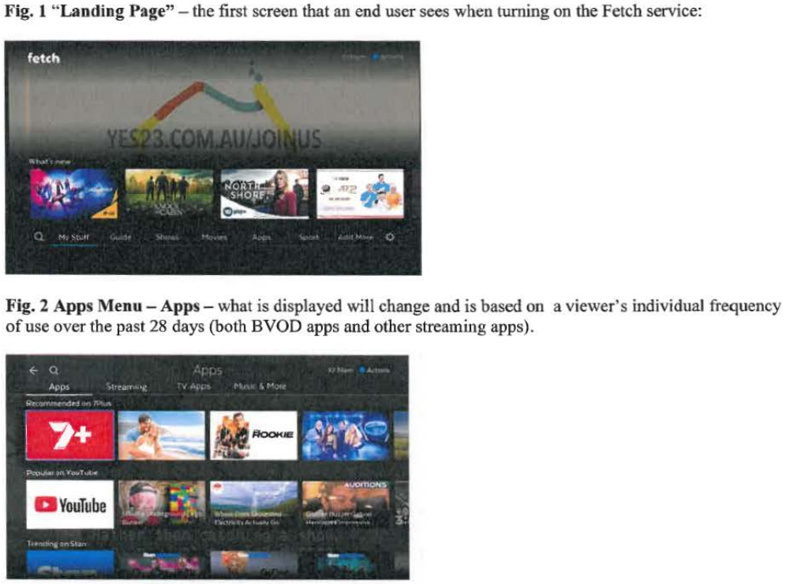

1. The *Communications Legislation Amendment (Prominence and Anti-siphoning) Act 2024*, which amended the *Broadcasting Services Act 1992* and the *Australian Communications and Media Authority Act 2005,* received Royal Assent in July 2024.
2. Department of Infrastructure, Transport, Regional Development, Communications and the Arts (DITRDCA), *[Prominence for Connected Television Devices–Proposal Paper](https://www.infrastructure.gov.au/media-communications-arts/television/prominence-connected-tv-devices)*, DITRDCA website, 2022, accessed 10 September 2024.
3. [Federal Register of Legislation - Australian Communications and Media Authority (Development of Technical Standards for Domestic Digital Television Reception Equipment) Direction No. 1 of 2009](https://www.legislation.gov.au/F2009L04140/asmade/text)
4. Available here: <https://www.aph.gov.au/Parliamentary_Business/Bills_Legislation/Bills_Search_Results/Result?bId=r7132>
5. [ParlInfo - Communications Legislation Amendment (Prominence and Anti-siphoning) Bill 2024 (aph.gov.au)](https://parlinfo.aph.gov.au/parlInfo/search/display/display.w3p;query=Id%3A%22legislation%2Fems%2Fr7132_ems_5b00cc5c-d1d4-4843-8c7c-f60c006503c7%22;rec=0). Page 16.
6. An expansive scope of 'regulated television devices’ is supported by [submissions](https://www.aph.gov.au/Parliamentary_Business/Committees/Senate/Environment_and_Communications/ProminenceAntiSiphoning/Submissions) from Janez Media, Australian Children’s Television Foundation and Swinburne University of Technology.
7. [Free TV](https://www.aph.gov.au/DocumentStore.ashx?id=b4cd5fd3-1711-41de-abe5-29991b5184dc&subId=751980) submission to the Senate Committee.
8. [CESA](https://www.aph.gov.au/DocumentStore.ashx?id=f3357acf-0c5a-4ab2-8a8c-1acb5dca1712&subId=751972) submission to the Senate Committee (page 10).
9. [RMIT University](https://www.aph.gov.au/DocumentStore.ashx?id=fbb751b5-df92-4a53-bfe3-2685e76b52ec&subId=751962) submission to the Senate Committee (page 9).
10. [ParlInfo - Communications Legislation Amendment (Prominence and Anti-siphoning) Bill 2024 (aph.gov.au)](https://parlinfo.aph.gov.au/parlInfo/search/display/display.w3p;query=Id%3A%22legislation%2Fems%2Fr7132_ems_91a284af-591d-4063-95f5-e0ef6ed45e0e%22;rec=0)
11. [ParlInfo - BILLS : Communications Legislation Amendment (Prominence and Anti-siphoning) Bill 2023 : Second Reading (aph.gov.au)](https://parlinfo.aph.gov.au/parlInfo/search/display/display.w3p;query=Id%3A%22chamber%2Fhansardr%2F27183%2F0009%22)
12. See for example, [Smart Monitor -4K All-In-One Screen | Samsung Australia](https://www.samsung.com/au/smart-monitor/)
13. See for example, [Projectors - Compare | Samsung Australia](https://www.samsung.com/au/projectors/all-projectors/?the-freestyle)
14. See for example, [LG 43" 4K UHD Smart Monitor with webOS 23 - JB Hi-Fi (jbhifi.com.au)](https://www.jbhifi.com.au/products/lg-43-4k-uhd-smart-monitor-with-webos-23#product-overview)
15. [Submissions – Parliament of Australia (aph.gov.au)](https://www.aph.gov.au/Parliamentary_Business/Committees/Senate/Environment_and_Communications/ProminenceAntiSiphoning/Submissions)
16. [Free TV submission - Prominence Regulations - 20240220 - Final](https://www.freetv.com.au/wp-content/uploads/2024/03/Free-TV-submission-Prominence-Regulations.pdf), page 6
17. [SBS Supplementary submission to Senate Committee](https://www.aph.gov.au/DocumentStore.ashx?id=f75b9b9d-b4e3-4cb5-b828-70796244ecc4&subId=752022), page 2.
18. Free TV, ABC, SBS - Joint response to question on notice, provided 6 March 2024. [Additional Documents – Parliament of Australia (aph.gov.au)](https://www.aph.gov.au/Parliamentary_Business/Committees/Senate/Environment_and_Communications/ProminenceAntiSiphoning/Additional_Documents?docType=Answer%20to%20Question%20on%20Notice).
19. [Impact Analysis](https://oia.pmc.gov.au/published-impact-analyses-and-reports/prominence-framework-connected-television-devices) (page 26).
20. See for example, [Quick-start Guide | Samsung Developer](https://developer.samsung.com/smarttv/develop/getting-started/quick-start-guide.html); [webOS TV Home | webOS TV Developer (lge.com)](https://webostv.developer.lge.com/); [Create an Application | BRAVIA Professional Displays Knowledge Center (sony.net)](https://pro-bravia.sony.net/develop/app/create/); [Android TV overview  |  Android Developers](https://developer.android.com/training/tv)
21. In a presentation to the [Electronics < > Ecologies #1 — REPAIR](https://www.admscentre.org.au/event/electronics-ecologies-1-repair/) workshop at Griffith University, Associate Professor Ramon Lobato and Dr Alexa Scarlata said smart TV software can have a lifespan from 2 years (LG) to 10 years (Hisense). 30 August 2023.
22. [Why is the SBS On Demand app being removed from my Sony TV? – SBS Help Centre](https://help.sbs.com.au/hc/en-au/articles/4407804487183-Why-is-the-SBS-On-Demand-app-being-removed-from-my-Sony-TV)
23. [Explanatory memorandum](https://parlinfo.aph.gov.au/parlInfo/search/display/display.w3p;query=Id%3A%22legislation%2Fems%2Fr7132_ems_5b00cc5c-d1d4-4843-8c7c-f60c006503c7%22), page 26.
24. Samsung (Tizen), LG (WebOS), Sony (Android/Google TV), Hisense (VIDAA) and Panasonic (Android/Google TV, for devices sold prior to discontinuing supply in Australia), [TV Consumer Survey 2022 - Final Report.pdf (infrastructure.gov.au)](https://www.infrastructure.gov.au/sites/default/files/documents/TV%20Consumer%20Survey%202022%20-%20Final%20Report.pdf), Page 57. [apo-nid321605.pdf](https://apo.org.au/sites/default/files/resource-files/2023-02/apo-nid321605.pdf) Operating systems provided as indication as at 2024 and manufacturers’ operating systems vary over time.
25. https://www.infrastructure.gov.au/sites/default/files/documents/pfpp--consumer-electronics-suppliers-association-cesa.pdf
26. What devices is 10 play available on? [What devices is 10 play available on? : 10 play (tenplay.com.au)](https://helpdesk.tenplay.com.au/support/solutions/articles/16000113662-what-devices-is-10-play-available-on-);  
    What devices is SBS On Demand available on? [What devices is SBS On Demand available on? – SBS Help Centre](https://help.sbs.com.au/hc/en-au/articles/360002033396-What-devices-is-SBS-On-Demand-available-on);  
    What devices and TVs can log in to ABC iview? [What devices and TVs can log in to ABC iview? – ABC iview](https://iviewsupport.abc.net.au/hc/en-us/articles/360003864996-What-devices-and-TVs-can-log-in-to-ABC-iview);  
    Ways to Watch, [Ways to Watch - 9Now - Watch Channel 9 Live and On Demand](https://www.9now.com.au/ways-to-watch);  
    On what devices can I watch 7plus? [On what devices, can I watch 7plus? – 7plus](https://support.7plus.com.au/hc/en-au/articles/360061267271-On-what-devices-can-I-watch-7plus).