Eligible revenue submission handbook
For participating and non-participating persons using TELLER
This handbook provides information for participating and non-participating persons on how to meet eligible revenue reporting requirements for the 2023–24 eligible revenue period using the TELLER system, in accordance with the Telecommunications (Consumer Protection and Service Standards) Act 1999 and relevant subordinate legislation.

Canberra
Level 3
40 Cameron Avenue
Belconnen ACT
PO Box 78
Belconnen ACT 2616
T +61 2 6219 5555
F +61 2 6219 5353
Melbourne
Level 32
Melbourne Central Tower
360 Elizabeth Street
Melbourne VIC
PO Box 13112
Law Courts
Melbourne VIC 8010
T +61 3 9963 6800
F +61 3 9963 6899
Sydney
Level 5
The Bay Centre
65 Pirrama Road
Pyrmont NSW
PO Box Q500
Queen Victoria Building
NSW 1230
T +61 2 9334 7700
F +61 2 9334 7799
Copyright notice
https://creativecommons.org/licenses/by/4.0/
Except for the Commonwealth Coat of Arms, logos, emblems, images, other third-party material or devices protected by a trademark, this content is made available under the terms of the Creative Commons Attribution 4.0 International (CC BY 4.0) licence.
All other rights are reserved.
The Australian Communications and Media Authority has undertaken reasonable enquiries to identify material owned by third parties and secure permission for its reproduction. Permission may need to be obtained from third parties to re-use their material.
We request attribution as © Commonwealth of Australia (Australian Communications and Media Authority) 2024.

Important notice 1
Further request for information 1
Release of information provided to the ACMA 1
Sharing of information 1
Enquiries 1
Terms and abbreviations 2
Introduction 5
Role of the ACMA 5
Reporting obligations 6
Who needs to lodge a return? 6
Non-compliance by a participating person 6
Non-compliance by a non-participating person 6
TELLER FAQs 7
Part A: Participating persons 8
Eligible revenue return (ERR) 9
What is an ERR? 9
When is an ERR due? 9
Financial statements to be lodged as part of an ERR 9
How do I calculate eligible revenue? 11
ERR submissions and the TIL charge – funding cycle example 12
Logging in to TELLER to submit an ERR 13
First-time users must register for a one-time token 14
Completing the Eligible Revenue Submission 16
Welcome page 16
Carrier Group page 17
Revenue Information page 17
What to do if eligible revenue is under AUD $25 million? 18
General Information page 18
Carrier Group Financial Information page 19
Sales revenue (per financial statements) 19
Non-telecommunications sales revenue 20
Other gross telecommunications sales revenue 20
Non-licence-holder revenue 21
Deductions 21
Deductions for overseas activities 21
Acts in Australia for services outside Australia 22
Customer equipment: rent, sell, install, insure, repair or maintain 22
Content services 22
Exempt base station 22
Infrastructure revenue 22
Inter-person input payments 23
Other input amounts 24
DRP Financial Information page 24
Information about DRPs 25
Eligible Revenue Summary Calculation page 27
Allocation page 27
Documents page 28
Declaration page 29
Finish page 30
Submission successful page 31
Log out of TELLER 32
Part B: Non-participating persons 33
Eligibility 34
How does a carrier determine if it is a non-participating person? 34
Requirement 1 – revenue thresholds 34
Requirement 2 – eligible statutory declaration 34
Calculations to be made on a group basis 34
Revenue thresholds 35
Initial sales revenue of less than AUD $25 million 35
Gross telecommunications sales revenue of less than AUD $25 million 35
Eligible revenue of less than AUD $25 million 35
Eligible statutory declaration (ESD) 36
What is an ESD? 36
What happens if an ESD is not submitted by 31 October? 36
How is an ESD lodged? 36
Log in to TELLER 37
Completing the Eligible Revenue Submission 38
Welcome page 38
Revenue Information page 38
Calculation page 40
Eligible Statutory Declaration page 41
Submission successful page 44

Important notice
These instructions are not intended as legal advice, nor do they indicate how the Australian Communications and Media Authority (ACMA) may treat any individual claim made by a telecommunications carrier licence holder (carrier). They are solely intended to provide information which may help carriers meet their eligible revenue submission requirements under the Telecommunications (Consumer Protection and Service Standards) Act 1999.
Carriers should familiarise themselves with the relevant provisions of the following:
The Telecommunications Act 1997 (the Telco Act)
The Telecommunications (Consumer Protection and Service Standards) Act 1999 (the TCPSS Act)
The Telecommunications (Eligible Revenue) Determination 2015 (the ER Determination)
The Telecommunications (Participating Persons) Determination 2015 (the PP Determination).

Further request for information
The ACMA may carry out inquiries it thinks necessary in order to determine whether or not a carrier’s eligible revenue submission correctly states the eligible revenue for the relevant period (section 46 of the TCPSS Act).

Release of information provided to the ACMA
The ACMA may be required to release information contained in eligible revenue submissions under the Freedom of Information Act 1982 or for other reasons, including for the purpose of parliamentary processes or where otherwise required by law (for example, a court subpoena). While the ACMA seeks to consult, where required, with submitters of confidential information before that information is provided to another party, it cannot guarantee that confidential information will not be released through these or other legal means.

Sharing of information
Under the Australian Communications and Media Authority Act 2005, the ACMA may disclose certain information to the Minister for Minister for Communications, authorised officials of the Department of Transport, Regional Development, Communication and the Arts, Royal Commissions, and other Commonwealth authorities as required.

Enquiries
For any enquiries on reporting requirements, please contact our Revenue Assurance Team or phone them on (02) 6219 5355. More information is also available on
our website.

Terms and abbreviations
Term or abbreviation | Particulars
ACMA | Australian Communications and Media Authority.
myGovID | myGovID is a secure login that identifies you, or a representative of your business, when you use participating government online services on behalf of a business.  You may already use a myGovID to access government online services, such as the Australian Taxation Office. Your existing ‘myGovID’ will enable you to access TELLER, in conjunction with a ‘one-time token’ to be issued by the ACMA.
bundled revenue | An amount of revenue is bundled revenue if the revenue comes from different sources or acts and is received in a way that does not show how much of the amount came from the individual sources or acts. Bundled revenue may also include the value of a benefit or service.  See section 13 of the ER Determination.
carrier | The holder of a carrier licence (as defined in section 7 of the Telco Act). Reporting requirements are based on whether a carrier is a participating or non-participating person.
consolidated related party | In relation to a participating person, an entity that is not the participating person and whose revenue is included in the annual consolidated financial statements of the participating person’s ultimate Australian parent entity.  In relation to a non-participating person, an entity that is not the non-participating person and whose revenue is included in the annual consolidated financial statements of the participating person’s ultimate Australian parent entity. See section 5 of the ER Determination.
declared related party (DRP) –participating person | DRP of a participating person has the same meaning as in section 6 of the ER Determination.
declared related party (DRP) – non-participating person | DRP of a non-participating person has the same meaning as in section 7 of the ER Determination.
due date | The date for submission of an ERR, being 4 months after the eligible revenue period ends (as specified in section 40 of the ER Determination).
eligible revenue | In accordance with Part 5 of the ER Determination.  Generally, net telecommunications sales revenue (which is gross revenue less certain allowable deductions) of participating persons and related parties, unless the net revenue is zero, in which case, the eligible revenue is zero.  See also section 37 of the ER Determination.
eligible revenue return form | The form approved by the ACMA under subsection 43(2) of the TCPSS Act to be used by participating persons to calculate eligible revenue for the relevant eligible revenue period.  The TELLER system contains the ERR form for the current eligible  revenue period.
eligible revenue return (ERR) | An ERR consists of:  ERR form approved by the ACMA  financial statements  outline of business structure
eligible statutory declaration (ESD) | In accordance with subsection 4(2) of the Participating Persons Determination, a declaration made in writing and in accordance with the Statutory Declarations Act 1959 by a director or company secretary of the company/carrier, or any person authorised by the company/carrier to make the declaration.
audited financial statements | The financial information required to be used as a source to identify the telecommunications sales revenue of a participating person, or of consolidated and declared related parties, in accordance with section 12 of the ER Determination.
grouped carrier | A carrier that has the same ultimate Australian parent entity as one or more other carriers (that is, they are in the same ‘group’). For the purposes of subsection 4(4) of the PP Determination, the revenue thresholds of all carriers within the group are calculated on a group basis, accounting for revenue and deductions, on a group basis.
carrier | A telecommunications carrier licence holder. Has the same meaning as ‘carrier’ (as defined in section 7 of the Telco Act).
non-participating person | Either:  a person whose initial sales revenue, gross telecommunications sales revenue or eligible revenue is less than AUD $25 million for an  eligible revenue period, and who provides an ESD to the ACMA by  the 31 October following the end of the eligible revenue period.  a person the ACMA is reasonably satisfied has initial sales revenue, gross telecommunications sales revenue or eligible revenue for the eligible revenue period of less than AUD $25 million.  The thresholds are determined in accordance with the ER Determination as if the person was a participating person.  When the person (carrier) has the same ultimate Australian parent entity as one or more other persons (carriers), the thresholds to be applied are on a group basis.
participating person | A person who was a carrier at any time during the eligible revenue period and is not a non-participating person. See section 44 of the TCPSS Act.
participating carriage service provider | A carriage service provider (as defined in section 7 of the Telco Act) for whom a determination under subparagraph 44(1)(b)(i) of the TCPSS Act is in force.  To date, the Minister has not made such a determination.
PP Determination | Telecommunications (Participating Persons) Determination 2015
related parties | All consolidated related parties and declared related parties of participating and non-participating persons as those terms are defined in the ER Determination.
revenue thresholds | For a non-participating person, application of one of 3 revenue thresholds:  Initial sales revenue for the eligible revenue period of less than AUD $25 million.  Gross telecommunications sales revenue for the eligible revenue period of less than AUD $25 million.  Eligible revenue for the eligible revenue period of less than AUD $25 million.  For each of these categories, if the carrier has the same ultimate Australian parent entity as one or more other carriers, the eligible revenue calculation is to be performed on a group basis.  The thresholds are calculated in accordance with the ER Determination as if the person was a participating person.
TCPSS Act | Telecommunications (Consumer Protection and Service Standards)  Act 1999
Telco Act | Telecommunications Act 1997
TELLER | TELLER is a system that streamlines the lodgement process for eligible revenue submissions online while providing a secure environment to exchange financial information with the ACMA.

Introduction
This handbook provides guidance to carriers about meeting legislative obligations in respect of eligible revenue reporting for the purposes of allowing the ACMA to calculate the telecommunication industry levy (TIL). It explains the process for submitting an eligible revenue return (ERR) for participating persons or an eligible statutory declaration (ESD) for non-participating persons using the ACMA’s online TELLER system.

Role of the ACMA
The ACMA is responsible for the regulation of broadcasting, radiocommunications, telecommunications and the internet.
As part of its administrative responsibilities, the ACMA collects financial information from the telecommunications industry in the form of an ERR. Eligible revenue is based on the gross sales revenue of the carrier and any related entities, less a series of revenue and expense deductions.
Participating persons (carriers with eligible revenue in excess of, or equal to AUD $25 million) and non-participating persons (carriers with eligible revenue less than AUD $25 million) are required to lodge an ERR or ESD with the ACMA by
31 October, following the end of the eligible revenue period.
The ACMA will make a written assessment of each participating person’s eligible revenue for each eligible revenue period. Each carrier’s eligible revenue is then used in the calculation of the TIL and the Annual Carrier Licence Charge (ACLC).
Further information regarding the calculation of these levies can be found on the Telecommunications funding arrangements page on the ACMA website.

Reporting obligations

Who needs to lodge a return?
Any carriers that held a licence at any time during the eligible revenue period (1 July
to 30 June) must lodge an eligible revenue submission (ERS) with the ACMA by 31 October, following the eligible revenue period. For example, a carrier holding a licence during 1 July 2023 and 30 June 2024 must lodge an ERS with the ACMA by 31 October 2024.
Carrier licence holders include those that:
held a carrier licence for all of the eligible revenue period
held a carrier licence for part of the eligible revenue period (that is, were granted or surrendered their carrier licence between 1 July and 30 June).
Reporting requirements are based on whether a carrier is a:
participating person as defined in the TCPSS Act (section 44)
non-participating person as defined in the PP Determination (subsection 4(3)).
For each eligible revenue period, a carrier must make a self-assessment against the relevant revenue thresholds applied in the legislation and based on the assessment either:
submit an ERR to the ACMA by 31 October as a participating person
submit an ESD to the ACMA by 31 October as a non-participating person.
Both participating persons and non-participating persons are strongly encouraged to submit supporting paperwork at the time of their returns, to verify their ERR or ESD submissions.

Non-compliance by a participating person
In accordance with subsection 43(1) of the TCPSS Act, all ERRs must be submitted in TELLER by the due date. Participating persons who fail to submit this documentation for the relevant eligible revenue period, or who submit an incomplete or non-compliant ERR, may face penalties and other enforcement action under the TCPSS Act or Telco Act.
Failure to provide the ACMA with an ERR in accordance with section 43 of the TCPSS Act is an offence of strict liability under subsection 69(1) of the TCPSS Act, with a maximum penalty of 50 penalty units.
The information contained in an ERR must be true and accurate. It is an offence to provide false or misleading information to the ACMA (see Part 7.4 of the Schedule – the Criminal Code, to the Criminal Code Act 1995).

Non-compliance by a non-participating person
If a carrier does not submit an ESD to the ACMA by 31 October stating that the person’s initial sales, gross telecommunications, or eligible revenue for the period was less than the AUD $25 million threshold in the PP Determination, the ACMA must be reasonably satisfied that the carrier is a non-participating person. The ACMA will estimate the carrier’s revenue for the relevant eligible revenue period using any information available. If based on its estimation, the ACMA determines the carrier is a participating person, then the ACMA will make a written assessment of eligible revenue using this estimate, as set out under section 48 of the TCPSS Act.

TELLER FAQs
FAQs on using the TELLER system can be accessed from the ACMA website.

Part A: Participating persons

Eligible revenue return (ERR)

What is an ERR?
An ERR submitted using TELLER must comprise of:
financial statements on which the return is based (including the financial statements of any declared related parties)
an outline of the carrier’s business structure for the eligible revenue period – a diagram with descriptions showing the structure of the group (where applicable), and identifying all entities that earn telecommunications sales revenue, including any consolidated and declared related parties.
Information provided in the ERR and supporting documents must be:
clearly legible
in Australian dollars (AUD), except for financial statements that have been prepared using its reporting currency
if converting into Australian dollars from another currency, it is recommended the relevant annual average ATO exchange rate is to be used
consistently prepared as per previous eligible revenue period
submitted using the ACMA-approved form for the current period.
Please note:
Where financial statements are expressed in a reporting currency other than Australian dollars, the exchange rate applied must be declared in preparing the ERR form in whole AUD$ (that is, the exchange rate of conversion applied against the reporting currency as noted in the financial statements and the basis for this exchange rate).

When is an ERR due?
A completed ERR must be received by the due date of 31 October each year.
The TCPSS Act does not allow the granting of extensions of time beyond the due date.

Financial statements to be lodged as part of an ERR
Financial statements provided to the ACMA should be prepared in accordance with relevant the Australian Accounting Standards or other accounting standards such as the International Financial Reporting Standards. If the financial statements are prepared under any other reporting framework, please advise the ACMA.
Carriers who are participating persons must base their ERR on the most recent audited financial statements for itself and all subsidiaries, for a 12-month period ending on or before 30 June of the eligible revenue period. The ERR may be based on one or more sets of audited financial statements, however, these statements must support the period on which they report.
For most participating persons, these will be financial statements for the period ending 30 June. Some participating persons may need to use a different 12-month period as their eligible revenue period. Subsection 12(3) of the ER Determination allows the ACMA to consider a participating person’s other financial statement period for the purposes of assessing revenue for the relevant eligible revenue period.
For example, for the 2023–24 eligible revenue period, the revenue to be reported in a participating person’s ERR has to be based on the most recent audited financial statement for the period ending within the 2023–24 eligible revenue period. Therefore, a participating person, with a financial reporting period ending 31 March, will be submitting their ERR by 31 October 2024, and will report on revenue based on financial statements for the period ending on 31 March 2024.
What financial statements are used if sales revenue is included in the consolidated financial statements of an ultimate Australian parent entity?
A participating person may make all calculations required under the ER Determination, identifying and accounting for revenue and deductions, and consolidated and declared related parties, in accordance with the ER Determination.
Alternatively, where 2 or more participating persons have the same ultimate Australian parent entity, those participating persons may choose to make all calculations required under the ER Determination, identifying and accounting for revenue and deductions, on a group basis.

How do I identify related party revenue so that I can include in my calculation of eligible revenue?
There are 2 types of related party revenue that carriers need to be aware of and include within their ERR:
- Consolidated related party
- revenue of an entity that is not the participating person but whose revenue is included in the annual consolidated financial statements of the participating person’s ultimate Australian parent entity.

- Declared related party (DRP):
- revenue of an entity who is not a participating person or a consolidated related party but was owned (having greater than 49% company interests) at any time during the eligible revenue period by a body that also owns
a participating or non-participating person at any time during the
relevant period.
More information about related parties can be found at the following link: Related parties for eligible revenue reporting.
What financial statements are used if the participating person is not part of a consolidated group or the ultimate parent entity is not an Australian company?
If the participating person is not part of a consolidated group, or the parent entity is not an Australian company, the participating person’s ERR information must be based on the most recent audited financial statements for the eligible revenue period.
If the financial statement reporting period of the carrier differs from the 1 July to 30 June period reporting period, the information submitted through the ERR must be based on the most recent audited financial statements for a period ending before the end of 30 June within the current eligible revenue period.

How do I calculate eligible revenue?
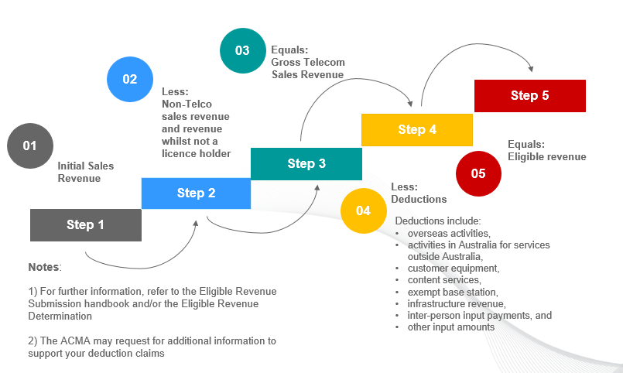

ERR submissions and the TIL charge – funding cycle example
The TIL is based on a 3-year cycle with the first year being the year in which carrier has earned revenue – the Eligible Revenue Period (ERP) which is currently based on financial years (1 July to 30 June).
Four months following the end of the ERP (31 October) carriers submit their ERR or ESD to the ACMA to ensure the compliance of reporting against legislation. This is the Eligible Levy Period (ELP).
The next part of the cycle occurs during the following financial year. The ACMA will make the written ‘Eligible Revenue Assessment’, publish on the ACMA website
and then send to all participating persons. After the ‘Overall Levy Target
Amount’ is determined, the ACMA will calculate the TIL amount payable by participating persons.

Logging in to TELLER to submit an ERR
Prior to making an eligible revenue submission in TELLER, ensure that you have a myGovID and access to the TELLER. You will be unable to access TELLER for participating persons unless you have a myGovID.
- Access TELLER from the eligible revenue portal on the ACMA website.
- Select the ‘Access ER portal’ button.
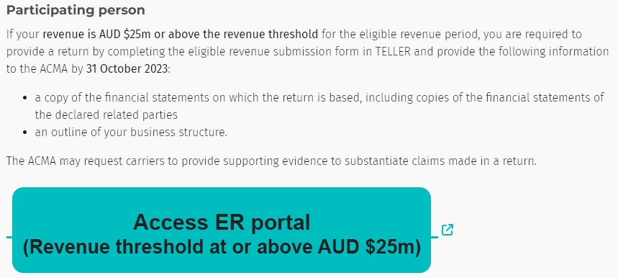

- You will then be redirected to the ‘Government Authentication Service’ website. To register for myGovID or to obtain further information, visit the myGovID website or phone 1300 287 539.
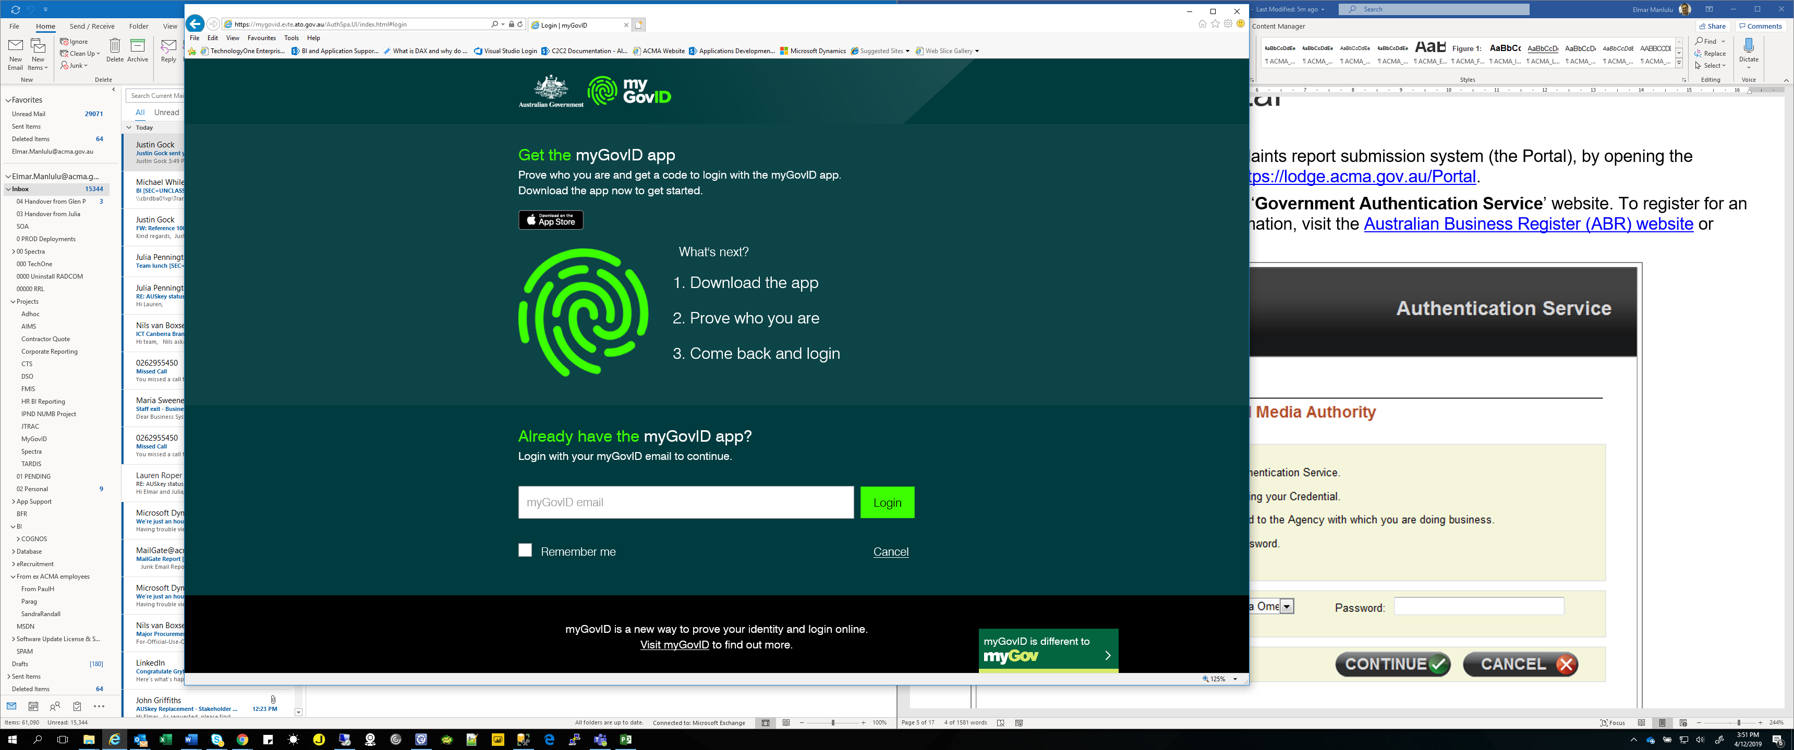

- Once you have been directed to the Authentication screen, open myGovID app on your phone and accept or enter the code given.
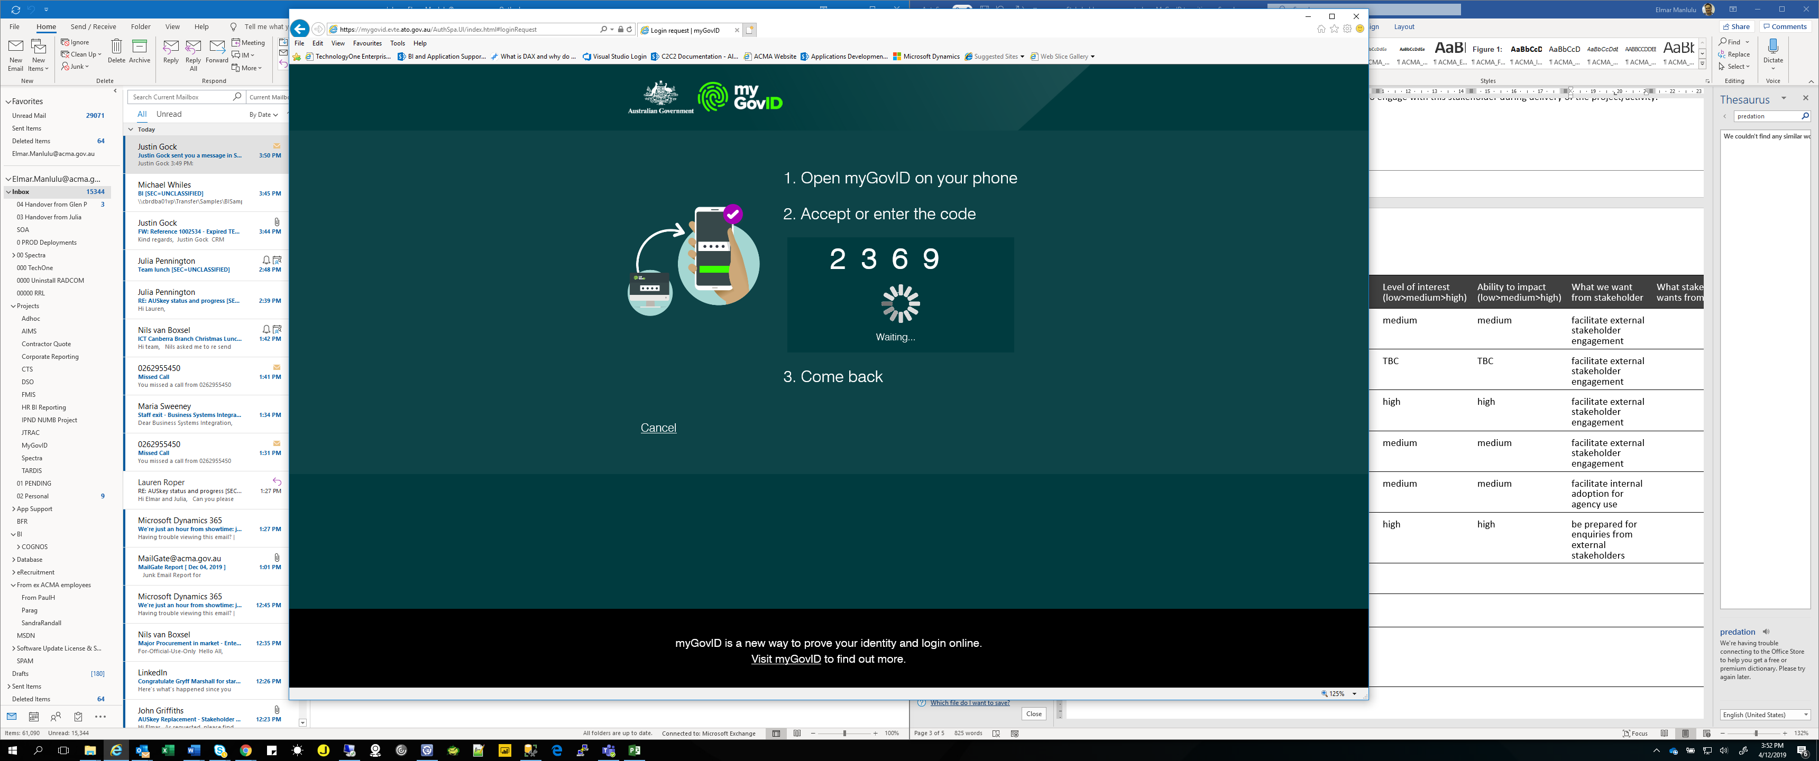

- Select ‘Continue’. You are now logged into the TELLER system.
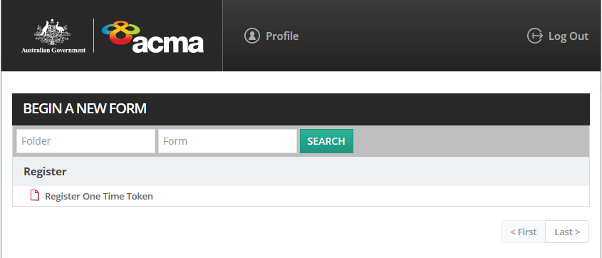

First-time users must register for a one-time token
To access the TELLER system for the first time, you will be required to register for a one-time token by emailing the ACMA Revenue Assurance Team or calling (02) 6219 5355.
- Once you have been issued a one-time token, select the ‘Register One Time Token’ link.
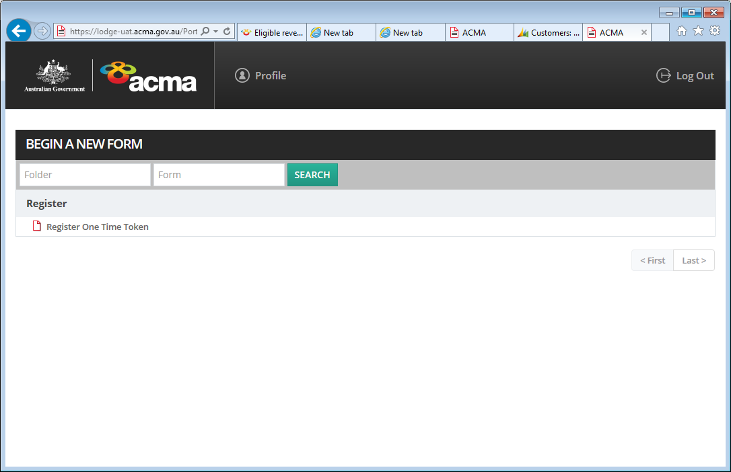

- A ‘Register One Time Token’ page will appear advising you to enter your one-time token.
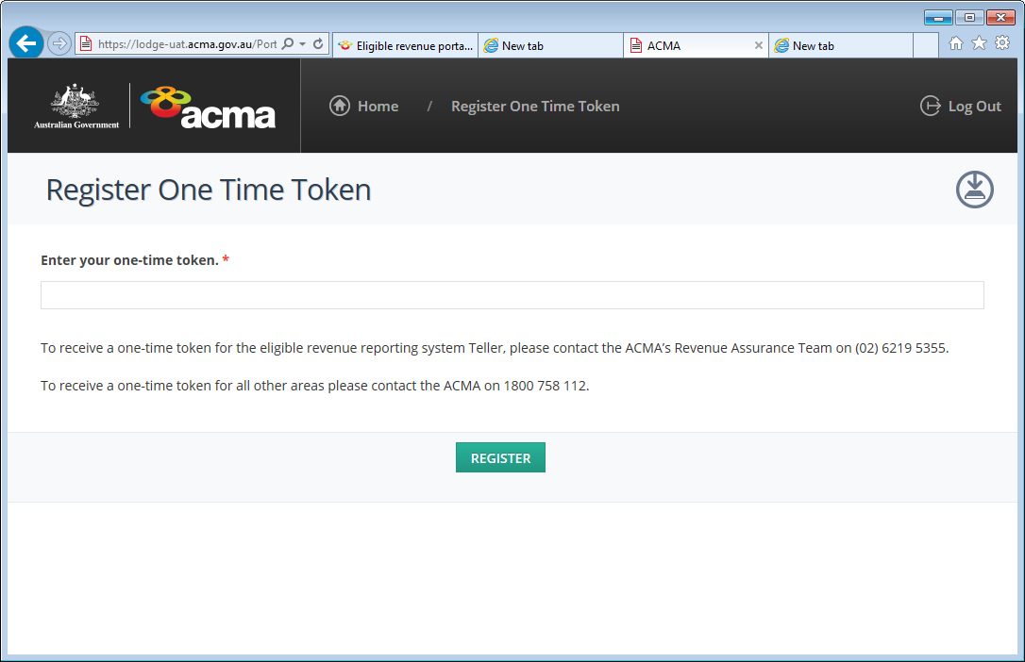

- Enter your one-time token and select ‘Register’. Once you have access, you will be able to view the ‘Eligible Revenue Submission’ form.
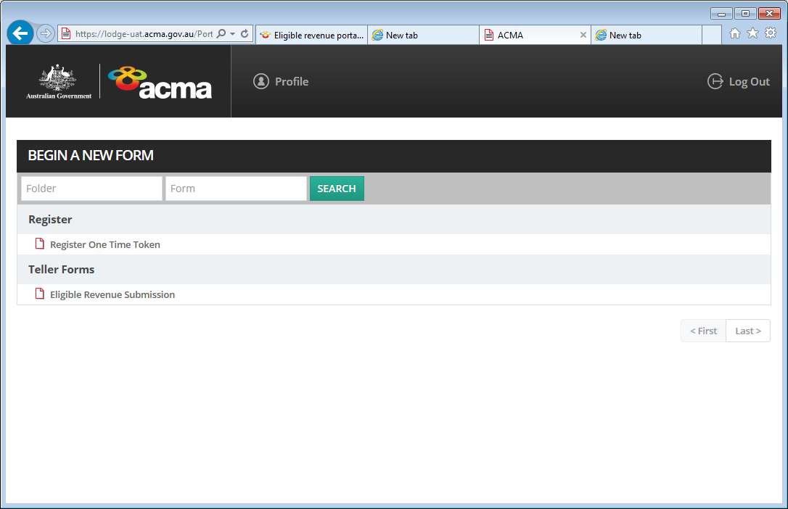

Completing the Eligible Revenue Submission
This section provides instructions to help participating persons to complete a compliant eligible revenue submission form in the TELLER system. If you are unable to make an eligible revenue submission to the ACMA via TELLER please contact the Revenue Assurance Team.

Welcome page
- On the ‘Welcome’ page, check the name and email address details are correct. If any details are incorrect, an authorised contact form must be completed and submitted to the ACMA by email.
- An acknowledgement email will be sent to the authorised contact email address once an eligible revenue submission has been lodged.
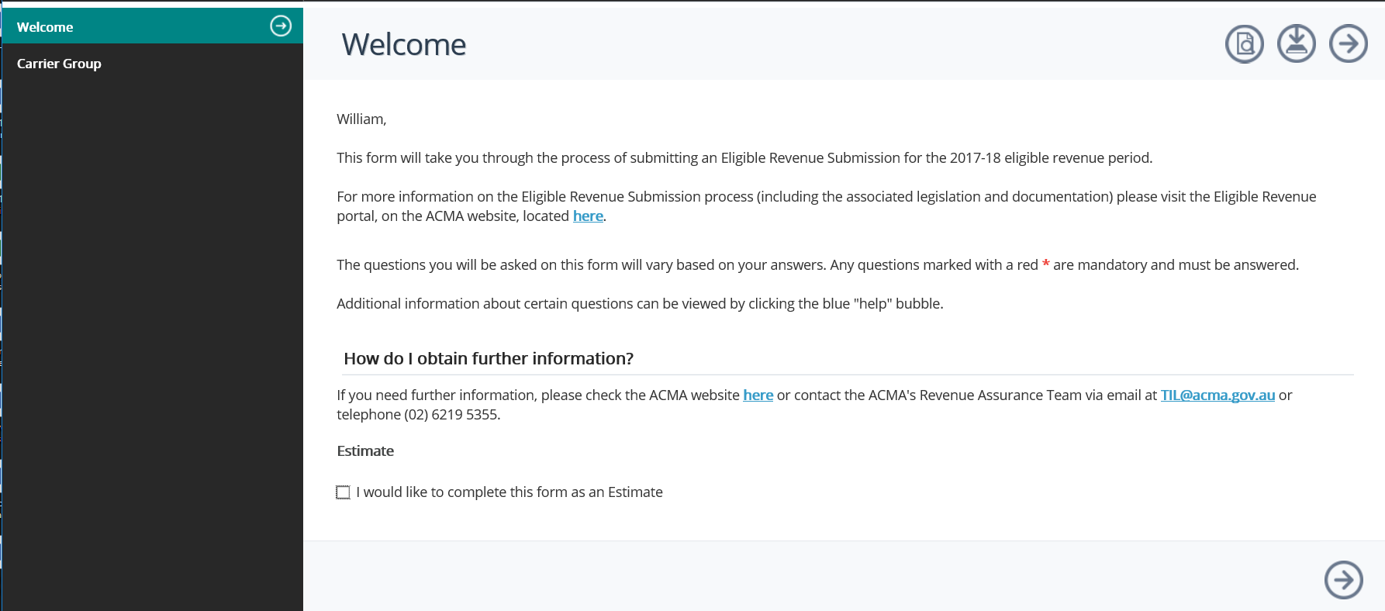

- Select the arrow icon 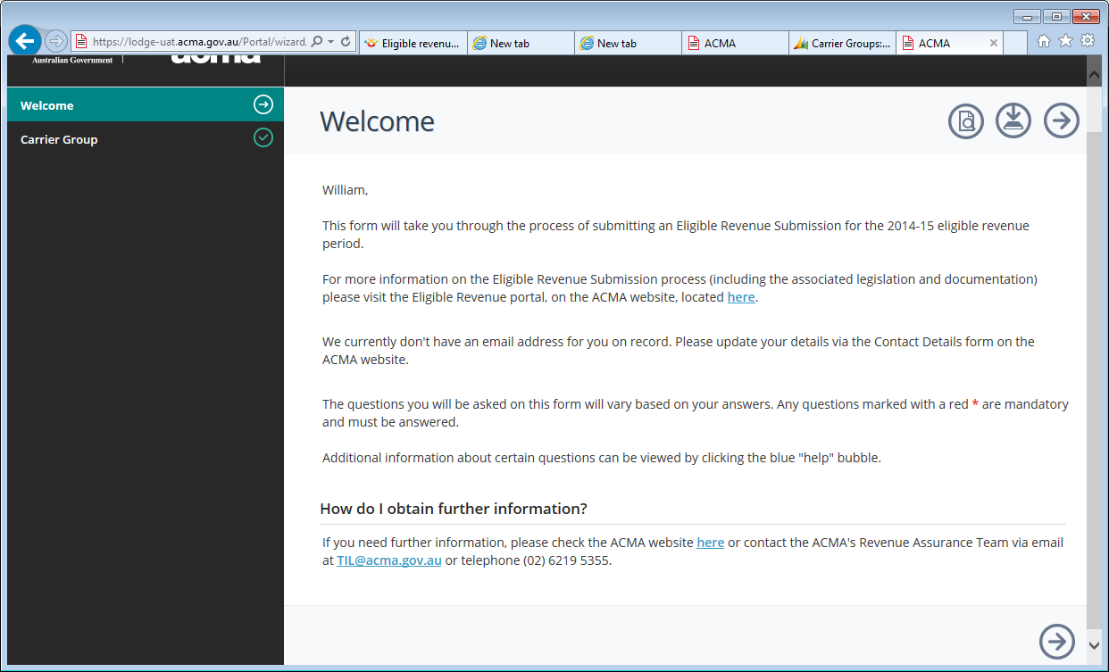 to navigate to the ‘Carrier Group’ page.
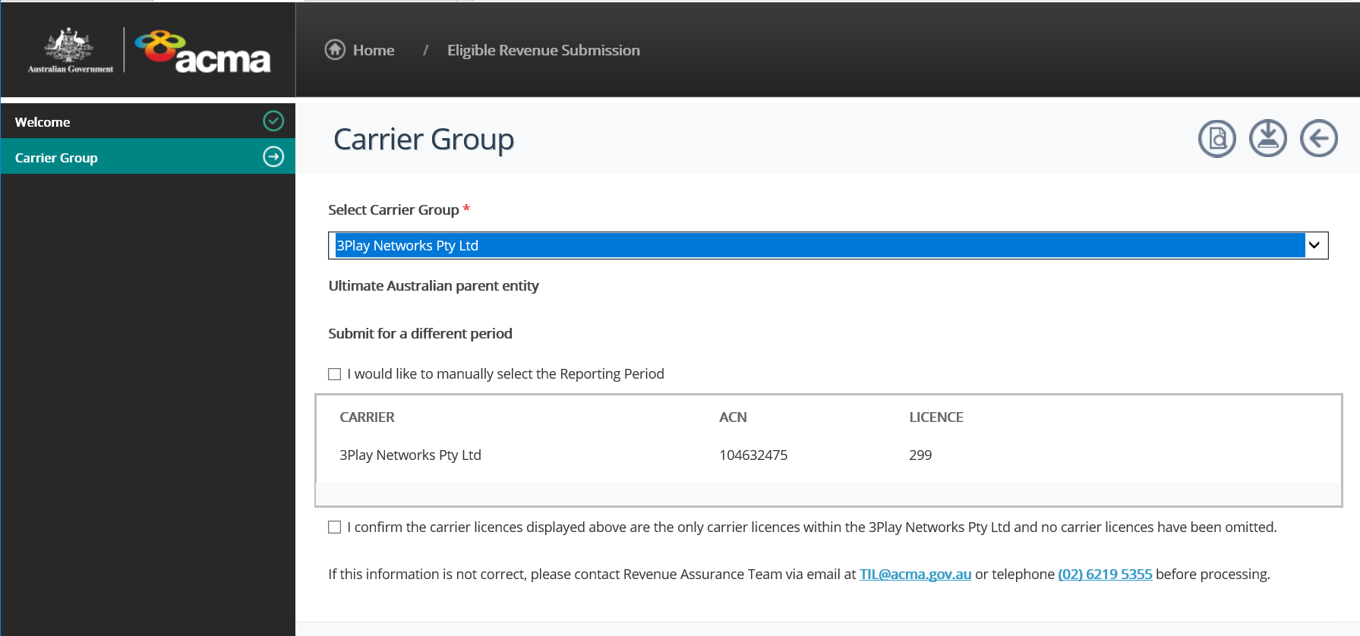

Carrier Group page
The ‘Carrier Group’ page should include:
Carrier Group name
each participating person’s name
each carrier licence number
each entity’s Australian Company Number (ACN) or, if not applicable, Australian Business Number (ABN).
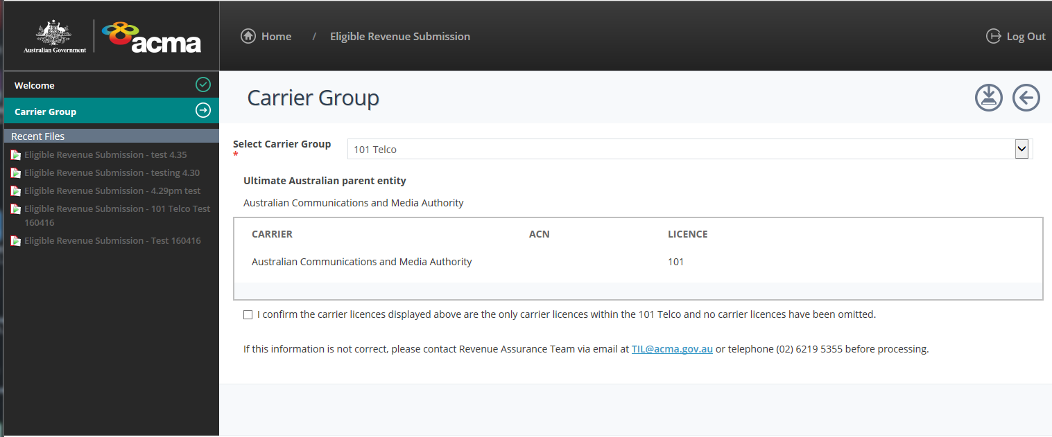
- Select the check box if the information as displayed is correct, then select the arrow icon to navigate to the ‘Revenue Information’ page.
- If the information listed on the ‘Carrier Group’ page is incorrect, please contact our Revenue Assurance Team or call (02) 6219 5355.

Revenue Information page
- On the ‘Revenue Information’ page, a participating person should select the ‘No’ radio icon under the question ‘Would you like to undertake a calculation of revenue?’
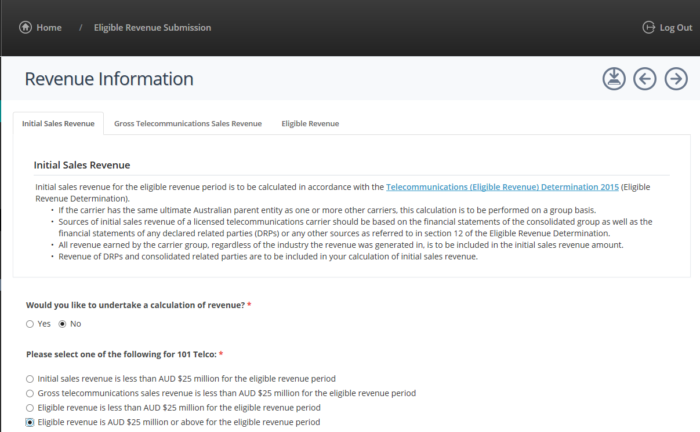
- Then select the ‘Eligible Revenue is AUD $25 million or above for the eligible revenue period’ radio icon.
- Select the arrow icon to navigate to the next page.
- If you have selected the threshold to indicate your ‘eligible revenue is AUD $25 million or above’ you will be directed to the ‘General Information’ page.

What to do if eligible revenue is under AUD $25 million?
If the carrier group’s initial sales revenue, gross telecommunications sales revenue or eligible revenue is less than AUD $25 million for the ERP, please refer to Part B: Non-participating persons of this handbook.

General Information page
On the ‘General Information’ page, provide the following information:
reporting period end date for financial statements – participating persons are to enter the financial year end date of the financial statements used to complete this ERR form (including any DRP financial statements)
the current legal status of the participating person(s). For example, ‘in external administration’
nominated carrier details if applicable
any business changes that are likely to have had a major impact on the carrier’s revenue and deductions, and therefore affect how the ACMA reviews the return. For example, a new product line has increased revenue significantly or telecommunications business operations have been divested.

- On the ‘General Information’ page, enter details under the ‘Supporting Financial Year End Date’ and ‘Business Activities’.
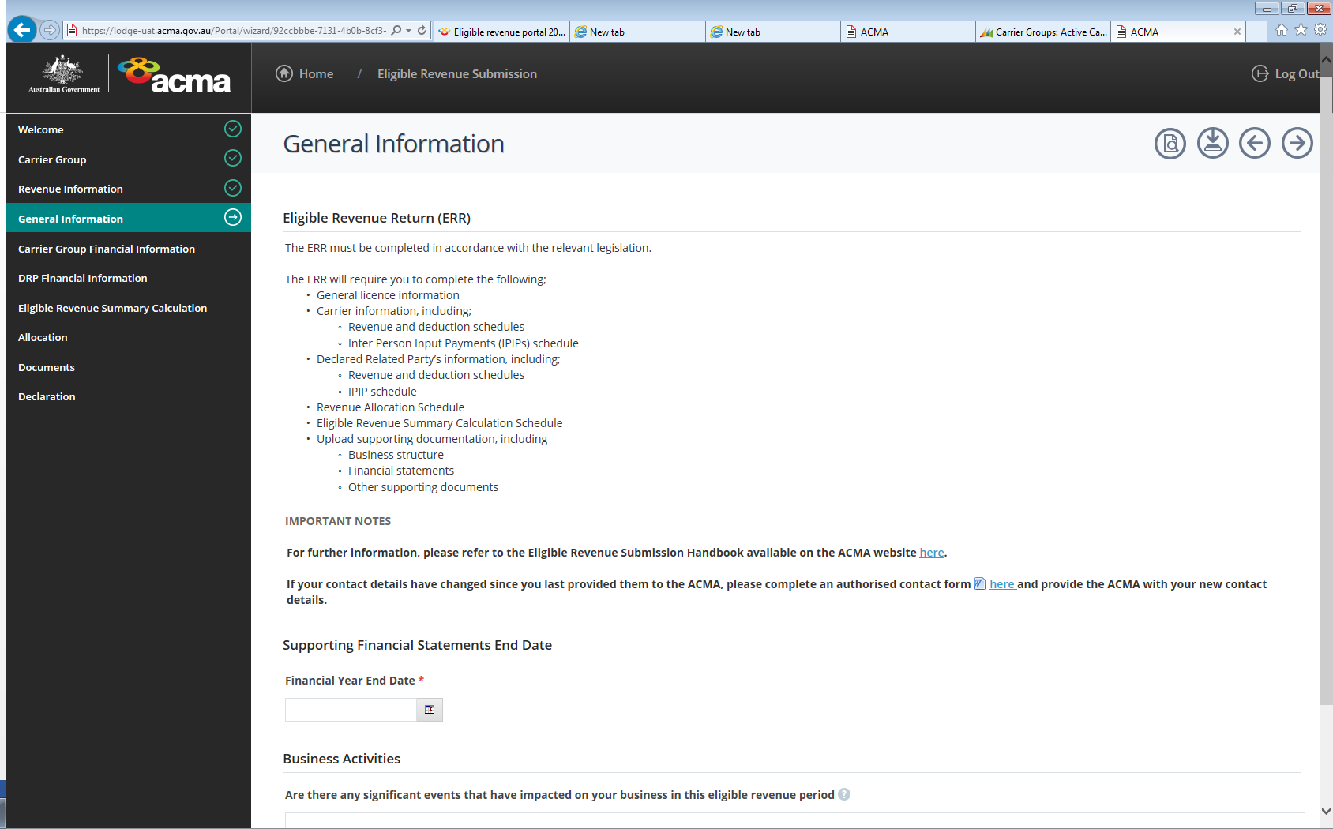
- Select the save icon 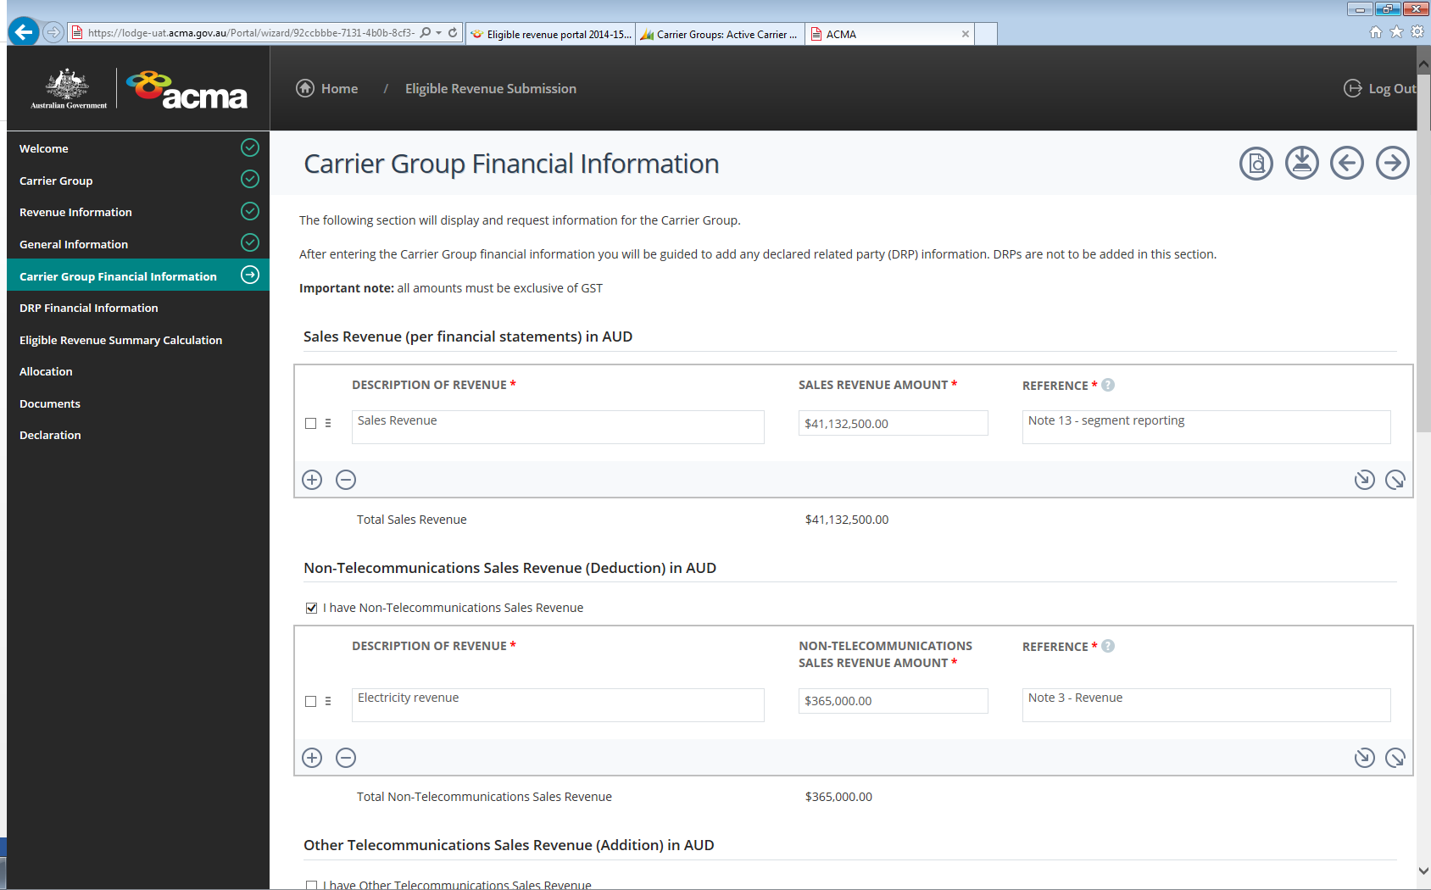 to save your eligible revenue submission. Please ensure that you save frequently to prevent the loss of your information.

- When a submission is saved, a copy is available under ‘Forms Assigned to Me’, located under the home button.
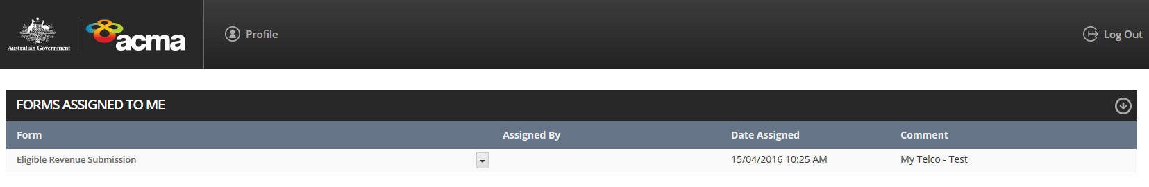

- You can print your eligible revenue submission at any stage of your submission by selecting the print icon
- Select the arrow icon to navigate to the ‘Carrier Group Financial Information’ page.

Carrier Group Financial Information page
- On the ‘Carrier Group Financial Information’ page, enter your revenue and deductions information. Declared related party (DRP) financial information should not be entered on this page but should be entered on the ‘DRP Financial Information’ page.
- To export or import revenue and deduction items within the submission select the:
- export data icon  from the submission, then select either ‘open’, ‘save’ or ‘cancel’
- import data icon  from the submission, then select ‘browse’ to select your CSV file to import. Note: CSV field names in the data file need to match the column names in the submission.
- Click on the arrow icon to navigate to the ‘DRP Financial Information’ page.

Sales revenue (per financial statements)
- Enter the initial sales revenue of the participating person and, if applicable, its consolidated related parties in the ‘Sales Revenue’ on the ‘Carrier Group Financial Information’ page.
Please note that sales revenue is not based on whether a carrier licence is required to earn that revenue. All sales revenue (including consolidated related party and declared related party revenue) must be reported in the eligible revenue submission.
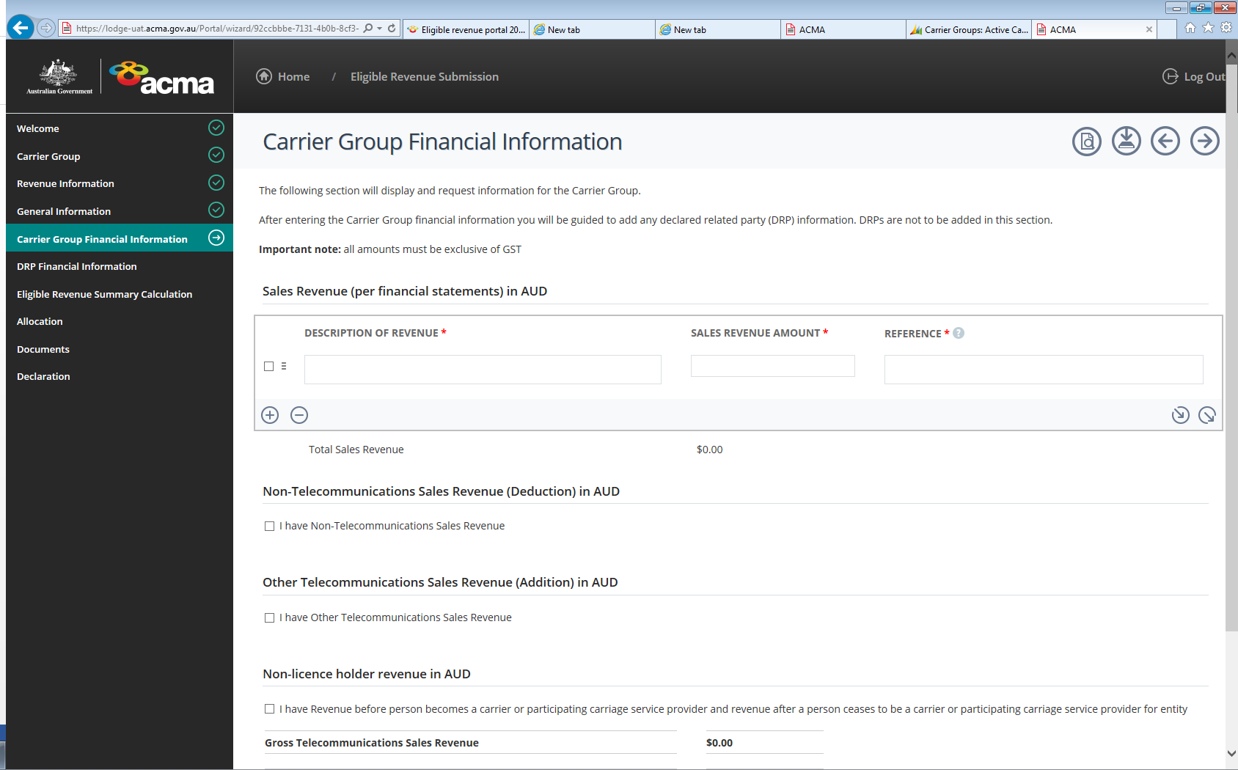

Non-telecommunications sales revenue
Enter the details of any portion of sales revenue that is earned from an activity outside the telecommunications industry (see the definition of ‘non-telecommunications sales revenue’ in section 9 of the ER Determination).
Section 7 of the Telecommunications Act 1997 defines ‘telecommunications industry’ as including an industry that involves either:
carrying on business as a carrier
carrying on business as a carriage service provider
supplying goods or services for use in connection with the supply of a listed carriage service
supplying a content service using a listed carriage service
manufacturing or importing customer equipment or customer cabling
installing, maintaining, operating or providing access to a telecommunications network or a facility used to supply a listed carriage service.
Examples of revenue earned from the following activities may be considered telecommunications sales revenue. (Please note that this list is not exhaustive):
telecommunications services for which a carrier licence is not required. For example, the provision of carriage services by carriage service providers who have been determined to be participating persons (paragraph 44(1)(b) of the TCPSS Act)
the sale of customer telecommunications equipment
internet service provider services
pay TV and content services.
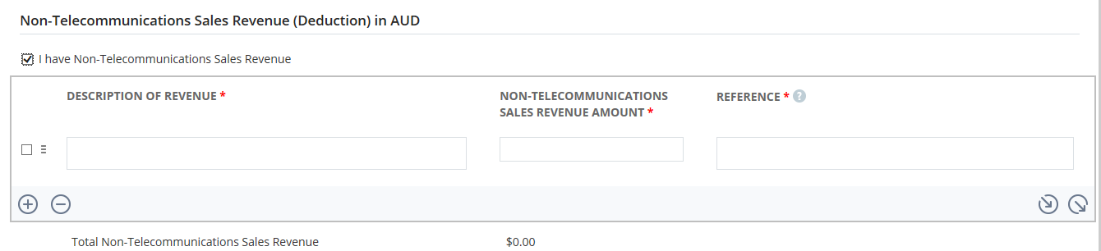

Other gross telecommunications sales revenue
Revenue that has not been included in ‘Sales revenue’ and that would reasonably be described as telecommunications sales revenue must be included in the ‘Other gross telecommunications sales revenue’ part of the page. This may include amounts that have not been described as sales revenue in the financial statements but fall within the definition of telecommunications sales revenue in the ER Determination.
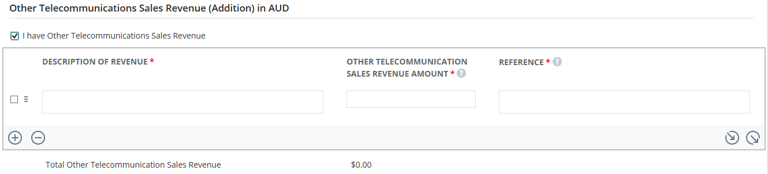

Non-licence-holder revenue
This refers to revenue earned before a participating person becomes a carrier or participating carriage service provider, and revenue earned after a participating person ceases to be a carrier or participating carriage service provider.
Participating persons are entitled to deduct any revenue earned while they did not hold a carrier licence or while they were not a participating carriage service provider (if applicable), subject to the conditions set out in sections 18 and 19 of the ER Determination.
The ACMA will accept a pro-rata calculation of this deduction based on the number of days the licence was not held.
Alternatively, financial reports should be uploaded showing the revenue earned during the period where a carrier licence was not held – these should reconcile to the financial statements. Please include any information in the explanatory notes field that may help the ACMA analyse the return.
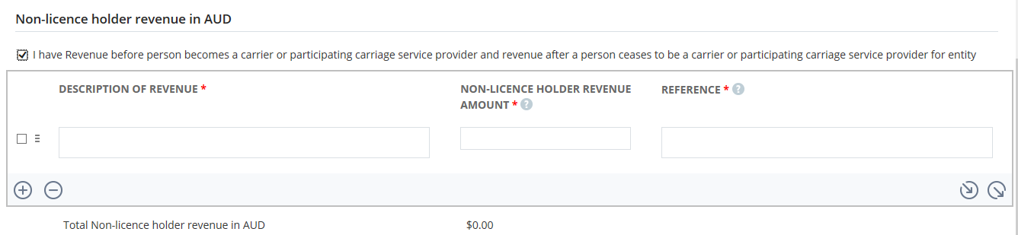

Deductions
Allowable deductions are specified in the ER Determination. Participating persons must provide sufficient details/evidence to support the deductions claimed, as the ACMA may reject deductions that are not supported by sufficient and appropriate information.
The deductions schedule permits participating persons to choose the deduction type by using a drop-down menu based on the categories of deductions provided in the ER Determination. Once this has been done, enter information to support the deduction claim, the entity claiming it and the deductible amount. All amounts should be entered as gross value excluding GST.
For it to be a deductible revenue, the revenue must be included in total ‘Sales revenue’ or ‘Other gross telecommunications sales revenue’ and must not have been deducted elsewhere.
Some streams of revenue allowed as deductions may have been ‘bundled’ with other revenue to meet financial reporting requirements. If an item contains deductible revenue bundled together with non-deductible revenue, these amounts must be ‘unbundled’ to be claimed as deduction. This means the amount of deductible revenue included in this figure must be clearly explained and identified along with any methodology used to calculate the deductible portion of this figure. Any additional documentation to support the bundled revenue should be uploaded to provide verification of the deductions.

Deductions for overseas activities
Under section 23 of the ER Determination, a participating person may claim a deduction for revenue earned from ‘overseas’ activities. These activities must take place entirely outside Australia and are defined in subsection 23(4) of the ER Determination.
For example, if a carriage service originates or terminates in Australia, the activity has an Australian connection and is not deductible under section 23 of the ER Determination.

Acts in Australia for services outside Australia
Under section 24 of the ER Determination, revenue earned from acts performed in Australia solely for the supply of carriage services that originate and terminate outside Australia may be deductable. Revenue earned from providing services in Australia (for example, management, switching or transit carriage services) for a carriage service originating and terminating outside Australia could be claimed as a deduction. However, a deduction would not be allowed if the supply of the carriage service either originated or terminated in Australia.

Customer equipment: rent, sell, install, insure, repair or maintain
Under section 25 of the ER Determination, a participating person may claim a deduction for revenue earned by the person or a consolidated related party of the participating person from renting, selling, installing, insuring, repairing or maintaining customer equipment which is part of the participating person’s gross telecommunications sales revenue. Customer equipment is defined in section 21 of the Telco Act and does not include a line.

Content services
Under section 26 of the ER Determination, a participating person may claim a deduction for revenue earned by the person or a consolidated related party of the participating person for the ‘content’ of a content service. For example, programs, including a program broadcast on a subscription broadcast service or a message on a ‘190’ telephone service. Revenue from the carriage of the ‘content’ cannot be claimed as a deduction.

Exempt base station
Under section 27 of the ER Determination, a participating person may claim a deduction for revenue earned by the person or a consolidated related party of the participating person from the use of an exempt base station during the eligible revenue period.
A base station is an exempt base station if the sole use of the base station is by a broadcaster to either:
supply broadcasting services to the public
supply a secondary carriage service by means of the main carrier signal of a primary broadcasting service.

Infrastructure revenue
Under section 28 of the ER Determination, a participating person may claim a deduction for revenue earned by the person or a consolidated related party of the participating person from the construction, installation or maintenance of the infrastructure of a telecommunications network, as well as management of construction, installation and maintenance of the infrastructure. A deduction may only be claimed for revenue from activities relating to the construction, installation or maintenance of telecommunications infrastructure on the network side of the boundary (not on the customer side of the network boundary) of the telecommunications network.
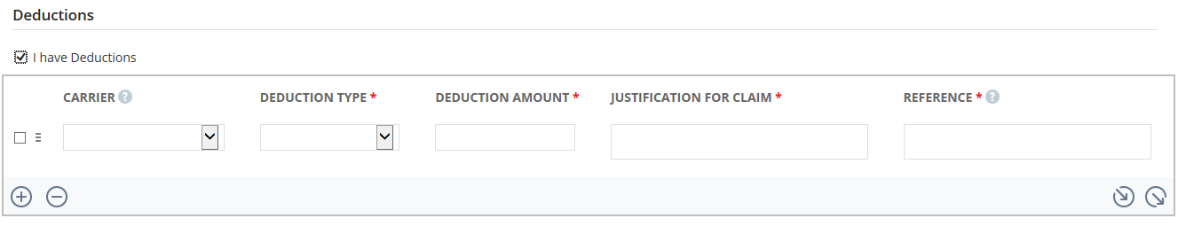

Inter-person input payments
Under section 29 of the ER Determination, a participating person may claim a deduction for inter-person input payments (IPIP) – payments which a participating person (the first person), or its consolidated or declared related party (DRP), has made, or is liable to make, to another licensed carrier (the second person). The second person can be a participating or non-participating person, or a consolidated or declared related party of a participating or non-participating person. To be an IPIP, the payment must be for an act done by the second person that allows the first person (or its consolidated related party or DRP) to provide a listed carriage service.
Enter any IPIP paid or payable by the first person and, if applicable, IPIP paid or payable by consolidated related parties of the first person in the IPIP schedule of under the ‘Carrier Group Financial Information’ page.
Any IPIP paid or payable by DRPs (multiplied by the DRP factor) of the first person should be recorded in the IPIP of the ‘DRP’ page.
Deduction of IPIP is to prevent double-recording of revenue. If the first person makes an IPIP to the second person (for example, if they purchase a service from the second person), the second person must show that revenue as part of its gross telecommunications sales revenue and not claim a deduction for that revenue received, in order for the first person to be able to claim the payment as a deduction. If the second person is a non-participating person, the requirement is that the payment would have been included as part of their gross telecommunications sales revenue if they were a participating person.
The ACMA may not accept a deduction unless the person to whom the payment was made (that is, the second person or its consolidated or declared related party) has been identified as part of its IPIP. IPIPs are only deductible if the payments were made while both the first and second persons held carrier licences. Supporting evidence may be requested to substantiate any deductions claimed; for example, creditor reports.
A deduction cannot be claimed for payments made between entities that have been consolidated into the same financial statements as the participating person. This is because the associated revenue and expenses would have been eliminated in the consolidated financial statements.
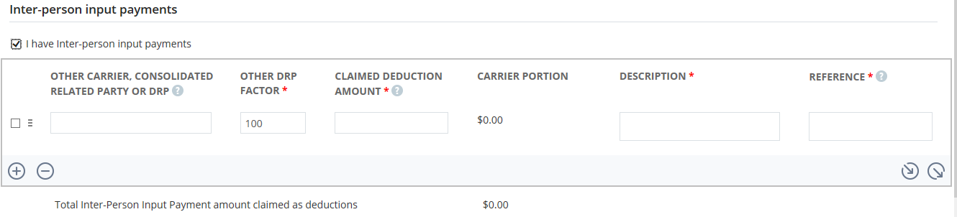

Other input amounts
Under section 30 of the ER Determination, the ACMA may, in writing, declare that a specified amount paid or payable by a participating person, or a consolidated related party or declared related party of the participating person, is an input amount. The ACMA may only do so if the payment was to allow the participating person to provide a telecommunications good or service (other than an inter-person input payment).
The ACMA has not declared any amounts as other input amounts to date.
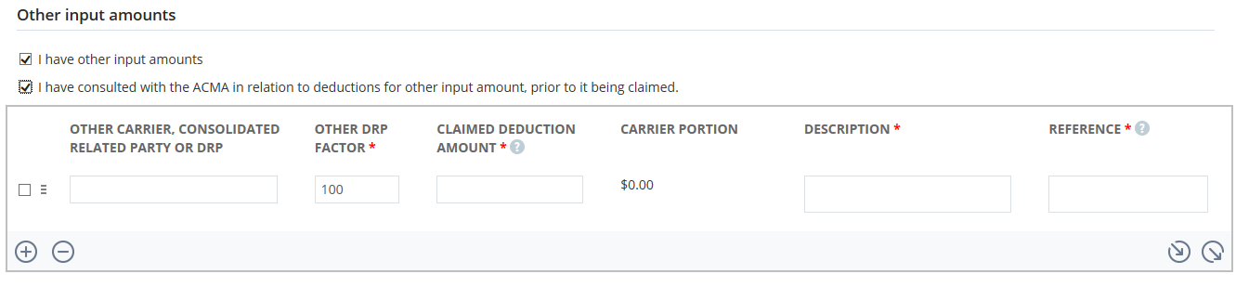

DRP Financial Information page
- Enter Declared Related Party (DRP) – information on the ‘DRP Financial Information’ page. Further information relating to DRPs is available below and in the ‘Related parties for eligible revenue reporting fact sheet’ from the eligible revenue portal on our website.
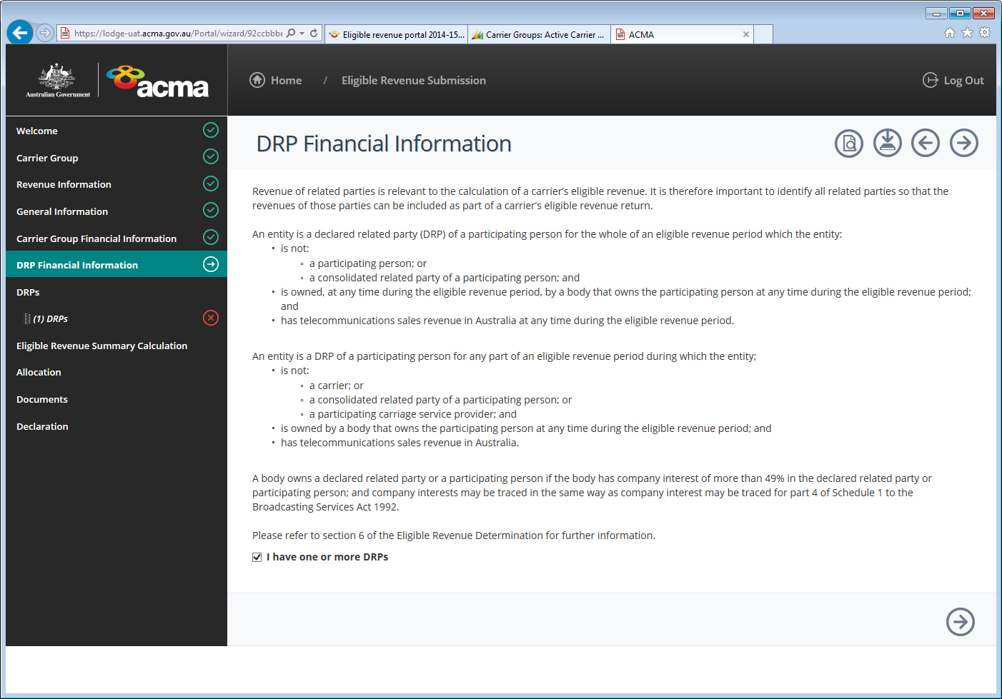

- Select the check box, if you have one or more DRP, and then select the arrow icon to enter DRP financial information. If there are no DRPs, select the arrow icon to navigate to the ‘Eligible Revenue Summary Calculation’ page.
- To add another DRP, select the plus icon 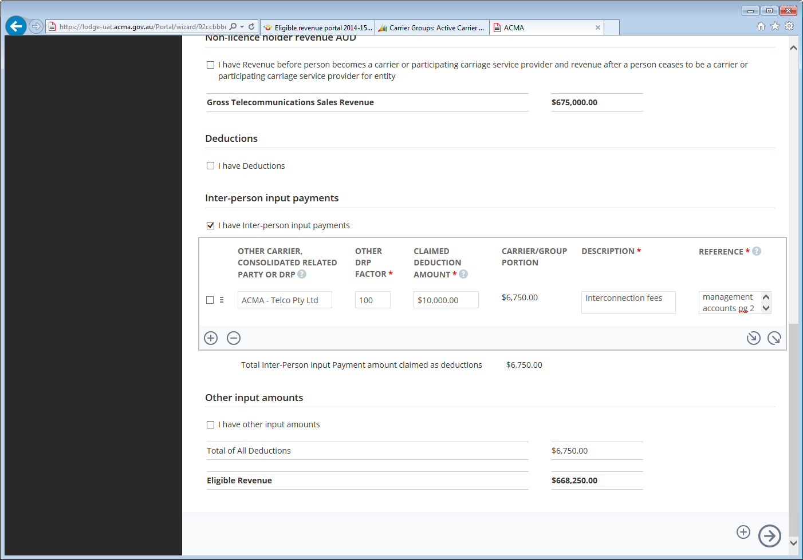 at the bottom of the form. Otherwise you can select the arrow icon to go to the ‘Eligible Revenue Summary Calculation’ page.

Information about DRPs
A DRP of a participating person and of a non-participating person for the whole, or any part, of an eligible revenue period is defined in sections 6 and 7 of the ER Determination, respectively.
Generally, a DRP is an entity that is not a carrier, a consolidated related party of a participating person, a non-participating person or a participating carriage service provider for the period for which the return is being completed, and the entity:
Is owned by a body which has company interests of more than 49% at any time during the eligible revenue period (which the body also has greater than 49% company interests in the participating or non-participating person or a participating carriage service provider).
has telecommunications sales revenue in Australia during the eligible revenue period.
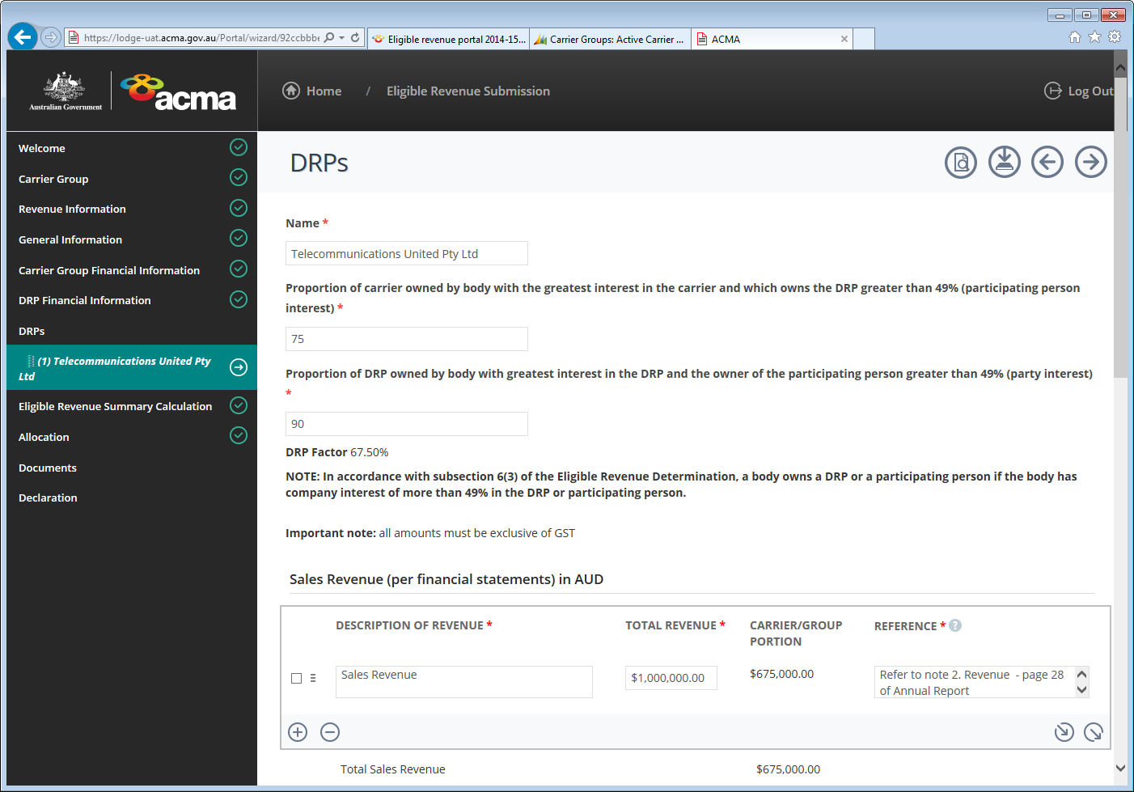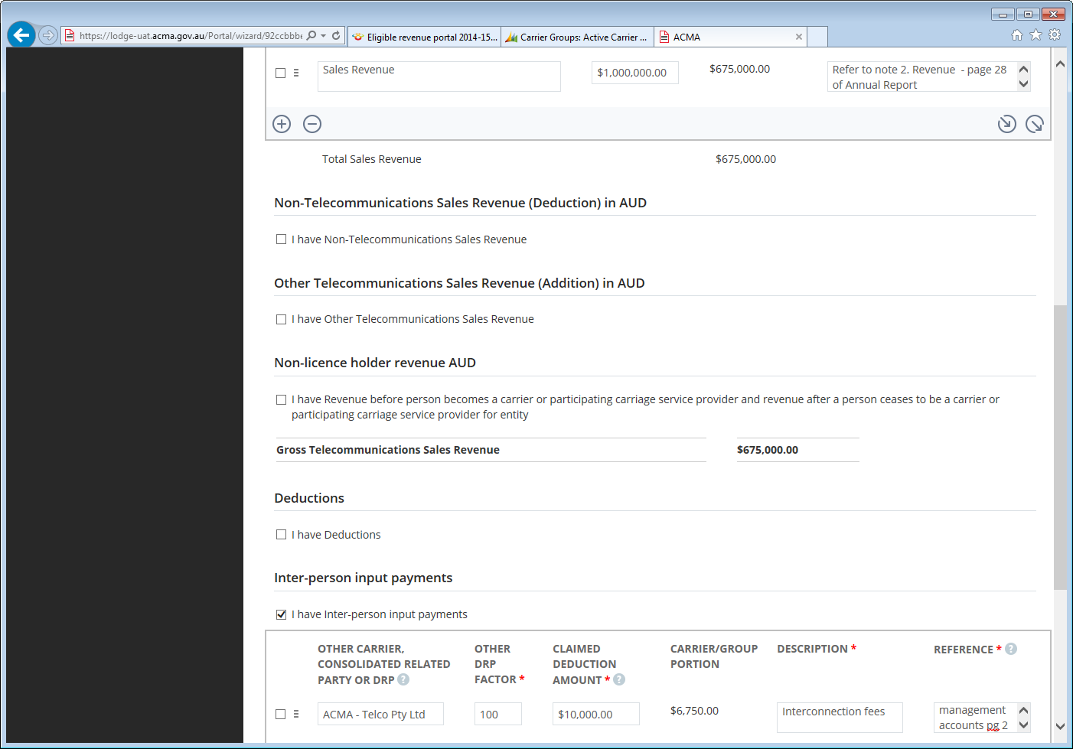
The following information should be included on the DRPs page:
all names of DRPs of each participating person
the proportion of each participating person owned by the body (meaning the body has company interests of more than 49%) that also owns the DRP
the proportion of the DRP owned by the body that also owns the participating person.
Revenue and deductions claimed by the participating person in relation to a DRP of the person should be dealt with in accordance with the ER Determination. See the ‘Carrier Group Financial Information’ above for further information regarding claiming deductions.
This data will be used to calculate the DRP factor (defined in section 8 of the ER Determination). The DRP factor is used to determine what proportion of the DRP’s revenue and deductions are attributable to the participating person (and its group).
The consolidated financial statements of the ultimate Australian parent entity must be used as well as financial statements of any DRPs to determine the amount of sales revenue, unless the participating person does not produce financial statements for an ultimate Australian parent entity. In these circumstances, the financial statements that include the participating person must be used as the source.

Calculating the percentage share of the declared related parties’ revenue, to be included in an ERR form
In accordance with section 8 of the ER Determination, the formula for calculating the percentage of the DRP’s revenue is either:
Participating person interest multiplied by the party interest.
Non-participating person interest multiplied by the party interest.

Eligible Revenue Summary Calculation page
The eligible revenue summary calculation provides a summary of the eligible revenue calculation. This schedule is automatically calculated based on information entered in the preceding pages of the form. No input of data is required here.
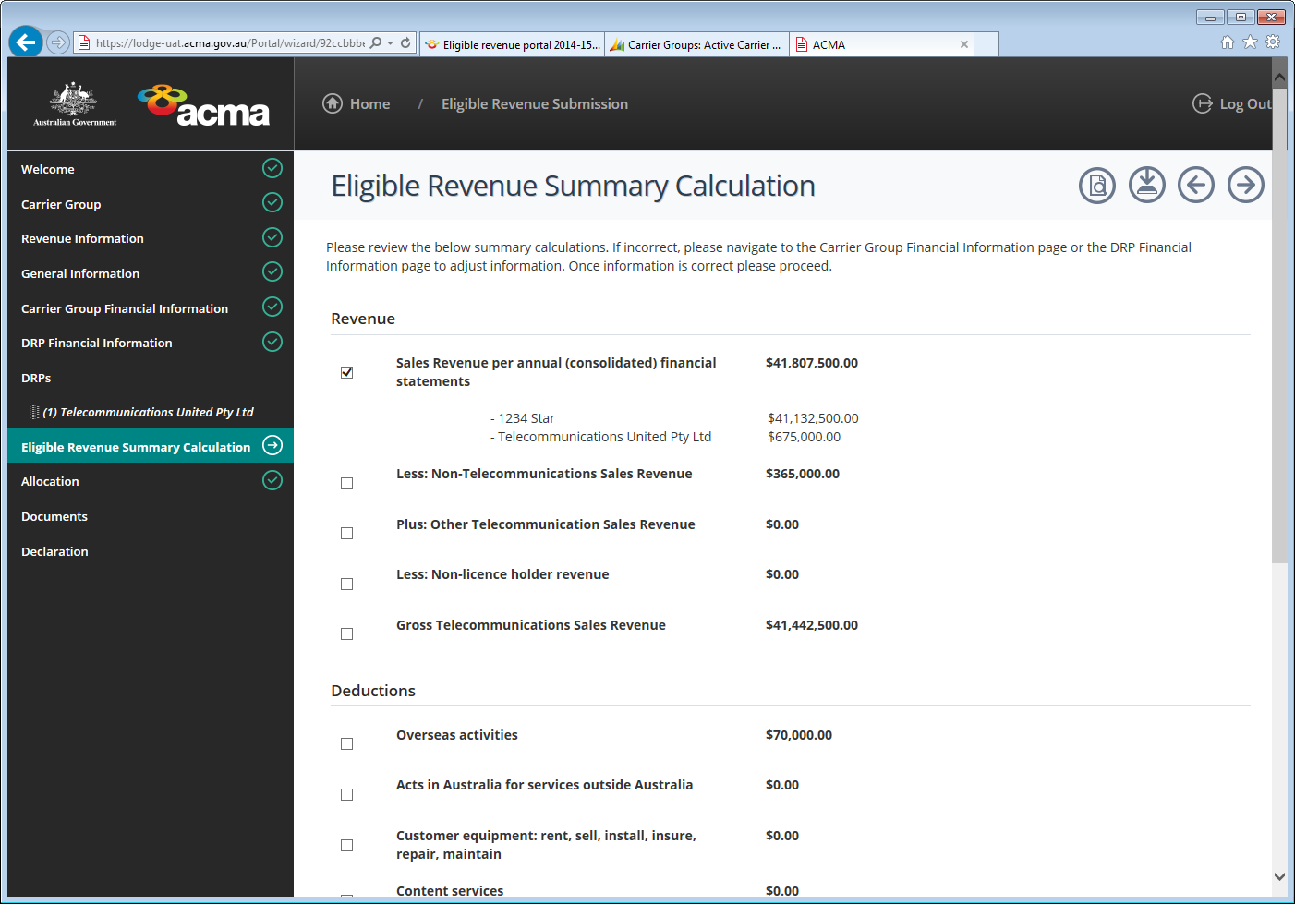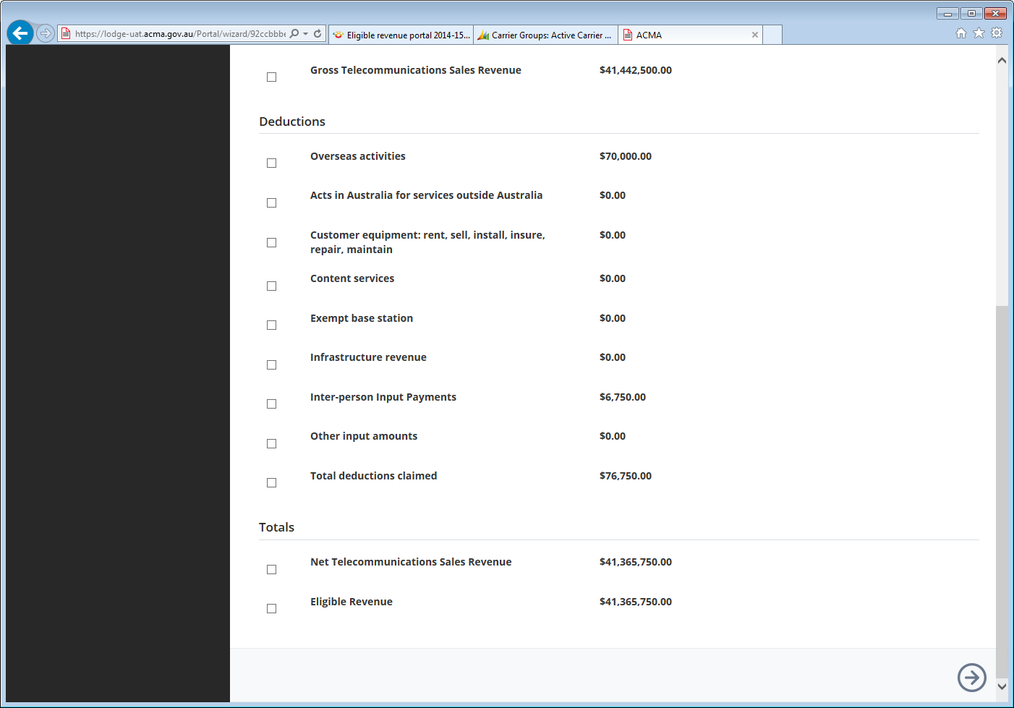
- Check that the information on the ‘Eligible Revenue Summary Calculation’ page is correct. To drilldown on a specific Revenue or Deduction total, select the check box for the items to be shown.
- Select the arrow icon to navigate to the ‘Allocation’ page.

Allocation page
If 2 or more participating persons with the same ultimate Australian parent entity submit a grouped return in accordance with section 11 of the ER Determination, the return must indicate the amount of net telecommunications sales revenue and the amount of eligible revenue that is attributable to each participating person in the group in the revenue allocation schedule.
The total amount of eligible revenue earned by the group and its DRPs must be attributed to participating persons in the group. Until this occurs, the amount not yet attributed will show as ‘unallocated’ and will be shaded red, indicating the allocation has not been completed.
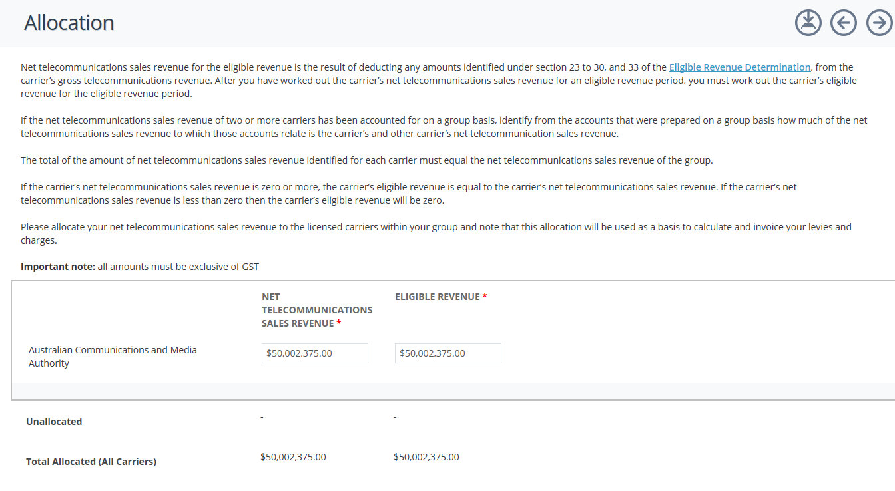
- Allocate the ‘Net Telecommunications Sales Revenue’ and the ‘Eligible Revenue’ against the carriers within the carrier group. Enter an explanation if further information is required to explain the allocation.
- Once complete, select the arrow icon to navigate to the ‘Documents’ page.

Documents page
The ‘Documents’ page allows the participating person to upload the following documents:
financial statements on which the return is based (including the financial statements of any declared related parties)
outline of the business structure for the current period – a diagram and description showing the structure of the group of companies (if applicable) and other entities, identifying all entities that earn telecommunications sales revenue including the participating person(s) and any consolidated and declared related parties
supporting documentation to support the revenue and deductions made in the eligible revenue submission.
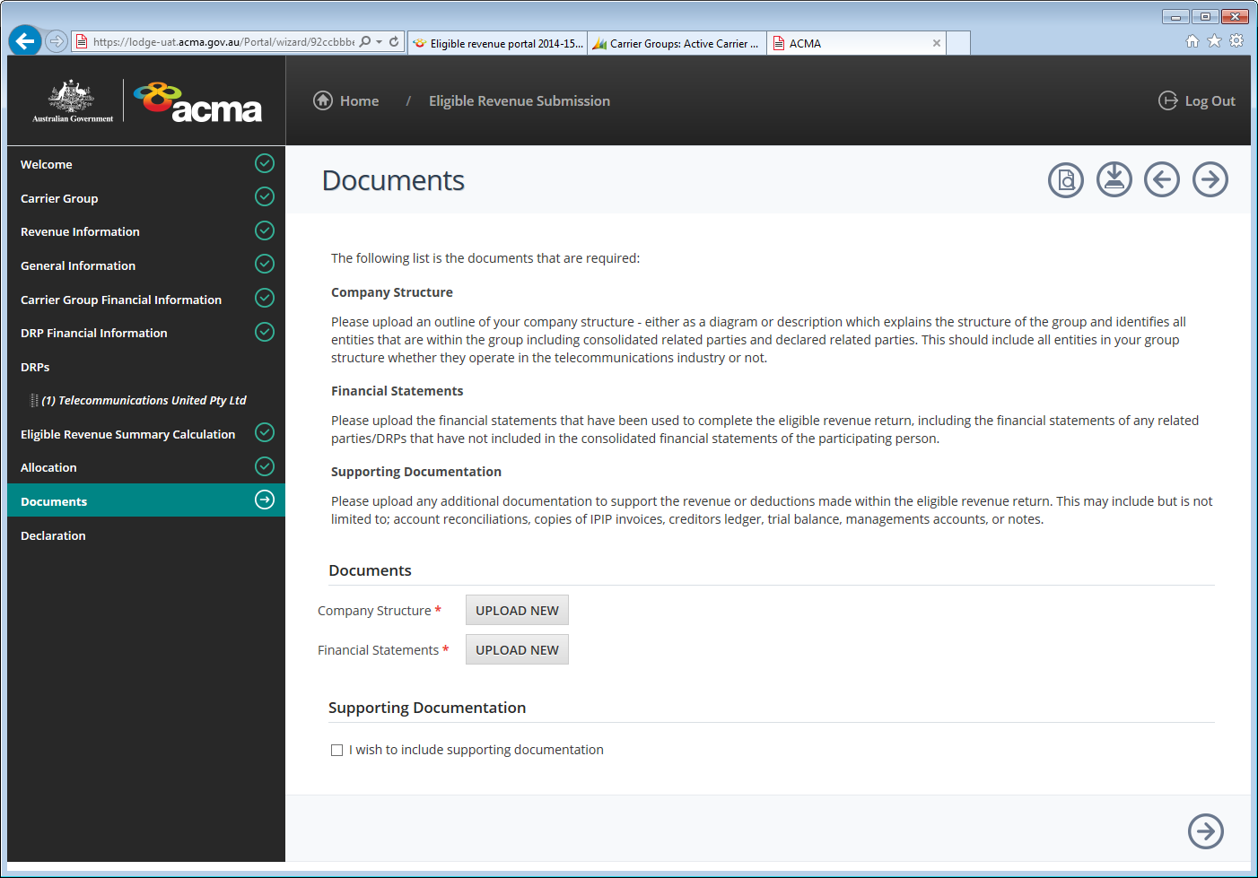
- On the ‘Documents’ page, upload the ‘Company Structure’ and ‘Financial Statements’ information by selecting ‘Upload New’
- A pop-up window will appear to allow you to locate your file from your computer. Once you have located your file, select ‘Start upload’.
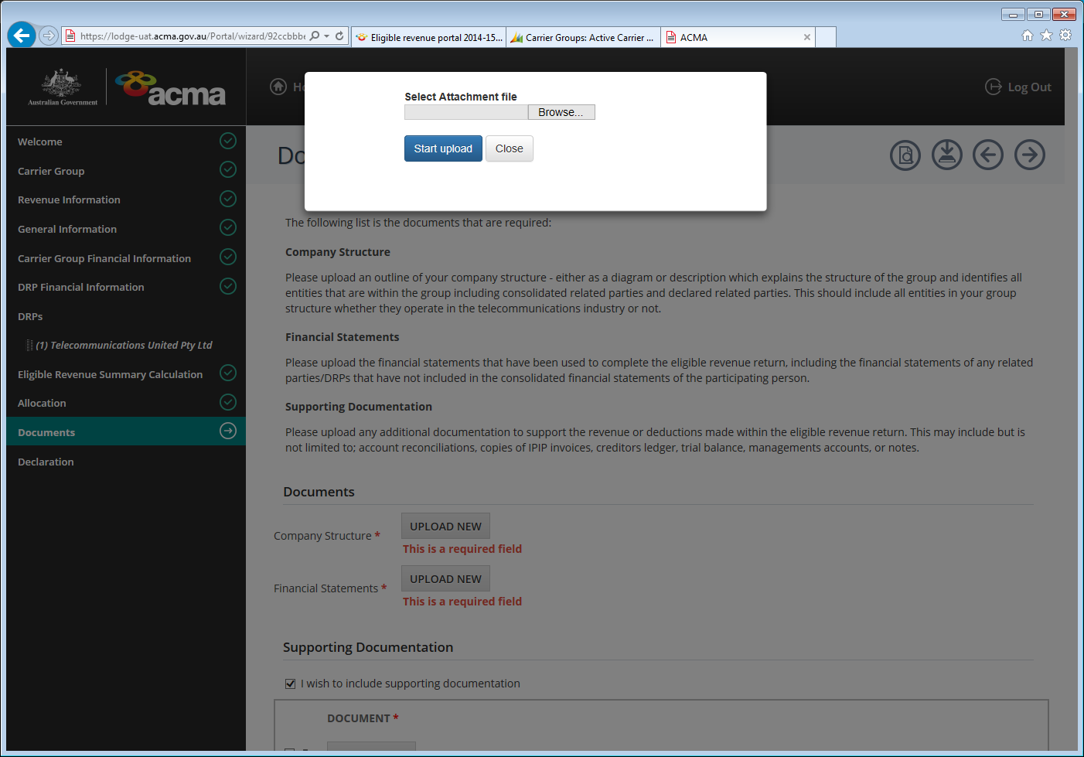
- Once the documents have been uploaded, the name of the files should appear under ‘Documents’.
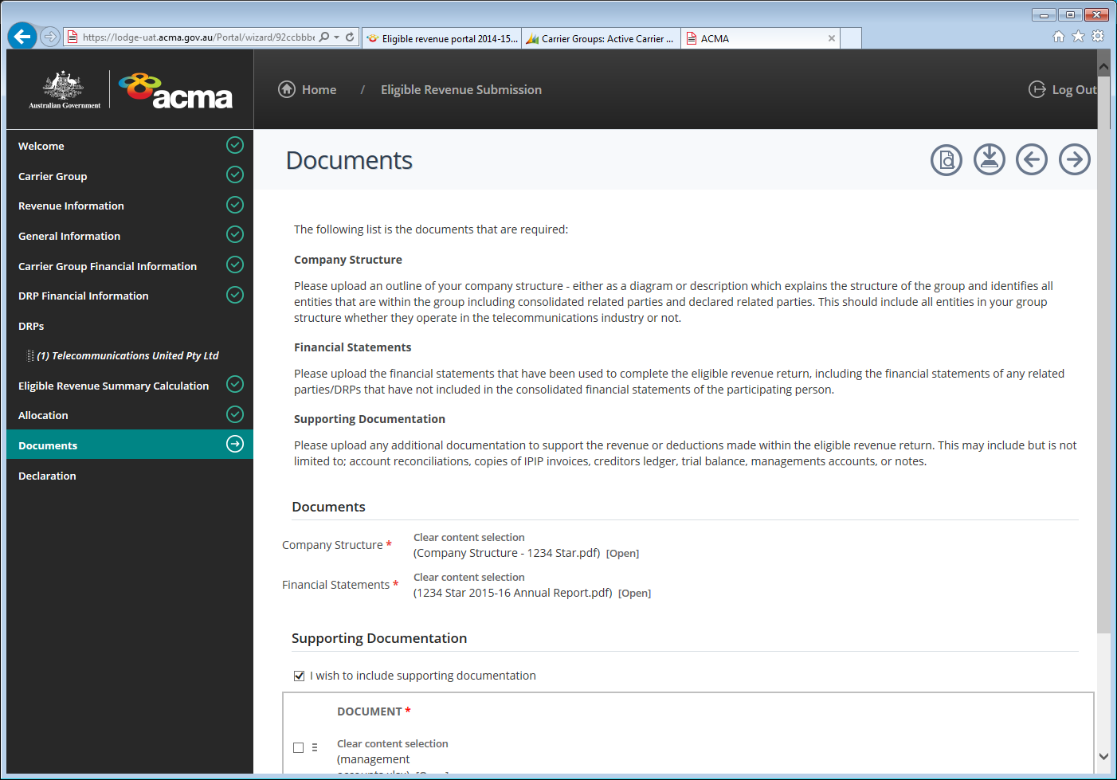
- To upload supporting documentation, select the ‘I wish to include supporting documentation’ check box.
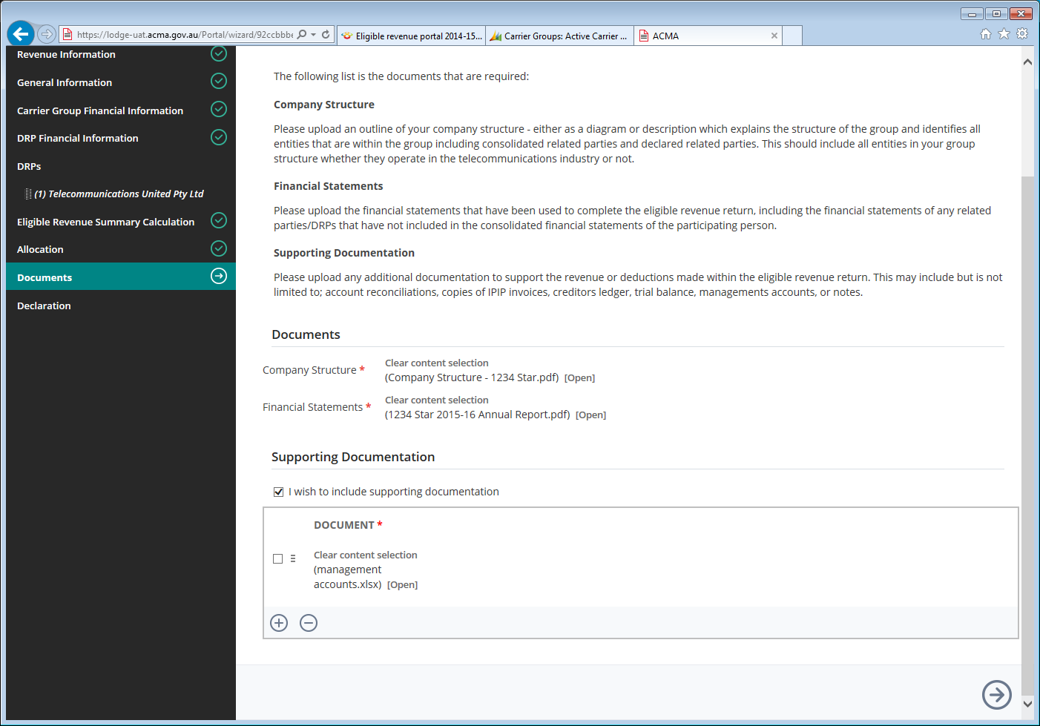
- Select the arrow icon to navigate to the ‘Declaration’ page.

Declaration page
An authorised officer is required to declare that the information that has been entered into the TELLER system as the eligible revenue return of the carrier group is:
true and correct to the best of their knowledge and belief
that the methodologies used to prepare the ERR have been fully disclosed
that the ERR has been prepared in accordance with the requirements of the TCPSS Act
that the ERR includes all revenue earned by the carrier’s consolidated related party and declared related party
the person understands that giving false or misleading information is a serious offence.
Authorised officers include the Chief Financial Officer, Chief Executive Officer and company secretary and any officer listed as an authorised contact with the ACMA.
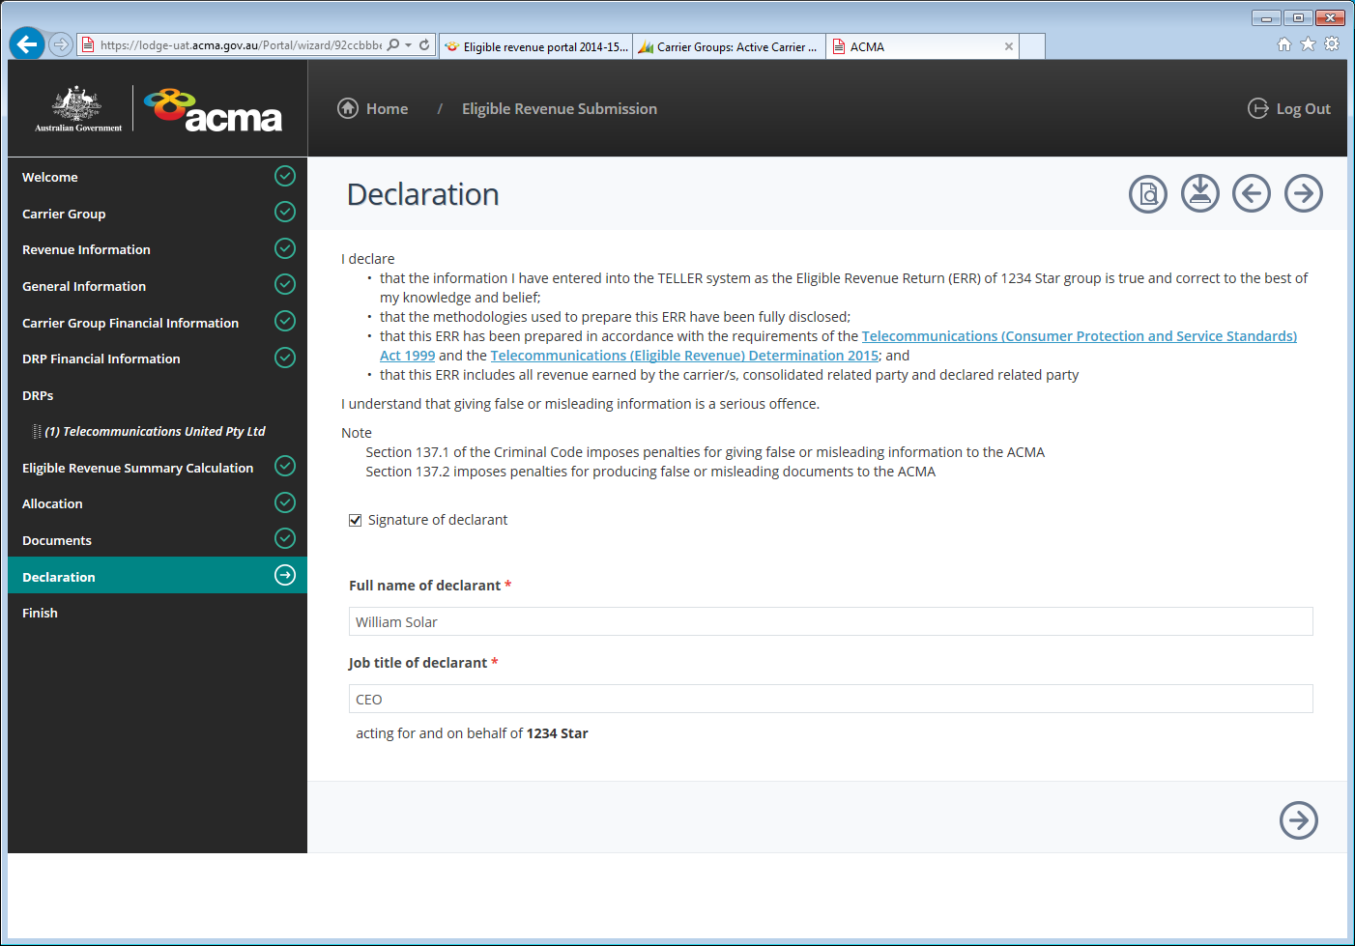
- Read the declaration and select the ‘Signature of declarant’ box to make the declaration. A drop-down box will appear for the declarant to enter their ‘full name’ and ‘job title’.
- Select the arrow icon to navigate to the ‘Finish’ page.

Finish page
On the ‘Finish’ page, you are given the option to save your submission in TELLER for your records, prior to submitting it to the ACMA.
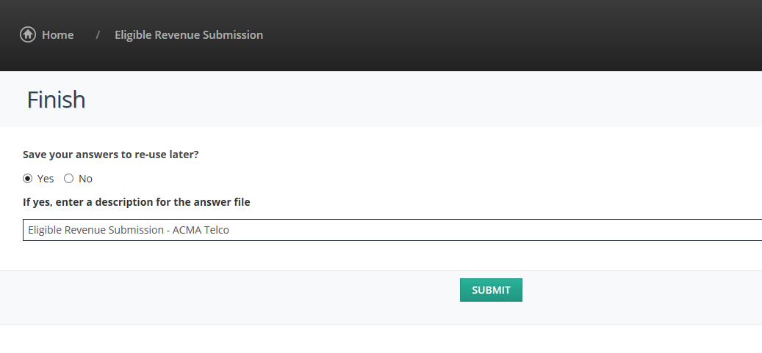
- From this page, you can save a copy of your submission for your records. If you would like to save a copy, select the ‘Yes’ check box. This will save your answers to re-use later and enter a description for the answer file.
- Select the ‘Submit’ button.
- A notification email will be sent to the email address as displayed on the ‘Welcome’ page and a ‘Submission successful’ page will appear with your accompanying reference number.

Submission successful page
Once you have successfully submitted your eligible revenue submission. The following confirmation will be displayed and an email acknowledgement will be sent to the submitter.
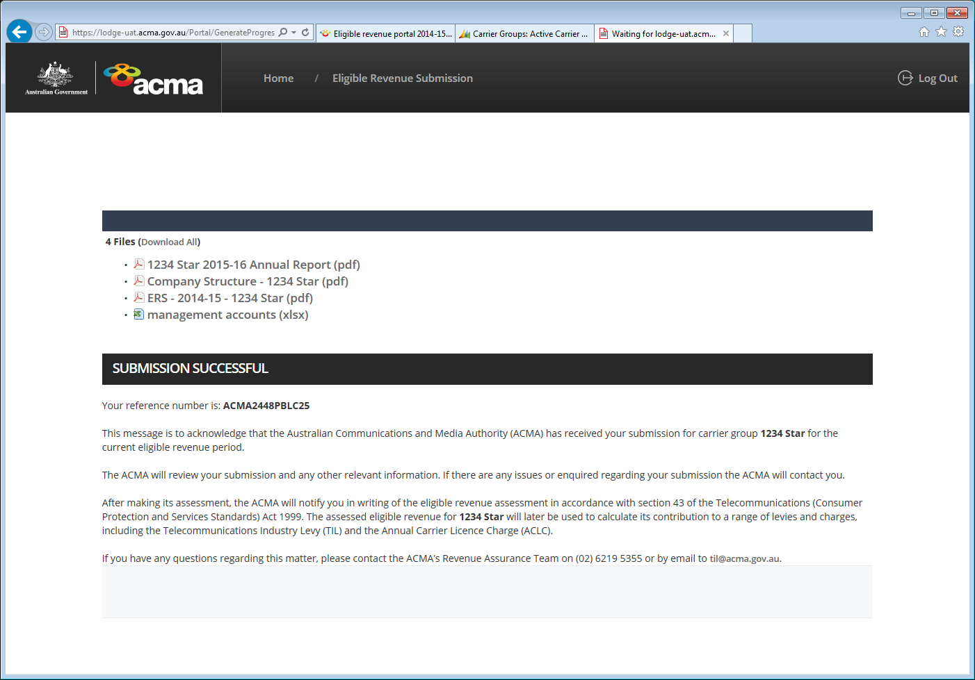
- A PDF copy of your submission can be printed from the files displayed on the ‘Submission successful’ page.
- A copy of the submitted return can also be found under ‘Documents’ on the top menu bar.
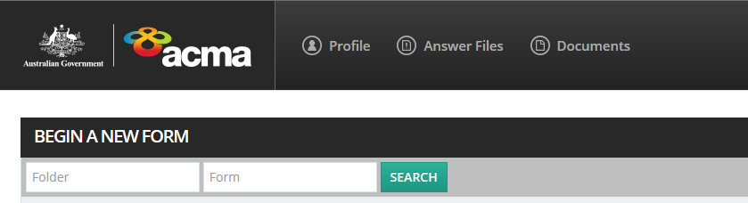

Log out of TELLER
To log out of the system, select the ‘Log Out’ button on the top right menu bar.

Part B: Non-participating persons

Eligibility

How does a carrier determine if it is a non-participating person?
Under the Participating Persons Determination, there are 2 requirements that must both be met for a carrier to be a non-participating person.

Requirement 1 – revenue thresholds
A carrier must meet one of the following criteria:
initial sales revenue for the eligible revenue period of less than AUD $25 million
gross telecommunications sales revenue for the eligible revenue period of less than AUD $25 million
eligible revenue for the eligible revenue period of less than AUD $25 million.
For carriers that have the same ultimate Australian parent entity as one or more other carriers, the threshold is to be calculated on a group basis.

Requirement 2 – eligible statutory declaration
If a carrier meets Requirement 1, it is a non-participating person if either:
the carrier provides to the ACMA by 31 October each year an eligible statutory declaration (ESD) stating that the carrier’s initial sales revenue, gross telecommunications sales revenue or eligible revenue (as applicable) for the eligible revenue period was less than AUD $25 million
the ACMA is otherwise reasonably satisfied that the person’s initial sales revenue, gross telecommunications sales revenue or eligible revenue was less than AUD $25 million for an eligible revenue period.
Under section 521 of the Telecommunications Act 1997 and Section 46 of the Telecommunications (Consumer Protections and Services Standards) Act 1999, the ACMA has the power to seek further information from carriers for reasonable assurance into the correctness of reported revenue.

Calculations to be made on a group basis
Subsection 4(4) of the Participating Persons Determination specifies that if a person has the same ultimate Australian parent entity as one or more other carriers, then the carrier must calculate:
initial sales revenue for the group
gross telecommunications sales revenue for the group
eligible revenue for the group.
If any of these amounts as calculated for the group is below AUD $25 million, the carriers within the group may each be considered a non-participating person.

Revenue thresholds

Initial sales revenue of less than AUD $25 million
Section 12 of the ER Determination sets out how the sales revenue of a carrier, consolidated related party of the carrier or declared related party of the carrier is to be calculated, including the sources that are to be used.

Gross telecommunications sales revenue of less than AUD $25 million
Part 3 of the ER Determination sets out how the gross telecommunications sales revenue of a carrier, consolidated related party of the carrier or declared related party of a carrier is to be calculated.
In summary, gross telecommunications sales revenue is calculated as follows:
initial sales revenue for the eligible revenue period
‘less’ non-telecommunications sales revenue
‘plus’ other telecommunications sales revenue
‘less’ revenue earned while not the holder of a carrier licence.

Eligible revenue of less than AUD $25 million
Part 5 of the ER Determination sets out how the eligible revenue of a carrier is to be calculated.

Eligible statutory declaration (ESD)

What is an ESD?
If a carrier or carrier group meets the requirements referred to above, it will be a non-participating person if it provides to the ACMA by 31 October each year an ESD stating that its initial sales revenue, gross telecommunications sales revenue or eligible revenue (as applicable) for the eligible revenue period was less than AUD $25 million.
An ESD must:
be in accordance with the Statutory Declarations Act 1959
be made by a director or company secretary or any person authorised in writing by the company to make the declaration (if the person is a company), or by a natural person (if the declarant is a natural person)
declare which of the 3 revenue thresholds the carrier or carrier group falls below
specify the eligible revenue period for which the carrier or carrier group is a non-participating person
be scanned and submitted to the ACMA by 31 October following the end of the eligible revenue period.
All information submitted must be:
clearly legible
in English
in Australian dollars (AUD$).
It is an offence under section 11 of the Statutory Declarations Act 1959 to intentionally make a false statement in a statutory declaration.

What happens if an ESD is not submitted by 31 October?
If a carrier does not submit an ESD to the ACMA by 31 October as required, the ACMA must be reasonably satisfied that the carrier is a non-participating person.
The ACMA will estimate the carrier/carrier group’s revenue for the eligible revenue period using any information available to determine the initial sales revenue, gross telecommunications sales revenue or eligible revenue is less than AUD $25 million.
If the ACMA determines the carrier is a participating person based on this estimation, then the ACMA will make a written assessment of eligible revenue, as set out under section 48 of the Telecommunications (Consumer Protection and Service Standards) Act 1999.
A carrier that is determined a participating person based on the estimation will also be liable to all levies and charges associated with being a participating person.

How is an ESD lodged?
A carrier or carrier group can make their eligible revenue submission of an ESD by using the TELLER system. The following pages identifies how to submit the ESD online using the TELLER system.

Log in to TELLER
Non-participating persons can access the TELLER system from the eligible revenue portal on our website.
Select the ‘Access ER portal’ button as shown below.

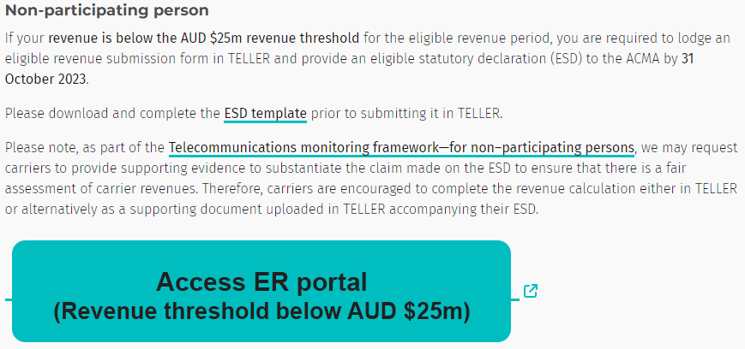

Completing the Eligible Revenue Submission
This section provides instructions to help non-participating persons complete the Eligible Revenue Submission form using ESD in TELLER that must be submitted as part of each non-participating person’s reporting requirements for each period.
If you are unable to make an ESD submission to the ACMA via TELLER, please contact the Revenue Assurance Team.

Welcome page
- On the ‘Welcome’ page, enter your ‘Carrier Group Name’ and ‘Contact Details’.
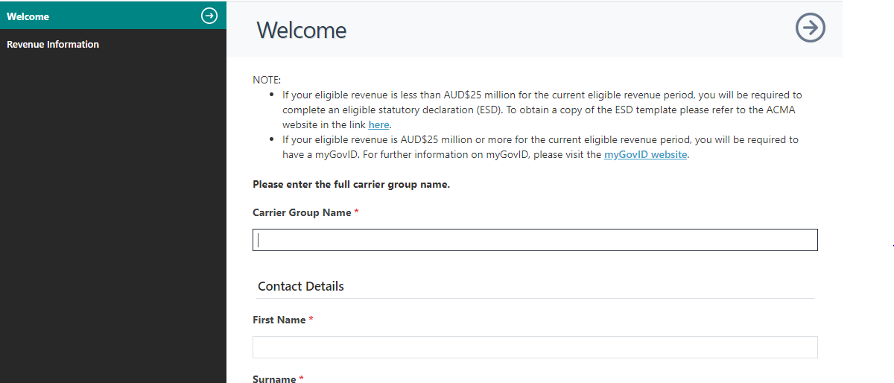
- Once you have entered your details, select the arrow icon to navigate to the ‘Revenue Information’ page.

Revenue Information page
- The ‘Revenue Information’ page is used to select your ‘Initial Sales Revenue’, ‘Gross Telecommunications Sales Revenue’ or ‘Eligible Revenue’ threshold.
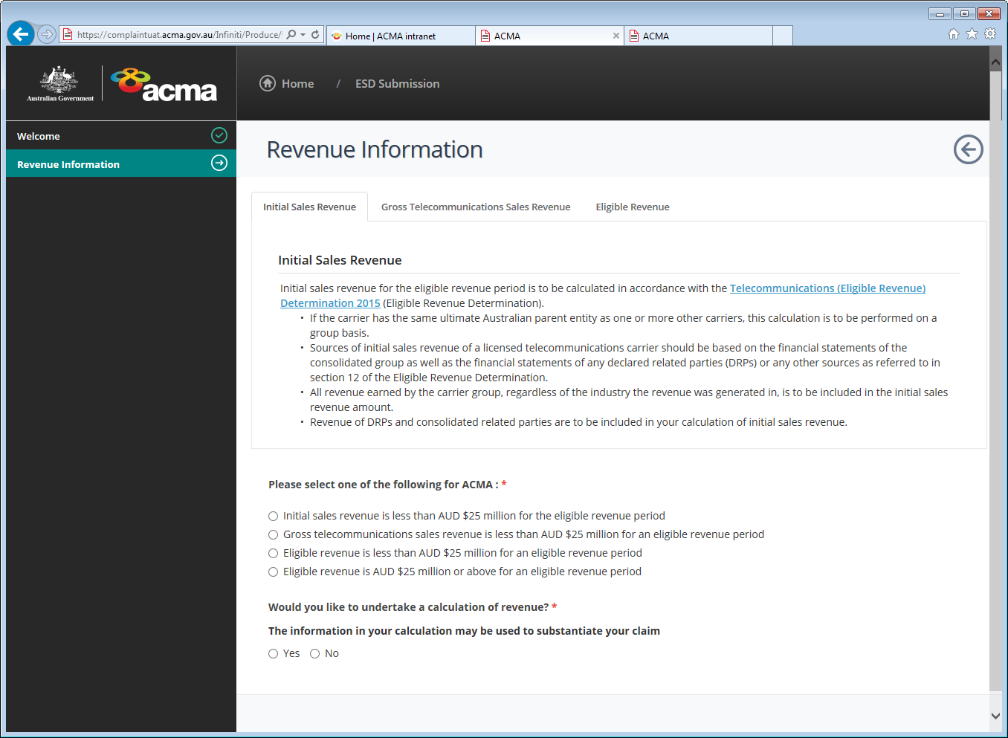
- Select the ‘Initial Sales Revenue’, ‘Gross Telecommunications Sales Revenue’ and ‘Eligible Revenue’ tabs to read and determine your revenue threshold.
- Once you have determined your revenue for the carrier group, select one of the following revenue thresholds that is applicable to your carrier/carrier group on any of the revenue tab pages.
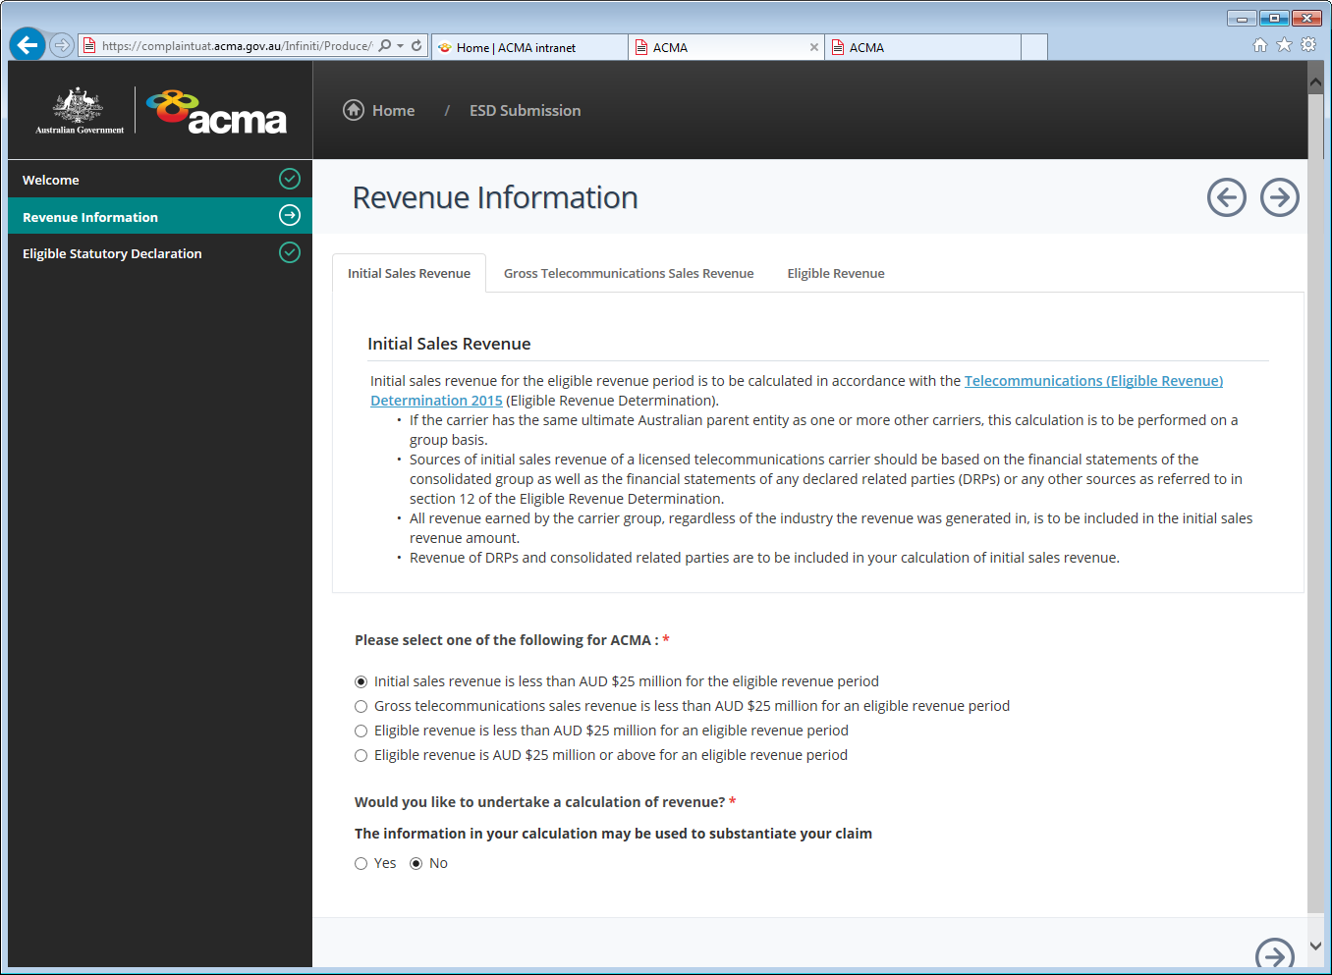
- If you are unsure which threshold you meet, you may undertake a ‘calculation of revenue’ to assist you in determining the revenue threshold to select.
- Select ‘Yes’ if you would like to undertake a calculation of revenue.
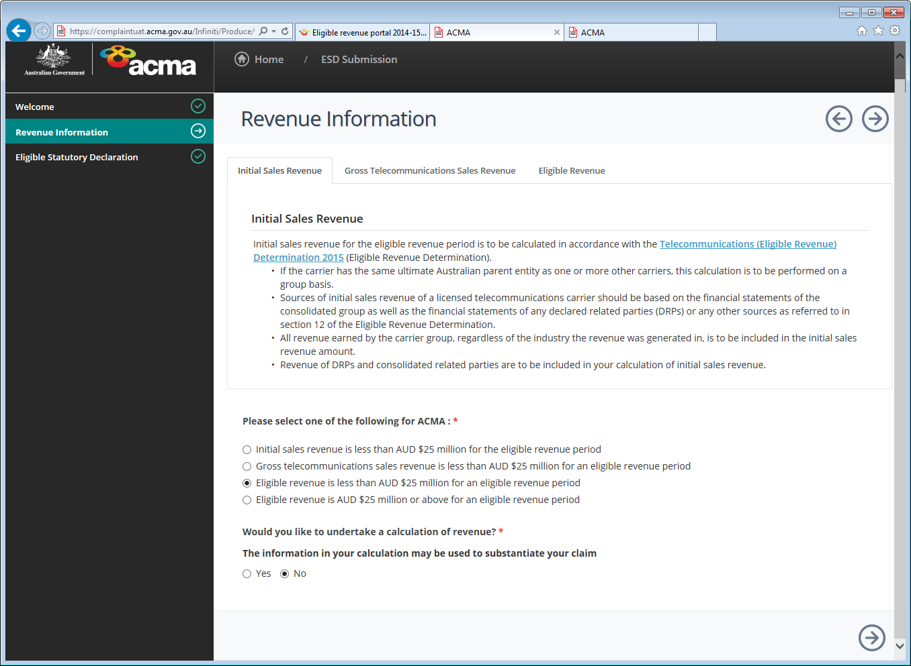
- Carriers are encouraged to undertake a calculation of revenue to reduce any subsequent requests made by the ACMA for supporting evidence of the claim made in your ESD.
- Select the arrow icon to navigate to the next page.
- If you selected ‘Yes’ (that you would like to undertake a calculation of revenue), you will be directed to the ‘Calculation’ page.

Calculation page
The ‘Calculation’ page is used to calculate your ‘Initial Sales Revenue’, ‘Gross Telecommunications Sales Revenue’ and/or ‘Eligible Revenue’.
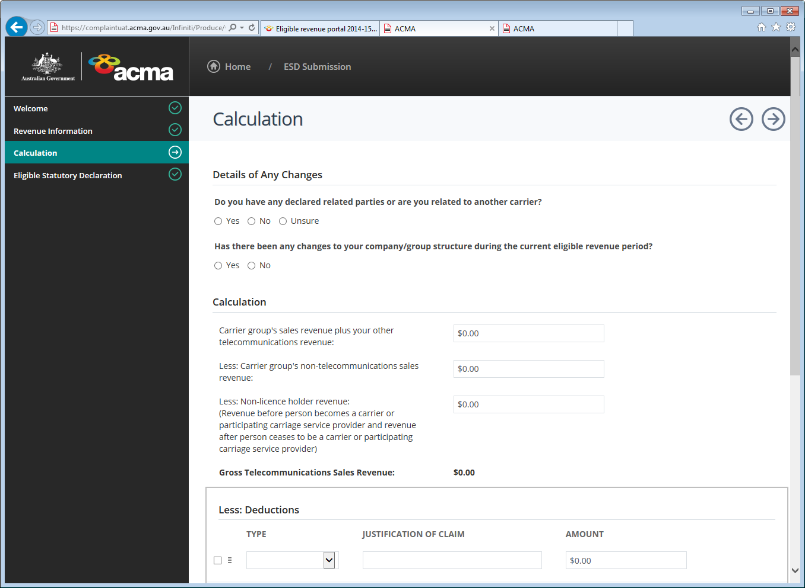
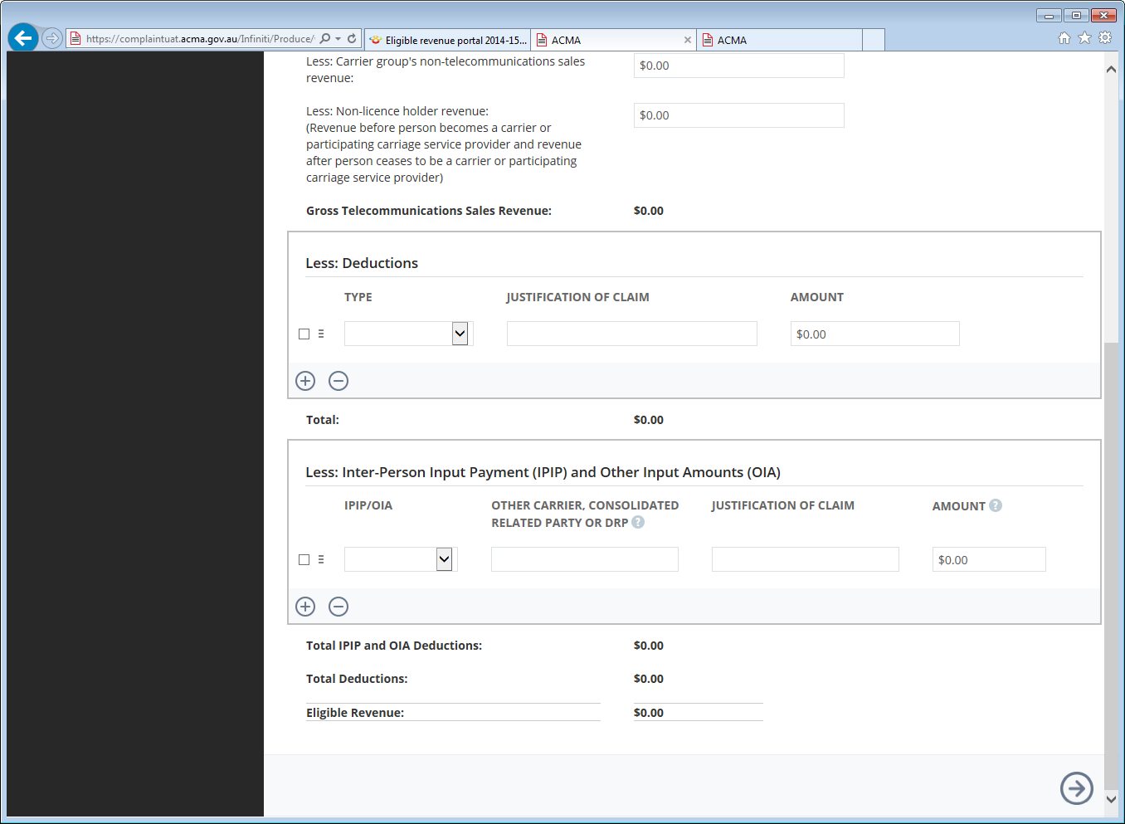
- Complete the information on the ‘Calculation’ page by entering your revenue and deductions.
- Select the arrow icon to navigate to the next page, or the back arrow icon to go back to the ‘Revenue Information’ page.
- Depending on the revenue threshold selected on the ‘Revenue Information’ page, you’ll be directed to the ‘Eligible Statutory Declaration’ page or you will be notified to complete an eligible revenue return.
- If you have indicated that your eligible revenue is over AUD $25 million for the current eligible revenue period, you will be notified to lodge a full eligible revenue return (return) on the ‘Revenue Information’ page. For further information on how you can lodge a return, please refer to the ‘Part A: Participating persons’ section of this handbook.
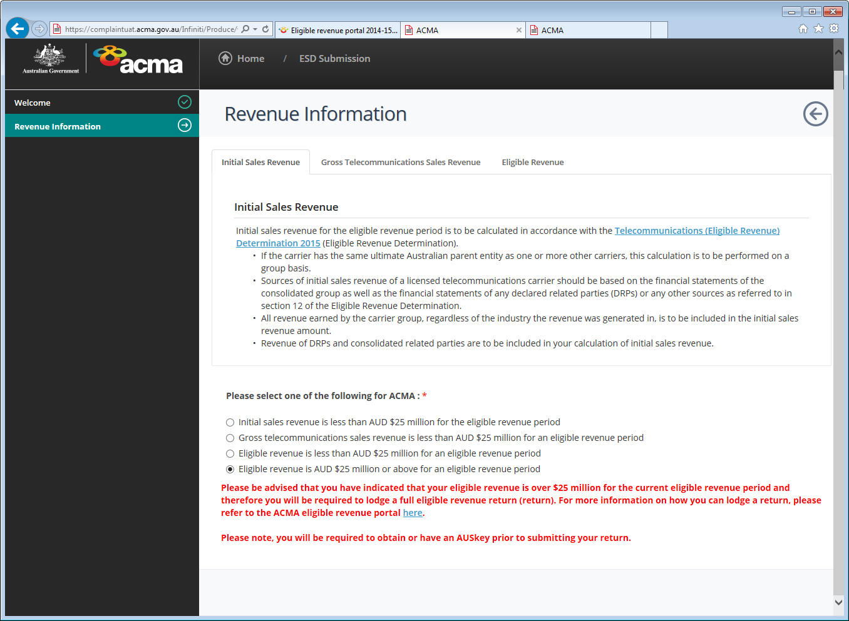
- If for the eligible revenue period, the carrier group’s initial sales revenue, gross telecommunications sales revenue or eligible revenue is less than AUD $25 million you will directed to the ‘Eligible Statutory Declaration’ page.

Eligible Statutory Declaration page
The ‘Eligible Statutory Declaration’ page allows you to upload your completed and signed ESD, and to upload supporting documentation.
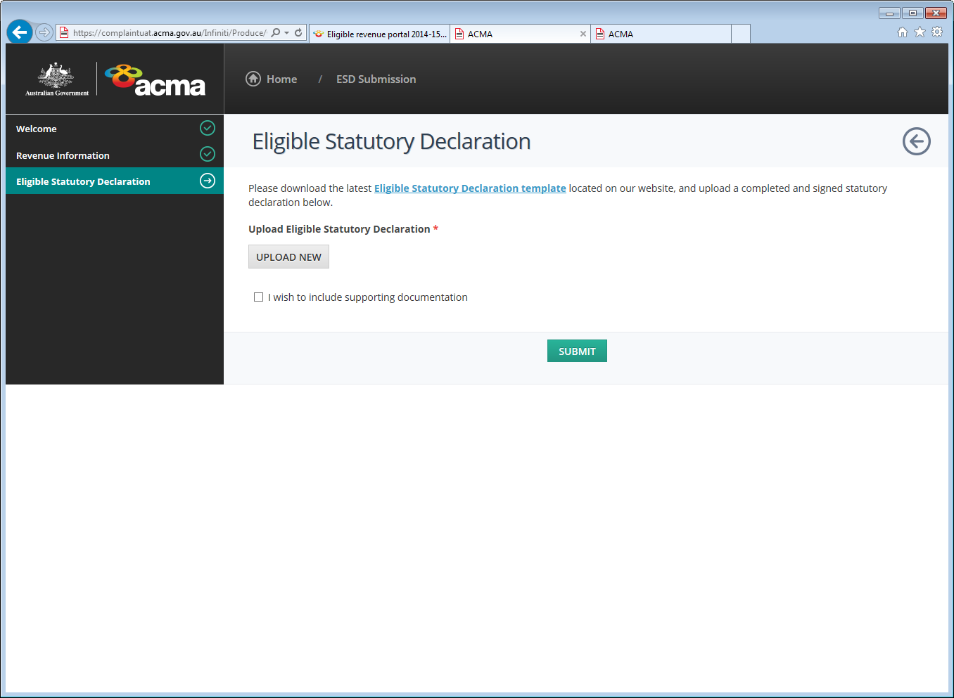
- Upload your completed and signed ESD by selecting the ‘Upload New’ button.
- Select ‘Browse’ to locate the file saved on your computer, and then select the ‘Start Upload’ button.
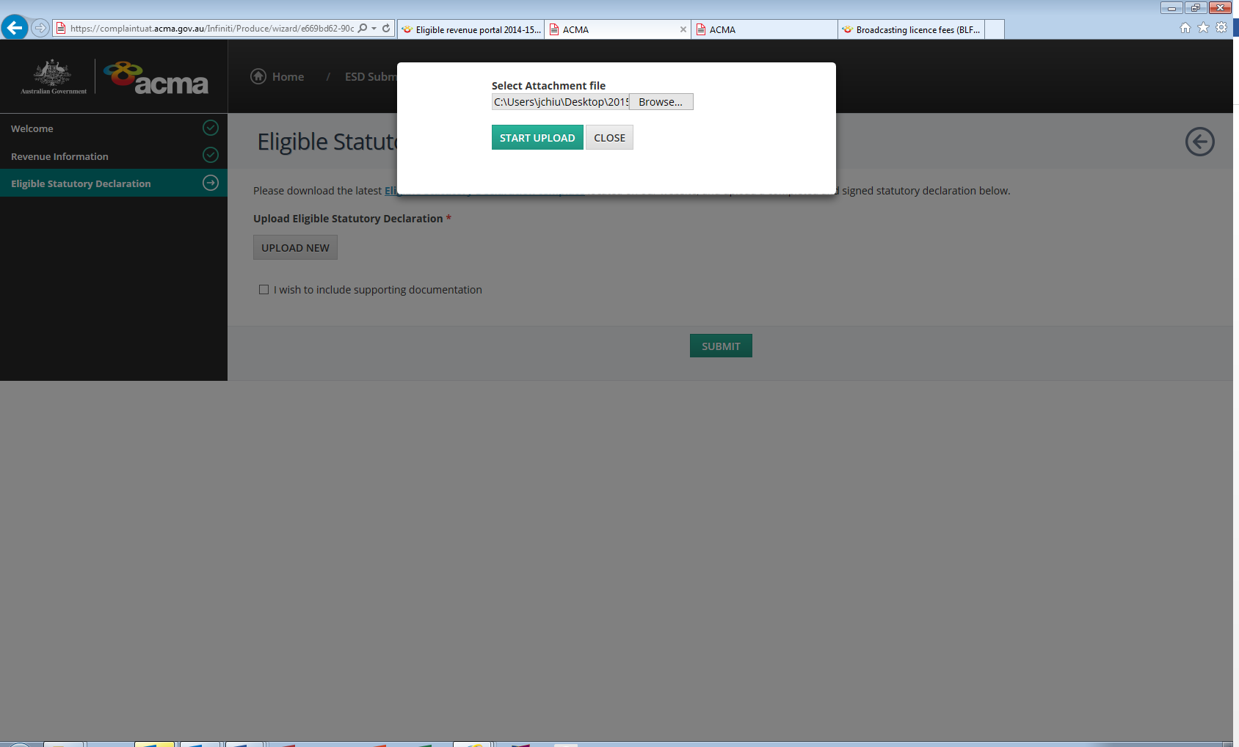
- The uploaded document will be displayed on the ‘Eligible Statutory Declaration’ page.
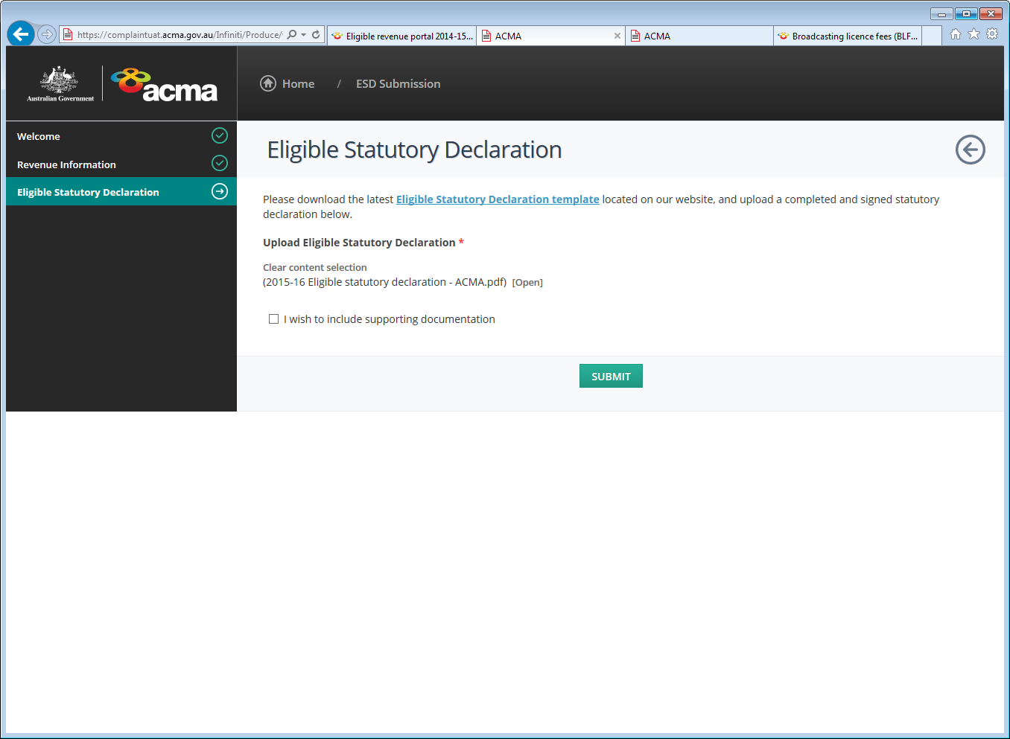
- To include supporting documentation to substantiate your claim made on your ESD, select the ‘I wish to include supporting documentation check box’.
- A drop-down box will appear. To upload a file, select the ‘Upload New’ button.
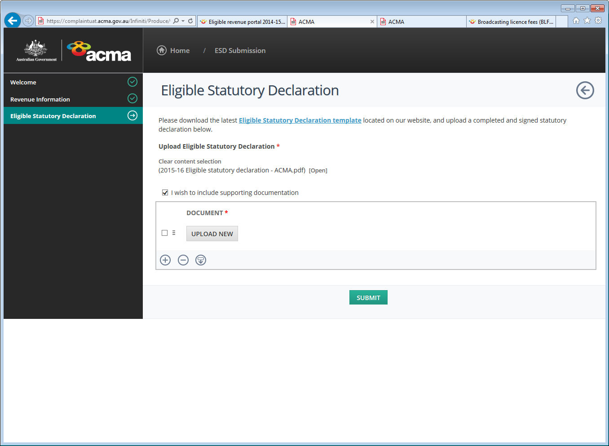
- Select ‘Browse’ to locate the file saved on your computer, and then select the ‘Start Upload’ button.
- The uploaded document will be displayed on the ‘Eligible Statutory Declaration’ page.
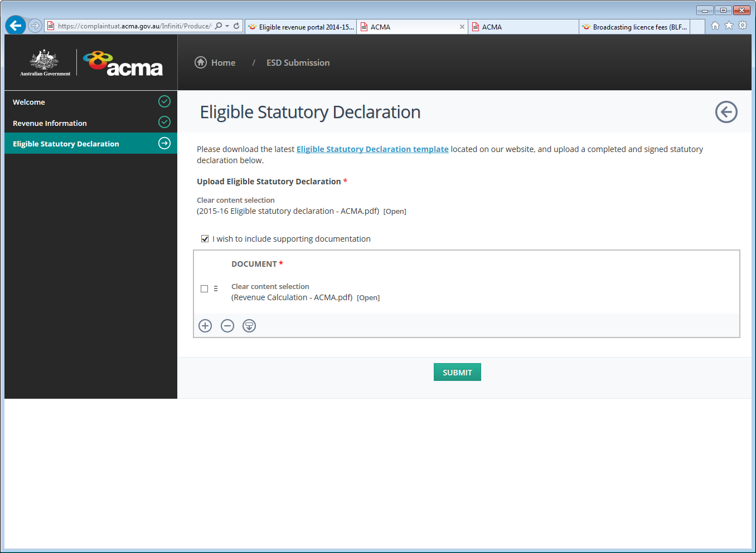
- To add documents, select the plus icon , or to remove documents, select the minus icon
- Once you have uploaded your ESD and supporting documentation, select the ‘Submit’ button.
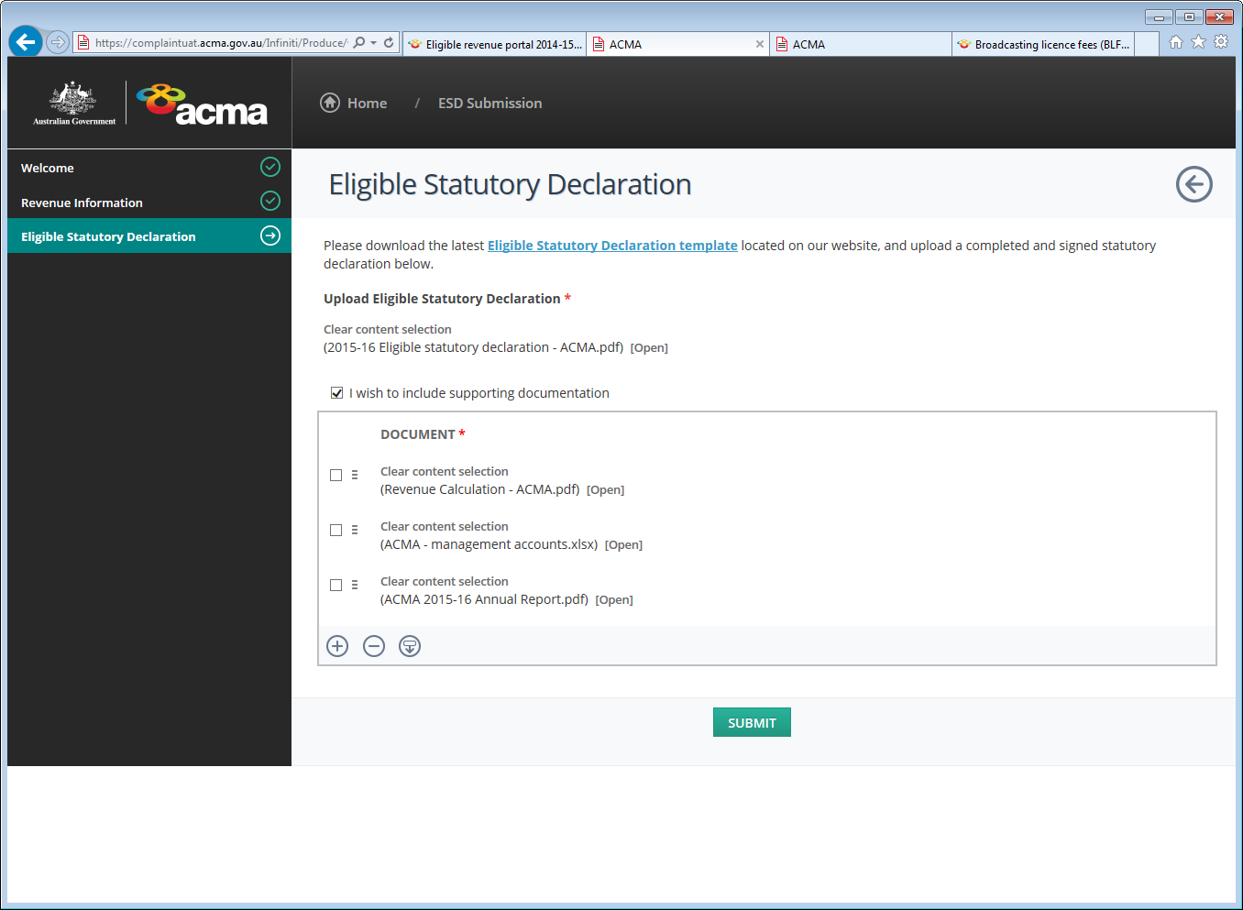

Submission successful page
If your submission has been successful, a confirmation screen will appear with a submission reference number.
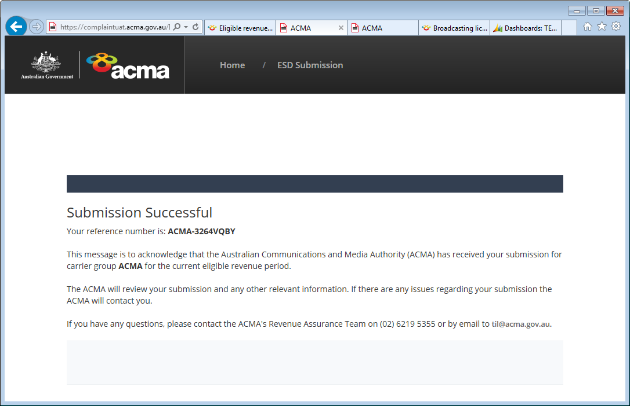
To log out of TELLER, close your browser.

While reasonable efforts have been made to ensure the accuracy, correctness and reliability of the material contained in this document, the ACMA does not accept responsibility for the accuracy or the completeness of the contents or any inferences, and expressly disclaims liability for any loss, however caused and whether due to negligence or otherwise, arising directly or indirectly from the use of, inferences drawn, deductions made, or acts done in reliance on, this document or the information contained in it, by any person.
An eligible revenue period is the period from 1 July to 30 June in the relevant year. A participating person may prepare an ERR form using financial information for a different 12-month period (ending prior to 30 June) in accordance with section 12 of the Telecommunications (Eligible Revenue) Determination 2015.
Section 10 of the Eligible Revenue Determination defines ‘inter-person input payments’.

