Proposal to vary the Melbourne   
television licence area plan regarding community TV

Consultation paper

May 2024

Canberra

Level 3  
40 Cameron Avenue   
Belconnen ACT

PO Box 78  
Belconnen ACT 2616

T +61 2 6219 5555  
F +61 2 6219 5353

Melbourne

Level 32   
Melbourne Central Tower  
360 Elizabeth Street   
Melbourne VIC

PO Box 13112  
Law Courts   
Melbourne VIC 8010

T +61 3 9963 6800  
F +61 3 9963 6899

Sydney

Level 5   
The Bay Centre  
65 Pirrama Road   
Pyrmont NSW

PO Box Q500  
Queen Victoria Building   
NSW 1230

T +61 2 9334 7700 or 1800 226 667  
F +61 2 9334 7799

Copyright notice

[Creative Commons logo](http://i.creativecommons.org/l/by/3.0/88x31.png)

<https://creativecommons.org/licenses/by/4.0/>

With the exception of coats of arms, logos, emblems, images, other third-party material or devices protected by a trademark, this content is made available under the terms of the Creative Commons Attribution 4.0 International (CC BY 4.0) licence.

We request attribution as © Commonwealth of Australia (Australian Communications and Media Authority) 2024.

All other rights are reserved.

The Australian Communications and Media Authority has undertaken reasonable enquiries to identify material owned by third parties and secure permission for its reproduction. Permission may need to be obtained from third parties to re-use their material.

Written enquiries may be sent to:

Manager, Editorial Services  
PO Box 13112  
Law Courts  
Melbourne VIC 8010  
Email: [info@acma.gov.au](mailto:info@acma.gov.au)

Issues for comment 1

Introduction 2

Planning broadcasting services 2

Overview of the Melbourne TLAP 2

Proposal: Community television 3

Preliminary view 4

Invitation to comment 5

Making a submission 5

# Issues for comment

We are seeking comments on proposed changes to the [Television Licence Area Plan (Melbourne) 2012](https://www.legislation.gov.au/F2012L02431/latest/text) (Melbourne TLAP). These updates relate to community television broadcasting services.

We welcome your comments on the issues raised in this paper, or on any other relevant issues.

You can find details on making a submission in the invitation to comment section at the end of this document.

# Introduction

## Planning broadcasting services

Our broadcasting planning functions are set out in Part 3 of the *Broadcasting Services Act 1992* (BSA). We promote the objects of the BSA (section 3), including the economic and efficient use of radiofrequency spectrum, and consider the planning criteria set out in section 23 of the BSA.

When planning broadcasting services, we refer to the [*ACMA approach to broadcast planning and varying LAPs*](https://www.acma.gov.au/broadcast-planning-resources). This provides an overview of the regulatory framework, policy objectives and planning process for broadcasting services.

Under subsection 26(1B) of the BSA, we must prepare television licence area plans (TLAPs) that determine the number and characteristics – including technical specifications – of television broadcasting services that are to be available in particular areas of Australia. The BSA also provides us with a power to vary TLAPs.

In proposing to vary the Melbourne TLAP, we have considered the planning criteria outlined in section 23 of the BSA. We considered the demographics, social and economic characteristics within the licence area, and the technical restraints relating to the delivery or reception of broadcasting services – paragraphs 23(a), (b) and (e) of the BSA.

## Overview of the Melbourne TLAP

The Melbourne TLAP determines the licence area of Melbourne TV1. The population of the Melbourne TV1 licence area is 5,313,617.[1]

For the Melbourne TV1 licence area, the Melbourne TLAP plans the following services:

2 national television broadcasting services

3 commercial television broadcasting services

one community television broadcasting service.

# Proposal: Community television

We propose to vary the [Melbourne](https://www.legislation.gov.au/F2012L02431/latest/text) TLAP to remove the allotment end dates for the community television broadcasting service provided by Melbourne Community Television Consortium Ltd (C31). The current end date is 30 June 2024.

C31 holds community television broadcasting licence 1150808 and 2 related transmitter licences.

The [*Broadcasting Services Amendment (Community Television) Act 2024*](https://www.legislation.gov.au/C2024A00015/asmade/text) (Amendment Act), which took effect on 9 April 2024, amended the BSA and the *Radiocommunications Act 1992* to:

Repeal the 30 June 2024 expiry date for the transmitter licences of C31 so that C31 can continue to operate radiocommunications transmitters to provide community television broadcasting services beyond that date.

Replace that expiry date with a new ACMA-led process to determine a future day when apparatus licensing for those community television channels will cease, namely:

A power for us to declare, by notifiable instrument, when an alternative use for the spectrum used by the existing community television broadcasting services within the prescribed area has been identified.

A period of at least 6 months after the declaration is registered before we can make a determination about the commencement date for the cessation of the transmitter licences for the community television broadcasting services in a prescribed area.

The specified day in the determination must be at least 6 months after the date the determination is registered.

The notes to new section 96C of the Radiocommunications Act provide that alternative uses could include the following:

1. transitioning of other technologies
2. consolidation of the spectrum to achieve a digital dividend
3. setting aside parts of the spectrum for future demand.

The proposed amendments to the Melbourne TLAP are intended to allow C31 to continue to deliver its services beyond the 30 June 2024 expiry date. They would allow C31 to continue to provide services until the day determined by the ACMA.

We are aware of broad discussions about the future of television, and that part of the broadcasting service bands used by C31 might be used for alternative purposes. This includes providing other broadcasting services, or potential future communications services.

The power given to us to declare, by notifiable instrument, when an alternative use for the spectrum used by C31 has been identified, ensures that C31 can continue to provide its service until the spectrum is needed for another use.

Transmitting in the broadcasting services bands requires a community television broadcast licensee to have a transmitter licence. Failure to operate a transmitter in accordance with the provisions of the relevant TLAP is a breach of a community television broadcasting licence. For further details, see subsection 26AA(3) of, and paragraph 9(1)(k) of Schedule 2 to, the BSA.

To allow C31 to continue to transmit its service beyond 30 June 2024, we propose to vary the Melbourne TLAP to support the effect of the Amendment Act by removing the end dates for C31. We propose to do this by varying Column 3 of Table 3.2 in Schedule 3 of the Melbourne TLAP, which is reproduced below:

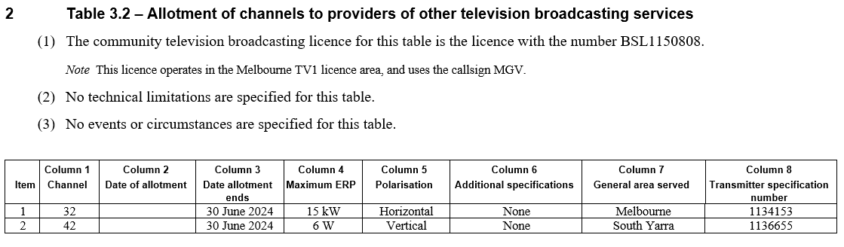

The proposed variation would remove each of the 2 dates ‘30 June 2024’, and not specify any date, so that the allotment continues.

We consider that this proposal is an economic and efficient use of spectrum that is likely to promote the objects in section 3 of the BSA. In particular, it promotes the availability of a diverse range of television services (paragraph 3(1)(a) of the BSA) and maintains diversity in community broadcasting in the transition to digital broadcasting (paragraph 3(1)(n) of the BSA). In developing this proposal, we have considered the planning criteria in section 23 of the BSA and especially the technical restraints relating to the delivery or reception of broadcasting services in the area (paragraph 23(e) of the BSA).

## Preliminary view

We consider the proposal to remove the allotment end dates for the community television broadcasting service provided by C31 is an economic and efficient use of spectrum. The proposal promotes the objects of the BSA, particularly paragraphs 3(1)(a) and 3(1)(n), as it would assist in the continued delivery of a diverse range of broadcasting services to the existing audience.

# Invitation to comment

## Making a submission

We invite comments on the issues set out in this consultation paper.

[Online submissions](https://www.acma.gov.au/have-your-say) can be made by uploading a document. Submissions in PDF, Microsoft Word or Rich Text Format are preferred.

Submissions by post can be sent to:

The Manager

Broadcasting Carriage Policy Section

Australian Communications and Media Authority

PO Box 78

Belconnen ACT 2616

The closing date for submissions is **COB,** **Friday 24 May 2024**.

Consultation enquiries can be emailed to [BCP@acma.gov.au](mailto:BCP@acma.gov.au).

#### Publication of submissions

We publish submissions on our website, including personal information (such as names and contact details), except for information that you have claimed (and we have accepted) is confidential.

Confidential information will not be published or otherwise released unless required or authorised by law.

#### Privacy

View information about our policy on the [publication of submissions](https://www.acma.gov.au/publication-submissions), including collection of personal information during consultation and how we handle that information.

Information on the *Privacy Act 1988,* how to access or correct personal information, how to make a privacy complaint and how we will deal with any complaints, is available in our [privacy policy](https://www.acma.gov.au/privacy-policy).

1. As determined by the ACMA under section 30 of the BSA. See [Broadcasting Services (Licence Area Population) Determination 2023](https://www.acma.gov.au/publications/2019-10/rules/determination-population-figures-under-section-30-broadcasting-services-act-1992).