

Investigation Report – Interactive gambling – Fast Codes - GINV-2022-00057

| **Summary** |  |
| --- | --- |
| **Entity involved in the services** | Entain Group Pty Ltd |
| **Name of services** | Ladbrokes  Neds |
| **Date services were accessed** | The services have been reviewed at different times from September 2022 to September 2023. |
| **URLs** | [www.ladbrokes.com.au](http://www.ladbrokes.com.au)  [www.neds.com.au](http://www.neds.com.au) |
| **Relevant legislation** | *Interactive Gambling Act 2001* |
| **Date finalised** | 19 October 2023 |
| **Findings** | * Entain Group Pty Ltd has contravened subsection 15(2A) of the *Interactive Gambling Act 2001* by the provision of prohibited interactive gambling services to customers in Australia, in the form of the in-play betting services using Fast Codes, available via its Ladbrokes and Neds services. |

**Background**

1. On 29 June 2022, the ACMA received a complaint from an Australian resident, made under section 16 of the IGA, about the use of Fast (or Quick) Codes by licensed wagering services. Pursuant to this complaint, the ACMA decided to commence an investigation on 30 September 2022, under section 21 of the IGA, into whether the use of Fast Codes by the Ladbrokes and Neds wagering services, are compliant with the in-play betting prohibitions in the IGA.

**The services and providers**

1. The ACMA investigated the in-play betting services using Fast Codes (the **Fast Code services**) that were provided as part of the following wagering services:

* Ladbrokes provided by Entain Group Pty Ltd (Entain), available at the website [www.ladbrokes.com.au](http://www.ladbrokes.com.au), operating under a licence issued by the Northern Territory Racing Commission.
* Neds provided by Entain, available at the website [www.neds.com.au](http://www.neds.com.au), operating under a licence issued by the Northern Territory Racing Commission.

1. The provider and licensing arrangements of these services are not in contention.

Key provisions of the IGA

1. Extracts of the key provisions of the IGA are provided at **Attachment A**.

Reasons for decision

1. To assess each of the Fast Code services being provided by Entain and determine whether they were provided in contravention of subsection 15(2A) of the IGA, the ACMA considered the following questions:

* How do the Fast Code services work for the Ladbrokes and Neds services?
* Is each Fast Code service a prohibited interactive gambling service as defined in subsection 5(1) of the IGA?
* Is each Fast Code service exempted under subsection 5(3) of the IGA?
* Does each Fast Code service have an Australian-customer link?

1. To answer the first 3 questions, staff considered the functionality of these Fast Code services and the information provided by Entain.
2. The answer to the fourth question is not in contention – the Ladbrokes and Neds services, including the Fast Code services, have an Australian-customer link as customers of these services are physically present in Australia (section 8).

**How do the Fast Code services work for each Ladbrokes and Neds services?**

1. Based on information provided by Entain and the review of the Ladbrokes and Neds services by ACMA staff, the ACMA’s understanding about how the Fast Codes services work is as follows:

* The customer uses the Ladbrokes or Neds service available on their website or App, to select their in-play bet (event, bet and bet type) and a pop-up is displayed with a Fast Code, prompting the customer to call the operator. Example pop up is below. On a mobile, the customer may press the ‘Call now to place a bet’ button, which prefills the betting line number to the customer’s phone. The customer still needs to press the call button to initiate the call. Only the customer’s phone number would be conveyed to the operator and no betting information. Entain has advised that it only offers Fast Codes in relation to single bets and on select markets.
* When the customer calls the operator, they are required to identify themselves and provide the Fast Code of their selection (such as ‘9U’) (or they may also describe their selection). The Fast Code enables the operator to identify the event, bet type and bet selection in their system. The ACMA understands that the Fast Code only encapsulates these 3 items of information.
* The operator reads back to the customer the relevant details of the bet which is incorporated in the Fast Code (event, bet type and bet selection) and the odds.
* The operator then asks the customer for the stake (bet amount).
* The operator re-reads the bet to the customer for final confirmation (which may include re-reading details of the Fast Code) as well as the current odds relevant to the customer’s bet selection (including any changes) and then asks the customer to confirm the bet.
* Once the customer confirms, the operator submits the bet in Ladbrokes’ or Neds’ system.

1. The ACMA understands that the Fast Codes service for Neds has remained the same since it commenced on or around May 2019. The Fast Codes service for Ladbrokes commenced earlier, on or around June 2018 and on or around May 2019 migrated to Neds’ process. Entain has advised that the Fast Codes generation and interaction between the customer and operator has remained the same since implementation.

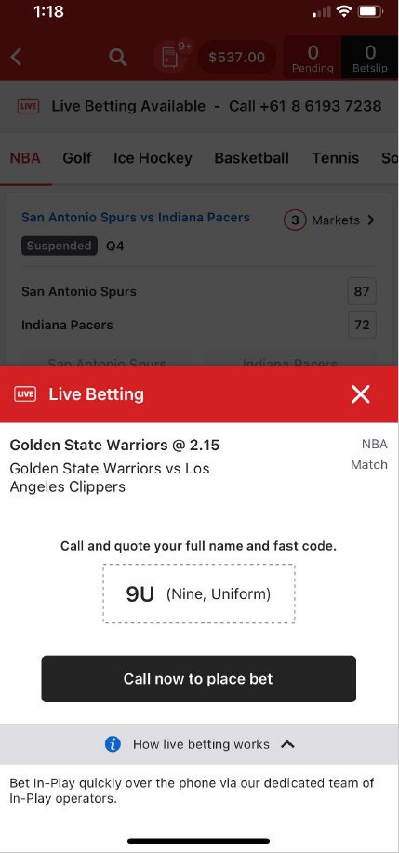 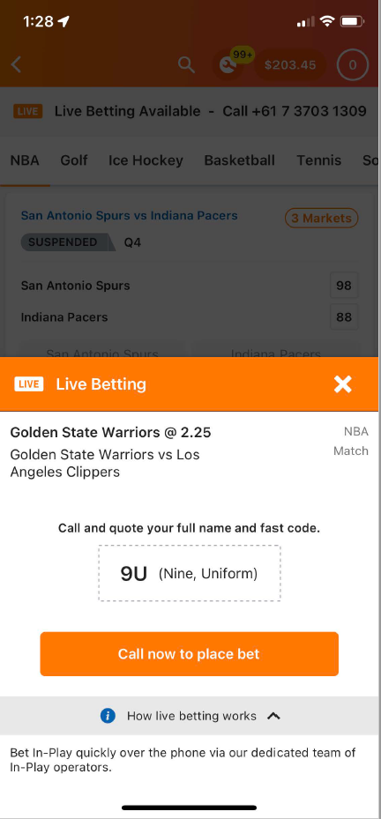

**Is each Fast Code service a prohibited interactive gambling service as defined in subsection 5(1) of the IGA?**

1. The key elements of a prohibited interactive gambling service are that:

* It is a gambling service as defined in section 4 of the IGA.
* It is provided in the course of carrying on a business (see paragraph 5(1)(a) of the IGA).
* It is provided to customers using certain services, including an internet carriage service (see subparagraph 5(1)(b)(i)) and/or any other listed carriage service (see subparagraph 5(1)(b)(ii)).
* It is not an exempted service listed in subsection 5(3) of the IGA.

1. Each of the Fast Code services satisfy the first 3 key elements of a prohibited interactive gambling service above, as:

* It is a gambling service for the placing, making, receiving or acceptance of bets.
* It is provided in the course of carrying on a business, as evidenced by the provision of the service to the public, with an apparent view to making a profit (evidenced by the requirement to deposit funds as a condition of participation).
* It is provided to customers using an internet carriage service and/or any other listed carriage service, as evidenced by the fact that the service is accessed using a combination of both an internet and telephone connection.

**Is each Fast Code service exempted under subsection 5(3) of the IGA?**

1. Certain kinds of services, specified in subsection 5(3) of the IGA, are exempted from the definition of prohibited interactive gambling service. Exemptions that are relevant to this investigation are considered below.

**Excluded wagering service**

1. An ‘excluded wagering service’, as defined in section 8A of the IGA, is not a prohibited interactive gambling service (see paragraph 5(3)(aa)). This includes wagering services for betting on, or on a series of, sporting events (paragraph 8A(3)(a)).
2. However, a wagering service for sporting events only satisfies the definition of an excluded wagering service to the extent that it is not an ‘in-play betting service’ (paragraph 8A(3)(b)).
3. Section 10B of the IGA provides that a gambling service is an ***in-play betting service***to the extent to which:

* The service relates to betting on the outcome of a sporting event, where the bets are placed, made, received or accepted after the beginning of the event; or
* The service relates to betting on a contingency that may or may not happen in the course of a sporting event, where the bets are placed, made, received or accepted after the beginning of the event.

1. The Fast Code services are not ‘excluded wagering services’ for the purposes of the IGA because they allow for in-play betting on sporting events and other events or contingencies.

**Telephone betting service**

*Wholly by way of voice calls*

1. A ‘telephone betting service’, as defined in section 8AA, is not a prohibited interactive gambling service (see paragraph 5(3)(a)). A telephone betting service must be provided on the basis that ‘dealings’ with customers are ‘wholly by way of voice calls using a carriage service’ (paragraph 8AA(1)(a)).
2. Subsection 8AA(3) of the IGA provides that a ***voice call*** means a voice call (within the ordinary meaning of that expression) the content of which consists wholly of spoken conversation between individuals (or the equivalent as required for a disabled customer) and as set out in subsections 8AA(4)-(7), does not involve a recorded or synthetic voice or tone signals in the service.
3. The ACMA considers that, based on the information provided by Entain, the Fast Codes services involve a voice call that satisfies this definition.

*Requirements of subsection 8AA(8) of the IGA for a telephone betting service*

1. However, this provision must be read in conjunction with subsection 8AA(8) which was inserted into the IGA by the *Interactive Gambling Amendment Act* *2017* (the **Amending Act**):

(8) Despite subsection (1), if a gambling service is provided on the basis that any or all of the following information can be provided by a customer otherwise than by way of a voice call:

(a) a selection of a bet;

(b) a selection of a bet type;

(c) a nomination of a bet amount;

(d) a confirmation of a bet;

(e) information of a kind determined under subsection (9);

the service is not a telephone betting service for the purposes of this Act.

1. Subsection 8AA(9) provides that "[t]he Minister may, by legislative instrument, determine one or more kinds of information for the purposes of paragraph (8)(e)”. There is currently no instrument made under this provision.
2. The ACMA considers that the substance of the bet (being the information set out in subsection 8AA(8)) are the dealings with the customer that are required to be wholly by way of voice call, rather than every step a customer might take in the process of placing a live bet, such as any prior engagement with an operator’s website or App.
3. As set out above, the Fast Codes services, generally require the customer to select the following elements of the live bet, using the wagering operator’s website or App, prior to initiating the voice call:

* Event (for example NRL match Team A v Team B).
* Bet type (for example winner of the match).
* Bet selection.

1. The customer is provided with a Fast Code (by a pop-up) which encapsulates this information. The customer then quotes this Fast Code during the voice call.
2. Two of the three elements of the live bet above cover information that must be ‘provided by a customer’ according to subsection 8AA(8), by way of voice call, in order for this to meet the requirement to be a telephone betting service (the bet type (paragraph 8AA(8)(b)) and bet selection (paragraph 8AA(8)(a)). The intention of this provision, as stated in the Explanatory Memorandum for the *Interactive Gambling Amendment Bill 2016* (**EM**),[1] is:

… to ensure that all information relating to the substance of a particular bet being placed must be conveyed by the customer by way of a voice call. For example, a service which allows the customer to provide to the service provider electronically any or all of the specified details necessary to place a bet and be provided with a generated code which they can quote to a phone operator in order to expedite or finalise the service would not be a telephone betting service. However, this is not intended to prevent customers from providing their customer or account number electronically prior to the call being placed, or codes or shorthand being provided to customers, for example, on websites, that allow them to conveniently identify the event (e.g. an NRL match) they wish to place a bet on. (**Relevant EM passage**).

1. It is not in contention that the customer provides the bet amount and confirmation of the bet, wholly by way of a voice call.

*Customer quotes the Fast Code*

1. The customer quoting a Fast Code to a representative of the wagering operator, an individual, during the voice call, satisfies the requirement for a telephone betting service that the customer provide the bet and bet type information wholly by way of a voice call. But this is only where the Fast Code is ultimately a shorthand reference for the event, bet type and bet selection and remains generic and the same for all customers (see Relevant EM passage).
2. Where the Fast Code is customer-specific, this indicates that the Fast Code is generated based on specific information about the bet or bet type being inputted by the customer prior to and outside of the subsequent phone call. In this scenario the Fast Code is no longer just a generic shorthand reference that remains the same for all customers.
3. Based on the information provided, the ACMA understands that Entain generates Fast Codes as follows:

* Its computer system randomly generates Fast Codes and assigns them to a specific in-play event/bet type selection when a customer first queries the price. Once a Fast Code is generated by a customer, it will remain the same, including for all other customers, throughout the duration that the specific in-play bet type for a particular event is available. We note that Entain only provides Fast Codes on single, not multiple, live bets.

1. The ACMA considers that the generation of Fast Codes is customer-specific, as the code appears to be individually generated for a customer (at least for the first customer).
2. Consequently, the ACMA considers that where the customer is quoting the Fast Code as part of these in-play betting services, this is not sufficient to satisfy the requirement of being a telephone betting service. This is because the customer is not providing this information wholly by way of a voice call, rather the customer is providing this information via the service’s web interface or App (subsection 8AA(8)).
3. If, in the alternative, these Fast Codes had been pre-set, independent of customer selection, then they may have been considered generic codes. In this instance, using such generic Fast Codes may satisfy the requirement that the customer is providing this information wholly by way of voice calls. For example, if Fast Codes were generated and assigned to each possible permutation of live bets (event, bet type and bet selection) prior to the events commencing and independent of customer selection (for both live bets with single and multiple legs).
4. The ACMA considers that as the Fast Code services are customer-specific rather than generic, they are not ‘telephone betting services’ for the purposes of the IGA.

**Conclusion**

1. The ACMA considers that the Fast Code services are not excluded wagering services or telephone betting services for the purpose of the IGA and are therefore prohibited interactive gambling services.

**Entain Submissions**

1. Entain has submitted that the Ladbrokes and Neds Fast Codes services are 'telephone betting services’ and that the prohibition on in-play betting on sporting events, does not apply.
2. In particular, Entain has submitted that:

* All dealings are wholly by way of a voice call as the customer is not providing any details of the bet to the operator until they speak to them, including the Fast Code (in particular, the Fast Code simply directs the operator to the relevant market the customer wishes to place a bet on, but customers are still making a bet selection via the call).
* By quoting the Fast Code to the operator the customer is providing the bet and bet type information. At all times Fast Codes are a shorthand reference for the event, bet type and bet selection which remains generic and the same for all customers. They are not customer-specific. Fast Codes are generated whether or not a person is a “customer”; for example, if a person clicks on a live bet selection while logged out.
* The Ladbrokes and Neds Fast Codes services are consistent with the amendments made to the IGA by the *Interactive Gambling Amendment Act 2017* to prohibit ‘click to call’ services to reduce the risk to problem and at-risk gamblers. Customers are not able to place in-play wagers within seconds and must speak to operators fully trained in responsible gambling. Any abnormal and/or red flag behaviour is investigated and passed through to the responsible gambling team.

1. The ACMA has considered Entain’s submissions but is not persuaded by them for the reasons set out above.

**Decision**

* Entain has contravened subsection 15(2A) of the *Interactive Gambling Act 2001* by the provision of prohibited interactive gambling services to customers in Australia, in the form of the in-play betting services using Fast Codes, available via its Ladbrokes and Neds services.

**Attachment A**

Key provisions of the IGA

4 Definitions

***gambling* *service*** means:

1. a service for the placing, making, receiving or acceptance of bets; or
2. a service the sole or dominant purpose of which is to introduce individuals who wish to make or place bets to individuals who are willing to receive or accept those bets; or
3. a service for the conduct of a lottery; or
4. a service for the supply of lottery tickets; or
5. a service for the conduct of a game, where:
   * 1. the game is played for money or anything or else of value; and
     2. the game is a game of chance or of mixed chance and skill; and
     3. a customer of the service gives or agrees to give consideration to play or enter the game; or
6. a gambling service (within the ordinary meaning of that expression) that is not covered by any of the above paragraphs.

5 Prohibited interactive gambling services

1. For the purposes of this Act, a ***prohibited interactive gambling service*** is a gambling service, where:
   1. the service is provided in the course of carrying on a business; and
   2. the service is provided to customers using any of the following:
      1. an internet carriage service;
      2. any other listed carriage service;
      3. a broadcasting service;
      4. any other content service;
      5. a datacasting service

Note: This definition relates to the offence provisions and civil penalty provisions set out in section 15 and Part 7A.

1. Subsection (1) has effect subject to subsection (3).

*Excluded services*

1. For the purposes of this Act, none of the following services is a ***prohibited interactive gambling service***:
   1. a telephone betting service;

(aa) an excluded wagering service (see section 8A);

(ab) an excluded gaming service (see section 8B);

(aba) a place-based betting service (see section 8BA);

(ac) a service that has a designated broadcasting link (see section 8C);

(ad) a service that has a designated datacasting link (see section 8C);

(ae) an excluded lottery service (see section 8D);

* 1. a service to the extent to which it relates to the entering into of contracts that are financial products within the meaning of Chapter 7 of the *Corporations Act 2001*;

(ba) a wholesale gambling service;

(bb) a trade promotion gambling service (see section 8BB);

* 1. an exempt service (see section 10).

**8 Australian‑customer link**

For the purposes of this Act, a gambling service has an Australian‑customer link if, and only if, any or all of the customers of the service are physically present in Australia.

**8AA Telephone betting service**

(1) For the purposes of this Act, a ***telephone betting service*** is a gambling service, where:

(a) the service is provided on the basis that dealings with customers are wholly by way of voice calls made using a carriage service; and

(aa) the service does not relate to betting on the outcome of a lottery; and

(ab) the service does not relate to betting on a contingency that may or may not happen in the course of the conduct of a lottery; and

(b) the conditions (if any) determined under subsection (2) have been satisfied.

(2) The Minister may, by legislative instrument, determine one or more conditions for the purposes of paragraph (1)(b).

(3) For the purposes of this section, ***voice call*** means:

(a) a voice call (within the ordinary meaning of that expression) the content of which consists wholly of a spoken conversation between individuals; or

(b) if a call covered by paragraph (a) is not practical for a particular customer with a disability (for example, because the customer has a hearing impairment)—a call that is equivalent to a call covered by that paragraph.

(4) The following are examples of calls that are not covered by paragraph (3)(a):

(a) a call the content of which includes a recorded or synthetic voice;

(b) a call the content of which includes one or more tone signals.

(5) Paragraph (3)(a) and subsection (4) have effect subject to subsections (6) and (7).

(6) For the purposes of this section, in determining whether a call is covered by paragraph (3)(a), disregard any recorded or synthetic voice used for either or both of the following purposes:

(a) call waiting;

(b) a menu system for transferring callers to an extension.

(7) For the purposes of this section, in determining whether a call is covered by paragraph (3)(a), disregard any tone signal used for the sole purpose of a menu system for transferring callers to an extension.

(8) Despite subsection (1), if a gambling service is provided on the basis that any or all of the following information can be provided by a customer otherwise than by way of a voice call:

(a) a selection of a bet;

(b) a selection of a bet type;

(c) a nomination of a bet amount;

(d) a confirmation of a bet;

(e) information of a kind determined under subsection (9);

the service is not a ***telephone betting service*** for the purposes of this Act.

(9) The Minister may, by legislative instrument, determine one or more kinds of information for the purposes of paragraph (8)(e).

**8A Excluded wagering service**

*Racing*

…..

*Sporting events*

(3) For the purposes of this Act, a service is an ***excluded wagering service***:

(a) to the extent to which the service relates to betting on, or on a series of, sporting events; and

(b) to the extent to which the service is not an in‑play betting service;

so long as the other conditions (if any) determined under subsection (4) have been satisfied.

(4) The Minister may, by legislative instrument, determine one or more conditions for the purposes of subsection (3).

*Other events or contingencies*

(5) For the purposes of this Act, a service is an ***excluded wagering service***:

(a) to the extent to which the service relates to betting on:

(i) an event; or

(ii) a series of events; or

(iii) a contingency;

that is not covered by subsection (1) or (3); and

(b) to the extent to which the service is not an in‑play betting service; and

(c) to the extent to which the service is not covered by any of the following subparagraphs:

(i) a service for the conduct of a scratch lottery or other instant lottery;

(ii) a service for the supply of tickets in a scratch lottery or other instant lottery;

(iii) a service relating to betting on the outcome of a lottery;

(iiia) a service relating to betting on a contingency that may or may not happen in the course of the conduct of a lottery;

(iv) a service for the conduct of a game covered by paragraph (e) of the definition of ***gambling service*** in section 4;

(v) a service relating to betting on the outcome of a game of chance or of mixed chance and skill;

so long as the other conditions (if any) determined under subsection (6) have been satisfied.

(6) The Minister may, by legislative instrument, determine one or more conditions for the purposes of subsection (5).

(7) For the purposes of paragraph (5)(a):

(a) assume that no conditions have been determined under subsection (2) or (4); and

(b) disregard paragraph (3)(b).

10B  In-play betting service

For the purposes of this Act, a gambling service is an **in-play betting service** to the extent which:

* 1. the service relates to betting on the outcome of a sporting event, where the bets are placed, made, received or accepted after the beginning of an event; or
  2. service relates to betting on a contingency that may or may not happen in the course of a sporting event, where the bets are placed, made, received or accepted after the beginning of an event.

15 Prohibited interactive gambling services not to be provided to customers in Australia

….

(2A) A person must not provide a prohibited interactive gambling service that has an Australian‑customer link (see section 8).

Civil penalty: 7,500 penalty units.

(3)  Subsections (1) and (2A) do not apply if the person:

      (a)  did not know; and

      (b)  could not, with reasonable diligence, have ascertained;

that the service had an Australian‑customer link.

Note:          In the case of proceedings for an offence against subsection (1), the defendant bears an evidential burden in relation to the matters in subsection (3) (see subsection 13.3(3) of the *Criminal Code*).

…

1. See EM, p 51-52*.*