**Technical design features and allocation considerations for the 2 GHz MSS band**

**(1980–2005 and 2170–2195 MHz)**

Discussion paper

november 2023

Canberra

Red Building   
Benjamin Offices  
Chan Street   
Belconnen ACT

PO Box 78  
Belconnen ACT 2616

T +61 2 6219 5555  
F +61 2 6219 5353

Melbourne

Level 32   
Melbourne Central Tower  
360 Elizabeth Street   
Melbourne VIC

PO Box 13112  
Law Courts   
Melbourne VIC 8010

T +61 3 9963 6800  
F +61 3 9963 6899

Sydney

Level 5   
The Bay Centre  
65 Pirrama Road   
Pyrmont NSW

PO Box Q500  
Queen Victoria Building   
NSW 1230

T +61 2 9334 7700 or 1800 226 667  
F +61 2 9334 7799

Copyright notice

[Creative Commons logo](http://i.creativecommons.org/l/by/3.0/88x31.png)

<https://creativecommons.org/licenses/by/4.0/>

With the exception of coats of arms, logos, emblems, images, other third-party material or devices protected by a trademark, this content is made available under the terms of the Creative Commons Attribution 4.0 International (CC BY 4.0) licence.

We request attribution as © Commonwealth of Australia (Australian Communications and Media Authority) 2023.

All other rights are reserved.

The Australian Communications and Media Authority has undertaken reasonable enquiries to identify material owned by third parties and secure permission for its reproduction. Permission may need to be obtained from third parties to re-use their material.

Written enquiries may be sent to:

Manager, Editorial Services  
PO Box 13112  
Law Courts  
Melbourne VIC 8010  
Email: [info@acma.gov.au](mailto:info@acma.gov.au)

Executive summary 1

Issues for comment 6

1 Introduction 8

1.1 Background 8

1.2 Purpose 8

1.3 Technical design features 9

2 Parameters for 2 GHz MSS 10

2.1 System model for 2 GHz MSS 10

2.2 Power limits 11

2.3 Unwanted emissions limits 11

3 Coordination considerations 15

3.1 Current spectrum arrangements 15

3.2 Fixed point-to-point links 15

3.3 Wireless broadband services 17

3.4 Television outside broadcasting services 20

3.5 Earth stations 21

3.6 Australian radio quiet zone 23

3.7 Defence aeronautical mobile telemetry systems 23

4 Review of narrowband MSS arrangements 24

5 Licensing and allocation considerations 25

5.1 Licensing of space-based communication systems 25

5.2 2 GHz MSS licence allocation considerations 26

6 Future work 29

7 Invitation to comment 30

7.1 Making a submission 30

7.2 Publication of submissions 30

7.3 Privacy 30

Appendix A: MSS reference documents and parameters 31

References 31

MSS parameters 32

# Executive summary

In January 2021, we announced the outcome of the review of the 2 GHz band   
(1980–2010/2170–2200 MHz),[1] and the decision to replan the band for mobile-satellite services. This would enable:

2 x 25 MHz (1980–2005 MHz and 2170–2195 MHz) for Australia-wide mobile-satellite services (MSS), with support for deployment of a complementary ground component (CGC) including direct air-to-ground communications services (DA2GC), [2] where a licensee wishes to supplement its MSS.

2 x 5 MHz (2005–2010 MHz and 2195–2200 MHz) for shared narrowband MSS including telemetry, short messaging, and low-data-rate services such as satellite IoT (internet of things) application.

In July 2022, we introduced arrangements supporting narrowband MSS systems with licences issued to 4[3] organisations.

We are now working on arrangements to support MSS in 2 x 25 MHz   
(1980–2005 MHz and 2170–2195 MHz), referred to in this paper as ‘2 GHz MSS’.

This paper outlines draft technical parameters and coordination requirements   
to support 2 GHz MSS (including the use of CGC). We also seeking further   
information on the extent of demand for the spectrum in this band, for the purposes   
of deploying MSS.

The intention is that submissions to this consultation will help inform the drafting   
of technical framework instruments supporting an allocation of licences in   
1980–2005/2170–2195 MHz, and also inform a decision on the allocation method.

Formal consultation on the technical framework and allocation design is envisaged to commence in Q3 2024. This has been delayed from the Q2 2024 timing outlined in the FYSO. The slightly later timing of the next consultation will allow consideration of the outcomes of the current consultation process. Timing for the allocation of licences is expected to occur in 2024–25.

**Technical design features**

While the administrative documents and legislative instruments supporting the technical framework will be developed closer to the allocation of licences for 2 GHz MSS band, it is useful to commence discussions on the technical parameters for   
2 GHz MSS and the coexistence arrangements with other spectrum uses and users (both within the 2 GHz band, between different 2 GHz MSS licensees and users adjacent to the 2 GHz MSS band).

The MSS requirements have been developed with regard to ITU requirements for the satellite component of IMT-2020[4], 3GPP[5] work on 2 GHz non-terrestrial network and European arrangements for 2 GHz MSS (including CGC). Where possible, to facilitate coexistence with adjacent band 2 GHz spectrum licensed services,[6] we consider that the technical framework for 2 GHz MSS band should align with that of the 2 GHz spectrum licensing framework.

For example, user equipment (whether being used as part of a mobile satellite service or a complementary ground component system) will have the same technical parameters, based on those specified for user equipment (known as registration exempt devices) in the 2 GHz spectrum licence technical framework. Similarly, parameters for CGC base stations will be based on those specified for a base station in the 2 GHz spectrum licence technical framework.

Coordination requirements with other spectrum uses (such as television outside broadcasting, earth station receivers, existing fixed point-to-point links and the radio quiet zone) may result in additional obligations (for example, more stringent out-of-band emission limits).The overall intent is that the technical framework is capable of supporting equipment operating in accordance requirements for 3GPP band n256 (non-terrestrial networks supporting MSS) and band 65/n65 for terrestrial networks (supporting CGC).[7]

These 2 design features – alignment with the 2 GHz spectrum licensing framework and alignment with equipment requirements for 3GPP band n256 and band 65/n65 inform the 2 GHz MSS technical parameters considered in section 2 and coordination requirements considered in section 3. These are summarised in tables 1 and 2 below. Views are sought on the feasibility of the parameters to support 2 GHz MSS systems and the suitability of the proposed coordination requirements.

Feedback received will inform the development of draft legislative instruments and administrative documents supporting the technical framework. Formal consultation on the draft instruments, along with allocation design matters, is envisaged to commence in Q3 2024.

Key 2 GHz MSS technical parameters

| Mobile earth stations |
| --- |
| **Mobile earth station transmitters (1980–2005 MHz)** |
| total radiated power of less than or equal to 25 dBm per occupied bandwidth  unwanted emissions limits as included in the 2 GHz spectrum licence technical framework for transmitters in the 1920–1980 MHz band, except for the unwanted emission limits above 2010 MHz of -60 dBW/MHz the equivalent isotropically radiated power (EIRP) which has been developed considering protection requirements for TOB receivers. |
| **Mobile earth station receivers (2170–2195 MHz)** |
| unwanted emissions limits as included in the 2 GHz spectrum licence technical framework for receivers in the 2110–2170 MHz band (users terminal receivers). |
| Complementary ground component |
| **User equipment: transmitters (1980–2005 MHz)** |
| Same parameters as for mobile earth station transmitter in 1980–2005 MHz that is:  total radiated power of less than or equal to 25 dBm per occupied bandwidth  unwanted emissions limits as included in the 2 GHz spectrum licence technical framework for transmitters in the 1920–1980 MHz band, except for the unwanted emission limit above  2010 MHz of -60 dBW/MHz EIRP which has been developed considering protection requirements for TOB receiver. |
| **User equipment: receivers (2170–2195 MHz)** |
| unwanted emissions limits as included in the 2 GHz spectrum licence technical framework for receivers in the 2110–2170 MHz band. |
| **Aeronautical transmitters (1980–2005 MHz)** |
| maximum EIRP of 40 dBm per occupied bandwidth  out-of-band power flux density limits based on ECC report 233. |
| **Base station transmitters (2170–2195 MHz)** |
| total radiated power of less than or equal to 53.5 dBm/5 MHz  unwanted emissions limits as included in the 2 GHz spectrum licence technical framework for transmitters in the 2110–2170 MHz band (base station transmitters), except for the unwanted emission limit above 2204 MHz of -45 dBm/MHz EIRP which has been developed considering protection requirements for TOB receivers. |
| **Base station receivers (1980–2005 MHz)** |
| unwanted emissions limits as included in the 2 GHz spectrum licence technical framework for receivers in the 1920–1980 MHz band (base station receivers). |

Coordination requirements

|  |  |
| --- | --- |
| Service | 2 GHz MSS coordination/co-existence requirements |
| **Wireless broadband** Adjacent band 2 GHz spectrum licensing and apparatus public telecommunications  service ([PTS](https://www.acma.gov.au/licences/public-telecommunications-service-pts-licence))  (1920–1980/2110–2170 MHz base receive/base transmit) | Technical parameters for 2 GHz MSS to be based on 2 GHz spectrum licensing technical framework.  Out-of-band power flux density limits for aeronautical transmitters operating in 1980–2005 MHz to protect adjacent bands base station receivers (1920–1980 MHz). Limits derived from ECC report 233. |
| **Fixed point to point links** | No new fixed point-to-point links in the 2 GHz MSS band  2 GHz MSS operation on condition of no interference to/from existing fixed point to point links  Fixed stations (CGC base stations) to be coordinated with co-channel and adjacent channel fixed point-point links using principles of RALI FX 3. |
| **Narrowband MSS**  (2005–2010/2195–2200 MHz) | no coordination arrangements proposed  2 GHz MSS narrowband services operating in accordance with condition of licence will be considered as not causing interference to 2 GHz MSS services  2 GHz MSS services operating in accordance with condition of licence will be considered as not causing interference to narrowband MSS services. |
| **Earth station transmitters**  (2025–2110 MHz) | with a minimum of 20 MHz separation, no coordination arrangements are considered necessary between CGC base stations receivers (1980–2005 MHz) and earth station transmitters (2025–2110 MHz). |
| **Earth station receivers**  (2200–2300 MHz) | protection of current and future earth stations at New Norcia, Mingenew earth station protection zone and Tidbinbilla  in other locations, CGC base transmitters (2170–2195 MHz) and earth station receivers to be coordinated on a  first-in-time basis  coordination of CGC transmitters with earth station receivers to be based on CGC out-of-band emissions. The approach used in Europe – refer ECC Recommendation (10)01. |
| **Television outside broadcast**  (2010–2110, 2200–2300 MHz) | no protection afforded from TOB transmitters  coordination of CGC base station transmitters  (2170–2195 MHz) with TOB collection station receivers  out-of-band power flux density limits for aeronautical transmitters operating in 1980–2005 MHz for emissions above 2010 MHz based on ECC report 233  unwanted emissions limits for 2 GHz MSS transmitters in bands used for TOB. |
| **Aeronautical mobile telemetry**  (2200–2300 MHz) | no coordination arrangements considered necessary with adjacent band AMT fixed station receivers  no protection afforded from AMT transmitters. |
| **Adjacent channel  2 GHz MSS** | out-of-band power flux density limits for aeronautical transmitters operating into adjacent channel 2 GHz MSS based on ECC report 233  no other arrangements considered necessary. |

**Licence allocation design**

The ACMA has not formed a final view on the allocation approach. An important consideration that will inform any decision on the design of a preferred allocation method is the level of expected demand for the spectrum. If demand is likely to exceed supply, we will generally look to design a mechanism to resolve competing demand that is transparent and results in an efficient allocation of the spectrum.

We are now seeking updated information about:

the likely demand from parties interested in the provision of MSS using the 2 GHz MSS spectrum

the availability of suitable equipment

how best to configure the spectrum for intended use cases.

Please see the questions in the issues for comment section and discussion   
in section 5.

# Issues for comment

We welcome feedback on the issues raised in this consultation or any other issues relevant to:

draft technical design to support 2 GHz MSS (including the use of CGC)

coexistence between 2 GHz MSS licensees

coexistence between 2 GHz MSS licensees and other spectrum users.

We are also seeking to better understand the likely demand for the use of MSS spectrum, the availability of suitable equipment and how best to configure the spectrum for intended use cases.

We seek specific comment on following key technical design features and licence allocation design issues:

**2 GHz MSS parameters**

1. What are your views on the proposal to develop technical requirements for mobile earth stations and CGC systems based on the 2 GHz spectrum licensing technical framework. Are there alternative approaches that could be used and different resulting values for key parameters such as power and unwanted emissions that we should consider?
2. Having arrangements based on the 2 GHz spectrum licensing technical framework means including support for active antenna systems. We seek views about the inclusion of active antenna systems in the technical framework for 2 GHz MSS.
3. What are your views on developing technical parameters for aeronautical transmitters in CGC/DA2GC systems based on ECC report 233?[8] Are there alternative parameters that should be used?
4. What are your views on the proposal to reduce the current the emission limit at the 2010 MHz boundary from of -66 to -60 dBW/MHz EIRP intended to provide protection for TOB receivers operating above 2010 MHz?
5. For 2 GHz MSS emission limits above 2010 MHz and 2200 MHz, which are intended to protect TOB receivers, do the limits achieve that objective? If not, please explain why and outline what the limits should be.
6. For 2 GHz MSS emission limits above 2010 MHz and 2200 MHz, we seek views on the merits of applying more relaxed limits in areas of lower TOB usage and views on relevant emissions limits to apply in areas on low TOB usage.

**Coordination requirements: 2 GHz MSS with other services**

1. Views are sought on the coordination requirements outlined in section 3.
2. Views are sought on the approach of coordinating CGC transmitters operating in the band 2170–2195 MHz with earth station receivers using the level of CGC unwanted emissions at the earth station receiver. What are appropriate earth station protection levels under such a methodology? Are there alternative approaches that we should consider?
3. Views are sought on the suitability of the arrangement for coordination with the radio quiet zone, and what requirements should apply for aeronautical transmitters in 1980–2005 MHz with respect to the radio quiet zone.

**Coordination requirements: 2 GHz MSS with 2 GHz MSS**

1. No coordination requirements are considered necessary between co-channel and adjacent channel MSS services. We are interested in views on this proposal, including views on any alternative coordination requirements considered necessary.

**Reconsideration of 2 GHz narrowband requirements**

1. We propose that the current the emission limit at the 2010 MHz boundary could reduce from -66 to -60 dBW/MHz EIRP. Are there other elements of arrangements for narrowband MSS that would be beneficial to review?
2. We are considering whether ITU-R Recommendation P.1812[9] configured to 10% time (percentage of average year for which the calculated signal level is exceeded) and 10% location (percentage of locations for which the calculated signal level is exceeded) is an appropriate propagation model to use if arrangements are reviewed. What are your views on this proposal?

**Licence allocation design**

1. We are interested in views about the intended uses of the 2 GHz MSS spectrum, as well as the availability of suitable equipment.
2. What is the minimum viable amount of spectrum for 2 GHz MSS services? Is a 2x5 MHz allocation useable or is a minimum of 2x10 MHz required?
3. Which of the following options is the most appropriate frequency lot configuration for the 2 GHz MSS spectrum?

Configuration 1

* 2 x 15 MHz paired (1980-1995 MHz with 2170–2185 MHz)
* 2 x1 0 MHz paired (1995–2005 MHz with 2185–2195 MHz).

Configuration 2

* 5 generic 2 x 5 MHz paired lots which would provide participants in the allocation the opportunity to bid for as many blocks as suits their use case.

# Introduction

## Background

In January 2021, we published an outcomes paper[10] on the review of the 2 GHz band (1980–2010/2170–2200 MHz) which detailed the decision to replan the band for mobile-satellite service as follows:

2 x 25 MHz (1980–2005 MHz and 2170–2195 MHz) for Australia-wide mobile-satellite services (MSS), with support for deployment of a complementary ground component (CGC) including direct air-to-ground communications services (DA2GC), where a licensee wishes to supplement its MSS. Our preliminary view was that licences should be allocated using a price-based allocation mechanism via auction.

2 x 5 MHz (2005–2010 MHz and 2195–2200 MHz) for shared narrowband MSS including telemetry, short messaging, and low-data-rate services such as satellite IoT (internet of things) application.

In July 2022, we introduced arrangements supporting narrowband MSS systems.

We are now working on arrangements to support 2 GHz MSS use in the band.

The outcomes paper also presented preliminary views on a range of matters that may apply to spectrum planning[11] and licensing arrangements for mobile-satellite services. Those views have formed the basis for the initial work in developing technical design features for 2 GHz MSS.

## Purpose

The ACMA’s spectrum management decisions are guided by the object of the *Radiocommunications Act 1992* (the Act), which is to promote the long-term public interest derived from the use of the spectrum.

In our [Five-year spectrum outlook 2023–28](https://www.acma.gov.au/publications/2023-10/five-year-spectrum-outlook-2023-28), we committed to commence preliminary consultation in Q4 2024 with industry on draft technical parameters and coordination requirements to support 2 GHz MSS (including the use of CGC). We also undertook to seek further information on the extent of demand for the spectrum in this band, for the purposes of deploying MSS. We are now consulting on these issues with the release of this paper. The first part of the paper considers the technical design features (sections 2 to 4 and supporting appendices). Section 5 considers licences   
allocations matters.

The intention is that submissions to this consultation will help inform the drafting   
of technical framework instruments supporting an allocation of licences in   
1980–2005/2170–2195 MHz and also inform a decision on the allocation method.

Formal consultation on the technical framework and allocation design is envisaged to commence in Q3 2024. This has been delayed from the Q2 2024 timing outlined in the FYSO. The slightly later timing of the next consultation will allow consideration of the outcomes of the current consultation process. Timing for the allocation of licences is expected to occur in 2024–25.

## Technical design features

While the administrative documents and legislative instruments supporting the technical framework will be developed closer to the allocation of licences for 2 GHz MSS band, it is useful to commence discussions on the technical parameters for   
2 GHz MSS and the coexistence arrangements with other spectrum uses and users (both within the 2 GHz band, between different 2 GHz MSS licensees, and users adjacent to the 2 GHz MSS band).

The MSS requirements have been developed with regard to ITU requirements for the satellite component of IMT-2020,[12] 3GPP work on 2 GHz non-terrestrial network and European arrangements for 2 GHz MSS (including CGC). Where possible, to facilitate coexistence with adjacent band 2 GHz spectrum licensed services, we consider that the technical framework for 2 GHz MSS band should align with that of the 2 GHz spectrum licensing framework. For example, user equipment (whether being used as part of a mobile satellite service or a complementary ground component system) will have the same technical parameters, based on those specified for user equipment (known as registration exempt devices) in the 2 GHz spectrum licence technical framework. Similarly, parameters for CGC base stations will be based on those specified for a base station in the 2 GHz spectrum licence technical framework.

Coordination requirements with other spectrum uses (such as television outside broadcasting, earth station receivers, existing fixed point-to-point links, the radio quiet zone) may result in additional obligations (for example more stringent out of band emission limits). The overall intent is that the technical framework is capable of supporting equipment operating in accordance requirements for 3GPP band n256 (non-terrestrial networks supporting MSS) and band 65/n65 for terrestrial networks (supporting CGC).[13]

Proposals for 2 GHz MSS technical parameters considered in section 2 and coordination requirements considered in section 3.

### Complimentary ground component deployment obligations

The ACMA has previously stated its preliminary view that some form of obligation (such as licence conditions) should be established to require licensees to deploy a mobile-satellite service before operation of a complementary ground component is permitted. The form of such an obligation is not discussed in this paper.

# Parameters for 2 GHz MSS

## System model for 2 GHz MSS

A system model for 2 GHz MSS with support for CGC is illustrated in Figure 1: 2 GHz MSS deployment model. The model consists of:

mobile satellite service (space stations and mobile earth stations)

CGC that is deployed to supplement mobile-satellite coverage

CGC as a DA2GC system with aircraft terminals communicating with a base station (or potentially a space station) .

2 GHz MSS deployment model

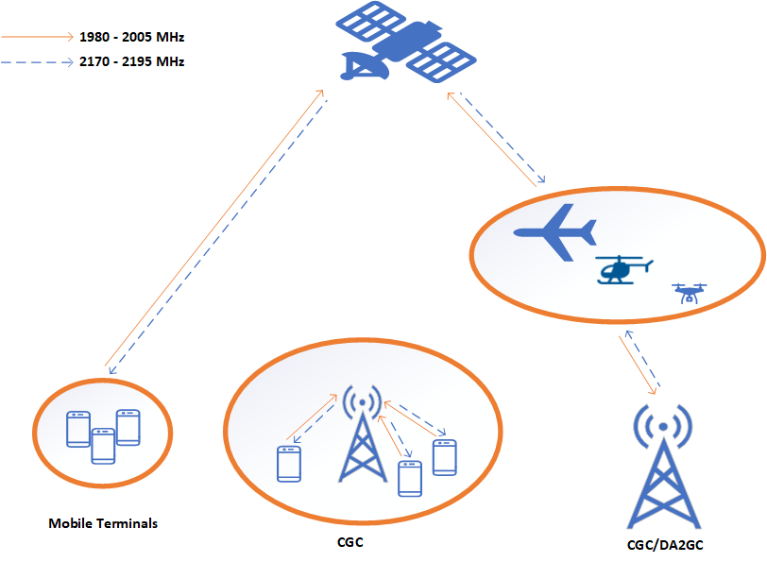

In the development of a technical framework for 2 GHz MSS, we have not considered requirements for space stations, noting that requirements for space stations are addressed by the ITU satellite coordination process.

As discussed in the outcomes paper, the ACMA’s preliminary view was that consistency with ITU requirements should be assessed as part of any eligibility requirements to participate in the allocation of licences for 2 GHz MSS.

While we can develop a framework to support the licensing of a mobile-satellite service, as with any satellite service, its viability is largely part dependent on the status of the satellite network in the ITU satellite coordination process. This a matter for prospective licensees to assess, and we make no assurances in this regard.

Technical design features for 2 GHz MSS have been developed from a review of ITU documentation, 3GPP, work on 2 GHz non-terrestrial network, European arrangements for 2 GHz MSS (including CGC) and ACMA documents. Documents considered are listed in Appendix A. The list is not necessarily exhaustive of all material that might be relevant to developing requirements for 2 GHz MSS. We are seeking views on any additional material that should be considered in the design of the relevant technical frameworks.

From these documents, we identified parameters for the different elements of 2 GHz MSS (see Appendix A), which were then used to identify technical parameters to support for 2 GHz MSS (see below) and coordination requirements (section 3).

In determining power limits, the parameters identified were similar to those in the   
2 GHz spectrum licence technical framework. To aid compatibility (between 2 GHz MSS and adjacent band 2 GHz spectrum licensing) the spectrum licencing power limits have been used, where relevant, as we did not identify need to apply   
different values.

As the 2 GHz spectrum licensing technical framework includes support for active antenna systems (AAS), we are seeking views on supporting AAS within the technical frameworks for 2 GHz MSS.

## Power limits

Proposed radiated power limits for 2 GHz MSS are:

* mobile earth station and mobile station transmitters in the band 1980–2005 MHz a total radiated power of less than or equal to 25 dBm per occupied bandwidth. This limit is the same as that specified for user equipment transmitters (transmitters operating in the band 1920–1980 MHz) in the 2 GHz spectrum licensing technical framework.
* aeronautical transmitters in the band 1980–2005 MHz a maximum EIRP of 40 dBm per occupied bandwidth. This limit is taken from ECC report 233.

CGC based station transmitter in the band 2170–2195 MHz a total radiated power limit of 53.5 dBm/5 MHz. This limit is the same as that specified for base station transmitters (transmitters operating in the band 2110–21170 MHz) in the 2 GHz spectrum licensing technical framework.

## Unwanted emissions limits

Our approach is to, where possible, align values for the 2 GHz MSS unwanted emissions limits with the values specified in 2 GHz spectrum licensing technical frameworks.[14] We are taking this approach to maximise coexistence between 2 GHz MSS and adjacent band 2 GHz spectrum licensed services. For example, unwanted emission limits for CGC base station transmitters operating in 2170–2195 MHz are based on unwanted emission limits for transmitters (base stations) operating in   
2110–2170 MHz. However, protection of some services in adjacent bands, such as TOB and earth station receivers, is likely to require more stringent unwanted emission limits than those specified in the 2 GHz spectrum licensing framework.

For aeronautical terminals in CGC/DA2GC systems, we considered European arrangements for 2 GHz MSS, noting that the 2 GHz spectrum licensing technical framework does not consider aeronautical terminals. Proposed limits are from   
[ECC Report 233](https://docdb.cept.org/document/339)[15] which investigated limits for aeronautical terminals in the bands 1980–2010/2170–2200 MHz.

Unwanted emission limits in bands used for TOB and for aeronautical terminals are discussed further below.

### Unwanted emission above 2010 MHz

Arrangements introduced in July 2022 for narrowband MSS in 2005–2010/2195–  
2200 MHz included a requirement in the Space Object Class Licence that emissions for MSS transmitters above 2010 MHz do not exceed an EIRP of -66 dBW/MHz. The limit was introduced as one of the mechanisms to manage coexistence with adjacent band TOB receivers (such as TOB collections station receivers), providing an interference environment similar to that where a wireless camera was operating in   
the band.[16]

For narrowband MSS, ETSI EN 300 744 was used as reference spectrum mask for TOB as it is the reference source listed in RALI FX 21 (assuming 50 dB as an adjacent channel leakage ratio).

Further review has identified that there are other references that contain emission masks that may be more applicable to the TOB scenario. For example, the 2015   
ITU-R Report F.2379[17] notes an adjacent channel leakage ratio of 45 dB for a 8 MHz TOB channel and [ETSI EN 302 064](https://www.etsi.org/deliver/etsi_en/302000_302099/302064/02.01.01_60/en_302064v020101p.pdf) that has an integrated power limit (relative to   
100 mW) in the first adjacent channel of -42 dB.

Considering these references, our preliminary view is that the emission limit at the 2010 MHz boundary could be reduce from –66 to -60 dBW/MHz EIRP and still ensure the protection of TOB receivers.

For areas of lower TOB usage or areas with no TOB collection receive stations, it is possible that more relaxed limits could provide adequate interference protection. This could be achieved by specifying different limits in different areas (for example, different limits in capital cities areas compared to regional/remote areas) or providing the flexibility for different limits with the agreement of the potentially impacted TOB licensees.

### Unwanted emission above 2200 MHz

Unwanted emission limits from CGC base station transmitters operating in the band 2170–2195 MHz above 2200 MHz require considering of protection requirements for TOB receivers operating in the band 2200–2300 MHz.

There are a number of frequency bands where terrestrial wireless broadband services operate adjacent to TOB receivers that might be relevant to developing 2 GHz MSS unwanted emission limits above 2200 MHz. These are:

* 2 GHz (1920–1980/2110–2170 MHz) spectrum licensing technical framework   
  (as revised in 2023) where base station transmitters (2110–2170 MHz) have a frequency boundary with TOB receivers at 2110 MHz
* 2.3 GHz (2302–2400 MHz) spectrum licensing technical framework (as revised in 2023) that has a frequency boundary with TOB and earth station receivers at   
  2300 MHz

2.5 GHz (2500–2570/2620–2690 MHz) spectrum licensing technical framework as developed in 2012 which considered TOB receivers operating under 2.5 GHz mid-band (2570–2620 MHz) spectrum licences. The most relevant matter identified is the 2620 MHz frequency boundary with TOB receivers and base station transmitters.

Of these technical frameworks, the 2.5 GHz spectrum licence technical framework with the 2620 MHz frequency boundary, with TOB receivers and base station transmitters, is seen as the most relevant because the 2.5 GHz framework was developed with consideration given to protecting TOB services. For the 2 and 2.3 GHz bands, terrestrial wireless broadcast services were well established when TOB services transition into the band 2010–2110/2200–2300 MHz as an outcome of work to provide long term arrangements for TOB.[18] TOB services had to accept interference from existing wireless broadcast services. No changes were made to arrangements for wireless broadcast services to provide protection for adjacent band to TOB.

The 2.5 GHz technical framework contains an unwanted emission limit of   
-45 dBm/MHz EIRP at a 5 MHz offset to protect adjacent band services,   
including TOB.

With the first TOB channel in the 2200–2300 MHz band starting at 2204 MHz, transposing the 2.5 GHz spectrum licensing requirements to 2 GHz MSS gives an emission limit at 2204 MHz of -45 dBm/MHz EIRP.

For areas of lower TOB usage, or areas with no TOB collection receive stations, it is possible that more relaxed limits could apply. This could be achieved by specifying different limits in different areas (for example, different limits in capital cities areas compared to regional/remote areas) or providing the flexibility for different limits with the agreement of the potentially impact TOB licensees.

For protection of earth station receivers in the 2200–2300 MHz, the envisaged coordination requirements (see section 3.5) are based on assessing the level of CGC out-of-band emissions at the earth station receiver. Given that there are only a small number of earth station locations most of which are mainly located outside of capital cities, our preliminary view is that 2 GHz MSS unwanted emissions limits do not need to consider earth station receiver protection requirements.

### Unwanted emission limits for aeronautical terminals

The 2 GHz spectrum licensing technical farmwork does not considered aeronautical terminals such as those used in CGC/DA2GC. So consistent with aligning with European arrangements for 2 GHz MSS unwanted emissions limits, we are proposing limits based on [ECC Report 233](https://docdb.cept.org/document/339).[19] ECC Report 233 developed an out-of-band power flux density (pfd) mask for aeronautical transmitters in 1980–2010 MHz to protect base station receivers in the band 1920–1980 MHz. The report also advised that a pfd mask could be applied within the band 1980–2010 MHz to protect adjacent band MSS systems using CGCs. The pfd mask would also help mitigate the potential for interference to adjacent band TOB receive stations in 2010–2110 MHz.[20]

We are proposing that aeronautical terminals be required to meet the ECC pdf mask at frequencies below 1980 MHz, above 2010 MHz and in the channel of any adjacent channel 2 GHz MSS system. The mask is:

$$PFD \left(δ\right)=2* δ-125.5 dB \left(W/{m^{2}.5 MHz}\right) for 0°≤δ≤5°$$

$$PFD \left(δ\right)=\frac{13}{85}* δ-116.3 dB \left(W/{m^{2}.5 MHz}\right) for 5°<δ≤90°$$

where δ is the angle of arrival at the Earth’s surface (degrees above the horizontal) and the pfd is calculated in a reference bandwidth of 5 MHz.

# Coordination considerations

## Current spectrum arrangements

The [Australian Radiofrequency Spectrum Plan 2021](https://www.acma.gov.au/australian-radiofrequency-spectrum-plan) (the Spectrum Plan) includes allocations in the 1980–2005 MHz and 2170–2195 MHz bands to the fixed, mobile and mobile-satellite services on a primary basis. Australian allocations are consistent with global allocations in the 2 GHz band. The adjacent bands support a range of fixed, mobile, space research, space operations and Earth exploration services.

The Figure 2 spectrum arrangement shows a summary of current and planned spectrum arrangements in and adjacent to those bands. A description of spectrum uses illustrated and coordination arrangements follows.

Spectrum arrangements

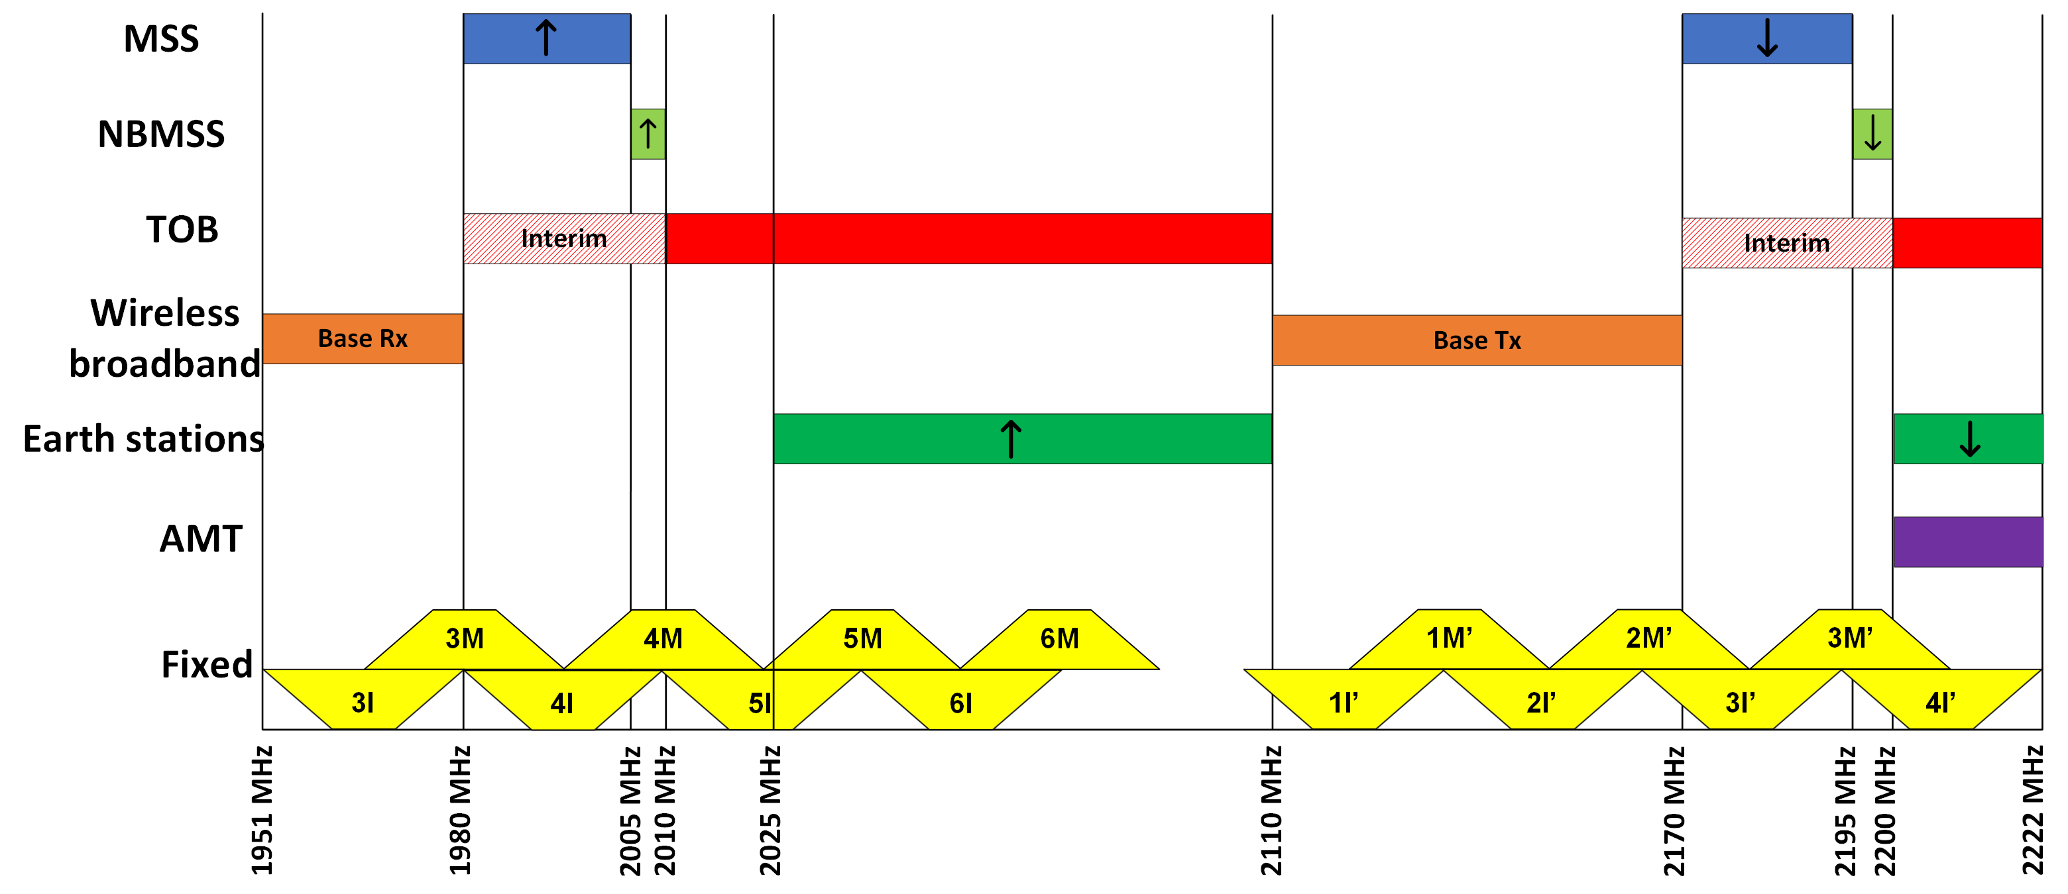

## Fixed point-to-point links

In the 2021 outcomes paper, we determined that the small number of legacy fixed point-to-point links in regional and remote areas should not impact deployment of   
2 GHz MSS. As a result, these links are be permitted to continue operating, subject to the existing licence renewal process on expiry with no new fixed point-to-point links   
(as per the MSS band plan) to be permitted in the 2 GHz band. To ensure compatibility between fixed point-to-point and complementary ground component applications (including direct air-to-ground), we acknowledge the need to develop coordination arrangements between fixed links and CGC.

Current arrangements for fixed point-to-point services are detailed in [RALI FX3](https://www.acma.gov.au/publications/2019-09/instruction/rali-fx3-microwave-fixed-services), which specifies channel arrangements for the fixed services in the 2.1 GHz band   
(1900–2300 MHz) and the 2.2 GHz band (2025–2285 MHz). These fixed services channel arrangements are detailed in Figure 3 along with proposed MSS (including CGC) services.

While no new fixed links are allowed in the 2 GHz MSS band, in the adjacent bands new fixed links are allowed though restricted due to spectrum licensing and PTS (1920–1980/2110–2170 MHz) and Embargo 23 restriction[21] on fixed point-to-point links in 2010–2110/2200–2300 MHz to support TOB operations.

Spectrum arrangements: Fixed links and 2 GHz MSS

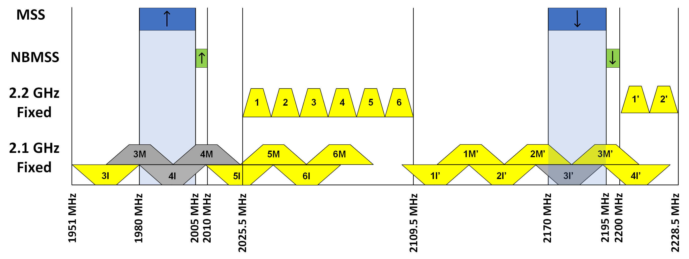

There are currently 14 point-to-point links in or immediately adjacent to the 2 GHz MSS band, most of which are licensed to Telstra in low or remote-spectrum density areas of Australia, as shown in Figure 4: Geographic distribution of fixed links.

For 1980–2005 MHz, there are no assignments on fixed links channels 3M, 4M or 4I, which overlap this band. There are 2 assignments on the lower adjacent channel 3I and 6 on the upper adjacent channel 5I.

For the 2170–2195 MHz band, 8 assignments on channel 2M’ for point-to-point services that partially overlap the 2170–2195 MHz band. There are a further   
12 assignments on channels 2I’ and 4I’, which are adjacent bands (in this case,   
2 assignments in 2135–2164 MHz and 10 assignments in 2200.5–2214.5 MHz.

The fixed service channels highlighted in yellow are those with assignments, and the channels highlighted in grey are those with no assignments (see Figure 3: Spectrum arrangements: Fixed links and 2 GHz MSS).

Geographic distribution of fixed links

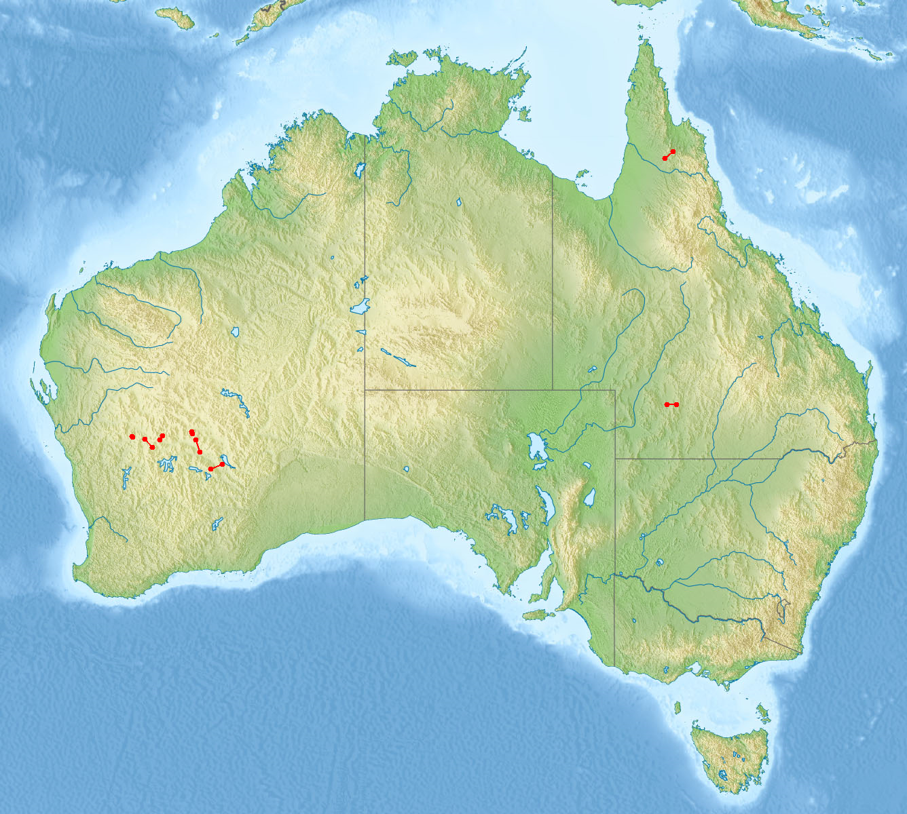

### Coordination requirements

The following coordination requirements between fixed point-to-point links and 2 GHz MSS are proposed:

no new fixed point to point links allowed in the 1980–2010/2170–2200 MHz band.

coordination methodology for CGC base station and fixed point-to-point links to be developed in consideration of fixed link protection requirements of FX3.

frequency and distance culls of FX3 to be used to identify co-channel and adjacent channel services for coordination.

2 GHz MSS user equipment operated on condition of no interference to and from existing fixed point to point link in the 2 GHz MSS band. This includes aeronautical terminals which could require large separation distances with respect to fixed link transmitters and receivers. FX3 protection requirements can be used to give a guide to likely separation distances.

## Wireless broadband services

The bands 1920–1980 MHz (base receive) and 2110–2170 MHz (base transmit) are used to provide wireless broadband services throughout Australia under a mixture of apparatus licences (public telecommunications services) and 2 GHz spectrum licences.

The 2 GHz spectrum licence band is defined as the frequency bands:

1920–1980 MHz and 2110–2170 MHz in capital city areas

1960–1980 MHz and 2150–2170 MHz in regional areas.

Apparatus licensed public telecommunications services (PTS) can be licensed in the 1920–1980 MHz and 2110–2170 MHz bands in areas outside of the spectrum licensed (refer [RALI MS26](https://www.acma.gov.au/publications/2021-05/instruction/rali-sm26-restrictions-apparatus-licensing-spectrum-licensed-spaces)). These areas are shown in Figure 5: Wireless broadband (from [RALI MS33](https://www.acma.gov.au/publications/2019-08/instruction/rali-ms33-frequency-coordination-and-licensing-procedures-apparatus-licensed-pts-2-ghz-bands)).

Wireless broadband

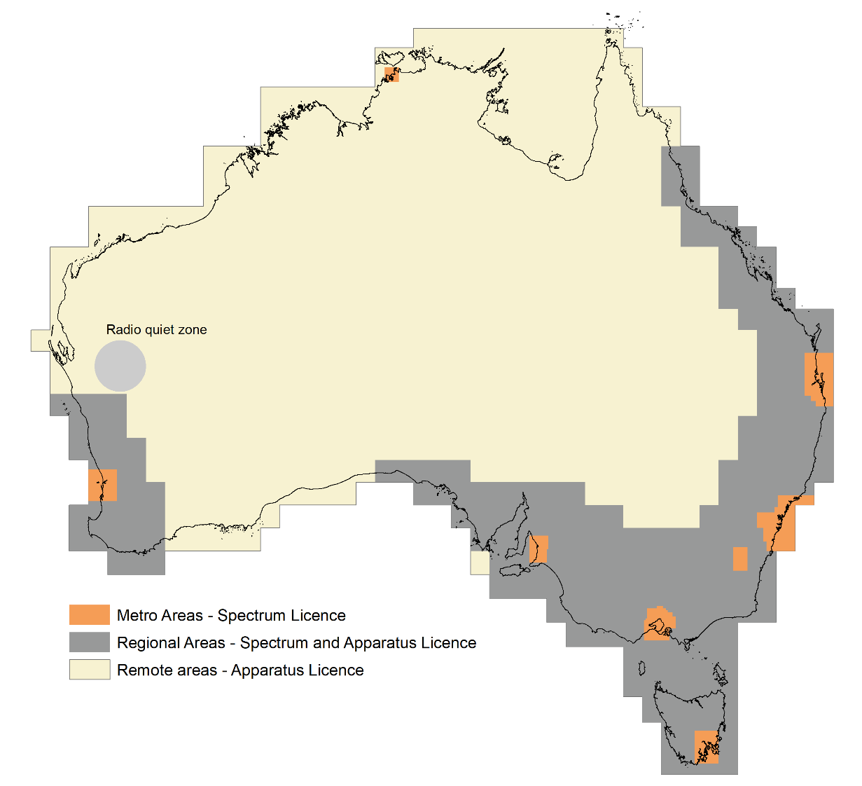

Arrangements for spectrum licensing in the 2 GHz band are detailed in the 2 GHz spectrum licensing technical framework.

Information on frequency coordination and licensing of PTS in the paired,   
1920–1980 MHz and 2110–2170 MHz frequency bands are detailed in [RALI MS33](https://www.acma.gov.au/publications/2019-08/instruction/rali-ms33-frequency-coordination-and-licensing-procedures-apparatus-licensed-pts-2-ghz-bands).

Our preliminary view (as stated in the outcomes paper) is that compatibility with adjacent band services (particularly adjacent band wireless broadband services) is largely addressed by current spectrum planning arrangements whereby there is compatibility in a frequency sense[22] and no cross boundary transmit/receive issues. That is, base transmit segments are adjacent to base transmit segments (illustrated   
in Figure 6).

In addition, to maximise coexistence with adjacent band 2 GHz spectrum licensed services,[23] where possible we are proposing the technical framework for 2 GHz MSS align with that of the [2 GHz spectrum licensing framework](https://www.acma.gov.au/2-ghz-technical-framework).

The result is that, as far as practical, technical requirements for mobile earth stations and CGC systems will be based on the 2 GHz spectrum licensing technical framework. For example, user terminals (whether being used as part of a mobile satellite service or a complementary ground component system) will have the same technical parameters based on those specified for user equipment in the 2 GHz spectrum licence technical framework). Similarly, parameters for CGC base stations will   
be based on those specified for base station in the 2 GHz spectrum licence   
technical framework.

Wireless broadband spectrum arrangements and 2 GHz MSS

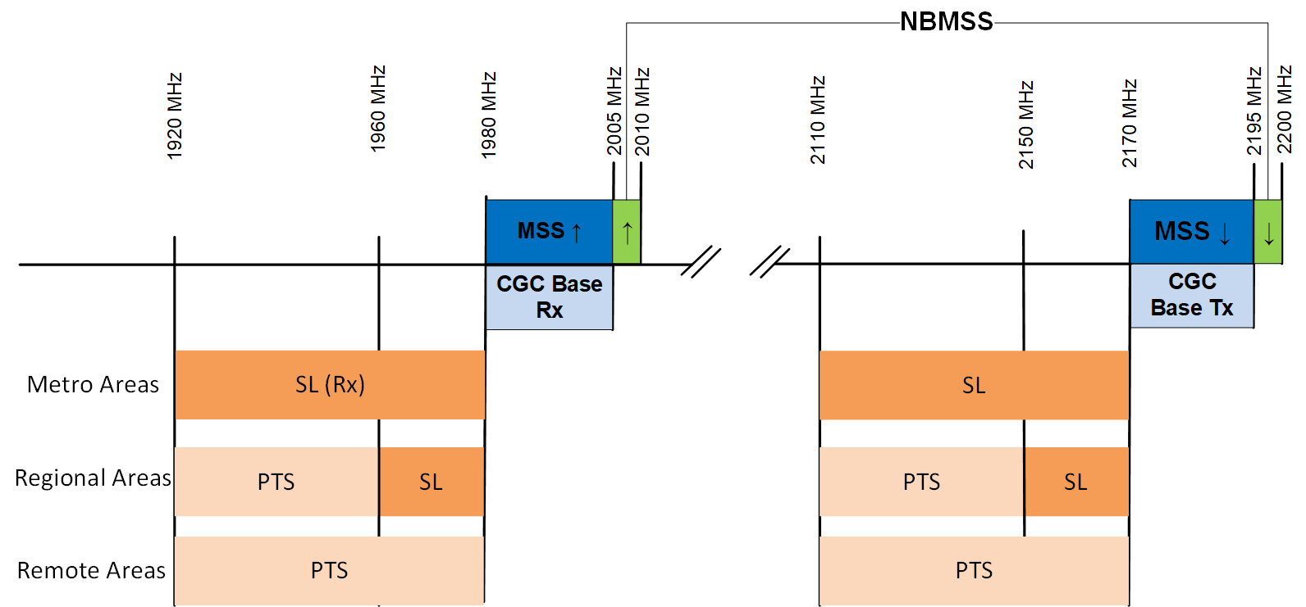

### Coordination features

Our preliminary view is that compatibility with adjacent band wireless broadband services is achieved through the combination of:

current spectrum planning arrangements whereby there is compatibility in a frequency sense[24] and no cross boundary transmit/receive issues

ensuring where possible the technical framework for 2 GHz MSS aligns with that of the 2 GHz spectrum licensing framework. For example, in terms of radiated power and unwanted emission limits

licensing framework for CGC (when developed) includes recording location of CGC base stations

use of the power flux density out of band emission mask of ECC report 233 for aeronautical transmitters operating in the band 1980–2005 MHz to protection base station receivers operating in 1920–1980 MHz (discussed in section 2).

## Television outside broadcasting services

TOB refers to wireless applications used as part of news gathering, special events or media production. Video is transmitted either using a wireless camera over a short distance or point-to-point link from an outside broadcast van to a central capture point, typically permanently located in a high point.

In the outcomes paper, one of the key planning decisions was that technical restrictions are required in the frequency range 2005–2010 MHz and 2195–2200 MHz to protect adjacent-band TOB services. The outcomes paper advised that consideration is also required as to whether arrangements for narrowband MSS in the restricted band (2005–2010/2195–2200 MHz) will be sufficient to protect adjacent-band TOB services, space research and space operations services operating above 2010 and 2200 MHz. The requirement to protect TOB of services is also a design consideration in the development of arrangements for 2 GHz MSS.

[RALI FX21](https://www.acma.gov.au/publications/2019-09/instruction/rali-fx21-television-outside-broadcasting-services) provides information on frequency coordination and licensing arrangements for TOB services in the bands 1980–2110 MHz and 2170–2300 MHz. It includes advice on coordination with adjacent band 2 GHz spectrum licenced services and PTS apparatus licenced services.

TOB systems are described in RALI FX21 may use some combination of the following:

fixed receivers: typically, high-sited, high gain receivers designed to provide reception over large distances (e.g., for a large metropolitan area)

high-power TOB transmitters: typically high-gain, with moderate antenna heights (for example an ENG van)

low-power TOB transmitters: typically low-gain, low-height mobile transmitters (for example a wireless camera)

aeronautical stations: For example, helicopter transmitters (limited to   
2010–2110 MHz) and receivers (which planning arrangements support in   
both bands).

### TOB transition arrangements (1980–2010/2170–2200 MHz)

TOB services in 1980–2010/2170–2200 MHz are required to cease operations to support the introduction of MSS. This will occur over an extended transition period to provide sufficient time for TOB to relocate to alternative spectrum. As per the Radiocommunications ([Mobile-Satellite Service](Https://Www.Legislation.Gov.Au/Series/F2022l00843)) (1980–2010 and 2170–2200 MHz) Frequency Band Plan 2022 (MSS Band Plan), the TOB services are to vacate the bands 1980–2010 MHz and 2170–2200 MHz by:

28 February 2026 in metropolitan area and designated areas[25] (sporting and event venues in regional areas where TOB services are used regularly)

29 February 2024 elsewhere (regionals areas).

Until the transition is completed, MSS services in the 1980–2010 MHz and   
2170–2200 MHz band will not be authorised to operate if they cause interference   
to, and will not be afforded protection from, TOB services. The MSS earth stations must not cause harmful interference to, nor claim protection from, TOB stations licensed in accordance with the MSS Band Plan.

There is no change to arrangements for TOB services in the bands 2010–2110 MHz and 2200–2300 MHz from the introduction of MSS service. MSS services are required to protect and not cause interference to TOB services in the bands 2010–2110 MHz and 2200–2300 MHz.

### Coordination requirements

In addition to unwanted emission levels for 2 GHz MSS discussion in section 2, the following coordination requirements between TOB and 2 GHz MSS are proposed:

coordination of fixed CGC transmitters operating in 2170–2195 MHz with TOB receivers operating in 2200–2300 MHz with reference to the requirements specified in Appendix B of RALI FX 21

operating of aeronautical transmitters in 1980–2005 MHz on a no interference basis with respect to TOB receivers operating in 2010–2110 MHz. Depending on frequency separation, this may limit the operation of aeronautical transmitters in the vicinity of TOB receivers

to facilitate coordination of CCG transmitters with TOB receivers, the recording of TOB fixed receivers on TOBN licences is recommended.

Further consideration of the emission limits 2 GHz MSS is required to consider different values specified for narrowband MSS in the Space Class Licence.

## Earth stations

Under current spectrum planning arrangements, earth station transmitters operate in the 2025–2110 MHz band, and earth station receivers in the 2200–2300 MHz band supporting space operation, earth exploration-satellite and space research services.[26] As set out in Spectrum Embargo 23 and RALI FX21, the operation of earth stations   
is restricted to certain locations, with new earth stations considered on a   
case-by-case basis.

Earth stations at New Norcia (WA) are operated under the terms of a treaty between the Australian Government and ESA. Similarly, the ongoing operation of earth station facilities at Tidbinbilla (ACT) is conducted under treaty between Australia and the USA. Location of these earth stations and other earth stations are illustrated in Figure 7.

Earth station locations

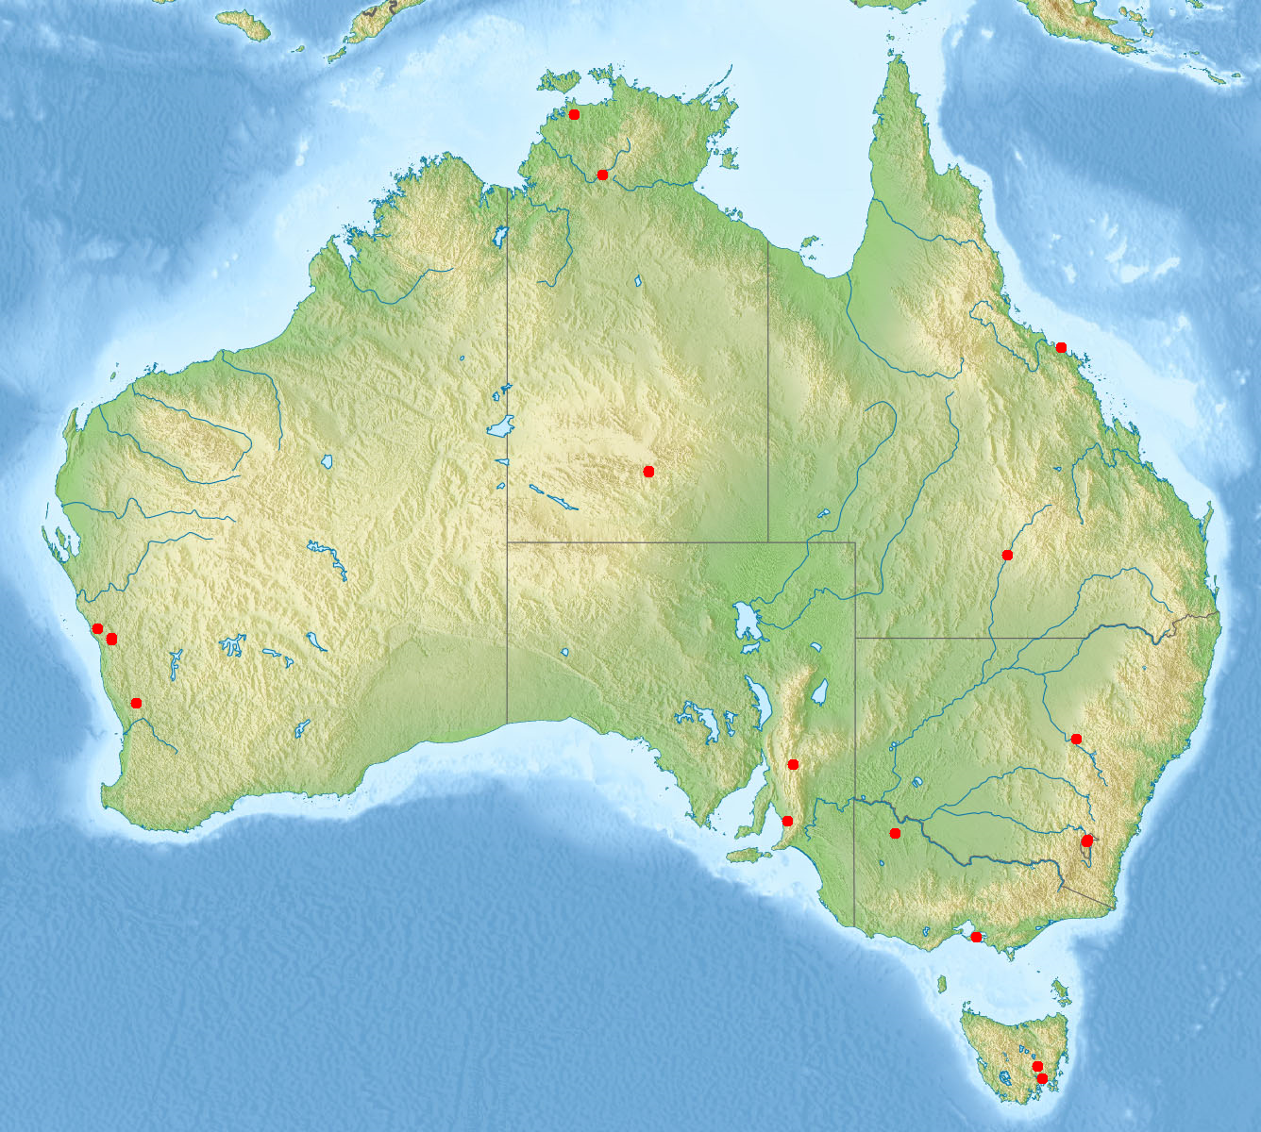

ECC Recommendation [(10)01](https://docdb.cept.org/document/494)[27] sets out an approach for coordination of CGC base station transmitters operating in 2170–2200 MHz with adjacent band earth station receiver. Coordination is based on assessing CGC unwanted emissions above   
2200 MHz against an earth station receive threshold. While further review is required to determine how such an approach could by applied in Australia, it is a simple approach that would seem to be able to be readily adapted for coordination between CGC bases stations and earth station receivers in Australia.

### Coordination principles

The following coordination principles between earth stations and 2 GHz MSS are envisaged:

* spectrum arrangement both internationally and in Australia provide compatibility (downlink adjacent to downlink) and there are no frequency-boundary transmit/receive issues. Accordingly, no coordination requirements are intended to be developed between MSS earth receivers (2170–2200 MHz) and the adjacent band earth station receivers (2200–2300 MHz)

no protection afforded from existing and future earth station transmitters to be provided to 2 GHz MSS receivers noting the 20 MHz frequency separation (between 2005 MHz and 2025 MHz)

CGC base station transmitters in 2170–2195 MHz to protect current and future earth stations at Mingenew earth station protection zone, New Norcia and Tidbinbilla

in other locations CGC base transmitters (2170–2195 MHz) to be coordinated with earth station receivers on a first-in-time basis

Coordination of CGC transmitters with earth station receivers to be based on CGC out-of-band emissions at the earth station receiver similar to the approach of ECC Recommendation (10)01. Different requirements may be required for earth station receivers at Mingenew earth station protection zone and those covered by treaty level agreements (that is, New Norcia and Tidbinbilla) and earth stations at   
other locations.

## Australian radio quiet zone

The Radiocommunications ([Australian Radio Quiet Zone Western Australia](https://www.legislation.gov.au/Series/F2023L00286)) Frequency Band Plan 2023 (RQZ Band Plan) establishes a radio quiet zone (RQZ) in the mid-west region of Western Australia to prevent harmful interference to radio astronomy services.

RALI MS32 [*Coordination of apparatus licensed services within the Australian Radio Quiet Zone Western Australia*](https://www.acma.gov.au/publications/2019-08/publication/rali-ms32-mid-west-radio-quiet-zone) provides a framework for the interference protection of radioastronomy activities sited within 50 km of the centre of the RQZ. A potential frequency assignment falls within the scope of this RALI if the assignment is for an apparatus-licensed transmitter of a coordinated terrestrial service station or earth station, and its frequency and geographical location is within the RQZ.

While space and space receive licensees are not subject to RALI MS32, space and space receive licensees are considered responsible for ensuring that their end-user earth station terminals do not cause harmful interference to radioastronomy services   
in the RQZ.

### Coordination principles

To preserve the radio quiet zone it is envisaged that:

* CGC base station transmitters will be subject to the coordination procedures for the RQZ as detailed in RALI MS 32
* mobile earth station transmitters and mobile station transmitters in band   
  1980–2005 MHz will not be permitted to operate in a defined area around the RQZ (similar to requirement under spectrum licensing where typically an area around the RQZ is excluded)
* further consideration is required for requirements for aeronautical transmitter in 1980–2005 MHz.

## Defence aeronautical mobile telemetry systems

Defence operates AMT systems on an intermittent basis in the 2200 to 2300 MHz frequency range at a number of locations within Australia and its territorial waters.

### Coordination principles

Noting the itinerant nature of AMT, the locations of AMT operations, frequency separation (of at least 5 MHz), no coordination procedures are proposed between AMT systems and the MSS systems.

# Review of narrowband MSS arrangements

In December 2021, we opened a consultation on narrowband MSS in the bands   
2005–2020/2195–2200 MHz. In July 2022, the ACMA published a response to submissions paper to inputs to that consultation. We indicated an openness to reviewing the narrowband MSS arrangements if the satellite industry provided supporting information (documenting the reasons for and the benefits of such   
a review.[28]

In anticipation of a possible review, consideration has been given to use of more detailed propagation modelling (of the potential for interference from NBMSS stations into TVOB). Our preliminary view is that a suitable propagation model is ITU-R Recommendation P.1812,[29] which considers terrain analysis, clutter factors, per cent of time and location factors. In terms of input values for time and location factors, considering the interference scenario to be modelled, 10% time (percentage of average year for which the calculated signal level is exceeded) and 10% location (percentage of locations for which the calculated signal level is exceeded)   
seem appropriate.

In considering arrangements for narrowband MSS in the July 2022 response to submission paper, a mobile earth station deployment density value of 2.4 per km2 was used – a value that industry had expressed a view as being too high. Since then, as part of the ITU work on satellite IMT-2020 submission and evaluation process, the ITU has published [Report ITU-R M.2514](https://www.itu.int/pub/R-REP-M.2514) on Vision, requirements and evaluation guidelines for satellite radio interface(s) of IMT-2020 which advised that density of at least 500 devices per km2 should be supported (assuming 30 MHz bandwidth, this implies around 16 devices per km2 per MHz). Duty cycle is not considered in the ITU report and beyond monitoring ITU developments no further work on duty cycle is proposed at this stage.

While the ACMA remains open to review arrangements for narrowband MSS, to do so we require confidence that industry still consider such a review is required and there is a clear understanding about the relevant aspects of the current framework[30] that should be reviewed. For example, whether changes to emission limit at 2010 MHz (beyond the preliminary view that the limit could be reduced by 6 dB from -66 to -60 dBW/MHz EIRP) or to changes to duty cycle requirements.

# Licensing and allocation considerations

## Licensing of space-based communication systems

In general, there are 2 broad options for licensing of space systems in Australia.

The first option requires operators to obtain apparatus licences for each of their earth stations individually: an earth licence or area-wide apparatus licences ([AWL](https://www.acma.gov.au/publications/2020-02/guide/area-wide-licensing-acma-approach-introducing-area-wide-licences))[31] for the uplink and an earth-receive licence for the downlink. Under this approach, a licence is not necessary for the space stations aboard a satellite. This method of licensing is typically used for fixed satellite services with a limited number of earth stations.

The second option involves a combination of apparatus and class licences. In certain bands specified in the [Radiocommunications (Communication with Space Object) Class Licence 2015](https://www.legislation.gov.au/Series/F2015L01486) (the Space Object Class Licence), operators may licence the space stations aboard a satellite with a space licence for the downlink and a space receive licence for the uplink. Earth stations in the network are then automatically authorised collectively under the Space Object Class Licence. This is provided the related space object is either:

an Australian space object listed in the [Australian Space Objects Determination](https://www.legislation.gov.au/Series/F2014L01586)

a foreign space object that is owned, controlled or operated by a company/entity listed in the [Foreign Space Objects Determination](https://www.legislation.gov.au/Series/F2014L01584).

This approach is typically used for satellite systems with numerous or ubiquitous earth stations. It provides an efficient means of licensing a large number of earth stations, avoiding the need to obtain a licence for every earth station in a satellite system.

A mobile-satellite service operating in the 2 GHz MSS band would normally be expected to require the second method of licensing, as it would likely involve deployment of an indeterminate and varying number of mobile user terminals (earth stations). Implementing such an approach would require the ACMA to amend the Space Object Class Licence to facilitate use of the 2 GHz MSS band and consider whether any revisions are required to our procedures for [submission and processing of applications for space and space receive apparatus licences](https://www.acma.gov.au/procedures-space-and-space-receive-licensing).

Before varying the Space Object Class Licence, the Australian Space Objects Determination or the Foreign Space Objects Determination, we would undertake consultation in accordance with the requirements of the *Legislation Act 2003*. This typically involves publication of a discussion paper with a period for submission of comments from interested parties.

### Complementary ground component licensing

The ACMA has not previously considered the method for authorising the operation of the complementary ground component of a mobile-satellite service. As outlined in the January 2021 outcomes paper, new apparatus licensing arrangements will need to be developed to support CGC systems, as CGC systems are not supported under licensing arrangements for space-based communication systems. The intention is to undertake this work as part of the allocation design work, which we intend to consult on commencing in Q3 2024.

### International satellite regulation considerations

Before operating a satellite system[32] in Australia, the technical details of the network must be filed with the ITU[33] for inclusion in the Master International Frequency Register. Satellite systems may be filed through any national administration recognised by the ITU.

As part of the licence assessment, we check whether the ITU satellite filing details are consistent with the licence application and the ITU coordination (regulatory) status of the satellite network (refer to ACMA procedures for [Submission and processing of applications for space and space receive apparatus licences](https://www.acma.gov.au/procedures-space-and-space-receive-licensing)).

The outcomes of these checks can result in a variety of licence conditions being included on a licence to reflect the status of the ITU filing and coordination with other services. One of the key outcomes is that the licence records details of the ITU satellite filing for which the licence authorises communications.

In the outcomes paper, we expressed the preliminary view that ITU requirements should be assessed as part of any eligibility requirements to participate in the auction of licences for 2 GHz MSS. In particular, we felt there should be an existing satellite filing for which the applicant is the responsible entity, or has an agreement to access.

While the ACMA can develop a framework to support the licensing of a mobile-satellite service to operate in Australia, as with any satellite service, its viability is in large part dependent on the status of the satellite network in the ITU satellite coordination process. This a matter for prospective licensees to assess, and we make no assurances in this regard.

## 2 GHz MSS licence allocation considerations

In allocating spectrum, where demand is likely to exceed supply, the ACMA generally looks to design a mechanism to resolve competing demand that is transparent and results in an efficient allocation of the spectrum. This promotes the long-term public interest derived from the use of the spectrum, as required by the objects of the Act.

Our normal approach for apparatus licensing of space-based communications systems is to issue licences to applicants that can demonstrate there is a relevant ITU satellite filing. We rely on the ITU satellite coordination process to resolve compatibility between different satellite systems. (See our business operating procedure for the submission and processing of applications for [space and space receive](https://www.acma.gov.au/publications/2020-08/guide/submission-and-processing-applications-space-and-space-receive-apparatus-licences) apparatus licences.)

In our 2021 outcomes paper, we explained that there were a number of factors supporting our preliminary view that the most appropriate mechanism for licence allocation was a price-based allocation mechanism. These reasons included:

a number of satellite operators had expressed interest in providing a mobile satellite service using the MSS band

the MSS arrangements would include support for deployment of a CGC system, which would likely require exclusive use of spectrum to avoid interference between different systems

coordination between mobile-satellite systems is largely concerned with band segmentation (segmenting the band between different operators).

Our preliminary view was that a price-based allocation was the most appropriate mechanism to resolve competing demand in the 2 GHz MSS band, noting that stakeholder responses indicated that demand for the spectrum was likely to exceed the available supply.

In our outcomes paper, we also noted that that price-based allocations of under section 106 of the *Radiocommunications Act 1992* are limited to the allocation of transmitter licences, which in this case would be space apparatus licences in the 2170–2195 MHz band. Given that, we indicated a preliminary view that we would only issue the associated space receive apparatus licences in the paired band   
1980–2005 MHz to those successful in the price-based allocation process.

We are aware that the satellite industry continues to express concerns about price-based allocation, in particular a potential auction of 2 GHz MSS spectrum, as reflected in submissions to our draft FYSO 2023–28. The ACMA is now seeking updated information on the likely level of demand for 2 GHz MSS spectrum, to assess whether it remains the case that demand for the spectrum is likely to exceed the available supply. We are also seeking stakeholder views on the availability of suitable equipment for deployment of MSS in the 2 GHz band.

### Lot configuration options

Currently 3 licences have been issued for 2 GHz MSS narrowband services, and we are aware of another 4 other satellite operators over the last year who have expressed interest in 2 GHz MSS.

[Submissions to the draft FYSO 2023–28](https://www.acma.gov.au/sites/default/files/2023-10/Submissions%20-%20IFC%2028-2023.zip) supported our view that 2 GHz MSS should be designed to support 3GPP equipment and encouraged the ACMA to allocate licences as 2 x 15 MHz and 2 x 10 MHz blocks of spectrum. An option of using   
2 x 5 MHz increments up to 15 MHz to fit the minimum requirements of 3GPP was also proposed.

We are interested in your views on the most appropriate frequency lot configuration for this spectrum. Options might include:

**Configuration 1**

* 2x15 MHz paired (1980-1995 MHz with 2170–2185 MHz)

2x10 MHz paired (1995–2005 MHz with 2185–2195 MHz)

**Configuration 2**

5 generic 2 x 5 MHz paired lots, which would provide participants in the auction the opportunity to bid for as many blocks as suits their use case.

We would welcome stakeholder views on the most appropriate amount of spectrum   
for their use case. For example, could 2 x 5 MHz be sufficient, or is a minimum   
2 x 10 MHz required? Stakeholders may provide any part of their submission in confidence if preferred.

Submissions to this consultation will inform our Q3 2024 consultation on allocation matters, including:

the proposed allocation method

frequency lot configuration

licensing arrangements

draft technical framework instruments to support the allocation of spectrum in the 1980-2005 MHz and 2170-2195 MHz frequency ranges.

# Future work

In this paper, we have provided proposed technical design principles for consideration. Industry input will assist drafting technical framework instruments supporting the allocation of licences in 1980–2005/2170–2195 MHz.

We envisage that formal consultation on the technical framework and allocation design will commence in Q3 2024, with – at this stage – allocation of licences occurring   
in 2024–25.

# Invitation to comment

## Making a submission

We invite comments on the issues set out in this discussion paper.

[Online submissions](https://www.acma.gov.au/have-your-say) can be made by uploading a document. Submissions in PDF, Microsoft Word or Rich Text Format are preferred.

Submissions by post can be sent to:

The Manager

Space Systems

Australian Communications and Media Authority

PO Box 78

Belconnen ACT 2616

The closing date for submissions is **COB,** **Tuesday 13 February 2024**.

Consultation enquiries can be emailed to [satellite.coordination@acma.gov.au](mailto:satellite.coordination@acma.gov.au).

## Publication of submissions

We publish submissions on our website, including personal information (such as names and contact details), except for information that you have claimed (and we have accepted) is confidential.

Confidential information will not be published or otherwise released unless required or authorised by law.

## Privacy

View information about our policy on the [publication of submissions](https://www.acma.gov.au/publication-submissions), including collection of personal information during consultation and how we handle that information.

Information on the *Privacy Act 1988,* how to access or correct personal information, how to make a privacy complaint and how we will deal with any complaints, is available in our [privacy policy](https://www.acma.gov.au/privacy-policy).

# Appendix A: MSS reference documents and parameters

## References

In developing the requirements for 2 GHz MSS, the documents listed below have been considered. The list is not necessarily exhaustive of material that might be relevant to developing requirements for 2 GHz MSS, and industry is encouraged to identify additional material that could be relevant.

3rd Generation Partnership Project (3GPP)Technical Standards and Reports (see [3GPP Specifications by Series](https://www.3gpp.org/specifications-technologies/specifications-by-series))

Technical Specification TS 38.101-1  
3rd Generation Partnership Project; Technical Specification Group Radio Access Network; NR; User Equipment (UE) radio transmission and reception; Part 1: Range 1 Standalone (Release 18, 2023-03)

Technical Specification TS 38.101-5  
3rd Generation Partnership Project; Technical Specification Group Radio Access Network; NR; User Equipment (UE) radio transmission and reception; Part 5: Satellite access Radio Frequency (RF) and performance requirements (Release 18, 2022-12)

Technical Specification TS 38.104  
3rd Generation Partnership Project; Technical Specification Group Radio Access Network; NR; Base Station (BS) radio transmission and reception (Release 18)

Technical Report TR 38.821  
3rd Generation Partnership Project; Technical Specification Group Radio Access Network; Solutions for NR to support non-terrestrial networks (NTN)(Release 16, 2023-03)

[European Telecommunications Standards Institute](https://www.etsi.org/)

ETSI EN 302 574-1 V2.1.1 (2016-06), Satellite Earth Stations and Systems (SES); Harmonised Standard for Mobile Earth Stations (MES) operating in the   
1980 MHz to 2010 MHz (earth-to-space) and 2170 MHz to 2200 MHz (space-to-earth) frequency bands covering the essential requirements of article 3.2 of the Directive 2014/53/EU; Part 1: Complementary Ground Component (CGC) for wideband systems

European Conference of Postal and Telecommunications Administrations (CEPT) . Electronic Communications Committee (ECC) Report (see [ECO Documentation Database](https://docdb.cept.org/))

ECC Report 233  
Adjacent band compatibility studies for aeronautical CGC systems operating in the bands 1980-2010 MHz and 2170-2200 MHz (May 2015)

ECC Report 197  
Compatibility Studies – MSS Terminals Transmitting to a Satellite in the Band 1980 - 2010 MHz and Adjacent Channel UMTS Services (May 2013)

ECC Report 348  
Usage of aerial UE in 1.8 GHz, 2 GHz and 2.6 GHz frequency bands with MFCN AAS base stations (November 2022)

ECC Report 298

Analysis of the suitability and update of the regulatory technical conditions for 5G MFCN and AAS operation in the 1920-1980 MHz and 2110-2170 MHz band (March 2019)

ECC Recommendation (10)01

Guidelines for compatibility between Complementary Ground Components (CGC) operating in the band 2170-2200 MHz and EESS/SOS/SRS Earth stations operating in the band 2200-2290 MHz (January 2010)

ACMA Radiocommunications assignment and licensing instructions (RALIs)

[RALI FX3](https://www.acma.gov.au/publications/2019-09/instruction/rali-fx3-microwave-fixed-services): microwave fixed services

[RALI FX21](https://www.acma.gov.au/publications/2019-09/instruction/rali-fx21-television-outside-broadcasting-services): Television outside broadcasting services

[RALI MS32](https://www.acma.gov.au/publications/2019-08/instruction/rali-ms32-mid-west-radio-quiet-zone): Mid West Radio Quiet Zone

[RALI MS33](https://www.acma.gov.au/publications/2019-08/instruction/rali-ms33-frequency-coordination-and-licensing-procedures-apparatus-licensed-pts-2-ghz-bands) Frequency coordination and licensing procedures for apparatus licensed PTS in the 2 GHz bands

ACMA spectrum licence technical framework

[2 GHz spectrum licensing technical framework](https://www.acma.gov.au/consultations/2022-11/review-2-ghz-spectrum-licensing-technical-framework-consultation-382022) (as revised)

[2.3 GHz spectrum licensing technical framework](https://www.acma.gov.au/23-ghz-technical-framework) (as revised)

[2.5 GHz spectrum licensing technical framework](https://www.acma.gov.au/25-ghz-technical-framework)

## MSS parameters

1. User equipment parameters

|  |  |  |
| --- | --- | --- |
| Parameter | Notional device | Notes |
| Transmit power | 23 dBm | 3GPP TR 38.821[34] Table 6.1.1.1-3 |
| Maximum antenna gain | 0 dBi |
| Carrier bandwidth | 0.2 MHz | ECC Report 197[35], Table 5 |
| Antenna gain pattern | Omni |  |
| EIRP density | 0 dBW/MHz |  |
| Antenna height | 1.5 m |  |
| Adjacent channel leakage ratio | 30 dB | As per TS 38.101-5[36]  (Table 6.5.2.4.1-2)) |
| Notional protection level for interference studies | -136.5 dBW/MHz | As per TS 38.101-5, discussed further below |
| Adjacent channel selectivity | 33 dB | As per TS 38.101-5 (Table 7.5-1) |

1. Aeronautical terminals (communication with space stations)

|  |  |  |
| --- | --- | --- |
| Parameter | Value | Notes |
| Transmit power max | 25 dBm | ECC Report 233[37], Table 7 |
| Bandwidth | 0.2 MHz |
| Maximum antenna gain | 15 dBi |
| Antenna type | Directional - rec. 4.1 of Rec. ITU-R F.1336-4 |
| Power density | 2 dBW/MHz |  |
| Altitude considered | 0-12 000 m | Assumed, similar to Table 7 of ECC Report 233 |
| Permissible interference (assumed[38]) | -136.5 dBW/MHz | See MSS terminal above |
| Adjacent channel leakage ratio | 30 dB | ECC Report 233, Table 7 |
| Adjacent channel selectivity | 33 dB | As per TS 38.101-5 (Table 7.5-1) |

1. Aeronautical terminals (communication with base stations)

|  |  |  |
| --- | --- | --- |
| Parameter | Value |  |
| Tx power | 37 dBm | ECC Report 233, Table 6 |
| Bandwidth | 10 MHz |
| Antenna type | Azimuth: omni-directional  Elevation: See Figure 6 of ECC Report 233 |
| Antenna gain | 3 dBi |
| Power density | -3 dBW/MHz |  |
| Permissible interference (assumed[39]) | -136.5 dBW/MHz | See MSS terminal above |
| Adjacent channel Selectivity (dB) | 33 | As per TS 38.101-5 (Table 7.5-1) |
| Adjacent channel leakage ratio | 37 dB | ECC Report 233, Table 6 |

1. CGC base stations

|  |  |  |
| --- | --- | --- |
| Parameter | Value | Notes |
| Transmit power | 17 dBW | ECC Report 233 |
| Bandwidth | 10 MHz | ECC Report 233 |
| Maximum antenna gain (dBi) | 18 | Assumed values - similar to MS33, ECC Report 233 Table 9 and licenced services in adjacent bands |
| Antenna gain pattern | ITU-R F.1336 (Recommends 3.1) |
| Antenna height (m) | 30 |
| Permissible interference | -138.7 dBW/3.84 MHz  (co-channel) | Derived from ECC 233 |
| -82 dBW/5MHz  (1st adjacent channel) | Derived from ETSI EN 302 574-1 Table 19 |
| Adjacent channel Selectivity (dB) | 44 | As per TS 38.104 Table 7.4.1.2-1 |
| Adjacent channel leakage ratio | 45 dB | ECC Report 233  TS 38.104 Table 6.6.3.2-1 |

1. Spectrum licensing

|  |  |  |
| --- | --- | --- |
| Value | Spectrum band | |
| **Base station transmitter** | | |
| 53.5 dBm/ 5 MHz (TRP) | | 2 GHz |
| 48 dBm/5MHz (TRP) | | 2.3 GHz |
| 45 dBm EIRP per 30 kHz (HRP) | | 2.5 GHz |
| **User equipment (transmitters)** | | |
| 25 dBm per occupied bandwidth (TRP) | | 2 GHz |
| 28 dBm per occupied bandwidth (TRP) | | 2.3 GHz |
| 35 dBm EIRP per 5MHz | | 2.5 GHz |

1. See [2 GHz band review](https://www.acma.gov.au/2-ghz-band-review).
2. A complementary ground component refers to a terrestrial wireless broadband network that is deployed to supplement mobile-satellite coverage. It is also sometimes referred to as ancillary terrestrial component. Direct air-to-ground communications (DA2GC) is considered a subset of CGC; it is used to provide communications between ground stations and aircraft, often for onboard communications services. For simplicity, throughout this paper the term CGC is used as a general term, covering both CGC and DA2GC.
3. See our online [Register of Radiocommunications Licences](https://web.acma.gov.au/rrl/).
4. See ITU-R [Circular letter 4/LCCE/134](https://www.itu.int/md/R00-SG04-CIR-0134/en) and ITU [web page for satellite IMT-2020 submission and evaluation process](https://www.itu.int/en/ITU-R/study-groups/rsg4/Pages/imt-2020-sat-submission-eval.aspx).
5. The 3rd generation partnership project (3GPP) is an umbrella for a number of international standards organisations that develop protocols for mobile telecommunications.
6. The revised technical framework being implemented as an outcome of the review of 2 GHz spectrum licensing technical framework – [consultation 38/2022](https://www.acma.gov.au/consultations/2022-11/review-2-ghz-spectrum-licensing-technical-framework-consultation-382022).
7. 3GPP band n265: 1980–2010 MHz user equipment/mobile earth station transmit, 2170–2200 MHz mobile earth station receive; 3GPP bands 65 and n65 (4 and 5G respectively): 1920–2010 MHz (base station receive/user equipment transmit) and 2100–2200 MHz (base transmit/user equipment receive).
8. ECC Report 233: Adjacent band compatibility studies for aeronautical CGC systems operating in the bands 1980–2010 MHz and 2170–2200 MHz (May 2015).
9. [P.1812](https://www.itu.int/rec/R-REC-P.1812/en): A path-specific propagation prediction method for point-to-area terrestrial services in the frequency range 30 MHz to 6,000 MHz.
10. See [2 GHz band review](https://www.acma.gov.au/2-ghz-band-review).
11. These views covered matters such as MSS technical considerations (and relevance of 3GPP standards), MSS licensing considerations (discussing the relevance of the ACMA current approach to space licensing,   
    to 2 GHz MSS and price-based allocation process, complementary ground component licencing and deployment considerations, international satellite regulation considerations and coordination considerations).
12. See ITU-R [Circular letter 4/LCCE/134](https://www.itu.int/md/R00-SG04-CIR-0134/en) and ITU [web page for satellite IMT-2020 submission and evaluation process](https://www.itu.int/en/ITU-R/study-groups/rsg4/Pages/imt-2020-sat-submission-eval.aspx).
13. 3GPP band n265: 1980–2010 MHz user equipment/mobile earth station transmit, 2170–2200 MHz mobile earth station receive; 3GPP bands 65 and n65 (4 and 5G respectively): 1920–2010 MHz (base station receive/user equipment transmit) and 2100–2200 MHz (base transmit/user equipment receive).
14. The revised technical framework being implemented as an outcome of review of 2 GHz spectrum licensing technical framework – [consultation 38/2022](https://www.acma.gov.au/consultations/2022-11/review-2-ghz-spectrum-licensing-technical-framework-consultation-382022).
15. ECC report 233: Adjacent band compatibility studies for aeronautical CGC systems operating in the bands 1980–2010 MHz and 2170–2200 MHz, March 2015.
16. The -66 dBW/MHz level models the expected level of unwanted emissions above 2010 MHz from a wireless camera operating in 1980–2010 MHz.
17. ITU_R [F.2379](https://www.itu.int/pub/R-REP-F.2379-2015): Sharing and compatibility issues between electronic news gathering and other systems in frequency bands allocated to the fixed, mobile and broadcasting services.
18. See [2.5 GHz band review](https://www.acma.gov.au/25-ghz-band-review).
19. ECC report 233: Adjacent band compatibility studies for aeronautical CGC systems operating in the bands 1980–2010 MHz and 2170–2200 MHz, March 2015.
20. While TOB services (referred to as PMSE in the report) were considered in the report, the studies in the report did not take into account high-site TOB collection receiving stations, as used in Australia, and, as such, no advice was provide in regard to requirement for such stations.
21. Refer MS 26 and Spectrum Embargo 23.
22. For example, uplink bands (the segment for users terminal/handset transmit) for both bands are adjacent to each other meaning no crossband compatibility site sense issues.
23. Being the revised technical framework being implemented as an outcome of the review of 2 GHz spectrum licensing technical framework – [consultation 38/2022](https://www.acma.gov.au/consultations/2022-11/review-2-ghz-spectrum-licensing-technical-framework-consultation-382022).
24. For example, uplink bands (the segment for users terminal/handset transmit) for both bands are adjacent to each other meaning no crossband compatibility site sense issues.
25. Current designated areas are Ballarat, Bathurst, Bendigo, Bunbury, Cairns, Launceston, Mackay, Phillip Island, Sunshine Coast, Townsville and Wanneroo.
26. Note under [Australian Radiofrequency Spectrum Plan](https://www.acma.gov.au/australian-radiofrequency-spectrum-plan) footnotes AUS106 and AUS106A, the operation of the Bilateration Ranging Transponder System earth station facility near Alice Springs is supported with reverse uplink/downlink arrangement. In the earth transmit band 2103.406–2109.406 MHz is used for earth station receivers and in the earth receive band the band 2284.5–2290.5 MHz for earth station transmitters.
27. Guidelines for compatibility between complementary ground components (CGC) operating in the band 2170–2200 MHz and EESS/SOS/SRS earth stations operating in the band 2200–2290 MHz, January 2010.
28. See <https://www.acma.gov.au/consultations/2021-12/proposed-licensing-arrangements-2-ghz-narrowband-mobile-satellite-services-and-28-ghz-fixed-satellite-services-consultation-462021>.
29. [P.1812](https://www.itu.int/rec/R-REC-P.1812/en): A path-specific propagation prediction method for point-to-area terrestrial services in the frequency range 30 MHz to 6,000 MHz.
30. Current requirements for narrowband band MSS (including those contained in the Space Object Class Licence) are outlined on Appendix H in the business operating procedure for the submission and processing of applications for [space and space receive](https://www.acma.gov.au/publications/2020-08/guide/submission-and-processing-applications-space-and-space-receive-apparatus-licences) apparatus licences.
31. The option of an area-wide licence (AWL) for satellite services is limited to the [26 and 28 GHz bands](https://www.acma.gov.au/area-wide-apparatus-licensing-26-and-28-ghz-bands). In the [3.8–4 GHz band in metropolitan and regional areas](https://www.acma.gov.au/consultations/2023-06/allocation-area-wide-apparatus-licences-38-ghz-band), we are proposing to introduce AWL-receive licences, which may be used by satellite earth stations.
32. The ITU defines a satellite system as a space system using one or more artificial earth satellites. A space system is defined as any group of cooperating earth stations and/or space stations employing space radiocommunication for specific purposes.
33. Refer ITU Radio Regulations Article 9 & 11, and ITU Rules of Procedures.
34. 3rd Generation Partnership Project; Technical Specification Group Radio Access Network; Solutions for NR to support non-terrestrial networks (NTN) (Release 16) V16.2.0, March 2023.
35. Compatibility Studies – MSS Terminals Transmitting To A Satellite In The Band 1980-2010 MHz And Adjacent Channel UMTS Services, May 2013.
36. 3rd Generation Partnership Project; Technical Specification Group Radio Access Network; NR; User Equipment (UE) radio transmission and reception; Part 5: Satellite access Radio Frequency (RF) and performance requirements (Release 18) December 2022.
37. ECC Report 233, Adjacent band compatibility studies for aeronautical CGC systems operating in the bands 1980–2010 MHz and 2170–2200 MHz, May 2015.
38. Information on aeronautical receivers was not readily available, and have been assumed to be similar to an earth station.
39. Information on aeronautical receivers was not readily available, and have been assumed to be similar to an earth station.