Spectrum planning framework

Information paper

OCTOBER 2023

Canberra

Red Building   
Benjamin Offices  
Chan Street   
Belconnen ACT

PO Box 78  
Belconnen ACT 2616

T +61 2 6219 5555  
F +61 2 6219 5353

Melbourne

Level 32   
Melbourne Central Tower  
360 Elizabeth Street   
Melbourne VIC

PO Box 13112  
Law Courts   
Melbourne VIC 8010

T +61 3 9963 6800  
F +61 3 9963 6899

Sydney

Level 5   
The Bay Centre  
65 Pirrama Road   
Pyrmont NSW

PO Box Q500  
Queen Victoria Building   
NSW 1230

T +61 2 9334 7700  
F +61 2 9334 7799

Copyright notice

[Creative Commons logo](http://i.creativecommons.org/l/by/3.0/88x31.png)

<https://creativecommons.org/licenses/by/4.0/>

With the exception of coats of arms, logos, emblems, images, other third-party material or devices protected by a trademark, this content is made available under the terms of the Creative Commons Attribution 4.0 International (CC BY 4.0) licence.

We request attribution as © Commonwealth of Australia (Australian Communications and Media Authority) 2022.

All other rights are reserved.

The Australian Communications and Media Authority has undertaken reasonable enquiries to identify material owned by third parties and secure permission for its reproduction. Permission may need to be obtained from third parties to re-use their material.

Written enquiries may be sent to:

Manager, Editorial Services  
PO Box 13112  
Law Courts  
Melbourne VIC 8010  
Email: [info@acma.gov.au](mailto:info@acma.gov.au)

1. Introduction 4

Purpose 4

Scope 5

Structure 5

2. Spectrum planning overview 6

Spectrum planning 6

Environmental context 7

3. Spectrum planning framework 9

Introduction 9

Framework overview 11

Framework elements 13

4. Case studies 19

Spectrum licensing 19

Broadcasting services 26

Space-based communications systems 28

Appendix A: Spectrum planning framework 32

Appendix B: Framework elements 33

**Amendment history**

|  |  |
| --- | --- |
| Date | Comments |
| August 2022 | Initial release |
| October 2023 | Updates to hyperlinks; changing equipment standards to  equipment rules; changing OBPR to OIA; minor updates to  spectrum re-allocation declaration and marketing plan text. |

# Introduction

* 1. Spectrum management establishes a regulatory framework for the use of the radiofrequency spectrum resource. In Australia, the primary objective for spectrum management is to promote the long-term public interest derived from the use of the spectrum.[1] The resulting spectrum management system comprises planning, licensing and allocation, and compliance and enforcement activities supported by regulatory decision-making frameworks.
  2. Spectrum planning is the aspect of spectrum management that determines the general service and application-level uses of the spectrum. It defines the technical and operational rules for issuing licences to specific spectrum users and for licensees to utilise the spectrum. The resulting regulatory framework establishes the coexistence arrangements that manage interference between spectrum uses and users. It also heavily influences the identification of the licensing mechanism(s) that best meet the identified spectrum planning outcomes.
  3. In Australia, the spectrum planning framework is designed by the Australian Communications and Media Authority (ACMA) consistent with its spectrum management functions.[2] These functions are underpinned by the legislative requirements detailed in the [*Radiocommunications Act 1992*](https://www.legislation.gov.au/Series/C2004A04465) (the Radiocommunications Act), the [*Broadcasting Services Act 1992*](https://www.legislation.gov.au/Series/C2004A04401) (the BSA), relevant government policy and administrative policy developed by the ACMA. It also has regard to the International Telecommunication Union (ITU) Radio Regulations.
  4. The spectrum planning framework is expressed through a combination of legislative instruments and administrative policy documents. The framework has complex relationships between various legislative and administrative policy documents and includes both technical and non-technical content.

## Purpose

* 1. This paper explains the role of the spectrum planning framework, the various documents that make up the framework and how they interact with each other and with other aspects of the overall spectrum management system.
  2. The information provided in this paper is intended as a guide only and should not be relied on as legal advice or replace detailed analysis by prospective licensees. Prospective licensees may wish to seek their own legal and engineering advice to determine what the current regulatory framework is and how it applies to their situation.
  3. The Australian Government’s [Resource Management Guide – Regulator Performance (RMG 128)](https://www.finance.gov.au/government/managing-commonwealth-resources/regulator-performance-rmg-128) outlines the principles of best practice that underpin the government’s expectations of regulators and their performance. The principles are:

**Continuous improvement and building trust**: regulators adopt a whole-of-system perspective, continuously improving their performance, capability and culture to build trust and confidence in Australia’s regulatory settings.

**Risk-based and data-driven**: regulators manage risks proportionately and maintain essential safeguards while minimising regulatory burden and leveraging data and digital technology to support those they regulate to comply and grow.

**Collaboration and engagement**: regulators are transparent and responsive communicators, implementing regulations in a modern and collaborative way.

* 1. By clearly articulating the spectrum planning framework, the ACMA is reducing barriers to information and increase the transparency of its decision-making frameworks.

## Scope

* 1. The scope of this document is limited to the ACMA’s spectrum planning framework. There are linkages between the spectrum planning framework and other parts of the overall spectrum management framework, as illustrated in Figure 1 and further discussed in Chapter 2. While these interfaces are identified and discussed in this document, detailed discussion is confined to the spectrum planning framework and its elements. This document is focused on those elements that are within the remit of the ACMA; that is, the administrative policies and legislative instruments the ACMA is responsible for developing or otherwise actioning.
  2. This information paper does not intend to convey any new or varied ACMA policy, either in general or in specific bands or for specific spectrum uses. Accordingly, this paper summarises arrangements already in place and does not propose new arrangements or to vary existing arrangements.

## Structure

* 1. Chapter 2 provides an overview of the spectrum planning framework and its place in the overall spectrum management system.
  2. Chapter 3 outlines the spectrum planning framework and the individual legislative and administrative elements that make up the framework.
  3. Chapter 4 provides case studies on several segments of the spectrum planning framework to illustrate how the various elements come together to produce a plan for the use of each part of the spectrum.
  4. Appendix A provides an illustration of the spectrum planning framework (also shown in Figure 2).
  5. Appendix B provides a summary table of the elements of the spectrum planning framework.

# Spectrum planning overview

## Spectrum planning

* 1. Spectrum planning is the aspect of spectrum management that determines general service and application level uses[3] of the spectrum. Spectrum planning defines the technical and operational rules for issuing licences (or registering devices) to specific spectrum users[4] and for users generally to utilise the spectrum (for example, under class licences). The resulting regulatory framework establishes coexistence arrangements for how to manage interference[5] between spectrum uses and users. It also informs the identification of the licensing mechanism(s) that best meet the identified spectrum planning outcomes.
  2. Spectrum sharing[6] is fundamental to effective spectrum management. Effective sharing allows spectrum uses and users to coexist, permitting both uses/users to operate in an environment where interference, and thus the impact on communications systems, is managed.
  3. Sharing generally implies some form of compromise and constraints on specific spectrum uses/users so that the overall benefits of access to and use of spectrum can be maximised. Coexistence of spectrum uses/users optimises spectrum utility. Thus, coexistence enables both the desired outcome and the objective of sharing, and contributes to maximising the overall utility of the spectrum.
  4. The spectrum planning framework in a particular band is often optimised for an expected spectrum use and users even if this is not mandatory. Spectrum licences for example, while ‘technology flexible’ in that they do not prescribe or preclude any specific use, are designed and optimised with the likely technology in mind to maximise the technical efficiency of these licences for their expected use. Similarly, licensing approaches are developed with likely uses (and hence expected types of users) in mind, meaning that the appropriate licence (and, by extension, allocation approach) will vary.
  5. Spectrum planning, and the spectrum planning framework that it is expressed by, is only one element of the overall spectrum management system. Other aspects include the [licensing and allocation](https://www.acma.gov.au/publications/2021-03/rules/our-approach-radcomms-licensing-and-allocation), [pricing](https://www.acma.gov.au/fees-apparatus-licences), [equipment rules](https://www.acma.gov.au/technical-standards) and [compliance and enforcement](https://www.acma.gov.au/compliance-and-enforcement-policy) frameworks administered by the ACMA (see Figure 1). The overarching spectrum management system is influenced by the broader environment including international developments, industry and relevant [policy considerations](https://www.infrastructure.gov.au/media-technology-communications/spectrum).

Spectrum management framework and environmental context

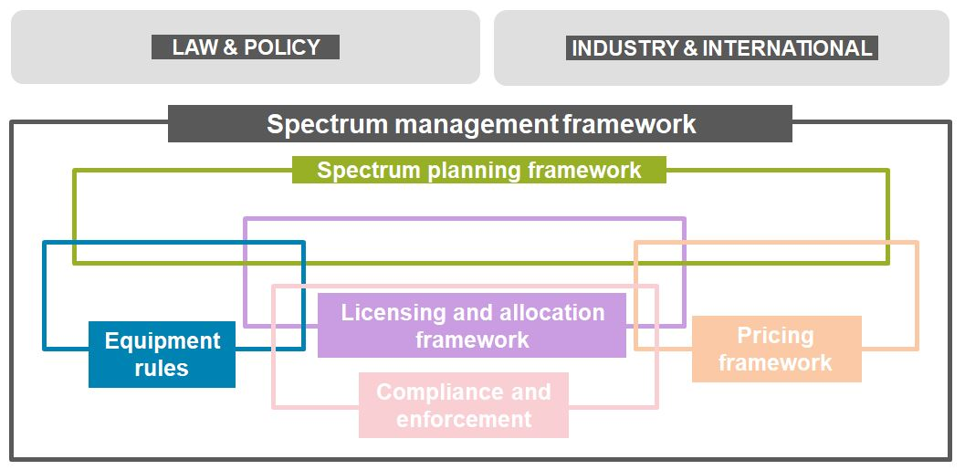

## Environmental context

* 1. Australian spectrum management, and hence spectrum planning, exists in a broader environment of constraints and influences. These includes domestic law and policy, industry developments and global technology developments, standardisation, equipment ecosystems, international treaties and spectrum harmonisation.

### Domestic law and policy

* 1. The spectrum management framework is governed by several pieces of primary legislation, including the:

*Radiocommunications Act 1992*

*Broadcasting Services Act 1992*

*Australian Communications and Media Authority Act 2005.*

* 1. Under Section 28B of the Radiocommunications Act, the minister may issue a ministerial policy statement (MPS). A MPS specifies a policy of the government that is to apply in relation to the performance of any of the ACMA’s spectrum management functions; or the exercise of any of the ACMA’s spectrum management powers.[7] The ACMA must consider any MPS in exercising its powers and performing its actions under the Radiocommunications Act.

### Industry and international

* 1. The Radiocommunications Act now requires, under section 28E, that once each financial year, the ACMA must determine a work program of not less than 5 financial years. This gives legislative recognition to the ACMA’s practice of publishing a [five-year spectrum outlook](https://www.acma.gov.au/five-year-spectrum-outlook) (FYSO) and a detailed annual work program.
  2. In the FYSO, the ACMA considers the drivers likely to shape spectrum demand and spectrum management requirements over the next 5 years. This informs the detailed work program the ACMA develops, in consultation with industry, for the financial year that can involve modification to existing elements or the creation of new elements within the spectrum planning framework.
  3. Australia is a member of the [International Telecommunication Union](https://www.itu.int/en/Pages/default.aspx) (ITU) and the [Asia-Pacific Telecommunity (APT)](https://www.apt.int/). Australia is also signatory to [Radio Regulations](https://www.itu.int/pub/R-REG-RR) of the ITU that influence the management of the spectrum in Australia.
  4. The [ITU Radiocommunication Sector](https://www.itu.int/en/ITU-R/Pages/default.aspx) (ITU-R) also develop [publications](https://www.itu.int/en/publications/ITU-R/Pages/default.aspx) such as reports and recommendations. While generally not binding, both provide guidance on technical measures relevant to the development of domestic planning frameworks and can become de facto ‘standards’ for some radiocommunications systems.
  5. Other international organisations such as the [International Civil Aviation Organization](https://www.icao.int/) (ICAO) and [the International Maritime Organisation](https://www.imo.org/) (IMO), also have direct and indirect (via relevant industries within member states) influences on domestic spectrum planning. In addition, international peer spectrum regulators (such as [Ofcom](https://www.ofcom.org.uk/) in the United Kingdom and the [Federal Communications Commission](https://www.fcc.gov/) (FCC) in the United States), and regional bodies (such as the [European Conference of Postal and Telecommunications Administrations](https://www.cept.org/cept/) (CEPT)) often consider similar issues to that faced in Australia and hence can be useful sources of information and learnings when considering approaches in Australia.
  6. As a part of international trade markets, Australia is influenced by industry technology specifications/standards, such as those developed by the [3GPP](https://www.3gpp.org/) and [IEEE](https://standards.ieee.org/), and developments in equipment markets. Where possible, implementing spectrum planning arrangements that can accommodate technologies developed for the global market is important to ensure Australians benefit from the associated economies of scale and roaming opportunities.
  7. Finally, domestic industry (government, commercial and non-commercial), individual organisations and peak bodies are key influences in informing domestic spectrum planning decisions. This is not only from the perspective of being the source for spectrum demand to deliver their services, but also as experts in the technologies used and services provided.

# Spectrum planning framework

## Introduction

* 1. The spectrum planning framework is expressed through a collection of legislative and administrative policy documentation that can be categorised as addressing:

**band planning** – establishes the general intended uses of spectrum space (geography and frequency range (band))

**frequency assignment** – defines the processes for identifying individual spectrum access arrangements for specific users

**licence conditions** – define the conditions of operation.

* 1. This categorisation has no formal basis and is used here solely to assist understanding. As a model, it is not perfect with some elements of the framework overlapping each other, for example.
  2. This model is illustrated in Figure 2 with each layer and element (document) discussed in greater detail under the framework and element sections below. Appendix A contains a full-page version of Figure 2. Appendix B provides similar information in a tabular form.

Spectrum planning framework

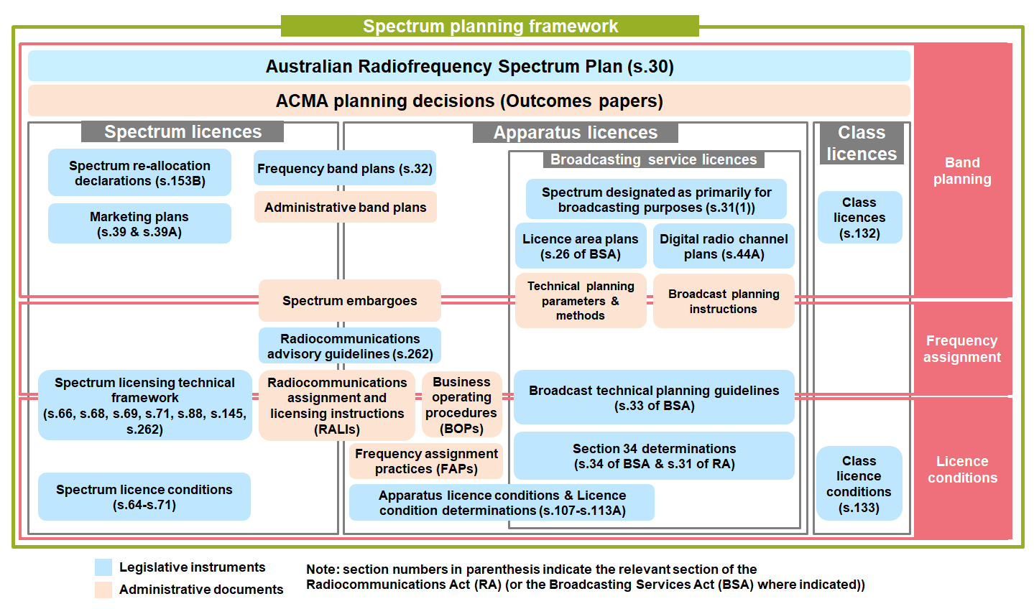

* 1. While many of the elements of the framework are applicable across all spectrum uses, some are unique to a particular service allocation or planning scenario. These are further discussed as case studies in the next chapter.

### Administrative policy documents versus legislative instruments

* 1. The spectrum planning framework comprises administrative policy documents and legislative instruments. In some cases, there is flexibility in whether an administrative policy or a legislative instrument is the preferred implementation path to achieve a desired outcome. However, in other cases, a legislative path is either not required or not available, hence necessitating the use of administrative policy tools.
  2. When there is discretion available to the ACMA, the choice between legislative or administrative approaches often comes down to balancing the flexibility afforded under administrative measures versus the predictability or certainty provided by a legislative instrument.[8] The ACMA makes decisions on the appropriate approach for a band and/or proposed use based on the merits of each approach in the context of the particular circumstances of the band/use. In some cases, a transition from administrative to legislative arrangements, or vice versa, over time can be used.
  3. For example, both administrative and legislative (frequency) band plans can have the same desired intent or outcome. However, policy included in an administrative document can be departed from by the ACMA (for example, by an out-of-policy exception), whereas a legislative instrument is legally binding. Therefore, legislative instruments, while providing certainty, can have the effect of restricting emerging technologies and use cases, which is a relevant factor in an environment of rapidly changing technologies and industry needs. On the other hand, the increased predictability of a legislative instrument (for example, a legislative frequency band plan) can, in some cases, provide increased confidence in future spectrum planning arrangements.
  4. Each request for an out-of-policy exception to an administrative policy is considered on its merits. Decisions, such as those made about a licence application, under administrative law are [reviewable](https://www.acma.gov.au/ask-us-review-our-decision-licence) and can ultimately be challenged in the Administrative Appeals Tribunal or Federal Court.
  5. In all cases, the ACMA adopts a best practice regulatory approach consistent with the Australian Government framework administered by the [Office of Impact Analysis](https://oia.pmc.gov.au/) (OIA). The OIA’s regulatory impact assessment process supports Australian Government decision-making by ensuring that the regulatory impacts – both positive and negative – of all regulatory changes are considered.

### Out-of-policy considerations

* 1. There are circumstances when it is appropriate for the ACMA to make decisions that support the object of the Radiocommunications Act in the absence of published policy, or which deviate from established policy. In practice, such out-of-policy decisions will most likely be about the decision whether to issue, vary or renew an apparatus licence, where such issue, variation or renewal would otherwise be inconsistent with an established policy.

In doing so, the ACMA considers a range of technical and non-technical factors and the principles of administrative decision-making, including conducting the necessary due diligence to understand the impact that operation of radiocommunications devices on an exceptional basis may have on other users of the spectrum and whether the issuing of the licence would be consistent with the object of the Radiocommunications Act.

In the context of the technical aspects of spectrum planning, ‘engineering best practice’ (sometimes referred to as ‘engineering judgement’) principles (see below) are used to inform consideration of the impact an out-of-policy exception would have on the interference environment and hence coexistence with other spectrum uses and users.

**What is ‘engineering best practice’?**

The design of the technical aspects of spectrum planning arrangements is founded in radiocommunications engineering theory. Judgements and decisions are informed by applying fundamental technical concepts of radiocommunications theory and accepted radiocommunications engineering practice, such as those articulated in ITU-R recommendations and reports. This occurs in the initial development of policy as well as during consideration of case-by-case exceptions to established policy.

For example, assignment instructions are developed by identifying typical technical parameters and, in some cases, designing service models to simplify the assignment process. This improves *procedural* efficiency and consistency, and avoids the need to coordinate every new assignment by resorting to the first principles of radiocommunications engineering theory.

Where codified assignment instructions are not in place, or where actual parameters vary significantly from those used to develop assignment instructions, practitioners seeking out-of-policy considerations are encouraged to use engineering best practice in making the case for the suitability of a potential spectrum use for a frequency band and area. Or, it may be that instructions are in place, but suitably qualified practitioners possess the knowledge and tools to make assignments that would not necessarily conform to generic service models but are otherwise practically feasible and/or may result in increased *spectral* efficiency consistent with the overall intent of the established policy.

Accordingly, this relies on an assumed level of professional competence and qualifications, and practitioners accept whatever risk may arise from making assignments outside the bounds of strict, codified guidance.

## Framework overview

### Band planning

* 1. The first layer of the spectrum planning framework identifies which spectrum uses are supported in each part of the spectrum– basically, what goes where. This varies between spectrum bands and can also vary within a band based on geography. This planning can also establish other important parameters of spectrum use, such as the:

level of exclusivity of the spectrum use(s) (that is, is more than one service and/or application envisaged?)

relationship and hierarchy between spectrum uses (if there is more than one use planned in a band). For example, the ‘primary, secondary’ construct[9]

mechanisms for sharing and coexistence between uses and users in the band, other geographies and adjacent bands. For example, whether spectrum users are coordinated on an assignment level

licensing construct adopted, such as class, apparatus (including what type) or spectrum licences.

* 1. Under the Australian spectrum planning framework, [the *Australian Radiofrequency Spectrum Plan 2021*](https://www.legislation.gov.au/Details/F2021L00617) (the Spectrum Plan) is a legislative instrument that provides the overarching plan for the use of the spectrum at a service level. Other tools are then used to provide more detailed arrangements as required; for example, in the form of legislative or administrative band plans specific to particular parts of the spectrum.
  2. For some parts of the spectrum, the Spectrum Plan provides only planning-level information. More detailed band planning or frequency assignment arrangements are developed as the need (such as expected demand for use of the spectrum) becomes proportionate to the resources involved in developing explicit arrangements.
  3. If the Spectrum Plan is the only planning guidance for a particular part of the spectrum, engineering best practice, among other considerations (see paragraph 3.12), is used when considering requests for spectrum use at a frequency-assignment level.
  4. The band planning layer also provides an important linkage into international spectrum management arrangements to support spectrum harmonisation of spectrum uses, and international coordination and coexistence between national systems.

### Frequency assignment

* 1. The frequency assignment layer defines how users are authorised to operate and ensures the most appropriate operating parameters (such as frequency, power, location) for the operation of a radiocommunication system are chosen. This considers existing assignments and the broader planning framework, as well as technical and non-technical aspects.
  2. Detailed planning arrangements are developed on an as-needs basis. For example, there are currently around 177,000 point-to-point assignments on the ACMA’s Register of Radiocommunications Licences.[10] However, there are only around 1,000 fixed-receive assignments.[11] Therefore, the proportional need for detailed planning arrangements for point-to-point assignments is arguably greater than for fixed-receive assignments.

### Licence conditions

* 1. The third layer of the spectrum planning framework comprises the conditions included in a radiocommunications licence. A person can only operate a radiocommunications transmitter if the transmitter is authorised under an apparatus, spectrum or class licence. Certain types of radiocommunications receivers included in a determination made under paragraph s.7(1)(b) of the Radiocommunications Act also require a licence.[12]
  2. For apparatus licences, conditions may be applied to licences of a particular type or category, as well as by case-specific details that apply to individual licences. In some cases, conditions give effect to the outcomes of preceding spectrum planning and frequency assignment rules. In the case of class licences, conditions give direct effect to planning decisions.
  3. This layer of the spectrum planning framework directly links with the licensing framework.

## Framework elements

|  |  |  |  |  |  |  |  |  |  |  |  |  |
| --- | --- | --- | --- | --- | --- | --- | --- | --- | --- | --- | --- | --- |
| * 1. Key to icons  |  |  |  |  | | --- | --- | --- | --- | |  | Band planning (legislative) |  | Band planning (administrative) | |  | Frequency assignment (legislative) |  | Frequency assignment (administrative) | |  | Licence conditions (legislative) |  | Licence conditions (administrative) | |

|  |  |
| --- | --- |
| Australian Radiofrequency Spectrum Plan |  |

* 1. The Spectrum Plan is a legislative instrument made under section 30 of the Radiocommunications Act and forms a key element of the band-planning layer by:

providing a basis for management of the radiofrequency spectrum in Australia

* informing and educating radiocommunication users and the public about the various types of services that can be operated in each frequency band

reflecting Australia's obligations as a member of the ITU.

* 1. The Spectrum Plan consists of 4 parts:

Part 1 is introductory and identifies, among other things, the commencement date of the Spectrum Plan, definitions, treatment of primary and secondary services, treatment of spectrum and class licences (there is no reference to apparatus licences), other circumstances for use of the spectrum, and how to interpret the Spectrum Plan.

* Part 2 contains the Table of Frequency Band Allocations. An extract is shown in Figure 3 for illustrative purposes. Column 2 (circled in blue) is the allocation made in the Spectrum Plan; column 1 (circled in red) is a replication of the Table of Frequency Allocations as contained in Article 5 of the ITU Radio Regulations and is only included for information.

Column 2 divides the radiofrequency spectrum into frequency bands, identifies the service allocations and their status. Additional and alternative allocations (from the Radio Regulations Region 3 identifications) are also shown. Footnotes can apply to an allocation in a frequency band or to the entire frequency band. These are either adopted from the Radio Regulations and listed in Part 4 (highlighted in green) or are Australian specific and listed in Part 3 (highlighted in yellow).

* Part 3 contains the references from Part 2 to Australian footnotes, where the operation of a service, or the use of the frequency band, is subject to the condition(s) or restriction(s) specified in that footnote.

Part 4 contains the references from Part 2 to the international footnotes, where the operation of a service, or the use of the frequency band, is subject to the condition(s) or restriction(s) specified in that footnote.

Extract of the Table of Frequency Band Allocation in the Spectrum Plan

* 1. In addition to service allocations in the Table of Frequency Band Allocations in Part 2, the footnotes in Part 2 – both Australian specific and from the Radio Regulations (Parts 3 and 4) – are critical aspects of the Spectrum Plan. These footnotes provide further important information on the status and relationships between spectrum uses in the Table of Frequency Band Allocations. It is often insufficient to simply consider the service allocations listed in the table to ascertain the intended use(s) for the specific band.
  2. The Spectrum Plan provides the basis for development of further regulation and policy to facilitate the use of the spectrum. The Spectrum Plan has an important relationship to apparatus licensing as, under most circumstances, the service of the licence applied for must be consistent with the Spectrum Plan.[13] However, the existence of a service allocation or footnote for applications does not automatically oblige the ACMA to issue a licence for this service or dictate how a licence would be allocated.
  3. Australian service allocations (Column 2 of Part 2), while broadly aligned with the allocations in the ITU Radio Regulations for Region 3, contain several variations to suit the Australian context. In accordance with No.**4.4** of the Radio Regulations, such variations are subject to the condition that the associated radio installations do not cause harmful interference to, or claim protection from, the radio services or communications of other countries that operate in accordance with the provisions of the Radio Regulations.

|  |  |
| --- | --- |
| ACMA planning decisions |  |

* 1. Following a review of arrangements in a band or for a spectrum use, the ACMA usually publishes an ‘outcomes’ paper. These papers contain statements of ACMA policy intent, including general policy decisions as well as preliminary views on how to implement these decisions. This is referred to in Figure 2 as ‘ACMA planning decisions (Outcomes papers)’.

|  |  |
| --- | --- |
| Frequency band plans |  |

* 1. Frequency band plans refine the specific uses that can operate in a frequency range, without being inconsistent with the Spectrum Plan. In doing so, they are part of the band-planning layer but provide a more detailed description of what the spectrum has been planned for than contained in the Spectrum Plan. However, they are made only as required for a particular band and do not cover the entire radiofrequency spectrum.
  2. The ACMA makes legislative and administrative band plans. The decision to utilise a legislative or administrative band plan depends on the intended objectives and the risks being managed. However, the preference of the ACMA in the past has often been to make use of administrative planning tools where practicable to ensure there is ongoing flexibility for licensees and to ensure the ACMA and industry are not constrained by the rigidity of legislative band plans.

|  |  |
| --- | --- |
| Legislative frequency band plans |  |

* 1. Legislative frequency band plans, made under section 32 of the Radiocommunications Act, articulate policies for the use of a band and can be used to aid replanning processes. A legislative frequency band plan may be used when implementing government policy or to provide further clarity about existing arrangements in a frequency band. As a legislative instrument, they offer certainty of the arrangements specified, but limit the flexibility of the ACMA and licensees. They are made on an as-needs basis and do not cover the entire radiofrequency spectrum.

|  |  |
| --- | --- |
| Administrative frequency band plans |  |

* 1. Administrative band plans are used to advise industry of ACMA policy on the use of the spectrum, to ensure consistency and promote harmonisation, to aid replanning processes (effecting transition to new arrangements resulting from those processes) and to provide further detail or structure of the use of a frequency band.
  2. Administrative band plans are policy documents, usually published as a Radiocommunications Assignment and Licensing Instruction (RALI).[14] They are intended to provide flexibility to licensees and the ACMA to adapt to changing planning scenarios as necessary, including by allowing policy exceptions in certain circumstances.

|  |  |
| --- | --- |
| Class licences |  |

* 1. Class licences (made under section 132 of the Radiocommunications Act) authorise access to the spectrum and are commonly used to manage uses that employ a limited set of common frequencies using equipment under a common set of conditions.
  2. Class licences generally authorise spectrum access on a no-interference/no-protection basis[15]; therefore, it is necessary to include technical conditions in a class licence to ensure that radiocommunications devices operated under a class licence can coexist among themselves and with apparatus and spectrum-licensed services. In particular, before issuing a class licence in spectrum-licenced space, the ACMA must be satisfied that operation of devices under the class licence would not cause unacceptable interference to devices operated under a spectrum licence (subsection 138(2) of the Radiocommunications Act).
  3. In some cases, other band planning arrangements can contribute to the coexistence of class-licensed devices and provide a degree of additional interference protection beyond that provided on face value by the ‘no interference, no protection’ condition. For example, in some bands where earth receive stations are permitted by class licensing, the ACMA may implement policy arrangements that would normally prevent the authorisation of terrestrial services in these bands that may cause interference to the class-licensed receivers.

|  |  |
| --- | --- |
| Ministerial designations of a band primarily for broadcasting purposes |  |

* 1. The minister is responsible for initiating the planning of broadcasting services by designating part of the spectrum as being primarily for broadcasting services under section 31 of the Radiocommunications Act. Before making the designations, the minister must consult with the ACMA. Decisions made under section 31 are otherwise not subject to statutory consultation requirements or merits review. A designation must not be inconsistent with the Spectrum Plan. After a designation has been made, the relevant spectrum is referred to the ACMA for planning under Part 3 of the BSA.

|  |  |
| --- | --- |
| Spectrum embargoes |  |

* 1. [Spectrum embargoes](https://www.acma.gov.au/spectrum-embargoes) are policy statements by the ACMA outlining the circumstances where it is likely to refuse to issue an apparatus licence in parts of the spectrum. The primary purpose of an embargo is to ensure that the status of a frequency band remains stable for the duration of a planning process. Spectrum embargoes are published as [RALI MS03](https://www.acma.gov.au/publications/2019-10/rules/rali-ms03).
  2. Over time however, embargoes have also been used to provide long-term policy guidance on the use of a frequency band if a legislative frequency band plan is too rigid. In this way, they achieve the same effect as administrative band plans.
  3. In general, embargoes are intended to be temporary, with effect generally spanning the period before and during a replanning exercise. They can be useful when used in conjunction with RALIs and/or administrative band plans to transition between old and new arrangements resulting from a replanning exercise.

In practice, embargoes are applicable to the licensing process. The publication of an embargo improves the transparency of ACMA’s decision-making processes. Applying an embargo to an application for an apparatus licence, resulting in refusal to issue an apparatus licence, is a reviewable decision. However, exceptions to the embargo are permitted via the out-of-policy consideration process.

|  |  |
| --- | --- |
| Spectrum re-allocation declaration for spectrum licensed bands |  |

* 1. Part 3.6 of the Radiocommunications Act details the provisions regarding re-allocation of spectrum. Section 153B allows the ACMA to make a declaration that one or more specified parts of the spectrum are subject to re-allocation. This is called a spectrum re-allocation declaration. This element of the spectrum planning framework is further discussed in the spectrum licensing case study (see paragraphs 4.7–4.10).

|  |  |
| --- | --- |
| Radiocommunications advisory guidelines (RAGs) |  |

RAGs made under section 262 of the Radiocommunications Act may address any aspect of radiocommunication or radio emission. As a spectrum planning tool, RAGs have been used to assist managing potential harmful interference to and from spectrum licences into adjacent apparatus licence space. More generally, RAGs cover a broad range of issues including, but not limited to use, performance, frequency assignment and coordination.

|  |  |
| --- | --- |
| Radiocommunications assignment and licensing instructions (RALIs) |  |

[RALIs](https://www.acma.gov.au/ralis-frequency-coordination)were originally produced to assist with consistent interpretation and application of the Radiocommunications Act by ACMA and its predecessors. Over time, RALIs have also been used to instruct not only staff, but also licensees, accredited persons and the public about assignment and licensing technical conditions.

In submitting a frequency assignment certificate to the ACMA, an accredited person is certifying that the proposed assignment is consistent with applicable RALIs or, if not, the assignment will not have adverse effects on radiocommunications services. In this context, RALIs that set out a prescriptive coordination procedure (noting that RALIs may serve a range of purposes) generally reflect an approach to frequency assignment using typical systems parameters and generalised planning models. RALIs typically provide assigners the flexibility to apply engineering best practice principles to take into account specific characteristics of the proposed assignment to make more spectrally-efficient assignments that are consistent with the planning intent.

Each RALI has a stated purpose – many provide instructions or procedures on how to complete certain coordination and assignment activities within a specific service (such as the land mobile or fixed services) or between services (such as satellite and fixed services).[16] Other RALIs provide general information, a policy base or advice such as spectrum embargoes. RALIs come into effect when approved by an authorised ACMA delegate and published on the ACMA website.

From a coordination and frequency assignment perspective, the ACMA prepares RALIs to ensure sharing and coordination between uses and users of the spectrum. RALIs in this context may address:

*channel plans* – a predefined set of (usually) paired frequencies and associated channels that licensees choose from to deploy a system.[17] Typically, channel plans have been used in the fixed and land mobile services where a particular frequency re-use distance between radiocommunications transmitters on the same frequency/channel is required to ensure interference is managed.

* *protection criteria* – are power limits, typically at a receiver (or antenna) that cannot be exceeded by potential interferers when undertaking coordination. Protection criteria are designed to contribute to a level of performance for the systems intended to be used in the band.
* *propagation criteria* – radio emissions are attenuated by a range of phenomena between transmitters and receivers. In determining whether interference will be caused to a receiver, it is necessary to define propagation criteria (or a methodology) to calculate that potential for interference.

*deployment constraints* – are restrictions on the deployment characteristics of transmitters and receivers to limit the potential to cause interference or be subject to interference. For example, transmitter powers, emissions masks and tower heights may be used.

Technical and operational characteristics, as well as licence conditions and advisory notes, may be specified in a RALI for consideration by accredited persons and licensees when submitting applications. This includes, but is not limited to, information about the frequencies, location (coordinates, area and height), transmission (bandwidth, power, modulation and coding) and antennas of radiocommunications devices.

|  |  |
| --- | --- |
| Business operating procedures (BOPs) |  |

* 1. [BOPs](https://www.acma.gov.au/business-operating-procedures-spectrum) are used to record the business policy, procedures and processes used by the ACMA. BOPs are relevant to the frequency assignment work of accredited persons. Particularly for BOPs related to space-based communications, these documents outline conditions for inclusion on apparatus licences. BOPs are also used to clarify requirements for data formatting used in the [Register of Radiocommunications Licences](https://web.acma.gov.au/rrl/), site data requirements for inclusion in the Register and procedures for submitting embargo exemption requests.

|  |  |
| --- | --- |
| Frequency assignment practices (FAPs) |  |

* 1. [FAPs](https://www.acma.gov.au/frequency-assignment-practices) support the frequency assignment policy contained in RALIs. They provide background information on an issue, explain relevant interference and/or spectrum considerations and detail a policy position for the assignment and licensing of affected radiocommunications services.

|  |  |
| --- | --- |
| Licence conditions |  |

Licence conditions apply to the operation of a radiocommunications transmitter or radiocommunications receiver operated under a licence. Conditions may also reflect different aspects of the spectrum planning framework.

Licence conditions capture the parameters of operation determined at the frequency assignment layer, such as frequency, power, location and height. These feedback into the frequency assignment layer so other users can implement the rules for coordination and assignment determined there.

For class licences, licence conditions describe the relevant spectrum planning framework, including for coexistence between spectrum uses and users.[18]

In some circumstances, licence conditions may ‘invoke’ other aspects of the spectrum planning framework. For example, spectrum licence conditions can require compliance with or otherwise refer to RALIs.

In the case of spectrum licences, section 66 of the Radiocommunications Act sets out the core conditions of the licence. These are the mandatory technical requirements that determine the overall technology flexibility of the licence. This is further discussed in the spectrum licence case study in the next chapter.

# Case studies

* 1. The following case studies illustrate how the spectrum planning framework operates and interacts with other parts of the spectrum management framework. Several elements of the spectrum planning framework are applicable across all services and spectrum planning scenarios. However, the case studies below highlight elements that are specific to a particular service (for example, broadcasting services) or spectrum planning scenario (such as spectrum licensing).
  2. These case studies are illustrative only. It is incumbent on prospective licensees and spectrum users to obtain an independent understanding of the technical and legal aspects of their intended spectrum use.

## Spectrum licensing

* 1. Spectrum licences authorise access to a parcel of spectrum space (that is, frequency and geography). Licensees can operate radiocommunications devices at any site within their spectrum space, providing the operation of the device complies with the conditions of their licence and other applicable aspects of the spectrum licence technical framework for that band.
  2. The spectrum planning framework that underpins spectrum licences is a combination of elements unique to the spectrum licensing regime and the more generic elements discussed in Chapter 3. Figure 4 illustrates the elements of the spectrum planning framework applicable to spectrum-licensed services.

Spectrum planning framework for spectrum-licensed services

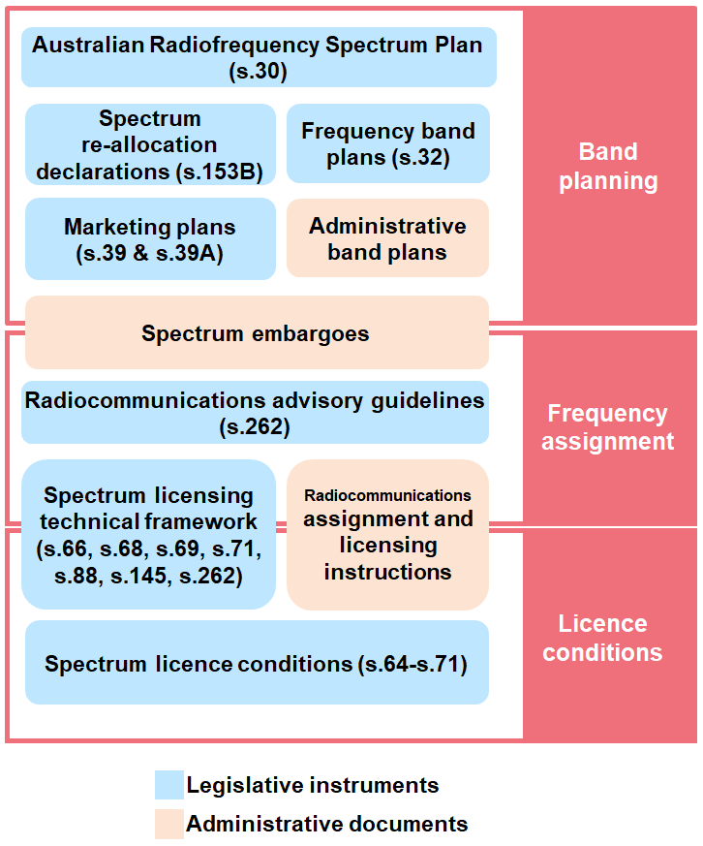

|  |  |
| --- | --- |
| Australian Radiofrequency Spectrum Plan |  |

* 1. Section 7 of the Spectrum Plan[19] contains specific provisions relating to spectrum licences. It states that a service operating under a spectrum licence is taken to be a primary service unless the spectrum licence specifies it as a secondary service.
  2. Section 9 of the Spectrum Plan allows a frequency band to be used for a service for which that band is not allocated in the Spectrum Plan, if the service is operated in accordance with a spectrum licence. This facilitates technology flexibility. For example, fixed services could be deployed in a spectrum-licensed space where there is no fixed service allocation, provided the conditions of the spectrum licence and other relevant aspects of the technical framework, are adhered to.

|  |  |
| --- | --- |
| Spectrum re-allocation declarations |  |

* 1. Part 3.6 of the Radiocommunications Act details the provisions regarding re-allocation of spectrum. Section 153B allows the ACMA to make a declaration that one or more specified parts of the spectrum are subject to re-allocation. This is called a spectrum re-allocation declaration.
  2. The initial spectrum planning decision to re-allocate spectrum space for the issue of spectrum licences (or even for the issue of apparatus licences) is an administrative spectrum planning decision based on a range of factors. Once a policy decision is made to pursue re-allocation of a particular part of the spectrum, the development of a spectrum re-allocation declaration signals the first legislative step in the issuing of spectrum licences.
  3. Key components of a spectrum re-allocation declaration are:
     1. Definition of the areas and frequencies subject to re-allocation (the spectrum space), including whether this is by issuing of spectrum or apparatus licences.
     2. The re-allocation period: the period of time that incumbent apparatus licences can continue operating before they are cancelled. This period must be at least 12 months.
     3. The re-allocation deadline: this must be no later than the end of the re-allocation period. If no licences are issued before this deadline, the spectrum re-allocation declaration is automatically revoked.
  4. A spectrum re-allocation declaration is only required if there are incumbent apparatus-licensed services within the spectrum space of interest. If there are none, this step is not required, and the ACMA can consult directly on the preparation of a marketing plan (see below).

|  |  |
| --- | --- |
| Marketing plans |  |

* 1. Part 2.2 of Chapter 2 of the Radiocommunications Act permits the ACMA to prepare marketing plans for the allocation of spectrum licences. This can be done for encumbered spectrum following the making of a spectrum re-allocation declaration. However, for unencumbered spectrum, the ACMA may make a marketing plan without making a spectrum re-allocation declaration.
  2. While Chapter 2 of the Radiocommunications Act is focused on radiofrequency planning, the practical effect of the provisions under Part 2.2 of Chapter 2 of the Radiocommunications Act relate to the licensing arrangements for access to spectrum; that is, whether access to spectrum is by apparatus or spectrum licensing.
  3. A marketing plan is a legislative instrument that defines the licensing product being allocated and the process that will be used for allocation. The product includes frequency and area lots, renewal statements (section 65A of the Radiocommunications Act) and the conditions (that is, the technical framework) that apply for the operation of radiocommunications devices under the spectrum licence.
  4. The marketing plan includes a sample spectrum licence, which sets out the proposed conditions intended to achieve coexistence with other spectrum uses and users, including those operating in other parts of the radiofrequency spectrum.[20]
  5. The marketing plan also describes statutory licence conditions and rules applying to spectrum licences, including those relating to spectrum trading, use by third parties[21], and registration of radiocommunications transmitters with the ACMA.[22] Statutory conditions are required to be applied to all spectrum licences under sections 67–69A of the Radiocommunications Act.
  6. Section 71 of the Radiocommunications Act provides that the ACMA may apply other conditions to spectrum licences. For example, the ACMA may include additional conditions to manage coexistence for a specific scenario.

|  |  |
| --- | --- |
| Frequency band plans |  |

* 1. Frequency band plans[23], legislative or administrative, can also be included as part of the spectrum planning framework for spectrum licences. For example, [RALI MS40](https://www.acma.gov.au/publications/2019-11/rules/rali-ms-40-800-mhz-band-plan) is an administrative band plan outlining arrangements in the 803–890 MHz band, including spectrum licences in the 825–845 MHz band, paired with the 870–890 MHz band. A band plan can be used to signal the intent to spectrum licence a band in the future before other legislative arrangements (for example, a re-allocation declaration) come into force.
  2. Any restrictions in an administrative band plan will only apply to a spectrum licence if it is incorporated by reference as a condition of the licence.

|  |  |
| --- | --- |
| Spectrum embargoes |  |

* 1. Spectrum embargoes[24] are typically used during a band review to stabilise the licensing environment in the frequency band while the review takes place. That is, the embargo restricts the issue of new apparatus licences in a band that is being considered for re-allocation or replanning in the short term. To that end, a spectrum embargo normally precedes the development of a spectrum re-allocation declaration in the spectrum licence development process and can be interchangeable with or complementary to a band plan in the longer term.

|  |  |
| --- | --- |
| Spectrum licence technical framework |  |

* 1. The spectrum licence technical framework is the collection of technical regulatory requirements that apply to the use of radiocommunications devices within spectrum-licensed bands. The Radiocommunications Act specifies the mandatory and optional statutory requirements for a spectrum licence technical framework. As well as the licence conditions discussed in paragraphs 4.34–4.36, the ACMA may make the following:
* written determinations under subsection 145(4) of the Radiocommunications Act setting out what is an unacceptable level of interference

advisory guidelines under section 262 of the Radiocommunications Act for any aspect of radiocommunication or radio emissions (discussed in paragraphs 4.27–4.31).

|  |  |
| --- | --- |
| Section 145 determination – Unacceptable levels of interference |  |

Although the core conditions form the basis of a spectrum licence and provide mechanisms for interference management, they are not normally sufficient. Further conditions or constraints (at the frequency assignment layer) are imposed on radiocommunications devices operating under spectrum licences. Some of these are implemented via conditions in the licences; for example, a requirement to synchronise the operation of services in certain situations, protect the radio quiet zone (RQZ) or protect incumbent services affected by a spectrum re-allocation declaration.

Another key mechanism for managing interference is the registration requirement in each spectrum licence for radiocommunications transmitters. Spectrum licensees are required to register a radiocommunications transmitter in the [Register of Radiocommunications Licences](https://web.acma.gov.au/rrl/) before the transmitter may be operated (unless the transmitter is of a kind exempt from registration). Transmitters exempt from registration are defined in the spectrum licence.

* 1. Subsection 145(1) of the Radiocommunications Act allows the ACMA to refuse to register a radiocommunications transmitter if it is satisfied the operation of the transmitter could cause an unacceptable level of interference to the operation of other radiocommunications devices. The ACMA makes determinations under subsection 145(4) of the Radiocommunications Act (a ‘section 145 determination’) that set out the unacceptable levels of interference for each spectrum-licensed band. The primary method for registering transmitters is to certify that a proposed transmitter meets the requirements of the section 145 determination.
  2. These determinations set out the circumstances in which radiocommunications transmitters cause unacceptable levels of interference, which generally include:
* if any part of the ‘device boundary’ falls outside the licensed geographical area of the spectrum licence (the section 145 determination sets out how to calculate the device boundary for any transmitter) or cannot be calculated
* if the operation of the transmitter will cause a breach of a core condition of the spectrum licence

if the deployment of the transmitter is outside any deployment constraints set in the section 145 determination.

* 1. The ACMA typically uses the section 145 determination to manage co-channel (adjacent area) coexistence. Although a proposed radiocommunications transmitter may comply with all conditions of its spectrum licence, there is still a risk of co-channel interference to radiocommunications receivers in adjacent areas, especially if the transmitter is high-powered and/or located near its area boundary. So, before a transmitter can be registered (except for registration exempt transmitters), they are assessed against the applicable section 145 determination.[25]
  2. In some bands, the section 145 determination is also used to manage co-channel interference into spectrum-licensed areas from area-adjacent apparatus-licensed radiocommunications transmitters.

|  |  |
| --- | --- |
| Radiocommunications advisory guidelines (RAGs) |  |

* 1. RAGs made under section 262 of the Radiocommunications Act may address any aspect of radiocommunication or radio emission. In the context of spectrum licensing, RAGs form part of the spectrum licence technical framework.
  2. Generally, RAGs include provisions to help assess possible interference between radiocommunications devices operated under spectrum licences and services operating under spectrum, apparatus or class licences. Potentially affected services are identified in the RAGs to enable licensees to assess and manage the risk of interference with these services. RAGs may also establish the amount of protection that will be afforded to radiocommunications receivers operated under spectrum licences (in the form of the notional level of receiver performance).
  3. If interference arises between a spectrum-licensed service and another service, the conditions in each of the licences may provide a path to resolution. If there is a dispute on how to resolve interference, the ACMA will consider any conditions of the licence as well as the provisions of the RAGs in resolving the matter. Some RAG provisions may also be incorporated by reference as a licence condition, and hence, would be mandatory for the licensee to meet.
  4. Typically, 2 RAGs are developed for each spectrum-licensed band:
* a RAG for managing interference from radiocommunications transmitters operated under a spectrum licence to provide guidance on the protection of apparatus and class licensed radiocommunications receivers

a RAG for managing interference to radiocommunications receivers operated under a spectrum licence to primarily provide guidance on the management of out-of-band interference to those receivers.

* 1. RAGs are typically used to manage coexistence scenarios that are not fully managed by the licence conditions and section 145 determination; for example, frequency-adjacent services. Although not always mandatory, it is expected that RAGs are considered before the registration (or at the very least operation) of a radiocommunications device under a spectrum licence, or as part of the frequency assignment process for apparatus-licensed radiocommunications devices.

|  |  |
| --- | --- |
| Radiocommunications assignment and licensing instructions (RALIs) |  |

* 1. RALIs can be used as part of the spectrum planning framework for spectrum licences to outline arrangements for adjacent band or adjacent-area apparatus licences to coordinate with spectrum-licensed space. If used, they are normally referenced from a RAG.
  2. [RALI SM26](https://www.acma.gov.au/publications/2021-05/instruction/rali-sm26-restrictions-apparatus-licensing-spectrum-licensed-spaces) was developed in 2021 to provide a consolidated reference of all areas and frequencies that are subject to spectrum licensing and support the re-allocation declarations that restrict apparatus licensing in areas and frequencies subject to spectrum licensing.

|  |  |
| --- | --- |
| Spectrum licence conditions |  |

* 1. The Radiocommunications Act requires that a number of conditions be specified in a spectrum licence (known as statutory conditions), including a number of conditions relevant to the spectrum planning framework. These include (but are not limited to):

*Core conditions –* A spectrum licence must include 4 specific conditions as required under section 66 of the Radiocommunications Act. These conditions are used to define the spectrum space of the licence and the frequencies, geographic areas and the maximum permitted level of radio emission both in-band and out-of-band.

*Conditions about registration of radiocommunications transmitters –* Under section 69 of the Radiocommunications Act, radiocommunications transmitters must not be operated under a spectrum licence unless the requirements of Part 3.5 of the Radiocommunications Act relating to registration of the transmitter have been met (unless exempt from registration).

*Other conditions –* Section 71 of the Radiocommunications Act permits the ACMA to include other conditions in a spectrum licence as it thinks fit. The other conditions of the licence may include planning and technical requirements that may limit operations to manage interference into other radiocommunications or limit the services to be operated under the spectrum licence. For example, in implementing spectrum planning arrangements in the 2.5 GHz mid-band gap (2570*–*2620 MHz), the operation of radiocommunications devices in this band was limited to the television outside broadcast service.

* 1. Separate to the spectrum planning framework, provisions that set out conditions for third-party use (section 68 of the Radiocommunications Act) also permit a spectrum licensee to authorise other persons to operate radiocommunications devices under the spectrum licence. The operation of devices by a third party must be in accordance with the conditions in the spectrum licence and any other rules made by the ACMA for third-party operations.
  2. Any conditions of a spectrum licence can be revoked or varied, and further conditions included, with or without agreement of the licensee (sections 72 and 73 of the Radiocommunications Act). However, core conditions cannot be revoked or varied without agreement of the licensee (section 72 of the Radiocommunications Act).

## Broadcasting services

* 1. Spectrum planning for broadcasting services has several unique elements. This case study is not broadly applicable across the spectrum planning framework. Figure 5 illustrates the elements of the spectrum planning framework applicable to broadcasting services.

Spectrum planning framework for broadcasting services

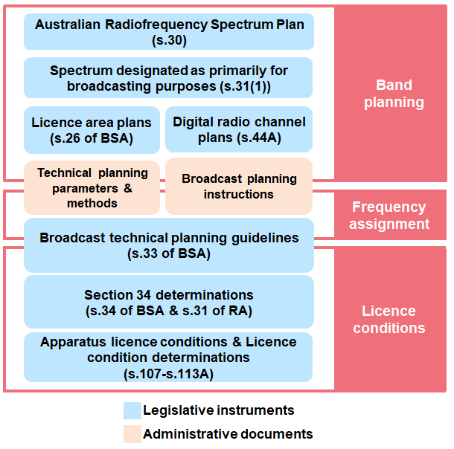

* 1. The part(s) of the spectrum designated by the minister under section 31 of the Radiocommunications Act is known as the ‘broadcasting services bands’ under the BSA. The minister may, by legislative instrument, notify the ACMA that capacity in the broadcasting services bands is to be reserved for a specified number of national and community broadcasting services. This is an element of the band planning layer unique to broadcasting services.
  2. With effect from 1 January 2015[26], the broadcasting services bands are:

526.5–1 606.5 kHz

45–52 MHz and 56–70 MHz (Band I)

85–108 MHz (Band II)

137–144 MHz (channel 5A)

174–230 MHz (Band III)

520–694 MHz (Bands IV and V).

* 1. As well as being designated as being primarily for broadcasting purposes under section 31 of the Radiocommunications Act, these bands have primary allocations to the broadcasting service in the Spectrum Plan.
  2. Radiocommunication licences issued to a broadcasting service authorise use in bands allocated as the broadcasting services bands and in accordance with the Broadcasting Services (Technical Planning) Guidelines 2017 (see paragraphs 4.47 to 4.48).

|  |  |
| --- | --- |
| Digital radio channel plans (DRCPs) |  |

* 1. Another element of the band planning layer for broadcasting services is digital radio channel plans. While most aspects relating to planning of the broadcasting services bands are governed by section 3 of the BSA, provisions to develop DRCPs form part of the Radiocommunications Act. The purpose of a digital radio channel plan is to allot frequency channel(s) for use by digital radio multiplex transmitter licensees.
  2. Before the ACMA issues a digital radio multiplex transmitter licence for a designated BSA radio area[27], the ACMA must prepare a digital radio channel plan in accordance with subsection 44A(1) of the Radiocommunications Act.
  3. The digital radio channel plan must be consistent with the Spectrum Plan, any relevant frequency band plans and any relevant licence area plans prepared under section 26 of the BSA.

|  |  |
| --- | --- |
| Licence area plans (LAPs) |  |

* 1. LAPs form part of the band planning layer for broadcasting services. Planning of free-to-air broadcasting, in the broadcasting services bands, for individual licence areas in Australia is prescribed in a LAP made under subsection 26(1) of the BSA.
  2. After consultation with affected stakeholders, the ACMA makes a LAP for one or more licence areas that is applicable to all AM and FM radio services or all VHF and UHF television services. Each LAP contains the technical characteristics of the licence area, as well as referencing theBroadcasting Services (Technical Planning) Guidelines 2017 (see paragraphs 4.51–4.53), that together form the non-negotiable envelope that broadcasting licensees must operate within.

|  |  |
| --- | --- |
| Technical planning parameters and methods for terrestrial broadcasting (TPPMs) |  |

[TPPMs](https://www.acma.gov.au/publications/2004-04/guide/technical-planning-parameters-and-methods-terrestrial-broadcasting-tpps) are elements of the spectrum planning framework for broadcasting services and have both band planning and frequency assignment functions.

* 1. TPPMs are a collection of planning practices and methods that are used to assist broadcasters, planning consultants and operators in the design of transmitting facilities or the preparation of planning submissions to the ACMA. They are based on ITU-R recommendations and reports, as well as planning practices developed internationally including in the US, Europe and the UK.

|  |  |
| --- | --- |
| Broadcast planning instructions (BPIs) |  |

* 1. BPIs straddle both the band planning and frequency assignment aspects of the spectrum planning framework for broadcasting services.
  2. BPIs are used to clarify existing, new or amended planning practices for broadcasting services. Presently, there are [11 BPIs](https://www.acma.gov.au/broadcast-planning-resources) that address a range of matters, including the Geocentric Datum of Australia (GDA), specifying antenna radiation patterns for inclusion in the [Register of Radiocommunications Licences](https://web.acma.gov.au/rrl/), antenna directivity and cross polarisation discrimination.

|  |  |
| --- | --- |
| Technical planning guidelines (TPGs) |  |

* 1. TPGs are published as the [Broadcasting Services (Technical Planning) Guidelines 2017](https://www.legislation.gov.au/Series/F2017L01290), and are made under section 33 of the BSA. TPGs are a legislative instrument and has both frequency assignment and licence condition functions.
  2. TPGs set out technical and other requirements to be applied by commercial, community (including temporary community) and datacasting licensees, when planning and operating new transmission facilities or proposing changes to existing facilities.
  3. The technical requirements specified in TPGs deal with establishing transmission facilities, site tolerances, minimum and maximum radiated power, maximum permitted field strength, interference to other services and radiated signal characteristics.

|  |  |
| --- | --- |
| Section 34 determination |  |

* 1. The ACMA authorises alternative uses (such as for the temporary transmission or the re‑transmission of programs, or for temporary community broadcasting licensees, for example) in bands identified in the broadcasting services bands (BSB) by making a determination under section 34 of the BSA and then issuing apparatus licences to authorise radiocommunications transmitters under section 100 of the Radiocommunications Act. Alternatively, the ACMA can make a determination under section 31 of the Radiocommunications Act.
  2. Operation in BSB bands is also permitted under a class licence (for example, through the Radiocommunications (Low Interference Potential Devices) Class Licence 2015) issued under the Radiocommunications Act and is not affected by any determination issued under section 34 of the BSA or section 31 of the Radiocommunications Act.

## Space-based communications systems

* 1. Like all radiocommunications services, the spectrum planning framework for space-based communications systems is developed in accordance with the Australian regulatory and spectrum environment. However, the international nature of space-based communications systems means that there are various international requirements to be considered, which may have a greater day-to-day impact than for many other spectrum uses.[28]
  2. This international dimension is a result of the inherent cross-border nature of spectrum use by space-based systems, which is in contrast to most other spectrum use in Australia due to our relative geographic isolation (a key exception being use of HF spectrum). The ITU satellite filing and coordination process (as contained in the ITU Radio Regulations) is therefore a key mechanism that the ACMA looks towards when determining the impact that issuing a domestic radiocommunications licence would have on other uses of the spectrum.
  3. Figure 6 illustrates the elements of the spectrum planning framework applicable to space-based communications systems.

Spectrum planning framework for space-based communications systems

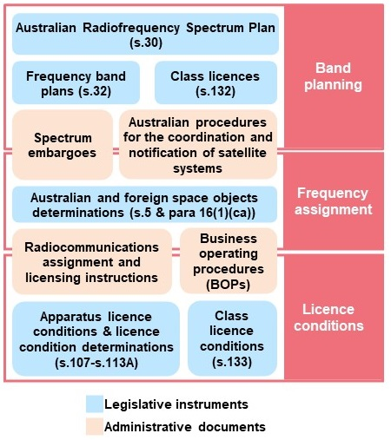

|  |  |
| --- | --- |
| Australian Radiofrequency Spectrum Plan |  |

* 1. The use of the spectrum by satellite and space services is facilitated by an appropriate allocation in the Spectrum Plan[29] in the first instance. There are several different satellite and space services with allocations in the Spectrum Plan and also a large number of both international and Australian footnotes to the Spectrum Plan that outline further details on these allocations. Importantly, in some cases, the allocations are limited to either the earth-to-space or space-to-earth direction.[30]

|  |  |
| --- | --- |
| Frequency band plans |  |

* 1. Frequency band plans[31], legislative or administrative, can also be included as part of planning arrangements for satellite and space services. An example is the [Radiocommunications (Australian Radio Quiet Zone Western Australia) Frequency Band Plan 2023](https://www.legislation.gov.au/Series/F2023L00286), which establishes a radio quiet zone (RQZ) in the mid-west region of Western Australia.

|  |  |
| --- | --- |
| Class licences |  |

* 1. Class licences[32] are used to authorise a class of radiocommunications devices in a particular frequency range where individual licensing is not required. The [Radiocommunications (Communication with Space Object) Class Licence 2015](https://www.legislation.gov.au/Series/F2015L01486) (the space object class licence) is used in satellite and space spectrum planning for ‘space segment licensing’. This supports the licensing of ubiquitous earth stations[33], often in ‘satellite-only’ bands[34] where there is an apparatus licence for the space object with which the earth stations are communicating. Transmissions from and/or to space stations are authorised via space and/or space receive licences.
  2. Provided a space and/or space receive licence is issued in bands identified in the space object class licence, and the space object is listed in the relevant determination[35], earth stations communicating with the space station are authorised by the space object class licence. This approach removes the requirement for the individual licensing of these earth stations.
  3. Class licensing is also used to authorise the operation of radionavigation-satellite service (RNSS) receivers, thus facilitating the use of the Global Positioning System (GPS) and other global navigation systems by the Australian community.[36]

|  |  |
| --- | --- |
| Spectrum embargoes |  |

* 1. Spectrum embargoes[37] play an important role in satellite and space spectrum planning. They are used to preserve a frequency band for a period so that it remains stable for the duration of a planning process.
  2. There are also a number of embargoes that act as quasi-administrative band plans by articulating a policy decision of the ACMA for a particular band or geographical area to be used for space or satellite services. For example, [Embargo 49](https://www.acma.gov.au/publications/2019-10/rules/embargo-49) supports the development of space communications facilities in the general area of Mingenew, Western Australia.

|  |  |
| --- | --- |
| Australian procedures for the coordination and notification of satellite systems |  |

* 1. The [*Australian procedures for the coordination and notification of satellite systems*](https://www.acma.gov.au/publications/2012-01/guide/australian-procedures-coordination-notification-satellite-systems) provides transparency about the procedures for the satellite industry to follow, from the initial assessment of a proposed satellite system to the eventual cessation of the satellite system. The document sets out the procedures that the ACMA anticipates would normally be followed in Australia in relation to ITU satellite system filing and coordination.

|  |  |
| --- | --- |
| Space object determinations |  |

* 1. Space object determinations bring particular space objects within the scope of the Radiocommunications Act. Australian space objects are determined by a legislative instrument made under section 5 of the Radiocommunications Act.*[38]* Foreign space objects are determined by a legislative instrument made under paragraph 16(1)(ca) of the Radiocommunications Act.[39]
  2. In deciding to make a space objects determination, the objective is to regulate Australian space objects or foreign space objects to the extent necessary to licence communications to and from Australia. Extending the application of the Radiocommunications Act allows satellite operators to apply to the ACMA for space and/or space receive apparatus licences for the space objects listed in the relevant determinations.

|  |  |
| --- | --- |
| Radiocommunications assignment and licensing instructions (RALIs) |  |

* 1. RALIs[40] are used in satellite and space spectrum planning to provide assignment and coordination advice for those seeking to obtain an apparatus licence. This includes RALIs that provide criteria for the coordination of services generally, such as [RALI MS45](https://www.acma.gov.au/publications/2019-08/instruction/frequency-coordination-requirements-between-microwave-fixed-point-point-links-and-fss-earth-stations) on frequency coordination requirements between microwave fixed point-to-point links and FSS earth stations, and also those that provide specific information for particular areas or facilities, such as [RALI MS43](https://www.acma.gov.au/publications/2019-09/instruction/rali-ms43-new-norcia-earth-station-and-other-services) on coordination procedures between New Norcia earth stations and other services.

|  |  |
| --- | --- |
| Business operating procedures (BOPs) |  |

* 1. [BOPs](https://www.acma.gov.au/business-operating-procedures-spectrum)[41] are used relatively extensively for satellite and space spectrum planning. This reflects the additional complication arising from the intertwining of the domestic and international spectrum management processes that occur in satellite and space spectrum planning. There are a number of BOPs covering procedures for space and space-receive licensing, procedures and restrictions for earth and earth-receive licensing, and registering earth stations.

# Appendix A: Spectrum planning framework



# Appendix B: Framework elements

| **Element** | **Acronym or shorthand** | **Legislative or administrative policy** | **Applicable planning layer** | | | **Paragraphs** |
| --- | --- | --- | --- | --- | --- | --- |
| **Band planning** | **Frequency assignment** | **Licence conditions** |
| Australian Radiofrequency Spectrum Plan | ARSP  Spectrum Plan | Legislative (s. 30) | Checkmark with solid fill |  |  | 3.24–3.28  Spectrum licensing: 4.5–4.6  Space-based: 4.59 |
| ACMA planning decisions | Outcomes paper | Administrative policy | Checkmark with solid fill |  |  | 3.29 |
| Frequency band plans |  | Legislative (s. 32) | Checkmark with solid fill |  |  | 3.30–3.32  Spectrum licensing: 4.17–4.18  Space-based: 4.60 |
| Administrative band plans |  | Administrative policy | Checkmark with solid fill |  |  | 3.30, 3.31, 3.33 and 3.34  Spectrum licensing: 4.17–4.18  Space-based: 4.60 |
| Class licences |  | Legislative (s.132) | Checkmark with solid fill |  |  | 3.35–3.37  Space-based: 4.61–4.63 |
| Ministerial designations of bands primarily for broadcasting purposes | BSB band designation | Legislative (s.31) | Checkmark with solid fill |  |  | 3.38 |
| Spectrum re-allocation declarations |  | Legislative (s. 153B) | Checkmark with solid fill |  |  | 3.43  Spectrum licensing: 4.7–4.10 |
| Marketing plans |  | Legislative | Checkmark with solid fill |  |  | Spectrum licensing: 4.11–4.16 |
| Digital radio channel plans | DRCP | Legislative (s. 44A) | Checkmark with solid fill |  |  | Broadcasting: 4.42–4.44 |
| Licence area plans | LAP | Legislative (s. 26 of the BSA) | Checkmark with solid fill |  |  | Broadcasting: 4.45–4.46 |
| Spectrum embargoes |  | Administrative policy | Checkmark with solid fill | Checkmark with solid fill |  | 3.39–3.42  Spectrum licensing: 4.19  Space-based: 4.64–4.65 |
| Australian procedures for the coordination and notification of satellite systems |  | Administrative policy | Checkmark with solid fill | Checkmark with solid fill |  | Space-based: 4.66 |
| Technical planning parameters and methods for terrestrial broadcasting | TPPM | Administrative policy | Checkmark with solid fill | Checkmark with solid fill |  | Broadcasting: 4.47–4.48 |
| Broadcast planning instructions | BPI | Administrative policy | Checkmark with solid fill | Checkmark with solid fill |  | Broadcasting: 4.49–4.50 |
| Radiocommunications advisory guidelines | RAG | Legislative (s. 262) |  | Checkmark with solid fill |  | 3.44  Spectrum licensing: 4.27–4.31 |
| Space objects determinations |  | Legislative (s. 5 & para 16(1)(ca)) |  | Checkmark with solid fill |  | Space-based: 4.67–4.68 |
| Spectrum licence technical framework | Technical framework, SLTF | Legislative |  | Checkmark with solid fill | Checkmark with solid fill | Spectrum licensing: 4.20–4.31 |
| Spectrum licence device registration/ Unacceptable levels of interference determinations | Section 145 determination | Legislative (s. 145) |  | Checkmark with solid fill | Checkmark with solid fill | Spectrum licensing: 4.21–4.26 |
| Radiocommunications Assignment and Licensing Instructions | RALI | Administrative policy |  | Checkmark with solid fill | Checkmark with solid fill | 3.45–3.49  Spectrum licensing: 4.32–4.33  Space-based: 4.69 |
| Broadcasting Services (Technical Planning) Guidelines | TPG | Legislative (s. 33 of the BSA) |  | Checkmark with solid fill | Checkmark with solid fill | Broadcasting: 4.51–4.53 |
| Business Operating Procedures | BOP | Administrative policy |  |  | Checkmark with solid fill | 3.50  Space-based: 4.70 |
| Frequency Assignment Practices | FAP | Administrative policy |  |  | Checkmark with solid fill | 3.51 |
| Licence conditions |  | Legislative |  |  | Checkmark with solid fill | 3.52–3.56  Spectrum licensing: 4.34–4.36 |
| Section 34 determination | Section 34 determination | Legislative (s. 31 of the RA & s. 34 of the BSA) |  |  | Checkmark with solid fill | Broadcasting: 4.54–4.55 |

1. Section 3 of the *Radiocommunications Act 1992*.
2. The ACMA’s spectrum management functions are outlined in Section 9 of the [*Australian Communications and Media Authority Act 2005*](https://www.legislation.gov.au/Series/C2005A00044).
3. ‘Uses’ refer to the general types of radiocommunications services (for example, a mobile service allocation) and more specific applications within a service (for example, such as mobile broadband or trunked land mobile, which operate within the regulatory envelope of the mobile service allocation).
4. ‘Users’ refer to individual entities obtaining authorisation to use the spectrum.
5. Interference occurs when unwanted radiofrequency emissions interact with wanted signals in an undesirable manner.
6. A more complete reference to ‘sharing’ is ‘sharing and compatibility’ to be consistent with established international (that is, ITU) terminology. In that framework, ‘sharing’ refers to in-band coexistence while ‘compatibility’ refers to adjacent band coexistence. However, for readability, the term ‘sharing’ will be used in this document but should be read as referring to both in-band and adjacent/nearby band considerations.
7. For example, the Minister for Communications, Urban Infrastructure, Cities and the Arts issued a [MPS](https://www.legislation.gov.au/Details/F2022N00015) for the allocation of the spectrum in the 3.4 GHz and 3.7 GHz bands.
8. Noting flexibility in legislative instruments often requires complex legal drafting.
9. Section II of Article 5 of the [ITU Radio Regulations](https://www.itu.int/pub/R-REG-RR) explains primary and secondary services as does various sections of the Spectrum Plan.
10. As at 1 September 2023.
11. As at 1 September 2023.
12. These are listed in the [Radiocommunications (Specified Radiocommunications Receivers and Types of Transmitter Licences and Receiver Licences) Determination 2014](https://www.legislation.gov.au/Details/F2020C00140).
13. See section 104 of the Radiocommunications Act.
14. Radiocommunications Assignment and Licensing Instructions (RALIs) have various roles. While they are all known as RALIs, the 3 distinct purposes of different RALIs are administrative band plans (see paragraphs 3.33 and 3.34), spectrum embargoes (see paragraphs 3.39 to 3.42) and RALIs for assignment and licensing instructions (see paragraphs 3.45 and 3.51).
15. No-interference/no-protection basis means no harmful interference may be caused to any radiocommunication service by the device and that no claim may be made for protection against harmful interference to the device from other radiocommunication services.
16. ‘Intra’ and ‘inter’ service coordination respectively.
17. Channel plans may also be specified in applicable band plans.
18. See discussion of class licences at paragraphs 3.35–37.
19. The Spectrum Plan is discussed in paragraphs 3.24–3.28.
20. See paragraphs 4.34–4.36 regarding spectrum licence conditions.
21. The ACMA may make rules about third-party use of spectrum licences under section 68 of the Radiocommunications Act.
22. Under section 69 of the Radiocommunications Act, a spectrum licence must include a condition that radiocommunications transmitters cannot be operated under the licence unless the requirements of Part 3.5 of the Radiocommunications Act (relating to registration of transmitters) have been met.
23. Frequency band plans are discussed in paragraphs 3.30–3.34.
24. Spectrum embargoes are discussed in paragraphs 3.39–3.42.
25. A radiocommunications transmitter can still be registered without this assessment if there is enough ‘guard space’ to ensure the transmitter will not cause unacceptable interference, or if the licensee has an agreement with all affected licensees.
26. See Section 12, Part 4 of Chapter 1 of the [Australian Radiofrequency Spectrum Plan 2021- including general information.](https://www.acma.gov.au/australian-radiofrequency-spectrum-plan)
27. See section 5 of the Radiocommunications Act for the definition of a *designated BSA radio area.*
28. For example, see the ACMA document, [*Satellite coordination and notification regulatory environment*](https://www.acma.gov.au/publications/2012-01/guide/satellite-coordination-and-notification-regulatory-environment).
29. The Spectrum Plan is discussed in paragraphs 3.25–3.29.
30. There are also provisions for space-to-space communications.
31. Frequency band plans are discussed in paragraphs 3.31–3.35.
32. Class licences are discussed in paragraphs 3.35–3.37.
33. Ubiquitous earth stations are uncoordinated (not unplanned) deployments of earth stations (typically user terminals) potentially across a large area (typically Australia-wide) communicating with space stations on space objects. They are typically, though not exclusively, deployed in bands solely used by satellite services. Examples of such stations include radionavigation-satellite receivers (such as in-car and mobile phones), mobile-satellite service stations (Globalstar and Iridium), direct-to-home television receivers (for example, Foxtel) and broadband (such as NBN).
34. Typically, not shared with terrestrial services and hence terrestrial stations would not normally be licensed in these bands removing potential coexistence issues. See discussion in paragraph 3.37.
35. See space object determinations in paragraphs 4.67 and 4.68.
36. See the [Radiocommunications (Radionavigation—Satellite Service) Class Licence 2015](https://www.legislation.gov.au/Details/F2021C00655).
37. Spectrum embargoes are discussed in paragraphs 3.39–3.42.
38. This is known as the [Radiocommunications (Australian Space Objects) Determination 2014](https://www.legislation.gov.au/Details/F2021C00361).
39. This is known as the [Radiocommunications (Foreign Space Objects) Determination 2014](https://www.legislation.gov.au/Series/F2014L01584).
40. RALIs are discussed in paragraphs 3.45–3.49.
41. BOPs are discussed in paragraph 3.50.