Proposal to vary the Roxby Downs licence area plan

Consultation paper

August 2023

Canberra

Red Building   
Benjamin Offices  
Chan Street   
Belconnen ACT

PO Box 78  
Belconnen ACT 2616

T +61 2 6219 5555  
F +61 2 6219 5353

Melbourne

Level 32   
Melbourne Central Tower  
360 Elizabeth Street   
Melbourne VIC

PO Box 13112  
Law Courts   
Melbourne VIC 8010

T +61 3 9963 6800  
F +61 3 9963 6899

Sydney

Level 5   
The Bay Centre  
65 Pirrama Road   
Pyrmont NSW

PO Box Q500  
Queen Victoria Building   
NSW 1230

T +61 2 9334 7700 or 1800 226 667  
F +61 2 9334 7799

Copyright notice

[Creative Commons logo](http://i.creativecommons.org/l/by/3.0/88x31.png)

<https://creativecommons.org/licenses/by/4.0/>

With the exception of coats of arms, logos, emblems, images, other third-party material or devices protected by a trademark, this content is made available under the terms of the Creative Commons Attribution 4.0 International (CC BY 4.0) licence.

We request attribution as © Commonwealth of Australia (Australian Communications and Media Authority) 2023.

All other rights are reserved.

The Australian Communications and Media Authority has undertaken reasonable enquiries to identify material owned by third parties and secure permission for its reproduction. Permission may need to be obtained from third parties to re-use their material.

Written enquiries may be sent to:

Manager, Editorial Services  
PO Box 13112  
Law Courts  
Melbourne VIC 8010  
Email: [info@acma.gov.au](mailto:info@acma.gov.au)

Executive summary 1

Proposed changes to a licence area plan (LAP) 1

Issues for comment 2

Introductions 3

Planning of broadcasting services 3

Overview of the Roxby Downs LAP 3

Proposal 1: Community radio – Roxby Downs LAP (Roxby Downs) 4

Summary 4

Background 4

Discussion of proposal 4

Preliminary view 5

Proposal 3: minor amendments 6

Roxby Downs LAP 6

Invitation to comment 7

Making a submission 7

Appendix A 8

Map of Roxby Downs RA1 licence area 8

Appendix B 9

Proposed technical specification for 5ROX transmitter at Roxby Downs 9

Executive summary

## Proposed changes to a licence area plan (LAP)

The Australian Communications and Media Authority (ACMA) is seeking comments on proposed changes to the [Licence Area Plan – Roxby Downs Community Radio – February 2004](https://www.legislation.gov.au/Details/F2005B00710) to:

vary the technical specifications for the community radio broadcasting service, 5ROX, in the Roxby Downs Community RA1 licence area (**Proposal 1**)

make other minor amendments (**Proposal 2**).

# Issues for comment

We welcome your comments on the issues raised in this paper, or on any other issues relevant to this LAP variation.

You can find details on making a submission at the invitation to comment section of this this document.

# Introduction

## Planning of broadcasting services

The ACMA’s broadcasting planning functions are set out in Part 3 of the *Broadcasting Services Act 1992* (BSA). We promote the objects of the BSA (section 3), including the economic and efficient use of radiofrequency spectrum, and consider the planning criteria set out in section 23 of the BSA.

When planning analog broadcasting services, we refer to the [*ACMA’s approach to broadcast planning and varying LAPs*](https://view.officeapps.live.com/op/view.aspx?src=https%3A%2F%2Fwww.acma.gov.au%2Fsites%2Fdefault%2Ffiles%2F2022-09%2FACMA%2520approach%2520to%2520broadcast%2520planning%2520and%2520varying%2520LAPs.docx&wdOrigin=BROWSELINK). It provides an overview of the regulatory framework, policy objectives and planning process for analog broadcasting services.

Under section 26 of the BSA, we must, by legislative instrument, prepare LAPs that determine the number and characteristics – including technical specifications – of broadcasting services that are to be available in particular areas of Australia. The BSA also provides us with discretionary power to vary LAPs.

## Overview of the Roxby Downs LAP

The [Licence Area Plan – Roxby Downs Community Radio – February 2004](https://www.legislation.gov.au/Details/F2005B00710) (Roxby Downs LAP) specifies one licence area, which is Roxby Downs Community RA1. One community radio broadcasting service is made available in that licence area.

# Proposal 1: Community radio – Roxby Downs LAP

## Summary

The ACMA proposes to vary the technical specification for the community radio broadcasting service, 5ROX, made available in the Roxby Downs Community RA1 licence area (see Appendix A). The revised specification would permit the service’s FM transmitter to operate with a maximum ERP of 500 W, with an omnidirectional radiation pattern, mixed polarisation, and a maximum antenna height of 20 m. The nominal location of the transmitter would be the Council Depot, 28 Olympic Way, Roxby Downs.

We consider this proposal is an economic and efficient use of the spectrum, which promotes the objects in section 3 of the BSA, particularly paragraph 3(1)(a) – to promote the availability of a diverse range of radio and television services. In putting this proposal forward, we have considered the planning criteria in section 23 of the BSA, especially paragraph 23(e)) regarding technical restraints relating to the delivery or reception of broadcasting services.

## Background

### Roxby Downs Community RA1

The Roxby Downs Community RA1 licence area is in South Australia and is approximately 500 km north-west of Adelaide and approximately 400 km west of the South Australia and Victoria border.

The 2016 Australian Bureau of Statistics (ABS) census shows the population of the existing Roxby Downs local government area to be 3884.[1] The licence area is located within the much wider Remote Commercial Radio Service Central Zone RA1 licence area and is also served by the commercial radio broadcasting service in that licence area (Flow FM).

We have made available one operating FM community radio broadcasting service in the Roxby Downs Community RA1 licence area, which is the 5ROX service (on air ID 105.5 RoxFM). The service operates on 105.5 MHz and serves Roxby Downs. The licensee is 105.5 RoxFM Incorporated (RoxFM).

Since 2001, RoxFM has been broadcasting a range of music for the Roxby Downs demographic including rock, pop, country music and jazz. The licensee of the service has requested that we vary the Roxby Downs LAP to improve coverage in some areas with poor reception.

## Discussion of proposal

### Technical specifications

The 5ROX service is LAP planned to operate on 105.5 MHz with 100 W ERP and with a maximum antenna height of 12 m with an omnidirectional radiation pattern, operating from 1–15 Richardson Place, Roxby Downs. However, this service currently operates from the Council Depot, 28 Olympic Way, Roxby Downs (site ID 140968) with 100 W maximum effective radiated power (ERP).

We are proposing to increase the maximum ERP to 500 W to improve the signal quality of the 5ROX service. This would match the ERP of the other LAP-planned services in Roxby Downs, such as high-powered open narrowcasting radio services and commercial radio broadcasting services, which all have ERP of at least 500 W. Therefore, 500 W ERP with omnidirectional antenna pattern is proposed for the 5ROX service to achieve the signal quality and coverage RoxFM requires.

We also propose that the current LAP nominal site be varied to Council Depot,   
28 Olympic Way, Roxby Downs, which is the location where the service has been transmitting.

### Spectrum demand and coverage

There is good availability of FM frequencies in the Roxby Downs region. We have determined that 105.5 MHz is available with 500 W ERP for the 5ROX service. As   
105.5 MHz has been in operation for over 2 decades, it is not necessary to consider alternative frequencies.

The maximum ERP of 500 W is consistent with the ERP of other services in the area and would provide adequate coverage of the service to the licence area including Olympic Dam Village, as well as the BHP Billiton mine site that is outside of the licence area.

### Interference and overspill

We have assessed the likelihood of interference and overspill for the 5ROX Roxby Downs service operating from the Council Depot, 28 Olympic Way, Roxby Downs on 105.5 MHz with 500 W omnidirectional ERP.

The interference assessments examined the potential for interference to and from other broadcasting services. Preliminary interference studies indicated the potential for interference from the 5ABCRN Woomera (105.7 MHz) service and the 5ABCRR Andamooka service. However, detailed analysis indicated that the proposed service   
will not receive unacceptable interference within the 54 dBuV/m contour from either of these services.

The [Broadcasting Services (Technical Planning) Guidelines 2017](https://www.legislation.gov.au/Details/F2021C01288) specify the planned minimum field strengths for broadcasting services. We note the 5ROX transmissions will exceed the minimum field strength outside the licence area in the area of BHP Billiton mine site, which appears to have no residential population according to available census data. The ACMA does not consider this to be an overspill as the signal from a transmitter operating at 500 W ERP with a mixed polarisation and 20 m antenna height would not exceed 54 dBµV/m (the planned minimum field strength for radio broadcasting services) into any urban centre or locality beyond the Roxby Downs Community RA1 licence area.[2] Under our long-standing spectrum planning practice, overspill is considered to occur only if the signal exceeds the planned minimum field strength in an urban centre or locality.

## Preliminary view

We consider that varying the Roxby Downs LAP to improve coverage of the 5ROX service in the Roxby Downs Community RA1 licence area meets the objects of the BSA. The proposal promotes the availability of a diverse range of radio services, which is consistent with paragraph 3(1)(a) of the BSA as the 5ROX service is the only operating community radio broadcasting service made available in that licence area. The proposal is also consistent with planning criteria in section 23 of the BSA, specifically paragraph 23(e), as it deals with a technical restraint affecting reception of the service. The proposed revised technical specification for the service’s transmitter is at Appendix B.

# Proposal 2: Minor amendments

## Roxby Downs LAP

We also propose to make minor amendments to the text, schedules, and attachments of the Roxby Downs LAP by:

Amending the title of the LAP.

Updating the name of the licence area from ‘Roxby Downs Community RA1’ to ‘Roxby Downs RA1’ to align with current naming standards and practices. This process will also involve the ACMA varying the licence area designation for the 5ROX’s licence under section 29 of the BSA to reflect the new licence area name.

* Amending Schedule One to delete ‘Community’ and ‘February 2004’ in the heading and other to make minor editorial amendments.
* Updating various transmitter site nominal locations and changing all Australian Map Grid references to Geocentric Datum of Australia (GDA94) coordinates.
* Removing from every attachment the reference to the ‘Technical Planning Guidelines’ and putting the reference in a substantive clause at the start of the LAP. These changes are not intended to affect the operation of the LAP.

Making formatting changes to various attachments.

# Invitation to comment

## Making a submission

We invite comments on the issues set out in this discussion paper.

[Online submissions](https://www.acma.gov.au/have-your-say) can be made by uploading a document. Submissions in PDF, Microsoft Word or Rich Text Format are preferred.

Submissions by post can be sent to:

The Manager

Broadcasting Carriage Policy Section

Australian Communications and Media Authority

PO Box 78

Belconnen ACT 2616

The closing date for submissions is **COB,** **22 September 2023**.

You can email consultation enquiries to [BCP@acma.gov.au](mailto:BCP@acma.gov.au).

#### Publication of submissions

We publish submissions on our website, including personal information (such as names and contact details), except for information that you have claimed (and we have accepted) is confidential.

Confidential information will not be published or otherwise released unless required or authorised by law.

#### Privacy

View information about our policy on the [publication of submissions](https://www.acma.gov.au/publication-submissions), including collection of personal information during consultation and how we handle that information.

Information on the *Privacy Act 1988,* how to access or correct personal information, how to make a privacy complaint and how we will deal with any complaints, is available in our [privacy policy](https://www.acma.gov.au/privacy-policy).

# Appendix A

## Map of Roxby Downs RA1 licence area

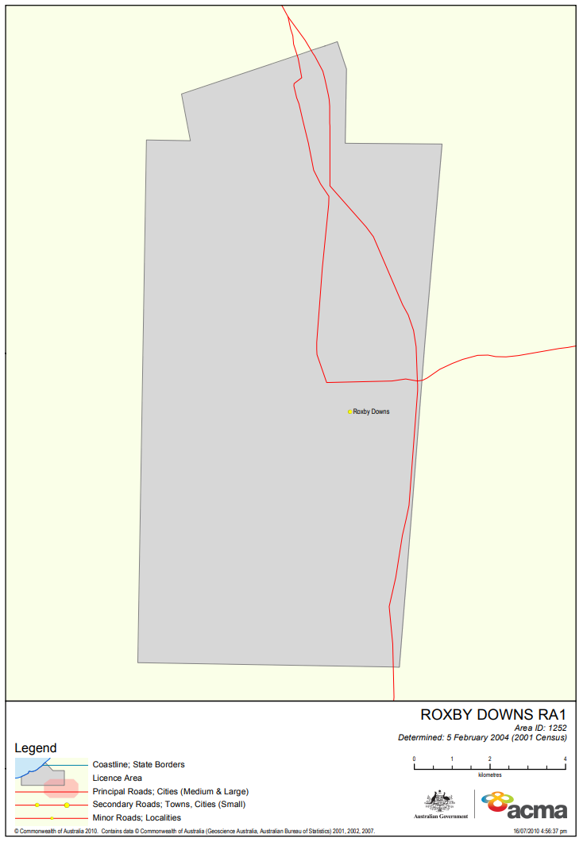

# Appendix B

## Proposed technical specification for the 5ROX transmitter at Roxby Downs

Category : Community

General Area Served : Roxby Downs (SA)

Service Licence Number : SL1150824

**TECHNICAL SPECIFICATION - FM Radio**

Specification Number : TS10010805

**Transmitter Site :-**

Nominal location : Council Depot 28 Olympic Way

ROXBY DOWNS

Nominal Co-ordinates Latitude Longitude  
(GDA94) : -30.554481 136.893775

**Emission :-**

Frequency Band & Mode : VHF-FM

Carrier Frequency : 105.5 MHz

Polarisation : Mixed

Maximum antenna height : 20 m

**Output Radiation Pattern :-**

|  |  |
| --- | --- |
| Bearing or Sector (Clockwise direction) | Maximum ERP |
| At all angles of azimuth | 500 W |

1. [2016 Roxby Downs, Census: All persons QuickStats | Australian Bureau of Statistics (abs.gov.au)](https://www.abs.gov.au/census/find-census-data/quickstats/2016/SSC41268)
2. Urban Centres and Localities represent areas of concentrated urban development. They are identified using dwelling and population density criteria and data from the 2021 Census of Population and Housing: [Urban Centres and Localities | Australian Bureau of Statistics (abs.gov.au)](https://www.abs.gov.au/statistics/standards/australian-statistical-geography-standard-asgs-edition-3/jul2021-jun2026/significant-urban-areas-urban-centres-and-localities-section-state/urban-centres-and-localities)