Australian spectrum map grid 2012

August 2020 update

Canberra

Red Building   
Benjamin Offices  
Chan Street   
Belconnen ACT

PO Box 78  
Belconnen ACT 2616

T +61 2 6219 5555  
F +61 2 6219 5353

Melbourne

Level 32   
Melbourne Central Tower  
360 Elizabeth Street   
Melbourne VIC

PO Box 13112  
Law Courts   
Melbourne VIC 8010

T +61 3 9963 6800  
F +61 3 9963 6899

Sydney

Level 5   
The Bay Centre  
65 Pirrama Road   
Pyrmont NSW

PO Box Q500  
Queen Victoria Building   
NSW 1230

T +61 2 9334 7700 or 1800 226 667  
F +61 2 9334 7799

Copyright notice

[Creative Commons logo](http://i.creativecommons.org/l/by/3.0/88x31.png)

<https://creativecommons.org/licenses/by/4.0/>

With the exception of coats of arms, logos, emblems, images, other third-party material or devices protected by a trademark, this content is made available under the terms of the Creative Commons Attribution 4.0 International (CC BY 4.0) licence.

We request attribution as © Commonwealth of Australia (Australian Communications and Media Authority) 2020.

All other rights are reserved.

The Australian Communications and Media Authority has undertaken reasonable enquiries to identify material owned by third parties and secure permission for its reproduction. Permission may need to be obtained from third parties to re-use their material.

Written enquiries may be sent to:

Manager, Editorial Services  
PO Box 13112  
Law Courts  
Melbourne VIC 8010  
Email: [info@acma.gov.au](mailto:info@acma.gov.au)

1. Introduction 1

1.1. Datum change 1

1.2. Improving the spectrum map grid 2

2. Background 3

2.1. AGD66 3

2.2. GDA94 3

2.3. GDA2020 3

2.4. WGS84 4

2.5. The challenge of using different datums 4

3. Australian spectrum map grid 2012 5

4. Transformation between datums 6

4.1 Transformations of points between datums 6

4.2 Transformations of lines between datums 6

4.3 Updating to use GDA2020 7

Attachment A—Australian spectrum map grid 8

Attachment B—ASMG boundary in AGD66 9

Attachment C—ASMG boundary in GDA94 11

Attachment D—ASMG boundary in GDA2020 14

Attachment E—the Hierarchical Cell Identification Scheme 17

Attachment F—Working example of a sample licence 20

Attachment G—The extended ASMG 21

# Introduction

Geospatial information (site coordinates) is an important parameter for many radiocommunications licences. Geospatial information is used to define geographic areas for spectrum licences, record the locations of radiocommunications devices in the Register for Radiocommunications Licences (RRL) and define areas where specific rules apply—such as location-based spectrum embargos, band plans and class licences.

Geographic areas are a core condition of spectrum licences under section 66 of the *Radiocommunications Act 1992* (the Act). The geographic area core condition specifies within which area of operation a licensee may deploy a service and helps with spectrum trading. The geographic separation between spectrum licence areas also helps incumbent licensees not to cause one another unacceptable levels of interference.

When the spectrum licence regulatory framework was introduced in the 1990s, a spectrum map grid (SMG) was developed to help identify geographic areas for spectrum licences. The SMG used a coordinate reference system based on the datum available at the time, Australian Geodetic Datum 1966 (AGD66).

The ACMA reviewed the SMG as part of its work on the expiring spectrum licence processes and decided that it was timely to provide an update to the grid, including changes to the way it communicates geospatial information on spectrum licences.[1] For example, the ACMA currently uses coordinate references to define the geographic area core condition of a spectrum licence using the AGD66 datum. Any change to another datum would increase the complexity of the coordinates, as well as the risk of human error in attempting to transcribe the coordinate references. Instead, the ACMA has decided to apply a different means of describing the geographic area that moves away from the use of coordinates. This approach is intended to simplify the way that geographic areas are defined in spectrum licences and relevant legislation such as designation notices and reallocation declarations.

The paper explains the changed way in which the ACMA will communicate geospatial information relating to the SMG. These changes are summarised as:

updating from AGD66 to the Geocentric Datum of Australia 1994 (GDA94) to align with government policy

improving the existing SMG by:

introducing a naming convention that moves away from the use of complex coordinates to define geographic areas for spectrum licences

providing a greater level of granularity in the definition of geographic areas.

## Datum change

AGD66 was developed to consolidate all surveying and mapping in Australia to a single datum, replacing a number of datums with applicability to particular jurisdictions. Although a revision to the datum was accepted in 1984 (known as AGD84), many jurisdictions continued to use AGD66 until changing to GDA94 in accordance with government policy—a process completed in 2000. In order to align with the policy, the ACMA updated the datum used in its own geospatial information systems from AGD66 to GDA94 in September 2015.

The datum change is not intended to substantially change spectrum licences but is intended to ensure continuity in the way that geographic areas are defined for both existing and new spectrum licences from 2012. The points on the ground that define an existing spectrum licence will not change, but a transformation method will be applied to ensure that these points are referred to using the updated GDA94 datum instead of AGD66 coordinates. Further information on datums is in Chapter 2 and further information on the transformation method is in Chapter 4.

The ACMA has also updated the RRL so that the geospatial information of licences uses the GDA94 datum.

In 2017, an update to the GDA94 datum known as the Geocentric Datum of Australia 2020 (GDA2020) was defined to realign the GDA datum with the International Terrestrial Reference Frame (ITRF) as of 1 January 2020. This update results in coordinate adjustments of 1.5–1.8 m from GDA94. The ACMA will be updating its geospatial records to use the GDA2020 datum in the near future and will update the RRL at the same time. In preparation for this change, this document has been updated to include information about transforming GDA94 datum coordinates to GDA2020 coordinates. Adoption of GDA2020 by the ACMA will not affect the description of spectrum licence areas.

## Improving the spectrum map grid

Although not explicitly stated, prior to September 2015, the ACMA used AGD66 to communicate geospatial information for spectrum and apparatus licensing. The SMG was based on AGD66 and used cells of varying sizes:

3 x 3 degrees

1 x 1 degree

5 x 5 minutes of arc.

The SMG referred to three sizes of cell because access to maps of areas of low population density was limited; consequently, areas with low population density were represented with large cells. This arrangement has limited the flexibility for trading in these areas.[2]

This paper marks an update to the SMG, as the ACMA releases what will now be known as the *Australian spectrum map grid 2012* (ASMG). The ASMG, while aligning with the SMG, will be able to be used with other GDA94 geospatial information. Rather than the three cell sizes on which the SMG relied, the cells of the ASMG will be 5 x 5 minutes of arc. This consistency simplifies the trading of spectrum between licensees.

# Background

Coordinate sets—both geographic coordinates (latitude/longitude) and grid coordinates (zones/eastings/northings)—are on their own insufficient to uniquely define a location. Rather, coordinates must be specified with reference to a datum.

A datum is a mathematical system used to map coordinates to locations on the surface of the Earth. Because the Earth is unevenly shaped, there are numerous different datums that have been created and could be used.

It is important to note that the datum used to define geographic areas for spectrum licences has been superseded during the tenure of existing licences. Therefore, in order to align with government policy, the ACMA describes the geographic areas in new spectrum licences using the GDA94 datum. For new spectrum licences issued from 2020 (resulting from the outcomes of expiring spectrum licence processes and new allocations), all regulatory and technical frameworks for licences will reflect the promulgation of the GDA2020 update to GDA94.

The four main datums currently relevant to Australia are noted below.

## AGD66

Presently, for the purposes of radiocommunications, the ACMA applies spatial data defined using AGD66.[3] AGD66 was the primary datum used between the 1960s and 2000. AGD66 is a local datum that was optimised for the Australian region. This optimisation resulted in a good approximation of the surface of the Earth for the Australian region. However, some limitations were identified (for example, AGD66 is not oriented around the centre of the Earth’s mass). As of 2020, AGD66 is considered a legacy or historic datum for geodesy purposes.

## GDA94

GDA94 was formally defined in 1995, and the Inter-governmental Committee on Surveying and Mapping (ICSM) was charged with coordinating its adoption by Commonwealth and state surveying and mapping agencies.[4] GDA94 is an Earth-centred datum compatible with satellite-based navigation systems and other major international geographic systems, such as the World Geodetic System 1984 (WGS84).

## GDA2020

GDA2020 was formally defined in 2017 as an update to GDA94 to realign with the WGS84 datum as of 1 January 2020, at which time the coordinate discrepancies between GDA2020 and WGS84 will be less than 10 cm. The need to update arises from the motion of the Australian tectonic plate in a roughly north-north-east direction at approximately 7 cm per year. The coordinate discrepancy between GDA94 and GDA2020 varies from approximately 1.5 m in south-eastern Australia, to approximately 1.8 m in north-western Australia. The UTM grid coordinate set associated with GDA2020 is known as the Map Grid of Australia 2020 (MGA2020).

Given the increasing importance of accurate location information to society, particularly for navigation purposes, the ICSM has indicated that it would like to keep Australia’s reference datum aligned to the ITRF to within 0.5 m. This suggests that datum updates could be expected every seven to eight years from 2020.

## WGS84

The World Geodetic System 1984 (WGS84) is used by the Global Positioning System (GPS) and is periodically revised to maintain close alignment with the ITRF. WGS84 is used for surveying and mapping in some parts of the world, notably the polar regions, as well as being used by data suppliers with world-wide scope.

## The challenge of using different datums

The ACMA currently uses GDA94 for geospatial information relating to radiocommunications (including the ASMG), unless otherwise noted. For example:

coordinates of radiocommunications sites in the RRL

coordinates of sites in spectrum embargoes and class licences.

Both GDA94 and WGS84 are currently in widespread use and adoption of GDA2020 is commencing.

While it is important to update to GDA2020 to align with mapping and surveying agencies, any update requires a transformation from GDA94—just as was required to transition from AGD66 to GDA94. During this transformation, some errors may occur. Although the coordinate discrepancy between GDA94 and GDA2020 is much smaller than the approximately 200 m discrepancy between AGD66 coordinates and GDA94 coordinates, at 1.5–1.8 m, the tectonic motion isn’t uniform and this needs to be reflected in the transformed coordinates. Use of the correct transformation method described in Chapter 4 is designed to minimise the potential for misrepresentation.

The difference between WGS84 and GDA94 is still small (1.5–1.8 m, as of 2020). While there are circumstances where the two can still be considered being close enough to treat as being the same, using GDA2020 instead of GDA94 is a better alternative.

# Australian spectrum map grid 2012

The ASMG takes into account the transition from AGD66 to GDA94 by retaining the locations on the ground, which are used to define a spectrum licence area. As part of the transition, a transformation method is applied to the AGD66 coordinates, in order to derive GDA94 coordinates for their respective locations.

The ASMG is created in four steps, by defining:

the outer boundary of the ASMG around the Australian land mass

the cells of the grid (within the boundary)

the transformation methods used to transform between different datum

the Hierarchical Cell Identification Scheme (HCIS).

On the basis of these four steps, the ASMG improves on the SMG in the following ways:

**Cells of the grid—augmentation**. The cell size has been changed to allow for 5 x 5-minute cells Australia-wide. This allows far greater granularity in the description of areas and, in many cases, the ability to trade smaller areas, particularly in regional Australia.

**Transformation**. The boundaries of the new ASMG (defined in GDA94) align with the existing spectrum map grid (defined in AGD66). The method used for transformation between AGD66 and GDA94 is identified in Chapter 4. With the update to GDA2020, this document has been revised to incorporate transformation of the ASMG from GDA94 to GDA2020. The ACMA is anticipating that datum updates will be more frequent in the future and will revise this document as new datum information becomes available.

**HCIS**. The HCIS is a way of describing geographic areas aligned with the ASMG. This naming convention succeeds in communicating geographic areas in two ways. First, the HCIS removes the need to refer to complex coordinate sets to describe a geographic area (reducing the risk of errors). Second, the HCIS may be used to describe areas regardless of the datum used. This means that although a newer datum may apply in the future, the HCIS will remain consistent in the way areas are described.

# 4. Transformation between datums

Any transformations between AGD66 and any other datum should use the methods recommended by the Intergovernmental Committee on Surveying and Mapping (ICSM).[5] The ICSM’s methods are employed by the ACMA and a number of Australian and state-based surveying and mapping agencies. The ACMA relies on the ICSM for its coordination and standards for surveying and mapping national datasets.

## 4.1 Transformations of points between datums

The *Geocentric Datum of Australia (GDA) Technical Manual* produced by the ICSM recommends the High Accuracy Transformation (grid transformation) for transformations between AGD66 and GDA94 in Australia[6], provided that a point is within the transformation grid extent. All transformations of points between AGD66 and GDA94 should be performed using the method identified in the GDA Technical Manual. Further information on this method, including links to free software to perform the transformations, are available in the GDA Technical Manual.

## 4.2 Transformations of lines between datums

The mathematical approximation of the shape of the Earth in GDA94 differs from that used in AGD66. As such, the line across the Earth’s surface between two locations slightly differs between the two datums. Provided that the end points are separated by no more than one degree of latitudinal or longitudinal arc, this difference is acceptably small. This is important because, when transforming from AGD66 to GDA94, the boundaries of geographic areas must remain consistent and accurate.

In some uncommon cases, the end points may initially be separated by more than one degree of arc. For these cases, following a particular method will allow information to be displayed with minimal difference between AGD66 and GDA94. These methods are:

The coordinates chosen must be those for corners of cells defined in the ASMG as transformed to GDA94 by the required method.

If the boundary segment is more than one degree but less than two degrees (in AGD66 coordinate terms) in length, the GDA94 coordinates of the ASMG cell corner nearest the centre of the segment is to be used. If two cell corners are equidistant from the centre of the boundary segment, the GDA94 coordinates of either cell corner may be used.

If the boundary segment is two degrees or more (in AGD66 coordinate terms) in length, the GDA94 coordinates for each ASMG cell corner along the boundary segment with an integral value (in degrees, in AGD66 coordinate terms) of latitude or longitude (as appropriate for the particular boundary segment) are to be used.

Geospatial data in computerised systems should incorporate each intervening ASMG cell corner along a boundary segment of an area, in order to accurately represent the geographic area in a transformed state.

## 4.3 Updating to use GDA2020

The *GDA2020 Technical Manual*[7] does not document any method to directly transform from AGD66/AGD84 to GDA2020 but advises that coordinates first be transformed from AGD66/AGD84 to GDA94, and then from GDA94 to GDA2020.

As a consequence, the ACMA will be transforming the ASMG coordinates in the existing published GDA94 ASMG spatial datasets to produce GDA2020 spatial datasets.

The transformation process documented in the *GDA2020 Technical Manual* with the best accuracy uses NTv2 grid transformation, as is documented in the *GDA Technical Manual* and used by the ACMA to transform AGD66 coordinates to GDA94 coordinates. However, there are two transformation grids defined for the GDA94 to GDA2020 transformation: ‘conformal’ and ‘conformal and distortion’. There are pros and cons for both choices. On balance, the ACMA has selected the ‘conformal and distortion’ transformation grid for transforming its spatial data from GDA94 to GDA2020, as it appears to best serve the ACMA’s purposes.

Transforming the GDA94 coordinates for the ASMG to GDA2020 coordinates follows the methods outlined in sections 4.1 and 4.2 above, except that the GDA94 to GDA2020 ‘conformal and distortion’ transformation grid is used, as documented in the *GDA2020 Technical Manual*. GDA94 coordinates outside the extent of the NTv2 ‘conformal and distortion’ transformation grid, which includes some locations on or very close to the ASMG boundary, require the use of the seven-parameter similarity transformation documented in the *GDA2020 Technical Manual,* instead of the NTv2 grid transformation.

# Attachment A—Australian spectrum map grid

**The boundary of the ASMG**

Figure 1 shows the outline of the ASMG. The boundary appears to approach the coast in a number of areas, but this is an artefact of the scale of the map—the boundary typically gets no closer to the coast than 10 kms. The ASMG is the area within this polygon. It is important to note that the ASMG does not include the external territories.

Table 1 lists AGD66 coordinates for the vertices of the ASMG. The boundary of the ASMG is found by joining consecutively numbered points from the table below.

Table 2 lists GDA94 coordinates for the vertices of the ASMG, along with necessary intermediary points to preserve accuracy.

Table 3 lists GDA2020 coordinates for the vertices of the ASMG, along with necessary intermediary points to preserve accuracy.

**The cells of the ASMG**

The area bound by the outer limits (illustrated in Figure 1) is subdivided into cells to form the ASMG. The cells have boundaries at five-minute arc intervals of both latitude and longitude (in AGD66), originating at the northernmost and westernmost edges of the ASMG outer boundary, respectively. These points can be transformed into GDA94 and GDA2020, using the methods described in Chapter 4.

ASMG outline

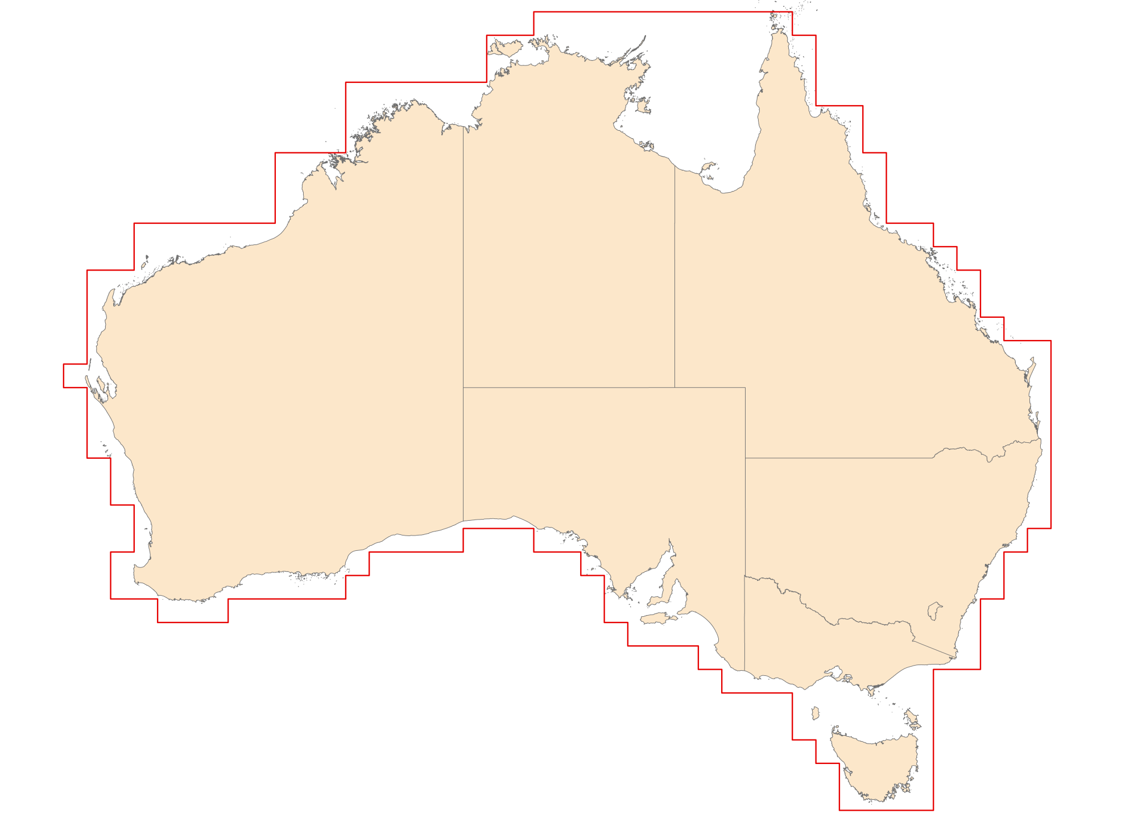

# Attachment B—ASMG boundary in AGD66

The outer limit of the ASMG is illustrated in Figure 1. The outer limit of the ASMG is represented by a line that starts at the location specified by the first set of AGD66 coordinates and passes sequentially through the locations specified by each subsequent set of coordinates, to the location of commencement.

ASMG boundary vertices in AGD66

|  |  |  |
| --- | --- | --- |
| Vertex no. | Latitude (degrees minutes and seconds) south | Longitude (degrees minutes and seconds) east |
| 1 | 25 00 00 | 112 00 00 |
| 2 | 25 00 00 | 113 00 00 |
| 3 | 21 00 00 | 113 00 00 |
| 4 | 21 00 00 | 115 00 00 |
| 5 | 19 00 00 | 115 00 00 |
| 6 | 19 00 00 | 121 00 00 |
| 7 | 16 00 00 | 121 00 00 |
| 8 | 16 00 00 | 124 00 00 |
| 9 | 13 00 00 | 124 00 00 |
| 10 | 13 00 00 | 130 00 00 |
| 11 | 11 00 00 | 130 00 00 |
| 12 | 11 00 00 | 132 00 00 |
| 13 | 10 00 00 | 132 00 00 |
| 14 | 10 00 00 | 143 00 00 |
| 15 | 11 00 00 | 143 00 00 |
| 16 | 11 00 00 | 144 00 00 |
| 17 | 14 00 00 | 144 00 00 |
| 18 | 14 00 00 | 146 00 00 |
| 19 | 16 00 00 | 146 00 00 |
| 20 | 16 00 00 | 147 00 00 |
| 21 | 19 00 00 | 147 00 00 |
| 22 | 19 00 00 | 149 00 00 |
| 23 | 20 00 00 | 149 00 00 |
| 24 | 20 00 00 | 150 00 00 |
| 25 | 21 00 00 | 150 00 00 |
| 26 | 21 00 00 | 151 00 00 |
| 27 | 23 00 00 | 151 00 00 |
| 28 | 23 00 00 | 152 00 00 |
| 29 | 24 00 00 | 152 00 00 |
| 30 | 24 00 00 | 154 00 00 |
| 31 | 32 00 00 | 154 00 00 |
| 32 | 32 00 00 | 153 00 00 |
| 33 | 33 00 00 | 153 00 00 |
| 34 | 33 00 00 | 152 00 00 |
| 35 | 35 00 00 | 152 00 00 |
| 36 | 35 00 00 | 151 00 00 |
| 37 | 38 00 00 | 151 00 00 |
| 38 | 38 00 00 | 149 00 00 |
| 39 | 44 00 00 | 149 00 00 |
| 40 | 44 00 00 | 145 00 00 |
| 41 | 42 00 00 | 145 00 00 |
| 42 | 42 00 00 | 144 00 00 |
| 43 | 41 00 00 | 144 00 00 |
| 44 | 41 00 00 | 143 00 00 |
| 45 | 39 00 00 | 143 00 00 |
| 46 | 39 00 00 | 140 00 00 |
| 47 | 38 00 00 | 140 00 00 |
| 48 | 38 00 00 | 139 00 00 |
| 49 | 37 00 00 | 139 00 00 |
| 50 | 37 00 00 | 136 00 00 |
| 51 | 36 00 00 | 136 00 00 |
| 52 | 36 00 00 | 135 00 00 |
| 53 | 34 00 00 | 135 00 00 |
| 54 | 34 00 00 | 134 00 00 |
| 55 | 33 00 00 | 134 00 00 |
| 56 | 33 00 00 | 132 00 00 |
| 57 | 32 00 00 | 132 00 00 |
| 58 | 32 00 00 | 129 00 00 |
| 59 | 33 00 00 | 129 00 00 |
| 60 | 33 00 00 | 125 00 00 |
| 61 | 34 00 00 | 125 00 00 |
| 62 | 34 00 00 | 124 00 00 |
| 63 | 35 00 00 | 124 00 00 |
| 64 | 35 00 00 | 119 00 00 |
| 65 | 36 00 00 | 119 00 00 |
| 66 | 36 00 00 | 116 00 00 |
| 67 | 35 00 00 | 116 00 00 |
| 68 | 35 00 00 | 114 00 00 |
| 69 | 33 00 00 | 114 00 00 |
| 70 | 33 00 00 | 115 00 00 |
| 71 | 31 00 00 | 115 00 00 |
| 72 | 31 00 00 | 114 00 00 |
| 73 | 29 00 00 | 114 00 00 |
| 74 | 29 00 00 | 113 00 00 |
| 75 | 26 00 00 | 113 00 00 |
| 76 | 26 00 00 | 112 00 00 |
| 77 | 25 00 00 | 112 00 00 |

# Attachment C—ASMG boundary in GDA94

The point coordinates in Table 2 have been transformed from the point coordinates in Table 1 using the method in Chapter 4 to create the AMSG boundary in GDA94.

The outer limit of the ASMG is illustrated in Figure 1. The outer limit of the ASMG is represented by a line that starts at the location specified by the first set of GDA94 coordinates and passes sequentially through the locations specified by each subsequent set of coordinates, to the location of commencement.

ASMG boundary vertices in GDA94

|  |  |  |  |  |  |  |  |  |  |  |  |  |  |  |  |  |  |  |  |  |  |  |  |  |  |  |  |  |  |  |  |  |  |  |  |  |  |  |  |  |  |  |  |  |  |  |  |  |  |  |  |  |  |  |  |  |  |  |  |  |  |  |  |  |  |  |  |  |  |  |  |  |  |  |  |  |  |  |  |  |  |  |  |  |  |  |  |  |  |  |  |  |  |  |  |  |  |  |  |  |  |  |  |  |  |  |  |  |  |  |  |  |  |  |  |  |  |  |  |  |  |  |  |  |  |  |  |  |  |  |  |  |  |  |  |  |  |  |  |  |  |  |  |  |  |  |  |  |  |  |  |  |  |  |  |  |  |  |  |  |  |  |  |  |  |  |  |  |  |  |  |  |  |  |  |  |  |  |  |  |  |  |  |  |  |  |  |  |  |  |  |  |  |  |  |  |  |  |  |  |  |  |  |  |  |  |  |  |  |  |  |  |  |  |  |  |  |  |  |  |  |  |  |  |  |  |  |  |  |  |  |  |  |  |  |  |  |  |  |  |  |  |  |  |  |  |  |  |  |  |  |  |  |  |  |  |  |  |  |  |  |  |  |  |  |  |  |  |  |  |  |  |  |  |  |  |  |  |  |  |  |  |  |  |  |  |  |  |  |  |  |  |  |  |  |  |  |  |  |  |  |  |  |  |  |  |  |  |  |  |  |  |  |  |  |  |  |  |  |  |  |  |  |  |  |  |  |  |  |  |  |  |  |  |  |  |  |  |  |  |  |  |  |  |  |  |  |  |  |  |  |  |  |  |  |  |  |  |  |  |  |  |  |  |  |  |  |  |  |  |  |  |  |  |  |  |  |  |  |  |  |  |  |  |  |  |  |  |  |  |  |  |  |  |  |  |  |  |  |  |  |  |  |  |  |  |  |  |  |  |  |  |  |  |  |  |  |  |  |  |  |  |  |  |  |  |  |  |  |  |  |  |  |  |  |  |  |  |  |  |  |  |  |  |  |  |  |  |  |  |  |  |  |  |  |  |  |  |  |  |  |  |  |  |  |  |  |  |  |  |  |  |  |  |  |  |  |  |  |  |  |  |  |  |  |  |  |  |  |  |  |  |
| --- | --- | --- | --- | --- | --- | --- | --- | --- | --- | --- | --- | --- | --- | --- | --- | --- | --- | --- | --- | --- | --- | --- | --- | --- | --- | --- | --- | --- | --- | --- | --- | --- | --- | --- | --- | --- | --- | --- | --- | --- | --- | --- | --- | --- | --- | --- | --- | --- | --- | --- | --- | --- | --- | --- | --- | --- | --- | --- | --- | --- | --- | --- | --- | --- | --- | --- | --- | --- | --- | --- | --- | --- | --- | --- | --- | --- | --- | --- | --- | --- | --- | --- | --- | --- | --- | --- | --- | --- | --- | --- | --- | --- | --- | --- | --- | --- | --- | --- | --- | --- | --- | --- | --- | --- | --- | --- | --- | --- | --- | --- | --- | --- | --- | --- | --- | --- | --- | --- | --- | --- | --- | --- | --- | --- | --- | --- | --- | --- | --- | --- | --- | --- | --- | --- | --- | --- | --- | --- | --- | --- | --- | --- | --- | --- | --- | --- | --- | --- | --- | --- | --- | --- | --- | --- | --- | --- | --- | --- | --- | --- | --- | --- | --- | --- | --- | --- | --- | --- | --- | --- | --- | --- | --- | --- | --- | --- | --- | --- | --- | --- | --- | --- | --- | --- | --- | --- | --- | --- | --- | --- | --- | --- | --- | --- | --- | --- | --- | --- | --- | --- | --- | --- | --- | --- | --- | --- | --- | --- | --- | --- | --- | --- | --- | --- | --- | --- | --- | --- | --- | --- | --- | --- | --- | --- | --- | --- | --- | --- | --- | --- | --- | --- | --- | --- | --- | --- | --- | --- | --- | --- | --- | --- | --- | --- | --- | --- | --- | --- | --- | --- | --- | --- | --- | --- | --- | --- | --- | --- | --- | --- | --- | --- | --- | --- | --- | --- | --- | --- | --- | --- | --- | --- | --- | --- | --- | --- | --- | --- | --- | --- | --- | --- | --- | --- | --- | --- | --- | --- | --- | --- | --- | --- | --- | --- | --- | --- | --- | --- | --- | --- | --- | --- | --- | --- | --- | --- | --- | --- | --- | --- | --- | --- | --- | --- | --- | --- | --- | --- | --- | --- | --- | --- | --- | --- | --- | --- | --- | --- | --- | --- | --- | --- | --- | --- | --- | --- | --- | --- | --- | --- | --- | --- | --- | --- | --- | --- | --- | --- | --- | --- | --- | --- | --- | --- | --- | --- | --- | --- | --- | --- | --- | --- | --- | --- | --- | --- | --- | --- | --- | --- | --- | --- | --- | --- | --- | --- | --- | --- | --- | --- | --- | --- | --- | --- | --- | --- | --- | --- | --- | --- | --- | --- | --- | --- | --- | --- | --- | --- | --- | --- | --- | --- | --- | --- | --- | --- | --- | --- | --- | --- | --- | --- | --- | --- | --- | --- | --- | --- | --- | --- | --- | --- | --- | --- | --- | --- | --- | --- | --- | --- | --- | --- | --- | --- | --- | --- | --- | --- | --- | --- | --- | --- | --- | --- | --- | --- | --- | --- | --- | --- | --- | --- | --- | --- | --- | --- | --- | --- | --- | --- | --- | --- | --- | --- | --- | --- | --- | --- | --- | --- | --- | --- | --- | --- | --- | --- | --- | --- | --- | --- | --- | --- | --- | --- | --- | --- | --- | --- | --- | --- | --- | --- |
| |  |  |  | | --- | --- | --- | | Vertex no. | Latitude (decimal degrees) south | Longitude (decimal degrees)  east | | 1 | 24.998757 | 112.001377 | | 2 | 24.998744 | 113.001346 | | 3 | 23.998738 | 113.001340 | | 4 | 22.998729 | 113.001347 | | 5 | 21.998721 | 113.001338 | | 6 | 20.998713 | 113.001332 | | 7 | 20.998705 | 114.001326 | | 8 | 20.998698 | 115.001297 | | 9 | 19.998688 | 115.001319 | | 10 | 18.998681 | 115.001312 | | 11 | 18.998673 | 116.001310 | | 12 | 18.998666 | 117.001309 | | 13 | 18.998658 | 118.001306 | | 14 | 18.998650 | 119.001304 | | 15 | 18.998642 | 120.001301 | | 16 | 18.998630 | 121.001292 | | 17 | 17.998630 | 121.001289 | | 18 | 16.998626 | 121.001281 | | 19 | 15.998622 | 121.001274 | | 20 | 15.998616 | 122.001271 | | 21 | 15.998607 | 123.001262 | | 22 | 15.998601 | 124.001256 | | 23 | 14.998601 | 124.001255 | | 24 | 13.998599 | 124.001249 | | 25 | 12.998597 | 124.001244 | | 26 | 12.998592 | 125.001239 | | 27 | 12.998586 | 126.001234 | | 28 | 12.998581 | 127.001229 | | 29 | 12.998576 | 128.001224 | | 30 | 12.998571 | 129.001218 | | 31 | 12.998580 | 130.001200 | | 32 | 11.998567 | 130.001205 | | 33 | 10.998568 | 130.001202 | | 34 | 10.998567 | 131.001191 | | 35 | 10.998568 | 132.001181 | | 36 | 9.998561 | 132.001184 | | 37 | 9.998558 | 133.001177 | | 38 | 9.998554 | 134.001170 | | 39 | 9.998550 | 135.001162 | | 40 | 9.998546 | 136.001154 | | 41 | 9.998543 | 137.001145 | | 42 | 9.998539 | 138.001137 | | 43 | 9.998535 | 139.001128 | | 44 | 9.998532 | 140.001118 | | 45 | 9.998528 | 141.001108 | | 46 | 9.998510 | 142.001113 | | 47 | 9.998506 | 143.001104 | | 48 | 10.998494 | 143.001114 | | 49 | 10.998513 | 144.001081 | | 50 | 11.998507 | 144.001084 | | 51 | 12.998499 | 144.001091 | | 52 | 13.998493 | 144.001090 | | 53 | 13.998490 | 145.001081 | | 54 | 13.998488 | 146.001070 | | 55 | 14.998483 | 146.001074 | | 56 | 15.998478 | 146.001078 | | 57 | 15.998474 | 147.001067 | | 58 | 16.998469 | 147.001072 | | 59 | 17.998465 | 147.001078 | | 60 | 18.998465 | 147.001089 | | 61 | 18.998456 | 148.001071 | | 62 | 18.998451 | 149.001058 | | 63 | 19.998451 | 149.001064 | | 64 | 19.998441 | 150.001050 | | 65 | 20.998438 | 150.001056 | | 66 | 20.998432 | 151.001042 | | 67 | 21.998429 | 151.001049 | | 68 | 22.998434 | 151.001058 | | 69 | 22.998420 | 152.001041 | | 70 | 23.998428 | 152.001046 | | 71 | 23.998411 | 153.001033 | | 72 | 23.998405 | 154.001018 | | 73 | 24.998402 | 154.001025 | | 74 | 25.998401 | 154.001033 | | 75 | 26.998397 | 154.001041 | | 76 | 27.998398 | 154.001049 | | 77 | 28.998397 | 154.001059 | | 78 | 29.998395 | 154.001068 | | 79 | 30.998395 | 154.001078 | | 80 | 31.998395 | 154.001088 | | 81 | 31.998405 | 153.001103 | | 82 | 32.998404 | 153.001116 | | 83 | 32.998415 | 152.001132 | | 84 | 33.998414 | 152.001145 | | 85 | 34.998416 | 152.001158 | | 86 | 34.998426 | 151.001172 | | 87 | 35.998427 | 151.001188 | | 88 | 36.998431 | 151.001203 | | 89 | 37.998434 | 151.001218 | | 90 | 37.998444 | 150.001236 | | 91 | 37.998457 | 149.001255 | | 92 | 38.998459 | 149.001268 | | 93 | 39.998464 | 149.001286 | | 94 | 40.998469 | 149.001304 | | 95 | 41.998475 | 149.001323 | | 96 | 42.998481 | 149.001343 | | 97 | 43.998488 | 149.001364 | | 98 | 43.998499 | 148.001382 | | 99 | 43.998511 | 147.001401 | | 100 | 43.998522 | 146.001418 | | 101 | 43.998534 | 145.001436 | | 102 | 42.998527 | 145.001413 | | 103 | 41.998522 | 145.001384 | | 104 | 41.998531 | 144.001408 | | 105 | 40.998524 | 144.001387 | | 106 | 40.998536 | 143.001403 | | 107 | 39.998529 | 143.001383 | | 108 | 38.998522 | 143.001358 | | 109 | 38.998534 | 142.001379 | | 110 | 38.998546 | 141.001393 | | 111 | 38.998557 | 140.001407 | | 112 | 37.998545 | 140.001384 | | 113 | 37.998562 | 139.001401 | | 114 | 36.998554 | 139.001381 | | 115 | 36.998567 | 138.001396 | | 116 | 36.998578 | 137.001408 | | 117 | 36.998590 | 136.001420 | | 118 | 35.998576 | 136.001402 | | 119 | 35.998595 | 135.001413 | | 120 | 34.998583 | 135.001401 | | 121 | 33.998570 | 135.001397 | | 122 | 33.998586 | 134.001398 | | 123 | 32.998580 | 134.001383 | | 124 | 32.998595 | 133.001387 | | 125 | 32.998608 | 132.001394 | | 126 | 31.998594 | 132.001397 | | 127 | 31.998606 | 131.001396 | | 128 | 31.998614 | 130.001404 | | 129 | 31.998623 | 129.001413 | | 130 | 32.998642 | 129.001419 | | 131 | 32.998653 | 128.001427 | | 132 | 32.998664 | 127.001435 | | 133 | 32.998675 | 126.001445 | | 134 | 32.998686 | 125.001456 | | 135 | 33.998699 | 125.001467 | | 136 | 33.998715 | 124.001479 | | 137 | 34.998719 | 124.001489 | | 138 | 34.998731 | 123.001496 | | 139 | 34.998749 | 122.001505 | | 140 | 34.998756 | 121.001505 | | 141 | 34.998769 | 120.001510 | | 142 | 34.998788 | 119.001513 | | 143 | 35.998793 | 119.001533 | | 144 | 35.998806 | 118.001537 | | 145 | 35.998819 | 117.001541 | | 146 | 35.998832 | 116.001543 | | 147 | 34.998831 | 116.001528 | | 148 | 34.998841 | 115.001532 | | 149 | 34.998846 | 114.001528 | | 150 | 33.998836 | 114.001511 | | 151 | 32.998821 | 114.001492 | | 152 | 32.998823 | 115.001497 | | 153 | 31.998805 | 115.001478 | | 154 | 30.998801 | 115.001459 | | 155 | 30.998798 | 114.001458 | | 156 | 29.998789 | 114.001441 | | 157 | 28.998773 | 114.001422 | | 158 | 28.998787 | 113.001428 | | 159 | 27.998776 | 113.001417 | | 160 | 26.998768 | 113.001394 | | 161 | 25.998754 | 113.001362 | | 162 | 25.998767 | 112.001389 | | 163 | 24.998757 | 112.001377 | |

# Attachment D—ASMG boundary in GDA2020

The point coordinates in Table 3 have been transformed from the point coordinates in Table 1 using the methods in Chapter 4 to create the AMSG boundary in GDA2020.

The outer limit of the ASMG is illustrated in Figure 1. The outer limit of the ASMG is represented by a line that starts at the location specified by the first set of GDA2020 coordinates and passes sequentially through the locations specified by each subsequent set of coordinates, to the location of commencement.

ASMG boundary vertices in GDA2020

|  |  |  |  |  |  |  |  |  |  |  |  |  |  |  |  |  |  |  |  |  |  |  |  |  |  |  |  |  |  |  |  |  |  |  |  |  |  |  |  |  |  |  |  |  |  |  |  |  |  |  |  |  |  |  |  |  |  |  |  |  |  |  |  |  |  |  |  |  |  |  |  |  |  |  |  |  |  |  |  |  |  |  |  |  |  |  |  |  |  |  |  |  |  |  |  |  |  |  |  |  |  |  |  |  |  |  |  |  |  |  |  |  |  |  |  |  |  |  |  |  |  |  |  |  |  |  |  |  |  |  |  |  |  |  |  |  |  |  |  |  |  |  |  |  |  |  |  |  |  |  |  |  |  |  |  |  |  |  |  |  |  |  |  |  |  |  |  |  |  |  |  |  |  |  |  |  |  |  |  |  |  |  |  |  |  |  |  |  |  |  |  |  |  |  |  |  |  |  |  |  |  |  |  |  |  |  |  |  |  |  |  |  |  |  |  |  |  |  |  |  |  |  |  |  |  |  |  |  |  |  |  |  |  |  |  |  |  |  |  |  |  |  |  |  |  |  |  |  |  |  |  |  |  |  |  |  |  |  |  |  |  |  |  |  |  |  |  |  |  |  |  |  |  |  |  |  |  |  |  |  |  |  |  |  |  |  |  |  |  |  |  |  |  |  |  |  |  |  |  |  |  |  |  |  |  |  |  |  |  |  |  |  |  |  |  |  |  |  |  |  |  |  |  |  |  |  |  |  |  |  |  |  |  |  |  |  |  |  |  |  |  |  |  |  |  |  |  |  |  |  |  |  |  |  |  |  |  |  |  |  |  |  |  |  |  |  |  |  |  |  |  |  |  |  |  |  |  |  |  |  |  |  |  |  |  |  |  |  |  |  |  |  |  |  |  |  |  |  |  |  |  |  |  |  |  |  |  |  |  |  |  |  |  |  |  |  |  |  |  |  |  |  |  |  |  |  |  |  |  |  |  |  |  |  |  |  |  |  |  |  |  |  |  |  |  |  |  |  |  |  |  |  |  |  |  |  |  |  |  |  |  |  |  |  |  |  |  |  |  |  |  |  |  |  |  |  |  |  |  |  |  |  |  |  |  |  |  |  |  |  |  |  |
| --- | --- | --- | --- | --- | --- | --- | --- | --- | --- | --- | --- | --- | --- | --- | --- | --- | --- | --- | --- | --- | --- | --- | --- | --- | --- | --- | --- | --- | --- | --- | --- | --- | --- | --- | --- | --- | --- | --- | --- | --- | --- | --- | --- | --- | --- | --- | --- | --- | --- | --- | --- | --- | --- | --- | --- | --- | --- | --- | --- | --- | --- | --- | --- | --- | --- | --- | --- | --- | --- | --- | --- | --- | --- | --- | --- | --- | --- | --- | --- | --- | --- | --- | --- | --- | --- | --- | --- | --- | --- | --- | --- | --- | --- | --- | --- | --- | --- | --- | --- | --- | --- | --- | --- | --- | --- | --- | --- | --- | --- | --- | --- | --- | --- | --- | --- | --- | --- | --- | --- | --- | --- | --- | --- | --- | --- | --- | --- | --- | --- | --- | --- | --- | --- | --- | --- | --- | --- | --- | --- | --- | --- | --- | --- | --- | --- | --- | --- | --- | --- | --- | --- | --- | --- | --- | --- | --- | --- | --- | --- | --- | --- | --- | --- | --- | --- | --- | --- | --- | --- | --- | --- | --- | --- | --- | --- | --- | --- | --- | --- | --- | --- | --- | --- | --- | --- | --- | --- | --- | --- | --- | --- | --- | --- | --- | --- | --- | --- | --- | --- | --- | --- | --- | --- | --- | --- | --- | --- | --- | --- | --- | --- | --- | --- | --- | --- | --- | --- | --- | --- | --- | --- | --- | --- | --- | --- | --- | --- | --- | --- | --- | --- | --- | --- | --- | --- | --- | --- | --- | --- | --- | --- | --- | --- | --- | --- | --- | --- | --- | --- | --- | --- | --- | --- | --- | --- | --- | --- | --- | --- | --- | --- | --- | --- | --- | --- | --- | --- | --- | --- | --- | --- | --- | --- | --- | --- | --- | --- | --- | --- | --- | --- | --- | --- | --- | --- | --- | --- | --- | --- | --- | --- | --- | --- | --- | --- | --- | --- | --- | --- | --- | --- | --- | --- | --- | --- | --- | --- | --- | --- | --- | --- | --- | --- | --- | --- | --- | --- | --- | --- | --- | --- | --- | --- | --- | --- | --- | --- | --- | --- | --- | --- | --- | --- | --- | --- | --- | --- | --- | --- | --- | --- | --- | --- | --- | --- | --- | --- | --- | --- | --- | --- | --- | --- | --- | --- | --- | --- | --- | --- | --- | --- | --- | --- | --- | --- | --- | --- | --- | --- | --- | --- | --- | --- | --- | --- | --- | --- | --- | --- | --- | --- | --- | --- | --- | --- | --- | --- | --- | --- | --- | --- | --- | --- | --- | --- | --- | --- | --- | --- | --- | --- | --- | --- | --- | --- | --- | --- | --- | --- | --- | --- | --- | --- | --- | --- | --- | --- | --- | --- | --- | --- | --- | --- | --- | --- | --- | --- | --- | --- | --- | --- | --- | --- | --- | --- | --- | --- | --- | --- | --- | --- | --- | --- | --- | --- | --- | --- | --- | --- | --- | --- | --- | --- | --- | --- | --- | --- | --- | --- | --- | --- | --- | --- | --- | --- | --- | --- | --- | --- | --- | --- | --- | --- | --- | --- | --- | --- | --- | --- | --- | --- | --- | --- | --- | --- | --- | --- | --- | --- | --- | --- | --- |
| |  |  |  | | --- | --- | --- | | Vertex no. | Latitude (decimal degrees) south | Longitude (decimal degrees) east | | 1 | 24.998744 | 112.001387 | | 2 | 24.998731 | 113.001356 | | 3 | 23.998725 | 113.001351 | | 4 | 22.998715 | 113.001358 | | 5 | 21.998708 | 113.001348 | | 6 | 20.998699 | 113.001343 | | 7 | 20.998692 | 114.001336 | | 8 | 20.998685 | 115.001307 | | 9 | 19.998675 | 115.001329 | | 10 | 18.998668 | 115.001322 | | 11 | 18.998660 | 116.001320 | | 12 | 18.998652 | 117.001318 | | 13 | 18.998644 | 118.001316 | | 14 | 18.998636 | 119.001313 | | 15 | 18.998629 | 120.001310 | | 16 | 18.998616 | 121.001302 | | 17 | 17.998616 | 121.001298 | | 18 | 16.998612 | 121.001291 | | 19 | 15.998609 | 121.001283 | | 20 | 15.998602 | 122.001280 | | 21 | 15.998594 | 123.001271 | | 22 | 15.998587 | 124.001266 | | 23 | 14.998586 | 124.001265 | | 24 | 13.998585 | 124.001258 | | 25 | 12.998583 | 124.001253 | | 26 | 12.998578 | 125.001248 | | 27 | 12.998572 | 126.001243 | | 28 | 12.998567 | 127.001238 | | 29 | 12.998562 | 128.001232 | | 30 | 12.998557 | 129.001226 | | 31 | 12.998566 | 130.001209 | | 32 | 11.998554 | 130.001215 | | 33 | 10.998554 | 130.001210 | | 34 | 10.998553 | 131.001199 | | 35 | 10.998554 | 132.001189 | | 36 | 9.998548 | 132.001193 | | 37 | 9.998544 | 133.001186 | | 38 | 9.998540 | 134.001178 | | 39 | 9.998536 | 135.001170 | | 40 | 9.998532 | 136.001162 | | 41 | 9.998529 | 137.001154 | | 42 | 9.998525 | 138.001145 | | 43 | 9.998522 | 139.001136 | | 44 | 9.998518 | 140.001127 | | 45 | 9.998515 | 141.001117 | | 46 | 9.998497 | 142.001122 | | 47 | 9.998493 | 143.001112 | | 48 | 10.998480 | 143.001122 | | 49 | 10.998499 | 144.001089 | | 50 | 11.998493 | 144.001093 | | 51 | 12.998486 | 144.001099 | | 52 | 13.998479 | 144.001098 | | 53 | 13.998477 | 145.001089 | | 54 | 13.998475 | 146.001078 | | 55 | 14.998470 | 146.001082 | | 56 | 15.998465 | 146.001086 | | 57 | 15.998460 | 147.001075 | | 58 | 16.998456 | 147.00108 | | 59 | 17.998452 | 147.001085 | | 60 | 18.998452 | 147.001096 | | 61 | 18.998443 | 148.001078 | | 62 | 18.998438 | 149.001065 | | 63 | 19.998438 | 149.001071 | | 64 | 19.998428 | 150.001057 | | 65 | 20.998425 | 150.001063 | | 66 | 20.998419 | 151.001049 | | 67 | 21.998416 | 151.001056 | | 68 | 22.998421 | 151.001065 | | 69 | 22.998408 | 152.001048 | | 70 | 23.998415 | 152.001053 | | 71 | 23.998398 | 153.001040 | | 72 | 23.998392 | 154.001024 | | 73 | 24.998390 | 154.001032 | | 74 | 25.998388 | 154.001039 | | 75 | 26.998384 | 154.001047 | | 76 | 27.998385 | 154.001055 | | 77 | 28.998385 | 154.001064 | | 78 | 29.998382 | 154.001073 | | 79 | 30.998382 | 154.001083 | | 80 | 31.998383 | 154.001093 | | 81 | 31.998392 | 153.001109 | | 82 | 32.998391 | 153.001122 | | 83 | 32.998402 | 152.001137 | | 84 | 33.998401 | 152.001150 | | 85 | 34.998403 | 152.001163 | | 86 | 34.998413 | 151.001177 | | 87 | 35.998415 | 151.001193 | | 88 | 36.998418 | 151.001208 | | 89 | 37.998422 | 151.001223 | | 90 | 37.998432 | 150.001241 | | 91 | 37.998444 | 149.001261 | | 92 | 38.998446 | 149.001273 | | 93 | 39.998452 | 149.001290 | | 94 | 40.998457 | 149.001308 | | 95 | 41.998463 | 149.001327 | | 96 | 42.998469 | 149.001347 | | 97 | 43.998476 | 149.001368 | | 98 | 43.998486 | 148.001387 | | 99 | 43.998498 | 147.001405 | | 100 | 43.998509 | 146.001423 | | 101 | 43.998521 | 145.001441 | | 102 | 42.998514 | 145.001418 | | 103 | 41.998509 | 145.001390 | | 104 | 41.998518 | 144.001414 | | 105 | 40.998511 | 144.001393 | | 106 | 40.998523 | 143.001409 | | 107 | 39.998516 | 143.001389 | | 108 | 38.998509 | 143.001364 | | 109 | 38.998521 | 142.001385 | | 110 | 38.998532 | 141.001400 | | 111 | 38.998544 | 140.001413 | | 112 | 37.998531 | 140.001391 | | 113 | 37.998548 | 139.001408 | | 114 | 36.998540 | 139.001388 | | 115 | 36.998553 | 138.001403 | | 116 | 36.998565 | 137.001415 | | 117 | 36.998576 | 136.001427 | | 118 | 35.998563 | 136.001410 | | 119 | 35.998581 | 135.001421 | | 120 | 34.998570 | 135.001409 | | 121 | 33.998556 | 135.001405 | | 122 | 33.998572 | 134.001406 | | 123 | 32.998567 | 134.001392 | | 124 | 32.998582 | 133.001395 | | 125 | 32.998595 | 132.001402 | | 126 | 31.998581 | 132.001405 | | 127 | 31.998592 | 131.001404 | | 128 | 31.998601 | 130.001413 | | 129 | 31.998609 | 129.001421 | | 130 | 32.998628 | 129.001428 | | 131 | 32.998640 | 128.001436 | | 132 | 32.998650 | 127.001444 | | 133 | 32.998661 | 126.001454 | | 134 | 32.998673 | 125.001466 | | 135 | 33.998685 | 125.001476 | | 136 | 33.998701 | 124.001489 | | 137 | 34.998705 | 124.001499 | | 138 | 34.998717 | 123.001505 | | 139 | 34.998735 | 122.001515 | | 140 | 34.998743 | 121.001515 | | 141 | 34.998755 | 120.001520 | | 142 | 34.998775 | 119.001523 | | 143 | 35.998779 | 119.001544 | | 144 | 35.998792 | 118.001548 | | 145 | 35.998805 | 117.001551 | | 146 | 35.998818 | 116.001554 | | 147 | 34.998818 | 116.001539 | | 148 | 34.998828 | 115.001543 | | 149 | 34.998832 | 114.001539 | | 150 | 33.998823 | 114.001522 | | 151 | 32.998808 | 114.001503 | | 152 | 32.998809 | 115.001507 | | 153 | 31.998792 | 115.001489 | | 154 | 30.998787 | 115.001471 | | 155 | 30.998785 | 114.001469 | | 156 | 29.998775 | 114.001452 | | 157 | 28.998760 | 114.001433 | | 158 | 28.998774 | 113.001439 | | 159 | 27.998762 | 113.001427 | | 160 | 26.998755 | 113.001404 | | 161 | 25.998740 | 113.001372 | | 162 | 25.998754 | 112.001400 | | 163 | 24.998744 | 112.001387 | |

# Attachment E—the Hierarchical Cell Identification Scheme

The Hierarchical Cell Identification Scheme (HCIS) is a naming convention developed by the ACMA that applies unique ‘names’ to each of the cells of the ASMG. Each five-minute of arc square cell in the ASMG is assigned a unique identifier, derived from the cell’s position in a hierarchically arranged grouping of cells. The hierarchy has four levels.

An illustration of the HCIS is at Figure 2.

The use of the HCIS permits the description of areas that align with ASMG cells to be made independent of coordinate and datum references, by listing the identifiers of cells within the area.

Descriptions for each level of grouped cells are in Table 4.

Illustration of the HCIS

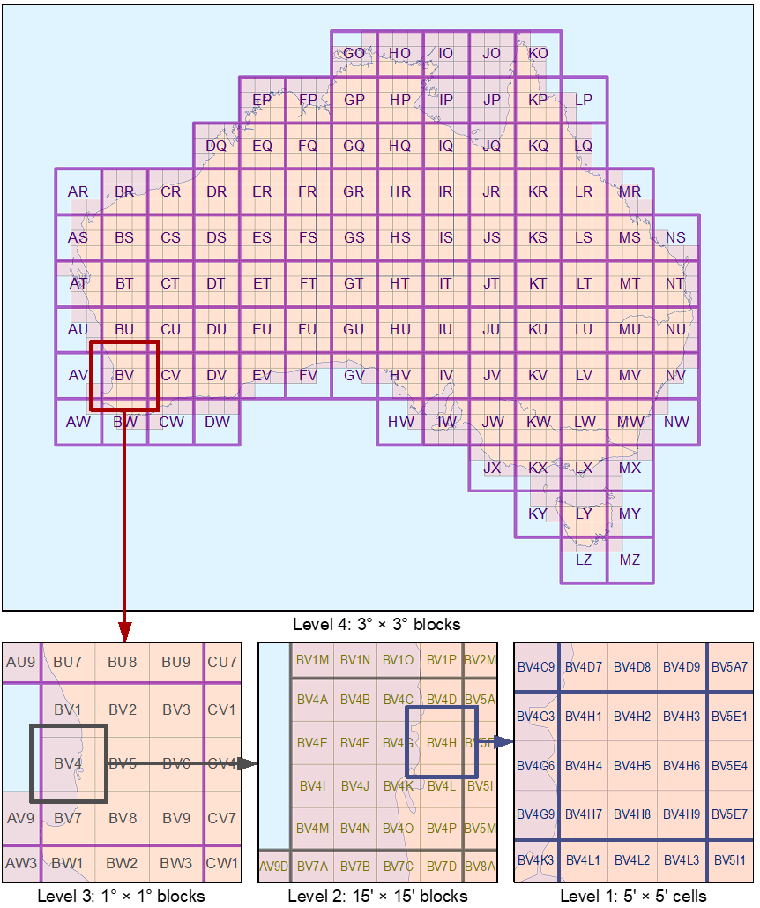

HCIS levels

|  |  |
| --- | --- |
| **Level** | **Description** |
| 4 | The highest level in the hierarchy is formed by grouping cells into blocks 3° east to west by 3° north to south, commencing at the westernmost and northernmost edges of the ASMG outer boundary, respectively.[8]  Each block is assigned a two-letter identifier, with the first letter in the range A–N according to the block’s position from the westernmost edge of the ASMG, and the second letter in the range O–Z according to the block’s position from the northernmost edge of the ASMG.  Blocks not completely within the ASMG outer boundary (for example, the block with identifier AR) are defined only for the purpose of providing identifier structure to blocks at lower levels in the hierarchy, and their identifiers are not valid in area descriptions. |
| 3 | Each Level 4 block of cells is subdivided into blocks 1° east to west by 1° north to south, commencing at the westernmost and northernmost edges of the Level 4 block, respectively.  Each block is assigned an identifier composed of the identifier of the Level 4 block and a numeric suffix.  The numeric suffix is in the range 1–9, assigned sequentially from left to right, and top to bottom.  Blocks not within the ASMG outer boundary (for example, the block with identifier AR1) are not valid in area descriptions. |
| 2 | Each valid Level 3 block of cells is subdivided into blocks 15’ east to west by 15’ north to south, commencing at the westernmost and northernmost edges of the Level 3 block, respectively.  Each block is assigned an identifier composed of the identifier of the Level 3 block and an alphabetic suffix.  The alphabetic suffix is in the range A–P, assigned sequentially from left to right, and top to bottom. |
| 1 | Each five-minute of arc cell is assigned an identifier composed of the identifier of the Level 2 block that encloses it and a numeric suffix.  The numeric suffix is in the range 1–9, assigned sequentially from left to right, and top to bottom according to the cell’s position within the Level 2 block. |

# Attachment F—Working example of a sample licence

Table 5 and Figure 3 demonstrate the way in which HCIS information appears in a sample licence for an area within Adelaide.

**Part 3—Geographic area**

For core condition 2, the area within which operation of radiocommunications devices is authorised by this licence is, with respect to the HCIS in the ASMG, as follows:

HCIS for example area

|  |
| --- |
| **HCIS identifiers** |
| IW3J, IW3K, IW3L, IW3N, IW3O, IW3P, IW6B, IW6C, IW6D, IW6F, IW6G, IW6H, IW3E5, IW3E6, IW3E8, IW3E9, IW3F4, IW3F5, IW3F6, IW3F7, IW3F8, IW3F9, IW3G4, IW3G5, IW3G6, IW3G7, IW3G8, IW3G9, IW3H4, IW3H5, IW3H6, IW3H7, IW3H8, IW3H9, IW3I2, IW3I3, IW3I5, IW3I6, IW3I8, IW3I9, IW3M2, IW3M3, IW3M5, IW3M6, IW3M8, IW3M9, IW6A2, IW6A3, IW6A5, IW6A6, IW6A8, IW6A9, IW6E2, IW6E3, IW6E5, IW6E6, IW6E8, IW6E9, JW1E4, JW1E7, JW1I1, JW1I4, JW1I7, JW1M1, JW1M4. |

HCIS—Map of example area

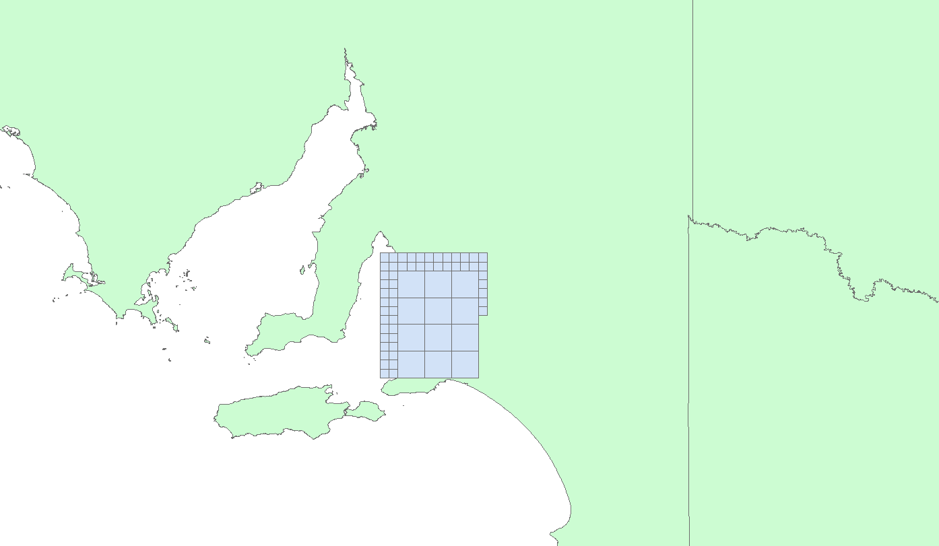

# Attachment G—The extended ASMG

The ASMG recognises geographic areas as small as 5 × 5 minutes of arc, which is approximately 9 km square. The ASMG assists in spectrum licensing where it is difficult to describe smaller geographic areas.

However, there are other licensing purposes, especially at mmWave and higher frequencies, where it would be advantageous to be able to describe much smaller areas. The area-wide apparatus licence type, intended to be used in the non-spectrum licensed parts of the 26 GHz and 28 GHz bands, is one example.[9]

This attachment describes an extension of the grid concept for these smaller areas—down to a grid resolution of approximately 500 m × 500 m. It is important to note that there are no changes to the outer boundary or any other details of the ASMG—this extension is only subdividing the existing ASMG Level 1 cells.

This attachment also describes an extension to the ASMG’s Hierarchical Cell Identifier Scheme (HCIS) to provide HCIS identifiers for cells in the additional grid levels subdivided from the ASMG.

### Extending the ASMG by subdivision

To reach the target of the smallest grid cells being approximately 500 m × 500 m, two grid levels below the ASMG’s Level 1 will be required:

1. Level 0, with each ASMG Level 1 cell subdivided into 25 cells each 1 × 1 minutes of arc (approximately 1.8 km × 1.8 km)
2. Level 00, with each Level 0 cell subdivided into 12 cells each 20 × 15 seconds of arc (approximately 608 m × 463 m at the northern edge of the ASMG, approximately 444 m × 463 m at the southern edge of the ASMG).

The Level 00 cells are not square in geographic coordinate terms because at these cell sizes, the cell width (west to east dimension) becomes substantially smaller (in linear coordinate terms) than the nominal target of 500 m, particularly in the southern half of the ASMG.

### Extending the HCIS to the ASMG subdivisions

The HCIS is described in Attachment E of this document.

The additional levels subdivided from the ASMG are described over in Table 6, which should be read as adding rows to Table 4 in Attachment E*.* An illustration of these additional HCIS levels is at Figure 4.

HCIS extension levels

|  |  |
| --- | --- |
| **Level** | **Description** |
| 0 | Each valid Level 1 cell is subdivided into cells 1’ east to west by 1’ north to south, commencing at the westernmost and northernmost edges of the Level 1 cell, respectively.  Each subdivided cell is assigned an identifier composed of the identifier of the Level 1 cell that encloses it and an alphabetic suffix.  The alphabetic suffix is in the range A–Y, assigned sequentially from left to right, and top to bottom, according to the cell’s position within the Level 1 cell. |
| 00 | Each valid Level 0 cell is subdivided into cells 20” east to west by 15” north to south, commencing at the westernmost and northernmost edges of the Level 0 cell, respectively.  Each subdivided cell is assigned an identifier composed of the identifier of the Level 0 cell that encloses it and an alphabetic suffix.  The alphabetic suffix is in the range A–L, assigned sequentially from left to right, and top to bottom, according to the cell’s position within the Level 0 cell. |

Illustration of the extended HCIS

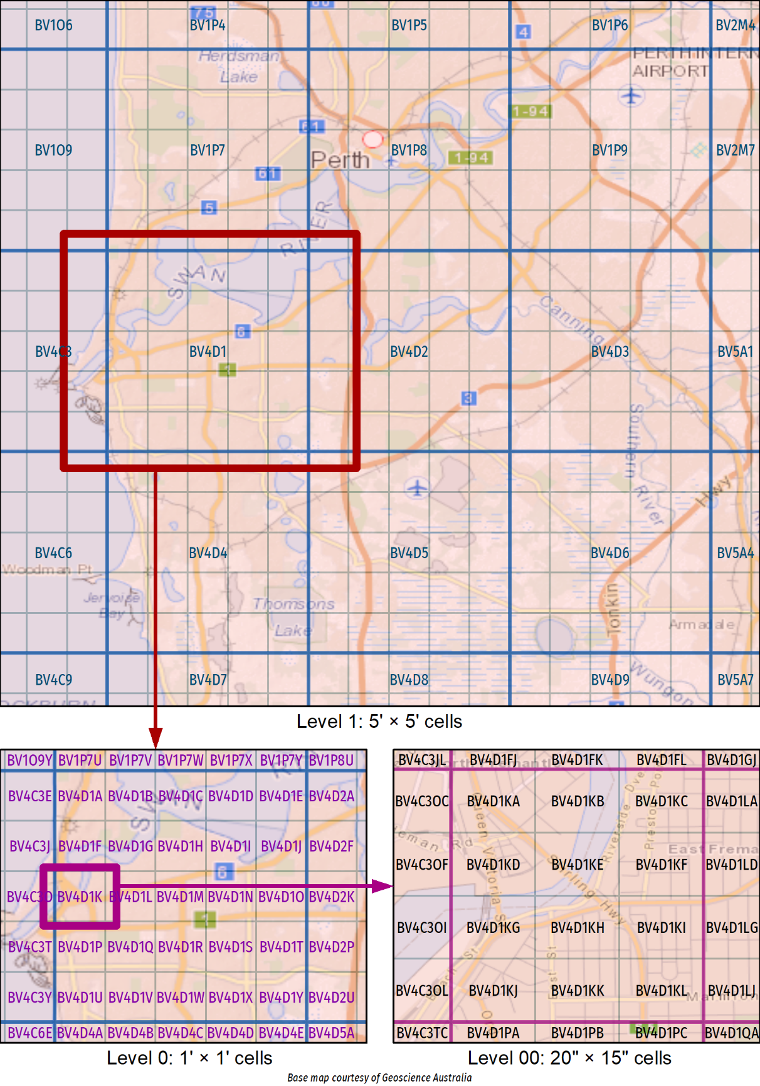

1. For the purposes of this paper, ‘spectrum map grid’ applies broadly to both the old SMG and the new ASMG.
2. In some cases, geographic areas of approximately 90,000 square km were the minimum area that could be traded.
3. The grid coordinates derived from a Universal Transverse Mercator projection of the AGD66 coordinates, using the Australian National Spheroid, is known as the Australian Map Grid 1966 (AMG66).
4. The UTM grid coordinate set based on GDA94 is known as the Map Grid of Australia 1994 (MGA94).
5. See <https://www.icsm.gov.au/>.
6. *Geocentric Datum of Australia Technical Manual* (version 2.4), ISBN 0-9579951-0-5, <https://www.icsm.gov.au/publications/gda94-technical-manual>.
7. *Geocentric Datum of Australia 2020 Technical Manual* (version 1.3 or later), <https://www.icsm.gov.au/gda2020-and-gda94-technical-manuals>.
8. The westernmost edge is 112° E and the northernmost edge is 10° S (AGD66).
9. Further information on the area-wide apparatus licences is available on the [ACMA website](https://www.acma.gov.au/area-wide-apparatus-licence).