Exploring the future use of the   
1880–1920 MHz band

Discussion paper

NOVEMBER 2021

UPDATED 21 JANUARY 2022

Canberra

Red Building   
Benjamin Offices  
Chan Street   
Belconnen ACT

PO Box 78  
Belconnen ACT 2616

T +61 2 6219 5555  
F +61 2 6219 5353

Melbourne

Level 32   
Melbourne Central Tower  
360 Elizabeth Street   
Melbourne VIC

PO Box 13112  
Law Courts   
Melbourne VIC 8010

T +61 3 9963 6800  
F +61 3 9963 6899

Sydney

Level 5   
The Bay Centre  
65 Pirrama Road   
Pyrmont NSW

PO Box Q500  
Queen Victoria Building   
NSW 1230

T +61 2 9334 7700 or 1800 226 667  
F +61 2 9334 7799

Copyright notice

[Creative Commons logo](http://i.creativecommons.org/l/by/3.0/88x31.png)

<https://creativecommons.org/licenses/by/4.0/>

With the exception of coats of arms, logos, emblems, images, other third-party material or devices protected by a trademark, this content is made available under the terms of the Creative Commons Attribution 4.0 International (CC BY 4.0) licence.

We request attribution as © Commonwealth of Australia (Australian Communications and Media Authority) 2021.

All other rights are reserved.

The Australian Communications and Media Authority has undertaken reasonable enquiries to identify material owned by third parties and secure permission for its reproduction. Permission may need to be obtained from third parties to re-use their material.

Written enquiries may be sent to:

Manager, Editorial Services  
PO Box 13112  
Law Courts  
Melbourne VIC 8010  
Email: [info@acma.gov.au](mailto:info@acma.gov.au)

Executive summary 1

Issues for comment 3

Introduction 4

Purpose 4

Scope 4

Legislative and policy environment 4

Case for action 7

Current domestic arrangements 8

Overview 8

Point-to-point services 9

Point-to-multipoint services 12

Cordless telecommunications services 15

[Adjacent-band spectrum-licensed and PMTS B and C   
apparatus-licensed services 16](#_Toc87534280)

Low interference potential devices (LIPD) 18

Australian Radio Quiet Zone Western Australia 18

Arrangements and technology trends in other countries 20

International Telecommunication Union (ITU) 20

European Union (EU) 21

Regulator approaches in other countries 22

Technology developments 22

Domestic considerations 26

DECT and DECT-2020 NR 26

Point-to-point 26

Wireless broadband services 26

Preliminary coexistence considerations 28

In-band services 28

Adjacent band services 28

Band planning scenarios 30

Scenario 1: Single service/application use of entire band 30

Scenario 2: All services/applications with dedicated, exclusive spectrum 31

Scenario 3: Geographic separation of services 31

Scenario 4: Sharing of spectrum by services/applications 32

Scenario 5: Combination or hybrid approach of other scenarios 32

Invitation to comment 34

Making a submission 34

Acronym list 35

Executive summary

There has been increasing interest in the 1880–1920 MHz band (referred to as the 1.9 GHz band) by current and potential new users domestically and internationally. Consequently, the ACMA considers a review of the band is required and is interested in views on existing and emerging uses in the band.

The 1.9 GHz band is allocated in the [Australian Radiofrequency Spectrum Plan 2021](https://www.legislation.gov.au/Details/F2021L00617) (ARSP) to fixed and mobile services on a primary basis. There are apparatus licensing arrangements in the 1900–1920 MHz frequency range for point-to-multipoint services on a primary basis and point-to-point services on a secondary basis, in regional and remote areas. In the 1880–1900 MHz frequency range, the use of cordless telecommunications systems (CTS) including digital enhanced cordless telecommunications (DECT) and the Personal Handy-phone System (PHS) is authorised under the [Radiocommunications (Cordless Communications Devices) Class Licence 2014](https://www.legislation.gov.au/Details/F2021C00645).

Before October 2017, the 1900–1920 MHz frequency range in metropolitan areas was subject to spectrum licensing. At licence expiry, licence holders did not seek renewal. Consequently, the frequency range was no longer allocated for spectrum licensing, with [Embargo 76](https://acmagovau-my.sharepoint.com/personal/prasanna_sooriyaaratchi_acma_gov_au/Documents/Downloads/Embargo-76-15112019.docx?web=1) put in place to preserve future planning options in metropolitan areas while making the band available elsewhere.

DECT[1] is a local area wireless technology used predominantly in the 1.9 GHz band and widely adopted for cordless phones as well as wireless microphones and headset use. Recent developments, including the standardisation of [DECT](https://www.etsi.org/committee/dect)-2020 new radio (DECT-2020 NR), the establishment of [MulteFire](https://www.mfa-tech.org/) technology, and the European review of 1900–1910 MHz for Future Railway Mobile Communication Systems (FMRCS), which are all driving increasing interest in the band. Domestically, there is also some demand for apparatus-licensed spectrum for fixed and mobile wireless broadband uses.

The 1900–1920 MHz frequency range is identified for International Mobile Telecommunications (IMT) in the International Telecommunication Union (ITU) Radio Regulations. Current domestic use for wireless broadband (WBB) services has been low, although there has been some recent increase in activity in the band. There is, however, substantial WBB use of spectrum licences in the adjacent bands below 1880 MHz and above 1920 MHz. This may indicate that the current Embargo 76 is masking potential demand. Additionally, the number of WBB devices available for this specific band has increased rapidly since 2019.

In response to these developments, the ACMA moved the band into the ‘initial investigation’ phase of replanning in its work program in the five-year spectrum outlook ([FYSO](https://www.acma.gov.au/five-year-spectrum-outlook)).

This paper seeks feedback to help inform us whether there is support for current or alternative uses of the band. To aid discussion, the following possible planning scenarios for the band are presented, including a consideration of potential coexistence issues:

Scenario 1: Use of the whole band by a single technology, such as DECT or wireless broadband.

Scenario 2: Dedicated frequency segments for multiple technologies, such as DECT or wireless broadband.

Scenario 3: Dedicated frequency segments for multiple technologies but with some geographical restriction for some, such as remote only, for point-to-point services.

Scenario 4: Sharing of frequency segments by multiple technologies.

Scenario 5: Hybrid approaches of the other scenarios involving geographic restriction but some sharing.

While we have yet to form any views on preferred long-term arrangements in the band, these scenarios are intended to promote a discussion about the relevant issues to inform the future of the band.

Submissions to this discussion paper will help us assess whether there is a case for potentially changing arrangements in the 1.9 GHz band, including whether to progress the band to the ‘preliminary replanning’ stage of the ACMA replanning process. If progressed, we will consult on detailed planning options for the band before any regulatory decisions are made.

# Issues for comment

We welcome comments – general or specific – from interested stakeholders on any of the issues raised in this paper. Questions appear in relevant sections throughout the paper and are summarised here. We specifically invite comments on:

1. What is the relevance of the Personal Handy-phone System (PHS) and should this use be retained?
2. What is the interest in the use of new technologies to provide a service?
3. How much spectrum is required to provide the service?
4. What interservice considerations need to be undertaken for the service to be deployed?
5. What are the deployment scenarios for the service?
6. Are services still using DECT or are they transitioning to DECT-2020 NR?
7. Are there any applicable coexistence scenarios not identified? Are there any scenarios that are unlikely to be practically achievable (and hence the associated planning scenario should be discounted), or are there any that are readily achieved?
8. What are possible planning scenarios and industry views on the overall future use of the 1.9 GHz band and its services:
9. How much spectrum is required (distinguishing between the minimum viable and desirable) to provide the service?
10. Is there a clear geographical delineation – for example, metropolitan or regional – for the service?
11. Is there or will there be equipment readily available for the service?

# Introduction

## Purpose

In Australia, the 1880–1920 MHz band (referred to as the 1.9 GHz band) is currently used by a mixture of services and applications, including cordless telecommunications services, point-to-multipoint services, and point-to-point services.

There has been interest in Australia in a range of new technology developments, including improved digital enhanced cordless telecommunications (DECT), MulteFire and the Future Railway Mobile Communication Systems (FMRCS). In addition, there is interest in accessing more apparatus-licensed spectrum for local area fixed and mobile wireless broadband services. Consequently, the ACMA is reviewing the current arrangements in this band to identify the uses that best promote the long-term public interest derived from use of the spectrum.

## Scope

The paper considers the future use of the 1.9 GHz band. While this paper outlines scenarios for feedback, it does not propose any particular planning option. Feedback to this discussion paper will inform our consideration of next steps, including whether there is a case to change arrangements in the band. If so, we will consult fully on possible replanning options before any changes are made to planning and access arrangements in the band.

## Legislative and policy environment

Managing spectrum efficiently and effectively for the benefit of all Australians is a key priority for the ACMA.[2]

### Guiding legislation and policy

The ACMA’s decisions are guided by the object of the [*Radiocommunications Act 1992*](https://www.legislation.gov.au/Details/C2019C00262) (the Act) to promote the long‑term public interest derived from the use of the spectrum by managing the spectrum in a manner that:

1. facilitates the efficient planning, allocation and use of the spectrum
2. facilitates the use of the spectrum for:
   1. commercial purposes
   2. defence, national security and other non‑commercial purposes (including public safety and community purposes)
3. supports the communications policy objectives of the Australian Government.

Several communications policy objectives relevant to possible future replanning considerations in this band have been identified.

The government’s [Digital Economy Strategy](https://digitaleconomy.pmc.gov.au/sites/default/files/2021-07/digital-economy-strategy.pdf), released in 2021, sets out how Australia will secure its future as a modern and leading digital economy and society by 2030. The strategy identified that digital infrastructure was a key enabler, making it possible to access the digital world.

[Australia’s Tech Future](https://www.industry.gov.au/news-media/australias-tech-future), released in December 2018, sets out the government’s strategy for Australia’s technology future. The strategy presents a vision that Australians have access to world-class digital infrastructure in their personal and working lives, with the following outcomes:

* Australians have reliable, secure and affordable access to high-speed broadband and mobile communications.
* Australia’s communications sector is sustainable and competitive.
* Australia’s world-leading navigation and positioning infrastructure supports emerging technologies.
* Australia’s researchers have the specialised high-performing computing and data infrastructure needed to stay ahead in everything from health to agriculture.

### Licensing arrangements

There are currently 3 licence types available to authorise access to spectrum – spectrum, apparatus and class. Each of these have differing characteristics regarding the allocation method commonly used, approach to pricing, associated level of exclusivity and interference environment. These approaches influence how options can be developed and implemented.

On 17 June 2021, amendments to the Actmade by the *Radiocommunications Legislation Amendment (Reform and Modernisation) Act 2020* (the Modernisation Act) came into force. The amendments allow for greater flexibility for the ACMA to manage spectrum and greater clarity for licensees. More information on the amendments can be found on the [ACMA website](https://www.acma.gov.au/radcomms-licensing-and-allocation-reform). We have developed an [overview](https://www.acma.gov.au/publications/2021-03/rules/our-approach-radcomms-licensing-and-allocation) of our approach to implementing the changes to licensing and allocation.

A spectrum licence authorises the operation of devices within a defined frequency range and geographic area, with a high degree of exclusivity. The geographic area can vary in size and can comprise the entire country. Spectrum licences are usually initially allocated by an auction and have historically been utilised for most bands used to deploy commercial mobile broadband networks. Spectrum licences may be allocated for up to 20 years.

An inherent feature of spectrum licensing is technological flexibility – that is, the licence conditions and associated technical framework, while usually optimised for an expected technology, specify generic technical conditions[3] and do not usually expressly mandate or limit specific technologies or services. This allows a licensee to deploy any technology that complies with the conditions of the licence. It is up to the licensee to manage interference between their radiocommunications devices (note that the adoption of international standards within the technical framework mitigates the potential for interference between devices). Spectrum licences are more conducive to secondary trading than apparatus licences, due to design features such as their longer tenure and their ability to be sub-divided.

An apparatus licence authorises the use of a radiocommunications device (or group of devices) operating under a specific radiocommunications service type, in a specific frequency range, and traditionally at one or more specific geographic locations for a period of up to 20 years. They are typically issued ‘over-the-counter’ in accordance with coordination policies developed by the ACMA. The ACMA [imposes cost recovery](https://www.acma.gov.au/fees-apparatus-licences) charges, and separate legislation imposes taxes, for apparatus licences. These amounts cover our costs and give licensees incentive to use spectrum efficiently.

The ACMA has also created a new apparatus licence type – the [area-wide apparatus licence](https://www.acma.gov.au/area-wide-apparatus-licence). This authorises the operation of one or more radiocommunications devices within a defined geographic area within frequencies specified in the licence, subject to the conditions included in the licence. This licence type is scalable, enabling its use for authorising different-sized geographic areas and bandwidths. Unlike existing apparatus licence types, which typically align with specific uses and purposes, the area-wide apparatus licence is capable of authorising a variety of services, uses, applications and technologies.

Class licences are a standing authorisation to access spectrum without the need to apply to the ACMA for an individual licence (or to incur any taxes or charges), subject to the conditions of the relevant class licence. These conditions include technical and geographic matters and/or pertain to the type of use or class of user.

### Spectrum planning options development

We are guided in our spectrum management functions by the object of the Act, set out in the *Guiding legislation and policy* section above. A balanced application of regulatory and market mechanisms is often necessary to achieve key elements of the object of the Act, in particular, maximising the overall public benefit from the efficient allocation and use of the radiofrequency spectrum, and meeting the government’s policy objectives.

Figure 1 outlines the approach the ACMA proposes to use in reviewing and developing the 1.9 GHz band in this paper and possible future papers. We will continue to apply this general approach as we consider the responses to this paper.

Spectrum planning options framework

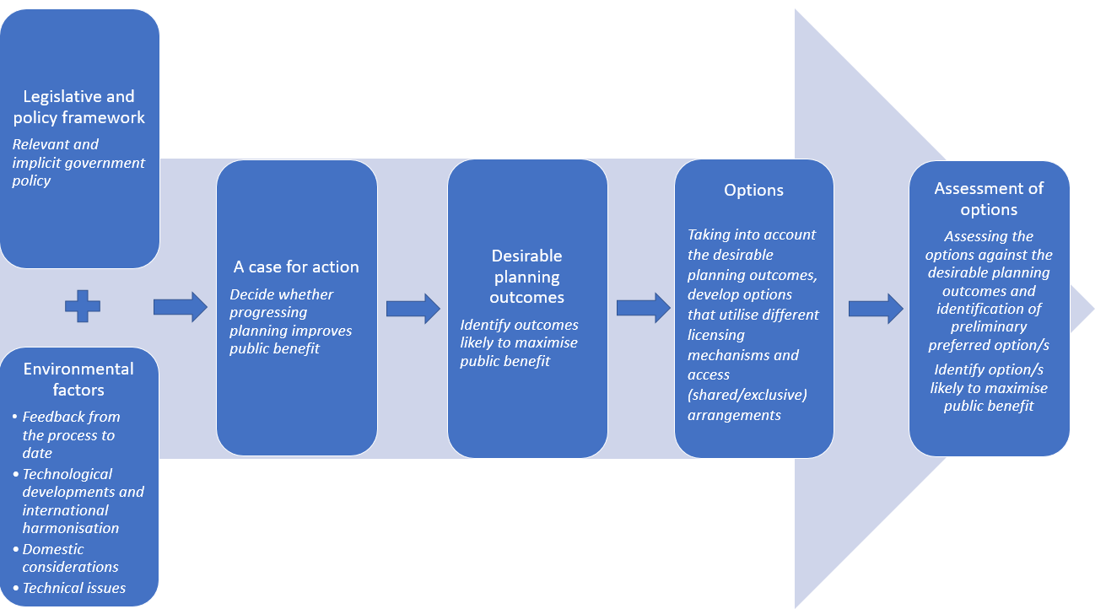

## Case for action

Spectrum arrangements in the 1.9 GHz band have their origin in the [1.9 GHz band plan](https://www.legislation.gov.au/Series/F2005B01374), repealed in 2015, established in 1996 to support the introduction of cordless telecommunications services in the 1880–1900 MHz frequency range in Australia. It supported the operation of cordless telecommunications services and ensured that no new licences were issued for fixed point-to-point links (which operated in the 1.9 GHz band at that time). While there have been amendments to the [cordless communications devices class licence](https://www.legislation.gov.au/Series/F2014L01800) that now supports the framework, the overall arrangements have not been reviewed since then.

Metropolitan areas of the 1900–1920 MHz band were spectrum licensed in 2000. However, when the licences expired in 2017, licensees did not seek to have them re-issued. While the band is identified internationally for IMT by the ITU, to date, domestic use for WBB services has been low.

Other recent international developments include standardisation work on DECT-2020[4] and the European review of the 1900–1910 MHz band for Future Railway Mobile Communication Systems (FRMCS).[5]

Submissions to the ACMA also supported a review of arrangements in the band. Feedback from the wireless microphone industry, including submissions to the [FYSO](https://www.acma.gov.au/consultations/2021-03/draft-five-year-spectrum-outlook-2021-26-consultation-102021) 2021–26 from the Australian Commercial & Entertainment Technologies Association, Shure, Jands and Sennheiser, indicated an interest in ensuring ongoing support for DECT in the 1880–1900 MHz frequency range and a possible expansion of arrangements into the 1900–1920 MHz band.

There is also interest, as supported by the Australasian Railway Association’s submission to the FYSO, in investigating possible use of the 1900–1910 MHz frequency range for FRMCS. They claim there are significant benefits that could be realised by the Australian rail industry by aligning with any European arrangements through its use.

The ACMA is also aware of an increasing interest from operators in accessing more apparatus-licensed spectrum for fixed and mobile wireless broadband services, noting technology developments in wireless broadband for business enterprise services operated by private entities within the confines of their own premises (generically referred to as ‘private networks’) in the 1.9 GHz band.

Given the evolving technologies and use cases in the band, we are of the preliminary view that the current regulatory arrangements in the band are unlikely to now align with the spectrum uses and users that best promote the long-term public interest derived from use of the spectrum. Consequently, there is a case for arrangements to be reviewed and potentially changed.

# Current domestic arrangements

## Overview

The 1.9 GHz band is allocated in the [Australian Radiofrequency Spectrum Plan 2021](https://www.legislation.gov.au/Details/F2021L00617) (ARSP) to fixed and mobile services on a primary basis.

In Australia, arrangements are currently in place to support the following uses in, and adjacent to, the 1.9 GHz band:

* In band:

fixed point-to-point (PTP) services, as detailed in in the [1900-1920 MHz Frequency Band Plan 2012](https://www.legislation.gov.au/Details/F2012L00733) and [RALI FX 3](https://www.acma.gov.au/theACMA/rali-fx3-microwave-fixed-services-frequency-coordination)

point-to-multipoint (PMP) services, as detailed in the [1900-1920 MHz Frequency Band Plan 2012](https://www.legislation.gov.au/Details/F2012L00733) and [RALI FX19](https://www.acma.gov.au/publications/2019-09/instruction/rali-fx19-broadband-wireless-access-1900-1920-and-3575-3700-mhz-bands)

cordless telecommunications services (CTS) technologies (including DECT and Personal Handy-phone (PHS) systems), under the [Radiocommunications (Cordless Communications Devices) Class Licence 2014](https://www.legislation.gov.au/Details/F2021C00645).

Adjacent bands:

Public Mobile Telecommunications Service (PMTS Class B and Class C), as detailed in [RALI MS33](https://www.acma.gov.au/publications/2019-08/instruction/rali-ms33-frequency-coordination-and-licensing-procedures-apparatus-licensed-pts-2-ghz-bands) and [RALI MS 34](https://www.acma.gov.au/sites/default/files/2019-08/RALI-MS34-PTS.docx)

1800 MHz spectrum licences as defined in the [1800 MHz technical framework](https://www.acma.gov.au/1800-mhz-technical-framework)

2 GHz spectrum licences as defined in the [2 GHz technical framework](https://www.acma.gov.au/2-ghz-technical-framework).

An overview of these arrangements is provided in Figure 2.

Illustration of current arrangements in and adjacent to   
1880–1920 MHz

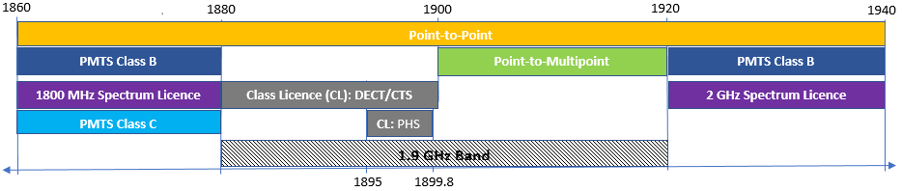

A numerical breakdown of apparatus-licensed services in the 1.9 GHz band and the 10 MHz adjacent to the 1.9 GHz band is provided in Table 1. There are 122 point-to-multipoint and 44 point-to-point assignments in the 1.9 GHz band. There are many spectrum-licensed PMTS Class B and some PMTS Class C services in the 10 MHz adjacent to the 1.9 GHz band. There are currently no scientific-assigned licences in the 1.9 GHz band. As the ACMA does not record the number and location of devices operating under class licences, we cannot provide information about the number of class-licensed DECT devices that have been deployed in the 1.9 GHz band, though the ACMA is aware that many DECT devices remain commercially available in Australia.

Number of apparatus-licensed services between 1870–1930 MHz

|  |  |  |  |
| --- | --- | --- | --- |
| Service type | Number of assignments | | |
| 1870–1880 MHz | 1880–1920 MHz | 1920–1930 MHz |
| 1800 MHz spectrum licence | 3,987 | 0 | 0 |
| PMTS Class B | 252 | 0 | 1,088 |
| PMTS Class C | 3 | 0 | 0 |
| Point-to-point | 28 | 44 | 44 |
| Point-to-multipoint | 0 | 122 | 0 |
| 2 GHz spectrum licence | 0 | 0 | 20,987 |
| **Total** | **4,270** | **166** | **22,119** |

*Data taken from* [*RRL*](https://web.acma.gov.au/rrl/register_search.main_page) *as at 2 August 2021.*

## Point-to-point services

Point-to-point services in the 1.9 GHz band are generally used for low to medium capacity radio links by telecommunications operators and industries such as mining. [RALI FX3](https://www.acma.gov.au/publications/2019-09/instruction/rali-fx3-microwave-fixed-services) provides the planning guidelines for fixed point-to-point services. There are 2 fixed point-to-point channel plans – 1.8 GHz and 2.1 GHz – that overlap the 1.9 GHz band. Figure 3 provides an illustration of the various channelling arrangements.

Point-to-point channelling arrangements in 1880–1920 MHz

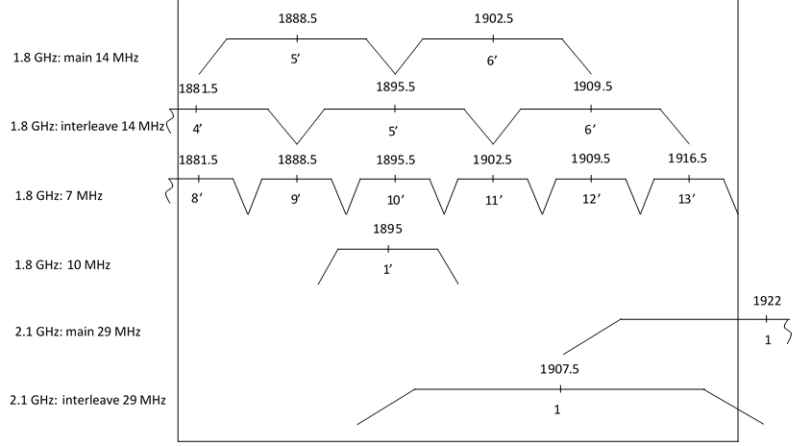

The use of the 1.9 GHz band by point-to-point services is restricted by the following:

[1.9 GHz spectrum arrangements](https://www.acma.gov.au/19-ghz-spectrum-arrangements) have been implemented to preserve the utility of the 1.9 GHz band for use by cordless telecommunications services. These arrangements prohibit the authorisation of new licences for other services to operate in the 1880 to 1900 MHz frequency range.

[Embargo 76](https://www.acma.gov.au/publications/2019-11/rules/embargo-76) applies to the 1900–1920 MHz band, restricting new apparatus licences for point-to-point services in metropolitan areas.

[1900–1920 MHz Frequency Band Plan 2012](https://www.legislation.gov.au/Details/F2012L00733) gives primary status to both fixed (point-to-multipoint) and mobile services, and secondary status to fixed (point-to-point) services in the 1900–1920 MHz band.

Consequently, only the 1900 to 1920 MHz portion of the 1.9 GHz band in regional and remote areas is available for new point-to-point fixed licences (on a secondary basis). Figure 4 provides an illustration of the general locations of the point-to-point services in Australia as at 2 August 2021. All the point-to-point assignments are in regional and remote areas, as expected.

Map of point-to-point (PTP) assignments in 1880–1920 MHz

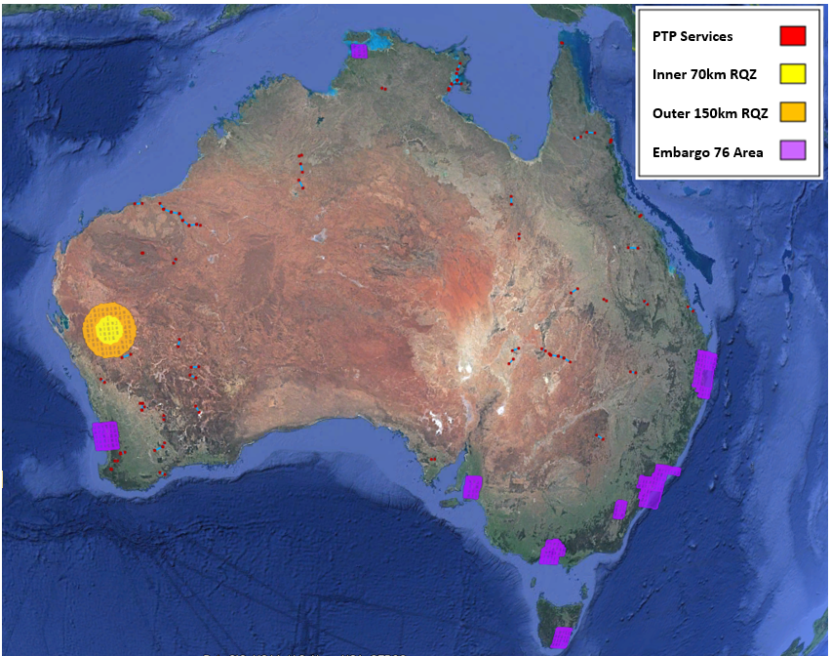

There are 44 point-to-point assignments in the 1.9 GHz band, 22 transmitters and 22 receivers.[6] For the 1.8 GHz band, there are 34 point-to-point assignments, consisting of 7 MHz assignments (10), 10 MHz assignments (2) and 14 MHz assignments (22).

For the 2.1 GHz band point-to-point assignments, there are 10 assignments overlapping the 1.9 GHz band and 44 assignments in the adjacent frequency range.

Table 2 provides a breakdown of the major licensees and Figure 5 shows the breakdown of assignments per channel. The majority of assignments in the 1.9 GHz band are in the 1900 to 1920 MHz range.

Point-to-point (PTP) assignments by licensees in the 1.9 GHz band

|  |  |  |  |
| --- | --- | --- | --- |
| **Licensee** | **Number of PTP assignments** | | |
| **1870**–**1880 MHz** | **1880**–**1920 MHz** | **1920**–**1930 MHz** |
| BHP Billiton Iron Ore Pty. Ltd. | - | 4 | - |
| Prime Television (Southern) Pty. Limited | - | - | 2 |
| Santos Limited | 2 | 4 | - |
| TEC Desert Pty Ltd and TEC Desert No.2 Ltd | - | 2 | - |
| Telstra Corporation Limited | 26 | 34 | 42 |

*Data taken from RRL as at 2 August 2021.

Point-to-point assignments per centre frequency in 1880–1920 MHz

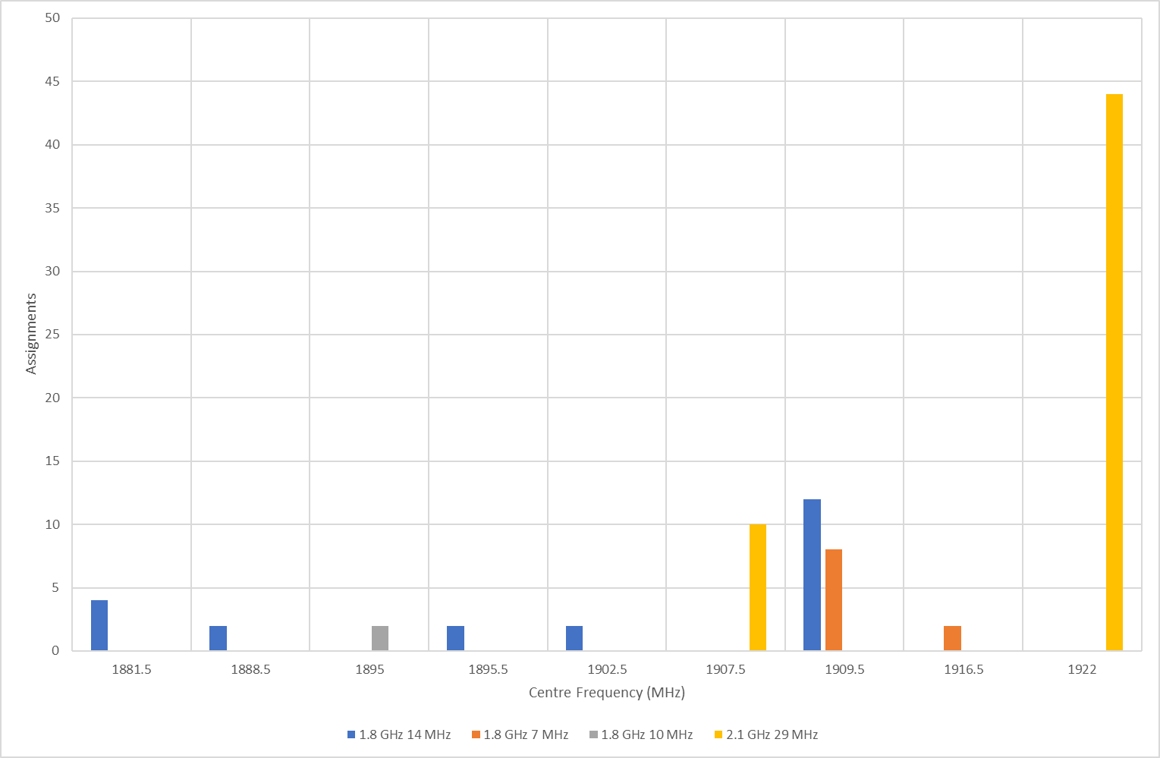

*Data taken from* [*RRL*](https://web.acma.gov.au/rrl/register_search.main_page) *as at 2 August 2021.*

Figure 6 shows the year-on-year trend for point-to-point assignments for the last 7 years. There was a steady decline in point-to-point assignments from 2015 to 2017. From 2018, the number of point-to-point assignments has stayed relatively constant at around 50.

Seven-year trend for point-to-point assignments

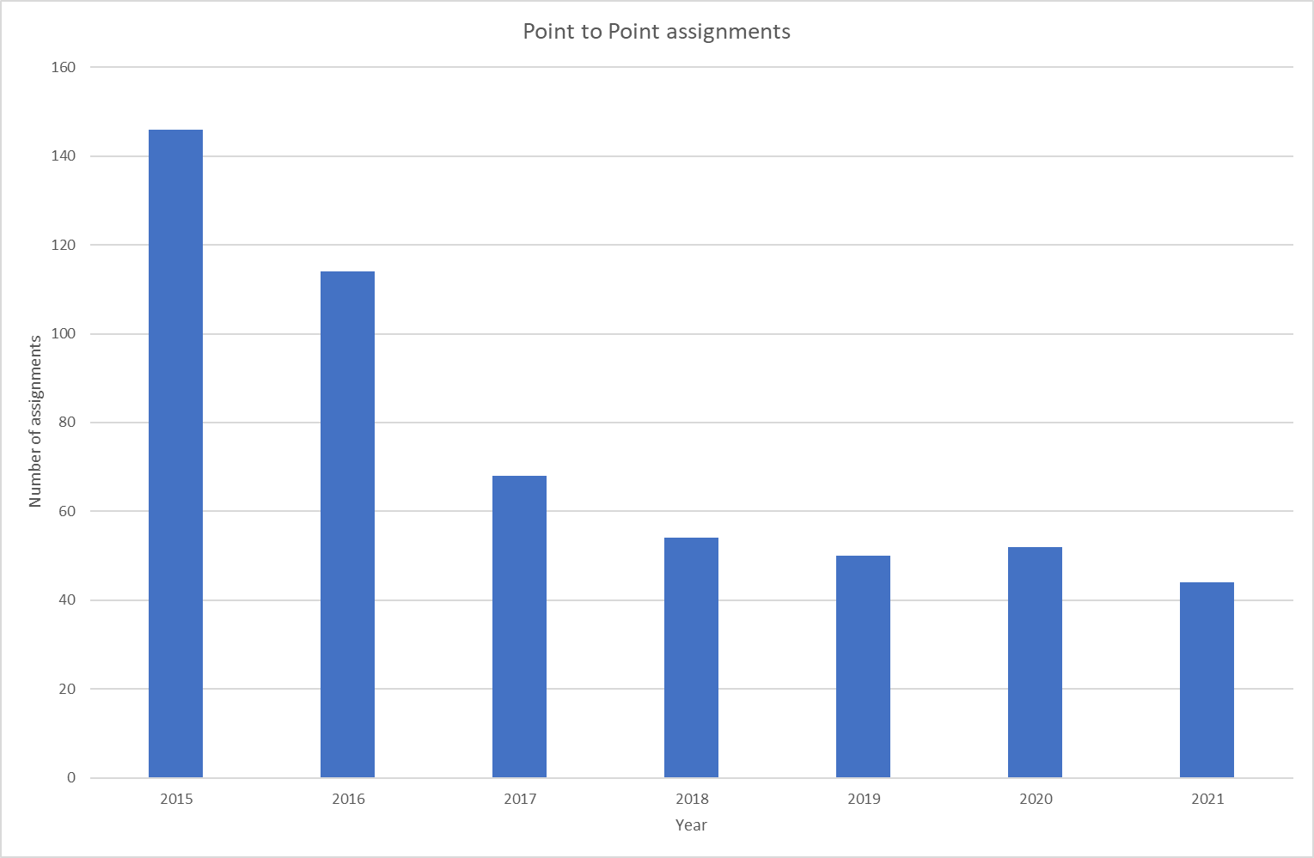

*Data taken from* [*RRL*](https://web.acma.gov.au/rrl/register_search.main_page) *as at first Monday of August for each year.*

## Point-to-multipoint services

Point-to-multipoint services in the 1.9 GHz band are used in Australia predominantly by regional operators to provide wireless broadband services for both public and private network applications. [RALI FX19](https://www.acma.gov.au/publications/2019-09/instruction/rali-fx19-broadband-wireless-access-1900-1920-and-3575-3700-mhz-bands) provides the planning guidelines for fixed point-to-multipoint services in the 1900–1920 MHz frequency range. Point-to-multipoint services have 3 different bandwidth options: 5 MHz, 10 MHz and 20 MHz. RALI FX19 does not prescribe a set channelling arrangement for these bandwidth options. Instead, it specifies an assignment priority based on existing assignments, number of channels and channel bandwidth required.

Like point-to-point services, [Embargo 76](https://www.acma.gov.au/publications/2019-11/rules/embargo-76) restricts new apparatus licences for point-to-multipoint services in metropolitan areas. Figure 7 shows the general location of the point-to-multipoint services in Australia as at 2 August 2021. All the point-to-point assignments are in regional and remote areas, as expected given the current regulatory framework.

Map of point-to-multipoint assignments in 1900–1920 MHz

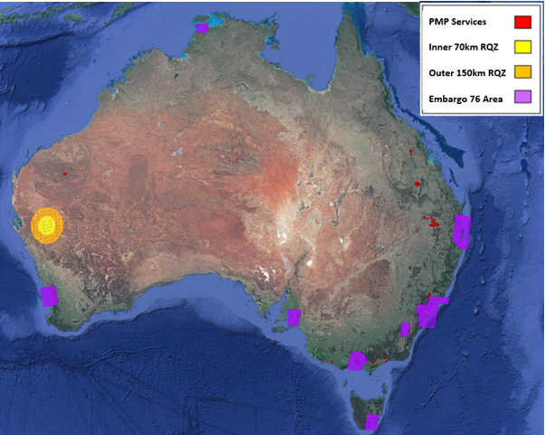

There are 122 point-to-multipoint assignments[7] in the 1.9 GHz band. Of these, 18 assignments have a 5 MHz channel bandwidth, while the rest of the 104 assignments have a 10 MHz channel bandwidth. Table 3 provides a breakdown of the major licensees and Figure 8 shows the breakdown of assignments per channel.

Point-to-multipoint licensees in the 1.9 GHz band

|  |  |
| --- | --- |
| Location | Number of PMP assignments |
| Arrow Energy Ltd | 6 |
| Aussie Broadband Pty Ltd | 12 |
| Australia Pacific LNG Pty Limited | 44 |
| BHP Billiton Iron Ore Pty. Ltd. | 4 |
| Bm Alliance Coal Operations Pty Limited | 14 |
| HV Operations Pty Ltd | 10 |
| Kalgoorlie Consolidated Gold Mines Pty Ltd | 6 |
| Peabody Energy Australia PCI (C&M Management) Pty Ltd | 26 |

Data taken from RRL as at 2 August 2021.

Point-to-multipoint assignments per centre frequency in 1900–1920 MHz

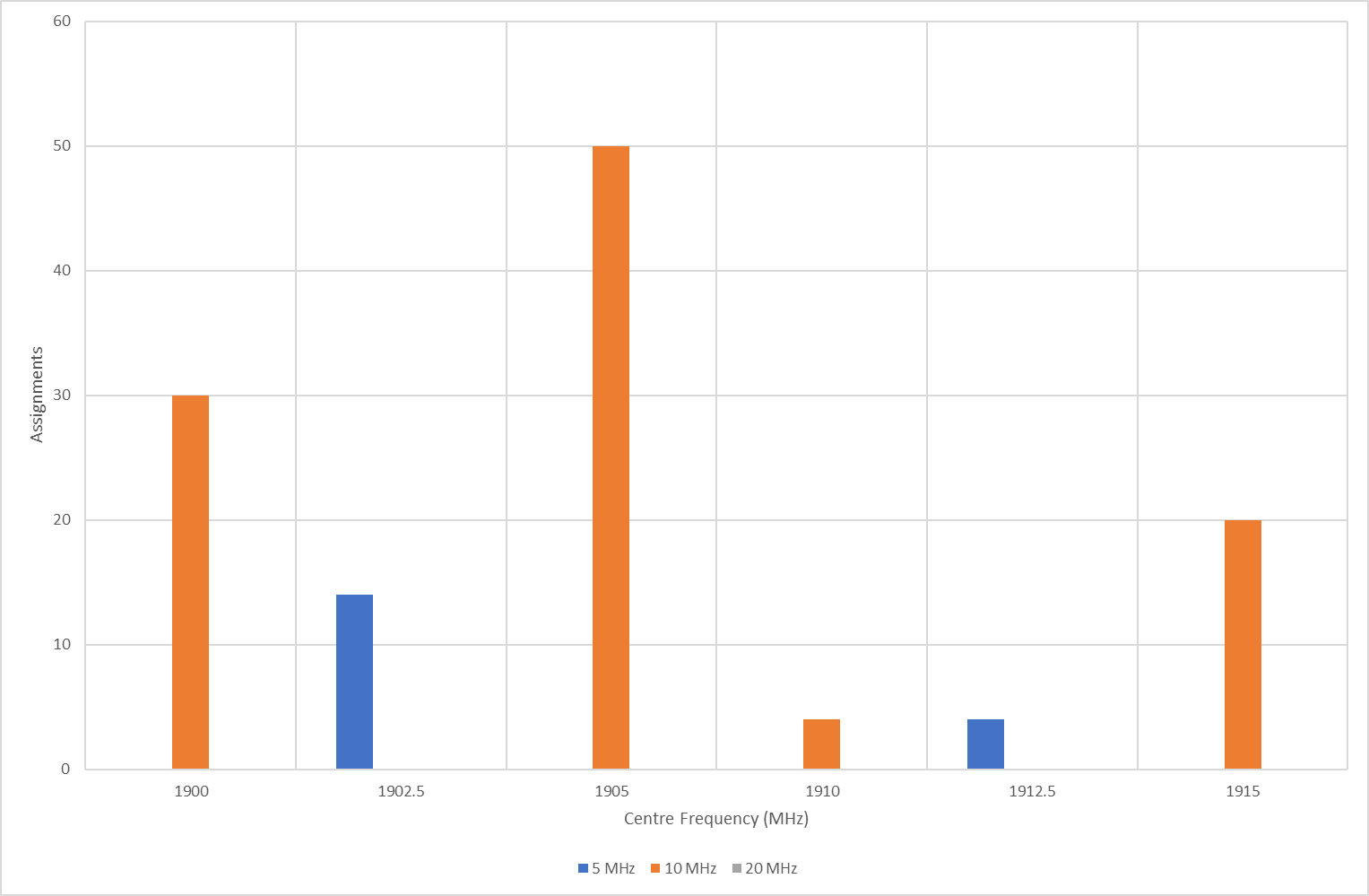

*Data taken from* [*RRL*](https://web.acma.gov.au/rrl/register_search.main_page) *as at 2 August 2021.*

Figure 9 shows the year-on-year trend for point-to-multipoint assignments for the last 7 years. There was a steady decline in point-to-multipoint assignments from 2015 to 2018. From 2018, the number of point-to-multipoint assignments has steadily increased. This increase has been driven by mining and energy companies using point-to-multipoint services for private networks in regional and remote areas.

Seven-year trend for point-to-multipoint assignments

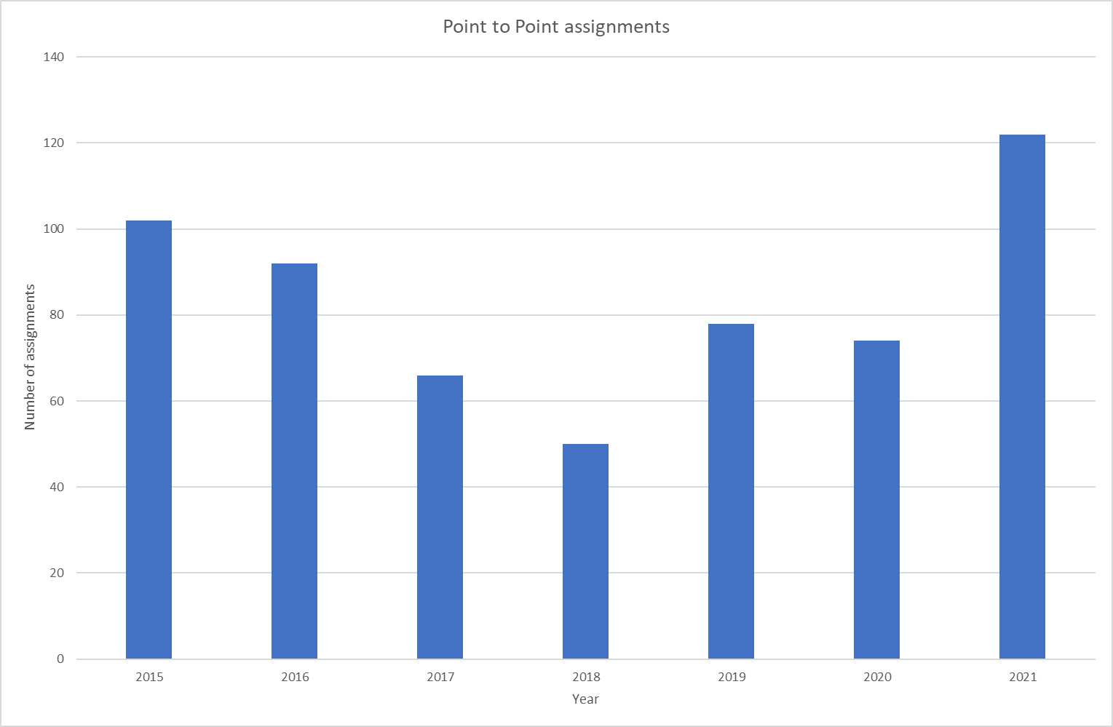

*Data taken from* [*RRL*](https://web.acma.gov.au/rrl/register_search.main_page) *as at first Monday of August for each year.*

## Cordless telecommunications services

These services are mostly cordless telephones used in both residential and commercial settings but can also include wireless microphones and headsets. The current arrangements in the 1880–1900 MHz range support the operation of cordless telecommunications services (CTS). The operation of these services is authorised under the [Radiocommunications (Cordless Communications Devices) Class Licence 2014](https://www.legislation.gov.au/Details/F2014L01800). These class licences do not require devices to be registered. Consequently, it is not possible to determine how many class-licensed devices there are and where they are deployed.

There are 2 technologies that are supported in the cordless communications devices class licence for use in the 1880–1920 MHz band. These are the:

**Personal Handy-phone System (PHS)**: The devices using the PHS are permitted to operate in the 1895–1899.8 MHz range.

**digital enhanced cordless telecommunications (DECT):** Devices using DECT may operate across the wider 1880–1900 MHz range and those devices must comply with the [Radiocommunications (Digital Cordless Communications Devices — DECT Devices) Standard 2017](https://www.legislation.gov.au/Details/F2017L01079).

**Issue for comment 1:**

What is the relevance of the Personal Handy-phone System (PHS) and should this use be retained?

## Adjacent-band spectrum-licensed and PMTS B and C apparatus-licensed services

There are spectrum-licensed bands either side of the 1.9 GHz band. The 1800 MHz spectrum licenced band (1710–1785 MHz and 1805–1880 MHz) is adjacent to the lower edge of the 1.9 GHz band, and the 2 GHz spectrum-licenced band is adjacent to the upper edge of the 1.9 GHz band.

Table 4 provides an analysis of the spectrum licensees in the [1800 MHz spectrum licensed band](https://www.legislation.gov.au/Details/F2017C01051). There is a total of 88,136 assignments, with 1,008 assignments having the upper edge of the channel bandwidth aligned with the 1880 MHz boundary. As the upper part of the band is used for base transmit, most of the recorded assignments are for use by radiocommunications transmitters.

Number of spectrum-licensed assignments between 1805–1880 MHz

|  |  |  |  |  |
| --- | --- | --- | --- | --- |
| Licensee | Number of assignments | | | |
| Total | Directly adjacent | Transmitters | Receivers |
| Optus Mobile Pty Limited | 20,379 | 256 | 20,356 | 23 |
| Telstra Corporation Limited | 28,761 | 0 | 28,761 | 0 |
| Vodafone Australia Pty Limited | 22,090 | 0 | 22,063 | 27 |
| Vodafone Hutchison Australia Pty Limited | 13,035 | 484 | 13,023 | 12 |
| Public Transport Authority of Western Australia | 25 | 13 | 25 | 0 |
| Queensland Rail Limited | 14 | 0 | 14 | 0 |
| Sydney Trains | 2,993 | 0 | 2,993 | 0 |
| TPG Internet Pty Ltd | 329 | 0 | 329 | 0 |
| Victorian Rail Track | 510 | 255 | 490 | 20 |
| **Total** | **88,136** | **1,008** | **88,054** | **82** |

*Data taken from* [*RRL*](https://web.acma.gov.au/rrl/register_search.main_page) *as at 2 August 2021.*

Table 5 provides an analysis of the spectrum licensees in the [2 GHz spectrum licensed band](https://www.legislation.gov.au/Details/F2015L00723). There is a total of 110,125 assignments, with 2,377 assignments having the lower edge of the channel bandwidth aligning with the 1920 MHz boundary. As the lower part of the band is used for base receive, the majority of the assignments are for use by radiocommunications receivers.

Number of spectrum-licensed assignments between 1920–1980 MHz

|  |  |  |  |  |
| --- | --- | --- | --- | --- |
| Licensee | Number of assignments | | | |
| Total | Directly adjacent | Transmitters | Receivers |
| Optus Mobile Pty Limited | 27,636 | 0 | 114 | 27,522 |
| Telstra 3G Spectrum Holdings Pty Ltd | 31,080 | 25 | 0 | 31,081 |
| Telstra Corporation Limited | 3,497 | 152 | 0 | 3,495 |
| Vodafone Australia Pty Limited | 25,268 | 0 | 0 | 25,268 |
| Vodafone Hutchison Australia Pty Limited | 22,644 | 2,200 | 0 | 22,644 |
| **Total** | **110,125** | **2,377** | **114** | **110,010** |

*Data taken from* [*RRL*](https://web.acma.gov.au/rrl/register_search.main_page) *as at 2 August 2021*

[RALI MS 34](https://www.acma.gov.au/sites/default/files/2019-08/RALI-MS34-PTS.docx) provides the planning guidelines for PMTS services in the adjacent 1805–1880 MHz band, and [RALI MS33](https://www.acma.gov.au/publications/2019-08/instruction/rali-ms33-frequency-coordination-and-licensing-procedures-apparatus-licensed-pts-2-ghz-bands) in the 1920–1980 MHz band. PMTS Class B licences operate in these spectrum licence frequencies in regional and remote areas outside of spectrum licence areas. As PMTS Class C licences are for aeronautical operation, they operate on an Australia-wide basis. Consequently, any changes in the 1880–1920 MHz band will need to consider coexistence with these services.

Table 6 provides an analysis of the PMTS Class B and C licensees in the 1805– 1880 MHz range and Table 7 provides a breakdown of the PMTS Class B and C licensees in the 1920–1980 MHz range.

Number of PMTS Class B and C assignments between 1805–1880 MHz

|  |  |  |  |  |
| --- | --- | --- | --- | --- |
| Licensee | Number of assignments | | | |
| Total | Directly adjacent | Transmitters | Receivers |
| BHP Billiton Iron Ore Pty. Ltd. | 145 | 59 | 145 | 0 |
| Pilbara Iron Company (Services) Pty Ltd | 144 | 0 | 144 | 0 |
| Roy Hill Holdings Pty Ltd | 106 | 86 | 106 | 0 |
| Challenge Networks Resources Pty Ltd | 87 | 10 | 87 | 0 |
| Other* | 228 | 75 | 227 | 1 |
| **Total** | **710** | **230** | **709** | **1** |

* There are 31 licensees, each having fewer than 50 assignments.

Data taken from [RRL](https://web.acma.gov.au/rrl/register_search.main_page) as at 2 August 2021.

Number of PMTS Class B and C assignments between 1920–1980 MHz

|  |  |  |  |  |
| --- | --- | --- | --- | --- |
| Licensee | Number of assignments | | | |
| Total | Directly adjacent | Transmitters | Receivers |
| BHP Billiton Iron Ore Pty. Ltd. | 195 | 196 | 0 | 196 |
| Challenge Networks resources Pty Ltd | 167 | 18 | 0 | 169 |
| Ergon Energy Corporation Limited | 169 | 10 | 0 | 170 |
| Optus Mobile Pty Limited | 4,227 | 0 | 16 | 4,206 |
| Pilbara Iron Company (Services) Pty Ltd | 55 | 0 | 0 | 55 |
| Roy Hill Holdings Pty Ltd | 60 | 0 | 0 | 61 |
| Santos Limited | 59 | 28 | 0 | 62 |
| Telstra Corporation Limited | 1,845 | 0 | 0 | 1,846 |
| Vodafone Hutchison Australia Pty Limited | 797 | 736 | 0 | 816 |
| Other* | 438 | 40 | 0 | 442 |
| **Total** | **8,012** | **1,028** | **16** | **8,023** |

* There are 45 licensees, each having fewer than 50 assignments.

Data taken from [RRL](https://web.acma.gov.au/rrl/register_search.main_page) as at 2 August 2021.

## Low interference potential devices (LIPD)

The [Radiocommunications (Low Interference Potential Devices) Class Licence 2015](https://www.legislation.gov.au/Series/F2015L01438) (the LIPD class licence) authorises the operation of ground penetrating radars in the 30–12400 MHz frequency range, which covers the 1.9 GHz the band. While devices operated under the LIPD class licence operate on a ‘no interference and no protection’ basis, any changes to licensing arrangements in the 1.9 GHz band will need to consider the effect to the interference environment for these class-licensed services.

## Australian Radio Quiet Zone Western Australia

The [Radiocommunications (Mid-West Radio Quiet Zone) Frequency Band Plan 2011](https://www.legislation.gov.au/Details/F2011L01520) establishes a radio quiet zone in Western Australia that includes the 1880–1920 MHz band. Now known as the Australian Radio Quiet Zone Western Australia (ARQZWA), the band plan was created to prevent harmful interference to radio astronomy services. The frequency band plan reserves spectrum, including the 1880–1920 MHz band, for radio astronomy purposes within 70 kilometres of latitude 26.704167° South, longitude 116.658889° East (GDA94 datum), near Boolardy Station in Western Australia.

The frequency band plan is supported by [Embargo 41](https://www.acma.gov.au/publications/2019-10/rules/embargo-41), which restricts new apparatus licences for services in the area described above.

In addition to the frequency band plan and Embargo 41, the ARQZWA is further supported by [RALI MS32: Coordination of Apparatus Licensed Services within the Australian Radio Quiet Zone Western Australia](https://www.acma.gov.au/publications/2019-08/instruction/rali-ms32-mid-west-radio-quiet-zone). This RALI places coordination requirements on apparatus-licensed services operating between 70 MHz and 25.25 GHz within frequency dependant distances of the ARQZWA centre. For the 1880–1920 MHz band, this distance is 140 kilometres.

Apparatus licences can only be use for services specified in the frequency band plan within 70 kilometres of the centre of the ARQZWA and have additional coordination requirements imposed by RALI MS32 from 70 to 150 kilometres of the centre of the ARQZWA. Any amendments to arrangements in the 1.9 GHz band must comply with existing arrangements supporting the ARQZWA in the band. Figures 4 and 7 illustrate the location of the ARQZWA.

# Arrangements and technology trends in other countries

This section provides a snapshot of global activity and developments in the 1.9 GHz band.

## International Telecommunication Union (ITU)

The international and domestic table of frequency allocations for the 1.9 GHz band is shown in Figure 10. The band is allocated to fixed and mobile services on a primary basis in all 3 ITU regions. Australia has aligned its domestic allocations to the respective regional allocations, Region 3.

Global and national frequency allocations for the 1.9 GHz band

The Radio Regulations [Resolution 212 (Rev.WRC-19)](https://www.itu.int/dms_pub/itu-r/oth/0C/0A/R0C0A00000F0068PDFE.pdf) identified the frequency bands 1885–2025 MHz and 2110–2200 MHz for the intended use, on a worldwide basis, by administrations wishing to implement International Mobile Telecommunications (IMT). The resolution noted that such use does not preclude the use of these frequency bands by other services to which they are allocated.

There are various footnotes in the [ARSP](https://www.legislation.gov.au/Details/F2021L00617) that apply to the 1880–1920 MHz band, including:

* **384A and 388:** These footnotes apply to the mobile service. They identify the 1710–1885 MHz and 1885–2025 MHz bands for IMT, respectively.

**388A:** This footnote applies to the mobile service. It identifies the 1885–1980 MHz band for use by high altitude platform stations (HAPS) for the provision of IMT.

The ITU Radiocommunication Sector (ITU-R) [Recommendation M.1036](https://www.itu.int/dms_pubrec/itu-r/rec/m/R-REC-M.1036-3-200707-S!!PDF-E.pdf) series provides guidance on the selection of frequency arrangements for the terrestrial component of IMT-2000 systems. The recommended frequency arrangements in and around the 1.9 GHz band are summarised as illustrated in Figure 11.

[ITU-R Recommendation M.1036-3](https://www.itu.int/dms_pubrec/itu-r/rec/m/R-REC-M.1036-3-200707-S!!PDF-E.pdf); frequency arrangements B1 to B7

Australia has implemented paired spectrum arrangements via spectrum licensing based upon frequency arrangement B4.

## European Union (EU)

The European Conference of Postal and Telecommunications Administrations (CEPT), Recommendation T/R 22-02[8], recommends European countries designate the frequency range 1880–1900 MHz for DECT services. The 2015 CEPT Report 52[9] assessed and identified alternative uses for the frequency range 1900–1920 MHz. The CEPT report identified Direct Air-to-Ground Communications, video links and cordless cameras and applications under general authorisation (similar to Australian class-licensing arrangements) be considered for possible harmonisation.

In 2018, the Electronic Communications Committee (ECC) decision (18)01[10] withdrew the prevision decision on harmonised use of the band for broadband Direct Air-to-Ground Communications systems in the frequency band 1900–1920 MHz. The ECC decision noted that use of 1900–1920 MHz was under discussion regarding the use by other alternative radio services.

The 2020 ECC Report 314[11] considered the possibility of introducing a 10 MHz Time Division Duplex (TDD) channel in the 1900–1910 MHz band for FRMCS, using either 4G LTE or 5G NR technology.

## Regulator approaches in other countries

Globally, there is no single harmonised arrangement for the 1.9 GHz band. For example, the United States has adopted the ITU-R Recommendation M.1036-3 B3 arrangements (see Figure 11) while Australia has adopted ITU-R Recommendation M.1036-3 B4 arrangements.

Japan is the only major foreign country that is working on amending arrangements in this band, being an early adopter of the MulteFire technology. As part of the unlicensed spectrum, 5 MHz was allocated for MulteFire in the range 1895 MHz to 1905 MHz (approximately between 1897.5 MHz and 1902.5 MHz). Japan is planning a MulteFire bandwidth expansion to use the 40 MHz n39 band, as shown in Figure 12.

Japan’s planned MulteFire bandwidth expansion (current vs planned)

|  |  |  |  |  |  |  |  |  |
| --- | --- | --- | --- | --- | --- | --- | --- | --- |
| **B3** | **B39**  **(1880–1920 MHz)** | | | | | | | **B1** |
| Current arrangement | | | | | | |
| Guard (5 MHz) | PHS (10 MHz) | Unlicensed (10 MHz) | | | PHS (10 MHz) | Guard (5 MHz) |
| DECT PHS | MulteFire (5 MHz) | DECT PHS |
| Planned arrangement | | | | | | |
| MulteFire ~40 MHz | | | | | | |

*Source: MulteFire Open day Mobile World Congress (MWC) Barcelona 2019.*

## Technology developments

### 3GPP

The 3rd Generation Partnership Project (3GPP) is a collaboration between groups of telecommunications standards associations. Most of the technical standardisation of 5G systems is considered in this group. The 3GPP ‘Release [16’](https://www.etsi.org/deliver/etsi_ts/138100_138199/13810101/16.05.00_60/ts_13810101v160500p.pdf)[12] provides the latest standards for 5G systems in various bands. Of these bands, the most relevant is n39, covering 1880–1920 MHz and supporting channel bandwidths of between 5 MHz and 40 MHz.

There has been a trend of increasing numbers of devices being available in the 1880–1920 MHz band. Figure 12 depicts the number of commercially available devices in 1900 B2/B25 and n39 bands, as defined in 3GPP. Figure 13 shows the number of devices available and the relevant vendors through the [GSA Analyser for Mobile Broadband Data](https://gsacom.com/gambod/).

Commercially available devices in 1900 B2/B25 and n39 bands over time

*Source: Global mobile Suppliers Association, GAMBoD - August 31, 2021.*

Number of devices in 1900 B2/B25 and n39 bands by vendor

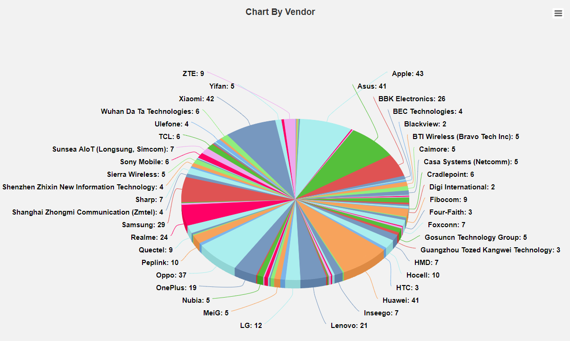

*Source: Global mobile Suppliers Association, GAMBoD - August 31, 2021.*

### Digital enhanced cordless telecommunications

[DECT](https://www.etsi.org/technologies/dect) is a general radio access technology for short range wireless telecommunications, with a range up to ~500 metres. It is suitable for voice services including PSTN and VoIP telephony, data including Integrated Services Digital Network (ISDN) and networking applications. The DECT standardisation has evolved to become a standard within the area of cordless telecommunications.

Europe, much of Asia and several other countries have allocated the basic DECT frequency band of 1880–1900 MHz for DECT. Several DECT bands have been defined for the spectrum range 1880–1939 MHz in the basic DECT standards, allowing DECT services to be introduced in countries where the basic DECT frequencies of 1880–1900 MHz are not available. The standards also allow the combination of DECT with other mobile technologies. The different DECT interoperability profile standards are designed to facilitate provision of a mixture of fixed and mobile services through a single infrastructure. Table 8 provides a summary of the DECT frequency allocations internationally.

DECT frequency allocations worldwide

|  |  |
| --- | --- |
| **Frequency band** | **Countries and details** |
| 1880–1900 MHz | Europe, South Africa, much of Asia, Hong Kong, Australia, and New Zealand (10 channels) |
| 1786–1792 MHz | Korea (3 channels only) |
| 1880–1895 MHz | Taiwan (8 channels) |
| 1893–1906 MHz | Japan (J-DECT) |
| 1910–1920 MHz | Brazil (10 channels) |
| 1910–1930 MHz | Much of Latin America excluding Brazil |
| 1920–1930 MHz | USA & Canada (DECT, DECT-6.0, NG-DECT, ULE, DECT Evolution) |

The technology has now matured to include [DECT-2020 New Radio (NR) standards.](https://www.etsi.org/standards#page=1&search=TS%20103%20636%20&title=0&etsiNumber=1&content=0&version=1&onApproval=0&published=1&historical=0&startDate=1988-01-15&endDate=2020-10-07&harmonized=0&keyword=&TB=&stdType=&frequency=&mandate=&collection=&sort=1) DECT-2020 NR was developed to support broad and diverse wireless internet of things (IoT) applications requiring both ultra-reliable and low-latency communication needed in voice and industrial applications. The DECT-2020 NR standard supports operation in the 1880 to 1900 MHz range and the 1900 to 1920 MHz range. The ACMA has identified commercially available products in overseas markets that are currently supplying DECT-2020 NR equipment.

### Future Rail Mobile Communication System

3GPP LTE and 5G [mobile communication system](https://www.etsi.org/deliver/etsi_ts/122200_122299/122289/16.01.00_60/ts_122289v160100p.pdf) are two candidates for the radio access technology to be used for the Future Rail Mobile Communications System (FRMCS). The European Telecommunications Standards Institute (ETSI) technical committees identified ongoing challenges in [FRMCS](https://www.etsi.org/deliver/etsi_tr/103400_103499/103459/01.02.01_60/tr_103459v010201p.pdf), including the integration of rail frequency spectrum for the use of 3GPP radio technologies, and other spectrum issues related to FRMCS.

FRMCS will rely on the defined Mission Critical ([MC](https://www.3gpp.org/news-events/1875-mc_services)) Service functionality to provide point-to-point and group communications for voice, video and data at train speeds of up to 500 km/h. The intent is that trains will simultaneously exchange control information and status information with the responsible traffic management system. This is considered important for driverless train operation and for traditional voice communication between train staff and ground staff.

### **MulteFire**

MulteFire is a technology designed to create new wireless networks by operating the LTE technology standalone in unlicensed[13] spectrum (for example, 2.4 GHz, and 5 GHz). The MulteFire Release 1.0 specification was completed in January 2017 by the MulteFire Alliance. The MulteFire Alliance is an open, international organisation dedicated to supporting the application of LTE and next generation mobile cellular technologies in configurations that use only unlicensed radio spectrum.

The MulteFire Alliance released a [white paper](https://www.mfa-tech.org/wp-content/uploads/MulteFire_Release-1.1_WhitePaper_03JAN.pdf) in 2019 identifying the plans for expansion of MulteFire into the 1.9 GHz band. The key target of MulteFire in the 1.9 GHz band is to reuse the existing 3GPP n39 band terminals. MulteFire 1.9 GHz uses the developments of the 3GPP standards for 5G. MulteFire technology can be deployed as a private LTE network to deliver local and customised services for industrial IoT applications.

Like DECT, MulteFire can be used to provide enhanced cordless phone services within enterprise, private and public venues. Besides voice and data services, various IoT and machine to machine services can also be supported by MulteFire in 1.9 GHz.

**Issue for comment 2:**

What is the interest in the use of new technologies to provide a service?

a) How much spectrum is required to provide the service?

b) What interservice considerations need to be undertaken for the service to be deployed?

c) What are the deployment scenarios for the service?

# Domestic considerations

Several representations to the ACMA from industry, along with the ACMA’s monitoring of technology developments, have identified new or evolving domestic interest in the 1.9 GHz band.[14] This section provides an overview of this interest.

## DECT and DECT-2020 NR

In Australia, DECT is the dominant technology used for providing CTS in the 1880 to 1900 MHz frequency range. While DECT uses other class-licensed bands[15], the 1.9 GHz band forms an integral part of the DECT services.

Several wireless microphone operators have provided feedback to the ACMA on the importance of DECT and the intention to use DECT-2020 NR within their business. The operators are using DECT-based wireless audio devices to provide services to audio visual and entertainment industries for applications such as production of intercom and video conference systems. In addition to these systems, a growing number of manufacturers are offering wireless microphone systems that operate using DECT in the 1.9 GHz band.

Feedback from operators indicate there should be continuing support for the use of DECT in this band. However, given we are undertaking a review of the band, the ACMA would like to determine the nature of this support.

**Issue for comment 3:**

Are services still using DECT or are they transitioning to DECT-2020 NR?

## Point-to-point

The 1.8 GHz and 2.1 GHz point-to-point channel plans in RALI FX 3 were created to provide capacity for long haul networks.

The use of point-to-point services the 1.9 GHz band has been relatively low, with a steady decline over a number of years up until 2017. Since 2017, the number of point-to-point links plateaued at around 50 assignments. This indicates that while operators see some utility in the band, there is a very low level of interest in the 1.9 GHz band for point-to-point services.

## Wireless broadband services

The ACMA allocated spectrum licences in the 1900–1920 MHz band optimised for Time Division Duplex (TDD in 2000 as part of the 2 GHz spectrum licence allocation process, but this band was not heavily used. As a result, the spectrum licences were not renewed in this band after an effective date of 2017.

Point-to-multipoint services in the 1.9 GHz band are used in Australia predominantly by regional operators to provide wireless broadband services. With the establishment of point-to-multipoint as a primary service via the [1900–1920 MHz Frequency Band Plan 2012](https://www.legislation.gov.au/Details/F2012L00733), operators have been deploying networks. While there was a steady decline in use of the band over a number of years, since 2017 there has been a steady increase in use with 72 new point-to-multipoint assignments. This indicates there may be some interest in the 1.9 GHz band for point-to-multipoint services.

The Australian railway industry has supported the outcome of the European review of the band for investigating use of 1900–1910 MHz for FMRCS. The Australian rail industry, in the Australasian Railway Association (ARA) submission to the 2021–26 FYSO [consultation](https://www.acma.gov.au/consultations/2021-03/draft-five-year-spectrum-outlook-2021-26-consultation-102021), believes that a similar arrangement could offer several benefits to the Australian rail industry by aligning with any European arrangements and developments on FMRCS, including access to standard 3GPP equipment to take advantage of economies of scale. They have indicated that obtaining spectrum outside the 1.8 GHz band for rail services would also be advantageous to providing a more reliable network.

# Preliminary coexistence considerations

While there are changing demand and use cases for spectrum in the 1.9 GHz band, consideration also needs to be given to the technical coexistence between services. This includes services both in the band and in adjacent bands. Early identification and consideration of coexistence issues can help inform which scenarios may (or may not) be practically viable and/or give early insight on potential sharing approaches and their impact on spectrum uses.

## In-band services

Based on the domestic considerations, there is potential for a range of services that could be considered for use in this band, including CTS using DECT (DECT and DECT-2020 NR), WBB (fixed point-to-multipoint, FRMCS) using various technologies such as MulteFire or 3GPP based technologies and fixed point-to-point services.

In any scenario where there is more than one spectrum use supported in the band, there will be in band coexistence boundaries, being spectral and/or geographic. The viability of these boundaries will be further influenced by the nature of the authorisation regime. For example, class-licensed devices are not coordinated or registered, so coexistence with other uses must depend solely on technical and expected usage characteristics of the devices. This may make sharing with other uses such as WBB impractical. Alternatively, some geographic sharing approaches may be more readily achieved when both spectrum uses are subject to a licensing regime where devices are registered and hence can be more readily coordinated – for example, WBB and point-to-point.

The band planning scenarios in the following chapter identify some potential spectral and geographic boundaries.

## Adjacent band services

In the bands adjacent to the 1.9 GHz band, there are spectrum licensed and PMTS Class B and C services operating in a Frequency Division Duplex (FDD) mode. Figure 2 and the section *Adjacent-band spectrum-licensed and PMTS B and C apparatus-licensed services* provide an overview.

Below the 1880 MHz band edge, the 1.8 GHz spectrum licensed and PMTS Class B and C services are used for base station transmitters. Above the 1920 MHz band edge, the 2 GHz spectrum licensed and PMTS Class B and C services are used for base station receivers. Any considerations regarding arrangements for services in the 1.9 GHz band need to consider the impact to and from these adjacent band services.

The ACMA notes that coexistence between TDD WBB systems below 1920 MHz and FDD systems above 1920 MHz are likely to result in a particularly challenging coexistence scenario (for example, high site to high site interference paths). This is especially likely in areas of high density FDD system deployment, such as metropolitan areas. This may require substantial restricted-use blocks (perhaps 10 MHz), which would reduce the amount of spectrum available for WBB use below 1920 MHz and hence may make this scenario unattractive in some areas. Similarly, if TDD WBB arrangements are extended below 1900 MHz, some form of frequency separation via a restricted-use block would be required with FDD services operating below 1880 MHz to manage interference

**Issue for comment 4:**

Are there any applicable coexistence scenarios not identified?

Are there any scenarios that are unlikely to be practically achievable (and hence the associated planning scenario should be discounted), or are there any that are readily achieved?

# Band planning scenarios

There is interest in access to the 1.9 GHz band for several different and, potentially competing, uses. To aid discussion about potential use cases in the band, we have developed a set of scenarios. It should be noted that these scenarios do not represent a preliminary view of the ACMA but are intended to invite feedback. In each of the following scenarios, we want to explore:

* What services/applications should be accommodated in the band?
* Which frequencies ranges should be made available for these services/applications?
* Which geographic areas should be made available for these services/applications?
* On what basis should access be provided? For example, should access be granted on an exclusive or shared basis, coordinated or uncoordinated?
* What licensing mechanisms are appropriate?

## Scenario 1: Single service/application use of entire band

One approach may be to establish optimised arrangements across most of the band for a single service or application. Figure 15 illustrates the band being used by DECT services and Figure 16 illustrates the band being used by wireless broadband services.

DECT single use

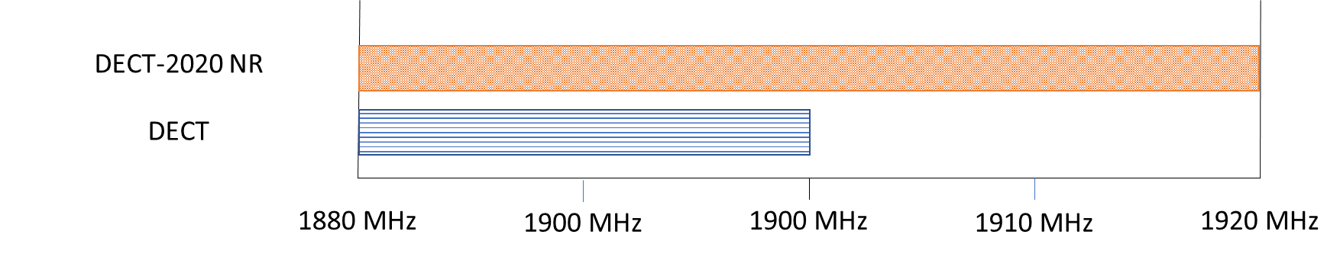

Wireless broadband single use

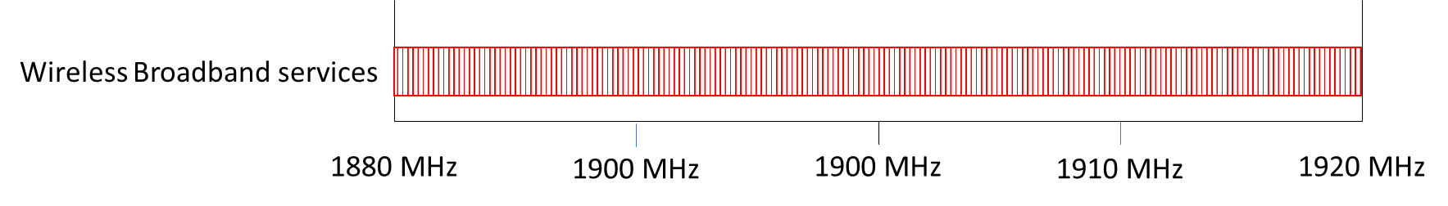

Questions raised by these scenarios may include:

* Will the demand for a single service be sufficient to justify the exclusion of other service types?
* What is the impact on services excluded from the band? Can they be accommodated in other bands?
* What are the related spectrum considerations? For point-to-point services, each channel usually has a relationship with another paired channel.

## Scenario 2: All services/applications with dedicated, exclusive spectrum

Another approach might be to provide all the services/applications with dedicated Australia-wide allocations. Providing all services/applications with dedicated spectrum, (given there is only finite spectrum available in the band) would result in each service/allocation only having access to a modest subset for the band. For example, in the scenario shown in Figure 17, DECT services have only been allocated to 1880–1900 MHz and wireless broadband services to 1900–1920 MHz. Also, given the limited spectrum available, in this scenario there is no spectrum for point-to-point services. Figure 17 illustrates the band with all potential services being allocated some spectrum Australia-wide.

This scenario also allows for different licensing mechanisms to be used for similar technologies based on the intended application. For example, wireless broadband services may use area-based licensing, while the DECT and DECT-2020 NR may use class licensing.

Dedicated spectrum approach

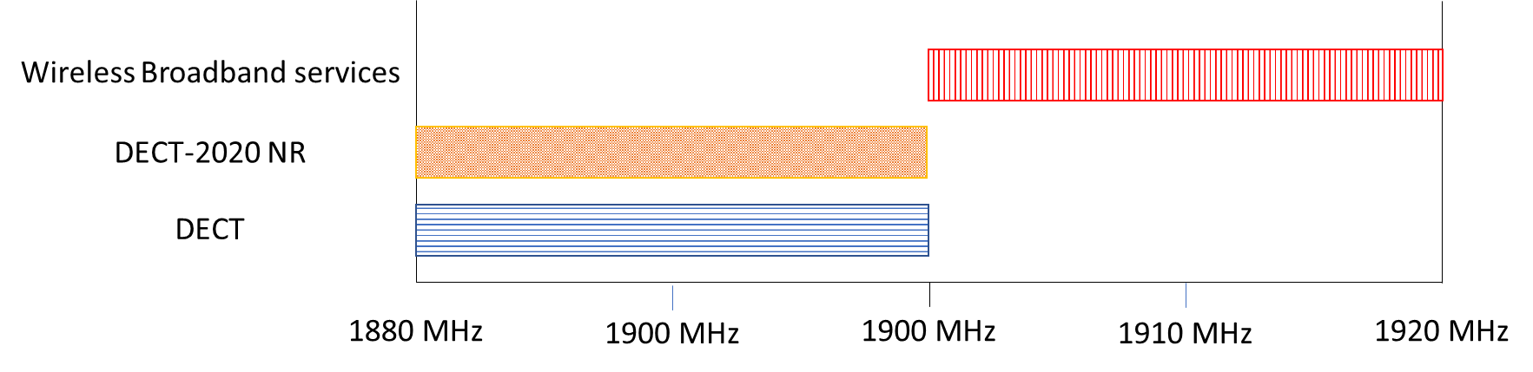

Questions raised by this scenario include:

* Is there demand for each service/application in the band?
* Does this allow enough spectrum for all services/applications?

## Scenario 3: Geographic separation of services

There is a possibility that demand for some services/applications may be localised to certain geographic areas. For example, wireless broadband services could be limited to major population areas and support for point-to-point services limited to regional areas, thus increasing the potential spectrum for use by the 2 services. Figure 18 illustrates the band with geographically separated services being allocated.

Geographically separated services

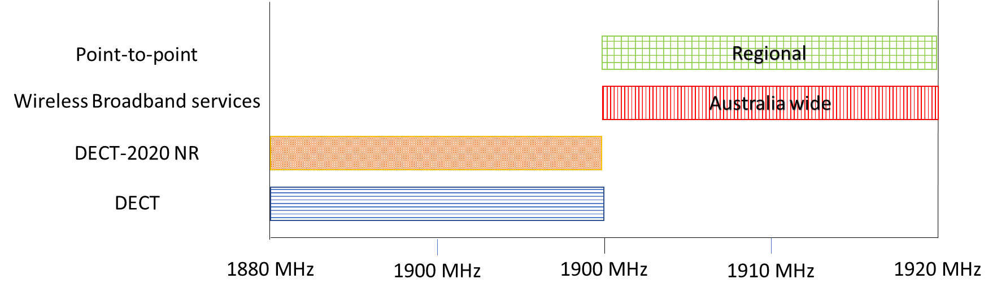

Questions raised by this scenario include:

* What is the impact of constraining a service geographically?
* How do trends/demand for allocations vary geographically?

## Scenario 4: Sharing of spectrum by services/applications

Where possible, this approach would utilise the ability of different services/applications coexisting in shared spectrum in the same geographic area. Under this scenario, in sections of the band, all the services are shown to be operating in the same band without geographic restrictions. This approach is obviously highly contingent on technical coexistence being achievable between spectrum uses in a viable manner. Figure 19 illustrates an example of the spectrum sharing/coexisting approach.

Co-channel services

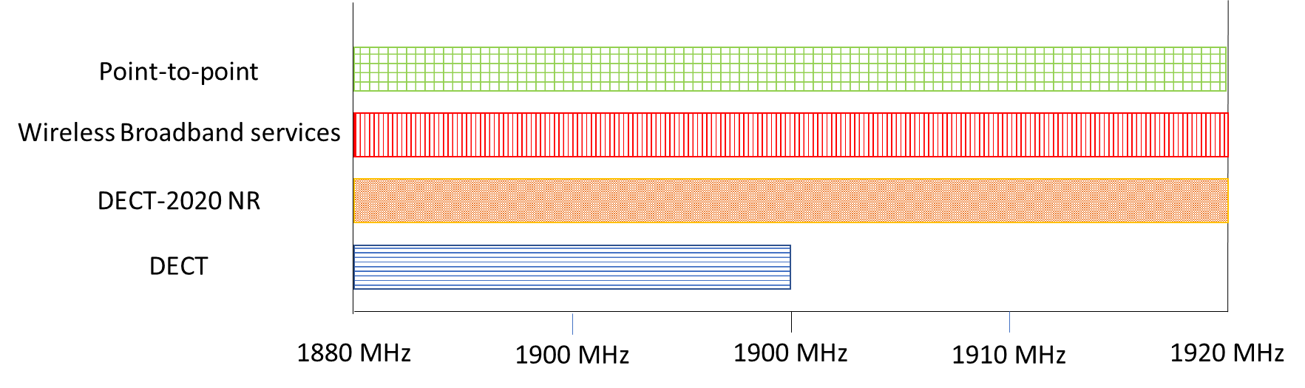

Questions raised by this scenario include:

* Does the sharing of spectrum by services cause inefficiencies?
* Are there any services that can coexist with minimal impact on spectrum efficiency?

## Scenario 5: Combination or hybrid approach of other scenarios

In considering scenarios 1 to 4, different possibilities may present themselves. Some services may be able to coexist in the same geographic area in the same spectrum, while other services may be able to share the same frequency range but are separated by geographic area. Some services/applications may require dedicated Australia-wide spectrum. Scenario 5 is a combination of scenarios 1 to 4. Figure 20 illustrates conceptually what this would look like.

Combination of all considerations

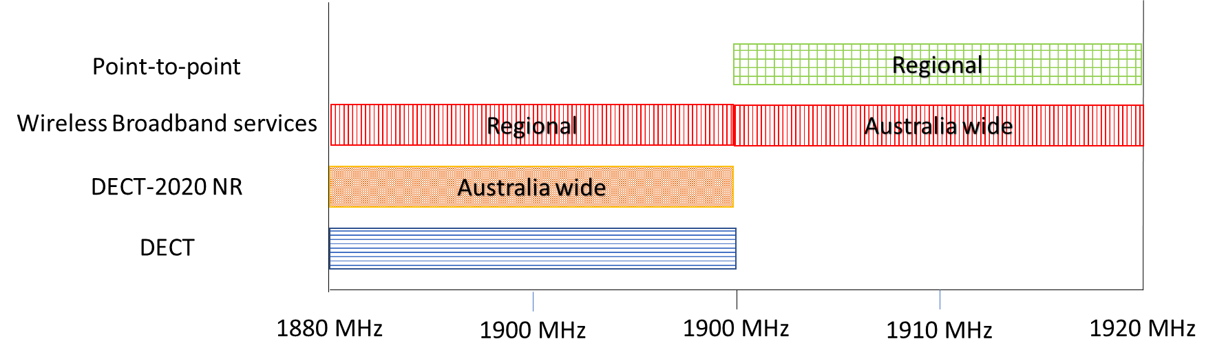

All questions raised in the previous scenarios would be relevant to this scenario.

Based on the current domestic and international considerations, and considering the planning scenarios and the questions the different scenarios raise, we invite comment on the following:

**Issue for comment 5:**

What are possible planning scenarios and industry views on the overall future use of the 1.9 GHz band and its services?

a) How much spectrum is required (distinguishing between the minimum viable and desirable) to provide the service?

b) Is there a clear geographical delineation – for example, metropolitan or regional – for the service?

c) Is there or will there be equipment readily available for the service?

# Invitation to comment

## Making a submission

We invite comments on the issues set out in this discussion paper.

[Online submissions](https://www.acma.gov.au/have-your-say) can be made by uploading a document. Submissions in PDF, Microsoft Word or Rich Text Format are preferred.

Submissions by post can be sent to:

The Manager

Wireless Broadband

Australian Communications and Media Authority

PO Box 78

Belconnen ACT 2616

The closing date for submissions is **COB, Friday 11 February 2022**.

Consultation enquiries can be emailed to [freqplan@acma.gov.au](mailto:xxx@acma.gov.au).

#### Publication of submissions

We publish submissions on our website, including personal information (such as names and contact details), except for information that you have claimed (and we have accepted) is confidential.

Confidential information will not be published or otherwise released unless required or authorised by law.

#### Privacy

View information about our policy on the [publication of submissions](https://www.acma.gov.au/publication-submissions), including collection of personal information during consultation and how we handle that information.

Information on the *Privacy Act 1988,* how to access or correct personal information, how to make a privacy complaint and how we will deal with any complaints, is available in our [privacy policy](https://www.acma.gov.au/privacy-policy).

# Acronym list

3GPP 3rd Generation Partnership Project

ARSP Australian Radiofrequency Spectrum Plan 2021

CEPT Conference of European Postal and Telecommunications

CTS cordless telecommunications services

DECT digital enhanced cordless telecommunications

ECC Electronic Communications Committee

ETSI European Telecommunications Standards Institute

FDD Frequency Division Duplex

FMRCS Future Railway Mobile Communication Systems

FYSO five-year spectrum outlook

IMT International Mobile Telecommunications

ISDN Integrated Services Digital Network

ITU International Telecommunication Union

ITU-R International Telecommunication Union Radiocommunication Sector

LIPD low interference potential devices

LTE Long Term Evolution

MC Mission Critical

NG-DECT New Generation DECT

NR New Radio

PHS Personal Handy-phone System

PSTN Public Switched Telephone Network

TDD time division duplex

UIC International Union of Railways

ULE Ultra Low Energy

1. DECT forum, [DECT Technology](https://www.dect.org/dect-technology), DECT forum, n.d., accessed 26 October 2021.
2. ACMA (Australian Communications and Media Authority), [*Corporate plan 2020–21*](https://www.acma.gov.au/publications/2020-08/report/corporate-plan-2020-21), ACMA, 2020, accessed 26 October 2021.
3. Technical conditions include maximum power, frequency range, out-of-band emissions limits, geographical licence area, and out-of-area emission limits.
4. S Antipolis, [ETSI launches DECT-2020 new radio interface for IoT](https://www.etsi.org/newsroom/press-releases/1839-2020-10-etsi-launches-dect-2020-new-radio-interface-for-iot) [media release], ETSI, 20 October 2020, accessed 9 March 2021.
5. UIC, [Future Railway Mobile Communication System](https://uic.org/rail-system/frmcs), UIC, n.d., accessed 9 March 2021.
6. For point-to-point services, every transmitter has a paired receiver. That is, every 2 assignments (one transmitter and one receiver) equals one point-to-point link.
7. For point-to-multipoint services, every site will have a transmitter and a receiver. That is every 2 assignments (one transmitter and one receiver) equals one point-to-multipoint site.
8. CEPT T/R 22-02, *frequency band to be designated for the European digital cordless telecommunication system (DECT).*
9. CEPT Report 52, Report from CEPT to the European Commission in response to the mandate: ‘To undertake studies on the harmonised technical conditions for the 1900–1920 MHz and 2010–2025 MHz frequency bands (“Unpaired terrestrial 2 GHz bands”) in the EU’.
10. ECC Decision (15)02 on ‘The harmonised use of broadband Direct Air-to-Ground Communications (DA2GC) systems in the frequency band 1900–1920 MHz.
11. ECC Report 314, Co-existence between Future Railway Mobile Communication System (FRMCS) in the frequency range 1900-1920 MHz and other applications in adjacent bands
12. This is a link to 3GPP TS 38.101-1 version 16.5.0 Release 16, ‘User Equipment (UE) radio transmission and reception; Part 1: Range 1 Standalone’, which includes lists of operating bands.
13. This is similar to the ACMA class licence mechanism, where an individual device licence is not required.
14. ACMA, [*Five-year spectrum outlook 2021−26*](https://www.acma.gov.au/publications/2021-09/plan/five-year-spectrum-outlook-2021-26), ACMA, September 2021, accessed 26 October 2021.
15. See [Radiocommunications (Low Interference Potential Devices) Class Licence 2015](https://www.legislation.gov.au/Series/F2015L01438).