Coordination procedures between earth stations at New Norcia and Tidbinbilla and other services in the bands: 7145-7235 MHz, 8400-8500 MHz, 22.55-23.15 GHz, 31.8-32.3 GHz and 34.2-34.7 GHz

Radiocommunications Assignment and Licensing Instruction

**rali: MS 43**

**date of effect: 13 DECEMBER 2022**

Amendment history

| Date | Comments |
| --- | --- |
| 5 November 2015 | Initial draft for public consultation ([IFC 27/2015](https://webarchive.nla.gov.au/awa/20160615185603/http:/www.acma.gov.au/theACMA/coordination-arrangements-with-esa-new-norcia-earth-station)) |
| 29 January 2016 | Final document released |
| 22 July 2022 | Update released for public consultation ([IFC 26/2022](https://webarchive.nla.gov.au/awa/20221128181955/https:/www.acma.gov.au/consultations/2022-07/updates-earth-coordination-requirements-consultation-262022)) to:   * include requirements for Tidbinbilla, * add the 22.55-23.15 GHz band * remove the 26 GHz band which is included in RALI MS 46 and in the Radiocommunications Advisory Guidelines (Managing Interference from Spectrum Licensed Transmitters – 26 GHz Band) 2020. * For unwanted emissions levels (section 2.1.2), include advice that dBc is decibels relative to mean power * correct Figure 1: Exclusion area around New Norcia for the bands 8400-8500 MHz and 31.8-32.3 GHz, which was missing HCIS cell BU8I7. |
| 12 September 2022 | Minor edits following July 2022 consultation. |
| 13 December 2022 | Consequential update to Appendix B to reflect changed TOB channel arrangements in the band 7145–7235 MHz as a result of finalisation of consultation [IFC 19/2022](https://webarchive.nla.gov.au/awa/20221128162030/https:/www.acma.gov.au/consultations/2022-06/proposed-updates-channel-arrangements-72-ghz-band-ifc-192022) (Proposed updates to channel arrangements in the 7.2 GHz band). |

Suggestions for improvements to Radiocommunications Assignment and Licensing Instruction MS 43 may be addressed to:

The Manager, Spectrum Planning Section  
Australian Communications and Media Authority  
PO Box 78   
Belconnen ACT 2616

or by email to: [freqplan@acma.gov.au](mailto:freqplan@acma.gov.au).

Please notify the ACMA of any inaccuracy or ambiguity found in this RALI, so that it can be investigated and appropriate action taken.

Contents

1 Introduction 1

1.1 Purpose 1

1.2 Background 1

2 Frequency coordination procedures 3

2.1 Coordination criteria 3

2.1.1 Earth station transmit bands 4

2.1.2 Earth station receiver bands 4

2.1.3 Coordination Procedure 5

3 Exceptions 11

4 RALI Authorisation 12

Appendix A: Antenna pattern for New Norcia and Tidbinbilla 13

Appendix B: Pre-existing Spectrum Arrangements 14

2022 update 14

Pre-existing Spectrum Arrangements (as of January 2016) 14

Earth Station Transmit Band 14

Earth Station Receive Band 15

Appendix C: Record of spectrum use by ESA and NASA 16

Appendix D: Exclusion Areas 17

New Norcia exclusion zone (earth station receive) 17

Tidbinbilla exclusion zone (earth station receive) 18

# Introduction

## Purpose

The purpose of this Radiocommunications Assignment and Licensing Instruction (RALI) is to provide coordination procedures between services operated in the bands 7145-7235 MHz, 8400-8500 MHz, 22.55-23.15 GHz, 31.8-32.3 GHz and 34.2-34.7 GHz on behalf of the European Space Agency (ESA) at New Norcia and the National Aeronautics and Space Administration (NASA) at Tidbinbilla and other services operating, or planning to operate, in and adjacent to those bands. Coordination and exclusion requirements for these sites in the 26 GHz band (25.5-27 GHz) are specified in [RALI MS 46](https://www.acma.gov.au/node/2974) and [Radiocommunications Advisory Guidelines (Managing Interference from Spectrum Licensed Transmitters — 26 GHz Band) 2020](https://www.legislation.gov.au/Series/F2020L01452).

The information in this document reflects the ACMA’s statement of current policy in relation to coordination procedures between services operated in the bands 7145-7235 MHz, 8400-8500 MHz, 22.55-23.15 GHz, 31.8-32.3 GHz and 34.2-34.7 GHz on behalf of ESA at New Norcia and NASA at Tidbinbilla and other services operating, or planning to operate, in and adjacent to those bands. In making decisions, accredited frequency assigners and the ACMA’s officers should take all relevant factors into account and decide each case on its merits. Issues relating to this document that appear to fall outside the enunciated policy should be referred to:

The Manager, Spectrum Planning Section  
Australian Communications and Media Authority  
PO Box 78   
Belconnen ACT 2616

or by email to: [freqplan@acma.gov.au](mailto:freqplan@acma.gov.au).

## Background

The ongoing operation of the New Norcia earth station facility is conducted under the terms of a treaty between the Australian government and ESA[1]. This treaty, amongst other things, agrees and supports the conduct of ESA’s co-operative space vehicle tracking program in Australia, with the Australian government extending best endeavours support to facilitate and protect the ongoing conduct of the Agreed Activities. The operation of New Norcia is managed in Australia by the Commonwealth Scientific and Industrial Research Organisation (CSIRO).

Similarly, the ongoing operation of the Canberra Deep Space Communication Complex (CDSCC) at Tidbinbilla is conducted under the terms of a government-to-government treaty between Australia and the USA as well as a Cooperating Agency Agreement between CSIRO and NASA[2]. The CDSCC is part of the NASA Deep Space Network and operations are managed by the CSIRO. It supports spacecraft missions throughout the solar system and radio and radar astronomy observations.

To provide support for current and future operations at New Norcia and Tidbinbilla, the ACMA has licensed earth station operations in the bands 2025-2120 MHz, 2200-2300 MHz, 7145‑7235 MHz, 8400-8500 MHz, 22.55-23.15 25.5-27 GHz, 31.8‑32.3 GHz and 34.2‑34.7 GHz.

The ACMA has developed this RALI to provide coordination requirements to be applied to other services (such as fixed and mobile services) in and adjacent to the frequency bands listed in Table 1 and used at the New Norcia and Tidbinbilla facilities.

1. Frequency Bands in use at New Norcia and Tidbinbilla Earth Stations covered by this RALI

|  |  |  |
| --- | --- | --- |
| **Frequency band** | **Earth station transmit/receive band** | **Licenced frequency range** |
| 7 GHz | Transmit | 7145 – 7235 MHz |
| 8.5 GHz | Receive | 8400 – 8500 MHz |
| 22 GHz | Transmit | 22.55 – 23.15 GHz |
| 32 GHz | Receive | 31.8 – 32.3 GHz |
| 34 GHz | Transmit | 34.2 – 34.7 GHz |

Coordination arrangements for the New Norcia and Tidbinbilla facilities operations in other frequency bands are documented in both spectrum licence and apparatus licence technical frameworks depending on the band of operation. For example, coordination and exclusion requirements for the 26 GHz (25.5-27 GHz) band are specified in [RALI MS 46](https://www.acma.gov.au/node/2974) and [Radiocommunications Advisory Guidelines (Managing Interference from Spectrum Licensed Transmitters — 26 GHz Band) 2020](https://www.legislation.gov.au/Series/F2020L01452)[3].

To assist in the assessment of requests for short term access, information on current frequencies used for space tracking activities by the earth stations at New Norcia and Tidbinbilla is provided on the [ACMA website](https://www.acma.gov.au/publications/2019-09/instruction/rali-ms43-new-norcia-earth-station-and-other-services).

# Frequency coordination procedures

This section sets out the coordination criteria used between services operated in the bands 7145‑7235 MHz, 8400-8500 MHz, 22.55-23.15 GHz, 31.8‑32.3 GHz and 34.2‑34.7 GHz on behalf of the European Space Agency (ESA) at New Norcia and the National Aeronautics and Space Administration (NASA) at Tidbinbilla and other services planning to operate in and adjacent to those bands.

Note: 2022 update

Both the New Norcia and Tidbinbilla facilities were already authorised to operate in the bands included in the 2022 update of this RALI. Accordingly, for earth stations operations at:

* New Norcia in the band 22.55-23.15 GHz: the arrangement in this RALI do not apply to existing services authorised before this RALI commenced on 12 September 2022.
* Tidbinbilla in the bands 7145‑7235 MHz, 8400-8500 MHz, 22.55-23.15 GHz, 31.8‑32.3 GHz and 34.2‑34.7: the arrangement in this RALI do not apply to existing services authorised before this RALI commenced on 12 September 2022.

## Coordination criteria

The procedures of this section apply to all applications for licensed services. Airborne services have not been considered in the development of the coordination criteria and will be considered on a case-by-case basis.

For earth station receiver bands, the coordination area in section 2.1.2 of this RALI is based on a service with the characteristics outlined in Table 2. Any new service that operates above these levels outside of the coordination areas outlined in section 2.1.2 below will need to follow the coordination procedures set out in section 2.1.3.

1. Typical transmitter parameters

|  |  |
| --- | --- |
| **System Parameter** | **Value** |
| Antenna Gain (dBi) | 35 |
| Transmitter Power (W) | 0.7 |
| EIRP (dBW/MHz) | -17.4 |
| Antenna height (m) | 30 |

In addition to the coordination requirements below, no new assignment in the bands 8400-8500 MHz and 31.8‑32.3 GHz will be made within the exclusion areas given in Annex D.

### Earth station transmit bands

As a general principle, new services that operate in and adjacent to the earth station transmit bands (7145-7235 MHz, 22.55-23.15 GHz and 34.2-34.7 GHz) do so on the basis that they are not afforded protection from interference from earth station transmitters at the New Norcia or Tidbinbilla facilities.

7145-7235 MHz and 34.2-34.7 GHz

New services that operate in and adjacent to the earth station transmit bands (7145‑7235 MHz and 34.2‑34.7 GHz) do so on the basis that they are not afforded protection from interference from earth station transmitters at the New Norcia or Tidbinbilla facilities. Arrangements for existing services are discussed in Annex B[4].

22.55-23.15 GHz

Services that operate in and adjacent to the earth station transmit band 22.55-23.15 GHz that were authorised before the commencement of this RALI are protected in accordance with the requirements for fixed-to-point links of RALI FX3. If the technical characteristics of an existing service change, then they will need to be coordinated as a new service.

New services (services authorised after the commencement of this RALI) will not be afforded protection from interference from earth station transmitters at the New Norcia or Tidbinbilla facilities. The ACMA encourages licensees to assess the likelihood of interference using the earth station parameters of this RALI and the fixed link protection requirements of RALI FX3.

### Earth station receiver bands

Co-Channel

Services that wish to operate in the earth station receive bands within:

* 400 km of the New Norcia Earth station or Tidbinbilla Earth stations below 10 GHz (8400-8500 MHz); and
* 200 km of the New Norcia Earth station or Tidbinbilla Earth stations for bands above 10 GHz (31.8-32.3 GHz)

must coordinate their use by using the procedure set out in section 2.1.3 of this RALI. All services wishing to operate in these bands must assume co-channel operation. Additional guidance on coordinating with earth stations can be found in Appendix 7 of the Radio Regulations of the ITU.

Adjacent Channel

For services to be operated in adjacent bands, considering spectrum planning arrangements at the time this RALI was updated (see Annex B), there are no coordination distances and frequency constraints at this point in time, other than the coordination requirements placed on the FSS in RALI MS 38. These will be developed when re-planning activities occur in those bands. In the interim, coordination will be based on the level of unwanted emissions (out-of-band and spurious) from a proposed transmitter in the earth station receive bands. The expectation is that unwanted emission levels will not exceed:

**43+10log(P) dBc** or **70 dBc**; whichever is less stringent

Where:

**P** is the power supplied to the antenna transmission line in watts, and ***x* dBc** is the attenuation (dB) below P, i.e. −x dBc

This value is based on ITU general limit for spurious emissions in the out-of-band domain[5] and in this case it applies to both out-of-band and spurious emissions. Examples on how to calculate this can be found in Appendix 3 of the ITU Radio Regulations (<https://www.itu.int/pub/R-REG-RR>). Note that emissions from adjacent bands into the 8400-8450 MHz and 31.8-32.3 GHz bands should not exceed the protection criterion for deep space research (Recommendation ITU-R SA.1157-1).

### Coordination Procedure

The values specified in Table 3 and Table 4 for the New Norcia earth station and Table 5 and Table 6 for the Tidbinbilla earth station are to be used when calculating the interference between the ESA and NASA earth stations and other services. They are based on the New Norcia 35 m antenna (NNO-1) and Tidbinbilla 34 m and 70 m antenna (NASA DSS-34 and DSS-43) characteristics and will encompass all smaller antennas within each of the earth stations.

The assessment of interference is based on the following method of determining the signal level from the proposed transmitter arriving at the location of the Earth station:

***PSDtx*+ *Gt* – *PL*(*p*) + *Gr* < Interference Threshold Level**

Where:

***PSDtx*** - Transmitter power spectral density within the transmitter’s occupied bandwidth (dBW/Hz)

***PL*(*p*)** - propagation path loss (dB) along the interference path not exceeded for *p*% time, where *p* is defined in Table 3 for New Norcia and Table 5 for Tidbinbilla

***Gt*** - transmit antenna gain in the direction of the interference path (dBi)

***Gr*** - (maximum) receive antenna gain in the direction of the interference path (dBi), see Table 3 for New Norcia and Table 5 for Tidbinbilla

**Interference Threshold Level** - maximum permissible unwanted signal PSD (dBW/Hz); see Table 3 for New Norcia and Table 5 for Tidbinbilla

Coordination calculations are to use propagation model [ITU Recommendation P.452](https://www.itu.int/rec/R-REC-P.452/en) with the values set out in Table 3 for New Norcia and Table 5 for Tidbinbilla.

For services that wish to operate adjacent to earth station receive bands, the spectral mask attenuation of the emission measured at the earth station band edge shall be factored into the ***PSDtx***.

1. Receive characteristics for New Norcia earth station

|  |  |  |  |
| --- | --- | --- | --- |
| **System parameter** | **Frequency of Operation (GHz)** | | |
| **8.4-8.45** | **8.45-8.5** | **31.8‑32.3** |
| **Interference threshold[6] (dBW/Hz)** | -220 | -216 | -216 |
| **Antenna coordinates (GDA94)** | -31.048214°, 116.191444° | | |
| **Antenna height (m)** | 22.5 | 22.5 | 22.5 |
| **Antenna diameter (m)** | 35 | 35 | 35 |
| **Minimum elevation angle** | 10° | 5° | 10° |
| **Gain (dBi)** | 68.8 | 68.8 | 77.3 |
| **Gain in the horizontal direction (dBi)** | 4 | 11.5 | 4 |
| **Antenna pattern**  **-Vertical**  **-Horizontal** | See Annex A for vertical pattern[7]  Omnidirectional (H) | | |
| **Percentage of time (p(%))** | 0.001 | 0.05 | 0.001 |
| **Delta N** | 45 | 45 | 45 |
| **Sea Level Surface Refractivity (No)** | 327 | 327 | 327 |
| **Digital elevation model (DEM)** | 3 arcsecond DEM or better | | |

1. Transmitter characteristics for New Norcia earth station

|  |  |  |  |  |
| --- | --- | --- | --- | --- |
| **System parameter** | **Frequency of Operation (GHz)** | | | |
| **7.145-7.190** | **7.190-7.235** | **22.55-23.15** | **34.2-34.7** |
| **Tx Power (dBW)** | 49 | 43 | 30 | 25 |
| **Tx Spectral power density (dBW/Hz)** | 13  (averaged over 4 kHz) | 7  (averaged over 4 kHz) | -30  (averaged over 1 MHz) | -35  (averaged over 1 MHz) |
| **Antenna coordinates (GDA94)** | -31.048214°, 116.191444° | | | |
| **Antenna height (m)** | 22.5 | 22.5 | 22.5 | 22.5 |
| **Antenna diameter (m)** | 35 | 35 | 35 | 35 |
| **Minimum elevation angle** | 10° | 5° | 5° | 10° |
| **Gain (dBi)** | 67.4 | 67.4 | 76.5 | 77.0 |
| **Gain in the horizontal direction (dBi)** | 4 | 11.5 | 11.5 | 4 |
| **Antenna pattern**  **-Vertical**  **-Horizontal** | See Annex A for vertical pattern[8]  Omnidirectional (H) | | | |

1. Receive characteristics for Tidbinbilla earth station

|  |  |  |  |
| --- | --- | --- | --- |
| **System parameter** | **Frequency of Operation (GHz)** | | |
| **8.4-8.45** | **8.45-8.5** | **31.8‑32.3** |
| **Interference threshold[9] (dBW/Hz)** | -220 | -216 | -216 |
| **Antenna coordinates (GDA94)** | -35.402424°, 148.981267° | | -35.398479°, 148.981964° |
| **Antenna height (m)** | 39 | 39 | 19 |
| **Antenna diameter (m)** | 70 | 70 | 34 |
| **Minimum elevation angle** | 10° | 6° | 10° |
| **Antenna Gain (dBi)** | 74.6 | 74.6 | 79 |
| **Gain in the horizontal direction (dBi)** | 7 | 12.5 | 7 |
| **Antenna pattern**  **-Vertical**  **-Horizontal** | See Annex A for vertical pattern[10]  Omnidirectional (H) | | |
| **Percentage of time (p(%))** | 0.001 | 0.05 | 0.001 |
| **Delta N** | 50 | 50 | 50 |
| **Sea Level Surface Refractivity (No)** | 330 | 330 | 330 |
| **Digital elevation model (DEM)** | 3 arcsecond DEM or better | | |

1. Transmitter characteristics for Tidbinbilla earth station

|  |  |  |  |  |
| --- | --- | --- | --- | --- |
| **System parameter** | **Frequency of Operation (GHz)** | | | |
| **7.145-7.190** | **7.190-7.235** | **22.55-23.15** | **34.2-34.7** |
| **Tx Power (dBW)** | 49 | 49 | 24 | 29 |
| **Tx Spectral power density (dBW/Hz)** | 13  (averaged over 4 kHz) | 13  (averaged over 4 kHz) | -36  (averaged over 1 MHz) | -31  (averaged over 1 MHz) |
| **Antenna coordinates (GDA94)** | -35.402424°, 148.981267° | | -35.398479°, 148.981964° | |
| **Antenna height (m)** | 39 | 39 | 19 | 19 |
| **Antenna diameter (m)** | 70 | 70 | 34 | 34 |
| **Minimum elevation angle** | 10° | 6° | 6° | 10° |
| **Antenna Gain (dBi)** | 73.2 | 73.2 | 75.4 | 79 |
| **Gain in the horizontal direction (dBi)** | 7 | 12.5 | 12.5 | 7 |
| **Antenna pattern**  **-Vertical**  **-Horizontal** | See Annex A for vertical pattern[11]  Omnidirectional (H) | | | |

# Exceptions

Exceptions to the requirements of this RALI for prospective assignments (for example for short term usage) require case-by-case consideration by the Manager, Spectrum Planning Section.

In case of emergency communications on frequencies other than those identified as currently used by ESA and NASA on the ACMA website, such exceptions will only be allowed where an agreement can be made between the applicant and the ESA or NASA.

A request for exemption from the requirements of this RALI would need to be accompanied by evidence to support the request.

All requests for exemptions should be submitted to [freqplan@acma.gov.au](mailto:freqplan@acma.gov.au).

# RALI Authorisation

Approved 13 December 2022

Xavier Halliwell

Manager  
Spectrum Planning Section  
Spectrum Planning and Engineering Branch

Communications Infrastructure Division  
Australian Communications and Media Authority

# Appendix A: Antenna pattern for New Norcia and Tidbinbilla

The pattern of the main ESA deep space antenna (NNO-1) at the New Norcia facility is defined by ITU/RR/AP7/ANNEX 3, modified:

G() = Gmax – 2.5  10-3  (D/)2 for 0 <  < m

G() = G1 for m <  < r

G() = 29 – 25  log () for r <  < 48o

G() = -13 for 48o <  < 180o

with:

G1 = 15  log (D/) – 1 dBi

m = 20  (/D)  (Gmax – G1)0.5 degrees

r = 15.85  (D/)-0.6 degrees

The pattern of the NASA deep space antenna (70 m and 34 m diameter antennas) at the Tidbinbilla facility is defined by ITU/RR/AP8/ANNEX 3:

G(j) = Gmax – 2.5 × 10-3 × (j×D/l)2 for 0 < j < jm

G(j) = G1 for jm < j < jr

G(j) = 32 – 25 × log (j) for jr < j < 48o

G(j) = -10 for 48o < j < 180o

with:

G1 = 2 + 15 × log (D/l) dBi

jm = 20 × (l/D) × (Gmax – G1)0.5 degrees

jr = 15.85 × (D/l)-0.6 degrees

where:

G(): antenna gain at off-axis angle ;

Gmax: maximum gain (dBi); : off-axis angle (degrees);

D: antenna diameter (m); : wavelength (m).

In accordance with the provisions of ITU/RR/AR21.15, ESA and NASA will limit its minimum elevation to 5 degrees (6 degrees for the Tidbinbilla antennas) above the horizontal plane for all services except Space Research (deep space), where the minimum elevation is 10 degrees. This limitation results in an antenna gain in the horizontal direction of 14.5 dBi (7 dBi for Space Research, deep space) for the New Norcia facility’s deep space antenna and 12.5 dBi (7 dBi for Space Research, deep space) for the Tidbinbilla facility’s antenna, at minimum elevation.

# Appendix B: Pre-existing Spectrum Arrangements

## 2022 update

Both the New Norcia and Tidbinbilla facilities were already authorised to operate in the bands included in the 2022 update of this RALI. Accordingly, for earth stations operations at:

* New Norcia in the band 22.55-23.15 GHz: the arrangement in this RALI do not apply to existing services authorised before this RALI commenced on 12 September 2022.
* Tidbinbilla in the bands 7145‑7235 MHz, 8400-8500 MHz, 22.55-23.15 GHz, 31.8‑32.3 GHz and 34.2‑34.7: the arrangement in this RALI do not apply to existing services authorised before this RALI commenced on 12 September 2022.

## Pre-existing Spectrum Arrangements (as of January 2016)

The information below is summaries spectrum arrangements as relevant to New Norcia at the time this RALI was first developed in 2015. With ESA missions extending to the year 2034 and beyond this RALI is intended as a reference point for the future. This annex is to capture spectrum arrangements with respect to non-space research services, rather than detail usage by space research services in Australia.

### Earth Station Transmit Band

7145-7235 MHz (Earth Tx)

The band 7145‑7235 MHz is allocated to the Space Research (Earth to space), Fixed and Mobile services. As outlined in the 7.2 GHz channel plan in RALI FX3, the band is also used by TOB.

Earth station licensed operations have been conducted in the band 7145-7235 MHz at Landsdale (Perth, Western Australia) as well as at New Norcia on behalf of ESA without coordination by the ACMA. The impact of operations at New Norcia on TOB services in the Perth area is expected to be less than that of operations at Lansdale.

No coordination is undertaken by the ACMA between earth station operations at New Norcia and TOB services in the band 7145-7235 MHz. Consequently, TOB will not be afforded protection from the New Norcia earth station facility. Technical characteristics of the ESA earth station are described in Table 1 of this RALI.

34.2-34.7 GHz (Earth Tx)

The band 34.2-34.7 GHz is allocated to Space Research (Earth to space) and also allocated to the Fixed Satellite and Radiolocation services.

At the time this RALI was prepared there are 240 existing assignments in this band, most are licensed to the Victorian Police Department for radiodetermination purposes. No coordination is required.

### Earth Station Receive Band

8400-8500 MHz (Earth Rx)

The band 8400‑8500 MHz is allocated to the Space Research (space to Earth), Fixed and Mobile services. As outlined in the 8.3 GHz channel plan in RALI FX 3 the band 8275-8400 MHz is used for TOB services. The interleaved channel 8 in the 8.3 GHz channel plan (identified for the ABC) extends to 8401 MHz except within 150 km of New Norcia where TOB emissions will not exceed 8400 MHz. See RALI FX3 for more details.

TOB services operate on the condition that they do not cause interference to other radiocommunications services. Coordination criteria between TOB transmitters and earth station receivers in the 8400-8500 MHz were included in RALI FX 3 as part of the development of this RALI in 2015.

The adjacent band 8500-8550 MHz is designated for use by the Australian Defence Force and the Department of Defence. The band is allocated to radiolocation services. The Department of Defence holds Australia wide licences in this band first issued in 2004.

25.5-27.0 GHz (Earth Rx)

The band 25.5-27.0 GHz is allocated to Earth Exploration (space to Earth), Space Research (space-Earth), Fixed and Mobile services. At the time of this RALI there are Body Scanners operating in major airports under a Radiodetermination – Body Scan Licence. Additionally at the time this RALI was developed, there were 108 FSS allocations in the adjacent band 27-30 GHz. Coordination criteria between earth station receivers and adjacent FSS in the band 27-30 GHz are included in RALI MS 38.

31.8-32.3 GHz (Earth Rx)

The band 31.8‑32.3 GHz is allocated to Space Research (Deep Space) (space to Earth), Fixed and Radionavigation services. At the time of the RALI there are only Earth receive licenses and no coordination is required.

# Appendix C: Record of spectrum use by ESA and NASA

Typical usage details at the New Norcia and Tidbinbilla earth stations will be provided as a link on the RALI [webpage](https://www.acma.gov.au/publications/2019-09/instruction/rali-ms43-new-norcia-earth-station-and-other-services).

# Appendix D: Exclusion Areas

No new assignments in the bands 8400-8500 MHz and 31.8‑32.3 GHz will be made in the areas described in this annex without the agreement of the earth station licensee. The areas are defined using Hierarchical Cell Identification Scheme (HCIS) cell identifiers, along with a graphical representation. A placemark (.kml file) representing these areas can be generated using the ACMA HCIS converter (<http://www.acma.gov.au/theACMA/convert-hcis-area-description-to-a-placemark>).

## New Norcia exclusion zone (earth station receive)

HCIS definition: BU8I7, BU8I8, BU8I9, BU8J7, BU8J8, BU8M2, BU8M3, BU8N, BU8M5, BU8M6, BU8O4, BU7P9, BU8M7, BU8M8, BU8M9, BV2A1, BV2A2, BV2A3, BV2B1, BV2A6, BV2B4

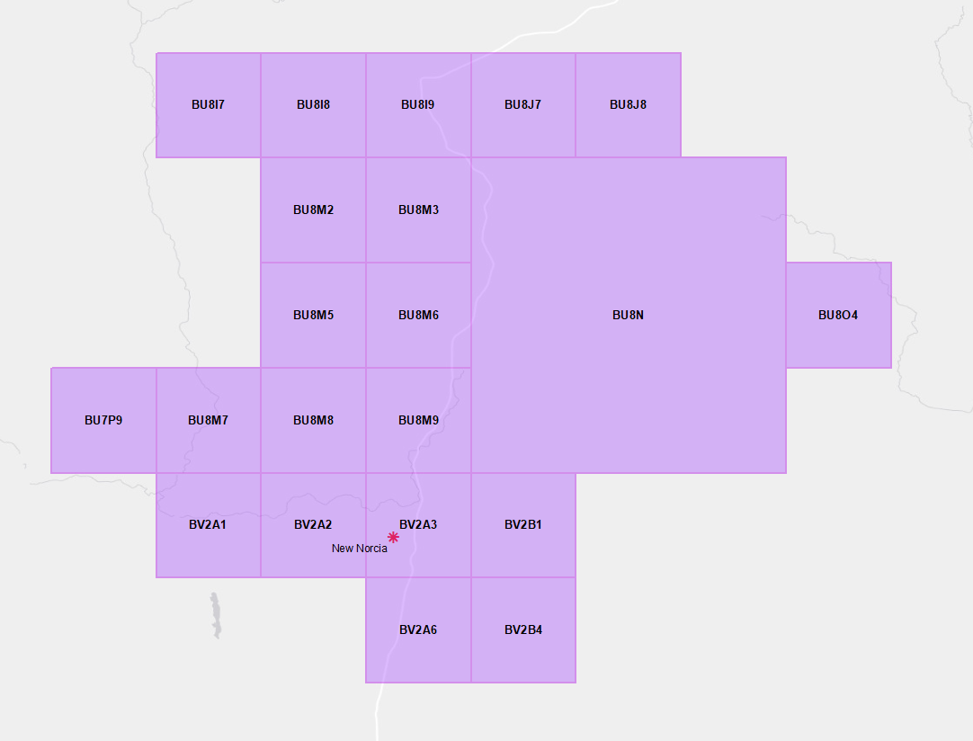

1. Exclusion area around New Norcia for the bands 8400-8500 MHz and 31.8-32.3 GHz

## Tidbinbilla exclusion zone (earth station receive)

HCIS definition: MW4H, MW5E, MW4D5, MW4D6, MW4D7, MW4D8, MW4D9, MW5A7, MW5A8, MW5A9, MW4L1, MW4L2, MW4L3, MW5I1, MW5F1, MW5F2, MW5F4, MW5F5, MW5F7

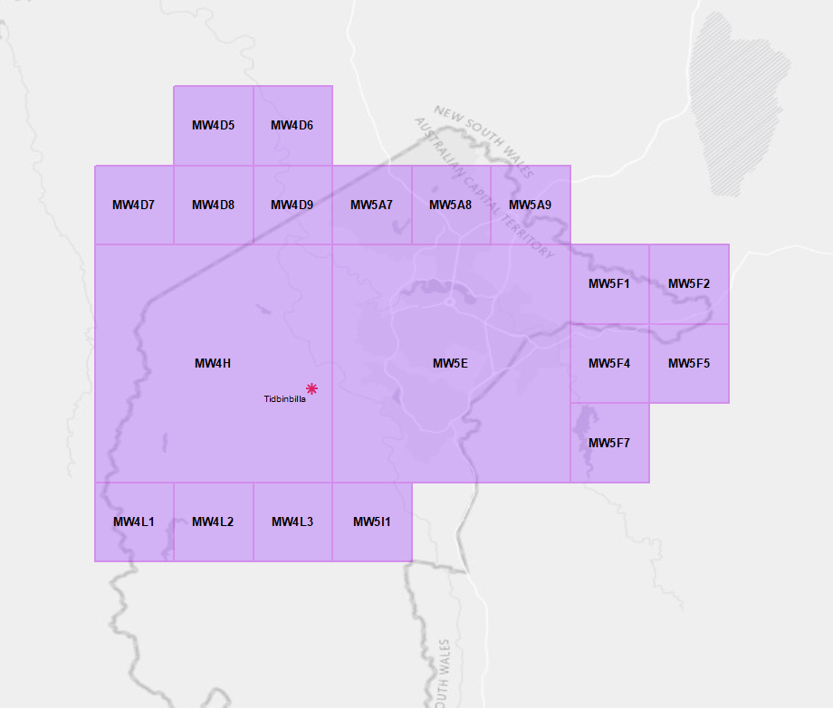

1. Exclusion area around Tidbinbilla for the bands 8400-8500 MHz, and 31.8-32.3 GHz

1. Agreement between the Government of Australia and the European Space Agency for a Co-operative Space Vehicle Tracking Program, <http://www.austlii.edu.au/au/other/dfat/treaties/ATS/2012/29.html>
2. Agreement between the Government of Australia and the Government of the United States of America for Space Vehicle Tracking and Communication Facilities, <http://www.austlii.edu.au/au/other/dfat/nia/2017/30.html>
3. Requires that emissions from all relevant transmitters operating under a single 26 GHz band spectrum licence must not exceed an aggregate level of -156 dBW/MHz for 0.001% of the time in any 24 hour period, at the input of the receiver.
4. At the time of the 2022 update 34 GHz band is only used in Victoria. In accordance with long standing arrangements television outside broadcast services in 7.2 GHz band are not be afforded protection from the New Norcia and Tidbinbilla earth station facilities..
5. As per Table 1 of ITU-R Radio Regulations Appendix 3
6. ITU Radio Regulations Appendix 7 Table 8c and Table 8d
7. Note that when assessing interference into the New Norcia earth station the receive antenna should be modelled as omnidirectional in the horizontal plane and maximum gain for elevations above the minimum elevation angle. The vertical pattern in Annex A should be used to calculate gain below the minimum elevation angle.
8. Note that when assessing interference from the New Norcia earth station the transmit antenna should be modelled as omnidirectional in the horizontal plane and maximum gain for elevations above the minimum elevation angle in the vertical plan. The vertical pattern in Annex A should be used to calculate gain below the minimum elevation angle.
9. ITU Radio Regulations Appendix 7 Table 8c and Table 8d
10. Note that when assessing interference into the Tidbinbilla earth station the receive antenna should be modelled as omnidirectional in the horizontal plane and maximum gain for elevations above the minimum elevation angle. The vertical pattern in Annex A should be used to calculate gain below the minimum elevation angle.
11. Note that when assessing interference from the Tidbinbilla earth station the transmit antenna should be modelled as omnidirectional in the horizontal plane and maximum gain for elevations above the minimum elevation angle in the vertical plan. The vertical pattern in Annex A should be used to calculate gain below the minimum elevation angle.