Review of the 2 GHz spectrum licence technical framework

Technical liaison group paper

November 2022

Canberra

Red Building   
Benjamin Offices  
Chan Street   
Belconnen ACT

PO Box 78  
Belconnen ACT 2616

T +61 2 6219 5555  
F +61 2 6219 5353

Melbourne

Level 32   
Melbourne Central Tower  
360 Elizabeth Street   
Melbourne VIC

PO Box 13112  
Law Courts   
Melbourne VIC 8010

T +61 3 9963 6800  
F +61 3 9963 6899

Sydney

Level 5   
The Bay Centre  
65 Pirrama Road   
Pyrmont NSW

PO Box Q500  
Queen Victoria Building   
NSW 1230

T +61 2 9334 7700 or 1800 226 667  
F +61 2 9334 7799

Copyright notice

[Creative Commons logo](http://i.creativecommons.org/l/by/3.0/88x31.png)

<http://creativecommons.org/licenses/by/3.0/au/>

With the exception of coats of arms, logos, emblems, images, other third-party material or devices protected by a trademark, this content is licensed under the Creative Commons Australia Attribution 3.0 Licence.

We request attribution as © Commonwealth of Australia (Australian Communications and Media Authority) 2022.

All other rights are reserved.

The Australian Communications and Media Authority has undertaken reasonable enquiries to identify material owned by third parties and secure permission for its reproduction. Permission may need to be obtained from third parties to re-use their material.

Written enquiries may be sent to:

Manager, Editorial and Design  
PO Box 13112  
Law Courts  
Melbourne VIC 8010  
Email: [info@acma.gov.au](mailto:info@acma.gov.au)

Version control iv

Introduction 1

Outline 2

Scope 3

Timeline 3

Discussion on proposed technical framework 4

2 GHz band spectrum licence technical framework 4

Conditions on the spectrum licence 5

In-band emission limits 5

Unwanted emission limits 6

Proposed unwanted emission limits for devices operating in the   
upper 2 GHz band 6

2110–2170 MHz 7

2170–2180 MHz 7

2100–2110 MHz 8

Proposed in-band emission limits for devices operating in the lower   
2 GHz band 11

Proposed spurious emission limits 11

Devices exempt from registration 13

Other conditions on the licence 14

Unacceptable levels of interference 14

Radiocommunications advisory guidelines 17

Radiocommunications assignment and licensing instruction   
(RALI) updates 18

RALI FX3: microwave fixed services 18

RALI FX21: television outside broadcasting services 18

Appendix A – Current use of the 2 GHz and adjacent bands 19

Appendix B – Current 2 GHz band unwanted emission limits 20

Frequency band and geographic areas 20

Emission limits outside the frequency band 20

Non-spurious emission limits 20

# Version control

|  |  |
| --- | --- |
| **Version** | **Comments** |
| Version 1.0 | Initial release: 18 November 2022 |
|  |  |

# Introduction

The Australian Communications and Media Authority (ACMA) develops a technical framework for every band subject to spectrum licensing. Each framework is a collection of technical and regulatory conditions applicable to the use of radiocommunications devices in the spectrum-licensed band. The purpose of the technical framework is to define the technical conditions and constraints under which a device may be deployed and operated within the specified geographic area and frequency band of the licence.

Although the technical framework is optimised for technologies, or services most likely to be deployed in the band, it is intended to be technology flexible. This means licensees can operate any type of radiocommunications device for any purpose, provided they comply with the technical framework relevant to the licence.

The paired frequency ranges 1920–1980 MHz and 2110–2170 MHz (the 2 GHz band) were designated for the issue of spectrum licences in metro and regional areas, as shown in Figure 1. The most recent modification of the technical framework of the 2 GHz band was finalised in 2016. This optimised use of the band for 4G technologies. Since then, 5G standards and advanced antenna systems (AAS) have been introduced and are now commercially available in the 2 GHz band. Therefore, it was considered, in consultation with stakeholders, that a revision to the 2 GHz technical framework to account for these developments was warranted.

We have stated our intention to progressively review the technical framework for all spectrum-licensed bands in the [*Five-year spectrum outlook 2019–23*](https://www.acma.gov.au/publications/2019-09/plan/five-year-spectrum-outlook-2019-23).

To assist with this work, we formed the 2 GHz technical liaison group (TLG). Members of the TLG included 2 GHz spectrum licensees, in-band and adjacent-band apparatus licensees, equipment manufacturers and accredited persons.

The TLG is the first step in the process of reviewing or establishing a technical framework. We will use the outcomes of the TLG to publicly consult on proposed changes to, or new, relevant, instruments that will form the 2 GHz band technical frameworks. TLG members are able to provide comments on the technical frameworks both as part of the informal TLG and the subsequent formal public consultation processes.

While we strive to achieve consensus with members, the final decision on the content of, or changes to, a spectrum or apparatus licence technical framework rests with the ACMA. This is particularly relevant in cases where consensus cannot be achieved on an issue, or advice from the TLG is not provided within a reasonable time frame.

The purpose of this paper is to summarise changes to the 2 GHz band spectrum licence technical framework proposed by the TLG.

1. 2 GHz band spectrum licence areas (purple shaded areas).

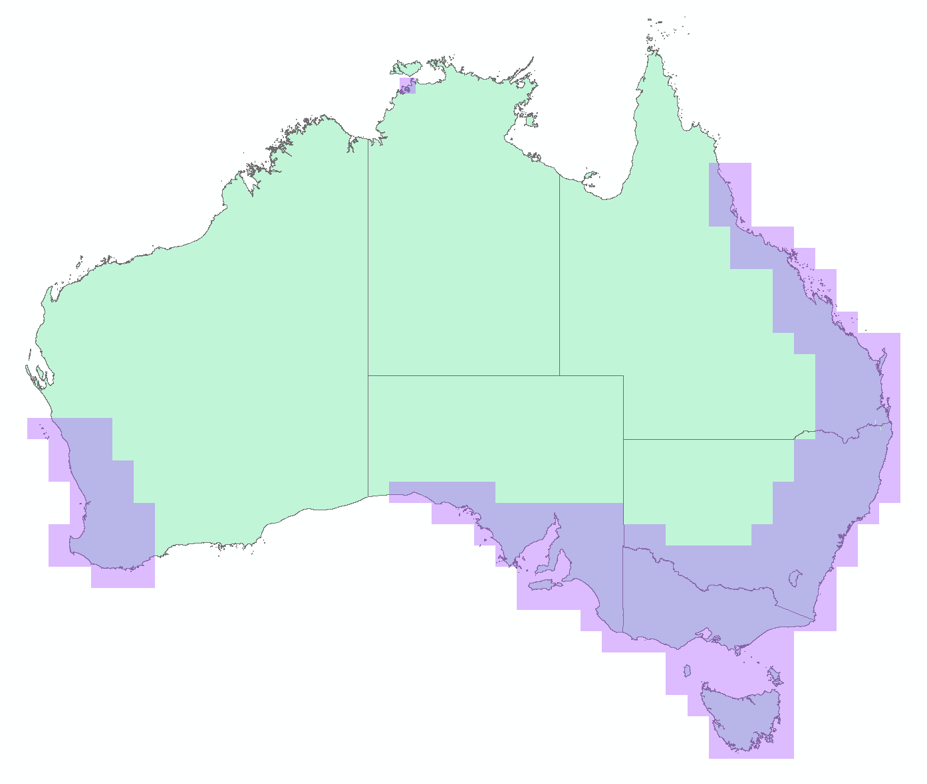

## Outline

This paper has been divided into discussion on the relevant instruments that form a spectrum licence technical framework as follows:

* The spectrum licence, specifically:
* unwanted emission limits
* other conditions on the licence.
* The s.145(4) determination on unacceptable levels of interference, specifically:
* the device boundary criteria (controlling emissions across geographical boundaries)
* deployment constraints.
* The advisory guidelines made under s.262 for:
* managing interference from spectrum licensed transmitters to the following:
* point-to-point fixed services operating in the 2 GHz band
* mobile satellite services (MSS) operating in spectrum adjacent to areas subject to spectrum licensing in the 2 GHz band
* space services
* television outside broadcast (TOB) services operating in spectrum adjacent to areas subject to spectrum licensing in the 2 GHz band
* public telecommunications services operating in spectrum in and adjacent to areas subject to spectrum licensing in the 2 GHz band
* class-licensed services
* wireless microphone services authorised under the low-interference potential devices (LIPD) Class Licence operating in the   
  1785–1805 MHz frequency range
* radio-astronomy services operating on an opportunistic basis in the frequency bands specified in Australian Footnote AUS87 of the Australia Radiofrequency Plan
* managing interference to spectrum-licensed receivers.
* additional device boundary criteria (DBC) for the 2 GHz lower band.

## Scope

This paper is focused on modifications to the technical framework for the areas and frequencies subject to spectrum licensing in the 2 GHz band to cater for the use of 5G technologies including advanced antenna systems.

## Timeline

The proposed timeline for updating the 2 GHz technical framework is:

| Key steps | Proposed date |
| --- | --- |
| TLG process | February 2022 to  October 2022 |
| Public consultation on the draft updates to the following technical framework instruments:   * Draft spectrum licence * Draft update to Radiocommunications (Unacceptable Levels of Interference – 2 GHz Band) Determination 2015. | October 2022 to November 2022 |
| Finalisation of technical framework | Q1 2023 |

It is noted that:

* The TLG is the first step in the process of developing or updating a technical framework. The ACMA will use the outcomes of the TLG to publicly consult on the relevant instruments that will form the 2 GHz band technical framework. This means TLG members will be able to provide comments on the technical framework both as part of the informal TLG and subsequent formal public consultation processes.
* A TLG is a short-term advisory body convened by the ACMA. Its purpose is to provide advice on the development of, or possible changes to, a spectrum or apparatus licence technical framework. While we strive to achieve consensus with members, the final decision on the content of, or changes to, a spectrum or apparatus licence technical framework rests with the ACMA. This is particularly relevant in cases where consensus cannot be achieved on an issue or advice from the TLG is not provided within a reasonable time frame.

# Discussion on proposed technical framework

A technical framework consists of 3 interlocking regulatory elements provided for under the *Radiocommunications Act 1992* (the Act):

* The conditions specified on the spectrum licence – in particular, the core conditions that define the spectrum space (both frequency and geographical area) and the level of emissions permitted inside and across the frequency boundaries of the licence (section 66 of the Act).
* A determination of unacceptable interference for the purpose of device registration in each band (section 145 of the Act). This defines permissible levels of emissions across geographical licence boundaries and can also define various deployment constraints.
* Radiocommunications advisory guidelines (RAG) that provide assistance and advice for coordination with stations in other services when and where required (section 262 of the Act). This includes detailing interference management criteria with incumbent apparatus and other spectrum licences.

A more comprehensive explanation of spectrum licence technical frameworks is provided in the document [*Spectrum licensees – know your obligations*.](https://www.acma.gov.au/publications/2012-12/guide/spectrum-licencees-know-your-obligations)

This section of the paper considers the development of each of these components. This would normally include the standard trading unit and minimum contiguous bandwidth, however, as these will not change, they are not discussed.

## 2 GHz band spectrum licence technical framework

The current 2 GHz spectrum licence technical framework is optimised for the use of frequency division duplex (FDD) technologies. We believe the continued optimisation arrangements for FDD are appropriate for future use of this band.

The relevant 2 GHz band technical framework instruments are the:

* Spectrum licence ([current licence holders and copies of licences](https://web.acma.gov.au/rrl/register_search.search_dispatcher))
* [Radiocommunications (Unacceptable Levels of Interference — 2 GHz Band) Determination 2016](https://www.legislation.gov.au/Details/F2017C00968)
* [Radiocommunications Advisory Guidelines (Managing Interference from Spectrum Licensed Transmitters — 2 GHz Band) 2016](https://www.legislation.gov.au/Details/F2016L01712)
* [Radiocommunications Advisory Guidelines (Managing Interference to Spectrum Licensed Receivers – 2 GHz Band) 2016](https://www.legislation.gov.au/Details/F2016L01711).

## Conditions on the spectrum licence

Each spectrum licence includes both core conditions and statutory conditions specified under relevant sections of the Act. The Act also provides that other specific conditions may be included by the ACMA.

* **Core conditions** — required under section 66, these conditions define the spectrum space within which the licensee is authorised to operate radiocommunications devices under the licence, and the maximum permitted level of radio emissions inside and outside the band. They are included in all spectrum licences.
* **Statutory conditions** — required under sections 67 to 69A, these conditions include information about payment of charges, use by third parties, residency, registration of transmitters and devices exempt from registration. They are included in all spectrum licences.
* **Other conditions** — conditions placed on licences under section 71 generally provide for the efficient management of the spectrum and administration of the Act. They may vary from one band or licence to another.

The core conditions of a spectrum licence form the fundamental building blocks for operation of a spectrum-licensed device, and for managing interference with adjacent frequency bands and geographic areas. Section 66 of the Act states spectrum licences must specify the following core conditions:

* The part or parts of the spectrum in which operation of radiocommunications devices is authorised under the licence (frequency range of operation).
* The maximum permitted level of radio emission, in parts of the spectrum outside the frequency range specified on the licence, that may be caused by operation of radiocommunications devices under the licence (outside-the-band emission).
* The area within which operation of radiocommunications devices is authorised under the licence (geographic area of operation).
* The maximum permitted level of radio emission that may be caused by the operation of radiocommunications devices under the licence (outside-the-area emission).

### In-band emission limits

The current in-band emission limit for 2 GHz band spectrum licences is:

77.2 dBm/5 MHz EIRP.[[1]](#footnote-2)

While traditionally emission limits in technical and regulatory frameworks have been defined in terms of EIRP, there is a general preference to define emission limits for services using AAS in the form of total radiated power (TRP). This is considered to more accurately reflect and limit the risk of interference presented by AAS (refer to section 6.3.2.1 of [ECC Report 281](https://docdb.cept.org/document/3360)).

Section 6.3.2.1 of ECC Report 281 provides a comparison on the use of TRP vs EIRP metrics to specify AAS emissions. Based on 3GPP studies,[[2]](#footnote-3) the impact of unwanted emissions on the adjacent mobile systems is best represented and limited by use of TRP. While these studies apply to mobile systems, similar logic is considered to apply for interference to other services.

Importantly, it is not intended that use of TRP replace the need for spectrum licensees to coordinate with other services, with known locations, using actual EIRP values. This requirement, along with the defined protection criteria for other services will not change.

The use of TRP also provides a level of flexibility to the technical framework that will help it accommodate future technologies.

Considering the current EIRP in-band limit of 77.2 dBm/5 MHz, the following in-band limit was proposed and agreed by 2 GHz band spectrum licensees:

* TRP of 53.5 dBm/5 MHz for all transmitters.[[3]](#footnote-4)

Adopting these levels also ensures existing registered devices operating in the 2 GHz band are not affected by the change.

### Unwanted emission limits

Existing unwanted emission limits that apply to 2 GHz band spectrum licences are reproduced at [Appendix B](#_Appendix_B_–). The term unwanted emission limits encompasses both out-of-band and spurious emission limits. 3GPP standards define different limits for both cases. For the upper 2 GHz band, out-of-band emissions are those that fall outside the lower and upper frequency limits of the licence and within the 2100–2180 MHz frequency range (that is, the operating band +/- 10 MHz either side). Spurious emissions are all emissions that fall outside the 2100–2180 MHz frequency range.

### Proposed unwanted emission limits for devices operating in the upper 2 GHz band

The TLG considered changes to the unwanted emission limits for devices operating in the 2110–2170 MHz band (the upper 2 GHz band). While we considered the flow-on effects for the spurious emission limits for devices operating in the 1920–1980 MHz band (the lower 2 GHz band), no changes were proposed to the out-of-band limits for devices operating in the lower 2 GHz band.

A summary of points raised in the TLG on this issue are:

* Mobile network operators (MNOs) Optus, Telstra and TPG currently operate 4G services using the 2 GHz spectrum licences. However, there is a desire to be able to deploy AAS and migrate to 5G technologies in the future.
* The current limits were defined to provide a degree of coexistence with services operating inside and adjacent to the 2 GHz band.
* Upper band emission limits above 2170 are in line with Category B (Option 1).
* Upper band emission limits below 2110 are derived to protect adjacent   
  TOB services.
* The unwanted emission limits for non-AAS base station transmitters in the upper 2 GHz band below 2110 MHz are more restrictive than Category B (Option 1) limits defined in 3GPP standards. Category B (Option 1) limits are preferred by the MNOs.
* TOB operators raised concerns regarding relaxing emission limits between   
  2100–2110 MHz. They highlighted that the 2100–2106 MHz frequency range is used by TOB operators for collection stations, particularly when used for communication with helicopters. TOB operators are concerned with any increase in interference which may impact on the utility of the spectrum.

All unwanted emission limits are defined as EIRP levels. However, AAS networks are more effectively defined in terms of TRP.

Taking into account the above issues, the TLG agreed a revision of the current upper 2 GHz band unwanted emission limits was required. The aim of the revision was to:

* ensure existing devices deployed under the current 2 GHz band framework can continue operating unaffected by any changes
* enable new technologies (for example, 5G and AAS) to be deployed
* avoid unnecessary costs and burdens on licensees to implement strict unwanted emission limits that are only required to enable compatibility in specific situations

align the way unwanted emission limits are defined with international standards except where appropriate to support coexistence with other services.

### 2110–2170 MHz

The TLG agreed to adopt TRP limits and the 3GPP 38.104 Category B option 1 limits for AAS devices – see Table 1. Non-AAS limits are defined as conducted powers (that is, mean power) per antenna port, see Table 2. AAS limits are defined in terms of TRP, which means they apply to the aggregate emissions from all transmitters and receivers contained in a piece of equipment. This is consistent with the approach adopted in the 1800 MHz band review.

1. Unwanted emission limits for transmitters operating in the upper   
   2 GHz band at frequencies inside the 2110–2170 MHz band   
   – AAS devices

|  |  |  |
| --- | --- | --- |
| **Frequency offset**  **(foffset)** | **Total radiated power (dBm) per cell/sector** | **Measurement bandwidth** |
| 0 MHz ≤ foffset < 5 MHz | 2 – (7/5) x (foffset ) | 100 kHz |
| 5 MHz ≤ foffset < 10 MHz | -5 | 100 kHz |
| 10 MHz ≤ foffset | -6 | 1 MHz |

1. Unwanted emission limits for transmitters operating in the upper   
   2 GHz band at frequencies inside the 2110–2170 MHz band   
   – non-AAS devices

|  |  |  |
| --- | --- | --- |
| **Frequency offset**  **(foffset)** | **Mean power (dBm) per transmitter port** | **Measurement bandwidth** |
| 0 MHz ≤ foffset < 5 MHz | -7 – (7/5) x (foffset ) | 100 kHz |
| 5 MHz ≤ foffset < 10 MHz | -14 | 100 kHz |
| 10 MHz ≤ foffset | -15 | 1 MHz |

*Note: foffset is the frequency offset from the upper or lower frequency limits set out in Part 2 of Licence Schedule 1. The closest -3dB point of the measurement bandwidth to the upper or lower frequency limits is placed at foffset.*

### 2170–2180 MHz

The existing unwanted emissions limits above 2170 MHz are defined as an EIRP based on the 3GPP Category B Option 1 non-AAS limits. The unwanted emission limits above 2170 MHz are less stringent than the limits below 2110 MHz, as they do not have to consider potential interference to TOB collection stations. The TLG   
agreed to:

* Adopt 3GPP Category B option 1 for non AAS (specified as a conducted power). This maintains the existing limits for non-AAS (but as a conducted power) and ensures existing devices would not be affected by any change – see Table 3.
* Adopt 3GPP Category B option 2 for AAS (TRP) – see Table 4.

1. Transmitter unwanted emission limits in the 2170–2180 MHz band   
   – non-AAS devices.

|  |  |  |
| --- | --- | --- |
| **Frequency offset**  **(foffset) (Note 1)** | **Mean power (dBm) per transmitter port** | **Measurement bandwidth** |
| 0 MHz ≤ foffset < 5 MHz | -7 – (7/5) x (foffset ) | 100 kHz |
| 5 MHz ≤ foffset < 10 MHz | -14 | 100 kHz |

1. Transmitter unwanted emission limits in the 2170–2180 MHz band   
   – AAS devices.

|  |  |  |
| --- | --- | --- |
| **Frequency offset**  **(foffset) (Note 1)** | **Total radiated power (dBm) per cell/sector** | **Measurement bandwidth** |
| 0 MHz ≤ foffset < 200 kHz | -5 | 30 kHz |
| 200 kHz ≤ foffset < 1 MHz | -5 – 15 x (foffset – 0.215) | 30 kHz |
| 1 MHz ≤ foffset < 10 MHz | -4 | 1 MHz |

*Note: foffset is the frequency offset from the upper band limit of 2170 MHz. The closest -3dB point of the measurement bandwidth is placed at foffset.*

The agreed proposed limits will have a low to negligible impact to the existing interference environment for MSS and TOB for the following reasons:

[ECC Report 298](https://docdb.cept.org/document/9069) concludes that wireless broadband services employing AAS and implementing 3GPP Category B Option 2 emission limits can coexist with MSS.

The non-AAS limits are the existing limits converted to conducted power assuming an 18 dBi antenna gain.[[4]](#footnote-5) Consequently, there should be negligible change to the existing interference environment that would be experienced by MSS.

the 3GPP Category B Option 2 limits mirror Category B Option 1 limits above   
2175 MHz (that is, the existing limits converted from EIRP to conducted power). Consequently, noting the 5 MHz guard band from 2170–2175 MHz, we would expect to see little change to the interference environment for TOB in the   
2175–2180 MHz frequency range.

### 2100–2110 MHz

The existing unwanted emissions limits below 2110 MHz (amended from EIRP to conducted power for comparison purposes) are shown by the orange line in Figure 1. The current unwanted emission limits below 2110 MHz are more stringent than 3GPP limits to enable coexistence with TOB services. For the purpose of comparison, we have overlaid the following relevant limits:

Orange – existing limit (converted from EIRP to conducted power assuming 18 dBi antenna).

Blue – 3GPP Category B Option 1 AAS (shown as TRP).

Black dotted – 3GPP Category B Option 1 non AAS (shown as conducted).

Green – 3GPP Category B Option 2 non-AAS (shown as conducted).

Yellow – the 2.3 GHz limits[[5]](#footnote-6) (AAS conducted).

Current 2GHz, 3GPP and indicative 2.3 GHz emissions limits below 2110 MHz

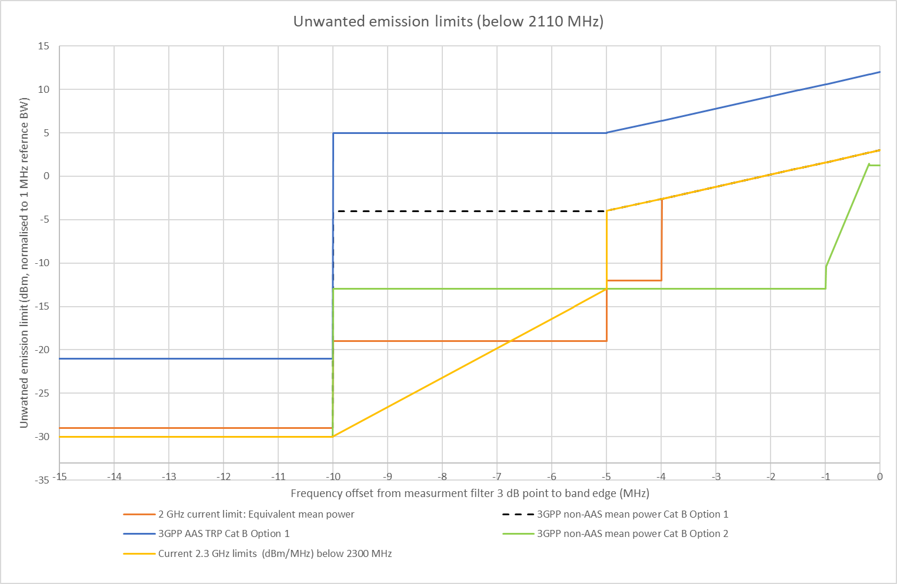

From Figure 1, the ACMA identified 2 points:

1. The Category B Option 1 limits (blue and black dotted) are higher than the existing 2 GHz limits, particularly below 2106 MHz (that is, -4 MHz).

The 3GPP Category B Option 2 non-AAS (green) and 2.3 GHz limits (yellow) are close to the existing 2 GHz emission limits.

Given the difference between Category B Option 1 and the existing limits, we did not believe relaxing current limits to Category B Option 1 was a viable option. However, given the smaller difference between the 2.3 GHz and existing limits, further consideration was given to this.

Our initial analysis indicated that within the 2100–2106 MHz frequency range, there is a difference of 6.25 dB in total integrated power between the 2.3 GHz and existing limits. This comes about due to the more relaxed limits in the 2103–2106 MHz frequency range for the 2.3 GHz limits. The difference in total integrated power decreases to approximately 0 dB if the 2.3 GHz emission limits are only adopted between 2100–2105 MHz.

The ACMA considered 3 possible options:

* no change
* adopting the 2.3 GHz mask

a hybrid mask based on Category B Option 2 and the 2.3 GHz mask.

Figure 3 illustrates the 3 options. All options are defined as TRP limits, and the same limit would apply to both AAS and non-AAS devices. We considered defining the emission mask as EIRP limits, which was the TOB operator’s preference as they felt it provided certainty when determining interference. However, we were satisfied that using TRP would not increase the interference environment and acknowledged that using EIRP is not the preferred method for expression limits for deploying modern networks by MNOs.

Proposed options below 2110 MHz

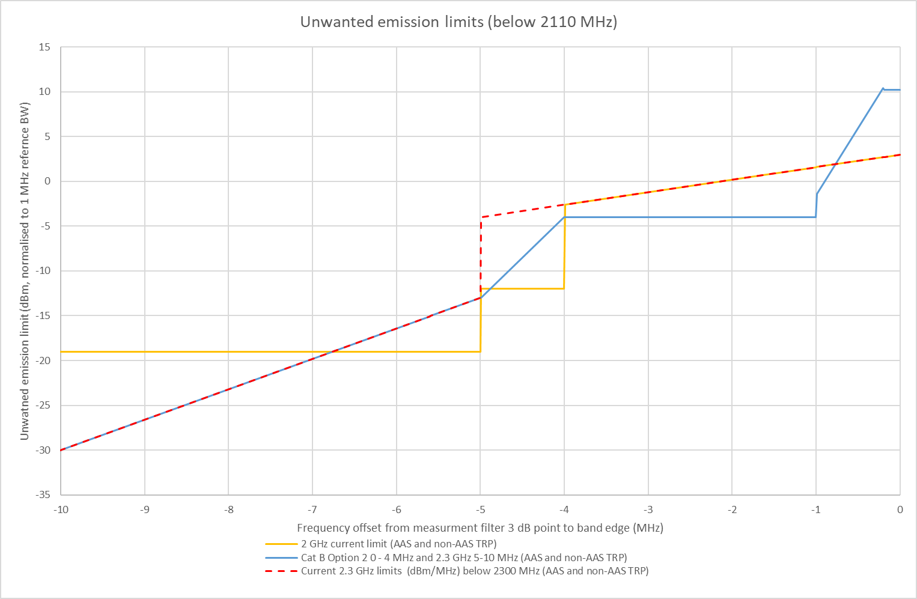

**Option 1: No change – maintain existing limits**. The proposed mask is converted to equivalent conducted power assuming 18 dBi antenna gain. While this would not be an issue for non-AAS devices, manufacturers would need to confirm if AAS devices can meet these limits.

**Option 2: Adopting the 2.3 GHz emission mask**. While this mask tightens the emission limits between 2100–2103 MHz, it relaxes the limits from 2103–2106 MHz. Based on discussions held during the 2.3 GHz TLG, the TLG is confident that AAS devices can meet these criteria.

**Option 3: Adopting a hybrid emission mask**. Establishes a 2.3 GHz emission mask between 2100–2105 MHz, Category B Option 2 emission mask between   
2106–2110 MHz, and a straight line from the 2.3 GHz mask at 2105 MHz to the Category B Option mask at 2106 MHz. Like Option 2, there is a trade-off between relaxing and tightening the emission mask between 2100–2105 MHz. The straight line between the 2.3 GHz emission mask and the category B Option 2 emission mask, limits the potential increase in the interference environment. Adopting the category B Option 2 emission mask provide flexibility for the MNOs to help ensure devices meet the criteria in the first 4 MHz from the band edge. We believe Option 3 presents a good compromise for both MNOs and TOB operators. As above, manufacturers would need to confirm what (if any) relaxation of limits are necessary to accommodate   
AAS devices.

While we engaged in further discussions with both TOB operators and MNOs, no consensus could be reached on a preferred option. The ACMA will present Option 1 and Option 3 in the public consultation to gather further information, before making a decision. Option 2 will not be included, as it presents too large an increase in emissions between 2105–2106 MHz.

### Proposed in-band emission limits for devices operating in the lower 2 GHz band

The ACMA proposed adopting 3GPP TS 38.101-1[[6]](#footnote-7) unwanted emission limits for in-band emission limits. Importantly this standard does not define separate limits for AAS transmitters. To future-proof arrangements for possible AAS use, we proposed to implement the 3GPP limits as TRP rather than conducted power – see Table 5. The TLG agreed with the ACMA’s proposals.

3GPP TS 38.101-1[[7]](#footnote-8) defines spurious emission limits as applying +/- (channel bandwidth + 5 MHz) outside a device’s assigned channel. This means non-spurious emissions apply at offsets of +/- (channel bandwidth + 5 MHz). So these limits also encompass possible LTE operating bandwidths of 5 MHz or less, the term max(Channel BW, 5) is used.

1. Unwanted emission limits for transmitters operating in the lower   
   2 GHz band at frequency offsets of channel bandwidth + 5 MHz   
   – all transmitters.

|  |  |  |
| --- | --- | --- |
| **Frequency offset**  **(foffset)** | **Total radiated power (dBm)** | **Measurement bandwidth** |
| 0 MHz ≤ foffset < 1 MHz | -13 | 30 kHz |
| 1 MHz ≤ foffset < 5 MHz | -10 | 1 MHz |
| 5 MHz ≤ foffset < 6 MHz | -13 | 1 MHz |
| 6 MHz ≤ foffset < max(Channel BW, 5) + 1 | -13 | 1 MHz |
| max(Channel BW, 5) + 1 ≤ foffset <  max(Channel BW, 5) + 5 MHz | -25 | 1 MHz |

### Proposed spurious emission limits

For the upper 2 GHz band, the spurious domain commences at +/- 10 MHz either side of the operating band (that is, 2110–2170 MHz band). Current 2 GHz spectrum licences define spurious emission limits as a radiated mean power (that is, EIRP) for all devices. The current limits do not align with international standards and do not clearly state where the spurious emission limits apply.

The TLG proposed adopting the transmitter and receiver spurious emissions limits specified in the 3GPP TS 38.104.[[8]](#footnote-9) 3GPP TS 38.104 defines separate limits for non-AAS and AAS devices. Non-AAS limits are defined as conducted powers (that is, mean power) per antenna port. AAS limits are defined in terms of TRP, which means they apply to the aggregate emissions from all transmitters/receivers that form   
a device.

The proposed spurious emission limits for non-AAS and AAS transmitters operating in the upper 2 GHz band are provided in Table 6 and Table 7 respectively.

The TLG similarly proposed to align the spurious emission limits for transmitters operating in the lower 2 GHz band with 3GPP standards. This will also help to more clearly define where the spurious emission limits apply. The current limits are defined in terms of EIRP, within the 1–3.5 GHz frequency range the limit is an EIRP of   
-2 dBm/MHz. This assumes an 18 dBi antenna gain applies in that frequency range. This limit is considered much higher than is necessary for most transmitters operating in the lower 2 GHz band. This is because devices in the lower 2 GHz band are typically lower gain mobile handsets and nomadic devices. In addition, the limits within the 9 kHz–1 GHz and 3.5 GHz–12.75 GHz frequency ranges assume a 0 dBi antenna gain to convert the standard 3GPP limits to an EIRP. As mobile handsets and other consumer devices are developed for the international market, it is usually preferable not to have to modify them to meet an Australian specific requirement. Aligning the lower 2 GHz band spurious emission limits with 3GPP standards would ensure this is not an issue. Due to the low level of emissions, there is expected to be a negligible change to the interference environment in doing this.

3GPP TS 38.101-1 defines the spurious domain for lower 2 GHz band transmitters as commencing +/- (channel bandwidth + 5 MHz) of a device’s assigned channel.

It is considered unlikely that transmitters with AAS will be deployed in the 2 GHz lower band. This means the same spurious emission limits can be applied for all transmitters. In the event AAS are deployed, it is proposed to define the limits in terms of TRP. The resulting proposed spurious emission limits for transmitters operating in the lower 2 GHz band are provided in Table 8.

1. Unwanted emission limits for transmitters operating in the upper   
   2 GHz band at frequency outside the 2100–2180 MHz band   
   – non-AAS devices

|  |  |  |
| --- | --- | --- |
| **Frequency  range (f)** | **Mean power (dBm) per transmitter port** | **Measurement bandwidth** |
| 9 kHz ≤ f < 150 kHz | -36 | 1 kHz |
| 150 kHz ≤ f < 30 MHz | -36 | 10 kHz |
| 30 MHz ≤ f < 1 GHz | -36 | 100 kHz |
| 1 GHz ≤ f < 12.75 GHz | -30 | 1 MHz |

1. Unwanted emission limits for transmitters operating in the upper   
   2 GHz band at frequency outside the 2100–2180 MHz band   
   – AAS devices

|  |  |  |
| --- | --- | --- |
| **Frequency  range (f)** | **Total radiated power (dBm) per cell/sector** | **Measurement bandwidth** |
| 9 kHz ≤ f < 150 kHz | -27 | 1 kHz |
| 150 kHz ≤ f < 30 MHz | -27 | 10 kHz |
| 30 MHz ≤ f < 1 GHz | -27 | 100 kHz |
| 1 GHz ≤ f < 12.75 GHz | -21 | 1 MHz |

1. Unwanted emission limits for transmitters operating in the lower   
   2 GHz band at frequency offsets of channel bandwidth + 5 MHz   
   – all transmitters

|  |  |  |
| --- | --- | --- |
| **Frequency**  **range (f)** | **Total radiated power (dBm)** | **Measurement bandwidth** |
| 9 kHz ≤ f < 150 kHz | -36 | 1 kHz |
| 150 kHz ≤ f < 30 MHz | -36 | 10 kHz |
| 30 MHz ≤ f < 1 GHz | -36 | 100 kHz |
| 1 GHz ≤ f < 12.75 GHz | -30 | 1 MHz |

The proposed spurious emission limits for non-AAS receivers operating in the lower   
2 GHz band are provided in Table 9. However, consistent with 3GPP TS 38.104, for a radiocommunications receiver where the antenna or transceiver array boundary connectors support both a radiocommunications receiver and a radiocommunications transmitter the limits in Table 6 will apply instead.

Due to the integrated nature of an AAS the proposed spurious emission limits for AAS receivers operating in the lower 2 GHz band are the same as the AAS transmitter spurious emission limits specified in Table 7.

It is similarly proposed to align the spurious emission limits for receivers operating in the upper 2 GHz band with 3GPP standards, this will also help to more clearly define where the limits apply. The same logic for changing the spurious emission limits for transmitters operating in the lower band also applies in this case. The resulting proposed spurious emission limits for receivers operating in the upper 2 GHz band are provided in Table 10.

1. Unwanted emission limits for receivers operating in the lower   
   2 GHz band at frequency outside the 2100–2180 MHz band   
   – non-AAS devices

|  |  |  |
| --- | --- | --- |
| **Frequency  range (f)** | **Mean power (dBm) per receiver port** | **Measurement bandwidth** |
| 30 MHz ≤ f < 1 GHz | -57 | 100 kHz |
| 1 GHz ≤ f < 12.75 GHz | -47 | 1 MHz |

1. Unwanted emission limits for receivers operating in the upper   
   2 GHz band at frequency offsets in the lower   
   2 GHz band at of channel bandwidth + 5 MHz – all transmitters

|  |  |  |
| --- | --- | --- |
| **Frequency  range (f)** | **Total radiated power (dBm)** | **Measurement bandwidth** |
| 30 MHz ≤ f < 1 GHz | -57 | 100 kHz |
| 1 GHz ≤ f < 12.75 GHz | -47 | 1 MHz |

### Devices exempt from registration

The TLG proposed changes to the definition of devices that are exempt from registration.

Devices exempt from registration, as defined on the current 2 GHz spectrum licences, fall into 2 categories:

1. Radiocommunications transmitters operating with a maximum EIRP less than or equal to 25 dBm per occupied bandwidth.

High-altitude platform services (HAPS) that do not exceed a power flux density of -121.5 dB(W/(m².MHz)) at the earth's surface outside the spectrum space.

For radiocommunication transmitters, 3GPP standards define numerous UE power classes that could apply. Power class 3 is the default power class, it defines a maximum power of 23 dBm per transmission bandwidth with a tolerance of +2 dB. As such, the TLG proposed to change the 25 dBm per occupied bandwidth limit from an EIRP to a TRP.

There was no proposal to change the HAPS condition.

The proposed new exemption from the registration requirements are as follows:

**Exemption from registration requirements**

4. The following kinds of radiocommunications transmitters are exempt from the registration requirement in statutory condition 3:

(a) a radiocommunications transmitter that operates in the 2 GHz band with a total radiated power of less than or equal to 25 dBm per occupied bandwidth;

(b) a HAPS that does not exceed a power flux density of -121.5 dB(W/(m².MHz)) at Earth's surface outside the spectrum space as defined for this licence in Table 1 of Licence Schedule 1 bandwidth.

### Other conditions on the licence

It is proposed to maintain all of the ‘other conditions’ (that is, those other than core and statutory conditions) that are currently contained in 2 GHz band spectrum licences. Please refer to the PDF image of current 2 GHz band spectrum licences [available on the RRL](https://web.acma.gov.au/rrl/register_search.main_page) for more details.

## Unacceptable levels of interference

Spectrum licensees are required to register a radiocommunications transmitter in the Register of Radiocommunications Licences before they may be operated under their licence. The only exception to this is if there is a condition on licences that exempts certain types of transmitters.

Subsection 145(1) of the Act gives the ACMA the power to refuse to register a radiocommunications transmitter if it is satisfied that the operation of the transmitter could cause an unacceptable level of interference to the operation of other radiocommunications devices. Under subsection 145(4) of the Act, we can make a determination (referred to as a section 145 determination) that sets out what is considered unacceptable levels of interference for each spectrum-licensed band.

A section 145 determination sets out the circumstances in which devices are deemed to cause unacceptable levels of interference. These circumstances typically include:

* if the levels of emissions from a device at the geographical boundary of a licence exceed a defined level
* if the operation of the transmitter will cause a breach of a core condition of the licence
* if the deployment of the device is outside any deployment constraints defined for the band.

The current section 145 determination for the 2 GHz band is the [Radiocommunications (Unacceptable Levels of Interference – 2 GHz Band) Determination 2016](https://www.legislation.gov.au/Details/F2017C00968).

Some of the key details of the 2 GHz band section 145 determination are:

* It is optimised for FDD use.
* The device boundary criteria (DBC) are based on the following:
* A defined level of protection of -96 dBm/5 MHz to a receiver with a gain of 0 dBi at a height of 1.5 m above the ground.
* Use of the modified HATA propagation model as specified in ERC Report 68.
* A calculation procedure similar to that implemented in other spectrum licence bands.

Based on discussions in the TLG, the following amendments are proposed to parts of the DBC:

* Keep the existing LOP of -96 dBm/5 MHz for non-AAS devices and increase the LOP for AAS devices to -88 dBm/5 MHz. Spectrum licensees proposed and are happy to adopt the increase of LOP for AAS devices.

The level of protection (LOP) is the benchmark protection given to receivers from co-channel emissions from transmitters operating in adjacent geographic licence areas. The current LOP is -96 dBm/5 MHz. This was based on compatibility with a UE receiver. The current nominal receive antenna height above ground level is 1.5 m and the current nominal receive antenna gain is Gr = 0 dBi.

For AAS devices, the possibility that a beam directed to a UE in one spectrum licence area would align with another operator’s UE in a different geographic area is very low. The TLG therefore proposed considering an antenna beam alignment loss of 8 dB when an AAS is being used by the base station. Therefore, the LOP for AAS devices is suggested to be -88 dBm/5 MHz.

* Increase in the accuracy of the base terrain data by applying 3-second DEM instead of 9-second DEM.

There are advantages in improving the accuracy of the base data. This change aligns with the changes made to the s.145 determination in the other bands, including the 850/900 MHz, 2.3 GHz, 3.4 GHz and 26 GHz bands. No changes to the height averaging are proposed.

To account for the higher resolution of the DEM, it was also proposed to increase the resolution of calculations from 500 m increments to 100 m increments.

* Increasing the maximum value of ‘m’ (which defines the maximum length of a DBC radial) from 80 to 400 (or equivalently 40 km). This is based on the path loss required, assuming smooth earth diffraction, from a 500 m high transmitter (Tx) to a 1.5 m receiver (Rx) (highest assumed Tx to Rx height difference) to meet the DBC. It also accounts for the change in the resolution of calculations from 500 m to 100 m.
* DBC failures over ocean paths not deemed as unacceptable interference.

The current DBC procedure has no exclusions for when the LOP outside a spectrum licensee’s area is exceeded over ocean paths only. This has resulted in device registration failures where there are no impacts to other licensees. This issue was addressed in TLG processes for the 850/900 MHz, 2.3, 3.4 GHz and 26 GHz bands. The TLG proposed including similar mechanisms for the 2 GHz band. Specifically, including the following new clause into the s.145(4) determination:

(2) A level of interference mentioned in paragraph 1(b) is not unacceptable in relation to a part of the device boundary of the radiocommunications transmitter that:

(a) lies outside the geographic area of the licence; and

(b) is connected to a radial that:

(i) is mentioned in Part 1 of Schedule 2; and

(ii) does not cross over land outside the geographical area of the

licence that is permanently above the Australian territorial sea

baseline as defined by Geoscience Australia;

(iii) does not cross into any of the following HCIS identifiers: IW3E, IW3I, IW3M, IW6A, IW6E, KX9, LX7, LX8, LX9.

* Transition arrangements.

Similar to s.145 determination amendments made in other bands, we proposed the inclusion of a grandfathering clause for existing device registrations. Such a clause is intended to clarify that a device is only required to adhere to the version of the s.145(4) determination that was in force at the time the device was registered. It also avoids any uncertainty over the impact the proposed changes may have on existing device registrations. The same clause as included in the 1800 MHz band is proposed. This also allows minor modifications to an existing registration to be made provided this is recorded on the RRL and the changes result in the same or smaller DBC.

|  |
| --- |
| Proposed amendment |
| **Transition – radiocommunications transmitter registered before commencement of this section**  (1) If a radiocommunications transmitter was included in the Register in relation to a spectrum licence in the 1800 MHz band before the commencement of this section (***relevant transmitter***), this section applies in relation to that transmitter.  (2) Subject to subsection (3), for the purposes of subsection 145(4) of the Act, a level of interference caused by a relevant transmitter is unacceptable if it would have been unacceptable under this Determination as in force at the time the relevant transmitter was included in the Register.  *Note*: This Determination, and previous versions of this Determination, can be obtained, free of charge, from the Federal Register of Legislation: [www.legislation.gov.au](http://www.legislation.gov.au).  (3) For the purposes of subsection 145(4) of the Act, if:  (a) after the commencement of this section, both:  (i) a detail of a relevant transmitter changes (***relevant change***); and  (ii) the change to the detail is recorded in the Register; and  (b) the distance of the new device boundary of the relevant transmitter is, on each radial mentioned in Part 1 of Schedule 2, equal to or less than the distance of the old device boundary of the relevant transmitter on that radial; and  (c) but for the effect of this subsection, a level of interference caused by the relevant transmitter, immediately after the change time, would be unacceptable;  the level of interference caused by the relevant transmitter, immediately after the change time, is not unacceptable because of the relevant change.  (4) In subsection (3):  ***change time***, for a relevant transmitter, means the time the relevant change is recorded in the Register.  ***new device boundary***, of a relevant transmitter, means the device boundary of the transmitter established immediately after the change time, in accordance with this Determination as in force at the change time.  ***old device boundary***, of a relevant transmitter, means the device boundary of the transmitter established immediately before the change time, in accordance with this Determination as in force at the registration time.  ***registration time***, for a relevant transmitter, means the time the transmitter was included in the Register. |

## Radiocommunications advisory guidelines

Further guidance on interference management with other licensed services is provided in Radiocommunications Advisory Guidelines (RAGs) made under section 262 of the Act. RAGs can refer to any aspect of radiocommunications or radio emissions.

Generally, RAGs include provisions to help assess the possible interference between spectrum-licensed devices and services operating under spectrum, apparatus or class licences. Potentially affected services are identified in the RAGs to enable licensees to assess and mitigate the risk of interference between these services.

It is important to note that where a case of interference arises between a spectrum-licensed device and another licensed device, the ACMA will refer to the provisions of the RAGs in resolving the matter. In general, affected licensees also have the ability to negotiate their own arrangements in order to manage interference. Such arrangements will also be taken into account when resolving any interference disputes.

Currently, there are three section 262 guidelines relevant to the deployment of services under 2 GHz band spectrum licences:

* [Radiocommunications Advisory Guidelines (Managing Interference from Spectrum Licensed Transmitters — 2 GHz Band) 2016](https://www.legislation.gov.au/Details/F2016L01712" \t "_self)
* [Radiocommunications Advisory Guidelines (Managing Interference to Spectrum Licensed Receivers – 2 GHz Band) 2016](https://www.legislation.gov.au/Details/F2016L01711)

We noted that as part of the sunsetting of spectrum licensing instruments of other bands, we will be remaking the 2 GHz RAGs. No substantial updates were proposed by the TLG.

## Radiocommunications assignment and licensing instruction (RALI) updates

The TLG discussed updates to RALIs to reflect the changes proposed changes to the technical framework. The ACMA identified 2 RALIs that would require updating –   
RALI FX 3 and RALI FX 21.

### RALI FX3: microwave fixed services

There will be updates to references contained in RALI FX3 (Appendix 7: Coordination of Apparatus Licences with Spectrum Licences: 1.8, 2.1 and 2.2 GHz Band Fixed Services). No other substantial updates were proposed.

### RALI FX21: television outside broadcasting services

There will be updates to references contained in RALI FX21 in Section 6.5 to unwanted emissions limits. No other substantial updates were proposed.

# Appendix A – Current use of the 2 GHz and adjacent bands

Figure 1 provides the current arrangements in the 2 GHz band (shown by the shaded area) and adjacent bands. Table 1 provides information on the number of existing apparatus-licensed services in the 2 GHz band and its adjacent bands.

1. 2 GHz band arrangements

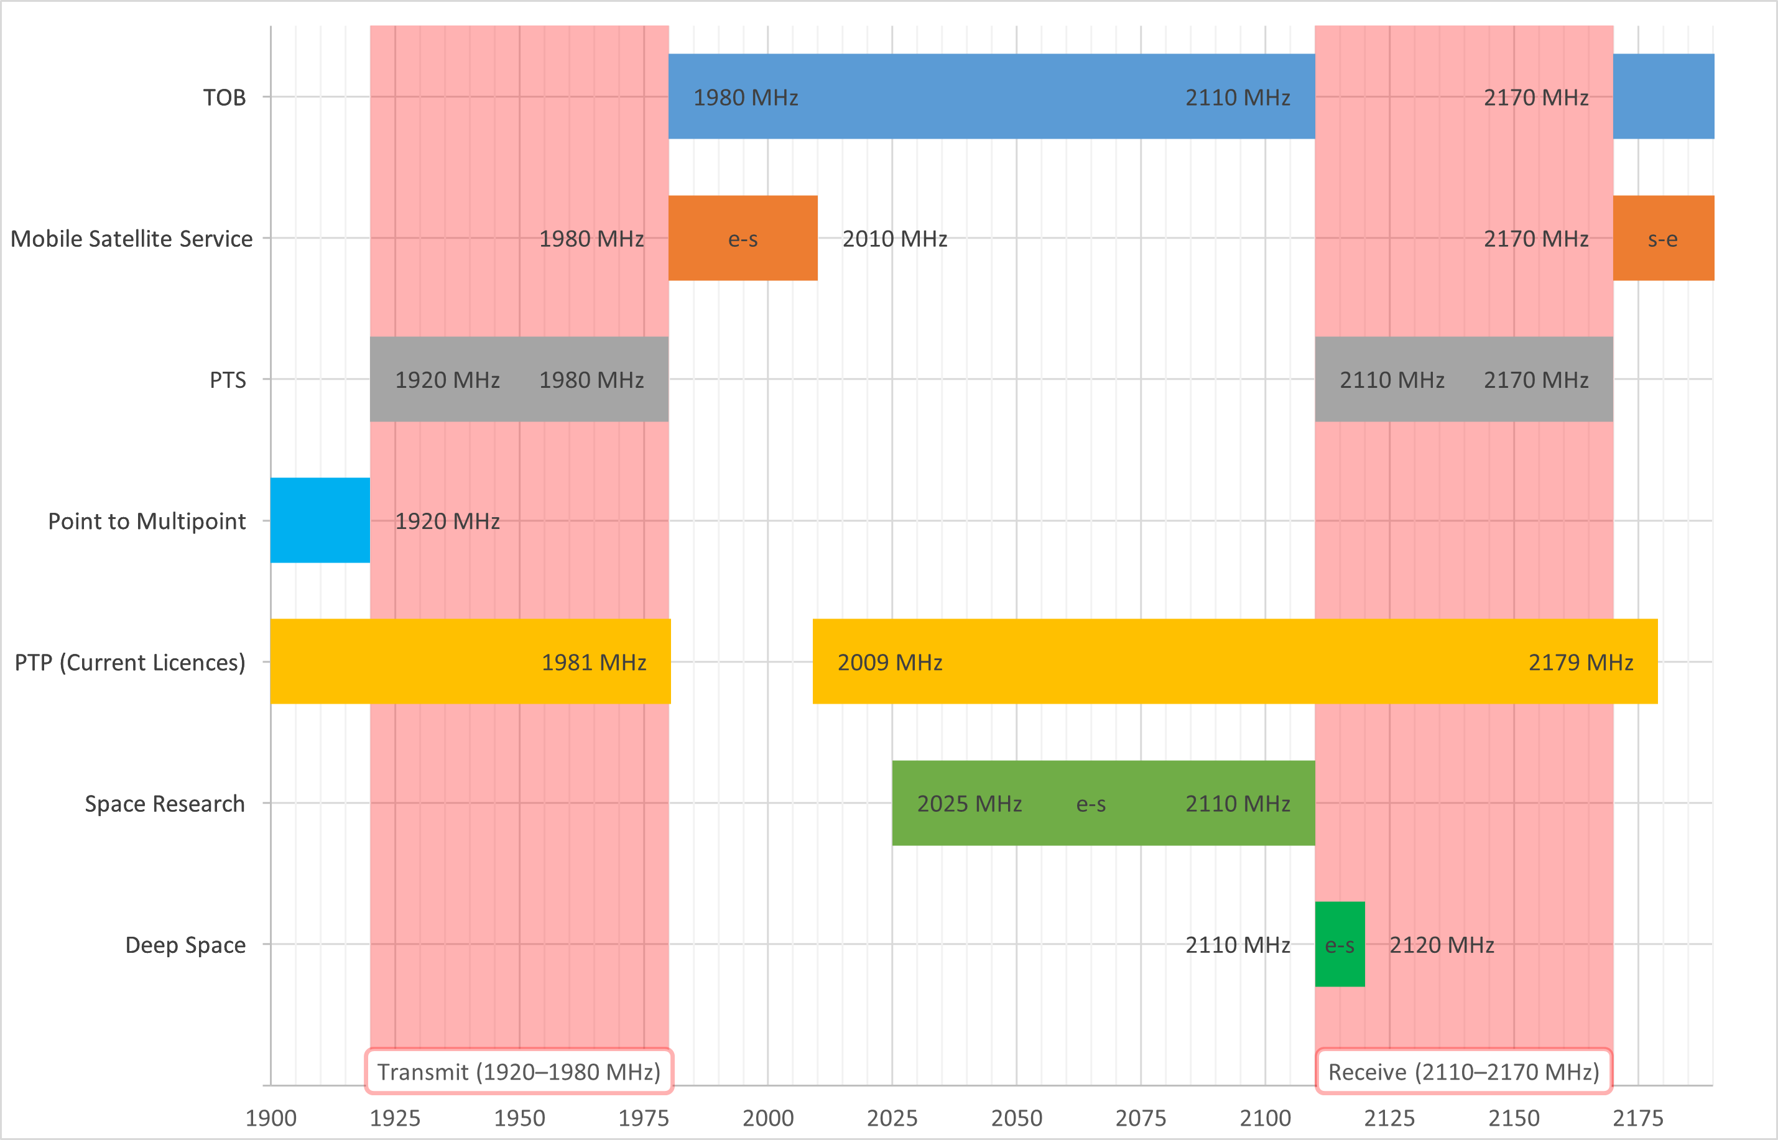

Table 1: Breakdown of apparatus licences in the 2 GHz band   
(RRL extract, August 2022)

| Licence type | No. of licences | No. of licensees |
| --- | --- | --- |
| PMTS (1920–1980 MHz, 2110–2170 MHz) | 16904 | 61 |
| 2.1 & 2.2 GHz point-to-point | 134 | 6 |

# Appendix B – Current 2 GHz band unwanted emission limits

## Frequency band and geographic areas

1. This licence authorises the operation of radiocommunications devices in the frequency bands and within the geographic areas set out in Part 2 of Licence Schedule 1.

## Emission limits outside the frequency band

1. Core conditions 3 to 10 apply in relation to those frequencies that are outside the frequency bands set out in Part 2 of Licence Schedule 1.
2. Where a written agreement specifying the maximum permitted level of radio emission for frequencies described in core condition 2 exists between:
   1. the licensee; and
   2. all the affected licensees of frequency-adjacent spectrum licences and area-adjacent spectrum licences;

the licensee must comply with that specified maximum permitted level of radio emission.

1. Where there is no written agreement for the purposes of core condition 3 in force, the licensee must comply with core conditions 5 to 10.

## Non-spurious emission limits

1. (1) Subject to sub-condition (2), the licensee must ensure that radiocommunications transmitters operated under this licence do not exceed the non-spurious emission limits in core conditions 6 and 7.

(2) For any frequency where an emission limit described in core conditions 8 to 10 is less than an emission limit described in core conditions 6 or 7, the emission limit in core conditions 8 to 10 applies.

1. The unwanted emission limits in Table 3 apply:
   1. to a radiocommunications transmitter operating in the frequency band 2110-2170 MHz;
   2. at frequencies outside the upper or lower frequency limits set out in Part 2 of Licence Schedule 1; and
   3. offset from the upper or lower frequency limits set out in Part 2 of Licence Schedule 1;

where:

**foffset** is the frequency offset from the 1785 MHz, 1805 MHz and 1880 MHz band edges. The -3dB point of the specified bandwidth closest to the band edge being frequency offset from, is placed at **foffset.**

**Table 3: Radiated maximum true mean power unwanted emission limits**

|  |  |  |
| --- | --- | --- |
| **Frequency offset range**  **(foffset)** | **Radiated maximum true mean power (dBm EIRP)** | **Specified Bandwidth** |
| 0 Hz < foffset < 5 MHz | 11 – (7/5) x f offset (MHz) | 100 kHz |
| 5 MHz < foffset < 10MHz | 4 | 100 kHz |
| foffset > 10 MHz | 3 | 1 MHz |

1. The unwanted emission limits in Table 4 apply:
   1. to a radiocommunications transmitters operating in the frequency band 1920-1980 MHz;
   2. at frequencies outside the upper or lower frequency limits set out in Part 2 of Licence Schedule 1; and
   3. offset from the upper or lower frequency limits set out in Part 2 of Licence Schedule 1;

where:

**foffset** is the frequency offset from the 1710 MHz band edge. The -3dB point of the specified bandwidth closest to the band edge being frequency offset from, is placed at **foffset.**

**Table 4: Radiated maximum true mean power unwanted emission limits**

|  |  |  |
| --- | --- | --- |
| **Frequency offset range**  **(foffset)** | **Radiated maximum true mean power (dBm EIRP)** | **Specified Bandwidth** |
| 0 Hz < foffset < 1 MHz | -15 | 30 kHz |
| 1 MHz < foffset < 5MHz | -10 | 1 MHz |
| 5 MHz < foffset < 39.8MHz | -13 | 1 MHz |
| foffset > 39.8 MHz | -25 | 1 MHz |

1. The unwanted emission limits in Table 5 apply:
   1. to a radiocommunications transmitter operating in the band 2110-2170 MHz;
   2. at frequencies above 2170 MHz; and
   3. offset from 2170 MHz;

where:

**foffset** is the frequency offset from the upper or lower frequency limits set out in Part 2 of Licence Schedule 1. The -3dB point of the specified bandwidth closest to the band edge being frequency offset from, is placed at **foffset.**

**Table 5: Radiated maximum true mean power unwanted emission limits**

|  |  |  |
| --- | --- | --- |
| **Frequency offset range**  **(foffset)** | **Radiated maximum true mean power**  **(dBm EIRP)** | **Specified Bandwidth** |
| 0 Hz < foffset < 4 MHz | 11 – (7/5) x f offset (MHz) | 100 kHz |
| 4 MHz < foffset < 5 MHz | -4 | 100 kHz |
| 5 MHz < foffset < 10 MHz | -1 | 1 MHz |
| foffset > 10 MHz | -11 | 1 MHz |

1. The unwanted emission limits in Table 6 apply:
   1. to a radiocommunications transmitter operating in the band 2110-2170 MHz;
   2. at frequencies above 2170 MHz; and
   3. offset from 2170 MHz;

where:

**foffset** is the frequency offset from the upper or lower frequency limits set out in Part 2 of Licence Schedule 1. The -3dB point of the specified bandwidth closest to the band edge being frequency offset from, is placed at **foffset.**

**Table 6: Radiated maximum true mean power unwanted emission limits**

|  |  |  |
| --- | --- | --- |
| **Frequency offset range**  **(foffset)** | **Radiated maximum true mean power**  **(dBm EIRP)** | **Specified Bandwidth** |
| foffset > 10 MHz | -11 | 1 MHz |

1. The additional unwanted emission limits in Table 7 apply to radiocommunications transmitters operating in the band 1920-1980 MHz.

**Table 7: Radiocommunications transmitter spurious emission limits**

|  |  |  |
| --- | --- | --- |
| **Frequency range**  **(f)** | **Radiated mean power**  **(dBm EIRP)** | **Specified**  **Bandwidth** |
| 9 kHz < f < 150 kHz | -36 | 1 kHz |
| 150 kHz < f < 30 MHz | -36 | 10 kHz |
| 30 MHz < f < 1 GHz | -36 | 100 kHz |
| 1 GHz < f < 1.875 GHz | -30 | 1 MHz |
| 2.025 GHz < f | -30 | 1 MHz |

1. Equivalent isotropic radiated power. [↑](#footnote-ref-2)
2. 3GPP R4-168430, ‘On NRb BS ACLR requirement’, Huawei, 3GPP TSG-RAN WG4 Meeting #80bis, October 2016. [↑](#footnote-ref-3)
3. A gain of 23.7 dBi (8x8 array) was used as we are converting from EIRP to TRP of an AAS system. [↑](#footnote-ref-4)
4. A gain of 18 dBi gain was assumed as we are converting from EIRP to conducted for a non-AAS system [↑](#footnote-ref-5)
5. The 2.3 GHz spectrum licensing technical framework was recently reviewed and is relevant because there are TOB services in the adjacent band also [↑](#footnote-ref-6)
6. 3GPP TS 38.101-1 is available at: <https://portal.3gpp.org/desktopmodules/Specifications/SpecificationDetails.aspx?specificationId=3283>. [↑](#footnote-ref-7)
7. 3GPP TS 38.101-1 is available at: <https://portal.3gpp.org/desktopmodules/Specifications/SpecificationDetails.aspx?specificationId=3283>. [↑](#footnote-ref-8)
8. 3GPP TS 38.104, available at: <https://portal.3gpp.org/desktopmodules/Specifications/SpecificationDetails.aspx?specificationId=3202>. [↑](#footnote-ref-9)