ACMA compliance priority 2021–22
final report
Electromagnetic energy (EME) near 5G mobile base stations
august 2022
Canberra
Red Building
Benjamin Offices
Chan Street
Belconnen ACT
PO Box 78
Belconnen ACT 2616
T +61 2 6219 5555
Melbourne
Level 32
Melbourne Central Tower
360 Elizabeth Street
Melbourne VIC
PO Box 13112
Law Courts
Melbourne VIC 8010
T +61 3 9963 6800
Sydney
Level 5
The Bay Centre
65 Pirrama Road
Pyrmont NSW
PO Box Q500
Queen Victoria Building
NSW 1230
T +61 2 9334 7700
Copyright notice
https://creativecommons.org/licenses/by/4.0/
With the exception of coats of arms, logos, emblems, images, other third-party material or devices protected by a trademark, this content is made available under the terms of the Creative Commons Attribution 4.0 International (CC BY 4.0) licence.
We request attribution as © Commonwealth of Australia (Australian Communications and Media Authority) 2022.
All other rights are reserved.
The Australian Communications and Media Authority has undertaken reasonable enquiries to identify material owned by third parties and secure permission for its reproduction. Permission may need to be obtained from third parties to re-use their material.
Written enquiries may be sent to:
Manager, Editorial Services
PO Box 13112
Law Courts
Melbourne VIC 8010
Email: info@acma.gov.au

Executive summary 1
Our 5G EME compliance program 1
EME measurement program 2
Summary of EME measurement results in New South Wales 3
Background 4
Methodology 5
Limitations 5
Base station site selection 5
Part 1: Environmental EME measurements 9
Purpose 9
Limitations 9
Methodology 9
Outcomes 10
Part 2: Comparisons to carriers predicted EME 13
Purpose 13
Limitations 13
Methodology 13
Outcomes 14
Part 3: Investigation of 5G beamform technology 18
Purpose 18
Limitations 18
Methodology 18
Outcomes 19
EME Checker: a tool for searching local EME measurements 21
Summary 22
Appendix A: Site list 24
Appendix B: Predicted maximum EME vs measured maximum EME 28
TPG Telecom Limited 28
Optus 29
Telstra 30
Appendix C: Active vs idle maximum beamformed EME 31
TPG Telecom Limited 31
Optus 32
Telstra 33

Executive summary
5G is the latest generation of wireless communication, offering improved connectivity and latency, and increased data speeds. However, misinformation has resulted in some community health concerns about electromagnetic energy (EME) as a result of Australia’s roll-out of the 5G mobile network.
The EME exposure standard in Australia is based on scientific assessment and established limits to human exposure to radiofrequency fields (RF). Exposure limits are set by the Australian Radiation Protection and Nuclear Safety Agency (ARPANSA). The Australian Communications and Media Authority regulates these limits by imposing conditions on network operators for the operation of radiocommunications transmitters.
The ARPANSA safety limits are set well below levels that can cause harm to people. ARPANSA and international organisations such as the World Health Organisation and the International Commission of Non-Ionising Radiation have found no established scientific evidence to support any adverse health effects from EME exposure to people.
The ACMA monitors EME limits to ensure that network operators are following the rules in the EME exposure standard.

Our 5G EME compliance program
In April 2020, we announced 5G EME as one of our compliance priorities for 2020–21. Given the continued rollout of 5G by Optus, Telstra and TPG Telecom Limited (the carriers), we again chose to focus on 5G and EME as one of our compliance priorities for 2021–22.
There are 2 main elements of the regulation of 5G mobile phone base stations under the legislation we administer:
carrier consultation and notification requirements under the C564:2020 Mobile Phone Base Station Deployment Code (the deployment code) when installing base stations.
carrier compliance with the mandatory standard for EME emissions in licence conditions under the Radiocommunications Licence Conditions (Apparatus Licence) Determination 2015 (the licence determination).
The outcomes of our 5G and EME compliance programs for 2021–22 are outlined in 2 reports that assess carriers’ compliance with:
EME exposure level standards
consultation and notification requirements under the deployment code when rolling out 5G technology.
Components of our 5G and EME compliance programs, 2021–22

This EME measurement program report focuses on carriers’ compliance with the EME standard for 5G deployments.
While this compliance program has focused on 5G sites in New South Wales this year and Victoria last year, the findings from this work provide a baseline for our continuing focus on 5G and EME deployments across all Australian states and territories.

EME measurement program
In early 2021, we measured EME public exposure levels at 129 5G-enabled mobile telecommunications base station sites in Victoria. We published our findings in the electromagnetic energy (EME) near 5G mobile base stations 2020–21 report in August 2021.
This year we have continued our EME measurement program to include 129 sites in New South Wales, measured between July 2021 and May 2022.
The measurement program assesses compliance by the carriers with their regulatory obligations to ensure that EME levels in areas accessible to the public are below the ARPANSA safety limits.
We undertook 3 different types of activity to assess carriers’ compliance with the EME standard:
environmental EME measurements – measuring the average cumulative EME at a telecommunications site
comparisons of actual maximum measured levels with carrier predicted maximum EME levels at a telecommunications site
EME measurements when 5G beamforming is in use at a telecommunications site to consider the impact of beamforming technology on EME exposure levels.

Summary of EME measurement results in New South Wales
Similar to the results of our measurement work undertaken in 2020–21 in Victoria, we found that carriers in NSW are complying with their obligations. We have also found that the results of our measurement work in NSW is very similar to the results of our measurement work in Victoria.

Environmental EME measurements
Average EME levels at all sites was less than 1.2% of the ARPANSA standard; the majority of sites were under 1%.

Comparisons of actual vs predicted maximum EME levels
Carrier EME predicted levels were, in all cases, higher than the actual levels measured. At 99% of sites measured, the total EME was less than 50% of the carrier predicted EME.

Beamforming EME maximum measurements
The maximum beamformed EME measured was less than 3.2% of the ARPANSA standard.

Background
The ACMA is responsible for ensuring that licensees and suppliers of communications equipment and devices comply with the EME standard. We undertake a range of compliance activities, including examining areas of specific interest or concern as new technologies are rolled out in Australia.
During the 2021–22 financial year, over 2,500 new 5G deployments were rolled out in Australia. Examples include the deployment of mobile network small cell infrastructure and the rapid rollout of 5G technology in the 3500 MHz band deployed on mobile network rooftop and tower sites.
In this year’s 5G EME compliance program, we’ve continued our focus on carriers’ compliance with the EME requirements of their licence conditions under the licence determination, and with their consultation requirements under the deployment code.
Our objectives for the 2021–22 5G EME compliance priority program audit selected mobile base stations to:
assess the effectiveness of current regulatory measures in managing the risks associated with EME emissions from 5G deployments
check whether carriers complied with their obligations to notify, and consult interested stakeholders before deploying 5G technology
ascertain and mitigate any identified risk of EME exposure to the public from 5G deployments
make sure the public were effectively educated and informed about EME exposure levels.
This report presents the results of our EME measurements taken between July 2021 and May 2022 at a selection of 5G-enabled telecommunications base stations in NSW, as part of our 5G EME compliance program.

Methodology
We took measurements in 3 separate categories to assess carriers’ compliance with the EME standard:
Part 1: Environmental EME measurements
This category seeks to establish whether the measured EME power density at a base station is within the limits set by the ARPANSA standard.
Part 2: Comparisons to carriers' predicted EME
For each base station facility, carriers publish a calculated prediction of the maximum level of EME and a distance from the base station where that maximum occurs. This category seeks to determine the integrity of the carriers’ EME predictions, by comparing them with field-based measurements taken at, or as close as practically possible to, the predicted distance from the base station provided by the carriers.
Part 3: Investigation of 5G beamforming technology
The purpose of this category is to use alternative measurement techniques to indicate the maximum level of EME that may be contained within a 5G beamformed transmission from base stations installed with beamforming capable antennas. This more accurately reflects the way 5G technology works.
Each category is discussed in detail in the following sections of this report.

Limitations
Having completed a measurement program of 5G enabled sites in Victoria last year, ACMA staff conducted measurements in metropolitan Sydney and regional New South Wales during the 2021–22 financial year as travel restrictions brought about by the COVID-19 pandemic and extensive flooding in New South Wales allowed. Our program will extend to other states of Australia in 2022–23 to provide a broader sample of measured sites.

Base station site selection
We selected a sample of mobile telecommunication sites for audit and measurement from the Radio Frequency National Site Archive (RFNSA), a public database of all Australian mobile phone base stations, hosted by the Australian Mobile Telecommunications Association (AMTA).
Last year in Victoria, we measured 129 5G-enabled base stations selected at random from the RFNSA; 43 each from Optus, Telstra and TPG Telecom Limited. For consistency with this year’s measurement program, we applied the same methodology and selected another 129 5G-enabled sites, 43 from each carrier, at random from the RFNSA in NSW.
The sites are shown below in Figure 2 and 3. Site numbers correlate with the list of sites at Appendix A.
- Site locations in Greater Sydney
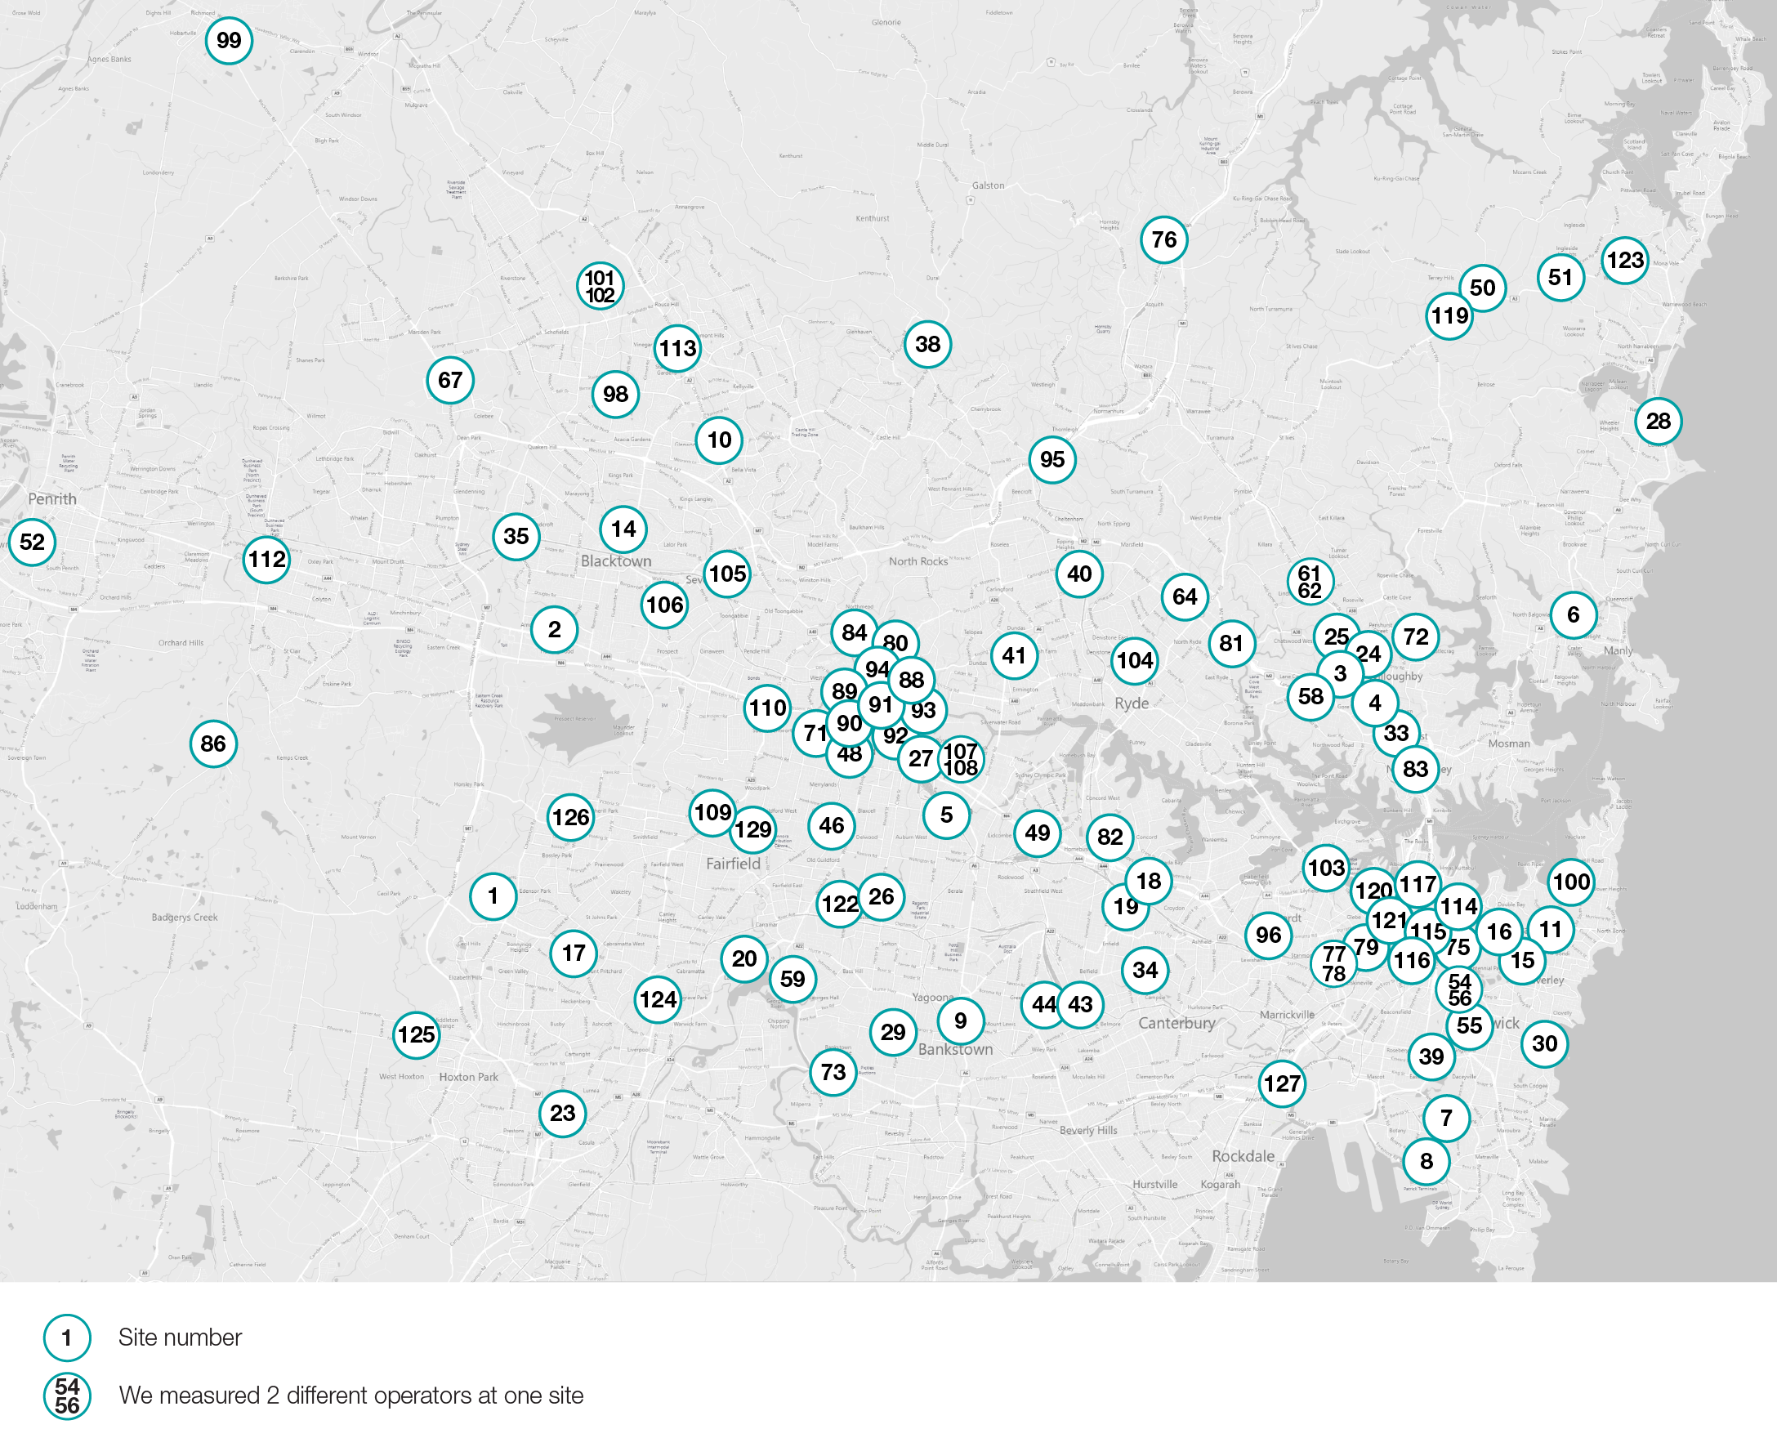
- Site locations outer Sydney and regional New South Wales
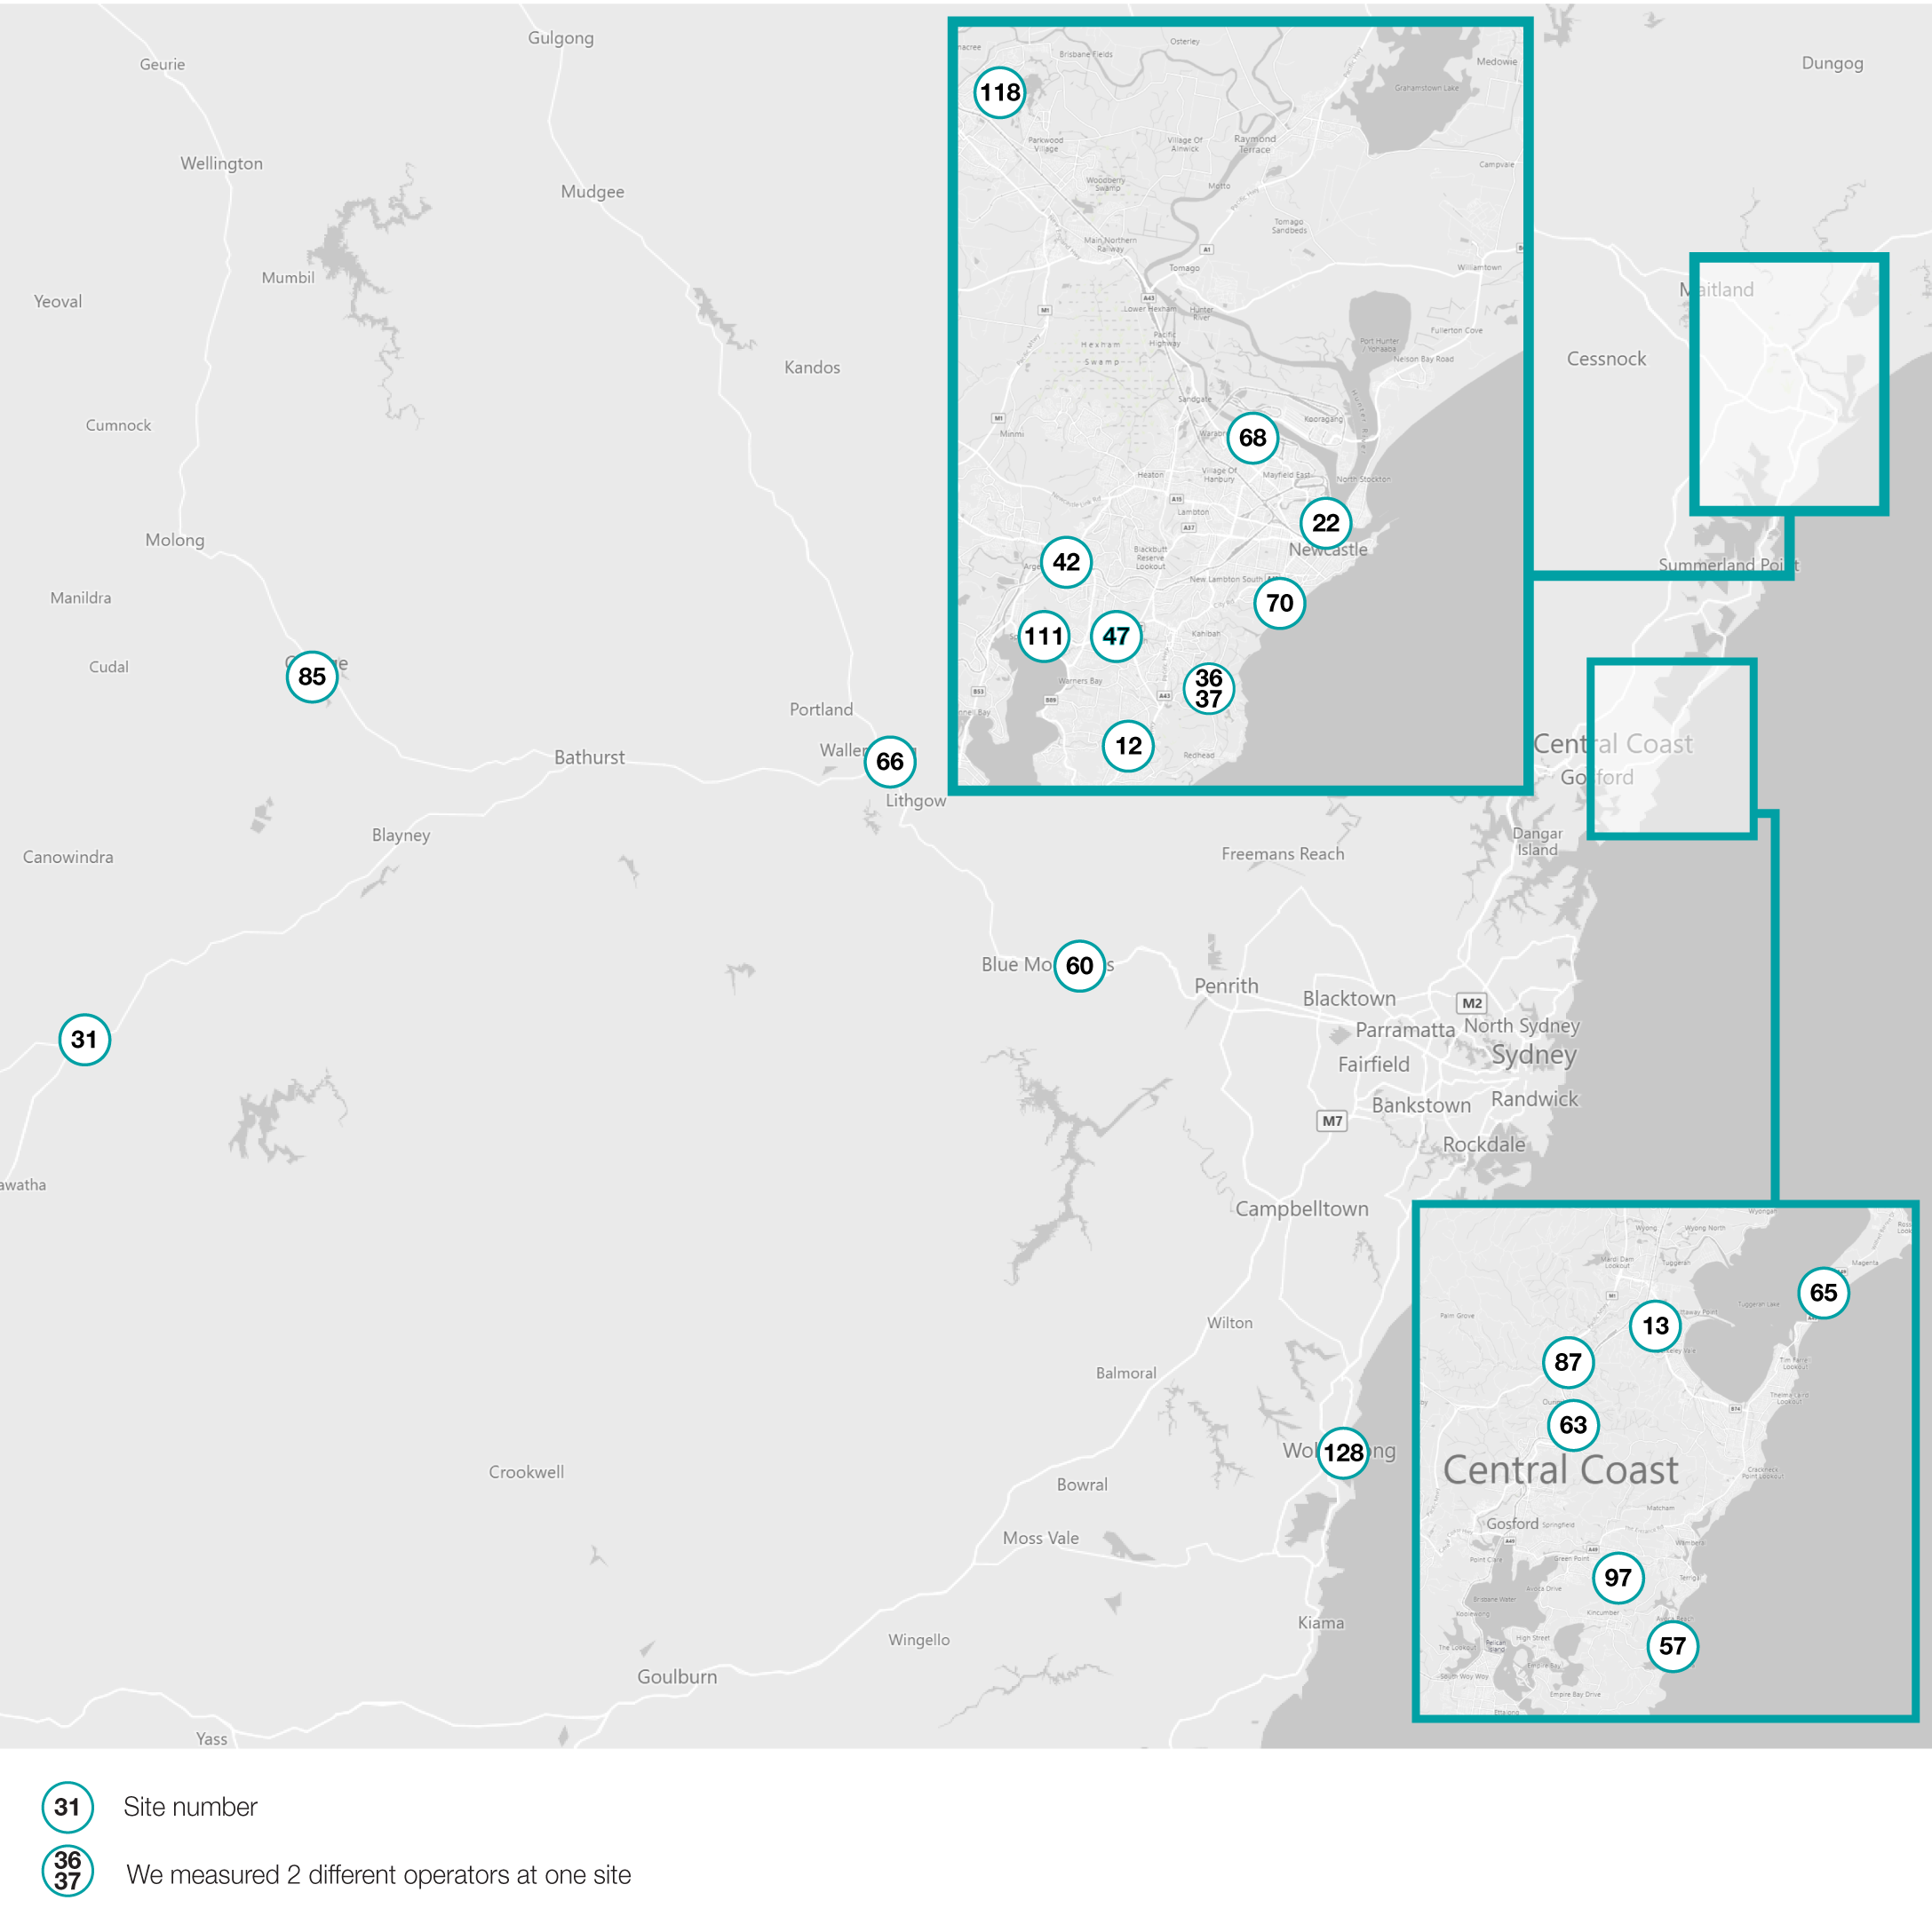

Selecting a suitable measurement location
Locations for conducting measurements at each base station were selected using all of the following criteria:
at a distance from the base station accessible to the public that is as close as possible to where the highest level of predicted EME is specified in the environmental EME report available from the RFNSA
has a clear and uninterrupted line-of-sight view to the base station antennas
in a direction not more than ±30 degrees from the centre line of the azimuth of one of the base station’s antenna sectors.
Before conducting each EME measurement, we identified known characteristics of the transmitters installed at each site, including the likely propagation and physical environment characteristics.
Physical site characteristics were visually inspected and compared with corresponding information for each base station in the environmental EME report and the EME guide available from the RFNSA. Photographs of each of the base stations were also taken. Observations made at each site were recorded and used to inform both the EME records and base station deployment code audit programs.
As shown in Figure 4 below, measurements in all 3 categories were conducted using a selective field strength measuring device – a Narda SRM-3006 selective radiation meter – along with an isotropic electric field probe – a Narda 3-axis antennae (420 MHz to 6 GHz). The meter was mounted on a tripod at a height of 1.5 metres above ground level.
Narda SRM-3006 measurement probe at a typical measurement location
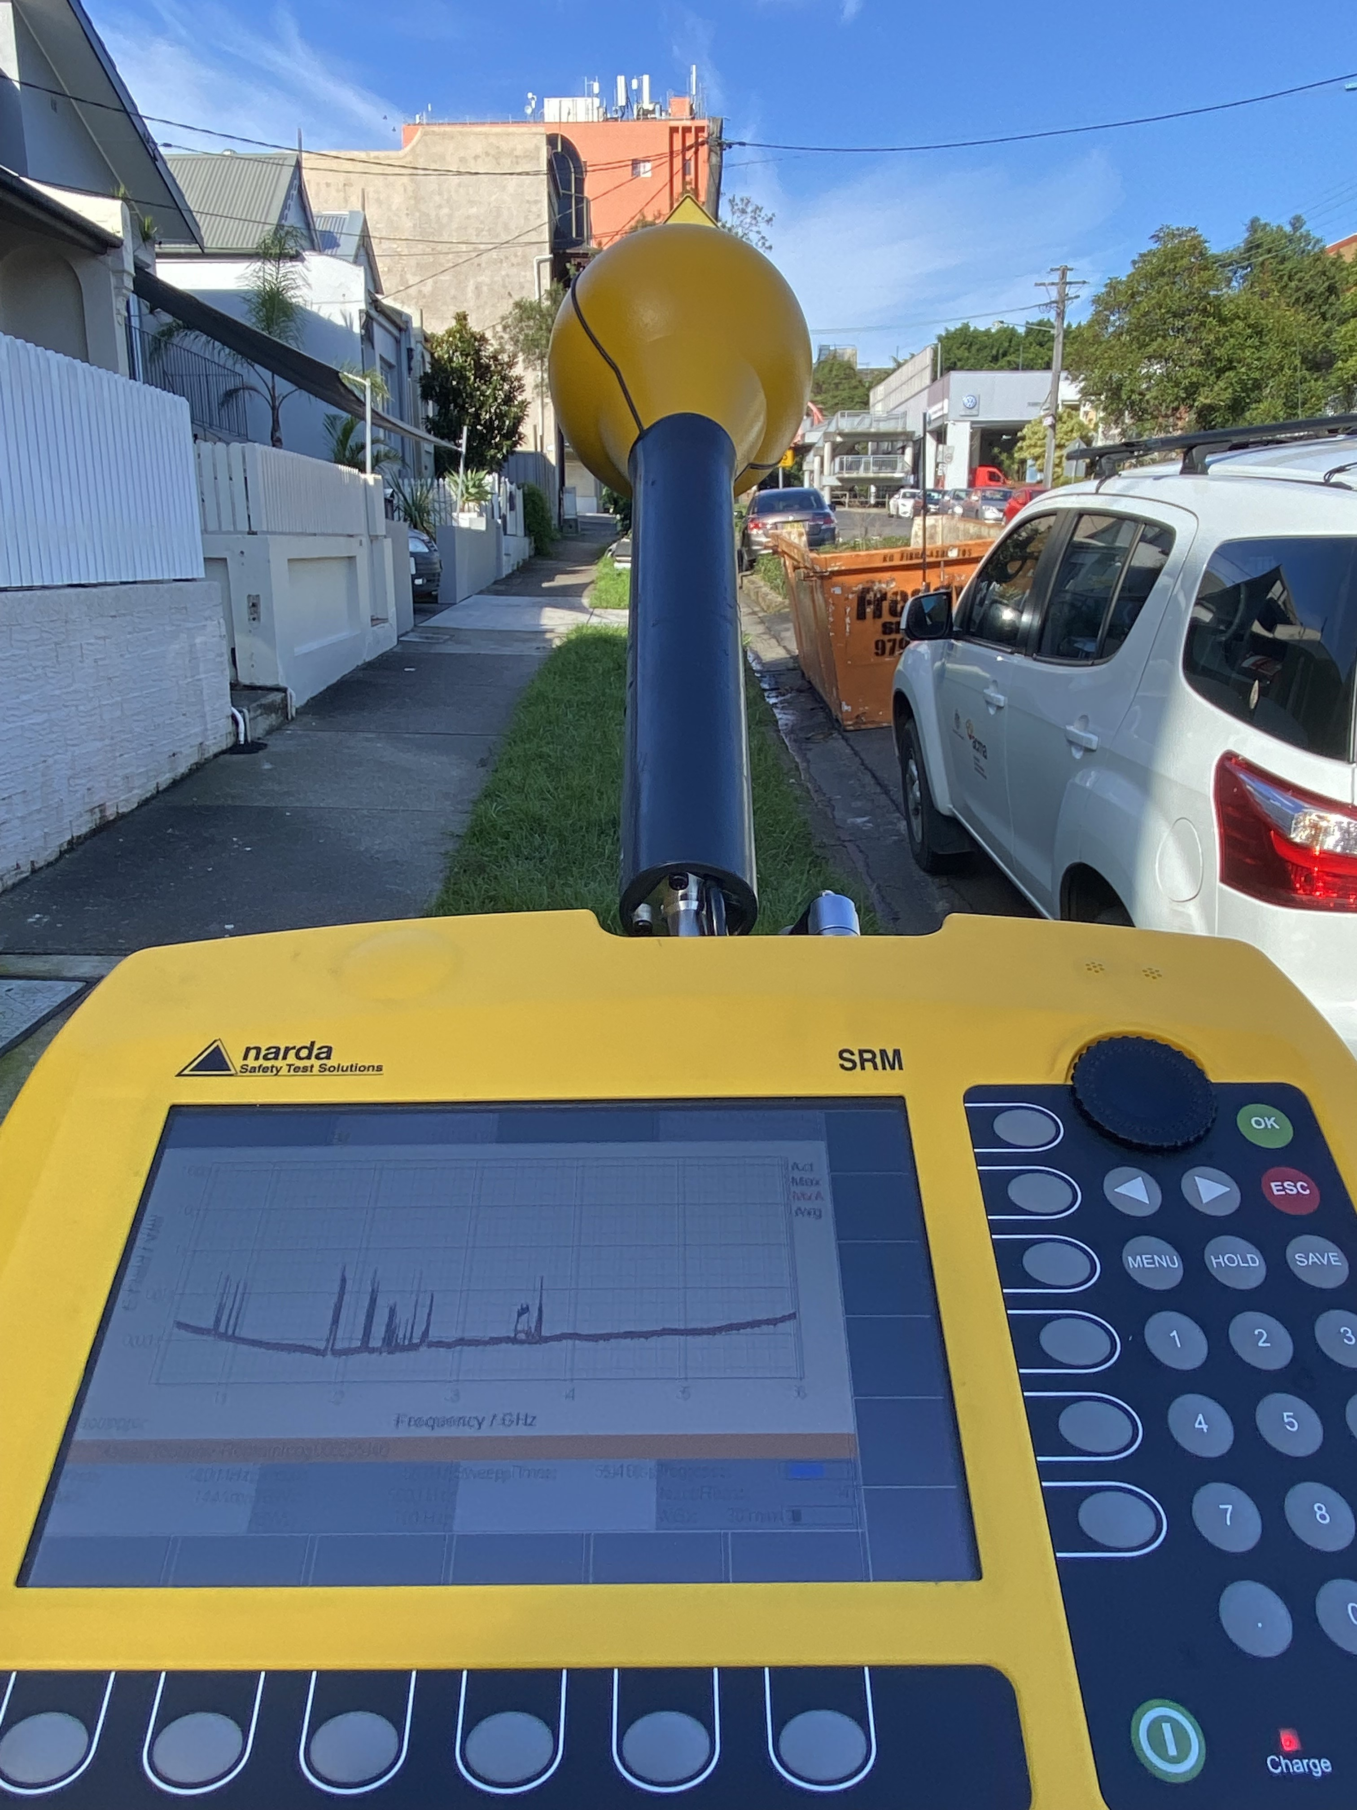

Part 1: Environmental EME measurements

Purpose
Environmental EME measurements were conducted to measure the average overall EME exposure levels between 420 MHz and 6 GHz at, or as close as practically possible to, the point of maximum predicted or calculated EME level at the selected sample of 129 active 5G base station sites. This was to ascertain whether EME is within the limits set by ARPANSA’s Radiation Protection Standard for Maximum Exposure Levels to Radiofrequency Fields – 3 KHz to 300 GHz (2002) (the ARPANSA RPS3 standard) as required by the reference levels for time-averaged exposure to RMS electric and magnetic fields (unperturbed fields).

Limitations
In February 2021, ARPANSA released a new standard, the Standard for Limiting Exposure to Radiofrequency Fields – 100 KHz to 300 GHz (the ARPANSA RPS S-1 standard). This new standard updates the Radiation Protection Standard for Maximum Exposure Levels to Radiofrequency Fields - 3 kHz to 300 GHz (2002) (the ARPANSA RPS3 standard)
The new ARPANSA RPS S-1 standard specifies a change to the averaging time for whole of body exposure to RF fields from 6 minutes to 30 minutes. This change was made to better match the time taken for body core temperature to rise. The EME power density exposure limits for frequencies we measured between 420 MHz and 6 GHz remain the same for both the ARPANSA RPS3 and RPS S-1 standards.
The ACMA updated its legislative instruments in November 2021 to reflect the new standard, specifically the Radiocommunications Licence Conditions (Apparatus Licence) Determination 2015 which, amongst other things, sets out the licence conditions for mobile network operator licensees.
The ACMA conducted environmental EME measurements using the ARPANSA RPS3 standard referenced in our legislative instruments in July 2021 when we commenced the measurements. However, we have chosen to depart from that standard and use the increased whole-of-body-exposure measurement time of 30 minutes specified in the new ARPANSA RPS S-1 standard.
The increased exposure measurement time was adopted in the interests of applying a best practice approach. The adoption of the 30-minute measurement period will enable us to make comparisons between results collected during this current measurement program with results collected in future programs using the ARPANSA RPS S-1 standard.

Methodology
Measurements were conducted in accordance with the Standards Australia document, Radiofrequency fields, Part 2: Principles and methods of measurement and computation – 3 kHz to 300 GHz – AS/NZS 2772.2 Standard (the AS/NZS 2772.2 Standard) and the ARPANSA RPS3 standard.
At each measurement location, measurements were conducted between 420 MHz and 6 GHz, which includes all public mobile telecommunication service bands currently used in Australia.
The equipment provided an overall exposure level made up of individual contributions made by the mobile base station and other sources present at the measurement location transmitting between 420 MHz and 6 GHz. The average EME expressed as a percentage of the ARPANSA RPS3 limit was measured over a period of 30 minutes.

Outcomes
Measurements at 129 individual, publicly-accessible base station sites in NSW revealed very low levels of average EME – under 1.2% of the ARPANSA limit.
We are satisfied that the carriers are complying with the exposure limits of the safety standard:
inside the Sydney metropolitan area, the highest average EME measured was 1.14% at Parramatta (RFNSA site 2150004) and the lowest measured was 0.05% at Terrey Hills (RFNSA site 2084009). See Figure 5.
- Outside of the Sydney metropolitan area, the highest average EME measured was: 1.12% at Glendale (RFNSA site 2285006) and the lowest measured was 0.05% at Pickets Valley (RFNSA site 2251001). See Figure 6.

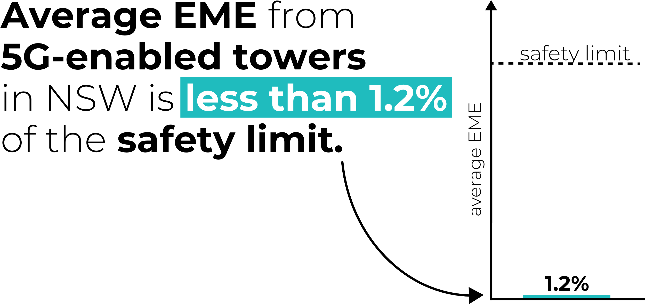
- Greater Sydney average EME site-by-site, as at 31 May 2022
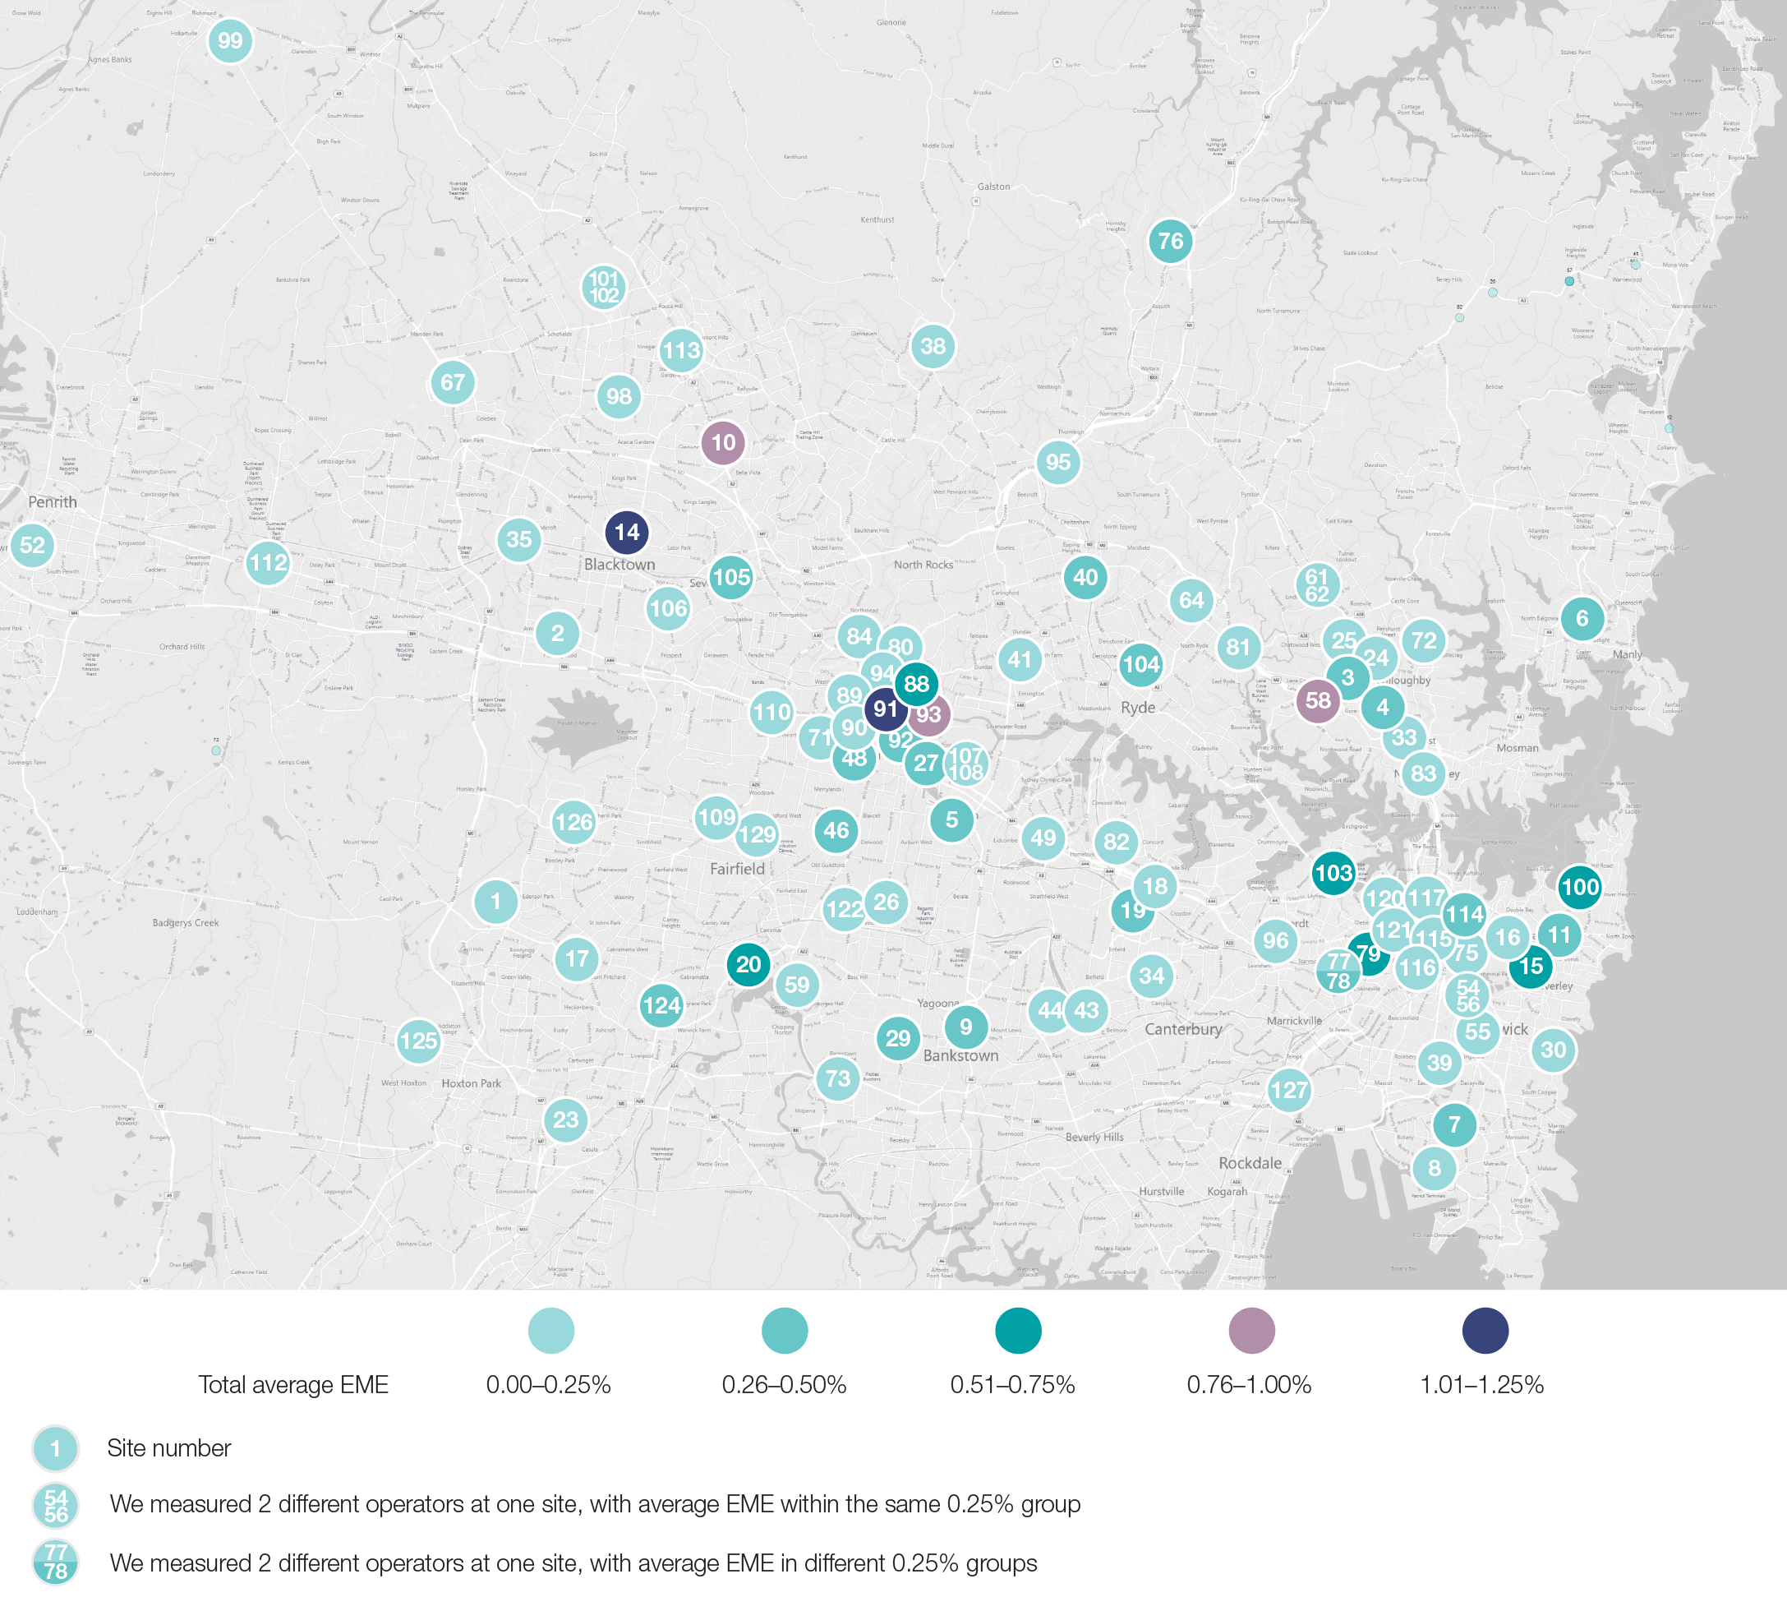
Outer Sydney and regional New South Wales average EME site-by-site, as at 31 May 2022
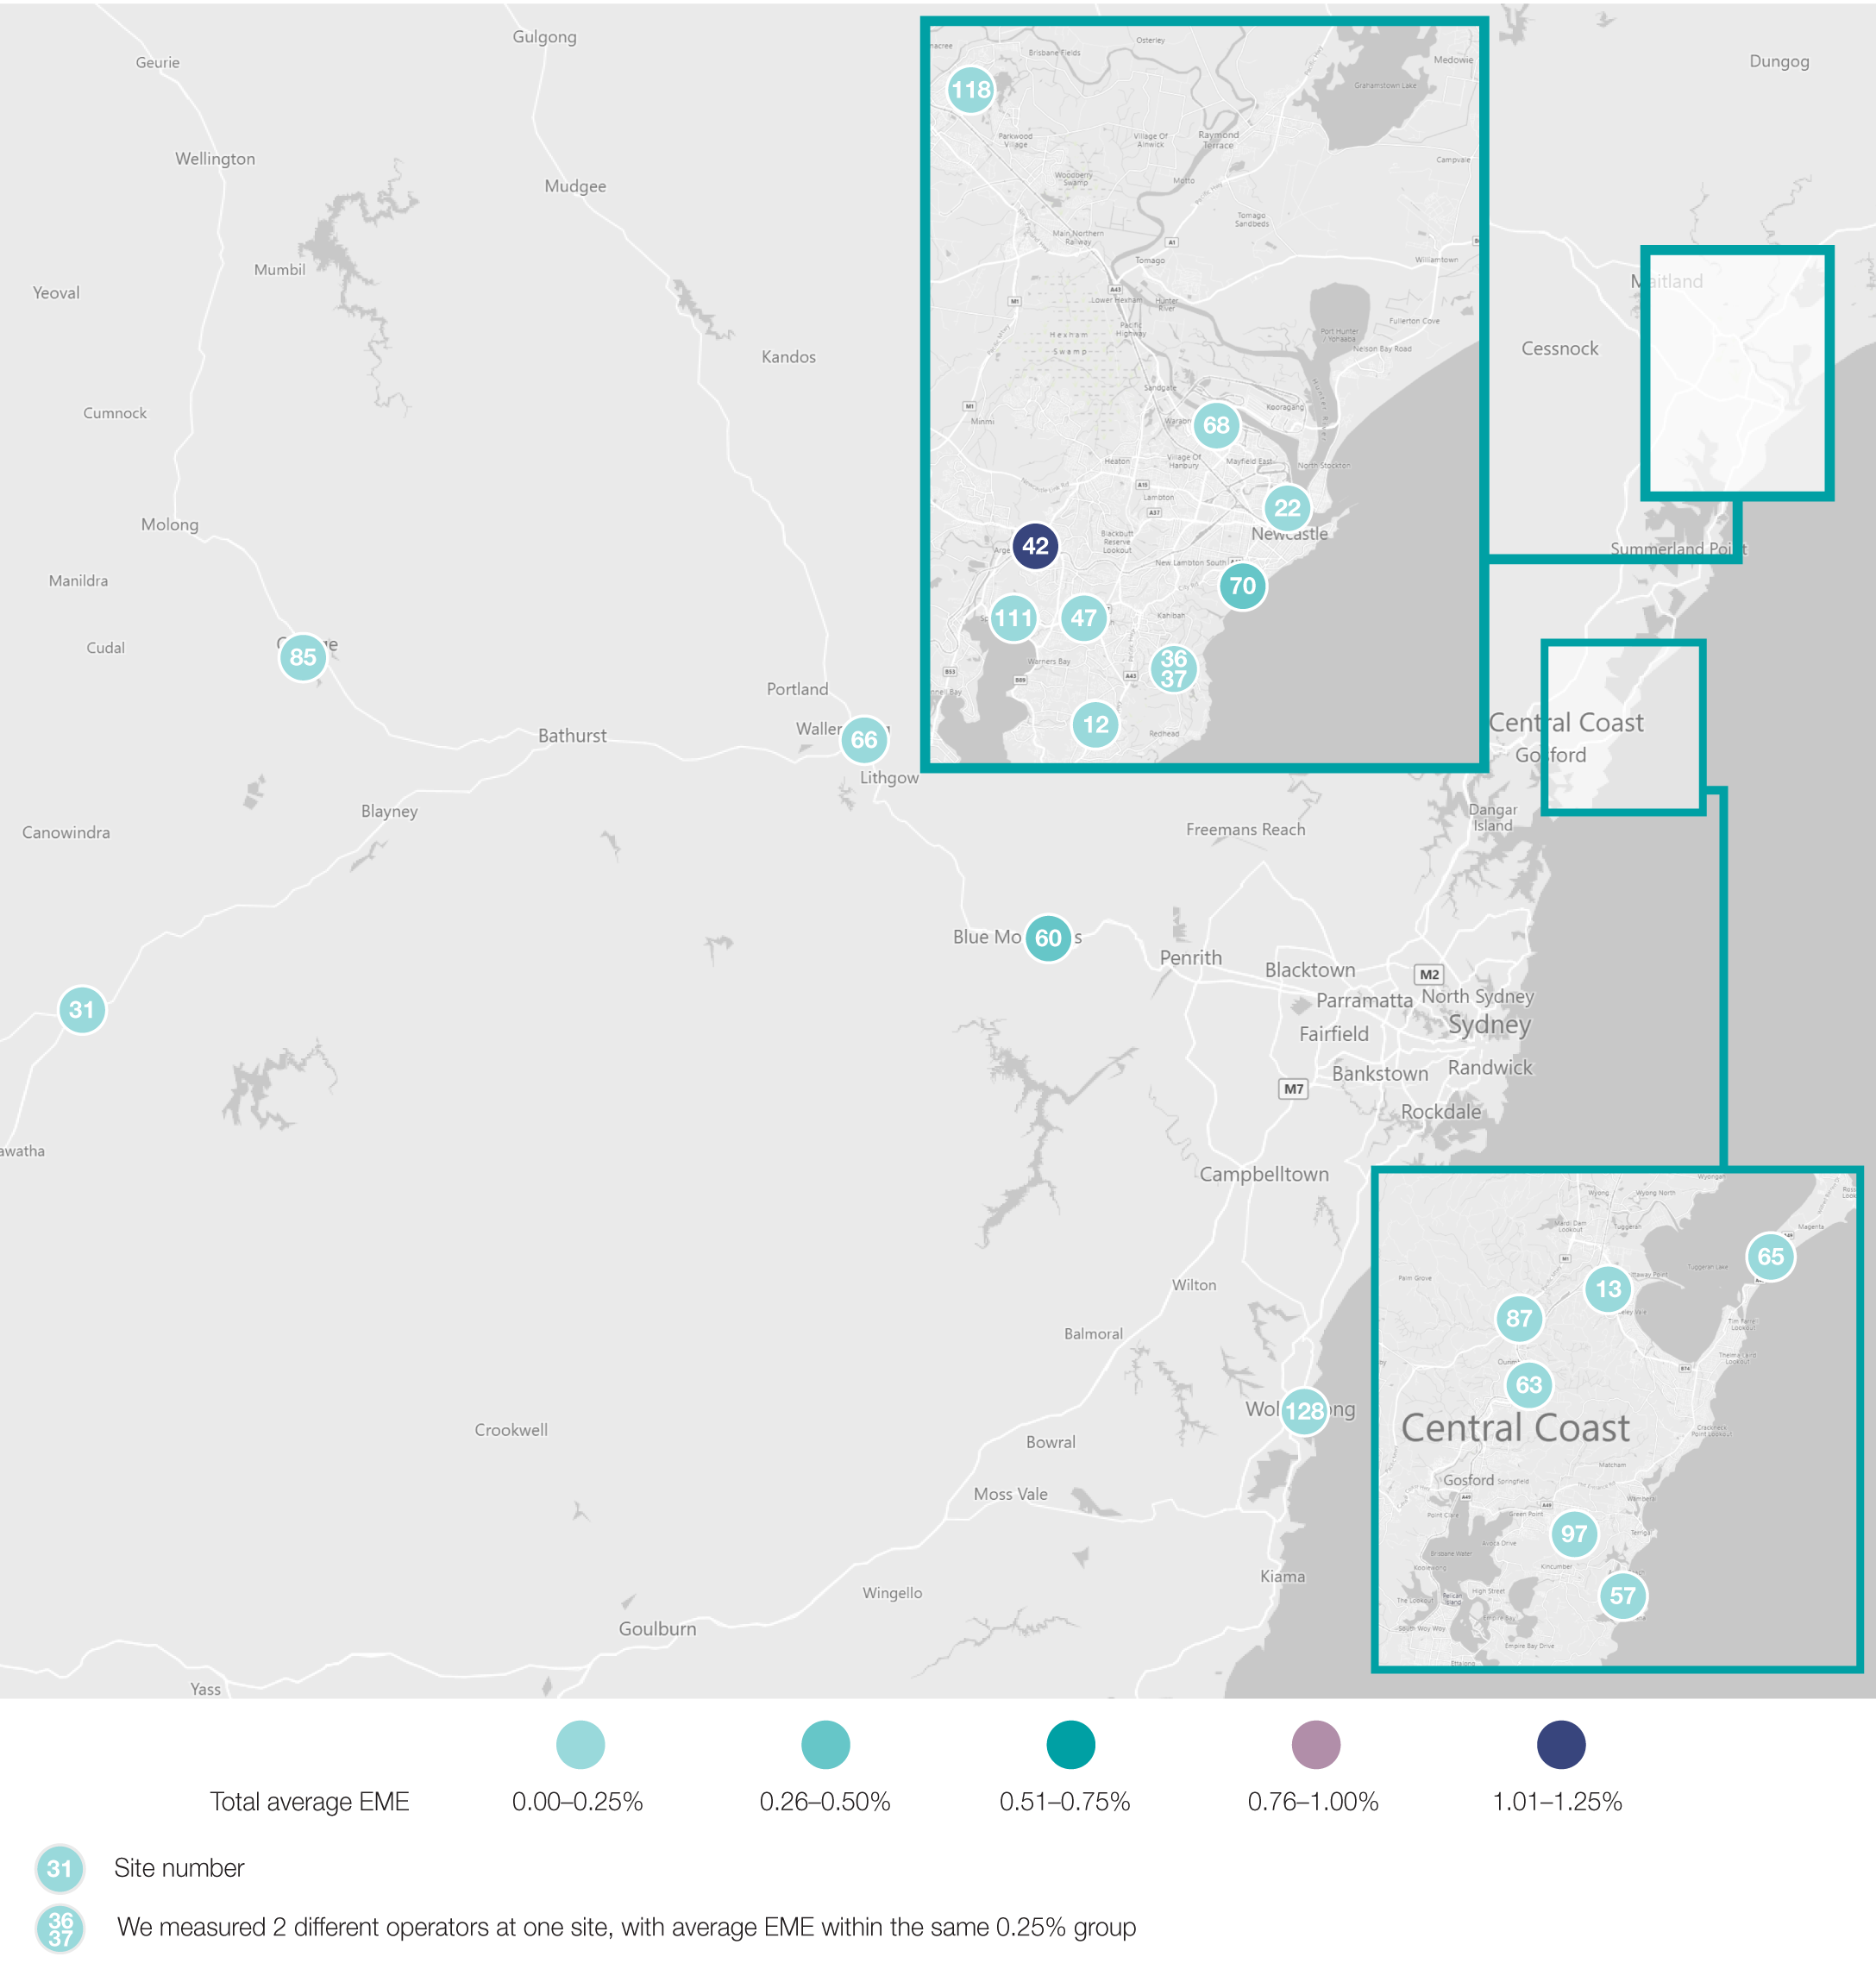

Part 2: Comparisons to carriers predicted EME

Purpose
For each mobile base station site, an assessment of the EME environment is conducted in accordance with the deployment code, which requires specific information be provided to the local community and government as a part of the consultative process. The environmental EME report is part of this process and is produced according to a methodology developed by ARPANSA. It provides conservative estimates of the maximum levels of EME exposure from a wireless base station for both existing base stations and proposed upgrades to base stations at the site.
As part of our measurement program, we compared the calculated maximum EME predicted in the environmental EME report with the actual maximum EME measured at each site. We did this to provide assurance that the calculations predicting cumulative EME at individual sites do not under-represent the level of emissions at a site.

Limitations
While the environmental EME report provides a calculated prediction of the maximum cumulative EME for all active and proposed transmitters at an individual site, it was not possible in a field environment to only measure the emissions from one individual carrier’s deployment of a particular technology, such as 5G, at a site. This is because infield measurements include EME from all transmitter sources present at the measurement location at the time of measurement. Additionally, the environmental EME report provides for proposed transmitters, which may not have been active at the time we conducted the measurement.
However, it is anticipated that the majority component of measured EME will be the emissions of the base station of interest and that only a small component of additional EME will come from other sources. Other sources could include more distant mobile phone base stations, as well as other nearby transmitters in the 420 MHz to 6 GHz band. We believe that a comparison between the EME levels measured at sites and predicted cumulative maximums will provide an acceptable point of comparison for evaluating the reasonableness of these calculations.

Methodology
At each location, we measured the maximum cumulative EME between 420 MHz and 6 GHz, as well as the maximum EME contained within all individual public mobile telecommunications service bands, including other defined service bands between 420 MHz and 6 GHz.
These bands include:
UHF LMRS
UHF TV
700 MHz 4G
800 MHz TRUNK
800 MHz 3G/4G
915 MHz LIPD
900 MHz 3G/4G
1800 MHz 4G
2100 MHz 3G/4G
2300 MHz 4G
2400 MHz LIPD
2600 MHz 4G
3500 MHz 5G
5800 MHz LIPD.
The maximum level of cumulative EME, expressed as a percentage of the ARPANSA RPS3 limit, was measured over a period of 30 minutes between 420 MHz to 6 GHz, as well as the maximum EME within each of the defined service bands.
The results compare predicted maximum with the measured maximum of all emissions between 420 MHz and 6 GHz, as well as the measured maximum of the 3500 MHz 5G service band.

Outcomes
Measurements at 129 individual base station sites in NSW reveal very low levels of EME, with maximum measured levels below 3.5% of the ARPANSA limit. Figure 7 below shows that for the majority of sites, EME levels were below 2% of the ARPANSA limit.
- Top 10 maximum EME levels measured at sites in NSW, as at 31 May 2022
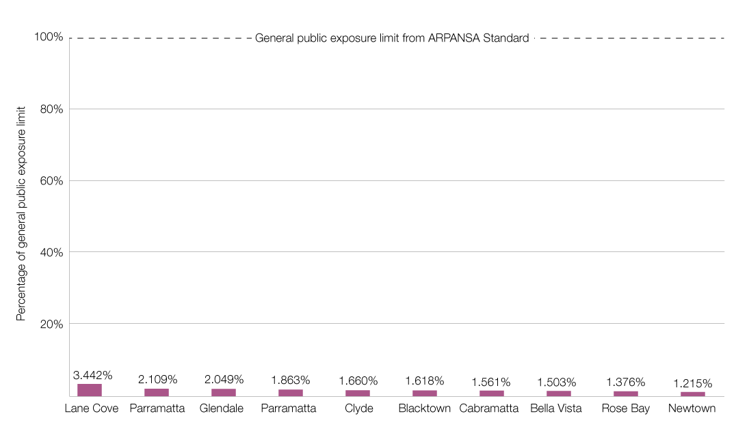
When the measured EME levels taken in publicly accessible locations were compared to carrier-predicted levels, we found that the carrier predictions have been modelled on maximum base station power assessments and the predictions are highly conservative.
We are satisfied that the carriers are compliant with the exposure limits of the safety standard:
for TPG Telecom Limited, the maximum measured EME was 3.44% at a site in Lane Cove (RFNSA site 2066010). The predicted EME was 7.31%.
for Optus, the maximum measured EME was 2.05% at a site in Glendale (RFNSA site 2285006). The predicted EME was 7.69%.
for Telstra, the maximum measured EME was 1.05% at a site in Mount Colah (RFNSA site 2077009). The predicted EME was 7.17%.
When we consider all measurements taken since the beginning of our measurement program in 2021, which now includes 258 sites in both Victoria and NSW, we observed that the EME levels from sites in both states are similar as illustrated by the top 10 maximum EME levels at Figure 8 below.
- Top 10 maximum EME levels measured at sites in Victoria and NSW, as at 31 May 2022
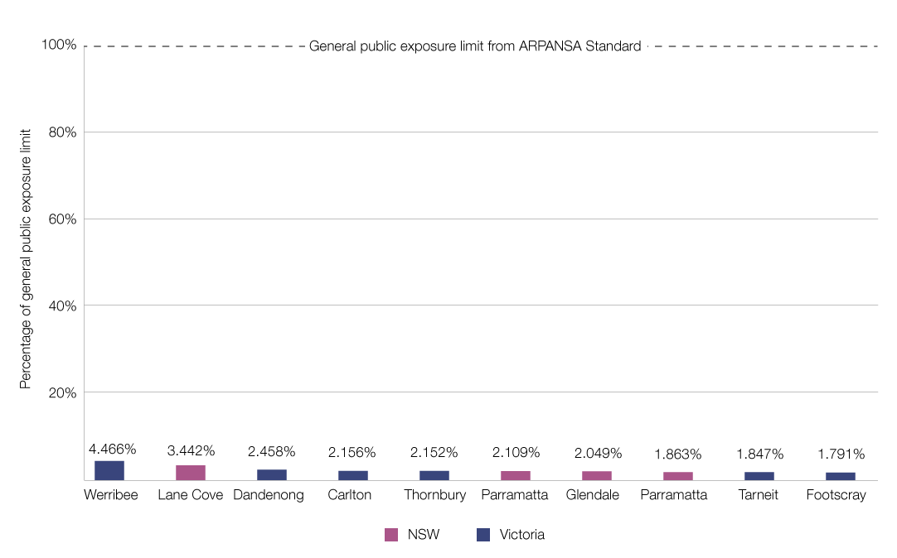
Comparison of predicted vs highest maximum measured EME by carrier in NSW, as at 31 May 2022
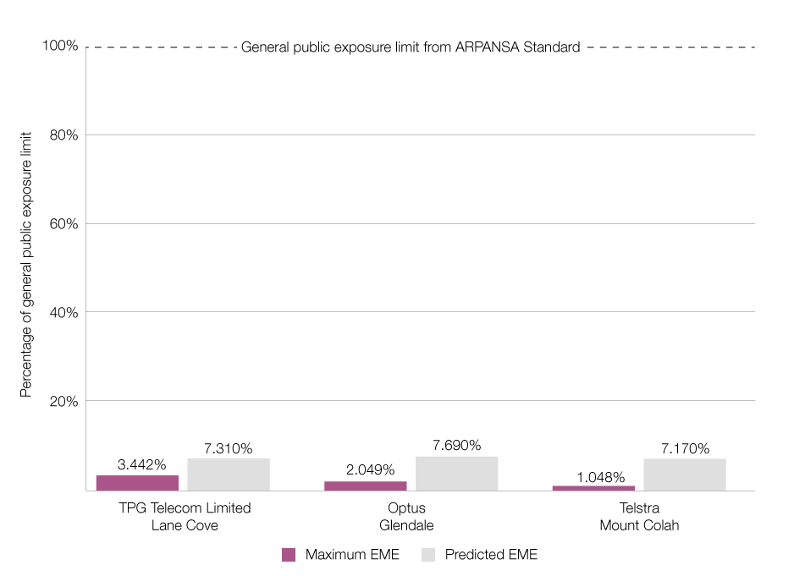
For 99% of sites, the measured total EME was less than 50% of the carrier’s predicted EME, and for 55% of sites, the measured total EME was less than 10% of the carrier’s predicted EME.
Full details of the predicted vs measured maximum EME levels for each carrier are at Appendix B.

Part 3: Investigation of 5G beamform technology

Purpose
In 2021–22, we continued our use of beamforming techniques to better understand the impact of 5G beamforming technology on EME levels.
Beamforming techniques are used for efficient delivery of 5G services, where one or more focused radiofrequency beams are directed to the mobile user’s handset from the base station’s antenna. By using beamforming-capable antennas, the transmitter power of the base station is typically lower than when non-beamforming-capable antennas are used because the transmitter’s energy can be directed more efficiently.
Beamformed radiofrequency emissions for 5G are typically very short and are only present when the mobile user’s handset is actively performing a transaction using 5G. Therefore, using an EME measurement technique that activates the 5G transmitter may provide a more accurate representation of 5G EME levels.

Limitations
We chose to conduct a series of measurements based on best practice knowledge from industry and other regulators globally to indicate the maximum 5G EME contained within an active beamformed transmission.
It is important to recognise that there is absence of agreed international measurement standards for measuring beamformed EME at this time. In this context, 5G beamforming measurements should be considered experimental and are based on current best practice knowledge gathered from mobile network operators and other regulators. Undertaking this work allows us to observe the impact of 5G beamforming technology on EME levels and will inform the development of future measurement methodologies.

Methodology
5G mobile base station transmitters adjust their power up and down to be just sufficient to manage user demand. To attract as much of the transmitter power resource available at any point in time, it is necessary to provide as much traffic load as possible on the 5G transmitter.
To achieve a high traffic load scenario, we used a 5G-capable smartphone handset and the Ookla speed-test application to activate the 5G transmitter. Maximum base station transmitter demand from the mobile handset occurs during the download part of the speed test transaction, and EME is measured during this short interval of time during the download.
As shown in Figure 9, to avoid measuring EME from the smartphone as much as possible, the phone is positioned no less than 3 metres behind the measurement probe to create a direct path for the beamform that intersects with the measurement probe. It should also be noted that the smartphone transmitter is least active during the Ookla speed-test download transaction, further reducing its contribution to the EME measured result.
The positioning of the measurement probe, base station and the smartphone
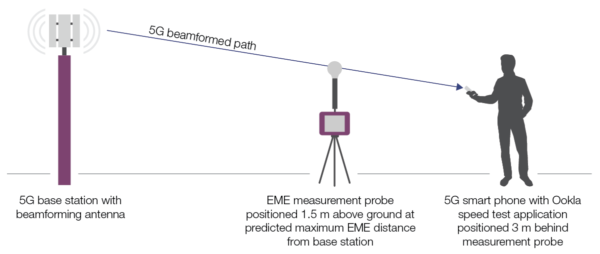
For the selected carrier at each site, we took 6 individual measurements of the active beamformed transmission for 10 seconds each, corresponding to the duration of the Ookla speed-test download transaction. We also took 6 idle measurements of 10 seconds each, in between active measurements, to measure the non-activated level of EME from the base station.
We recorded the highest of the 6 active and idle measurements, expressed as a percentage of the ARPANSA RPS3 limit.
Measurements were made in the 3500 MHz band where all the carriers in Australia are currently active with their 5G services. Of the 43 sites selected for each carrier, the frequency bands measured were:
Telstra 5G:
Sydney metropolitan (3575 MHz to 3635 MHz).
NSW regional (3575 MHz to 3640 MHz)
Optus 5G:
Sydney metropolitan (3475 MHz to 3575 MHz).
NSW regional (3670 MHz to 3700 MHz)
TPG Telecom Limited 5G:
Sydney metropolitan (3640 MHz to 3700 MHz)
NSW regional (3640 MHz to 3670 MHz).

Outcomes
Measurements at 129 individual, publicly accessible, base station sites in NSW revealed very low levels of beamformed EME, with maximum levels at 3.2% of the ARPANSA limit.
We are satisfied that the carriers are complying with the exposure limits of the safety standard.
In some cases, we were not able to consistently attract a 5G beamform. We expect that in these cases, the mobile handset was using a combination of 3G, 4G and/or 5G connections from the measured site or from other nearby sites.
At a small number of sites, measured idle levels were close to, or higher than, active levels, suggesting that we were measuring other nearby user-traffic at the time of the idle measurement.
Figure 10 shows the sites with the highest maximum active beamformed EME for Optus, Telstra and TPG Telecom Limited.
Highest active maximum beamformed EME measured in NSW by carriers as of 31 May 2022
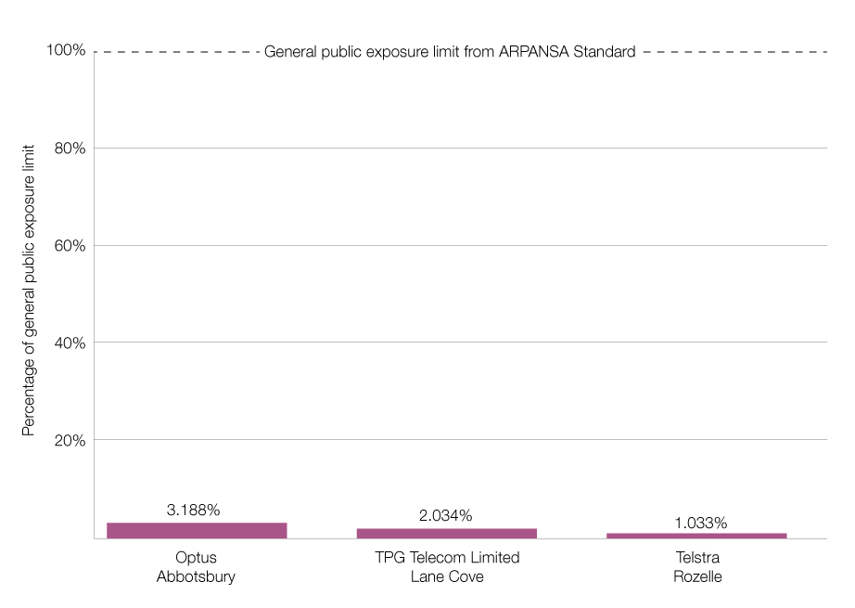
For 78% of sites measured, the idle beamformed EME was less than 50% of the active beamformed EME, and for 28% of sites measured, the idle beamformed EME was less than 10% of the active beamformed EME.
A full breakdown of the maximum EME measured for both idle and active beamformed 5G at all sites is at Appendix C.

EME Checker: a tool for searching local EME measurements
The ACMA’s EME Checker enables enhanced monitoring and visualisation of EME data for mobile phone base station sites that we have measured.
Anyone can visit our website and use EME Checker to:
compare the average EME from mobile phone towers with the ARPANSA safety limit
compare the predicted maximum EME values that the carriers provide for each mobile phone tower with actual maximum levels measured by us
find the maximum level of 5G EME at individual sites (measured using 5G beamforming techniques) and how this compares to the ARPANSA safety limit.
EME Checker currently reflects our measurements taken in Victoria and New South Wales. More sites and locations will be added over time. We will also return to previously measured sites over time to provide updated measurements and insight to any changes in measured levels over time.

Summary
For all of the 129 mobile phone base station sites visited in NSW, and in all measurement categories, we observed very low levels of EME. The EME levels were well below the public exposure limits set by ARPANSA, meaning that carriers are complying with the rules in the EME exposure standard. These results support previous studies and audits that show emission levels of 5G equipment are well under the ARPANSA limits.
Our environmental EME measurements in NSW determined that the average EME from sites was less than 1.2% of the ARPANSA standard. Figure 12 illustrates the top 10 average measured EME levels in NSW, the majority (98%) of sites measured under 1%. This is similar to the EME measurements in Victoria undertaken in 2020-21 where the average EME at all sites was less than 1.5% of the ARPANSA standard and the majority of sites were under 1%. Figure 8 above shows the top 10 maximum EME level sites across NSW and Victoria.
Top 10 average measured EME levels in NSW by site, as at 31 May 2022
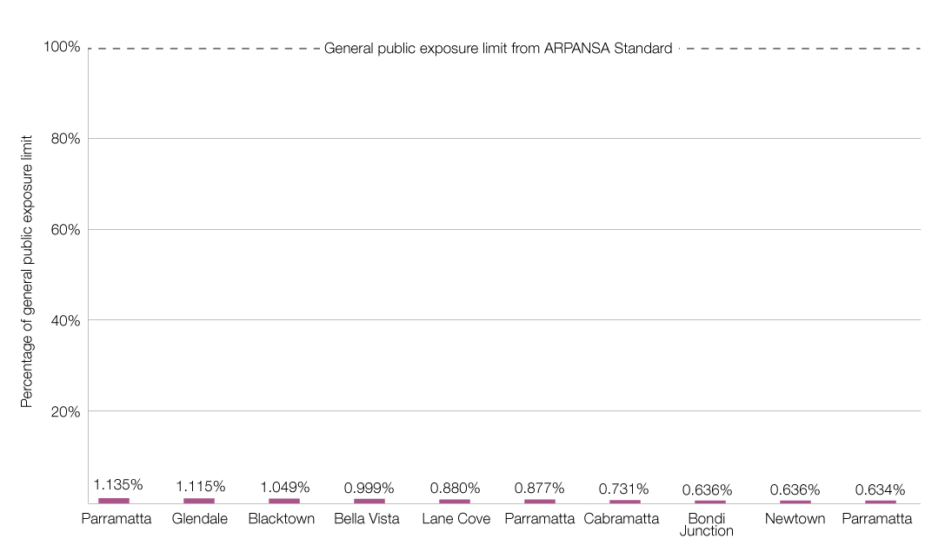
Our comparison to the carriers’ predicted EME measurements found that the measured levels were significantly lower than the predicted levels. The carriers’ predictions have been modelled on worse-case exposure assessments and are very conservative.
Our investigation into 5G beamforming indicated peak levels of EME of up to 3.2% of the ARPANSA standard under a heavily loaded base station scenario, with 84% of sites measured under 1%.
We also observed that sites with the highest EME levels for both environmental and beamforming measures were typically sites with multiple operators and multiple technologies in place. All sites were well within the ARPANSA standard and lower than predicted EME levels.

Appendix A: Site list
Audit site number | Suburb | Carrier | RFNSA site ID | Address
1 | Abbotsbury | Optus | 2176001 | Calmsley City Farm, Cowpasture Road
2 | Arndell Park | Optus | 2148030 | 4 Hoadley Place
3 | Artarmon | Telstra | 2064007 | 192-196 Hampden Road
4 | Artarmon | TPG Telecom Limited | 2065015 | 39 Herbert Street
5 | Auburn | Optus | 2144004 | Corner Queen Street and Vales Lane
6 | Balgowlah | Optus | 2093001 | 4 Hayes Street
7 | Banksmeadow | Optus | 2019004 | 77 Corish Circle
8 | Banksmeadow | TPG Telecom Limited | 2019033 | 5 Exell Street
9 | Bankstown | TPG Telecom Limited | 2200004 | 66-72 Rickard Road
10 | Bella Vista | Optus | 2153032 | 29-31 Lexington Drive
11 | Bellevue Hill | Telstra | 2023001 | 13-17 Bellevue Road
12 | Belmont North | Optus | 2280001 | Water Reserve, Violet Town Rd
13 | Berkeley Vale | Telstra | 2261016 | 6 Apprentice Drive
14 | Blacktown | Optus | 2148012 | 25 Chicago Avenue
15 | Bondi Junction | Telstra | 2022002 | 1 Newland Street
16 | Bondi Junction | TPG Telecom Limited | 2022012 | 55 Grafton Street
17 | Bonnyrigg | Optus | 2177001 | Corner Cabramatta Road & Elizabeth Drive
18 | Burwood | TPG Telecom Limited | 2134002 | 74-76 Burwood Road
19 | Burwood | TPG Telecom Limited | 2134025 | 1 Railway Parade
20 | Cabramatta | Optus | 2166010 | 178-180 Hume Highway
21 | Campbelltown | Optus | 2560015 | 171-179 Queen Street
22 | Carrington | Telstra | 2294001 | 150 Dennison Street
23 | Casula | TPG Telecom Limited | 2170009 | Corner Wonga and Kurrajong Road
24 | Chatswood | Telstra | 2067003 | 21 Johnson Street
25 | Chatswood | TPG Telecom Limited | 2067002 | 1-5 Railway Street
26 | Chester Hill | Telstra | 2162001 | 40 Hector Street
27 | Clyde | TPG Telecom Limited | 2142025 | M4 Road Reserve, Martha Street
28 | Collaroy | Optus | 2097002 | 1114 Pittwater Road
29 | Condell Park | Optus | 2200003 | 1A Simmat Avenue
30 | Coogee | Telstra | 2034006 | 242 Arden Street
31 | Cowra | Telstra | 2794002 | Scenic Drive
32 | Cronulla | Telstra | 2230004 | 59-63 Ewos Parade
33 | Crows Nest | Telstra | 2065025 | 118-124 Willoughby Road
34 | Croydon Park | Telstra | 2133001 | 18A Wentworth Street
35 | Doonside | Optus | 2767001 | Francis Lane, off Hill End Road
36 | Dudley | Optus | 2290005 | 147 Ocean Street
37 | Dudley | Telstra | 2290005 | 147 Ocean Street
38 | Dural | Telstra | 2158015 | 243 New Line Road
39 | Eastlakes | TPG Telecom Limited | 2018017 | 5 Florence Avenue
40 | Epping | TPG Telecom Limited | 2121002 | 16-18 Bridge Street
41 | Ermington | Optus | 2115001 | 272 Kissing Point Road
42 | Glendale | Optus | 2285006 | 387 Lake Road
43 | Greenacre | Optus | 2190006 | 113-115 Punchbowl Road
44 | Greenacre | TPG Telecom Limited | 2190046 | 12 Bellfrog Road
45 | Gregory Hills | TPG Telecom Limited | 2557006 | 2 Steer Road
46 | Guildford | TPG Telecom Limited | 2161005 | 276-280 Guildford Road
47 | Hillsborough | Optus | 2290003 | Barker Street, Charlestown Golf Club
48 | Holroyd | TPG Telecom Limited | 2160003 | 8 Robert Street
49 | Homebush West | TPG Telecom Limited | 2140018 | M4 Expressway and Railway Track
50 | Ingleside | Optus | 2101012 | 3 Mona Vale Road
51 | Ingleside | Telstra | 2101003 | 176-178 Mona Vale Road
52 | Jamisontown | TPG Telecom Limited | 2750033 | 5 Harford Street
53 | Kearns | Telstra | 2558001 | Macarthur Grange Golf Club, Raby Road
54 | Kensington | Telstra | 2033003 | 56 Anzac Parade
55 | Kensington | Telstra | 2033004 | University of NSW, Kensington Campus
56 | Kensington | TPG Telecom Limited | 2033003 | 56 Anzac Parade
57 | Kincumber | Optus | 2251004 | 189 Cape Three Points Road
58 | Lane Cove | TPG Telecom Limited | 2066010 | 79-83 Longueville Road
59 | Lansvale | Telstra | 2166003 | 13 Bindaree Street
60 | Lawson | Optus | 2783001 | 259 Great Western Highway
61 | Lindfield | Optus | 2070003 | 280 Pacific Highway
62 | Lindfield | TPG Telecom Limited | 2070003 | 280 Pacific Highway
63 | Lisarow | Optus | 2250053 | 25A Tuggerah Street
64 | Macquarie Park | Optus | 2113018 | 13-15 Lyonpark Road
65 | Magenta | Telstra | 2261017 | 300 Wilfred Barrett Drive
66 | Marrangaroo | Telstra | 2790004 | 754 Mudgee Road
67 | Marsden Park | Optus | 2765021 | 879 Richmond Road
68 | Mayfield North | Optus | 2304002 | 122 Woodstock Street
69 | Menai | Optus | 2234002 | 824 Old Illawarra Road
70 | Merewether | Telstra | 2291001 | 129 Scenic Drive
71 | Merrylands North | TPG Telecom Limited | 2160008 | Corner Burnett Street and M4 Motorway
72 | Middle Cove | Telstra | 2068007 | 213-215 Eastern Valley Way
73 | Milperra | Telstra | 2214005 | Byron Aviation, 2 Ashford Avenue
74 | Miranda | TPG Telecom Limited | 2226005 | 169 Port Hacking Road
75 | Moore Park | TPG Telecom Limited | 2021005 | Sydney Cricket Ground, Driver Avenue
76 | Mount Colah | Telstra | 2077009 | 601 Pacific Highway
77 | Newtown | Telstra | 2042003 | 295-303 King Street
78 | Newtown | TPG Telecom Limited | 2042003 | 295-303 King Street
79 | Newtown | TPG Telecom Limited | 2042007 | 88 King Street
80 | North Parramatta | Telstra | 2151012 | 83-85 Sorrell Street
81 | North Ryde | Telstra | 2113053 | 1 Rivett Road
82 | North Strathfield | Optus | 2137002 | Corner Concord and Wellbank Street
83 | North Sydney | TPG Telecom Limited | 2060003 | 124 Walker Street
84 | Northmead | TPG Telecom Limited | 2152005 | 6 Boundary Road
85 | Orange | Telstra | 2800036 | 1635 Forest Road
86 | Orchard Hills | Telstra | 2748005 | 319 Luddenham Road
87 | Ourimbah | Optus | 2258008 | 2 Burns Road
88 | Parramatta | Optus | 2150003 | 68-80 George Street
89 | Parramatta | Optus | 2150005 | 17-21 Macquarie Street
90 | Parramatta | Telstra | 2150001 | 15 Campbell Street
91 | Parramatta | TPG Telecom Limited | 2150004 | Westfield Shoppingtown Parramatta, 159-175 Church Street
92 | Parramatta | TPG Telecom Limited | 2150038 | 20 Charles Street
93 | Parramatta | TPG Telecom Limited | 2150056 | 94 Phillip Street
94 | Parramatta | TPG Telecom Limited | 2151002 | 460 Church Street
95 | Pennant Hills | Telstra | 2120002 | 383-385 Penant Hills Road
96 | Petersham | TPG Telecom Limited | 2049001 | 606-610 Parramatta Road
97 | Picketts Valley | Optus | 2251001 | 345 Island View Drive
98 | Quakers Hill | TPG Telecom Limited | 2768006 | Paterson Reserve, Beetle Street
99 | Richmond | Optus | 2753005 | University of Western Sydney, 2 College Street
100 | Rose Bay | TPG Telecom Limited | 2029002 | 624-634 New South Head Road
101 | Rouse Hill | Optus | 2155017 | 119 Cudgegong Road
102 | Rouse Hill | Telstra | 2155017 | 119 Cudgegong Road
103 | Rozelle | Telstra | 2039005 | 3 Hornsey Street
104 | Ryde | Optus | 2112002 | 353 Blaxland Road
105 | Seven Hills | Optus | 2147002 | Prospect Electricity, Powers Rd
106 | Seven Hills | TPG Telecom Limited | 2147001 | 2 Leabons Lane
107 | Silverwater | Optus | 2128014 | 106 Derby Street
108 | Silverwater | TPG Telecom Limited | 2128014 | 106 Derby Street
109 | Smithfield | Telstra | 2164011 | 4 Robert Street
110 | South Wentworthville | Optus | 2145010 | 43A Old Prospect Road
111 | Speers Point | Telstra | 2284002 | 39 Plan 239504 Farm Street
112 | St Marys | Optus | 2760007 | 38 King Street
113 | Stanhope Gardens | Telstra | 2768003 | 1324 Old Windsor Road
114 | Surry Hills | Telstra | 2010006 | 322 Bourke Street
115 | Surry Hills | Telstra | 2010007 | 418A Elizabeth Street
116 | Surry Hills | TPG Telecom Limited | 2010009 | 124-140 Chalmers Street
117 | Sydney | TPG Telecom Limited | 2000375 | 140 Elizabeth Street
118 | Tenambit | Telstra | 2323006 | 271 Plan 755237 Houston Avenue
119 | Terrey Hills | Telstra | 2084009 | 1 Kamber Road
120 | Ultimo | Telstra | 2007006 | 355 Bulwara Road
121 | Ultimo | TPG Telecom Limited | 2007001 | 620 Harris Street
122 | Villawood | TPG Telecom Limited | 2163017 | 7 Epic Place
123 | Warriewood | Optus | 2102002 | 92A Mona Vale Road
124 | Warwick Farm | Optus | 2170004 | 12 Homepride Avenue
125 | West Hoxton | TPG Telecom Limited | 2171028 | 195 Fifteenth Avenue
126 | Wetherill Park | Optus | 2164006 | 12 Lagana Place
127 | Wolli Creek | Telstra | 2205005 | 20 Levey Street
128 | Wollongong | TPG Telecom Limited | 2500007 | Crown Central Shopping Centre, 168-218 Crown Street
129 | Yennora | TPG Telecom Limited | 2161019 | 205-231 Fairfield Road

Appendix B: Predicted maximum EME vs measured maximum EME

TPG Telecom Limited
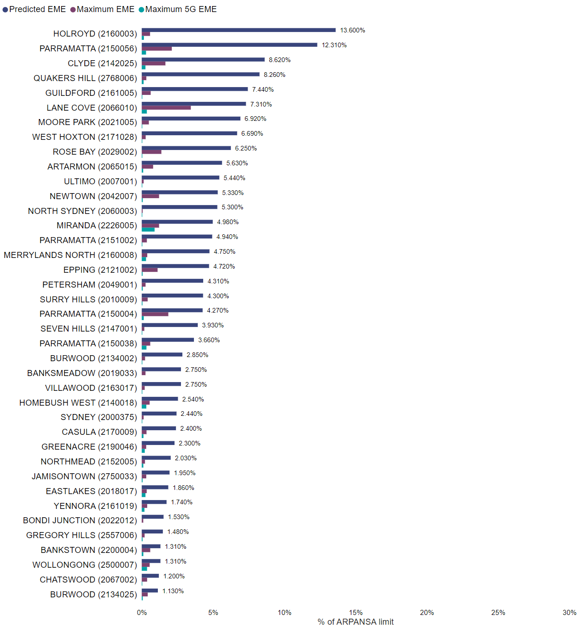

Optus
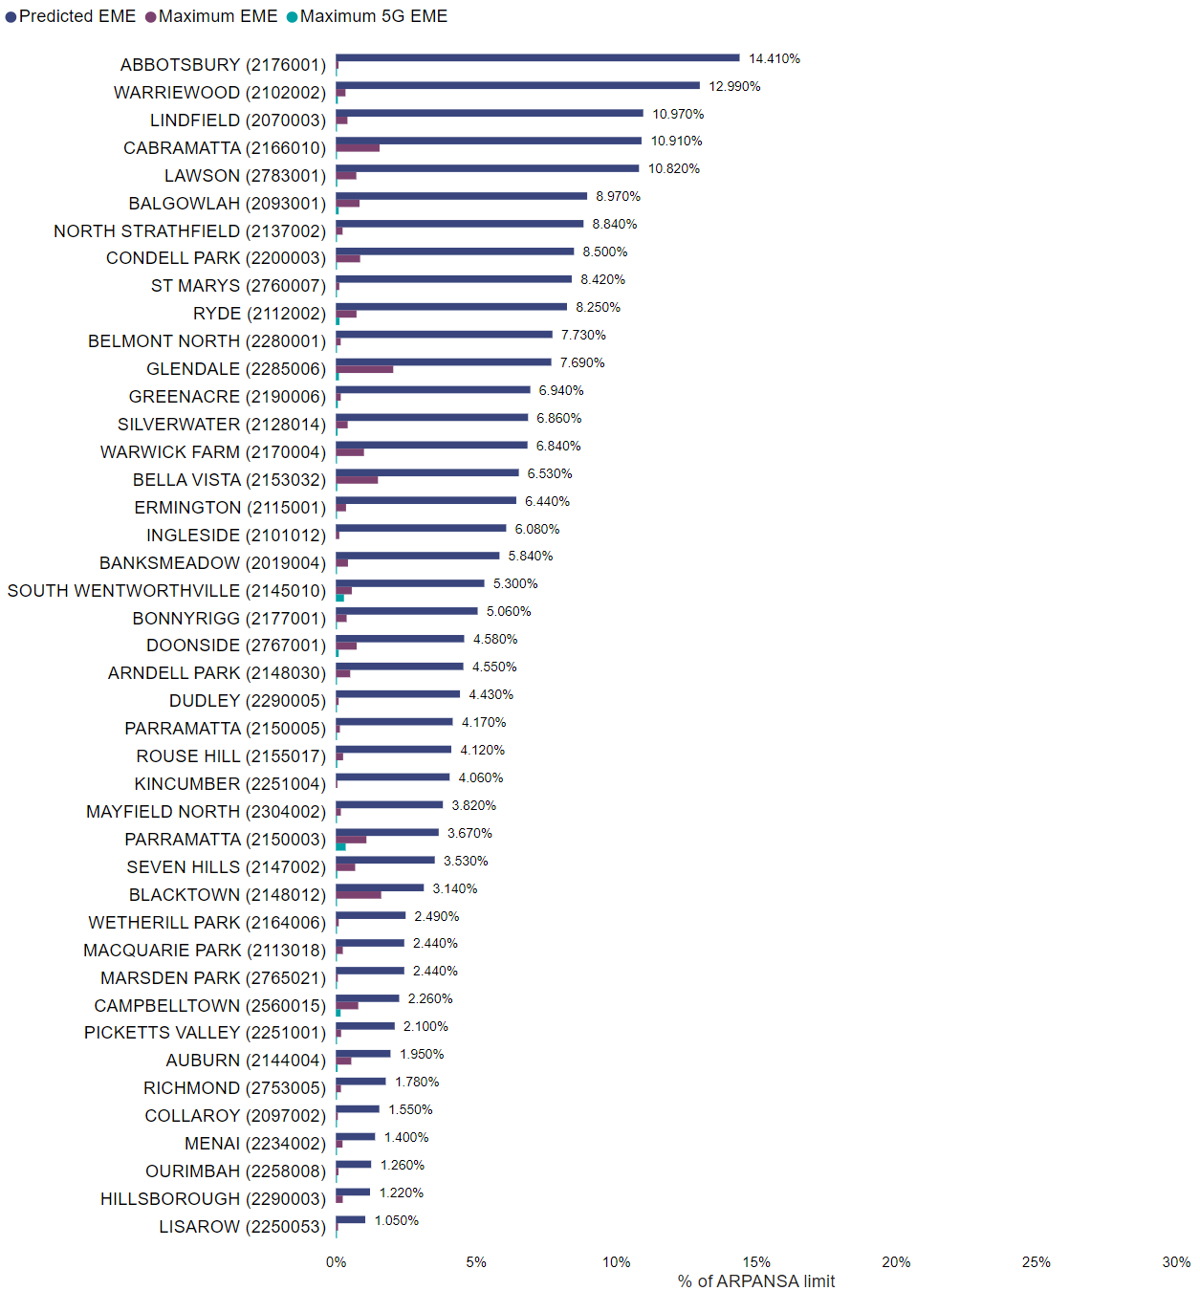

Telstra
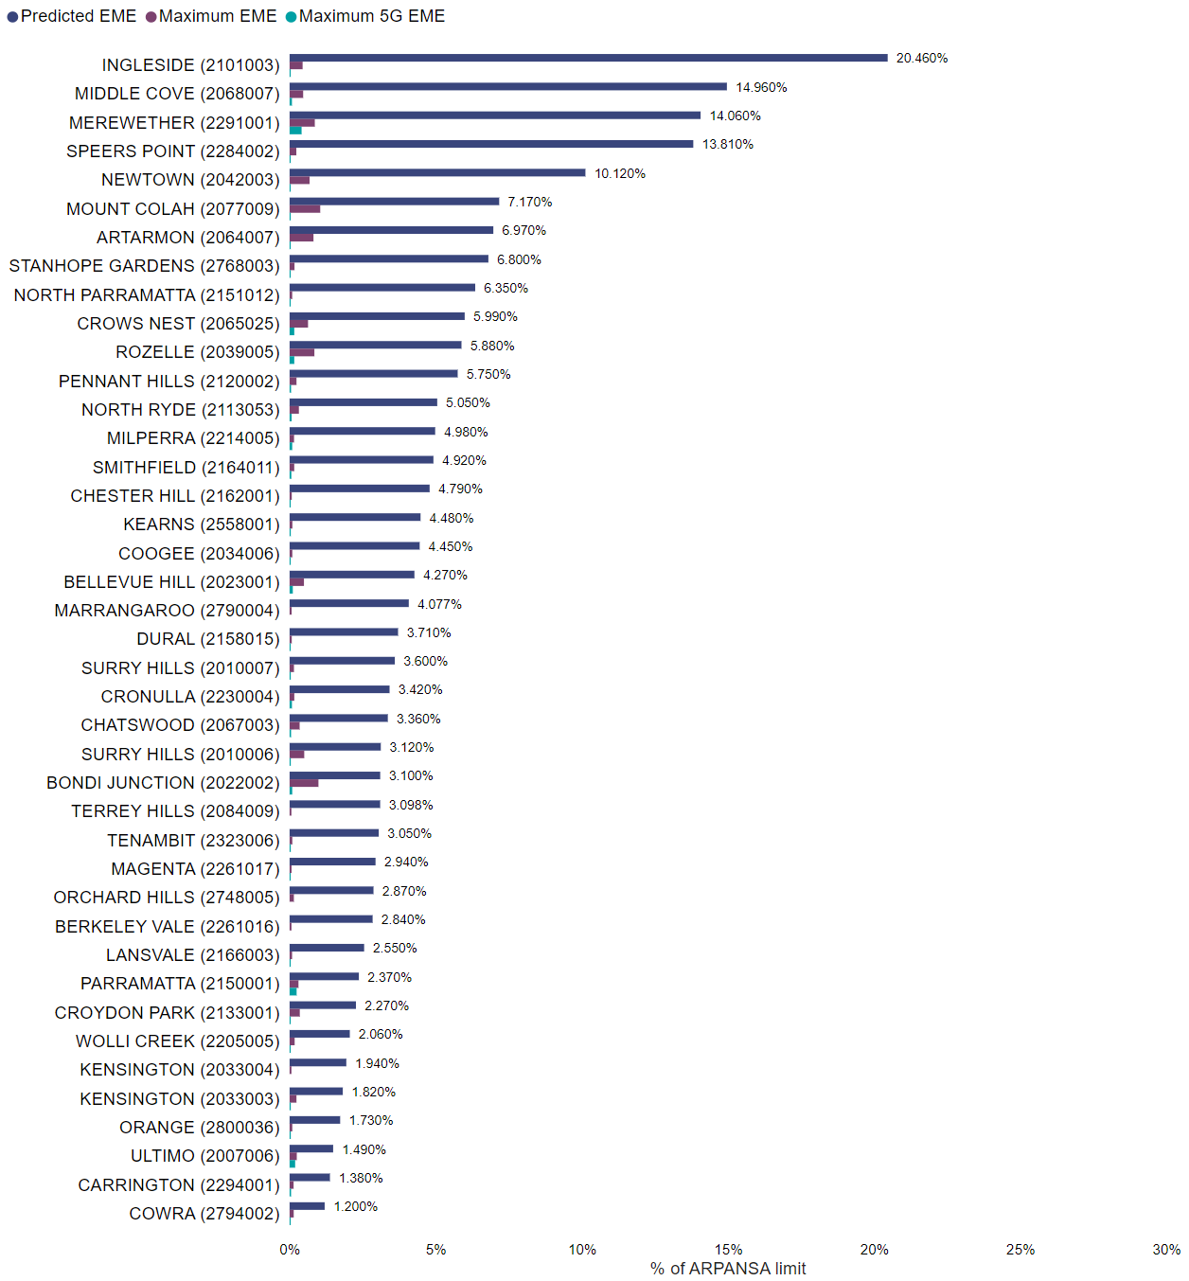

Appendix C: Active vs idle maximum beamformed EME

TPG Telecom Limited
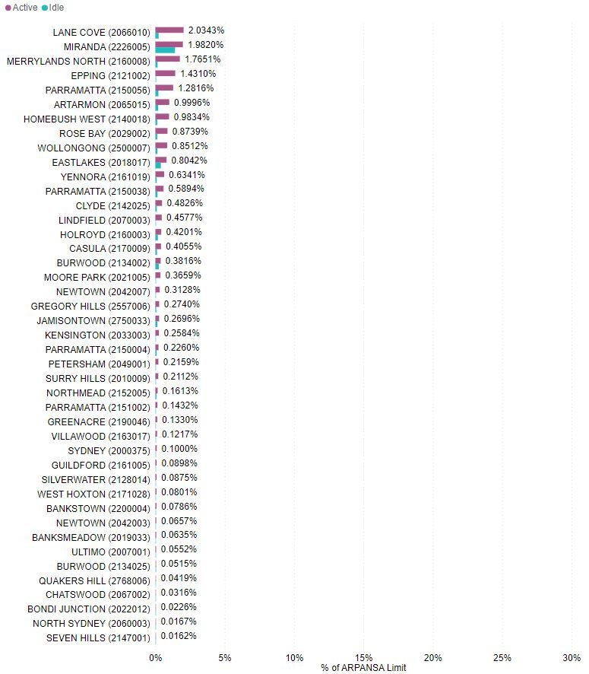

Optus
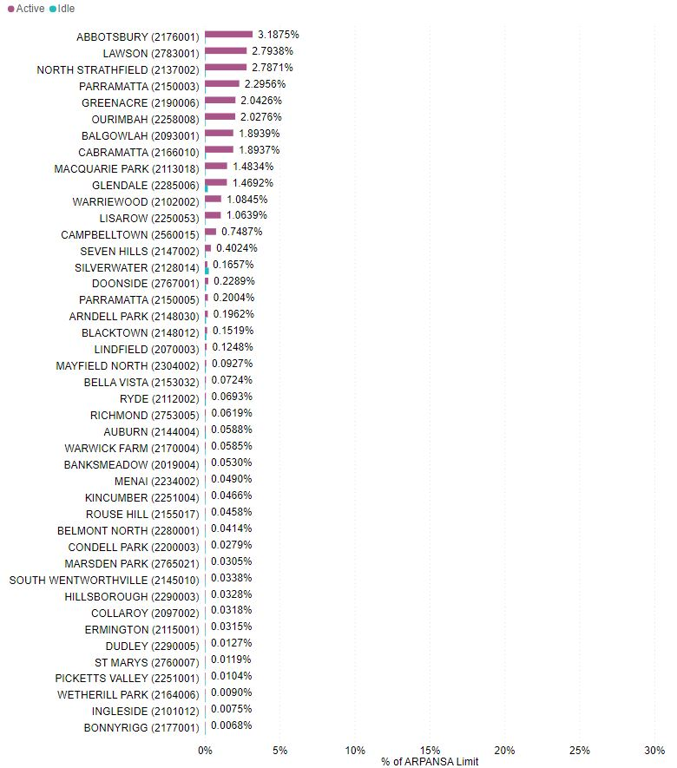

Telstra
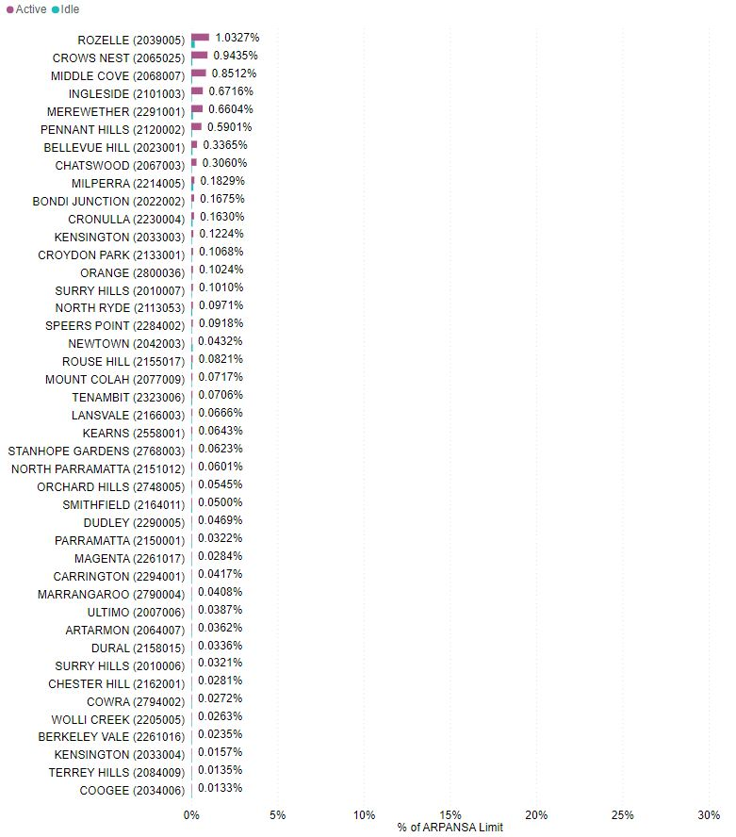

In 2020, TPG and Vodafone Hutchison Australia merged to form TPG Telecom Limited.
The carrier predicted maximum EME is calculated based on a methodology developed by ARPANSA. This methodology is explained in the ARPANSA Technical Report – Radio Frequency EME Exposure Levels – Prediction Methodologies.
5G mobile base station transmitters adjust their power up and down to be just sufficient to manage user demand. Beamformed radiofrequency emissions for 5G are directed towards the user and are typically very short and only present when the mobile user’s handset is actively performing a transaction using 5G. Therefore, an EME measurement technique that activates the 5G transmitter may provide a more accurate representation of 5G EME levels.
Australian Communications and Media Authority, Electromagnetic energy (EME) near 5G mobile base stations, August 2021, p. 3.
We have measured all telecommunications service bands between 700MHz and 3500MHz. Some network operators in Australia have commenced deploying 5G services on 26GHz. This is known as millimetre wave (mmWave). This is an evolving technology that we will consider in future measurement programs.
When Telco sites are deployed or upgraded, an EME compliance report must be provided in accordance with the Deployment Code.
To address this, we used the ‘Maximum level EME for proposed changes’ figure calculated in the environmental EME report as opposed to the current calculated EME figure.
Predicted maximum EME was based on the ‘Maximum level EME for proposed changes’ figure calculated in the environmental EME reports for each site on the date of measurement.
Australian Communications and Media Authority, Electromagnetic energy (EME) near 5G mobile base stations, August 2021, p. 3.

