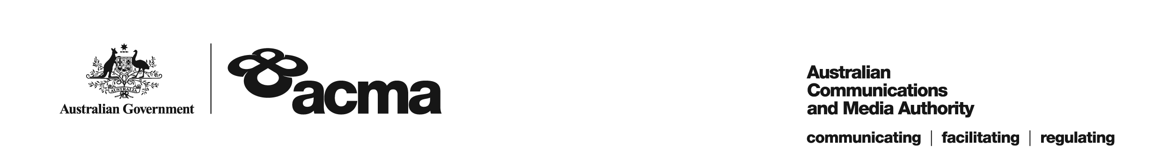

**AUSTRALIAN COMMUNICATIONS AND MEDIA AUTHORITY**

**Target Reduction Order STV-TRO-138  
made under subsection 130ZY(3) of the *Broadcasting Services Act 1992***

**1. Interpretation**

In this instrument:

***ACMA*** means the Australian Communications and Media Authority

***Act*** means the *Broadcasting Services Act 1992*

***Applicant*** means Fetch TV Pty Ltd (ACN 130 669 500)

***Application*** means the target reduction order application made on 31 March 2022 in respect of the Service

***Service*** means Discovery Turbo

***Specified Eligible Period*** means 1 July 2021 to 30 June 2023.

**2. Target Reduction**

Under subsection 130ZY(3) of the Act, the ACMA:

(a) having considered the written representations made by the Applicant in the Application, the supporting evidence submitted with the Application and the submissions received during the consultation period from the Australian Communications Consumer Action Network; and

(b) being satisfied that a refusal to make the target reduction order would impose an unjustifiable hardship on the Applicant;

***ORDERS*** that, for the Specified Eligible Period, the reduced annual captioning target for the Applicant in respect of the Service will be:

1. 60% for the 2021-22 financial year; and
2. 65% for the 2022-23 finacial year.

Dated: 27 June 2022