Draft Telecommunications (Numbering Charges) (Allocation Charge) Amendment Determination 2022 (No. 1) – consultation paper

June 2022

Canberra

Red Building   
Benjamin Offices  
Chan Street   
Belconnen ACT

PO Box 78  
Belconnen ACT 2616

T +61 2 6219 5555  
F +61 2 6219 5353

Melbourne

Level 32   
Melbourne Central Tower  
360 Elizabeth Street   
Melbourne VIC

PO Box 13112  
Law Courts   
Melbourne VIC 8010

T +61 3 9963 6800  
F +61 3 9963 6899

Sydney

Level 5   
The Bay Centre  
65 Pirrama Road   
Pyrmont NSW

PO Box Q500  
Queen Victoria Building   
NSW 1230

T +61 2 9334 7700 or 1800 226 667  
F +61 2 9334 7799

Copyright notice

[Creative Commons logo](http://i.creativecommons.org/l/by/3.0/88x31.png)

<https://creativecommons.org/licenses/by/4.0/>

With the exception of coats of arms, logos, emblems, images, other third-party material, or devices protected by a trademark, this content is made available under the terms of the Creative Commons Attribution 4.0 International (CC BY 4.0) licence.

We request attribution as © Commonwealth of Australia (Australian Communications and Media Authority) 2022.

All other rights are reserved.

The Australian Communications and Media Authority has undertaken reasonable enquiries to identify material owned by third parties and secure permission for its reproduction. Permission may need to be obtained from third parties to re-use their material.

Written enquiries may be sent to:

Manager, Editorial Services  
PO Box 13112  
Law Courts  
Melbourne VIC 8010  
Email: [info@acma.gov.au](mailto:info@acma.gov.au)

Contents

Summary 2

Issues for comment 3

Introduction 4

Background and description of activity 4

Charging framework 4

Proposed fee 5

Costs to be recovered 5

Reason for under recovery of costs 5

Calculating the new transaction fee 8

Financial estimates 9

Invitation to comment 10

Making a submission 10

# Summary

The Australian Communications and Media Authority (ACMA) is responsible for the administration, allocation, and regulation of Australian telephone numbers.

In 2014, the Australian Government awarded a contract to ZOAK Solutions Pty Ltd (ZOAK) to provide number allocation and administrative services in relation to most of Australia’s telephone numbers. The contract is for 7 years from 3 August 2015 to 2 August 2022, and has recently been extended for another 2 years to 2024. Consistent with government policy, we recover the cost of the contract by imposing numbering charges on entities that use numbering services.

We set fees to recover the cost of the contract with ZOAK through 2 separate charging instruments:

the [Telecommunications Charges Determination 2012](https://www.legislation.gov.au/Details/F2017C00285) made under the [*Australian Communications and Media Authority Act 2005*](https://www.legislation.gov.au/Details/C2021C00233) (ACMA Act)

the [Telecommunications (Numbering Charges) (Allocation Charge) Determination 2015](https://www.legislation.gov.au/Details/F2017C00284) made under the [*Telecommunications (Numbering Charges) Act 1997*](https://www.legislation.gov.au/Details/C2020C00005) (Numbering Charges Act).

These instruments set the same flat transaction fee, calculated using the same charging model, noting all applicable transactions occur in the same Numbering System, are largely automated and use the same amount of processing time per transaction. Accordingly, the fees in each instrument have previously been and are currently, being consulted on and made together.

As a result of a sustained downward trend in demand from users, revenue generated from the current fee of $35 per transaction is insufficient to meet the cost of the contract and has resulted in a cumulative under-recovery, as of April 2022, of $215,851. This under-recovery is estimated to increase to $412,816 by the end of the current Numbering Services contract.

We engaged economic consultants, HoustonKemp, in March 2022 to review and update the fee and cost recovery model. This included reviewing all assumptions, forecasting future demand and estimating the fee required to obtain neutral cost recovery by 2024.

To address the existing and forecasted under-recovery, we propose to increase the flat transaction fee in the Numbering System to $57, which is the fee calculated to generate revenue required to achieve neutral cumulative cost recovery by the anticipated end of the contract, noting that demand is forecast to continue to decline over this period.

# Issues for comment

The ACMA seeks submissions from interested parties on the new fee of $57 as set out in the draft Telecommunications (Numbering Charges (Allocation Charge) Amendment Determination 2022 (No 1). The draft determination is available on the landing page for this consultation paper.

We are simultaneously consulting on the proposed new fee set out in the draft Telecommunications (Charges) Determination 2022 (covering geographic number allocations and carriage service provider and smartnumber account registrations) and associated Cost Recovery Implementation Statement, noting the ACMA sets fees for numbering services through 2 separate charging instruments.

Interested parties may, if they wish, make one submission in regard to the proposed changes in both instruments.

# Introduction

## Background and description of activity

Telephone numbers are used by carriage service providers (CSPs) to provide carriage services to the public. The [Telecommunications Numbering Plan 2015](https://www.legislation.gov.au/Details/F2015L00319/Download) (the Numbering Plan) is made by the ACMA under section 455 of [*Telecommunications Act 1997*](https://www.legislation.gov.au/Details/C2022C00071) (the Telecommunications Act). It sets out the framework for the numbering of carriage services in Australia and the use of numbers in connection with the supply of such services.

The Numbering Plan sets out rules about the allocation of numbers to carriage service providers (CSPs), the transfer of allocated numbers between CSPs, surrender and withdrawal, as well as rules around the portability and use of different types of numbers in connection with the supply of carriage services.

ZOAK operates the Numbering System on behalf of the ACMA under contract. The Numbering System provides registration, allocation, transfer, surrender and other administrative services to CSPs for most of Australia’s telephone numbers consistent with the rules in the Numbering Plan.

## Charging framework

The ACMA recovers the cost of the contract with ZOAK through numbering charges consistent with the [Australian Government Charging Framework](https://www.finance.gov.au/government/managing-commonwealth-resources/managing-money-property/managing-money/australian-government-charging-framework). The Charging Framework sets out that direct cost recovery is preferred where the cost of the specific function can be easily attributed to and recovered from the user.

Recovering the costs for numbering services means that those who create the demand for the service contribute towards its costs.

We charge fees to recover the cost of our contract with ZOAK through 2 separate charging instruments – one made under the ACMA Act, and one under the Numbering Charges Act.

Charges related to the allocation of geographic numbers and charges to register as a CSP or a smartnumbers user are set out in the Telecommunications Charges Determination 2012, made under the ACMA Act. Charges for these functions must comply with the Charging Framework and the [Cost Recovery Guidelines](https://www.finance.gov.au/publications/resource-management-guides/australian-government-cost-recovery-guidelines-rmg-304#-part-i-australian-government-cost-recovery-policy-) and are included in the draft *Cost Recovery Implementation Statement – fees for radiocommunications, telecommunications and broadcasting services: Budget year 2022–23*.

Charges for the allocation of all other numbers, including free and local rate numbers (FLRNs), premium rate numbers (PRN), and mobile numbers, are set out in the Telecommunications (Numbering Charges) (Allocation Charge) Determination 2015, made under the Numbering Charges Act. The same cost recovery approach has been used here as it represents a robust and defensible methodology on which to charge.

The instruments made under the ACMA Act and Numbering Charges Act set the same flat transaction fee calculated using the same methodology, noting all applicable transactions occur in the Numbering System, are largely automated and use the same amount of processing time per transaction.[1] Accordingly, the proposed fees in each instrument are proposed to be amended together (as per past practice).

# Proposed fee

## Costs to be recovered

Since August 2015, the majority of the ACMA’s numbering-related allocation and other administration functions have been provided under contract by ZOAK. The initial total value of this contract was $9,322,102 (GST- exclusive[2]) over seven years. Under the contract, the ACMA had the option to extend the term for two periods of 12 months. The ACMA recently extended the contract to August 2024.

Table 1 sets out the contract costs to be recovered by the ACMA. As at 30 April 2022, $5,412,382 of these costs have been recovered through revenue generated by fees. The contract costs associated with the calculation of, and support for the collection of the Annual Numbering Charge and sale of smartnumbers are excluded. Costs of system enhancements provided by ZOAK in 2015 and 2016 under the contract as additional services have been added to the recoverable costs.

Costs to be *recovered*

|  |  |
| --- | --- |
| **Costs** | **Amount** |
| Initial contract price | $9,322,102 |
| ***Less*** contract cost supporting the collection of the annual numbering charge | ($1,128,553) |
| ***Less*** contract cost of providing smartnumbers | ($2,625,679) |
| ***Plus*** additional ZOAK services for system enhancements | $268,816 |
| ***Subtotal*** Contract costs to be recovered in first seven years | **$5,836,686** |
| ***Plus*** estimated contract price year 8 and 9 * | $964,243 |
| **Total costs to be recovered** | **$6,800,929** |

*Contract price for years 8 and 9 to be recovered has been estimated by deducting the proportion of costs attributable to smartnumbers and ANC – approximately 40% - from the total contract price for years 8 and 9.

## Reason for under recovery of costs

Following the commencement of the contract, the ACMA set a flat-fee allocation and registration charge of $19.50. The charge was calculated by dividing the annualised cost of the contract to be recovered from Numbering System users (then $854,000) by the anticipated number of transactions (43,795) per annum.

Following lower than anticipated numbers of transactions in the first 18 months of the contract, that resulted in a significant under-recovery of $748,879, a further review of the cost recovery arrangements was undertaken and a new fee of $35 was introduced on 1 April 2017. This fee was calculated by annualising the cost of the contract still to be recovered ($986,347) by the revised estimated number of transactions (28,287) per annum.

While initially this resulted in revenues tracking to recover costs, the actual number of transactions (demand from users) has continued to decline, and in 2020–21 and 2021–22 (to 30 April 2022) there have been significantly lower than the number of transactions required by the model to achieve neutral cost recovery (see Table 2 and figures 1 and 2).

As a result, at 31 April 2021, the contract was under-recovered by $215,851, and is predicted to be under-recovered by $412,816 by the end of the contract extension in August 2024.

Required transactions verses actual transactions

|  |  |  |  |  |  |  |
| --- | --- | --- | --- | --- | --- | --- |
| **Transaction** | **Required** | **2017–18** | **2018–19** | **2019–20** | **2020–21** | **2021–22\*** |
| Allocation of FLRN and PRN | 25,025 | 21,999 | 30,813 | 24,328 | 15,837 | 14,373 |
| Allocation of mobile numbers | 7 | 8 | 6 | 9 | 3 | 4 |
| Allocation of other numbers** | 2 | 1 | 2 | 3 | 2 | 1 |
| Allocation of geographic numbers | 55 | 50 | 39 | 35 | 36 | 24 |
| CSP registrations | 79 | 23 | 26 | 27 | 36 | 20 |
| Registration to use the Numbering System | 3,119 | 2,789 | 2,431 | 2,272 | 2,400 | 1,820 |
| **Total** | **28,287** | **24,870** | **33,317** | **26,674** | **18,314** | **16,242** |

*To May 2022.  
** Includes interconnection and routing numbers, data network access service numbers.

As part of its review of the arrangements, HoustonKemp analysed past demand and provided a forecast of future demand for numbering services until the end of the contract. Two distinct patterns were identified relating to FLRN transactions and for all other transactions.

For FLRN transactions, demand was found to be characterised by an overall decline with sporadic spikes, the most recent coinciding with the start of the COVID pandemic in Australia in March 2020. The most significant spike in demand occurred in March 2017 – the month prior to the last fee increase for numbering services from $19.50 to $35. This suggests that there was significant demand shifting or ‘stockpiling’ prior to the last price increase for FLRN transactions.

This indicates there may be some sensitivity to transaction fee changes and likely reflects that FLRNs tend to be allocated singly and, as past consultation has indicated, CSPs pass on the full change to the end user. While this may be the case, we also note the transaction fee usually forms only a small component of the overall costs to users of the purchase and ongoing use of FLRNs.[3] Further, demand analysis indicates the price increase did not appear to impact demand in the longer term (see Figure 1). The stockpiling effect has been incorporated in demand forecasts for 2022–23 and 2023–24. Specifically, it has been assumed that 25% of the forecast demand for the period will occur in the month before the proposed price change comes into effect (see Figure 1 and Table 3).

Historical and forecast FLRN transactions

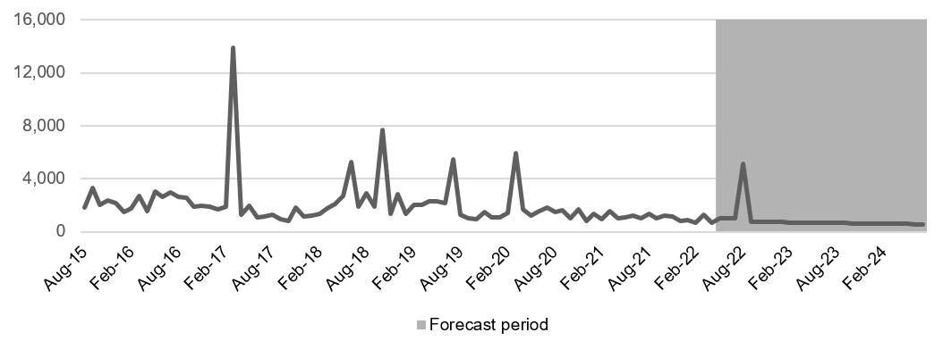

Source: HoustonKemp..

For other transactions, analysis shows that since the establishment of the Numbering System, demand has been steadily declining and is forecast to continue to do so in 2022–23 and 2023–24 (Figure 2 and Table 3). Unlike for FLRN transactions, the COVID-19 pandemic did not seem to impact demand and there was no demand shifting or stockpiling apparent in response to the previous price change in April 2017. This may be because other number transactions usually involve allocations of large blocks of numbers and so the pass-through of any price increase by CSPs to end users is likely to be miniscule. For example, in 2020–21, the average number of geographic telephone numbers allocated to carriage service providers per transaction was 48,758 numbers. This means the proposed fee increase of $22 would equate to an additional $0.004 cents per number.

Historical and forecast other transactions

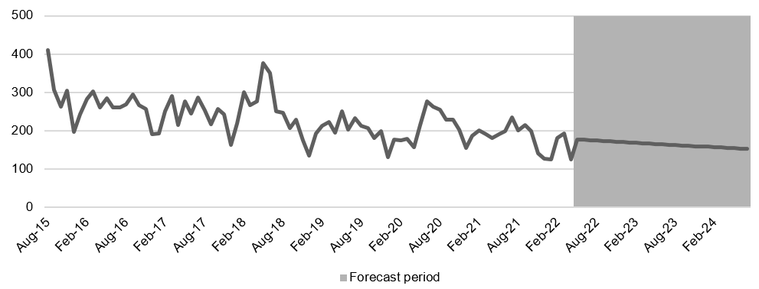

Source: HoustonKemp.

Forecasted transactions

|  |  |  |
| --- | --- | --- |
| **Transaction** | **2022–23** | **2023–24** |
| Allocation of FLRNs | 13,381* | 7,360 |
| Registrations and all other number allocations | 2,106 | 2,021 |
| **Total** | **15,487** | **9,382** |

*To account for stockpiling, 25% of forecasted demand for 2022–23/2023–24 is assumed to occur in the month before the proposed price change comes into effect, i.e., August 2022. Source: HoustonKemp.

## Calculating the new transaction fee

The appropriate transaction fee to achieve cumulative neutral cost recovery has been calculated by matching total revenues (historical and forecast) and total costs. Total costs to be recovered from transaction fees are summarised in Table 1 above. Total revenue is made up of 3 parts:

historical revenue

forecast revenue for the period before the price change

forecast revenue for the period after the price change.

Table 4 sets out cost information from Table 1 with historical and forecast revenue to derive the transaction fee that will achieve neutral cost recovery. We propose to round up the transaction fee as calculated in Table 4 to $57.

Calculating the new fee

|  |  |
| --- | --- |
| **Cost** | **Amount** |
| Total costs to be recovered (from Table 1) | $6,800,929 |
| ***Less*** historical revenue already recovered, August 2015 to April 2022 | ($5,412,382) |
| ***Less*** estimated revenue in the period before the proposed price change (May 2022 to September 2022) | ($310,706) |
| ***Total*** remaining costs to recover by end of the contract in 2024 | $1,077,841 |
| ***Total*** forecasted transactionsfrom September 2022 to the end of the contract in 2024 | 19,086 |
| ***Divide remaining costs to be recovered by forecasted transactions*** |  |
| **New transaction fee** | **$56.47** |

The combination of the forecast transaction demand and proposed increase in transaction fee to $57 results in a path to a neutral cumulative cost recovery position by the end of July 2024, as illustrated in Figure 3.

Cumulative cost recovery position

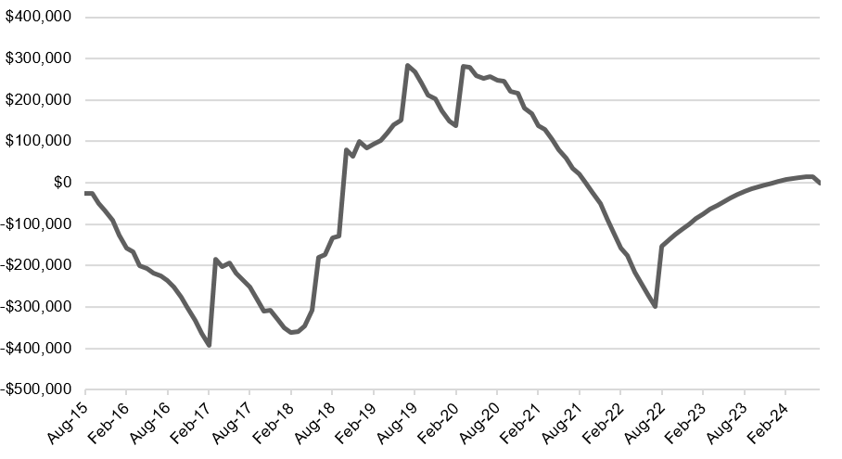

Source: HoustonKemp.

# Financial estimates

Financial performance for the financial years 2019**–**20, 2020**–**21 and estimates for 2021–22, 2022–23 and 2023–24 are provided below.

Table 5 sets out financial estimates for costs and revenues based on no change in fees. Table 6 sets out the estimates based on an increase in transaction fee from $35 to $57 from 1 September 2022.

Cost and revenue estimates – no change in transaction fees

|  |  |  |  |  |  |
| --- | --- | --- | --- | --- | --- |
|  | **Actual**  **2019–20 ($m)** | **Actual**  **2020–21 ($m)** | **Estimate**  **2021–22 ($m)** | **Estimate**  **2022–23 ($m)** | **Estimate\***  **2023–24 ($m)** |
| Costs = X | 0.83 | 0.83 | 0.83 | 0.50 | 0.49 |
| Revenue = Y | 0.93 | 0.64 | 0.50 | 0.46 | 0.39 |
| Balance = Y – X | 0.10 | -0.19 | -0.33 | -0.04 | -0.10 |
| **Cumulative balance** | 0.25 | 0.06 | -0.27 | -0.31 | -0.41 |

Cost and revenue estimates: increase numbering transaction fees to $57 from 1 September 2022

|  |  |  |  |  |  |
| --- | --- | --- | --- | --- | --- |
|  | **Actual**  **2019–20 ($m)** | **Actual**  **2020–21 ($m)** | **Estimate**  **2021–22 ($m)** | **Estimate**  **2022–23 ($m)** | **Estimate\***  **2023–24 ($m)** |
| Costs = X | 0.83 | 0.83 | 0.83 | 0.50 | 0.49 |
| Revenue = Y | 0.93 | 0.64 | 0.50 | 0.73 | 0.53 |
| Balance = Y – X | 0.10 | -0.19 | -0.33 | 0.23 | 0.04 |
| **Cumulative balance** | 0.25 | 0.06 | -0.27 | -0.04 | 0.00 |

# Invitation to comment

## Making a submission

We invite comments on the issues set out in this consultation paper.

[Online submissions](https://www.acma.gov.au/have-your-say) can be made by uploading a document. Submissions in PDF, Microsoft Word or Rich Text Format are preferred.

Submissions by post can be sent to:

The Manager

Numbers Section

Australian Communications and Media Authority

PO Box 13112

Law Courts

Melbourne VIC 8010

The closing date for submissions is COB, **25 July 2022**.

Consultation enquiries can be emailed to [numbering@acma.gov.au](mailto:numbering@acma.gov.au).

#### Publication of submissions

We publish submissions on our website, including personal information (such as names and contact details), except for information that you have claimed (and we have accepted) is confidential.

Confidential information will not be published or otherwise released unless required or authorised by law.

#### Privacy

View information about our policy on the [publication of submissions](https://www.acma.gov.au/publication-submissions), including collection of personal information during consultation and how we handle that information.

Information on the [*Privacy Act 1988*](https://www.legislation.gov.au/Details/C2022C00135)*,* how to access or correct personal information, how to make a privacy complaint and how we will deal with any complaints, is available in our [privacy policy](https://www.acma.gov.au/privacy-policy).

1. The ACMA consulted industry on number of alternative charging methodologies for the setting of numbering allocation and administration charges in 2015 prior to implementing current cost recovery arrangements. This included calculations that sought to attribute charges to reflect the complexity of the system design. It concluded that a methodology that delivers a flat charge structure (no differentiation in the charges for different transaction types) is most appropriate. The flat-charge structure reflects that the Numbering System is almost entirely fully automated; for the majority of transactions there will be no human decision-making or discretion.
2. The ACMA does not recover the GST component of its contract with ZOAK from users of the Numbering System.
3. For example, in addition to the one-off transaction cost, other costs may include the monthly cost of providing services to the number and an Annual Numbering Charge liability which depending on the length of the FLRN can be up to $6,110.