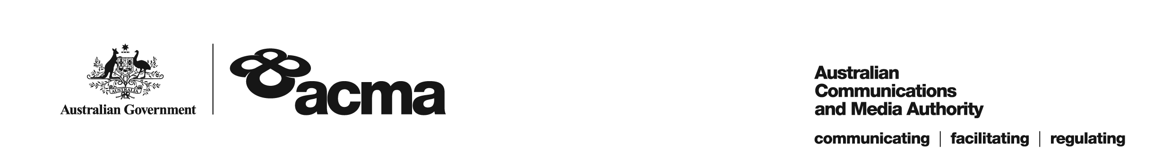

**AUSTRALIAN COMMUNICATIONS AND MEDIA AUTHORITY**

**DRAFT Target Reduction Order STV-TRO-133  
made under subsection 130ZY(3) of the *Broadcasting Services Act 1992***

**1. Interpretation**

In this instrument:

***ACMA*** means the Australian Communications and Media Authority

***Act*** means the *Broadcasting Services Act 1992*

***Applicant*** means Foxtel Cable Television Pty Limited (ACN 069 008 797)

***Application*** means the target reduction order application made on 3 March 2022 in respect of the Service

***Service*** means Sky Thoroughbred Central

***Specified Eligible Period*** means 1 July 2021 to 30 June 2022.

**2. Target Reduction**

Under subsection 130ZY(3) of the Act, the ACMA:

(a) having considered the written representations made by the Applicant in the Application, the supporting evidence submitted with the Application [and the submissions received during the consultation period from...] [1]; and

(b) being satisfied that a refusal to make the target reduction order would impose an unjustifiable hardship on the Applicant;

***ORDERS*** that, for the Specified Eligible Period, the reduced annual captioning target for the Applicant in respect of the Service will be 25%.

Dated: 22 April 2022

1. Any submissions received in response to the publication of this draft order during the 30-day consultation period will be considered by the ACMA in deciding whether to make any final order.