Proposal to vary the Mudgee licence   
area plan

Consultation paper

MARCH 2022

Canberra

Red Building   
Benjamin Offices  
Chan Street   
Belconnen ACT

PO Box 78  
Belconnen ACT 2616

T +61 2 6219 5555  
F +61 2 6219 5353

Melbourne

Level 32   
Melbourne Central Tower  
360 Elizabeth Street   
Melbourne VIC

PO Box 13112  
Law Courts   
Melbourne VIC 8010

T +61 3 9963 6800  
F +61 3 9963 6899

Sydney

Level 5   
The Bay Centre  
65 Pirrama Road   
Pyrmont NSW

PO Box Q500  
Queen Victoria Building   
NSW 1230

T +61 2 9334 7700 or 1800 226 667  
F +61 2 9334 7799

Copyright notice

[Creative Commons logo](http://i.creativecommons.org/l/by/3.0/88x31.png)

<https://creativecommons.org/licenses/by/4.0/>

With the exception of coats of arms, logos, emblems, images, other third-party material or devices protected by a trademark, this content is made available under the terms of the Creative Commons Attribution 4.0 International (CC BY 4.0) licence.

We request attribution as © Commonwealth of Australia (Australian Communications and Media Authority) 2022.

All other rights are reserved.

The Australian Communications and Media Authority has undertaken reasonable enquiries to identify material owned by third parties and secure permission for its reproduction. Permission may need to be obtained from third parties to re-use their material.

Written enquiries may be sent to:

Manager, Editorial Services  
PO Box 13112  
Law Courts  
Melbourne VIC 8010  
Email: [info@acma.gov.au](mailto:info@acma.gov.au)

Executive summary 1

Proposed changes to licence area plan (LAP) 1

Issues for comment 2

Introduction 3

Planning broadcasting services 3

AM to FM conversions 3

Overview of the Mudgee LAP 4

Proposal 1: commercial radio – Mudgee LAP (Mudgee) 5

Summary 5

Background 5

Preliminary view 9

Proposal 2: other amendments 10

Invitation to comment 11

Making a submission 11

Appendix A 12

Map of Mudgee RA1 licence area 12

Appendix B 13

Proposed technical specification for 2MG FM transmitter to serve the Mudgee area 13

Appendix C 14

Proposed technical specification for 2MG FM repeater to serve the Kandos area 14

Appendix D 15

Map of Mudgee RA2 licence area 15

Executive summary

## Proposed changes to licence area plan (LAP)

We are seeking comment on proposed changes to the following licence area plan:

### ****Licence Area Plan—Mudgee Radio****

The ACMA is proposing to vary the [Licence Area Plan – Mudgee (Radio) – June 1997](https://www.legislation.gov.au/Details/F2013C00504) (Mudgee LAP) to:

allow the commercial radio broadcasting service, 2MG, in the Mudgee RA1 licence area to convert transmission from AM to FM (**Proposal 1**)

omit the technical specification for the planned, but not operating, community radio broadcasting service in the Mudgee RA2 licence area (**Proposal 1**)

omit the Mudgee RA2 licence area definition (**Proposal 1**)

make other minor amendments (**Proposal 2**).

The draft variation instrument, Variation to Licence Area Plan – Mudgee Radio 2022 (No. 1), which would give effect to the proposed changes, is available alongside this paper on the ACMA website.

# Issues for comment

We welcome comments from interested stakeholders on the issues raised in this paper, or any other issues relevant to the LAP variation proposed.

Details on making a submission can be found at Invitation to comment at the end of this paper.

# Introduction

## Planning broadcasting services

Our broadcasting planning functions are set out in Part 3 of the *Broadcasting Services Act 1992* (the BSA). We promote the objects of the BSA (section 3), including the economic and efficient use of radiofrequency spectrum, and consider the planning criteria set out in section 23 of the BSA.

When planning analog broadcasting services, we refer to the [*ACMA approach to broadcast planning and varying LAPs*](https://www.acma.gov.au/broadcast-planning-resources) document, which provides an overview of the regulatory framework, policy objectives and planning process for analog broadcasting services.

Under section 26 of the BSA, we must, by legislative instrument, prepare LAPs that determine the number and characteristics, including technical specifications, of broadcasting services that are to be available in particular areas of Australia. The BSA also provides us with a discretionary power to vary LAPs.

In deciding whether to vary any LAP, we consider all submissions received. The ACMA website contains further information about [AM and FM planning](https://www.acma.gov.au/broadcast-planning-resources).

## AM to FM conversions

Our policy about AM-FM conversions is set out in the [*AM to FM conversions and requests for FM in-fill transmitters*](https://www.acma.gov.au/publications/2017-11/guide/am-fm-conversion-and-requests-fm-fill-transmitters) (the AM-FM guidance). In summary, we will generally consider requests for variations to LAPs to enable AM-FM conversion of existing AM commercial radio broadcasting services when the requests are from licensees in:

* single licensee (solus) regional licence areas with less than 30% overlap with any other licence area for commercial radio broadcasting services
* other licence areas where we consider that the circumstances do not put existing FM commercial radio broadcasting licensees as a competitive disadvantage.

We will have regard to the following when considering whether to exercise the discretion to vary any LAP to facilitate an AM-FM conversion for a commercial radio broadcasting service:

* That FM conversion should not result in any existing radio services being adversely affected in terms of their use of spectrum and the technical parameters of their radio transmissions. Other existing radio services should not have to be retuned, replanned, or cancelled, unless a solution can be found that mitigates these impacts without imposing any undue costs on the affected parties.
* That FM conversion should not result in any significant coverage differences for radio listeners within the affected licence areas. The vast majority of radio listeners who were able to receive services in AM should be able to continue to do so following FM conversion.

More information about [how the ACMA assesses coverage loss](https://www.acma.gov.au/publications/2017-11/guide/am-fm-conversion-and-requests-fm-fill-transmitters) can be found on our website.

## Overview of the Mudgee LAP

The Mudgee LAP defines and plans services for the licence areas of Mudgee RA1, Mudgee RA2, Kandos RA1 and Mudgee RA3.

The following services are made available in the Mudgee RA1 licence area:

one national radio broadcasting service planned to serve the Mudgee (town) area, which serves the township

2 national radio broadcasting services planned to serve the Kandos area

one commercial radio broadcasting service planned to serve the wider Mudgee area

one open narrowcasting radio service planned to serve the Mudgee (town) area, which serves the township.

One community radio broadcasting service is made available in the Mudgee RA2 licence area (which is planned to serve the Mudgee area) and one community radio broadcasting service is made available in the Kandos RA1 licence area (which is planned to serve the Kandos area). However, no licence has been allocated for the community radio broadcasting service for the Mudgee RA2 licence area.

One commercial radio broadcasting service is made available in the Mudgee RA3 licence area, which is planned to serve Mudgee and Kandos.

# Proposal 1: commercial radio – Mudgee LAP (Mudgee)

## Summary

We propose to vary the Mudgee LAP to:

Allow the commercial radio broadcasting service 2MG (the 2MG service) in the Mudgee RA1 licence area to convert transmission from AM to FM.

Make spectrum available for a new FM transmitter for the 2MG service that is currently planned on the AM frequency 1449 kHz within the Mudgee RA1 licence area (see Appendix A). The proposed technical specification would permit the FM transmitter to operate on the frequency of 97.1 MHz at 10 kW maximum effective radiated power (ERP), with an omnidirectional radiation pattern and a maximum antenna height of 50 m, from the Broadcast/Country Energy Site, Magpie Hill, Gulgong, Mudgee (see Appendix B).

Make spectrum available for an FM repeater for the 2MG service that would serve the Kandos area. The proposed technical specification would permit the FM repeater to operate on the frequency 101.5 MHz at 250 W maximum ERP, with a directional radiation pattern and a maximum antenna height of 30 m from the Communal Site, Mt Bocoble, Bocoble (see Appendix C).

Omit Schedule Two in the Mudgee LAP to remove the community radio broadcasting service planned in the Mudgee RA2 licence area (see Appendix D) and remove the Mudgee RA2 licence area definition in Attachment 2.1.

We consider that this proposal is an economic and efficient use of the spectrum that is likely to promote the objects in section 3 of the BSA. Specifically, the proposal is likely to promote the availability of a diverse range of radio services (paragraph 3(1)(a)) and is responsive to audience needs (paragraph 3(1)(b)), having regard to the matters that are listed in section 23 of the BSA, especially:

relevant demographics and social economic characteristics (paragraphs 23(a) and (b))

the number of existing broadcasting services and the demand for new services (paragraph 23(c)

the technical restraints relating to the delivery or reception of broadcasting services in the licence area (paragraph 23(e)).

## Background

### Mudgee RA1 licence area

The Mudgee RA1 licence area includes the urban centres/localities of Gulgong (population: 2,521),[1] Mudgee (pop: 10,966) and Kandos (pop: 1,261), and the localities of Putta Bucca – Bombira (pop: 569) and Rylstone (pop: 644). The licence area’s population is 21,194.[2] It is overlapped by the Mudgee RA3 licence area (see Appendix E) and the Remote Commercial Radio Service North East Zone RA1 (which is planned in the Licence Area Plan – Remote Central and Eastern Australia). The percentages of the Mudgee RA1 licence area’s population that are in the overlaps are 100% and 1.80% respectively.[3]

### Commercial radio broadcasting services in Mudgee

In the Mudgee RA1 licence area, the ACMA has planned for:

one AM commercial radio broadcasting service (the 2MG service) with a transmitter at Mudgee.

In the Mudgee RA3 licence area, the ACMA has planned for:

one FM commercial radio broadcasting service (the 2GEE service)[4] with transmitters at Mudgee and Kandos.

Both commercial radio broadcasting services planned in the Mudgee RA1 and Mudgee RA3 licence areas are licensed to Mudgee Broadcasting Co Pty Ltd (MBC). The AM transmitter for the 2MG service is planned to operate on 1449 kHz, with a maximum cymomotive force (CMF) of 1145 V and an omnidirectional antenna radiation pattern. The nominal location of the transmitter is 2 kilometres northwest of town. The transmitter serves Mudgee.

The FM transmitter for the 2GEE service is planned to operate on 93.1 MHz, with a maximum effective radiated power (ERP) of 10 kW and an omnidirectional antenna radiation pattern. The nominal location of the transmitter is Magpie Hill, Gulgong, Mudgee. The transmitter also serves Mudgee. The 2GEE service has a repeater which services Kandos. That repeater is located at Mt Bocoble and is planned to operate on 97.9 MHz.

The proposed FM transmitter for the 2MG service would be planned to operate on 97.1 MHz, with a maximum ERP of 10 kW. The antenna would have an omnidirectional radiation pattern and a maximum height of 50 m. The nominal location of the transmitter would be the same as for the 2GEE service’s main transmitter, the Broadcast/Country Energy Site, Magpie Hill, Gulgong, Mudgee. There are no proposed changes to the 2GEE service.

The proposed FM repeater for the 2MG service to serve the Kandos area would be planned to operate on 101.5 MHz, with a maximum ERP of 250 W. The antenna would have a directional radiation pattern and a maximum antenna height of 30 m. MBC has proposed that the repeater would be located at the same nominal location as the 2GEE service’s repeater at Mt Bocoble.

The nominal location of the 2MG service’s repeater would be the Communal Site, Mt Bocoble, Bocoble. While this location is outside the Mudgee RA1 licence area, we consider it appropriate because it would serve the Mudgee RA1 licence area, would provide equivalent coverage to the 2GEE service’s repeater, and the licensee has existing infrastructure at that site.

### Eligibility of the 2MG service for AM to FM conversion

The Mudgee RA1 licence area is overlapped by the Mudgee RA3 licence area by 100%. The larger Mudgee RA3 licence area was included in the Mudgee LAP in 2008[5] following a request by MBC as the licensee of the licence for the Mudgee RA1 licence area.[6]

Generally, we will consider the prospect of an AM to FM conversion in solus markets, where only one commercial radio broadcasting licence exists. The Mudgee RA1 licence area is not a solus licence area because the degree of overlap between it and the Mudgee RA3 licence area is not less than 30%. However, the ACMA’s AM to FM guidance states that ‘in cases where the population of an overlap exceeds 30% of either of the two licence areas, we will consider the particular circumstances of each application’.[7]

In this instance, MBC is the licensee of both the commercial radio broadcasting services planned in Mudgee RA1 and Mudgee RA3. Were the AM to FM conversion to go ahead, we are of the view that competitive disadvantage issues could not arise. Consequently, having regard to our AM to FM guidance, it is appropriate to consider MBC’s request.

### Spectrum availability assessment

MBC has nominated the frequency 97.1 MHz for a main transmitter to serve the Mudgee area and 101.5 MHz for a repeater to serve the Kandos area. 97.1 MHz is the frequency of a community radio broadcasting service that was planned in the Mudgee RA2 licence area when the Mudgee LAP was made in June 1997.

The allocation of licences for community radio broadcasting services is determined by a range of factors, including demand. We have never allocated a community radio broadcasting licence for the Mudgee RA2 licence area[8] nor have we allocated any temporary community radio broadcasting licences[9] on the frequency 97.1 MHz to serve the Mudgee RA2 licence area. While we are not aware of any aspirant community broadcasters who might wish to provide a community radio broadcasting service to the Mudgee RA2 licence area, we are interested in understanding whether there is any demand for such a service.

There is currently a community radio broadcasting service operating in the Kandos RA1 licence area (KRR 98.7 MHz) which serves the Kandos area.

Our assessment indicates that the nominated frequency of 101.5 MHz would provide equivalent coverage to the 2GEE service’s Kandos repeater.

Given the outcome of our assessment process and that there is a planned but not licensed community radio broadcasting service for the Mudgee RA2 licence area, we consider that both nominated frequencies (97.1 and 101.5 MHz) are suitable for the proposed AM to FM conversion of the 2MG service.

### Coverage assessment

Our assessment indicates that there would be a small amount of coverage loss following the conversion of the 2MG service from AM to FM transmission. Depending on the prediction model used, we predict that the interference-free coverage of the 2MG service’s FM transmitter and the repeater for Kandos within the footprint of the current AM coverage would be between 95.9%[10] and 98.9%[11] of the total population coverage of 18,781[12] within the Mudgee RA1 licence area.

### Interference assessment to and from other services

Our assessment indicates that the risk of interference to other services from the 2MG service’s proposed FM main transmitter is low to medium.

There is, however, a medium risk of interference to the 2SBSFM Tamworth retransmission of a national radio broadcasting service, with the interference potentially occurring on the periphery of that service and to the 2HVR Murrurundi national broadcasting service.

Our assessment indicates that the risk of interference to other services from the proposed repeater to serve Kandos alone is low.

Coverage modelling predictions indicate that there would be inference from other services to the 2MG service’s proposed main transmitter coverage in the areas of Kandos and Rylstone. However, the proposed repeater to serve Kandos would provide alternative coverage to these areas.

Coverage modelling predictions also indicate that interference from other services to the 2MG service’s proposed repeater for the Kandos area would be low.

### Overspill assessment

Our assessment indicates that overspill from the 2MG service’s proposed main FM transmitter into the Remote Commercial Radio Service North East Zone RA1 (RCRS NEZ RA1) licence area would be similar to the overspill from the 2MG service’s current AM transmitter. We predict that the overspill into the non-overlapping area of RCRS NEZ RA1 would be between 1.04%[13] and 1.79%[14] of the total population of the RCRS NEZ RA1 licence area of 213,623. [15] The predicted overspill for the current AM signal is between 1.05%[16] and 1.22%.[17]

#### Kandos

Our assessment indicates that the predicted overspill into the RCRS NEZ RA1 licence area outside the Mudgee RA1 licence area from the proposed repeater to serve Kandos would be between approximately 800 and 1,300 people. This overspill would be the same as the overspill from the existing repeater for the 2GEE service (which is not proposed to change) in the Kandos area, outside of the Mudgee RA3 licence area.

Predictions indicate that overspill into RCRS NEZ RA1 outside of the Mudgee RA3 licence area would be between approximately 500 and 1,000 people for both the 2MG and 2GEE repeaters. The slight difference in overspill between the proposed FM transmission of the 2MG service and the existing transmission of the 2GEE service is a result of the differences between the Mudgee RA1 and Mudgee RA3 licence area boundaries. It is expected that the areas outside of the Mudgee RA1 licence area that are predicted to receive coverage from the 2MG service’s repeater for the Kandos area currently receive fortuitous reception of the 2MG service’s AM transmission.

### Licence area description – Mudgee RA2 licence area

The proposed AM to FM conversion of the 2MG service will use the planned frequency of a community radio broadcasting service that has never operated. Given this, we do not propose to nominate an alternative frequency for that community broadcasting service. Instead, we propose to remove that service and the Mudgee RA2 licence area definition from the Mudgee LAP.

## Preliminary view

We propose to make spectrum available for a new FM transmitter at Mudgee for the 2MG service as well as a repeater for the Kandos area. As part of these arrangements, we want to vary the 2MG service’s existing AM technical specification so that it ceases to be available 28 days after the commencement of FM transmission of the 2MG service.

We are also proposing to remove the community radio broadcasting service that was made available in the Mudgee RA2 licence area, and to allocate the frequency planned for that community radio broadcasting service as part of the AM to FM conversion of the 2MG service. The licence area description of that licence area would also be removed.

In putting forward this proposal, we have considered the objects of the BSA, and the planning criteria specified in section 23. We consider that the proposal promotes the objects of the BSA, particularly paragraph 3(1)(a) and paragraph 3(1)(b). The proposal adds to the diverse range of radio services that would be available in the Mudgee RA1 licence area and is responsive to audience needs. We consider that the proposal is consistent with our policy on AM to FM conversions as set out in our AM to FM guidance.

# Proposal 2: other amendments

We propose making other amendments to the text, schedules, and attachments of the Mudgee LAP:

change the name of the Mudgee LAP from Licence Area Plan - Mudgee (Radio) – June 1997 to Licence Area Plan – Mudgee Radio

update and modernise the drafting of the ‘Determination’ and ‘Schedules’ sections of the LAP to align with recent amendments to other LAPs

update the headings and titles in the Attachments

update various transmitter site nominal locations in the Attachments to better reflect the current names of the sites

update all site coordinates to latitude and longitude format using the Geocentric Datum of Australia 1994 (GDA94)

change all references to the Technical Planning Guidelines to Broadcasting Services (Technical Planning) Guidelines 2017

change the title ‘Notes’ to ‘Special Conditions’ in Attachment 1.2 (TS10004233) to better reflect the content, which remains unchanged and include an additional provision about the availability of the technical specification

change the title ‘Special Conditions’ to ‘Advisory Note’ in Attachment 1.6 (TS10004643) to better reflect the content, and update the text to include GDA94 co-ordinates

change to the ‘Output Radiation Pattern’ in Attachment 1.2 to provide a greater level of detail of the maximum cymomotive force for each bearing or sector

change the maximum antenna height in Attachment 1.5 (TS10002537) from 10 m to 12 m to reflect the licensed height

change the maximum antenna height in Attachments 1.7 and 1.8 (TS10002542 and TS10002544) from 30 m to 23 m to reflect the licensed height

change the maximum antenna height in Attachment 4.2 (TS10002539) from 30 m to 50 m to reflect the operational height

change the maximum antenna height in Attachment 4.3 (TS1130173) from 30 m to 15 m to reflect the operational height and the licensed height

include a technical specification for an existing transmitter at Lower Mount Misery (near Mudgee) that is operated by a national broadcasting service

make consequential amendments to the Schedules because of amendments to the Attachments

make formatting and grammatical changes to various Attachments.

# Invitation to comment

## Making a submission

We invite comments on the issues set out in this consultation paper.

[Online submissions](https://www.acma.gov.au/have-your-say) can be made by uploading a document. Submissions in PDF, Microsoft Word or Rich Text Format are preferred.

Submissions by post can be sent to:

The Manager

Broadcasting Carriage Policy Section

Australian Communications and Media Authority

PO Box 78

Belconnen ACT 2616

The closing date for submissions is **COB**, **29 April 2022**.

Consultation enquiries can be emailed to [BCP@acma.gov.au](mailto:BCP@acma.gov.au).

#### Publication of submissions

We publish submissions on our website, including personal information (such as names and contact details), except for information that you have claimed (and we have accepted) is confidential.

Confidential information will not be published or otherwise released unless required or authorised by law.

#### Privacy

View information about our policy on the [publication of submissions](https://www.acma.gov.au/publication-submissions), including collection of personal information during consultation and how we handle that information.

Information on the *Privacy Act 1988,* how to access or correct personal information, how to make a privacy complaint and how we will deal with any complaints, is available in our [privacy policy](https://www.acma.gov.au/privacy-policy).

# Appendix A

## Map of Mudgee RA1 licence area

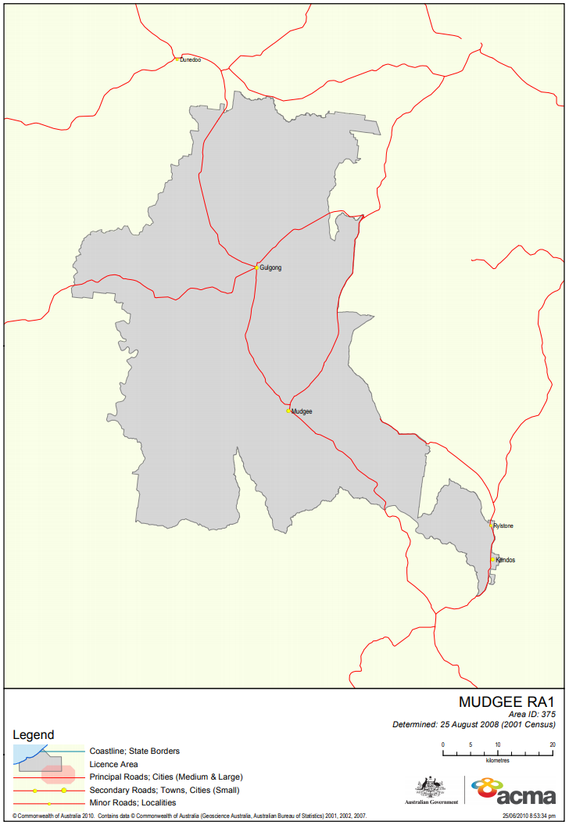

# Appendix B

## Proposed technical specification for 2MG FM transmitter to serve the Mudgee area

Attachment 1.3

LICENCE AREA PLAN : Mudgee Radio

Category : Commercial

General Area Served : Mudgee (NSW)

Service Licence Number : SL10251

TECHNICAL SPECIFICATION - FM Radio

Specification Number : TS12000907

Transmitter Site :-

Nominal location : Broadcast/Country Energy Site Magpie Hill   
Gulgong MUDGEE

Nominal Co-ordinates Latitude Longitude

(GDA94): -32.443431 149.561955

Site Tolerance : Refer to *Broadcasting Services   
 (Technical Planning) Guidelines 2017*

Emission :-

Frequency Band & Mode : VHF-FM

Carrier Frequency : 97.1 MHz

Polarisation : Mixed

Maximum antenna height : 50 m

Output Radiation Pattern :-

|  |  |
| --- | --- |
| Bearing or Sector (Clockwise direction) | Maximum ERP |
| At all angles of azimuth | 10 kW |

# Appendix C

## Proposed technical specification for 2MG FM repeater to serve the Kandos area

Attachment 1.4

LICENCE AREA PLAN : Mudgee Radio

Category : Commercial

General Area Served : Kandos (NSW)

Service Licence Number : SL10251

TECHNICAL SPECIFICATION - FM Radio

Specification Number : TS12000831

Transmitter Site :-

Nominal location : Communal Site Mt Bocoble BOCOBLE

Nominal Co-ordinates Latitude Longitude

(GDA94): -32.806630 149.750663

Site Tolerance : Refer to *Broadcasting Services   
 (Technical Planning) Guidelines 2017*

Emission :-

Frequency Band & Mode : VHF-FM

Carrier Frequency : 101.5 MHz

Polarisation : Mixed

Maximum antenna height : 15 m

Output Radiation Pattern :-

|  |  |
| --- | --- |
| Bearing or Sector (Clockwise direction) | Maximum ERP |
| 0°T - 215°T | 250 W |
| 215°T - 245°T | 100 W |
| 245°T - 305°T | 60 W |
| 305°T - 335°T | 100 W |
| 335°T - 360°T | 250 W |

# Appendix D

## Map of Mudgee RA2 licence area

# Appendix E

## Map of Mudgee RA3 licence area

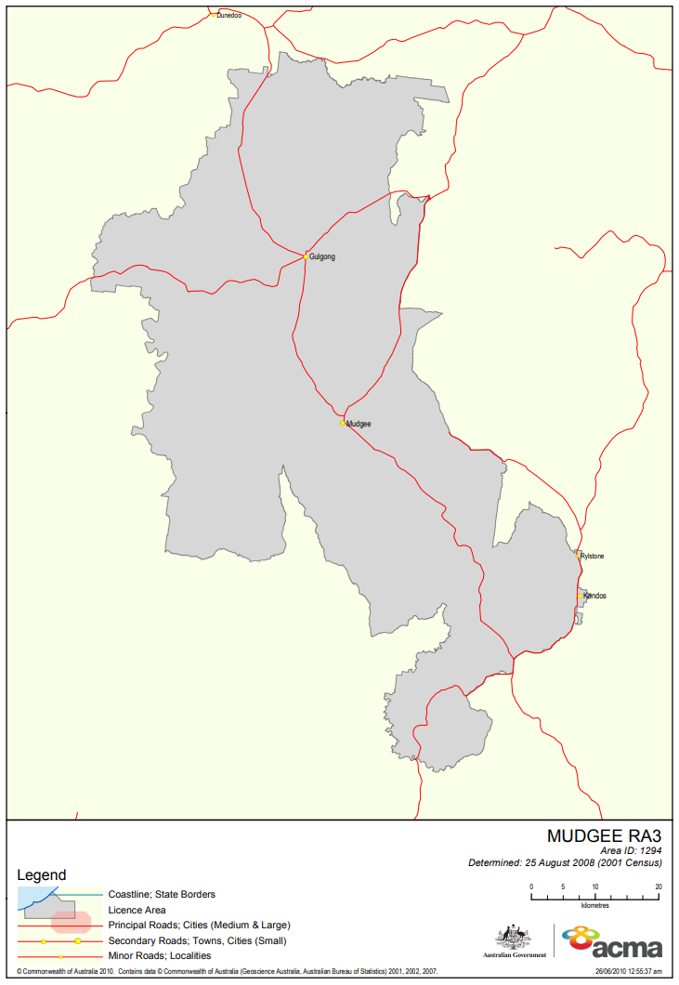

1. Except as otherwise indicated, all population figures are from the Australian Bureau of Statistics, 2016 Census.
2. Determined by the ACMA under section 30 of the BSA.
3. Australian Communications and Media Authority, ‘[Section 30 Schedule by licence area](https://www.acma.gov.au/section-30-schedule-licence-area)’, n.d., accessed 25 October 2021.
4. Under section 39 of the BSA. Broadcast services licence number 10101.
5. Australian Government, ‘[Federal Register of Legislation](https://www.legislation.gov.au/Details/F2008L03234/Download)’, n.d., accessed 25 October 2021.
6. The licensee advised us that the specified location of the transmitter used to serve the general area of Kandos/Rylstone was not appropriate. They wanted to serve the area of Pyramul and Illford to the immediate south of the existing licence area. (Explanatory Statement to the [Variation to the Licence Area Plan – Mudgee (Radio) – Variation No. 1 of 2008](https://www.legislation.gov.au/Details/F2008L03234/Download)).
7. Australian Communications and Media Authority, [*ACMA’s approach to AM-FM conversions and infill transmitters for commercial radio broadcasting services*](https://www.acma.gov.au/publications/2017-11/guide/am-fm-conversion-and-requests-fm-fill-transmitters), (page 3), n.d., accessed 25 October 2021.
8. Under Part 6 of the BSA.
9. Under Part 6A of the BSA.
10. The predicted population figure is 18,026.
11. The predicted population figure is 18,583.
12. 2016 Census datum.
13. The predicted population figure is 2,213.
14. The predicted population figure is 3,832.
15. Determined by the ACMA under section 30 of the BSA.
16. The predicted population figure is 2,245.
17. The predicted population figure is 2,610.