Indexation of Australian program production budget and licence fee figures

© Commonwealth of Australia 2022
This work is copyright. Apart from fair dealings for the purpose of private study, research, criticism or review, as permitted by the Copyright Act 1968, no part may be reproduced or transmitted, in any form or by any means or process, without the written permission of the publishers.
Published by the Australian Communications and Media Authority
PO Box Q500
Queen Victoria Building NSW 1230

Indexation of Australian program production budget and licence fee figures
Section 13 of the Broadcasting Services (Australian Content and Children’s Television) Standards 2020 (ACCTS) requires commercial free-to-air television licensees to broadcast at least 250 points each year of first release Australian programs from genres including drama, documentary and children’s non-drama.
Points are calculated by multiplying the duration of the program (in hours) by the pre-determined genre point allocation for the particular program genre and production budget.
Production budgets and licence fees for 2021
For 2021, Schedule 1 to the ACCTS sets out the following genre point allocation.
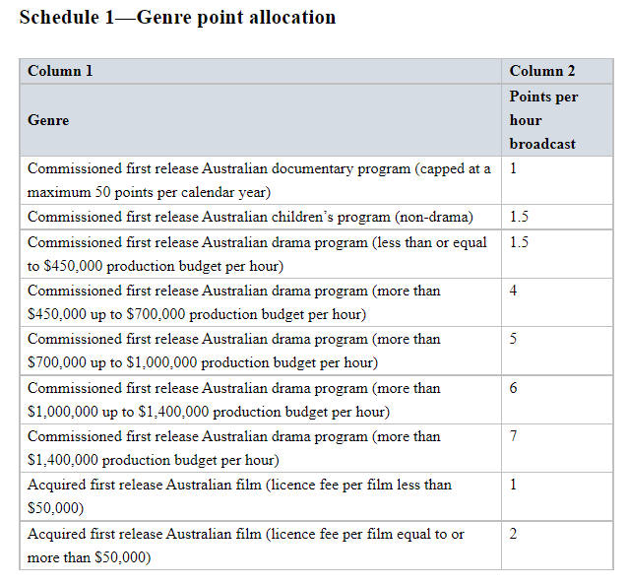
Production budget and licence fee figures for 2022 and later years
Section 15 of the ACCTS specifies a formula for calculating increases for the production budget and licence fee figures for 2022 and later years. If the CPI number increased over the twelve months to the September quarter preceding 1 January of the relevant year, an increase to the amount is calculated using the formula:

‘previous indexable amount x latest CPI number ÷ earlier CPI number’.

The result is to be rounded to the nearest thousand dollars and if the amount to be rounded is $500, it is to be rounded down.

The following table sets out the production budget and licence fee figures for genre points calculation for 2022.

 | 2022 |  |  | Basis of calculation
Schedule 1 - Genre point allocation table | Points per hour broadcast | Lower or only value ($) | Higher value ($) | Latest CPI number (CPI number for quarter ending 30 SEP of previous year) | Earlier CPI number (CPI number for quarter ending 30 SEP two years before) | Lower or only original value x Latest CPI ÷ earlier CPI | Higher original value x Latest CPI ÷ earlier CPI
Commissioned first release Australian drama program (less than or equal to $450,000 production budget per hour) | 1.5 | 464,000 | N/A | 119.70 | 116.20 | 463,554.22 | N/A
Commissioned first release Australian drama program (more than $450,000 up to $700,000 production budget per hour) | 4 | 464,000 | 721,000 | 119.70 | 116.20 | 463,554.22 | 721,084.34
Commissioned first release Australian drama program (more than $700,000 up to $1,000,000 production budget per hour) | 5 | 721,000 | 1,030,000 | 119.70 | 116.20 | 721,084.34 | 1,030,120.48
Commissioned first release Australian drama program (more than $1,000,000 up to $1,400,000 production budget per hour) | 6 | 1,030,000 | 1,442,000 | 119.70 | 116.20 | 1,030,120.48 | 1,442,168.67
Commissioned first release Australian drama program (more than $1,400,000 production budget per hour) | 7 | 1,442,000 | N/A | 119.70 | 116.20 | 1,442,168.67 | N/A
Acquired first release Australian film (licence fee per film less than $50,000) | 1 | 52,000 | N/A | 119.70 | 116.20 | 51,506.02 | N/A
Acquired first release Australian film (licence fee per film equal to or more than $50,000) | 2 | 52,000 | N/A | 119.70 | 116.20 | 51,506.02 | N/A

‘CPI number’ means the All Group Consumer Price Index number (being the weighted average of the 8 Australian capital cities) published on the Australian Statistician.
‘Previous indexable amount’ refers to the indexable amount in force immediately before 1 January of the relevant year.
‘Latest CPI number’ means the CPI number for the quarter ending on 30 September before the relevant year.
‘Earlier CPI number’ means the CPI number for the quarter ending on 30 September two years before the relevant year.

