Replanning the 2 GHz band: Review of the 2 GHz Television Outside Broadcast Frequency Band Plan

Consultation paper

DECEMBER 2021

updated 7 february 2022

Canberra

Red Building   
Benjamin Offices  
Chan Street   
Belconnen ACT

PO Box 78  
Belconnen ACT 2616

T +61 2 6219 5555  
F +61 2 6219 5353

Melbourne

Level 32   
Melbourne Central Tower  
360 Elizabeth Street   
Melbourne VIC

PO Box 13112  
Law Courts   
Melbourne VIC 8010

T +61 3 9963 6800  
F +61 3 9963 6899

Sydney

Level 5   
The Bay Centre  
65 Pirrama Road   
Pyrmont NSW

PO Box Q500  
Queen Victoria Building   
NSW 1230

T +61 2 9334 7700 or 1800 226 667  
F +61 2 9334 7799

Copyright notice

[Creative Commons logo](http://i.creativecommons.org/l/by/3.0/88x31.png)

<https://creativecommons.org/licenses/by/4.0/>

With the exception of coats of arms, logos, emblems, images, other third-party material or devices protected by a trademark, this content is made available under the terms of the Creative Commons Attribution 4.0 International (CC BY 4.0) licence.

We request attribution as © Commonwealth of Australia (Australian Communications and Media Authority) 2021.

All other rights are reserved.

The Australian Communications and Media Authority has undertaken reasonable enquiries to identify material owned by third parties and secure permission for its reproduction. Permission may need to be obtained from third parties to re-use their material.

Written enquiries may be sent to:

Manager, Editorial Services  
PO Box 13112  
Law Courts  
Melbourne VIC 8010  
Email: [info@acma.gov.au](mailto:info@acma.gov.au)

Executive summary 1

Issue/s for comment 3

Introduction 4

Background 4

Proposed frequency band plans for the 2 GHz band 4

Implementation progress 5

2 GHz MSS band plan 6

Transition timeframes 6

TOB and MSS licensing arrangements during the transition period 10

Complementary ground component and direct air-to-ground services 11

Consequential amendments to other spectrum planning arrangements 11

Revised TOB band plan 12

Relocation arrangements for TOB services 13

Invitation to comment 14

Making a submission 14

Executive summary

The Australian Communications and Media Authority (ACMA) is reviewing the [Television Outside Broadcast (1980–2110 MHz and 2170–2300 MHz) Frequency Band Plan 2012](https://www.legislation.gov.au/Details/F2012L00731) (the current TOB band plan), which sets outs the purposes for which the 2 GHz band may be used.

As an outcome of the ACMA’s [review of the 2 GHz band](https://www.acma.gov.au/consultations/2020-07/replanning-options-2-ghz-band-consultation-232020), we are developing spectrum management arrangements to support the introduction of mobile-satellite services (MSS) in the frequency bands 1980–2010 MHz and 2170–2200 MHz, and to facilitate ceasing television outside broadcast (TOB) services in these bands. These arrangements were explained in the 2 GHz [outcomes paper](https://www.acma.gov.au/consultations/2020-07/replanning-options-2-ghz-band-consultation-232020) published in January 2021, in which we detailed our decisions to replan the 2 GHz band.

The 2 GHz band is currently used for TOB services on a shared and non-exclusive basis for short-term applications, such as covering special events. To support the introduction of MSS in the band, we proposed in the outcomes paper that TOB services be required to cease operating in the band in metropolitan areas over a transition period of 5 years, ending 28 February 2026. In non-metropolitan areas (all remaining parts of Australia), we proposed a shorter transition period of 3 years, ending 29 February 2024. This is intended to support earlier introduction of MSS where TOB usage is limited and infrequent, or non-existent.

To implement these arrangements, we propose to repeal the current TOB band plan and replace it with 2 new frequency band plans, namely:

* Radiocommunications (Mobile-Satellite Service) (1980–2010 MHz and 2170–2200 MHz) Frequency Band Plan 2022 (the 2 GHz MSS band plan), which deals with the 2 GHz band as replanned for MSS

Radiocommunications (Television Outside Broadcasting) (2010–2110 MHz and 2200–2300 MHz) Frequency Band Plan 2022 (therevised TOB band plan), dealing with the remaining frequencies that are not affected by the 2 GHz band review and remain planned and licensed for TOB use.

The 2 GHz MSS band plan establishes that the band may be used for MSS and provides certainty to existing and future licensees by setting the transition deadlines for when TOB services must stop operating in the band.

There are some sporting and event venues in regional areas where TOB services are used regularly. We propose to allow these to continue operation for an additional 2 years to the end of the transition period ending 28 February 2026. We have proposed an initial list of such venues in the 2 GHz MSS band plan, where they are referred to as *designated areas*.

While the 2 GHz outcomes paper noted that replanning arrangements would include support for complementary ground component (CGC)[1] and direct air-to-ground communications (DA2GC)[2] services, at this stage we have not made provision for them in the draft 2 GHz MSS band plan. We intend to deal with these services in a later update to the band plan, to allow time for further consideration of the best approach.

The revised TOB band plan deals with the remaining frequencies not covered by the 2 GHz MSS band plan, which were outside the scope of our review of the 2 GHz band. This plan would give effect to the same arrangements for these frequencies, as specified in the current TOB band plan. While we have not modified the practical effect of this band plan, it has been updated to reflect contemporary legislative drafting practices.

We are also working to facilitate the transition of TOB services to alternative spectrum in the 7.2 GHz TOB band (7100–7425 MHz) and intend to consult on proposed planning arrangements in Q1 2022.

Alongside this paper, we are also consulting on proposed licensing arrangements for narrowband MSS, which could result in the introduction of narrowband MSS services in regional areas in early 2022. During the TOB transition period, the operation of MSS services will be restricted to protect TOB services.

# Issue/s for comment

This consultation does not ask specific questions. The ACMA welcomes comment from interested stakeholders on the issues raised in this consultation paper and the accompanying draft band plans.

# Introduction

## Background

The Australian Communications and Media Authority (ACMA) concluded a review of the 2 GHz band (1980–2010 MHz paired with 2170–2200 MHz) with the publication of an [outcomes paper](https://www.acma.gov.au/consultations/2020-07/replanning-options-2-ghz-band-consultation-232020) in January 2021. The outcomes paper detailed our decision to replan the band for mobile-satellite services, including introducing:

* Australia-wide mobile-satellite services (MSS) in the frequency range 1980–2005 MHz paired with 2170–2195 MHz (a bandwidth of 2 x 25 MHz) for exclusive licensed use

Australia-wide narrowband MSS in the ranges 2005–2010 MHz and 2195–2200 MHz (a bandwidth of 2 x 5 MHz) for shared use by services such as telemetry, short messaging, and low-date-rate services (for example satellite internet of things (IoT) applications).

The 2 GHz band is currently used for TOB services on a shared and non-exclusive basis for short-term applications, such as covering special events. To support the introduction of MSS in the band, we proposed that TOB services be required to cease operating in the band over a proposed transition period ending 28 February 2026. We proposed a shorter transition period ending 29 February 2024 in regional and remote areas where TOB usage is limited and infrequent.

Frequencies covered by the 2 GHz band are subject to the [Television Outside Broadcast (1980–2110 MHz and 2170–2300 MHz) Frequency Band Plan 2012](https://www.legislation.gov.au/Details/F2012L00731) (the TOB band plan), which sets outs the purposes for which the band may be used. This is a legislative instrument made by the ACMA under section 32 of the *Radiocommunications Act 1992.*

To support the introduction of MSS and facilitate ceasing TOB services in the 2 GHz band, we propose to repeal the TOB band plan and replace it with 2 new frequency band plans covering the relevant frequencies.

Before making or revoking a frequency band plan, the ACMA is required under the *Radiocommunications Act 1992* to provide the public with reasonable opportunity to make representations to the ACMA on the draft plan and revocation. This paper provides that opportunity.

## Proposed frequency band plans for the 2 GHz band

The 2 GHz band comprises a subset of frequencies contained in the current TOB band plan. The current TOB band plan covers the 2 GHz band (30 MHz of paired spectrum), as well as the adjacent bands 2010–2110 and 2200–2300 MHz. The adjacent bands – which are outside the scope of the 2 GHz review – support TOB operations of the free-to-air broadcasters (ABC, Seven, Nine and Ten) and subscription television companies. Figure 1 illustrates the layout of these parts of the spectrum and their place in the current and proposed frequency band plans.

Current and proposed band plan frequency arrangements

If you need help accessing or reading this diagram, please contact the ACMA's Customer Service Centre by phone on 1300 850 115 or by email at info@acma.gov.au

The proposed new plans are detailed in the draft legislative instruments accompanying this consultation paper:

* the Radiocommunications (Mobile-Satellite Service) (1980–2010 MHz and 2170–2200 MHz) Frequency Band Plan 2022 (the 2 GHz MSS band plan), which deals with the 2 GHz band as replanned for MSS

the Radiocommunications (Television Outside Broadcasting) (2010–2110 MHz and 2200–2300 MHz) Frequency Band Plan 2022 (therevised TOB band plan), dealing with the remaining frequencies that are not affected by the 2 GHz band review and remain planned and licensed for TOB use.

## Implementation progress

Our review of the TOB band plan is one part of a broader program of work to implement outcomes of the 2 GHz band review. To date, we have amended 2 planning documents, [Embargo 23](https://www.acma.gov.au/publications/2019-10/rules/embargo-23) and [RALI FX21](https://www.acma.gov.au/publications/2019-09/instruction/rali-fx21-television-outside-broadcasting-services), to limit any new or reissued TOB licences to a term of no longer than one year, and to note on these licences that forthcoming replanning activities may require licensees to change frequency or cease transmission.

We are also conducting a concurrent consultation on implementing class-licensing arrangements to authorise earth stations in the 2 GHz narrowband MSS segment. For further information, please refer to our consultation paper on proposed licensing arrangements for 2 GHz narrowband mobile-satellite services.

# 2 GHz MSS band plan

The draft 2 GHz MSS band plan is designed to achieve the following key objectives:

* Establish that the band may be used for the purpose of MSS.[3]
* Provide certainty to existing and future licensees by setting dates by which TOB services must cease operating in the 2 GHz band, to facilitate the transition of TOB services to alternative frequencies. The proposed timeframes (discussed below) are reflected in the draft band plan.

Provide ongoing support for legacy fixed point-to-point services licensed before the commencement of the TOB band plan in 2012.[4] As these are all in remote areas, we consider the continued operation of these services poses a negligible interference risk to future MSS.

## Transition timeframes

### Metropolitan areas

To implement the proposed transition timeframe for TOB services to cease operating in the 2 GHz band, the draft 2 GHz MSS band plan specifies that the band must not be used for a TOB service in a metropolitan area from 1 March 2026.

Metropolitan areas are defined at Schedule 1 of the draft band plan and comprise populated areas around capital cities and surrounds where operation of TOB services is most frequent. These area boundaries are unique to this process and were informed by our apparatus licence fee areas, location of sporting stadiums, 2 GHz spectrum-licensed capital city areas, and requirements to protect TOB services in the upper-adjacent band (2010–2110 MHz and 2200–2300 MHz). The areas are illustrated in Figure 2.

Map of proposed metropolitan areas

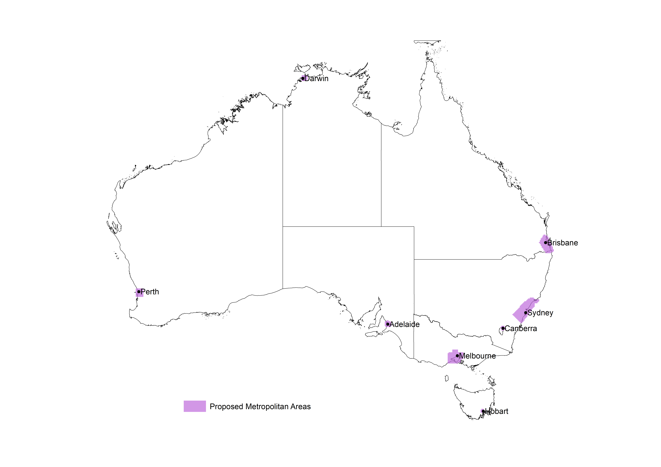

While TOB services in metropolitan areas are required to cease operation in the 2 GHz band by 28 February 2026, we propose 2 exceptions to permit operation after this date. These exceptions aim to provide limited flexibility to support a TOB service in special circumstances if it does not impact on MSS operations.

The first exception is where agreement in writing is obtained from the new licensee. This may be feasible, for example, in cases where a licence has been obtained to operate an MSS in the 2 GHz band but the licensee has not yet deployed a service. Another example may be where an MSS is in operation but the licensee considers operation of a TOB service in a specified location or a specified area does not pose a risk of harmful interference. Before operating a TOB service under any such agreement, a prospective operator must obtain a licence from the ACMA under our usual licensing process, and provide a copy of the agreement to us. The licence will authorise operation of a TOB service only at a location or within an area specified in a condition of the licence.

The second exception for a TOB service to operate after 28 February 2026 is in circumstances where there is no MSS licensee in a given frequency range or geographical area. This may occur, for example, if certain licences are not taken up in the forthcoming 2 GHz MSS allocation process, or if an MSS licensee surrenders a licence at a later date and there is no succeeding licensee. The ACMA may allow use of a TOB service in these and similar circumstances in accordance with our usual licensing process, when we are satisfied that operation of the TOB service in accordance with the licence would not cause harmful interference to an MSS.

### Regional and remote areas

We propose a shorter transition period (ending 29 February 2024) in regional and remote areas. These areas comprise all the parts of Australia that are not metropolitan areas, as defined at Schedule 1 of the draft band plan. The aim of the shorter transition period in these areas is to allow earlier access to the 2 GHz band for MSS, since TOB usage in these areas is limited and infrequent.

To implement this transition timeframe, the draft 2 GHz MSS band plan requires TOB services to cease operation from 1 March 2024 in non-metropolitan areas.

TOB services provided at specified event and sporting venues – referred to as *designated areas* in the draft band plan – may continue to operate until the end of the metropolitan transition period (ending 28 February 2026). Industry stakeholders have advised us that the same equipment is used in both regional and metropolitan areas. Allowing this equipment to be used in designated regional areas where regular events are held will provide the maximum transition time for TOB operators, thereby delaying the impact of equipment replacement costs in relocating to alternative spectrum. Designated areas are discussed in further detail below.

TOB services may also continue to operate in regional areas after 29 February 2024 in the same 2 circumstances described for metropolitan areas above. That is, if agreement is obtained in writing from the new licensee, or where there is no licensee, the ACMA may allow use for a TOB service in accordance with our usual licensing process.

### Designated areas

Designated areas are dealt with in Schedule 2 of the draft 2 GHz MSS band plan. The operation of TOB services will be permitted at these locations before 1 March 2026 (in line with transition timing for metropolitan areas).

We have specified an initial list of designated areas in the draft band plan, and welcome feedback on the proposed places. These are sporting and event venues in regional areas where TOB services are expected to be used regularly (for example, rugby league stadiums and motor racing in Bathurst).

The proposed designated areas cover venues in the following locations, and are shown in Figure 3:

* Ballarat, Victoria
* Bathurst, New South Wales
* Bendigo, Victoria
* Bunbury, Western Australia
* Cairns, Queensland
* Launceston, Tasmania
* Mackay, Queensland
* Phillip Island, Victoria
* Sunshine Coast, Queensland
* Townsville, Queensland

Wanneroo, Western Australia.

Map of proposed designated areas

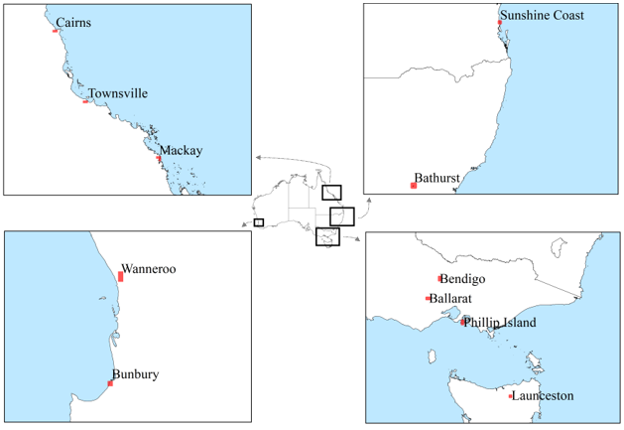

The draft band plan, if made, would permit the ACMA to amend the designated areas until 28 February 2026 by way of a notifiable instrument. Such an instrument is published on the [Federal Register of Legislation](https://www.legislation.gov.au/).

In addition to amendments initiated by us, a person may apply in writing for the ACMA to designate an area. We must decide whether to grant the application within 90 days after the application is made. If we decide not to designate the proposed area, a range of review and appeal mechanisms are available to the applicant, as detailed in Schedule 2 of the draft band plan.

### Transition timing considerations

We anticipate that the proposed transition period will allow ongoing TOB operators to relocate to alternative spectrum at a time that aligns to the extent possible with their equipment replacement lifecycles. While satellite services are expected to take some time to be deployed, providing earlier access in regional and remote areas will support initial deployment in areas that are likely to benefit most from new services, with minimal impact on TOB services.

To avoid transition occurring during the summer period where TOB activities are normally at a higher activity level due to coverage of sporting events, our view (stated in the 2 GHz outcomes paper) is that the transition periods should end on 29 February 2024 and 28 February 2026.

## TOB and MSS licensing arrangements during the transition period

In the 2 GHz outcomes paper, we noted that early access for narrowband MSS (2005–2010 MHz paired with 2195–2200 MHz) would be considered.

We consider operation of narrowband MSS is feasible outside of areas where TOB is used, with appropriate interference management arrangements to protect TOB services during the transition period. For example, operation of narrowband MSS would be feasible in regional areas outside of designated areas and in remote parts of Australia where TOB operation is unlikely. Proposed arrangements are outlined in our concurrent consultation paper on proposed licensing arrangements for 2 GHz narrowband MSS.

As previously noted, the ACMA has placed a one-year limit on the term of any new or reissued TOB licences issued during the transition period. These licences will include a note advising that forthcoming replanning activities may require licensees to change frequency or cease transmission.

The ACMA intends to support operation of scientific licences in the 2 GHz band for experimental and demonstration purposes for satellite and other uses on a short-term basis, with appropriate interference management arrangements to protect TOB services during the transition period.

Development of a framework for the allocation of licences for MSS in 1980–2005 MHz paired with 2170–2195 MHz is expected to commence Q3 2022. Timing for an allocation of MSS licences will be considered alongside other allocation processes, with an indicative allocation occurring after mid-2023.

We are also consulting on proposed licensing arrangements for narrowband MSS, which could result in the introduction of narrowband MSS services in regional areas in early 2022. During the TOB transition period, operation of MSS services will be restricted to protect TOB services during the transition to new arrangements. Proposed transition and licensing arrangements for MSS and TOB are summarised in Table 1.

MSS and TOB transitional arrangements in the 2 GHz band*

|  |  |  |
| --- | --- | --- |
| Area | Service | Requirement |
| **Metropolitan areas and designated areas** | TOB | Operations cease by 28 February 2026, protected from narrowband MSS until then. |
| Narrowband MSS | Operations not to commence until 1 March 2026. |
| MSS (2 x 25 MHz) | Licence allocation arrangements to be determined. Operations not to commence until 1 March 2026. |
| **Outside metropolitan areas and outside designated areas** | TOB | Operations cease by 29 February 2024, protected from narrowband MSS until then. |
| Narrowband MSS | Until 29 February 2024, operation is on the basis of no protection afforded from TOB and no interference to TOB.  From 1 March 2024 until 29 February 2026, only TOB services in metropolitan areas and designated areas require protection. |
| MSS (2 x 25 MHz) | Licence allocation arrangements to be determined.  Until 29 February 2024, operation is on the basis of no protection afforded from TOB and no interference to TOB.  From 1 March 2024 until 28 February 2026, only TOB services in metropolitan areas and designated areas require protection. |

* Coexistence arrangements between 2 GHz MSS and TOB in the adjacent band (2010–2110 / 2200–2300 MHz) will be developed and will include MSS operations being afforded no protection from adjacent band TOB services.

## Complementary ground component and direct air-to-ground services

The 2 GHz outcomes paper noted that we would include arrangements in planning the 2 x 25 MHz MSS segment to support deployment of a complementary ground component (CGC), including direct air-to-ground communications (DA2GC) services, where a licensee wishes to supplement its mobile-satellite service.

At this stage, we have not made provision in the draft 2 GHz MSS band plan to allow for operation of CGC and DA2GC services. Arrangements for these services do not need to be finalised until closer to licence allocation (anticipated around mid-2023). We propose to address this in a later update to the band plan to allow for further consideration of the best approach. Since we have not previously implemented planning arrangements for these services, we need to consider, among other things, whether there should be any restrictions that allow access only for MSS licensees who have deployed an active satellite service, and whether this is best achieved under a frequency band plan or through the licence allocation process.

## Consequential amendments to other spectrum planning arrangements

If the band plans are made, consequential updates will be made to ACMA policies on licensing and coordination arrangement for services in the 2 GHz band, as recorded in [Embargo 23](https://www.acma.gov.au/publications/2019-10/rules/embargo-23) and [RALI FX21](https://www.acma.gov.au/publications/2019-09/instruction/rali-fx21-television-outside-broadcasting-services).

# Revised TOB band plan

The revised TOB band plan deals with the remaining frequencies (2010–2110 MHz and 2200–2300 MHz) not covered by the 2 GHz MSS band plan, which were outside the scope of our review of the 2 GHz band.

This plan would give effect to the same arrangements for these frequencies as are specified in the current TOB band plan. While we have not modified the practical effect of the revised TOB band plan, it has been updated to reflect contemporary legislative drafting practices.

# Relocation arrangements for TOB services

The ACMA considers that the majority of services in the 2 GHz band can be accommodated in the 7.2 GHz TOB band (7100–7425 MHz), which has similar arrangements to the 2 GHz band. The 7.2 GHz band has a number of channels that are specifically identified for shared non-exclusive usage, similar to the arrangements for the 2 GHz band. With current arrangements in the 7.2 GHz band intended to support analog technologies, we are reviewing channel arrangements to reflect current digital technologies in use. Our intention is to develop a single channel plan that replaces current interleaved channelling arrangements.

Accordingly, we are developing changes to planning arrangements in the 7.2 GHz band to prepare for migration of TOB services during the 2 GHz transition period. This involves amendments to [RALI FX3](https://www.acma.gov.au/publications/2019-09/instruction/rali-fx3-microwave-fixed-services) by modernising channel arrangements in the 7.2 GHz band to accommodate additional TOB use.

We expect to commence public consultation on proposed amendments to RALI FX3 in Q1 2022.

# Invitation to comment

## Making a submission

We invite comments on the issues set out in this consultation paper.

[Online submissions](https://www.acma.gov.au/have-your-say) can be made by uploading a document. Submissions in PDF, Microsoft Word or Rich Text Format are preferred.

Submissions by post can be sent to:

The Manager

Space Systems Section

Australian Communications and Media Authority

PO Box 78

Belconnen ACT 2616

The closing date for submissions is COB, **Monday 28 February 2022**.

Consultation enquiries can be emailed to [satellite.coordination@acma.gov.au](mailto:satellite.coordination@acma.gov.au).

#### Publication of submissions

We publish submissions on our website, including personal information (such as names and contact details), except for information that you have claimed (and we have accepted) is confidential.

Confidential information will not be published or otherwise released unless required or authorised by law.

#### Privacy

View information about our policy on the [publication of submissions](https://www.acma.gov.au/publication-submissions), including collection of personal information during consultation and how we handle that information.

Information on the *Privacy Act 1988,* how to access or correct personal information, how to make a privacy complaint and how we will deal with any complaints, is available in our [privacy policy](https://www.acma.gov.au/privacy-policy).

1. Complementary ground component refers to a terrestrial wireless broadband network that is deployed to supplement mobile-satellite coverage. It is also sometimes referred to as an ancillary terrestrial component.
2. DA2GC is used for the provision of inflight broadband services and involves a ground-based transmitter communicating to aircraft.
3. We have also made provision in the draft band plan to support in TOB services in certain exceptional circumstances.
4. There are currently 14 legacy point-to-point links, all of which are licensed to Telstra in remote areas of Australia.