Review of the 1800 MHz band spectrum licence technical framework

Consultation paper

October 2021

Canberra

Red Building   
Benjamin Offices  
Chan Street   
Belconnen ACT

PO Box 78  
Belconnen ACT 2616

T +61 2 6219 5555  
F +61 2 6219 5353

Melbourne

Level 32   
Melbourne Central Tower  
360 Elizabeth Street   
Melbourne VIC

PO Box 13112  
Law Courts   
Melbourne VIC 8010

T +61 3 9963 6800  
F +61 3 9963 6899

Sydney

Level 5   
The Bay Centre  
65 Pirrama Road   
Pyrmont NSW

PO Box Q500  
Queen Victoria Building   
NSW 1230

T +61 2 9334 7700 or 1800 226 667  
F +61 2 9334 7799

Copyright notice

[Creative Commons logo](http://i.creativecommons.org/l/by/3.0/88x31.png)

<https://creativecommons.org/licenses/by/4.0/>

With the exception of coats of arms, logos, emblems, images, other third-party material or devices protected by a trademark, this content is made available under the terms of the Creative Commons Attribution 4.0 International (CC BY 4.0) licence.

We request attribution as © Commonwealth of Australia (Australian Communications and Media Authority) 2021.

All other rights are reserved.

The Australian Communications and Media Authority has undertaken reasonable enquiries to identify material owned by third parties and secure permission for its reproduction. Permission may need to be obtained from third parties to re-use their material.

Written enquiries may be sent to:

Manager, Editorial Services  
PO Box 13112  
Law Courts  
Melbourne VIC 8010  
Email: [info@acma.gov.au](mailto:info@acma.gov.au)

Contents

Issues for comment 1

Introduction 2

Case for action 3

Background 5

Proposed amendments to the technical framework 6

1800 MHz TLG 6

Issues considered by the TLG 6

Effect on incumbent services 13

1800 MHz spectrum licences 14

Fixed (point-to-point) services 15

Meteorological-satellite service (space-to-Earth) operating below   
1710 MHz and adjacent to the 1800 MHz band 15

Cordless communications devices (i.e., DECT), operating in the   
1880 MHz to 1900 MHz frequency range 16

Radio Astronomy Service (RAS) receivers 16

Public Telecommunications Service 17

Class licensed services 17

Aeronautical mobile 17

Proposed changes 18

Proposed changes to the conditions on the spectrum licence 18

Proposed changes to the s.145(4) determination 21

Invitation to comment 25

Making a submission 25

Appendix A – Relevant conditions of current 1800 MHz band spectrum licences 26

Licence Schedule 2 – Core Conditions 26

Frequency band and geographic areas 26

Emission limits outside the frequency band 26

Non spurious emission limits 26

Spurious Emission Limits 28

Emission limits outside the geographic areas 29

Licence Schedule 3 – Statutory Conditions 29

Exemption from registration requirements 29

# Issues for comment

The Australian Communications and Media Authority (ACMA) invites comments on the issues set out in this consultation paper and draft amendments to the s.145(4) determination.

1. While all aspects of the proposed changes to conditions of spectrum licences in the 1800 MHz band (1800 MHz spectrum licences) are open for comment, the ACMA would like to draw attention to the proposed frequency range that out-of-band emission limits would apply for transmitters operating in the lower 1800 MHz band (1710–1785 MHz). Comment is sought on whether the frequency range should be either:

(a)+/- 45 MHz either side of the lower 1800 MHz band

(b) +/- (licensed bandwidth + 5 MHz) measured from the lower and upper frequency limits of the licence in a defined area.

Other proposals could also be considered.

1. Comment is sought on the effect the proposed changes to the 1800 MHz technical framework may have on incumbent services in the 1800 MHz (1710–1785 MHz and 1805–1880 MHz) band and adjacent bands.
2. Comment is sought on the changes proposed to the:

* 1800 MHz band spectrum licences conditions
* the Radiocommunications (Unacceptable Levels of Interference – 1800 MHz Band) Determination 2012 (s.145(4) determination) for the 1800 MHz band.

1. In relation to the draft amendments proposed to the s.145(4) determination (separate attachment in key documents section of this consultation), should additional measures be included to also grandfather device registrations when minor modifications are made? If so, what minor modifications should be permitted? For example, what should happen to changes that results in the same or lower horizontal radiated power for the purposes of device boundary calculations? Alternatively, what should happen to changes that result in the same or smaller device boundary as originally calculated when registering a device?

# Introduction

The review of the 1800 MHz spectrum licence technical framework is part of the ACMA’s broader work program outlined in the [*Five-year spectrum outlook 2021–26*](https://www.acma.gov.au/five-year-spectrum-outlook) (FYSO), to review existing spectrum licence technical frameworks to cater for new developments such as 5G and AAS. To date, the ACMA has updated the technical frameworks in the 850/900 MHz, 2.3 GHz and 3.4 GHz bands to support 5G and AAS. Informed by feedback from spectrum licensees across multiple bands, the ACMA has identified the priorities for these reviews, which are outlined in the FYSO. The 1800 MHz band is the next band in focus for these technical framework reviews.

The 1800 MHz band is subject to spectrum licensing in metropolitan and regional areas of Australia. Licences were first allocated in 1998 and the current licensees are:

* Mobile network operators (MNOs): Optus, Telstra and TPG.
* State rail operators: The Department of Planning Transport and Infrastructure (South Australia), Queensland Rail Limited, Public Transport Authority of Western Australia, Sydney Trains and Victorian Rail Track.

In 2012, the 1800 MHz spectrum licence technical framework (the 1800 MHz technical framework) was updated as part of the ACMA’s renewal of expiring spectrum licences. At that time, use of the band was optimised for 4G technologies. Support was also provided for GSM-R[[1]](#footnote-2) deployments by state rail operators. The 1800 MHz technical framework was modified again in 2015 to support the expansion of spectrum licensing arrangements in regional areas.

Since the 1800 MHz technical framework was last modified, advanced antenna systems (AAS) have matured to the point where they are now commercially available in the 1800 MHz band. While largely associated with 5G networks, AAS can also be deployed in existing 4G networks. Deploying AAS can enhance network coverage and capacity. However, the current 1800 MHz technical framework is not optimised for such use and spectrum licensees have indicated it will limit their ability to deploy, or prevent them from deploying, AAS.

In July 2020, the ACMA convened a [technical liaison group](https://www.acma.gov.au/spectrum-licence-technical-liaison-groups) (TLG) to provide advice on changes to the 1800 MHz technical framework, including changes to accommodate AAS technologies while managing interference between spectrum licences and adjacent band services. The TLG concluded its work in August 2021 – the outcomes are detailed in the [*Review of the 1800 MHz spectrum licence technical framework Technical Liaison Group* paper](https://www.acma.gov.au/spectrum-licence-technical-liaison-groups) (1800 MHz TLG paper).

In addition to band-specific considerations, this work will also consider aligning arrangements between different bands where it makes sense to do so. For example, it will include reviewing changes and lessons learned from the development and review of technical frameworks for the 850/900 MHz, 2.3 GHz, 3.4 GHz and 26 GHz bands.

Subject to consideration of feedback received to this paper, the ACMA would commence implementation of the proposed changes in the fourth quarter of 2021.

# Case for action

Developments since the 1800 MHz technical framework was reviewed in 2013 include:

Development of 3GPP standards for 5G. Band n3 (1710–1785 MHz and   
1805–1880 MHz) has been identified as a 5G profile band and commercial 5G equipment is now available.

Interest from MNOs in deploying AAS and 5G services in the 1800 MHz band.

Interest from State rail operators planning for the long-term migration to Future Rail Mobile Communication Systems (FRMCS).[[2]](#footnote-3) FRMCS is set to become the global standard for railway communications. FRMCS networks will utilise 5G technologies.

The ACMA has received representations from spectrum licensees that they would like to review several aspects of the 1800 MHz technical framework to accommodate AAS and FRMCS technologies. This includes unwanted emission limits, in-band emission limits, the definition of devices exempt from registration and aspects of the device boundary criteria (DBC) in the [s.145(4) determination](https://www.legislation.gov.au/Details/F2021C00360).

The benefits of the changes are as follows:

* Aligning technical criteria with international standards, where possible, helps to minimise costs so that manufacturers do not have to develop equipment to meet bespoke Australian arrangements.
* Enabling support for 5G and AAS will also enhance an operator’s network coverage and capacity. This will help to reduce network costs to meet the rising demand for additional capacity as well as improve the end user experience. 5G technologies will also enable licensees to support ultra-low latency applications (e.g. remote control of critical infrastructure, vehicular automation and remote medical procedures), and massive IoT[[3]](#footnote-4) as well as improve reliability for mission critical communications.[[4]](#footnote-5)
* Providing support for FRMCS will allow state rail operators to plan for and migrate to the next generation of railway communications and tap into international economies of scale for equipment. This mobile broadband-ready technology is intended to enable rail operators to improve safety, operational efficiency and support innovative passenger services. FRMCS is expected to also minimise network latency, by using cloud technology to automate train operations and support broadband machine-to-machine communication.
* Broadening the scope of devices exempt from registration would provide greater flexibility for licensees to support a larger range of end user equipment in Australia. Due to the mobile, nomadic and ubiquitous nature of their deployment, it is not always practical to register the location of these devices on the Register of Radiocommunications Licences.
* More accurate modelling of interference to allow licensees to deploy services closer to their licence boundaries. This will result in greater utility of existing spectrum licences.

# Background

A technical framework for a spectrum licensed band consists of 3 interlocking regulatory elements provided for under the *Radiocommunications Act 1992* (the Act):

* The conditions specified in the spectrum licence – in particular, the core conditions that define the spectrum space (both frequency and geographical area) and the level of emissions permitted inside and across the frequency boundaries of the licence (section 66 of the Act). Section 71 also provides for the ACMA to include other conditions in a spectrum licence.
* A determination of unacceptable interference for the purpose of device registration in each band (section 145 of the Act). Under a spectrum licence, a radiocommunications device must not be used unless it is registered on the Register of Radiocommunications Licences or exempt from registration. The ACMA may refuse to register a device if it is satisfied it would cause an unacceptable level of interference. A determination under section 145 defines what is an unacceptable level of interference, generally by reference to levels of emissions across geographical licence boundaries, and also by reference to various deployment constraints.
* Radiocommunications advisory guidelines (RAG) provide assistance and advice for coordination with stations providing other services when and where required (section 262 of the Act). This includes detailing interference management guidelines in relation to apparatus licences and other spectrum licences.

A more comprehensive explanation of spectrum licence technical frameworks is provided in the document [*Spectrum licensees*](https://www.acma.gov.au/publications/2012-12/guide/spectrum-licencees-know-your-obligations) *– know your obligations*.

The elements that comprise the current 1800 MHz technical framework are available on the [ACMA website](https://www.acma.gov.au/1800-mhz-technical-framework).

# Proposed amendments to the technical framework

This section of the paper proposes changes to the 1800 MHz technical framework. An assessment is also provided on the effect the proposed changes will have on services within and adjacent to the 1800 MHz band.

## 1800 MHz TLG

The ACMA generally reviews or develops a new technical framework with the [assistance of a TLG](https://www.acma.gov.au/spectrum-licence-technical-liaison-groups). A TLG is a short-term advisory body convened by the ACMA to provide advice on specific technical issues. While not having any decision-making powers, it provides advice on the development of, or possible changes to, the technical framework that applies to a particular frequency band.

The ACMA convened a TLG for the 1800 MHz band to provide advice on changes to the 1800 MHz technical framework to accommodate AAS technologies, while managing interference to other licensed services. The TLG also took the opportunity to review, where appropriate, other aspects of the 1800 MHz technical framework to align with recent updates made and lessons learned in other bands including the 850/900 MHz, 2.3 GHz, 3.4 GHz and 26 GHz bands. Membership of the TLG included:

Australasian Railway Association

Department for Infrastructure and Transport - South Australia

Department of Transport for NSW

Department of Transport for Victoria

Ericsson

Metro Trains

Optus

Public Transport Authority of Western Australia

Queensland Rail Limited

Telstra

TPG

VicTrack.

The TLG concluded its work in August 2021. The outcomes are detailed in the   
[1800 MHz TLG paper](https://www.acma.gov.au/spectrum-licence-technical-liaison-groups).

The ACMA is proposing to adopt all the changes proposed by the TLG, as well as the additional changes identified regarding AAS receiver spurious emission limits. The detail of all changes proposed is provided in the ‘Proposed changes’ section.

### Issues considered by the TLG

The TLG considered the following issues for review in the 1800 MHz technical framework.

#### Conditions in the spectrum licence

The changes proposed to conditions in the spectrum licence are intended to provide support for 5G and AAS, align technical conditions with 3GPP standards where coexistence with other licensed services is still achieved and provide greater flexibility for licensees to support a larger range of end user equipment. The proposed changes include:

* **Metric used for defining in-band and unwanted emission limits**. Currently, emission limits on spectrum licences in the 1800 MHz band are defined in terms of either an equivalent isotropic radiated power (EIRP) or mean power (that is, the power measured at the antenna connector, often referred to as ‘conducted power’). However, these are not considered appropriate for AAS for the following reasons:
* Due to the integrated nature of radio units and antenna elements in AAS, it is not possible to measure conducted power. For this reason, 3GPP standards define unwanted emission limits for AAS in terms of total radiated power (TRP). TRP is equivalent to the conducted power minus the antenna efficiency (typically ≤ 3 dB for AAS). Consequently, in practice, there is little difference between the use of TRP or mean power.
* In some cases, use of TRP is considered to more accurately reflect and limit the risk of interference presented by AAS. Section 6.3.2.1 of [ECC Report 281](https://docdb.cept.org/document/3360) provides a comparison on the use of TRP vs EIRP metrics to specify AAS emissions. Based on 3GPP studies[[5]](#footnote-6), it states that the impact of unwanted emissions on the adjacent mobile systems is best represented and limited by use of TRP.

Importantly, it is not intended that use of TRP replace the need for spectrum licensees to coordinate with other services using actual EIRP values. This requirement, along with the defined protection criteria for other services detailed in the technical framework, will not change. Refer to the ‘Effect on incumbent services’ section for further discussion.

Europe and bodies such as the International Telecommunication Union (ITU) are moving to set unwanted emission limits in terms of TRP to support AAS. Use of TRP for AAS was also proposed by the TLG.

* **Level of in-band emission limits**. The current in-band emission limit for all services is 54.5 dBm/30 kHz measured as an EIRP. The TLG proposed to maintain the existing EIRP limit of 54.5 dBm/30 kHz for GSM-R services, as they operate over narrower bandwidths than later generation technologies. The TLG also proposed to adopt a TRP of 50 dBm/5 MHz in metropolitan areas and 53 dBm/5 MHz in regional areas for all other services.

The 53 dBm/5 MHz limit for TRP is equivalent to the existing EIRP limit and an AAS with an 8x8 array (antenna gain of approximately 23.7 dBi) that is, 54.5 + 22.2 (conversion factor from 30 kHz to 5 MHz) -23.7 = 53 dBm/5 MHz. A lower limit of 50 dBm/5 MHz was proposed for metropolitan areas to reduce the potential for blocking to GSM-R receivers. It is noted that the TRP of all existing non-GSM-R device registrations in the 1800 MHz band is below this new limit.

For the purposes of in-band emission limits, metropolitan areas are the areas of high mobile use defined in Schedule 4 of the s.145(4) determination: Adelaide, Brisbane, Melbourne, Perth and Sydney.

* **Level of unwanted emission limits**. Issues with the existing unwanted emission limits in the 1800 MHz technical framework were raised by spectrum licensees and equipment manufacturers. The current limits present a challenge for the manufacture of cost effective and compliant AAS equipment.
* When reviewing the unwanted emission limits, the TLG also considered the impact any potential change would have on spectrum licensees operating different systems (i.e. 4G/5G and GSM-R) and other adjacent band services.

Unwanted emissions encompass both out-of-band and spurious emissions. 3GPP standards defined different limits for both cases.

* Unwanted emission limits for transmitters operating in the 1805–1880 MHz band (the upper 1800 MHz band) and receivers operating in the   
  1710–1785 MHz band (the lower 1800 MHz band)

For the upper 1800 MHz band, 3GPP TS 38.104[[6]](#footnote-7) defines out-of-band limits as applying to those emissions that fall outside the lower and upper frequency limits of the licence and within the 1795–1890 MHz frequency range (i.e., the licensed operating band +/- 10 MHz either side). Spurious emissions are those emissions that fall outside the 1795–1890 MHz frequency range.

State rail operators expressed concern that relaxing the existing out-of-band limits could increase the risk of interference to existing GSM-R terminals. While several options were considered, the TLG proposed keeping the existing EIRP limits for non-AAS devices and proposed adopting new TRP limits for AAS devices. The AAS limits were developed by converting the existing EIRP limits to TRP (by subtracting an assumed antenna gain) and then adding a 9 dB margin. The resulting out-of-band limits for non-AAS and AAS encompass Category B (option 2) non-AAS limits defined in 3GPP TS 38.104.

The TLG proposed adopting spurious emissions limits specified in the 3GPP TS 38.104 for transmitters operating in the upper 1800 MHz band and receivers operating in the lower 1800 MHz band. 3GPP TS 38.104 defines separate limits for non-AAS and AAS devices. Non-AAS limits are defined as conducted powers (i.e. mean power) per antenna port. AAS limits are defined in terms of TRP which means they apply to the aggregate emissions from all transmitters and receivers that form a piece of equipment.

* Unwanted emission limits for transmitters operating in the lower 1800 MHz band and receivers operating in the upper 1800 MHz band

For the lower 1800 MHz band, 3GPP TS 38.101-1[[7]](#footnote-8) defines spurious emission limits as applying +/- (channel bandwidth + 5 MHz) outside a device’s assigned channel. The largest contiguous bandwidth held in the 1800 MHz band is 40 MHz. Consequently, it is proposed that for devices operating in the lower 1800 MHz band, the spurious emission limits apply +/- 45 MHz either side of the lower 1800 MHz band, i.e., 1665–1830 MHz. Out-of-band emission limits would then apply within the 1665–1830 MHz band and outside the lower and upper frequency limits of the licence.

It is considered unlikely that transmitters with AAS will be deployed in the 1800 MHz lower band. This means the same out-of-band and spurious emission limits can be applied for all transmitters. In the event AAS are deployed, it is proposed to define the limits in terms of TRP.

The TLG did not consider any amendments to the in-band unwanted emission limits in the lower 1800 MHz band, as licensees considered the existing requirements meet the needs of the band. However, clarification is provided to the frequency range these and the spurious emissions limits apply to.

Similar to the upper 1800 MHz band, the TLG proposed adopting the transmitter and receiver spurious emissions limits specified in the 3GPP TS 38.101-1 but specifying them in terms of TRP rather than conducted power.

Figures 1–4 illustrate the proposed transmitter unwanted emission limits.

1. Transmitters operating in the upper 1800 MHz band: Proposed unwanted emission limits in the 1795–1890 MHz band

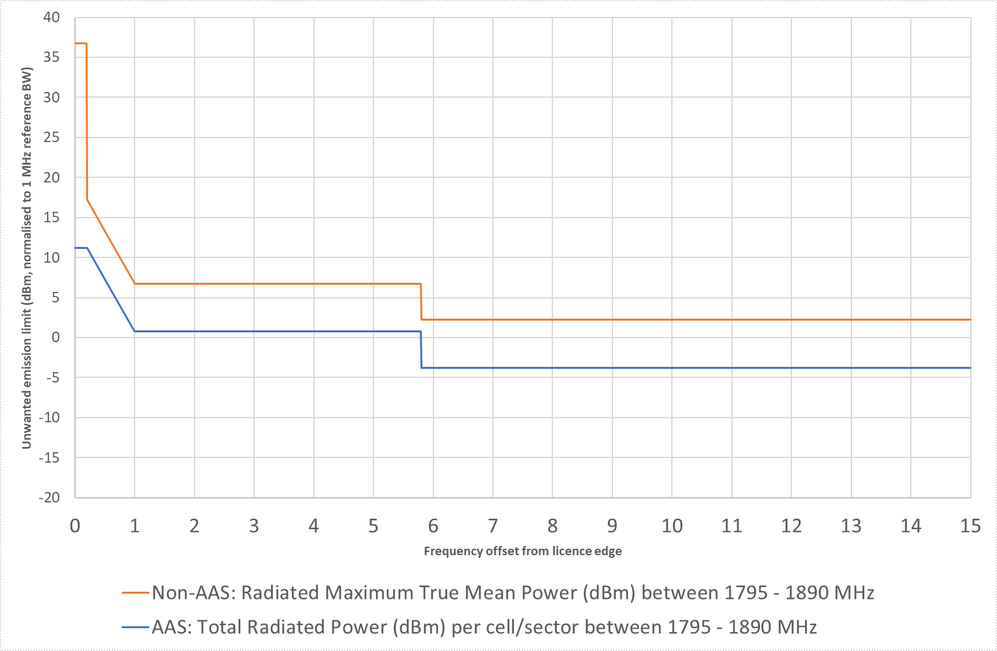

1. Transmitters operating in the lower 1800 MHz band: Proposed unwanted emission limits in the 1665–1830 MHz band

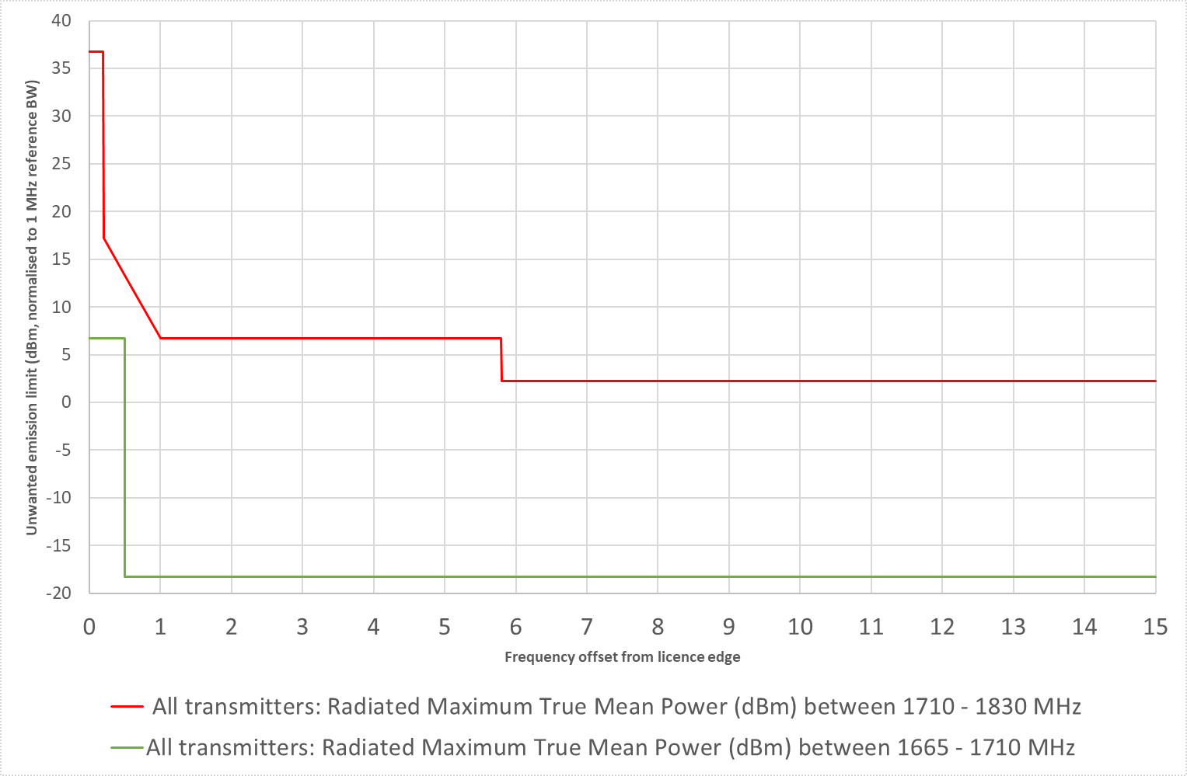

1. Transmitters operating in the upper 1800 MHz band: Proposed transmitter unwanted emission limits outside the 1795–1890 MHz band

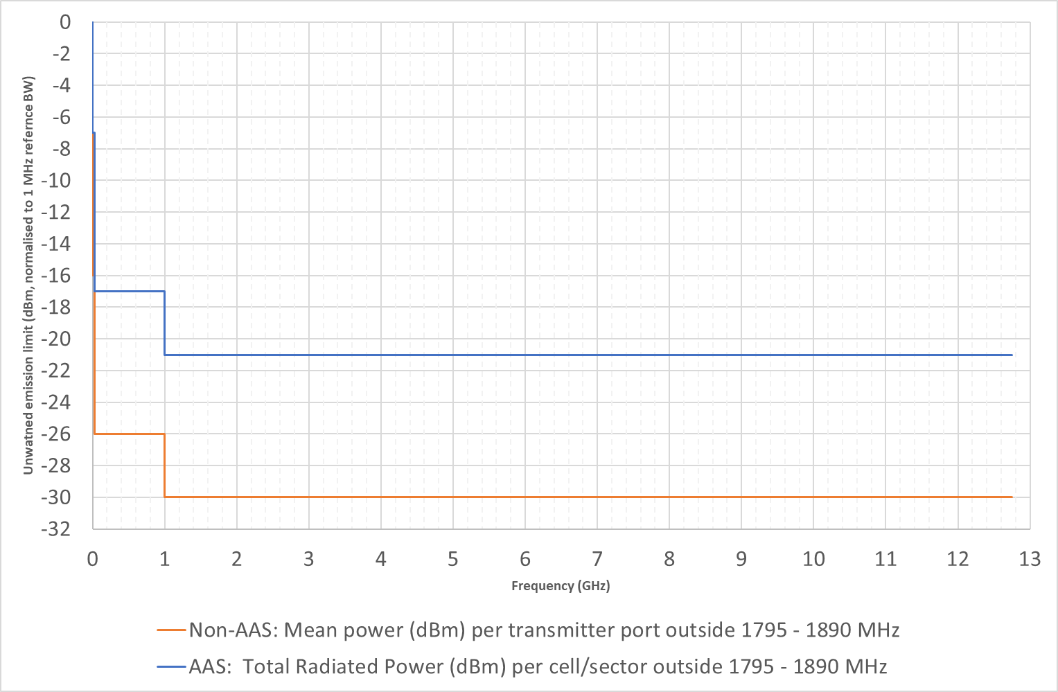

1. Transmitters operating in the lower 1800 MHz band: Proposed transmitter unwanted emission limits outside the 1665–1830 MHz band

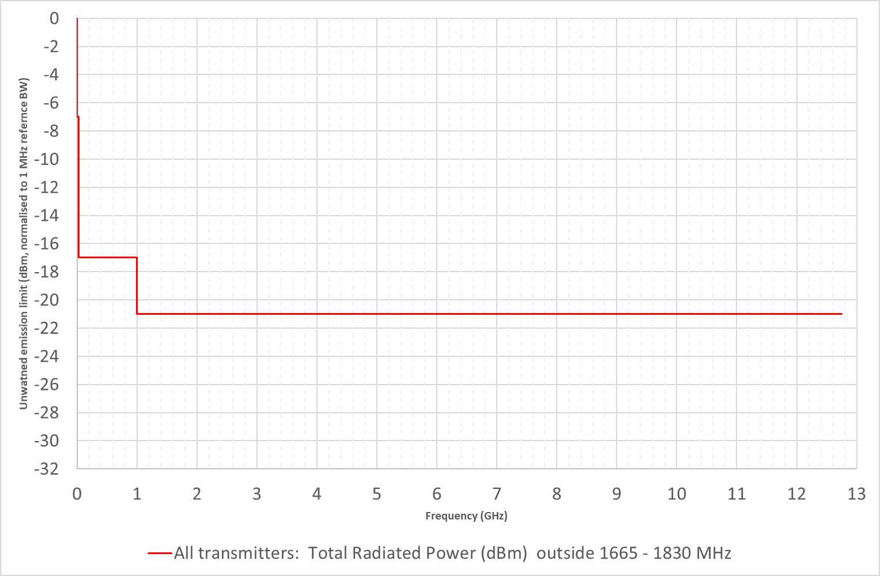

While all aspects of the proposed changes to conditions of 1800 MHz spectrum licences are open for comment, the ACMA would like to draw attention to the proposed frequency range in which the out-of-band emission limits would apply for transmitters operating in the lower 1800 MHz band.

The frequency range identified in the TLG is based on the maximum contiguous bandwidth currently held by a licensee in the 1800 MHz band. However, it may be possible for larger bandwidths to be obtained via trading. In this case, the proposed changes to the frequency range to which the out-of-band emission limits would apply may not enable devices to fully utilise this bandwidth. The ACMA is interested in feedback on whether a larger frequency range, or alternate means to define the frequency range, should be considered. For example, the out-of-band emissions could apply +/- (licensed bandwidth in an area + 5 MHz) either side of the lower and upper frequency limits of the licence. Spurious emission limits would then apply outside this frequency range.

|  |
| --- |
| 1. While all aspects of the proposed changes to conditions of spectrum licences in the 1800 MHz band (1800 MHz spectrum licences) are open for comment, the ACMA would like to draw attention to the proposed frequency range that out-of-band emission limits would apply for transmitters operating in the lower 1800 MHz band (1710-1785 MHz). Comment is sought on whether the frequency range should be: (a)+/- 45 MHz either side of the lower 1800 MHz band or (b) +/- (licensed bandwidth + 5 MHz) measured from the lower and upper frequency limits of the licence in a defined area? Other proposals could also be considered. |

* **Definition of devices exempt from registration**. For 1800 MHz spectrum licences, those devices that are exempt from registration on the Register of Radiocommunications Licences are identified by reference to their maximum EIRP. To align with a change in metric from EIRP to TRP for AAS and to simplify the licence condition, the TLG proposed to amend this definition to adopt similar arrangements applied in other technical framework updates.

The TLG proposed to maintain the existing EIRP limit of 39 dBm/30 kHz for GSM-R transmitters. This aligns with limits defined for rail cab radios in EIRENE[[8]](#footnote-9) System Requirements Specification Version 15.1.[[9]](#footnote-10) For other mobile transmitters, an in-band TRP limit for unregistered devices of 28 dBm per occupied bandwidth was proposed. This aligns with the registration exemption requirements in place for the 2.3 GHz and 3.4 GHz bands and would cover existing and future user terminals as well as other devices such as repeaters and small cells with higher gain antennas.

The TLG also proposed to include an additional definition to exempt future high powered FRMCS cab radios from having to be registered. In this case, the European Union report [Study On The Architecture Of On-Board Radio Communication Equipment](https://www.era.europa.eu/sites/default/files/activities/docs/study_on_architecture_on-board_radio_equipment_en.pdf) specifies a maximum TRP of 31 dBm per occupied bandwidth should be supported.

#### Unacceptable levels of interference – s.145(4) determination

Most of the changes proposed by 1800 MHz band spectrum licensees (and the TLG) include innovations adopted in s.145(4) determinations that were implemented in the previous review of the determinations of unacceptable levels of interference for the 850/900 MHz, 2.3 GHz, 3.4 GHz and 26 GHz bands. In addition to these, consideration was also given to the current EIRP restriction in the 1877.5–1880 MHz frequency range.

The changes proposed to the s.145(4) determination are intended to more accurately model interference and allow licensees to deploy services closer to their licence boundaries. This will result in greater utility of existing spectrum licences. The proposed changes include:

* **The Level of Protection (LOP)**. The current LOP used in the DBC does not differentiate between the interference potential of non-AAS and AAS. Specifically, for non-AAS, the interference environment is largely static (though there may be fluctuations due to factors like base station loading, for example), while for AAS, the use of beamforming results in a more dynamic interference environment. To account for this, spectrum licensees proposed defining different LOPs for non-AAS and AAS devices.

The TLG proposed maintaining the existing LOP of -115 dBm/30 kHz MHz for non-AAS. Based on work conducted in the development of the 26 GHz technical framework, wireless broadband operators proposed that an 8 dB margin be used to account for the dynamic interference environment associated with AAS. The resulting LOP proposed for AAS was then -107 dBm/30 kHz.

* **Adopt a higher resolution Digital Elevation Model (DEM)**. A DEM defines the height of terrain above sea level at specific intervals. It is used in predicting propagation losses between 2 points. Currently the DBC makes use of a 9 second DEM. This provides the height of terrain at approximately 250 m intervals. Higher resolution DEMs are now available and are progressively being implemented in new and revised spectrum licence technical frameworks. Geoscience Australia has published a 3 second DEM[[10]](#footnote-11) (equivalent to approximately 90 m resolution) that provides much higher terrain resolution. The TLG identified a preference for adopting this DEM.

To take full advantage of a 3 second DEM, it was further proposed that the resolution of path loss calculations be increased. Currently the DBC is calculated at 500 m intervals along the 360 radials centred on the relevant radiocommunications device. Changing this to a resolution of 100 m, which more closely matches the resolution of a 3 second DEM, would result in a more accurate prediction of propagation losses.

* **DBC failures over ocean paths**. Currently, DBC failures (that is, the points at which the DBC results in the device boundary being outside the geographic area of the licence) that are only over ocean paths result in the relevant device being taken to cause an unacceptable level of interference by the s.145(4) determination.
* Through experience, 1800 MHz band spectrum licensees have identified that this unnecessarily restricts the deployment of some devices that pose no real interference risk. An equivalent issue has been addressed in the recent review of the 2.3 GHz and 3.4 GHz technical frameworks and the new 850/900 MHz and 26 GHz technical frameworks.
* The TLG proposed that the same measures be adopted for the 1800 MHz band. Specifically, this would involve inclusion of a provision that states that DBC failures that occur over ocean paths, where the relevant radial does not cross any land outside the geographic area of the licence, would not result in a device being taken to cause an unacceptable level of interference.
* **In-band EIRP limit of 50 dBm/30 kHz in 1877.5-1880 MHz**. This requirement was originally adopted to mitigate potential interference concerns and ensure coexistence between DECT[[11]](#footnote-12) and spectrum licensed services. However, studies in the [Electronic Communications Committee (ECC) Report 96](https://docdb.cept.org/download/425), [ECC Report 146](https://docdb.cept.org/download/584), the [European Conference of Postal and Telecommunications Administrations (CEPT) Report 41](https://docdb.cept.org/download/61) and [ECC Report 297](https://docdb.cept.org/download/1387) show that this restriction is not required. Based on this, the TLG proposed to remove this requirement.

#### Radiocommunications advisory guidelines (RAGs)

The following RAGs are part of the 1800 MHz technical framework:

* [Radiocommunications Advisory Guidelines (Managing Interference from Spectrum Licensed Transmitters – 1800 MHz Band) 2012 (RAG Tx)](https://www.legislation.gov.au/Details/F2017C01051" \t "_self)
* [Radiocommunications Advisory Guidelines (Managing Interference to Spectrum Licensed Receivers – 1800 MHz Band) 2012](https://www.legislation.gov.au/Details/F2015C00771) (RAG Rx)
* [Radiocommunications Advisory Guidelines (Additional Device Boundary Criteria – 1800 MHz Lower Band) 2012](https://www.legislation.gov.au/Details/F2015C00769) (RAG DBC).

The TLG did not propose changes to any of these RAGs.

## Effect on incumbent services

When reviewing a spectrum licence technical framework, the effect any changes may have on other services needs to be considered. This is to ensure there are adequate measures in place to manage interference and facilitate coexistence with other services. While industry standards developed by 3GPP are established from the perspective of wireless broadband services, as the national spectrum manager the ACMA must also consider the broader implications of possibly adopting these standards without any changes.

Figure 5 details the current arrangements in place for the 1800 MHz band and adjacent bands. The effect on each of the services identified in Figure 5 has been considered when reviewing the 1800 MHz technical framework.

|  |
| --- |
| 1. Comment is sought on the effect the proposed changes to the 1800 MHz technical framework may have on incumbent services in the 1800 MHz band and adjacent bands. |

1. Current arrangements in the 1800 MHz and adjacent band arrangements

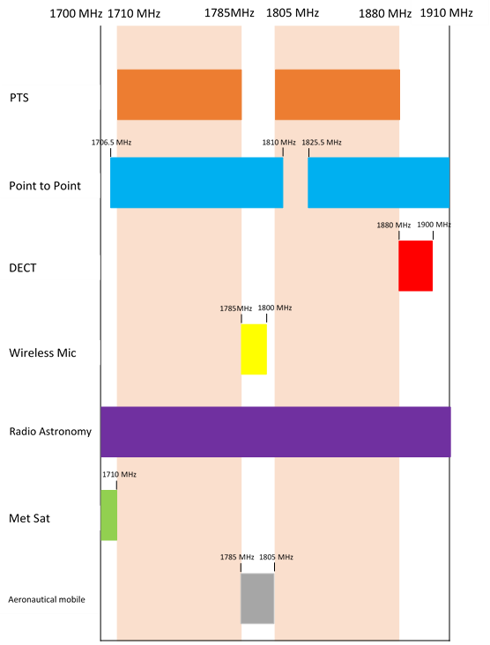

### 1800 MHz spectrum licences

The changes proposed to the s.145(4) determination, as well as the in-band and unwanted emission limits, have the potential to affect compatibility between current and future services deployed by spectrum licensees. Advice from the TLG, however, is that the proposed changes are acceptable to and supported by existing spectrum licensees. In addition, the technical parameters of existing devices do not exceed any of the proposed new limits. This means no modifications need to be made to any existing devices operating under an 1800 MHz spectrum licence.

### Fixed (point-to-point) services

There are arrangements for point-to-point services to operate in the 1700–1900 MHz band. Radiocommunications assignment and licensing instruction (RALI) FX 3 details the relevant protection criteria that apply.

Existing adjacent channel point-to-point licences will not be affected by the proposed changes. This is because newly registered spectrum-licensed devices are expected to protect existing apparatus-licensed point-to-point services to the levels stated in RALI FX3—irrespective of the in-band or unwanted emission limits defined.

All existing point-to-point licences in the 1710–1785 MHz or 1805–1880 MHz frequency ranges (existing co-channel licences) were issued before 13 June 2013. As stated in the RAG Tx, point-to-point licences issued before 13 June 2013 are protected by a first-in-time coordination process. This means new devices operated under a spectrum licence should protect them to the levels defined in RALI FX3. Therefore, the proposed changes to the DBC will have no impact on existing co-channel licences.

The proposed changes to the unwanted emission limits will have no impact on the licensing of new point-to-point links in adjacent bands for the following reasons:

The 1800 MHz band is subject to spectrum licensing in metropolitan and regional areas (refer to RALI SM26). RALI FX3 restricts new assignments in those frequencies and areas subject to spectrum licensing.

RALI FX3 restricts new assignments in the 1785–1805 MHz and   
1880–1900 MHz bands.

The proposed changes to the s.145(4) determination are expected to have a negligible impact on the licensing of new co-channel point-to-point links in remote areas. This is due to the low density of point-to-point and spectrum licence service deployments near the boundary between regional spectrum licences and remote areas. Additionally, demand for new point-to-point licences in the 1800 MHz band has declined over time.

While the changes to the registration exemption limits could support devices with higher gain antenna (and therefore higher EIRPs), the effect on point-to-point services is likely to be low for the following reasons:

The low density of point-to-point and spectrum licence service deployments near the boundary between regional spectrum licences and remote areas.

New point-to-point services are expected to meet the DBC in the upper 1800 MHz band or the RAG DBC in the lower 1800 MHz band. This limits how close they can deploy to a spectrum licence area boundary. The geographical separation will help to reduce potential interference from devices that are exempt from registration.

Devices operated under a spectrum licence that are exempt from registration will operate on a no interference basis. In the event there is interference it will be the responsibility of the spectrum licensee to resolve the issue.

Consequently, it is considered that the existing arrangements in place to manage interference with point-to-point services are suitable and do not need to be modified to account for proposed changes to the 1800 MHz technical framework.

### Meteorological-satellite service (space-to-Earth) operating below 1710 MHz and adjacent to the 1800 MHz band

The meteorological-satellite (Met-Sat) service operates in the band below 1710 MHz and adjacent to the 1800 MHz band.

No changes are proposed to the unwanted emissions in the 1665–1710 MHz frequency range for transmitters operating in the lower 1800 MHz band. This means there will be no change to the interference environment for meteorological services in that frequency range.

While the changes to the registration exemption limits could support devices with higher gain antennas (and therefore higher EIRPs), the effect on the existing Met-Sat interference environment is likely to be low. It is expected that a majority of devices will operate at much lower EIRPs. Also, the directional nature of devices operating with higher gain antennas means they are unlikely to be pointing directly at a Met-Sat receiver. This means that the unwanted emissions from these devices are expected to be the dominant source of interference. Devices operated under a spectrum licence that are exempt from registration will also operate on a no interference basis. In the event there is interference, it will be the responsibility of the spectrum licensee to resolve the issue.

It is considered that the existing arrangements in place to manage interference with Met-Sat radiocommunications receivers are suitable and do not need to be modified to account for proposed changes to the 1800 MHz technical framework.

### Cordless communications devices (i.e., DECT), operating in the 1880 MHz to 1900 MHz frequency range

Cordless communications devices are authorised to operate in the 1880–1900 MHz band by the [*Radiocommunications (Cordless Communications Devices) Class   
Licence 2014*](https://www.legislation.gov.au/Details/F2021C00645). This band is adjacent to the 1800 MHz spectrum licensed band. European studies in the [ECC Reports 96](https://docdb.cept.org/download/425) and 146, and the [CEPT Report 41](https://docdb.cept.org/download/61) have been used to inform the protection requirement for DECT services from non-AAS transmitters. [ECC Report 297](https://docdb.cept.org/download/1387) considers the potential interference from the introduction of an AAS service into adjacent bands.

Based on results of studies provided in these reports, it is considered that the proposed amendments to the 1800 MHz technical framework will result in a minor change to the existing interference environment experienced by DECT services. Consequently, it is considered that the RAG Tx does not need to be modified to take into account proposed changes to the 1800 MHz technical framework.

### Radio Astronomy Service (RAS) receivers

RAS receivers conduct passive observations in the frequency bands specified in footnote AUS87 of the [*Australian Radiofrequency Spectrum Plan 20*](https://www.legislation.gov.au/Details/F2021L00617)*21*. This includes the 1710–1780 MHz band. Operation of RAS receivers under footnote AUS87 is done on an opportunistic basis.

The RAG Tx requests that 1800 MHz spectrum licensees have regard to RAS receivers operating in bands covered by footnote AUS87. In planning for the operation of fixed transmitters under a spectrum licence in the 1800 MHz band, spectrum licensees are encouraged to follow the notification arrangements specified in   
[RALI MS31](https://www.acma.gov.au/publications/2019-09/publication/rali-ms31-notification-zones-around-radio-astronomy-facilities) before operating transmitters.

Since RAS receiver operation is limited to a small number of sites, typically located outside of major population centres, no changes are proposed to the existing interference management criteria.

### Public Telecommunications Service

Public Telecommunications Services (PTS) operate in areas that are adjacent to areas subject to spectrum licensing in the 1800 MHz band. PTS is a service that consists of one or more base stations, operated under apparatus licences, that are operated for the purposes of supplying a public mobile telecommunications service (PMTS). Mobile stations that communicate with PTS land stations are authorised by the [*Radiocommunications (Cellular Mobile Telecommunications Devices) Class   
Licence 2014*](https://www.legislation.gov.au/Details/F2021C00641).

There are two kinds of PTS licences available in the 1800 MHz band:

PMTS Class B – which authorises the use of terrestrial systems.

PMTS Class C – which authorises the use of systems onboard aircraft.

PTS employ the same or similar technology used by 1800 MHz spectrum licensees. Co-channel interference between PTS licences and services deployed under 1800 MHz spectrum licences is managed via the DBC in the s.145(4) determination for the upper 1800 MHz band and the RAG DBC in the lower 1800 MHz band.

Existing services operating under PTS licences in remote areas will not be impacted by the proposed changes to the s.145(4) determination. While the proposed changes are aimed at enabling services to deploy closer to spectrum licence boundaries in the upper 1800 MHz band, they are expected to have a negligible impact on the licensing of new co-channel PTS. This is due to the low density of PTS and spectrum licence service deployments near the boundary between regional spectrum licences and remote areas.

No changes are being proposed to the RAG DBC or RAG Tx.

### Class licensed services

The [*Radiocommunications (Low Interference Potential Devices) Class Licence 2015*](https://www.legislation.gov.au/Series/F2015L01438)(the LIPD Class Licence) defines arrangements for a range of different types of transmitters in the 1710–1880 MHz band. This includes wireless microphones in the 1785–1800 MHz frequency range and ground penetrating radars in the   
30–12,400 MHz frequency range.

Transmitters operated under an 1800 MHz spectrum licence, in accordance with the conditions of the licence, are not deemed to cause unacceptable interference to devices operating in accordance with the LIPD Class Licence. In addition, devices operated under the LIPD Class Licence operate on a ‘no interference and no protection’ basis. The changes proposed will have a negligible impact on the existing interference environment. No changes are proposed to the RAG Tx.

### Aeronautical mobile

Aeronautical systems are operated by the Department of Defence in the 1800 MHz mid-band gap. These services are authorised to operate Australia-wide on a no-interference and no protection basis.

The ACMA has considered the effect the proposed changes may have on aeronautical systems.

For non-AAS device we believe there will be no appreciable change to the existing interference environment. This is because the changes will not result in higher levels of unwanted emissions in the 1800 MHz mid-band gap. Also, while a move to TRP for in-band emissions is proposed for non-GSM-R devices, the value proposed was derived from the existing EIRP limits assuming a maximum gain of 23.7 dBi (based on an 8x8 array for an AAS). This is a much higher gain than would normally be used by non-AAS WBB devices.

Higher levels of unwanted emission limits are proposed for AAS devices in the 1800 MHz mid-band gap. Also, the adoption of a TRP metric for in-band emission limits could technically enable higher radiated powers for AAS devices than the existing limit does. However, due to the dynamic pointing of beams from AAS (which results in a lower probability of interference), coupled with the limited operation time and mobility of aeronautical services, the probability of an appreciable change in the existing interference environment occurring is considered low. In addition, advice from industry is that practical AAS devices are unlikely to deploy systems with arrays greater than 8x8 in size due to the size of the antenna required in the 1800 MHz band.

## Proposed changes

This section details the proposed changes to the conditions of 1800 MHz band spectrum licences and the s.145(4) determination.

For comparison purposes, here is the link to the existing [s.145(4) determination](https://www.legislation.gov.au/Details/F2015C00768). In addition, the relevant sections of existing spectrum licences where changes are proposed have been reproduced at Appendix A.

For more information on the proposed changes, please refer to the ‘1800 MHz TLG’section and the [1800 MHz TLG paper](https://www.acma.gov.au/spectrum-licence-technical-liaison-groups).

3. Comment is sought on the changes proposed to the:

> 1800 MHz band spectrum licence conditions

> s.145(4) determination for the 1800 MHz band.

### Proposed changes to the conditions on the spectrum licence

The ACMA is proposing to seek agreement from 1800 MHz band spectrum licensees to vary their licences, under section 72 of the Act, as detailed below.

#### Unwanted emission limits

It is proposed to replace the unwanted emission limits (both spurious and non-spurious) defined in Core Conditions 6 to 11 of Licence Schedule 2 of existing spectrum licences with the unwanted emission limits detailed below.

It is noted that:

No changes are proposed to the out-of-band emission limits for transmitters operating in the lower 1800 MHz band. However, it is proposed to clarify the frequency range these limits and the associate spurious emission limits apply   
(refer to tables 5 and 6).

For tables 1, 2 and 5, the term foffset refers to the frequency offset from the upper or lower frequency limits for each geographic area specified in Licence Schedule 1 of an 1800 MHz spectrum licence. The closest -3dB point of the measurement bandwidth to the upper or lower frequency limits is placed at foffset. For table 6, the term foffset refers to the frequency offset below the frequency 1710 MHz. The closest -3dB point of the measurement bandwidth 1710 MHz is placed at foffset.

The term ‘radiated maximum true mean power’ is taken to mean the EIRP of a device in a particular azimuth and elevation. It is measured considering the combination of all radiating elements on an antenna panel or individual device.

The term ‘total radiated power’ is defined as the integral of the power transmitted in different directions over the entire radiation sphere of a device. It is measured considering the combination of all radiating elements on an antenna panel or individual device.

The term ‘mean power’ refers to the power delivered to an antenna port. It can be considered equivalent to the term ‘conducted power’ commonly used in radiocommunications.

1. Unwanted emission limits for transmitters operating in the upper 1800 MHz band at frequencies inside the 1795–1890 MHz band   
   – non-AAS devices

|  |  |  |
| --- | --- | --- |
| **Frequency offset**  **(foffset)** | **Radiated maximum true mean power (dBm EIRP)** | **Measurement bandwidth** |
| 0 MHz ≤ foffset < 200 kHz | 21.5 | 30 kHz |
| 200 kHz ≤ foffset < 1 MHz | 2 – 13.125 x (foffset – 0.2) | 30 kHz |
| 1 MHz ≤ foffset < 5.8 MHz | -8.5 | 30 kHz |
| 5.8 MHz ≤ foffset | -13 | 30 kHz |

1. Unwanted emission limits for transmitters operating in the upper 1800 MHz band at frequencies inside the 1795–1890 MHz band   
   – AAS devices

|  |  |  |
| --- | --- | --- |
| **Frequency offset**  **(foffset)** | **Total radiated power (dBm)** | **Measurement bandwidth** |
| 0 MHz ≤ foffset < 200 kHz | -4 | 30 kHz |
| 200 kHz ≤ foffset < 1 MHz | -4 – 13.125 x (foffset – 0.2) | 30 kHz |
| 1 MHz ≤ foffset < 5.8 MHz | 0.7 | 1 MHz |
| 5.8 MHz ≤ foffset | -3.7 | 1 MHz |

1. Unwanted emission limits for transmitters operating in the upper 1800 MHz band at frequencies outside the 1795–1890 MHz band   
   – non-AAS devices.

|  |  |  |
| --- | --- | --- |
| **Frequency range**  **(f)** | **Mean power (dBm) per transmitter port** | **Measurement bandwidth** |
| 9 kHz ≤ f < 150 kHz | -36 | 1 kHz |
| 150 kHz ≤ f < 30 MHz | -36 | 10 kHz |
| 30 MHz ≤ f < 1 GHz | -36 | 100 kHz |
| 1 GHz ≤ f < 12.75 GHz | -30 | 1 MHz |

1. Unwanted emission limits for transmitters operating in the upper 1800 MHz band at frequencies outside the 1795–1890 MHz band   
   – AAS devices.

|  |  |  |
| --- | --- | --- |
| **Frequency range**  **(f)** | **Total radiated power (dBm)** | **Measurement bandwidth** |
| 9 kHz ≤ f < 150 kHz | -27 | 1 kHz |
| 150 kHz ≤ f < 30 MHz | -27 | 10 kHz |
| 30 MHz ≤ f < 1 GHz | -27 | 100 kHz |
| 1 GHz ≤ f < 12.75 GHz | -21 | 1 MHz |

1. Unwanted emission limits inside the 1710–1830 MHz band for transmitters operating in the lower 1800 MHz band – all transmitters.

|  |  |  |
| --- | --- | --- |
| **Frequency offset**  **(foffset)** | **Radiated maximum true mean power (dBm EIRP)** | **Measurement bandwidth** |
| 0 MHz ≤ foffset < 200 kHz | 21.5 | 30 kHz |
| 200 kHz ≤ foffset < 1 MHz | 2 – 13.125 x (foffset – 0.2) | 30 kHz |
| 1 MHz ≤ foffset < 5.8 MHz | -8.5 | 30 kHz |
| 5.8 MHz ≤ foffset | -13 | 30 kHz |

1. Unwanted emission limits for transmitters operating in the lower 1800 MHz band at frequency inside the 1665–1710 MHz band   
   – all transmitters.

|  |  |  |
| --- | --- | --- |
| **Frequency offset**  **(foffset) [Note 1]** | **Radiated maximum true mean power (dBm EIRP)** | **Measurement bandwidth** |
| 0 Hz < foffset < 500 kHz | -8.5 | 30 kHz |
| foffset > 500 kHz | -33.5 | 30 kHz |

*Note 1: In addition to the limits in Table 6, transmitters in the lower 1800 MHz band are also limited to a radiated peak power of 10 dBm EIRP per 30 kHz within the 1709.7–1710 MHz frequency range.*

1. Unwanted emission limits for transmitters operating in the lower 1800 MHz band at frequencies outside the 1665–1830 MHz band   
   – all transmitters.

|  |  |  |
| --- | --- | --- |
| **Frequency range**  **(f)** | **Total radiated power (dBm)** | **Measurement bandwidth** |
| 9 kHz ≤ f < 150 kHz | -36 | 1 kHz |
| 150 kHz ≤ f < 30 MHz | -36 | 10 kHz |
| 30 MHz ≤ f < 1 GHz | -36 | 100 kHz |
| 1 GHz ≤ f < 12.75 GHz | -30 | 1 MHz |

1. Unwanted emission limits for receivers operating in the lower 1800 MHz band at frequencies outside the 1795–1890 MHz band   
   – non-AAS devices.

|  |  |  |
| --- | --- | --- |
| **Frequency range**  **(f)** | **mean power (dBm)** **per receiver port** | **Measurement bandwidth** |
| 30 MHz ≤ f < 1 GHz | -57 | 100 kHz |
| 1 GHz ≤ f < 12.75 GHz | -47 | 1 MHz |

The proposed spurious emission limits for non-AAS receivers operating in the lower 1800 MHz band are provided in Table 8. However, consistent with 3GPP TS 38.104, for a radiocommunications receiver where the antenna or transceiver array boundary connectors support both a radiocommunications receiver and a radiocommunications transmitter, the limits in Table 3 will apply instead.

Due to the integrated nature of AAS, the proposed spurious emission limits for AAS receivers operating in the lower 1800 MHz band are the same as the AAS transmitter spurious emission limits specified in Table 4.

1. Unwanted emission limits for receivers operating in the upper 1800 MHz band at frequencies outside the 1665–1830 MHz band   
   – all devices.

|  |  |  |
| --- | --- | --- |
| **Frequency range**  **(f)** | **Total radiated power (dBm)** | **Measurement bandwidth** |
| 30 MHz ≤ f < 1 GHz | -57 | 100 kHz |
| 1 GHz ≤ f < 12.75 GHz | -47 | 1 MHz |

#### In-band emission limits

It is proposed to change the existing in-band emission limits as detailed below. This would involve a change to Core Condition 15 of Licence Schedule 2 of existing 1800 MHz band spectrum licences:

EIRP of 54.5 dBm/30 kHz for GSM-R transmitters.

TRP of 50 dBm/5 MHz for all other transmitters operating in metropolitan areas. For the purposes of this condition, metropolitan areas are the following areas of high mobile use defined in Schedule 4 of the s.145(4) determination: Adelaide, Brisbane, Melbourne, Perth and Sydney.

TRP of 53 dBm/5 MHz for all other transmitters operating outside of metropolitan areas.

#### Devices exempt from registration

It is proposed to amend the existing definition of devices that are exempt from registration, as defined in statutory condition 4 of Licence Schedule 3 of existing 1800 MHz band spectrum licences:

**Exemption from registration requirements**

1. The following kinds of radiocommunications transmitters are exempt from the registration requirement in Statutory Condition 3:

(a) a transmitter that operates in the 1800 MHz band with a total radiated power of less than or equal to 28 dBm per occupied bandwidth;

(b) a GSM-R mobile transmitter that operates in the 1800 MHz band with an EIRP of less than or equal to 39 dBm per occupied bandwidth; or

(c) a FRMCS mobile transmitter that operates in the 1800 MHz band with a total radiated power of less than or equal to 31 dBm per occupied bandwidth.

### Proposed changes to the s.145(4) determination

The ACMA is proposing to amend the s.145(4) determination as detailed in the amendment instrument, available in the key documents section of this consultation. A high-level summary of the key changes is provided in Table 10.

While not considered in the TLG, the ACMA has also identified other minor changes to the determination:

Paragraph 9(g) of the s.145(4) determination is not required. This paragraph states that mobile transmitters that operate with a horizontally radiated power greater than 39 dBm EIRP within their occupied bandwidth are deemed to cause interference. It is considered that this is already covered by the proposed paragraph 9(1)(b), proposed to be inserted by the amendment instrument.

A minor error in Vincenty’s formulae detailed in Part 3 of Schedule 3 of the s.145(4) determination should be corrected. The ACMA proposes amending the formula to correct this error.

Several minor amendments to align the s.145(4) determination with recently made and amended determinations for the 850/900 MHz, 2.3 GHz, 3.4 GHz and 26 GHz bands are proposed.

The inclusion of a grandfathering clause for existing device registrations is proposed. Such a clause is intended to clarify that a device is only required to adhere to the version of the s.145(4) determination that was in force at the time the device was registered. It also avoids any uncertainty over the impact the proposed changes may have on existing device registrations. A similar clause has been included in the unacceptable levels of interference determination for other spectrum licensed bands. However, the grandfathering clause, as currently specified for other bands, does not cover minor modifications to an existing registration. For example, changes that results in the same or lower horizontal radiated power for the purposes of device boundary calculations, or changes that result in the same or smaller device boundary as originally calculated when registering a device, would result in the clause not applying to the device. Feedback is sought on whether the grandfathering clause should enable such changes.

1. Summary of the key proposed changes to the s.145(4) determination

|  |  |
| --- | --- |
| Item | Proposed change |
| Adopt a higher resolution DEM | Adopt the [3 Second SRTM Derived Digital Elevation Model (DEM) Version 1.0. Record 1.0](https://data.gov.au/data/dataset/12e0731d-96dd-49cc-aa21-ebfd65a3f67a) (given the persistent identifier <http://pid.geoscience.gov.au/dataset/ga/69888> by Geoscience Australia) |
| DBC failures over ocean paths | Add a new subsection 9(2) which would provide that DBC failures over ocean-only paths are not taken to cause an unacceptable level of interference. |
| Increase DBC calculation resolution | Change DBC calculation resolution along each radial from 500 m to 100 m in Schedules 2 and 3. To account for the change in calculation resolution, the maximum value of ‘m’ (used in DBC calculations) also needs to be changed. The parameter ‘m’ relates to the number of increments along each radial the DBC is calculated. The intention is that the maximum length of each radial is maintained at 40 km. If 100 m increments are used this means the maximum value of ‘m’ would need to be 400. |
| Modify the level of protection (LOP) | Define the following LOPs in Part 2 of Schedule 2:  Non-AAS: -115 dBm/30 kHz  AAS: -107 dBm/30 kHz |
| Transition arrangements | To ensure existing registered devices are not affected, a new section 11 is proposed. This will ensure that devices registered before the changes to the s.145(4) determination come into effect do not need to adhere to the new requirements. Instead they are required to adhere to the requirements that were in place at the time they were registered. |

|  |
| --- |
| 4. In relation to the draft amendments proposed to the s.145(4) determination (separate attachment in key documents section of this consultation), should additional measures be included to also grandfather device registrations when minor modifications are made? If so, what minor modifications should be permitted? For example, what should happen to changes that results in the same or lower horizontal radiated power for the purposes of device boundary calculations? Alternatively, what should happen to changes that result in the same or smaller device boundary as originally calculated when registering a device? |

# Invitation to comment

## Making a submission

The ACMA invites comments on the issues set out in this consultation paper.

[Online submissions](http://intranet/resources-and-tools/communications-and-engagement/corporate-style-guide) can be made by uploading a document. Submissions in PDF, Microsoft Word or Rich Text Format are preferred.

Submissions by post can be sent to:

The Manager

Wireless Broadband Section

Australian Communications and Media Authority

PO Box 78

Belconnen ACT 2616

The closing date for submissions is **COB,** **5 November 2021**.

Consultation enquiries can be emailed to [freqplan@acma.gov.au](mailto:freqplan@acma.gov.au).

#### Publication of submissions

The ACMA publishes submissions on our website, including personal information (such as names and contact details), except for information that you have claimed (and we have accepted) is confidential.

Confidential information will not be published or otherwise released unless required or authorised by law.

#### Privacy

View information about our policy on the [publication of submissions](https://www.acma.gov.au/publications/2019-08/publication/frequency-coordination-procedures-earth-station-protection-zones), including collection of personal information during consultation and how we handle that information.

Information on the *Privacy Act 1988,* how to access or correct personal information, how to make a privacy complaint and how we will deal with the complaint, is available in our [privacy policy](https://www.acma.gov.au/have-your-say).

# Appendix A – Relevant conditions of current 1800 MHz band spectrum licences

This section reproduces the relevant conditions of existing 1800 MHz band spectrum licences where changes are proposed. This includes:

Licence Schedule 2 – Core Conditions

Clause 4 of Licence Schedule 3 – Exemption from registration requirements

Full copies of [existing 1800 MHz band spectrum licences](https://web.acma.gov.au/rrl/browse_licences.licence_list?pSV_ID=85&pSS_ID=857) are available on the RRL.

## Licence Schedule 2 – Core Conditions

### Frequency band and geographic areas

1. This licence authorises the operation of radiocommunications devices in the frequency bands and within the geographic areas set out in Part 2 of Licence Schedule 1.

### Emission limits outside the frequency band

1. Core conditions 3 to 11 apply in relation to those frequencies that are outside the frequency bands set out in Part 2 of Licence Schedule 1.
2. Where a written agreement specifying the maximum permitted level of radio emission for frequencies described in Core Condition 2 exists between:
   1. the licensee; and
   2. all the affected licensees of frequency-adjacent and area-adjacent licences;

the licensee must comply with that specified maximum permitted level of radio emission.

1. Where there is no written agreement for the purposes of Core Condition 3 in force, the licensee must comply with Core Conditions 5 to 11.

### Non spurious emission limits

1. (1) Subject to sub-condition (2), the licensee must ensure that radiocommunications transmitters operated under this licence do not exceed the non spurious emission limits in core conditions 6 and 7.

(2) For any frequency where an emission limit described in core condition 8 is less than an emission limit described in core condition 6 or 7, the emission limit in core condition 8 applies instead of the emission limits in core condition 6 or 7.

1. The non spurious emission limits in Table 3 apply:
   1. at frequencies outside the 1710-1785 MHz and 1805-1880 MHz frequency bands; and

(b) offset from 1785 MHz, 1805 MHz and 1880 MHz;

where:

**foffset:** is the frequency offset from the 1785 MHz, 1805 MHz and 1880 MHz band edges.

The -3dB point of the specified bandwidth closest to the band edge being frequency offset from, is placed at foffset.

**Table 3: Radiated maximum true mean power non-spurious emission limits**

|  |  |  |
| --- | --- | --- |
| **Frequency offset range**  **(foffset)** | **Radiated maximum true mean power (dBm EIRP)** | **Specified Bandwidth** |
| 0 kHz < foffset < 200 kHz | 2 | 30 kHz |
| 200 kHz < foffset < 900 kHz | 2 - 15 x (f offset (MHz)-0.2) | 30 kHz |
| 900 kHz < foffset < 5.6 MHz | -8.5 | 30 kHz |
| foffset > 5.6 MHz | -18.5 | 30 kHz |

1. The non spurious emission limits in Table 4a and 4b apply:
   1. at frequencies outside 1710-1785 MHz frequency band; and
   2. offset from 1710 MHz;

where:

**foffset** is the frequency offset from the 1710 MHz band edge. The -3dB point of the specified bandwidth closest to the band edge being frequency offset from, is placed at **foffset**.

**Table 4a: Radiated maximum true mean power non-spurious emission limits**

|  |  |  |
| --- | --- | --- |
| **Frequency offset range**  **(foffset)** | **Radiated maximum true mean power (dBm EIRP)** | **Specified Bandwidth** |
| 0 Hz < foffset < 500 kHz | -8.5 | 30 kHz |
| foffset > 500 kHz | -33.5 | 30 kHz |

**Table 4b: Radiated peak power non-spurious emission limits**

|  |  |  |
| --- | --- | --- |
| **Frequency offset range**  **(foffset)** | **Radiated peak power**  **(dBm EIRP)** | **Specified Bandwidth** |
| 0 Hz < foffset < 300 kHz | 10 | 300 kHz |

1. The non spurious emission limits in Table 5 apply:
   1. at frequencies outside the upper or lower frequency limits as set out in Part 2 of Licence Schedule 1; and
   2. offset from the upper or lower frequency limits set out in Part 2 of Licence Schedule 1;

where:

**foffset:** is the frequency offset from the upper or lower frequency limits set out in Part 2 of Licence Schedule 1. The -3dB point of the specified bandwidth closest to the band edge being frequency offset from, is placed at **foffset.**

**Table 5: Radiated maximum true mean power non-spurious emission limits**

|  |  |  |
| --- | --- | --- |
| **Frequency offset range**  **(foffset)** | **Radiated maximum true mean**  **power (dBm EIRP)** | **Specified Bandwidth** |
| 0 kHz < foffset < 200 kHz | 21.5 | 30 kHz |
| 200 kHz < foffset < 1 MHz | 2 – 13.125 x (f offset (MHz) – 0.2) | 30 kHz |
| 1 MHz < foffset < 5.8 MHz | -8.5 | 30 kHz |
| foffset > 5.8 MHz | -13 | 30 kHz |

### Spurious Emission Limits

1. The licensee must ensure that radiocommunications devices operated under this licence do not exceed the spurious emission limits in core conditions 10 and 11
2. For radiocommunications transmitters operated under this licence, the spurious emission limits in Table 6 apply at frequencies outside the 1710-1785 MHz and 1805-1880 MHz frequency bands, measured over the specified bandwidth for the relevant frequency range.

**Table 6: Radiocommunications transmitter spurious emission limits**

|  |  |  |
| --- | --- | --- |
| **Frequency range**  **(f)** | **Radiated mean power**  **(dBm EIRP)** | **Specified**  **Bandwidth** |
| 9 kHz < f < 150 kHz | -36 | 1 kHz |
| 150 kHz < f < 30 MHz | -36 | 10 kHz |
| 30 MHz < f < 1 GHz | -36 | 100 kHz |
| 1 GHz < f < 3.5 GHz | -2 | 1 MHz |
| 3.5 GHz < f < 12.75 GHz | -30 | 1 MHz |

1. For radiocommunications receivers operated under this licence, the spurious emission limits in Table 7 apply at frequencies outside the 1710-1785 MHz and 1805-1880 MHz frequency bands, measured over the specified bandwidth for the relevant frequency range

**Table 7: Radiocommunications receiver spurious emission limits**

|  |  |  |
| --- | --- | --- |
| **Frequency range**  **(f)** | **Radiated mean power**  **(dBm EIRP)** | **Specified**  **Bandwidth** |
| 9 kHz < f < 1 GHz | -57 | 100 kHz |
| 1 GHz < f < 3.5 GHz | -19 | 1 MHz |
| 3.5 GHz < f < 12.75 GHz | -47 | 1 MHz |

### Emission limits outside the geographic areas

1. Core Conditions 13 to 15 apply in relation to those areas that are outside the geographic areas set out in Part 2 of Licence Schedule 1.
2. Where a written agreement specifying the maximum permitted level of radio emission for areas described in Core Condition 12 exists between:
   1. the licensee; and
   2. all the affected licensees of frequency-adjacent licences and area-adjacent licences;

the licensee must comply with that specified maximum permitted level of radio emission.

1. Where there is no written agreement for the purposes of Core Condition 13 in force, the licensee must comply with Core Condition 15.
2. (1) The licensee must ensure that the maximum permitted level of radio emission for an area described in core condition 12 caused by operation of radiocommunications devices under this licence does not exceed a radiated maximum true mean power of 54.5 dBm EIRP per 30 kHz.

(2) The licensee complies with sub-condition (1) by ensuring that no radiocommunications device is operated under this licence in excess of a radiated maximum true mean power of 54.5 dBm EIRP per 30 kHz.

## Licence Schedule 3 – Statutory Conditions

### Exemption from registration requirements

1. The following kinds of radiocommunications transmitters are exempt from the registration requirement in Statutory Condition 3:
2. a mobile transmitter that operates in the 1800 MHz band with a radiated power of less than or equal to 39 dBm EIRP per occupied bandwidth; or
3. a fixed transmitter that operates in the 1800 MHz band with a radiated power always less than or equal to 33 dBm EIRP per occupied bandwidth.

1. Global System for Mobile Communications – Railway (GSM-R): Relevant ETSI standards for GSM-R can be obtained from <https://www.etsi.org/technologies/rail-communications>. [↑](#footnote-ref-2)
2. ETSI TR 103 459 V1.2.1 (2020-08), <https://www.etsi.org/deliver/etsi_tr/103400_103499/103459/01.02.01_60/tr_103459v010201p.pdf> [↑](#footnote-ref-3)
3. Massive IoT (Internet of Things) is the connection of a large number of devices embedded with sensors, processing ability, software and other technologies to exchange date with other devices. The aim is to facilitate the transmission and reception of small amounts of data from a large number of devices while providing low equipment costs and longer battery life. [↑](#footnote-ref-4)
4. [What is 5G | Everything You Need to Know About 5G | 5G FAQ | Qualcomm](https://www.qualcomm.com/5g/what-is-5g) [↑](#footnote-ref-5)
5. 3GPP R4-168430, ‘On NRb BS ACLR requirement’, Huawei, 3GPP TSG-RAN WG4 Meeting #80bis, October 2016. [↑](#footnote-ref-6)
6. 3GPP TS 38.104, available at: <https://portal.3gpp.org/desktopmodules/Specifications/SpecificationDetails.aspx?specificationId=3202>. [↑](#footnote-ref-7)
7. 3GPP TS 38.101-1 is available at: <https://portal.3gpp.org/desktopmodules/Specifications/SpecificationDetails.aspx?specificationId=3283>. [↑](#footnote-ref-8)
8. European Integrated Railway Radio Enhanced Network. [↑](#footnote-ref-9)
9. <https://uic.org/IMG/pdf/eirene_srs_15.1.pdf> [↑](#footnote-ref-10)
10. 3 Second SRTM Derived Digital Elevation Model (DEM) Version 1.0. Record 1.0, given the persistent identifier <http://pid.geoscience.gov.au/dataset/ga/69888>. [↑](#footnote-ref-11)
11. Digital enhanced cordless telecommunications (DECT). [↑](#footnote-ref-12)