ACMA compliance priority 2020–21

5G mobile phone base stations: carrier compliance with licence conditions for electromagnetic energy (EME)

AUGUST 2021

Canberra

Red Building   
Benjamin Offices  
Chan Street   
Belconnen ACT

PO Box 78  
Belconnen ACT 2616

T +61 2 6219 5555

Melbourne

Level 32   
Melbourne Central Tower  
360 Elizabeth Street   
Melbourne VIC

PO Box 13112  
Law Courts   
Melbourne VIC 8010

T +61 3 9963 6800

Sydney

Level 5   
The Bay Centre  
65 Pirrama Road   
Pyrmont NSW

PO Box Q500  
Queen Victoria Building   
NSW 1230

T +61 2 9334 7700

Copyright notice

[Creative Commons logo](http://i.creativecommons.org/l/by/3.0/88x31.png)

<https://creativecommons.org/licenses/by/4.0/>

With the exception of coats of arms, logos, emblems, images, other third-party material or devices protected by a trademark, this content is made available under the terms of the Creative Commons Attribution 4.0 International (CC BY 4.0) licence.

We request attribution as © Commonwealth of Australia (Australian Communications and Media Authority) 2021.

All other rights are reserved.

The Australian Communications and Media Authority has undertaken reasonable enquiries to identify material owned by third parties and secure permission for its reproduction. Permission may need to be obtained from third parties to re-use their material.

Written enquiries may be sent to:

Manager, Editorial Services  
PO Box 13112  
Law Courts  
Melbourne VIC 8010  
Email: [info@acma.gov.au](mailto:info@acma.gov.au)

Executive summary 1

Our 5G and EME compliance program 1

Carriers are providing reliable information on EME levels at 5G sites 2

Background 3

Methodology 4

Audit methodology 4

Scope 4

Limitations 8

Outcomes 9

Summary 9

Appendix A: List of 5G sites audited 10

Appendix B: List of discrepancies 15

Executive summary

Regarded as the next step in the evolution of mobile wireless communication, 5G promises improved connectivity and increased data download speeds. There is considerable interest in this technology and concern from some members of the community about potential health effects from electromagnetic energy (EME) emissions from 5G mobile phone base stations.

## Our 5G and EME compliance program

With the continuation of the expansive 5G rollout by Optus, Telstra and TPG Telecom Limited[1] (the carriers) expected over the next few years, in April 2020, the Australian Communications and Media Authority (ACMA) announced [5G and EME as](https://www.acma.gov.au/publications/2019-04/creina-chapman-commsday-summit-2019) one of our [compliance priorities for 2020–21](https://www.acma.gov.au/node/467).

There are two main elements of the regulation of 5G mobile phone base stations under the legislation we administer:

carrier consultation and notification requirements under the [C564:2018 Mobile Phone Base Station Deployment](https://www.commsalliance.com.au/Documents/all/codes/c564) code (the deployment code) when deploying base stations

carrier compliance with the mandatory standards for EME emissions that are given effect through licence conditions under the [Radiocommunications Licence Conditions (Apparatus Licence) Determination 2015](https://www.legislation.gov.au/Details/F2019C00870)(the licence determination).

We have published 3 reports outlining the [outcomes of our 5G and EME compliance programs in 2020–21](https://www.acma.gov.au/previous-compliance-priorities). They provide information on our audits to assess carriers’ compliance with:

EME exposure level standards

consultation and notification requirements under the deployment code when rolling out 5G technology

licence conditions.

Components of our 2020–21 compliance programs

This licence condition audit report focuses on carriers’ compliance with the licence determination for 5G deployments.

While this compliance program has focused on 5G sites in Victoria, the findings from this work provide a baseline for our continuing focus on 5G and EME deployments in other Australian states and territories in the coming year.

## Carriers are providing reliable information on EME levels at 5G sites

In early 2021, we conducted an audit of carrier records to assess their compliance with the licence determination. We selected 129 5G sites in Victoria and carrier records were gathered for analysis against the requirements of the licence determination.

This compliance activity aimed to determine whether the carriers were complying with their record-keeping obligations under their licence conditions. These obligations ensure the radiofrequency field produced by transmitters operated under their licence do not exceed the reference levels for exposure at places accessible to the public.[2] This, along with the 2 other components of the 5G EME compliance priority work program, allows us to ascertain carrier compliance with all of the regulatory arrangements for the deployment and operation of 5G mobile phone base stations.

This audit found that the carriers have maintained necessary records for their transmitters at each of the sites audited. It provides assurance that carriers are aware of their obligations and compliant with their record-keeping licence conditions under the licence determination.

Some additional observations from the audit identified opportunities for best practice improvement by the carriers in their record-keeping requirements under the licence determination and information-provision requirements under the deployment code. However, these are not issues of compliance with the licence determination.

We have now audited carrier compliance with the EME requirements of the licence determination for 2 years and, in each year, have found carriers to be compliant with the requirements. We recently announced that 5G and EME will continue to be a compliance priority for the 2021–22 financial year, when we will focus on carrier compliance with community consultation obligations under the deployment code and continue our EME measurement program at 5G mobile base station sites.

# Background

5G is the latest generation of mobile phone technology. Considered to be more efficient than previous technologies, the 5G network currently uses similar frequency bands to the 4G network to provide additional capacity and faster data rates to mobile network users.

In 2019–20, we conducted a compliance program comprising EME measurements and 2 audit programs assessing carrier compliance with:

notification and consultation requirements under the deployment code

licence conditions under the licence determination for small cell mobile phone base stations (the small cells compliance program).

The small cells compliance program found no significant issues of non-compliance stemming from each of the audit programs. The EME measurements program found that average overall EME levels near all small cell sites measured less than 1% of the safe levels for public exposure set by the [Australian Radiation Protection and Nuclear Safety Agency](https://www.arpansa.gov.au) (ARPANSA).

Consistent with the small cells compliance program, the 2020–21 5G and EME compliance program continued to focus on the compliance of carriers – Optus, Telstra and TPG Telecom Pty Ltd – with their EME-related licence conditions.

This report focuses on the carriers’ compliance with their record-keeping obligations under the licence determination for 5G mobile phone base station deployments in Victoria. Although the 2020–21 5G and EME compliance program was intended to be a national program, interstate travel restrictions resulting from the COVID-19 pandemic prevented the completion of a national program. We then turned our focus to state-based studies, commencing in Victoria, which had a similar sample size to the original national program. The program will be expanded to other states and territories over the next year.

Through the licence determination, the ACMA sets licence conditions that carriers must comply with regarding EME levels. ARPANSA sets the EME human exposure limits, outlined in the [Radiation Protection Standard for Maximum Exposure Levels to Radiofrequency Fields - 3 KHz to 300 GHz](https://www.arpansa.gov.au/sites/default/files/legacy/pubs/rps/rps3.pdf) (the ARPANSA Standard).

Part 3 of the licence determination requires that the radiofrequency field produced by a transmitter operated under a licence must not exceed the reference levels for general public exposure at a place accessible to members of the general public.

Part 4 of the licence determination requires carriers to maintain records and provide information to the ACMA on request.

This audit sought to ensure both these obligations were being met.

# Methodology

This audit was desktop-based, with on-site inspections to confirm data, if required. All records formally requested by the ACMA were assessed against the EME requirements for the operation of transmitters under Part 3 of the licence determination and the record-keeping requirements under Part 4 of the licence determination.

## Audit methodology

**Develop site selection**

Selecting a sample of sites for the audit by collecting publicly available information on the location of 5G mobile phone base stations in Victoria and applying a sampling method.

**Request carrier's records**

Preliminary engagement with the carriers to inform them of commencement of the audit program.

**Assess carrier's records**

Conducting the audit in accordance with Part 4 of the licence determination, by formally requesting the carriers’ records for the selected sample of Victorian sites.

Assessing the carrier’s records against the requirements of Part 3 and 4 of the licence determination.

**Quality assurance processes**

Engaging with the carriers to seek clarification on technical information in the records provided, where necessary.

**Report on findings**

Identifying any issues of non-compliance.

Identifying opportunities for potential improvement to carrier’s record-keeping practices.

Reporting on the findings of the audit.

**Notify carriers of audit findings**

Notifying the carriers of the findings and any resulting compliance action.

## Scope

### Site selection

A sample of mobile telecommunication sites for audit and measurement was selected from the [Radio Frequency National Site Archive](https://www.rfnsa.com.au/?first=1) (RFNSA), a public database of all Australian mobile phone base stations hosted by the Australian Mobile Telecommunications Association (AMTA).

We filtered the list to only include sites with active 5G services and by site operator (Optus, Telstra and TPG Telecom Limited).

Each carrier had progressed the rollout of 5G services at different rates. After determining that TPG Telecom Limited had the smallest number of active 5G sites in Victoria at 43 sites, we used 43 as a base figure for the number of sites to measure for each carrier, to maintain fairness.

A random sample was then applied to the list of Victorian sites to produce a selection of 43 sites each for Optus, Telstra and TPG Telecom Limited, to arrive at a final figure of 129 sites.

To provide a holistic picture of compliance for the ACMA’s 2020–21 compliance priority for 5G/EME, this sample of 129 sites was used for the 3 programs under the compliance priority.

#### Joint venture

TPG Telecom Pty Ltd and Optus have a joint venture for shared access to mobile network sites. In these cases, only one carrier takes the lead in undertaking the community consultation or notification process. The ACMA was advised that Optus took the community notification lead for audit site numbers 87 and 105.[3] For this report, we have assessed these sites as being deployed by Optus.

This has resulted in the final audit being conducted across 45 sites for Optus, 43 sites for Telstra and 40 sites for TPG Telecom Pty Ltd. A list of all sites audited is at Appendix A.

Figures 2 and 3 below show the sites selected for this audit; site numbers correlate with the list of sites at Appendix A.

1. Site locations in outer Melbourne and regional Victoria

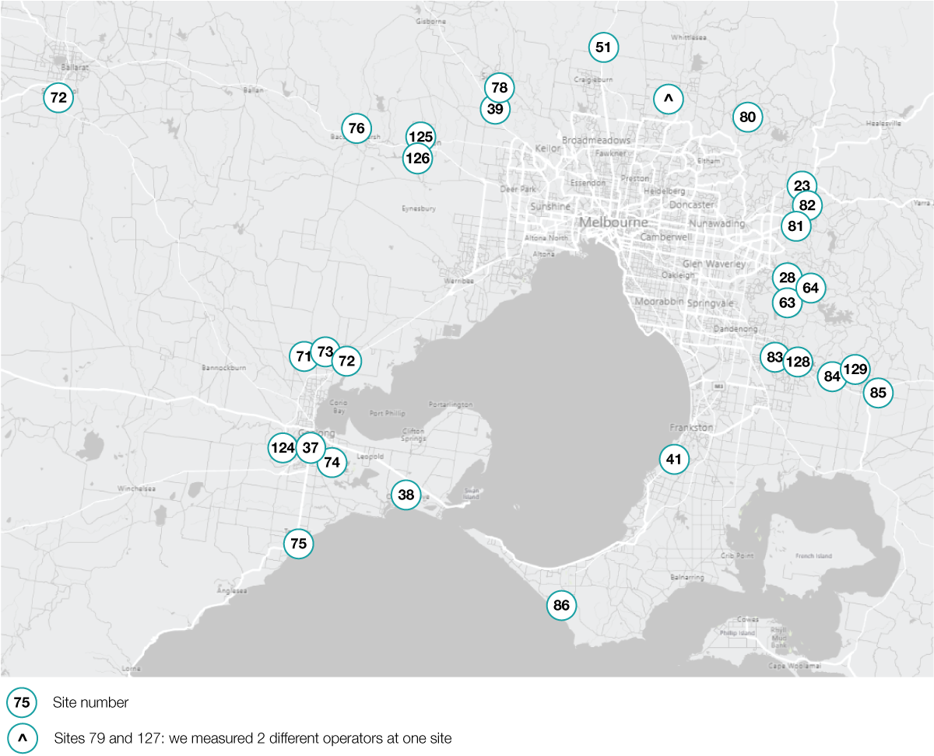

1. Site locations in greater Melbourne

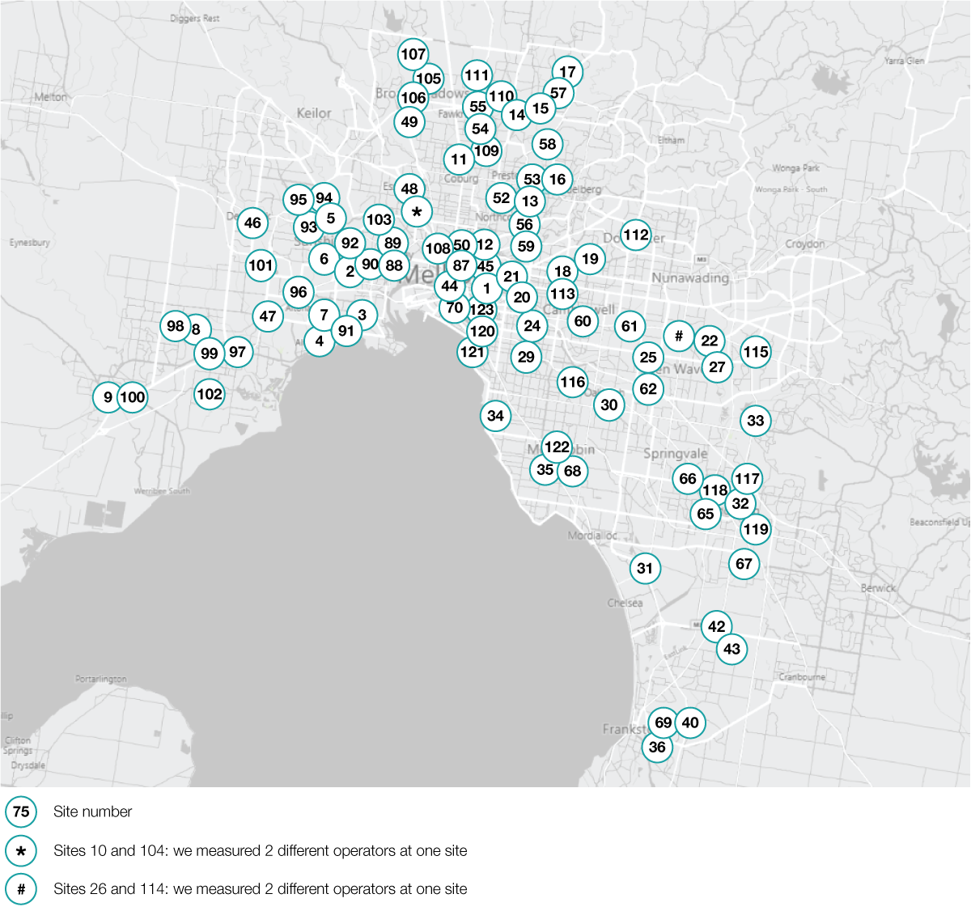

### EME licence conditions

To ensure the community is protected from exposure to EME, the licence determination imposes conditions on licensees (including carriers) for transmitters, which include 5G mobile phone base station deployments.

EME licence conditions

|  |  |
| --- | --- |
| **The licence determination**  Conditions imposed by the licence determination include permitted communications and the exposure of the public to EME from radiocommunications transmitters | |
| 5G and EME | Part 3 requires:  carriers to ensure that members of the general public are not exposed, in excess of recognised exposure limits, to EME produced by a transmitter operated by the licensee (section 8)  carriers assess compliance with the exposure limits and keep records in accordance with section 15, Part 4 (section 10). |
| List outline | Part 4 requires:  carriers keep certain records relating to any assessment of their compliance with the EME exposure limits, including a declaration of conformity for each transmitter, dates and results of any assessments, and transmitter details (including power level, gain, tilt, manufacturer, model number and emission designator) (section 15)  carriers provide this documentation to the ACMA within 20 days upon request (section 16). |

### 

### Stakeholder engagement

The ACMA informed the carriers about the scope of the audits, however, withheld site identification from the carriers until the start of the audit. At this time, ACMA staff liaised with the carriers on the development of a consistent template for the declaration of conformity and a consistent approach by all 3 carriers on the records they would submit for assessment under the audit, as required by section 15 of the licence determination.

## Limitations

### COVID-19 travel restrictions

Travel restrictions resulting from the COVID-19 pandemic meant that a nation-wide measurement program was not feasible. We chose to conduct measurements only in Victoria so that program timelines would not be put at risk.

# Outcomes

All carriers submitted their compliance records to the ACMA in accordance with our request. We then assessed their compliance records, consisting of declarations of conformity, compliance certificates and relevant assessments, as well as other site information available to ACMA staff on the [RFNSA](https://www.rfnsa.com.au/?first=1) and the [ACMA Register of Radiocommunications Licences](https://web.acma.gov.au/rrl/register_search.main_page) (RRL).

For all the sites audited, we found that all 3 carriers demonstrated compliance with the licence determination.

While a very small number of minor discrepancies were identified relating to the consistency of information across the RFNSA and RRL, they were of no substantive consequence to the carriers’ compliance with the licence determination. A list of these discrepancies is recorded at Appendix B.

## Summary

Throughout the audit process, all 3 carriers demonstrated a willingness to engage with the ACMA to ensure compliance with their EME record-keeping obligations under the licence determination and a commitment to improving their record-keeping practices. Notably, all 3 carriers took action to ensure consistency across their compliance records for this audit, a recommendation made by the ACMA following its findings in the previous audit under the small cells compliance program in 2019–20.

On conclusion of the audit, we found:

All of the carriers were compliant with their record-keeping obligations under the licence determination. All demonstrated the required knowledge of their EME obligations and associated record-keeping requirements under the licence determination.

While the focus of this audit was carrier compliance with record-keeping conditions under the licence determination, a small number of other observations were made about consistency of information across the RRL and RFNSA. We have engaged with the carriers to discuss process improvements and arrange for information in the RFNSA or RRL to be updated where necessary.

The ACMA has now audited carrier compliance with the EME requirements of the licence determination for 2 years and, in each year, found the carriers to be compliant. 5G and EME will continue to be an ACMA compliance priority for the 2021–22 financial year, focusing on carrier compliance with community consultation obligations under the deployment code. We will also continue our EME measurement program at 5G mobile base station sites.

# Appendix A: List of 5G sites audited

|  |  |  |  |  |
| --- | --- | --- | --- | --- |
| **Audit site number** | **Carrier** | **RFNSA site ID** | **Address** | **Suburb** |
| 1 | Optus | 3002005 | Melbourne Cricket Ground, Brunton Avenue | East Melbourne |
| 2 | Optus | 3012005 | 8 Cromwell Parade | West Footscray |
| 3 | Optus | 3015005 | 120 Mason Street | Newport |
| 4 | Optus | 3018002 | Bluegum Drive and Fresno Street | Altona |
| 5 | Optus | 3020008 | 78 Berkshire Road | Sunshine North |
| 6 | Optus | 3020011 | Judge Street | Sunshine |
| 7 | Optus | 3025005 | 17 Chambers Road | Altona North |
| 8 | Optus | 3029014 | 1 Alexandra Avenue | Hoppers Crossing |
| 9 | Optus | 3030021 | Werribee Racecourse, 12-16 Bulban Road | Werribee |
| 10 | Optus | 3039001 | 641-649 Mt Alexander Road | Moonee Ponds |
| 11 | Optus | 3058005 | 61 Spry Street | Coburg North |
| 12 | Optus | 3065003 | 105 Victoria Street | Fitzroy |
| 13 | Optus | 3071005 | 364 Rossmoyne Street | Thornbury |
| 14 | Optus | 3074002 | 391 Settlement Road | Thomastown |
| 15 | Optus | 3074005 | 23 Macquarie Drive | Thomastown |
| 16 | Optus | 3081008 | Coomalie Crescent | Heidelberg West |
| 17 | Optus | 3082002 | The Stables Shopping Centre, Childs Road | Mill Park |
| 18 | Optus | 3101009 | Kew Reservoir, 378 Cotham Road | Kew |
| 19 | Optus | 3103009 | 255A Belmore Road | Balwyn |
| 20 | Optus | 3121001 | 100 Madden Grove | Burnley |
| 21 | Optus | 3121041 | 36 Crown Street | Richmond |
| 22 | Optus | 3133001 | TOC Depot, Morack Road | Vermont South |
| 23 | Optus | 3140003 | 122-124 Beresford Road | Lilydale |
| 24 | Optus | 3144002 | 322 Glenferrie Road | Malvern |
| 25 | Optus | 3149002 | Melbourne Water Site, St Albans Street | Mount Waverley |
| 26 | Optus | 3151002 | 643 Highbury Road | Burwood East |
| 27 | Optus | 3152004 | 1166 High Street Road | Wantirna South |
| 28 | Optus | 3158001 | Guy Road | Upwey |
| 29 | Optus | 3161004 | 230 Balaclava Road | Caulfield North |
| 30 | Optus | 3166015 | Railway Avenue | Oakleigh |
| 31 | Optus | 3175006 | 56 Soden Road | Bangholme |
| 32 | Optus | 3175011 | 121 Stud Road | Dandenong |
| 33 | Optus | 3178003 | Stud Park Shopping Centre, Stud Road | Rowville |
| 34 | Optus | 3186004 | 120 Church Street | Brighton |
| 35 | Optus | 3190001 | 1123A Nepean Highway | Highett |
| 36 | Optus | 3199022 | 183 Cranbourne Road | Frankston |
| 37 | Optus | 3216009 | 209 High Street | Belmont |
| 38 | Optus | 3226001 | 1-13 Adco Grove | Ocean Grove |
| 39 | Optus | 3427001 | 1376 Calder Highway | Diggers Rest |
| 40 | Optus | 3910008 | 7 Duiker Court | Langwarrin |
| 41 | Optus | 3930005 | Peninsula School, Wooralla Drive | Mount Eliza |
| 42 | Optus | 3975006 | 505 Thompsons Road | Lyndhurst |
| 43 | Optus | 3977022 | Wedge Road | Sandhurst |
| 44 | Telstra | 3000262 | 522-552 Flinders Lane | Melbourne |
| 45 | Telstra | 3002017 | 282-336 Victoria Parade | East Melbourne |
| 46 | Telstra | 3023005 | 27 Station Road | Deer Park |
| 47 | Telstra | 3026005 | 167 Cherry Lane | Laverton North |
| 48 | Telstra | 3040007 | 53 Brewster Street | Essendon |
| 49 | Telstra | 3046008 | 2 Hartington Street | Glenroy |
| 50 | Telstra | 3053020 | 720 Swanston Street | Carlton |
| 51 | Telstra | 3064002 | 1327 Hume Freeway | Mickleham |
| 52 | Telstra | 3071001 | 739-741 High Street | Thornbury |
| 53 | Telstra | 3072007 | 6B Rennick Street | Preston |
| 54 | Telstra | 3073014 | 229 Broadhurst Avenue | Reservoir |
| 55 | Telstra | 3074003 | 25 Lawson Crescent | Thomastown |
| 56 | Telstra | 3078003 | 36-38 Montefiore Street | Fairfield |
| 57 | Telstra | 3083007 | 289W McKimmies Road | Bundoora |
| 58 | Telstra | 3083020 | La Trobe University, 1040 Plenty Road | Bundoora |
| 59 | Telstra | 3101010 | 2 Chandler Highway | Kew |
| 60 | Telstra | 3124020 | 2-4 Bright Street | Camberwell |
| 61 | Telstra | 3125005 | 301 Burwood Highway | Burwood |
| 62 | Telstra | 3149014 | 8-12 Gilby Road | Mount Waverley |
| 63 | Telstra | 3156006 | 830 Wellington Road | Lysterfield |
| 64 | Telstra | 3159001 | 14 Maskells Hill Road | Selby |
| 65 | Telstra | 3173007 | 48-60 Popes Road | Keysborough |
| 66 | Telstra | 3174002 | 41 Plan 10582 Heatherton Road | Noble Park |
| 67 | Telstra | 3175014 | 8-10 Kitchen Road | Dandenong South |
| 68 | Telstra | 3189008 | 56 Keys Road | Cheltenham |
| 69 | Telstra | 3199014 | 211-279 Skye Road | Frankston |
| 70 | Telstra | 3205042 | 220 Albert Road | South Melbourne |
| 71 | Telstra | 3212002 | 290 Elcho Road | Lovely Banks |
| 72 | Telstra | 3212005 | 130 Coonawarra Drive | Avalon |
| 73 | Telstra | 3212010 | 15 McHarrys Road | Lara |
| 74 | Telstra | 3219005 | 471-489 Wilsons Road | St Albans Park |
| 75 | Telstra | 3228008 | 45 A Geelong Road | Torquay |
| 76 | Telstra | 3340016 | 29 Holts Lane | Darley |
| 77 | Telstra | 3356002 | Miles Street (near Todd Street) | Sebastopol |
| 78 | Telstra | 3429007 | The Heights, Jacksons Hill Estate | Sunbury |
| 79 | Telstra | 3752002 | 152 Cravens Road | Mernda |
| 80 | Telstra | 3759001 | 5 Church Road | Panton Hill |
| 81 | Telstra | 3765002 | Montrose Recreational Reserve, Aileen Avenue | Montrose |
| 82 | Telstra | 3796003 | 138 York Road | Mount Evelyn |
| 83 | Telstra | 3805004 | 1 Fullard Road | Narre Warren |
| 84 | Telstra | 3809002 | Officer Recreation Reserve, Princes Highway | Officer |
| 85 | Telstra | 3810020 | 2-8 Bate Close | Pakenham |
| 86 | Telstra | 3941004 | 745 Truemans Road | Fingal |
| 87 | TPG Telecom Limited | 3000042 | RMIT (Building 51), 80 Victoria Street | Carlton |
| 88 | TPG Telecom Limited | 3011013 | Victoria University, Buckley Street | Footscray |
| 89 | TPG Telecom Limited | 3012015 | Victoria University, 70-100 Ballarat Road | Footscray |
| 90 | TPG Telecom Limited | 3012028 | 260-262 Geelong Road | West Footscray |
| 91 | TPG Telecom Limited | 3016021 | 3-7 Fink Street | Williamstown North |
| 92 | TPG Telecom Limited | 3019009 | 85 Ashley Street | Braybrook |
| 93 | TPG Telecom Limited | 3020020 | 74-76 Sydney Street | Albion |
| 94 | TPG Telecom Limited | 3020026 | 42 Harvester Avenue | Sunshine North |
| 95 | TPG Telecom Limited | 3021008 | 176 Furlong Road | St Albans |
| 96 | TPG Telecom Limited | 3026011 | 1-11 Little Boundary Road | Laverton North |
| 97 | TPG Telecom Limited | 3028003 | 30 Triholm Avenue | Laverton |
| 98 | TPG Telecom Limited | 3028004 | 380 Sayers Road | Tarneit |
| 99 | TPG Telecom Limited | 3029006 | 428 Old Geelong Road | Hoppers Crossing |
| 100 | TPG Telecom Limited | 3030001 | 75 Watton Street | Werribee |
| 101 | TPG Telecom Limited | 3030044 | 30 Fulton Drive | Derrimut |
| 102 | TPG Telecom Limited | 3030047 | 29-31 Windorah Drive | Point Cook |
| 103 | TPG Telecom Limited | 3032004 | Highpoint City Shopping Centre, 120-200 Rosamond Road | Maribyrnong |
| 104 | TPG Telecom Limited | 3039001 | 641-649 Mt Alexander Road | Moonee Ponds |
| 105 | TPG Telecom Limited | 3047001 | 61 Riggall Street | Broadmeadows |
| 106 | TPG Telecom Limited | 3047003 | 1100 Pascoe Vale Road | Broadmeadows |
| 107 | TPG Telecom Limited | 3048002 | 55-63 Paringa Boulevard | Meadow Heights |
| 108 | TPG Telecom Limited | 3051005 | 163-171 Flemington Road | North Melbourne |
| 109 | TPG Telecom Limited | 3073013 | 92 Newlands Road | Reservoir |
| 110 | TPG Telecom Limited | 3074014 | 59 Strong Avenue | Thomastown |
| 111 | TPG Telecom Limited | 3075002 | 50T Gillwell Road | Lalor |
| 112 | TPG Telecom Limited | 3108001 | Westfield Doncaster, 619 Doncaster Road | Doncaster |
| 113 | TPG Telecom Limited | 3124010 | 965-969 Burke Road | Camberwell |
| 114 | TPG Telecom Limited | 3151002 | 643 Highbury Road | Burwood East |
| 115 | TPG Telecom Limited | 3152005 | Knox City Shopping Centre, Burwood Highway | Wantirna South |
| 116 | TPG Telecom Limited | 3163002 | 2 Railway Parade | Murrumbeena |
| 117 | TPG Telecom Limited | 3175038 | 270 Stud Road | Dandenong North |
| 118 | TPG Telecom Limited | 3175039 | 208 Princes Highway | Dandenong |
| 119 | TPG Telecom Limited | 3177005 | 1 Lace Street | Eumemmerring |
| 120 | TPG Telecom Limited | 3181003 | 55 Commercial Road | Melbourne |
| 121 | TPG Telecom Limited | 3182001 | 21 The Esplanade | St Kilda |
| 122 | TPG Telecom Limited | 3189015 | 488-490 South Road | Moorabbin |
| 123 | Vodafone/TPG | 3205004 | 10 Queens Road | Melbourne |
| 124 | TPG Telecom Limited | 3216003 | 9-29 Cityview Drive | Wandana Heights |
| 125 | TPG Telecom Limited | 3337019 | 206 Coburns Road | Melton West |
| 126 | TPG Telecom Limited | 3338002 | 20-40 Rees Road | Melton South |
| 127 | TPG Telecom Limited | 3752002 | 152 Cravens Road | Mernda |
| 128 | TPG Telecom Limited | 3806003 | 100 Clyde Road | Berwick |
| 129 | TPG Telecom Limited | 3810026 | 130 Thewlis Road | Pakenham |

# Appendix B: List of discrepancies

|  |  |  |
| --- | --- | --- |
| **Carrier** | **Discrepancy** | **Corrective action** |
| **Optus** | For 1 site audited, the site number in the declaration of conformity submitted by the carrier was inaccurate. | We requested Optus correct the declaration of conformity. |
| For 1 site audited, the address recorded on the RRL was inaccurate and substantially differed to the actual site location. | We requested Optus liaise with the ACMA to correct the site details on the RRL. |
| For all sites audited, the centre frequency in the declaration of conformity submitted by the carrier for transmitters operating in the 3500 MHz band did not reflect Optus’ recent frequency transitioning arrangements under an ACMA defragmentation process for 3.4 GHz spectrum holdings. Through the EME measurement program we found that for all Optus sites audited, Optus has re-tuned to the 3475-3575 MHz frequency range in Melbourne, in accordance with these arrangements. | We requested Optus correct the declaration of conformity to reflect these recent changes. |
| **Telstra** | For 4 sites audited, the licence number for a number of transmitters in the declaration of conformity submitted by the carrier was inaccurate when compared to corresponding site information on the RRL. | We requested Telstra correct the declaration of conformity. |
| **TPG Telecom Limited** | For 1 site audited, the address in the declaration of conformity submitted by the carrier was inaccurate and substantially differed to the actual site location. | We requested TPG Telecom Limited correct the declaration of conformity. |
| For 1 site audited, the address recorded on the RRL was inaccurate and substantially differs to the actual site location. | We requested TPG Telecom Limited liaise with the ACMA to correct the site details on the RRL. |

1. In 2020, TPG and Vodafone Hutchison Australia merged to form TPG Telecom Limited.
2. Section 8, [Radiocommunications Licence Conditions (Apparatus Licence) Determination 2015](https://www.legislation.gov.au/Details/F2019C00870).
3. ‘Audit site numbers’ have been developed to refer to sites in ACMA’s 2020–21 5G/EME compliance priority for ease. More detailed information for each audit site number is available at Appendix A.