ACMA compliance priority 2020–21

5G mobile phone base station deployment:  
carrier notification and consultation requirements

AUGUST 2021

Canberra

Red Building   
Benjamin Offices  
Chan Street   
Belconnen ACT

PO Box 78  
Belconnen ACT 2616

T +61 2 6219 5555

Melbourne

Level 32   
Melbourne Central Tower  
360 Elizabeth Street   
Melbourne VIC

PO Box 13112  
Law Courts   
Melbourne VIC 8010

T +61 3 9963 6800

Sydney

Level 5   
The Bay Centre  
65 Pirrama Road   
Pyrmont NSW

PO Box Q500  
Queen Victoria Building   
NSW 1230

T +61 2 9334 7700 or 1800 226 667

Copyright notice

[Creative Commons logo](http://i.creativecommons.org/l/by/3.0/88x31.png)

<https://creativecommons.org/licenses/by/4.0/>

With the exception of coats of arms, logos, emblems, images, other third-party material or devices protected by a trademark, this content is made available under the terms of the Creative Commons Attribution 4.0 International (CC BY 4.0) licence.

We request attribution as © Commonwealth of Australia (Australian Communications and Media Authority) 2021.

All other rights are reserved.

The Australian Communications and Media Authority has undertaken reasonable enquiries to identify material owned by third parties and secure permission for its reproduction. Permission may need to be obtained from third parties to re-use their material.

Written enquiries may be sent to:

Manager, Editorial Services  
PO Box 13112  
Law Courts  
Melbourne VIC 8010  
Email: [info@acma.gov.au](mailto:info@acma.gov.au)

Executive summary 1

Our 5G and EME compliance program 1

Carriers are following the consultation rules 2

Background 3

Compliance process 3

Methodology 4

Purpose 4

Scope 4

Site selection 4

Audit methodology 8

Limitations 8

Outcomes 9

Carriers’ compliance with the deployment code 9

Summary 11

Appendix A: List of sites audited 12

Appendix B: Section 7 extract 17

# Executive summary

Regarded as the next step in the evolution of mobile wireless communication, 5G promises improved connectivity and increased data download speeds. There is considerable interest in the new technology and concern from some members of the community about potential health effects from electromagnetic energy (EME) emissions from 5G mobile phone base stations.

## Our 5G and EME compliance program

With the continuation of the expansive 5G rollout by Optus, Telstra and TPG Telecom Limited[1] (the carriers) expected over the next few years, in April 2020, we announced [5G and EME as](https://www.acma.gov.au/publications/2019-04/creina-chapman-commsday-summit-2019) one of our [compliance priorities for 2020–21](https://www.acma.gov.au/node/467).

There are two main elements of the regulation of 5G mobile phone base stations under the legislation we administer:

carrier consultation and notification requirements under the [C564:2018 Mobile Phone Base Station Deployment](https://www.commsalliance.com.au/Documents/all/codes/c564) Code (the deployment code) when deploying base stations

carrier compliance with the mandatory standards for EME emissions that are given effect through licence conditions under the [Radiocommunications Licence Conditions (Apparatus Licence) Determination 2015](https://www.legislation.gov.au/Details/F2019C00870)(the licence determination).

We have published 3 reports outlining the [outcomes of our 5G and EME compliance programs in 2020–21](https://www.acma.gov.au/previous-compliance-priorities). They provide information on our audits to assess carriers’ compliance with:

EME exposure level standards

consultation and notification requirements under the deployment code when rolling out 5G technology

licence conditions.

Components of our 2020–21 compliance programs

This audit report focuses on the carrier consultation and notification requirements under the deployment code.

The deployment code is designed to provide:

councils and local communities with an opportunity to participate in the decisions made by carriers before they deploy mobile phone base stations

greater transparency to the local community and councils when a carrier is planning, selecting sites for, installing, and operating mobile phone base stations.

## Carriers are following the consultation rules

In March and April 2021, we audited 128 5G mobile phone base station deployment processes to assess carriers’ compliance with the deployment code. The audit showed that carriers are meeting their obligations under the deployment code to provide local councils and communities with the necessary information and consultation mechanisms for proposed 5G mobile phone base station deployments.

Minor observations to inform better practice improvements were identified, but these did not have a material effect on the consultation process required by the deployment code.

# Background

Optus, Telstra and TPG Telecom Limited are expanding their 5G networks across Australia and there has been an increase in activation of 5G technology. From January to July 2020, the carriers deployed 1,635 5G base stations.

Carriers must follow the rules in the *Telecommunications Act 1997*. Under Division 3 of the Act, the telecommunications industry may develop industry codes relating to their activities and register those Codes with the ACMA. The deployment code is one such code registered under the Act.

The deployment code outlines provisions that carriers must follow to notify and consult with interested stakeholders about the deployment and operation of mobile phone base stations. It aims to promote community participation in carrier decision-making when deploying mobile phone base stations and understanding of their planning, site selection and installation processes.

The deployment code sets out best practice processes in the selection of sites for mobile phone base stations, and for their design and operation. Before deploying a mobile phone base station, the deployment code places obligations on carriers to provide information to, and consult and engage with, different groups within affected communities (see Figure 2).

Deployment code stakeholders

Compliance process  
Complaints can be made about the carrier’s performance of its obligations under the deployment code. If a complainant is unsatisfied with the carrier’s response, they may make a complaint to the ACMA. From time to time, the ACMA may also undertake audits, such as this one, to monitor carrier compliance with the deployment code.

# Methodology

## Purpose

As part of the ACMA’s 2020–21 compliance priority, we undertook an audit to monitor how carriers [follow the rules](https://www.acma.gov.au/node/812) for 5G mobile phone base station deployments to consult and give accurate information about rollouts or upgrades of 5G networks in local areas.

## **Scope**

The program used a desk-based audit of 129 mobile phone base station sites in Victoria. To provide a holistic picture, this sample of 129 sites was used for the 3 programs under the compliance priority.

One site deployed by TPG Telecom Limited was subsequently found to be subject to a development application under the relevant local government planning processes, which meant the deployment code did not apply. That site was excluded from this component of the compliance priority program, resulting in 128 sites audited. This TPG site was still relevant to, and included in, the other programs.

## Site selection

We exported an initial list of all active mobile phone base stations from the   
[Radio Frequency National Site Archive](https://www.rfnsa.com.au/), a public database of all Australian mobile phone base stations. We filtered the list to only include sites with active 5G services and by carrier (Optus, Telstra or TPG Telecom Limited).

The list was further filtered to include Victorian sites only to mitigate limitations raised by COVID-19 travel restrictions. These are discussed further in the limitations section below.

Each operator had progressed the rollout of 5G sites at different speeds. After determining that TPG Telecom Limited had the smallest number of 5G sites in Victoria at 43 sites, we used 43 as a base figure for the number of sites to audit for each operator to ensure consistency.

A random sample was then applied to the list of Victorian sites to produce a selection of 43 sites each for Optus and Telstra and 42 sites for TPG Telecom Limited, to arrive at a final figure of 128 sites.

#### Joint venture

TPG Telecom Limited and Optus have a joint venture for shared access to mobile network sites. In these cases, only one carrier takes the lead in undertaking the community consultation or notification process. The ACMA was advised that Optus took the community notification lead for audit site numbers 87 and 105.[2] For this report, we have assessed these sites as being deployed by Optus.

This has resulted in the final audit being conducted across 45 sites for Optus, 43 sites for Telstra and 40 sites for TPG Telecom Limited. A list of all sites audited is at Appendix A.

Figures 3 and 4 below show the sites selected for this audit; site numbers correlate with a list of 5G sites at Appendix A.

1. Site locations in outer Melbourne and regional Victoria

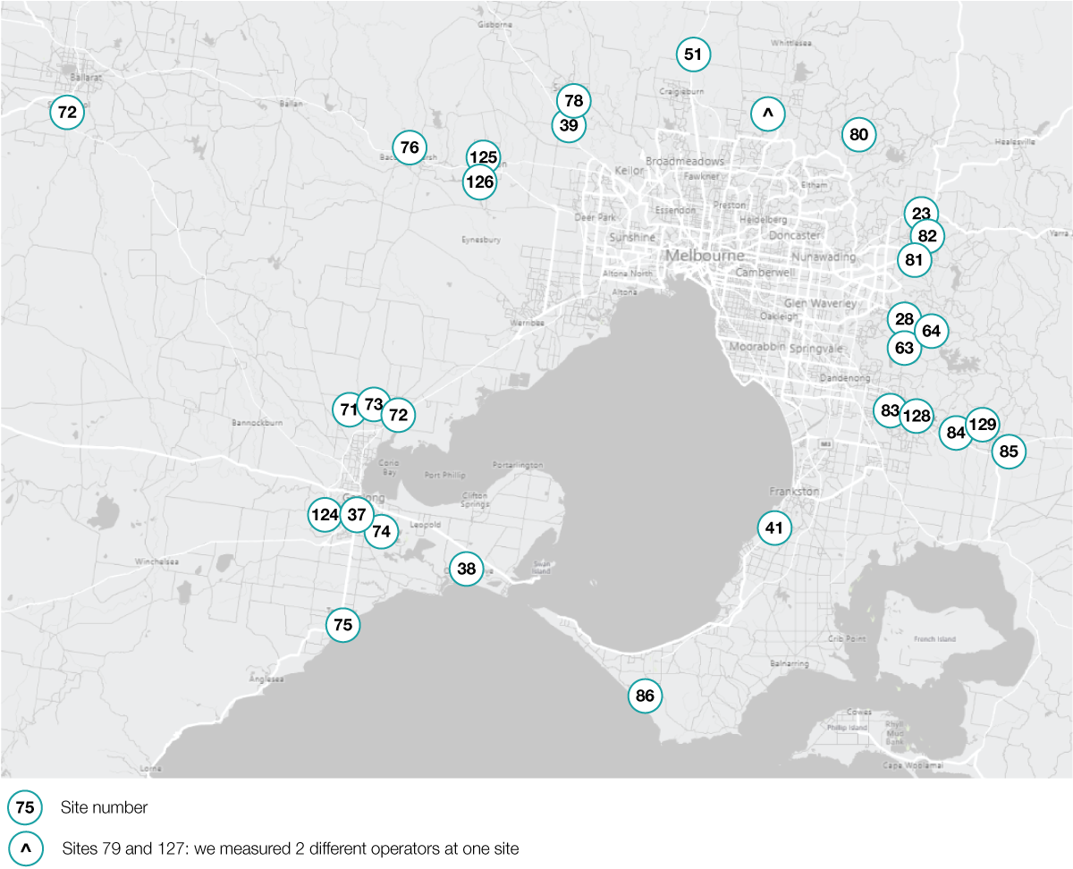

1. Site locations in greater Melbourne

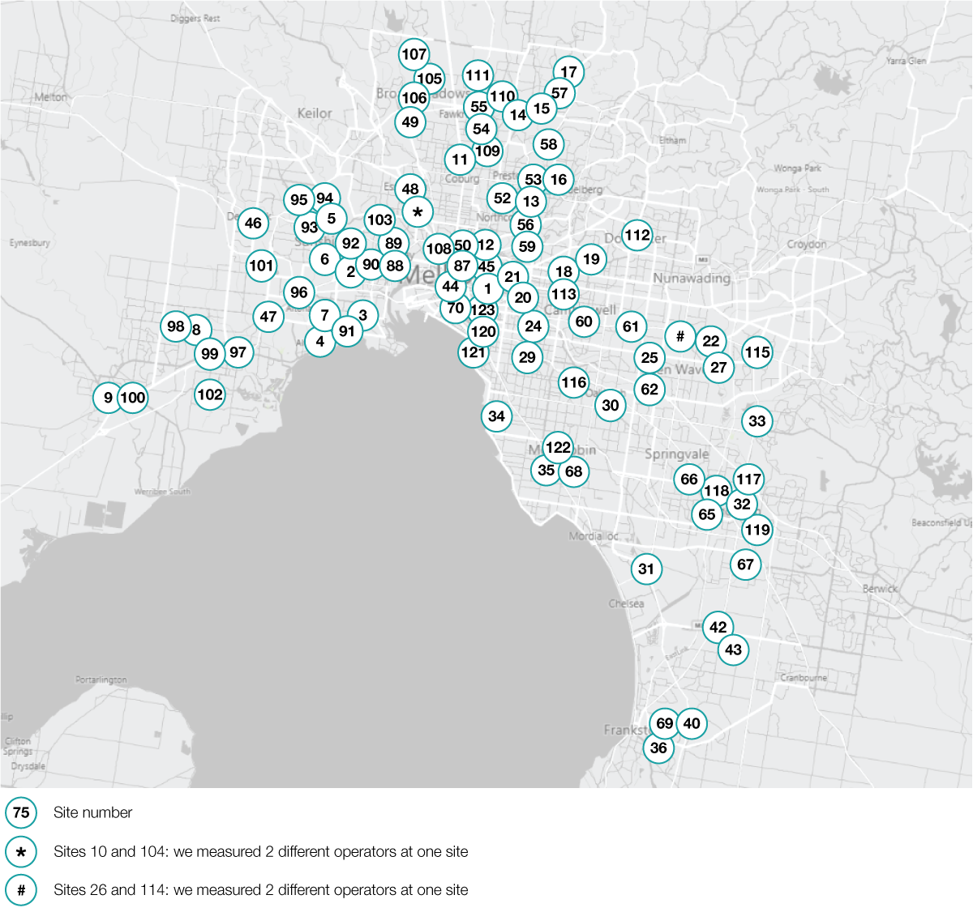

Notification and consultation provisions under the deployment code vary slightly depending on the nature of the site, type of infrastructure or planning approvals required. However, the intent of the deployment code is clear: carriers must consider stakeholder views when deploying mobile phone base stations.

The focus areas of this audit were notification and consultation clauses of the deployment code. Figure 5 shows an overview of the sections in-scope.

Sections in-scope for this audit

|  |  |  |  |
| --- | --- | --- | --- |
| **Deployment code consultation provision** | | | |
| **Clause 5.2** | **Section 6** | **Section 7** | **Not applicable** |
| **Small scale infrastructure** | **Base station  at a new site** | **Base station  at an existing site** | **New base station – development approval required** |
| Targeted consultation requirements  Small cells installed on power poles | Extensive consultation requirements  Base stations are proposed at a new site | Modest consultation requirements  Base stations are being upgraded | Local council/state-based consultation laws apply  Base stations are proposed as part of new development |
| **Audits undertaken** | | | |
| **0** | **0** | **128** | **1** |

Section 7 of the deployment code applied to all the sites audited, as carriers in the early stages of their roll-out of 5G services have appeared to primarily focus on upgrading existing mobile base station sites. In section 7, there are 3 key notification provisions that a carrier must follow before it can deploy a mobile phone base station at an existing site that does not require development approval:

7.1: The carrier must notify the local council about the proposal.

7.2: The carrier must undertake a notification to the area surrounding the location of the proposal.

7.3: The carrier must have regard to submission received from the council and the public before proceeding with the proposed installation.

An extract of section 7 is provided in Appendix B for information. The deployment code can be viewed in full on the [Communications Alliance website](https://www.commsalliance.com.au/Documents/all/codes/c564).

## Audit methodology

**Develop site selection**

Selecting a sample of sites for the audit by collecting publicly available information on the location of 5G mobile phone base stations in Victoria and applying a sampling method.

**Develop audit methodology**

Preliminary engagement with the carriers to inform them of commencement of the audit program.

**Desktop audit**

Conducting the audit in accordance with the deployment code.

Assessing the carriers’ records against the requirements of section 7 of the deployment code.

**Quality assurance processes**

Engaging with the carriers to seek clarification on technical information in the records provided, where necessary.

**Final report**

Identifying any issues of non-compliance.

Opportunities record-keeping practices improvement.

Reporting on the findings of the audit.

**Notify carriers of audit findings**

Notifying the carriers of the findings and any resulting compliance action.

## Limitations

### COVID-19 travel restrictions

Travel restrictions and lockdowns resulting from the COVID-19 pandemic during the 2020–21 financial year meant that a nation-wide measurement program was not feasible. Measurements were conducted only in Victoria. We intend to extend the program to other states of Australia in 2021–22 to provide a broader sample of measured sites.

# Outcomes

## Carriers’ compliance with the deployment code

We found that carriers are substantially compliant with the deployment code’s consultation requirements.

The local community, councils, property owners and occupiers, and community members in sensitive locations are being notified and consulted before construction.

While several observations were made about the accuracy and clarity of descriptions and referencing of regulation in public notifications sent to councils and interested and affected parties, none of those issues indicated any substantive non-compliance with the deployment code requirements.

The key observations are outlined below.

The ACMA has engaged with the carriers on these observations to inform better practice outcomes in complying with consultation requirements in the future.

### **Address of the proposed location and site position**

We applied 2 tests to subclauses 7.1.1(a) and 7.2.1(a):

Test 1: Determine whether the carrier’s notification included an address of where the mobile phone base station will be installed.

Test 2: Determine whether the carrier included a site position in its notification to the relevant council.

Subclause 7.1.1(a) applies to council notifications, while subclause 7.2.1(a) applies to public notifications.

For Test 2, the deployment code defines the site position to mean ‘*… information that specifically identifies the physical placement of the facility.*’ The ACMA understands that carriers’ usual practice in fulfilling this obligation is either:

placing a pin marked on a map to identify the placement of the mobile phone base station facility at a site, or

having a written description that is clear enough to identify the position of the facility on the site.

The site position provision is designed to provide the council and interested and affected parties with a specific indication of where a mobile phone base station will be installed at a site (such as on a rooftop or at the far-left side of a park).

For 3 Optus sites, one TPG Telecom Limited site and 11 Telstra sites, the written description of the site position was limited. While this is not material to compliance with subclauses 7.1.1(a) and 7.2.1(a), a full written description ensures that that those notified understand the exact placement of a proposed mobile phone base station facility and can comment accordingly.

The ACMA has advised the carriers that there is scope for further best practice improvement in this area and has requested information on how they will improve consultation practices to better address this issue for future deployments.

### **7.1.1(b) and 7.2.1(b) – include a written description of proposed facility**

The deployment code requires carriers to include a written description of the proposed facility in their notifications to the council and the local community.

While we found the written descriptions compliant, some information could be clearer, more informative or less technical. Using hard-to-understand language or not including enough detail reduces the ability of those notified to understand what is specifically proposed for a site.

In relation to clause 7.1.1(b), which applies to council notifications, the audit observed that Telstra’s written descriptions for 5 sites could have more clearly described the relevant details the proposed facilities. In addition, using technical language did not aid the description of the proposed facilities.

Written descriptions should balance the technical characteristics of mobile phone base stations with a plain English description so a non-technical audience can fully comprehend the carrier’s proposal.

In relation to clause 7.2.1(b), which applies to public notifications, the same observation was made for 4 sites.

The ACMA has advised Telstra about its observations and requested information on the actions it will take to ensure its descriptions are clearer and easier to understand on future deployments. We have also emphasised to all carriers the importance of providing detailed descriptions in plain English to ensure public understanding of proposals.

### **7.1.1(e) – Compliance with the ACMA EME regulatory arrangements**

Subclause 7.1.1(e) requires a carrier include a statement that the proposed infrastructure will comply with the ACMA EME regulatory arrangements in notifications to council.

We found that many notifications to council included statements like:

*This proposal is in compliance with Australian Government regulatory arrangements.*

Subclause 7.1.1(e) requires that carriers must state that the proposal is in compliance with ‘*ACMA EME regulatory arrangements*’. This is a technical observation in terms of the use of the correct phrasing, which we have assessed as not having a material impact on the objectives of the deployment code. However, use of the correct phrase enables the public to more easily identify the regulatory framework that applies to proposed deployments, and therefore more easily find the relevant information.

We found this issue in 44 out of 45 Optus sites, 34 out of 43 Telstra sites and 39 out of 40 TPG Telecom Limited sites. As this issue is widespread across all carriers, we have contacted the carriers to ensure they address finer details of the requirements under the deployment code.

# Summary

The regulatory framework about consultation and notification of mobile phone base station deployments provides the public, interested and affected parties, and councils with the opportunity to shape how mobile phone base stations interact with their community and individual circumstances.

Although there was some minor observations in relation to best practice improvements, our audit found that carriers are substantially compliant with the deployment code’s consultation requirements. Across the 17 provisions of section 7 and the 128 sites audited, we found that overall carriers were compliant with the provisions.

While we found that carriers were generally technically compliant for the ‘written description’ clauses 7.1.1(a) and 7.2.1(a), they varied in quality and ease of public understanding. Given the intent of the deployment code to provide opportunities for public stakeholder comment on areas of concern, this is an area for carriers to focus on to improve public confidence in the 5G mobile base station deployment program.

There were also technical improvements identified for all carriers, particularly in relation to clause 7.1.1(e). We have engaged directly with carriers to ensure they are addressed to augment the already high rate of compliance.

The audit findings reinforce the outcomes from 2019–20 about the high levels of overall compliance with the deployment code by carriers. We have confidence that comprehensive and consistent information is being made available to local communities about EME, 5G and small cells. We will continue to monitor the deployment of 5G services and carrier compliance under our 2021–22 compliance priority.

# Appendix A: List of sites audited under section 7

|  |  |  |  |  |
| --- | --- | --- | --- | --- |
| **Audit site number** | **Carrier** | **RFNSA site ID** | **Address** | **Suburb** |
| 1 | Optus | 3002005 | Melbourne Cricket Ground, Brunton Avenue | East Melbourne |
| 2 | Optus | 3012005 | 8 Cromwell Parade | West Footscray |
| 3 | Optus | 3015005 | 120 Mason Street | Newport |
| 4 | Optus | 3018002 | Bluegum Drive and Fresno Street | Altona |
| 5 | Optus | 3020008 | 78 Berkshire Road | Sunshine North |
| 6 | Optus | 3020011 | Judge Street | Sunshine |
| 7 | Optus | 3025005 | 17 Chambers Road | Altona North |
| 8 | Optus | 3029014 | 1 Alexandra Avenue | Hoppers Crossing |
| 9 | Optus | 3030021 | Werribee Racecourse, 12-16 Bulban Road | Werribee |
| 10 | Optus | 3039001 | 641-649 Mt Alexander Road | Moonee Ponds |
| 11 | Optus | 3058005 | 61 Spry Street | Coburg North |
| 12 | Optus | 3065003 | 105 Victoria Street | Fitzroy |
| 13 | Optus | 3071005 | 364 Rossmoyne Street | Thornbury |
| 14 | Optus | 3074002 | 391 Settlement Road | Thomastown |
| 15 | Optus | 3074005 | 23 Macquarie Drive | Thomastown |
| 16 | Optus | 3081008 | Coomalie Crescent | Heidelberg West |
| 17 | Optus | 3082002 | The Stables Shopping Centre, Childs Road | Mill Park |
| 18 | Optus | 3101009 | Kew Reservoir, 378 Cotham Road | Kew |
| 19 | Optus | 3103009 | 255A Belmore Road | Balwyn |
| 20 | Optus | 3121001 | 100 Madden Grove | Burnley |
| 21 | Optus | 3121041 | 36 Crown Street | Richmond |
| 22 | Optus | 3133001 | TOC Depot, Morack Road | Vermont South |
| 23 | Optus | 3140003 | 122-124 Beresford Road | Lilydale |
| 24 | Optus | 3144002 | 322 Glenferrie Road | Malvern |
| 25 | Optus | 3149002 | Melbourne Water Site, St Albans Street | Mount Waverley |
| 26 | Optus | 3151002 | 643 Highbury Road | Burwood East |
| 27 | Optus | 3152004 | 1166 High Street Road | Wantirna South |
| 28 | Optus | 3158001 | Guy Road | Upwey |
| 29 | Optus | 3161004 | 230 Balaclava Road | Caulfield North |
| 30 | Optus | 3166015 | Railway Avenue | Oakleigh |
| 31 | Optus | 3175006 | 56 Soden Road | Bangholme |
| 32 | Optus | 3175011 | 121 Stud Road | Dandenong |
| 33 | Optus | 3178003 | Stud Park Shopping Centre, Stud Road | Rowville |
| 34 | Optus | 3186004 | 120 Church Street | Brighton |
| 35 | Optus | 3190001 | 1123A Nepean Highway | Highett |
| 36 | Optus | 3199022 | 183 Cranbourne Road | Frankston |
| 37 | Optus | 3216009 | 209 High Street | Belmont |
| 38 | Optus | 3226001 | 1-13 Adco Grove | Ocean Grove |
| 39 | Optus | 3427001 | 1376 Calder Highway | Diggers Rest |
| 40 | Optus | 3910008 | 7 Duiker Court | Langwarrin |
| 41 | Optus | 3930005 | Peninsula School, Wooralla Drive | Mount Eliza |
| 42 | Optus | 3975006 | 505 Thompsons Road | Lyndhurst |
| 43 | Optus | 3977022 | Wedge Road | Sandhurst |
| 44 | Telstra | 3000262 | 522-552 Flinders Lane | Melbourne |
| 45 | Telstra | 3002017 | 282-336 Victoria Parade | East Melbourne |
| 46 | Telstra | 3023005 | 27 Station Road | Deer Park |
| 47 | Telstra | 3026005 | 167 Cherry Lane | Laverton North |
| 48 | Telstra | 3040007 | 53 Brewster Street | Essendon |
| 49 | Telstra | 3046008 | 2 Hartington Street | Glenroy |
| 50 | Telstra | 3053020 | 720 Swanston Street | Carlton |
| 51 | Telstra | 3064002 | 1327 Hume Freeway | Mickleham |
| 52 | Telstra | 3071001 | 739-741 High Street | Thornbury |
| 53 | Telstra | 3072007 | 6B Rennick Street | Preston |
| 54 | Telstra | 3073014 | 229 Broadhurst Avenue | Reservoir |
| 55 | Telstra | 3074003 | 25 Lawson Crescent | Thomastown |
| 56 | Telstra | 3078003 | 36-38 Montefiore Street | Fairfield |
| 57 | Telstra | 3083007 | 289W McKimmies Road | Bundoora |
| 58 | Telstra | 3083020 | La Trobe University, 1040 Plenty Road | Bundoora |
| 59 | Telstra | 3101010 | 2 Chandler Highway | Kew |
| 60 | Telstra | 3124020 | 2-4 Bright Street | Camberwell |
| 61 | Telstra | 3125005 | 301 Burwood Highway | Burwood |
| 62 | Telstra | 3149014 | 8-12 Gilby Road | Mount Waverley |
| 63 | Telstra | 3156006 | 830 Wellington Road | Lysterfield |
| 64 | Telstra | 3159001 | 14 Maskells Hill Road | Selby |
| 65 | Telstra | 3173007 | 48-60 Popes Road | Keysborough |
| 66 | Telstra | 3174002 | 41 Plan 10582 Heatherton Road | Noble Park |
| 67 | Telstra | 3175014 | 8-10 Kitchen Road | Dandenong South |
| 68 | Telstra | 3189008 | 56 Keys Road | Cheltenham |
| 69 | Telstra | 3199014 | 211-279 Skye Road | Frankston |
| 70 | Telstra | 3205042 | 220 Albert Road | South Melbourne |
| 71 | Telstra | 3212002 | 290 Elcho Road | Lovely Banks |
| 72 | Telstra | 3212005 | 130 Coonawarra Drive | Avalon |
| 73 | Telstra | 3212010 | 15 McHarrys Road | Lara |
| 74 | Telstra | 3219005 | 471-489 Wilsons Road | St Albans Park |
| 75 | Telstra | 3228008 | 45 A Geelong Road | Torquay |
| 76 | Telstra | 3340016 | 29 Holts Lane | Darley |
| 77 | Telstra | 3356002 | Miles Street (near Todd Street) | Sebastopol |
| 78 | Telstra | 3429007 | The Heights, Jacksons Hill Estate | Sunbury |
| 79 | Telstra | 3752002 | 152 Cravens Road | Mernda |
| 80 | Telstra | 3759001 | 5 Church Road | Panton Hill |
| 81 | Telstra | 3765002 | Montrose Recreational Reserve, Aileen Avenue | Montrose |
| 82 | Telstra | 3796003 | 138 York Road | Mount Evelyn |
| 83 | Telstra | 3805004 | 1 Fullard Road | Narre Warren |
| 84 | Telstra | 3809002 | Officer Recreation Reserve, Princes Highway | Officer |
| 85 | Telstra | 3810020 | 2-8 Bate Close | Pakenham |
| 86 | Telstra | 3941004 | 745 Truemans Road | Fingal |
| 87 | Joint venture:  Optus lead with TPG Telecom Limited | 3000042 | RMIT (Building 51), 80 Victoria Street | Carlton |
| 88 | TPG Telecom Limited | 3011013 | Victoria University, Buckley Street | Footscray |
| 89 | TPG Telecom Limited | 3012015 | Victoria University, 70-100 Ballarat Road | Footscray |
| 90 | TPG Telecom Limited | 3012028 | 260-262 Geelong Road | West Footscray |
| 91 | TPG Telecom Limited | 3016021 | 3-7 Fink Street | Williamstown North |
| 92 | TPG Telecom Limited | 3019009 | 85 Ashley Street | Braybrook |
| 93 | TPG Telecom Limited | 3020020 | 74-76 Sydney Street | Albion |
| 94 | TPG Telecom Limited | 3020026 | 42 Harvester Avenue | Sunshine North |
| 95 | TPG Telecom Limited | 3021008 | 176 Furlong Road | St Albans |
| 96 | TPG Telecom Limited | 3026011 | 1-11 Little Boundary Road | Laverton North |
| 97 | TPG Telecom Limited | 3028003 | 30 Triholm Avenue | Laverton |
| 98 | TPG Telecom Limited | 3028004 | 380 Sayers Road | Tarneit |
| 99 | TPG Telecom Limited | 3029006 | 428 Old Geelong Road | Hoppers Crossing |
| 100 | TPG Telecom Limited | 3030001 | 75 Watton Street | Werribee |
| 101 | TPG Telecom Limited | 3030044 | 30 Fulton Drive | Derrimut |
| 102 | TPG Telecom Limited | 3030047 | 29-31 Windorah Drive | Point Cook |
| 103 | TPG Telecom Limited | 3032004 | Highpoint City Shopping Centre, 120-200 Rosamond Road | Maribyrnong |
| 104 | TPG Telecom Limited | 3039001 | 641-649 Mt Alexander Road | Moonee Ponds |
| 105 | Joint venture:  Optus led with  TPG Telecom Limited | 3047001 | 61 Riggall Street | Broadmeadows |
| 106 | TPG Telecom Limited | 3047003 | 1100 Pascoe Vale Road | Broadmeadows |
| 107 | TPG Telecom Limited | 3048002 | 55-63 Paringa Boulevard | Meadow Heights |
| 108 | TPG Telecom Limited | 3051005 | 163-171 Flemington Road | North Melbourne |
| 109 | TPG Telecom Limited | 3073013 | 92 Newlands Road | Reservoir |
| 110 | TPG Telecom Limited | 3074014 | 59 Strong Avenue | Thomastown |
| 111 | TPG Telecom Limited | 3075002 | 50T Gillwell Road | Lalor |
| 112 | TPG Telecom Limited | 3108001 | Westfield Doncaster, 619 Doncaster Road | Doncaster |
| 113 | TPG Telecom Limited | 3124010 | 965-969 Burke Road | Camberwell |
| 114 | TPG Telecom Limited | 3151002 | 643 Highbury Road | Burwood East |
| 115 | TPG Telecom Limited | 3152005 | Knox City Shopping Centre Burwood Highway | Wantirna South |
| 116 | TPG Telecom Limited | 3163002 | 2 Railway Parade | Murrumbeena |
| 117 | TPG Telecom Limited | 3175038 | 270 Stud Road | Dandenong North |
| 118 | TPG Telecom Limited | 3175039 | 208 Princes Highway | Dandenong |
| 119 | TPG Telecom Limited | 3177005 | 1 Lace Street | Eumemmerring |
| 120 | TPG Telecom Limited | 3181003 | 55 Commercial Road | Melbourne |
| 121 | TPG Telecom Limited | 3182001 | 21 The Esplanade | St Kilda |
| 122 | TPG Telecom Limited | 3189015 | 488-490 South Road | Moorabbin |
| 123 | TPG Telecom Limited | 3205004 | 10 Queens Road | Melbourne |
| 124 | TPG Telecom Limited | 3216003 | 9-29 Cityview Drive | Wandana Heights |
| 125 | TPG Telecom Limited | 3337019 | 206 Coburns Road | Melton West |
| 126 | TPG Telecom Limited | 3338002 | 20-40 Rees Road | Melton South |
| 127 | TPG Telecom Limited | 3752002 | 152 Cravens Road | Mernda |
| 128 | TPG Telecom Limited | 3806003 | 100 Clyde Road | Berwick |
| 129 | TPG Telecom Limited | 3810026 | 130 Thewlis Road | Pakenham |

# Appendix B: Section 7 extract

|  |  |  |
| --- | --- | --- |
| **Section 7: Notification to Councils and the Public – Installation at an Existing Site Without Development Application** | | |
| Section 7 applies if a Carrier proposes to install Mobile Phone Radiocommunications Infrastructure at an existing site. For the purposes of section 7, an existing site is a site where there is existing Mobile Phone Radiocommunications Infrastructure, except small scale infrastructure as described under section 5.  Section 7 does not apply if Development Approval is required for all or part of the facility. Section 7 does not apply to the installation of small-scale infrastructure as described under section 5. | | |
| Notes:  1. The consultation requirements of this Code do not apply to Mobile Phone Radiocommunications Infrastructure that require Development Approval. In such cases it is expected that public consultation will occur through the Development Application process.  2. Where there is a large physical separation between facilities on a premise, they should be dealt with as separate sites for the purposes of consultation. | | |
| 7.1.1 The Carrier must give the Council notice of the proposed work which must include:  (a) the address of the proposed location and Site Position;  (b) a written description of the proposed facility;  (c) a statement setting out the applicable regulatory arrangements that the Carrier intends to rely on to install the infrastructure and the reasons that those provisions apply;  (d) a reference to the relevant section of this Code applicable to the proposal;  (e) a statement that the proposed infrastructure will be in compliance with the ACMA EME regulatory arrangements;  (f) an ARPANSA EME report for the proposal (see Appendix B); and  (g) a statement that Council may obtain further information on the proposed work and contact details for the Carrier’s representative from whom the information may be obtained. | 7.2.1 The Carrier must also undertake notification to the area surrounding the location of the proposed work which must include:  (a) the address of the proposed location and Site Position;  (b) a written description of the proposed facility;  (c) a statement setting out the applicable regulatory arrangements that the Carrier intends to rely on to install the infrastructure and the reasons that those provisions apply;  (d) a reference to the relevant section of this Code applicable to the proposal;  (e) a statement that members of the public may obtain further information on the proposed work, and set out contact details for the Carrier’s representative from whom the information may be obtained;  (f) an invitation for written comments on the proposed work;  (g) the closing date for comments, which must be at least 10 Business Days after the date on which the notice is published; and  (h) the contact details to which comments should be sent. | 7.2.2 The Carrier must ensure the notification is legible and delivered in a method that would reasonably assume any Interested and Affected Parties would be notified.  Notes:  1. Notification may include newspaper advertising, locally circulating public notices, a notice placed on site, or social media with significant local penetration.  2. Where an Interested and Affected Party has subscribed their ongoing interest in the existing facility via the RFNSA website, this party will be emailed notification. |

1. In 2020, TPG and Vodafone Hutchison Australia merged to form TPG Telecom Limited.
2. ‘Audit site numbers’ have been developed to refer to sites in ACMA’s 2020–21 5G/EME compliance priority for convenience. More detailed information for each audit site number is available at Appendix A.