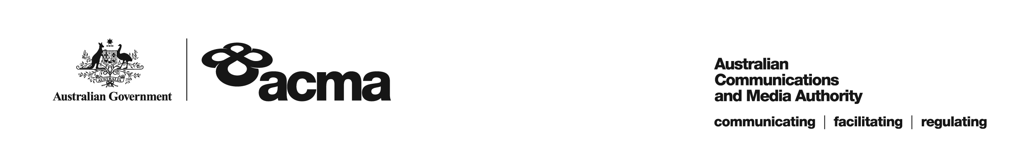

**AUSTRALIAN COMMUNICATIONS AND MEDIA AUTHORITY**

**Target Reduction Order STV-TRO-00127  
made under subsection 130ZY(3) of the *Broadcasting Services Act 1992***

**1. Interpretation**

In this instrument:

***ACMA*** means the Australian Communications and Media Authority;

***Act*** means the *Broadcasting Services Act 1992*;

***Applicant*** means Optus Vision Media Pty Ltd;

***Application*** means the target reduction order application made on 31 March 2021 in relation to the Service;

***Service*** means CMT;

***Specified Eligible Period*** means 1 July 2020 to 30 June 2021.

**2. Target Reduction**

Under subsection 130ZY(3) of the Act, the ACMA:

(a) having considered the written representations made by the Applicant in the Application, the supporting evidence submitted with the Application and the submissions received during the consultation period from 19 May 2021 until 18 June 2021; and

(b) being satisfied that a refusal to make the target reduction order would impose an unjustifiable hardship on the Applicant;

***ORDERS*** that, for the Specified Eligible Period, the reduced annual captioning target for the Applicant in relation to the Service will be 17.5%.

Dated: 24 June 2021