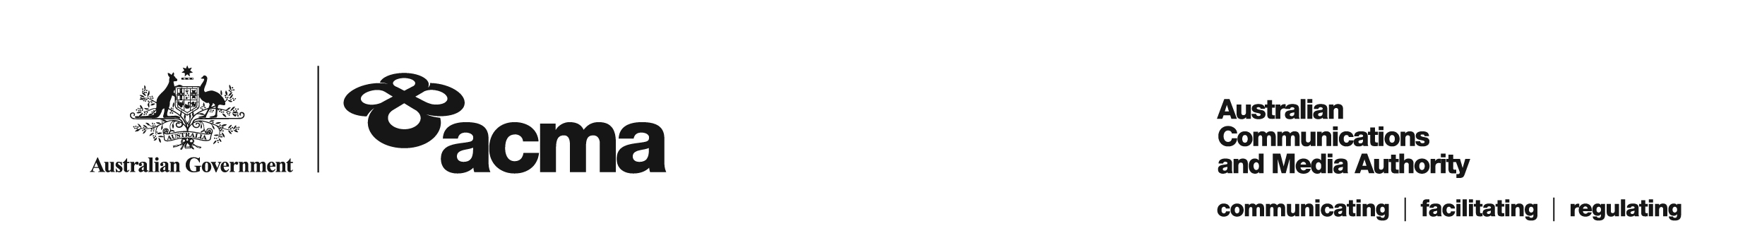**AUSTRALIAN COMMUNICATIONS AND MEDIA AUTHORITY**

**Target Reduction Order STV-TRO-00123  
made under subsection 130ZY(3) of the *Broadcasting Services Act 1992***

**1. Interpretation**

In this instrument:

***ACMA*** means the Australian Communications and Media Authority;

***Act*** means the *Broadcasting Services Act 1992*;

***Applicant*** means FetchTV Pty Ltd (ACN 130 669 500);

***Application*** means the target reduction order application made on 23 March 2021, in relation to the Service;

***Service*** means Nat Geo Wild; and

***Specified Eligible Period*** means 1 July 2020 to 30 June 2022.

**2. Target Reduction**

Under subsection 130ZY(3) of the Act, the ACMA:

(a) having considered the written representations made by the Applicant in the Application, the supporting evidence submitted with the Application [and the submissions received during the consultation period from 12 May 2021 until 11 June 2021; and

(b) being satisfied that a refusal to make the target reduction order would impose an unjustifiable hardship on the Applicant,

***ORDERS*** that, for the Specified Eligible Period, the reduced annual captioning target for the Applicant in relation to the Service will be:

1. 55% for the 2020-21 financial year; and
2. 60% for the 2021-22 financial year.

Dated: 21 June 2021