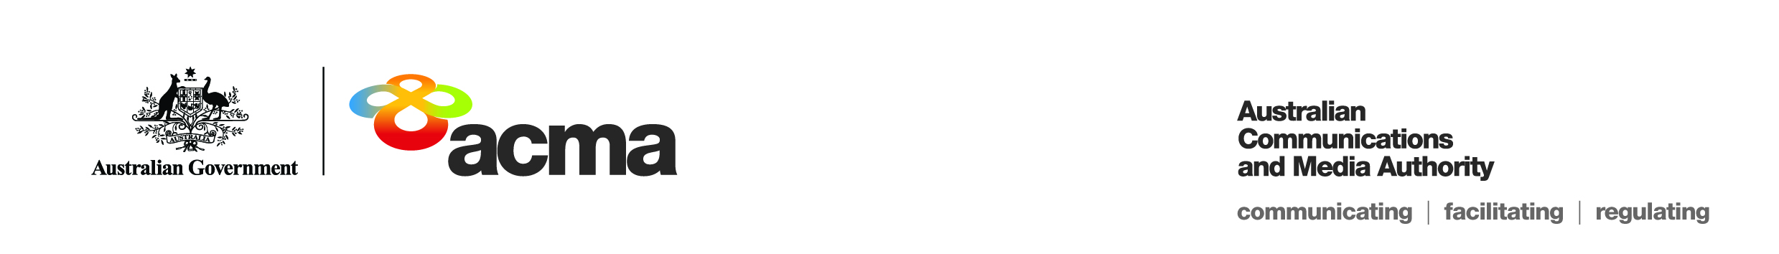Notice of draft

target reduction order

for FetchTV Pty Ltd

(Application 00124)

On 23 March 2021, FetchTV Pty Ltd (ACN 130 669 500) (**the Applicant**) applied to the Australian Communications and Media Authority (**the ACMA**) for a target reduction order under paragraph 130ZY(1)(b) of the *Broadcasting Services Act 1992* (**BSA**) in relation to the subscription television service, Al Jazeera (English) (**the Service**), for the financial year, 1 July 2020 to 30 June 2021 (**the Specified Eligible Period**).

This notice sets out the draft target reduction order for the Service (**the Target Reduction Order**) and invites persons to make submissions about the Target Reduction Order to the ACMA within 30 days after this notice is published, that is by Friday, 11 June 2021, in accordance with subsection 130ZY(6) of the BSA.

The Applicant is a subscription television licensee. The Service is one of 64 subscription television services (channels) that are provided by the Applicant in the English language. The Service is a 24-hour international news and current affairs channel which is described as featuring fearless journalism and award-winning programming.

The Service is a pass-through channel. It is obtained under licence wholly from the channel provider which acquires and compiles the channel and then delivers it to the Applicant. The Applicant provides no input into the content of the channel.

The Service is offered as part of the Applicant’s ‘Knowledge’ package, ‘Ultimate’ package or the ‘Entertainment’ package (a legacy package). Subscribers are not able to subscribe solely to the Service.

**Summary of reasons – unjustifiable hardship**

The ACMA’s preliminary assessment of the application is that a refusal to make the Target Reduction Order would impose an unjustifiable hardship on the Applicant for the reasons explained in the Preliminary Statement of Reasons for Application 00124.

To view the proposed Target Reduction Order, please refer to the document titled ‘DRAFT Target Reduction Order STV-TRO-00124’.

All submissions received up to and including Friday, 11 June 2021, will be considered in making the ACMA’s final decision. Submissions received after this date will not be considered.

**Publication of submissions**

In general, the ACMA publishes all submissions it receives. The ACMA prefers to receive submissions that are not claimed to be confidential. However, the ACMA accepts that a submitter may sometimes wish to provide information in confidence. In these circumstances, submitters are asked to identify the material over which confidentiality is claimed and provide a written explanation for the claim.

The ACMA will consider each confidentiality claim on a case-by-case basis. If the ACMA accepts a claim, it will not publish the confidential information unless authorised or required by law to do so.

Please note that the ACMA does not formally acknowledge the receipt of submissions.

**Effective consultation**

The ACMA is working to enhance the effectiveness of its stakeholder consultation processes, which are an important source of evidence for its regulatory development activities. To assist stakeholders in formulating submissions to its formal, written consultation processes, it has developed a guide called [Effective consultation: A guide to making a submission](http://www.acma.gov.au/~/media/Legal%20Services/Advice/pdf/ACMA%20Effective%20Consultation%20The%20ACMAs%20Guide%20to%20Making%20a%20Submission.PDF). This guide provides information about the ACMA’s formal, written, public consultation processes and practical guidance on how to make a submission.

Please forward submissions quoting Application Number 00124 to:

Email: [captioning@acma.gov.au](mailto:captioning@acma.gov.au)

Post:

Submissions to Order Applications  
Diversity, Localism and Accessibility Section  
Australian Communications and Media Authority

PO Box Q500  
Queen Victoria Building  
NSW 1230