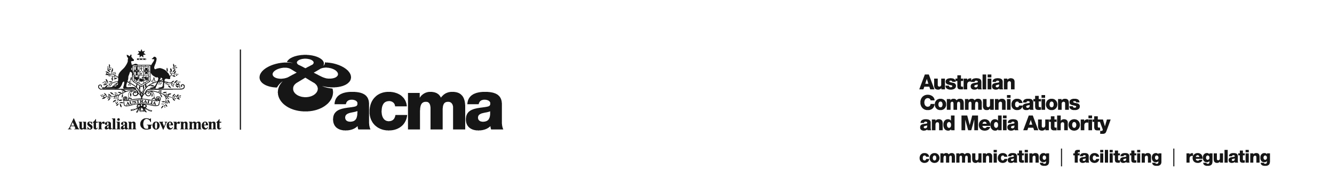

**AUSTRALIAN COMMUNICATIONS AND MEDIA AUTHORITY**

**Target Reduction Order STV-TRO-00125  
made under subsection 130ZY(3) of the *Broadcasting Services Act 1992***

**1. Interpretation**

In this instrument:

***ACMA*** means the Australian Communications and Media Authority

***Act*** means the *Broadcasting Services Act 1992*

***Applicant*** means Telstra Pay TV Pty Ltd (ACN 095 931 614)

***Application*** means the target reduction order application made on 24 March 2021 in respect of the Service

***Service*** means TRT World

***Specified Eligible Period*** means 1 July 2020 to 30 June 2021.

**2. Target Reduction**

Under subsection 130ZY(3) of the Act, the ACMA:

(a) having considered the written representations made by the Applicant in the Application, the supporting evidence submitted with the Application and the submissions received during the consultation period from 16 April 2021 to 17 May 2021; and

(b) being satisfied that a refusal to make the target reduction order would impose an unjustifiable hardship on the Applicant;

***ORDERS*** that, for the Specified Eligible Period, the reduced annual captioning target for the Applicant in respect of the Service will be 20%.

Dated: 25 May 2021