Telecommunications outages –   
Sydney storms, February 2020

Report for the Minister for Communications, Urban Infrastructure, Cities and the Arts

February 2021

Canberra

Red Building   
Benjamin Offices  
Chan Street   
Belconnen ACT

PO Box 78  
Belconnen ACT 2616

T +61 2 6219 5555  
F +61 2 6219 5353

Melbourne

Level 32   
Melbourne Central Tower  
360 Elizabeth Street   
Melbourne VIC

PO Box 13112  
Law Courts   
Melbourne VIC 8010

T +61 3 9963 6800  
F +61 3 9963 6899

Sydney

Level 5   
The Bay Centre  
65 Pirrama Road   
Pyrmont NSW

PO Box Q500  
Queen Victoria Building   
NSW 1230

T +61 2 9334 7700 or 1800 226 667  
F +61 2 9334 7799

Copyright notice

[Creative Commons logo](http://i.creativecommons.org/l/by/3.0/88x31.png)

<https://creativecommons.org/licenses/by/4.0/>

With the exception of coats of arms, logos, emblems, images, other third-party material or devices protected by a trademark, this content is made available under the terms of the Creative Commons Attribution 4.0 International (CC BY 4.0) licence.

We request attribution as © Commonwealth of Australia (Australian Communications and Media Authority) 2021.

All other rights are reserved.

The Australian Communications and Media Authority has undertaken reasonable enquiries to identify material owned by third parties and secure permission for its reproduction. Permission may need to be obtained from third parties to re-use their material.

Written enquiries may be sent to:

Manager, Editorial Services  
PO Box 13112  
Law Courts  
Melbourne VIC 8010  
Email: [info@acma.gov.au](mailto:info@acma.gov.au)

Executive summary 1

Introduction 4

Background 4

Scope of the report 4

Sydney storms overview 4

Information collected by the ACMA 5

Impact of COVID-19 5

Facility outages 6

Overview 6

Facility outages by location 6

Facility outages by network and facility type 9

Facility outages by primary cause 12

Duration of facility outages 16

Observations about facility outages 21

Restoration actions 22

Observations about restoration actions 30

Copper cable facility outages 30

Case study: copper cable restoration 32

Fixed-line service outages 34

Overview 34

Service outages by location and proportion 34

Customer Service Guarantee Standard and Mass Service Disruptions 36

Appendix A 40

Appendix B 42

Executive summary

In August 2020, at the request of the Department of Infrastructure, Transport, Regional Development and Communications, the Australian Communications and Media Authority (ACMA) commenced a review into the impact of severe storms that occurred in Sydney between 7 and 10 February 2020 (the Sydney storms) on the telecommunications networks of NBN Co, Optus, Telstra and TPG (the telcos).

Using information provided by the telcos, the ACMA looked at the impact on mobile, fixed-line and fixed wireless telecommunications networks.

For these networks, the review looked at:

* the types of facilities impacted
* mobile and fixed wireless base stations
* nodes[1]
* exchanges
* copper cable
* hybrid fibre coaxial (HFC) cables and equipment[2]
* optical fibre cables
* the duration of facility outages
* any actions that were taken to temporarily restore facilities
* the actions taken to permanently restore facilities.

In addition to looking at facilities, the review also broadly considered the impact of the Sydney storms on fixed-line services. It did not consider the impact on mobile services because the number of mobile users in an area at any given time is variable.

We make the following conclusions and observations:

### Facility outages

* A total of 1,723 facilities in 67 geographic areas were directly or indirectly impacted by the Sydney storms, resulting in 1,927 facility outages.
* Fixed-line networks were the most impacted by the Sydney storms, experiencing more than 2.5 times the number of outages as mobile networks.
* Access to reliable mains power continues to be an important factor in network resilience across all network types.
* Water damage had the greatest impact on facilities on fixed-line networks and caused the longest outages.
* Fixed-line networks (particularly copper cable facilities) may be more susceptible than mobile networks to water damage from storms.
* Mobile base stations were the facility type that experienced the most outages due to the Sydney storms and most of these were caused by power outages.
* Copper cables were the facility type second most impacted by the storms, followed by nodes and HFC equipment.
* Water damage caused the longest facility outages, followed by wind damage.
* A small number of mobile facilities affected by water damage experienced the longest outages.

For a significant number (16.0%) of facility outages, the telcos were not able to identify the primary cause.

### Restoration actions

* The telcos took temporary restoration action for 116 (6.0%) out of a total of 1,927 facility outages that resulted from the Sydney storms.
* Approximately three-quarters of all facilities that experienced an outage were permanently restored within a week.[3]
* Four facility outages out of a total of 1,927 took longer than 3 months to permanently restore.
* Restoration of power was the main action taken to permanently restore 86.0% of mobile facilities, while replacement of hardware and equipment (56.0%) and restoration of power (32.7%) were the main permanent restoration actions for fixed-line facilities.
* On average, replacing hardware or equipment was the longest permanent restoration action (16.6 days).
* On average, the time taken to permanently restore facilities impacted by water damage (20.8 days) or wind damage (19.6 days) was substantially longer than the time taken to restore facilities impacted by other causes.
* In a small number of cases, the restoration of facilities that experienced an outage was impeded because of extreme weather conditions, for example, fallen trees and blocked roads caused by heavy rain, high winds and flooding.

Backup power was available for just over one-quarter of facility outages that occurred.

### Copper cable facility outages

* Based on the data of one telco, 0.01% of all copper cable segments in the relevant geographic areas were impacted by the Sydney storms.

While water damage was the primary cause of copper cable facility outages (88.1%), there were sometimes other contributing factors which may account for the longer than average restoration times.

### Fixed-line service outages

* All of the geographic areas impacted by the Sydney storms experienced service outages.
* Pennant Hills–Epping, Hornsby and Dural–Wisemans Ferry experienced the greatest disruption to fixed-line services.
* Relying on the information available to us, our assessment is that all of the mass service disruptions appear to have been justified.[4]

# Introduction

## Background

On 18 August 2020, the Department of Infrastructure, Transport, Regional Development and Communications (the Department) asked the ACMA to look into telecommunications outages that resulted from the Sydney storms.

The findings of the ACMA’s review are summarised in this report for the Minister for Communications, Urban Infrastructure, Cities and the Arts.

## Scope of the report

The report considers facility outages across fixed-line, fixed wireless and mobile networks located in areas affected by the storms, including the Sydney metropolitan and Illawarra districts and parts of the South Coast, Central Tablelands and Hunter districts of New South Wales (NSW).

The review also broadly considers the extent of fixed-line service disruptions caused by the facility outages.

The report does not look at:

* impacts to mobile services because of the storms or the availability of alternative mobile coverage
* power outages from electricity companies.

## Sydney storms overview

Between 7 and 9 February 2020, the Sydney metropolitan area received its heaviest rainfall in 30 years. The Sydney storms brought vast flooding and strong winds that caused transport issues and left many homes without power.

On Friday 7 February, the State Emergency Service (SES) warned people in NSW to prepare for dangerous flooding, as torrential rain was expected over the weekend. The Bureau of Meteorology also issued a severe weather warning for heavy rainfall and damaging winds from Goulburn to the Queensland border on 7 February.

Sydney city recorded around 391.6 mm of rain within those 3 days, more than 3 times the average rainfall for February.

On Sunday 9 February, the NSW SES issued multiple evacuation orders[5] to people living in low-lying areas, such as those in Narrabeen and southwest of Sydney near Georges River, due to floodwaters and rising river levels. At least 200 people were rescued by emergency services over that weekend.

A record number of calls for help were made to the NSW SES and NSW Fire and Rescue over that weekend. NSW Fire and Rescue received a record number of 16,000 calls for help in the 48-hour period from 8 am on 8 February.

Power provider, Ausgrid, said it was ‘one of the worst storms on the network in 20 years’, with power outages affecting more than 200,000 homes.[6] On 10 February, it was reported that 80,000 homes remained without power.[7]

## Information collected by the ACMA

The ACMA sought information about facilities that were directly or indirectly impacted by the Sydney storms from the 4 main network operators (the telcos):

* NBN Co
* Singtel Optus Pty Limited
* Telstra Corporation Limited

TPG Telecom Limited.

Each reporting telco provided information about their own individual networks, facilities and customers only.

The types of facilities identified by the telcos as being impacted by outages included mobile and fixed wireless base stations, nodes, exchanges, HFC, copper and optical fibre cables and HFC equipment. No telco reported facility outages in relation to satellite-based facilities.

## Impact of COVID-19

The restoration of some facilities damaged by the storms would have coincided with the onset of restrictions related to the COVID-19 pandemic. The ACMA does not have evidence to identify how the restrictions impacted the telcos’ responses to the storms other than to note that COVID-19 restrictions impeded site access in a small number of cases.

# Facility outages

## Overview

A total of 1,723 facilities were directly or indirectly impacted by the Sydney storms, resulting in 1,927 facility outages. The number of facility outages is higher than the number of facilities because, in some cases, single facilities experienced more than one outage due to the storms. The analysis in this report looks at facility outages. This is because we consider that the number of facility outages, rather than the number of facilities impacted, is a better indicator of the impact of the storms.

Fixed-line facilities experienced the most impact from the storms, followed by mobile facilities. The fixed-line facility outages were experienced in similar numbers across 3 facility types (copper cable, nodes and HFC equipment) but optical fibre cable and HFC cable suffered a very low number of outages.Fixed wireless facilities were the least impacted.

It is important to note that some outages that may not be related to the Sydney storms may also be captured in the data used for this report. This is because it is not always possible for telcos to determine the root cause of an outage. This is particularly the case for cables, where damage may have occurred a significant time after the weather event.[8] As there was further heavy rain across Sydney from 13 to 19 February 2020, outages related to this event may also be captured in the data, as well as other unrelated outages that occurred in the same time period.

It should also be noted that the number of facility outages does not include instances where backup power was used (either via battery or permanent onsite generator) and there was no disruption to customer services. As there was no loss of service, the telcos do not record these as facility outages.

## Facility outages by location

This section looks at the facility outages that occurred in 67 geographic areas that were impacted by the Sydney storms.[9] The areas in question are Statistical Areas Level 3 (SA3) which are used by the Australian Bureau of Statistics and provide a regional breakdown of Australia.[10]

It is important to note that the size and distribution of different network types, as well as the number of facilities, varies significantly in each impacted geographic area. For this reason, the number of facility outages may not be an accurate indicator of the susceptibility of a particular network or facility type to extreme weather conditions.

Figure 1 maps the geographic areas that were impacted by the storms and indicates the number of facility outages for each area. It shows that facilities in the inner and northern Sydney areas experienced the greatest impact from the storms. However, facilities in much of south eastern NSW, from Taree on the Central Coast to Batemans Bay on the South Coast and inland as far as Lithgow–Mudgee, were also impacted by the storms.

Appendix A lists the number and proportion of facility outages for the 67 geographic areas impacted by the storms.

Facility outages by geographic area

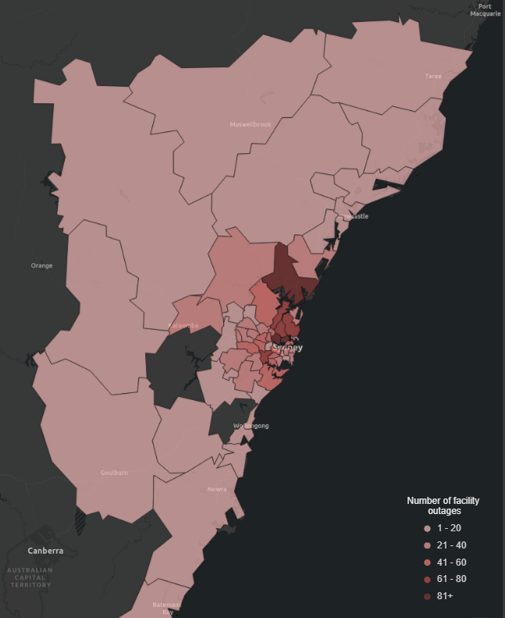

Figure 2shows the geographic areas which experienced facility outages due to the storms in greater detail. The geographic area of Gosford had the most facility outages (141), representing 7.3% of facility outages overall. This was followed by Ryde–Hunters Hill with 92 facility outages (4.8%) and Chatswood–Lane Cove with 88 facility outages (4.6%).

Facility outages by geographic area

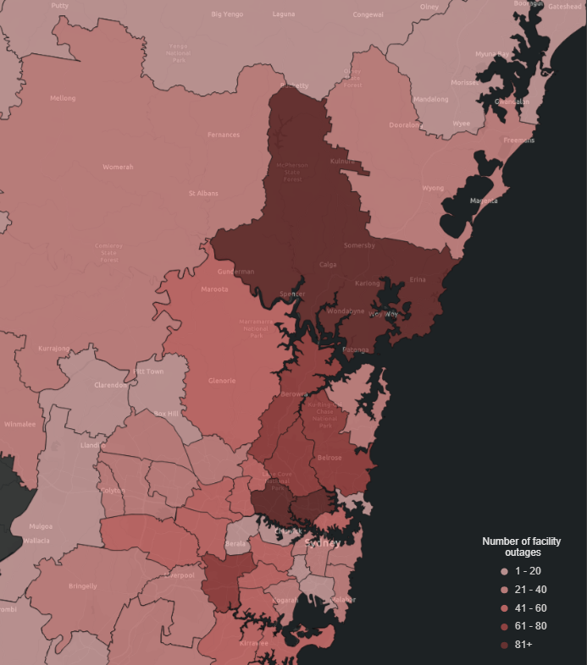

## Facility outages by network and facility type

Figure 3 shows that fixed-line networks experienced the most facility outages from the storms. Of 1,927 facility outages overall, 72.2% were in fixed-line networks followed by 27.0% in mobile networks and 0.7% in fixed wireless networks.

Facility outages by network type

Figure 4 shows a breakdown of all the facility types impacted by the storms, across all networks. As shown in Figure 4, mobile base station facilities accounted for 27.0% of all facility outages, followed by copper cable at 25.2%, nodes at 24.2% and HFC equipment at 21.6%. We understand that HFC equipment may not be able to operate to specification once it has experienced water ingress, requiring the equipment to be replaced.

HFC cable, fixed wireless base stations, exchanges, optical fibre cable and other facilities were impacted by the storms to a much lesser extent.

Facility outages by facility type

### Fixed-line facility outages

Table 1 below provides a breakdown of fixed-line facility outages. Copper cable, nodes and HFC equipment together accounted for 98.3% of all fixed-line facility outages. Copper cables experienced the greatest impact (34.9% of all fixed-line facility outages) followed closely by nodes (33.5%) and HFC equipment (29.9%).

Number and proportion of fixed-line facility outages

|  |  |  |
| --- | --- | --- |
| **Fixed-line facility type** | **Facility outages** | **Proportion of fixed-line facility outages** |
| Copper cable | 486 | 34.9% |
| Node | 466 | 33.5% |
| HFC equipment | 416 | 29.9% |
| HFC cable | 17 | 1.2% |
| Exchange | 3 | 0.2% |
| Optical fibre cable | 1 | 0.1% |
| Other | 3 | 0.2% |
| **Total** | **1,392** | **100.0%** |

### Base station facility outages

A total of 521 mobile base stations were impacted by the Sydney storms, accounting for 27.0% of all facility outages. Mobile base station facility outages accounted for all mobile network outages and no mobile base stations experienced more than one facility outage.

While mobile base stations were the facility type most impacted by the storms, only 8.0% of a total of 6,525 mobile base stations across all the impacted areas experienced facility outages.

Table 2 shows the number and proportion of mobile base stations impacted in areas where more than 20.0% of all mobile base stations had facility outages. Dural–Wisemans Ferry had the highest proportion of all base station facility outages at 37.3%.

Geographic areas with more than 20.0% of mobile base stations impacted

|  |  |  |
| --- | --- | --- |
| **SA3** | **Mobile base station facility outages** | **Proportion of all mobile base stations impacted** |
| Dural–Wisemans Ferry | 19 | 37.3% |
| Hawkesbury | 9 | 29.0% |
| Carlingford | 14 | 28.0% |
| Maitland | 12 | 27.9% |
| Gosford | 43 | 27.4% |
| Sutherland–Menai–Heathcote | 23 | 27.1% |
| Pennant Hills–Epping | 15 | 26.3% |
| Hornsby | 27 | 26.2% |
| Rouse Hill–McGraths Hill | 6 | 26.1% |
| Cronulla–Miranda–Caringbah | 14 | 21.2% |
| Chatswood–Lane Cove | 39 | 21.1% |

Table 3 below shows that there were 9 fixed wireless base stations impacted by the storms, a number of which experienced multiple outages. Out of a total of 68 fixed wireless base stations across all the impacted areas, 13.2% experienced outages.

Geographic areas with fixed wireless base stations impacted

|  |  |  |  |
| --- | --- | --- | --- |
| **SA3** | **Fixed wireless base station outages** | **Impacted fixed wireless base stations** | **Proportion of all fixed wireless base stations impacted** |
| Gosford | 7 | 4 | 100.0% |
| Dural–Wisemans Ferry | 3 | 2 | 33.3% |
| Hawkesbury | 2 | 1 | 8.3% |
| Campbelltown (NSW) | 1 | 1 | 100.0% |
| Dapto–Port Kembla | 1 | 1 | 100.0% |

## Facility outages by primary cause

This section looks at the primary cause of facility outages. Table 4 and Figure 5 show that approximately half of all facility outages were caused by power outages and just under 30.0% were due to water damage. For 16.0% of facility outages, the cause was unknown.

The ACMA understands that in most cases where the primary cause of a facility outage was reported as unknown, telcos were able to rectify the outage without identifying the source of the problem. For example, a broken connector may require replacement, but the cause of the broken connector is not immediately obvious. It may be due to rain, a rodent or a pre-existing condition. Telcos advised that their priority in these situations is restoring impacted services rather than determining the cause of the outage.

However, in a small number of cases (45 out of 309), the problem rectified itself before the telco could identify the cause. In these cases, the average duration of the facility outage was relatively short (0.6 days).

Wind damage and ‘other’ causes of facility outages contributed to less than 5.0% of all facility outages and lightning caused just one outage. ‘Other’ causes of facility outages included fallen trees and faulty or damaged hardware.

Facility outages by primary cause

|  |  |  |
| --- | --- | --- |
| **Primary cause** | **Facility outages** | **Proportion of all facility outages** |
| Power outage | 962 | 49.9% |
| Water damage | 566 | 29.4% |
| Unknown | 309 | 16.0% |
| Wind damage | 43 | 2.2% |
| Lightning damage | 1 | 0.1% |
| Other | 46 | 2.4% |
| **Total** | **1,927** | **100%** |

*Note: Power outage includes upstream power outages (111). Water damage includes upstream water damage (2).*

Facility outages by primary cause

*Note: Power outage includes upstream power outages (111). Water damage includes upstream water damage (2).*

Table 5 and Figure 6 show that power outages were the primary cause of facility outages on mobile networks, accounting for 91.2% of all mobile facility outages. Power outages also accounted for all the facility outages on fixed wireless networks, which represented 0.7% of all facility outages.

Water damage was the primary cause of facility outages on fixed-line networks, accounting for 40.2% of all fixed-line facility outages. Power outages were also a major cause of fixed-line facility outages (34.0%). For a significant proportion of outages in the fixed-line network (21.8%), the cause was unknown.

It is also noteworthy that 98.8% of all facility outages caused by water damage occurred on the fixed-line network (559 out of 566), with only very few outages in the mobile network (1.2%). In contrast, power outages impacted both fixed and mobile networks in similar numbers.

Facility outages by primary cause and network type

|  |  |  |  |  |
| --- | --- | --- | --- | --- |
| **Facility outages** | **Network type** | | | |
| **Primary cause** | **Fixed-line** | **Mobile** | **Fixed wireless** | **Total** |
| Power outage | 473 | 475 | 14 | **962** |
| Water damage | 559 | 7 | 0 | **566** |
| Unknown | 303 | 6 | 0 | **309** |
| Wind damage | 43 | 0 | 0 | **43** |
| Lightning damage | 1 | 0 | 0 | **1** |
| Other | 13 | 33 | 0 | **46** |
| **Total** | **1,392** | **521** | **14** | **1,927** |

*Note: Power outage includes (111) upstream power outages and water damage includes (2) upstream water damage outage incidents.*

Facility outages by primary cause and network type

Table 6 and Figure 7 below provide a breakdown of fixed-line facility outages by facility type and primary cause. Water damage accounted for 88.1% of copper cable facility outages and power outages were responsible for 81.1% of node facility outages. It is also worth noting that copper cable outages accounted for 76.6% of all fixed-line facility outages caused by water damage (428 out of 559).

For HFC equipment, the cause of 51.2% of facility outages was unknown, with most of the remaining facility outages due to power outages or water damage.

Facility outages on HFC cable represented 1.2% of all fixed-line facility outages and the cause of most of these outages was unknown.

Fixed-line facility outages by primary cause and facility type

|  |  |  |  |  |  |  |  |
| --- | --- | --- | --- | --- | --- | --- | --- |
| **Facility outages** | **Primary cause** | | | | | | |
| **Fixed-line facility type** | Water damage | Power outage | Unknown | Wind damage | Other | Lightning damage | **Total** |
| Copper cable | 428 | 3 | 9 | 43 | 2 | 1 | **486** |
| Node | 14 | 378 | 64 | 0 | 10 | 0 | **466** |
| HFC equipment | 114 | 88 | 213 | 0 | 1 | 0 | **416** |
| HFC cable | 3 | 0 | 14 | 0 | 0 | 0 | **17** |
| Exchange | 0 | 2 | 1 | 0 | 0 | 0 | **3** |
| Optical fibre cable | 0 | 0 | 1 | 0 | 0 | 0 | **1** |
| Other | 0 | 2 | 1 | 0 | 0 | 0 | **3** |
| **Total** | **559** | **473** | **303** | **43** | **13** | **1** | **1,392** |

Fixed-line facility outages by primary cause and facility type

## Duration of facility outages

The duration of a facility outage refers to the period where service was not available for a facility impacted by the storms.[11] In most instances, the duration of the facility outage is calculated as the period of time between commencement of the outage and the time when the facility was permanently restored. However, where temporary restoration occurred, the duration of the facility outage excludes the time that temporary restoration measures were in place because service was available during that time. It should be noted that temporary restoration action was taken for 116 facility outages out of a total of 1,927 facility outages.

Table 7 shows the average[12] duration of facility outages by network and facility type and primary cause. The average duration of all facility outages was 7.8 days, and the median was 1.5 days. On average, facility outages on fixed-line networks were much longer (9.8 days) than facility outages on mobile or fixed wireless networks (2.8 and 1.6 days respectively). The average duration of fixed-line facility outages was significantly longer than the median[13] (2.0 days) because of the longer duration of copper cable outages (24.9 days on average) compared to other fixed-line facilities.

Exchange facilities experienced the shortest outages on average (0.3 days). All other facilities (apart from copper cable) had average outage durations of less than 3 days.

The average durations of facility outages caused by water damage or wind damage (20.8 days and 19.5 days respectively) were substantially longer than other causes such as lightning damage, power outages or unknown causes. As Figure 7 above shows, water damage largely related to copper cable facility outages, and wind damage caused a very small number of outages that were only to copper cable.

Number, average and median duration of facility outages

|  |  |  |  |
| --- | --- | --- | --- |
|  | **Facility outages** | **Average duration of facility outages (days)** | **Median duration of facility outages (days)** |
| All facility outages | 1,927 | 7.8 | 1.5 |
| **Network type** | | | |
| Fixed-line | 1,392 | 9.8 | 2.0 |
| Mobile | 521 | 2.8 | 0.6 |
| Fixed wireless | 14 | 1.6 | 0.5 |
| **Facility type** | | | |
| Base station (mobile) | 521 | 2.8 | 0.6 |
| Copper cable | 486 | 24.9 | 21.6 |
| Node | 466 | 2.0 | 1.5 |
| HFC equipment | 416 | 1.1 | 0.8 |
| HFC cable | 17 | 2.6 | 1.2 |
| Base station (fixed wireless) | 14 | 1.6 | 0.5 |
| Exchange | 3 | 0.3 | 0.2 |
| Optical fibre cable | 1 | 0.8 | 0.8 |
| Other | 3 | 2.7 | 2.1 |
| **Primary cause** | | | |
| Power outage | 962 | 1.7 | 1.0 |
| Water damage | 566 | 20.8 | 15.6 |
| Unknown | 309 | 1.4 | 0.7 |
| Wind damage | 43 | 19.5 | 18.3 |
| Lightning damage | 1 | 3.7 | 3.7 |
| Other | 46 | 7.5 | 2.2 |

*Note: Power outage includes (111) upstream power outages and water damage includes (2) upstream water damage outage incidents.*

When considering the duration of outages by network type, Table 8belowagain highlights that outages from water and wind damage lasted longer on average. Table 8 also shows that where water damage impacted the mobile network (exclusively at mobile base stations) the average duration was substantially longer than other causes. However, it should be noted that only 7 facility outages in the mobile network were caused by water damage (Table 5 above).

The average durations of fixed-line facility outages caused by water damage or wind damage (20.3 days and 19.5 days respectively) are largely the same as the corresponding figures for all facility outages (20.8 days and 19.5 days respectively). As noted above, this is because wind and water damage largely relate to copper cable facility outages.

Average duration of facility outages (days) by primary cause and network type

|  |  |  |  |
| --- | --- | --- | --- |
| **Average duration of facility outages (days)** | **Network type** | | |
| **Primary cause** | Fixed-line | Mobile | Fixed wireless |
| Water damage | 20.3 | 62.3 | - |
| Wind damage | 19.5 | - | - |
| Lightning damage | 3.7 | - | - |
| Power outage | 2.0 | 1.5 | 1.6 |
| Unknown | 1.4 | 0.6 | - |
| Other | 3.8 | 8.9 | - |

Figure 8 and Table 9provide a breakdown of the duration of facility outages by days. This table shows that the duration of more than half (1,111) of all facility outages was less than 2 days. However, nearly one-quarter (436) of facility outages lasted more than 7 days. This largely relates to copper cable facility outages.

Facility outages by duration (days)

|  |  |  |
| --- | --- | --- |
| **Duration (days)** | **Facility outages** | **Proportion of all facility outages** |
| Less than 1 | 752 | 39.0% |
| 1 to 2 | 359 | 18.6% |
| 2 to 3 | 161 | 8.4% |
| 3 to 4 | 99 | 5.1% |
| 4 to 5 | 50 | 2.6% |
| 5 to 6 | 35 | 1.8% |
| 6 to 7 | 35 | 1.8% |
| More than 7 | 436 | 22.6% |
| **Total** | **1,927** | **100.0%** |

*Note: Aside from the ‘less than 1’ and ‘more than 7’ categories, each category is lower value inclusive and upper value exclusive.*

Facility outages by duration (days)

*Note: Aside from the ‘less than 1’ and ‘more than 7’ categories, each category is lower value inclusive and upper value exclusive.*

When considering outages of less than one day duration, Figure 9 and Table 10below show that the duration of facility outages on the mobile network were generally shorter than facility outages on other networks. Of the facility outages that were shorter than 3 hours, 68.8% were on the mobile network.

Facility outages (less than 24 hours) by duration and network type

*Note: Aside from the ‘less than 3’ and ‘21 to 24’ categories, each category is lower value inclusive and upper value exclusive.*

Facility outages (less than 24 hours) by duration and network type

|  |  |  |  |  |
| --- | --- | --- | --- | --- |
| **Duration (hours)** | **Fixed-line facility outages** | **Mobile facility outages** | **Fixed wireless facility outages** | **Total** |
| Less than 3 | 68 | 150 | 0 | **218** |
| 3 to 6 | 71 | 42 | 0 | **113** |
| 6 to 9 | 46 | 39 | 3 | **88** |
| 9 to 12 | 49 | 12 | 4 | **65** |
| 12 to 15 | 53 | 21 | 2 | **76** |
| 15 to 18 | 48 | 15 | 0 | **63** |
| 18 to 21 | 38 | 31 | 1 | **70** |
| 21 to 24 | 54 | 5 | 0 | **59** |
| **Total** | **427** | **315** | **10** | **752** |

*Note: Aside from the ‘less than 3’ and ‘21 to 24’ categories, each category is lower value inclusive and upper value exclusive.*

Table 11 below shows that for those facility outages that were longer than a week, 57.3% lasted less than a month and a further 39.7% lasted less than 2 months.

Four mobile facilities had the longest outages, exceeding 3 months. However, the vast majority (96.3%) of facility outages that lasted for more than a week related to fixed-line facilities. The telcos provided some information about why restoration was delayed in some instances, which is discussed in the ‘Impediments to restoration’ section below.

Facility outages (more than 1 week) by duration and network type

|  |  |  |  |  |
| --- | --- | --- | --- | --- |
| **Duration** | **Fixed-line facility outages** | **Mobile facility outages** | **Fixed wireless facility outages** | **Total** |
| More than 1 week and less than 1 month | 241 | 8 | 1 | **250** |
| Between 1 and 2 months | 172 | 1 | 0 | **173** |
| Between 2 and 3 months | 7 | 2 | 0 | **9** |
| More than 3 months | 0 | 4 | 0 | **4** |
| **Total** | **420** | **15** | **1** | **436** |

*Note: Aside from the ‘more than 1 week and less than 1 month’ and ‘more than 3 months’ categories, each category is lower value inclusive and upper value exclusive.*

## Observations about facility outages

* **A total of 1,723 facilities in 67 geographic areas were directly or indirectly impacted by the Sydney storms, resulting in 1,927 facility outages.**
* **Fixed-line networks were the most impacted by the Sydney storms, experiencing more than 2.5 times the number of outages as mobile networks.** Fixed-line networks experienced 72.2% of all facility outages.
* **Reliance on mains power continues to be an important factor in network resilience across all network types**. Approximately half of all facility outages were caused by power outages and the average duration of facility outages caused by power outages was 1.7 days. Power outages accounted for 91.2% of mobile facility outages, 34.0% of fixed-line facility outages and 100% of fixed wireless facility outages.
* **Water damage had the greatest impact on facilities on fixed-line networks and caused the longest outages.** Water damage accounted for 40.2% of fixed-line facility outages with an average outage duration of 20.3 days. Water damage only caused 1.3% of mobile facility outages but the duration of the outages was, on average, very long (62.3 days).
* **Fixed-line networks (particularly copper cable facilities) may be more susceptible than mobile networks to water damage from storms.** Just under 99.0% of all facility outages caused by water damage occurred on the fixed-line network. Copper cable outages accounted for 76.6% of all fixed-line facility outages caused by water damage.
* **Mobile base stations were the facility type that experienced the most outages due to the Sydney storms and most of these were caused by power outages.** While mobile base stations were the facility type most impacted by the Sydney storms, out of a total of 6,525 mobile base stations across all geographic areas impacted by the storms, 8.0% experienced outages. Power outages accounted for 91.2% of mobile facility outages.
* **Copper cables were the facility type second most impacted by the storms, followed by nodes and HFC equipment.** Copper cable facility outages accounted for 25.2% of total facility outages and 34.9% of fixed-line facility outages. Water damage was responsible for 88.1% of all copper cable facility outages which lasted an average of 24.9 days. Leaving aside a small number (7) of mobile base stations that experienced outages from water damage, copper cable facility outages were, on average, the longest outages.
* **Water damage caused the longest facility outages, followed by wind damage.** Across all networks, the average duration of facility outages caused by water damage (20.8 days) or wind damage (19.5 days) was considerably longer than outages caused by lightning, power, or unknown causes. Water and wind damage largely relate to copper cable facility outages.
* **A small number of mobile facilities affected by water damage experienced the longest outages.** While only a small number (7) of mobile base stations experienced outages from water damage, those were the longest outages experienced at any facility, with an average duration of 62.3 days. This compares to the average outage duration for mobile facility outages caused by power, which was 2.8 days.
* **For a significant number (16.0%) of facility outages, the telcos were not able to identify the primary cause.** These facility outages were mainly in the fixed-line network and had an average duration of 7.5 days. In most of these cases, telcos rectified the outage without identifying the source of the problem.

## Restoration actions

This section looks at the temporary and permanent restoration actions taken by the telcos to restore services and facilities and the corresponding timeframes. The time taken to permanently restore a facility is the same as the duration of the facility outage, except where temporary restoration action was taken.[14]

Figure 10 below shows the cumulative number of unrestored facility outages from the start of the Sydney storms on 7 February 2020 to 3 May 2020[15], against the number of new facility outages and facility outages that were permanently restored on a daily basis for the same period.

This figure indicates that the number of new facility outages peaked within a few days of the storm commencing and the number of restored facility outages peaked a few days later. The grey shaded area in Figure 10 shows the progression towards permanent restoration of all facility outages over time.

At 3 May 2020, 5 mobile base stations and one copper cable remained unrestored.

Facility outages and permanent restoration over time

### Temporary restoration actions

Temporary restoration action was taken for 116 facility outages, representing only 6.0% of all facility outages resulting from the Sydney storms (116 out of 1,927). Table 12 below shows that following an outage, the main action taken by telcos to temporarily restore service was to use portable generators, accounting for 96.6% of all temporary restoration actions.

Table 12 also shows that for most outages where temporary action was taken (to deploy portable generators), the average time to commence that action was 1.7 days.

Number of facility outages and average days to commence temporary restoration by type of restoration action

|  |  |  |
| --- | --- | --- |
| **Temporary restoration action** | **Facility outages** | **Average days to commence** |
| Portable generators deployed | 112 | 1.7 |
| Call re-routed | 2 | 1.5 |
| Temporary cable deployed | 1 | 0.9 |
| Equipment manually cooled | 1 | 2.4 |
| **Total** | **116** | **1.7** |

Figure 11showsthat of the 112 portable generators deployed to temporarily restore facilities, 53.6% were used for nodes, 36.6% were used for mobile base stations and 9.8% were used for fixed wireless base stations.

Facility outages by type of temporary restoration action and type of facility

Table 13 below shows that temporary restoration actions were taken in relation to 8.4% of mobile base station outages, 12.9% of node outages and 78.6% of fixed wireless base station outages. Temporary restoration actions were only taken in relation to 0.2% of copper cable facility outages.

Facility outages by type of temporary restoration action

|  |  |  |  |
| --- | --- | --- | --- |
| **Facility type** | **Facility outages** | **Temporary restoration action** | **Proportion of all facility outages with temporary restoration** |
| Base station (mobile) | 521 | 44 | 8.4% |
| Copper cable | 486 | 1 | 0.2% |
| Node | 466 | 60 | 12.9% |
| HFC equipment | 416 | 0 | 0.0% |
| HFC cable | 17 | 0 | 0.0% |
| Base station (fixed wireless) | 14 | 11 | 78.6% |
| Exchange | 3 | 0 | 0.0% |
| Optical fibre cable | 1 | 0 | 0.0% |
| Other | 3 | 0 | 0.0% |
| **Total** | **1,927** | **116** | **6.0%** |

### Permanent restoration actions

At the time of writing, a single mobile base station facility had not been permanently restored but continued to operate under a temporary restoration measure. This facility has been excluded from permanent restoration analysis because it is not permanently restored.

Across all networks, 47.6% of facility outages were permanently restored when power was restored. In 50.1% of cases, the carriers either replaced, reset or repaired hardware and equipment to permanently restore the facility. In some instances, facility outages caused by power outages required manual intervention to permanently restore the facility, such as resetting tripped circuit breakers.

Figure 12 below shows that for fixed-line facilities, hardware and equipment had to be replaced to permanently restore service in 56.0% of outages and restoration of power was required in 32.7% of outages. For mobile networks, 86.0% of facility outages were permanently restored when power to the site was restored and 7.5% were restored when hardware and equipment was replaced. For fixed wireless networks, 100% of facility outages were permanently restored when power to the site was restored.

Facility outages by network type and permanent restoration action

Figure 13below shows that restoration of power or replacement of hardware and equipment were the most common restoration actions required to permanently restore facilities. All copper cables were restored by replacing hardware and equipment.

Facility outages by facility type and permanent restoration action

Table 14 shows the average and median time to permanently restore facilities by primary cause of the facility outage. On average, the time taken to permanently restore facilities impacted by water damage (20.8 days) or wind damage (19.6 days) was substantially longer than the time taken to restore facilities impacted by other causes.

Average and median time (days) to permanently restore a facility by primary cause

|  |  |  |
| --- | --- | --- |
| **Primary cause** | **Average days to permanently restore facility** | **Median days to permanently restore facility** |
| Water damage | 20.8 | 15.6 |
| Wind damage | 19.6 | 18.3 |
| Lightning damage | 3.7 | 3.7 |
| Power outage | 2.5 | 1.1 |
| Unknown | 1.4 | 0.7 |
| Other | 7.5 | 2.2 |

Table 15 shows the average and median time to permanently restore facilities by action taken. On average, replacing hardware or equipment took 16.6 days, which was significantly longer than other permanent restoration actions. The average time taken to reset or repair hardware/equipment was 1.2 and 1.9 days respectively, with power typically restored within 2.2 days.

Average and median time (days) to permanently restore a facility by action taken

|  |  |  |
| --- | --- | --- |
| **Permanent restoration action type** | **Average days to permanently restore facility** | **Median days to permanently restore facility** |
| Hardware/equipment replaced | 16.6 | 8.5 |
| Power restored | 2.2 | 1.0 |
| Hardware/equipment repaired | 1.9 | 0.9 |
| Hardware/equipment reset | 1.2 | 0.3 |
| Other | 0.6 | 0.2 |

Table 16 shows that the average and median time taken to replace hardware/equipment to permanently restore a copper cable facility was 25.0 days and 21.6 days respectively.

The average time taken to permanently restore mobile base stations by replacing hardware/equipment was 25.6 days. This is substantially higher than the median of 4.3 days because a small number of mobile base station facility outages took more than 2 months to permanently restore.

Average time (days) to replace hardware/equipment by facility type

|  |  |  |
| --- | --- | --- |
| **Facility type** | **Average days to replace hardware/equipment** | **Median days to replace hardware/equipment** |
| Base station (mobile) | 25.6 | 4.3 |
| Copper cable | 25.0 | 21.6 |
| Node | 3.9 | 0.9 |
| HFC cable | 1.2 | 2.4 |
| HFC equipment | 1.1 | 0.9 |
| Other | 4.0 | 0.9 |

### Impediments to restoration

Telcos reported that in some cases, extreme weather conditions impeded access to sites preventing them from assessing damage, deploying temporary facilities, or undertaking remediation or restoration activities.

The telcos reported a total of 66 instances where restoration of service was impeded because of the storms. Seven of these related to temporary restoration and 59 related to permanent restoration. As this information relies on telco technical staff accurately recording relevant impediments at the time of restoration, it should be regarded as indicative only.

Impediments to restoration of service were categorised as follows:

* Weather related:

heavy rain, flooding, lightning and strong winds caused unsafe working conditions for technicians

heavy rain and flooding blocked roads and access to repair sites

facilities such as pits and trenches were submerged in water

fallen trees blocked access to repair sites, caused power failures and damaged cables.

* Property issues:

obtaining permission to access private property and securing of livestock.

* COVID-19:

delays caused by compliance with restrictions on access to nursing homes and a university.

Availability of materials such as cable.

### Backup power

This section looks at the availability of backup power for facilities that experienced an outage. It does not look at instances where backup power was used (either via battery or permanent onsite generator) and there was no disruption to customer services.

Figure 14 and Table 17 show that backup power was available for 26.4% of facility outages that occurred because of the storms.

Backup power was available in all facility outages for wireless base stations, exchanges, and optical cables and in approximately half of facility outages occurring in nodes and mobile base stations.

Availability of backup power was limited for copper cable, HFC cable and HFC equipment outages (see Figure 14 and Table 17 below). We understand that backup power for copper cable outages is not available because copper cables are passive (unpowered) infrastructure. While power is required for compressors to keep the cables pressurised, loss of power to a compressor doesn’t automatically lead to an outage and conversely, when there is no loss of power to a compressor, outages can still occur. As it can be very difficult to determine whether backup power on a compressor (not the cable itself) has been used, the telcos have reported nearly all copper cable outages[16] as not having backup power available.

There is no backup power availability (battery or otherwise) for HFC nodes.

Facility outages by facility type and backup power availability

Facility outages by facility type and backup power availability

|  |  |  |
| --- | --- | --- |
| **Facility type** | **Facility outages** | **Backup power availability** |
| Base station (mobile) | 521 | 54.5% |
| Copper cable | 486 | 0.6% |
| Node | 466 | 43.1% |
| HFC equipment | 416 | 0.0% |
| HFC cable | 17 | 0.0% |
| Base station (fixed wireless) | 14 | 100.0% |
| Exchange | 3 | 100.0% |
| Optical fibre cable | 1 | 100.0% |
| Other | 3 | 66.7% |
| **Total** | **1,927** | **26.4%** |

## Observations about restoration actions

* **The telcos took temporary restoration action for 116 (6.0%) out of a total of 1,927 facility outages that resulted from the Sydney storms.** Portable generators were the main temporary restoration action and took on average 1.7 days to deploy.
* **Approximately three-quarters of all facilities that experienced an outage were permanently restored within a week.**[17]
* **Four facility outages out of a total of 1,927 took longer than 3 months to permanently restore**. These were mobile base stations.
* **Restoration of power was the main action taken to permanently restore 86.0% of mobile facilities, while replacement of hardware and equipment (56.0%) and restoration of power (32.7%) were the main permanent restoration actions for fixed-line facilities.**
* **On average, replacing hardware or equipment was the longest permanent restoration action (16.6 days)**, followed by restoring power (2.2 days) and repairing or resetting hardware/equipment (1.9 and 1.2 days respectively).
* **On average, the time taken to permanently restore facilities impacted by water damage (20.8 days) or wind damage (19.6 days) was substantially longer than the time taken to restore facilities impacted by other causes.**
* **In a small number of cases, the restoration of facilities that experienced an outage was impeded because of the extreme weather conditions, for example, heavy rain, high winds and flooding causing fallen trees and blocked roads.**
* **Backup power was available for just over one-quarter of facility outages that occurred.** It should be noted that the number of facility outages does not include instances where backup power was used (either via battery or permanent onsite generator) and there was no disruption to customer services. As there was no loss of service, the telcos do not record these as facility outages.

## Copper cable facility outages

Copper cables were the most impacted fixed-line facility, accounting for 34.9% of all fixed-line facility outages and 25.2% of total facility outages. Copper cables also experienced the longest outages – on average 24.9 days and a median of 21.6 days.

To better understand how copper cables were impacted by the Sydney storms, we have examined data and information provided by one of the telcos about the proportion of copper cables impacted and the causes of copper cable facility outages.

### Proportion of outages

Due to variations in the way that different telcos categorise cables, we have focused on the data provided by one telco to make sure that we are comparing like with like. The data in this section therefore does not represent all of the relevant telcos.

Although copper cables were the most impacted fixed-line facility, our analysis found that the overall proportion of copper cables impacted in the geographic areas affected by the storms was negligible (0.01%). We don’t have information indicating the proportion of services affected by copper cable outages.

We calculated the percentage of copper cables segments impacted for each of the 67 geographic areas affected by the storms. For context, cable segments are generally between 50 to 100 metres long, although they can be anything from less than a metre to a few hundred metres in length.

We found that the storms had no impact on copper cable segments in 6 of the geographic areas.

In 59 of the geographic areas, the storms were found to have impacted less than 0.05% of copper cable segments – the number of copper cable segments impacted was very small compared to the total number of segments in each area. For example, in the Gosford area, only 4 copper cable segments were impacted (0.003%), out of a total of 126,058 segments (totalling 5,365.3 km in length).

In the remaining 2 geographic areas, Dural–Wisemans Ferry and Hawkesbury, 0.13% and 0.07% of total copper cables segments were impacted respectively. Out of a total of 21,253 copper cable segments in Dural–Wisemans Ferry (totalling 1745.3 km in length), 27 copper cable segments were impacted. For Hawkesbury, 14 copper cable segments were impacted out of 18,954 (totalling 1933.7 km).

The factors that may have contributed to copper cable facility outages and the length of time it took to repair them are discussed below.

### Cause of outages

Water damage, specifically water ingress, was the primary cause of 88.1% of all copper cable facility outages. The telco told the ACMA, however, that in combination with water ingress, power outages and (to a lesser extent) wear and tear of aging cables also played a role.

The telco explained to us that power is required to run compressed air through copper cables to keep them dry and protect them from water ingress. If power is cut and backup power is exhausted, this system stops working. The Sydney storms caused widespread power outages and by the time power was restored, a proportion of copper cables had been damaged by water ingress.

We were also informed that wear and tear of aging cables also contributed to copper cable damage, for example, contractors accessing the pits where the cables are located in the weeks/months/years before the storm event. We understand that there was more access than usual leading up to the Sydney storms due to work related to migration of services to the NBN.

We have not independently corroborated the explanation provided to us about the causes of the outages.

### Time taken to restore

Several factors contributed to the time taken to permanently repair copper cables impacted by the storms. Our data shows that for every copper cable facility outage, hardware/equipment had to be replaced, which on average took 25.0 days.

We understand that in practice, lengths of copper cable had to be replaced. The time required to replace a cable can be significant and is dependent on the location of the damaged cable (for example, if the cable ran under or immediately adjacent to a road), and if council permits and/or access to private property was required to obtain access to the cable.

The following case study illustrates these issues.

## Case study: copper cable restoration

This case study has been included to illustrate some unusual problems that were encountered with the repair of a cable that was damaged by the Sydney storms.

The storms caused a fault on a segment of a 200 pair copper cable between Richmond and Windsor in NSW. The cable was situated in a flood prone area, near a creek and adjacent to a major road.

After a preliminary investigation, the fault was assigned a lower priority to allow time for flood waters at the site to recede and to prioritise the repair of larger damaged cables that were impacting more customers. Figure 15 shows the water level inside a pit at the site.

The site was accessed in early March 2020 for repairs. Access to three pits was required, however, only two pits could be located because the third pit had been buried by earthworks in the area. Figures 16 and 17 show the location of the third pit. Once the pit was located, an assessment of damage determined that 210 metres of the cable should be replaced, which required trenching works on private property containing livestock. After identifying and contacting the property owner, technicians were advised that the locks on the gate closest to the repair site were controlled via a nearby airfield. An alternative route required trenching machinery to cross land that was initially too wet for heavy machinery.

Trenching commenced in late April 2020. However, undocumented underground power cables in the area[18] had to be located before it could be safely completed.

The repair was completed on 7 May 2020.

Second pit with water

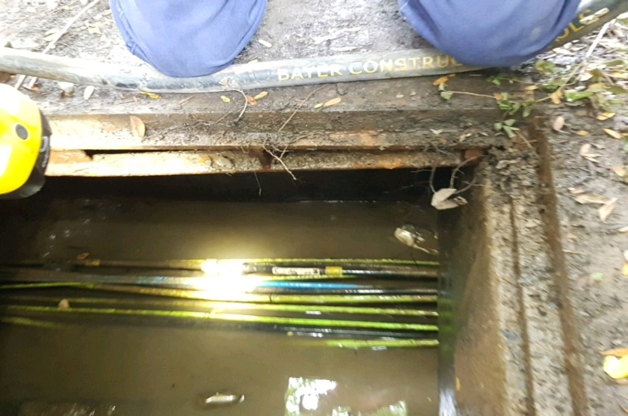

Identifying the location of the third pit

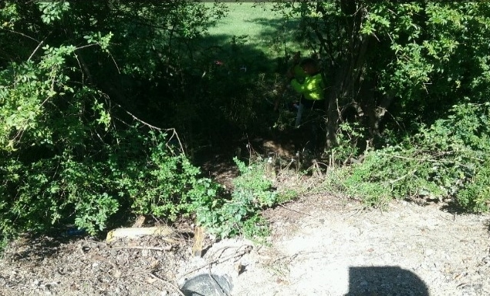

Unearthing the third pit

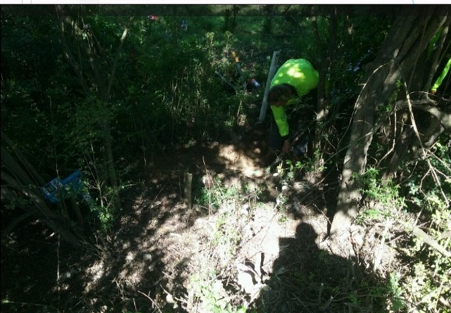

### Additional observations about copper cable facility outages

* Based on the data of one telco, 0.01% of all copper cable segments in the relevant geographic areas were impacted by the Sydney storms.
* While water damage was the primary cause of copper cable facility outages (88.1%), there were sometimes other contributing factors which may account for the longer than average restoration times.

# Fixed-line service outages

## Overview

This section looks at the impact of the Sydney storms on fixed-line services. We do not look at the impact on mobile services in this report. Unlike fixed services, the number of mobile users in an area may vary continually.

We understand that it is not possible to capture the number of mobile services that attempted to make a call via a mobile facility that is not operating. While an estimate using historical data may be possible, it may not be reliable if the area is experiencing atypical conditions, such as extreme weather. In addition, the data for impacted mobile facilities does not indicate whether there is any overlapping coverage from neighbouring mobile sites. If coverage is available from a neighbouring mobile base station, customers for the impacted mobile site may not have experienced any significant service impact.

The qualifications below apply to this section:

* The figures for fixed-line outages may include duplication of services. Where a customer’s service outage was caused by the failure of multiple facilities, it may be counted as a service outage for each of those facilities. For example, if both a node and a cable providing service to a customer failed, that service would be counted as 2 service outages – one for the node and one for the cable. This has the effect of inflating the number of potentially affected customers.
* The number of services connected in each geographic area may be based on the number of services connected in late 2020 (the time that the telcos extracted this data), rather than the number of services connected in February 2020. We understand that this is because telcos may not have historic data about how many customers were connected at a particular point in time.

All of the information in this section is based on data reported by 3 of the 4 telcos. This is because one of the telcos could not readily provide the number of services connected in each of the geographic areas impacted by the storms.[19]

For the reasons listed above, the fixed-line service outage data in this section is therefore indicative only.

## Service outages by location and proportion

Figure 18 shows fixed-line service outages by geographic location. Table 18 lists the geographic areas where more than 10% of connected fixed-line services experienced an outage due to storms. It includes the total number of services connected in each geographic area and the number and proportion of fixed-line services impacted.

Appendix B shows the total number of fixed-line services connected in each geographic area and the number and proportion of fixed-line services impacted.

Pennant Hills–Epping, Hornsby and Dural–Wisemans Ferry experienced the largest proportion of fixed-line service disruptions from the storms. More than 40% of fixed-line services connected in these areas experienced outages.

Pennant Hills–Epping experienced the greatest fixed-line service impact, with 69% of its 23,338 fixed-line connections impacted. Although Gosford experienced the most fixed-line facility outages (91), only 12.6% (11,459) of its 91,216 fixed-line services were impacted.

Fixed-line service outages by location

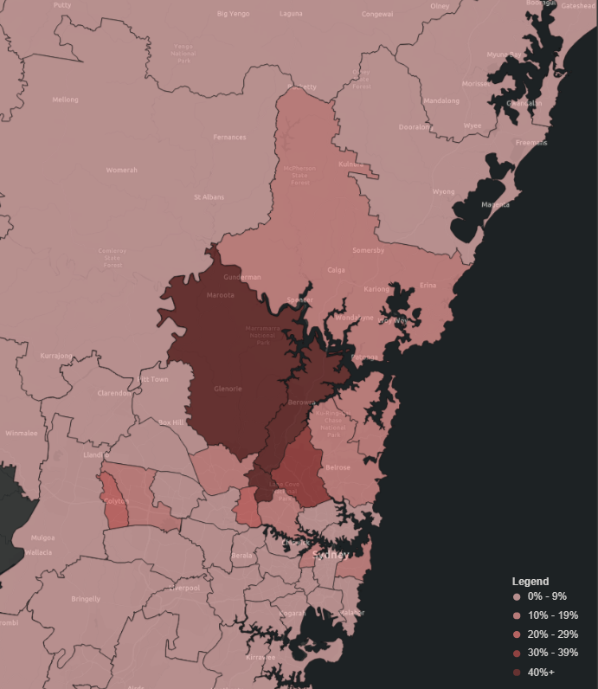

Geographic areas with more than 10% of fixed-line services impacted

|  |  |  |  |  |
| --- | --- | --- | --- | --- |
| **SA3** | **Fixed-line facility outages** | **Fixed-line services connected** | **Fixed-line services impacted** | **Proportion of fixed-line services impacted** |
| Pennant Hills–Epping | 33 | 23,338 | 16,099 | 69.0% |
| Hornsby | 39 | 38,621 | 18,973 | 49.1% |
| Dural–Wisemans Ferry | 37 | 9,190 | 3,960 | 43.1% |
| Ku-ring-gai | 66 | 54,447 | 18,887 | 34.7% |
| Carlingford | 27 | 29,940 | 8,184 | 27.3% |
| St Marys | 28 | 23,590 | 5,949 | 25.2% |
| Leichhardt | 27 | 27,221 | 4,599 | 16.9% |
| Eastern Suburbs–North | 25 | 63,903 | 8,238 | 12.9% |
| Gosford | 91 | 91,216 | 11,459 | 12.6% |
| Baulkham Hills | 30 | 64,941 | 8,143 | 12.5% |
| Mount Druitt | 26 | 38,952 | 4,855 | 12.5% |
| Warringah | 50 | 70,647 | 8,301 | 11.7% |
| Ryde–Hunters Hill | 57 | 65,965 | 7,436 | 11.3% |

## Customer Service Guarantee Standard and Mass Service Disruptions

Given the fixed-line service outages that resulted from the Sydney Storms, the ACMA has considered the application of the[Telecommunications (Customer Service Guarantee) Standard 2011](https://www.legislation.gov.au/Details/F2011C00791) (CSG Standard).

The CSG Standard sets minimum performance standards that carriage service providers (CSPs) are required to meet for the connection, fault repair and related appointments of fixed-line voice services for residential and small business customers. The timeframes in the performance standards vary depending on the location of a service.[20] If a CSP fails to meet the performance standards, it is generally liable to pay compensation to the impacted customers.[21] A customer may choose to waive their rights (in part or in full) under the CSG standard provided certain safeguards are met.[22]

### Mass Service Disruptions

The CSG Standard sets out the circumstances where a CSP is exempt from complying with performance standards.[23] Of particular relevance to the Sydney storms, the CSG Standard provides that a CSP is exempt from complying with a performance standard to the extent that non‑compliance is a result of either:

* circumstances beyond its control

needing to redeploy staff or equipment to an area affected by circumstances beyond its control.[24]

Circumstances beyond a CSP’s control include natural disasters or extreme weather conditions that cause mass outages of services and restrict connection of a service or rectification of a fault.[25]

Such exemptions are self-declared by CSPs and customers must be notified either individually[26] or by a published general notice[27]. Exemptions that are notified via a general notice are commonly referred to as Mass Service Disruptions (MSD). MSD notices are usually prepared by CSPs based on information provided by network operators.

In practical terms, MSDs effectively ‘stop the clock’ for the period of the exemption, extending the time period within which CSG connections and repairs must be completed. During the period of an MSD, when the ‘clock is stopped’, a CSP is not required to pay CSG compensation to affected customers. CSPs can extend or revise existing MSDs if warranted.

If a CSP declares an MSD, it must:

* request a publisher to publish the notice
* provide the notice to the ACMA and the Telecommunications Industry Ombudsman (TIO)
* publish the notice on its website
* provide the notice to each of its resellers who has customers likely to be affected by the exemption[28]

include information specified in the CSG Standard in the notice, including the approximate number of affected customers and the number ranges to which the exemption relates.[29]

Exemptions are self-declared by CSPs and do not require regulatory approval. So long as a CSP has followed the exemption requirements set out in the CSG Standard, the CSP is able to rely on that exemption.

If it appears that a CSP has not complied with the exemption notification requirements under the CSG Standard, an impacted customer can request the CSP to reconsider the exemption grounds or complain to the TIO.

### MSDs declared during Sydney storms

Five MSD notices were provided to the ACMA from different CSPs in February 2020, covering all of the areas and relevant services impacted by the Sydney storms. Each of the notices commenced on 10 February and covered a period of 55 days until 5 April 2020. Each of these notices was subsequently extended to cover a period of 83 days until 3 May 2020.

We consider that all of the notices met the requirements of the CSG Standard. This means that the CSPs were able to rely on the exemptions and the CSPs were not required to comply with the performance standards or pay compensation to impacted customers.

In broadly considering the application of the CSG Standard to the Sydney storms, we looked at the data for fixed-line service outages. It is important to note, however, that fixed-line service outages include both broadband and voice services. The CSG Standard only applies to some fixed-line voice services.

In the data analysed for this review, the ACMA has not identified any instances where it appears that a service that may have been subject to the CSG Standard was not covered by an MSD exemption. While there was one fixed-line facility which was not repaired until 7 May 2020,[30] after the MSD exemption had expired, the delay was due to a property access issue, which is itself a valid reason for an exemption.[31]

Based on the data collected for this review, the ACMA has also broadly considered if the scope and duration of the MSDs were commensurate with the impact of the Sydney storms. As noted in Appendix B, all of the geographic areas that were covered by the MSDs experienced fixed-line service outages, ranging from 69% of services impacted (Pennant Hills–Epping) to 2 services impacted (Goulburn–Mulwaree). It therefore appears that the geographic areas covered by the MSDs were broadly justifiable.

As shown in Table 11,for facility outages on fixed-line networks that lasted longer than a week, 41.0% lasted between one and 2 months and 1.7% lasted between 2 and 3 months. While we do not have data about the duration of service outages, it seems reasonable to conclude that there would have been some CSG services connected to the facilities in question. From the information provided, it therefore appears that the duration of the MSDs (until 3 May 2020) was broadly justifiable.

### Status of CSG Standard

The ACMA notes that the [*Consumer Safeguards Review – Part B (reliability of services) – Final report*](https://www.communications.gov.au/documents/part-b-reliability-services-consumer-safeguards-review-final-report) recommends amending the CSG framework. Specifically, it recommends[32]:

…moving to a framework of retail level service commitments underpinned by wholesale rules and benchmarks, reflecting that the majority of premises will only be able to access fixed voice and broadband services from a retailer that does not control the underlying network infrastructure. However, the CSG should continue to apply in areas outside the NBN fixed-line footprint, while Telstra remains an integrated network and retail provider in those areas.

### Service outage observations

* **All of the geographic areas impacted by the Sydney storms experienced service outages**, ranging from 69.0% of all connected services impacted in one area, to 2 services impacted in another.
* **Pennant Hills–Epping, Hornsby and Dural–Wisemans Ferry experienced the greatest disruption to fixed-line services** with a total of 54.9% of fixed-line services in these areas impacted.
* **Relying on the information available to us, our assessment is that all of the mass service disruptions appear to have been justified.**[33] As a result, the CSG performance standard (including the compensation payment requirement) did not apply to the services impacted by the Sydney storms.

# Appendix A

|  |  |  |
| --- | --- | --- |
| **SA3** | **Facility outages** | **Proportion of all facility outages** |
| Gosford | 141 | 7.3% |
| Ryde–Hunters Hill | 92 | 4.8% |
| Chatswood–Lane Cove | 88 | 4.6% |
| Ku-ring-gai | 80 | 4.2% |
| Warringah | 71 | 3.7% |
| Bankstown | 66 | 3.4% |
| Hornsby | 66 | 3.4% |
| Dural–Wisemans Ferry | 59 | 3.1% |
| Parramatta | 56 | 2.9% |
| Merrylands–Guildford | 56 | 2.9% |
| Strathfield–Burwood–Ashfield | 51 | 2.6% |
| Pennant Hills–Epping | 48 | 2.5% |
| North Sydney–Mosman | 48 | 2.5% |
| Sutherland–Menai–Heathcote | 48 | 2.5% |
| Canterbury | 46 | 2.4% |
| Hurstville | 44 | 2.3% |
| Fairfield | 42 | 2.2% |
| Cronulla–Miranda–Caringbah | 42 | 2.2% |
| Carlingford | 41 | 2.1% |
| Kogarah–Rockdale | 39 | 2.0% |
| Sydney Inner City | 38 | 2.0% |
| Baulkham Hills | 37 | 1.9% |
| Campbelltown (NSW) | 34 | 1.8% |
| Blue Mountains | 34 | 1.8% |
| Blacktown | 33 | 1.7% |
| Pittwater | 32 | 1.7% |
| Wyong | 32 | 1.7% |
| Eastern Suburbs–North | 30 | 1.6% |
| Mount Druitt | 29 | 1.5% |
| St Marys | 29 | 1.5% |
| Eastern Suburbs–South | 28 | 1.5% |
| Leichhardt | 28 | 1.5% |
| Hawkesbury | 25 | 1.3% |
| Bringelly–Green Valley | 22 | 1.1% |
| Liverpool | 22 | 1.1% |
| Blacktown–North | 22 | 1.1% |
| Penrith | 17 | 0.9% |
| Canada Bay | 17 | 0.9% |
| Southern Highlands | 15 | 0.8% |
| Botany | 14 | 0.7% |
| Maitland | 13 | 0.7% |
| Lithgow–Mudgee | 13 | 0.7% |
| Rouse Hill–McGraths Hill | 12 | 0.6% |
| Newcastle | 11 | 0.6% |
| Marrickville–Sydenham–Petersham | 9 | 0.5% |
| Wollondilly | 9 | 0.5% |
| Manly | 9 | 0.5% |
| Lake Macquarie–East | 9 | 0.5% |
| Wollongong | 8 | 0.4% |
| Auburn | 8 | 0.4% |
| Lake Macquarie–West | 8 | 0.4% |
| Port Stephens | 7 | 0.4% |
| Kiama–Shellharbour | 7 | 0.4% |
| Lower Hunter | 6 | 0.3% |
| Richmond–Windsor | 6 | 0.3% |
| Upper Hunter | 5 | 0.3% |
| Shoalhaven | 5 | 0.3% |
| Dapto–Port Kembla | 5 | 0.3% |
| South Coast | 4 | 0.2% |
| Great Lakes | 3 | 0.2% |
| Camden | 3 | 0.2% |
| Bathurst | 2 | 0.1% |
| Taree–Gloucester | 2 | 0.1% |
| Goulburn–Mulwaree | 1 | 0.1% |
| **Total** | **1,927** | **100.0%** |

# Appendix B

The information in this table is based on data reported by 3 of the 4 telcos. This is because one of the telcos could not readily provide the number of services connected in each of the geographic areas impacted by the storms.

The number of services connected in each geographic area may be based on the number of services connected in late 2020 (the time that the telcos extracted this data), rather than the number of services connected in February 2020.

|  |  |  |  |  |
| --- | --- | --- | --- | --- |
| **SA3** | **Fixed-line**  **facility outages** | **Fixed-line services connected** | **Fixed-line service outages** | **Proportion of fixed-line services impacted** |
| Pennant Hills–Epping | 33 | 23,338 | 16,099 | 69.0% |
| Hornsby | 39 | 38,621 | 18,973 | 49.1% |
| Dural–Wisemans Ferry | 37 | 9,190 | 3,960 | 43.1% |
| Ku-ring-gai | 66 | 54,447 | 18,887 | 34.7% |
| Carlingford | 27 | 29,940 | 8,184 | 27.3% |
| St Marys | 28 | 23,590 | 5,949 | 25.2% |
| Leichhardt | 27 | 27,221 | 4,599 | 16.9% |
| Eastern Suburbs–North | 25 | 63,903 | 8,238 | 12.9% |
| Gosford | 91 | 91,216 | 11,459 | 12.6% |
| Baulkham Hills | 30 | 64,941 | 8,143 | 12.5% |
| Mount Druitt | 26 | 38,952 | 4,855 | 12.5% |
| Warringah | 50 | 70,647 | 8,301 | 11.7% |
| Ryde–Hunters Hill | 57 | 65,965 | 7,436 | 11.3% |
| Pittwater | 27 | 28,219 | 2,714 | 9.6% |
| Campbelltown (NSW) | 26 | 65,468 | 6,136 | 9.4% |
| Fairfield | 32 | 75,935 | 6,521 | 8.6% |
| Lake Macquarie–East | 6 | 63,287 | 5,302 | 8.4% |
| Bankstown | 56 | 76,344 | 6,175 | 8.1% |
| Chatswood–Lane Cove | 49 | 53,534 | 4,303 | 8.0% |
| Liverpool | 19 | 55,138 | 4,213 | 7.6% |
| Hurstville | 38 | 56,711 | 3,948 | 7.0% |
| Blue Mountains | 20 | 23,650 | 1,600 | 6.8% |
| North Sydney–Mosman | 28 | 53,852 | 3,480 | 6.5% |
| Canterbury | 41 | 60,547 | 3,791 | 6.3% |
| Cronulla–Miranda–Caringbah | 28 | 57,610 | 3,284 | 5.7% |
| Parramatta | 46 | 66,028 | 3,444 | 5.2% |
| Blacktown–North | 22 | 44,412 | 2,168 | 4.9% |
| Eastern Suburbs–South | 27 | 54,735 | 2,510 | 4.6% |
| Strathfield–Burwood–Ashfield | 44 | 74,182 | 3,184 | 4.3% |
| Kogarah–Rockdale | 34 | 57,705 | 2,447 | 4.2% |
| Hawkesbury | 14 | 5,620 | 225 | 4.0% |
| Merrylands–Guildford | 52 | 63,693 | 2,501 | 3.9% |
| Manly | 8 | 20,721 | 692 | 3.3% |
| Wyong | 20 | 73,304 | 2,399 | 3.3% |
| Rouse Hill–McGraths Hill | 6 | 17,562 | 498 | 2.8% |
| Lake Macquarie–West | 8 | 29,648 | 702 | 2.4% |
| Blacktown | 26 | 67,229 | 1,510 | 2.2% |
| Sutherland–Menai–Heathcote | 25 | 49,559 | 839 | 1.7% |
| Bringelly–Green Valley | 14 | 34,141 | 536 | 1.6% |
| Sydney Inner City | 33 | 111,560 | 1,670 | 1.5% |
| Southern Highlands | 6 | 20,378 | 275 | 1.3% |
| Lithgow–Mudgee | 6 | 15,163 | 202 | 1.3% |
| South Coast | 2 | 23,186 | 305 | 1.3% |
| Penrith | 7 | 61,642 | 727 | 1.2% |
| Port Stephens | 6 | 28,145 | 316 | 1.1% |
| Canada Bay | 14 | 34,299 | 362 | 1.1% |
| Newcastle | 10 | 87,895 | 890 | 1.0% |
| Lower Hunter | 5 | 31,442 | 313 | 1.0% |
| Botany | 9 | 26,411 | 220 | 0.8% |
| Camden | 2 | 27,197 | 211 | 0.8% |
| Kiama–Shellharbour | 2 | 42,624 | 299 | 0.7% |
| Marrickville–Sydenham–Petersham | 6 | 29,596 | 192 | 0.6% |
| Wollondilly | 2 | 13,210 | 61 | 0.5% |
| Auburn | 6 | 42,339 | 142 | 0.3% |
| Richmond–Windsor | 3 | 16,155 | 54 | 0.3% |
| Upper Hunter | 5 | 10,321 | 28 | 0.3% |
| Shoalhaven | 3 | 41,056 | 63 | 0.2% |
| Wollongong | 4 | 67,134 | 62 | 0.1% |
| Taree–Gloucester | 2 | 20,996 | 17 | 0.1% |
| Dapto–Port Kembla | 3 | 37,617 | 29 | 0.1% |
| Maitland | 1 | 32,954 | 10 | 0.0% |
| Goulburn–Mulwaree | 1 | 13,869 | 2 | 0.0% |
| **Total** | **1,390** | **2,765,994** | **206,655** | **7.5%** |

1. A node is an electronic device that can receive, create or send data over a communications channel such as an optical fibre or copper cable.
2. HFC equipment includes taps (cable joints), amplifiers (signal boosters) and splitters (cable splitters).
3. The time taken to permanently restore a facility is the same as the duration of the facility outage, where no temporary restoration action was taken.
4. The ACMA does not approve mass service disruption notices and did not obtain detailed data that would be necessary to assess that all mass service disruptions declared by telcos in connection with the Sydney storms fulfilled the conditions for exemption from compliance with performance standards in the Customer Service Guarantee (CSG) Standard.
5. Source: <https://7news.com.au/weather/nsw-weather-state-battered-by-rain-as-power-outages-and-flood-warnings-ensue-c-688433>
6. Source: <https://www.smh.com.au/national/nsw/record-calls-for-help-as-east-coast-reels-after-wild-weather-20200210-p53zgt.html>
7. Ibid.
8. For example, where there is water ingress to cables, the damage may not occur until sometime after the event.
9. The 67 geographic areas are listed in Appendix A.
10. SA3s generally have a population of between 30,000 and 130,000 people. In regional areas, SA3s represent the area serviced by regional cities that have a population over 20,000 people. In the major cities, SA3s represent the area serviced by a major transport and commercial hub. They often closely align to large urban Local Government Areas (for example, Gladstone, Geelong). In outer regional and remote areas, SA3s represent areas which are widely recognised as having a distinct identity and similar social and economic characteristics.
11. In respect of mobile base stations, customers may still be able to receive service from other base stations with overlapping coverage even where service is not available from an impacted base station.
12. The average or mean value in a set of numbers is the middle value.
13. The median is the value separating the higher half from the lower half in a set of numbers.
14. Temporary restoration action was only taken for 116 facility outages out of a total of 1,927 facility outages.
15. Mass Service Disruptions were in effect from 10 February to 3 May 2020. See section titled Customer Service Guarantee Standard and Mass Service Disruptions for further information.
16. The telcos reported backup power was available for just 3 FTTN copper cable facility outages.
17. The time taken to permanently restore a facility is the same as the duration of the facility outage, where no temporary restoration action was taken. Temporary restoration action was only taken for 116 facility outages out of a total of 1,927 facility outages.
18. The power cables were used to operate runway landing lights for a nearby airfield.
19. The telco in question did provide information about the number of service outages. These numbers were small and only related to 2 of the geographic areas. To avoid skewing the data from the other three telcos, all of the fixed-line service outage data for the telco in question has been excluded from this section.
20. For example, the fault rectification timeframes are different depending on whether the affected service is located in an urban, rural, or remote community.
21. Section 116 of the *Telecommunications (Consumer Protection and Service Standards) Act 1999.*
22. CSG waiver is not available where a service is supplied to a customer in fulfilment of the universal service obligation.
23. Part 3 of the CSG Standard.
24. Subsection 21(1) of the CSG Standard.
25. Paragraph 21(2)(b) & (c) of the CSG Standard.
26. Section 23 of the CSG Standard.
27. Section 24 of the CSG Standard.
28. Subsection 24(1) of the CSG Standard.
29. Subsection 25(2) of the CSG Standard.
30. See Case study: copper cable restoration.
31. Paragraph 21(2)(e) of the CSG Standard.
32. Page 18 of the final report.
33. The ACMA does not approve mass service disruption notices and did not obtain detailed data that would be necessary to assess that all mass service disruptions declared by telcos in connection with the Sydney storms fulfilled the conditions for exemption from compliance with performance standards in the Customer Service Guarantee (CSG) Standard.