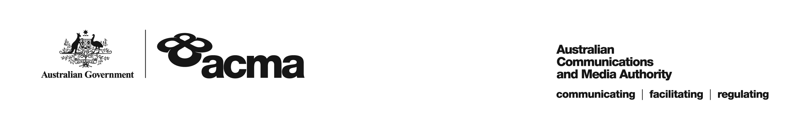

**AUSTRALIAN COMMUNICATIONS AND MEDIA AUTHORITY**

**Target Reduction Order STV-TRO-00102  
made under subsection 130ZY(3) of the *Broadcasting Services Act 1992***

**1. Interpretation**

In this instrument:

***ACMA*** means the Australian Communications and Media Authority

***Act*** means the *Broadcasting Services Act 1992*

***Applicant*** means Foxtel Cable Television Pty Limited (ACN 069 008 797)

***Application*** means the target reduction order application made on 23 December 2020 in respect of the Service

***Service*** means CMT

***Specified Eligible Period*** means 1 July 2020 to 30 June 2021.

**2. Target Reduction**

Under subsection 130ZY(3) of the Act, the ACMA:

(a) having considered the written representations made by the Applicant in the Application, the supporting evidence submitted with the Application and the submission received during the consultation period from 10 February 2021 to 12 March 2021; and

(b) being satisfied that a refusal to make the target reduction order would impose an unjustifiable hardship on the Applicant;

***ORDERS*** that, for the Specified Eligible Period, the reduced annual captioning target for the Applicant in respect of the Service will be 17.5%.

Dated: 22 March 2021