

News in Australia: diversity and localism   
**News measurement framework**

December 2020

Canberra

Red Building   
Benjamin Offices  
Chan Street   
Belconnen ACT

PO Box 78  
Belconnen ACT 2616

T +61 2 6219 5555  
F +61 2 6219 5353

Melbourne

Level 32   
Melbourne Central Tower  
360 Elizabeth Street   
Melbourne VIC

PO Box 13112  
Law Courts   
Melbourne VIC 8010

T +61 3 9963 6800  
F +61 3 9963 6899

Sydney

Level 5   
The Bay Centre  
65 Pirrama Road   
Pyrmont NSW

PO Box Q500  
Queen Victoria Building   
NSW 1230

T +61 2 9334 7700 or 1800 226 667  
F +61 2 9334 7799

Copyright notice

[Creative Commons logo](http://i.creativecommons.org/l/by/3.0/88x31.png)

<https://creativecommons.org/licenses/by/4.0/>

With the exception of coats of arms, logos, emblems, images, other third-party material or devices protected by a trademark, this content is made available under the terms of the Creative Commons Attribution 4.0 International (CC BY 4.0) licence.

We request attribution as © Commonwealth of Australia (Australian Communications and Media Authority) 2020.

All other rights are reserved.

The Australian Communications and Media Authority has undertaken reasonable enquiries to identify material owned by third parties and secure permission for its reproduction. Permission may need to be obtained from third parties to re-use their material.

Written enquiries may be sent to:

Manager, Editorial Services  
PO Box 13112  
Law Courts  
Melbourne VIC 8010  
Email: [info@acma.gov.au](mailto:info@acma.gov.au)

Executive summary 3

Overview 5

The 2019–20 news project 5

Design of a news measurement framework 6

Background 9

Media diversity 9

Localism 14

International approaches to measurement 19

Measurement considerations 21

Defining sources of news and opinion 21

Geographic scales 25

Measuring diversity in news and opinion 27

Measuring availability of local news 32

Measurement framework design 39

Indicators 39

Framework compilation 41

Outputs of a news measurement framework 42

Options for implementation 44

Research activities 44

Repeatability 48

Stakeholder considerations 49

Appendix A – Detailed framework 51

Appendix B – ACMA research methodology 53

Desktop research 53

Stakeholder consultation 53

Indicator matrix and framework design 54

Appendix C – Measurement examples 55

Measures of media diversity 55

Measures of local content 60

Foreword

As Australia’s media regulator, the Australian Communications and Media Authority (ACMA) seeks to identify, monitor and report on changes in the media market. Our research supports us in being responsive to developments in the market and changing consumer expectations.

As a part of our 2019–20 research program, the ACMA began a research project exploring the Australian news environment (the ‘news project’). This research was multifaceted, and included exploring Australians’ attitudes to news, consumption patterns and market changes. We focused our research on 4 topics relating to key public policy objectives and existing regulatory settings for the news and media market: commercial influence, impartiality, diversity and localism.

In early 2020, we released the first tranche of our research on impartiality and commercial influence in news.[1] This included a review of relevant literature and research, and quantitative and qualitative research into Australians’ attitudes on these matters. We also released a discussion paper on impartiality and commercial influence in broadcast news to provide a framework for public consultation on these issues.

As announced on 27 March 2020[2], the news project was suspended alongside other non-urgent activities as we responded to the priority matters raised by the impact of the COVID-19 pandemic on Australia’s communications and media industries.

In recent months, the state of Australia’s media ecosystem and the diversity of voices in media has continued to grow as an issue of public interest. We consider it timely to release our research into measuring news diversity and localism to contribute additional information and insights into this important topic of public discussion.

The current media diversity and localism rules, as set by the Australian Parliament, are limited to commercial television, radio broadcasting and associated newspapers. Diversity, in particular, is measured by the number of ‘voices’ in a market, assessed through ownership and control.

This paper, *News in Australia: diversity and localism – News measurement framework* sets out an alternative framework to measure the current levels of news diversity and the availability of local news throughout Australia.

The Australian news ecosystem has undergone significant structural and operational changes in recent years and in light of the COVID-19 pandemic. While most Australians now have access to a wide range of information sources online, there are concerns about the health and viability of Australia’s news industry. To assess the impact of change in the industry, a holistic view of the contemporary news market, including online and offline sources, is needed.

A measurement framework for diversity and localism could provide greater insight into how Australia’s media ecosystem is changing and contribute to the evidence-base informing the ACMA and policymakers. As part of this work, we explored the use of measurement frameworks for diversity and localism internationally and considered the type of framework that may be suitable for the Australian context.

This paper synthesises the research we completed in the 2019–20 financial year and outlines our thinking on a potential methodology that could be applied to the Australian news ecosystem. It aims to encourage discussion on the type of measurement framework that could feasibly be delivered through an ongoing research program. The paper outlines our views on the potential scope of a measurement framework that may be a better fit for the contemporary media market, indicators for diversity and localism, and research activities to capture this information.

We are not proposing to implement the measurement framework outlined in this paper at this stage. Further consultation and review of the methodology would be necessary to settle on a framework to successfully measure diversity and localism in Australia. Shifts in priorities since the conclusion of our 2019–20 research program have meant that further work on the design of a measurement framework has not been progressed within the 2020–21 research program.

Readers should note that this paper reflects our research and thinking at a point in time. Since the conclusion of our research, Australia’s media ecosystem has continued to change and research activities relating to news diversity and localism have progressed. However, the core issues, regulatory requirements, and overarching market trends discussed in this paper remain relevant to the current public discussion on media diversity and localism.

This paper has been released as part of our News in Australia: diversity and localism package, with additional ACMA research that includes a literature review, qualitative research on consumer attitudes on diversity and localism in news, and a background paper on international regulatory approaches to news diversity and localism.

# Executive summary

News and journalism deliver a range of benefits to society and are an essential component of a well-functioning, pluralistic democracy.[3] In recent years, there have been considerable structural and operational changes across the media industry in Australia, including in the production, dissemination and consumption of news. While this has increased the amount of news and the range of news sources available, it has also led to growing concerns about the influence of digital platforms and the long-term viability of news and journalism in Australia.[4]

As Australia’s media regulator, the Australian Communications and Media Authority (ACMA) seeks to identify, monitor and report on changes in the media market.

These shifts in the media environment may have implications for 2 of Australia’s longstanding regulatory objectives – diversity and localism. In order to properly assess this impact, and the underlying state of the contemporary news media landscape in Australia, a holistic view of the market is necessary.

#### We need to develop new approaches to measuring media diversity

Media diversity laws are a common feature of communications regulation internationally, designed to ensure there is a sufficiently wide range of information and viewpoints delivered across the media market, while preventing any single media voice from exerting undue influence over public discourse.[5] While these regulatory protections do not seek to definitively measure media diversity, they are often used as a proxy for such an assessment.

The news media market and Australians’ news consumption has changed markedly since the introduction of media diversity regulatory requirements. Australians now have access to a wide variety of sources of news and opinion. In addition to ‘traditional’ offline sources of news, a wealth of news content can now be found through the web presence and mobile apps of large media outlets, digital-only news websites, blogs, podcasts, and via social media and third-party news aggregators. As a result, online is now starting to rival TV as the most popular way to consume news in Australia.[6]

In this complex and shifting media landscape, with the increasing influence and reach of digital platforms, new approaches to measuring media diversity are necessary to enable a more nuanced understanding of the extent to which audiences have access to, and consume, a diversity of news and opinion.

#### Concerns about the decline of local news and public interest journalism need to be better understood and quantified

Separately, given the financial challenges facing newspapers and other traditional media outlets, there are growing concerns about the current state and long-term viability of local news in Australia. While local news is highly regarded and valued among communities[7], it is a resource-intensive endeavour, and less likely to be profitable than more ‘mainstream’ news that targets a wider audience and can be   
re-used across different localities and platforms.[8]

A growing body of research has shown a decline in availability of local news over recent years, across both regional and metropolitan Australia. This has raised concerns about the availability of stories that are of civic or public interest, such as those about local governments.[9] Understanding the true extent of these changes, however, is challenging. Data about local news availability is highly fragmented, with most studies to date looking at specific platforms or types of news content, without seeking to map or identify all participants in the market. Further, limited work has been undertaken to identify particular geographic areas of concern or examine what specific factors may be driving these changes.

#### As a part of the ACMA’s remit to monitor changes across Australia’s news market, we are considering how diversity in news and opinion, and the availability of local content, could be measured

This paper outlines our thinking on how a news measurement framework for diversity and localism in Australian news could potentially be designed. The framework is the result of broad consideration of issues across a variety of inputs: a commissioned review of literature and research, commissioned research, desktop research, and stakeholder and academic forums. The design consists of 8 indicators of performance of the news media market, split across the categories of news infrastructure, news output and news engagement. Assessed collectively as a bundle of metrics, this framework could allow the ACMA, the government or others, to baseline and assess both the level of media diversity and the availability of local content in Australia in a way that is both flexible and future-proof.

This project builds on similar news measurement work being undertaken internationally, including in:

the European Union (EU), the Media Pluralism Monitor from the Centre for Media Pluralism and Media Freedom

the United Kingdom (UK), the Measurement Framework for Media Plurality from Ofcom

the United States (US), the News Measures Research Project from the Dewitt Wallace Center from Media and Democracy at Duke University, North Carolina.

# Overview

## The 2019–20 news project

One of the key strategic priorities of the ACMA is to monitor market changes and influence regulatory responses.[10] In 2019, we commenced work on a cross-agency research project on the Australian news market. The purpose of our news project is to examine whether existing safeguards around news and journalistic content are continuing to meet community expectations and support an open, pluralistic democracy in Australia.

The news project comprises 2 discrete elements, each with different conceptual focus areas. The first element is focused on an examination of the concepts of impartiality and commercial influence in broadcast news media, and the appropriateness of current community safeguards and co-regulatory arrangements. Public consultation on this work began in January 2020, with the publication of the [*Impartiality and commercial influence in broadcast news*](https://www.acma.gov.au/consultations/2020-01/impartiality-and-commercial-influence-broadcast-news-consultation-022020)discussion paper, and closed late February 2020.

Since the publication of the discussion paper and associated research, a number of developments occurred that further affect the production and distribution of broadcast news content. In particular, the COVID-19 pandemic led to a sharp increase in audiences turning to ‘traditional’ media sources for accurate news and information. However, there has been a contradictory downturn in advertising revenue, which has resulted in significant financial pressure on the broadcasting sector, especially in regional areas.[11] While the aims of this work remain important, we have deferred consideration of these matters due to current industry pressures relating to COVID-19. We intend to recommence this work at an appropriate time.

The second element of the news project is focused on the production, dissemination and consumption of news across the Australian media. This allows us to analyse the extent to which changes in the news media market have impacted on:

the diversity of news services across Australia

the availability of local news services.

As a part of this work, we researched and considered how a ‘news measurement framework’ could be designed. A contemporary approach to measuring media diversity and localism could provide a better understanding of which news outlets ‘speak with the loudest voice’ in a cross-platform digital media environment, as well as the availability of local news. This could help inform future debate and government decision-making on what, if any, safeguards or interventions are needed to ensure a competitive, sustainable and diverse news media environment well into the future.

To support this work, the ACMA has developed the following publications:

*News in Australia: diversity and localism – Review of literature and research*

*News in Australia: diversity and localism – Qualitative research*

*News in Australia: diversity and localism – International comparison*s*.*

This paper outlines the findings of our research into news measurement approaches and a potential news framework design that could be adopted in the Australian context. While there is no universally accepted method for measuring either diversity or localism in news, our methodology has been informed by extensive research into international measurement approaches. This has included an international comparative regulatory analysis of diversity and localism measures, and a detailed review of alternative news measurement approaches and their potential applicability in the Australian context.

We have also consulted with subject-matter experts across government and academia on measurement issues, including through a series of targeted stakeholder workshops and one-on-one discussions. Further details about the research methodology and consultations are outlined in Appendix B.

## Design of a news measurement framework

In seeking to assess the state of diversity and localism across the news media market, we identified a number of key measures that we consider necessary to support a robust examination. As illustrated in Figure 1, key measures of diversity include source diversity, content diversity and consumption (or exposure) diversity. For localism, these include connection, originality and civic journalism.

Key measures of diversity and localism

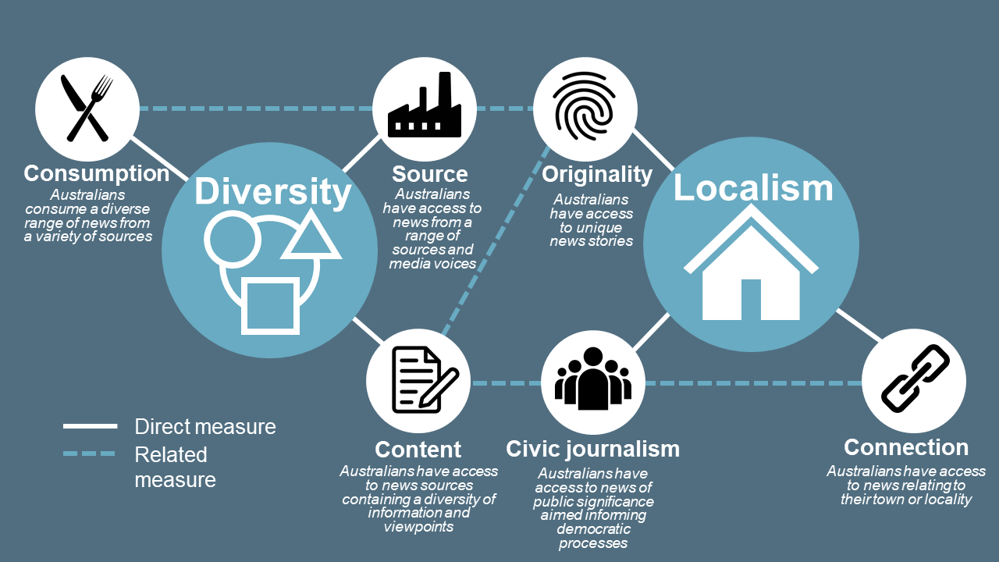

Although the ACMA’s regulatory remit focuses on broadcasting, we considered it necessary to examine all forms of professional news produced in Australia – across print, TV, radio and online –to understand the breadth of changes occurring across the market and to future-proof this work.

We have outlined a series of 8 measurement indicators of diversity and localism in news below. These could make up the primary structure of a news measurement framework in Australia, and have been selected based on their simplicity, replicability, efficiency, and the extent to which they have been tested in other jurisdictions and measurement models.

Indicators of diversity and localism

|  |  |  |  |
| --- | --- | --- | --- |
| **Category** | **Indicator** | **Framing question** | **Measure** |
| **News infrastructure** | Availability of sources | What sources of news and opinion are available to Australians? | Source diversity  Connection |
|  | Availability of journalists | How many journalists contribute to the production of local news? | Source diversity  Originality  Connection |
|  | Number of owners | How many people exercise control over Australia’s most influential sources of news? | Source diversity |
| **News content** | Range of topics | How much variety is present in Australia’s news media market? | Content diversity  Originality |
|  | Range of viewpoints | How many viewpoints are presented in Australia’s news media market? | Content diversity  Civic journalism |
|  | Local relevance | To what extent does local news cover matters of local significance? | Content diversity  Connection  Civic journalism |
| **News engagement** | Consumption | What are the most consumed sources of news in Australia? | Consumption diversity  Civic journalism |
|  | Impact | What are the most impactful sources of news in Australia? | Consumption diversity  Civic journalism  Connection |

As outlined later in this paper, each of these indicators would assist in the measurement of different aspects of diversity and localism. Collectively, these indicators could provide a valuable data set, allowing for a comprehensive analysis and assessment of the performance of the news media market in Australia. More information about the indicators is in Appendix A.

These indicators could be used to inform several key outputs, including:

the establishment of a news diversity baseline that, in addition to diversity of ownership and control, would also seek to examine diversity of content and consumption over time

a standalone assessment of the volume of local news and factors driving local news production

a comprehensive database and map of local news availability across Australia.

In order to capture the necessary data to inform these outputs, several key activities are suggested. Figure 2 demonstrates how these various components interact.

News measurement framework overview

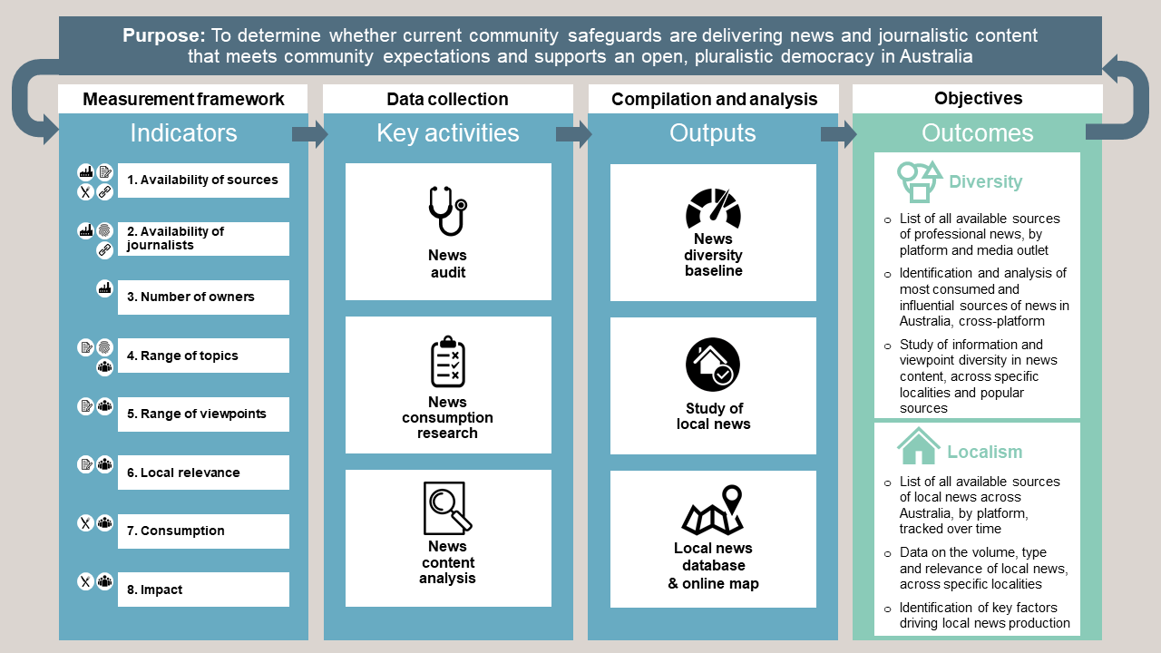

# Background

## Media diversity

Media diversity (or media plurality[12]) is a core objective of communications regulation around the world. Governments regularly place restrictions on who can own and control media outlets, and demand heightened public scrutiny over mergers and acquisitions involving media companies. Media diversity objectives are also promoted through other forms of regulatory intervention. These can range from specific content obligations on publicly funded broadcasters, to subsidies for the production of broadcasting content that promotes specific diversity objectives.

The underlying rationale in seeking to protect and promote media diversity relates to the unique role of the media (particularly news outlets) in informing citizens, reporting on institutions and their actions, supporting community cohesion and contributing to a well-functioning, pluralistic democracy. In the absence of any form of intervention, entire media markets could theoretically be controlled by a single individual or company, limiting the range and types of media voices available in the market. This, in turn, could provide media owners or controllers with excessive influence over the news agenda, public opinion and political discourse.

In Australia, media diversity is explicitly recognised among the objects of the *Broadcasting Services Act 1992* (BSA), signalling the intent of parliament to ensure the availability of a diverse range of broadcast content and diversity in the control of the more influential broadcast services.[13] These objects are primarily enacted through Australia’s media diversity and ownership rules, which place limits on who can control commercial TV and radio broadcast licences.[14]

#### Australia’s primary media ownership and control rules

|  |  |
| --- | --- |
|  | **‘5/4’ rule (the ‘minimum voices rules’):** As a constraint on mergers and acquisitions, at least 5 independent media ‘voices’ must be present in metropolitan commercial radio licence areas (the mainland state capitals), and at least 4 in regional commercial radio licence areas. |
|  | **‘1-to-a-market’ TV rule:** A person, either in their own right or as a director of one or more companies, must not be able to exercise control of more than one commercial TV broadcast licence in a licence area. |
|  | **‘2-to-a-market’ radio rule:** A person, either in their own right or as a director of one or more companies, must not be able to exercise control of more than 2 commercial radio broadcast licences in a licence area. |

Diversity measures also feature in several broadcasting codes of practice, requiring, for example, that public broadcasters present a diversity of views and perspectives in their news coverage[15],commercial radio stations include alternative viewpoints when covering controversial issues in current affairs programs[16], and community radio stations provide access to views not adequately represented by mainstream broadcasters.[17]

The ACMA oversees these regulatory settings, including advising parties on their disclosure and notification requirements, maintaining media ownership and control registers and investigating alleged breaches of the media diversity rules.

### Rationale for examination

Building on previous work by the ACMA, the 2016 Department of Communications and the Arts’ Review of the ACMA identified that ‘diversity of voices’ was one of the enduring policy concepts for Australian communications and media markets, noting that:

There should be a diversity of major information sources and perspectives expressed in the public sphere to foster and informed citizenry and healthy democracy.[18]

While raising concerns about a ‘misplaced emphasis’ in the regulation of legacy outlets to meet public policy objectives, the review noted that the regulatory concept of ‘influence’ does not consider new forms and suppliers of communications and media content, or new patterns of consumer behaviour.[19]

Research published by the ACMA shows that online now rivals TV as the most popular way to consume news.[20] Given many of the key media diversity safeguards pre-date the internet, debate has intensified over recent years as to the impact of the digital news environment on media diversity. On one hand, there is the view that online news has significantly improved the state of media diversity by providing Australians with access to a virtually endless stream of news content.

This view was expressed by focus group participants in qualitative research commissioned by the ACMA in 2019 as part of the news project[21]:

|  |
| --- |
| Since the online explosion there is so many different places, even if you just Google, you’ll get 50 million … Whereas before you had a newspaper and you had a TV channel and word of mouth down the pub or at golf or whatever. Now days you can get it from anywhere.[22]  *Interview participant, Emerald, 35–54 years,  medium-high media consumption* |

The wide availability of online news was also one of the reasons behind the repeal of 2 of Australia’s media control and cross-ownership rules in 2017.[23] This was in recognition that online media was no longer viewed as distinct from traditional media platforms, and that audiences could ‘discover and access news from multiple sources across a range of media platforms, including online, social media, TV, radio and newspapers’.[24]

However, in a news environment defined by an abundance of information and potential news sources, there is a divergent view that the influence of outlets should not be defined purely by an examination of what is available and who owns them, but also by what audiences are actually consuming. The News and Media Research Centre at the University of Canberra, for example, noted:

In an era now characterised by the networked distribution of news-based media content and a scarcity of news consumer attention for – rather than a scarcity of access to – this content, it is no longer appropriate to assume a relationship between number and diversity of news sources and the health of liberal democratic society. To put it another way, simply having access to a diverse range of sources of news is not a sufficient measure of the health of society. Access does not lead to consumption, let alone the critical engagement required of citizens to develop a functioning democratic public sphere.[25]

A similar view was expressed by Ofcom in its 2012 advice to the UK Government, which led to the development of its media pluralism measurement framework that continues to be used today:

Adopting a count of the number and range of media enterprises, without taking account of their ability to influence opinion would mean that all news and current affairs providers would be included as contributing to plurality simply by being available, regardless of whether they were used by several million or very few consumers. We [do] not believe this approach to be credible.[26]

We do not currently have robust evidence to measure the extent to which, if at all, the internet has resulted in a wider variety of news content being consumed in Australia. There are, however, some indications that many Australians lack diversity in their ‘media diets’. Roy Morgan Research survey data suggests that most Australians still rely heavily on a small number of traditional print and broadcasting outlets when seeking online news content.[27] International research has also highlighted, when compared against 36 other countries, online Australians are among the ‘lightest’ news consumers and also access fewer sources of news than their international counterparts.[28]

This may be, in part, due to a perceived lack of originality or diversity within much of the online news content available in Australia. The re-use, licensing and syndication of news content across platforms and media groups is a key characteristic of the contemporary news market[29], and has been raised by some consumers as a matter of concern and frustration, including through qualitative research commissioned by the ACMA in 2019:

|  |
| --- |
| Participant: ...it’s very repetitive.  Participant: Yeah, there’s a lot. So, I'm like sure there’s enough numbers but it doesn’t mean the quality is as good, so to answer your question, satisfied sure because there’s lots but not satisfied because I don’t…  Participant: I would say overwhelmed but not satisfied.  Participant: Yeah, that’s a good way to put it.  Participant: There really isn’t like diversity, like if one catches a story they’ll pretty much all follow, so you don’t really get, well I don’t really see many different things, see it here you’ll generally see it in the other sources.[30]  *Group participants, Perth, 18–34 years,  low-medium news consumption* |

Despite this perceived lack of original news content, Australians are increasingly using online sources to access news, driven in part by the popularity of social media. Almost half of online Australian news consumers access news via social media, with just under 1-in-5 nominating social media as their main source of news – after TV at 42% and online news at 25% (see Figure 3).[31]

Main source of news among online Australians (%)

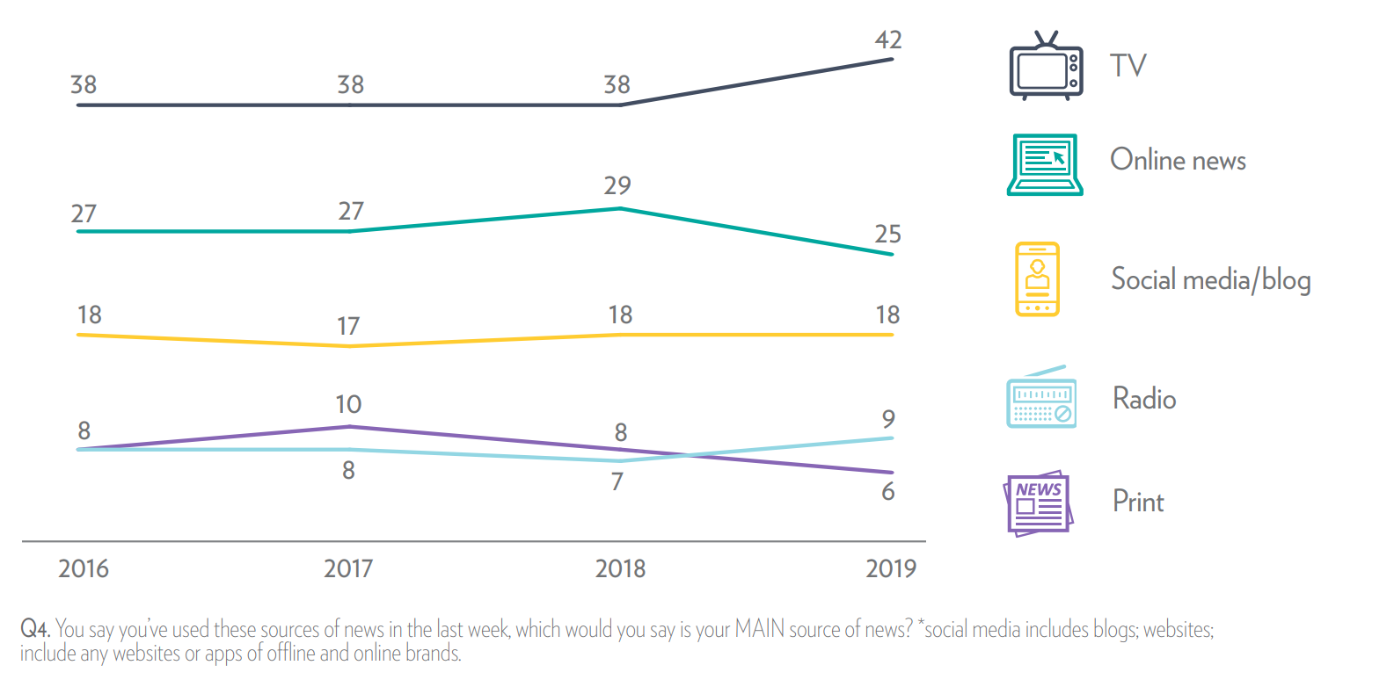

Source: Fisher, C., Park, S., Lee, J., Fuller, G. and Sang, Y., [Digital News Report: Australia 2019](https://apo.org.au/node/240786), News & Media Research Centre, University of Canberra, 2019. p. 26.

News on social media is unlike other mediums. Designed to keep users engaged and on the platform, embedded algorithms on these sites rank and select news content for users based on their social circles, interests, likes and dislikes. While this arguably has positive benefits in exposing users to a greater number and variety of news sources, it also raises concerns that passive users of these platforms could become caught in so-called ‘filter bubbles’ or ’echo chambers’ of like-minded people with a similar set of viewpoints or opinions, despite having access to a wider range of news content.[32]

Another concern about the consumption of news on digital platforms relates to the rise of ‘clickbait’ journalism and deluge of easily sharable sensationalised or ‘fake news’ stories. These are stories designed to elicit an emotional response and be accepted without critical examination. This has led to declining levels of trust in news content posted on digital platforms and higher levels of news avoidance.[33] These behaviours highlight some of the contradictions and complexities of examining media diversity in the digital age and the need to better understand news consumption behaviours, including the influence of social media and news aggregators.

A contemporary approach to measuring media diversity, involving an assessment of content and consumption as well as ownership, could provide a better understanding of which news outlets ‘speak with the loudest voice’ in a cross-platform digital media environment. This could help inform future debate and government decision-making on what, if any, safeguards or interventions are needed to ensure a competitive, sustainable and diverse news media environment in the future.

## Localism

Local news content is highly valued by Australians. Consumer research commissioned by the ACMA in 2016 found that 86% of regional Australians considered local news important[34], and a Roy Morgan Research survey commissioned by the Australian Competition and Consumer Commission (ACCC) in 2018 found local news was regarded as the most important genre of news content in ‘allowing people to participate and engage in Australian society’ (71%), ranking slightly above national news (70%) and Australian politics (65%).[35]

Local news in Australia has traditionally fulfilled 2 key roles. The first is in helping to build community identity and cohesion. It does this by keeping residents informed about matters of local interest or significance, promoting and covering community events, and serving as a de facto advocate for the locality and its people. Compared to national or state news coverage, local news reporting is viewed particularly favourably in regional Australia, with stories less likely to be perceived as overly negative or sensationalised.[36] The importance of the social cohesion aspect of local news was raised by participants during the ACMA’s commissioned qualitative research:

|  |
| --- |
| I think it fosters a sense of community, I think so like a local community newspaper is all about the local schools, they just did this like art and crafts sale, it’s kind of, you know, you can be like my kids are in that or you know, so and so is my hairdresser and it’s that kind of, you can relate to it a lot more.[37]  Group participants, Perth, 18–34 years,  low-medium news consumption |

The second important role of local news is in facilitating the local production and distribution of civic or ‘public interest journalism’, defined by the ACCC as ‘journalism with the primary purpose of recording, investigating and explaining issues of public significance in order to engage citizens in public debate and inform democratic decision making at all levels of government’.[38] This could include reporting on the actions and decisions of local or state governments and courts, or on matters of general civic importance to the community such as health, education and crime.

Our qualitative research also found support for this aspect of local news. Among the focus group participants, there was broad appreciation of the role of local news in keeping informed about the happenings in their local area:

|  |
| --- |
| Well just being in the know, not finding out later that a decision has been made and you haven't been aware that it was being spoken about.[39]  Group participant, Burnie, 35–54 years,  low-medium news consumption  Yeah, community events, what the local government’s up to, especially state government, things that will directly affect me, all factors in general …[40]  Group participant, Burnie, 18–34 years,  medium-high news consumption |

These 2 roles are broadly reflected in the objects of the BSA, which signal the intent of parliament for audiences across Australia to have access to local broadcasting content.[41]

Under the BSA and related legislative instruments, regional commercial TV and radio broadcasters have statutory obligations to provide minimum levels of ‘local content’ within applicable licence areas.[42] Local content may include material that is produced in, hosted in or relates to a local area, as well as material that is associated with or affects people, organisations, events or issues in a local area. Some examples of local content include local news, local sport, local weather and material related to local business activities or local community events.

#### Examples of broadcasting local content obligations

|  |  |
| --- | --- |
|  | **Commercial free-to-air TV broadcasters in regional areas:** Licensees must show a minimum of 720 points of material of local significance per 6-week period (unless subject to a trigger event). |
|  | **Commercial radio broadcasters in regional areas:** Licensees must broadcast a minimum level of local content from 5 am to 8 pm each business day, of either 30 minutes for small licence holders in areas with less than 30,000 people, or 3 hours for all other relevant licences (unless subject to a trigger event). |

These regulations help safeguard the production of local content – particularly local news bulletins – in an increasingly challenging operating environment. Indeed, as part of the 2017 media reforms, the government expanded the local content requirements for commercial broadcasters to capture more media outlets and require more local content to be produced. The rationale behind these changes were discussed in the second reading speech of the Bill:

In the absence of regulation, the high costs of local content production and the structural changes underway in the media more broadly will create incentives for broadcasters to achieve efficiencies, placing pressure on the continued supply of local programming at current levels.[43]

These economic pressures are similarly impacting on publishers and print journalists, who are also facing significant and sustained decline in advertising revenue.[44] In 2018, the government established a $60.4 million package over 3 years, designed to help small metropolitan and regional publishers adapt to the challenges they face in the contemporary media environment, create employment opportunities for cadet journalists, and support regional students to study journalism.[45]

The ACMA is responsible for administering, monitoring and enforcing the various local content obligations under the BSA, including investigating alleged breaches of these rules, as well as administering the Regional and Small Publishers Innovation Fund.[46]

### Rationale for examination

As with the broader legacy media market, local media outlets face the challenges of adapting to changing business models and a reduction in advertising revenues brought on by the rise of digital competition. This has resulted in a variety of consolidations, cutbacks and local newsroom closures over the last decade, impacting unevenly across Australia, and reducing the ability of local media in some areas to meet the needs of local communities.[47] Figure 4 highlights some of the recent changes to the Australian news media market that have affected local news production and distribution.

Summary of key changes in the Australian local news media market

While still relatively high, the number of regional Australians who report having access to sources of local content about their local area has fallen in recent years, across local print (down 6 percentage points from 2013 to 2016), commercial radio (down 5 percentage points), commercial TV (down 6 percentage points) and local ABC radio (down 11 percentage points).[48] There has also been a decline in the number of regional Australians who report having access to all the local content they want (from 91% in 2013 to 78% in 2016).[49] These findings are supported by ACCC research showing a long-term decline in the number of regional newspapers in operation across major publishers, shown in Figure 5 below.[50]

Total number of unique newspapers from 2008–09 to 2017–18

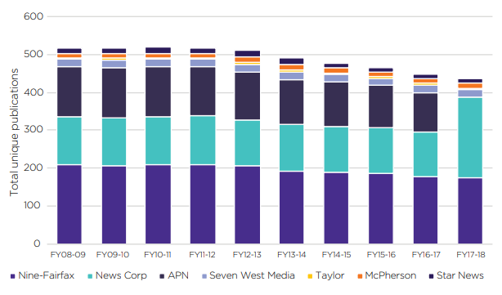

Source: Australian Competition and Consumer Commission, Digital Platforms Inquiry – Final Report, 2019, p. 562.

A decline in the volume or presence of traditional local media could have a negative impact on community cohesion; however, this may be partly offset by the rise of digital news sources and the increased use of social media for accessing local news in regional communities. According to the Centre for Media Transition, almost 2-in-5 regional news consumers gain local news from social media at least once a day.[51] Hyperlocal media is also emerging among some communities as a source of local events and human-interest stories.[52] However, it is unclear whether all communities are or will be adequately served by alternative local news sources.[53]

Several Australian studies, including by the Public Interest Journalism Initiative (PIJI) and the ACCC, have highlighted a decline in public interest stories and ‘hard’ journalism in localities across Australia, both in regional and metropolitan Australia. A 2019 survey of local governments by the PIJI, for example, found a reduction in the number of journalists fulfilling the important accountability or ‘local watchdog’ function, with almost a third of councils reporting that no journalists attend local government meetings, resulting in many of their activities going unreported.[54] The ACCC similarly found that, between 2010 and 2018, there had been a decline in the number of articles in major Australian newspapers on topics relevant to the provision of public interest journalism, like local government, local courts, health and education.[55]

Given continued economic pressures on media outlets to cut costs, the PIJI survey also raised concerns that some local journalists are covering stories across a larger number of localities without an equivalent increase in resources, restricting their capacity to undertake high-quality journalism and leading to high rates of turnover.[56]

In response to the changing news environment and the apparent decline in local news in some communities across regional Australia, a comprehensive analysis of the availability of local news content would support a better understanding of the market and help to identify particular areas of concern.

## International approaches to measurement

The widespread disruption to the news media market is not unique to Australia. Governments, regulators and academics around the world also have been grappling with questions of how to assess media diversity in a contemporary media landscape, and concerns about the availability and sustainability of local news content. Although no universally accepted measurement methodology has emerged to provide a clear path forward, a number of existing international measurement frameworks and research projects may be of relevance in the Australian context. A summary of these is provided below, with further detail outlined in Appendix C.

### United Kingdom

*Measurement Framework for Media Plurality*: Following concerns about media market concentration, Ofcom was requested by the UK Government to develop a framework for measuring media pluralism. The UK measurement framework, which was finalised in 2015, has 4 key categories: availability, consumption, impact and contextual factors; combining a series of quantitative and qualitative metrics, including from Ofcom’s annual news consumption survey. The measurement framework is primarily used in the context of public interest tests, helping inform media merger and acquisition decisions.

### European Union

*Media Pluralism Monitor* *(MPM)*: The MPM is an attempt to offer a holistic, risk-based approach to the measurement of media pluralism. First established in 2009, and co-funded by the European Commission, the MPM employs an expansive definition of media plurality across 4 risk areas: basic protection, market plurality, political independence and social inclusiveness. Based on a detailed survey completed by a team of academics in each country, the MPM acts as a regular audit of the EU’s performance on media pluralism, identifying growing risks and facilitating a direct comparison between the 28 member countries.

### South Korea

*Committee on the Impact of Media Concentration*: In 2010, in response to the changing media environment, the Republic of Korea (South Korea) established the independent Committee on the Impact of Media Concentration to examine the level of concentration of media influences on the formation of public opinion. The committee consists of professionals from across industry and academia, who examine levels of news consumption and influence. Usage concentration is tracked annually, using a series of indexed measures to monitor changes within and across different media sectors.

### United States

*Diversity Index*: In 2003, the US Federal Communications Commission (FCC) implemented a new analytical tool designed to assess the degree of consolidation in local media markets and guide decision-making on cross-media ownership and diversity regulation in a changing media environment. The Diversity Index (DI) merged traditional media concentration data with information on consumer preferences for accessing local news. The FCC used the DI to identify ‘at risk’ localities; however, this was challenged in the courts and eventually struck down due to insufficient justification.

*The Expanding News Desert:* Researchers from the University of North Carolina have compiled a database of more than 9,000 local newspapers and have been tracking key metrics about these publications since 2004 to identify communities without newspapers or access to information that feeds grassroots democracy. More recently, the study has also expanded to include ‘ghost newspapers’, or publications that no longer provide the kind of local news information they once provided, due to shrinking newsroom staff or restructuring and mergers.

*News Measures Research Project:* Researchers from Duke University have developed a series of local journalism assessment tools to help academics and policymakers assess the nature of journalistic content; the needs, interests, and preferences of local news audiences; and the health and rigour of the local news infrastructures in communities. One of the major outputs of the project is a scalable measurement model for assessing the availability of local journalism across communities, including whether the available local journalism is meeting community information needs.

### Canada

*Local News Research Project*: Researchers from Ryerson University have been tracking the closures and mergers of local newspapers, broadcast outlets and online news sites across Canada since the recession of 2008. In 2016, the Local News Research Project launched an online map that visualised this data, and invited academics, journalists and citizens to add additional information about local news sources using crowdsourcing tools. With its active community of researchers and volunteers, the map has become a useful tool in tracking ‘local news poverty’ across Canada.

# Measurement considerations

In undertaking this project, we explored the design of a news measurement framework that could provide a robust and meaningful examination of both diversity and localism, while also being easily comprehensible, replicable, achievable and cost-effective. With these objectives in mind, this chapter outlines some of the preliminary measurement considerations that informed the measurement framework design outlined in the next chapter.

## Defining sources of news and opinion

|  |
| --- |
| To assess the levels of diversity and localism in the Australian news market, it is important to look beyond the broadcast media and newspaper industries. The measurement framework should include all news platforms – traditional and digital – and account for the role of news aggregators and social media.  A flexible definition of news and opinion, capturing both ‘hard’ and ‘soft’ news stories, should be used while excluding content that is primarily designed to entertain rather than inform.  News sources should only be included if they have an ongoing local presence or attract a high level of consumption within Australia. Examination should also be limited to ‘professional’ sources of news and opinion, thereby excluding most citizen journalism. |

‘News’ has changed considerably since the introduction of the BSA. Where once the news market could be defined exclusively by the content produced by a limited number of newspaper, TV and radio journalists, the information age has lowered barriers to entry, bringing with it novel business models and new ways to create, disseminate and consume news. This has led to the blurring of lines between producers and consumers, and between news, opinion and entertainment.[57]

With the expansion and ‘democratisation’ of news, where anyone can theoretically comment on or contribute to a news story, the first challenge of a ‘news market’ measurement study is deciding what sources should be included and excluded.

One approach considered was adopting a functional definition of the news market, limiting the focus to ‘public interest news’ like in the UK Cairncross Review[58], or the ACCC’s definition of ‘public interest journalism’ as outlined in its Digital Platforms Inquiry.[59] This approach acknowledges that not all forms or types of news have equal weight or importance in society, and that government intervention may be most justified when improving access to ‘hard’ news, or the types of news required to support democratic processes. Indeed, the Australian Government’s Regional and Small Publishers Innovation Fund was specifically designed to fund initiatives that ‘support the availability of Australian civic journalism’.[60]

On balance, however, we believe that a broader and more flexible definition of the news market capturing both hard and soft types of news would be necessary. This is in recognition of the broader role of ‘lighter’ news in building social cohesion and community identity, which is relevant to an examination of both diversity and localism. Softer news also plays a significant role in supporting the viability of commercial news outlets, as stories on lighter topics such as sports, local events and celebrity gossip are often more popular than ‘hard’ news and therefore helps to drive sales and advertising spend.

#### Hard vs soft news

|  |
| --- |
| In journalism studies, news stories are often categorised according to whether they are ‘hard’ or ‘soft’. Hard news stories are usually timely, important and consequential, involving topics like politics, economics, international affairs or matters considered to be in the ‘public interest’.[61] By contrast, soft news stories are more closely aligned to social or cultural news; these are ‘lighter’ in nature and typically have lower substantive informational value, covering topics such as celebrities, entertainment, lifestyle, sports or human-interest pieces.[62]  While this distinction is simplistic, and not all news stories can easily fit into one of these categories, it is nevertheless a relatively easy means by which researchers are able to assess what kinds of news are being produced and how news is presented in a given market. Noting the widespread use of these terms within the literature, we have chosen to adopt these categories in this paper. |

To capture both hard and soft news across platforms, all sources of professional news and opinion in Australia could be examined across TV, radio, print and online sources (see Table 2).

Categories of news and opinion

| **Platform** | **Source** | **In-scope** |
| --- | --- | --- |
| **TV** | * National public TV * Commercial free-to-air TV * Pay TV * Community TV | News and current affair programs primarily designed to inform and/or facilitate public debate |
| **Radio** | * Public radio * Commercial radio * Community radio * Podcasts | News programs, news bulletins and talk-back radio programs focused on discussing the news of the day and/or facilitate public debate |
| **Print (offline)** | * National/state newspapers * Regional/local newspapers * Free daily/weekly newspapers | Newspapers (or other physical publications) that report on topical news and opinion and are published on a regular basis |
| **Print (online)** | * News websites * News apps * Email newsletters | Online websites or mobile apps of broadcasters, print outlets, or  stand-alone digital native news outlets that publish topical stories on a regular basis |
| **Digital platforms (online)** | * Social media (for example Facebook, Twitter, YouTube) * News aggregators (for example Apple News, Google News) | Social media presence of broadcasters, print outlets or stand-alone digital native news outlets, in addition to news stories from these outlets circulated on Apple News and Google News |

Despite embracing a broad definition that captures both hard and soft news, we consider that some professional sources of news and opinion should nevertheless be out of scope. Specialised industry or trade publications, as well as entertainment-oriented publications or programs entirely dedicated to topics like celebrity gossip, fashion or lifestyle, could be excluded due to their limited relevance in either shaping public opinion or supporting community cohesion. However, recognising the line between news and entertainment may at times be blurred, particularly when examining sources of commentary or opinion, we would seek to align with existing regulatory definitions where possible if this work was undertaken. Generally, we consider that sources of news and opinion should be included if their predominant purpose is to present factual, new information, analysis or discussion on current events, but not if their predominant purpose is to entertain.[63]

### Defining ‘professional’ sources

Limiting examination to professional sources of news and opinion would help maintain a manageable scope for measuring news diversity and localism. A professional news organisation may be defined as any outlet that:

maintains independence from those it covers

demonstrates a commitment to accuracy, transparency and journalistic ethics

is devoted primarily to reporting and publishing timely, originally produced news or informed opinion about people, places, issues and events.[64]

Independent or hyperlocal sources of journalism that meet the definition of professional journalism could also be considered (for example, Carol Altmann’s The Terrier[65] and Michael West’s independent news website[66]). By contrast, other participatory or citizen-led journalism sources, such as personal blogs, community-run Facebook groups or comments on social media would not meet the above definition. This definition would also exclude advocacy-style journalism from peak industry groups or bodies, PR firms, lobby groups or non-government organisations, as well as news stories that are directly produced or distributed by government bodies, including local councils.

### Treatment of international sources

A measurement framework could capture information about all locally produced, professional news outlets. This would include online-only sources of news like the Guardian Australia, which despite being entirely owned by the UK Guardian Media Group, has a significant local presence with a large team of embedded local journalists, editors and producers. Similarly, this examination could include international news agencies or newswires that employ local journalists on an ongoing basis, despite these organisations not directly publishing news in Australia.[67]

International sources of news without any ongoing local presence, like the Washington Post, may ordinarily be excluded from examination within an Australian news measurement framework project. This would allow for a more manageable scope based on the news sources that are most likely to inform Australians and impact the daily news cycle. Other international sources of news could be incorporated, however, if consumer research indicated a particularly high level of popularity, consumption, or reliance among Australians.

### Treatment of social media and news aggregators

News consumption via social media, news aggregators or other third-party intermediaries present a unique challenge for measurement. Firstly, these platforms are not considered to be media outlets or news publishers, yet they wield considerable and growing influence over the news diets of their users. Secondly, the ‘atomisation’ or story-by-story presentation of the news on digital platforms, while exposing consumers to a wider variety of news sources, has the effect of weakening the relationship between outlet and reader. This makes it more difficult for consumers to recall or critically assess news sources based on quality and credibility[68], and also presents challenges for researchers attempting to identify the types and sources of news that are being consumed on these platforms.[69]

There is also considerable variation in the level and types of engagement with news on social media and via news aggregators. The majority of news consumption on social media occurs on a smartphone, and tends to be more incidental or passive in nature, driven through the design of newsfeeds that promote incidental scrolling and swiping behaviours rather than proactive searching and exploration.[70] At the other end of the spectrum, social media also encourages greater levels of participatory journalism, allowing users to actively engage with articles on social media, from reacting, to commenting and sharing news stories of interest among their friends and family. This variance makes it difficult to determine the impact and influence of news distributed on digital platforms.

For these reasons, we consider that social media should be considered as a distinct category of news platform within a news measurement framework; noting, however, that examination of news content should still be limited to the posts of professional news outlets (for example, through a branded Facebook page or Twitter account). Although public figures can use Twitter to instantly share newsworthy information to millions of people, this form of mass communication would not generally be categorised as ‘professional’ news under the definition outlined above, as it lacks independence, may not adhere to professional ethics, and generally does not contain any analysis or reporting.

Like social media, third-party news aggregators like Google News or Apple News wield similar control over the news diets of their users and are similarly problematic in terms of measurement. According to recent research, aggregators represent the least popular means of accessing online news in Australia, with only 7% of online Australians reporting aggregators as their main pathway for accessing online news, compared to 39% searching or going directly to a brand, and 24% using social media.[71] Despite the relative low levels of consumption currently, we consider that news aggregators should be included in this type of examination in order to adapt to changes in the market and help future-proof the approach to measurement.

## Geographic scales

|  |
| --- |
| A news measurement framework should seek to examine news availability and consumption at differing geographic scales – national, state and local. Practical considerations will help guide which elements of diversity and localism should be assessed at which scale. |

There is an inherent geographic dimension to all news production, dissemination and consumption. Some news sources appeal to a broad audience, with stories of national (or international) relevance or importance. At the other end of the spectrum, some outlets seek to target a much smaller audience, with a greater focus on news stories only of interest to a region, town or community, such as community events or local politics.

In a similar vein, the levels and relative strength of both news diversity and localism can be assessed at various geographic scales – from a national to a local lens. For a measurement framework to support a holistic examination of the media market, including helping to identify areas and localities of potential concern, it is important to consider the differences in performance across a variety of geographic scales.

It may not, however, be practical to measure all elements of diversity and localism at all possible levels of geography. For example, while the financial data of a company could be relied upon to help assess its market share or concentration level, this information may only be attainable at a national level and may not even exist for a more localised area. As such, geographic scale is an important consideration in the development and design of a news measurement framework. As discussed in later sections, each of the indicators for diversity and localism we’ve considered has an accompanying geographic dimension – be it nationally representative (such as a nationwide audit of news sources) or based on a collection of individual localities (such as a study of local news content in a series of communities). Figure 6 below highlights our thinking on an approach to measurement across national, state and local scales.

Geographic scales for measuring news diversity and localism

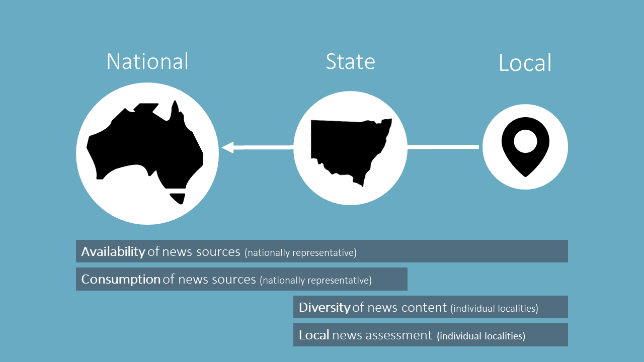

### National

At a national level, both the availability and consumption of news sources could be assessed. As discussed below, this would provide a comprehensive dataset of all professional news sources in Australia, in addition to consumption information on the most popular or impactful sources of news across Australia. Collectively, this data could be used to help construct a national diversity baseline, which could be tracked over time.

A national lens is important for 2 reasons. First, much of the available industry data, like revenue, is reported on a national basis. Second, an Australia-wide view is the most appropriate scale for examining the consumption and potential influence of online sources of news, which have no easily defined geographic bounds. Many of the international studies into media plurality are also conducted at a national level, allowing for greater levels of comparability.

### State

A state-level examination of diversity and localism is also important, as much of Australia’s media and newsrooms are located across the state capitals, and Australia’s mainstream press publications have traditionally maintained a heavy state-based focus.

Part of a state-level assessment can be based on a ‘top-down’ approach, where existing national data is disaggregated. We envision that availability and consumption information obtained at a national level, for example, could be broken down and analysed at a state or territory level, which may help highlight regional or geographic differences.

Separately, some generalised insights may be able to be formed through ‘bottom-up’ analysis, aggregating data from individual localities or regions. Further, while the focus of the localism examination is on the health and performance of local news outlets and their journalistic output, state-based publications and media outlets will also frequently report on stories that are about – or of direct relevance to – a particular local community. As such, a selection of the most popular state-based news sources could be included in an analysis of local news outlets and their news content for comparison purposes.

### Local

As discussed below, the ‘local’ geographic scale could be based on local government areas (LGAs), with a sampling approach used to assess the levels of local news content present in local news outlets across a limited number of LGAs (around 20). The sample of LGAs should be chosen to ensure a mix of socio-demographic and geographic factors.

#### Analysing data by geotype

|  |
| --- |
| A ‘geotype’ refers to a specific geographic category or type of locality based on common characterises, like the level of regionality or the population density. The use of geotypes could be helpful in examining and analysing differences in the availability of news between LGAs, and in drawing some generalised conclusions about local news production.  The Australian Classification of Local Governments (ACLG) may be a useful guide, as it classifies each local government into one of 22 categories according to its population, population density and the proportion of the population classified as urban. From the ACLG, it is possible to characterise all LGAs against 5 broad and distinct ‘geotypes’ – Urban Developments, Urban Fringe, Urban Regional, Rural Agricultural and Rural Remote. |

## Measuring diversity in news and opinion

|  |
| --- |
| Media diversity safeguards support democratic processes by ensuring consumers have access to a variety of viewpoints, while simultaneously preventing any one voice from having a disproportionate amount of influence over public opinion or political discourse.  Current media diversity laws seek to prevent excessive market consolidation, on the assumption that a greater number of owners and controllers will result in more sources and greater content diversity.  The internet has undermined traditional assessments of media diversity, as consumers now have access to an expansive array of content from an increasingly long tail of niche news providers. Much of this content, however, is not original, and most Australians gravitate towards a limited number of mainstream sources.  Ownership of media outlets is no longer a suitable standalone metric of diversity. A contemporary assessment requires consideration of diversity within news content itself and consideration of the consumption and impact of news sources. |

### Categories of diversity

The term ‘media diversity’ has a unique meaning within the Australian regulatory context. Whereas in many other jurisdictions, media diversity and media plurality are somewhat interchangeable terms, media diversity in Australia has a narrow focus based on the BSA rules that place limits on the ownership and control of broadcasting licenses.

However, in considering the broader regulatory objectives underpinning the current media diversity rules, we propose a more holistic and expansive definition of media diversity. In qualitative research we commissioned, news diversity was most likely to be associated with variety in the types, topics and sources of news, rather than ownership structures.[72] In its Digital Platforms Inquiry, the ACCC reached a similar conclusion. Rather than focus exclusively on the traditional regulatory definition of media diversity in Australia, the ACCC sought to assess the impacts of digital platforms on the ‘plurality of journalism’ in Australia, including the number of independent editorial voices, the variety of coverage as it relates to topic, format, and geographic focus and the range of perspectives represented.[73]

In considering a framework for measuring diversity, we have also drawn on the work of media scholar Professor Philip Napoli, who provides a useful framework for assessing the key dimensions of media diversity across the supply chain.[74] This includes an examination of media outlets and their owners (source diversity), the media content itself (content diversity), and its eventual consumption and impact (exposure diversity). In a literature review we commissioned, the University of Technology Sydney’s Centre for Media Transition (CMT) adapted this framework to better accommodate aspects of the Australian industry, policy and regulatory environment as outlined in Figure 7.[75]

Categories of media diversity

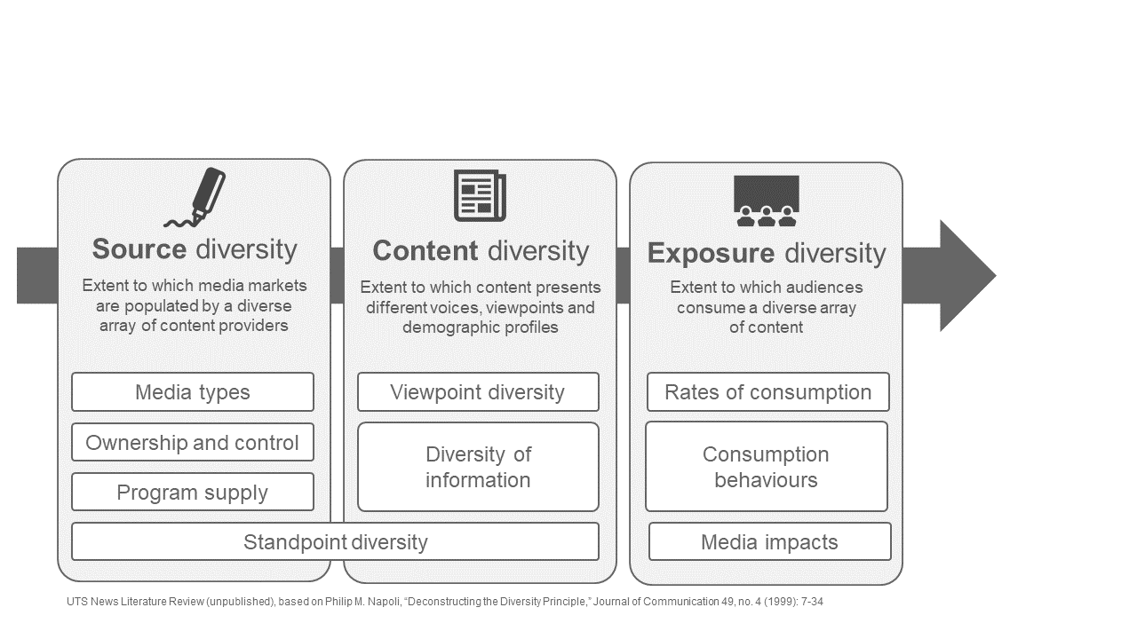

Source: Based on Australian Communications and Media Authority, News in Australia: diversity and localism – Review of literature and research, p. 18.

Traditional measures of media diversity or pluralism, including Australia’s media ownership and control rules, have focused primarily on ‘source diversity’. This regulatory emphasis is based on a longstanding presumption that, in a competitive media environment, media outlets will seek to differentiate themselves by producing a diversity of content and viewpoints that will capture the differing needs and niches of the public.[76] As such, a diversity of sources is believed to produce diversity across the supply chain, resulting in less focus on measuring or monitoring either content or exposure diversity.

As discussed in the chapter above, this presumption may no longer hold true. While there is a wealth of available digital news content, much of it is shared and recycled between platforms and outlets, with commercial incentives driving ‘clickbait’ journalism and risking the under-provision of public interest journalism. In assessing influence in this environment, it becomes crucial to know whether a news source is being relied upon by millions or just a handful of consumers. As such, in order to measure diversity in news and opinion across the contemporary Australian media landscape, we consider that an examination of source, content and exposure diversity would be necessary to understand contemporary media power and concentration. The discussion below will highlight some of our preliminary considerations for the design of a measurement framework capturing all 3 aspects of media diversity.

### Measuring source diversity

Source diversity is concerned with the structural aspects of the media sector. Its focus is on preventing the concentration of media ownership and control, of both media outlets and programming, across media types.

Many communications regulators around the world, including in Australia, assess levels of source diversity when there has been a market trigger event like a media merger or change in ownership structure. However, our current statutory rules relating to source diversity are based on individual broadcasting licence areas and do not account for the availability of online sources, or the influence or control that the owners of these sources may be able to exert on the media market.

In order to test source diversity across the news market more broadly, existing economic indicators for measuring market concentration could be used. This could be in the form of basic concentration ratios (CR(k)), which form part of the EU Media Pluralism Monitor, or more complicated measures like the Herfindahl-Hirschman Index (HHI), which is used by the FCC in the US and other competition regulators to assess market power of firms.

A common critique of using these market power measures in a media context is that they fail to account for the different roles played by firms within a media market. A market with 4 major and 4 minor players, for example, is inherently more diverse than one consisting of just 4 players; however, certain market power indices could produce an identical result across both markets. Another downside to use of these economic indicators is that they are dependent on the availability of detailed information about industry revenue and audience share, which often is not publicly available (particularly for smaller independent or online media sources). As there is no universally agreed indicator of concentration in media markets, we do not consider that a measure of concentration should be included in a measurement framework for diversity at this time. A selection of these measures may, however, assist in establishing a baseline and tracking media diversity over time, similar to how the CR(k) and HHI are used in South Korea as part of its periodic studies into the uses and influences of news media.[77]

### Measuring content diversity

Content diversity refers to diversity between, and within, media content itself. Unlike source diversity, which is grounded in market data, an examination of content diversity is more difficult as it requires bespoke research to review and assess a sufficiently large sample of news content from across media outlets and platforms.

While all media diversity regulation seeks to encourage or promote some form of content diversity, specific content diversity requirements are rarely imposed on private media outlets. Instead, content diversity is often regarded as the purview of public broadcasters. This is because governments can place specific content obligations on publicly-funded media outlets without being seen to be imposing on general freedoms of expression.

The ABC, for example, is tasked by the Australian Parliament under the ABC Charter ‘to provide broadcasting programs that contribute to a sense of national identity and inform and entertain, and reflect the cultural diversity of, the Australian community’.[78] Building on this legislative requirement, the ABC’s own code of practice further states that the organisation:

aims to present, over time, content that addresses a broad range of subjects from a diversity of perspectives reflecting a diversity of experiences, presented in a diversity of ways from a diversity of sources, including content created by ABC staff, generated by audiences and commissioned or acquired from external content-makers.[79]

Viewpoint diversity is particularly relevant to an examination of the news market given its role in providing audiences or readers with a wide range of perspectives or voices on a given topic. The availability of multiple viewpoints can help consumers make up their minds on important matters, including democratic and political processes, and is considered a means through which consumers can avoid getting caught in online ‘filter bubbles’ or ‘echo chambers’.[80] For the purposes of measuring viewpoints, the number of sources referred to in news stories could be viewed as a proxy for the availability of multiple perspectives or viewpoints being examined by the news media environment.

Information diversity is also an important feature of a healthy news market. There are many types of news, opinion and current affairs programs across the Australian media landscape, ranging from long-form, investigative style journalism, to shorter and more reactive stories on immediate events. Social news and user-generated news content all help contribute to greater levels of source diversity. Yet as traditional media outlets have made the transition to multi-platform suppliers, many commentators and researchers have observed a noticeable increase in rates of ‘clickbait’ and ‘churnalism’, or the reliance on second-hand stories and recycled or repurposed content between publications and across platforms.[81] To determine levels of information diversity, a sample of news content could be assessed for both originality and the range and types of topics that are reported on. This would allow for an incidental examination of public interest journalism.

### Measuring exposure diversity

While both source and content diversity are concerned with the availability of content, exposure diversity is about understanding the diversity of media that is actually consumed by the viewer (or ‘content as received’). Exposure diversity has not traditionally factored into assessments of media diversity but is increasingly regarded as a critical component when assessing diversity within online environments.[82] With that in mind, 2 possible measurement paths exist – measuring actual exposure or measuring barriers to exposure.

Measuring actual exposure is the path adopted by Ofcom, which looks at rates of consumption and multi-sourcing as key parts of its media pluralism framework. This assessment builds on the ‘share of references’ metric, constructed from a national survey about consumers’ use of news sources, from which Ofcom is able to determine each provider’s overall reach and ‘influence’.

An alternative approach could be to measure the external factors or barriers that could prevent audiences from being exposed to news. This could range from ‘access’ issues (for example, lack of home broadband access), findability (for example, digital literacy), and affordability (for example, ability to access paywalled content). This resembles the approach taken by the EU’s Media Pluralism Monitor.

### Out of scope

#### Standpoint diversity

Standpoint diversity is the extent to which all people are both a part of, and represented by, the media environment. This includes a diversity of culture, ethnicity, indigeneity, gender, sexual orientation and disability. The level of minority and female ownership of broadcast media outlets is, for example, a key measure of media diversity considered by the FCC in the US.[83]

Specific minority or disadvantaged groups, including from immigrant and indigenous backgrounds, often report feeling unrepresented or unable to make a direct and meaningful contribution to public debate in Australian society.[84] These groups are more likely to seek out news sources online or via social media that better meet their needs – both in terms of language and representation.[85] Poor representation or marginalisation of minorities in mainstream media is understood to contribute to the worsening or fragmentation of social cohesion.[86]

While the level of standpoint diversity in news is clearly an important and underexamined component of a diverse media environment, it would not be included in the initial news measurement framework if this work was undertaken. This is because it would require a much more expansive research agenda, significantly increasing the scope and complexity of the project, while being less immediately relevant to the sustainability challenges facing the news market. Standpoint diversity could, however, be an area for examination in later iterations of research into news diversity, depending on stakeholder views.

#### Impartiality/Internal plurality

We consider that an examination of internal plurality, or the balance of viewpoints or political ideologies of individual news sources would not be included in a measurement framework. This is because the diversity component of this work would primarily be concerned with assessing the availability of a diverse range of viewpoints *across* the news media market, rather than examining diversity within particular outlets or journalistic content. Concerns about bias or impartiality in the Australian news market have already been examined separately through the first part of our news project.

#### Barriers to access

Although a wide variety of news content may be available, there are additional factors that can limit a consumer’s access to news. The most obvious barriers for consumers are financial, such as website paywalls, which are increasingly a feature of the online print media market, including for local and regional online publications. Other barriers may include reduced access to digital infrastructure, for example, in rural areas, as well as poor digital and media literacy.

While these factors are highly relevant in helping to understand what drives news consumption and news avoidance, much like the reasons for excluding standpoint diversity from the measurement framework, an examination of barriers to access goes beyond what we consider can reasonably be assessed through this project. Nevertheless, some relevant data points, like the pricing strategy of news outlets, would be captured through this project and could be assessed separately at a later point.

## Measuring availability of local news

|  |
| --- |
| * Assessing the availability of local news requires an examination of both news infrastructure (outlets, journalists) and news output (volume of content that directly relates to the locality). * Local government areas are the most appropriate disaggregated geographic unit of measurement, as they are well understood by the community, large enough to sustain local journalism, and have been used in similar studies seeking to examine the role and impact of local media. * Local news can be assessed for relevance through an examination of a sample of news sources. Public interest journalism can be assessed at the same time through topic classifications. * The availability and volume of news produced within and/or relating to a locality is driven by a range of factors including population, remoteness, demographics and socio-economic profile. |

### Defining ‘local’

In seeking to measure the availability of local news content across Australia, a key consideration is what geographic unit or scale constitutes ‘local’. As part of the local content requirements for regional commercial TV and radio broadcasters, for example, content is considered ‘local’ if it ‘relates to’ a licensee’s licence area.[87] While a study of local news according to broadcast licence areas would align with current regulatory settings, it may not be appropriate for a cross-media study including print and online sources. Further, radio and TV licence areas often have very different geographic boundaries, and broadcast licence areas do not necessarily align with what individuals consider to be their ‘local’ area.[88]

Instead of broadcast licence areas, we consider local government areas (LGAs) to be the most appropriate geographic unit of measurement to measure the availability of local news. This is because LGA or local council boundaries are understood within the community, can be compared against other statistical data from the Australian Bureau of Statistics (ABS), and have been used in similar studies seeking to examine the role and impact of local media, including previously by the ACMA.[89]

#### Sampling localities

As at 2019, there were over 560 LGAs.[90] As there can be significant variation between LGAs, and practical limits on the number of localities that can be studied, determining an appropriate sampling methodology is critical.

In selecting a sample of LGAs to examine as part of this study, there are several factors that should be considered and accounted for, including:

Population – Larger communities can generally support larger, more robust journalism ecosystems than smaller communities. This is acknowledged through Australia’s current local content requirements, where regional commercial radio broadcasters in small licence areas (of under 30,000 people) must air 30 minutes of local content per business day, compared to 3 hours for radio broadcasters in larger licence areas.[91] While the LGA sample should include a mix of population sizes, it may be necessary to weight journalistic infrastructure and/or output on a per capita basis for comparability.

Remoteness – Communities located away from a capital city or large urban centre are less likely to be serviced by national or state news media, arguably placing greater importance on having access to dedicated ‘local’ news. Remoteness of localities could be assessed via the ABS Remoteness Area classification and/or the road distance to the nearest capital city.

Demographic profile – Age plays a significant role in news consumption choices and behaviours. Research suggests that older Australians (aged 65+) are both more interested in news and more likely to rely on traditional news platforms (TV and radio) compared to younger Australians.[92] As such, demographic factors may need to be considered when choosing sample LGAs, particularly given regional areas.

Socio-economic profile – Lower education and income levels are associated with lower news consumption and a reduced willingness to pay for news.[93] This, in turn, could impact on the viability of local news production in certain communities. The socio-economic profile of a locality could be assessed through the ABS Socio-Economic Indexes for Areas (SEIFA).

Local content requirements – Any assessment of the availability of local news on TV or radio needs to consider the impact of the current regulatory requirements on broadcasters. Where regional broadcasters are required to meet local content obligations, for example, these interventions may create a distorted view of the commerciality of local news production in an area.

Another key requirement in selecting a sample is that all states and territories are represented, and there is an appropriate mix between urban and non-urban localities.

### Determining the availability of local news

Previous examinations of local news have tended to focus on the number of news outlets and different news formats that are available in a locality.[94] However, given concerns around the closure and consolidation of newsrooms and the decline in public interest journalism, a more detailed assessment of local news, based on an examination of local news content, could be valuable.

A large-scale 2018 US study into local news availability provides a useful methodological framework.[95] After determining an appropriate geographic scale and sample localities, this study first involved the identification of the journalistic infrastructure or sources of local news in a locality. It then assessed the journalistic output, or the quantity of news produced by these outlets, before assessing a sample of the content for relevance to the community, or the extent to which the content met community information needs. An overview of an approach to measuring localism, based on this study is shown in Figure 8.

An approach to measuring local news availability

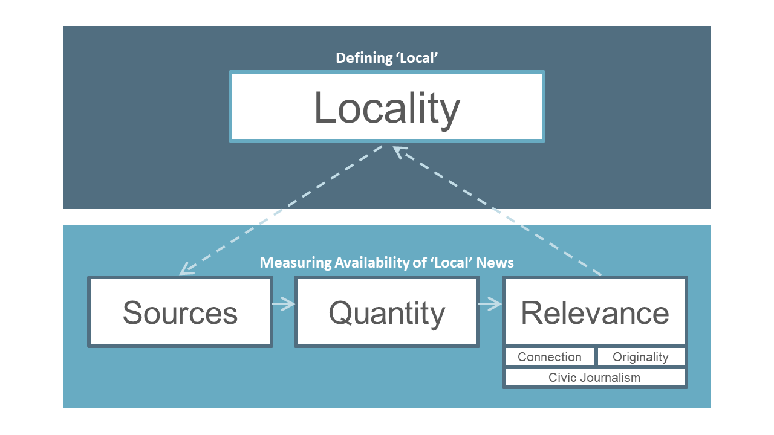

Under this framework, the local content can be explored across 3 measures of ‘relevance’ – connection, originality and civic journalism.

#### Connection

To understand how much genuine local content is being produced and made available across a locality, a sample of news stories would need to be assessed for whether there is direct link or connection to the locality. This is a familiar area of examination for the ACMA, as the current regulatory regime requires certain broadcasters to produce minimum quantities of ‘material of local significance’. For regional commercial radio operators, this means material that is ‘produced in’, ‘hosted in’, or ‘relates to’the licence area, whereas regional TV broadcasters must ensure the content relates directly to either the ‘local area’ (for aggregated broadcast licence areas) or the licensee’s licence area.[96]

Guidance as to what ‘relates to’ means can be found in existing instruments, such as the determination of ‘material of local significance’ as per sections 6 and 7 of the Broadcasting Services (Regional Commercial Radio — Material of Local Significance) Licence Condition 2014. This could form the basis of an assessment of ‘connection’.

#### Meaning of ‘relates to the licence area’

|  |
| --- |
| 1. Material relates to the licence area if it relates to any of the following matters:    1. an economic issue as it affects the licence area;    2. a government or political issue as it affects the licence area;    3. a social issue as it affects the licence area;    4. an education issue as it affects the licence area;    5. a health issue as it affects the licence area;    6. an employment issue as it affects the licence area;    7. an event in the licence area, including an event that has not yet occurred;    8. a person or organisation associated with the licence area;    9. the views of a person or organisation associated with the licence area;    10. weather conditions in the licence area;    11. a cultural interest, or an issue relating to culture, as it affects the licence area;    12. the natural or built environment in the licence area;    13. a body, operating in the licence area, that deals with community, welfare, religious, educational or other community service;    14. an emergency warning broadcast at the request of an emergency service agency. 2. Material of any kind that is not described in subsection (3) relates to the licence area if a direct and substantial relationship between the material and the licence area exists.[97] |

#### Originality

In an environment of increasing consolidation, shared journalistic resources and greater syndication or repurposing of stories between outlets, an assessment of originality can help demonstrate the amount of local journalism produced exclusively for a local audience.

Under the US study, a story is classed as ‘original’ if there is a by-line from an outlet’s reporter, or if it has no indicators of being posted or reported elsewhere. Similarly, social media posts are considered original if they are from local outlets and are not shares or re-tweets of content produced by another outlet.

This originality assessment can be complicated by news stories that have been copied from other outlets with minor editorial tweaks. If originality is to form part of an assessment of local news, alternative tests for originality may need to be considered, particularly if examining content across different media platforms.

#### Civic journalism

The final measure of ‘relevance’ looks at whether the news item could be considered an example of civic journalism, according to whether it is reporting on a topic that is determined to be in the public interest. This is based on the idea that all communities, irrespective of size, socio-demographic profile or other factors, have a series of basic information needs, and that the media plays an important role in ensuring these needs are met.[98]

This assessment could draw upon 2012 research commissioned by the FCC on ‘community information needs’ (CINs)[99], as well as the ACCC’s 10 categories of public interest journalism (including stories relating to local courts, local governments, education and science), which are considered important for the healthy functioning of the democratic process.[100] While this indicator may not strictly be necessary to assess the availability of local news, it would provide valuable insights to help assess the extent of the decline of public interest journalism, particularly in local reporting.

### Selection and classification of local news content

A key measurement consideration for the assessment of localism is how to assess and ‘code’ a suitably robust sample of news stories for relevance while maintaining an achievable scope.

Although this work would be broadly based on a recognised and proven research methodology[101], content analysis is heavily resource intensive and is also susceptible to unique measurement issues. While coding processes should be simple and unambiguous, there is always a risk of inconsistency between human coders, particularly if an element of qualitative judgement is required. If the process is automated through algorithmic classifiers rather than human coders, a much larger sample of news could be assessed. This approach, however, would require specialist computer science expertise, have a much longer development time, and may miss some of the important nuances required to accurately assess content for local significance or contributions to civic journalism.

Whichever process, content analysis would ideally be used to measure aspects of both diversity and localism, requiring multiple classifications, and increasing the complexity of the measurement. Ideally, coders would be able to respond to several close-ended questions for each news item, such as:

What is the story about? (with a predefined list of news topics)

Is the story hard or soft news?

Does the story ‘directly relate to’ the local area?

How many unique sources (or, for TV or radio, interviewees) are referenced in the story?

Does the story contain a by-line (or, for TV or radio news, is the name of the journalist identified)?

Irrespective of machine or human coders, detailed guidance or business rules would be necessary, particularly on the more difficult questions like how to determine whether a news story relates to a local area.

Another outstanding measurement issue is how to analyse content across different platforms like print, radio and TV. The US study into local news sidestepped this issue by looking exclusively at news content posted on the website homepages and social media accounts of local news outlets. This is based on an economic assumption that news outlets will ordinarily seek to maximise the potential reach of their content by distributing it online, and that digital news content is therefore seen as a proxy for total news output, irrespective of the originating platform.

It is not clear whether this assumption holds true in the Australian context, particularly given the lower population density and reduced access to digital infrastructure in some regional and rural areas of the country. A pilot project could help assess whether this methodology could be adopted in Australia.

### Out of scope

#### Localities below 10,000 people

In selecting sample localities for examination, we suggest that LGAs with a population of fewer than 10,000 people might not be included. This is in recognition that, below a certain population threshold, the commercial viability of local news production rapidly diminishes as the audience size becomes too small to justify the costs.

#### Although a population of 10,000 is a somewhat arbitrary cut-off, it aligns with the ABS definition of a ‘small town’ and is well below the definition of a ‘small’ radio licence area’ (a population of fewer than 30,000). Previous ACMA research into the availability of local content, published in both 2013 and 2017, similarly adopted a case study approach focusing primarily on communities with populations over 10,000.[102]

#### Excluding these LGAs has a practical benefit of making sample selection easier and allowing for greater comparability when examining local news content across communities. However, we also recognise that this approach to LGA sample selection may raise concerns about a lack of regional and remote representation. Due to Australia’s vast geography, almost half of all LGAs have a population below the suggested 10,000 threshold, despite only 10% of Australia’s population living in small towns.[103]

Local government areas by estimated population

|  |  |  |  |  |  |
| --- | --- | --- | --- | --- | --- |
|  | **Very small** (below 10k) | **Small** (>10–30k) | **Medium** (>30–70k) | **Large** (>70–120k) | **Very large** (above 120k) |
| City | 0 | 18 | 32 | 26 | 49 |
| Other | 243 | 101 | 45 | 13 | 17 |
| **Total** | **243** | **119** | **77** | **39** | **66** |

Source: Derived from Australian Bureau of Statistics, 3235.0 Regional Population by Age and Sex, Australia, Estimated Resident Population by Age, by Local Government Area, Persons – 30 June 2018.

Information on professional news outlets servicing smaller LGAs and communities could still be captured through a news measurement framework as part of an Australia-wide examination of all news sources.

#### Local news consumption

While consumption is a primary measure of diversity, it would likely be too resource intensive to undertake qualitative and quantitative consumption research across each of the LGAs examined within this type of framework.

Instead, geographic differences in news consumption could be measured at either a state or possibly a ‘geotype’ (for example, metro, regional and rural) level. This data could be captured through a national news consumption survey with over-sampling in certain geographic localities, such as regional Australia.

# Measurement framework design

In considering how diversity and localism across the Australian news media market could be measured, we examined similar projects undertaken internationally, including:

Ofcom’s Measurement Framework for Media Plurality in the UK

the Media Pluralism Monitor from the Centre for Media Pluralism and Media Freedom in the EU

the News Measures Research Project from the DeWitt Wallace Center for Media and Democracy in the US

the Local News Research Project from Ryerson School of Journalism in Canada (Appendix C).

Building on this research and discussions with leading media academics on measurement considerations, we identified 6 key concepts or sub-categories that are relevant to the study of diversity and localism in the Australian news media market, as shown in Figure 9.

Key measures of diversity and localism



## Indicators

From these categories, we identified a series of 8 indicators of market performance, split across 3 broad measurement categories. Some of these could be assessed at a national or state level (nationally representative), while others could be based on a sample of localities (sample). Together, these indicators provide a basket of metrics that could be used to help assess the efficacy of the current regulatory settings around diversity and localism, and monitor changes to Australia’s news market over time.

A detailed breakdown of these indicators is provided in Appendix A.

### News infrastructure indicators

The ‘infrastructure’ indicators assess supply-side factors of news production, including the number of sources, the number of journalists, and market concentration. These indicators primarily measure ‘source’ diversity, expanding on the information captured by the ACMA through its disclosure and notification regime, and would allow for a more detailed examination of cross-platform news media markets. These metrics could help inform an assessment of localism, providing data on the volume of journalistic infrastructure at various localities and geographic scales:

1. **Availability of sources**Count of all professional news outlets in Australia, by locality and platform (nationally representative).

**Availability of journalists**Count of journalists working at professional news outlets in Australia, by source, locality and employment status (sample).

**Number of owners**Count of owners of professional news outlets in Australia, by locality and media network (nationally representative).

### News output indicators

The ‘output’ indicators assess journalistic output, including the type and qualities of the stories or articles produced in news markets across Australia. This assessment would be critical to the measurement of localism, as it would provide data on the actual volume of local content produced in different localities. These indicators could also enable an examination of key aspects of content diversity, including the types of news being reported and the extent to which stories capture multiple viewpoints:

1. **Range of topics**The spread of hard and soft news stories, by category, platform, originality and locality (sample).
2. **Range of viewpoints**  
   The average number of unique sources referenced or quoted in a news story, by platform and locality (sample).
3. **Local relevance**The spread of news stories directly relating to a defined geographic locality, by platform (sample).

### News engagement indicators

Engagement indicators are critical to a contemporary understanding of media diversity, as they provide information on the actual reach and influence of news sources. This allows for an examination of demand-side factors, which may be more qualitative in nature, but provide context on what drives news consumption habits:

1. **Consumption**An assessment of the relative popularity of cross-platform news sources in Australia, by reach and frequency of use (nationally representative)
2. **Impact**An assessment of the relative importance of cross-platform news sources in Australia, based on consumers’ relative trust of, and reliance on, individual news sources (nationally representative)

## Framework compilation

Each of the above indicators are intended to support the measurement of different aspects of diversity and localism across the news media market. There are 2 main ways in which this information could be used and presented.

The first, as seen in the EU’s Media Pluralism Monitor, is to design a schema around these indicators, where relative performance is translated to a score or rating for comparison between geographic localities or over time. For example, a locality with 5 local news outlets could be scored higher than a locality with 3, so long as relevant variables like population size are considered. Scores for each of the indicators could then be aggregated across localities or other geographic scales to arrive at a single number that indicates the level of diversity or localism present in the respective media market.

While there is appeal in the simplicity of this output, lessons from the US FCC’s Diversity Index highlight some of the dangers of trying to construct sophisticated cross-media metrics from a series of disparate measures. An assessment of this kind requires data to be weighted and manipulated, and relies heavily on an arbitrary scoring criterion, which is more likely to be criticised and may hide or distort important findings or insights. It also raises the inevitable question as to what constitutes a ‘sufficient’ level, which cannot be answered satisfactorily without reference to some kind of baseline or ‘bright line’ regulation.[104]

The second approach, as adopted by Ofcom’s Measurement Framework for Media Plurality, is to use the framework as a broad tool for making a qualitative assessment, rather than a purely quantitative, mechanical measure of plurality. This allows Ofcom to review, through its public interest test process, the performance of the market against an agreed set of indicators, including qualitative ‘contextual factors’ that may be relevant to the case or a particular firm in the proposed media merger. This aligns with Ofcom’s definition of media pluralism, which is outcomes-focused rather than prescriptive:

Ensuring that there is diversity in the viewpoints that are available and consumed, across and within media enterprises. There should be a diverse range of independent news media voices across all platforms, a high overall consumption across demographics and consumers, and active use of a range of different news sources.

Preventing any one media owner, or voice, having too much influence over public opinion and the political agenda. This can be achieved by ensuring that no organisation or news source has a share of consumption that is so high that there is a risk that people are exposed to a narrow set of viewpoints.[105]

The Ofcom model is also not without its critics. Concerns with the Ofcom model include that it relies too heavily on self-reported usage data from consumers, fails to account for the agenda setting role of media outlets, and is only applied in the context of a public interest test review at the specific request of the Secretary of State.

An approach to measurement in Australia could combine aspects from both the EU and UK models. A bundle of metrics assessment approach, similar to the Ofcom Measurement Framework for Media Plurality, could be adopted from the outset to enable a broad ranging assessment.

Once data for each indicator is compiled, a measurement framework could inform several discrete outputs, including a national baseline for media diversity and an assessment of factors driving local news production, against which changes to the market could be assessed and quantified. These are discussed further in following chapters.

## Outputs of a news measurement framework

A measurement framework could provide a wealth of new data on the news market that could be used for a variety of purposes. We envision 3 potential outputs that could support the monitoring of diversity and localism in news across Australia over time.

|  |  |
| --- | --- |
| Image result for benchmark icon | News diversity baseline |

The most challenging aspect of measuring media diversity is determining what should constitute a ‘sufficient’ level of diversity across each of the relevant indicators. As there is no existing statutory guidance or local benchmarks, we do not consider that work on a measurement framework would involve establishing subjective performance criteria or recommending a minimum number of outlets, variety of news content, or volume of consumption that should be present across the news media market in Australia.

Instead, the point-in-time data captured through a measurement framework could be used to establish a baseline for news diversity.[106] This could include the number of news sources (by platform, locality and owner), the list of the most consumed and influential cross-platform sources of news at a national level, and a high-level analysis of content diversity among the most popular sources of news at a national and state level. Once a baseline has been established, further research could track changes to the news media market over time and, if needed, provide the relevant data to help inform any new bright line metrics for assessing diversity in the future.[107]

An output could include a report detailing the state of the news market in Australia, including analysis of news diversity between platforms and, where possible, localities. This type of report could also include an exploration of current media ownership structures and alternative ways in which cross-platform media power and market concentration could be assessed and tracked over time, ranging from simple concentration tests (like the 4-firm CR4 concentration ratio), to more formal tests of market power (like the Herfindahl-Hirschman Index), and specialised media diversity metrics.

|  |  |
| --- | --- |
|  | Local news assessment |

Data on local news availability, obtained through a measurement framework, could be employed to provide a comprehensive overview and analysis of the state of local news in Australia. This local news assessment could seek to achieve 3 objectives:

1. identify the amount of local news infrastructure in sample communities

ascertain the volume of genuine local news content that is being produced within the community

assess the factors or characteristics driving healthy local news production in a locality.

This work would rely on the data obtained through the content analysis research. Data could be analysed and assessed on a locality-by-locality basis, with findings to be aggregated by state and/or geotype and combined with data on the availability of news outlets across all of Australia. Further analysis could be undertaken to investigate what geographic, socioeconomic or demographic factors may help contribute to a healthy market of local news.

|  |  |
| --- | --- |
|  | Local news database and online map |

A comprehensive database of news sources across Australia would be needed in order to undertake the research activities described in this paper. In addition to informing the other key outputs of this project, this database would be a valuable resource in its own right, allowing researchers, regulators and policymakers to monitor mergers, closures and other changes in the Australian news media market.

To maximise the value of this output, the dataset could be made publicly available, such as on the Australian Government’s open data platform, [data.gov.au](https://data.gov.au/), with all known sources of local news in Australia presented visually by locality on the NationalMap. The development of a standalone Australian local news map, based on the Canadian model, could also be considered.

An ongoing challenge would be maintaining the accuracy and relevance of the news availability dataset. To assist in this process, a standalone map could be developed with crowdsourcing functionality that would allow journalists, media outlets, researchers and members of the community to contribute directly to the dataset, assisting in identifying missing news sources or changes to local news production. To maintain integrity of the data, it would be important to verify any crowd-sourced information prior to its publication. This could closely mirror the process followed in compiling the Canadian Local News Map (discussed in more detail in Appendix C).

Given ongoing concerns around ‘news deserts’ and declining journalistic output in regional areas, this tool could be an invaluable long-term resource in monitoring ongoing changes in the media market and building a robust, community-driven evidence base to support future policy or regulatory changes to local news obligations or production incentives.

# Options for implementation

While this paper is primarily focussed on the potential design and outputs of a news measurement framework, this chapter explores some possible implementation options, should this work progress.

## Research activities

At present, there is a lack of data available to adequately assess and track the 8 indicators discussed in the previous chapter. To address this limitation, a series of research activities could be undertaken to gather the necessary data to support multiple indicators. If this work progresses, the below research activities could be undertaken by either the ACMA or third parties, subject to resourcing considerations and potential sensitivities.

|  |  |
| --- | --- |
| Stethoscope | News audit |
| *Indicators:* | 1. Availability of source 2. Availability of journalists 3. Number of owners |
| *Outputs:* | National diversity baseline  Local news assessment  Local news database and online map |
|  |  |

The news audit could include a comprehensive examination of all professional Australian news sources, across print, TV, radio and online. For each identified news source, the audit could seek to capture and record information on:

media type and platform(s) (including social media presence)

frequency of news reporting (daily, weekly, fortnightly, monthly)

pricing strategy (paid or free)

target audience by geography (local, regional, state or national)

place of publication

number of employed journalists and/or editors

media group/owner(s) (and, where available, controllers).

Much of this information is publicly available, and could be validated against a range of commercial media databases, contact lists and guides, including:

Telum Media Database

AAP/Margaret Gee’s Australian Media Guide

iSentia contact lists

list of members of the Audited Media Association of Australia.

To capture smaller independent and hyperlocal news sources, which may not be present in media databases, a series of manual online searches could also be undertaken for news relating to specific localities.

While this data is key to identifying sources of local news and establishing a news diversity baseline, any broader analysis of the news media market would benefit from a comprehensive database on news availability. Given the low levels of risk associated with this activity, the ACMA would likely be best placed to undertake this type of research. Contacting media outlets directly to request missing data could also be considered. Once compiled, the database could be a valuable public resource for research.

|  |  |
| --- | --- |
| Image result for survey icon | News consumption research |
| *Indicators:* | 1. Consumption 2. Impact |
| *Outputs:* | News diversity baseline |
|  |  |

News consumption research is essential to understanding, measuring and tracking levels of diversity in contemporary news markets. For this research activity to be of most value, it should provide a holistic view of which individual news sources are the most frequently used, trusted and relied upon by Australians, irrespective of the technology platform or media type.

A large, bespoke, nationally representative consumer survey could act as the cornerstone of this research. Based on the annual Ofcom News Consumption survey and its bespoke ‘share of references’ metric, this consumption survey could allow for a direct comparison of the popularity of news outlets across print, radio, TV and online using a consistent methodology and common market definitions. To our knowledge, this information is not currently available in Australia.[108] Research of this kind would, therefore, provide new insight into how much cross-platform diversity exists across the most consumed news sources, as well as allowing an assessment of market concentration by audience share, such as in the ‘share of reference’ findings from Ofcom below.

Top 20 news sources in the UK (2019)

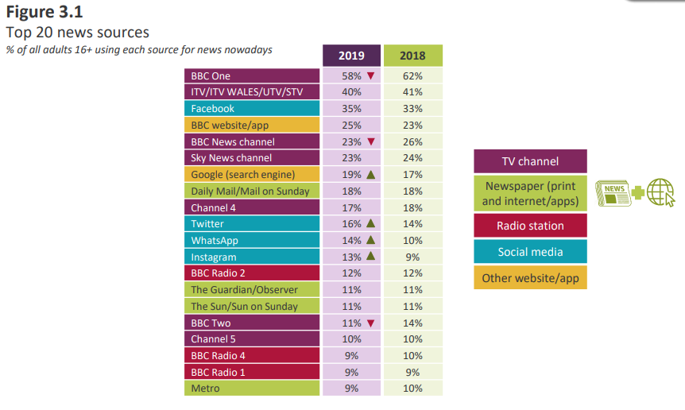

Source: Ofcom, [News Consumption in the UK: 2019](https://www.ofcom.org.uk/__data/assets/pdf_file/0027/157914/uk-news-consumption-2019-report.pdf), p. 20.

By asking respondents questions about their trust of, reliance on, and personal views about the quality of individual news outlets, this survey could also seek to measure impact – allowing for comparisons between the most consumed and the most influential news sources. This, in turn, could provide a more nuanced view of media diversity, helping researchers and policymakers to better understand which media voices have the greatest ability to set the news agenda and influence the formation of public opinion.

A key methodological challenge for surveys is that consumers have increasingly fragmented and complex media diets and tend to underestimate their engagement with digital news sources when asked to recall usage – particularly while on mobile devices and accessing news via aggregators or social media.[109] This issue is further compounded by the high levels of passive and incidental exposure to news on social media[110], with varying levels of awareness among users about the origin of their digital news.

To compensate for this shortcoming and provide greater confidence in the accuracy of the results, it would be important to supplement such a survey with additional information that can specifically address digital news consumption. This could include:

qualitative research tools like media diaries, in-depth at-home ethnographic interviews, and an examination of browsing behaviours and internet histories

commercially available audience and consumption data, from research companies such as Roy Morgan, OzTAM, or Nielsen[111]

* observational data on the consumption of, and engagement with, news stories that are published online or via social media.

#### Additional area of possible future research: news engagement via social media

|  |
| --- |
| Attempting to quantify the impact of individual news sources is a particularly challenging endeavour. Beyond consumer research, a more immediate and tangible indicator of impact could be obtained through observational means, namely the level of engagement with Australian news sources online and on social media, such as the volume of clicks, likes, comments and shares.  While there are significant limitations on the availability and use of social media metadata, a number of Australian academics now have access to Facebook’s CrowdTangle – a content discovery and data analytics tool that provides real-time information about news content being shared on the platform. Similarly, an existing longitudinal academic project from the Queensland University of Technology has been tracking the distribution of links to news stories from around 30 popular Australian media sources via Twitter since 2012.[112]  CrowdTangle, the Australian Twitter News Index (ATNIX) and other research of this kind could be relied upon to support or supplement survey findings on Australian news consumption. The use of such technology could allow for the impact of news media to be monitored in real-time, facilitated through data on digital news engagement. |

We have considerable experience in designing and undertaking consumer research and would be well placed to lead any future work of this kind. We appreciate that there may, however, be some concerns among stakeholders about the ACMA measuring and tracking the ‘impact’ of individual news sources.

|  |  |
| --- | --- |
|  | News content analysis |
| *Indicators:* | 1. Range of topics 2. Range of viewpoints 3. Local relevance |
| *Outputs:* | News diversity baseline Local news assessment |

In seeking to assess the availability of local news across Australia, there would be a need to undertake some level of content analysis. This is because local news outlets report on a variety of stories, including those not directly relevant to the local community. As such, the presence of media outlets in a locality does not automatically translate to the production of original news stories of local interest. An examination of the actual output of local news would be necessary to determine the extent to which the content covers matters of local significance.

A potential research activity could involve identifying a geographic sample of approximately 20 localities of different sizes and populations, spread across metropolitan, regional and rural Australia. This selection of localities could be informed by the design of the news consumption survey and may require expert advice to ensure consistency between activities.

Based on the information about available news sources obtained through the news audit, researchers could capture a representative sample of news articles from all local news outlets servicing each selected locality, excluding national or state-based news outlets. Each news article could then be sorted either through an algorithmic classifier, or manually coded by researchers, according to its topic, whether it is an example of hard or soft news, whether it appears to be original content, the number of referenced or quoted sources in the article, and whether the content directly relates to the locality.

The results of the local news content analysis could provide data on how much original local news content (including how much public interest journalism) is being produced in certain localities. From this data, researchers could then identify any potential areas of concern and build models to help identify what, if any, geographic and demographic characteristics in a community contribute towards local news production.

An advantage of this potential approach is that it would allow for a simultaneous assessment of localism and content diversity. This is because, in assessing news articles for localism, coders would also be able to capture information about the extent of information diversity (via the range and spread of topics) and viewpoint diversity (via the number of quoted sources) present in articles across the local media landscape.

Although the primary focus of this potential research activity would be on local news outlets, researchers could also seek to assess a sample of news articles from the most popular sources of national or state-based news, which could be based on the findings of the consumption research. This would enable a comparison of the results from mainstream, national and local news outlets to better understand how content diversity differs based on geographic scale.

Beyond high-level examinations of local content as part of our broader compliance and enforcement activities, we do not have any experience in undertaking content analysis work of this kind. Although this activity would not seek to assess regulatory compliance, we are also aware that some stakeholders could be concerned about any future direct involvement of the media regulator in an assessment of news media content, particularly in deciding what constitutes public interest news.

## Repeatability

Noting the lack of comparable or existing data, there is potential value in setting a baseline and repeating this research to track changes to the market over time. To this end, a measurement framework could form a part of an ongoing research agenda. If the ACMA were to undertake this work, for example, we could consider conducting a periodic major review, or repeating certain measures at different intervals based on considerations like the ease of collection or the pace of change.

Another possibility is that once a baseline is established and a methodology released, academics or other interested parties could conduct future data collections. A key value of data of this type would be its ability to be replicated over time and compared. Changes to the dynamic media market and consumer behaviours over time would also need to be accounted for in any methodology.

## Stakeholder considerations

Given the high levels of interest among certain key stakeholder groups, there could be merit in further exploration of partnerships across government, academia and industry.

### Government involvement

Work to implement a news measurement framework could have a much broader application outside of the ACMA. Work to measure and track levels of diversity and localism over time would likely be valuable to policymakers across the government and could provide an evidence base that helps inform future regulatory reform in the media sector, including on issues of regulatory harmonisation.

If this work were to be undertaken, we could seek to partner with the Department of Infrastructure, Transport, Regional Development and Communications to ensure a broad alignment with government priorities and leverage the knowledge and strategic insight of the department’s content policy area.

Similarly, noting the government’s response to the Digital Platforms Inquiry, the ACCC could have an ongoing interest in this type of work. Given the ACCC’s earlier research into tracking local and regional newspaper closures and declines in public interest journalism, the ACCC would be well placed to advise on measurement difficulties and could assist with issues relating to measuring market concentration.

### Academic involvement

In our ongoing discussions with academia, we have become aware of a variety of news and journalism-related research, some of which could intersect with or support an assessment of localism or diversity in Australia news.[113] Given the desire to avoid duplicating research, and the potential sensitivities associated with the ACMA examining areas that may be perceived to be outside of our remit, a potential avenue could be to explore partnerships or more formal levels of involvement with one or more universities or other academic institutions.

Building on our existing consultation with leading academics in this field, we believe there could be merit in seeking interest in the creation of an academic reference panel. This panel could be used to test new ideas, validate data, and provide quality assurance via peer review.

Noting the resourcing considerations that would apply, we could also consider engaging academic institutions to undertake discrete research pieces or key activities on a standalone basis. This could allow the ACMA to remain at arm’s length for some of the more sensitive aspects of the project, such as the content analysis work. For example, Ofcom partnered with Cardiff University’s School of Journalism, Media and Culture to undertake content analysis as part of a study into the range and depth of BBC news and current affairs[114], which is a model that could be replicated in Australia. Similarly, the annual assessment of media concentration and influence in South Korea is undertaken at arm’s length to the government, by a committee of academics and other experts in the field, with membership rotating every three years.

Alternatively, we could seek interest among academic institutions in formally partnering on existing or upcoming academic research projects where our interests align, such as through an Australian Research Council (ARC) Linkage Program.

### Industry involvement

If a project of this type was to be undertaken, we may need to test whether Australian news media outlets would be willing to assist in the information-gathering component of this work, either through the completion of a survey that could help inform aspects of any news audits in the future, or to provide a sample of news content for analysis. As with the academic community, we consider there could be value in assembling a reference group of media outlets, digital platforms, peak bodies, journalists or other interested industry participants.

# Appendix A – Detailed framework

|  | **Indicator** | **Framing question** | **Metric(s)** | **Scale** | **Methodology** | **Rationale and treatment** | **Comments** |
| --- | --- | --- | --- | --- | --- | --- | --- |
| **News  infrastructure** | **1. Availability of  sources** | How many sources of news and opinion are available to Australians? | Count of all professional news outlets operating in Australia by:  media platform  place of publication/broadcast  frequency of reporting  pricing strategy  target audience, by geography. | National  State  Local | Search commercial media databases and government registers.  Request information directly from media outlets.  Crowd-source missing information via online news map (optional). | Data would be required to establish a ‘diversity baseline’, deliver a local news database, and enable direct comparison of news infrastructure at a local level.  Tracking this indicator over time would allow for longitudinal assessment of source diversity. | Given the vast quantities of news content available online, this indicator would not capture data from international sources (highly consumed or impactful international sources of news could instead be captured and assessed through indicators #7 and #8).  News availability could inform other indicators, including the identification of local news outlets for content analysis, and could assist in a future research on news impact and engagement (e.g., understanding the impact of paywalls). |
|  | **2. Availability of journalists** | How many journalists contribute to the production of local news? | Count of journalists and editors employed by professional news outlets operating in Australia (if available, split by full-time, part-time and casual). | Local | Search commercial media databases and contact lists.  Request information directly from media outlets.  Validate against ABS statistics. | Results could be compared between localities. Data could enable the ACMA to assess the extent to which the number of journalists impacts on journalistic output in a locality (e.g., as an independent variable in regression analysis). | This approach would not provide a definitive count of journalists in a locality, as it would not capture freelancers or those employed by non-media outlets. Data collection could also be difficult due to definitional issues and greater sharing of resources between and within newsrooms. Due to these limitations, data on journalists would only be captured and assessed at a local level. |
|  | **3. Number of owners** | How many people exercise control over Australia’s most influential sources of news? | Count of the number of media networks owners (and, if available, controllers) of the most popular and impactful professional news outlets, across media platforms.  Count of the number of media networks owners (and, if available, controllers) of local news outlets in sample localities. | National  State  Local | Survey consumers about what news sources they consume and group by company.  Search media registers and undertake desktop research to identify owners.  Request information directly from media outlets. | Key metric that could inform assessment of media ownership and control. Where available, this could be included in a news diversity baseline and local news database. | Information could be difficult to ascertain for non-public companies and outlets without disclosure obligations (e.g., print, online). |
| **News  output** | **4. Range of topics** | How much variety is present in Australia’s news media market? | Count of articles, by category or news topic.  Count of ‘hard’ articles, as a % of total news output. | Local  State (optional) | Collect sample of news sources from local media outlets.  Code articles according to topic and whether hard or soft news.  Compare results against a sample of national news sources (optional). | Results could be compared between platforms and localities, as a measure of content (information) diversity. As part of this assessment, ACMA could seek to test whether there is a relationship between source diversity (indicator #1) and content diversity measures (indicators #4 and #5). Data on news articles by topic could also support an assessment of the availability of public interest journalism, including identifying any particular areas of concern. | This indicator could allow ACMA to look at the mix between hard (e.g., local government, health, education) and soft (e.g., arts and culture, human interest, weather) news in local markets. As part of the coding process, the ACCC definition and list of ‘public interest journalism’ topics could be adopted, coupled with more community-focused topics, in line with the dual objectives of local content. |
|  | **5. Range of viewpoints** | How many viewpoints are presented in Australia’s news media market? | Average number of sources quoted or interviewed in news articles. | Local  State (optional) | Collect sample of news sources from local media outlets.  Code articles according to the number of quotes sources.  Average by locality and platform.  Compare results against a sample of national news sources (optional). | Results could be compared between platforms and localities, as a potential measure of content (viewpoint) diversity. As part of this assessment, ACMA could seek to test whether there is a relationship between source diversity (indicator #1) and content diversity measures (indicators #4 and #5). | Viewpoint diversity is about exposure to multiple perspectives or ideas, which are essential to a well-functioning pluralistic society. While a count of sources is a relatively simplistic measure, this could be an achievable and appropriate proxy for viewpoint diversity as part of a broader examination of content diversity. |
|  | **6. Local relevance** | To what extent does local news cover matters of local significance? | Count of news articles with a direct ‘connection’ to the local area.  Count of original news stories as a % of total news output. | Local | Collect sample of news sources from local media outlets.  Code sample according to whether articles relate to locality. | Results could be compared between localities and platforms, as a measure of localism. Data on which localities have higher levels of genuine and original local news output would enable the identification of areas of concern and help with assessing what factors may contribute to local news production. | An assessment of what constitutes ‘local’ should be based on existing legislative definitions under the BSA and related legislative instruments. Originality assessment should be based on the presence of a by-line by local journalist or evidence of local production. |
| **News  engagement** | **7. Consumption** | What are the most consumed sources of news in Australia? | * List of most popular cross-media sources of news, by audience size and frequency of use (including international sources). | National  State | Survey consumers about what news sources they consume, and how often.  Combine use and frequency data to determine ‘share of reference’.  Validate against commercial ratings and circulation data. | Data could help inform examination and baselining of media diversity levels in the context of cross-media consumption. | Adopts Ofcom’s bespoke ‘share of references’ metric for assessing cross-media consumption, using a consistent methodology and definition of news. Although consumption would not be measured at a local level, this type of survey sampling could be designed to allow for comparison between ‘geotypes’ (metro, regional and rural localities). |
|  | **8. Impact** | What are the most impactful sources of news in Australia? | * List of most popular cross-media sources of news, by stated reliance or personal importance (including international sources). | National  State | Survey consumers about which news sources they consider high quality, rely on, and trust.  Supplement with qualitative research and detailed examination of news engagement via social media (optional). | The list of most impactful sources of news could be compared against the list of the most consumed sources of news (from indicator #7) to provide insights into the relationship between news consumption and influence in the Australian news market. | Adopts the Ofcom model, where impact is assessed through a range of proxies collected via consumer research. Additional data on the sharing of online news content, coupled with qualitative research, may be necessary to supplement quantitative research given concerns around passive news consumption, media literacy and access. |

# Appendix B – ACMA research methodology

## Desktop research

In scoping this project, we first undertook a comparative regulatory analysis of diversity and localism measures across Australia, the United Kingdom, Canada, the United States, France and Norway (see *News in Australia: diversity and localism – International comparisons*).

We then commenced a detailed review of alternative news measurement approaches in use around the world, and their potential applicability in the Australian context. Findings from this research are summarised in Appendix C.

This work was also informed by research undertaken as part of the broader news project, including:

a commissioned review of literature and research from the Centre for Media Transition at the University of Technology Sydney (see *News in Australia: diversity and localism – Review of literature and research*)

commissioned quantitative consumer research on news consumption and community concerns regarding news

commissioned qualitative research that involved 15 focus groups across regional and metropolitan areas in 4 states around Australia, 12 face-to-face interviews preceded by participants creating a week-long news consumption diary, and 10 telephone interviews with people located in regional and rural areas across Australia. Topics included an examination of opinions of diversity and localism and any concerns (see *News in Australia: diversity and localism – Qualitative research*).

Relevant findings from this research are provided in this paper.

## Stakeholder consultation

We ran 4 workshops (2 in Sydney, 2 in Canberra) during the second half of 2019. These sought expert views on the most appropriate ways to measure both the levels of diversity in news and opinion, and the availability of local news, across Australia.

These workshops comprised a mix of representatives from across academia and government. Government attendees included officers from then Department of Communications and the Arts, the ACCC, ACMA authority members and ACMA staff. Academic attendees included:

Assoc. Prof. Kristy Hess, Deakin University

Assoc. Prof. Andrea Carson, La Trobe University

Prof. Lawrie Zion, La Trobe University

Assoc. Prof. Margaret Simons, Monash University

Dr Kathryn Bowd, University of Adelaide

Asst. Prof. Caroline Fisher, University of Canberra

Assoc. Prof. Sora Park, University of Canberra

Assoc. Prof. Tim Dwyer, University of Sydney

Prof. Peter Fray, University of Technology Sydney[115]

Prof. Saba Bebawi, University of Technology Sydney

Prof. Derek Wilding, University of Technology Sydney

Dr Chrisanthi Giotis, University of Technology Sydney

Prof. Axel Bruns, Queensland University of Technology.

In addition to the workshops, we met with experts from academia and government on a one-on-one basis to discuss possible approaches to measurement. Experts included:

members of from Ofcom’s Strategy and Policy, Content Policy and Market Analysis sections (UK)

a delegation of the Committee on the Impact of Media Concentration in the Republic of Korea

Dr Philip Napoli, James R. Shepley Professor of Public Policy, DeWitt Wallace Center for Media & Democracy, Duke University (US)

members of the ACCC’s Digital Platforms Inquiry project team

Prof. Kerry McCallum, Director of the News & Media Research Centre, University of Canberra

members of the ARC-funded Media Pluralism and Online News project team from the University of Technology Sydney and the University of Sydney.

## Indicator matrix and framework design

Following our desktop research and stakeholder consultation, we compiled a series of indicators to measure both diversity and localism in the Australian context. These were informed by a number of international models and studies, including the work of Ofcom, Dr Philip Napoli and the Centre for Media Pluralism and Media Freedom.

The indicators outlined in Appendix A were chosen according to a number of practical considerations, including that they were:

simple – able to be easily understood and measured

replicable – able to be repeatedly assessed over time

efficient – able to address both diversity and localism concerns across all relevant measurement categories, using the minimum number of indicators

tested – the extent to which they had been used and applied in other jurisdictions and measurement models.

These indicators were then validated with the internal News Project Steering Committee, members of the ACMA executive and select academics and subject-matter experts.

# Appendix C – Measurement examples

## Measures of media diversity

There is no standardised or commonly accepted approach to measuring media diversity or pluralism. The most well-known and documented examples internationally are the US Diversity Index, the EU Media Pluralism Monitor, the UK Measurement Framework for Media Plurality and the Republic of Korea’s Uses and Influences of News Media.

### Diversity Index – Federal Communications Commission (US)

In 2003, the Federal Communications Commission (FCC) implemented a new analytical tool designed to assess the degree of consolidation in local media markets and guide decision-making on cross-media ownership and diversity regulation in a changing media environment. The Diversity Index sought to overcome some of the limitations of the well-known Herfindahl-Hirschman Index (HHI), adopting a more consumer-centric assessment of market power that accounted for audience preferences regarding news consumption.

To help with this assessment, the FCC surveyed consumers on the relative popularity of local news across different formats. These results allowed the FCC to develop a weighting for each media platform (TV, radio, newspapers and the internet), which was used to determine an equal weighted market share for each outlet operating across the same media format. For example, if there were 10 radio channels, each would be given a market share of 10%, multiplied by the weight assigned to the radio format based on its popularity. The weighted market shares of each company were then added together to determine the level of media diversity in a local media market.

The diversity index was used to identify ‘at risk’ localities, and its application to a sample of media markets led the FCC to conclude that the bulk of its ownership regulations could be substantially relaxed.[116] Due to the controversial nature of this assessment, the FCC’s use of the Diversity Index was challenged in the courts and eventually struck down due to the FCC employing ‘several irrational assumptions and inconsistencies’.[117] For example, as all outlets within the same media type were given equal market share, it was criticised for ignoring the reach and influence of specific outlets. Further, while the FCC stated it sought to account for viewpoint diversity, it did not assess any of the broadcast content – meaning the Diversity Index included sources irrespective of whether they actually provided local news.

Given the high levels of controversy and its rejection by the courts, the Diversity Index should not be regarded as a potential model for use in the current Australian media context. It nevertheless provides a valuable lesson to regulators on how *not* to apply market concertation assessments to media environments. In particular, it warns against designing measurement frameworks that treat each media platform as a distinct silo and highlights the dangers of reducing pluralism to a single quantitative measurement – as opposed to a ‘basket’ of indicators.

### Media Pluralism Monitor – Centre for Media Pluralism and Media Freedom (EU)

The Media Pluralism Monitor (MPM), unlike the Diversity Index, is an attempt to offer a more holistic, risk-based approach to the measurement of media pluralism across the EU. First established in 2009, and co-funded by the European Commission, the MPM employs an expansive definition of media plurality across the 4 risk areas of basic protection, market plurality, political independence and social inclusiveness. In total, the MPM contains 20 broad indicators, split across 200 variables, with data collected from a survey of legal, economic and socio-economic questions compiled by academics in each country.

Media Pluralism Monitor – risk areas and indicators (2017)

| **Basic protection** | **Market plurality** | **Political independence** | **Social inclusiveness** |
| --- | --- | --- | --- |
| Protection of freedom of expression | Transparency of media ownership | Political independence of media | Access to media for minorities |
| Protection of right to information | Media ownership concentration (horizontal) | Editorial autonomy | Access to media for local/regional communities and for community media |
| Journalistic profession,  standards and protection | Cross-media concentration of ownership and competition enforcement | Media and democratic electoral process | Access to media for people with disabilities |
| Independence and effectiveness of the media authority | Commercial & owner influence over editorial content | State regulation of resources and support for the media sector | Access to media for women |
| Universal reach of traditional media and access to the Internet | Media viability | Independence of PSM governance and funding | Media literacy |

The MPM acts as a regular audit of the EU’s performance on media pluralism, identifying growing risks and facilitating a direct comparison between member countries. In 2017, the MPM was used to assess 31 countries (28 in the EU and 3 candidate countries – the former Yugoslav Republic of Macedonia, Serbia and Turkey), and showed general stagnation or deterioration across all major areas, with media ownership concentration identified as one of the most significant risks to media pluralism throughout the EU. Work was undertaken to update the monitor for 2020 to better capture and measure information about online media.

While comprehensive, there is limited applicability of the MPM in the Australian context, given our smaller market and much narrower and less interventionist regulatory focus. Many of the areas examined in the MPM fall outside the traditional definitions of media diversity, for example, by capturing data on the levels of media protections and freedoms of expression. It is also based on a complicated survey methodology that would take considerable resourcing to adapt to the Australian context. Despite this, we consider some specific indicator variables could be relevant, particularly under the market plurality risk area. These include the use of C4 concentration ratios and revenue trends by sector.

### Measurement Framework for Media Plurality – Ofcom (UK)

The UK Measurement Framework for Media Plurality originated from the proposed acquisition of BSkyB by News Corp in 2010, and the subsequent News Corp phone hacking scandal, both of which highlighted serious concerns about the state of media plurality in the UK. Following this, Ofcom was requested by the UK Government to develop a framework for measuring media pluralism, which was finalised in 2015 after a long period of development and a public consultation process.

The UK measurement framework has 3 key quantitative categories: availability, consumption and impact. It also allows for contextual factors, in appreciation that there are relevant contributors of pluralism that may not be able to be quantified, like an individual media outlet’s editorial policy. The framework is outlined in Table 5.

Measurement Framework for Media Plurality

|  |  |  |  |  |  |
| --- | --- | --- | --- | --- | --- |
| **Category** |  | **Metrics** | **Description** | **Source** | **What it indicates** |
| **Availability** | Availability and consumption metrics to be calculated at retail and wholesale levels to allow analysis of media ownership. | Number of providers | * A count of the number of entities providing news sources | * Industry data | An indication of the potential for diversity of viewpoints |
| **Consumption** | Reach | * By platform – TV, radio, newspapers, internet * By provider within platform | * Industry measurement systems * Consumer research | An indication of the variety of viewpoints disseminated |
|  |  | * Cross platform | * Consumer research | As above  Cross-media reach establishes the capability for each provider to reach the population regardless of platform |
|  | Share of consumption | * By platform – TV, radio, newspapers, internet * By provider within platform | * Industry measurement systems * Consumer research | An indication of the potential concentration in patterns of consumption  Note: This would be calculated from time spent for each platform as measured by the industry measurement systems |
|  |  | * Cross platform * Cross platform by provider | * Consumer research | As above  Note: this can be in the form of the share of reference metric that captures the reach and frequency of consumption |
|  | Multi-sourcing | * By platform and cross platform | * Consumer research | An indication of the extent to which consumers are sourcing their news from one or a range of sources |
| **Impact** | Personal importance | | * By platform * By provider | * Consumer research | Provides one proxy for measuring the potential to influence opinion |
|  | Perceived impartiality, reliability and trust and the extent to which a news source helps people make up their minds about news | | * By platform * By provider | * Consumer research | Provide additional context to the metric of personal importance |
| **Contextual factors** | A range to be considered | | * A description of the qualitative differences between news sources and organisations | * Multiple sources * Examples of relevant factors include, but are not limited to: * internal plurality * internal governance processes * editorial policy * impartiality requirements * market trends and future market developments | Elements relevant to an understanding of plurality that are not able to be quantified by metrics |

This measurement framework places less weight on availability or source diversity metrics in favour of a more detailed examination of audience consumption patterns. This is predicated on Ofcom’s belief that a simple head count of companies or news providers is not a sufficient indicator of diversity, because not all outlets are similarly able to influence public opinion and set the news agenda. Significantly, the model does not seek to directly assess content diversity.

Due to a similar market structure and regulatory environment, the Ofcom measurement framework would have a high degree of applicability in the Australian context, particularly if exposure diversity was to be assessed in the future. Building on the measures outlined in the framework, Ofcom reports annually on the consumption of news in the UK, and publishes its questionnaire, along with the raw data and a technical report that discusses sample sizes, weighting and confidence intervals. Based on this documentation, this consumer research could be replicated for Australian audiences.

It should also be noted that, despite a long period of development, the measurement framework has not been widely adopted and appears to have had limited applicability outside public interest tests for media merger and acquisition decisions. While the original intent of the work was to provide a baseline assessment of media plurality in the UK, this work has not yet been progressed. As such, Ofcom does not define or provide guidance on what it considers to be a minimum ‘adequate’ level of pluralism. The approach has also been criticised for failing to account for the agenda setting role of the news media.

### Uses and Influences of News Media – the Committee on the Impact of Media Concentration (the Republic of Korea)

In response to the changing media environment, the Committee on the Impact of Media Concentration was established in 2010 to examine the level of concentration of media influences on the formation of public opinion in the Republic of Korea (South Korea). The committee is independent from the government and comprises members with professional experience from across industry and academia, operating on a 3-year term. The committee’s primary task is to research and survey the level of media pluralism and measure the news media’s impact on the formation of public opinion over time, primarily through the lens of news consumption.

As a first step, the committee collects data on audience share and market share of firms within each media sector (newspapers, TV, radio and internet). Media sectoral weights of influence are then applied to determine each media company’s overall share of influence on public opinion. Similar to the approach taken by the FCC, these are based on annual national consumer surveys, where respondents are asked to evaluate the influences of each media sector on their attitude and opinion formation. These weights are then multiplied by the market share of firms within each sector and added together to determine cross-sectorial influence. For example, using the illustrative figures in the table below, a media company owning Newspaper1, Broadcast TV2, Broadcast radio3 and Internet news4 would have a total consolidated cross-media influence on public opinion of 14.5% (30% x 0.2 + 15% x 0.4 + 10% x 0.1 + 5% x 0.3).

Evaluation model of cross-media influences on public opinion

|  | **Newspaper  sector** | **TV broadcasting sector** | **Radio broadcasting sector** | **Internet news  sector** |
| --- | --- | --- | --- | --- |
| **Cross-media influence share within a media sector** | Newspaper1 (30% x 0.2) | Broadcast TV1 | Broadcast radio1 | Internet news1 |
| Newspaper2 | Broadcast TV2 (15% x 0.4) | Broadcast radio2 | Internet news2 |
| Newspaper3 | Broadcast TV3 | Broadcast radio3 (10% x 0.1) | Internet news3 |
| Newspaper4 | Broadcast TV4 | Broadcast radio4 | Internet news4 (5% x 0.3) |
| … | … | … | … |
| Newspaper n | Broadcast TV n | Broadcast radio n | Internet news n |
| **Sectoral weight of influence** | 0.2 | 0.4 | 0.1 | 0.3 |

The evaluation of each media sector's level of usage concentration is conducted with the indexical tools of CR and HHI. However, as these are primarily tools of competition law and do not account for other factors relevant to an assessment of influence on public media sector, the committee advises that these should not be read on a standalone basis or compared to other industries. Instead, the committee uses CR and HHI to monitor and track the changes in sector and cross-sector market concentration over time. This approach could be adopted in the Australian context if there is an appetite to adopt specific quantifiable tests of media ownership and media concentration.

## Measures of local content

### *Availability of local content in regional Australia: Case studies* – ACMA

In 2017, we undertook a qualitative study of the availability of local content and local news[118], across commercial TV, radio, newspapers, online content and social media, in the following 11 regional localities (defined by local government areas (LGAs)):

South Australia: Mount Gambier, Port Augusta and Renmark

Western Australia: Bunbury, Geraldton and Kalgoorlie

Northern Territory: Alice Springs

Victoria: Mildura

New South Wales: Griffith

Queensland: Townsville

Tasmania: Launceston.

These localities were based on those surveyed previously as part of our 2013 local content investigation, chosen as a representative sample of varying geographic locations, population sizes, and mix of localities across states and territories and in licence areas with and without local content requirements.

To determine whether an outlet produced local news content, statements from broadcasters, program titles, examination of online samples of stories from publisher’s websites, and manual searches on Google and social media for relevant information or news being posted about the town or local area were referred to.

The 2017 study found that commercial media remained the predominant source of local news in regional Australia, with each surveyed area having at least one traditional operator providing a local newspaper or online local news content. It also highlighted some examples of the declining availability of local news via print and commercial TV (for example, WIN stopped producing 30-minute local news bulletins in Mount Gambier and Renmark), coupled with the sustained or increasing availability of local news services online (for example, an additional independent online-only newspaper was launched in Townville), since the previous investigation in 2013.

The ACMA’s qualitative case studies in 2013 and 2017 could serve as a precedent for using a sample approach to measuring localism in Australia, providing an established methodology that could theoretically be repeated should there be an interest in continuing to monitor changes in these 11 individual markets. A key advantage to this approach is that unlike in some of the other studies referenced below, a broad view of the media market was taken and included independent news outlets, local online news content, and content distributed by social media and via other local news aggregators in its examination.

Due to the reliance on manual processes and broader resourcing constraints, however, this kind of study would likely only be appropriate when undertaking a sample approach – it would not be feasible to map the availability of local content across all of Australia using this method. Another limitation of this approach is that it does not provide a sense of the quantity or relevance of the local content itself.

### Local and regional newspaper closures – Australian Competition and Consumer Commission

As part of its recent Digital Platforms Inquiry (DPI), the Australian Competition and Consumer Commission (ACCC) undertook research to quantity the under-provision of local journalism via an analysis of trends in the number and location of local and regional newspapers across Australia.[119] Using its legislative powers to obtain information or documents as part of an inquiry, the ACCC received data from all major Australian news media businesses about the publication history and circulation areas of their regional newspaper titles from 2008–09 to 2017–18.

The ACCC matched 545 unique newspapers to 376 LGAs using circulation postcodes, adopting the methodology from a US study on the impact of closing local newspapers on local government borrowing costs.[120] The ACCC’s decision to focus exclusively on newspapers was based on research by the ACMA and others that highlighted the role of print media as the key source of public interest journalism in regional Australia.

This research found a 15% net decline in the number of available local and regional newspapers over the decade, representing 106 newspaper closures. None of these publications subsequently offered online-only versions, leaving 21 LGAs originally serviced by at least one local newspaper without access to any dedicated local or regional newspapers. The ACCC concluded that, based on the available data, this trend was likely to continue.

Total number of unique local and regional newspapers from 2008–09 to 2017–18, by major media company

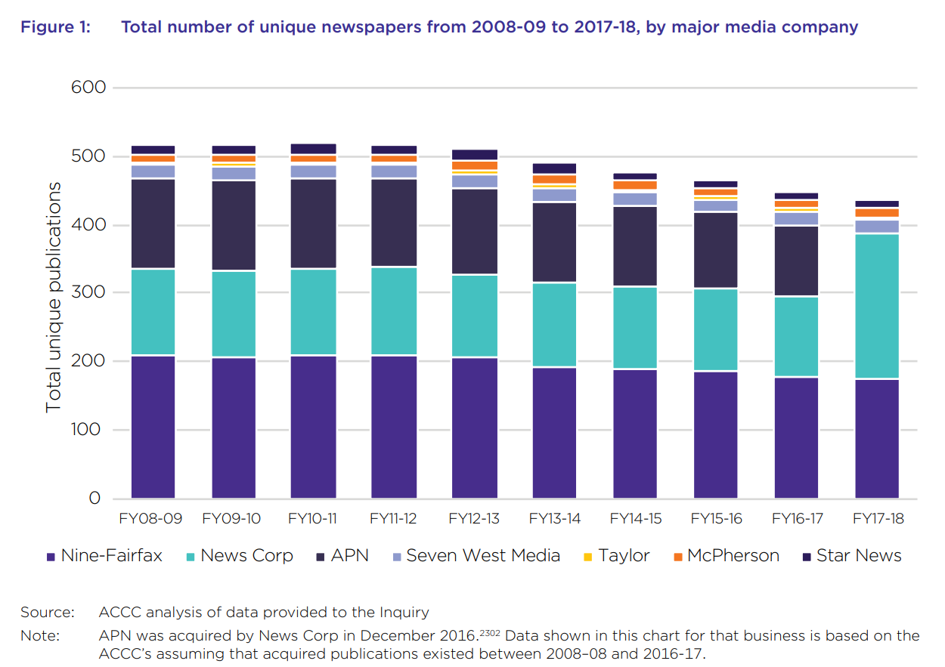

Source: (ACCC 2019), p. 562.

The ACCC’s DPI research is a useful snapshot of the health of regional print media, capturing important data about the coverage and circulation of regional newspapers, obtained directly from the major publishers via the ACCC’s information-gathering powers. Its findings suggest a need for ongoing monitoring of newspapers in regional Australia, which could be a focus of a measurement framework.

Although the ACCC produced a rich dataset that could be of value, legal limitations prevent the sharing of this information, meaning that the ACMA would need to approach newspaper publishers directly if it wanted to replicate the process. The ACCC study also chose not to focus on other sources of local news across mediums like TV, radio and online, and did not capture independent newspaper operators or other types of hyperlocal content that could possibly be considered as a part of a measurement framework.

### Availability of Local News and Information – Public Interest Journalism Initiative

The Public Interest Journalism Initiative (PIJI) brought together information and research about the quantum of local news journalism in regional Australia as part of the Australian Local Government Association’s 2019 State of the Regions report.[121] This included information about media market trends, research on the demand for local news, data from the ABS showing the decline of journalists employed in Australia from 2006 to 2016, and new data from a survey of 117 local government media managers from 84 LGAs.

The PIJI decided to focus on local government media managers due to their knowledge of local media markets and regular interactions with local news journalists. The national survey asked respondents whether, to the best of their knowledge, the amount of available local news had increased, declined or stayed the same over the last 5 years. The key findings from the survey suggested sharply declining levels of local news, felt greater among metropolitan LGAs (68%) compared to regional or rural LGAs (45%). Follow-up interviews highlighted several instances where local councils tried to address gaps in coverage through their own media efforts and deliberate attempts to contact journalists directly, particularly through the use of social media.

Results from PIJI survey – volume of local news in LGAs

|  | Metro | % | Regional/ Rural | % | Total | % |
| --- | --- | --- | --- | --- | --- | --- |
| Significant decline | 12 | 31 | 20 | 26 | 32 | 28 |
| Some decline | 14 | 37 | 15 | 19 | 29 | 25 |
| About the same | 8 | 21 | 24 | 31 | 32 | 28 |
| Some increase | 3 | 8 | 11 | 14 | 14 | 12 |
| Significant increase | 0 | 0 | 5 | 6 | 5 | 4 |
| Unsure | 1 | 3 | 3 | 4 | 4 | 3 |
| **Total** | **38** |  | **78** |  | **116** |  |

Table 6. Q13. To the best of your knowledge, has the amount of local news available from all media to residents of your local government areas increased, declined or stayed about the same over the last five years? n = 116. Source: PIJI 2019, p. 5.

The PIJI survey also asked respondents to provide the number of outlets providing local news to residents of their LGAs, across newspapers (including websites run by newspaper outlets), radio (excluding the ABC), TV (excluding the ABC), the ABC, independent web-based news outlets (not run by newspaper, radio or TV outlets) and news outlets run by ordinary citizens. This highlighted that newspapers (including their websites) remain a major source of local news in most of Australia, but that most local governments are also aware of citizen-run news in their local area.

Local government media managers are a credible source of information about the state of local news across individual communities, and the work of the PIJI could be particularly helpful in identifying the sources and types of local news available. The ACMA could engage with PIJI and ALGA to enquire about gaining access to their disaggregated survey results. As only 15% of LGAs responded to the request, it is unclear whether this could be regarded as a representative sample for all of Australia.

### The Expanding News Desert – Center for Innovation and Sustainability in Local Media (US)

In the US, researchers from the Center for Innovation and Sustainability in Local Media at the University of North Carolina have compiled a database of more than 9,000 local newspapers and have been tracking key metrics about these publications since 2004 to identify communities without newspapers or access to information that feeds grassroots democracy.[122] More recently, the study has expanded to include ‘ghost newspapers’, or publications that no longer provide the kind of local news information they once did, due to shrinking newsroom staff or restructuring and mergers.

This research found a net loss of 1,800 local newspapers since 2004, resulting in almost 200 of the 3,143 counties in the US being without a local paper and ‘hundreds – if not thousands – of communities at risk of becoming isolated news deserts’.[123] Significantly, 70%, or 1,300, of the newspapers that closed or merged were suburban papers, providing further evidence that the impact of local news closures is not isolated to regional or rural localities.

Abernathy’s study into ‘news deserts’ helps to highlight the dual importance of access to local news. The research found that communities without local news tended to have lower voter turnout, higher municipal expenses and reduced social cohesion.

The ‘news desert’ study has become a key measure of local news availability in the US. It includes a comprehensive and publicly available database, presented visually, which allows citizens to examine the local news environment in their own counties. This approach helps easily convey the problem and provides high levels of transparency about the research and its findings.

As with the ACCC study, there are some key limitations of this work. It focuses exclusively on newspapers, downplaying the role played by TV, radio and online sources of local news in the US. The study also doesn’t seek to assess the volume, quality, originality or relevance of the local news being produced by local newspapers, but rather excludes some types of ‘newspapers’ like those that are distributed free in public venues and are entirely advertiser-supported.

### Assessing Local Journalism – DeWitt Wallace Center for Media and Democracy (US)

The News Measures Research Project at Duke University in the US seeks to develop a series of local journalism assessment tools to help academics and policymakers assess the nature of journalistic content, the needs, interests, and preferences of local news audiences, and the health and rigor of the local news infrastructures in communities.

One of the major outputs of the research project is a scalable measurement model for assessing the availability of local journalism, including whether it meets community information needs.[124] This model consists of 3 broad stages – assessing journalistic infrastructure or sources of news, assessing journalistic outputs or quantity of news, and assessing journalistic performance or the relevance of the news to the local community. In designing this methodology, researchers controlled for population size, and also assessed concentration of stories among outlets using the Herfindahl-Hirschman Index (HHI).

To test their approach, the authors applied the analytical framework to local news content across 3 New Jersey communities substantially different from one another in size, demographic composition and geographic location within the state.

The methodology was replicated in a significantly larger 2018 study involving 100 randomly sampled US communities with populations between 20,000 and 300,000, and an assessment of over 16,000 local news stories.[125] Using regression analysis, this study found local news production in the US was positively associated with community attributes such as a large distance to major news markets and the presence of universities. A subsequent study of this dataset found that local newspapers significantly outperform local TV, radio and online outlets in news production.[126]

This measurement approach could be replicated in the Australian context. Of particular note, the methodology was designed with scale in mind, sacrificing depth in favour of breadth to be a useful tool for researchers and policymakers to assess the health of local journalism in communities across the US. In this regard, it appears highly relevant to an Australian context, noting a key limitation is its reliance on digital sources of news as a proxy for the broader news market.

### Local News Map – Local News Research Project (Canada)

In Canada, university researchers have been tracking the closures and mergers of local newspapers, broadcast outlets and online news sites since the recession of 2008. In 2016, the Local News Research Project launched an online map that visualised this data and invited academics, journalists and citizens to add additional information about local news sources through crowdsourcing tools.[127]

Screenshot of Canadian Local News Map

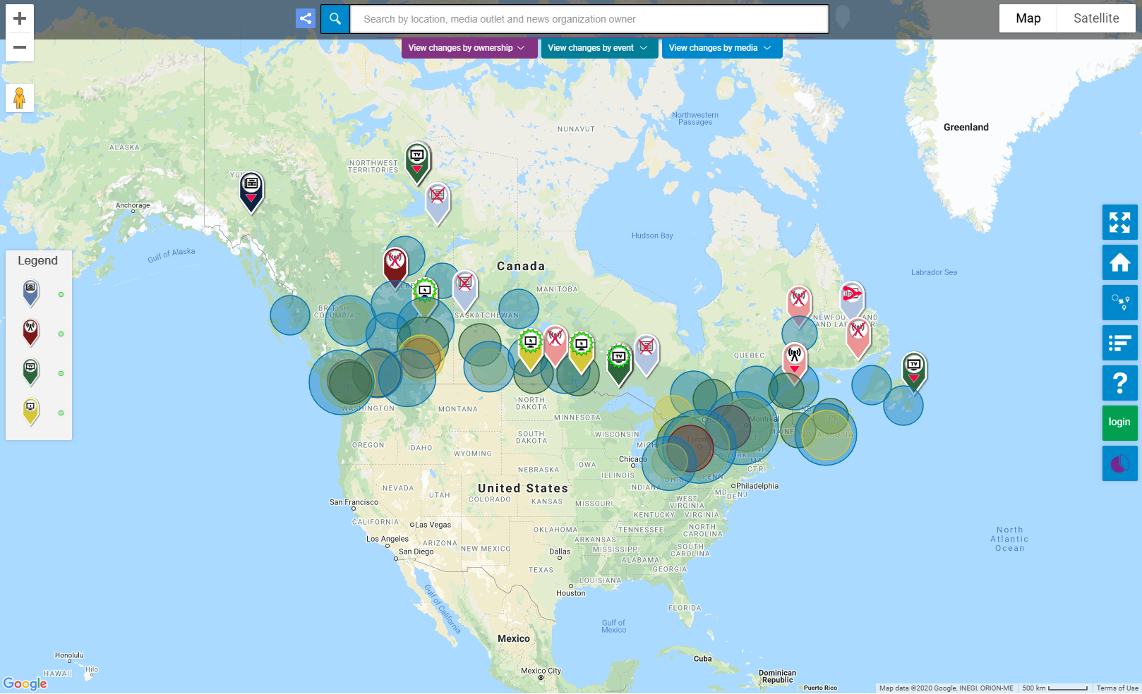

Source: The Local News Map, <https://newspoverty.geolive.ca/> (accessed 20 February 2020).

Unlike other studies, this project captures information about news sources across all mediums, but excluding Facebook groups, opinion blogs and magazines. All crowd-sourced contributions are quality-controlled through a verification process by the moderators of the map, and reports on key changes, as well as the raw data, are published online monthly.

This project presents a unique response to the challenges of measuring smaller and independent sources of local news at a community level. By maintaining an active community of researchers and volunteers, the map has become a useful tool in tracking ‘local news poverty’ across Canada. A comparable approach could be explored in the Australian context, asking researchers and the general public to assist the ACMA to identify the availability of local news within communities, particularly from independent or less popular sources.

The Local News Research Project limits their examination to local news organisations that:

… maintain independence from those it covers, demonstrate a commitment to accuracy/transparency, and are devoted primarily to reporting and publishing timely, originally produced news about local people, places, issues and events in a defined geographic area.[128]

There are 2 key limitations of this approach. The first is that the map only tracks news sources and does not seek to assess the relevance of news output to local communities. The second is its reliance on crowd-sourced data, which means that the Local News Map may be incomplete or lacking key sources of local news in areas where there is limited interest or public support for the project.

1. Australian Communications and Media Authority, [*Australians and news—impartiality and commercial influence*](https://www.acma.gov.au/publications/2020-01/report/australians-and-news-impartiality-and-commercial-influence), November 2020, accessed 20 November 2020.
2. Australian Communications and Media Authority, [COVID-19: Important information for industry](https://www.acma.gov.au/articles/2020-03/covid-19-important-information-industry), June 2020, accessed 20 November 2020.
3. Australian Competition and Consumer Commission, [*Digital Platforms Inquiry – Final Report*](https://www.accc.gov.au/publications/digital-platforms-inquiry-final-report), 2019, Ch. 6.
4. Australian Competition and Consumer Commission, [*Digital Platforms Inquiry – Final Report*](https://www.accc.gov.au/publications/digital-platforms-inquiry-final-report), 2019, p. 280.
5. See, for example, UK definition of media plurality; Ofcom, [*Measurement framework for media plurality: Ofcom’s advice to the Secretary of State for Culture, Media and Sport*](https://www.ofcom.org.uk/consultations-and-statements/category-1/media-plurality-framework), 2015, p. 6.
6. Australian Communications and Media Authority, [*Attitudes to news today—Impartiality and commercial influence: quantitative research*](https://www.acma.gov.au/publications/2020-01/report/australians-and-news-impartiality-and-commercial-influence), 2020, p. 7.
7. Australian Communications and Media Authority, [*Local content in regional Australia*](https://www.acma.gov.au/publications/2017-05/report/local-content-regional-australia), 2017, p. 7.
8. Mediatique Limited, [*Overview of recent dynamics in the UK press market*](https://www.gov.uk/government/publications/the-cairncross-review-a-sustainable-future-for-journalism), 2018. Report commissioned by Department for Digital Culture, Media and Sport [UK].
9. Simons, M. & Dickson, G.,[*Availability of Local News and Information*](https://apo.org.au/node/248231)*: State of the Regions Report*, Public Interest Journalism Initiative, 2019.
10. See Strategy 3, Australian Communications and Media Authority, [*Corporate plan 2019–20*](https://www.acma.gov.au/publications/2019-08/report/corporate-plan-2019-20), 2019.
11. The Treasury, [*ACCC mandatory code of conduct to govern the commercial relationship between digital platforms and media companies*](https://ministers.treasury.gov.au/ministers/josh-frydenberg-2018/media-releases/accc-mandatory-code-conduct-govern-commercial), 20 April 2020.
12. While the terms ‘media plurality’ and ‘media diversity’ are often used synonymously and have a similar meaning across both the Australian and UK regulatory contexts (referring to the variety of structures and content of a media system), ‘pluralism’ in academic literature often captures a wider range of factors including, for example, access to media by people with disabilities. For discussion, see: Australian Communications and Media Authority, *News in Australia: diversity and localism – Review of literature and research*, pp. 14–15.
13. s. 3(a),3(c),3(e), *Broadcasting Services Act 1992.*
14. s. 53, 54, 61AB, *Broadcasting Services Act 1992.*
15. See, for example, Standard 4.2, [ABC Code of Practice (2019)](https://about.abc.net.au/reports-publications/code-of-practice/); Code 2.2, [SBS Codes of Practice (2014)](http://media.sbs.com.au/home/upload_media/site_20_rand_1765533537_sbs_codes_of_practice_2014_july_2019_.pdf).
16. Code 3.9, [Commercial Radio Code of Practice (2017)](http://commercialradio.com.au/CR/media/CommercialRadio/Commercial-Radio-Code-of-Practice.pdf).
17. Code 3.6, [Community Radio Broadcasting Codes of Practice (2008)](https://www.cbaa.org.au/sites/default/files/media/Community%20Radio%20Broadcasting%20Codes%20of%20Practice%20-%20Print%20Friendly%20PDF.pdf).
18. Department of Communications and the Arts, [*Review of the Australian Communications and Media Authority – Final Report*](https://www.communications.gov.au/what-we-do/television/media/acma-review/acma-review-final-report), 2016, p. 89.
19. Department of Communications and the Arts, [*Review of the Australian Communications and Media Authority – Final Report*](https://www.communications.gov.au/what-we-do/television/media/acma-review/acma-review-final-report), 2016, pp. 85–86.
20. 51% of Australians read or watch the news online or on social media daily, compared to 52% watching news or current affairs on TV; Australian Communications and Media Authority, [*Attitudes to news today—Impartiality and commercial influence: quantitative research*](https://www.acma.gov.au/publications/2020-01/report/australians-and-news-impartiality-and-commercial-influence), 2020, p. 7. Other research has found online Australians now consume more news online than offline; Park, S., Fisher, C., Fuller, G. and Lee, J., [*Digital News Report: Australia 2018*](https://apo.org.au/node/174861), News & Media Research Centre, University of Canberra, 2018, p. 53.
21. The ACMA commissioned qualitative research that was conducted in August and September 2019 to provide an in-depth look at a range of consumer experiences relating to news, including diversity and localism. The research included 15 focus groups, 10 in-depth regional/rural telephone interviews and 12 face-to-face in-depth interviews where the participants had compiled visual diaries of their media consumption. There was a total of 136 adult participants who had read, watched or listened to news in the previous month, with a mix of ages, genders and news consumption patterns; Australian Communications and Media Authority, *News in Australia: diversity and localism – Qualitative research*, 2020, p. 5.
22. Australian Communications and Media Authority, *News in Australia: diversity and localism – Qualitative research*, 2020, p. 14.
23. These were the ‘2-out-of-3 rule’, which prevented a person being in a position to control more than two of commercial radio, commercial TV or newspapers in the same licence area, and the ‘75% audience reach rule’, which prevented a person being in a position to control commercial TV licences whose combined licence area population exceeded 75% of the population of Australia.
24. Commonwealth Parliamentary Debates, House of Representatives, [15 June 2017](https://parlinfo.aph.gov.au/parlInfo/download/chamber/hansardr/3219af20-da22-4762-b08e-ad4cf9b7009e/toc_pdf/House%20of%20Representatives_2017_06_15_5167_Official.pdf;fileType=application%2Fpdf), p. 6603.
25. Watkins, J., Fuller, G. and Fisher, C., [Submission to the Select Committee on Future of Public Interest Journalism (Submission 50)](https://www.aph.gov.au/DocumentStore.ashx?id=9c064951-a826-4336-b139-0056dd66f43c&subId=512271), News & Media Research Centre, University of Canberra, 2017, p. 2.
26. Ofcom, [Measuring Media Plurality: Ofcom’s advice to the Secretary of State for Culture, Media and Sport](https://www.ofcom.org.uk/__data/assets/pdf_file/0031/57694/measuring-media-plurality.pdf), 2012, p. 18.
27. For example, traditional Australian media outlets made up 14 of the top 20 most visited news websites in 2018; Roy Morgan, [It’s official: Most Australians now visit news or newspaper websites](http://www.roymorgan.com/findings/7595-top-20-news-websites-march-2018-201805240521), Finding No. 7595, 2018.
28. Fisher, C., Park, S., Lee, J., Fuller, G. and Sang, Y., [Digital News Report: Australia 2019](https://apo.org.au/node/240786), News & Media Research Centre, University of Canberra, 2019.
29. See, for discussion, Dwyer, T. and Martin, F., Updating Diversity of Voice Arguments for Online News Media, 4(1), *Global Media Journal*, 2010.
30. Australian Communications and Media Authority, *News in Australia: diversity and localism – Qualitative research*, 2020, p. 14.
31. Fisher, C., Park, S., Lee, J., Fuller, G. and Sang, Y., [Digital News Report: Australia 2019](https://apo.org.au/node/240786), News & Media Research Centre, University of Canberra, 2019, p. 27.
32. ‘The term ‘filter bubble’ has been used to refer to a scenario in which the choice of material displayed to a user is selected by algorithms according to the user’s previous behaviours, and this material is ‘devoid of attitude-challenging content’. In other words, it is a situation where users of digital platforms are repeatedly exposed to the same perspectives, as a result of algorithms curating content and presenting only material that they might prefer. A similar concept of ‘echo chambers’ describes the repeated exposure to perspectives that affirm a person’s own beliefs, which may occur on social media platforms either as a result of curation by algorithms or sharing behaviour of other users populating a person’s newsfeed. Australian Competition and Consumer Commission, [*Digital Platforms Inquiry – Final Report*](https://www.accc.gov.au/publications/digital-platforms-inquiry-final-report), 2019, p. 346.
33. Distrust in news on social media grew from 45% in 2018 to 49% in 2019; Fisher, C., Park, S., Lee, J., Fuller, G. and Sang, Y., [Digital News Report: Australia 2019](https://apo.org.au/node/240786), News & Media Research Centre, University of Canberra, 2019.
34. Australian Communications and Media Authority, [*Local content in regional Australia*](https://www.acma.gov.au/publications/2017-05/report/local-content-regional-australia), 2017, p. 7.
35. Roy Morgan Research, [Consumer Use of News Final Report](https://www.accc.gov.au/focus-areas/inquiries/digital-platforms-inquiry/accc-commissioned-research), 2018, p. 28. Report commissioned by the ACCC.
36. See, for example, Richards, I., [Beyond city limits: Regional journalism and social capital](https://journals.sagepub.com/doi/abs/10.1177/1464884912453280#articleCitationDownloadContainer), *Journalism*, 14(5), 2013, pp. 627-642.
37. Australian Communications and Media Authority, *News in Australia: diversity and localism – Qualitative research*, 2020, p. 18.
38. Australian Competition and Consumer Commission, [*Digital Platforms Inquiry – Final Report*](https://www.accc.gov.au/publications/digital-platforms-inquiry-final-report), 2019, p.283.
39. Australian Communications and Media Authority, *News in Australia: diversity and localism – Qualitative research*, 2020, p. 18.
40. The ACMA qualitative research report contains a summary of the findings and a selection of quotes and examples from participants. Some quotes in this paper are from the full material provided by the research consultant and not all are published in the research report; Australian Communications and Media Authority, *News in Australia: diversity and localism – Qualitative research*, 2020.
41. See, for example, s.3(ea), (g), *Broadcasting Services Act 1992*.
42. See, for example, s.61CW, *Broadcasting Services Act 1992*.
43. Commonwealth, [Parliamentary Debates](https://parlinfo.aph.gov.au/parlInfo/search/display/display.w3p;query=Id%3A%22chamber%2Fhansardr%2F3219af20-da22-4762-b08e-ad4cf9b7009e%2F0013%22), 15 June 2017, p. 6603.
44. Australian Competition and Consumer Commission, [*Digital Platforms Inquiry – Final Report*](https://www.accc.gov.au/focus-areas/inquiries-ongoing/digital-platforms-inquiry/final-report-executive-summary), 2019, pp. 294–296.
45. Department of Infrastructure, Transport, Regional Development and Communications, [Regional and Small Publishers Jobs and Innovation Package](https://www.communications.gov.au/what-we-do/television/regional-and-small-publishers-jobs-and-innovation-package), viewed 18 February 2020. It is further noted that in early 2020, the government established the Public Interest News Gathering (PING) program to support public interest journalism delivered by commercial television, newspaper and radio businesses in regional Australia. Department of Infrastructure, Transport, Regional Development and Communications, [*Supporting public interest journalism*](https://minister.infrastructure.gov.au/fletcher/media-release/supporting-public-interest-journalism)*,* 24 April 2020.
46. The Small Publishers Innovation Fund is one of 3 programs funded as part of the Australian Government Regional and Small Publishers Jobs and Innovation Package, providing up to $16 million in grants over 3 years. Eligible publishers can apply for grant money from the fund to find new ways to work in the modern media environment and make their business more sustainable; Australian Communications and Media Authority, [Regional and Small Publishers Innovation Fund](https://www.acma.gov.au/regional-and-small-publishers-innovation-fund), accessed 26 February 2020.
47. Simons, M. & Dickson, G., [*State of the Regions Report: Availability of Local News and Information*](https://apo.org.au/node/248231), Public Interest Journalism Initiative, 2019.
48. Australian Communications and Media Authority, [*Regional Australians’ access to local content – Community research*](https://www.acma.gov.au/publications/2017-05/report/local-content-regional-australia), 2017, p. 6.
49. Australian Communications and Media Authority, [*Regional Australians’ access to local content – Community research*](https://www.acma.gov.au/publications/2017-05/report/local-content-regional-australia), 2017, p. 5.
50. Australian Competition and Consumer Commission, [*Digital Platforms Inquiry – Final Report*](https://www.accc.gov.au/publications/digital-platforms-inquiry-final-report), 2019, Appendix F.
51. Fray, P., [Crisis, Challenge and Choice in Regional and Local News Media: The Case for a Service-first Recovery](https://apo.org.au/node/305888), Centre for Media Transition, University of Technology Sydney, 2018.
52. Carson, A., Muller, D., Martin, J. & Simons, M., [A new symbiosis? Opportunities and challenges to hyperlocal journalism in the digital age](https://journals.sagepub.com/doi/abs/10.1177/1329878X16648390), *Media International Australia*, 161(1), 2016, pp. 132–146.
53. Looking at the US market, for example, the hyperlocal model appears to have found the most traction in affluent communities; Hindman, M., [Stickier News. What Newspapers Don’t Know about Web Traffic Has Hurt Them Badly - But There is a Better Way](https://shorensteincenter.org/stickier-news-matthew-hindman/), Shorenstein Center on Media, Politics and Public Policy, Harvard Kennedy School, 2015.
54. Simons, M. & Dickson, G., [State of the Regions Report: Availability of Local News and Information](https://apo.org.au/node/248231), Public Interest Journalism Initiative, 2019.
55. Australian Competition and Consumer Commission, [*Digital Platforms Inquiry – Final Report*](https://www.accc.gov.au/publications/digital-platforms-inquiry-final-report), 2019, Appendix E.
56. Simons, M. & Dickson, G., [*State of the Regions Report: Availability of Local News and Information*](https://apo.org.au/node/248231), Public Interest Journalism Initiative, 2019.
57. In qualitative research commissioned by Ofcom, for example, participants interpreted the category of ‘news’ broadly to include comedy and satire (such as ‘The Last Leg’), word of mouth (including discussions via social media), documentaries (including current affairs programming) and ‘selfie news’ (individuals reporting on hyper-local activities and events); Jigsaw Research, [The Changing World of News: Qualitative research](https://www.ofcom.org.uk/__data/assets/pdf_file/0023/115916/The-Changing-World-of-News.pdf), 2018. Report commissioned by Ofcom.
58. ‘This review argues there are two areas of public-interest news that matter greatly... One is investigative and campaigning journalism, and especially investigations into abuses of power in both the public and the private sphere…. The second is the humdrum task of reporting on the daily activities of public institutions, particularly those at local level, such as the discussions of local councils or the proceedings in a local Magistrates Court’; Cairncross, F., [The Cairncross Review – A sustainable future for journalism](https://www.gov.uk/government/publications/the-cairncross-review-a-sustainable-future-for-journalism), 2019, p. 17.
59. ‘Journalism with the primary purpose of recording, investigating and explaining issues of public

    significance in order to engage citizens in public debate and inform democratic decision making at all

    levels of government’; Australian Competition and Consumer Commission, [*Digital Platforms Inquiry – Final Report*](https://www.accc.gov.au/publications/digital-platforms-inquiry-final-report), 2019, p. 285.
60. Department of Communications and the Arts, [Regional and Small Publishers Innovation Fund Update](https://www.communications.gov.au/sites/default/files/regional-and-small-publishers-innovation-fund-update_26-oct-2017.pdf?acsf_files_redirect), 2017.
61. Reuters Institute for the Study of Journalism, [Digital News Report 2016](https://reutersinstitute.politics.ox.ac.uk/our-research/digital-news-report-2016), University of Oxford, 2016, p. 96.
62. See, for discussion, Lehman-Wilzig, S. and Seletzky, M., ‘[Hard news, soft news, ‘general’ news: The](https://www.researchgate.net/publication/249689936_Hard_news_soft_news_'general'_news_The_necessity_and_utility_of_an_intermediate_classification)

    [necessity and utility of an intermediate classification](https://www.researchgate.net/publication/249689936_Hard_news_soft_news_'general'_news_The_necessity_and_utility_of_an_intermediate_classification)’, *Journalism*, 11(1), 2010, pp. 37–56.
63. For example, under the definitions of the 2017 [Commercial Radio Code of Practice](https://www.acma.gov.au/industry-codes-practice), a News Program means ‘a program, bulletin or news flash, the predominant purpose of which is to present factual new information on current events and which is typically prepared by journalists’, whereas a Current Affairs Program means a ‘program the predominant purpose of which is to provide interviews, analysis, commentary or discussion, including open-line discussion with listeners, about current social, economic or political issues’.
64. This is based on the definition of a local news outlet by the Canadian Local News Research Project; Lindgren, A. and Corbett, J., [Local News Map Data](https://localnewsresearchproject.ca/2020/12/08/local-news-map-data-reports/), February 2020, p. 1.
65. [www.the-terrier.com.au/](https://www.the-terrier.com.au/)
66. [www.michaelwest.com.au/](https://www.michaelwest.com.au/)
67. This could include news agencies like Reuters or the Associated Press. Where available, local news agencies would also be examined.
68. Australian Competition and Consumer Commission, [*Digital Platforms Inquiry – Final Report*](https://www.accc.gov.au/publications/digital-platforms-inquiry-final-report), 2019, p. 350.
69. Researchers will often rely on consumer surveys or similar self-reporting methods to identify which news sources are being consumed. Due to difficulties with recall and blurring of news and other content, these methods may be less appropriate when examining news consumption via social media and news aggregators.
70. Revealing Reality, [*Scrolling news: The changing face of online news consumption*](https://www.revealingreality.co.uk/work/scrolling-news/), 2018, p. 5. Report commissioned by Ofcom.
71. Fisher, C., Park, S., Lee, J., Fuller, G. and Sang, Y., [Digital News Report: Australia 2019](https://apo.org.au/node/240786), News & Media Research Centre, University of Canberra, 2019, p. 28.
72. However, some participants did express a view that concentrated media ownership could lead to repetition and narrow coverage; Australian Communications and Media Authority, *News in Australia: diversity and localism – Qualitative research*, 2020, p. 4–13.
73. Australian Competition and Consumer Commission, [*Digital Platforms Inquiry – Final Report*](https://www.accc.gov.au/publications/digital-platforms-inquiry-final-report), 2019, pp. 286–288.
74. Napoli, P., 'Deconstructing the diversity principle', *Journal of Communication*, 49(4), 1999, pp. 7–34.
75. Australian Communications and Media Authority, *News in Australia: diversity and localism – Review of literature and research*, p. 17–18.
76. Napoli, P., 'Exposure diversity reconsidered', *Journal of Information Policy*, 2011, pp. 246–259.
77. The Committee on the Impact of Media Concentration, Uses and Influences of News Media, 2015. Report prepared for Minister of Culture, Sports and Tourism (Republic of Korea).
78. s. 6(1)(a)(i), [*Australian Broadcasting Corporation Act 1983*](https://www.legislation.gov.au/Details/C2020C00015)(Cth)*.*
79. Clause IV(4), [ABC Code of Practice (and associated standards)](https://about.abc.net.au/reports-publications/code-of-practice/), January 15, 2019.
80. Dubois, E, Blank, G., ‘The echo chamber is overstated: the moderating effect of political interest and diverse media’, *Information, Communication & Society*, 21(5), 2018, pp. 729–745.
81. See, for example, Champion, K., ‘Measuring Content Diversity in a Multi-Platform Context’, *The Political Economy of Communication*, 3(1), 2015, pp. 39–56.
82. Napoli, P., ‘Exposure Diversity Reconsidered’, *Journal of Information Policy*, 2011, pp. 246–259.
83. Scherer, D., [Federal Communications Commission (FCC) Media Ownership Rules](https://crsreports.congress.gov/product/details?prodcode=R45338), *Congressional Research Service*, 2018, p. 1.
84. See discussion on research from Emeritus Professor Andrew Jakubowicz, Professor of Sociology at UTS, on ‘standpoint diversity’; Australian Communications and Media Authority, *News in Australia: diversity and localism – Review of literature and research*, pp. 48–51.
85. Roy Morgan,[*Consumer Views and Behaviours on Digital Platforms: Final Report*](https://www.accc.gov.au/focus-areas/inquiries-ongoing/digital-platforms-inquiry/accc-commissioned-research), 2018. Report commissioned by the ACCC.
86. Jakubowicz, A., 'New groups and social cohesion in Australia', in Higley, J., Nieuwenhuysen, J., & Neerup, S. (eds.), *Nations of Immigrants: Australia and the USA Compared*, 2009.
87. See, for example, s. 7, Broadcasting Services (Meaning of Local) Instrument 2018. Similarly, under s. 6 of the Broadcasting Services (Regional Commercial Radio — Material of Local Significance) Licence Condition 2014, material is of ‘local significance’ if it is hosted in, produced in, or related to the licence area.
88. Consumer research commissioned by the ACMA in 2016 identified several factors influencing perceptions of local area boundaries in regional Australia. These included an individual’s feelings of personal connection, their age and life experience, the natural characteristics of an area, proximity to major centres, and the historic and economic characteristics of an area; Hall&Partners, *Regional local content qualitative research – final research report*, 2017. Report commissioned by the ACMA.
89. See, for example, Australian Communications and Media Authority, [Availability of local content in regional Australia: Case studies](https://www.acma.gov.au/publications/2017-05/report/local-content-regional-australia), 2017.
90. Including unincorporated areas; Australian Bureau of Statistics, [1270.0.55.003 - Australian Statistical Geography Standard (ASGS): Volume 3 - Non ABS Structures](https://www.abs.gov.au/ausstats/abs@.nsf/Lookup/by%20Subject/1270.0.55.003~July%202019~Main%20Features~Local%20Government%20Areas%20(LGAs)~2), 2019.
91. Broadcasting (Hours of Local Content) Declaration No. 1 of 2017
92. Fisher, C., Park, S., Lee, J., Fuller, G. and Sang, Y., [Digital News Report: Australia 2019](https://apo.org.au/node/240786), News & Media Research Centre, University of Canberra, 2019.
93. Fisher, C., Park, S., Lee, J., Fuller, G. and Sang, Y., [Digital News Report: Australia 2019](https://apo.org.au/node/240786), News & Media Research Centre, University of Canberra, 2019.
94. See, for example, Australian Communications and Media Authority, [Availability of local content in regional Australia: Case studies](https://www.acma.gov.au/publications/2017-05/report/local-content-regional-australia), 2017.
95. Napoli, P., Weber, M., McCollough, K. and Wang, Q., [Assessing Local Journalism: News deserts, journalism divides, and the determinants of the robustness of local news](https://dewitt.sanford.duke.edu/assessing-news-media-infrastructure-report-released/), 2018.
96. s. 6, Broadcasting Services Local Programming Determination 2018*.*
97. ss. 7(3) and (4), Broadcasting Services (Regional Commercial Radio — Material of Local Significance) Licence Condition 2014.
98. The ACCC defines ‘public interest journalism’ as 'journalism with the primary purpose of recording, investigating and explaining issues of public significance in order to engage citizens in public debate and inform democratic decision making at all levels of government’. While the term ‘civic journalism’ can be used interchangeability with ‘public interest journalism’, we are framing the former as news with civic value relating to a specific locality.
99. Friedland, L, et al, [Review of the Literature Regarding Critical Information Needs of the American Public](https://www.fcc.gov/news-events/blog/2012/07/25/review-literature-regarding-critical-information-needs-american-public), Submitted to the Federal Communications Commission, 2012.
100. Australian Competition and Consumer Commission, [*Digital Platforms Inquiry – Final Report*](https://www.accc.gov.au/publications/digital-platforms-inquiry-final-report)*,* Appendix E, 2019, pp. 550–560.
101. Napoli, Stonbely, McCollough and Renninger, [Local Journalism and the Information Needs of Local Communities – Towards a scalable assessment approach](https://www.tandfonline.com/doi/pdf/10.1080/17512786.2016.1146625?needAccess=true), 11(4), *Journalism Practice*, 2017, pp. 373–395.
102. Australian Communications and Media Authority, [Availability of local content in regional Australia: Case studies](https://www.acma.gov.au/publications/2017-05/report/local-content-regional-australia), 2017.
103. Australian Bureau of Statistics, [2071.0 - Census of Population and Housing: Reflecting Australia - Stories from the Census, 2016: Small Towns](https://www.abs.gov.au/ausstats/abs@.nsf/Lookup/by%20Subject/2071.0~2016~Main%20Features~Small%20Towns~113), 2018.
104. A ‘bright line’ refers to a clear-cut, consistent and readily enforceable rule or standard, such as fixed ownership limits for media outlets. For discussion, see Smith, R., ‘Bright-Line versus Responsive Regulation: Some Thoughts from the United Kingdom’, in Valcke, P., Sükösd. M. and Picard, R. (eds.), *Media Pluralism and Diversity: Concepts, Risks and Global Trends*, 2015, pp. 310–324.
105. Ofcom, [Measurement framework for media plurality: Ofcom’s advice to the Secretary of State for Culture, Media and Sport](https://www.ofcom.org.uk/consultations-and-statements/category-1/media-plurality-framework), 2015, p. 6.
106. This is similar to the baseline measure that was advocated for by the Centre for Media Transition (CMT) in its 2018 report to the ACCC. CMT noted that a media pluralism baseline would offer a richer understanding of media pluralism in Australia and assist in addressing specific concerns about the narrowing of choice for consumers; Wilding, D., Fray, P., Molitorisz, S. and McKewon, E., [The Impact of Digital Platforms on News and Journalistic Content](https://www.accc.gov.au/focus-areas/inquiries-ongoing/digital-platforms-inquiry/accc-commissioned-research), Centre for Media Transition, University of Technology Sydney, 2018, p. 146. Report commissioned by the Australian Competition and Consumer Commission.
107. See note 100.
108. Individual measures of consumption for each media platform are available to varying degrees of reliability. Due to the different methodologies used, however, they cannot be appropriately combined to provide a comprehensive and accurate view of news consumption across all platforms.
109. Revealing Reality, [*Scrolling news: The changing face of online news consumption*](https://www.revealingreality.co.uk/work/scrolling-news/), 2018, p. 5. Report commissioned by Ofcom.
110. Fletcher, R. & Nielsen, R.K., 'Are people incidentally exposed to news on social media? A comparative analysis', *New Media & Society*, 20(7), 2018, pp. 2450–2468.
111. While this commercial data is still primarily platform specific, the Virtual Australia (VOZ) total TV database will provide ratings data for all Australian TV programming across both linear and online broadcast streaming and catch-up services (from ABC, Seven Network, Nine Network, Network 10, SBS and Foxtel). Launching later in 2020, as a partnership between OzTAM and Nielsen, VOZ will provide ratings data for Australian TV programming across both traditional linear TV as well as broadcast video on demand services.
112. Bruns, A., ‘Making Audience Engagement Visible: Publics for Journalism on Social Media Platforms’, in B. Franklin & S. A. Eldridge II (eds.), *The Routledge Companion to Digital Journalism Studies*, 2017, pp. 325–334.
113. These include the Centre for Media Transition’s [Media Pluralism and Online News](https://mediapluralism.org.au/) project (2018 to 2021), the ARC Linkage Project between the Alfred Deakin Institute and Country Press Association on [Media innovation and the civic future of Australia's country press](https://www.deakin.edu.au/about-deakin/media-releases/articles/country-press-survival-the-focus-of-newly-funded-deakin-research)(2019 to 2021), and the work underway as part of the news and media priority domain through the [2020 ARC Centre of Excellence for Automated Decision-Making and Society](https://www.arc.gov.au/2020-arc-centre-excellence-automated-decision-making-and-society) (2020 to 2027).
114. Cushion, S., [*The Range and Depth of BBC News and Current Affairs: A Content Analysis*](https://www.ofcom.org.uk/tv-radio-and-on-demand/information-for-industry/bbc-operating-framework/performance/review-bbc-news-current-affairs), Cardiff University, School of Journalism, Media and Culture, 2019. Report commissioned by Ofcom.
115. Peter Fray has subsequently left UTS.
116. Napoli, P., Assessing Media Diversity in the U.S.: A Comparative Analysis of the FCC’s Diversity Index and the EU’s Media Pluralism Monitor, *Media Pluralism and Diversity: Concepts, Risks and Global Trends,* 2015.
117. *Prometheus Radio Project v. Federal Communications Commission*, 373 F.3d 372 (3rd Cir. 2004).
118. Australian Communications and Media Authority, [Availability of local content in regional Australia: Case studies](https://www.acma.gov.au/publications/2017-05/report/local-content-regional-australia), 2017.
119. Australian Competition and Consumer Commission, [*Digital Platforms Inquiry – Final Report*](https://www.accc.gov.au/publications/digital-platforms-inquiry-final-report), 2019, pp. 560–566 (Appendix F).
120. See, P Gao, C Lee, D. Murphy, [Financing Dies in Darkness? The Impact of Newspaper Closures on Public Finance](https://www.brookings.edu/research/financing-dies-in-darkness-the-impact-of-newspaper-closures-on-public-finance/), *Journal of Financial Economics*, 2019.
121. Simons, M. & Dickson, G., [State of the Regions Report: Availability of Local News and Information](https://apo.org.au/node/248231), Public Interest Journalism Initiative, 2019.
122. Abernathy, P., [The Expanding News Desert](https://www.usnewsdeserts.com/reports/), The Center for Innovation and Sustainability in Local Media, University of North Carolina, 2018.
123. Abernathy, P., [The Expanding News Desert](https://www.usnewsdeserts.com/reports/), The Center for Innovation and Sustainability in Local Media, University of North Carolina, 2018.
124. Napoli, P., Stonbely, S., McCollough, K., and Renninger, B., [Local Journalism and the Information Needs of Local Communities – Towards a scalable assessment approach](https://www.tandfonline.com/doi/pdf/10.1080/17512786.2016.1146625?needAccess=true), 11(4), *Journalism Practice*, 2017, pp. 373–395.
125. Napoli, P., Weber, M., McCollough, K. and Wang, Q., [Assessing Local Journalism: News deserts, journalism divides, and the determinants of the robustness of local news](https://dewitt.sanford.duke.edu/assessing-news-media-infrastructure-report-released/), DeWitt Wallace Center for Media & Democracy, 2018.
126. Mahone, J., Wang, Q., Napoli, P., Weber, M. and McCollough, K., [Who’s Producing Local Journalism? Assessing journalistic output across different outlet types](https://dewitt.sanford.duke.edu/wp-content/uploads/2019/08/Whos-Producing-Local-Journalism_FINAL.pdf), DeWitt Wallace Center for Media & Democracy, 2019.
127. Lindgren, A. and Corbett, J., [Local News Map Data](https://localnewsresearchproject.ca/2020/12/08/local-news-map-data-reports/), February 2020, p. 1.
128. Lindgren, A. and Corbett, J., [Local News Map Data](https://localnewsresearchproject.ca/2020/12/08/local-news-map-data-reports/), February 2020, p. 1.