

Telco consumer experience—  
Australian businesses:

Phone and internet services

October 2020

Canberra

Red Building   
Benjamin Offices  
Chan Street   
Belconnen ACT

PO Box 78  
Belconnen ACT 2616

T +61 2 6219 5555  
F +61 2 6219 5353

Melbourne

Level 32   
Melbourne Central Tower  
360 Elizabeth Street   
Melbourne VIC

PO Box 13112  
Law Courts   
Melbourne VIC 8010

T +61 3 9963 6800  
F +61 3 9963 6899

Sydney

Level 5   
The Bay Centre  
65 Pirrama Road   
Pyrmont NSW

PO Box Q500  
Queen Victoria Building   
NSW 1230

T +61 2 9334 7700 or 1800 226 667  
F +61 2 9334 7799

Copyright notice

[Creative Commons logo](http://i.creativecommons.org/l/by/3.0/88x31.png)

<https://creativecommons.org/licenses/by/4.0/>

With the exception of coats of arms, logos, emblems, images, other third-party material or devices protected by a trademark, this content is made available under the terms of the Creative Commons Attribution 4.0 International (CC BY 4.0) licence.

We request attribution as © Commonwealth of Australia (Australian Communications and Media Authority) 2020.

All other rights are reserved.

The Australian Communications and Media Authority has undertaken reasonable enquiries to identify material owned by third parties and secure permission for its reproduction. Permission may need to be obtained from third parties to re-use their material.

Written enquiries may be sent to:

Manager, Editorial Services  
PO Box 13112  
Law Courts  
Melbourne VIC 8010  
Email: [info@acma.gov.au](mailto:info@acma.gov.au)

Key findings 1

Consumer behaviour, expectations and engagement with services 1

Experience and satisfaction with services 2

Emerging issues 4

Background 5

researchacma 6

About the research 6

Objectives 7

Methodology 8

Statistical reliability of the quantitative results 8

General notes for reading this report 8

Terms used in this report 9

Business survey 10

Chapter summary—At a glance 10

Introduction 12

Detailed findings 12

Types of services in use 12

Number of business telco services 14

Types of connection 14

Use of residential and business plans for telco services 15

Web-connected business services and technologies 16

Importance of telco service experience factors 18

Being on the right plan, or switching telcos in the next 12 months 20

Attitudes about telcos and telco services 21

Contact with telcos 22

Enquiries 23

Reasons for most recent enquiry 24

Contact channel for most recent enquiry 25

Satisfaction with enquiries 26

Issues or faults with business telco services 26

Types of issue or faults 27

Type of issue or fault nominated as biggest problem 28

Frequency of dropouts or outages 29

What those with issues or faults did next 29

Complaints 30

Reason for most recent complaint 32

Contact channel for most recent complaint 32

Time to resolve most recent complaint 33

Satisfaction with complaints-handling 34

Compensation for complaints 35

The impact of outages or dropouts 35

Satisfaction 36

Managing data, security and telco services 43

Business consideration of smart devices and 5G 44

Consideration of 5G 44

Appendix A 45

Overview

There have been significant changes in the telecommunications landscape in recent years. With the rollout of the National Broadband Network (NBN), a proliferation of over-the-top services, mobile apps and devices have entered the market leading to an increase in demand from data-hungry consumers.

Past research by the Australian Communications and Media Authority (ACMA) has highlighted that customer service, complaints-handling, and service reliability are areas of concern for consumers. It has also showed that Australian adults, households and businesses have common, yet distinct, issues and expectations about their telecommunications services.

To ensure regulatory settings remain appropriate, consumer research is an important input, particularly in understanding current experiences and emerging issues.

This report presents an in-depth view of the telecommunications consumer experience at the end of 2019. Our findings highlight the reported experience of Australian small and medium-sized businesses, as well as their expectations and preferences in relation to telecommunications services. The individual and household survey findings are published in *Telco consumer experience—Australian adults and households: Phone and internet services*, available alongside this report on the ACMA website.

Please note that this report covers data collected between November and December 2019. The effects of the COVID-19 pandemic are not reflected in this report.

## Key findings

The findings from this research indicate a more positive consumer experience with mobile services compared to fixed internet and phone services.

### Consumer behaviour, expectations and engagement with services

#### Device and service usage

The research highlights the range of technologies, services and activities used by businesses.

Nine in 10 businesses are connected to a fixed line or NBN service for internet (92 per cent) or have mobile phones paid for by the business (89 per cent). Nearly all businesses (97 per cent) had at least two of the four types of telco services (internet, mobile phone, business phone or mobile broadband), with a third using all four types of telecommunication services.

Online banking was by far the most commonly used technology or service (94 per cent). Six in ten (61 per cent) used online or email marketing or social media, and cloud computing was used by 56 per cent of businesses.

Four in five businesses agreed that they had the right telco plan to meet their needs.

#### Important service factors

The research investigated the factors that may affect business consumers’ experience with their telecommunications services. Multiple factors could be selected as important (refer to Figure 4).

While price was important to many, other non-price factors ranked higher overall for businesses.

The factors most frequently rated as important were reliability of services (98 per cent), getting the services paid for (95 per cent), issues or faults being fixed (94 per cent) and good customer service (89 per cent).

Around half of businesses agreed that telcos understood the needs of businesses (49 per cent)—32 per cent disagreed; and that they act quickly when issues arise (53 per cent)—30 per cent disagreed.

Nearly a quarter of businesses (23 per cent) agreed they were actively considering switching telcos in the next 12 months. The likelihood of a business considering switching was a little higher among those with four types of telco services (27 per cent) compared with those with any two types of services (15 per cent). The likelihood of considering switching was lower among those that agreed their telco understood their needs.

### Experience and satisfaction with services

#### Contact with telcos

Two thirds of businesses (68 per cent) had contacted their telco/s at least once about their services in the previous six months. Contact was more likely to be a complaint (40 per cent of all businesses) compared with an enquiry (33 per cent of all businesses). Those with business phone or business internet contacted their telco with an enquiry at slightly higher rate compared to other services.

Among all businesses that contacted their telco for an enquiry, one in five enquired about outages and 17 per cent enquired about changing, renewing or buying a new plan.

#### Issues or faults

Businesses commonly experienced issues and faults with their telecommunications services, but not all led to complaints.

Two thirds (66 per cent) of businesses had at least one type of issue or fault across any service. Business internet had the highest rate of issues or faults (52 per cent) compared with other services. The rate for business phone was 40 per cent. The most frequently mentioned issues or faults for businesses by service type were:

* business internet—loss of service, planned or unplanned outages (51 per cent), dropouts (30 per cent) or internet speed (23 per cent)
* business phone—loss of service, planned or unplanned outages (51 per cent) and fault or technical issue (33 per cent)

business mobile phone—coverage (45 per cent) and dropouts (26 per cent).

Three quarters of businesses that experienced outages or loss of service for their business internet reported the impact as major (42 per cent) or moderate (33 per cent).

For businesses that experienced an issue or fault with their telco services, 73 per cent contacted their telco or made a complaint. One in 10 businesses did nothing in response to an issue or fault.

The link between issues and faults and complaints is clear—the rate of complaint was over 12 times higher for businesses that had an issue or fault in the previous six months (58 per cent) compared with those with no issues or faults (five per cent).

#### Complaints

Four in 10 businesses had made at least one complaint to their telco in the previous six months. Those with business internet had a higher rate of complaint compared to other services—26 per cent had a recent complaint about their business internet, compared with 19 per cent for business phone. The most common reason for the most recent complaint was outages (29 per cent) (Figure 17).

The impact of outages or dropouts, regardless of contacting their telco or making a complaint was more severe for business internet than for business phone:

* three quarters of businesses (75 per cent) who were left without their business internet reported the impact as major (42 per cent) or moderate (33 per cent)

nearly two thirds of businesses (64 per cent) who were left without their business phone reported the impact as major (35 per cent) or moderate (28 per cent).

Too many complaints, however, took too long to resolve or remained unresolved. For businesses that made a complaint, 25 per cent reported that their most recent complaint to their telco took between three days and three weeks to resolve, with 21 per cent reporting it took more than three weeks.

Four in 10 businesses (40 per cent) who made a complaint and had it resolved were satisfied with how the complaint was handled—46 per cent were dissatisfied.

Businesses that had complaints resolved sooner were more satisfied with how their complaint was handled. The proportion of businesses satisfied with complaints-handling, by time to resolve the complaint:

* resolved on the same day: 74 per cent
* resolved in two working days: 68 per cent
* resolved within one week: 59 per cent
* resolved over a week: 15 per cent.

#### Satisfaction with services

Satisfaction with service reliability was highest for business mobile phone services and lowest for business internet:

* nearly nine in 10 businesses (89 per cent) were satisfied with the reliability of their business mobile phone service
* three quarters (75 per cent) of businesses were satisfied with the reliability of their business phone service
* nearly three quarters (73 per cent) of businesses were satisfied with the reliability of their business mobile broadband service

two thirds (67 per cent) of businesses were satisfied with the reliability of their business internet service.

Around six in 10 businesses (62 per cent) were satisfied with the monthly cost of their business telco service/s and 64 per cent were satisfied with customer service overall.

Half (54 per cent) of businesses agreed their day-to-day operations had been negatively affected by the delivery of their telco services.

### Emerging issues

#### Data privacy, security and 5G

Most businesses agreed they were well equipped to make customer information available to customers when requested (83 per cent), and to manage data privacy for business and customers (77 per cent). Seven in 10 (69 per cent) agreed they were well equipped to manage cybersecurity threats and issues, with 15 per cent not well equipped.

A small group (two per cent) of businesses indicated they were already using 5G and a further 22 per cent were considering it.

# Background

A key priority for the ACMA in our [corporate plan](https://www.acma.gov.au/publications/2020-08/report/corporate-plan-2020-21) is public confidence in media and communications services. Our plan outlines activities we will undertake to deliver safeguards that meet the needs of Australians using media and communications services. In 2020–21, protecting telco customers and a better move to the NBN are two of the ACMA’s key [compliance priorities](https://www.acma.gov.au/compliance-priorities).

The increasing complexity of the telecommunications landscape and continued demand for online services were key findings outlined in our [*Communications report 2018–19*](https://www.acma.gov.au/publications/2020-02/report/communications-report-2018-19), including:

the majority of Australians access the internet, with the mobile phone the most common device used

the largest volume of data is downloaded over fixed networks

increased use of mobile voice and data services

declines in fixed-line phone services at home

* continued rollout of the NBN

the rollout of 5G mobile services

the rise of the Internet of Things (IoT) and smart devices.

Along with broader technology changes, telco-provided plans for consumers have also evolved.

* Household telco plans now include higher data allowances or even unlimited data to meet demand, speeds have increased, various bundles include streaming and music services, and home phone connections are also often included.
* Data download volumes show that fixed internet accounts for 88 per cent, even though mobile handsets out-number fixed connections by a large margin.[1]
* For mobile phone plans, unlimited calls and SMS are the norm, with price competition focused on increases to data and inclusions.[2] There has been a move away from lock-in contracts, with shorter-term and more flexible arrangements.
* The average real prices across all fixed and mobile services fell in 2018–19.[3]
* Increased products and services are available to support business customers to stay connected.[4]

Both industry-reported data and data from the Telecommunications Industry Ombudsman (TIO) on escalated complaints show a downward trend in late 2019 (when compared to the previous quarter). However, complaints remain high relative to other sectors.[5]

Our [record-keeping rules](https://www.acma.gov.au/publications/2020-03/report/telco-complaints-handling-performance-september-and-december-2019) data from large and medium-sized telcos on complaints-handling performance (to December 2019) shows that internet services, particularly non-NBN services, continue to account for the highest proportion of complaints (in terms of services in operation) compared with other services—though mobiles account for the highest actual number of complaints to telcos. [TIO](https://www.tio.com.au/sites/default/files/2020-05/TIO%202019-20%20Q3%20Report_%28f%29.pdf)-escalated complaints data also shows internet services were the most complained about service type by residential and business customers in the same period (December quarter 2019).

As the take-up and use of smartphones and the internet has increased, so too has concern around privacy and data-handling. Australians have relatively low levels of trust that their information is being handled appropriately in today’s digital environment. In response, the Australian Government is taking action to strengthen privacy arrangements.[6]

There is also an increasing focus on the privacy and security of consumer smart devices and a significant challenge to safeguarding consumers relates to awareness and understanding of their functionality. A number of activities are underway across the private sector and government that may help address privacy and security concerns.[7]

## researchacma

Our [research program](https://www.acma.gov.au/research-program)—researchacma—makes an important contribution to our work as an evidence-informed regulator. It informs our strategic policy development, regulatory reviews and investigations, and helps us to support a media and communications environment that works for all Australians.

## About the research

In June 2019, the ACMA commissioned ENGINE to conduct research to explore Australians’ use of, and attitudes towards, their telecommunications services[8] and devices.[9]

It included three related surveys, targeting:

* **individuals**[10]*—*about the personal telco services that they use (mobile phone services and mobile broadband services)
* **households**[11]—about telco services that are used by members of a household (home phones, home internet, mobile broadband services and family plans for data sharing among multiple mobile phones used by household members)

**small and medium-sized businesses**[12] (with up to 199 employees)—about telecommunications services paid for by the business and used in the business (fixed-line business phones, business internet services, mobile phones and mobile broadband services for business purposes that are paid for by the business).

## Objectives

The research was conducted to:

* understand business consumers’ changing behaviours, expectations and engagement with modern telecommunication services
* monitor business consumers’ experience and satisfaction with telecommunications products and service providers

explore current and emerging issues that impact business consumers’ experience with their telecommunications services.

# Methodology

The target population for the business survey was small and medium sized businesses in Australia. They were private businesses with one to 199 employees, and self-employed sole proprietors of private businesses with no employees.

The respondent was a main or joint decision-maker for managing the business’ phone and internet services. Services were included when they were used and paid for by the business—as the business was the decision-maker for those services.[13]

Interviews were conducted between 11 November and 18 December 2019. The survey was conducted by telephone, using Computer-Assisted Telephone Interviewing (CATI) and Random Digit Dialling (RDD) within strata based on the industry and size of businesses. The sample frame was a list of businesses in Australia maintained by Illion.

We obtained a sample size of 850 completed interviews. Businesses were interviewed about their usage and attitudes for their business’ phone and internet services.

The data was post-weighted to align the final sample of businesses to Australian Bureau of Statistics (ABS) business counts, including only private businesses within the industry and size definitions noted. This ensured that the weighted sample represented all Australian businesses within the definition of this research. They are referred to in this report as ‘businesses’.

More detail on the methodology can be found in the separate Methodology report, published alongside this report on the ACMA website.

### Statistical reliability of the quantitative results

As this survey is a random sample of a defined population, standard errors based on a simple random sample apply. In addition, there is a Weight Effect (WEFF) due to the sampling and weighting design that needs to be accounted for in calculating statistical tests. The margin of error for various sample sizes and sample results (proportions of totals), with the appropriate WEFF for each survey, is shown in the Methodology report.

### General notes for reading this report

* Where bases refer to respondents with a service it represents those who are also the main or joint decision maker for telco services in the business.
* The research often asked about ‘the last six months’—this is the period prior to when data was collected, from approximately November to December 2019.
* Unless otherwise stated, all percentages are based on weighted estimates.
* Base sizes are shown as the unweighted number of respondents.
* All percentages have been rounded to the nearest whole number. As a result, there may be discrepancies between sums of the component items in a table or chart and the total.
* Some of the questions invited a multiple response, so total responses may sum to more than 100 per cent.
* Some questions have been filtered depending on the respondent’s previous response (for example, a question asked only of those who made a complaint to their telco). This is always shown as the ‘base’ on a chart or in a table. Care needs to be taken when interpreting the results, so that the data is read in the correct context.
* In some cases, ‘don’t know’ or other responses with only small levels of response are not shown—these are noted.
* A <0.5 per cent in a cell in a table of percentages indicates that while there was at least one respondent in the cell, the weighted percentage was less than 0.5.
* All results shown have been tested for statistical significance at the 95 per cent confidence level.
* The report refers to businesses located in ‘major cities’ and ‘other areas’. Major cities are defined based on [The Australian Statistical Geography Standard Remoteness Structure](https://www.abs.gov.au/websitedbs/d3310114.nsf/home/remoteness+structure), so includes Australian cities with populations in excess of 250,000 (Sydney, Melbourne, Brisbane, Perth, Adelaide, Gold Coast-Tweed Heads, Newcastle-Maitland, Canberra-Queanbeyan, Central Coast, Wollongong and Geelong), together with the surrounding areas that have easy road access (as defined by the Remoteness Area definitions) to those cities.

### Terms used in this report

Refer to Appendix A.

# Business survey

The survey explored the experience of businesses that have telco services used and paid for by the business (fixed-line business phones, business internet services, mobile phones and mobile broadband services for business purposes that are paid for by the business).

## Chapter summary—At a glance

|  |  |
| --- | --- |
|  | **Telco services**  92% business internet  89% mobile phone/s  78% business phones  45% mobile broadband  Overall, many had three or four types of telco services  (40% three, 33% all four) |
|  | **Telco plans**  Among all businesses:  67% had only business plan/s  18% had a mix of business and residential plans  14% had only residential plan/s |
|  | **Technologies or services used**  94% used online banking  61% did online or email marketing or social media  56% used cloud computing |
|  | **Important telco service factors**  98% reliability of services  95% getting the services paid for  94% issues and faults being fixed  89% good customer service |
|  | **Enquiries**  33% contacted their telco for an enquiry in the previous six months  Rate of enquiries (most recent enquiry), for those with each service:  17% business phone  16% business internet  10% mobile phone  2% mobile broadband  Most recent enquiry about:  20% loss of service or unplanned outage  17% to change, renew or buy a new plan  Overall, 64% satisfied with how enquiry was handled |
|  | **Issues or faults with business telco services**  66% with telco services had an issue or fault in the previous six months  Issues and faults among all those with each service:  52% business internet  40% business phone  14% mobile phones  11% mobile broadband  Most common reason/s:  51% loss of service, outages (phone or internet)  45% coverage (mobile phones) |
|  | **Complaints**  40% made a complaint to their telco in the previous six months  Complaints for all those with each service:  26% about internet  19% about phone  5% about mobile phones  2% about mobile broadband  Most common reason (for most recent complaint) was:  29% outages  17% fault or technical issue  Most recent complaint resolved:  14% on same day  15% in two working days  25% between three working days and three weeks  21% more than three weeks  23% unresolved at time of interview  Overall, 40% satisfied with complaints-handling, 46% dissatisfied |
|  | **Satisfaction**  Reliability with service:  89% mobile phones  75% business phone  73% mobile broadband  67% business internet  62% satisfied with monthly cost  Overall, 64% satisfied with customer service |

## Introduction

Between 11 November and 18 December 2019, 850 Australian small and medium-sized businesses were interviewed by phone about the telco services they used.

They were private businesses with one to 199 employees and self-employed sole proprietors of private businesses with no employees.

Of the total sample of 850 businesses with at least one telecommunication service used and paid for by the business, there were:

* 788 with internet (other than mobile broadband)[14]
* 384 with mobile broadband[15]
* 704 with a phone (other than mobile phones)[16]

749 with a mobile phone/s[17].

In this research, the profile of the weighted target population of businesses included:

* self-employed sole proprietor of a business with no employees: 36 per cent
* private business for profit: 64 per cent

number of locations—one: 88 per cent, two or more: 12 per cent.

Number of employees among private businesses:

* one employee: 4 per cent
* two to four employees: 54 per cent
* five to 19 employees: 35 per cent
* 20 to 199 employees: 7 per cent.

## Detailed findings

### Types of services in use

All businesses included in this research had at least one type of telco service.

Most businesses had internet (92 per cent) and mobile phone/s (89 per cent). There was also a high proportion with a business phone (78 per cent), and just under half had mobile broadband (45 per cent) (Figure 1).

Business telco services (%)

Base: Businesses with one or more business telco services (n=850).

BS1. Which of the following services has your business connected to?

Note: Data includes multiple responses.

Businesses more likely to have internet included those:

with at least one employee (96 per cent) compared with those with no employees (sole proprietors) (76 per cent)

with more than one site (99 per cent) compared with those with multiple sites (91 per cent).

The likelihood of having both a business phone and business internet (with or without other services) increased as the number of employees increased:

no employees: 46 per cent

one employee: 65 per cent

2–4 employees: 83 per cent

5–199 employees: 93 per cent.

The most common combinations of telco services were those that had both a business phone and internet, with or without other services (75 per cent overall):

all four types of services—business phone, internet, mobile phone and mobile broadband: 33 per cent

* business phone, internet and mobile phone: 32 per cent

business phone and internet, but no other types of telco services: 9 per cent.

While most businesses with up to 19 employees had at least one mobile phone (89 per cent), it was slightly lower for businesses with 20–199 employees (69 per cent).

The likelihood of having a business phone increased as the number of employees increased:

* 51 per cent of those with no employees
* 69 per cent of those with one employee
* 86 per cent of those with 2–4 employees

95 per cent for those with 5–199 employees.

The incidence of businesses with mobile broadband was higher among those that operated from multiple sites (61 per cent) compared with those with just one site (42 per cent).

### Number of business telco services

Nearly all businesses (97 per cent) had at least two of the four types of telco services included in the research. Of all businesses:

* 3 per cent had only one type of service
* 24 per cent had two types of services
* 40 per cent had three types of services

33 per cent had four types of services.

Similarly, the likelihood of having all four types of telco services increased as the number of employees increased:

* no employees: 13 per cent
* one employee: 28 per cent
* 2–4 employees: 36 per cent

5–199 employees: 49 per cent.

Businesses with multiple sites were more likely to have all four types of telco services (53 per cent) compared with those with one site (31 per cent).

One in five businesses did not have a business phone (22 per cent), and nearly all (98 per cent) of those had a mobile phone. Only two per cent of businesses had a mobile phone and no other business services.

Among businesses with at least two types of telco services (apart from mobile phones), three quarters (76 per cent) had one telco providing their services, one quarter (24 per cent) used more than one telco.

### Types of connection

With the rollout of the NBN nearing completion at the time of the research, there were approximately 10.3 million premises[18] ready to connect and 6.2 million premises activated with services delivered over the NBN[19] (‘on the NBN’).

Just over half of businesses with a fixed phone (55 per cent) had their phone connected to the NBN. Among all business with internet, over three in five (63 per cent) had that service on the NBN.

Other internet technologies included:

* one quarter (26 per cent) with ADSL, ADSL2 or ADSL2+
* four per cent with cable
* two per cent with non-NBN highspeed broadband
* one per cent with non-NBN satellite
* one per cent with non-NBN fixed wireless broadband

less than one per cent with dial-up.

### Use of residential and business plans for telco services

The majority of businesses use business plans (rather than residential plans) for each of their telco services (Figure 2).

Use of business or residential plans for telco services (%)

Base: Businesses with a business phone service (n=704); Businesses with a business mobile broadband service (n=384); Businesses with a business internet service (n=788); Businesses with a business mobile phone service (n=749).

BU2a-d. What kind of plan does your business use for its landline phone or VOIP services/fixed internet services/mobile phone services/mobile broadband services? Is it a business or a residential plan?

Note: Data does not add to 100 per cent, ‘Refused’ and ‘Don’t know’ not shown.

Among all businesses:

* two thirds (67 per cent) had only business plan/s
* one in seven (14 per cent) had only residential plan/s

one in five (18 per cent) had a mix of business plans and residential plans for their business telco services.

Most businesses use a telco business plan, with very high rates for those with 5–199 employees, and the rate is somewhat lower for businesses with 0–4 employees.

|  |  |
| --- | --- |
| Businesses with 5–199 employees were more likely to have business telco plans. Rates for each service: | Businesses with 0–4 employees were less likely to have business telco plans. Rates for each service: |
| * phone—97 per cent | * phone—78 per cent |
| * internet—95 per cent | * internet—67 per cent |
| * mobile phones—89 per cent | * mobile phones—69 per cent |
| * mobile broadband—93 per cent. | * mobile broadband—73 per cent. |

### Web-connected business services and technologies

Businesses were asked about their use of a range of business services and technologies.

Among all businesses, an average of four of the services shown in Figure 3 were used.

Nearly all (94 per cent) used internet banking, with online or email marketing or social media (61 per cent) the next most common internet service from the range included in the survey. Cloud computing was used by a little over half of businesses (56 per cent).

Web-connected business services and technologies (%)

Base: Businesses with one or more telco services (n=850).

BU1. Does your business use any of the following technologies or services?

Note 1: Options read out.

Note 2: Data includes multiple responses.

Note 3: ‘Don’t know’ and ‘Refused’ not shown as data is less than one per cent.

Businesses with 5–199 employees were more likely than businesses with 0–4 employees to use the technologies or services shown in Table 1, except for online banking, mobile payment terminals or an in-house call centre.

The largest difference by business size was for the use of an intermediary to manage telco services, used by one quarter (27 per cent) of those with 5–199 employees, but only by a small group (six per cent) of businesses with 0–4 employees. The businesses with 5–199 employees (60 per cent) were also more likely than the smaller businesses with 0–4 employees to use a monitored security alarm or fire alarm (27 per cent) (Table 1).

Online services and technologies and number of employees (%)

|  | 0–4 employees | 5–199 employees |
| --- | --- | --- |
| Online banking* | 93* | 96* |
| Cloud computing | 50 | 74 |
| Online or email marketing, social media | 58 | 68 |
| Monitored security alarm or fire alarm | 27 | 60 |
| Online booking or enquiries at company website | 41 | 52 |
| Merchant services | 22 | 38 |
| Third party apps or websites | 23 | 35 |
| Online video conferencing | 21 | 31 |
| Intermediary to manage business's telco services | 6 | 27 |
| Mobile payment terminals* | 18* | 22* |
| Online shopping or payments at company website* | 13 | 18 |
| Web connected cash register | 2 | 9 |
| In-house call centre* | 4* | 6* |
| None* | 2* | <0.5* |

Base: Businesses with 0–4 employees (n=454); Businesses with 5–199 employees (n=396).

BU1. Does your business use any of the following technologies or services?

Note 1: Options read out.

Note 2: Data includes multiple responses.

Note 3: ‘Don’t know’ and ‘Refused’ not shown as data is less than one per cent.

* No statistical difference between major cities and outside major cities for these data points.

Businesses operating from multiple sites were more likely to use the following services than those with one site:

* third party apps or websites: 38 per cent (25 per cent with one site)
* merchant services: 38 per cent (25 per cent with one site)

an intermediary to manage telco services: 29 per cent (10 per cent with one site).

Common combinations of technologies or services used by businesses included:

* online marketing or bookings—just over two thirds (69 per cent) of businesses used bookings or enquiries via their website, or online or email marketing or social media activity
* some form of transaction or business generation online—two thirds (65 per cent) of businesses used merchant services, online shopping, payments, bookings or enquiries on their website or third-party apps/websites
* business generation online—just over half (54 per cent) used online bookings or enquiries on their own website or via third party apps or websites

transacting with merchant services or online shopping at their website—one third (36 per cent).

Businesses with 5–199 employees were more likely than those with 0–4 employees to utilise some online services:

|  |  |
| --- | --- |
| Business with 5–199 employees were more likely to do the following online: | Businesses with 0–4 employees were less likely to do the following online: |
| * online marketing or booking—77 per cent | * online marketing or booking—67 per cent |
| business generation online—65 per cent | business generation online—49 per cent |
| * transactions (merchant services or online shopping)—49 per cent. | * transactions (merchant services or online shopping)—31 per cent. |

### Importance of telco service experience factors

The research measured the relative importance businesses placed on eight factors that might affect their experience with their telco services.

The top four factors considered extremely important or very important were:

* reliability of services—98 per cent
* getting the services paid for—95 per cent
* issues and faults being fixed—94 per cent
* good customer service—89 per cent.

Having a designated account manager was rated less important (29 per cent) than the other factors (Figure 4).

Importance of telco service experience factors (%)

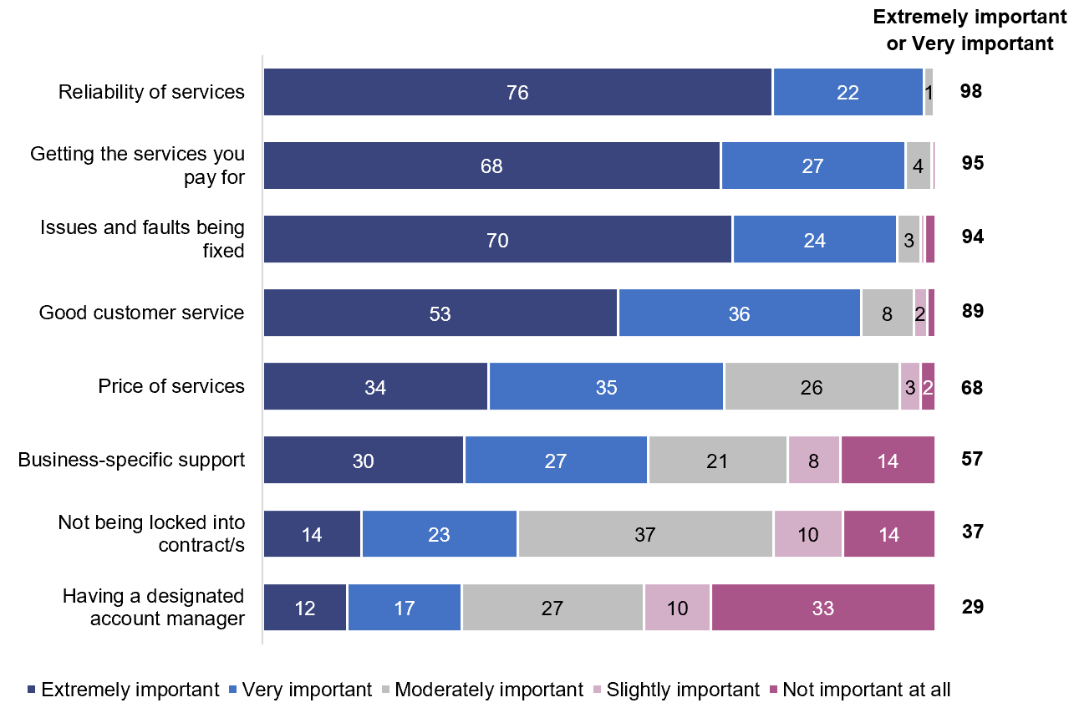

Base: Businesses with one or more telco services (n=850).

BU3. I’m now going to read some factors that might affect your business’s experience with your business’s telco services, such as business phone, business internet, business mobile phone and business mobile broadband. For each one could you please tell me whether it is extremely important, very important, moderately important, slightly important or not important at all to your business.

Note 1: Options read out, except for ‘Refused’ and ‘Don’t know’. Order randomised.

Note 2: Data may not add up to 100 per cent, ‘Don’t know’ and ‘Refused’ not shown.

Note 3: Totals may not equal the sum of the rounded percentages shown for the individual responses. The totals are calculated on the unrounded data.

Good customer service was extremely or very important for nearly nine in 10 businesses overall (89 per cent), although for a lower proportion of those with 20–199 employees (70 per cent).

The price of services received similar ratings of importance from businesses based on size, if they were located in major cities[20] or other areas, or how many different types of telco services they had. Those that used an intermediary to manage their telco services were less likely to rate price as extremely or very important, compared to those without an intermediary (50 per cent and 71 per cent respectively).

Not being locked into a contract became less important as the number of employees increased. Half (49 per cent) of businesses with no employees rated it as extremely or very important. This fell to 37 per cent for those with 1–4 employees and 28 per cent of those with 5–199 employees.

The rating of a designated account manager as extremely or very important increased as the number of employees increased. It was rated extremely or very important by:

* one-fifth (21 per cent) of businesses with 0–1 employee
* three in 10 (30 per cent) businesses with 2–4 employees
* a third (36 per cent) of those with 5–19 employees

just over half (54 per cent) of those with 20–199 employees.

A designated account manager was more important to businesses with more telco services, rated very or extremely important by 37 per cent of those with four types of telco services compared with 21 per cent of those with any two types of telco services.

Business-specific support was also more important for those with four telco services (72 per cent) compared with those with any two types of services (42 per cent).

### Being on the right plan, or switching telcos in the next 12 months

Four in five (80 per cent) businesses agreed (strongly agreed or agreed) that they had the right telco plan to meet their needs.

One quarter (23 per cent) of businesses agreed that they would be actively considering switching to a new telco in the next 12 months (Figure 5).

Suitability of current telco plan, intention to change telco in next year (%)

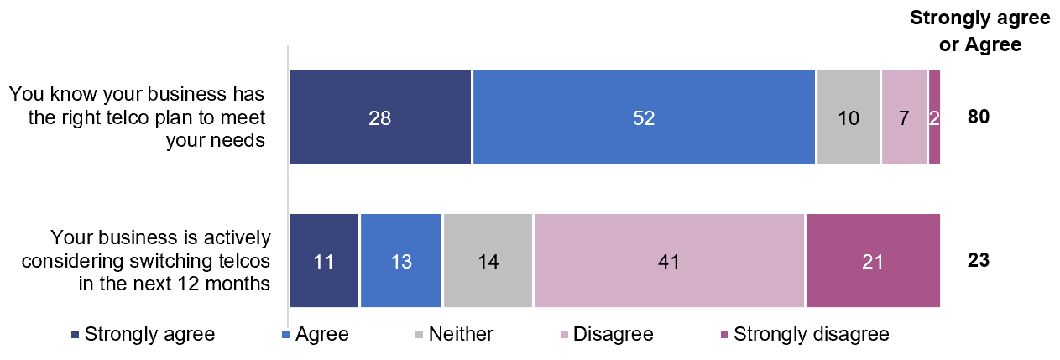

Base: Businesses with one or more telco services (n=850).

BX1. I am going to read some statements related to all your business’s telco plans or services such as business phone, business internet, business mobile phone and business mobile broadband. For the statements: you know your business has the right telco plan to meet your need and your business is actively considering switching telcos in the next 12 months, can you please tell me whether you strongly agree, agree, neither agree nor disagree, disagree or strongly disagree.

Note: Options read out, except for ‘Refused’ and ‘Don’t know’. Order randomised.

Note 2: Data may not add up to 100 per cent, ‘Don’t know’ and ‘Refused’ not shown.

Note 3: Totals may not equal the sum of the rounded percentages shown for the individual responses. The totals are calculated on the unrounded data.

Most businesses agreed they had the right plan for their needs regardless of the number of employees, whether they were in major cities or not, or operating from one site or multiple sites.

Businesses with four types of telco services were more likely (27 per cent) to consider changing their telco in the coming 12 months than those with any two types of services (15 per cent).

Businesses that agreed they were on the right plan were less likely to consider switching telco in the next 12 months (18 per cent) compared with those that disagreed they were on the right plan (55 per cent). Similarly, those that agreed their telco understood their needs were less likely to consider a switch of telco in the next 12 months (15 per cent) compared with those that disagreed telcos understood their needs (39 per cent).

### Attitudes about telcos and telco services

There were similar levels of agreement (about half) that telcos understood the needs of businesses, acted quickly when issues arose or that the day to day activities of their own businesses had been negatively affected by the delivery of telco services.

Around half of businesses agreed (strongly agreed or agreed) that telcos understood the needs of businesses (49 per cent)—32 per cent disagreed; and that they act quickly when issues arise (53 per cent)—30 per cent disagreed (Figure 6).

Attitudes about telco services (%)

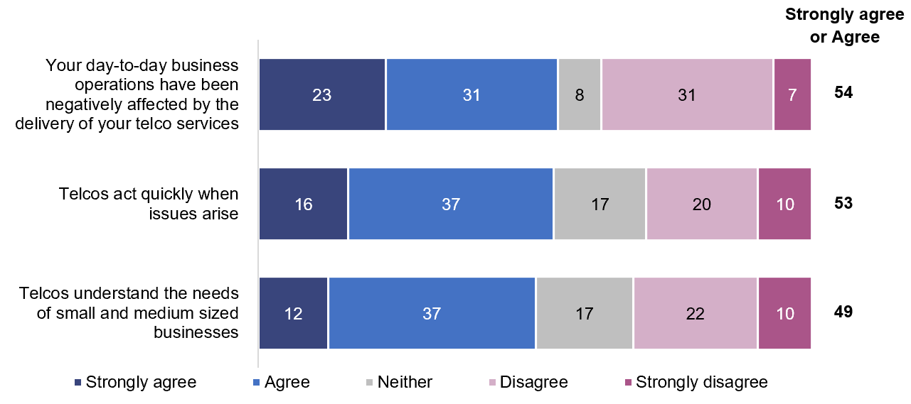

Base: Businesses with one or more telco services (n=850).

BX1. I am going to read some statements related to all your business’s telco plans or services such as business phone, business internet, business mobile phone and business mobile broadband. For the statements: your day-to-day business operations have been negatively affected by the delivery of your telco services, telcos act quickly when issues arise and telcos understand the needs of small and medium sized businesses, can you please tell me whether you strongly agree, agree, neither agree nor disagree, disagree or strongly disagree.

Note: Options read out, except for ‘Refused’ and ‘Don’t know’. Order randomised.

Note 2: Data may not add up to 100 per cent, ‘Don’t know’ and ‘Refused’ not shown.

Businesses with four types of telco services were more likely to have had their operations negatively affected by the delivery of telco services (62 per cent) than those with any two types of services (47 per cent).

Businesses using merchant services or online shopping were more likely to have had their operations negatively affected (62 per cent) than those not undertaking those activities (54 per cent).

There was little difference in the proportion of businesses that agreed that telcos acted quickly when issues arose.

There were some differences in proportions of businesses that agreed that telcos understood their needs. Those with no employees were less likely to agree (39 per cent) compared with businesses with 5–19 employees (55 per cent) or 20–199 employees (59 per cent).

Those employing an intermediary were more likely to agree their telco understood their needs (63 per cent) compared with those who did not employ an intermediary (48 per cent agreed).

## Contact with telcos

Businesses were asked if they had contacted their telco/s about services in the previous six months. Two thirds (68 per cent) had contacted their telco at least once.

Businesses were asked if the reason for their contact was to make a complaint.[21] The alternate reason for contact was described in the research as ‘another reason, not a complaint’ which is referred to as an *enquiry*.

As a proportion of all businesses, a total of:

* 33 per cent contacted their telco with an enquiry

40 per cent contacted their telco to make a complaint.

Of those who made contact in the previous six months (68 per cent):

* 49 per cent made an enquiry (39 per cent who only made an enquiry and 9 per cent who made both an enquiry and a complaint)

59 per cent made a complaint (50 per cent who only made a complaint and 9 per cent who made both an enquiry and a complaint) (Figure 7).

Contact with telco and reason for contact (%)

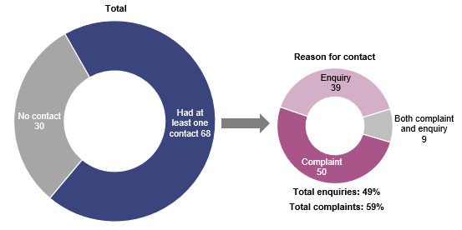

Base: Total: Businesses with one or more telco services (n=850); Reason for contact: Businesses that contacted their telco in the previous six months (n=611).

BO1. In the last six months did you or someone on behalf of your business, contact your current telco about any of your business’s telco services in Australia? This contact could have been in any form such as by phone, online, in-person etc. but does not include bill paying.

BO2. And for which of the following has your business contacted your telco in the last six months? To make a complaint, for another reason, not a complaint, or both complaint and another reason (Options read out, except for ‘Refused’ and ‘Don’t know’).

Note 1: ‘Don’t know’ not shown as data is less than two per cent.

### Enquiries

Businesses that had contacted their telco in the previous six months for an enquiry were asked about the most recent enquiry they had made, and which service it related to.

Among all businesses with each service (not just those that made enquiries), the rate of most recent enquiries was higher for business phone and internet:

* business phone: 17 per cent (10 per cent that enquired about phone only and seven per cent that enquired about both internet and phone)
* business internet: 16 per cent (10 per cent that enquired about internet only, and six per cent that enquired about both internet and phone)
* business mobile phone: 10 per cent
* business mobile broadband: 2 per cent

not specific to one service: 1 per cent.

Only among those that enquired, there were higher rates of the most recent enquiry for business internet and business phone (Figure 8).

Most recent enquiries by service (%)

Base: Businesses that made an enquiry in the previous six months (n=323).

BN1. For which particular telco service did you or someone on behalf of your business most recently contact your telco for in that case? Was it for a particular service (if business has more than one service)?

Note 1: ‘Don’t know’ not shown as data is less than 0.5 per cent.

Among businesses that enquired about internet (43 per cent of enquiries) this was comprised of 28 per cent that enquired about internet only, and 15 per cent that enquired about internet and phone in the one enquiry.

Among businesses that enquired about phone (39 per cent) this was comprised of 24 per cent that enquired about phone only, and 15 per cent that enquired about phone and internet in the one enquiry.

### Reasons for most recent enquiry

Businesses were asked the reason for their most recent enquiry.

The main reasons for enquiries were about a loss of service or unplanned outage (20 per cent) or to change, renew or buy a new plan (17 per cent) or account information enquiries not related to billing (15 per cent) (Figure 9).

Reasons for most recent enquiry (%)

Base: Businesses that made an enquiry in the previous six months (n=319).

BN2. What did your business most recently contact your telco for about in that case (contacted about an enquiry)?

Note 1: Options not read out.

Note 2: If more than one reason, respondent was asked for the most important/primary reason.

Note 3: Data does not add to 100 per cent, data less than three per cent not shown.

### Contact channel for most recent enquiry

For the most recent enquiries, the most common channel for first contact to a telco was by phone (77 per cent), which is a combination of calls to a general number (53 per cent), a business call centre (13 per cent) or account manager or dedicated contact (11 per cent) (Figure 10).

Contact channel for most recent enquiry (%)

Base: Businesses that made an enquiry in the previous six months (n=323).

BN3. How did your business first contact your telco (for your most recent enquiry)?

Note: Data does not add to 100 per cent. Data less than three per cent not shown.

### Satisfaction with enquiries

Two thirds of businesses (64 per cent) were satisfied (either very satisfied or satisfied) with how their enquiry with their telco was handled. One quarter (25 per cent) were dissatisfied (very dissatisfied or dissatisfied) with the way their telco handled their enquiry (Figure 11).

Satisfaction with handling of enquiry (%)

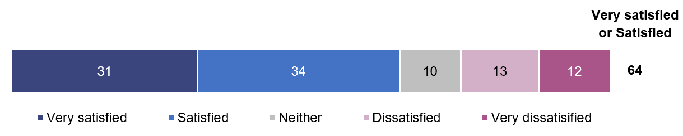

Base: Businesses that made an enquiry in the previous six months (n=323).

BN4. Overall, how satisfied or dissatisfied was your business with how your telco handled the enquiry? Would you say your business was very satisfied, satisfied, neither satisfied nor dissatisfied, dissatisfied, or very dissatisfied?

Note 1: Options read out, except for ‘Refused’ and ‘Don’t know’.

Note 2: ‘Don’t know’ not shown as data is less than one per cent.

Note 3: Totals may not equal the sum of the rounded percentages shown for the individual responses. The totals are calculated on the unrounded data.

Only a small group (n=72) reported they were dissatisfied with how their telco handled their complaint, so results should be considered indicative only. The most common reasons for dissatisfaction were poor communication, the problem not being resolved, or taking too long to action or resolve.

### Issues or faults with business telco services

Businesses were asked whether they had experienced any issues or faults with their business telco services in the previous six months, regardless of whether they had contacted their telco about them. The data does not report how many times a type of issue or fault occurred except for specific types of issues and faults.

Two thirds (66 per cent) of businesses indicated at least one type of issue or fault had occurred with any of their telco services.

Among all businesses with each service, those with a business internet service were more likely to report an issue or fault with the service (52 per cent), followed by those with a business phone (40 per cent) (Figure 12).

Issues or faults by business service type (%)

Base: Businesses with a business internet service (n=788); Businesses with a business phone service (n=704); Businesses with a business mobile phone service (n=749); Businesses with a business mobile broadband service (n=384).

BI1a. For which particular telco services did your business experience any issues or faults (in the last six months)?

Note 1: Data includes multiple responses.

Note 2: ‘Don’t know’ and ‘Refused’ not shown as data is less than 0.5 per cent.

Among the businesses that had an issue or fault, they were more likely to be about:

* business internet: 73 per cent
* business phone: 47 per cent
* mobile phone: 19 per cent

mobile broadband: 8 per cent.

### Types of issue or faults

With internet the most likely business service to experience issues or faults, the most commonly reported type was unplanned outages—experienced by half of businesses (48 per cent of those with an issue or fault with their internet). A further three per cent had planned outages or could not recall if any outage was planned or unplanned)—total of 51 per cent with outages.

Similarly, for businesses with issues or faults with their business phone, 51 per cent reported unplanned outages in that period, with a further one per cent with planned outages.

Those with issues or faults with their business mobile phone services were most likely to experience an issue or fault relating to coverage (45 per cent).

Dropouts were the second most mentioned type of issue or fault for business internet (30 per cent), business phone (18 per cent) or mobile phones (26 per cent).

Problems with internet speed were experienced by nearly a quarter (23 per cent) of businesses with issues or faults in that period (Figure 13).

Types of issues or faults with phone, internet or mobile phone services (%)

Base: Businesses with issues or faults with their business phone in the previous six months (n=289); Businesses with issues or faults with their business internet in the previous six months (n=401); Businesses with issues or faults with their business mobile phone in the previous six months (n=94).

BI2a. What issues or faults has your business experienced with your business phone in the last six months?

BI2b. What issues or faults has your business experienced with your business internet in the last six months?

BI2c. What issues or faults has your business experienced with your business mobile phone in the last six months?

Note 1: Data includes multiple responses.

Note 2: What issues or faults were experienced was asked of those who reported they had experienced issues or faults with their business mobile broadband, but as sample size was small (n=49) they are not reported.

### Type of issue or fault nominated as biggest problem

Two thirds (66 per cent) of businesses indicated at least one type of issue or fault had occurred with any of their telco services.

Around four in 10 of all businesses (38 per cent) experienced more than one type of issue or fault, or the same type of issue or fault with more than one service in the previous six months. This group was asked which was the biggest problem for their business.

Internet outages were most likely to be reported as the biggest problem (19 per cent), followed by outages to both phone and internet (11 per cent) or outages to phones (eight per cent) (Figure 14).

With multiple issues or faults, which were biggest problem (%)

Base: Businesses that had two or more types of issue or fault, or the same type of issue or fault with more than one service in the previous six months (n=331).

BI3. And which one of those issues or faults has been the biggest problem for your business in the last six months?

### Frequency of dropouts or outages

All businesses that experienced outages or dropouts, as their biggest or only problem with a service the previous six months, were asked about their frequency.

Among businesses experiencing loss of service or outages in the previous six months:

* 36 per cent experienced one occurrence
* 28 per cent experienced two or three
* 19 per cent experienced four to 10
* 9 per cent experienced 10 to 50

7 per cent experienced more than 50.

Among businesses experiencing dropouts in the previous six months:

* 37 per cent reported between one and five occurrences
* 28 per cent reported between six and 50
* 16 per cent reported between 50 and 365

19 per cent reported large numbers of dropouts, above 365.

### What those with issues or faults did next

Businesses that experienced an issue or faults in the previous six months were asked what they did about their (biggest or only) fault, the most common response was to contact and/or complain to their telco (73 per cent). This action was nearly three times more likely than the next which was to switch the device off and on again (24 per cent). One in 10 businesses did nothing (Figure 15).

Actions in response to issues or faults (%)

Base: Businesses with issues or faults in the previous six months (n=578).

BI4. What, if anything, did your business do about that issues or fault on the last occasion?

Note: Data includes multiple responses.

## Complaints

Respondents were asked if the reason for their contact was to make a complaint [22].

As noted earlier in the report, four in 10 (40 per cent) of all businesses made at least one complaint to their telco in the previous six months. The research explored the experience of their most recent complaint.

Among all businesses with each service (not just those that made complaints), the rate of most recent complaints was higher for business phone and internet:

* business internet: 26 per cent (20 per cent that complained about internet only, and six per cent that complained about both internet and phone)
* business phone: 19 per cent (12 per cent that complained about phone only and seven per cent that complained about both internet and phone)
* business mobile phone: 5 per cent
* business mobile broadband: 2 per cent

not specific to one service: 1 per cent.

Of all business that complained to their telco, the most recent complaints were more likely to be about business internet (60 per cent) followed by phone (37 per cent). They were less likely to be related to mobile phones (11 per cent) or mobile broadband (two per cent). A small proportion (four per cent) made complaints not specific to one service (Figure 16).

Most recent complaint by service (%)

Base: Businesses that made a complaint to their telco in the previous six months (n=354).

BC1. For which particular telco service did your business or someone on behalf of your business most recently make a complaint to your telco? Was it specific to a particular service?

Note: ‘Don’t know’ not shown.

Among businesses that complained about internet (60 per cent of complaints) this comprised 46 per cent that complained about internet only, and 14 per cent that complained about internet and phone in the one complaint.

Among businesses that complained about phone (37 per cent) this was comprised of 23 per cent that complained about phone only, and 14 per cent that complained about phone and internet in the one complaint.

### Reason for most recent complaint

The most common reasons for a business’s most recent complaint were for outages (29 per cent) and other fault or technical issue (17 per cent) (Figure 17).

Reason for most recent complaint (%)

Base: Businesses that made a complaint to their telco in the previous six months (n=352); Businesses with an issue or fault in the previous six months (n=578).

BC2. What was your business’s most recent complaint about?

BI2a. What issues or faults has your business experienced with your business landline/VOIP phone in the last six months? (Data includes multiple responses).

BI2b. What issues or faults has your business experienced with your business fixed internet in the last six months? (Data includes multiple responses).

BI2c. What issues or faults has your business experienced with your business mobile phones in the last six months? (Data includes multiple responses).

BI2d. What issues or faults has your business experienced with your business mobile broadband in the last six months? (Data includes multiple responses).

Note: Data less than three per cent not shown, including ‘Refused’ and ‘Don’t know’

The link with issues and faults and complaints is clear—the rate of complaint is over 12 times higher for businesses that had an issue or fault in the previous six months (58 per cent) than those with no issues or faults (5 per cent). However, while not all issues and faults led to complaints, three-quarters of businesses (73 per cent) that had an issue or fault with any service in that period either contacted their telco and/or made a complaint about it.

### Contact channel for most recent complaint

For complaints made to telcos in the previous six months, the majority (79 per cent) of businesses made their initial complaint by phone. It was most often a call to a general number (59 per cent of all contacts), followed by a business call centre (14 per cent), or an account manager or dedicated contact (six per cent) (Figure 18).

Contact channel for most recent complaint (%)

Base: Businesses that made a complaint to their telco in the previous six months (n=354).

BC3. How did your business firstcontact your telco to make your most recent complaint?

Note: Data may not add to 100 per cent due to rounding, ‘Don’t know’ not shown. ‘Other’ not shown as data is less than 0.5 per cent.

The proportion of businesses that used the phone to make enquiries and complaints was very similar (77 per cent and 79 per cent respectively).

### Time to resolve most recent complaint

Around one in seven (14 per cent) businesses reported that their most recent complaint to their telco was resolved on the day it was made. Nearly three in 10 (29 per cent) of all complaints were resolved in one to two working days. A little under half (44 per cent) of all complaints were resolved within a week.

Nearly one quarter (25 per cent) said that their most recent complaint to their telco took between three days and three weeks to resolve, with 21 per cent reporting it took more than three weeks.

Three in 10 (30 per cent) took more than one week to resolve and nearly one quarter (23 per cent) were unresolved at the time of the research[23] (Figure 19).

Time to resolve most recent complaint (%)

Base: Businesses that made a complaint to their telco in the previous six months (n=354).

BC4. How long did it take to resolve this complaint, from the first time your business contacted your telco until your complaint was resolved? Was it resolved on the same day, within 2 working days, within 3 working days, between 4 working days and one week, between one week and 3 weeks, more than 3 weeks, or it is not currently resolved?

Note 1: Options read out, except for ‘Refused’ and ‘Don’t know’.

Note 2: ‘Don’t know’ not shown as data is less than three per cent.

Note 3: Those with unresolved complaints were asked to confirm that they were still waiting for their telco to respond to them on the complaint.

Only a small group (n=86) reported their complaint as unresolved so results should be considered indicative only. Three quarters (74 per cent) of businesses with an unresolved complaint said the complaint was first made more than one month prior. A little over half (55 per cent) said it was first made more than three months ago.

### Satisfaction with complaints-handling

Businesses with resolved complaints were asked how satisfied or dissatisfied they were with how their most recent complaint was handled by their telco.

Four in 10 (40 per cent) businesses indicated they were satisfied (either very satisfied or satisfied. Just under half (46 per cent) were dissatisfied (very dissatisfied or dissatisfied) (Figure 20).

Satisfaction with complaints-handling (%)

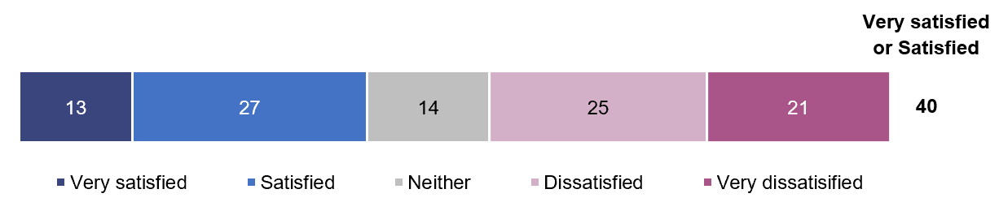

Base: Businesses that had made a complaint to their telco in the previous six months and they report it has been resolved (n=268).

BC6. Overall, how satisfied or dissatisfied was your business with how that complaint was handled by the telco? Would you say your business was very satisfied, satisfied, neither satisfied nor dissatisfied, dissatisfied, or very dissatisfied?

Note: Options read out, except for ‘Refused’ and ‘Don’t know’.

Satisfaction levels (very satisfied or satisfied) were higher for those with complaints resolved sooner:

* resolved on the same day: 74 per cent
* resolved in two working days: 68 per cent
* resolved in one week: 59 per cent

resolved over a week: 15 per cent.

Businesses that were dissatisfied with how their complaint was handled provided the following reasons for their dissatisfaction:

* too long to be fixed, or for the telco to take action—62 per cent
* poor communication or lack of communication—43 per cent
* nobody took responsibility for fixing problems—29 per cent
* multiple calls to get something done—20 per cent
* it was a recurring or ongoing problem—19 per cent
* too many transfers, on the phone for too long—17 per cent

the problem or issue was not resolved—16 per cent.

### Compensation for complaints

Businesses with resolved complaints other than those about billing, were asked if their telco offered compensation. One in six (17 per cent) were offered compensation.

Among all businesses with resolved complaints, compensation offers included:

* discount or credit for more than one bill—8 per cent
* money off the next bill—6 per cent
* interim replacement services—3 per cent

extra data—2 per cent.

### The impact of outages or dropouts

Among businesses that reported experiencing a loss of service, outages or dropouts with their business internet or phone, regardless of whether they were reported to their telco, or made a complaint, were asked about their impact on their business.

Three quarters of those that experienced these types of issues or faults with their business internet described the impact as moderate or major. Over six in 10 (64 per cent) of those with the same problems with the business phone described the impact as moderate or major (Figure 21).

Impact of loss of service or outage among businesses losing service for fixed-line voice or fixed internet (%)

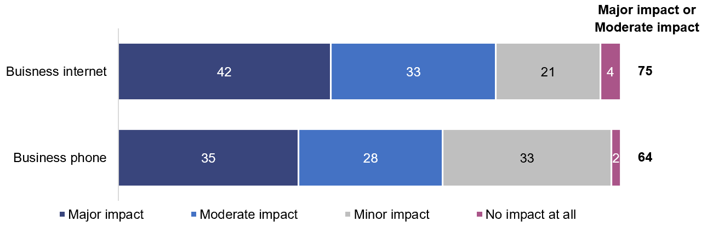

Base: Businesses that experienced business internet service dropouts or loss of service (n=303); Businesses that experienced business phone service dropouts or loss of service (n=182).

BL1a. What impact did being left without your business phone service have on your business? Was there no impact at all, minor impact, moderate impact, or major impact?

BL2a. What impact did being left without your business internet service have on your business? Was there no impact at all, minor impact, moderate impact, or major impact?

Note 1: Options read out, except for ‘Refused’ and ‘Don’t know’

Note 2: Data may not add up to 100 per cent, ‘Don’t know’ and ‘Refused’ not shown.

Note 3: Dropouts or loss of service experienced was asked of those who have a business mobile phone service or business mobile broadband service, but as sample sizes were small they are not reported.

In response to dropouts or loss of internet service, three quarters (74 per cent of those that experienced the issue) used other services such as mobile phones or mobile data instead. A small group (eight per cent) used interim or alternate services provided by their telco, and a smaller group (four per cent) were offered interim or alternate services but chose not to use them.

In response to dropouts or loss of phone service, the majority (83 per cent of those that experienced the issue) used other services such as mobile phones instead. One in 10 (10 per cent) used interim or alternate services provided by their telco. A small group (seven per cent) were offered interim or alternate services but chose not to use them.

## Satisfaction

Businesses were asked about their satisfaction with their services (overall and reliability), the monthly cost of their service and customer service overall.

Across all service types, businesses were more likely to be satisfied than dissatisfied with various aspects of their telco services.

Satisfaction (very satisfied or satisfied) was highest for those with mobile phone services, both overall and for reliability, nearly nine in 10 for both. Of the four telco services in the research, businesses were less likely to be satisfied with internet.

Businesses were more likely to be dissatisfied (around one in five) with monthly costs and customer service (Figure 22).

Satisfaction with services (%)

Base: Businesses with business mobile phones (n=749); Businesses with business phone (n=704); Businesses with business mobile broadband (n=384); Businesses with business internet (n=788); All services: Businesses with one or more telco services (n=850).

BF1. I’d now like you to tell me the extent to which your business is satisfied with your business’s telco services. For each of these, can you please tell me whether you are very satisfied, satisfied, neither satisfied nor dissatisfied, dissatisfied, or very dissatisfied? So firstly, how satisfied is your business with your <each service they have> overall? The reliability of your <each service they have>? The monthly cost of your business telco services? Customer service from your telco/s overall? Would you say…(read out scale)?

Note 1: Options and scale read out, except for ‘Not applicable’, ‘Refused’ and ‘Don’t know’.

Note 2: Data shown is total satisfied, the addition of very satisfied and satisfied.

Three quarters of businesses were satisfied with their business phone services—they were nearly three times more likely to be satisfied (56 per cent) than very satisfied (19 per cent) (Figure 23).

Satisfaction with business phone service (%)

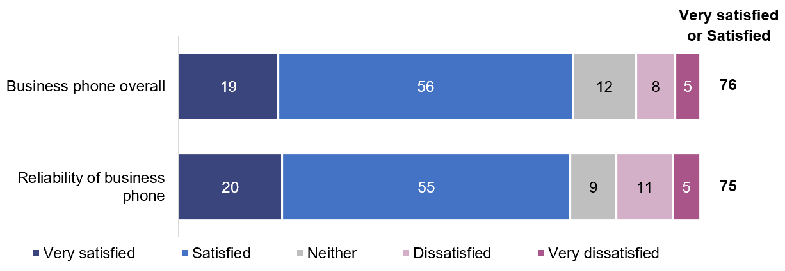

Base: Businesses with business phone (n=704).

BF1. I’d now like you to tell me the extent to which your business is satisfied with its business phone service overall and the reliability of its business phone service. For each of these, can you please tell me whether you are very satisfied, satisfied, neither satisfied nor dissatisfied, dissatisfied, or very dissatisfied?

Note 1: Options and scale read out, except for ‘Not applicable’, ‘Refused’ and ‘Don’t know’.

Note 2: ‘Don’t know’ not shown as data is less than one per cent.

Note 3: Totals may not equal the sum of the rounded percentages shown for the individual responses. The totals are calculated on the unrounded data.

Satisfaction with the reliability of business phone services was impacted by:

* a fault with that service—58 per cent were satisfied compared with those with no fault or issue with their business phone (86 per cent)

their most recent complaint about that service—57 per cent were satisfied compared with those businesses that had made no complaint or their most recent complaint was not about business phone (78 per cent).

Two thirds of businesses were satisfied with their business internet overall and the reliability of the service, and more likely to be satisfied than very satisfied (Figure 24).

Satisfaction with business internet service (%)

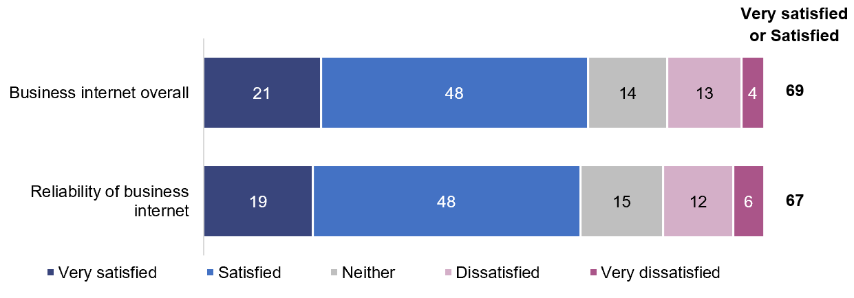

Base: Businesses with a business internet service (n=788).

BF1. I’d now like you to tell me the extent to which your business is satisfied with its business internet service overall and the reliability of its business internet service. For each of these, can you please tell me whether you are very satisfied, satisfied, neither satisfied nor dissatisfied, dissatisfied, or very dissatisfied?

Note 1: Options and scale read out, except for ‘Not applicable’, ‘Refused’ and ‘Don’t know’.

Note 2: ‘Don’t know’ not shown as data is less than one per cent.

Satisfaction with their overall business internet service was lower for:

* those that had experienced an issue or fault with that service (50 per cent) compared with those that had not (84 per cent)
* those that had made a complaint about their business internet (36 per cent) compared with businesses that had made no complaint, or their most recent complaint was not about business internet (77 per cent)

those with 20–199 employees (51 per cent) compared with those with 0–19 employees (69 per cent).

Satisfaction with the reliability of a business internet service was lower for:

* those that had experienced an issue or fault for that service (46 per cent) compared with those that had not (91 per cent)
* those that had made a complaint (35 per cent) compared with those businesses that had made no complaint, or their most recent complaint was not about business internet (75 per cent)

those with 20–199 employees (53 per cent) compared with those with 0–19 employees (68 per cent).

There is a larger proportion of businesses that were very satisfied with their mobile phone services (for reliability and the service overall) compared with other telco services in the research, but there were still fewer very satisfied than just ‘satisfied’. The levels of satisfaction with mobile phones overall was similar to that for their reliability (Figure 25).

Satisfaction with business mobile phone service (%)

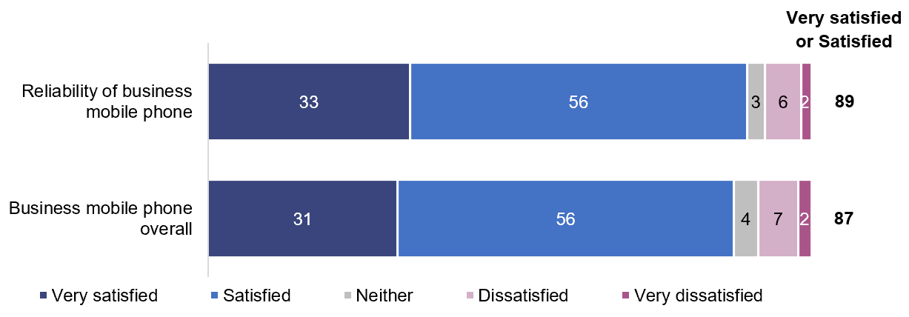

Base: Businesses with a business mobile phone service (n=749).

BF1. I’d now like you to tell me the extent to which your business is satisfied with its business mobile phone service overall and the reliability of its business mobile phone service. For each of these, can you please tell me whether you are very satisfied, satisfied, neither satisfied nor dissatisfied, dissatisfied, or very dissatisfied?

Note 1: Options and scale read out, except for ‘Not applicable’, ‘Refused’ and ‘Don’t know’.

Note 2: ‘Don’t know’ not shown as data is less than one per cent.

Satisfaction with a mobile phone service overall was lower for those that had experienced an issue or fault with that service (60 per cent) compared with those that did not (74 per cent).

Satisfaction with the reliability of a mobile phone service was lower if businesses had multiple sites (73 per cent) compared with those with one site (91 per cent).

Around three quarters of those with mobile broadband were satisfied, with businesses more than twice as likely to indicate they were satisfied, rather than very satisfied (Figure 26).

Satisfaction with business mobile broadband service (%)

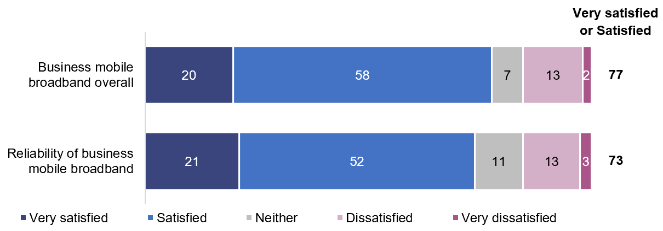

Base: Businesses with a business mobile broadband service (n=384).

BF1 I’d now like you to tell me the extent to which your business is satisfied with its business mobile broadband service overall and the reliability of its business mobile broadband service. For each of these, can you please tell me whether you are very satisfied, satisfied, neither satisfied nor dissatisfied, dissatisfied, or very dissatisfied?

Note 1: Options and scale read out, except for ‘Not applicable’, ‘Refused’ and ‘Don’t know’.

Note 2: ‘Don’t know’ not shown as data is less than one per cent.

Note 3: Totals may not equal the sum of the rounded percentages shown for the individual responses. The totals are calculated on the unrounded data.

Businesses were asked about customer service overall, not relating to a particular service and the monthly cost of all business services.

Businesses reported the lowest levels of satisfaction for customer service overall or the monthly cost of their telco services (Figure 27).

Overall satisfaction with customer service and cost (%)

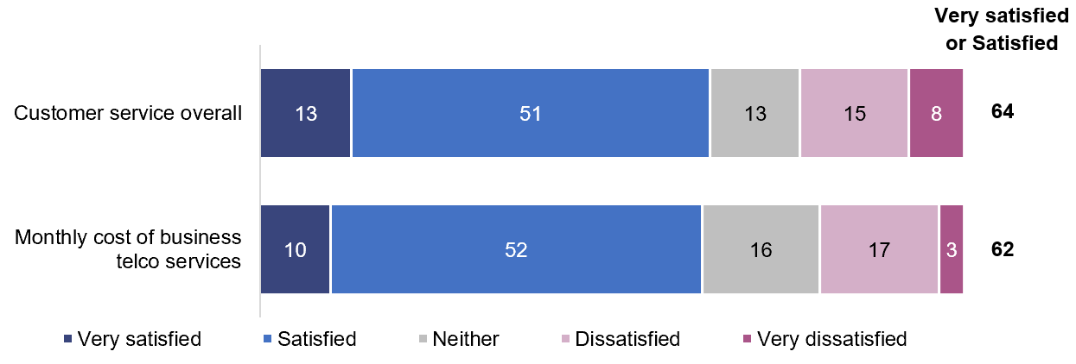

Base: Businesses with one or more business telco services (n=850).

BF1. I’d now like you to tell me the extent to which your business is satisfied with customer service overall and the monthly cost of your business telco services. For each of these, can you please tell me whether you are very satisfied, satisfied, neither satisfied nor dissatisfied, dissatisfied, or very dissatisfied?

Note 1: Options and scale read out, except for ‘Not applicable’, ‘Refused’ and ‘Don’t know’.

Note 2: ‘Don’t know’ not shown as data is less than one per cent.

Note 3: Data may not add up to 100 per cent, ‘Don’t know’ and ‘Refused’ not shown.

A range of factors were associated with higher or lower levels of satisfaction with customer service overall.

|  |  |
| --- | --- |
| More likely to be satisfied (very satisfied or satisfied) with customer service overall were those that: | Less likely to be satisfied (very satisfied or satisfied) with monthly customer service overall were those that: |
| * had no issue or fault in the previous six months— 87 per cent | * had at least one type of issue or fault in the previous six months—52 per cent |
| * made an enquiry in the previous six months—75 per cent | * made a complaint in the previous six months—40 per cent |
| * made a complaint that was resolved within one week—55 per cent | * made a complaint that took more than one week to resolve—31 per cent |
| * were satisfied with complaints-handling—66 per cent | * were dissatisfied with complaints-handling—34 per cent |
| * had 0–19 employees—64 per cent | * had 20–199 employees—46 per cent |
| * agreed their business was on the right telco plan—71 per cent. | * disagreed their business was on the right telco plan—28 per cent. |

Satisfaction with monthly costs showed little variation whether or not a business had experienced issues or faults or were satisfied with complaints-handling.

## Managing data, security and telco services

Businesses were asked for their level of agreement with a series of statements related to data, security and managing their telco services.

Of the four statements in the research, businesses were most likely to agree (strongly agreed or agreed) they were well equipped to make customer information available to customers when requested (83 per cent), and to manage data privacy for their business and customers (77 per cent).

There was a lower proportion that agreed their business was well equipped to manage cybersecurity threats and issues (69 per cent), with 15 per cent not well equipped.

One in five businesses (22 per cent) agreed that their business spends too much time managing telco services (Figure 28).

Managing data, security and telco services (%)

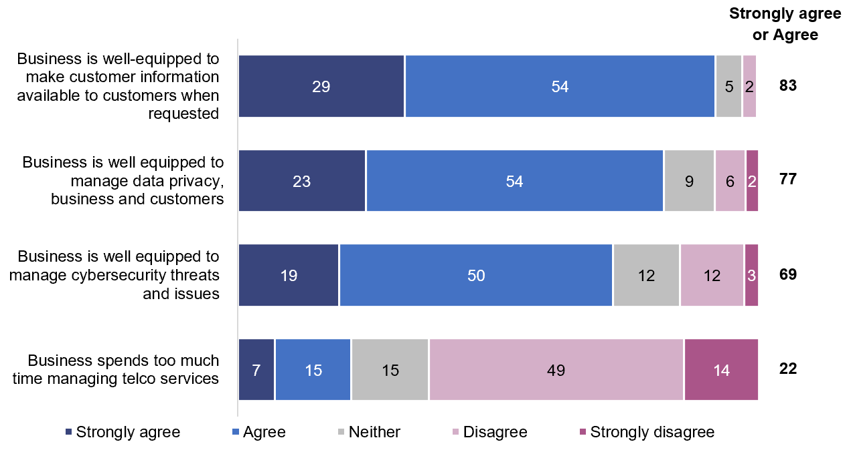

Base: Businesses with one or more business telco services (n=850).

BP1. I am now going to read out some statements relating to your business. For each one, can you please tell me whether your business would strongly agree, agree, neither agree nor disagree, disagree or strongly disagree.

Note 1: Options and scale read out, except for ‘Not applicable’, ‘Refused’ and ‘Don’t know’.

Note 2: ‘Don’t know’ and ‘Refused’ not shown as data is less than three per cent.

Note 3: Data may not add up to 100 per cent, ‘Don’t know’ and ‘Refused’ not shown.

Businesses with 5–19 employees were the most likely to agree (91 per cent) that they were well-equipped to manage data privacy for their own data, or customer data. The proportion of smaller businesses (0–4 employees) that agreed was 73 per cent, and larger businesses (20–199) was 74 per cent.

Businesses with 5–199 employees were more likely to agree (81 per cent) that they were well equipped to manage cybersecurity threats and issues compared with business with 0–4 employees (64 per cent).

Certain factors were associated with businesses’ views on the time they spend managing their telco services.

|  |  |
| --- | --- |
| More likely to agree they spend too much time managing telco services were those: | Less likely to agree they spend too much time managing telco services were those: |
| * with four telco services—32 per cent | * with two telco services—9 per cent |
| * with an issue or fault in the previous six months—29 per cent | * with no issue or fault in the previous six months—8 per cent |
| * that were dissatisfied with complaints-handling for their most recent complaint —50 per cent | * that were satisfied with the complaints-handling for their most recent complaint —24 per cent |
| * that did not agree that their business had the right telco—62 per cent. | * that agreed their business had the right plan to meet needs—17 per cent. |

### Business consideration of smart devices and 5G

One in five businesses (19 per cent) agreed they were working on or considering how customers could access their products or services with smart devices. Four in ten (42 per cent) disagreed—they are not considering smart devices for their business and one in five indicated that this did not apply to their business (Figure 29).

Consideration of smart device delivery of products or services (%)

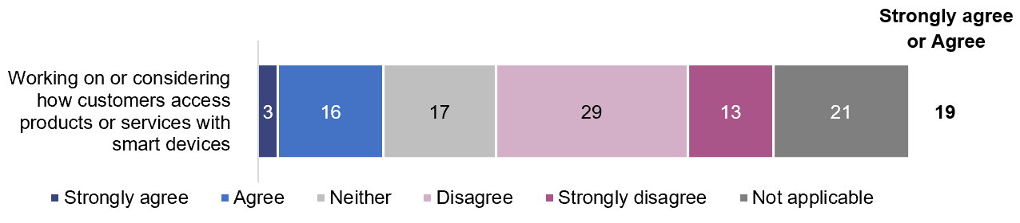

Base: Businesses with one or more business telco services (n=850).

BP1. I am now going to read out some statements relating to your business. For each one, can you please tell me whether your business would strongly agree, agree, neither agree nor disagree, disagree or strongly disagree.

Note 1: Options and scale read out, except for ‘Not applicable’, ‘Refused’ and ‘Don’t know’.

Note 2: ‘Don’t know’ and ‘Refused’ not shown as data is less than three per cent. May not add to 100 per cent due to rounding.

### Consideration of 5G

Businesses were asked if they were considering adoption of any 5G services.

A small group (two per cent) indicated they were already using 5G for their business. One in five (22 per cent) were considering it, and the remainder (71 per cent) were not.

Among those considering 5G reported that:

* it depended on coverage: 49 per cent
* they were waiting until technology is more established: 43 per cent
* it depended on the cost of handsets or plans: 40 per cent
* it was just a possibility at this stage: 40 per cent

they were seriously thinking of adopting 5G: 22 per cent.

# Appendix A

Terms used in this report

| Terms used | Definition |
| --- | --- |
| 5G | The fifth-generation technology for cellular wireless networks. It is the successor to the 4G networks which provide connectivity to most current mobile devices. 5G networks have greater bandwidth, giving faster download speeds. Due to the lower latency, it is more responsive and has the ability to connect more devices simultaneously. 5G became commercially available in 2019. |
| ADSL | Asymmetric digital subscriber line—Transmission technology that enables high-speed data services to be delivered over a copper line. ADSL2+ is an enhanced ADSL technology that adds new features and functionality that may provide higher data rates. |
| businesses | In this report, ‘businesses’ refer to small and medium sized businesses in Australia. They were private businesses with employment size in the range 1–199 and self-employed sole proprietors of private businesses with no employees. |
| business internet | A fixed broadband or other type of fixed internet connection, including the use of a wireless modem for wi-fi for the business. |
| business phone | A phone service to make and receive calls, including a landline (that uses the PSTN network or a fixed-line broadband network) or VoIP telephone. Excludes mobile phones.  Note - The PSTN is the public switched telecommunications network that provides traditional analog phone services to subscribers.  VoIP refers to voice over internet protocol that delivers voice communications over the internet or some other connected network, instead of the PSTN. |
| combination of services | Where a business has more than one telco service. Services may or may not be purchased from the same telco. |
| complaint | An expression of dissatisfaction made to a service provider (telco) about an NBN service or its complaints-handling process, where the customer expects a response or resolution. Unless otherwise noted, complaints data relates to complaints made to a current or previous telco. |
| considerers | Telecommunications customers who actively considered changing their telecommunications service in the previous 12 months without actually doing so. By ‘actively’ considering we mean that customers looked at offers available but did not proceed to purchase or make the change to their existing service. |
| dongle or USB modem | A small piece of equipment that is inserted into a device to allow connection to mobile broadband. |
| household | One or more people who reside at the same dwelling. They were part of the broader research conducted on the telco consumer experience, with findings for individuals and households published in a separate report. |
| individual | A resident of Australia aged 18 years and over who is a main or joint decision-maker for either a mobile phone service or a mobile broadband service. They were part of the broader research conducted on the telco consumer experience, with findings for individuals and households published in a separate report. |
| interim or alternative service | When there are issues with the customer’s service, a telco may in some circumstances offer or be required to offer, an interim or replacement service. For example, the provision of a mobile telephone service (at the standard telephone service rates) to replace a standard telephone service or a call diversion to an existing mobile telephone service. Alternatively, dongles or SIM cards could be provided to replace internet services. |
| IoT (Internet of Things) | The interconnection of many devices and objects utilising internet protocols, with or without the active involvement of individuals. This may include laptops, routers, tablets and smartphones,  which are integral to operating, reading and analysing the state of IoT devices. |
| issue or fault—dropout | When a phone or internet service disconnects unexpectedly, and temporarily stops working. A loss of service for a short period of time, for example between 30 seconds and 5-10 minutes. |
| issue or fault—interruptions | In streaming audio or video from the internet, buffering refers to downloading a certain amount of data before starting to play the music or video. Sometimes this might happen while watching video or listening to audio, causing an interruption. |
| issue or fault—loss of service or outage | A prolonged period when the internet or phone service is not able to be used. This may be planned (by the telco) or unplanned. |
| issue or fault—poor voice quality | Noise on the phone line, voice distortion or delay. Noise can be static, hum, crosstalk or popping. Voice distortion includes echoed voice, garbled voice or incorrect volume. |
| issue or fault—internet speed | Lower than expected internet speeds. |
| mobile broadband | A service you use to connect to the internet on devices such as a laptop or a tablet, but not including the internet service on a mobile phone. Mobile broadband connections can be supplied using a data-only SIM card, dongle, USB modem or portable wi-fi modem. |
| mobile phone | A handheld, electronic, mobile device used to transmit or communicate data, images or voice over a cellular network. |
| NBN | National Broadband Network—the wholesale broadband network being built across Australia |
| NBN Co | The government-owned business enterprise building and delivering services on the National Broadband Network.  NBN Co delivers a wholesale-only network to telcos and does not provide services directly to consumers surveyed in this report. |
| plan | Offerings of telecommunications products and services by telco providers to consumers. Different plans vary with their offerings for different costs and inclusions. |
| portable wi-fi modem | Contains a SIM card that allows multiple devices to connect to the internet simultaneously. |
| satellite | Predominately used for remote or rural locations and involves a satellite dish being installed at a customer’s premises. Satellite Broadband (Sky Muster™) is one of the connection types in the NBN multi-technology mix, and there are also some non-NBN satellite connections. |
| services delivered over the NBN | Connecting to and using services provided by telcos that are delivered using the NBN network. |
| SIM card | Subscriber Identity Module—a small card inserted in a device to provide a mobile voice and/or data service. |
| smart device | Devices that connect to the internet and can be controlled from a remote location. This excludes computers, tablets and mobile phones.  The business survey asked about smart devices such as speakers like Google Home or Amazon Alexa, or other internet connected devices. |
| SMS | Short message service—A mobile telecommunications data transmission service that allows users to send short text  messages to each other using a mobile handset. |
| telco | Telecommunications retail service carriage providers. This report commonly uses the term “telco” but there are instances where other sources cited in this report refer to them as ‘service providers’, ‘retail service providers’ or ‘carriage service providers’. While there are some slight differences in the definitions of these terms, their use in this report can be covered by the term ‘telco’. Telcos provide retail phone and internet services to consumers surveyed in the report. A telco is the main point of contact for their customers about telco services, including ordering a service, connection of service, payments, queries and complaints. |
| wi-fi | A type of wireless technology that uses radio waves to provide  high-speed internet connections. |

1. Australian Competition and Consumer Commission—Communications Market Report 2018-19, page 6 <https://www.accc.gov.au/system/files/Communications%20Market%20Report%202018-19%20-%20December%202019_D07.pdf>
2. ibid, page 6.
3. ibid, page 5.
4. [Technology, Media and Telecommunications Predictions 2020](https://www2.deloitte.com/content/dam/Deloitte/au/Documents/technology-media-telecommunications/deloitte-au-tmt-predictions-2020-summary-170220.pdf), Deloitte Insights, page 7.
5. Consumer Safeguards Review—Part C—Choice and Fairness: Consultation paper <https://www.communications.gov.au/have-your-say/consumer-safeguards-review-consultation-part-c-choice-and-fairness>.
6. Regulating in the digital age: Government Response and Implementation Roadmap for the Digital Platforms Inquiry <https://treasury.gov.au/publication/p2019-41708>.
7. [Internet of Things in media and communications: Occasional paper](https://www.acma.gov.au/publications/2020-08/publication/internet-things-media-and-communications-occasional-paper).
8. A service is the connection that a consumer pays a telco for, that connects a device to a PSTN telephone network, mobile network or the internet.
9. A device relies on its internet connection either from a separate mobile service or it connects to wi-fi from a home internet services other networks outside the home.
10. Residents of Australia aged 18 years and over, at least one type of mobile service; either a mobile phone service or a mobile broadband service—for which they were the main or joint decision makers for those service(s).
11. Any adult in a household who was a main or joint decision maker able to report on the household’s experience and expectations related to services in the household: a landline voice service, a landline data service which enabled the dissemination of a wi-fi signal in the households (such as ADSL, cable or NBN), mobile broadband services to household devices which enable the dissemination of a wi-fi signal in the household or a family plan for data sharing among multiple mobile phones in the households.
12. Private businesses with employment size between 1–199 and self-employed sole proprietors of private businesses with no employees, for a landline voice service, a landline data service which enabled the dissemination of a wi-fi signal in the business (such as ADSL, cable or NBN), mobile broadband services or mobile phones paid for business purposes.
13. To avoid overlap with the related individual and household surveys conducted as part of this research program, services were excluded from the business survey when costs were reimbursed by a business but where the consumer rather than the business is the main decision-maker—as they were included in the individual and household surveys.
14. Internet connection (fixed line or NBN), not including mobile broadband.
15. Mobile broadband, using data-only SIM card, dongle, or other connections such as USB modem or portable wi-fi modem.
16. Phone service to make and receive calls, including a landline or VoIP telephone, but excluding mobile phones.
17. Mobile phones used for business purposes and paid for by the business.
18. Premises includes addressable locations used for residential, business, government, health or educational purposes. It includes all connection types, FTTP, FTTN, FTTC, FTTB, HFC, satellite and fixed wireless.
19. As at 31 October 2019, [NBN Co weekly progress report](https://www.nbnco.com.au/corporate-information/about-nbn-co/corporate-plan/weekly-progress-report).
20. Major cities were defined according to [The Australian Statistical Geography Standard Remoteness Structure](https://www.abs.gov.au/websitedbs/d3310114.nsf/home/remoteness+structure), Remoteness Areas divide Australia into five classes of remoteness on the basis of a measure of relative access to services. Major cities: Sydney, Melbourne, Brisbane, Perth, Adelaide, Gold Coast-Tweed Heads, Newcastle-Maitland, Canberra-Queanbeyan, Central Coast, Wollongong and Geelong), together with the surrounding areas which have easy road access (as defined by the Remoteness Area definitions) to those cities.
21. The definition provided in the survey was consistent with the [Telecommunications (Consumer Complaints Handling) Industry Standard 2018](https://www.legislation.gov.au/Details/F2018L00727) as ‘an expression of dissatisfaction made to a carriage service provider by a consumer in relation to its telecommunications products or the complaints handling process itself, where a response or resolution is explicitly or implicitly expected by the consumer’.
22. The definition provided in the survey was consistent with the [Telecommunications (Consumer Complaints Handling) Industry Standard 2018](https://www.legislation.gov.au/Details/F2018L00727) as ‘an expression of dissatisfaction made to a carriage service provider by a consumer in relation to its telecommunications products or the complaints handling process itself, where a response or resolution is explicitly or implicitly expected by the consumer’.
23. If complaint described as unresolved, respondent was asked to confirm that the telco was yet to respond to them on their complaint.