Telco consumer credit checks

Findings of shadow shopping study

JUNe 2020

Canberra

Red Building   
Benjamin Offices  
Chan Street   
Belconnen ACT

PO Box 78  
Belconnen ACT 2616

T +61 2 6219 5555  
F +61 2 6219 5353

Melbourne

Level 32   
Melbourne Central Tower  
360 Elizabeth Street   
Melbourne VIC

PO Box 13112  
Law Courts   
Melbourne VIC 8010

T +61 3 9963 6800  
F +61 3 9963 6899

Sydney

Level 5   
The Bay Centre  
65 Pirrama Road   
Pyrmont NSW

PO Box Q500  
Queen Victoria Building   
NSW 1230

T +61 2 9334 7700 or 1800 226 667  
F +61 2 9334 7799

Copyright notice

[Creative Commons logo](http://i.creativecommons.org/l/by/3.0/88x31.png)

<https://creativecommons.org/licenses/by/4.0/>

With the exception of coats of arms, logos, emblems, images, other third-party material or devices protected by a trademark, this content is made available under the terms of the Creative Commons Attribution 4.0 International (CC BY 4.0) licence.

We request attribution as © Commonwealth of Australia (Australian Communications and Media Authority) 2020.

All other rights are reserved.

The Australian Communications and Media Authority has undertaken reasonable enquiries to identify material owned by third parties and secure permission for its reproduction. Permission may need to be obtained from third parties to re-use their material.

Written enquiries may be sent to:

Manager, Editorial Services  
PO Box 13112  
Law Courts  
Melbourne VIC 8010  
Email: [info@acma.gov.au](mailto:info@acma.gov.au)

Snapshot 1

Introduction 2

Responsible provision of services 2

Credit assessment rules 2

Other options for managing telco spend 3

Key findings 4

Obtaining capacity to pay information 4

Obtaining an external credit check 4

Informed about credit assessment 4

Next steps 5

Detailed information 6

Communications about capacity to pay 6

Informed about credit assessment 8

External credit checks 8

Shadow shopping methodology 9

Notes 10

Attachment A 11

# Snapshot

# Introduction

In 2019–20, the Australian Communications and Media Authority (the ACMA) commissioned a shadow shopping research study to look at the credit assessment practices of Singtel Optus Pty Limited, Telstra Corporation Limited and Vodafone Hutchison Australia Pty Limited.

We commissioned this research study to help test, via a sample customer survey, whether telcos have changed the way they are interacting with their customers, as envisioned by the new credit assessment rules contained in the revised Telecommunications Consumer Protections Code (the [TCP Code](https://www.acma.gov.au/how-law-protects-telco-customers)).[1] These new rules require telcos from 1 August 2019, in certain circumstances, to obtain information from new customers at point-of-sale about their capacity to pay for telco products and undertake an external credit check (see clause 6.1.1(b) of the TCP Code).

The research study is not intended to measure the current state of compliance with the new rules. Rather, where the survey has identified potential issues, we will use it to engage with telcos about what they need to do to fully align their credit assessment practices with the TCP Code.

Participants in the research study were real customers who had recently purchased (or were about to purchase) post-paid[2] telco products on a minimum-term contract longer than a month. The purchase had to cost more than $1,000 and was typically a new mobile phone and service. We engaged a research agency, Lonergan Research Pty Ltd, to recruit the shoppers and conduct the research between December 2019 and March 2020.

Our study resulted in 37 individual ‘shadow shopping’ purchases for analysis. The sample size is not representative of the market share of the telcos.

This report provides the results of the study, based on information obtained from the research study as well as information obtained from the three telcos.

Compliance with the rules governing credit assessments in the TCP Code is one of the [ACMA’s compliance priorities for 2019–20](https://www.acma.gov.au/compliance-priorities) and for [2020–21](https://www.acma.gov.au/compliance-priorities).

## Responsible provision of services

The TCP Code contains important rules that telcos must follow when communicating and dealing with customers. These include rules aimed at protecting customers from financially overcommitting themselves, such as having to conduct credit assessments and provide spend management tools. There are also specific requirements on telcos to promote and sell products in a fair and responsible manner.

## Credit assessment rules

Under the TCP Code, telcos must undertake a credit assessment before providing a customer with a post-paid service with a minimum term greater than one month and explain the financial implications of that post-paid service.

The type of credit assessment required depends on the value of the contract and whether the customer is a *new* customer or an *existing* customer*:*[3]

For new customers purchasing telco products at a cost of more than $1,000 (typically $45 per month), telcos must obtain details from the consumer as to how they will be able to afford their commitments under the contract (clause 6.1.1(b)(i)). The telco must also obtain an external credit check from a credit reporting body for these purchases (clause 6.1.1(b)(ii)).

For existing customers, telcos are required to undertake an internal check of the customer’s payment history with them (clause 6.1.1(a)).

Following the credit assessment, if a telco concludes that a consumer would be unable to satisfy their financial obligations under the contract, or would only be able to meet those financial obligations by incurring substantial hardship, the telco must:

advise the consumer of that outcome

provide the consumer with information about alternative products or services that may meet their needs, such as lower-cost contracts or prepaid services (clause 6.1.2).

Under the TCP Code, telcos are also required to ensure that their staff are adequately trained about code obligations related to their roles, and in the use of systems and processes that support code obligations (clause 3.3.3).

Where a telco breaches a provision of the TCP Code, such as clause 6.1.1(b), it may be directed by the ACMA to comply with that provision. Telcos face penalties of up to $250,000 for failing to comply with directions to comply with the TCP Code.

## Other options for managing telco spend

Some telcos offer options that may help consumers to manage their telco spend, such as prepaid mobile services and post-paid month-to-month service plans. Prepaid services (where the customer pays upfront) enable consumers to spend only as much as they can afford and avoid possible bill shock. At 30 June 2019, there were 8.9 million prepaid mobile services in Australia, compared with 17.4 million post-paid mobile services.[4]

Month-to-month service contracts provide consumers with the opportunity to avoid the financial commitment of lengthy plans, as they typically allow customers to change their plan size once a month and contain no exit fees.

For consumers who wish to purchase a mobile device but are unwilling or unable to pay for it up front, 12, 24 or 36-month payment plans remain the only options. In August 2017, financial counsellors surveyed by the Financial and Consumer Rights Council identified post-paid 24-month contracts for mobile phone handsets and services as the biggest contributor to their clients’ telecommunications debts.[5]

# Key findings

Our findings are based on the results of the shadow shopping research and on information obtained from the three telcos.

This study focused on the credit assessment practices of the three telcos under the rules in clause 6.1.1(b) of the TCP Code.

## Obtaining capacity to pay information

We found:

Six of the 37 survey participants **were** **not asked anything** about their capacity to pay for the telco product at the point of sale (in-store, online or over the phone). All six purchases were made in-store.

31 of the 37 survey participants **were asked something** about their capacity to pay for the telco product at the point of sale. Of these:

six were only asked about their employment status (that is, whether they are working, and if they were, whether they were part-time, full-time or permanently employed).

one advised that their primary source of income was from employment but was not asked about their employment circumstances (for example, whether they were part-time, full-time or permanently employed).

## Obtaining an external credit check

An external credit check, required by clause 6.1.1(b)(ii), was obtained for 36 of the 37 of survey participants.

In the one instance where an external credit check was not obtained, information provided by the telco indicated that the survey participant had been a previous post-paid customer of that telco.

## Informed about credit assessment

Although not a TCP Code requirement, survey participants were questioned by Lonergan Research about whether they were informed about the credit assessment process:

62 per cent were informed about the credit assessment process or were given sufficient information to reasonably infer that a credit assessment would or had occurred.

52 per cent were informed the credit assessment process would involve an external credit check.

Based on the survey findings, it appears that the telcos are aware of the new obligations they have had since 1 August 2019 to obtain information to assess a new customer’s capacity to pay for telco products. The new TCP Code rules appear to be reflected to a greater or lesser extent in the credit assessment practices across the various sales channels of the three telcos.

The survey findings also indicate some deficiencies in the interactions between the telcos and their new customers about their capacity to pay for telco products purchased in-store. These deficiencies include those instances where new customers were not asked about their capacity to pay for the telco product or were asked only about their employment status.

To address these deficiencies, telcos should review:

the adequacy of their training for in-store sale representatives about the new credit assessment rules

their monitoring of the conduct of their in-store sales representatives and take steps to address any issues that are identified that relate to staff’s adherence to sales procedures

the scope of the information they obtain from new customers under the new credit assessment rules.

As the rules require telcos to obtain details from the consumer about how they will be able to afford their commitments under the customer contract, this requires more than asking if someone is working full-time, part-time or in some other capacity. For example, a new customer may advise they are working full-time, but their capacity to pay may not be evident without asking whether they are an unpaid volunteer or on a low income.

We also believe that consumers would benefit from more information from their telcos about the credit assessment process.

## Next steps

Over the next 12 months, our approach to telco compliance with the credit assessment rules will move from education to more formal compliance assessments, investigations and, where necessary, enforcement action.

As a first step, we will be engaging with each of the telcos, inviting them to respond to the study results and work with us on what changes may be needed in terms of their future practices.

We will also consider whether further guidance to telcos on the application of the credit assessment rules would be useful.

We will also seek views on the research study findings from other stakeholders, including groups representing the interests of consumers.

# Detailed information

The charts and supporting information in this section are based on the information provided by Lonergan Research.

## Communications about capacity to pay

1. Communications about capacity to pay, by telco

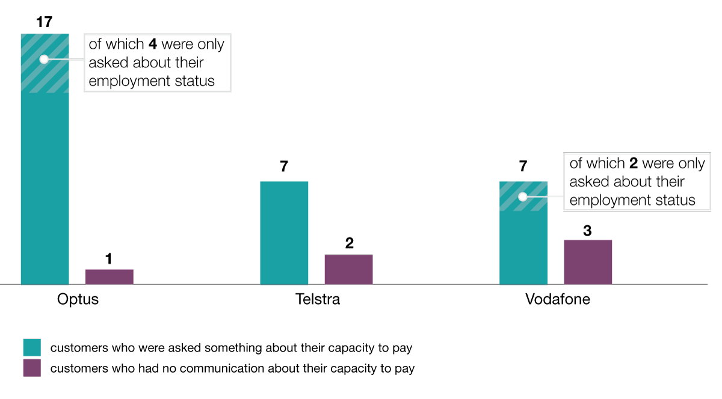

1. Communications about capacity to pay, by channel

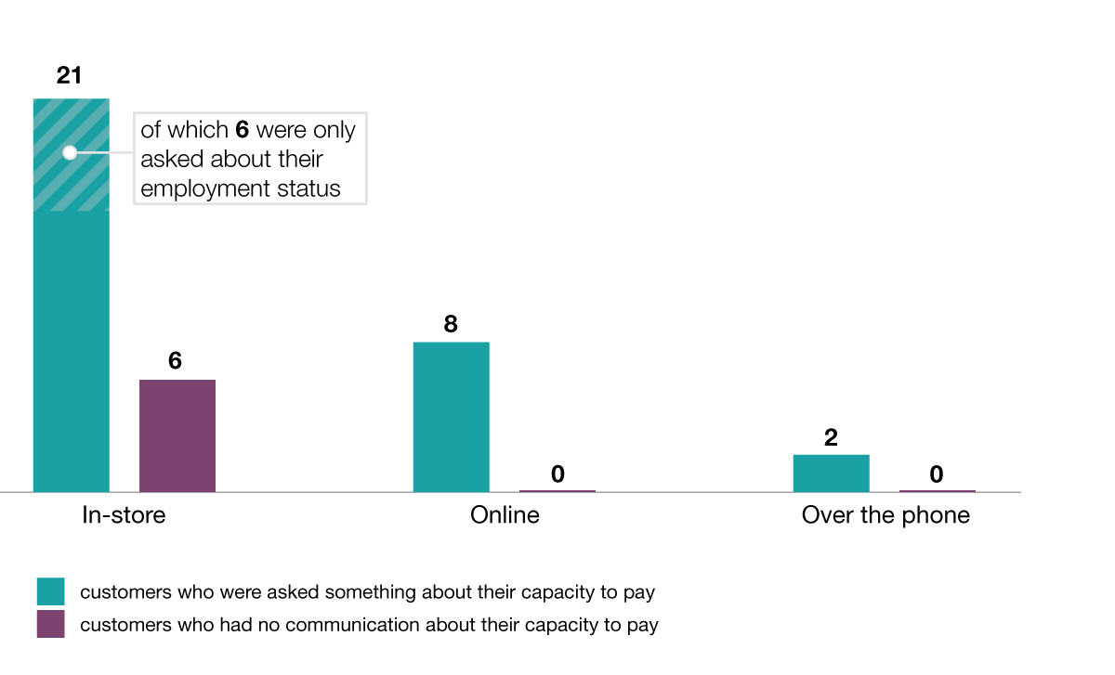

1. Types of communications with the 37 survey participants about capacity to pay, by telco

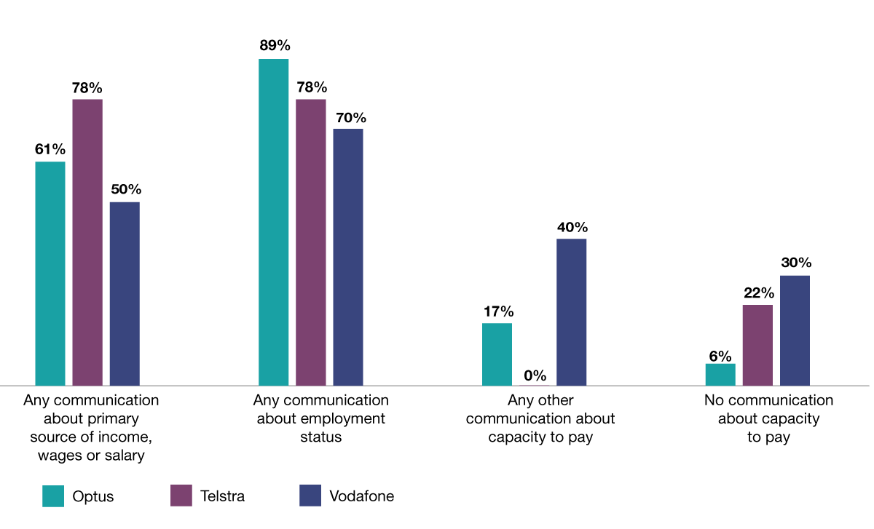

1. Types of communications with the 37 survey participants about capacity to pay, by channel

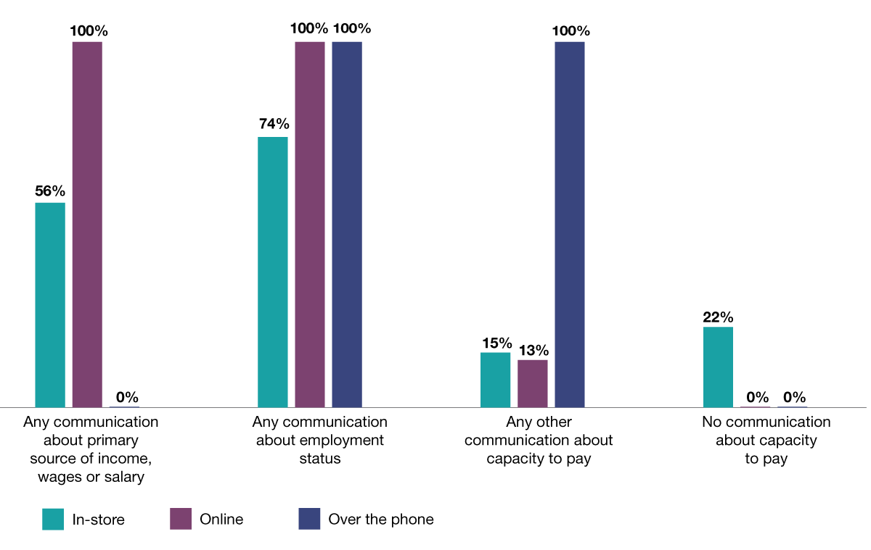

## Informed about credit assessment

1. Communications with the 37 survey participants about the credit assessment, by telco

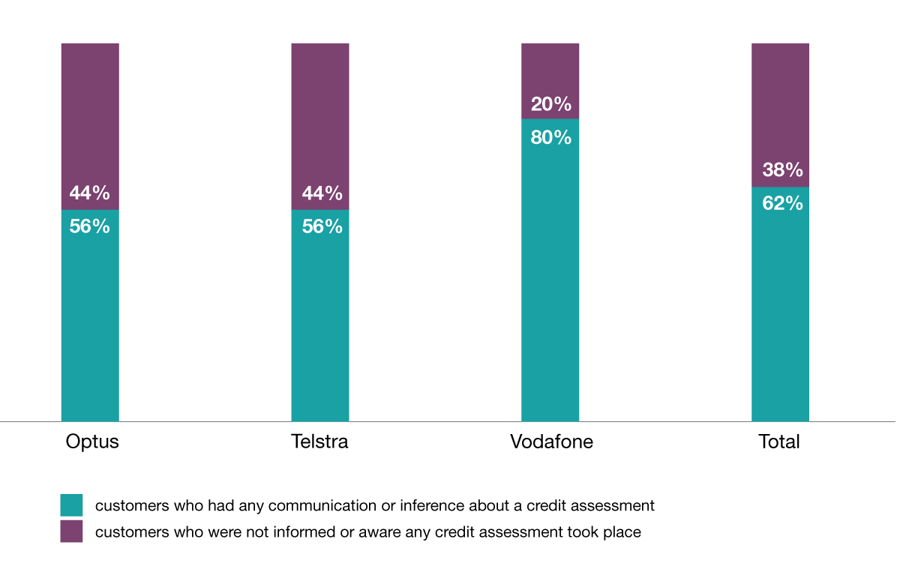

## External credit checks

1. Proportion of the 37 survey participants that were informed about the external credit check, by telco

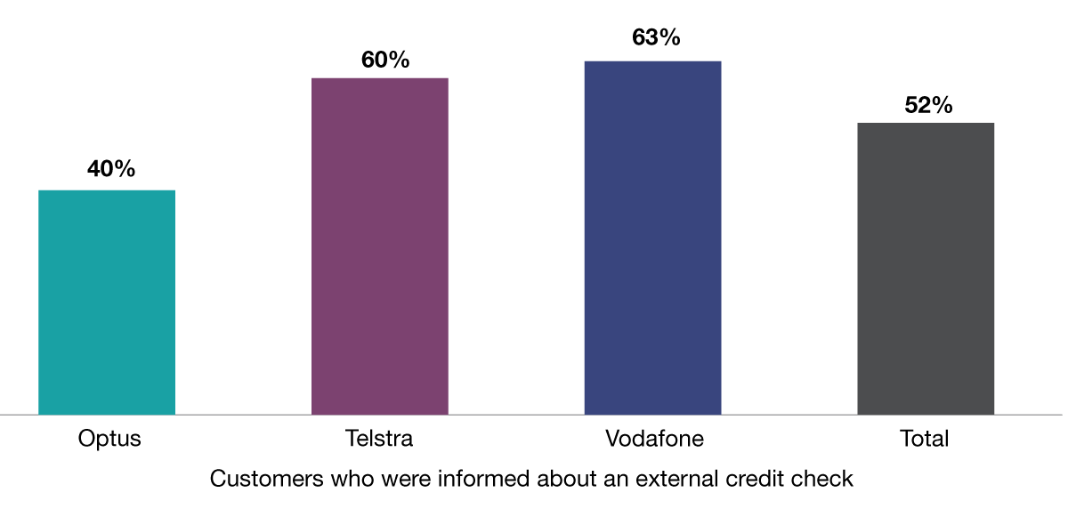

# Shadow shopping methodology

Two broad approaches to the shadow shopping research were used:

A pre-purchase methodology, where consumers were recruited before signing up to a new contract. To qualify, respondents were asked about their likely purchase behaviour during a pre-screening questionnaire. After this pre-screening, they were sent the survey questionnaire to fill out post-purchase.

A post-purchase methodology, where telco customers were recruited shortly after they had purchased a telco product.In this approach, customers were recruited within two weeks after entering a contract with one of the selected telcos.

A copy of the survey questionnaire is at Attachment A.

Survey participants were limited to new residential customers purchasing one or more post-paid telco products with a minimum price of more than $1,000, and a contract period greater than one month.

Lonergan Research used the Equifax system to assess a potential survey participant’s credit risk. Lonergan Research required each potential participant to obtain their credit score using the free website [www.getcreditscore.com.au](http://www.getcreditscore.com.au). Potential survey participants in the lowest quintile (bottom 20 per cent) were deemed ineligible for the study, to reduce the risk that survey participants purchased products they couldn’t afford.

The study sample included consumers from different demographic, geographic and income groups, and from regional and metropolitan areas.

Recruitment channels included via Lonergan Research’s network of shadow shoppers and registered research panels.

All survey participants were required to provide documentation to prove they had made a purchase.

# Notes

The information in this report is sourced from the responses provided by the 37 participants in the study conducted by Lonergan Research and information obtained from the three telcos.

While the ACMA believes the information in this report is accurate, we cannot confirm the accuracy of the information collected by Lonergan Research. The information stems from the recollection of the participants about their experience when they purchased a telco product. We acknowledge that how a participant recalls events, or views their experience, can affect the quality of the responses provided to Lonergan Research.

We sought information from the telcos on the customer status of the survey participants, and in particular, whether the customer was a new or existing customer. This was necessary to validate the survey sample.

We also sought information from the telcos on whether they obtained a credit check from a credit reporting body. Some of this information was obtained through the use of the ACMA’s compulsory information-gathering powers. Part 7A of the *ACMA Act 2005* constrains the ACMA’s ability to publicly disclose information collected under notice without the consent of the telco that supplied the information. The information provided by the telcos for the external credit checks obtained has therefore been aggregated and anonymised in this report.

No adverse findings have been made by the ACMA that a breach of the TCP Code has taken place.

# Attachment A

Questionnaire Screener

2078 ACMA Shadow Shopping

# Introduction Text for Survey Respondents

**BEFORE YOU BEGIN YOUR PURCHASE**

Please read this questionnaire in full before you begin.

Please confirm the following information is correct:

* We understand you are purchasing a post-paid telecommunications product from [CARRIER]
* We would like you to make this purchase {INSERT CHANNEL – INCLUDING URL IF REQUIRED].
* You understand the total value of this purchase will exceed $1,000
* You understand that you will be responsible for making all payments for this service, which will **NOT** be reimbursed
* You agree that this is a purchase that you have decided to make, and your choice of product was not influenced by Lonergan Research
* If you face financial hardship during the course of this contract which impacts your ability to meet your repayments, please collect evidence, and contact Lonergan Research

**If this differs from your understanding, please contact Lonergan Research prior to making the purchase. You may not be eligible for your incentive.**

You will not be able to submit this result until you have been able to activate your service. You may have to do this over several sittings.

Please use the “Save and Continue” button at any time. This will send you an email with a link to your survey response.

**The scenario**

Please be honest as to the reasons you are buying the phone, your needs and your financial situation.

Please **do not disclose** that this purchase is part of a shadow shopping exercise.

Please **do not volunteer any information** about your capacity to pay, including wages, income, savings etc. unless you are asked. If asked, please provide this information in a true and accurate manner.

Please **do not in any way prompt or encourage** any staff member to ask about your capacity to pay at any time.

Please **read all information provided to you** by the telecommunications provider, even if you wouldn’t usually do this.

# Questionnaire

|  |  |  |  |  |  |
| --- | --- | --- | --- | --- | --- |
| ASK ALL | | | | | |
|  | Is the purchase process complete?  This means you either have a mobile phone service that is active, or you have been informed that you will **not** be offered a service? | | | | |
|  | Please select one response only | | DO NOT RANDOMISE | SR |  |
|  |  | Process complete – I now have an active service | | 01 |  |
|  |  | Process complete – I was offered a service, but at a lower value, or a prepaid service | | 02 |  |
|  |  | Process complete – I was told I will not be offered a service | | 03 |  |
|  |  | Process not complete – application still in progress | | 04 |  |

**IF STILL IN PROGRESS: Please complete the survey once your service is active.**

|  |  |  |  |  |  |
| --- | --- | --- | --- | --- | --- |
| ASK ALL | | | | | |
|  | What is the name of the person who served you / who you spoke with? If there was more than one person, please record all names. | | | | |
|  | Please enter a response below | | DO NOT RANDOMISE | SR |  |
|  |  | _______________________ | | 01 |  |

|  |  |  |  |  |  |
| --- | --- | --- | --- | --- | --- |
| ASK ALL | | | | | |
|  | On what **date** did you make the purchase?  If this extended over a period of time, please enter the date when the process started. | | | | |
|  | Please enter a response below | |  | SR |  |
|  |  | INSERT CLICKABLE CALENDAR | | 01 |  |

|  |  |  |  |  |  |
| --- | --- | --- | --- | --- | --- |
| ASK ALL | | | | | |
|  | What time of day was this? | | | | |
|  | Please enter a response below | | DO NOT RANDOMISE | SR |  |
|  |  | _______________________ | | 01 |  |

|  |  |  |  |  |  |
| --- | --- | --- | --- | --- | --- |
| ASK ALL | | | | | |
|  | At any stage during any of your contacts with the telecommunications agency, were you asked **about your primary source of income?** For example, whether or not you are working, if you plan to pay for the phone using savings or investment income, whether someone else would pay the phone bill or anything else? | | | | |
|  | Please select all that apply | | DO NOT RANDOMISE | MR |  |
|  |  | Yes – by a person | | 01 |  |
|  |  | Yes – as information you entered into a form, computer or website | | 02 |  |
|  |  | Yes – in some other way (specify) | | 03 |  |
|  |  | No – this was never asked in any way | | 04 | SKIP TO Q7 |

|  |  |  |  |  |  |
| --- | --- | --- | --- | --- | --- |
| ASK IF PRIMARY SOURCE OF INCOME DISCUSSED | | | | | |
|  | What did you tell them your **primary source of income** was? If you told them more than one thing, please record all of them below. | | | | |
|  | Please select all that apply | | DO NOT RANDOMISE | MR |  |
|  |  | Wages or salary | | 01 |  |
|  |  | Savings | | 02 |  |
|  |  | Investment income | | 03 |  |
|  |  | Something else (specify) | | 04 |  |

|  |  |  |  |  |  |
| --- | --- | --- | --- | --- | --- |
| ASK ALL | | | | | |
|  | At any stage during any of your contacts with the telecommunications agency, were you asked **about your salary, wages or income from work**? | | | | |
|  | Please select all that apply | | DO NOT RANDOMISE | MR |  |
|  |  | Yes – by a person | | 01 |  |
|  |  | Yes – as information you entered into a form, computer or website | | 02 |  |
|  |  | Yes – in some other way (specify) | | 03 |  |
|  |  | No – this was never asked in any way | | 04 | SKIP TO Q9 |

|  |  |  |  |  |
| --- | --- | --- | --- | --- |
| ASK IF SALARY OR WAGES INCOME DISCUSSED | | | | |
|  | Please provide details about what you were asked, and what you told them, in the space below. | | | |
|  | Please enter a detailed response below |  |  |  |
|  | _______________________________________________________________ | |  |  |

|  |  |  |  |  |  |
| --- | --- | --- | --- | --- | --- |
| ASK ALL | | | | | |
|  | At any stage during any of your contacts with the telecommunications agency, were you asked **about your employment status?** For example, whether or not you are working, and whether this is full time or part time hours, casually employed or permanently employed, etc. | | | | |
|  | Please select all that apply | | DO NOT RANDOMISE | MR |  |
|  |  | Yes – by a person | | 01 |  |
|  |  | Yes – as information you entered into a form, computer or website | | 02 |  |
|  |  | Yes – in some other way (specify) | | 03 |  |
|  |  | No – this was never asked in any way | | 04 | SKIP TO Q11 |

|  |  |  |  |  |
| --- | --- | --- | --- | --- |
| ASK IF EMPLOYMENT STATUS DISCUSSED | | | | |
|  | Please provide details about what you were asked, and when, in the space below. | | | |
|  | Please enter a detailed response below |  |  |  |
|  | _______________________________________________________________ | |  |  |

|  |  |  |  |  |  |
| --- | --- | --- | --- | --- | --- |
| ASK ALL | | | | | |
|  | At any stage during any of your contacts with the telecommunications agency, were you asked **about your savings**? | | | | |
|  | Please select all that apply | | DO NOT RANDOMISE | MR |  |
|  |  | Yes – by a person | | 01 |  |
|  |  | Yes – as information you entered into a form, computer or website | | 02 |  |
|  |  | Yes – in some other way (specify) | | 03 |  |
|  |  | No – this was never asked in any way | | 04 | SKIP TO Q13 |

|  |  |  |  |  |
| --- | --- | --- | --- | --- |
| ASK IF SAVINGS DISCUSSED | | | | |
|  | Please provide details about what you were asked, and what you told them, in the space below. | | | |
|  | Please enter a detailed response below |  |  |  |
|  | _______________________________________________________________ | |  |  |

|  |  |  |  |  |  |
| --- | --- | --- | --- | --- | --- |
| ASK ALL | | | | | |
|  | At any stage during any of your contacts with the telecommunications agency, were you asked **about your investment income, or income from any other source**? | | | | |
|  | Please select all that apply | | DO NOT RANDOMISE | MR |  |
|  |  | Yes – by a person | | 01 |  |
|  |  | Yes – as information you entered into a form, computer or website | | 02 |  |
|  |  | Yes – in some other way (specify) | | 03 |  |
|  |  | No – this was never asked in any way | | 04 | SKIP TO Q15 |

|  |  |  |  |  |
| --- | --- | --- | --- | --- |
| ASK IF INVESTMENT INCOME DISCUSSED | | | | |
|  | Please provide details about what you were asked, and what you told them, in the space below. | | | |
|  | Please enter a detailed response below |  |  |  |
|  | _______________________________________________________________ | |  |  |

|  |  |  |  |  |  |
| --- | --- | --- | --- | --- | --- |
| ASK ALL | | | | | |
|  | At any stage during any of your contacts with the telecommunications agency, were you asked **any other information about your ability to pay** (that you have not already provided)? | | | | |
|  | Please select all that apply | | DO NOT RANDOMISE | MR |  |
|  |  | Yes – by a person | | 01 |  |
|  |  | Yes – as information you entered into a form, computer or website | | 02 |  |
|  |  | Yes – in some other way (specify) | | 03 |  |
|  |  | No – this was never asked in any way | | 04 | SKIP TO Q17 |

|  |  |  |  |  |
| --- | --- | --- | --- | --- |
| ASK OTHER ABILITY TO PAY INFORMATION DISCUSSED | | | | |
|  | Please provide details about what you were asked, and when, in the space below. | | | |
|  | Please enter a detailed response below |  |  |  |
|  | _______________________________________________________________ | |  |  |

|  |  |  |  |  |
| --- | --- | --- | --- | --- |
| ASK ALL | | | | |
|  | What **evidence**, if any, were you asked to provide about your ability to pay.  This may include payslips, payment summaries, bank statements, rental income statements, previous bills with evidence of payment or any other information. | | | |
|  | Please enter a detailed response below |  |  |  |
|  | _______________________________________________________________ | |  |  |

|  |  |  |  |  |  |
| --- | --- | --- | --- | --- | --- |
| ASK ALL | | | | | |
|  | Were you informed at any stage that you would undergo any form of **credit assessment**, to verify your ability to pay? | | | | |
|  | Please select all that apply | | DO NOT RANDOMISE | MR |  |
|  |  | Yes – by a person | | 01 |  |
|  |  | Yes – by email, mail or as information provided on a form | | 02 |  |
|  |  | Yes – in some other way (specify) | | 03 |  |
|  |  | No – I was never informed of this | | 04 | SKIP TO Q20 |

|  |  |  |  |  |
| --- | --- | --- | --- | --- |
| ASK IF CREDIT ASSESSMENT DISCUSSED | | | | |
|  | Please provide details about what you were told, and when, in the space below. | | | |
|  | Please enter a detailed response below |  |  |  |
|  | _______________________________________________________________ | |  |  |

|  |  |  |  |  |  |
| --- | --- | --- | --- | --- | --- |
| ASK ALL | | | | | |
|  | Were you informed of the **purpose** of the credit assessment at any stage? | | | | |
|  | Please select all that apply | | DO NOT RANDOMISE | MR |  |
|  |  | Yes – by a person | | 01 |  |
|  |  | Yes – by email, mail or as information provided on a form | | 02 |  |
|  |  | Yes – in some other way (specify) | | 03 |  |
|  |  | No – I was never informed of this | | 04 | SKIP TO Q22 |

|  |  |  |  |  |
| --- | --- | --- | --- | --- |
| ASK IF PURPOSE OF CREDIT ASSESSMENT DISCUSSED | | | | |
|  | Please provide details about what you were told, and when, in the space below. | | | |
|  | Please enter a detailed response below |  |  |  |
|  | _______________________________________________________________ | |  |  |

|  |  |  |  |  |  |
| --- | --- | --- | --- | --- | --- |
| ASK ALL | | | | | |
|  | Were you informed at any stage that the **credit assessment** would include a credit check from an **external reporting body**? | | | | |
|  | Please select all that apply | | DO NOT RANDOMISE | MR |  |
|  |  | Yes – by a person | | 01 |  |
|  |  | Yes – by email, mail or as information provided on a form | | 02 |  |
|  |  | Yes – in some other way (specify) | | 03 |  |
|  |  | No – I was never informed of this | | 04 | SKIP TO Q24 |

|  |  |  |  |  |
| --- | --- | --- | --- | --- |
| ASK IF EXTERNAL CREDIT AGENCY DISCUSSED | | | | |
|  | Please provide details about what you were told, and when, in the space below. | | | |
|  | Please enter a detailed response below |  |  |  |
|  | _______________________________________________________________ | |  |  |

|  |  |  |  |  |  |
| --- | --- | --- | --- | --- | --- |
| ASK ALL | | | | | |
|  | Did you have any direct contact with the credit assessment department, or team at any stage? | | | | |
|  | Please select all that apply | | DO NOT RANDOMISE | MR |  |
|  |  | Yes – by a person from the telecommunications company (i.e. Telstra, Optus or Vodafone) | | 01 |  |
|  |  | Yes – by a person from an external credit assessment agency | | 02 |  |
|  |  | Yes - but it is not clear if they work for the telecommunications company or an external credit assessment agency | | 03 |  |
|  |  | Yes – by email, mail or as information requested or provided on a form | | 04 |  |
|  |  | Yes – in some other way (specify) | | 05 |  |
|  |  | No – I had no contact | | 06 | SKIP TO Q26 |

|  |  |  |  |  |
| --- | --- | --- | --- | --- |
| ASK IF HAD CONTACT WITH CREDIT DEPARTMENT OR AGENCY | | | | |
|  | Please provide details about this contact in the space below. | | | |
|  | Please enter a detailed response below |  |  |  |
|  | _______________________________________________________________ | |  |  |

|  |  |  |  |  |  |
| --- | --- | --- | --- | --- | --- |
| ASK ALL | | | | | |
|  | Were you informed of the outcome of the credit assessment at any stage? | | | | |
|  | Please select all that apply | | DO NOT RANDOMISE | MR |  |
|  |  | Yes – by a person | | 01 |  |
|  |  | Yes – by email, mail or as information provided on a form | | 02 |  |
|  |  | Yes – in some other way (specify) | | 03 |  |
|  |  | No – I was never informed of the outcome | | 04 | SKIP TO Q29 |

|  |  |  |  |  |  |
| --- | --- | --- | --- | --- | --- |
| ASK IF INFORMED OF OUTCOME | | | | | |
|  | What was the outcome of the assessment? | | | | |
|  | Please select all that apply | | DO NOT RANDOMISE | MR |  |
|  |  | You were approved to get credit for the service and plan you originally wanted | | 01 | SKIP TO Q29 |
|  |  | You were approved to get credit, but for a service or plan of a lower value | | 02 |  |
|  |  | You were **not** approved to get credit, but obtained a prepaid plan or service instead | | 03 |  |
|  |  | You were **not** approved to get credit, and did not obtain any type of service from this company | | 04 |  |
|  |  | Something else (specify) | | 05 |  |
|  |  | Don’t know – I was never informed of the outcome | | 06 | SKIP TO Q29 |

|  |  |  |  |  |
| --- | --- | --- | --- | --- |
| IF INFORMED OF A NEGATIVE OUTCOME | | | | |
|  | What information, if any, were you given about the reasons for not being approved for the credit you originally applied for? | | | |
|  | Please enter a detailed response below |  |  |  |
|  | _______________________________________________________________ | |  |  |

|  |  |  |  |  |  |
| --- | --- | --- | --- | --- | --- |
| ASK ALL | | | | | |
|  | At any stage did anyone …? | | | | |
|  | Please select all that apply | | DO NOT RANDOMISE | MR |  |
|  |  | Suggest that you switch to a plan with a lower monthly commitment | | 01 |  |
|  |  | Suggest that you use a prepaid service instead of a post-paid service | | 02 |  |
|  |  | Suggest that you consider any other alternate products or services, that come at a lower financial commitment but meet your needs (specify) | | 03 |  |
|  |  | No – none of these | | 04 | SKIP TO Q31 |

|  |  |  |  |  |  |
| --- | --- | --- | --- | --- | --- |
| ASK IF LOWER CREDIT OPTION SUGGESTED | | | | | |
|  | To what extent did the alternatives suggested meet your needs? | | | | |
|  | Please select one response only | | DO NOT RANDOMISE | SR |  |
|  |  | Met my needs very well | | 01 |  |
|  |  | Met my needs well | | 02 |  |
|  |  | Did not meet my needs well | | 03 |  |
|  |  | Did not meet my needs at all | | 04 |  |

|  |  |  |  |  |
| --- | --- | --- | --- | --- |
| ASK ALL | | | | |
|  | Please provide any other details that you have not provided elsewhere, including   * anything else what you were told about the credit assessment process * any other evidence or information that may help us to understand if a credit assessment took place | | | |
|  | Please enter a detailed response below |  |  |  |
|  | _______________________________________________________________ | |  |  |

|  |  |  |  |  |
| --- | --- | --- | --- | --- |
| ASK ALL | | | | |
|  | Please provide the phone number of your new service in the space below. If you were also provided with an account number, please also provide this below. | | | |
|  | Please enter a detailed response below |  |  |  |
|  | _______________________________________________________________ | |  |  |

|  |  |  |  |  |
| --- | --- | --- | --- | --- |
| ASK ALL | | | | |
|  | Please attach photos of **every page** of your contract here. If this is too big, please use our upload link <https://spaces.hightail.com/uplink/LonerganResearch>  Please ensure that you include your name and email in the upload.  Alternatively, these can be emailed to [telcosurvey@lonerganresearch.com.au](mailto:telcosurvey@lonerganresearch.com.au) (maximum email size 20MB) | | | |
|  |  |  |  |  |
|  | _______________________________________________________________ | |  |  |

1. ACMA media release, Stronger protections for telecommunications consumers, 23 June 2019, <https://www.acma.gov.au/articles/2019-06/stronger-protections-telecommunications-consumers>
2. A post-paid service or device is one that can be used fully or in part before being paid for by the consumer.
3. While the TCP Code does not define a ‘new’ or ‘existing’ customer, the ACMA considers that, for the purposes of clause 6.1.1(b) of the TCP Code, a customer of a telco will be a new customer if they do not already have an existing post-paid contract with that telco. An existing customer of a telco, for the purposes of clause 6.1.1(a) of the TCP Code, is understood to be any customer who has an existing post-paid contract with that telco.
4. ACMA *Communications report 2018–19*, p. 39.
5. Financial and Consumer Rights Council, *Rank the Telc*o, April 2017, p. 13.