**Electromagnetic energy (EME) measurements near small cell base stations**

Summary of results

JUNE 2020

Canberra

Red Building   
Benjamin Offices  
Chan Street   
Belconnen ACT

PO Box 78  
Belconnen ACT 2616

T +61 2 6219 5555  
F +61 2 6219 5353

Melbourne

Level 32   
Melbourne Central Tower  
360 Elizabeth Street   
Melbourne VIC

PO Box 13112  
Law Courts   
Melbourne VIC 8010

T +61 3 9963 6800  
F +61 3 9963 6899

Sydney

Level 5   
The Bay Centre  
65 Pirrama Road   
Pyrmont NSW

PO Box Q500  
Queen Victoria Building   
NSW 1230

T +61 2 9334 7700 or 1800 226 667  
F +61 2 9334 7799

Copyright notice

[Creative Commons logo](http://i.creativecommons.org/l/by/3.0/88x31.png)

<https://creativecommons.org/licenses/by/4.0/>

With the exception of coats of arms, logos, emblems, images, other third-party material or devices protected by a trademark, this content is made available under the terms of the Creative Commons Attribution 4.0 International (CC BY 4.0) licence.

We request attribution as © Commonwealth of Australia (Australian Communications and Media Authority) 2020.

All other rights are reserved.

The Australian Communications and Media Authority has undertaken reasonable enquiries to identify material owned by third parties and secure permission for its reproduction. Permission may need to be obtained from third parties to re-use their material.

Written enquiries may be sent to:

Manager, Editorial Services  
PO Box 13112  
Law Courts  
Melbourne VIC 8010  
Email: [info@acma.gov.au](mailto:info@acma.gov.au)

Executive summary 1

What we found 2

Background 3

Methodology 4

Sampling method 4

Measurement method 4

Measurement results by state 9

New South Wales 9

Queensland 11

South Australia 13

Tasmania 15

Victoria 16

Western Australia 18

Summary of measurement results 19

Glossary 22

Executive summary

In early 2020, the Australian Communications and Media Authority (ACMA) measured electromagnetic energy (EME) public exposure levels at 59 small cell sites across Australia.

The measurement program demonstrated that, for all small cell sites measured, the levels of EME emissions in publicly accessible areas are very low (less than 1 per cent) compared to the Australian Standard for EME emissions.

The deployment of small cell technology for mobile and wireless broadband communication networks in recent years has generated community interest and some concern about the level of EME emissions from these facilities and perceived risk to public health.

EME standards in Australia are built upon scientific assessment, establishing limits to human exposure to radiofrequency fields set by the Australian Radiation Protection and Nuclear Safety Agency (ARPANSA). The ACMA gives regulatory effect to these limits by, amongst other things, imposing conditions on carriers with respect to the operation of radiocommunications transmitters.

The ARPANSA limits to human exposure to radiofrequency fields are set well below levels at which harm to people may occur. At exposure levels below the limits set within the ARPANSA safety standard, it is the assessment of ARPANSA and international organisations, such as the [World Health Organisation](http://www.who.int/peh-emf/publications/facts/fs304/en/) (WHO) and the [International Commission on Non-Ionising Radiation (ICNIRP)](https://www.icnirp.org/en/applications/base-stations/index.html), that there is no established scientific evidence to support any adverse health effects from very low RF EME exposures to populations or individuals.[1]

In recent years we have undertaken a number of reactive and proactive compliance activities to ensure telecommunications carriers are meeting their licence conditions with respect to mobile base station deployments, including an audit of small cell deployments in early 2019.

With a more expansive small cell and 5G rollout underway in Australia, we identified compliance with the EME Standard in relation to small cell deployments as one of our  [compliance priorities for 2019–20](https://www.acma.gov.au/compliance-priorities-2019-20).

The purpose of the current measurement program is to assess compliance by carriers with their regulatory obligations to ensure that EME levels in areas accessible by the general public are below the limits referenced in the ARPANSA safety standard.

## What we found

For all 59 small cell sites visited nationally, the EME levels were found to be at a small percentage of the EME reference level for exposure to the general public in the ARPANSA Safety Standard.

All measurements were recorded at well below 1 per cent of the ARPANSA limit. The highest level recorded was 0.737 per cent of the ARPANSA limit.

For all small cell sites visited, the average EME levels were below the calculated EME levels recorded in the carrier’s corresponding EME environmental reports.

All of the measurements were taken in publicly accessible areas, demonstrating that the public exposure levels attributed to emissions from the small cell sites visited was extremely low.

# Background

The ACMA has responsibility to ensure compliance with EME standards, and to this end, undertakes a range of compliance activities.

These activities include focusing on areas of specific interest or concern as new technology or infrastructure is rolled out. Recent examples include small cell deployments and new technologies such as 5G.

In January 2019, we conducted an audit of TPG Telecom Limited’s (TPG) compliance with its EME obligations in relation to its small cell deployments (the TPG compliance assessment)[2]. The audit found no significant issues of non-compliance[3].

In April 2019, noting the continuing public interest and concern about public health impacts from the level of EME emissions from small cell facilities, we announced carrier compliance with the EME Standard in relation to small cell deployments as one of our [compliance priorities for 2019–20](https://www.acma.gov.au/publications/2019-04/creina-chapman-commsday-summit-2019) (the small cells compliance program). While, at that time, small cells were predominantly being used to deliver 4G services, it was anticipated the deployment of small cells would increase with the rollout of 5G technology.

Consistent with the TPG compliance assessment, the smalls cells compliance program has continued our focus on the role of carriers, specifically Telstra, Optus and Vodafone, to ascertain their awareness and compliance with their licence conditions under the [Radiocommunications Licence Conditions (Apparatus Licence) Determination 2015](https://www.legislation.gov.au/Details/F2019C00870), and with their consultation requirements under the [Mobile Phone Base Station Deployment Code](https://www.commsalliance.com.au/__data/assets/pdf_file/0018/62208/C564_2018-181206.pdf) for small cell deployments.

The ACMA will ascertain the carrier’s compliance with their licence conditions and the consultation requirements through corresponding audits of the carrier’s records under each of these regulatory frameworks, the results of which are expected to be reported in the coming months. We have also undertaken an EME measurement program to ascertain the overall EME exposure levels near a sample of the carriers’ 4G small cell sites nationally.

This report presents the results of our EME measurements at 4G-enabled small cells in January and February 2020, as part of the small cells compliance program.

# Methodology

The purpose of the EME measurement program was to measure the average overall EME exposure levels at, or as close as practically possible to, the point of maximum predicted or calculated EME level at a select sample of 60 small cell sites. This was to ascertain whether they are within the limits set by the [*Radiation Protection Standard for Maximum Exposure levels to Radiofrequency Fields – 3 kHz to 300 GHz (2002*)](https://www.arpansa.gov.au/regulation-and-licensing/regulatory-publications/radiation-protection-series/codes-and-standards/rps3) (the ARPANSA Standard).

## Sampling method

The sample was derived from a randomised sampling method applied to all Telstra, Optus and Vodafone small cell sites. The carriers provided us with lists of all active small cells nationally. These lists were then matched to the data in the Radio Frequency National Site Archive (RFNSA)[4].

Only sites that were within a 200km radius of the capital cities in Australia were considered for this program. Random sampling method was applied to the list of small cell sites to select a sample of 60 sites (approximately 5 per cent) for the measurement program. Of the 60 small cell sites selected for the EME measurement program, the EME levels near 59 of the selected sites were measured, with one site excluded as it was subsequently found to be an in-building cell.

## Measurement method

The EME measurement program was conducted in accordance with the Standards Australia document, *Radiofrequency fields, Part 2: Principles and methods of measurement and computation - 3 kHz to 300 GHz*—AS/NZS 2772.2 Standard (the AS/NZS 2772.2 Standard) and the ARPANSA Standard.

Before conducting each of the EME measurements, in accordance with section 3.5 of the AS/NZS 2772.2 Standard, ACMA staff identified known characteristics of each of the transmitters, including the likely propagation and physical environment characteristics. The characteristics observed included:

the nature of the equipment installed

antenna height

signage installed at the site.

The characteristics were visually inspected and compared with corresponding information for each small cell site in the ARPANSA/Environmental EME report and the EME guide, both available on the [RFNSA website](https://www.rfnsa.com.au/). Photographs of each of the small cell sites were also taken.

In order to be able to visually inspect the sites at the time of the measurements, all measurements were taken during daylight hours and, in some cases, at days and times dictated by health alerts issued by the Department of Health due to bushfire and smoke affecting air quality in Victoria and New South Wales in January and February 2020.

Small cell sites

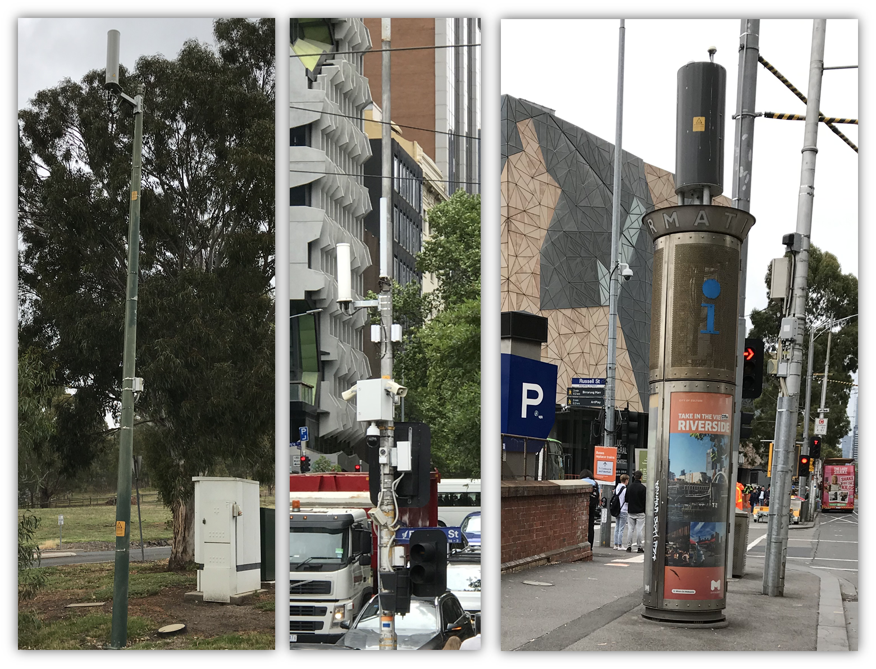

The EME measurements were conducted in accordance with section 3.9 of the AS/NZS 2772.2 Standard. Additional information was drawn from the ARPANSA/Environment EME report for each small cell site on the RFNSA website. This information related to the location of the maximum predicted or calculated EME level in order for the measurement to be taken from that location, where possible, so that some correlation and comparison could be made with the carrier’s empirical measurements at each small cell site.

For each site, the overall EME exposure level was measured in all the public mobile telecommunications services bands from 420 MHz to 6 GHz. This was based on the bands listed in the ARPANSA/Environmental EME report on the RFNSA website for each of the small cell sites. Importantly, it encompassed all frequency bands used by each of the small cell transmitters at the time the measurements were taken. These included:

UHF LMRS

UHF TV

700 MHz 4G LTE

800 MHz TRUNK

800 MHz 3G/4G

900 MHz LIPD

900 MHz 3G

1800 MHz 4G LTE

2.1 GHz 3G/4G

2.3 GHz 4G LTE

2.4 GHz LIPD

2.6 GHz 4G LTE

3.4 GHz spectrum licence

3.6 GHz 5G

5.7 GHz LIPD

The EME measurements were conducted using a selective field strength meter—a Narda SRM-3006 selective radiation meter, along with an isotropic electric field probe—a Narda three axis antenna (420 MHz to 6 GHz). The probe was mounted on a tripod at a height of 1.5 metres above ground level.

The equipment provided an overall exposure level and the individual contributions to it made by the small cell transmitter and other sources present in the vicinity transmitting in the abovementioned bands. The total exposure level can be expressed as a relative value as a percentage of the permitted limit values as per the ARPANSA standard.

Narda SRM-3006 selective radiation meter connected to an isotropic electric field probe on a tripod at a height of 1.5 metres above ground level

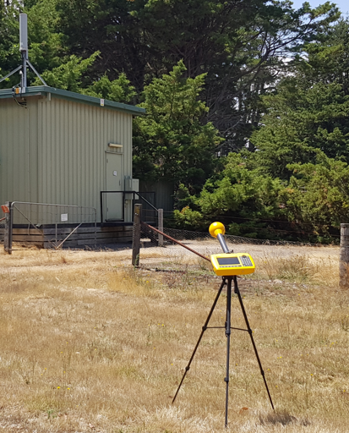

The EME measurements were averaged over six-minute time intervals, as specified in the ARPANSA standard[5], and the following measurements were recorded at each selected small cell site:

Measurement one—the electric field (E-Field) strength values in V/m of the RF wave at different frequency points from 420 MHz to 6 GHz at 250 kHz apart was measured over a period of six minutes.

Measurement two—the cumulative E-Field strength values in V/m in different bands of interest and the total E-Field strength value between 420 MHz to 6 GHz was measured over a period of six minutes.

Measurement three—the cumulative percentage of the ARPANSA exposure limit in different bands of interest and the total percentage of the ARPANSA exposure limit value between 420 MHz to 6 GHz was measured over a period of six minutes.

The measurements were presented in the following units:

volts per metre (V/m)—the electric field component of the RF wave (obtained directly from the measurement equipment)

as a percentage (%) of the ARPANSA Standard public exposure limit (the public exposure limit = 100%) (obtained directly from the measurement equipment).

The measurements taken were the emissions of the individual signals present at the measurement location at the time, evaluated against the limit value and added together to provide a cumulative value. The power output from the transmitter varied considerably according to the actual loading of the base station. Therefore, it is important to acknowledge the values present at the time of measurement may not have been the maximum EME levels from the small cell site.

While the measurements are not accredited measurements by the National Association of Testing Authorities (NATA), they are traceable to the International System of Units in accordance with the International Organisation of Standardisation (ISO)—ISO/IEC 17025 Standard which demonstrates operational competency and validity.

The measurement results for each site were then compared to the calculated maximum EME levels recorded in the carrier’s corresponding EME environmental reports on the RFNSA website. The carrier-calculated levels are maximum predicted levels for the frequency bands that are used at the site, whereas the ACMA measurements are average overall levels for all bands between 420MHz to 6GHz.

For 58 sites visited, the ACMA measurements were lower than the carrier-calculated levels, notwithstanding the broader frequency ranges covered. For the remaining site, when the ACMA measurements were refined to only include the frequency bands used at the site, the measurements were well below the carrier-calculated levels.

This analysis provides a high level of confidence that the calculated EME levels, reported by the carriers using the ARPANSA methodology, produce a conservative result and measured emissions at the site are lower than the reported calculated levels.

# Measurement results by state

Having carried out EME measurements at, or as close as practically possible to, the point of maximum predicted or calculated EME level at 59 small cell sites across Australia, this section provides a summary of these results, both by state and overall.

Due to the nature of the randomised sampling and there being fewer small cells in the territories, there were no measurements taken in the Northern Territory and Australian Capital Territory.

The individual site reports for each location where measurements were recorded will be available shortly and are proposed to be made publicly available as links from this summary report.

## New South Wales

Locations of the ACMA’s EME measurements in NSW

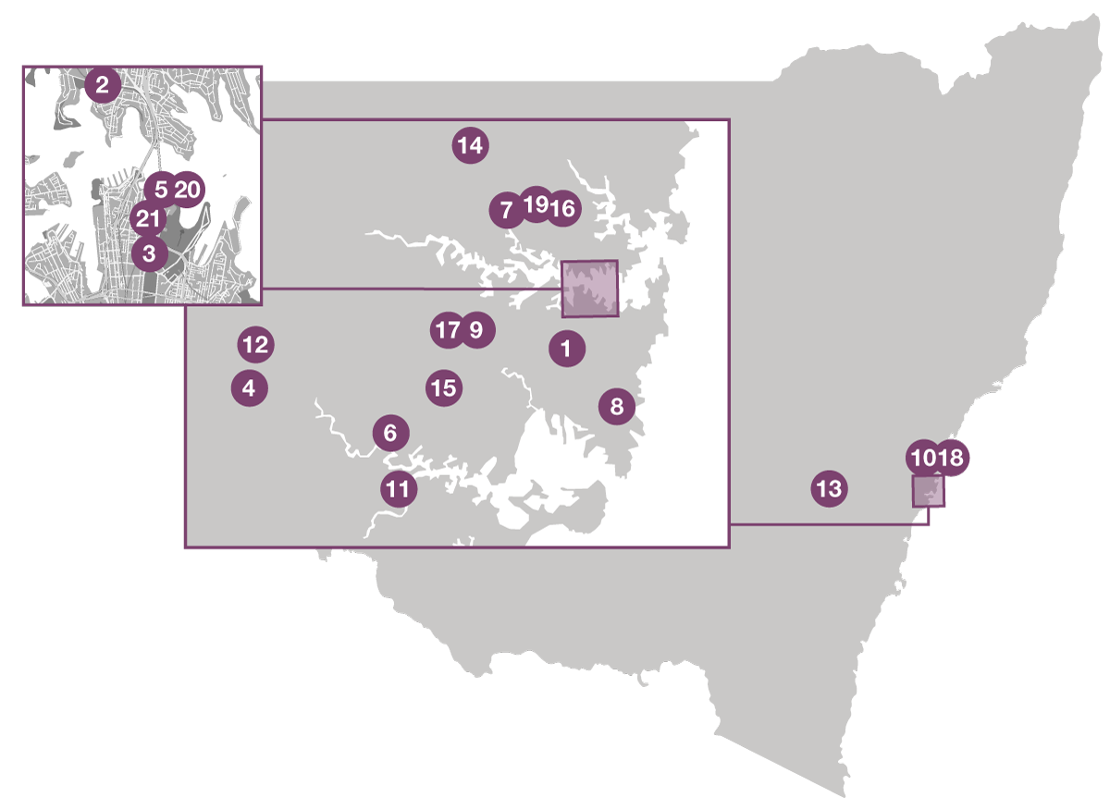

Note: Map is for illustration purposes only and is not to scale. See Table 1 for map location references.

Average EME level measured at each of the NSW small cell sites

|  |  |  |  |  |
| --- | --- | --- | --- | --- |
| Map reference | Suburb | Measurement location | Date | Average EME level* |
| 1 | Erskineville | 105 Railway Parade | Jan 2020 | 0.205 % |
| 2 | North Sydney | 38 Bank Street | Feb 2020 | 0.04 % |
| 3 | Sydney | 58–60 Martin Place | Feb 2020 | 0.121 % |
| 4 | Heckenberg | 48 Matthew Avenue | Feb 2020 | 0.056 % |
| 5 | Sydney | 2B Macquarie Street | Feb 2020 | 0.737 % |
| 6 | Padstow | 6 Cairo Avenue | Feb 2020 | 0.059 % |
| 7 | Lindfield | 107 Grosvenor Road | Feb 2020 | 0.079 % |
| 8 | Maroubra | 80 Cooper Street | Feb 2020 | 0.078 % |
| 9 | Burwood | Pole LE21541 (opposite 90 Burwood Road) | Jan 2020 | 0.605 % |
| 10 | Ku-ring-gai Chase NP | 21 D Liberator General San Mar Drive | Feb 2020 | 0.016 % |
| 11 | Alfords Point | 7 Plan 331160 Alfords Point Road | Feb 2020 | 0.443 % |
| 12 | Greenfield Park | 2 Sayonara Place | Feb 2020 | 0.001 % |
| 13 | Mt David | 40 Plan DP3552 Robson Road | Feb 2020 | 0.034 % |
| 14 | Warrawee | 1397 Pacific Highway | Feb 2020 | 0.114 % |
| 15 | Lakemba | Haldon Street & Railway Parade | Feb 2020 | 0.168 % |
| 16 | Roseville | 84 Boundary Street | Feb 2020 | 0.226 % |
| 17 | Burwood | Pole LE32086 (near 36 Park Avenue) | Jan 2020 | 0.24 % |
| 18 | Church Point | 2 A McCarrs Creek Road | Feb 2020 | 0.312 % |
| 19 | Roseville | Outside 28 Archbold Road | Feb 2020 | 0.131 % |
| 20 | Sydney | 2B Macquarie Street | Feb 2020 | 0.081 % |
| 21 | Sydney | 2 Alfred Street | Feb 2020 | 0.185 % |

* As a percentage of the ARPANSA general public exposure limit.

## Queensland

Locations of the ACMA’s EME measurements in Queensland

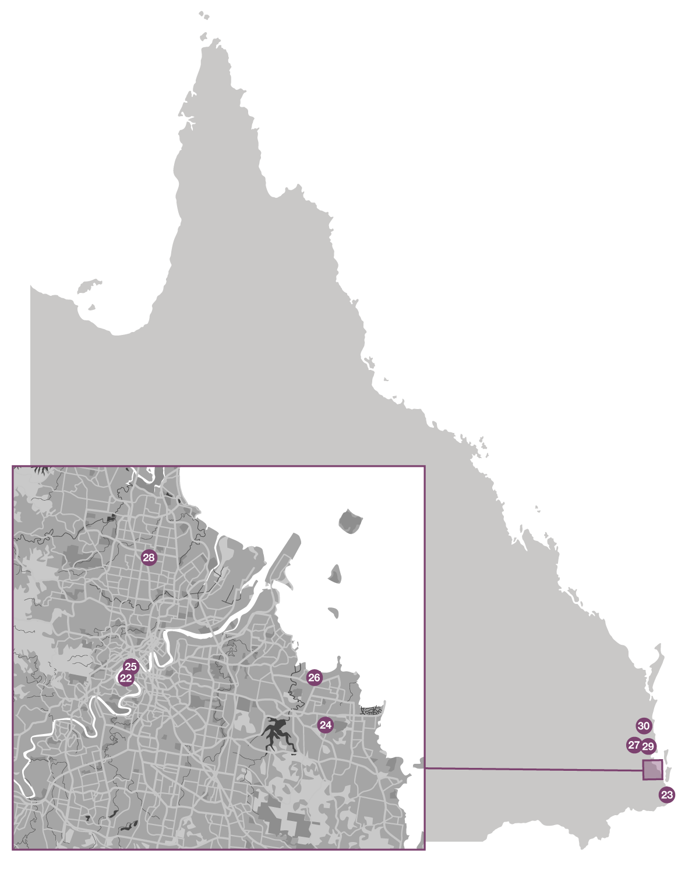

Note: Map is for illustration purposes only and is not to scale. See Table 2 for map location references.

Average EME level measured at each of the Queensland small cell sites

|  |  |  |  |  |
| --- | --- | --- | --- | --- |
| Map reference | Suburb | Measurement location | Date | Average EME level* |
| 22 | West End | 6 Ambleside Street | Feb 2020 | 0.017 % |
| 23 | Surfers Paradise | 20 Cavill Avenue | Feb 2020 | 0.082 % |
| 24 | Alexandra Hills | 3 Heffernan Road | Feb 2020 | 0.079 % |
| 25 | South Brisbane | 144 Montague Road | Feb 2020 | 0.206 % |
| 26 | Birkdale | 7 Agnes Street | Feb 2020 | 0.231 % |
| 27 | Woodford | 32 Coronation Avenue | Feb 2020 | 0.014 % |
| 28 | Aspley | 19 Chartwell Street | Feb 2020 | 0.432 % |
| 29 | Beerburrum | 10 Anzac Avenue | Feb 2020 | 0.131 % |
| 30 | Mapleton | 44 Flaxton Drive | Feb 2020 | 0.346 % |

* As a percentage of the ARPANSA general public exposure limit.

## South Australia

Locations of the ACMA’s EME measurements in South Australia

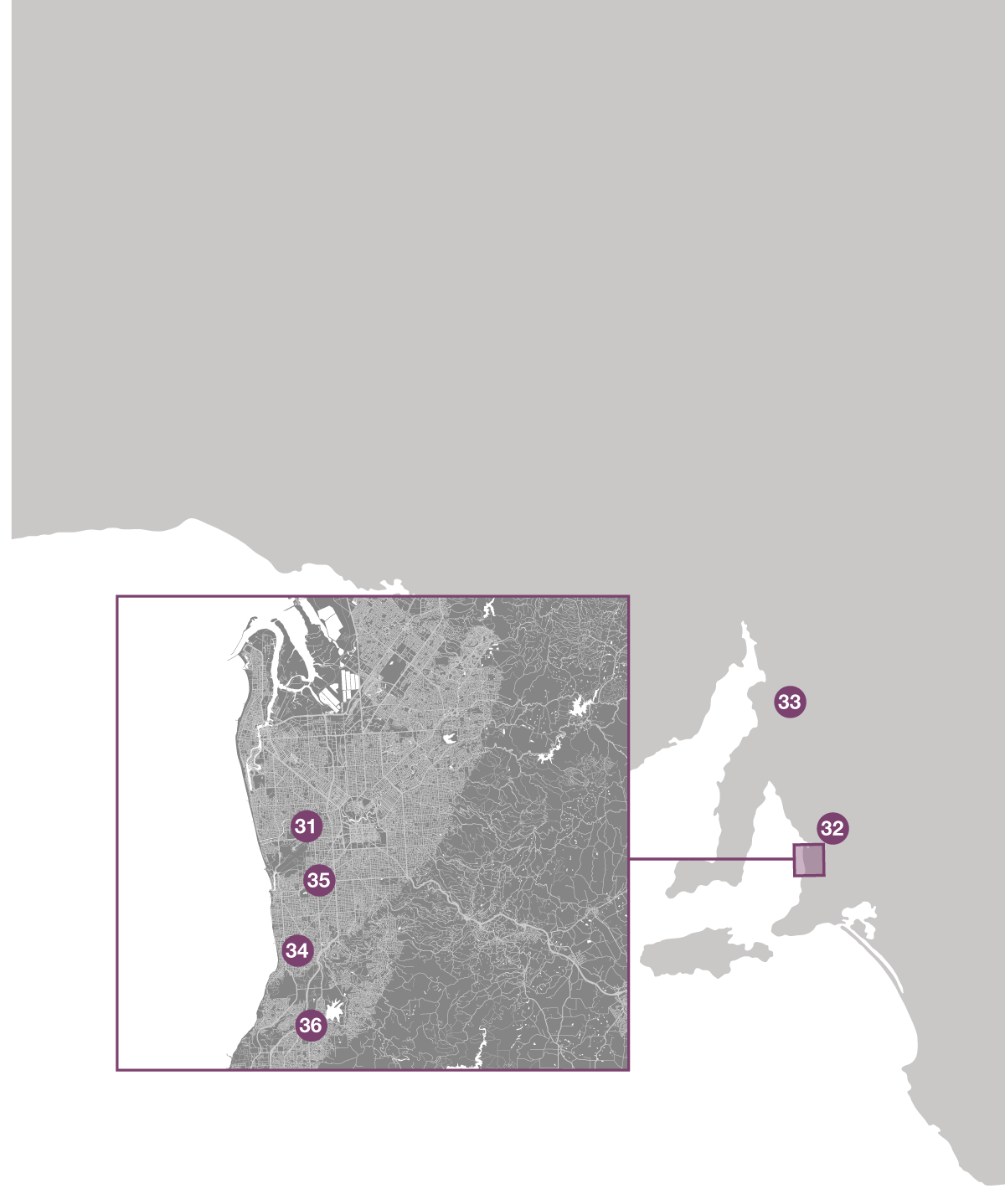

Note: Map is for illustration purposes only and is not to scale. See Table 3 for map location references.

Average EME level measured at each of the South Australian small cell sites

|  |  |  |  |  |
| --- | --- | --- | --- | --- |
| Map reference | Suburb | Measurement location | Date | Average EME level* |
| 31 | Brooklyn Park | 34 Airport Road | Feb 2020 | 0.043 % |
| 32 | Lyndoch | 159 Hermann Thumm Drive | Feb 2020 | 0.286 % |
| 33 | Narridy | 21 Bowman Street | Feb 2020 | 0.032 % |
| 34 | Dover Gardens | 26 Quintus Terrace | Feb 2020 | 0.092 % |
| 35 | South Plympton | 38 Kerr Grant Terrace | Feb 2020 | 0.203 % |
| 36 | Reynella East | 4 Buchanan Grove | Feb 2020 | 0.433 % |

* As a percentage of the ARPANSA general public exposure limit.

## Tasmania

Locations of the ACMA’s EME measurements in Tasmania

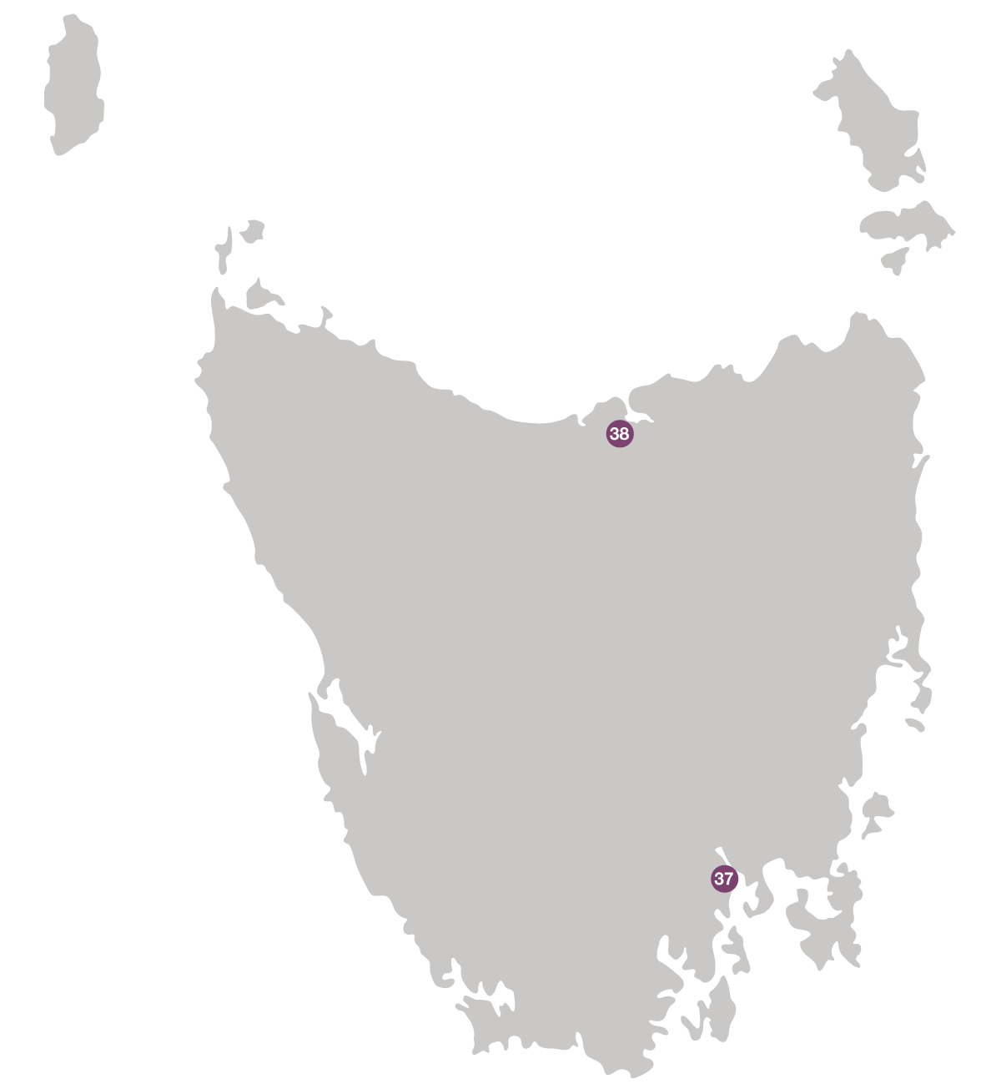

Note: Map is for illustration purposes only and is not to scale. See Table 4 for map location references.

Average EME level measured at each of the Tasmanian small cell sites

|  |  |  |  |  |
| --- | --- | --- | --- | --- |
| Map reference | Suburb | Measurement location | Date | Average EME level* |
| 37 | Battery Point | 24 Salamanca Square | Feb 2020 | 0.107 % |
| 38 | Beaconsfield | 108 Weld Street | Feb 2020 | 0.089 % |

* As a percentage of the ARPANSA general public exposure limit.

## Victoria

Locations of the ACMA’s EME measurements in Victoria

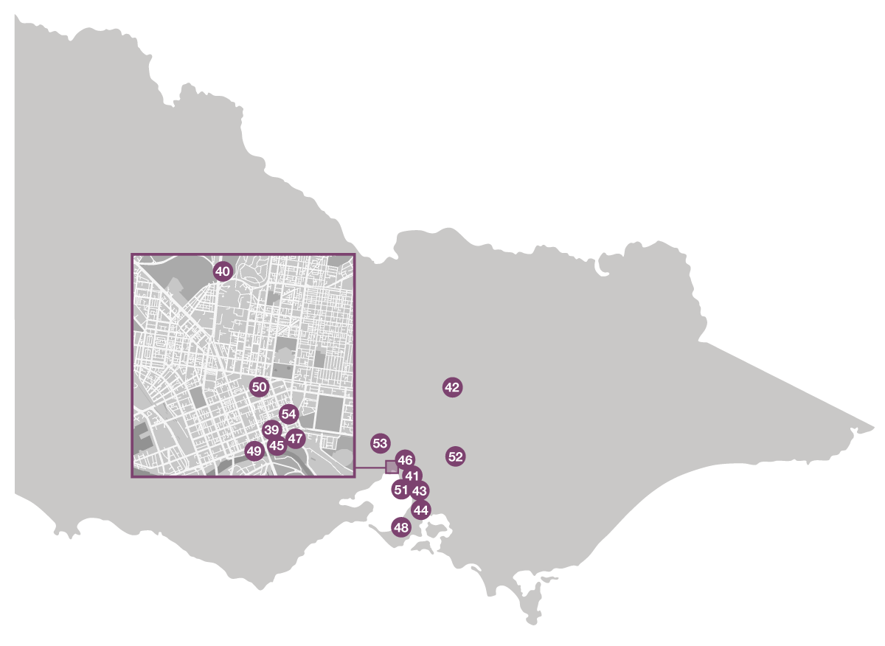

Note: Map is for illustration purposes only and is not to scale. See Table 5 for map location references.

Average EME level measured at each of the Victorian small cell sites

|  |  |  |  |  |
| --- | --- | --- | --- | --- |
| Map reference | Suburb | Measurement location | Date | Average EME level* |
| 39 | Melbourne | 2 Russell Street | Jan 2020 | 0.252 % |
| 40 | Parkville | 151–153 Royal Parade | Jan 2020 | 0.004 % |
| 41 | Elsternwick | 141 Orrong Road | Jan 2020 | 0.006 % |
| 42 | Ruffy | Nolans Road | Jan 2020 | 0.010 % |
| 43 | Mentone | 46 Beach Road | Jan 2020 | 0.001 % |
| 44 | Cranbourne South | 169 Smiths Lane | Jan 2020 | 0.027 % |
| 45 | Melbourne | Corner Flinders & Russell Streets | Jan 2020 | 0.296 % |
| 46 | Kew | 94 Studley Park Road | Jan 2020 | 0.002 % |
| 47 | Melbourne | 60 Flinders Street | Jan 2020 | 0.047 % |
| 48 | Mount Martha | 59 Bradford Road | Jan 2020 | 0.046 % |
| 49 | Melbourne | Corner Flinders & Swanston Streets | Jan 2020 | 0.383 % |
| 50 | Melbourne | 336 Russell Street | Jan 2020 | 0.060 % |
| 51 | Black Rock | 227 Beach Road | Jan 2020 | 0.001 % |
| 52 | Healesville | Maroondah Highway | Jan 2020 | 0.030 % |
| 53 | Sunbury | 5 Stringer Court | Jan 2020 | 0.004 % |
| 54 | Melbourne | 37 Little Collins Street | Jan 2020 | 0.050 % |

* As a percentage of the ARPANSA general public exposure limit.

## Western Australia

Locations of the ACMA’s EME measurements in Western Australia

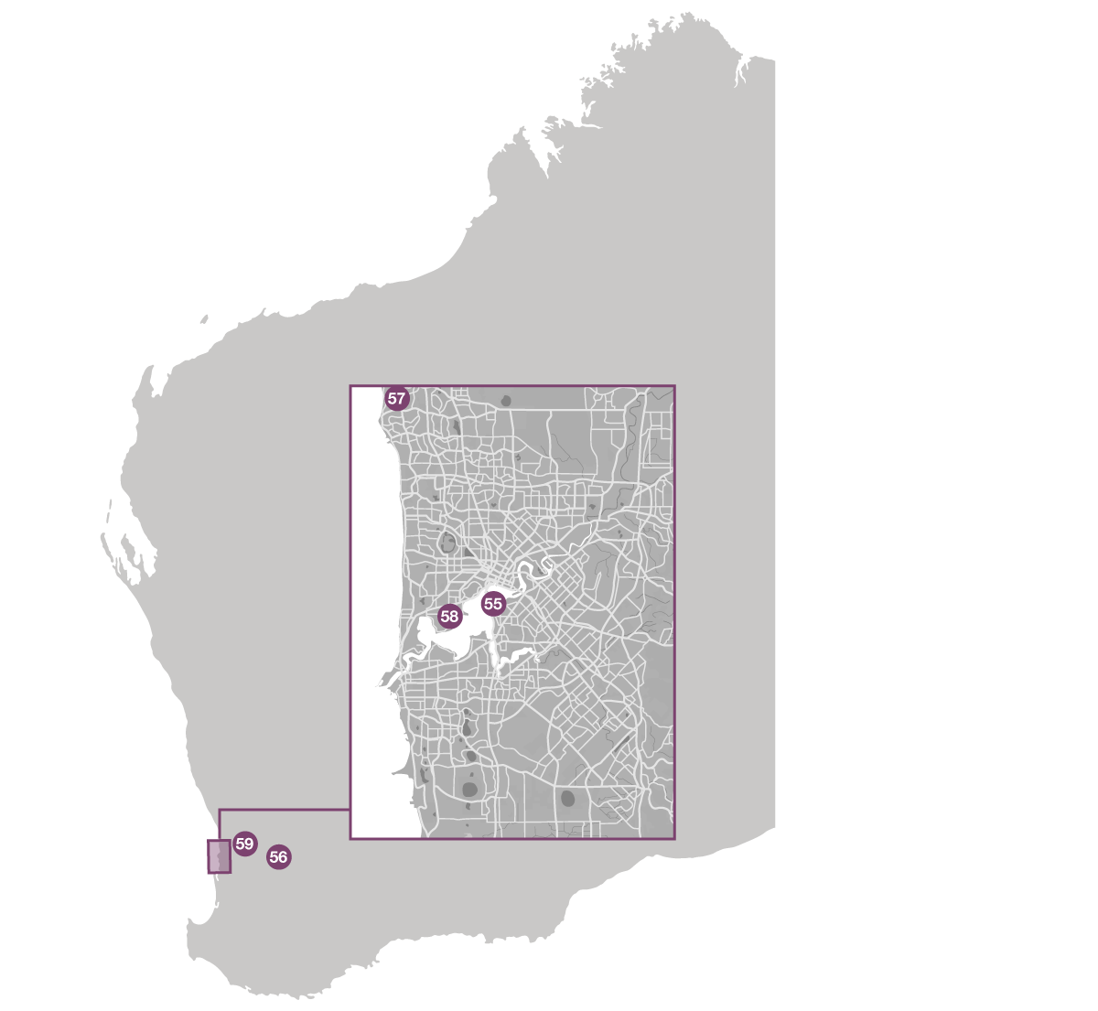

Note: Map is for illustration purposes only and is not to scale. See Table 6 for map location references.

Average EME level measured at each of the Western Australian small cell sites

|  |  |  |  |  |
| --- | --- | --- | --- | --- |
| Map reference | Suburb | Measurement location | Date | Average EME level* |
| 55 | South Perth | Light Pole Number 1018 on road reserve adjacent to 80 Mill Point Road | Feb 2020 | 0.068 % |
| 56 | Dangin | 6 Dangin Terrace | Feb 2020 | 0.015 % |
| 57 | Craigie | 1 Coral Street | Feb 2020 | 0.032 % |
| 58 | Crawley | 35 Stirling Highway | Feb 2020 | 0.324 % |
| 59 | Wundowie | 1 Boronia Avenue | Feb 2020 | 0.001 % |

* As a percentage of the ARPANSA general public exposure limit.

# Summary of measurement results

All of the small cell sites visited as part of our measurement program produced measurement results that were a small percentage of the reference level for limits of exposure to the general public in the ARPANSA Standard.

All measurements were recorded at well below 1 per cent of the ARPANSA limit, recording an approximate average of 0.143 per cent of the ARPANSA limit for all 59 small cell sites visited. The highest level recorded was 0.737 per cent of the ARPANSA limit and the lowest level recorded was 0.001 per cent of ARPANSA limit, at four of the small cell sites visited.

In all cases the measured emissions at the site were lower than the calculated EME levels reported on the RFNSA website by the carriers using the ARPANSA methodology.

All of the measurements were taken in publicly accessible areas and demonstrate that the overall public exposure levels attributed to emissions from the small cell sites visited as part of this program, as well as any other services which may have been operating in close proximity on the measured bandwidths from 420MHz to 6GHz, were extremely low.

Average EME exposure levels measured at 59 small cell sites (as a percentage of the reference levels for general public exposure set by the ARPANSA Standard).

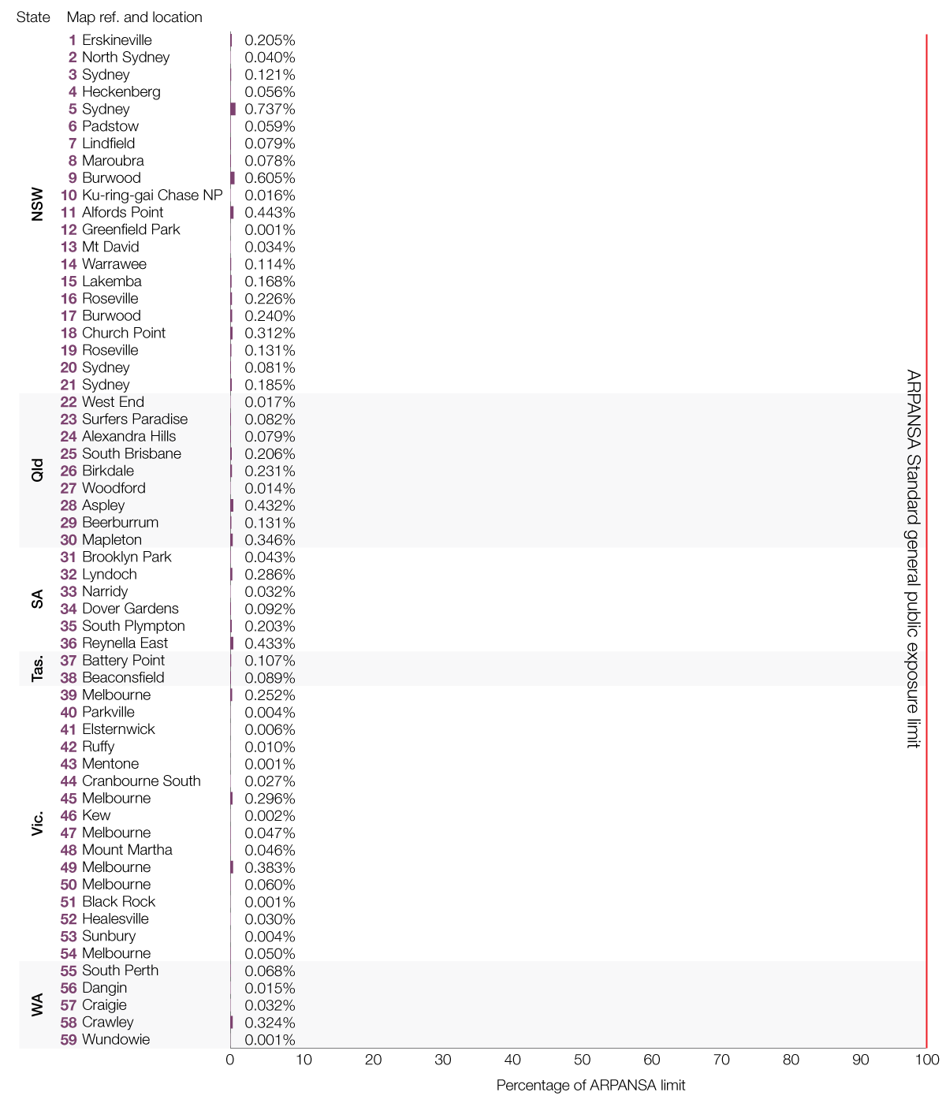

Results on an expanded scale at 2 per cent of the general public exposure limit set by the ARPANSA Standard

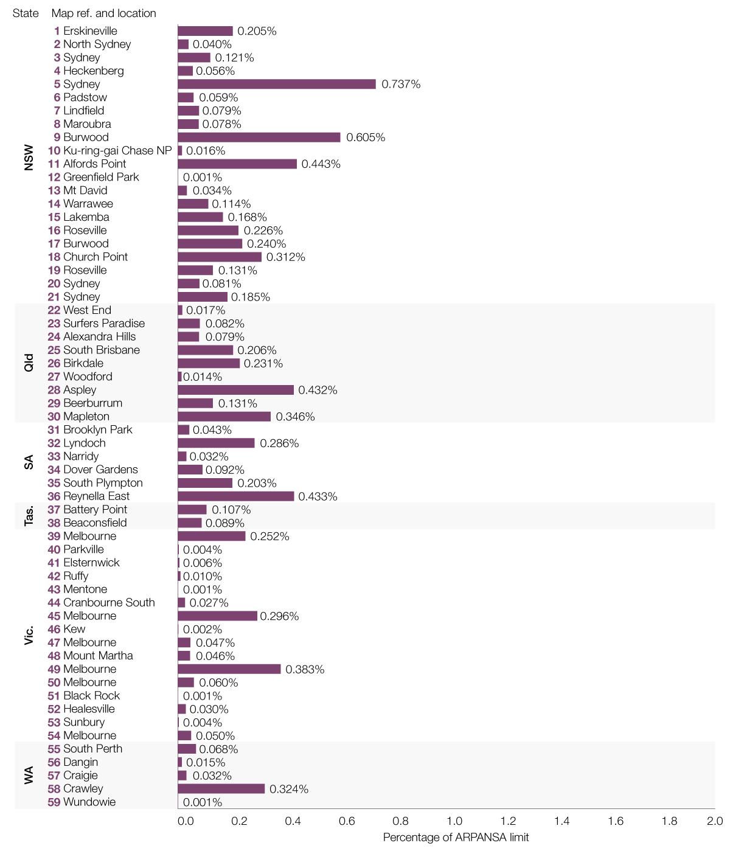

# Glossary

**List of acronyms and definitions**

|  |  |
| --- | --- |
| 3G | The third generation of mobile technology |
| 4G | The fourth generation of mobile technology |
| 5G | The fifth generation of mobile technology |
| Base station | Radio transmitter infrastructure that controls and communicates to mobile phones |
| EME | Electromagnetic energy |
| LIPD | Low interference potential devices |
| LMRS | Land mobile radio system |
| LTE | Long term evolution technology |
| GHz | Gigahertz (1GHz is equivalent to 1000 MHz) |
| kHz | Kilohertz (1 kilohertz is equivalent to 1000 hertz) |
| MHz | Megahertz (1 MHz is equivalent to 1000 KHz) |
| Spectrum | The range of frequencies within which radiocommunications are capable of being made |
| Spectrum licence | A spectrum licence issued under Part 3.2 of the *Radiocommunications Act 1992* (Cth) |
| Small cells | Small cells are low-powered base stations that provide additional capacity and coverage in highly populated areas and strengthen local coverage in regional and rural areas. They are generally placed on existing infrastructure, such as light and power poles. |
| TRUNK | In a trunked system, a group of channels at the base station site is time-shared between a large number of users so that the channels can be used more efficiently |
| UHF | Ultra high frequency designated in the range between 300 to 3000 megahertz (or 3 gigahertz) |

1. See ARPANSA’s statement: [*5G: the new generation of the mobile phone network and health*](https://www.arpansa.gov.au/news/5g-new-generation-mobile-phone-network-and-health).
2. TPG was selected as it was preparing to deploy a substantial small cell network and in the months prior, the ACMA had found one of TPG’s subsidiaries not to have complied with the rules for small cell base stations specified in the [*C564:2018 Mobile Phone Base Station Deployment*](https://www.commsalliance.com.au/__data/assets/pdf_file/0018/62208/C564_2018-181206.pdf)*.*
3. <https://www.acma.gov.au/publications/2020-02/report/compliance-assessment-tpg-small-cell-eme>
4. The Radio Frequency National Site Archive is a website maintained by the carriers with information on installed base stations, including site specific environmental EME reports, site locations, carrier contact details for existing sites and community consultation information for new sites.
5. Note 2 in Table 7 of the ARPANSA Standard.