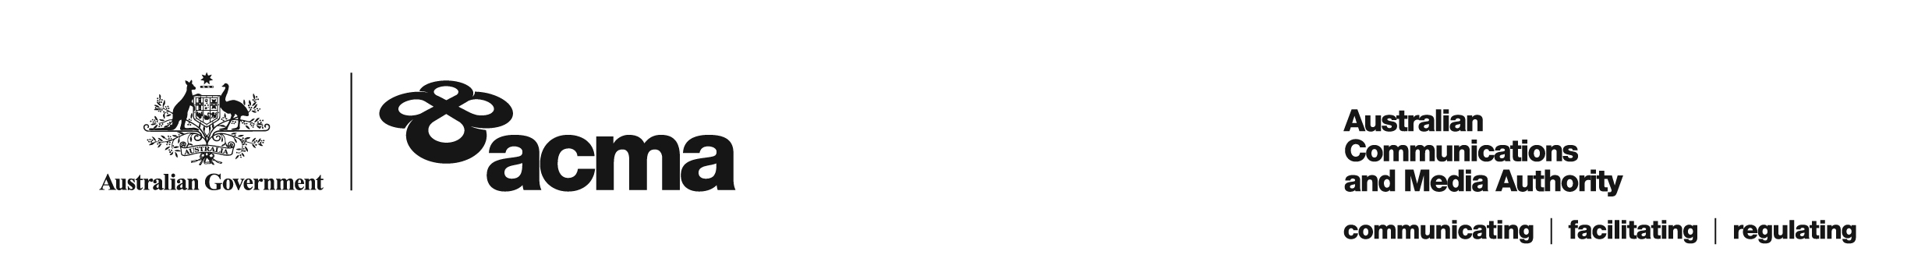**AUSTRALIAN COMMUNICATIONS AND MEDIA AUTHORITY**

**Exemption Order STV-EO-373  
made under subsection 130ZY(3) of the *Broadcasting Services Act 1992***

**1. Interpretation**

In this instrument:

***ACMA*** means the Australian Communications and Media Authority;

***Act*** means the *Broadcasting Services Act 1992*;

***Applicant*** means FetchTV Pty Ltd (ABN 36 130 669 500);

***Application*** means the exemption order application made on 29 March 2019 in respect of the Service;

***Service*** means the Australian Christian Channel; and

***Specified Eligible Period*** means 1 July 2018 to 30 June 2019.

**2. Exemption**

Under subsection 130ZY(3) of the Act, the ACMA:

(a) having considered the written representations made by the Applicant in the Application, the supporting evidence submitted with the Application and the submissions received within the period of 30 days from the date the draft order was published; and

(b) being satisfied that a refusal to make the exemption order would impose an unjustifiable hardship on the Applicant;

***EXEMPTS*** the Applicant from the application of subsection 130ZV(1) of the Act in respect of the Service for the Specified Eligible Period.

Dated: 26 June 2019