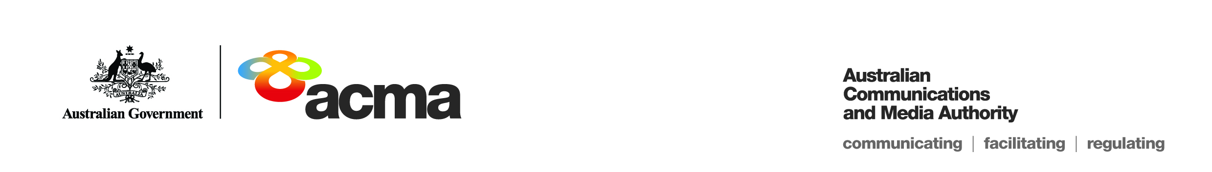Notice of draft target reduction order for   
Telstra Pay TV Pty Ltd

(Application 087)

On 30 March 2020, Telstra Pay TV Pty Ltd (**Telstra**) submitted an application seeking a target reduction order under paragraph 130ZY(1)(b) of the *Broadcasting Services Act 1992* (BSA) in relation to the subscription television service BBC World News (**the Service**) for the financial year 1 July 2019 to 30 June 2020 (**the Specified Eligible Period**) reducing the annual captioning target to 20% for that year.

This notice sets out the draft target reduction order for the Service (**the Target Reduction Order**) and invites persons to make submissions about the Target Reduction Order to the Australian Communications and Media Authority (**ACMA**) within 30 days after this notice is published, being Monday, 18 May 2020, in accordance with subsection 130ZY(6) of the BSA.

Telstra is a subscription television licensee. The Service is an English-language international news and current affairs channel and is one of 105 subscription television services (channels) provided by Telstra.

The Service is offered to Telstra subscribers as part of Telstra’s ‘Foxtel Plus Bundle’ package. Subscribers are not able to subscribe solely to the Service.

**Summary of reasons – unjustifiable hardship**

The ACMA’s preliminary assessment of the application is that a refusal to make the Target Reduction Order would impose an unjustifiable hardship on Telstra for the reasons explained in the Preliminary Statement of Reasons for Application 087.

To view the proposed Target Reduction Order, please refer to the document titled ’87 DRAFT Target Reduction Order’.

All submissions received up to and including Wednesday, 17 June 2020, will be considered in making the ACMA’s final decision. Submissions received after this date will not be considered.

**Publication of submissions**

In general, the ACMA publishes all submissions it receives. The ACMA prefers to receive submissions that are not claimed to be confidential. However, the ACMA accepts that a submitter may sometimes wish to provide information in confidence. In these circumstances, submitters are asked to identify the material over which confidentiality is claimed and provide a written explanation for the claim.

The ACMA will consider each confidentiality claim on a case-by-case basis. If the ACMA accepts a claim, it will not publish the confidential information unless authorised or required by law to do so.

Please note that the ACMA does not formally acknowledge the receipt of submissions.

Please forward submissions quoting Application Number 087 to:

Email: [captioning@acma.gov.au](mailto:captioning@acma.gov.au)

Post:

Submissions to Order Applications  
Diversity, Localism and Accessibility Section  
Australian Communications and Media Authority

PO Box Q500  
Queen Victoria Building  
NSW 1230