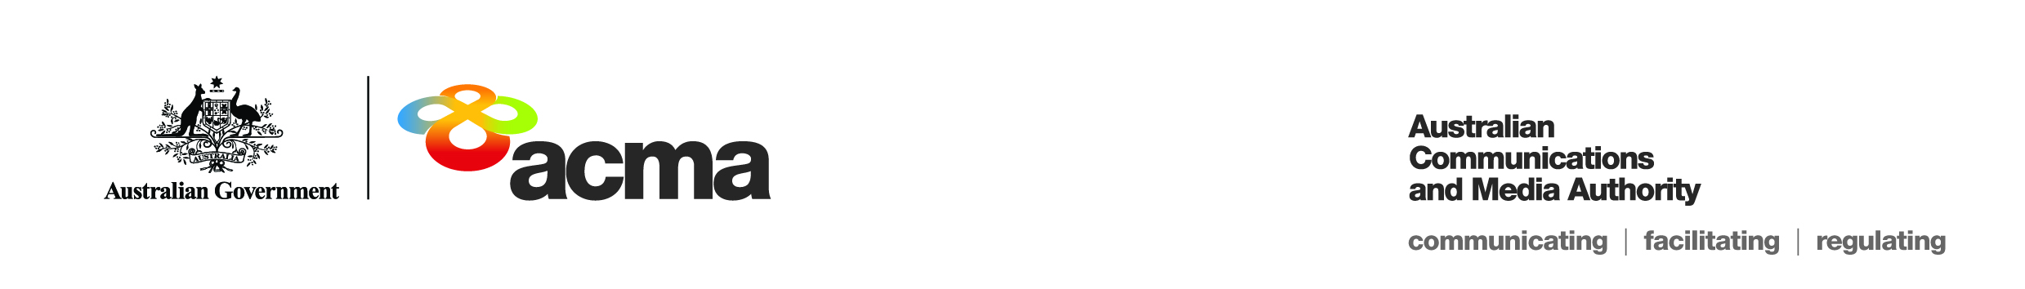Notice of draft exemption order for   
FetchTV Pty Ltd

(Application 384)

On 31 March 2020, FetchTV Pty Ltd (**the Applicant**) submitted an application seeking an exemption order under paragraph 130ZY(1)(a) of the *Broadcasting Services Act 1992* (**BSA**) in relation to the subscription television news service BBC World News (**the Service**) for the financial year 1 July 2019 to 30 June 2020 (**the Specified Eligible Period**).

This notice sets out the draft exemption order for the Service (**the Exemption Order**) and invites persons to make submissions about the Exemption Order to the ACMA within 30 days after this notice is published, being Monday, 18 May 2020, in accordance with subsection 130ZY(6) of the BSA.

The Applicant is a subscription television licensee. The Service is one of 67 subscription television services (channels) that are provided by the Applicant in the English language. The Service describes itself as a 24-hour English language international news and current affairs television channel which broadcasts BBC news bulletines, documentatries, lifestyle programmes and interviews.

The Service is a pass through channel. It is obtained under licence wholly from the channel provider which acquires and compiles the channel and then delivers it to the Applicant. The Applicant provides no input into the content of the channel.

The Service is offered as part of the Applicant’s ’Knowledge’ package, ‘Ultimate’ package or the ‘Entertainment’ package. Subscribers are not able to subscribe solely to the Service.

**Summary of reasons – unjustifiable hardship**

The ACMA’s preliminary assessment of the application is that a refusal to make the Exemption Order would impose an unjustifiable hardship on the Applicant for the reasons explained in the Preliminary Statement of Reasons for Application 384.

To view the draft Exemption Order, please refer to the document titled ‘384 DRAFT Exemption Order’.

All submissions received up to and including Wednesday, 17 June 2020, will be considered in making the ACMA’s final decision. Submissions received after this date will not be considered.

**Publication of submissions**

In general, the ACMA publishes all submissions it receives. The ACMA prefers to receive submissions that are not claimed to be confidential. However, the ACMA accepts that a submitter may sometimes wish to provide information in confidence. In these circumstances, submitters are asked to identify the material over which confidentiality is claimed and provide a written explanation for the claim.

The ACMA will consider each confidentiality claim on a case-by-case basis. If the ACMA accepts a claim, it will not publish the confidential information unless authorised or required by law to do so.

Please note that the ACMA does not formally acknowledge the receipt of submissions.

Please forward submissions quoting Application Number 384 to:

Email: [captioning@acma.gov.au](mailto:captioning@acma.gov.au)

Post:

Submissions to Order Applications  
Diversity, Localism and Accessibility Section  
Australian Communications and Media Authority

PO Box Q500  
Queen Victoria Building  
NSW 1230