Future use of the 1.5 GHz and 3.6 GHz bands

Initial investigation of the 1427–1518 MHz and 3575–3700 MHz bands for mobile broadband services discussion paper

OCTOBER 2016

Canberra

Red Building   
Benjamin Offices  
Chan Street   
Belconnen ACT

PO Box 78  
Belconnen ACT 2616

T +61 2 6219 5555  
F +61 2 6219 5353

Melbourne

Level 32   
Melbourne Central Tower  
360 Elizabeth Street   
Melbourne VIC

PO Box 13112  
Law Courts   
Melbourne VIC 8010

T +61 3 9963 6800  
F +61 3 9963 6899

Sydney

Level 5   
The Bay Centre  
65 Pirrama Road   
Pyrmont NSW

PO Box Q500  
Queen Victoria Building   
NSW 1230

T +61 2 9334 7700 or 1800 226 667  
F +61 2 9334 7799

Copyright notice

[Creative Commons logo](http://i.creativecommons.org/l/by/3.0/88x31.png)

<http://creativecommons.org/licenses/by/3.0/au/>

With the exception of coats of arms, logos, emblems, images, other third-party material or devices protected by a trademark, this content is licensed under the Creative Commons Australia Attribution 3.0 Licence.

We request attribution as © Commonwealth of Australia (Australian Communications and Media Authority) 2016.

All other rights are reserved.

The Australian Communications and Media Authority has undertaken reasonable enquiries to identify material owned by third parties and secure permission for its reproduction. Permission may need to be obtained from third parties to re-use their material.

Written enquiries may be sent to:

Manager, Editorial and Design  
PO Box 13112  
Law Courts  
Melbourne VIC 8010  
Email: [candinfo@acma.gov.au](mailto:candinfo@acma.gov.au)

Executive summary 6

Issues for comment 7

Introduction 10

The ACMA’s role 10

Spectrum Review 12

Background 13

Mobile broadband strategy and work program 13

Past consideration of the 1.5 GHz and 3.6 GHz bands 15

Purpose 15

Next steps 16

Scope 17

In scope—planning options 17

Out of scope—licensing and allocation options 18

Out of scope—Spectrum currently subject to spectrum licensing 18

Out of scope—Engagement in international activities 18

Structure 18

1.5 GHz band 19

International arrangements 19

International organisations 19

Country-specific arrangements 21

Summary of international considerations 22

Australian context 22

Current planning arrangements and use 22

Initial investigation of the 1.5 GHz band for use by MBB services 25

Potential spectrum options 25

Potential geographic options 27

Coexistence and sharing with incumbent services 28

Preliminary assessment of the highest value use of the 1.5 GHz band 29

3.6 GHz band 31

International arrangements 31

International organisations 31

Country-specific arrangements 32

Summary of international considerations 33

Australian context 34

Current planning arrangements and use 34

Initial investigation of the 3.6 GHz band for use by MBB services 37

Potential spectrum options 37

Potential geographic options 38

Coexistence and sharing with incumbent services 40

Optimising use of the 3400–3700 MHz band 42

Preliminary assessment of the highest value use of the 3.6 GHz band 43

Invitation to comment 44

Making a submission 44

Appendix A—Current use of the 1.5 GHz band 46

Defence aeronautical usage 46

Fixed services 48

Appendix B—Current use of the 3.6 GHz band 53

Licence overview 53

Embargoes 53

Appendix C—Preliminary assessments of the highest-value use of the 1.5 GHz and 3.6 GHz bands 58

Elements to be considered in assessments of highest-value use 58

Benefits, costs and externalities 58

Analysis required under constant- and variable-output cases 59

Preliminary assessments of HVU 59

1.5 GHz Preliminary assessment of HVU 60

Indicators of potential change in HVU 60

Potential benefits of spectrum re-farming 60

Potential costs of spectrum re-farming—Incumbency considerations 61

Preliminary assessment 61

3.6 GHz Preliminary assessment of HVU 62

Indicators of potential change in HVU 62

Potential benefits of spectrum re-farming 62

Potential costs of spectrum re-farming—Incumbency considerations 63

Preliminary assessment 64

Executive summary

The 1427–1518 MHz band (the 1.5 GHz band) and the 3575–3700 MHz band (the 3.6 GHz band) are currently included in the *initial investigation* stage of the ACMA’s mobile broadband work program.

The use of both the 1.5 GHz and 3.6 GHz bands for mobile broadband (MBB) services has progressed internationally in the International Telecommunication Union- Radiocommunication Sector (ITU-R), Asia–Pacific Telecommunity (APT) and in individual countries around the world. The progress of this consideration means it is timely to consider the potential re-planning of these bands in Australia.

The main intention of this discussion paper is to determine whether consideration of the 1.5 GHz and 3.6 GHz bands should be progressed to the *preliminary re-planning stage* of the ACMA’s process for consideration of additional spectrum for MBB services.

These bands are currently used by other services, including fixed and satellite services. An analysis of current usage, as well as potential planning options for re-farming informed by a preliminary technical assessment, are outlined in this paper. This will provide an opportunity for stakeholders to inform the ACMA about their views and the effects of different options on incumbent and potential new services, so the costs and benefits can be accurately gauged and considered.

To assist in forming a judgement on whether bands should be progressed to the *preliminary re-planning stage*, the ACMA has performed a preliminary assessment of highest-value use. Based on the outcomes of this assessment, the ACMA believes that the highest-value use of the 1.5 GHz and 3.6 GHz bands has changed, or may be changing, in some areas. The ACMA is therefore inviting comment on the proposal to progress consideration of the bands for MBB to the *preliminary re-planning stage* of the ACMA’s MBB work program.

It is noted that although the term ‘mobile broadband’ is used throughout this paper, all discussion equally applies to fixed broadband services.

# Issues for comment

The ACMA invites comments on the issues set out in this discussion paper.

Specific questions are featured in the relevant sections of this paper and collated below. Details on making a submission can be found at *Invitation to comment*at the end of this document*.*

1. Should the 1.5 GHz band and/or the 3.6 GHz band be progressed from the *initial investigation* stage to the *preliminary re-planning* stage in the ACMA’s process for consideration of additional spectrum for MBB services? Why/Why not?
2. Should either of the 1.5 GHz and 3.6 GHz bands be prioritised through the ACMA’s process for consideration of additional spectrum for MBB services? If so, which band? Why?
3. Are there specific issues, other than those mentioned, that may affect the timeframe in which the 1.5 GHz or 3.6 GHz bands could be made available for MBB?
4. If the 1.5 GHz and 3.6 GHz bands are re-farmed for MBB, would there be benefit in allocating the bands simultaneously?

Questions specific to the 1.5 GHz band:

1. The ACMA seeks comment on expected future use of the 1.5 GHz band by the fixed, broadcasting and broadcasting-satellite services and by the Department of Defence in Australia.
2. Comment is sought on the potential deletion or modification of footnote AUS3 from the Australian Radiofrequency Spectrum Plan (ARSP).
3. If the 1.5 GHz band is re-farmed for MBB services, what frequency arrangement should be adopted? Should a frequency division duplex (FDD), supplemental downlink (SDL) or time division duplex (TDD) arrangement be adopted? Why/why not? What type of arrangement should be adopted (that is, 3GPP bands 11 and/or 21, 3GPP band 32, 3GPP band 45 or another arrangement)?
4. If the 1.5 GHz band is re-farmed for MBB services, what geographical areas should be re-farmed? To what extent are mobile network operators (MNOs) interested in the 1.5 GHz band outside of metropolitan areas?
5. If the 1.5 GHz band is re-farmed for MBB services, should a geographically and/or spectrally staged process be considered, where more heavily utilised parts/areas are re-farmed later than those that are more lightly utilised?
6. What are the alternative spectrum or delivery options for current users of the 1.5 GHz band if the band is re-farmed for MBB services and migration of incumbent services is required?
7. Could services, in particular fixed services, provided in the 1.5 GHz band be migrated to new or existing mobile networks in areas where the band is re-farmed for MBB services?
8. Should existing users (some or all) be allowed to continue operation within the band either temporarily or on an ongoing basis?
9. What types of sharing arrangements could be put in place to facilitate coexistence between MBB services and existing users of the 1.5 GHz band in both the short and long term?
10. Comment is sought on the ACMA’s proposal to progress the 1.5 GHz band to the *preliminary re-planning* stage of its process for consideration of additional spectrum for MBB services, as detailed in the ACMA’s [mobile broadband strategy](http://www.acma.gov.au/~/media/Spectrum%20Transformation%20and%20Government/Issue%20for%20comment/IFC%2022%202015/MBB%20strategyThe%20ACMAs%20spectrum%20management%20strategy%20to%20address%20the%20growth%20in%20mobile%20broadband%20capacity%20docx.docx).
11. To assist the ACMA in conducting a comprehensive assessment of the highest-value use for the 1.5 GHz band, responses to the following questions are requested:
12. Do you see demand for fixed broadband/MBB services in the 1.5 GHz band?
13. What benefits do you envision from using the band for fixed broadband/MBB services?
14. What are relevant data points (for example, market based allocation results) for considering the demand for 1.5 GHz band spectrum for use by MBB providers?
15. Is demand the same or similar across regions (that is, across metropolitan, rural and remote areas), or are some regions more likely to be in demand for MBB providers?
16. Do incumbent 1.5 GHz band licensees require ongoing access to the band, or are there plans to cease operation at some future point?
17. Do other options exist for the delivery of point-to-point, point-to-multipoint, fixed receive, aeronautical and radiodetermination incumbent services? How practical are they? What are the costs involved? Will there be a diminution of the service delivered if MBB services are introduced in the band?

Questions specific to the 3.6 GHz band:

1. The ACMA seeks comment on expected future use of the 3.6 GHz band by fixed, fixed‑satellite, amateur and radiolocation services in Australia.
2. If the 3.6 GHz band is re-farmed for MBB services:
3. Do you agree that a time division duplex (TDD) arrangement should be adopted? Why/Why not?
4. Should all or only part of the band be considered for re-farming?
5. Should different amounts of spectrum be re-farmed in different areas?
6. If the 3.6 GHz band is re-farmed for MBB services, what geographical areas should be considered?
7. If the 3.6 GHz band is re-farmed for MBB services, should existing users (some or all) be allowed to continue operation within the band, either temporarily or on an ongoing basis? Should/could sharing arrangements be developed? Should sharing only be considered for some services or specific licences? If yes, what kind of arrangements would be suitable to support the ongoing operation of incumbent services or specific licences? If no, why?
8. If the 3.6 GHz band is re-farmed for MBB services, and migration of incumbent services is required, are there alternative spectrum or delivery options?
9. In determining whether to re-farm the 3.6 GHz band for MBB, are there any adjacent band issues that should be considered? This includes:
10. the effect such use may have on adjacent band services
11. the effect adjacent band services may have on the utility of the 3.6 GHz band for MBB services.
12. If the 3.6 GHz band is re-farmed for MBB services, should the ACMA review arrangements in the broader 3400–3700 MHz band? Why/Why not?
13. Would such a review be facilitated through the alignment of geographical boundaries in the 3.6 GHz band with existing boundaries defined for spectrum and apparatus licensing in the 3400–3575 MHz band (that is, to facilitate trading)?
14. Is there anything else that could be considered as part of the 3.6 GHz band process that may facilitate a future review of the broader 3400–3700 MHz frequency range?
15. Comment is sought on the ACMA’s proposal to progress the 3.6 GHz band to the *preliminary re-planning* stage of its process for consideration of additional spectrum for MBB services, as detailed in the ACMA’s [mobile broadband strategy](http://www.acma.gov.au/~/media/Spectrum%20Transformation%20and%20Government/Issue%20for%20comment/IFC%2022%202015/MBB%20strategyThe%20ACMAs%20spectrum%20management%20strategy%20to%20address%20the%20growth%20in%20mobile%20broadband%20capacity%20docx.docx).
16. To assist the ACMA in conducting a comprehensive assessment of the highest-value use for the 3.6 GHz band, responses to the following questions are requested:
17. Do you see increasing demand for fixed broadband/MBB services in the 3.6 GHz band? What benefits do you envision from using the band for fixed broadband/MBB services?
18. Which regions of Australia will be in demand for fixed broadband/MBB services in the 3.6 GHz band?
19. Is demand the same or similar across regions, or are some regions/areas more likely to be in demand for MBB providers?
20. Do incumbent 3.6 GHz band licensees require ongoing access to the band, or are there plans to cease operation at some future point?
21. Do other options exist for the delivery of fixed, fixed-satellite and amateur incumbent service, how practical are they? What are the costs involved? Will there be a diminution of the service delivered if MBB services are introduced in the band?
22. Should further consideration be given to the migration of incumbent 3.6 GHz band FSS earth stations to low density population areas?

# Introduction

The ACMA published its [*Mobile broadband strategy*](http://www.acma.gov.au/~/media/Spectrum%20Transformation%20and%20Government/Issue%20for%20comment/IFC%2022%202015/MBB%20strategyThe%20ACMAs%20spectrum%20management%20strategy%20to%20address%20the%20growth%20in%20mobile%20broadband%20capacity%20docx.docx) in February 2016, along with the [*Mobile broadband work program—February 2016 update*](http://www.acma.gov.au/~/media/Spectrum%20Transformation%20and%20Government/Issue%20for%20comment/IFC%2022%202015/Mobile%20broadband%20work%20programFebruary%202016%20update%20docx.docx). The work program was subsequently updated in September 2016 as part of the ACMA’s Five-year spectrum outlook 2016–2020.

As part of the work program, the 1427–1518 MHz band (the 1.5 GHz band) and the 3575–3700 MHz band (the 3.6 GHz band) were included under the *initial investigation* stage of the process for consideration of additional spectrum for MBB services.

This paper considers the current use of the 1.5 GHz and 3.6 GHz bands internationally and in Australia. A preliminary assessment of the highest value use of the 1.5 GHz and 3.6 GHz bands is also presented. Finally, options for potential future use for MBB services are outlined.

For simplicity in this paper, the term ‘mobile broadband’ is used to refer to a variety of different technologies and terms such as 3G, 4G, 5G and long term evolution (LTE). The term should also be taken to equally refer to fixed broadband systems.

## The ACMA’s role

Section 9 of the *Australian Communications and Media Authority Act 2005* (the ACMA Act) sets out the spectrum management functions of the ACMA, including to:

* manage the radiofrequency spectrum in accordance with the *Radiocommunications Act 1992* (the Act)

advise and assist the radiocommunications community.

Consistent with the spectrum management functions set out in the ACMA Act, the object of the Act is to provide for management of the radiofrequency spectrum in order to (among other goals):[1]

maximise, by ensuring the efficient allocation and use of the spectrum, the overall public benefit derived from using the radiofrequency spectrum.

The ACMA takes into account both economic and broader social impacts when considering the public benefit derived from using spectrum. The economic value of spectrum is broader than the price paid for access (that is, licence charges and taxes) and the cost of equipment. It is best characterised as the impact that use of spectrum has on the Australian economy. In the absence of market failures (for example, interference or safety-of-life issues), what a user is willing to pay for the spectrum acts as a proxy for the economic value that that party expects to generate by using the spectrum.

As noted, the ACMA also takes into account broader social impacts when considering the public benefit derived from spectrum. These impacts can be characterised as ‘non-economic’, in that they are not well captured by an economic framework. For example, science services, including remote monitoring of the ‘fingerprints of nature’[2] provide an enormous social benefit that is not easily quantified in dollar terms. Such services are also usually unable to gather the information they need using another part of the spectrum.

Therefore, the ACMA needs to assess the use of spectrum holistically and consult with affected stakeholders to enable informed determinations regarding the value of a particular spectrum band.

The ACMA is also guided by its [*Principles for Spectrum Management*](http://www.acma.gov.au/theACMA/About/The-ACMA-story/Facilitating/decisionmaking-process-fyso-25-1)[3](the Principles), which are:

1. Allocate spectrum to the highest value use or uses.
2. Enable and encourage spectrum to move to its highest value use or uses.
3. Use the least cost and least restrictive approach to achieving policy objectives.
4. To the extent possible, promote both certainty and flexibility.

Balance the cost of interference and the benefits of greater spectrum utilisation.

The ACMA achieves the goals of the object of the Act and the Principles through a balanced application of market and regulatory mechanisms.

**Error! Reference source not found.** describes the ACMA’s general approach to spectrum management decision-making. The reviews of the 1.5 GHz and 3.6 GHz bands were flagged in the ACMA’s *Five-year spectrum outlook 2016–2020*, including in the *Mobile broadband work program—September 2016 update*. In terms of the general approach, the release of this paper falls under the ACMA’s public consultation ‘filter’. The ACMA will use the elements of its spectrum management decision framework, including the spectrum management principles, as it considers the responses to this paper and continues the reviews of the 1.5 GHz and 3.6 GHz bands.

1. Spectrum management decision framework

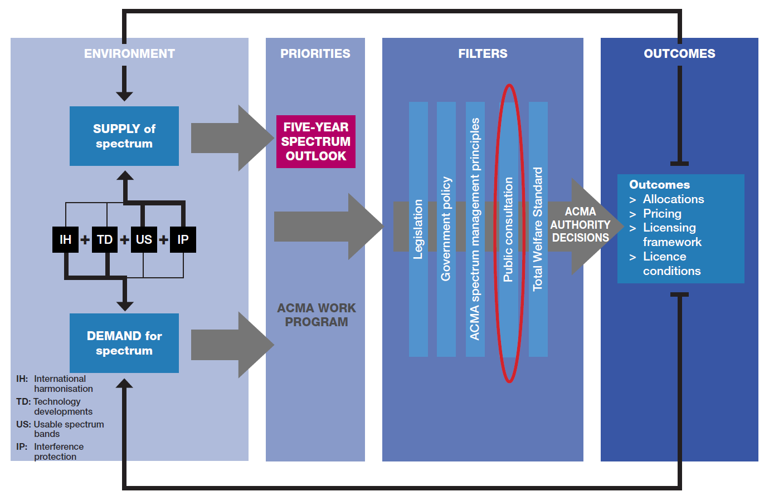

### Spectrum Review

In May 2014, the then Minister for Communications, the Hon Malcolm Turnbull MP, announced a review of Australia’s spectrum policy and management framework.[4] The Spectrum Review looked at the changes needed to cope with the increase in demand for spectrum and changes in technology, markets and consumer preferences. The review reported to the minister in March 2015.

The resulting Spectrum Review Report[5] outlines recommended changes to improve Australia’s spectrum policy and management framework. On 25 August 2015, the government released its response, agreeing to implement the recommendations of the Spectrum Review.[6] The main reforms include:

* replacing the current legislative arrangements with new legislation that removes prescriptive process and streamlines licensing, for a simpler and more flexible framework
* better integrating the management of public sector and broadcasting spectrum to improve the consistency and integrity of the framework

reviewing spectrum pricing to ensure consistent and transparent arrangements to support the efficient use of spectrum and secondary markets.

On 10 March 2016, the government released a *Legislative Proposals Consultation Paper*[7] on its proposed approach to new radiocommunications legislation. The proposed legislation seeks to make Australia’s spectrum framework simpler, more efficient and flexible to use and better support innovative communication technologies and services.

The Spectrum Review indicated that transitional arrangements would need to be worked through carefully with stakeholders, and that the full transition to a new framework would take place over a number of years. It is proposed that:

* licensing processes currently underway will continue under the current framework
* where practicable, class licences will be deemed as spectrum authorisations on commencement of the new legislation
* apparatus licences will transition to the new framework over a period of time in a staged approach

spectrum licences will continue until expiry, unless the parties agree to transition earlier.

Given the time frames associated with any changes in arrangements in the 1.5 GHz and 3.6 GHz bands, it is envisaged that any new arrangements would be developed under the anticipated new regulatory regime. However, if new arrangements are developed under the existing regulatory regime, it is acknowledged that these arrangements would need to be transitioned to the new regime in line with transitional arrangements for the broader Spectrum Review.

## Background

### Mobile broadband strategy and work program

**Error! Reference source not found.** shows the stages of the process for consideration of additional spectrum for MBB services from the ACMA’s [mobile broadband strategy](http://www.acma.gov.au/~/media/Spectrum%20Transformation%20and%20Government/Issue%20for%20comment/IFC%2022%202015/MBB%20strategyThe%20ACMAs%20spectrum%20management%20strategy%20to%20address%20the%20growth%20in%20mobile%20broadband%20capacity%20docx.docx). The 1.5 GHz and 3.6 GHz bands are currently in the *initial investigation* stage.

1. Stages of the process for consideration of additional spectrum for MBB services

| Stage | | Description |
| --- | --- | --- |
| Monitoring | | ‘Business-as-usual’ **monitoring** of international and domestic MBB spectrum trends. |
| Initial investigation | | Initial investigation and scoping of potential **options** for domestic re-farming of a band, informed by preliminary technical assessment.  If initial scoping and technical assessment shows potential, **preliminary assessment of highest value use** of the spectrum is undertaken. |
| Preliminary re-planning | | Identification of re-planning/re-farming **proposals** (including mechanisms to address incumbent issues) informed by detailed technical sharing studies and analysis of ongoing incumbent spectrum needs. A **comprehensive assessment of the highest value use or uses** of the band is undertaken. |
| Re-farming | | **Decisions** made on preferred re-farming proposal. |
| Re-farming sub-stage a | Re-planning | Detailed band/channel re-planning undertaken to support the change in the use of the spectrum to MBB. Where possible, long-term transition arrangements are put in place, allowing incumbents to transition **voluntarily** over time (incumbents **retain their rights** during the re-planning stage in accordance with the Act). In this scenario, a change of spectrum use commences at this stage, with final implementation concluded in the *allocation sub-stage* via an allocation of spectrum to specific MBB users.  However, in some cases it may be appropriate for spectrum already available for MBB to be replanned in order to better support new MBB technologies. In this scenario, a change of use of spectrum and subsequent allocation may not be necessary. In such cases, the *allocation* sub-stage is not required and the process would stop here. |
| Re-farming sub-stage b | Allocation (to MBB users) | Development of final technical framework and allocation instruments/tools for near-term re-farming. Incumbents are **obliged** to transition to new arrangements or cease operations in specified time frame (incumbents **rights are varied and/or removed** in accordance with the Act). Mobile broadband users are given the opportunity to acquire and use re-farmed spectrum. |

In classifying the 1.5 GHz and 3.6 GHz bands within the *initial investigation* stage, the ACMA took into account a range of factors, as outlined in its [mobile broadband strategy](http://www.acma.gov.au/~/media/Spectrum%20Transformation%20and%20Government/Issue%20for%20comment/IFC%2022%202015/MBB%20strategyThe%20ACMAs%20spectrum%20management%20strategy%20to%20address%20the%20growth%20in%20mobile%20broadband%20capacity%20docx.docx), including:

* the level of interest or investigation in these bands both nationally and internationally for MBB services
* incumbent use of the spectrum, including whether there is any strong reason why the band is fundamentally unsuitable or otherwise not viable for MBB
* technology standardisation developments (for example, progress within the 3GPP[8])

international spectrum harmonisation considerations, such as considerations in the International Telecommunication Union (ITU) and APT, and in overseas jurisdictions.

The *initial investigation* stage involves scoping of potential planning options for domestic re-farming of a band informed by preliminary technical assessment, which is the primary purpose of this paper. The initial scoping and technical assessment outlined in this paper shows potential for domestic re-farming of the 1.5 GHz and 3.6 GHz bands, and therefore a preliminary assessment of the highest-value use of the spectrum has been undertaken and presented.

### Past consideration of the 1.5 GHz and 3.6 GHz bands

1.5 GHz band

The ACMA released *Planning for mobile broadband in the 1.5 GHz mobile band* in May 2012 to gather further information on issues related to the potential use of the 1427.9–1510.9 MHz band for MBB services.[9] Further progress domestically on the 1.5 GHz band has been on hold, pending the outcomes of the 2015 World Radiocommunications Conference (WRC-15).

[Embargo 70](http://www.acma.gov.au/~/media/Spectrum%20Engineering/Regulation/Word%20Document/Embargo%20No%2070%20docx.docx) was put in place on 20 April 2016 to preserve future planning options.

3.6 GHz band

In December 2006, ACMA released the discussion paper [*Strategies for Wireless Access Services: Spectrum Access Options*](http://www.acma.gov.au/webwr/_assets/main/lib100639/was_discussion.pdf). This discussion paper sought comment from stakeholders about the suitability of a number of identified bands for Wireless Access Services (WAS), including the 3.6 GHz band. In October 2008, ACMA released the paper [*Strategies for Wireless Access Services: Consultation Outcomes*](http://www.acma.gov.au/webwr/_assets/main/lib310081/spp08_08_spp08_08_strategies_for_was_consultation_outcomes.pdf). In this paper, among other things, the ACMA announced its intention to allow the use of the 3.6 GHz band for the deployment of WAS in regional and remote areas of Australia.

In November 2009, the 3575–3700 MHz band was made available for broadband services in regional and remote Australia. At the time, the band was not made available for broadband services in capital cities (except Hobart), to preserve future planning options within these areas. [Embargo 42](http://www.acma.gov.au/webwr/radcomm/frequency_planning/spectrum_embargoes/emb42.pdf) was revised to support this measure.

## Purpose

As discussed, the 1.5 GHz and 3.6 GHz bands are in the *initial investigation* stage of the process for consideration of additional spectrum for MBB services. This stage involves scoping of potential planning options for domestic re-farming of a band informed by preliminary technical assessment, which is the primary purpose of this paper.

This paper provides an opportunity for stakeholders to inform the ACMA about their views, and the effects of different options on incumbent and potential new services, so the costs and benefits can be accurately gauged and considered.

In forming a judgement as to whether a band should progress from the *initial investigation* stage to the *preliminary re-planning* stage in the process, the ACMA’s decision will be informed by the results of the preliminary assessment of highest value use. To that end, preliminary assessments of highest value use for the 1.5 GHz and 3.6 GHz bands are provided in this paper for stakeholder comment and feedback. The main outcome sought from this paper is to determine if the bands should be progressed from the *initial investigation* stage to the *preliminary re-planning* stage.

1. **Should the 1.5 GHz band and/or the 3.6 GHz band be progressed from *the initial investigation* stage to the *preliminary re-planning* stage in the ACMA’s process for consideration of additional spectrum for MBB services? Why/Why not?**

As part of the request for feedback, the ACMA is also seeking information to inform development of a comprehensive assessment of highest-value use, which will be completed as part of the *preliminary re-planning* stage should the bands progress to that stage.

### Next steps

Should the 1.5 GHz and 3.6 GHz bands progress to the *preliminary re-planning* stage, it is likely they will be advanced through the remaining stages at different rates. This is partly to enable resources to be focused on facilitating the timely release of spectrum. However, timing is also likely to be affected by factors unique to each band, such as:

* incumbency issues, for example, whether services will be required to re-locate from a band (or geographical location), and how much time is required to do this
* international considerations, such as the development of internationally-harmonised band arrangements

the availability of MBB equipment.

Scrutiny of these factors will assist in determining how fast consideration of a band for MBB could be progressed. In the 1.5 GHz band, for example, although there are arrangements in place for MBB, they only encompass a portion of the band. Arrangements for MBB use that maximise the utility of the entire 1.5 GHz band are currently under consideration by international bodies, including the ITU, 3GPP and APT. While this work is going on, a decision needs to be made as to how fast consideration of the 1.5 GHz band for MBB domestically should progress. For example, should domestic consideration of the band be paused until international work is finalised? Or can, and should, the work continue in parallel? This issue is discussed further in the 1.5 GHz *Potential spectrum options* section of this paper.

**Error! Reference source not found.** provides an indication of the notional timeline for the progression of a single band under consideration through the ACMA’s planning process. Under some circumstances and if required, it may be possible for this process to be accelerated by running more steps in parallel, or by compressing steps. However, there would be practical limits as to how fast some issues can be progressed, and there may also be a corresponding increase in associated risks. It should also be noted that if consideration of both bands is undertaken together, this would likely extend the timeframes indicated in **Error! Reference source not found.**.

Importantly, whether the notional timeline is achievable and/or appropriate is contingent on variety of factors, a critical one being the feedback received to ACMA discussion papers that contributes to the ACMA’s evidenced-informed decision-making processes.

1. Indicative timeline for the progression of one band through the process for consideration of additional spectrum for MBB services

| Stage | Milestone | Date |
| --- | --- | --- |
| **Stage 1— Initial investigation** | Release: Initial investigation of the 1427–1518 MHz and 3575–3700 MHz bands for MBB services discussion paper | October 2016 |
| Submissions due to discussion paper | November 2016 |
| Consideration of whether to progress consideration of the band to stage 2—*preliminary re-planning* | January 2017 |
| **Stage 2— Preliminary re-planning** | Release: second discussion paper focused on one band providing draft definitive highest-value use assessment and planning options | Q2 2017 |
| Submissions due to second discussion paper | Q3 2017 |
| Release: decision paper on whether or not band will move to stage 3—*re-farming* | Q3–Q4 2017 |
| **Stage 3– Re-farming** | Commencement of *re-farming* stage | Q4 2017 |

The ACMA is seeking comment as to how consideration of the 1.5 GHz and 3.6 GHz bands should be progressed. For example, should they progress in parallel or should the timing of one be prioritised over the other?

Although consideration of the bands may advance at different rates, there may be strong drivers (if a decision to re-farm is made) to ultimately allocate them at the same time, noting that access to the different bands may occur at separate times. In practice, this may or may not be practical to achieve. The ACMA seeks comment on whether there would be benefit in allocating the bands simultaneously.

1. **Should either of the 1.5 GHz and 3.6 GHz bands be prioritised through the ACMA’s process for consideration of additional spectrum for MBB services? If so, which band? Why?**
2. **Are there specific issues, other than those mentioned, that may affect the timeframe in which the 1.5 GHz or 3.6 GHz bands could be made available for MBB?**
3. **If the 1.5 GHz and 3.6 GHz bands are re-farmed for MBB, would there be benefit in allocating the bands simultaneously?**

## Scope

### In scope—planning options

This paper provides a snapshot of current arrangements in the 1.5 GHz and 3.6 GHz bands in Australia and internationally. It also canvasses potential planning options for facilitating MBB services in these bands, including an indication of the impact of these on incumbent services. The ACMA is seeking comment on these broad planning options, including on suggested spectrum planning arrangements and potential differences across geographic areas.

### Out of scope—licensing and allocation options

Licensing and allocation options are not discussed in this paper. Depending on the mix of services that will use these bands in the future, and the implementation of the recommendations of the Spectrum Review, different regulatory arrangements and associated licensing and allocation methods may be appropriate. Licensing and allocation options will be considered when the most suitable planning direction is determined.

### Out of scope—Spectrum currently subject to spectrum licensing

This paper covers the 1427–1518 MHz and the 3575–3700 MHz bands.

Spectrum adjacent to the 3.6 GHz band (the 3425–3492.5 MHz and 3542.5–3575 MHz bands) is subject to spectrum licensing in metropolitan and regional areas. Any planning arrangements developed for the 3.6 GHz band will, as a matter of course, take this into account. However, while options to optimise and improve the overall utility of the 3400–3700 MHz band may be explored as part of (or separate to) the consideration of the 3.6 GHz band for future use for MBB, these will be subject to the limitations of the existing licensing arrangements. This includes the need to obtain agreement from spectrum licensees before any licence core conditions can be varied.

### Out of scope—Engagement in international activities

Various international developments and activities are discussed in this paper, as they form an important part of the consideration of the 1.5 GHz and 3.6 GHz bands domestically. However, the ACMA’s actual international engagement process into these matters is not considered in this paper. The ACMA will continue to monitor and engage with stakeholders via the usual international preparatory process, to develop Australian positions on issues regarding the 1.5 GHz and 3.6 GHz bands in the ITU-R and APT. Those interested in participating in these activities should email the International Radiocommunications Section of the ACMA at [IRS@acma.gov.au](mailto:IRS@acma.gov.au).

## Structure

The rest of this document is structured as follows:

* ***1.5 GHz band***describes international arrangements in the 1.5 GHz band, the current use of the 1.5 GHz band in Australia, the potential future planning options for MBB services, along with a preliminary assessment of the highest-value use of the band.

***3.6 GHz band***describes international arrangements in the 3.6 GHz band, the current use of the 3.6 GHz band in Australia, the potential future planning options for MBB services, along with a preliminary assessment of the highest-value use of the band.

# 1.5 GHz band

## International arrangements

This section provides an overview of international arrangements and developments in the 1427–1518 MHz band. This section is divided into three parts:

* arrangements and developments within international organisations
* country-specific arrangements and developments

a high-level summary of international arrangements and developments.

### International organisations

ITU

Article 5 of the ITU Radio Regulations defines the current service allocations for the 1427–1518 MHz frequency range for all Regions of the world (refer to Table 3). As a result of WRC-15 agenda item 1.1, numerous changes were made that will take effect in 2017. These changes are defined in the [*Final Acts WRC-15*](http://www.itu.int/pub/R-ACT-WRC.12-2015). In summary, the changes to the 1427–1518 MHz frequency range were:

* Identification of the 1427–1518 MHz frequency range for International Mobile Telecommunications (IMT) in all of Region 2 and Region 3.
* Identification of the 1427–1452 MHz and 1492–1518 MHz frequency ranges for IMT in Region 1.

Identification of the 1452–1492 MHz frequency ranges for IMT in African and Arab states of Region 1. CEPT[10] countries did not identify this band due to an ongoing disagreement with RCC countries over the protection of Aeronautical Mobile Telemetry services. However, CEPT have indicated their intention to use the band for MBB services under the existing primary mobile allocation.

Article 5 of the ITU Radio Regulations also shows that there are primary allocations to the space operation, fixed, broadcasting and broadcasting-satellite services worldwide.

Studies are ongoing in the ITU-R on the 1.5 GHz band. The following text was included in the *Invites ITU-R* of Resolution **223 (Rev. WRC-15)**:

1. to conduct compatibility studies in order to provide technical measures to ensure coexistence between MSS in the frequency band 1518–1525 MHz and IMT in the frequency band 1492–1518 MHz;

to develop harmonised frequency arrangements to facilitate IMT deployment in the frequency band 1427–1518 MHz, taking into account the results of sharing and compatibility studies.

An additional outcome of WRC-15 was Resolution **761 (WRC-15)**. This resolution invites the ITU-R to conduct, in time for WRC-19, the appropriate regulatory and technical studies, with a view to ensuring the compatibility of IMT and the broadcasting-satellite service (BSS) (sound) in the frequency band 1452–1492 MHz in Regions 1 and 3, taking into account IMT and BSS (sound) operational requirements.

1. 2013 Australian and ITU Radio Regulations Table of Allocations for the 1427–1518 MHz frequency range

|  |  |  |  |
| --- | --- | --- | --- |
| **Region 1** | **Region 2** | **Region 3** | **Australian Table of Allocations** |
| **1 427–1 429** SPACE OPERATION (Earth-to-space)  FIXED  MOBILE except aeronautical mobile        338A 341 | | | **1 427–1 429**  SPACE OPERATION (Earth-to-space)  FIXED  MOBILE except aeronautical mobile  338A 341 AUS87 AUS103 |
| **1 429–1 452**  FIXED  MOBILE except aeronautical mobile  338A 341 342 | **1 429–1 452**  FIXED  MOBILE 343    338A 341 | | **1 429–1 452**  FIXED  MOBILE AUS3  338A 341 AUS87 AUS103 |
| **1 452–1 492**  FIXED  MOBILE except aeronautical mobile  BROADCASTING 345  BROADCASTING–SATELLITE 208B 345  341 342 | **1 452–1 492**  FIXED  MOBILE 343  BROADCASTING 345  BROADCASTING–SATELLITE 208B 345      341 344 | | **1 452–1 492**  BROADCASTING 345  BROADCASTING–SATELLITE 208B 345  FIXED  MOBILE AUS3  341 AUS87 AUS103 |
| **1 492–1 518**  FIXED  MOBILE except aeronautical mobile  341 342 | **1 492–1 518**  FIXED  MOBILE 343  341 344 | **1 492–1 518**  FIXED  MOBILE  341 | **1 492–1 518**  FIXED  MOBILE AUS3  341 AUS87 AUS103 |

Asia–Pacific region

The 20th meeting of the APT Wireless Group (AWG) held in September 2016, developed a work plan to study arrangements in the 1427–1518 MHz band. A working document towards a draft new report was developed, which included the current arrangements in Japan (that is, 3GPP bands 11 and 21), a new FDD arrangement and a downlink-only option. Further work will be undertaken at future meetings, depending on input contributions.

3GPP

Part of the 1.5 GHz band has been included in standards developed by the [Third Generation Partnership Project](http://www.3gpp.org/About-3GPP) (3GPP) as shown in Table 4. The 1427.9–1462.9 MHz and 1475.9–1510.9 MHz frequency ranges (bands 11 and 21) are standardised for LTE. The 1452–1496 MHz frequency range (band 32) is also identified as a downlink-only operating band for LTE for use when carrier aggregation is configured. The 1447–1467 MHz frequency range (band 45) is identified as a TDD operating band for LTE.

1. 3GPP frequency bands for the 1.5 GHz band

|  |  |  |  |  |  |  |  |  |  |  |  |  |  |  |  |  |  |  |  |  |
| --- | --- | --- | --- | --- | --- | --- | --- | --- | --- | --- | --- | --- | --- | --- | --- | --- | --- | --- | --- | --- |
| |  |  |  |  | | --- | --- | --- | --- | | E‑UTRA operating band | Uplink (UL) operating band BS receive UE transmit | Downlink (DL) operating band BS transmit  UE receive | Duplex mode | | 11 | 1427.9–1447.9 MHz | 1475.9 MHz–1495.9 MHz | FDD | | 21 | 1447.9–1462.9 MHz | 1495.9–1510.9 MHz | FDD | | 32 | N/A | 1452–1496 MHz | FDD* | | 45 | 1447–1467 MHz | 1447–1467 MHz | TDD | |
| *\* Restricted to E-UTRA operation when carrier aggregation is configured.*  As harmonised frequency arrangements are developed within the ITU-R, it is expected that additional operating bands may be added for LTE. |

### Country-specific arrangements

Europe

On 8 May 2015, the European Commission adopted a decision to open up the 1452–1492 MHz frequency band for wireless broadband use as downlink only.[11] The decision provides protection for terrestrial broadcasting systems operating within the 1452–1479.5 MHz frequency band. The Maastricht special arrangement of 2002, as revised in 2007[12], provides the technical and regulatory framework for the deployment of terrestrial DAB (T-DAB) in the 1452–1479.5 MHz band.

In May 2015, Ofcom (UK) varied the spectrum access licence for the 1452–1492 MHz band, held by Qualcomm since 2008, to enable use for mobile/fixed communication supplemental downlink.[13]

In June 2015, the 1452–1492 MHz band was auctioned in Germany, with Telekom Deutschland and Vodafone each obtaining 20 MHz of spectrum.[14]

In September 2015, Italy's ministry for economic development (MiSE) announced that Telecom Italia and Vodafone had been awarded two 20 MHz frequency lots in the 1452–1492 MHz band for MBB use.[15]

Japan

In Japan, MBB services, including LTE, have been deployed in 3GPP bands 11 and 21.[16]

US

In the US, the 1452–1525 MHz segment is covered by international footnote 344 to the ITU Radio Regulations Table of Allocations:

**344** *Alternative allocation*: in the United States of America, the band 1452–1525 MHz is allocated to the fixed and mobile services on a primary basis.

There is no provision in either the federal or non-federal frequency allocation tables of the US for cellular communications systems in this band segment. The segment 1435–1525 MHz is used by defence organisations and NASA for aeronautical telemetry. While the US has no current intention of deploying MBB services in this band, it has nonetheless allowed the regional identification of the band for IMT, with the acknowledgment that coexistence with IMT could be achieved by coordination with neighbouring countries.

### Summary of international considerations

Internationally, there appears to be growing interest in use of the 1.5 GHz band for MBB. This is evident from the recent outcomes of WRC-15, as well as moves to identify and/or use parts of the band for MBB in Europe. It is also supported by industry-driven technology standardisation for LTE in the band. This suggests that economies of scale for MBB equipment in the bands are likely to develop. Although there is growing interest, it is noted that studies and development of various channelling arrangement options are ongoing in a number of international bodies, which may need to be taken into consideration if re-farming occurs in Australia.

## Australian context

This section provides an overview of the current planning arrangements and use of the 1.5 GHz band within Australia.

### Current planning arrangements and use

The current arrangements for the 1.5 GHz band are provided in the [Radiocommunications 1.5 GHz Frequency Band Plan 2015](https://www.legislation.gov.au/Details/F2015L01271) (the 1.5 GHz Band Plan). The 1.5 GHz Band Plan was created in 1996 and remade in August 2015, without any significant changes.[17] [Embargo 70](http://www.acma.gov.au/~/media/Spectrum%20Engineering/Regulation/Word%20Document/Embargo%20No%2070%20docx.docx) was created on 10 April 2016 to restrict all new frequency assignments in the 1427–1518 MHz frequency range in metropolitan and regional areasto preserve future planning options.

As a result of the 1.5 GHz Band Plan and the arrangements defined in RALI FX3, use of the 1.5 GHz band is currently dominated by fixed point-to-point and point-to-multipoint services. The current usage of this band is unusual, in that it is heavy in remote areas, but relatively light in metropolitan and regional areas.

**Error! Reference source not found.**2 provides the current arrangements in the 1.5 GHz band and adjacent bands. As at 1 September 2016, there were 6,264 apparatus-licensed services operating in the 1.5 GHz band. More details on current licences in the band are available in Appendix A.

1. 1.5 GHz band arrangements

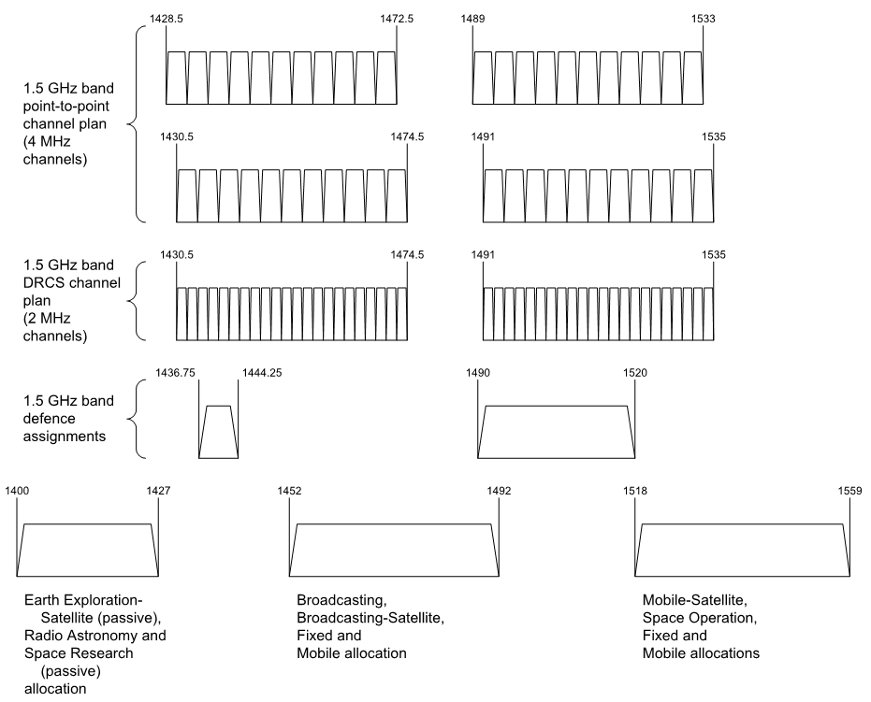

Fixed service

In the 1.5 GHz band, there are 4,698 frequency assignments to point-to-point and 1,546 frequency assignments to point-to-multipoint services (as detailed in Appendix A). The existing arrangements in the 1.5 GHz band provide for low-capacity point-to-point fixed links, as well as provisions to enable use by the Digital Radio Concentrator System (DRCS) and High Capacity Radio Concentrator (HCRC). These provide point-to-point and point-to-multipoint fixed links as part of the public telecommunications network in rural and remote areas.

For point-to-point services, 3,666 (79 per cent) are licensed to Telstra, as well as 1,436 (93 per cent) of point-to-multipoint services. These are used to deliver voice telecommunications services to customers in regional and remote areas, as part of its universal service obligation (USO) responsibilities.

Broadcasting services

Allocations to the broadcasting and broadcasting-satellite (both intended for digital sound broadcasting—DSB) services were made in the 1452–1492 MHz frequency range at the 1992 ITU World Administrative Radio Conference (WARC-92). The 1.5 GHz Band Plan prevents new assignments being made for other services in the frequency band 1452–1492 MHz, in order to preserve the band for future DSB services.

While there were trials carried out in Australia during the 1990s and 2000s, the DSB allocation in the 1.5 GHz Band has remained unused for broadcasting services.

[Responses](http://www.acma.gov.au/Industry/Spectrum/Spectrum-planning/About-spectrum-planning/ifc-152012-planning-for-mobile-broadband-within-the-15-ghz-mobile-band) from the broadcasting industry to the ACMA’s *Planning for mobile broadband in the 1.5 GHz mobile band* in 2012 expressed an interest in retaining the 1452–1492 MHz allocation for sound broadcasting, as digital radio planning in VHF band III had not yet been completed. This was despite limited use worldwide. While deployments in Vatican City, the Czech Republic and Italy were highlighted in submissions, these deployments have been limited in nature.

Broadcasting-satellite services

Australia is the notifying administration for the satellite filing of an existing operational satellite network that has provided digital sound and multimedia satellite broadcasting services to Asia in the 1467–1492 MHz band. However, this filing does not service Australia. Filings that covered Australia and included this frequency range have been suppressed.

[Responses](http://www.acma.gov.au/Industry/Spectrum/Spectrum-planning/About-spectrum-planning/ifc-152012-planning-for-mobile-broadband-within-the-15-ghz-mobile-band) from the satellite industry to the ACMA’s *Planning for mobile broadband in the 1.5 GHz mobile band* in 2012 suggested that a 12.5 MHz allocation would be sufficient for BSS(S) in the 1452–1492 MHz range.

Defence frequency assignments

In the 1.5 GHz mobile band, there are 26 frequency assignments to the Department of Defence, including both area-wide and location-specific assignments for fixed receive, aeronautical assigned system, aircraft assigned, point-to-point and radiodetermination services.

The 1435–1535 MHz band is subject to Australian Footnote AUS3 in the ARSP, which states:

**AUS3** The use of the band 1 435–1 535 MHz by the aeronautical mobile service for telemetry has priority over other uses by the mobile service.

Should the 1.5 GHz band be re-farmed, sharing arrangements will need to be considered between services providing aeronautical telemetry and new services. A potential consequence of the review of the 1.5 GHz band could be the deletion or modification of AUS3, should the band be re-farmed.

1. **The ACMA seeks comment on expected future use of the 1.5 GHz band by the fixed, broadcasting and broadcasting-satellite services and by the Department of Defence in Australia.**
2. **Comment is sought on the potential deletion or modification of footnote AUS3 from the ARSP.**

Adjacent band services—Science services

Adjacent band users include the science community. 1400–1427 MHz is a passive sensing band with primary allocations to the Earth Exploration-Satellite (passive), Radio Astronomy and Space Research (passive) services. This band is one of the most important bands for radio astronomy, since it encompasses a fundamental spectral line of hydrogen, which is by far the most prevalent element in the universe. ITU-R Resolution **750 (WRC-15)** defines unwanted emission limits in the 1400–1427 MHz band for mobile devices operating in the 1.5 GHz band. This limit was defined at WRC-15 to protect passive Earth Exploration Satellite services (EESS) operating in 1400–1427 MHz band, from adjacent band IMT systems.

Adjacent band services—Mobile-satellite services

The upper side of the 1.5 GHz band is allocated to the mobile-satellite service. Licensees in Australia include Inmarsat, Thuraya and Optus. As noted earlier, the ITU-R is conducting compatibility studies in order to provide technical measures to ensure coexistence between MSS and IMT.

## Initial investigation of the 1.5 GHz band for use by MBB services

The 1.5 GHz band is currently in the *initial investigation* stage of the ACMA’s process for consideration of additional spectrum for MBB services. As part of the work conducted at thisstage, the ACMA performs an initial investigation and scoping of potential options for domestic re-farming of a band. This includes considering the following three issues:

* potential spectrum options for re-farming
* potential geographical options for re-farming

coexistence and sharing issues with incumbent services.

The outcomes of this work are presented in this section.

### Potential spectrum options

As mentioned previously, there are some internationally-harmonised arrangements defined for the 1.5 GHz band, though they currently only encompass a portion of the band. Arrangements for MBB use that maximise the utility of the entire 1.5 GHz band are currently under consideration by international bodies, including the ITU, 3GPP and APT. Until this work is finalised, a decision needs to be made as to how quickly consideration of the 1.5 GHz band for MBB domestically should progress. For example, should domestic consideration of the band be paused until international work is finalised? Or should the work continue in parallel?

If domestic consideration of the band is paused, resources could be focused on optimising arrangements being developed by international bodies towards Australia’s interests. If both domestic and international consideration of the band occurs in parallel, domestic work could be progressed to the point where international arrangements could be quickly adopted when they are finalised. Alternatively, options for a staged re-farming of spectrum in the band could also be considered (this option is discussed further below). This could occur in those parts of the band where arrangements for MBB already exist.

In general, there are three potential band arrangement options that could be considered in the 1.5 GHz band, as described below and displayed in **Error! Reference source not found.**3:

* a FDD arrangement using arrangements compatible with 3GPP bands 11 and/or 21 or a new arrangement
* a downlink-only arrangement, known as supplemental downlink (SDL), using arrangements compatible with 3GPP band 32 or a new arrangement

a TDD arrangement, using arrangements compatible with 3GPP band 45 or a new arrangement.

Once a specific arrangement for MBB is chosen for the band, a further consideration could be whether re-farming of the band should be staged—that is, should there be a release of those segments of the 1.5 GHz band that are more lightly utilised by incumbent services ahead of those used more heavily? This would provide more time for many incumbent services to re-locate from the band, if required. If and how this can be done will vary depending on the arrangements adopted in any future re-farming of the band for MBB services.

The different arrangements for MBB in the 1.5 GHz band, as well as options for a staged re-farming of the band, are discussed further below.

1. Potential arrangements for MBB in the 1.5 GHz band

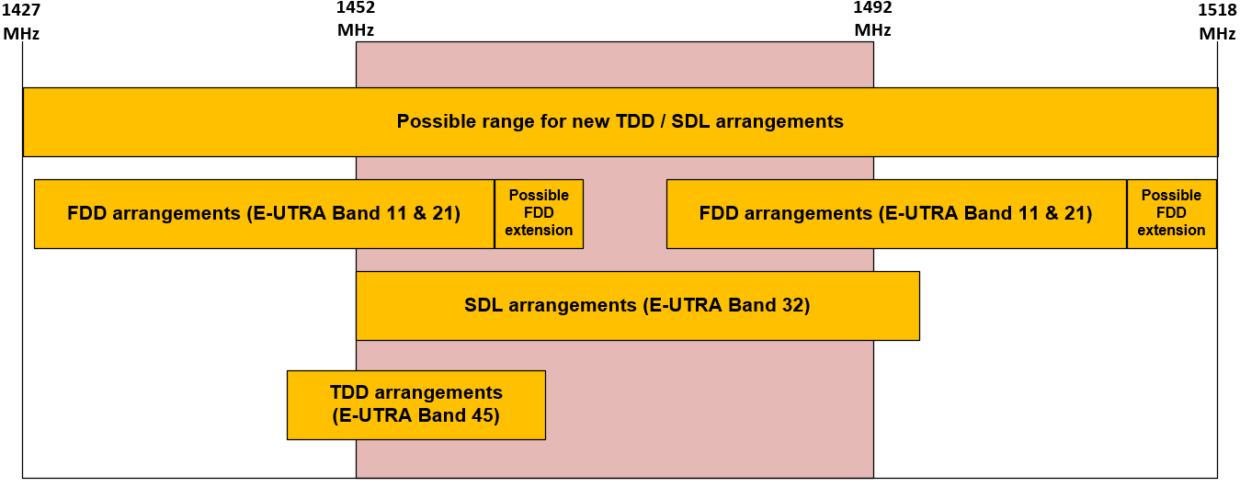

Option 1: FDD arrangement

FDD arrangements using 3GPP bands 11 and 21 have been utilised for LTE services in Japan, and therefore, there is device availability. These arrangements use 70 MHz (2 × 35 MHz) of the 91 MHz identified for IMT. In Australia; there are currently 5,640 fixed services deployed in 3GPP bands 11 and 21, with 1,829 (or 32 per cent) of these services in metropolitan and regional areas. Of note, the mid-band gap of this arrangement falls within the frequency range previously identified for DSB, which is relatively lightly used by other services compared to the rest of the band.

New FDD arrangements may be developed over the coming years within the ITU and 3GPP, which may be more suitable for use within Australia. For example, at the 20th meeting of the APT Wireless Group, Japan submitted a contribution proposing a new FDD arrangement for the 1.5 GHz band. However, it is unclear at this stage what these arrangements might look like, noting technical requirements for a sufficient duplex frequency split and mid-band gap.

Option 2: SDL arrangement

The 1452–1492 MHz band has been opened up for wireless broadband use for downlink-only services in Europe, and allocated for this purpose in some European countries. This is compatible with SDL arrangements defined in 3GPP band 32. In Australia, there are currently 1,028 fixed services deployed in 1452–1492 MHz. This includes 267 (or 26 per cent) of these services in metropolitan and regional areas in the 1452–1492 MHz band. Of note, these arrangements overlap the least utilised part of the 1.5 GHz band, which was previously identified for DSB.

New SDL arrangements may be developed over the coming years within the ITU and 3GPP, which may also be suitable for use within Australia. This could include arrangements that make use of most of the 1.5 GHz band, pending any requirement for guard bands, to facilitate adjacent band-sharing with science and MSS services.

Another aspect of SDL arrangements that needs to be considered is that SDL spectrum is utilised via carrier aggregation. That is, a licensee requires holdings in another frequency band to be able to utilise this spectrum. Therefore, potential users of this spectrum would be restricted to those who currently hold spectrum in other frequency bands that can be suitably paired with SDL spectrum in the 1.5 GHz band for operation. This includes spectrum held in apparatus- or spectrum-licensed bands currently available for MBB within Australia.

Option 3: TDD arrangement

3GPP band 45 is a TDD arrangement that was developed for use in China. However, there are currently no deployments using this frequency arrangement. In Australia, there are currently 1,315 fixed services deployed in 3GPP band 45, with 390 (or 30 per cent) of these services in metropolitan and regional areas. Of note, these arrangements overlap the least utilised part of the 1.5 GHz band, which was previously identified for DSB.

New TDD arrangements may be developed over the coming years within the ITU and 3GPP, which may be suitable for use within Australia. These may include arrangements that make use of most of the 1.5 GHz band, pending any requirement for guard bands to facilitate adjacent band-sharing with space and MSS services.

1. **If the 1.5 GHz band is re-farmed for MBB services, what frequency arrangement should be adopted? Should a frequency division duplex (FDD), supplemental downlink (SDL) or time division duplex (TDD) arrangement be adopted? Why/why not? What type of arrangement should be adopted (that is, 3GPP bands 11 and/or 21, 3GPP band 32, 3GPP band 45 or another arrangement)?**

### Potential geographic options

The ACMA is considering a number of options regarding the geographical areas that should be considered for re-planning as part of any 1.5 GHz band release. Factors that need to be considered include areas where there is high demand for MBB services, incumbency issues, and ensuring areas are large enough to be of practical use.

For the areas of demand, the ACMA’s starting assumption is that the highest demand will be in metropolitan and regional areas, similar to those areas defined for the 2 GHz spectrum licences, as shown in Figure A3 in Appendix A.

Details of current licences in the 1.5 GHz band are available in Appendix A. The largest proportion of users are in remote areas. Therefore, if the 1.5 GHz band is re-farmed for MBB services, options to geographically limit or stage the re-farming of spectrum warrant investigation. Table A2 in Appendix A shows the number of fixed services that may be affected in each area for different spectrum options for re-farming. It should be noted that this is an estimate based on co-channel services within the areas noted. It does not, for example, take account of any sharing arrangements that may be developed (this is discussed in the next section) or additional services affected due to requirements for spectral or geographic separation.

If re-farming is limited to metropolitan and regional areas, between 26–32 per cent of incumbent services will be affected, depending on the spectrum option pursued.

1. **If the 1.5 GHz band is re-farmed for MBB services, what geographical areas should be re-farmed? To what extent are mobile network operators (MNOs) interested in the 1.5 GHz band outside of metropolitan areas?**

### Coexistence and sharing with incumbent services

Fixed services

Current use of the band is dominated by fixed services. It is envisaged that there will continue to be some demand for these services in the 1.5 GHz band in the future. Current usage includes extensive use by Telstra to deliver voice telecommunications services to customers in regional and remote areas, as part of its USO responsibilities. These services may potentially be able to migrate to new or existing mobile networks in areas where the band is re-farmed for MBB services. It is also noted that the Productivity Commission is currently undertaking an inquiry into the future direction of a USO in the telecommunications market.[18]

To limit the effect on incumbent fixed services, re-farming of the 1.5 GHz band could also be confined to metropolitan areas (or metropolitan and regional areas). Or alternatively, a staged re-farming of the band could occur to provide more time for services to relocate from the band, as discussed in the *Potential geographic options* section above.

Defence frequency assignments

Regardless of the geographical areas pursued in any re-farming process, another option is to allow some existing users to remain on an ongoing basis. This option would be particularly applicable to Defence use of the band. New MBB services could be required to coordinate with incumbent services via a pre-determined technical framework, or negotiate sharing arrangements with incumbent services on a case-by-case basis.

Broadcasting services

There is no use of broadcasting services in Australia in the 1.5 GHz band. Given dwindling interest in this band for broadcasting services internationally, there is not expected to be future demand in this band. Therefore, coexistence or sharing with broadcasting services has not been considered further.

Broadcasting-satellite services

There is currently no use of broadcasting-satellite services in Australia in the 1.5 GHz band. However, sharing of the 1.5 GHz band between MBB services and broadcasting-satellite services is being considered in the ITU-R, and the results of these studies will be considered in the development of future arrangements for the 1.5 GHz band in Australia.

Adjacent band services—Science services

In order to protect science services operating in the 1400–1427 MHz band from any future MBB services, the emission limits described in ITU-R Resolution **750 (WRC-15)** will be considered. This will likely result in specific out-of-band emission limits or guard bands in any future technical arrangements for MBB in the 1.5 GHz band.

Adjacent band services—Mobile-satellite services

Co-existence between MBB services in the 1.5 GHz band and adjacent band mobile-satellite services is currently the subject of study within the ITU-R. The results of these studies will be considered in the development of future arrangements for the 1.5 GHz band in Australia. This could potentially result in specific out-of-band emission limits or guard bands in any future technical arrangements for MBB in the 1.5 GHz band.

1. **If the 1.5 GHz band is re-farmed for MBB services, should a geographically and/or spectrally staged process be considered, where more heavily utilised parts/areas are re-farmed later than those that are more lightly utilised?**
2. **What are the alternative spectrum or delivery options for current users of the 1.5 GHz band if the band is re-farmed for MBB services and migration of existing services is required?**
3. **Could services, in particular fixed services, provided in the 1.5 GHz band be migrated to new or existing mobile networks in areas where the band is re-farmed for MBB services?**
4. **Should existing users (some or all) be allowed to continue operation within the band either temporarily or on an ongoing basis?**
5. **What types of sharing arrangements could be put in place to facilitate coexistence between MBB services and existing users of the 1.5 GHz band in both the short and long term?**

## Preliminary assessment of the highest value use of the 1.5 GHz band

A preliminary assessment of the highest value use of the 1.5 GHz band is provided at Appendix C for stakeholder feedback. In deciding whether or not to progress the 1.5 GHz band to the *preliminary re-planning* stage, the ACMA will consider the results of feedback to the analysis presented. At this stage, the preliminary assessmentindicates that the amount of public benefit provided from use of the band could be increased through re-planning the band.

It is therefore proposed to progress consideration of the 1.5 GHz band for MBB to the *preliminary re-planning* stage of the ACMA’s process for consideration of additional spectrum for MBB services. As discussed previously, re-planning considerations may include geographical and spectrum band limitations on re-planning, in order to maximise the benefit derived from the use of the band.

1. **Comment is sought on the ACMA’s proposal to progress the 1.5 GHz band to the *preliminary re-planning* stage of its process for consideration of additional spectrum for MBB services, as detailed in the ACMA’s** [**mobile broadband strategy**](http://www.acma.gov.au/~/media/Spectrum%20Transformation%20and%20Government/Issue%20for%20comment/IFC%2022%202015/MBB%20strategyThe%20ACMAs%20spectrum%20management%20strategy%20to%20address%20the%20growth%20in%20mobile%20broadband%20capacity%20docx.docx).

As part of the work conducted at the *preliminary re-planning* stage, the ACMA would conduct a comprehensive assessment of the highest value use for the 1.5 GHz band.

1. **To assist the ACMA in conducting a comprehensive assessment of the highest-value use for the 1.5 GHz band, responses to the following questions are requested:**
2. **Do you see demand for fixed broadband/MBB services in the 1.5 GHz band?**
3. **What benefits do you envision from using the band for fixed broadband/MBB services?**
4. **What are relevant data points (for example, market-based allocation results) for considering the demand for 1.5 GHz band spectrum for use by MBB providers?**
5. **Is demand the same or similar across regions (that is, across metropolitan, rural and remote areas), or are some regions more likely to be in demand for MBB providers?**
6. **Do incumbent 1.5 GHz band licensees require ongoing access to the band, or are there plans to cease operation at some future point?**
7. **Do other options exist for the delivery of point-to-point, point-to-multipoint, fixed receive, aeronautical and radiodetermination incumbent services? How practical are they? What are the costs involved? Will there be a diminution of the service delivered if MBB services are introduced in the band?**

# 3.6 GHz band

## International arrangements

This section provides an overview of international arrangements and developments—not just for the 3575–3700 MHz (3.6 GHz) band, but also for the broader 3400–3800 MHz band. The reason for this is that standards organisations and the resulting equipment ecosystems for MBB systems are typically defined for operation over this larger frequency range. So, a country’s or Region’s decision to use all or part of the 3400–3800 MHz band for MBB has an effect on the resulting equipment availability and economies of scale that develop. It therefore, makes sense to consider all international factors that would affect the viability of MBB in the 3.6 GHz band when considering planning options for the band in Australia.

This section is divided into three parts:

* arrangements and developments within international organisations
* country-specific arrangements and developments

a high-level summary of international arrangements and developments.

### International organisations

ITU

Article 5 of the ITU Radio Regulations defines the current service allocations for the 3400–3700 MHz frequency range for all Regions of the world (refer to **Error! Reference source not found.**5). As a result of WRC-15 agenda item 1.1, numerous changes were made that will take effect in 2017. These changes are defined in the [*Final Acts WRC-15*](http://www.itu.int/pub/R-ACT-WRC.12-2015). In summary, the changes to the 3400–3700 MHz frequency range were:

* identification of the 3400–3600 MHz frequency range for IMT in all of Region 1 and Region 2
* inclusion of Australia and the Philippines in a list of 12 Region 3 countries that identify all or part of the 3400–3600 MHz frequency range for IMT

identification of the 3600–3700 MHz frequency range for IMT in Canada, Columbia, Costa Rica and the US.

It is noted that at WRC-15, both Australia and New Zealand tried to identify the 3600–3700 MHz frequency range for IMT; and Europe, Japan and Korea tried to identify the 3600–3800 MHz frequency range for IMT. However, this was not supported by other countries, and a ‘no change’ approach was adopted. Due to the existing mobile allocation in the 3600–3800 MHz band, Europe, Japan, Korea, New Zealand and Australia have indicated they will continue to investigate use of all or part of the band for MBB, despite the outcomes of WRC-15.

The Radio Regulations also define primary allocations to the fixed and fixed-satellite services worldwide in the 3400–4200 MHz frequency range.

IEEE

In 2008, the Institute of Electrical and Electronics Engineers (IEEE) made an amendment to the 802.11 standard (commonly known as Wi-Fi), referred to as 802.11y, to support operation in the 3650–3700 MHz band within the US.

3GPP

3GPP has identified the 3400–3600 MHz (bands 22 and 42) and 3600–3800 MHz (band 43) frequency ranges as profile bands for LTE.[19] Both TDD and FDD arrangements are defined for the 3400–3600 MHz band. However, only TDD arrangements are defined for the 3600–3800 MHz band.

3GPP is also considering whether a new band should be defined for LTE to facilitate use of the 3550–3700 MHz frequency range in the US. This is due to concerns that the technical arrangements in place for bands 42 and 43 may not be compatible with the US-defined arrangements.[20]

Global Mobile Suppliers Association (GSA)

GSA reported that as at July 2016, there were 19 networks in operation worldwide in bands 42 and/or 43. These include networks in the following countries: Argentina, Bangladesh, Brazil, Canada, Italy, Nigeria, Peru, Philippines, Slovak Republic, Spain and the UK.[21] GSA also reported that the ecosystem for bands 42 and 43 continues to grow, with 82 devices available as at June 2016.[22] This compares to just 32 devices in June 2015.

No mention of networks and equipment in band 22 (FDD arrangements for 3400–3600 MHz) was made in these GSA reports.

### Country-specific arrangements

Canada

In December 2014, Industry Canada (the Canadian radiofrequency spectrum regulator) announced plans to introduce a flexible-use band plan in the 3475–3650 MHz band that would allow both fixed broadband and MBB services to operate.[23] Canada also has arrangements for wireless broadband services in the 3650–3700 MHz frequency range.[24] The *Canadian Table of Frequency Allocations*[25]provides no allocation for the fixed-satellite service (FSS) in the 3400–3500 MHz frequency range. It also indicates that:

* in the 3475–3500 MHz frequency range, in certain locations, radiolocation service has priority over the mobile service
* in the 3500–3650 MHz frequency range, the FSS must be located in areas, so as not to constrain the implementation of fixed wireless access and mobile systems

In the 3650–3700 MHz frequency range, the FSS operates on a secondary basis.

Europe

[EC Decision 2008/411/EC](http://www.erodocdb.dk/doks/filedownload.aspx?fileid=3455&fileurl=http://www.erodocdb.dk/Docs/doc98/official/pdf/2008411EC.PDF)[26], as amended by [EC Decision 2014/276/EU](http://www.erodocdb.dk/doks/filedownload.aspx?fileid=4073&fileurl=http://www.erodocdb.dk/Docs/doc98/official/pdf/2014276EU.PDF), identifies the 3400–3600 MHz and 3600–3800 MHz frequency ranges for MBB applications within Europe. [EC Decision 2008/411/EC](http://www.erodocdb.dk/doks/filedownload.aspx?fileid=3455&fileurl=http://www.erodocdb.dk/Docs/doc98/official/pdf/2008411EC.PDF) states that sharing with FSS earth stations is considered feasible due to the extent of their deployment in Europe, geographical separation requirements and case-by-case evaluation using actual terrain topography.

In June 2016, the Radio Spectrum Group of the European Commission also released a [consultation on spectrum related aspects for 5G](https://circabc.europa.eu/d/a/workspace/SpacesStore/1a40dd19-c8a8-4ed0-bc9c-6cc5a7755f7d/RSPG16-031Final_Opinion_5G_for_public_consultation.pdf). This paper promoted the 3400–3800 MHz band as being suitable for the early introduction of 5G, potentially before 2020. Submissions to this paper were largely supportive of this proposal. Incumbent operators also re-iterated the need to share with existing FSS.

In September 2016, the European Commission also released its [5G Action Plan](https://ec.europa.eu/digital-single-market/en/news/communication-5g-europe-action-plan-and-accompanying-staff-working-document). In this plan they state:

The Commission will work with Member States and industry stakeholders towards the voluntary establishment of a common timetable for the launch of early 5G networks by the end of 2018, followed by the launch of fully commercial 5G services in Europe by the end of 2020.

The 3400–3800 MHz band is seen as having high potential for the early launch of 5G services in Europe.

Japan

At WRC-07, Japan identified the 3400–3600 MHz band for IMT. In 2014, the Japanese regulator allocated three 40 MHz lots in the 3480–3600 MHz band for MBB services.[27] At WRC-15, Japan was also a strong supporter of identifying the 3600–4200 MHz band for IMT under agenda item 1.1.

The Japanese *Frequency Assignment Plan* also includes:

* No allocation for the FSS in the 3400–3456 MHz frequency range. Instead, there are primary fixed and mobile service allocations, which are used for commercial telecommunications and broadcast auxiliary service applications.

Primary allocations to the FSS in the 3456–4200 MHz frequency range for the purpose of commercial telecommunications and public services.

US

The US has developed arrangements for MBB services in the 3550–3700 MHz frequency range.[28] These arrangements define a three-tiered spectrum authorisation framework to support shared access to the 3550–3700 MHz frequency range by a variety of services, including radiolocation services, FSS and MBB services.

### Summary of international considerations

Internationally, there appears to be growing interest in use of the 3400–3800 MHz band for MBB. This is evident from the recent outcomes of WRC-15, as well as moves to identify the bands for MBB in Europe, the US and Japan. It is also supported by industry-driven technology standardisation for LTE and Wi-Fi in the band. There are also indications that the 3400–3800 MHz band is considered suitable for the early introduction of 5G. This suggests that economies of scale for MBB equipment in the 3.6 GHz band are likely to develop.

1. 2013 Australian and ITU Radio Regulations Table of Allocations for the 3400–3700 MHz frequency range

|  |  |  |  |
| --- | --- | --- | --- |
| **Region 1** | **Region 2** | **Region 3** | **Australian Table of Allocations** |
| **3 400–3 600**  FIXED  FIXED–SATELLITE (space-to-Earth)  Mobile 430A  Radiolocation  431 | **3 400–3 500**  FIXED  FIXED–SATELLITE (space-to-Earth)  Amateur  Mobile 431A  Radiolocation 433  282 | **3 400–3 500**  FIXED  FIXED–SATELLITE (space-to-Earth)  Amateur  Mobile 432B  Radiolocation 433  282 432 432A | **3 400–3 600**  FIXED  MOBILE  RADIOLOCATION 433 AUS101A  Amateur  Fixed–satellite (space-to-Earth)  282 |
| **3 500–3 700**  FIXED  FIXED–SATELLITE (space-to-Earth)  MOBILE except aeronautical mobile  Radiolocation 433 | **3 500–3 600**  FIXED  FIXED–SATELLITE (space-to-Earth)  MOBILE except aeronautical mobile 433A  Radiolocation 433 |
| **3 600–4 200**  FIXED  FIXED–SATELLITE (space-to-Earth)  Mobile | **3 600–3 700**  FIXED  FIXED–SATELLITE (space-to-Earth)  MOBILE except aeronautical mobile  Radiolocation  435 | **3 600–4 200**  FIXED  FIXED–SATELLITE (space-to-Earth)  MOBILE except aeronautical mobile |
| **3 700–4 200**  FIXED  FIXED–SATELLITE (space-to-Earth)  MOBILE except aeronautical mobile | |

## Australian context

This section provides an overview of the current planning arrangements for, and use of, the 3.6 GHz band in Australia.

### Current planning arrangements and use

Historically, the 3.6 GHz band has been used by the FSS and point-to-point links. However, in 2005 as part of the ACMA’s [*Strategies for Wireless Access Services*](http://www.acma.gov.au/webwr/_assets/main/lib100639/was_discussion_paper_feb_06.pdf) consultation process, the band was embargoed Australia-wide. In 2009, the ACMA made the band available for MBB applications in regional and remote areas. The band remains embargoed in capital cities (excluding Hobart) for MBB services and Australia-wide for all other services.

**Error! Reference source not found.**4 provides the current arrangements in the 3.6 GHz band (shown by the shaded area) and adjacent bands. As at 7 July 2016, there were 465 apparatus-licensed services operating in the 3.6 GHz band. More details on current licences in the band are available in Appendix B.

1. 3.6 GHz band arrangements

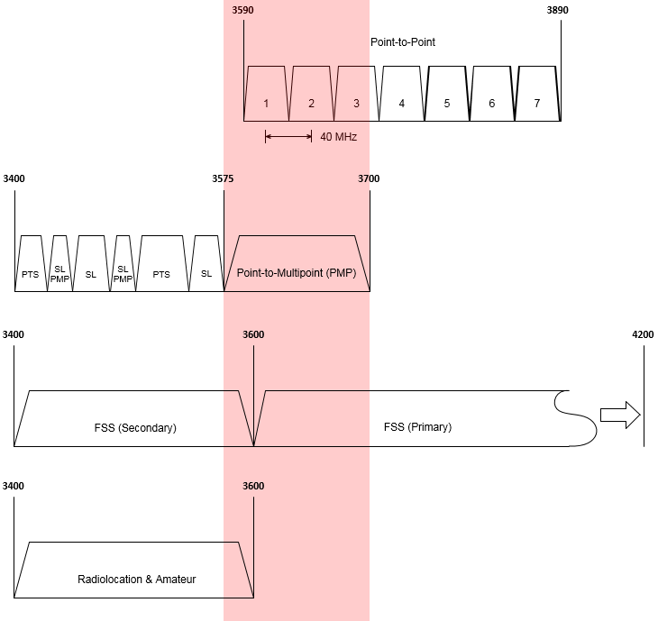

KEY

FSS: Fixed-satellite service

PTS: Public Telecommunication Service

PMP: Point-to-multipoint

SL: Arrangements for spectrum licensing in place

*Shaded area indicates the 3575–3700 MHz band

Fixed service

There is currently an embargo in the 3.6 GHz band that has been in place since 2005. This embargo restricts any new point-to-point licences being issued in the band on an Australia-wide basis. Due to the embargo, point-to-point link use has steadily declined since 2005.

The embargo does not restrict new point-to-multipoint licences being issued in regional and remote areas. As a result, point-to-multipoint use of the 3.6 GHz band, which can be considered to be a form of MBB service, has steadily increased over time. Currently, access to capital cities (except Hobart) is embargoed for point-to-multipoint services.

Relatively speaking, the arrangements in regional and remote areas of Australia for MBB services (that is, point-to-multipoint services) are reasonably new, since they have only been in place since 2009. Interest in ongoing access to the 3.6 GHz band by new and incumbent licensees is therefore considered very likely.

The ACMA has developed the following frequency assignment instructions for fixed services operating in the 3.6 GHz band:

* [RALI FX3 *Microwave fixed services frequency coordination*](http://www.acma.gov.au/theACMA/rali-fx3-microwave-fixed-services-frequency-coordination)*;*

[RALI FX19 *Frequency Coordination and Licensing Procedures for apparatus licensed Broadband Wireless Access Services in the 1900–1920 and 3575–3700 MHz bands*](http://www.acma.gov.au/theACMA/frequency-coordination-licensing-bwa-19001920-20102025-and-35753700-mhz-bands).

Fixed-satellite service (FSS)

In Australia, FSS usage of the 3600–4200 MHz frequency range is on a primary basis, while use of the 3400–3600 MHz frequency range is on a secondary basis.

Traditionally, a majority of FSS use has been in the 3700–4200 MHz frequency range (also known as the standard C-band). This, in combination with the embargo in the band, means there are relatively few licensed FSS Earth stations in the 3.6 GHz band. Of particular note are the services located in the Belrose/Oxford Falls area in Sydney, as well as Lonsdale and Lockridge in Perth.

Interest in ongoing access to the 3.6 GHz band by new and existing FSS systems is expected into the future.

Amateur

Amateur use of the band is comparatively lower than other services. It is currently limited to two locations, one in Adelaide and one in Sydney. Amateur use of the band is on a secondary basis and in accordance with the [*Australian Amateur Band Plan*](http://www.wia.org.au/members/bandplans/data/documents/Australian%20Band%20Plans%20160211.pdf).

Radiolocation

There is a primary allocation to the radiolocation service in Australia. Currently there are only licences in the 3400–3500 MHz frequency range.

Low interference potential devices

The [Radiocommunications (Low Interference Potential Devices) Class Licence 2015](https://www.legislation.gov.au/Details/F2016C00432) defines arrangements for the following devices to operate across the 3.6 GHz band:

* building material analysis transmitters operating in the 2200–8500 MHz frequency range

ultra-wideband transmitters operating in the 3400–4800 MHz frequency range.

C-band television receive-only (TVRO)[29] systems

In previous ACMA consultation processes, it was identified that there are unlicensed TVROs operating in the 3400–4200 MHz frequency range in Australia. These are typically used to obtain satellite television services meant for other countries. In response to previous consultations, satellite industry representatives have suggested that there may be in the order of 200,000 TVROs operating in Australia. TVROs operating in the 3400–4200 MHz frequency range are unlicensed, and as such, are not afforded protection from interference in Australia.

1. **The ACMA seeks comment on expected future use of the 3.6 GHz band by fixed, fixed-satellite, amateur and radiolocation services in Australia.**

## Initial investigation of the 3.6 GHz band for use by MBB services

The 3.6 GHz band is currently in the *initial investigation* stage of the ACMA’s [mobile broadband strategy](http://www.acma.gov.au/~/media/Spectrum%20Transformation%20and%20Government/Issue%20for%20comment/IFC%2022%202015/MBB%20strategyThe%20ACMAs%20spectrum%20management%20strategy%20to%20address%20the%20growth%20in%20mobile%20broadband%20capacity%20docx.docx). As part of the work conducted at thisstage, the ACMA conducts an initial investigation and scoping of potential options for domestic re-farming of a band. The outcomes of this work are presented in the following sections:

* Potential spectrum options
* Potential geographic options
* Coexistence and sharing issues with incumbent services

Optimising use of the 3400–3700 MHz band.

### Potential spectrum options

If the 3.6 GHz band is to be re-farmed for MBB services, the type of spectrum arrangements to implement need to be considered.

3GPP has identified the 3400–3600 MHz (bands 22 and 42) and 3600–3800 MHz (band 43) frequency ranges as profile bands for LTE.[30] Both TDD and FDD arrangements are defined for the 3400–3600 MHz band. However, only TDD arrangements are defined for the 3600–3800 MHz band. Discussions are also currently underway on whether a new TDD band in the 3550–3700 MHz frequency range will be developed.

The ACMA has already implemented TDD arrangements in spectrum- and apparatus-licensed segments of the 3400–3575 MHz frequency range, and in regional and remote areas of the 3.6 GHz band. Although there are FDD arrangements defined for the 3425–3442.5/3575–3492.5 MHz frequency ranges, these were developed for legacy technologies and no longer align with international standards.

Due to existing spectrum and apparatus licence arrangements in the 3400–3600 MHz band (refer to **Error! Reference source not found.**), the ACMA believes the options for the 3575–3600 MHz frequency range are limited to TDD arrangements only. The 3600–3700 MHz band is also restricted to TDD arrangements, as there are no FDD arrangements defined for the frequency range.

A possible advantage of TDD arrangements is the flexibility they could provide in identifying all or part of the 3.6 GHz band for MBB in different locations. For example, only the 3575–3625 MHz frequency range could be made available for MBB services in one area, while the entire band is made available in others. This is something that could be considered to provide compatibility with incumbent services.

Appendix B provides details on what spectrum is used in the 3.6 GHz band by different services in different areas.

1. **If the 3.6 GHz band is re-farmed for MBB services:**
2. **Do you agree that a time division duplex (TDD) arrangement should be adopted? Why/Why not?**
3. **Should all or only part of the band be considered for re-farming?**
4. **Should different amounts of spectrum be re-farmed in different areas?**

### Potential geographic options

The ACMA is considering a number of options concerning the geographical areas that could form part of any re-farming activity in the 3.6 GHz band. Factors that need to be considered include identifying areas where there is high demand for MBB services, the effect on incumbent services, and ensuring areas are large enough to be of practical use.

In identifying areas of demand, the ACMA’s starting assumption is that this could, at a minimum, include the metropolitan areas covered by [Embargo 42](http://www.acma.gov.au/Industry/Spectrum/Radiocomms-licensing/Class-licences/spectrum-embargoes-spectrum-planning-acma) (refer to Area 1 in **Error! Reference source not found.**5).

Defining areas that are large enough to deploy a meaningful area-wide MBB service is an important consideration. This is because co-channel interference from services operating in adjacent areas may limit an operator’s ability to deploy services in some locations. This can be a particular issue when trying to manage interference between TDD MBB services. Larger areas are therefore generally preferred, to assist in managing co-channel interference and improving the utility of the spectrum space in areas of high demand. For example, anecdotal evidence suggests that the current sizes of metropolitan areas in the 2.3 GHz and 3.4 GHz spectrum licence bands are not ideal for TDD MBB services. These areas are comparable in size to those specified in Embargo 42.

With this in mind, the ACMA has defined four geographical area options that could be considered for re-farming in the 3.6 GHz band. These areas are displayed in **Error! Reference source not found.**5. A brief description of each follows:

* Area 1—this mirrors the areas specified in [Embargo 42](http://www.acma.gov.au/Industry/Spectrum/Radiocomms-licensing/Class-licences/spectrum-embargoes-spectrum-planning-acma).
* Area 2—this mirrors the areas developed by the ACMA in implementing the [October 2014 Ministerial Direction](https://www.legislation.gov.au/Details/F2014L01399). The areas were defined as large enough to support the deployment of services in outer-metro and fringe areas, while reducing adjacent area interference concerns. Refer to [Annex D of RALI MS39](http://www.acma.gov.au/~/media/Spectrum%20Engineering/Information/Word%20Document/RALI%20MS39%20final%20docx.docx) for area descriptions.
* Area 3—this mirrors the metro and regional areas subject to spectrum licensing in the 3.4 GHz band. Refer to Schedule 2 of the [Radiocommunications (Spectrum Re-allocation) Declaration 2000](http://auction.acma.gov.au/auction_results/3.4ghz_results_page/34_pdf/aip_pdf/re-allocation.pdf) for a description of the area.

The fourth area option covers all of Australia.

1. 3.6 GHz band geographical area re-farming options overlaid with incumbent licences

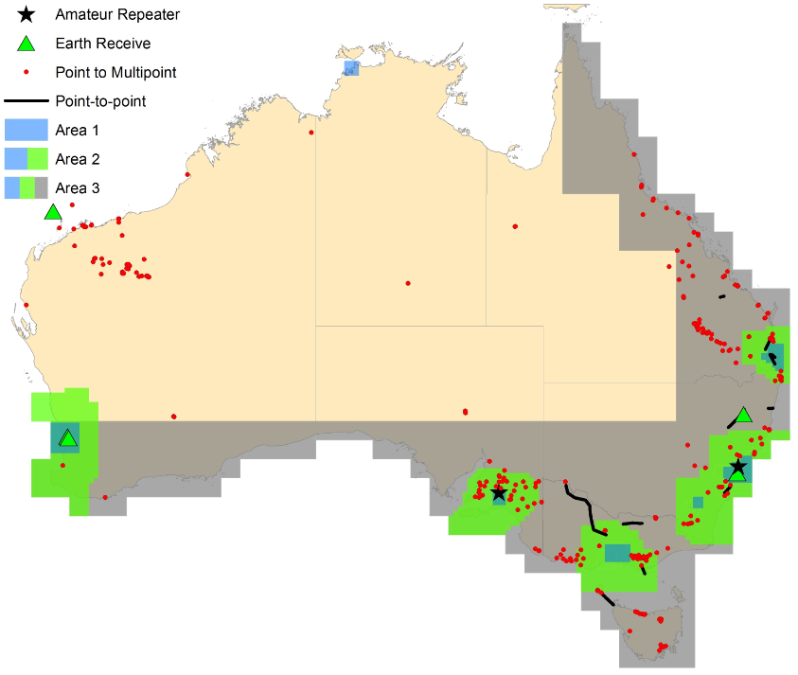

Details of current licences in the 3.6 GHz band are available in Appendix B. Table 6 shows the number of services that may be affected in each area in **Error! Reference source not found.**5. It should be noted that this is an estimate based on the number of co-channel services within the areas defined. It does not, for example, take into account any sharing arrangements that may be developed (this is discussed in the next section).

1. Number of incumbent users in different areas across the 3.6 GHz band

|  |  |  |  |  |  |  |  |  |  |  |  |  |  |  |  |  |  |  |  |  |  |  |  |  |  |  |  |  |  |  |  |  |  |  |
| --- | --- | --- | --- | --- | --- | --- | --- | --- | --- | --- | --- | --- | --- | --- | --- | --- | --- | --- | --- | --- | --- | --- | --- | --- | --- | --- | --- | --- | --- | --- | --- | --- | --- | --- |
| |  |  |  |  |  | | --- | --- | --- | --- | --- | | Licence type | Number of incumbent licences | | | | | Area 1 | Area 2 | Area 3 | Australia-wide | | Point-to-multipoint | 0 | 135 | 305 | 396 | | Point-to-point | 2 | 14 | 47 | 47 | | Earth station | 17 | 17 | 19 | 20 | | Amateur repeater | 2 | 2 | 2 | 2 | | **Total** | **21** | **168** | **373** | **465** | |

In summary, the number of incumbent services potentially affected decreases as the size of the area to be re-farmed decreases. Conversely, the ability of a licensee to deploy wide-area TDD MBB services also decreases if the area defined is too small. Both these issues need to be considered when determining the size of any area that may be subject to re-farming.

1. **If the 3.6 GHz band is re-farmed for MBB services, what geographical areas should be considered?**

### Coexistence and sharing with incumbent services

Incumbent services

It is envisaged that there will be demand for numerous incumbent services to continue operating in the 3.6 GHz band in the future. For example, if the band is re-farmed for MBB services, it may not be practical for all services to relocate to new bands or alternative means of delivery. One option to enable such services to continue operating is to implement sharing arrangements in the band.

Sharing could take many different forms. At its most basic level, it could allow certain services or licences to continue operating in the 3.6 GHz band after any re-farming has occurred. Such operation may be on a primary or secondary basis, or alternatively a multi-tiered access sharing arrangement could be developed:

* If a service type or specified licence(s) continue to operate on a primary basis, any new services would need to ensure they do not cause unacceptable interference to them. This would allow incumbent licensees to continue operating in the 3.6 GHz band unaffected by any re-farming activities.
* If a service type or specified licence(s) continue to operate on a secondary basis, they must not cause unacceptable interference to primary services. This would allow incumbent licensees to continue operating in the band, until a primary user deployed services in the same (or potentially nearby) area.

In a multi-tiered approach, primary, secondary, tertiary and potentially more levels are defined for different services types or specified licences.

Other alternatives for sharing include providing adequate geographical separation between services. This could allow an incumbent service to continue operating in the band by ensuring sufficient geographical separation with new services, or by moving it to a different location. The latter may not be a practical solution in many cases, particularly for those services that are area/location specific.

When considering if and how to implement sharing arrangements, the best solution may be different for different service types and/or licences. The ACMA is open to considering alternative options.

1. **If the 3.6 GHz band is re-farmed for MBB services, should existing users (some or all) be allowed to continue operation within the band either temporarily or on an ongoing basis? Should/could sharing arrangements be developed? Should sharing only be considered for some services or specific licences? If yes, what kind of arrangements would be suitable to support the ongoing operation of incumbent services or specific licences? If no, why?**
2. **If the 3.6 GHz band is re-farmed for MBB services, and migration of incumbent services is required, are there alternative spectrum or delivery options?**

Compatibility issues with adjacent band services below 3575 MHz

Primary services

3.4 GHz band spectrum licences are issued in the 3442.5–3575 MHz frequency range in metropolitan and regional areas across Australia. The technical framework for the 3.4 GHz spectrum licence band has been optimised for TDD MBB services. In order to manage interference and optimise use of the 3.4 GHz and 3.6 GHz bands for MBB, there is potential for the 3.4 GHz band technical framework to be modified and extended to incorporate the 3.6 GHz band.

Radiolocation services are currently licensed to operate in the 3400–3500 MHz frequency range. The ACMA will liaise with the Department of Defence to develop options for co-existence between radiolocation and MBB services.

Secondary services

Secondary services are authorised to operate on the basis that they do not cause interference to, and do not claim protection from, licensed primary services. Both amateur and FSS services operate on a secondary basis in the 3400–3600 MHz frequency range. Primary services operating under 3.4 GHz spectrum licences, as well as PTS and PMP licences in the 3400–3575 MHz, are required to coordinate with these secondary services on a ‘best efforts’ basis. However, in the event a practical solution for coexistence cannot be found, the primary service has right of way.

If the 3.6 GHz band is re-farmed for MBB, it is likely that similar ‘best efforts’ arrangements would be adopted for coordination with adjacent band secondary services.

Compatibility issues with adjacent band services above 3700 MHz

Primary services

There are 296 FSS Earth stations licensed in the 3700–4200 MHz frequency range. They are typically located in major cities or remote locations. Licensees in the band include Telstra, Optus, Intelsat, Foxtel, Inmarsat and Speedcast Australia.

Since this band is used for the Earth-receive segment of the satellite link, there is no concern about interference from FSS Earth stations to MBB services. The main interference issues are from MBB transmitters into FSS Earth station receivers; this includes adjacent band interference and blocking.

If the 3.6 GHz band is re-farmed for MBB, further consideration would be required to develop suitable co-existence arrangements between FSS Earth stations and MBB systems. There are numerous international studies that can be drawn on to assist with this work. The ACMA has also previously defined sharing criteria between fixed broadband/MBB services and C-band FSS Earth station receivers that can be considered. These are defined in the following frequency assignment documents:

* RALI FX19 — [Frequency Coordination and Licensing Procedures for apparatus licensed Broadband Wireless Access Services in the 1900–1920 and 3575–3700 MHz bands](http://www.acma.gov.au/theACMA/frequency-coordination-licensing-bwa-19001920-20102025-and-35753700-mhz-bands)
* RALI MS39 — [Frequency Coordination and Licensing Procedures for Apparatus Licensed Public Telecommunications Services in the 3.5 GHz Band](http://www.acma.gov.au/~/media/Spectrum%20Engineering/Information/Word%20Document/RALI%20MS39%20final%20docx.docx)

[Radiocommunications Advisory Guidelines (Managing Interference from Spectrum Licensed Transmitters — 3.4 GHz Band) 2015](http://www.comlaw.gov.au/Details/F2015L00728).

There are 138 point-to-point licences in the 3700–4200 MHz band. Digital Distribution and Telstra hold around 97 per cent of the licences between them. Most links are located in regional areas of Australia and used for long-range back haul.

If the 3.6 GHz band was re-farmed for MBB, there would be potential for interference both to, and from, fixed services operating in the 3700–4200 MHz band. Channel arrangements and protection criteria for point-to-point links are defined in [RALI FX3](http://www.acma.gov.au/theACMA/rali-fx3-microwave-fixed-services-frequency-coordination).

Secondary services

The ARSP defines no secondary service allocations in the 3700–4200 MHz for Australia. However, it does indicate there is a secondary radiolocation service allocation in Region 3 (the Asia–Pacific region). There is one radiolocation licence (authorised to operate over three channels) issued in remote Australia, covering various portions of the 3835–4040 MHz frequency range. If the 3.6 GHz band is re-farmed for MBB, a ‘best efforts’ arrangement would be adopted for coordination with adjacent band secondary services, though it is noted these services operate on a ‘no interference and no protection’ basis.

1. **In determining whether to re-farm the 3.6 GHz band for MBB, are there any adjacent band issues that should be considered? This includes:**
2. **the effect such use may have on adjacent band services**
3. **the effect adjacent band services may have on the utility of the 3.6 GHz band for MBB services.**

### Optimising use of the 3400–3700 MHz band

Representatives of fixed broadband and MBB interests have indicated their support for progressing the 3.6 GHz band to the *preliminary* *replanning* stage. They have also indicated that since the 3400–3575 MHz band is already available for MBB, utility of the band for MBB would be further increased if the 3575–3700 MHz band was also made available and licences across the entire range were subsequently rearranged to yield larger contiguous segments (that is, defragmented). This would require a broader review of the entire 3400–3700 MHz band, taking into account the rights of existing spectrum licence holders.

It should be noted that the progression of the 3.6 GHz band is not contingent on a review of the broader 3400–3700 MHz band occurring. However, depending on progress in the 3.6 GHz band, the ACMA considers there may be benefit in running a separate future process to reconfigure spectrum arrangements and consolidate spectrum holdings in the broader 3400–3700 MHz band. However, any such undertaking would require support and involvement from existing spectrum and apparatus licensees to implement.

Although this would be a separate process, such a review may be facilitated by aligning, as far as possible, the definition of any geographical boundaries in the 3.6 GHz band with existing boundaries defined for spectrum and apparatus-licensing in the 3400–3575 MHz band—the idea being that trading and the re-arranging of spectrum holdings in the broader 3400–3700 MHz frequency range could be better facilitated.

1. **If the 3.6 GHz band is re-farmed for MBB services, should the ACMA review arrangements in the broader 3400–3700 MHz band? Why/Why not?**
2. **Would such a review be facilitated through the alignment of geographical boundaries in the 3.6 GHz band with existing boundaries defined for spectrum and apparatus licensing in the 3400–3575 MHz band (that is, to facilitate trading)?**
3. **Is there anything else that could be considered as part of the 3.6 GHz band process that may facilitate a future review of the broader 3400–3700 MHz frequency range?**

## Preliminary assessment of the highest value use of the 3.6 GHz band

It is acknowledged that arrangements for MBB already exist in regional and remote areas of Australia in the 3.6 GHz band, these being the arrangements in place for point-to-multipoint licences. These are site-based licences with low density deployments, typically providing services over a small area or multiple small areas. Highest-value use in this case relates to whether areas should be re-farmed to allow for the rollout of high-density MBB services. The answer may differ between areas in that any change in highest-value use might be confined to metropolitan areas, or might extend into regional and remote areas. Any re-farming in this sense has the potential to affect all incumbent licensees, including point-to-multipoint licensees.

Based on this, a preliminary assessment of the highest-value use of the 3.6 GHz band is provided in Appendix C. After consideration of the preliminary assessment, the ACMA believes that the highest-value use of the band may be changing in some areas. Further consideration is proposed to assess this in detail. This includes determining whether to re-farm some or all of the 3.6 GHz band for MBB, and exactly which areas this should encompass. It is therefore proposed to progress consideration of the 3.6 GHz band for MBB to the *preliminary replanning* stage of the ACMA’s process for consideration of additional spectrum for MBB services.

1. **Comment is sought on the ACMA’s proposal to progress the 3.6 GHz band to the *preliminary re-planning* stage of its process for consideration of additional spectrum for MBB services, as detailed in the ACMA’s** [**mobile broadband strategy**](http://www.acma.gov.au/~/media/Spectrum%20Transformation%20and%20Government/Issue%20for%20comment/IFC%2022%202015/MBB%20strategyThe%20ACMAs%20spectrum%20management%20strategy%20to%20address%20the%20growth%20in%20mobile%20broadband%20capacity%20docx.docx)**.**

As part of the work conducted at the *preliminary replanning* stage, the ACMA would conduct a comprehensive assessment of the highest-value use for the 3.6 GHz band.

1. **To assist the ACMA in conducting a comprehensive assessment of the highest-value use for the 3.6 GHz band, responses to the following questions are requested:**
2. **Do you see increasing demand for fixed broadband/MBB services in the 3.6 GHz band? What benefits do you envision from using the band for fixed broadband/MBB services?**
3. **Which regions of Australia will be in demand for fixed broadband/MBB services in the 3.6 GHz band?**
4. **Is demand the same or similar across regions, or are some regions/areas more likely to be in demand for MBB providers?**
5. **Do incumbent 3.6 GHz band licensees require ongoing access to the band, or are there plans to cease operation at some future point?**
6. **Do other options exist for the delivery of fixed, fixed-satellite and amateur incumbent services, how practical are they? What are the costs involved? Will there be a diminution of the service delivered if MBB services are introduced in the band?**
7. **Should further consideration be given to the migration of incumbent 3.6 GHz band FSS earth stations to low density population areas?**

# Invitation to comment

## Making a submission

The ACMA invites comments on the issues set out in this discussion paper or any other issues relevant to the future use of the 1.5 GHz and 3.6 GHz bands.

* + [**Online submissions**](http://www.acma.gov.au/theACMA/Consultations/Consultations)—submissions can be made via the comment function or by uploading a document. The online consultation page provides details.
  + **Submissions by post**—can be sent to:

The Manager

Spectrum Planning Section

Spectrum Infrastructure Branch

Australian Communications and Media Authority

PO Box 78

Belconnen ACT 2616

**The closing date for submissions is COB, Friday 25 November 2016.**

Electronic submissions in Microsoft Word or Rich Text Format are preferred.

Enquiries

* + Consultation enquiries can be emailed to [freqplan@acma.gov.au](mailto:freqplan@acma.gov.au).
  + Media enquiries can be directed to Emma Rossi on 02 9334 7719 or by email to [media@acma.gov.au](mailto:media@acma.gov.au).

Effective consultation

The ACMA is working to enhance the effectiveness of its stakeholder consultation processes, which are an important source of evidence for its regulatory development activities. To assist stakeholders in formulating submissions to its formal, written consultation processes, it has developed [*Effective consultation—a guide to making a submission*](http://www.acma.gov.au/theACMA/About/Corporate/Responsibilities/acma-evidenceinformed-regulation-and-effective-consultation). This guide provides information about the ACMA’s formal written public consultation processes and practical guidance on how to make a submission.

Publication of submissions

In general, the ACMA publishes all submissions it receives. The ACMA prefers to receive submissions that are not claimed to be confidential. However, the ACMA accepts that a submitter may sometimes wish to provide information in confidence. In these circumstances, submitters are asked to identify the material over which confidentiality is claimed and provide a written explanation for the claim.

The ACMA will consider each confidentiality claim on a case-by-case basis. If the ACMA accepts a claim, it will not publish the confidential information unless authorised or required by law to do so.

Release of submissions where authorised or required by law

Any submissions provided to the ACMA may be released under the [*Freedom of Information Act 1982*](https://www.comlaw.gov.au/Series/C2004A02562) (unless an exemption applies) or shared with various other government agencies and certain other parties under Part 7A of the [*Australian Communications and Media Authority Act 2005*](https://www.comlaw.gov.au/Series/C2005A00044). The ACMA may also be required to release submissions for other reasons including for the purpose of parliamentary processes or where otherwise required by law (for example, under a court subpoena). While the ACMA seeks to consult submitters of confidential information before that information is provided to another party, the ACMA cannot guarantee that confidential information will not be released through these or other legal means.

Privacy

The [*Privacy Act 1988*](http://www.comlaw.gov.au/Series/C2004A03712) imposes obligations on the ACMA in relation to the collection, security, quality, access, use and disclosure of personal information. These obligations are detailed in the [*Australian Privacy Principles*](http://www.oaic.gov.au/privacy/privacy-resources/privacy-fact-sheets/other/privacy-fact-sheet-17-australian-privacy-principles).

The ACMA may only collect personal information if it is reasonably necessary for, or directly related to, one or more of its functions or activities.

The purposes for which personal information is being collected (such as the names and contact details of submitters) are to:

* contribute to the transparency of the consultation process by clarifying, where appropriate, whose views are represented by a submission

enable the ACMA to contact submitters where follow-up is required or to notify them of related matters (except where submitters indicate they do not wish to be notified of such matters).

The ACMA will not use the personal information collected for any other purpose, unless the submitter has provided their consent or the ACMA is otherwise permitted to do so under the Privacy Act.

Submissions in response to this paper are voluntary. As mentioned above, the ACMA generally publishes all submissions it receives, including any personal information in the submissions. If a submitter has made a confidentiality claim over personal information that the ACMA has accepted, the submission will be published without that information. The ACMA will not release the personal information unless authorised or required by law to do so.

If a submitter wishes to make a submission anonymously or use a pseudonym, they are asked to contact the ACMA to see whether it is practicable to do so in light of the subject matter of the consultation. If it is practicable, the ACMA will notify the submitter of any procedures that need to be followed and whether there are any other consequences of making a submission in that way.

Further information on the Privacy Act and the ACMA’s privacy policy is available at [www.acma.gov.au/privacypolicy](http://www.acma.gov.au/privacypolicy). The privacy policy contains details about how an individual may access personal information about them that is held by the ACMA, and seek the correction of such information. It also explains how an individual may complain about a breach of the Privacy Act and how the ACMA will deal with such a complaint.

# Appendix A—Current use of the 1.5 GHz band

Table A1 shows the total number of licences by service type in the 1427–1518 MHz band from the 1 September 2016 Register of Radiocommunications Licences.

Table A1: Number of licences by service type in the 1.5 GHz band (RRL Extract 1 September 2016)

|  |  |
| --- | --- |
| Service | # Licences |
| Point-to-multipoint | 1,546 |
| Point-to-point | 4,698 |
| Fixed receive | 12 |
| Aircraft assigned | 5 |
| Aeronautical assigned system | 2 |
| Radiodetermination | 1 |

More detail on these services is provided in this Appendix. Fixed receive, aircraft assigned, aeronautical assigned system and radiodetermination licences are discussed in the section *Defence aeronautical usage*. Fixed point-to-point and point-to-multipoint usage is discussed in the section *Fixed services*.

## Defence aeronautical usage

Figure A1 below shows a map of the 12 fixed receive and one radiodetermination licences in the 1.5 GHz band and Figure A2 shows the frequency assignments for these services. These licences are all held by the Department of Defence. There are also two aeronautical assigned systems, which are licensed for the Australian Aero licence area and five aircraft assigned licences, one of which is an Australia-wide licence, while the remainder cover the states of NSW, NT, WA and SA respectively.

Figure A1: Defence fixed receive and radiodetermination licences in the 1.5 GHz band

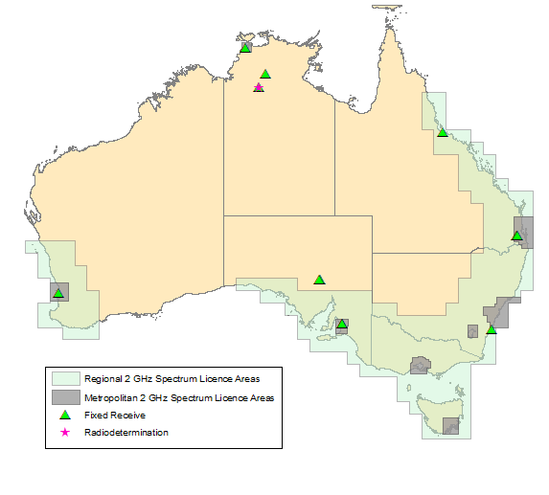

Figure A2: Defence aeronautical usages (frequency assignments) in the 1.5 GHz band

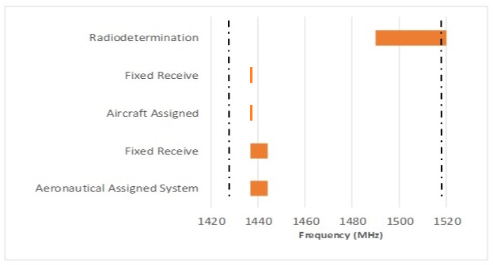

## Fixed services

This analysis uses data taken from the 1 September 2016 Register of Radiocommunications Licences. Only fixed services are considered in this section. The areas used in this exercise are modelled on those used for the 2 GHz spectrum licences. The 10 defined areas comprise eight metropolitan areas covering the state and territory capitals, one regional area surrounding Perth, denoted as ‘West Australia’ and a second regional area, denoted as ‘East Australia’, which follows the coast from north of Cairns to half way through the Great Australian Bight. The remainder of Australia is not in an explicitly-defined area, however it will be referred to as ‘Remote Australia’. Figure A3 shows the metropolitan and regional 2 GHz spectrum licence areas.

Figure A3: 2 GHz spectrum licence areas used in analysis of 1.5 GHz band fixed service usage

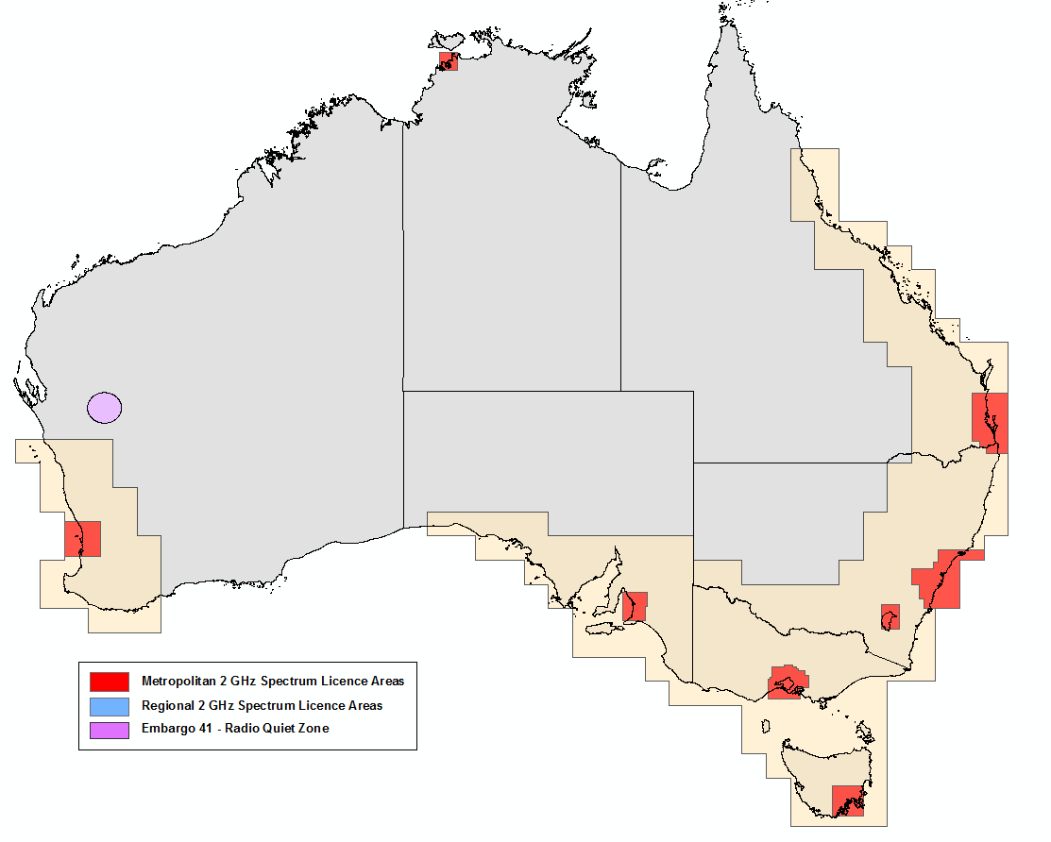

Figure A4 below illustrates the geographical location of point-to-point services in the 1.5 GHz band for the areas described above. Figure A5 below illustrates the geographical location of point-to-multipoint services in the 1.5 GHz band for the areas described above.

Figure A4: Fixed point-to-points links in the 1.5 GHz band

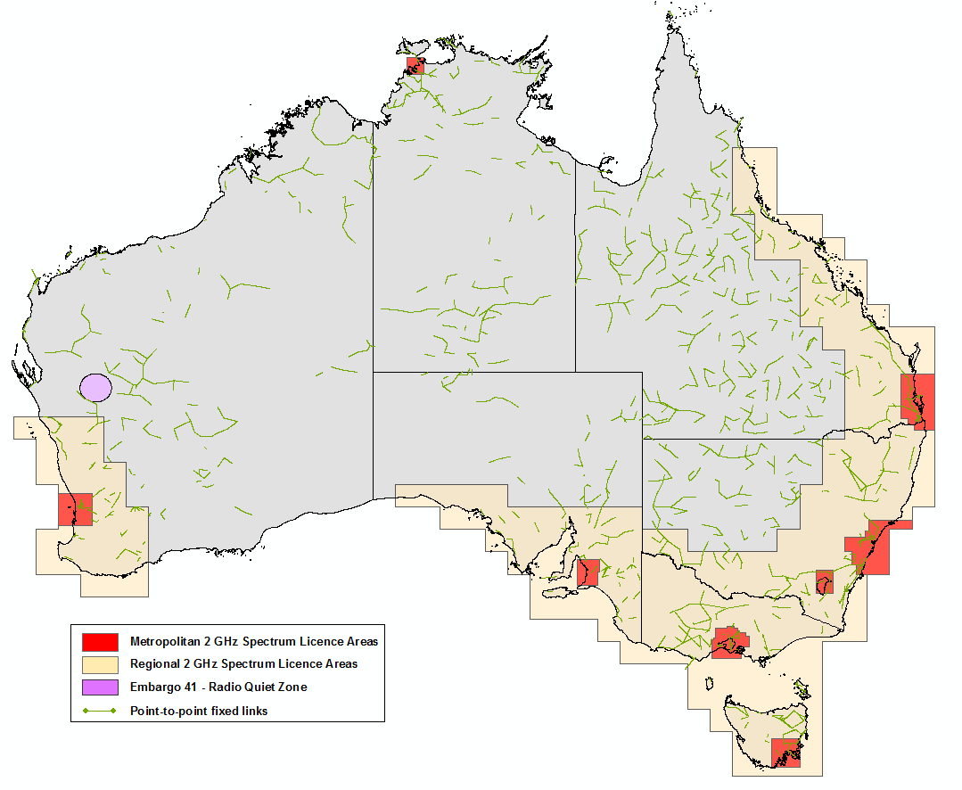

Figure A5: Point-to-multipoint services in the 1.5 GHz band

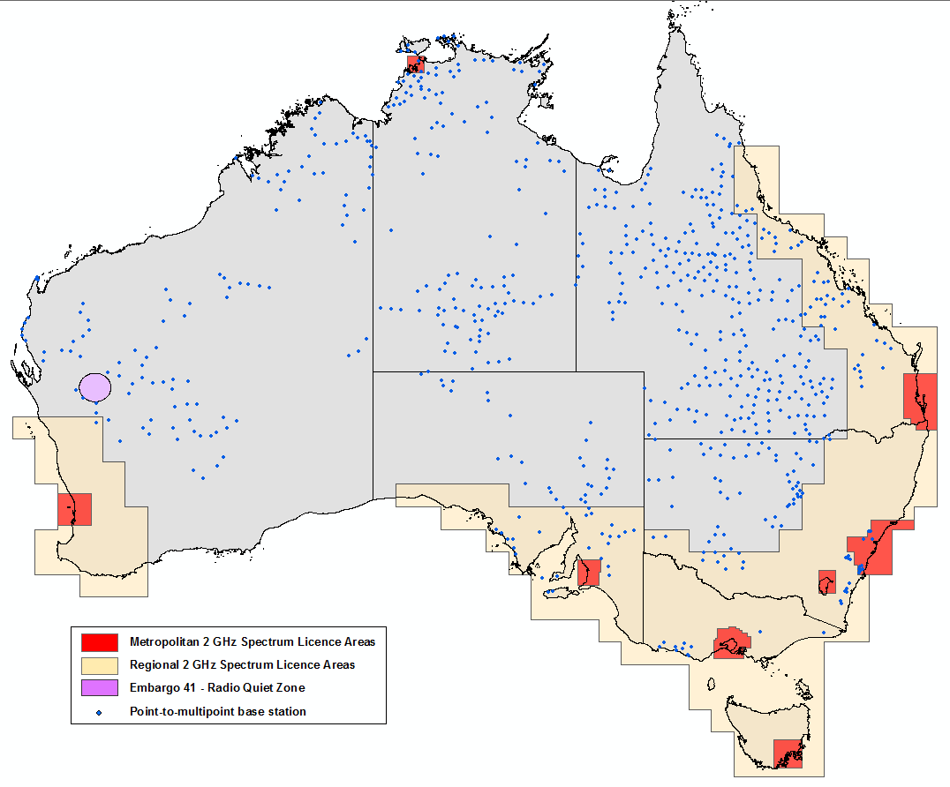

Table A2: Fixed services in the 1.5 GHz band, as at 1 September 2016*

|  | Metropolitan | | | | | | | | | Regional | | | Remote |
| --- | --- | --- | --- | --- | --- | --- | --- | --- | --- | --- | --- | --- | --- |
|  | Adelaide | Brisbane | Canberra | Darwin | Hobart | Melbourne | Perth | Sydney | Total metropolitan | West Australia | East Australia | Total Regional | Remote Australia | Total |
| Whole band  1427–1518 MHz | 10 | 65 | 13 | 15 | 28 | 31 | 44 | 113 | 319 (5.1%) | 161 | 1,483 | 1,644 (26.5%) | 4,252 (68.4%) | 6,215 |
| 3GPP bands 11 and 21  1427.9–1462.9MHz/ 1475.9–1510.9 MHz | 10 | 57 | 13 | 14 | 28 | 23 | 40 | 102 | 287 (5.1%) | 155 | 1,387 | 1,542 (27.3%) | 3,811 (67.6%) | 5,640 |
| 1452–1492 MHz | 0 | 21 | 4 | 3 | 0 | 9 | 15 | 16 | 68 (6.6%) | 21 | 178 | 199 (19.4%) | 761 (74.0%) | 1,028 |
| 3GPP band 45  1447–1467 MHz | 1 | 20 | 5 | 3 | 1 | 11 | 9 | 22 | 72 (5.4%) | 282 | 36 | 318 (24.2%) | 925 (70.3%) | 1,315 |

*\* It should be noted that an FDD point-to-point link is considered to be* ***two*** *services as it consists of two transmit frequencies.*

Table A2 shows the number of point-to-point and point-to-multipoint fixed services in the 1427–1518 MHz band, as well as various segments discussed in the section *Potential spectrum options*. It also shows that from an area perspective, the majority of services are found in regional and remote Australia, with only 5.1 per cent of services located within metropolitan areas.

To show the distribution of licences across the 1.5 GHz band, an analysis was conducted to determine the number of licences in each 5 MHz segment of the band. The results are shown in Table A3.

Table A3: Fixed services in each 5 MHz segment of the 1.5 GHz band, as of 1 September 2016

|  | Metropolitan | | | | | | | | | Regional | | | *Remote Australia* |
| --- | --- | --- | --- | --- | --- | --- | --- | --- | --- | --- | --- | --- | --- |
|  | Adelaide | Brisbane | Canberra | Darwin | Hobart | Melbourne | Perth | Sydney | *Total metropolitan* | West Australia | East Australia | *Total regional* | Total |
| 1427–1432 MHz | 0 | 4 | 0 | 2 | 0 | 0 | 5 | 3 | *14* | 8 | 64 | *72* | *122* | 208  (3.3%) |
| 1432–1437 MHz | 4 | 14 | 1 | 5 | 8 | 0 | 12 | 13 | *57* | 34 | 288 | *322* | *644* | 1,023 (16.5%) |
| 1437–1442 MHz | 2 | 8 | 1 | 3 | 9 | 4 | 7 | 22 | *56* | 29 | 225 | *254* | *489* | 799 (12.9%) |
| 1442–1447 MHz | 1 | 7 | 3 | 2 | 6 | 6 | 3 | 26 | *54* | 38 | 255 | *293* | *674* | 1,021 (16.4%) |
| 1447–1452 MHz | 1 | 7 | 3 | 2 | 1 | 4 | 3 | 15 | *36* | 25 | 185 | *210* | *462* | 708 (11.4%) |
| 1452–1457 MHz | 0 | 6 | 2 | 0 | 0 | 4 | 4 | 10 | *26* | 4 | 94 | *98* | *421* | 545 (8.8%) |
| 1457–1462 MHz | 0 | 9 | 0 | 0 | 0 | 5 | 4 | 5 | *23* | 5 | 57 | *62* | *157* | 242 (3.9%) |
| 1462–1467 MHz | 0 | 9 | 2 | 1 | 0 | 5 | 4 | 4 | *25* | 9 | 37 | *46* | *130* | 201 (3.2%) |
| 1467–1472 MHz | 0 | 4 | 0 | 1 | 0 | 0 | 2 | 2 | *9* | 4 | 10 | *14* | *35* | 58 (0.9%) |
| 1472–1477 MHz | 0 | 0 | 0 | 0 | 0 | 0 | 2 | 2 | *4* | 0 | 0 | *0* | *6* | 10 (0.2%) |
| 1477–1482 MHz | 0 | 0 | 0 | 0 | 0 | 0 | 0 | 0 | *0* | 0 | 0 | *0* | *12* | 12 (0.2%) |
| 1482–1487 MHz | 0 | 0 | 0 | 0 | 0 | 0 | 0 | 0 | *0* | 0 | 0 | *0* | *18* | 18 (0.3%) |
| 1487–1492 MHz | 0 | 4 | 0 | 2 | 0 | 0 | 5 | 0 | *11* | 8 | 43 | *51* | *132* | 194 (3.1%) |
| 1492–1497 MHz | 4 | 14 | 0 | 4 | 8 | 2 | 12 | 10 | *54* | 34 | 264 | *298* | *648* | 1,000 (16.0%) |
| 1497–1502 MHz | 4 | 12 | 1 | 3 | 13 | 4 | 9 | 18 | *64* | 39 | 317 | *356* | *675* | 1,095 (17.6%) |
| 1502–1507 MHz | 1 | 7 | 3 | 2 | 6 | 6 | 3 | 22 | *50* | 38 | 253 | *291* | *688* | 1,029 (16.6%) |
| 1507–1512 MHz | 1 | 7 | 4 | 2 | 1 | 6 | 3 | 20 | *44* | 25 | 227 | *252* | *638* | 934 (15.0%) |
| 1512–1518 MHz* | 0 | 6 | 2 | 0 | 0 | 8 | 4 | 12 | *32* | 4 | 119 | *123* | *421* | 576 (9.3%) |
| **Area totals#** | **10** | **65** | **13** | **15** | **28** | **31** | **44** | **113** | ***319*** | **161** | **1,483** | ***1,644*** | ***4,252*** | **6,215** |

* *Note this segment is 6 MHz.*

*# Note area totals are not the sum of preceding rows since a fixed licence bandwidth may straddle two frequency ranges, in which case, it is counted in both ranges.*

The results in Table A3 show that the 1452–1492 MHz band is much less utilised than other parts of the band, particularly in metropolitan areas. Two main factors contribute to this. Firstly, historic planning arrangements reserved that section of the band for DSB. Secondly, the spectral location of the mid-band gap for both the point-to-point and point-to-multipoint channel plans overlaps this section of the band.

# Appendix B—Current use of the 3.6 GHz band

## Licence overview

An indication of the different licence types and locations of services in the 3.6 GHz band is contained in Table B1 and Figure B1 (based on data taken from the 7 July 2016 Register of Radiocommunications Licences (RRL)).

In the event that the 3.6 GHz band is re-farmed for MBB, the ACMA has performed work to determine the number and type of licences that may be affected for four different geographical area options. The areas are displayed in **Error! Reference source not found.** and a brief definition is provided below. The results of the analysis are displayed in Table B2, Figure and Figure .

* Area 1—this mirrors the areas specified in [Embargo 42](http://www.acma.gov.au/Industry/Spectrum/Radiocomms-licensing/Class-licences/spectrum-embargoes-spectrum-planning-acma).
* Area 2—this mirrors the areas developed by the ACMA in implementing the [October 2014 Ministerial Direction](https://www.legislation.gov.au/Details/F2014L01399). The areas were defined large enough to support the deployment of service to outer metro and fringe areas, while minimising adjacent area interference concerns. Refer to [Annex D of RALI MS39](http://www.acma.gov.au/~/media/Spectrum%20Engineering/Information/Word%20Document/RALI%20MS39%20final%20docx.docx) for area descriptions.
* Area 3—this mirrors the metro and regional areas subject to spectrum licensing in the 3.4 GHz band. Refer to Schedule 2 of the [Radiocommunications (Spectrum Re-allocation) Declaration 2000](http://auction.acma.gov.au/auction_results/3.4ghz_results_page/34_pdf/aip_pdf/re-allocation.pdf) for a description of the area.

Area 4—this area covers all of Australia.

### Embargoes

There are four embargoes currently in effect that cover all or part of the 3.6 GHz band:

* [Embargo 41](http://www.acma.gov.au/~/media/Spectrum%20Engineering/Regulation/pdf/Embargo%20No%2041.pdf): This embargo covers the 70 MHz–25.25 GHz frequency range. It was established to create a radio quiet zone near Boolardy Station in Western Australia to facilitate the development and use of new radio astronomy technologies.
* [Embargo 42](http://www.acma.gov.au/webwr/radcomm/frequency_planning/spectrum_embargoes/emb42.pdf): This embargo covers the 3575–3710 MHz frequency range. It was put in place in September 2005 while future planning options for the band were being considered under the ACMA’s [*Strategies for Wireless Access Services*](http://www.acma.gov.au/webwr/_assets/main/lib100639/was_discussion_paper_feb_06.pdf) consultation process. In 2009, the ACMA made the decision to make the 3575–3700 MHz frequency range available for MBB services in regional and remote areas of Australia. The embargo was subsequently modified to support this outcome. However, restrictions still apply Australia-wide to the issue of new licences for point-to-point links and FSS earth stations.
* [Embargo 49](http://www.acma.gov.au/webwr/radcomm/frequency_planning/spectrum_embargoes/emb42.pdf): This embargo covers numerous frequency ranges used by satellite, space research and radio astronomy services. This includes the 3400–4200 MHz frequency range. The embargo limits the deployment of services other than satellite, space research and radio astronomy services operating in the 3400–4200 MHz frequency range, within 150 kilometres of a location near Mingenew in Western Australia.
* [Embargo 52](http://www.acma.gov.au/webwr/radcomm/frequency_planning/spectrum_embargoes/embargo_52.pdf): This embargo covers the 3400–3575 MHz and 3600–3700 MHz frequency ranges within the Woomera Prohibited Area (WPA). It was created to facilitate the ongoing use of the WPA by the Department of Defence.

Table B1: Breakdown of licences in the 3.6 GHz band (RRL extract, 7 July 2016)

|  |  |  |  |
| --- | --- | --- | --- |
| Licence type | Number of licences | Number of sites | Major licensees  (number of licences) |
| Earth receive | 21 | 11 | Telstra (9), Inmarsat (6), Optus (2) |
| Point-to-multipoint | 388 | 280 | Aus Pacific LNG (43), Rio Tinto (34), Aussie Broadband (32), QEStel (29), Agile (25), Dep Transport Qld (19), Tasmanet (19) |
| Point-to-point | 47 | 33 | Digital Distributions Australia (37), Telstra (7) |
| Amateur repeater | 2 | 2 | Elizabeth Amateur Radio Club (1),  Central Coast Amateur Radio Club (1) |

**Figure B1: Location of embargoed areas and licenced services in the 3.6 GHz band (RRL extract, 7 July 2016)**

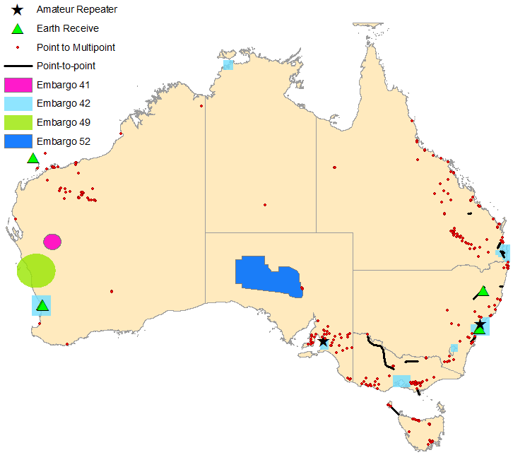

Table B2: Breakdown of licences in the 3.6 GHz band by Area (RRL extract, 7 July 2016)

| Area | | All licences | Point-to-multipoint | Point-to-point | Amateur repeater | Earth receive |
| --- | --- | --- | --- | --- | --- | --- |
| **Area 1** | Adelaide | 1 | 0 | 0 | 1 | 0 |
| Brisbane | 2 | 0 | 2 | 0 | 0 |
| Canberra | 0 | 0 | 0 | 0 | 0 |
| Darwin | 0 | 0 | 0 | 0 | 0 |
| Melbourne | 0 | 0 | 0 | 0 | 0 |
| Perth | 13 | 0 | 0 | 0 | 13 |
| Sydney | 5 | 0 | 0 | 1 | 4 |
| Total | 21 | 0 | 2 | 2 | 17 |
| **Area 2** | Adelaide + Buffer | 36 | 35 | 0 | 1 | 0 |
| Brisbane + Buffer | 25 | 22 | 3 | 0 | 0 |
| Canberra + Buffer | 36 | 25 | 6 | 1 | 4 |
| Melbourne + Buffer | 47 | 44 | 3 | 0 | 0 |
| Perth + Buffer | 14 | 1 | 0 | 0 | 13 |
| Total | 160 | 127 | 14 | 2 | 17 |
| **Area 3** | Regional (minus Area 2) | 213 | 178 | 33 | 0 | 2 |
| Regional (including Area 2) | 373 | 305 | 47 | 2 | 19 |
| **Area 4** | Remote (minus Area 3) | 85 | 83 | 0 | 0 | 2 |
| Australia-wide | 458 | 388 | 47 | 2 | 21 |

**Figure B2: Number of licences per 5 MHz channel and area in the 3.6 GHz band Top figure=Area 1, Bottom figure=Area 2**

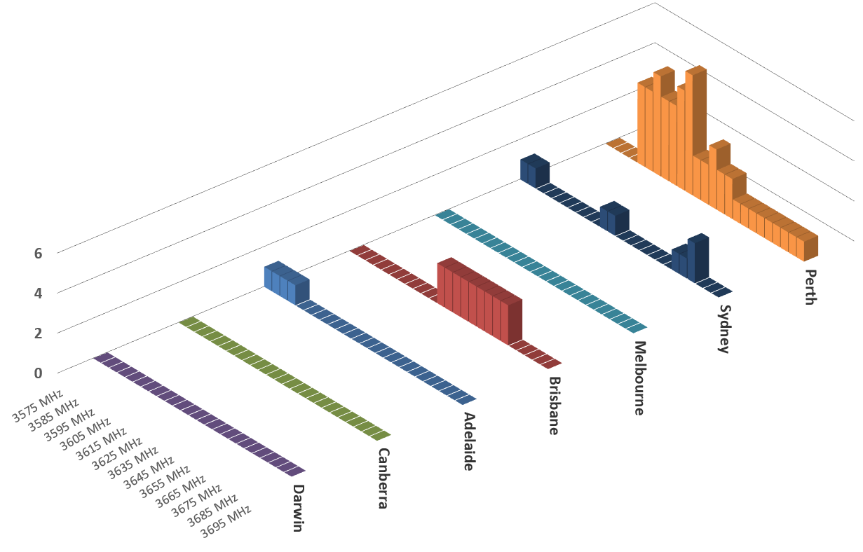

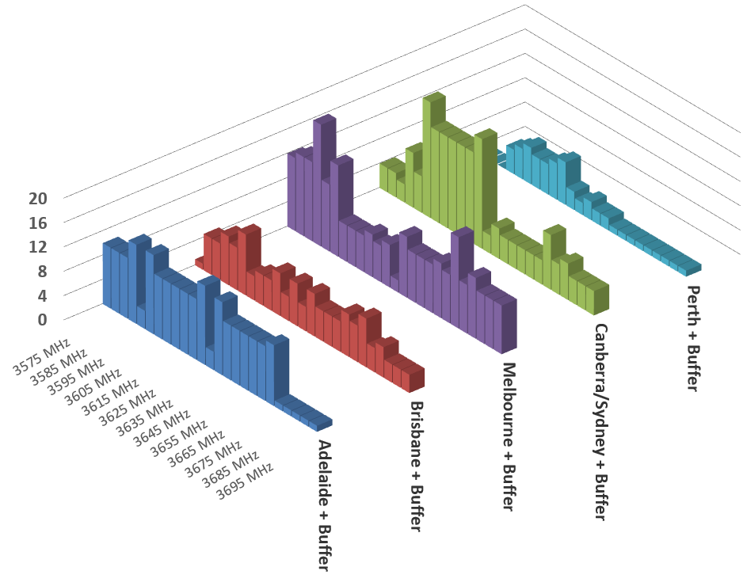

**Figure B3: Number of licences per 5 MHz channel in regional and remote areas in the 3.6 GHz band**

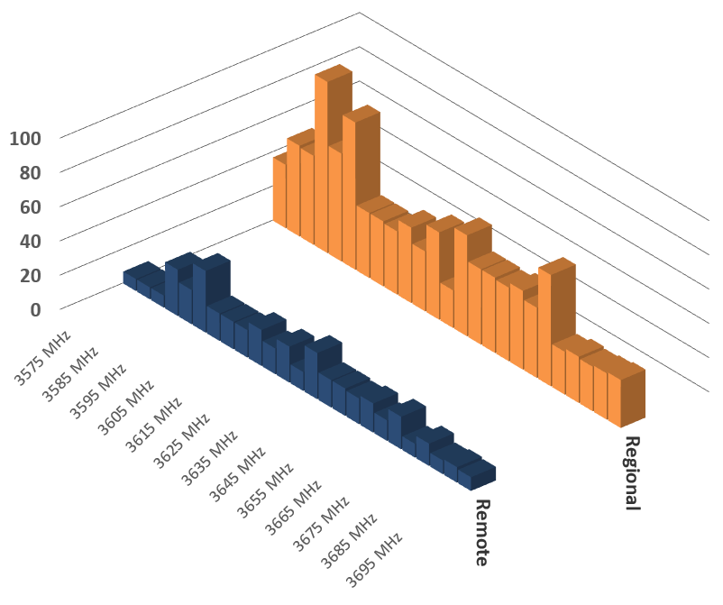

# Appendix C—Preliminary assessments of the highest-value use of the 1.5 GHz and 3.6 GHz bands

The 1.5 GHz and 3.6 GHz bands are currently in the *initial investigation* stage of the ACMA’s [mobile broadband strategy](http://www.acma.gov.au/~/media/Spectrum%20Transformation%20and%20Government/Issue%20for%20comment/IFC%2022%202015/MBB%20strategyThe%20ACMAs%20spectrum%20management%20strategy%20to%20address%20the%20growth%20in%20mobile%20broadband%20capacity%20docx.docx). As part of the work conducted at thisstage, the ACMA performs a simple preliminary assessment of the highest-value use of the band. It was envisaged in the ACMA’s [mobile broadband strategy](http://www.acma.gov.au/~/media/Spectrum%20Transformation%20and%20Government/Issue%20for%20comment/IFC%2022%202015/MBB%20strategyThe%20ACMAs%20spectrum%20management%20strategy%20to%20address%20the%20growth%20in%20mobile%20broadband%20capacity%20docx.docx) that at this stage the assessment would be mainly qualitative. However, quantitative elements could be included where available. The preliminary assessment of the highest-value use of the band will include consideration of issues such as relocation or retuning costs for incumbent users, and any detrimental effects to service delivery that a change in use of the band may cause. As noted in the ACMA’s [mobile broadband strategy](http://www.acma.gov.au/~/media/Spectrum%20Transformation%20and%20Government/Issue%20for%20comment/IFC%2022%202015/MBB%20strategyThe%20ACMAs%20spectrum%20management%20strategy%20to%20address%20the%20growth%20in%20mobile%20broadband%20capacity%20docx.docx), the highest-value use may vary across different geographical areas.

Based on the outcome of this assessment, a decision is made on whether or not to progress to the *preliminary re-planning* stage. A comprehensive assessment of the highest-value use is performed at this stage.

## Elements to be considered in assessments of highest-value use

A key aspect of the ACMA’s work is to encourage and enable spectrum to move to its highest-value use or uses. When assessing the optimal approach for individual bands, the ACMA uses a total welfare standard as its overarching framework. As such, in considering the highest-value use (HVU) for a given spectrum band, the ACMA endeavours to consider the impact that a change in use would have on all parties in the economy. Importantly, this will include not only an assessment of those costs and benefits that can be readily quantified monetarily, but also those costs/benefits that are more intangible and may be harder to quantify.

### Benefits, costs and externalities

There are two chief types of potential benefits that result from the re-farming of spectrum:

1. additional revenues or lowering costs for producers providing new services using the re-farmed spectrum (that is, an increase in producer surplus)

reduction in price of services, or new or increased quality of services being rolled out (that is, an increase in consumer surplus).[31]

There are two types of potential costs that result from the re-farming of spectrum:

1. an increase in costs for incumbent providers (that is, a reduction in producer surplus)

an increase in the prices of services provided by incumbent spectrum users, or a degradation in quality of services (that is, a reduction in consumer surplus).[32]

In addition, spectrum is an input into many services that generate benefits beyond those enjoyed by the individuals that use the services. In the economic literature, these broader social benefits and costs are referred to as ‘externalities’. An externality arises when the welfare of a person not party to a transaction is affected by the transaction.

### Analysis required under constant- and variable-output cases

It should be noted that it is not always necessary to consider all of the elements outlined above in every case of spectrum re-farming. In many cases, spectrum re-farming decisions will affect only the relative cost of delivering certain services or the price at which the services are supplied. In these cases, the outputs of all affected parties—both those parties losing spectrum and those parties gaining spectrum—do not change. It is for this reason that these cases are referred in the literature as ‘constant output cases’.[33]

In constant output cases, the provider of the existing service is able to fully mitigate the impact of the change in spectrum use, albeit at an increased cost of supply. They do this by using some combination of different spectrum, additional network investment, and/or increased use of other inputs and methods of supply. This is a crucial point—constant output cases do not always depend upon the availability of equivalent spectrum. The same or very similar output may be able to be achieved using non-spectrum options. Similarly, the new service uses the additional spectrum to provide the same output at lower cost.

In these cases, given the services are unaffected, there is no need to estimate the impact of the proposed change in allocation on the benefits to consumers and citizens from either service, and hence, there is no need to consider changes in private value or broader social value for either service. In these cases, it will be sufficient to only evaluate the cost implications of the reform, and it will not be necessary or appropriate to determine how much society values the existence of the service.

In contrast, there may be cases where spectrum re-farming will disallow the incumbent service (at risk of losing spectrum) being able to continue at all, or to significantly alter the output or quality of the service being offered. In order for this to be the case, there has to be no close substitute to the spectrum available (that is, either other spectrum or other communications platforms). Such cases are referred to as ‘variable output’ cases. In such variable output cases, the analysis is more complex, in that it is necessary to estimate the impacts on consumer surplus and externalities, as well as the usual cost/producer surplus impacts.

## Preliminary assessments of HVU

The analysis performed in this appendix is intended to be a *preliminary assessment of HVU* for the 1.5 GHz and 3.6 GHz bands. For this reason, it is mainly a qualitative assessment. If it is decided to progress consideration of the 1.5 GHz and/or 3.6 GHz band to the *preliminary re-planning* stage of the ACMA’s process for consideration of additional spectrum for MBB services, it is intended that a *comprehensive assessment of HVU* will be performed to inform progression to the *re-farming* stage.

Given international trends in the 1.5 GHz and 3.6 GHz bands, the preliminary assessment of highest-value use in this appendix has been conducted, assuming that fixed broadband or MBB services will be the new user of the band should it be re-farmed. However, it is noted that under current arrangements, spectrum is typically allocated on a technology-flexible basis.

## 1.5 GHz Preliminary assessment of HVU

### Indicators of potential change in HVU

Domestically, representatives of the MBB community have indicated interest in accessing the 1.5 GHz band, particularly in metropolitan and major regional areas. As discussed in the 1.5 GHz band *International arrangements* section, the band is already used or allocated for MBB services in a number of countries. There is growing interest for deployment of MBB services in this band internationally, following identification of this band for IMT at WRC-15. Such developments suggests that a viable MBB equipment ecosystem will develop in the 1.5 GHz band.

### Potential benefits of spectrum re-farming

There are a number of potential benefits that could be realised if the 1.5 GHz band is re-farmed for MBB services. An overview of some of the more significant benefits follows:

* Mobile network operators have three broad techniques available to them to address the continued growth in MBB capacity. These techniques involve deploying increasingly spectrally-efficient technologies, increasing the amount of spectrum used, and deploying appropriate network infrastructure and topologies (including more base station sites). Various combinations of the three techniques have been used to meet the growth in demand for MBB capacity to date.

Although these techniques are partially substitutable, there can be substantially different intricacies and costs involved for each. For example, there can be numerous public sensitivities and legal hurdles, as well as significant costs involved in gaining access to more sites to increase network densification. In situations where the complexities and costs involved in gaining access to new sites is high, obtaining access to more spectrum to increase network capacity may be seen as a more favourable solution. The potential benefits realised in such cases are reduced costs to carriers to provide greater MBB capacity.

* Identifying spectrum for MBB that is both internationally harmonised and aligns with technology standards is important to the ultimate success of a frequency band. International spectrum harmonisation and technology standardisation generate economies of scale, reducing the price of equipment for both network operators and consumers. They also provide greater global roaming opportunities for consumers, allowing the same handset to be operated on networks in many different countries.
* When considering the highest-value use of a band, it is important to take into account the value of the service to consumers beyond the price paid. This is called the ‘consumer surplus’. Access to more spectrum could allow mobile operators to deploy higher quality services and provide higher peak and average data rates at a similar price, resulting in an increase in consumer surplus. It is also possible that an allocation of additional spectrum could be used to allow for lower prices by reducing cost structure, again leading to an increase in consumer surplus.

Up to 90 MHz of spectrum could be made available in the 1.5 GHz band for MBB in metropolitan and regional areas. This has the potential to improve competition in the MBB market by providing incumbent and with access to considerable amounts of spectrum in key market areas.

### Potential costs of spectrum re-farming—Incumbency considerations

There are a number of incumbent services operating in the 1.5 GHz band. Depending on the frequency range and geographical area considered, a varying number of incumbent licenses may be affected by a decision to re-farm the 1.5 GHz band. This number also depends on the type of re-planning arrangements implemented. For example, in the event sharing arrangements are developed, it is possible that no or few licensees would be affected.

If a decision was made to relocate incumbent services in specified areas, any options available (including associated costs) for licensees to continue to deliver their service need to be considered. In some cases, a licensee may already have plans to wind down and decommission their service. However, many licensees are likely to have a desire to continue delivering existing services.

A simple analysis of the effect on incumbent services and alternative delivery options available follows:

* The band is used extensively for fixed services concentrated in regional and remote areas. In areas where the band is re-farmed for MBB services, services may potentially be able to be migrated to new or existing mobile networks. The effect of re-farming on fixed services could also be minimised by limiting it to metropolitan areas.
* The use of the band by the Department of Defence for aeronautical mobile telemetry is expected to continue in the 1.5 GHz band. However, given the limited geographic nature of this use, sharing arrangements to allow ongoing access to the band by the Department of Defence could potentially be developed.
* While there is an allocation to broadcasting services in the band, there is no current or future planned use of the 1.5 GHz band for broadcasting services. Therefore, the cost of re-farming in this case is zero.
* While there is an allocation to broadcasting-satellite services in the band, there is no current use of the 1.5 GHz band for broadcasting-satellite services in Australia. Therefore, the cost of re-farming in this case is minimal.

Concerns have previously been raised regarding the effect of re-farming the 1.5 GHz band to MBB services on adjacent band mobile-satellite services and passive sensing services. It is envisaged that any costs can be minimised through the development of appropriate technical frameworks to govern adjacent band emissions.

It is noted that all of the alternative delivery options described above come at a cost, and in some cases, may not be practical or possible to implement. However, the ACMA believes there is merit in investigating these and any other viable options further before anything is discounted. The cost and effect on incumbent licensees in implementing these alternatives, including the ability to deliver the same level of service, are important considerations. These are things that will be considered in further detail in a future comprehensive assessment of highest-value use.

### Preliminary assessment

Based on the preceding discussion, the ACMA believes that the highest-value use of the 1.5 GHz band has changed, or may be changing, in some areas. Further consideration is proposed to assess this in detail. This includes determining whether to re-farm some or all of the 1.5 GHz band for MBB, and exactly what areas this should encompass. It is therefore proposed to progress consideration of the 1.5 GHz band for MBB to the *preliminary replanning* stage of the ACMA’s process for consideration of additional spectrum for MBB services.

## 3.6 GHz Preliminary assessment of HVU

### Indicators of potential change in HVU

Domestically, representatives of the MBB community have indicated interest in accessing the 3.6 GHz band, not only in regional and remote areas, but the currently embargoed metropolitan areas. Also, there appears to be growing interest in using the 3400–3800 MHz frequency range for MBB services internationally. This is evidenced by recent developments at ITU-R WRC-15 in identifying spectrum for IMT, as well as announcements made within Europe and the US regarding their intended use of all or part of the frequency range for MBB. 3GPP has also identified the 3400–3600 MHz and 3600–3800 MHz frequency ranges as profile bands for LTE, and a further band covering the 3550–3700 MHz range is under consideration. Such developments suggests that a viable MBB equipment ecosystem will develop in the 3.6 GHz band.

### Potential benefits of spectrum re-farming

There are a number of potential benefits that could be realised if the 3.6 GHz band is re-farmed for MBB services. An overview of some of the more significant benefits follows:

* Mobile network operators have three broad techniques available to them to address the continued growth in MBB capacity. These techniques involve deploying increasingly spectrally efficient technologies, increasing the amount of spectrum used, and deploying appropriate network infrastructure and topologies (including more base station sites). Various combinations of the three techniques have been used to meet the growth in demand for MBB capacity to date.

Although these techniques are partially substitutable, there can be substantially different intricacies and costs involved for each. For example, there can be numerous public sensitivities and legal hurdles, as well as significant costs involved in gaining access to more sites to increase network densification. In situations where the complexities and costs involved in gaining access to new sites is high, obtaining access to more spectrum to increase network capacity may be seen as a more favourable solution. The potential benefits realised in such cases are reduced costs to carriers to provide greater MBB capacity.

* Identifying spectrum for MBB that is both internationally harmonised and aligns with technology standards is important to the ultimate success of a frequency band. International spectrum harmonisation and technology standardisation generate economies of scale, reducing the price of equipment for both network operators and consumers. They also provide greater global roaming opportunities for consumers, allowing the same handset to be operated on networks in many different countries.
* When considering the highest-value use of a band, it is important to take into account the value of the service to consumers beyond the price paid. This is called the ‘consumer surplus’. Access to more spectrum could allow mobile operators to deploy higher quality services and provide higher peak and average data rates at a similar price, resulting in an increase in consumer surplus. It is also possible that an allocation of additional spectrum could be used to allow for lower prices by reducing cost structure, again leading to an increase in consumer surplus.
* Up to 125 MHz of spectrum could be made available in the 3.6 GHz band for MBB in metropolitan and regional areas. This has the potential to improve competition in the MBB market by providing incumbent and/or new operators with access to considerable amounts of spectrum in key market areas.

There is growing interest internationally in identifying the 3.6 GHz band and the broader 3400–3800 MHz frequency range for the early implementation of 5G or ‘5G-like’ services. This is due to the potentially large bandwidths on offer, and the fact that this frequency band (and higher frequency bands) lend themselves to the deployment of massive MIMO systems. Re-farming the 3.6 GHz band for MBB in Australia could therefore support the early implementation of 5G or ‘5G-like’ services.

### Potential costs of spectrum re-farming—Incumbency considerations

There are a number of incumbent services operating in the 3.6 GHz band. Depending on the frequency range and geographical area considered, a varying number of incumbent licenses may be affected by a decision to re-farm the 3.6 GHz band. This number also depends on the type of re-planning arrangements implemented. For example, in the event that sharing arrangements are developed, it is possible that no or few licensees would be affected.

If a decision was made to relocate incumbent services in specified areas, any options available (including associated costs) for licensees to continue to deliver their service need to be considered. In some cases, a licensee may already have plans to wind down and decommission their service. However, many licensees are likely to have a desire to continue delivering existing services.

A simple analysis of the effect on incumbent services and alternative delivery options available follows:

* There are only a small number of point-to-point links left in the 3.6 GHz band. Most of these are located in regional areas of Australia. There are numerous alternative delivery options available for this service. These include retuning to a different channel in the 3.8 GHz fixed link band, relocating to another fixed link band, or investigating fixed line options.
* Point-to-multipoint licences are used to provide fixed broadband and MBB services. The number of point-to-multipoint services has steadily increased since arrangements were put in place in 2009. This means most services are relatively new. Licensees are likely to have obtained licences and purchased equipment on the assumption of ongoing or long-term access to the band. There are few, and in some locations no, alternative apparatus licensed spectrum options available for the re-location of these services. Negotiating access to spectrum held by spectrum licensees in the area is the only other alternative. Fixed line options may not be practical, due to cost factors or the fact that communications is with mobile or nomadic devices.
* There are large FSS installations located in the Belrose/Oxford Falls area in Sydney, as well as at Lonsdale and Lockridge in Perth. There are also a few located in regional/remote areas. The frequency range that an FSS Earth station operates on is dictated by the satellite it communicates with. This is determined by a combination of the intended use of the satellite system and international coordination processes. Re-tuning to different frequencies is unlikely to be a practical option. As such, interest in ongoing access to the 3.6 GHz band by new and incumbent FSS systems is expected into the future. A possible option to facilitate this, while also supporting the release of populated areas for MBB, would be to geographically relocate FSS Earth stations to less densely populated locations.
* There are two licensed amateur repeater services operating in the 3575–3600 MHz band. These are located in Sydney and Adelaide. Amateur use is on a secondary basis, which means they operate on a ‘no interference and no protection’ basis with primary fixed, mobile, FSS and radiolocation services. The [*Australian Amateur Band Plan*](http://www.wia.org.au/members/bandplans/data/documents/Australian%20Band%20Plans%20160211.pdf) (the amateur plan) indicates that the 3580–3600 MHz band is identified for wideband amateur television (ATV) operations. The amateur plan also indicates alternative ATV frequency options are available in the 3300–3320 MHz and 3360–3380 MHz frequency ranges.
* The radiolocation service allocation is subject to footnote AUS101A. This means the service is to be used principally for the purposes of defence and national security. There are currently no radiolocation services operating in the 3575–3600 MHz frequency range. The ACMA will liaise with the Department of Defence on any future requirements in the 3575–3600 MHz frequency range.
* The Radiocommunications (Low Interference Potential Devices) Class Licence 2015 defines arrangements for building material analysis and ultra-wideband transmitters to operate within (and beyond) the 3.6 GHz band. Arrangements defined for these devices already allow them to co-exist with MBB services operating under spectrum and apparatus licences in the 3.4 GHz and 3.6 GHz bands. The ACMA believes that no change would be required to these arrangements to enable coexistence with any new MBB services in the 3.6 GHz band.

If interference to a TVRO occurs from a MBB system operating in the 3.6 GHz band (or from any other licensed service operating on any other frequency), they are not afforded protection from that interference in Australia.

It is noted that all of the alternative delivery options described above come at a cost, and in some cases, may not be practical or possible to implement. However, the ACMA believes there is merit in investigating these and any other viable options further before anything is discounted. The cost and effect on incumbent licensees in implementing these alternatives, including the ability to deliver the same level of service, are important considerations. These are things that will be considered in further detail in a future formal assessment of highest-value use.

### Preliminary assessment

Based on the preceding discussion, the ACMA believes that the highest-value use of the band has, or may be changing in some areas. Further consideration is proposed to assess this in detail. This includes determining whether to re-farm some or all of the 3.6 GHz band for MBB, and exactly what areas this should encompass. It is therefore proposed to progress consideration of the 3.6 GHz band for MBB to the *preliminary replanning* stage of the ACMA’s process for consideration of additional spectrum for MBB services.

1. The object of the *Radiocommunications Act 1992* is to provide for management of the radiofrequency spectrum, to achieve the goals set out in paragraphs 3(a) to 3(h) of that Act.
2. The fingerprints of nature are the radio frequencies that are emitted and/or absorbed by particular molecules. The presence of molecules can be detected by monitoring radio emissions on these frequencies.
3. Available on the [ACMA website](http://www.acma.gov.au/Industry/Spectrum/Spectrum-planning/About-spectrum-planning/principles-for-spectrum-management).
4. The Hon Malcolm Turnbull MP, Minister for Communications, [Spectrum reform to drive future innovation and productivity](http://www.minister.communications.gov.au/malcolm_turnbull/news/spectrum_reform_to_drive_future_innovation_and_productivity#.VZN9wvN--70), media release, 23 May 2014.
5. Available on the [Department of Communications website](https://www.communications.gov.au/publications/spectrum-review-report).
6. The Hon Malcolm Turnbull MP, Minister for Communications, [Next stage of spectrum reform to commence](http://www.minister.communications.gov.au/malcolm_turnbull/news/next_stage_of_spectrum_reform_to_commence#.Vdvf5fN--70), media release, 25 August 2015.
7. [www.communications.gov.au/have-your-say/spectrum-reform-legislative-proposals-consultation](https://www.communications.gov.au/have-your-say/spectrum-reform-legislative-proposals-consultation)
8. The Third Generation Partnership Project (3GPP) is a telecommunications standardisation group responsible for the development of equipment standards for cellular mobile telephony technologies such as LTE.
9. Available on the [ACMA website](http://www.acma.gov.au/Industry/Spectrum/Spectrum-planning/About-spectrum-planning/ifc-152012-planning-for-mobile-broadband-within-the-15-ghz-mobile-band).
10. The European Conference of Postal and Telecommunications Administrations (CEPT) is a co-ordinating body of 48 European countries cooperating to regulate posts, radio spectrum and communications networks.
11. [Commission Implementing Decision (EU) 2015/750](http://eur-lex.europa.eu/legal-content/EN/TXT/?qid=1431416821549&uri=OJ:JOL_2015_119_R_0006).
12. [Final Acts of the CEPT Multi-lateral Meeting for the frequency band 1452–1479.5 MHz](http://cept.org/files/1051/Topics/Broadcasting/T-DAB/MA02revCO07/final%20acts%20MA02revCO07.pdf), Constanta, 2007.
13. [Variation of the Spectrum Access licence for 1452–1492 MHz and changes to fixed link use in the paired bands 1350–1375 MHz and 1492–1517 MHz](http://stakeholders.ofcom.org.uk/binaries/consultations/licence-variation-1.4ghz/statement/Statement_on_1.4_ghz_licence_variation.pdf), Ofcom, 29 May 2015.
14. [Mobile Broadband – Project 2016](http://www.bundesnetzagentur.de/EN/Areas/Telecommunications/Companies/FrequencyManagement/ElectronicCommunicationsServices/MobileBroadbandProject2016/project2016_node.htmlhttp:/www.bundesnetzagentur.de/EN/Areas/Telecommunications/Companies/FrequencyManagement/ElectronicCommunicationsServices/MobileBroadbandProject2016/project2016_node.html), Bundesnetzagentur, 24 June 2015.
15. [Italy raises EUR 460 mln with L-band auction](http://www.telecompaper.com/news/italy-raises-eur-460-mln-with-l-band-auction--1101734), Telecompaper, 10 September 2015.
16. [GSA Evolution to LTE Report](http://gsacom.com/type/gsa-report/), April 2016.
17. For more information, see the [ACMA website](http://www.acma.gov.au/~/media/Spectrum%20Transformation%20and%20Government/Issue%20for%20comment/IFC%2015%202015%20Remaking%20the%201%205%20GHz%20Band%20Plan/Proposal%20to%20remake%2015%20GHz%20Band%20PlanFinal%20docx.docx).
18. Further information is available on the [Productivity Commission website](http://www.pc.gov.au/inquiries/current/telecommunications#draft).
19. 3GPP LTE (Evolved UTRA), LTE-Advanced, LTE-Advanced Pro radio technology, <http://www.3gpp.org/DynaReport/36-series.htm>.
20. [RP‑161103](http://www.3gpp.org/ftp/tsg_ran/TSG_RAN/TSGR_72/Docs/RP-161103.zip), Motivation for a 3.5 GHz new TDD band proposal in US, 3GPP written contribution to RP-72 in Busan 13-16 June 2016.
21. GSA Snapshot *LTE-TDD (TD-LTE) global status*, June 2016, <http://gsacom.com/communities/lte-tdd/>.
22. GSA Report *Status of the LTE Ecosystem*, June 2016, <http://gsacom.com/community/lte-user-devices/>.
23. Decisions Regarding Policy Changes in the 3500 MHz Band (3475–3650 MHz) and a New Licensing Process, Industry Canada, 18 December 2014, <http://www.ic.gc.ca/eic/site/smt-gst.nsf/eng/sf10914.html>.
24. Wireless Broadband Services (3650-3700 MHz), Industry Canada, <http://www.ic.gc.ca/eic/site/smt-gst.nsf/eng/h_sf09570.html>.
25. *Canadian Table of Frequency Allocations,* [*http://www.ic.gc.ca/eic/site/smt-gst.nsf/eng/sf10759.html*](http://www.ic.gc.ca/eic/site/smt-gst.nsf/eng/sf10759.html).
26. Available on the European Communications office (ECO) website at: [www.erodocdb.dk/Docs/doc98/official/pdf/ECCDEC1106.PDF](http://www.erodocdb.dk/Docs/doc98/official/pdf/ECCDEC1106.PDF).
27. Refer to Table 3 and Annex 10-3 of the May 2015 update to the Japanese [*Frequency Assignment Plan*](http://www.tele.soumu.go.jp/e/adm/freq/search/share/plan.htm).
28. Refer to [Rulemaking 12-354](https://www.fcc.gov/rulemaking/12-354).
29. TVRO refers to the reception of satellite television from the fixed-satellite service.
30. 3GPP LTE (Evolved UTRA), LTE-Advanced, LTE-Advanced Pro radio technology, [www.3gpp.org/DynaReport/36-series.htm](http://www.3gpp.org/DynaReport/36-series.htm).
31. It should be noted that a reduction in price might be captured in lower costs. The interaction between these elements will be considered if required.
32. It should be noted that an increase in price might be the result of increasing costs. The interaction between these elements will be considered if required.
33. Martin Cave et al. Incorporating Social Value into Spectrum Allocation Decisions. p 22.