Telco customer service report

february 2019

Canberra

Red Building   
Benjamin Offices  
Chan Street   
Belconnen ACT

PO Box 78  
Belconnen ACT 2616

T +61 2 6219 5555  
F +61 2 6219 5353

Melbourne

Level 32   
Melbourne Central Tower  
360 Elizabeth Street   
Melbourne VIC

PO Box 13112  
Law Courts   
Melbourne VIC 8010

T +61 3 9963 6800  
F +61 3 9963 6899

Sydney

Level 5   
The Bay Centre  
65 Pirrama Road   
Pyrmont NSW

PO Box Q500  
Queen Victoria Building   
NSW 1230

T +61 2 9334 7700 or 1800 226 667  
F +61 2 9334 7799

Copyright notice

[Creative Commons logo](http://i.creativecommons.org/l/by/3.0/88x31.png)

<https://creativecommons.org/licenses/by/4.0/>

With the exception of coats of arms, logos, emblems, images, other third-party material or devices protected by a trademark, this content is made available under the terms of the Creative Commons Attribution 4.0 International (CC BY 4.0) licence.

We request attribution as © Commonwealth of Australia (Australian Communications and Media Authority) 2019.

All other rights are reserved.

The Australian Communications and Media Authority has undertaken reasonable enquiries to identify material owned by third parties and secure permission for its reproduction. Permission may need to be obtained from third parties to re-use their material.

Written enquiries may be sent to:

Manager, Editorial Services  
PO Box 13112  
Law Courts  
Melbourne VIC 8010  
Email: [info@acma.gov.au](mailto:info@acma.gov.au)

Customer service from Australia’s largest telcos 1

Detailed results 3

Consumers like to talk to telcos 3

Wait times vary 4

Some callers are hanging up 5

Resolving issues at first contact 6

Next steps 7

# Customer service from Australia’s largest telcos

As part of the ACMA’s monitoring of the experience of telco consumers, this report provides a snapshot of the customer service performance of five major Australian telcos[1].

Under the [Telecommunications Consumer Protections Code](https://www.commsalliance.com.au/Documents/all/codes/c628) telcos are required to ensure customer service enquiries are dealt with in a timely and effective manner. This includes:

keeping average wait times to a minimum

aiming to resolve customer service enquiries at the first contact.

The selected telcos have different strategies to respond to customer service enquiries, which may impact on individual results and may not allow for direct comparisons between telcos. For example, a strategy focusing on resolving enquiries at the first contact may impact on wait time. The individual results assist in understanding the varied experiences of customers when making a customer service enquiry.

The infographic below summarises the performance data.

Let's talk: Aussie telcos and customer service performance. New customer service stats from Australia's five largest telcos reveal how we prefer to contact them, how long they're making us wait and if we're getting the answers we need first time. 
In 2017–18:
• the five telcos received over 88 million customer service enquiries
• 80 per cent of these customer enquiries were made by phone and 15 per cent using webchat
• for phone enquiries, the average wait time for customers to have their call answered was between 51 seconds to just over 4 minutes
• call abandonment rates ranged from 4.9 per cent to 15.3 per cent
• just over 70 per cent of customer enquiries were resolved on first contact.

# Detailed results

## Consumers like to talk to telcos

Consumers made a total of over 88 million contacts to the five telcos in 2017–18 (Figure 1).

Picking up the phone was the most common way for consumers to make contact with the selected telcos. This was followed by webchat, which increased in use over the 12 months to the June 2018 quarter. Email and social media were the least utilised channels (Figure 2).

Figure 1: Total customer contacts (millions), by quarter

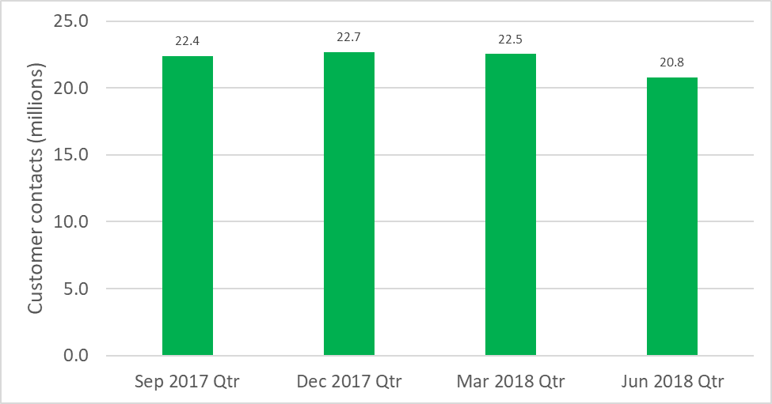

Figure 2: Customer contact by channel (%), by quarter

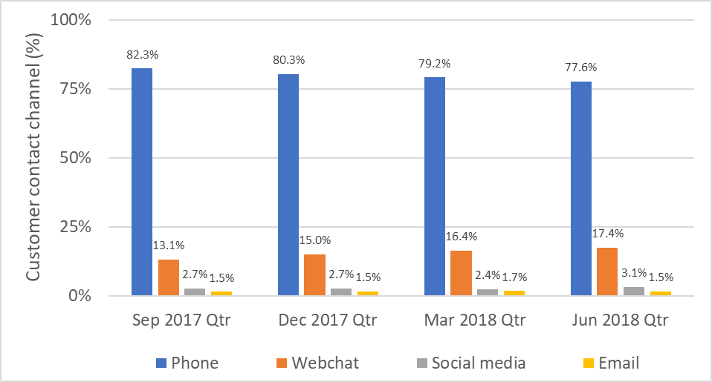

## Wait times vary

The average initial time that a caller had to wait[2] when contacting a telco by phone varied by telco over the course of the year, from 44 seconds in the September 2017 quarter for Telcos A, B and C, to over six minutes in the March 2018 quarter for Telco E(Figure 3).

Figure 3: Average call wait times (minutes) for the selected telcos, by quarter (lower is better)

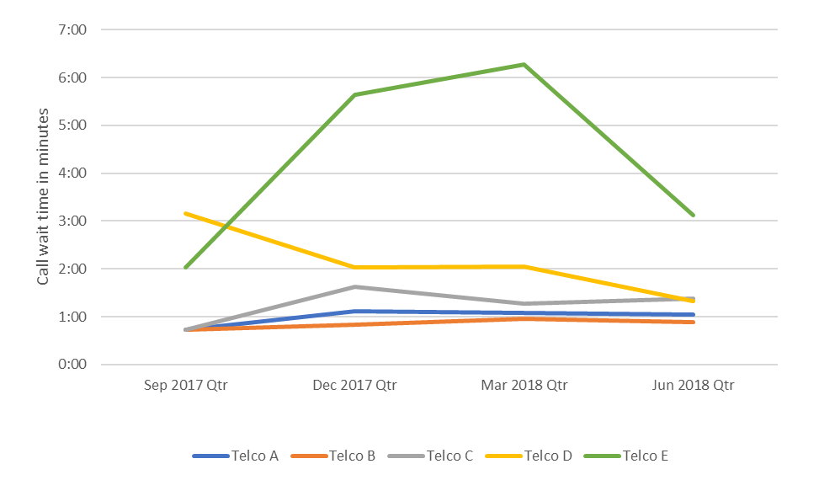

Figure 4 contains the average call wait times for the five telcos. Three of the five telcos had an average call wait time of less than two minutes.

Figure 4: Average call wait times (minutes and seconds) for the selected telcos in 2017–18 (lower is better)

Average = 1:54

## Some callers are hanging up

The average percentage of calls that were abandoned per quarter varied by telco over the course of the year, from 3.6 per cent (Telco C) in the September 2017 quarter to 21.2 per cent in the March 2018 quarter (Telco E).

Figure 5: Average call abandonment rate (%) by consumers contacting the selected telcos, by quarter (lower is better)

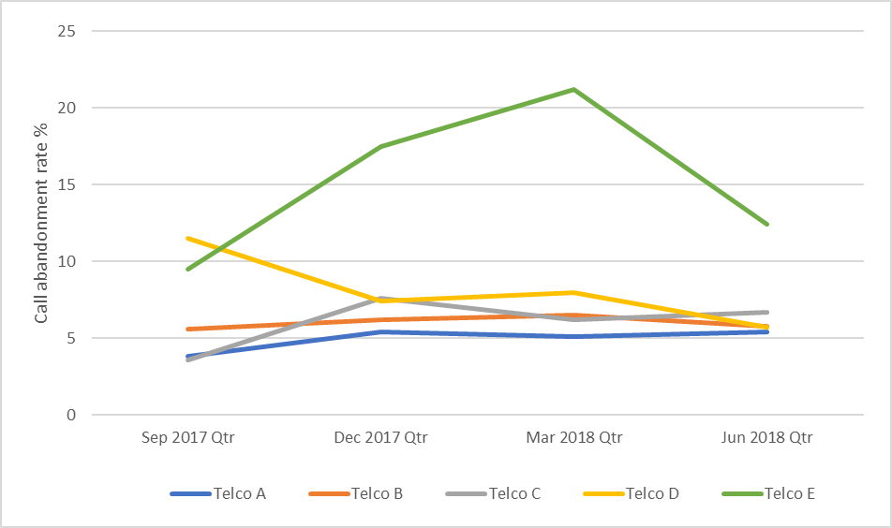

Four of the five telcos had an average call abandonment rate over the year of less than 10 per cent.

Figure 6: Average call abandonment rate (%) for the selected telcos in 2017–18 (lower is better)

## Resolving issues at first contact

The rate that matters raised by consumers were resolved on first contact varied over the course of the year, from 59 per cent for Telco D in the December 2017 quarter, to 86 per cent for Telco E in the March 2018 quarter.

Figure 7: Minimum and maximum rates of first contact resolution (%) for the selected telcos, by quarter (higher is better)

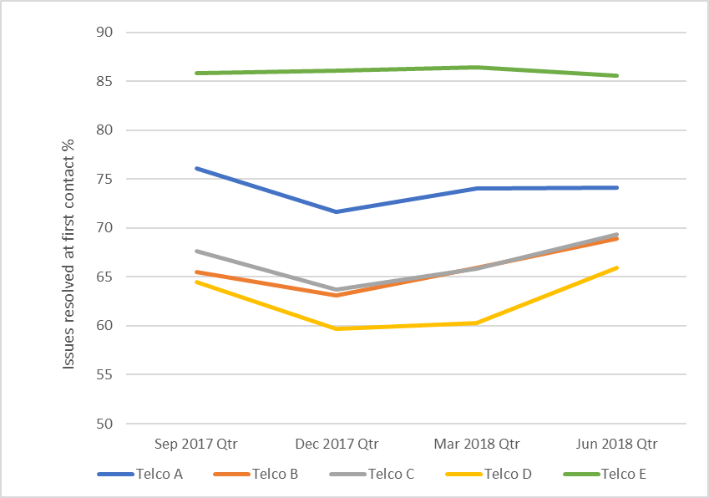

Telco E had a substantially higher average rate of first contact resolution than the other telcos.

Figure 8: Average rate of first contact resolution (%) for the selected telcos in 2017–18 (higher is better)

## Next steps

The ACMA is using the information received through this exercise to:

assist its industry monitoring and compliance activities

provide a baseline for any future monitoring and reporting of performance

provide an opportunity for comparison against performance in other sectors

inform ACMA contributions to the government’s Consumer Safeguards Review.

1. The ACMA gave statutory notices to the five selected telcos to obtain the performance data. It is not permissible for the ACMA to publicly disclose the information collected under notice without the permission of that company. Consequently, the information provided by the telcos has been anonymised*.*
2. The initial wait time may not be the only wait time customers experienced when making a customer service enquiry by phone. There may be additional wait times if callers are transferred to a different customer service agent, depending on the enquiry.