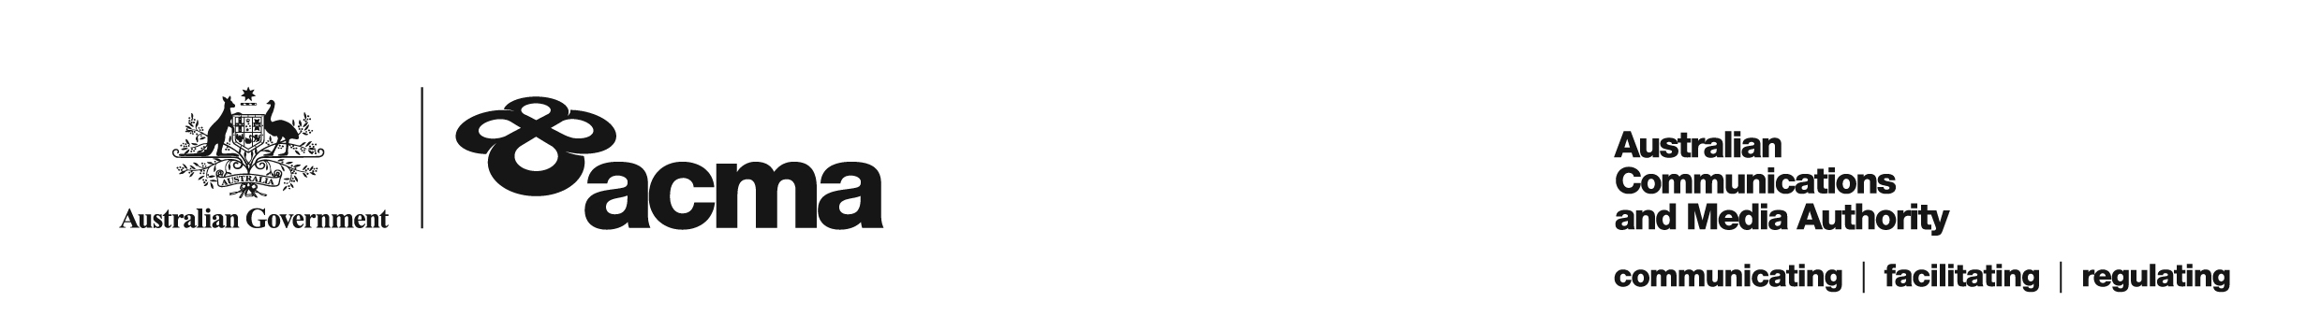**AUSTRALIAN COMMUNICATIONS AND MEDIA AUTHORITY**

**Target Reduction Order STV-TRO-0078  
made under subsection 130ZY(3) of the *Broadcasting Services Act 1992***

**1. Interpretation**

In this instrument:

***ACMA*** means the Australian Communications and Media Authority;

***Act*** means the *Broadcasting Services Act 1992*;

***Applicant*** means Foxtel Cable Television Pty Limited (ABN 45 069 008 797);

***Application*** means the target reduction order application made on 9 April 2019 in respect of the Service;

***Service*** means the Australian Christian Channel; and

***Specified Eligible Period*** means 1 July 2019 to 30 June 2020.

**2. Target Reduction**

Under subsection 130ZY(3) of the Act, the ACMA:

(a) having considered the written representations made by the Applicant in the Application, the supporting evidence submitted with the Application and the submissions received within the period of 30 days from the date the draft order was published; and

(b) being satisfied that a refusal to make the target reduction order would impose an unjustifiable hardship on the Applicant;

***ORDERS*** that, for the Specified Eligible Period, the reduced annual captioning target for the Applicant in respect of the Service will be 20%.

Dated: 26 June 2019