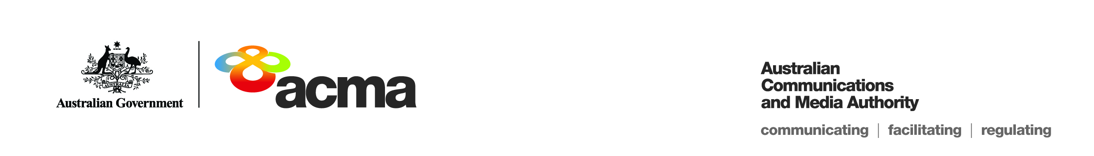Notice of draft exemption order for   
Foxtel Cable Television Pty Limited

(Application 362)

On 29 March 2019, Foxtel Cable Television Pty Limited (Foxtel) submitted an application seeking an exemption order under paragraph 130ZY(1)(a) of the *Broadcasting Services Act 1992* (BSA) in relation to the subscription television General Entertainment Category C service **Australian Christian Channel** (the Service) for the financial year 1 July 2018 to 30 June 2019 (the Specified Eligible Period).

This notice sets out the draft exemption order for the Service (the Exemption Order) and invites persons to make submissions about the Exemption Order to the ACMA within 30 days after this notice is published, being Monday, 20 May 2019, in accordance with subsection 130ZY(6) of the BSA.

Foxtel is a subscription television licensee. The Service is one of 102 subscription television services (channels) provided by Foxtel. The Service provides religious (Christian) programming.

The Service is offered as part of the Applicant’s ‘Entertainment’ package. Subscribers are not able to subscribe solely to the Service.

**Summary of reasons – unjustifiable hardship**

The ACMA’s preliminary assessment of the application is that a refusal to make the Exemption Order would result in unjustifiable hardship to Foxtel for the reasons explained in the Preliminary Statement of Reasons for Application 362.

To view the draft Exemption Order, please refer to the document titled ‘DRAFT Exemption Order STV-EO-362’.

All submissions received up to and including, Wednesday, 19 June 2019, will be considered in making the ACMA’s final decision. Submissions received after this date will not be considered.

**Publication of submissions**

In general, the ACMA publishes all submissions it receives. The ACMA prefers to receive submissions that are not claimed to be confidential. However, the ACMA accepts that a submitter may sometimes wish to provide information in confidence. In these circumstances, submitters are asked to identify the material over which confidentiality is claimed and provide a written explanation for the claim.

The ACMA will consider each confidentiality claim on a case-by-case basis. If the ACMA accepts a claim, it will not publish the confidential information unless authorised or required by law to do so.

Please note that the ACMA does not formally acknowledge the receipt of submissions.

**Effective consultation**

The ACMA is working to enhance the effectiveness of its stakeholder consultation processes, which are an important source of evidence for its regulatory development activities. To assist stakeholders in formulating submissions to its formal, written consultation processes, it has developed a guide called [Effective consultation: A guide to making a submission](http://www.acma.gov.au/~/media/Legal%20Services/Advice/pdf/ACMA%20Effective%20Consultation%20The%20ACMAs%20Guide%20to%20Making%20a%20Submission.PDF). This guide provides information about the ACMA’s formal, written, public consultation processes and practical guidance on how to make a submission.

Please forward submissions quoting Application Number 362 to:

Email: [captioning@acma.gov.au](mailto:captioning@acma.gov.au)

Post:

Submissions to Order Applications  
Diversity, Localism and Accessibility Section  
Australian Communications and Media Authority

PO Box Q500  
Queen Victoria Building  
NSW 1230