

Gambling advertising in Australia

Consumer and advertising placement research

NOVEMBER 2019

Canberra

Red Building   
Benjamin Offices  
Chan Street   
Belconnen ACT

PO Box 78  
Belconnen ACT 2616

T +61 2 6219 5555  
F +61 2 6219 5353

Melbourne

Level 32   
Melbourne Central Tower  
360 Elizabeth Street   
Melbourne VIC

PO Box 13112  
Law Courts   
Melbourne VIC 8010

T +61 3 9963 6800  
F +61 3 9963 6899

Sydney

Level 5   
The Bay Centre  
65 Pirrama Road   
Pyrmont NSW

PO Box Q500  
Queen Victoria Building   
NSW 1230

T +61 2 9334 7700 or 1800 226 667  
F +61 2 9334 7799

Copyright notice

[Creative Commons logo](http://i.creativecommons.org/l/by/3.0/88x31.png)

[https://creativecommons.org/licenses/by/4.0//](https://creativecommons.org/licenses/by/4.0/)

With the exception of coats of arms, logos, emblems, images, other third-party material or devices protected by a trademark, this content is made available under the terms of the Creative Commons Attribution 4.0 International (CC BY 4.0) licence.

We request attribution as © Commonwealth of Australia (Australian Communications and Media Authority) 2019.

All other rights are reserved.

The Australian Communications and Media Authority has undertaken reasonable enquiries to identify material owned by third parties and secure permission for its reproduction. Permission may need to be obtained from third parties to re-use their material.

Written enquiries may be sent to:

Manager, Editorial Services  
PO Box 13112  
Law Courts  
Melbourne VIC 8010  
Email: [info@acma.gov.au](mailto:info@acma.gov.au)

Executive summary 1

About the research 4

Objectives 4

Methodology overview 4

Nielsen Ad Intel 5

Guidelines for reading this report 6

researchacma 7

Volume and placement trends in gambling advertising 8

Consumer research findings 14

Regulation of gambling advertising 14

Viewing behaviours and the consumption of live sport 21

Exposure to gambling advertising 30

Attitudes towards gambling advertising 38

Perceived change in volume of gambling advertising 42

Appendix A—Background to the gambling advertising restrictions 44

Appendix B—Methodology 46

Qualitative research 46

Quantitative research 48

Appendix C—Nielsen Ad Intel overview 50

# Executive summary

In May 2017, the Minister for Communications announced a package of media reforms which included additional restrictions on gambling advertising during live sport. The purpose of the new restrictions was to ‘establish a clear safe-zone during which parents can have confidence that their children will not be exposed to gambling advertisements’.[1]

Gambling advertising restrictions were updated with amendments to the broadcasting codes of practice on 30 March 2018 and introduced for online content service providers on 28 September 2018. In summary, the restrictions apply between 5.00 am and 8.30 pm and ban gambling advertising during play, within breaks in play, and five minutes either side of the coverage of the live sporting event. At all other times of the day, gambling advertising is restricted in coverage of live sport during play and permitted in scheduled and unscheduled breaks.

Further background on the development and operation of the restrictions is at Appendix A.

The ACMA monitored the operation of the new restrictions since their commencement. As part of this monitoring exercise, the ACMA analysed advertising placement and volume data and commissioned qualitative and quantitative research among parents to understand:

* placement and volume of gambling advertising before and after the introduction of the new restrictions
* awareness and perceptions of the new restrictions
* consumption of live sport and recall of gambling advertising
* attitudes to exposure to gambling advertising (including children’s exposure)

perceived change in the volume of gambling advertising.

### The volume of gambling advertisements broadcast during live sport and during pre and post-game coverage markedly decreased

Following introduction of the new restrictions, there was a decrease in the total volume of gambling advertising spots broadcast between 5.00 am and 8.30 pm for the majority of sporting events examined using ad placement data. This includes gambling advertising during play, breaks and pre and post-game coverage.

For example, there was a 96 per cent reduction in gambling ads broadcast between 5.00 am and 8.30 pm on metro television during the 2019 *Australian Open* tennis tournament compared to 2018.

This significant reduction is attributable to broadcasters’ compliance with the new restrictions, while accounting for gambling advertising that is permitted up to five minutes before live coverage (where a ‘scheduled start of play’ has been notified to the audience) and more than five minutes after the game’s conclusion.

### There was a shift in gambling advertising to later times

Gambling advertising spots broadcast after the 8.30 pm watershed on metro television increased 131 per cent between the 2017 and 2018 Australian Football League (AFL) home and away seasons.

Gambling spots broadcast during breaks in play after 8.30 pm and in post-game coverage in the 2018 National Rugby League (NRL) season increased by 25 per cent from the previous year.

### There has been an increase in gambling advertising in non-sports content

While there has been a decline in gambling advertising during live sport, there has been an increase in gambling ads on television and radio generally. Therefore, it follows that gambling ads in other types of programs have increased.

A comparison of the volume of gambling advertising spots in comparable periods before and after the broadcasting rule change found that the total volume of gambling spots on Australian television and radio increased by 50 per cent between 2016–17 and 2018–19. This included an 86 per cent increase in the volume of gambling spots on regional television, 61 per cent on radio and 24 per cent on metro television. These increases largely appeared from 6.00–10.30 pm.

### Digital gambling advertising impressions remained stable

In contrast to the increase of gambling ads on television and radio in recent years, digital gambling advertising impressions (the number of times an advertisement is served to a user’s screen regardless of whether it was viewed or clicked) decreased significantly between 2016 and 2017 (42 per cent) and remained stable between 2017 and 2018, following the introduction of the online rules.

### Low level of awareness of the new restrictions

Most parents (at least 84 per cent) indicated that they were not aware of the restrictions during live sport. Fourteen per cent claimed to be aware of the restrictions as they apply to television and only 5 per cent were aware of the restrictions as they apply to online and radio.

### New restrictions are welcome although concerns were raised about application

When participants in the qualitative research were presented with an overview of the new broadcasting restrictions, they were regarded ‘as a step in the right direction’.

Some concerns were raised about the effectiveness of the regulations and the challenges of enforcement across platforms. They felt the restrictions on gambling advertising five minutes before and after live play were insufficient because children often watched the pre-match build up or post-match review.

### Parents were bothered when their children are exposed to gambling advertising and this concern is greater for older children

While most parents were bothered by gambling advertising (62 per cent), a larger proportion of parents (73 per cent) were bothered by their children being exposed to gambling advertisements.

The level of bother and concern was greater among those with older children. For example, parents with teenagers 13 to 17 years were significantly more likely than those with younger children, aged below five, to be ‘bothered a lot’ (34 per cent versus 21 per cent) or ‘bothered a fair amount’ (16 per cent versus 11 per cent) by gambling advertising.

The qualitative research indicated that this may be due to the accessibility of mobile devices to older children, the fact that they have later bedtimes and are more likely to watch content on their own without the supervision of parents.

### Concerns are relatively greater for live sport than other content

Among the parents whose children watch live sport (42 per cent), gambling advertising was of greater concern in live sport than other types of content.

Just under half of these parents (47 per cent) said they were ‘extremely’ or ‘very’ concerned about the presence of gambling advertising. This was higher than the two in five parents (39 per cent) who said they were ‘extremely’ or ‘very’ concerned about gambling advertisements in shows other than sport and other sports-related shows their children watch.

### There is no consensus among parents on the earliest time to allow gambling advertisements in live sport

When asked how they restrict content accessed by children, the most common methods used by parents were to limit the time of day that content is consumed (75 per cent) and the types of shows that are consumed (70 per cent). When asked to nominate an acceptable time in the evening for gambling advertising to appear during live sport, 21 per cent of parents asserted that gambling should never be advertised and 4 per cent said it should be allowed at any time.

Among the 71 per cent of parents who nominated a time for the restrictions to end, 6 in 10 nominated a time already covered by the existing regulation set at 8.30 pm. The remaining 40 per cent specified a time of 9.00 pm or later. Parents of older children, who were the group most concerned about gambling advertising, were more inclined to select later times for such advertisements to begin appearing.

### Television is the most common way parents and children consume live sport

The quantitative research found that two-thirds of parents surveyed had consumed live sport in the past month. Television, including both free-to-air and subscription television, is the most common way these parents said that they consumed live sport.

Two in five children (42 per cent) watched live sport in the preceding month. Of those, 95 per cent watched it on television, 27 per cent streamed it online and 10 per cent listened via radio, according to their parents.

### More than half of parents perceived there to be an increase in gambling advertising during live sport, despite ad placement data revealing an overall decrease

Of the parents who had watched live sport in the preceding month, 88 per cent said that they recalled gambling advertising while doing so.

More than half of the parents (55 per cent) noticed an increase in gambling ads on television and radio in the previous six months. Of those who perceived an increase, two-thirds said it had ‘increased a lot’.

### High levels of recall of gambling advertising on social media, outdoor sources and print media

Four in five parents (81 per cent) said they had seen gambling ads via one or more sources other than television or radio, including online sources such as social media. Two-thirds recalled seeing gambling ads via one or more offline sources:

* 48 per cent saw these ads on outdoor billboards, bus stops and the like

46 per cent saw gambling ads in newspapers and magazines or while reading news, blogs or articles online.

This is supported by year-on-year increases in advertising spend across all media.[2]

# About the research

## Objectives

The main aim of this research was to measure recent trends in gambling advertising, as well as parents’ experience of and attitudes to gambling advertising in the context of live sport—especially their children’s exposure to it—since the new rules were introduced.

The specific research objectives were to:

1. examine the volume and placement of gambling advertising spots broadcast on television and radio and displayed online
2. assess awareness of the regulation of gambling advertising on broadcast and online platforms, including the new restrictions during live sport
3. explore viewing behaviours among parents, guardians and carers in relation to the consumption of live sport
4. assess audience exposure to gambling advertising while watching or listening to live sport and other content
5. gauge parents’, guardians’ and carers’ attitudes towards children’s exposure to gambling advertising
6. explore parents’, guardians’ and carers’ perceptions of change in gambling advertising that their children may have been exposed to on broadcast and online services (since the new rules were introduced).

## Methodology overview

### Qualitative research

The qualitative phase of the research comprised:

* thirteen focus groups with parents of children aged 5–17 years
* four paired interviews with teenagers aged 14–17 years

two mini focus groups with teenagers aged 14–15 years who already knew each other.

The research considered the views of children under 18 years of age and parents of children under 18 years in line with the definition of ‘child’ in the online rules. At times, the research findings are broken down into different age categories of children to provide further detail and context.

The qualitative fieldwork was conducted in Melbourne, Bendigo, Dubbo, Parramatta, Mandurah, Perth, and Adelaide in July and August 2018. Each focus group was recruited by a professional research recruitment agency, comprised approximately six to eight participants and ran for 90 minutes. The two mini focus groups each comprised five teenagers who knew each other through high school or sport. The discussions were facilitated by specialist qualitative researchers from the Social Research Centre, using separate discussion guides for the focus groups with parents and the interviews with teenagers.

Further detail on the qualitative methodology can be found in Appendix B.

### Quantitative research

The quantitative phase of the research was also carried out by the Social Research Centre (SRC) and involved computer-assisted telephone interviews with a representative sample of Australian parents aged 18 and over (n=1,507).

The fieldwork was carried out from 2–21 October 2018.

Adults were eligible to complete the interview provided they were aged 18 years and over, used a mobile phone and were the parent, guardian or carer of a child aged zero to 17 years.

The definition of ‘child’ varies across broadcasting codes of practice and the online rules. For example, a child means a person under 15 years of age in the commercial television code, a person under 16 years of age in the commercial radio code and an individual who has not yet reached 18 years in the online rules.

Although much of the interview focussed on parent behaviours around their own program consumption behaviour and attitudes to gambling advertising, some questions related to their children’s consumption behaviour and exposure to gambling advertising.

The questionnaire was developed by the ACMA and the SRC. The average interview length was 15.8 minutes.

The adult data was post-weighted so that the sample matched Australian Bureau of Statistics (ABS) population estimates related to mobile phone ownership, adult age, gender and location.

The child data was separately post-weighted so that the sample matched ABS estimated residential population related to birth order, age, gender and location.

Further detail on the quantitative methodology can be found in Appendix B**.**

## Nielsen Ad Intel

Nielsen Ad Intel is an advertising information service which uses spot monitoring methodology to quantify the number of advertising spots on broadcasting and online platforms.

All advertisements for free-to-air metropolitan TV (primary stations only), newspapers, magazines and digital are visually verified and coded. Advertisements for free-to-air metropolitan TV (multi-channels), metropolitan radio, cinema and outdoor are collated from logs provided by the media owners. This enables spot counts which can then be used to estimate advertising expenditure across key media.

This provides a picture of the media landscape in Australia, with detailed breakdowns on when, where and how many ads were placed, including on which medium, how much was spent, by campaign, by key industry sector and individual advertiser and by ad formats.

The following reference periods were selected to represent before and after the new broadcasting and online restrictions came into effect:

* Television and radio: April–June 2016 and April–June 2017 (pre) and April–June 2018 and April–June 2019 (post).

Digital: October–December 2016 and October–December 2017 (pre) and October–December 2018 (post).

Find out further details on the Nielsen Ad Intel methodology in Appendix C.

## Guidelines for reading this report

* The results presented are from the advertising placement data, qualitative research and the quantitative survey.
* The advertising placement captures detailed information about gambling advertisements broadcast on free-to-air television (metropolitan and regional) including the advertiser’s name, the time the ad was broadcast and program in which it appeared but does not capture data about advertising on subscription television. It also captures advertising on radio but is limited to the advertiser’s name and the time the ad was broadcast.
* The qualitative research findings include verbatim comments from both parents and teenagers.
* Base sizes are shown as the unweighted number of respondents.
* All percentages are based on the weighted estimates.
* All percentages have been rounded to the nearest whole number. As a result, there may be discrepancies between sums of the component items in a table or chart and the total.
* Where questions allowed multiple responses, the total of these responses may sum to more than 100 per cent due to multiple responses being given by some respondents.
* Some questions have been filtered depending on the respondent’s previous response. These are always shown as a reduced ‘base’ on a chart or in a table. Care needs to be taken when interpreting the results, so that the data is read in the correct context.
* In some cases, ‘don’t know’ or other responses with only small levels of response are not shown—these are noted.
* Questions that were addressed to adult respondents about their attitudes and behaviours (‘did you watch or listen to…’) are weighted using the adult weights.
* Questions in which the respondent described the behaviours of the selected child (‘has <selected child> watched or listened to...’) are weighted using the child weights.
* Questions which give rise to both adult and child data (e.g., ‘… how often did you watch or listen to <insert program type> with <your child>?’) use the child weights and are presented separately by the parents’ genders. This is because these questions were only asked of one parent about one child in the household.
* All results shown have been tested for statistical significance at the 95 per cent confidence level.
* All consumer research referenced in this report is from the ACMA-commissioned qualitative research or quantitative survey unless otherwise stated.

1. Terms used in this report

| **Terms used** | **Definition** |
| --- | --- |
| ACMA (Australian Communications and Media Authority) | Commonwealth regulatory authority for broadcasting, radiocommunications, telecommunications and some internet content, with responsibilities under the *Broadcasting Services Act 1992*, the *Radiocommunications Act 1992*, the *Telecommunications Act 1997*, the *Do Not Call Register Act 2006,* the *Spam Act 2003* and related Acts. |
| Watching or viewing | Unless otherwise stated, ‘watching’ or ‘viewing’ any type of content includes listening to that content, for example using a radio. |
| Parents | The term ‘parents’ is intended to include parents, carers and guardians of children aged 0–17 years including uncles, aunts and grandparents of these children. |
| Mothers | Female carers including aunts, grandmothers and any other female guardians. |
| Fathers | Male carers including uncles, grandfathers and any other male guardians. |
| Children | The term ‘children’ is intended to include children, step-children and may also include nieces, nephews and grandchildren. |
| Live sport | Live sport includes sporting events that are broadcast live or close to live including football matches, cricket matches, tennis tournaments, netball games, basketball games, etc. |
| Other sports-related shows | Other sports-related shows include programs such as *Sports Sunday*, *The Front Bar* and *Footy Classified*, which typically feature a panel of commentators reviewing past and future sporting events. |
| Shows other than sport | Shows other than sport includes all types of programs besides sport. This includes news, current affairs, dramas, reality programs, movies, music, variety and comedy programs. |

## researchacma

Our [research program](https://www.acma.gov.au/research-program)—researchacma—underpins our work and decisions as an evidence-informed regulator. It contributes to our strategic policy development, regulatory reviews and investigations, and provides a regulatory framework that anticipates change in dynamic communications and media markets.

The consumer and advertising placement research referenced in this report contributes to the ‘Gambling advertising research’ project. Further details can be found in the [ACMA research program 2019–20](https://www.acma.gov.au/research-program).

# Volume and placement trends in gambling advertising

The ACMA examined Nielsen Ad Intel data into when, where and how many gambling advertising ‘spots’ were placed in the free-to-air media and the volume of digital ‘impressions’ online. Unless otherwise stated, gambling ads appearing ‘during live sport’ includes those that appear in pre and post-match coverage as permitted under the new restrictions, and those appearing in breaks in play permitted after 8.30 pm.

**Broadcasting and live sport**

The new restrictions have impacted on the volume of gambling advertisements being broadcast in live sport. For the majority of Australian sporting events examined using the Ad Intel data, there was a decrease in the total volume of gambling ad spots broadcast during live sport between 5.00 am and 8.30 pm (including pre and post-match coverage and breaks in play). The decrease reflects compliance with gambling advertising restrictions by broadcasters during these times, while accounting for allowable advertising in coverage up to five minutes before the commencement of play and more than five minutes after the game’s conclusion.

For example, following introduction of the new restrictions, there was a 96 per cent reduction in gambling ads broadcast before 8.30 pm on metro television during the 2019 Australian Open tennis tournament (see Figure 1).

### Shift in gambling advertising spots

The restrictions appear to have affected when gambling spots are broadcast during live sport. Gambling advertisers appear to have shifted some of their spots to later time periods since the new broadcasting restrictions were introduced. Gambling spots broadcast *before* the 8.30 pm watershed, during allowable periods of pre and post-game coverage, declined 58 per cent between the 2017 and 2018 AFL home and away seasons.[3] However, gambling spots broadcast during breaks in play and pre and post-game coverage *after* 8.30 pm increased 131 per cent over the same period (see Figure 1 and Figure 2).

Similarly, during the 2018 NRL home and away season, gambling spots broadcast prior to 8.30 pm during allowable periods in the coverage declined 26 per cent from the previous season, while gambling spots broadcast after 8.30 pm (in breaks in play and pre and post-game coverage) increased by 25 per cent (see Figure 1 and Figure 2).

1. Metropolitan TV gambling spots during live sporting events  
    before 8.30 pm

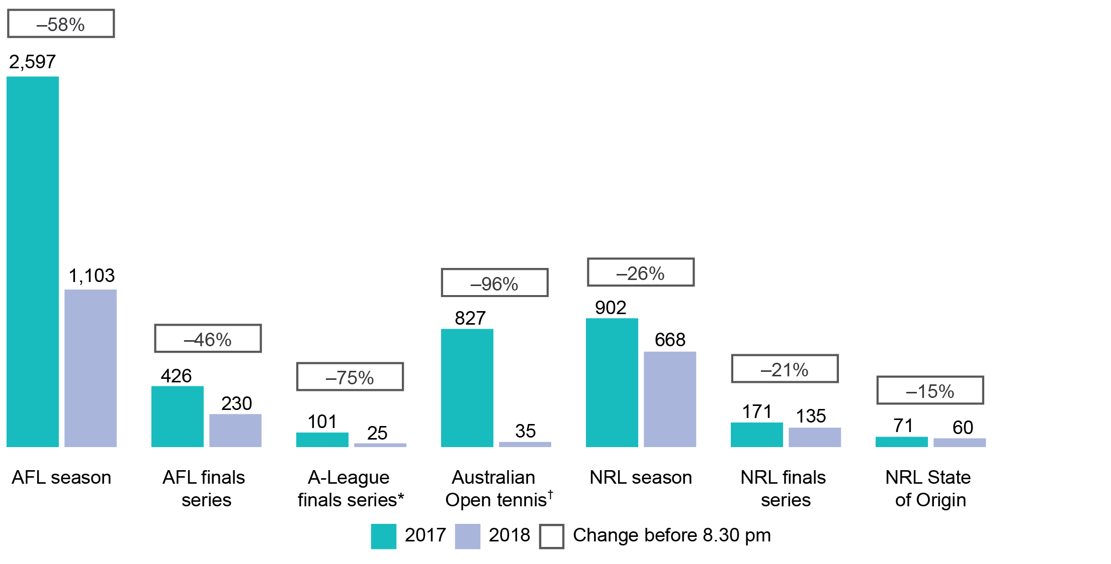Source: Compiled by the ACMA based on Nielsen Ad Intel data.

*A-League finals series includes 2016–17 season and 2017–18 season.

†Australian Open tennis includes January 2018 tournament and January 2019 tournament.

1. Metropolitan TV gambling spots during live sporting events   
   after 8.30 pm

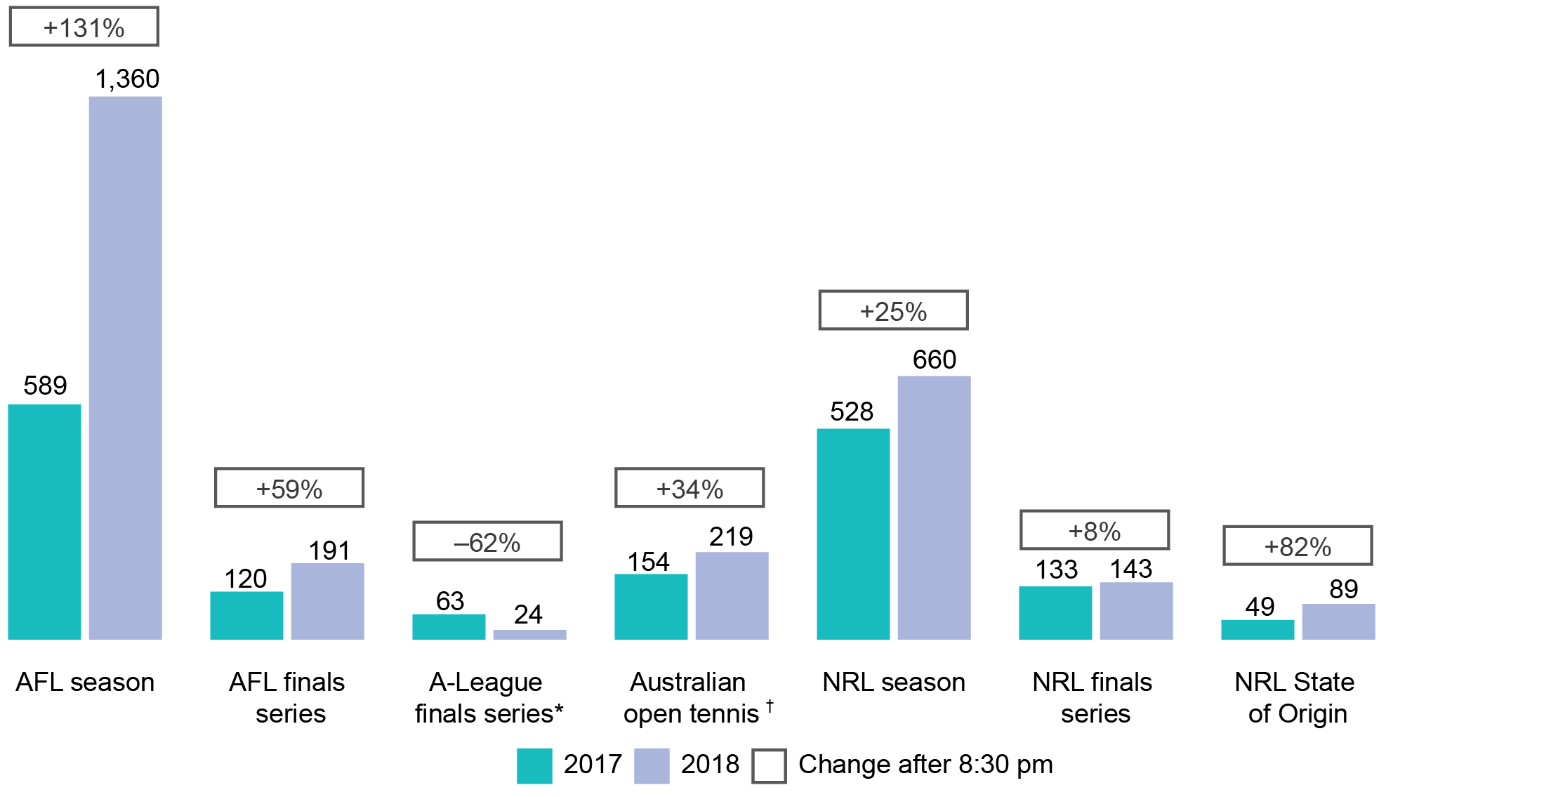

Source: Compiled by the ACMA based on Nielsen Ad Intel data.

*A-League finals series includes 2016–17 season and 2017–18 season.

†Australian Open tennis includes January 2018 tournament and January 2019 tournament.

### Broadcast media spots

A comparison of the volume of gambling advertising spots in comparable periods between April and June in 2016, 2017, 2018 and 2019 (before and after the new broadcasting restrictions were introduced on 30 March 2018) found that the total volume of gambling spots on Australian television and radio increased by 50 per cent between the 2016–17 (pre rules) and 2018–19 (post rules) combined periods. This included an 86 per cent increase in the volume of gambling spots on regional television, 61 per cent on radio and a 24 per cent increase on metro television (see Figure 3 and Figure 4).

The general increase in gambling advertising reflects broader trends of growth in ad spending in Australia. Data collected by Standard Media Index (SMI), and reported by AdNews[4], confirmed that 2018 was the highest calendar year of advertising expenditure in 12 years across the major media types.

1. Broadcast media total spot count—pre and post rule change

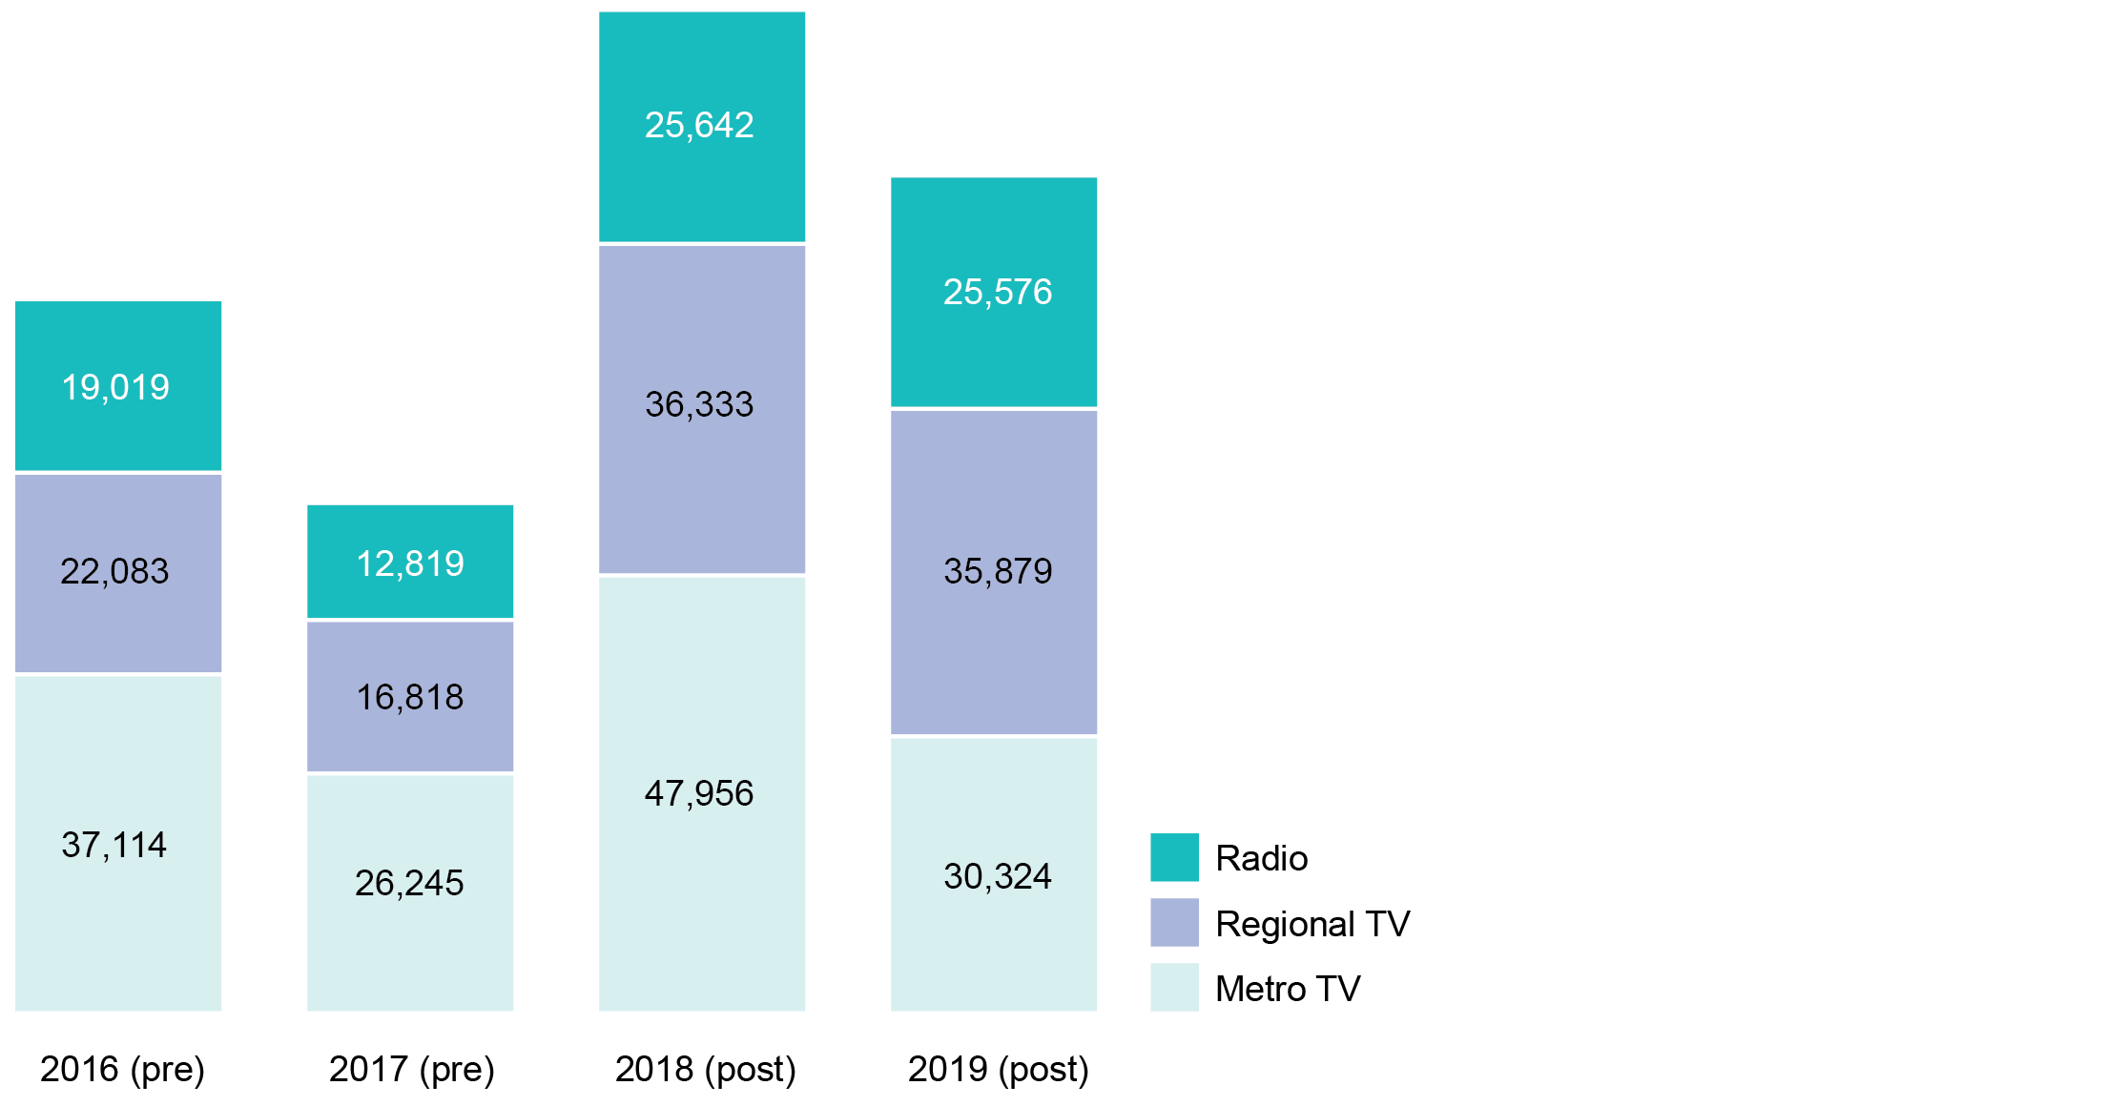

Source: Compiled by the ACMA based on Nielsen Ad Intel data.

1. Average broadcast media total spot count (April to June average)

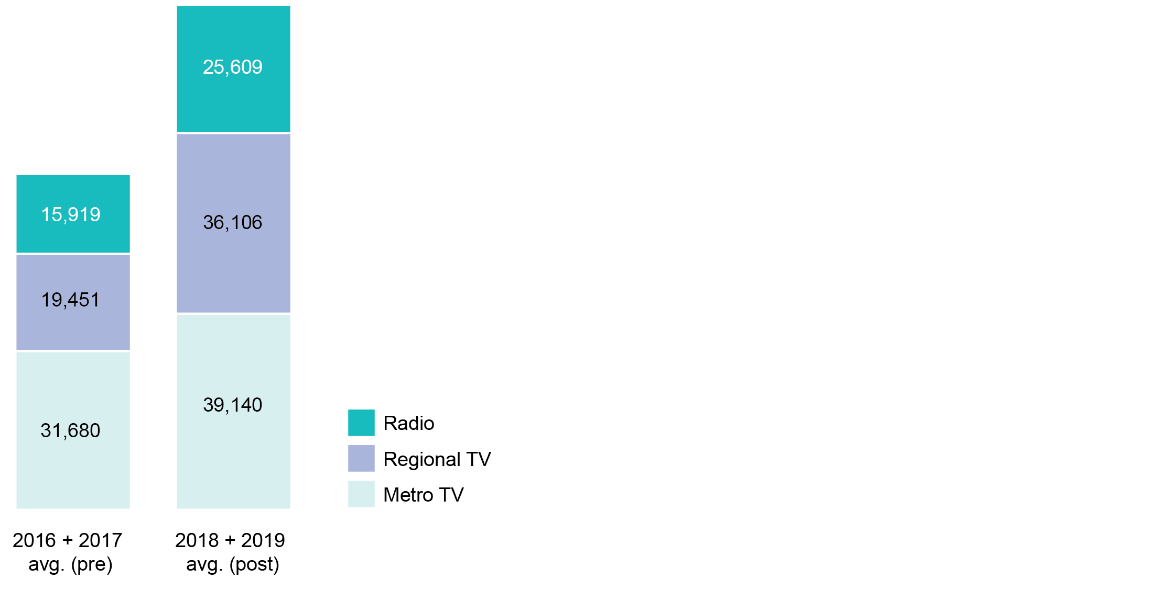Source: Compiled by the ACMA based on Nielsen Ad Intel data.

Increases in gambling advertising spots appear to have been largely driven by increased advertising spots during ‘prime time’ viewing hours on television (6.00–10.30 pm). While metro television gambling spots outside prime time remained relatively stable between the 2016 and 2019 periods, prime time spots showed more variation. Between 2016 and 2017 spots decreased 24 per cent yet increased by 91 per cent between 2017 and 2018, before decreasing 30 per cent between 2018 and 2019. However, when combining the pre (2016–17) and post (2018–19) rule change periods there was a 40 per cent increase in prime-time gambling spots on metro television (see Figure 5).

1. Metro TV spot count by time of day—pre and post rule change

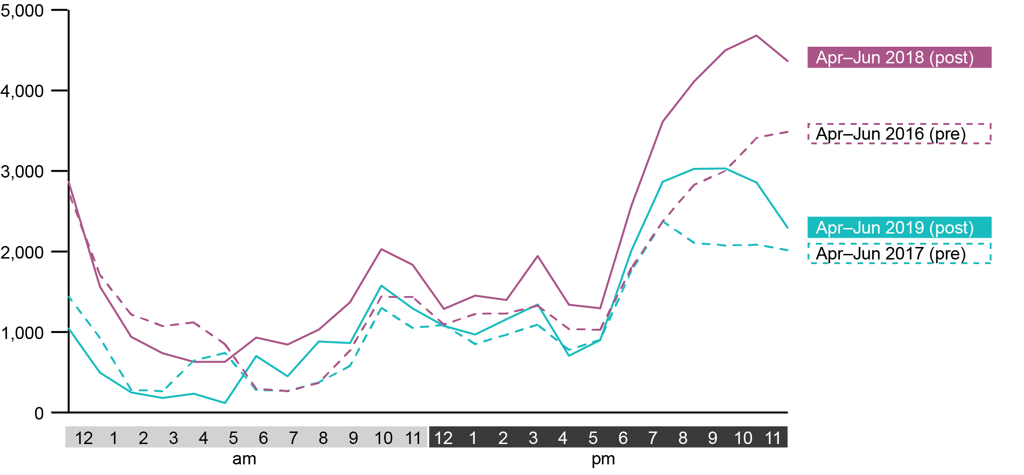

Source: Compiled by the ACMA based on Nielsen Ad Intel data.

Like metro television, there was some variation in prime-time gambling spots on regional television between 2016 and 2019. Between 2016 and 2017, there was a 25 per cent decrease, a 126 per cent increase between 2017 and 2018 and a small decrease of 3 per cent between 2018 and 2019. When looking at the combined pre and post rule change periods, there was a 90 per cent increase in spots after the rule change (see Figure 6).

1. Regional TV spot count by time of day

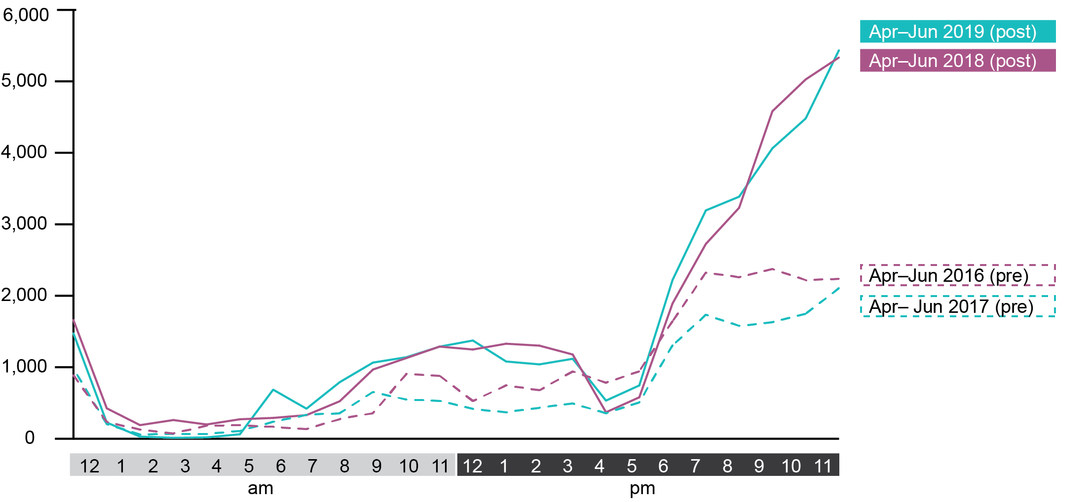

Source: Compiled by the ACMA based on Nielsen Ad Intel data.

Radio gambling spots increased substantially during peak times, when comparing the pre and post rule change periods. Between 2016 and 2017 (pre rules) and 2018 and 19 (post rules), the Monday to Friday ‘breakfast’ shift (5.30–9.00 am) and ‘drive’ shift (4.00–7.00 pm) both increased 94 per cent (see Figure 7).

1. Radio gambling spots by time of day—pre and post rule change

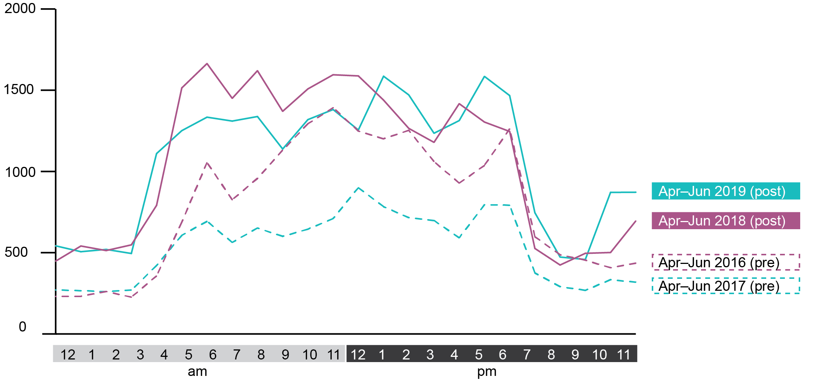

Source: Compiled by the ACMA based on Nielsen Ad Intel data.

Between April and June 2018, an average of 823,000 children aged 0–17 were reached per night through commercial metro television channels (including SBS Network) during prime-time hours (6.00–10.30 pm), a period when the highest volume of gambling advertising was aired on television. Over the same period, an average of 365,000 children aged 0–17 were reached per night through commercial regional television channels (including SBS). The data also demonstrates that child audiences of both metro and regional television generally peak at around 8.00 pm before declining (see Figure 8).

1. Average hourly audience of metro and regional TV viewing per week, aged 0–17 years

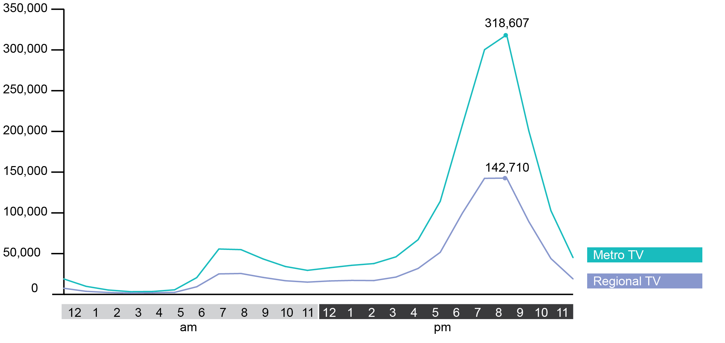

Source: OzTAM. Average hourly ratings per week, five city metro, 1 April to 30 June 2018, Sunday to Saturday, Consolidated 28, combined commercial and SBS networks. Regional TAM. Average hourly ratings per week, combined aggregate markets, 1 April to 30 June 2018, Sunday to Saturday, Consolidated 28, combined commercial and SBS networks.

Note: ABC has been excluded because there are no commercials on the ABC Network.

### Online media

In contrast to the increase in gambling advertising spots in broadcast media, the volume of digital media gambling advertising impressions[5] was virtually unchanged after the new online rules were introduced in September 2018. Between the 2017 and 2018 periods, digital gambling impressions decreased by 1 per cent. This followed a significant decrease in gambling advertising impressions served online between 2016 and 2017 (42 per cent) (see Figure 9).

1. Digital media gambling impressions (‘000s)—pre and post rule change

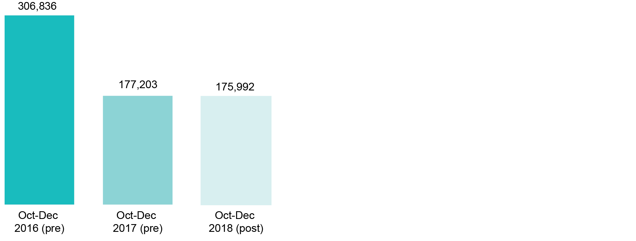

Source: Compiled by the ACMA based on Nielsen Ad Intel data.

# Consumer research findings

## Regulation of gambling advertising

### Awareness of the regulation of gambling advertising

An objective of the research was to assess parents’, guardians’ and carers’ awareness of the regulation of gambling advertising including the new restrictions during live sport via broadcast and online services.

The majority of parents (at least 84 per cent as at the date of the quantitative survey) indicated they were not aware of the restrictions. Only 14 per cent claimed to be aware of the restrictions as they apply to television, and only 5 per cent were aware of the restrictions as they apply to online and radio (see Figure 10).

1. Whether parents are aware of restrictions applying to gambling advertising (%)

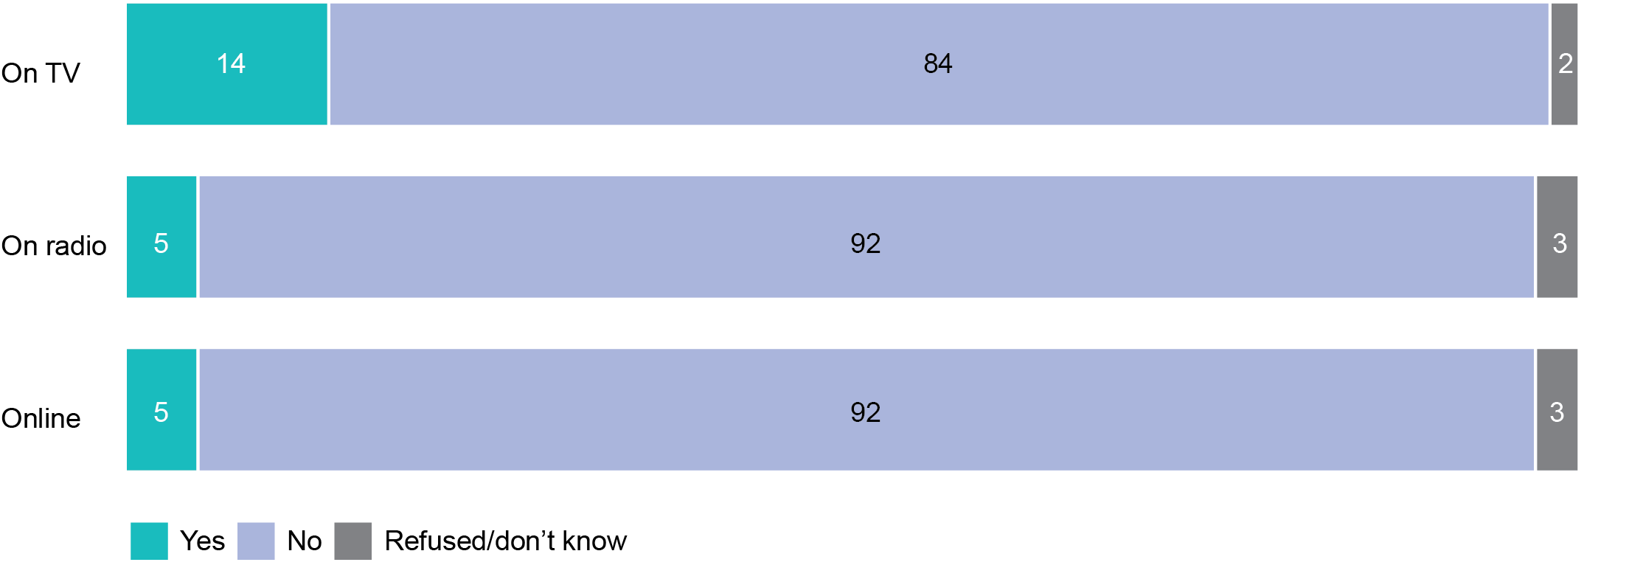

Base: All parents (n=1,507).

In the qualitative research, there was very low awareness among parents of the restrictions that apply to gambling advertising.

‘No, I don't think there's any regulations, not around gambling.’  
(Parent group 11, 9–13 years, Perth)

Some parents mentioned the ‘gamble responsibly’ disclaimer which was seen as an indication of the existence of some form of legislation for gambling advertising and promotion.

Moderator: ‘Are you guys aware of any [regulations]?’

Participant: ‘I would assume that, obviously because they always say, “Please gamble responsibly”.’   
(Parent group 2, 14–17 years, Melbourne)

Only a few parents reported they were aware of the change in gambling advertising rules for television and radio. For example, some referred to changes to the promotion of live odds introduced in 2013.

‘[Gambling company] used to be able to get up live odds and stuff like that but now they can only jump on TV at half-time, end of game, before game, to talk about the game that's in process.’   
(Parent group 5, 5–8 years, Dubbo)

Teenagers’ awareness of regulations was also low. None of the teenage participants were aware of any gambling advertising restrictions. Again, it was only the disclaimer for responsible gambling that came to mind.

‘I think they have to say “gamble responsibly” … that’s one of the rules.’   
(Teen group 4, Melbourne)

### Reactions to the gambling advertising restrictions

The research also sought to explore perceptions of the impact of the new restrictions on gambling advertising. This objective was addressed in the qualitative research only.

Participants in the qualitative research were presented with an overview of the new gambling advertising restrictions for television and radio introduced in March 2018.

Overall, the new gambling advertising restrictions were welcomed by most parents and regarded as a step in the right direction, while the challenges of implementing regulation across different platforms were acknowledged.

‘I think any development is a good development. It’s heading in the right direction.’   
(Parent group 3, 14–17 years, Bendigo)

Some of the teenagers also felt the new gambling advertising restrictions were an improvement.

‘I think that's really good that they changed to that instead of having it on all the time during the games.’   
(Teen group 6, Bendigo)

Despite these positive reactions, some concerns were raised about the effectiveness of gambling advertising restrictions, whether they were sufficient and how they could be enforced.

‘But it certainly doesn’t prevent the exposure to it. It’s still hard to control it across all the different channels.’   
(Parent group 3, 14–17 years, Bendigo)

Participant 1: ‘I don't really think it's doing enough, to be honest.’

Participant 2: ‘And it almost feels like it's been industry-led.’   
(Parent group 1, 5–8 years, Melbourne)

Some parents mentioned how time restrictions for advertisements during live sport could possibly result in an overflow of gambling advertising before and after the games, therefore moving advertisements to other times when children could be viewing television.

As mentioned earlier in the report, for some of the major sports reviewed, there has been a notable shift in when gambling advertising is broadcast. Across the AFL, NRL, Australian Open tennis and A-League finals series there was an increase in gambling advertising after 8.30 pm in the season after the restrictions came into effect (see Figure 2).

Some parents felt the rules restricting gambling advertising or promotions being shown five minutes before or after live play were inadequate. This was because their children often watched the pre-match build-up or the post-match review. Parents suggested this time could be extended to ensure children were not exposed to gambling advertising at any point in the pre and post-match times.

‘That's a bit too close, especially if kids are sitting down to start watching it, because I guess that's the main aim of why we're here, is to discuss kids. If kids are sitting down to watch the game from the start, they might want to see the team run through the banner or whatever on the TV.’(Parent group 1, 5–8 years, Melbourne)

A few teenagers suggested the five-minute rule did not sufficiently cover the potential times children could be exposed to gambling advertisements. To this end, they also suggested the gambling advertising restrictions should extend beyond the five-minute time period.

‘You can easily see an ad 10 minutes before the game and still think, “Hey the game is on tonight, let’s gamble” so it should be like an hour.’(Teen group 4, Melbourne).

**Whether awareness of the restrictions impacts perceptions of the volume of gambling advertising**

While perceptions of the impact of the new restrictions were not explicitly measured in the research, parents’ perceptions of the volume of gambling advertising in sport were assessed against their awareness of the restrictions.

The data in Figure 11 shows that parents who said they were aware of the gambling advertising restrictions were:

* significantly more likely to think that the amount of gambling advertising in live sport had ‘decreased a little’—9 per cent of the aware group selected this option whereas only 3 per cent of the unaware group selected this option
* less likely to think that it had ‘increased a lot’ over the previous six months—only 25 per cent of the aware group selected this option whereas 39 per cent of the unaware group selected this option

less likely to ‘not know’ if the volume had changed—only 3 per cent of the group selected this option compared to 8 per cent of those unaware group.

These results indicate that awareness of the restrictions tends to be associated with more accurate perceptions of the change in the volume of gambling advertising in live sport.

1. Perceived change in volume of gambling advertising in live sport—by awareness of restrictions applying to gambling advertising (%)

Figure 11: Perceived change in volume of gambling advertising in live sport— 
by awareness of restrictions applying to gambling advertising (%)


Base: Watched or listened to live sport on TV/radio (n=1,020); aware of the restrictions that apply to gambling advertising during live sport on TV (n=160); not aware or don't know (n=860).

Note: Red/green arrows denote significant differences between those aware and unaware of the restrictions.

### Parents more concerned about gambling advertising in visual media

Across the different media types, parents were more concerned about gambling advertisements in visual media—on television and online—than they were about gambling advertisements on the radio (see Figure 12).

Two in five (39 per cent) said they were ‘extremely’ or ‘very’ concerned about their child being exposed to gambling advertising on television and a similar proportion (37 per cent) were concerned about exposure online.

By comparison, only one in four (24 per cent) expressed ‘extreme’ or ‘very’ great concern about gambling advertisements being heard by their children via the radio.

Concern about television exposure was greater among older parents including those aged 45–54 (46 per cent) and those aged 55-plus (48 per cent).

1. Concern about children being exposed to gambling advertising (%)

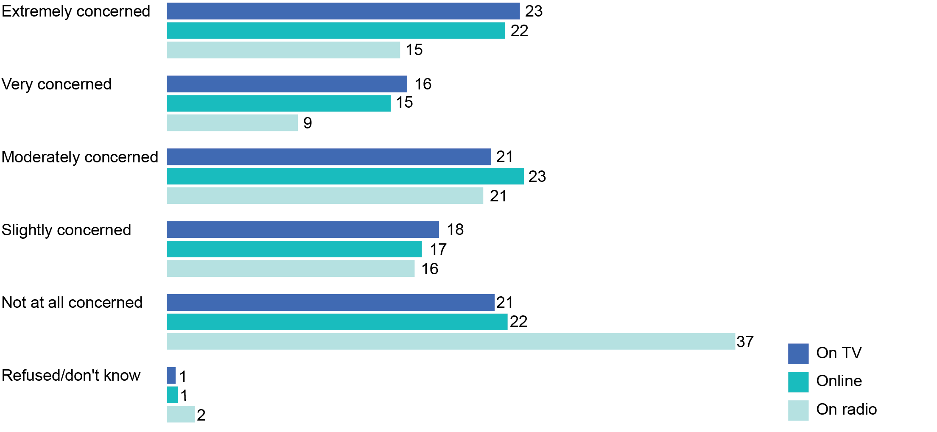

Base: All parents (n=1,507).

### Gambling advertising concerns in live sport

Across the different types of content, parents were more concerned about gambling advertisements that appear during live sport than they were about these advertisements during other program types (see Figure 13).

Just under half of the parents whose children watch live sport (47 per cent) stated they were ‘extremely’ or ‘very’ concerned about the presence of gambling advertising during live sport. This was significantly higher than the two in five parents (39 per cent) who said they were ‘extremely’ or ‘very’ concerned about gambling advertisements in shows other than sport and other sports-related shows that their children watch.

Of the parents whose children watch live sport, only 17 per cent reported they were ‘not at all concerned’ about their children being exposed to gambling advertising in live sport.

1. Concern about children being exposed to gambling advertising (%)

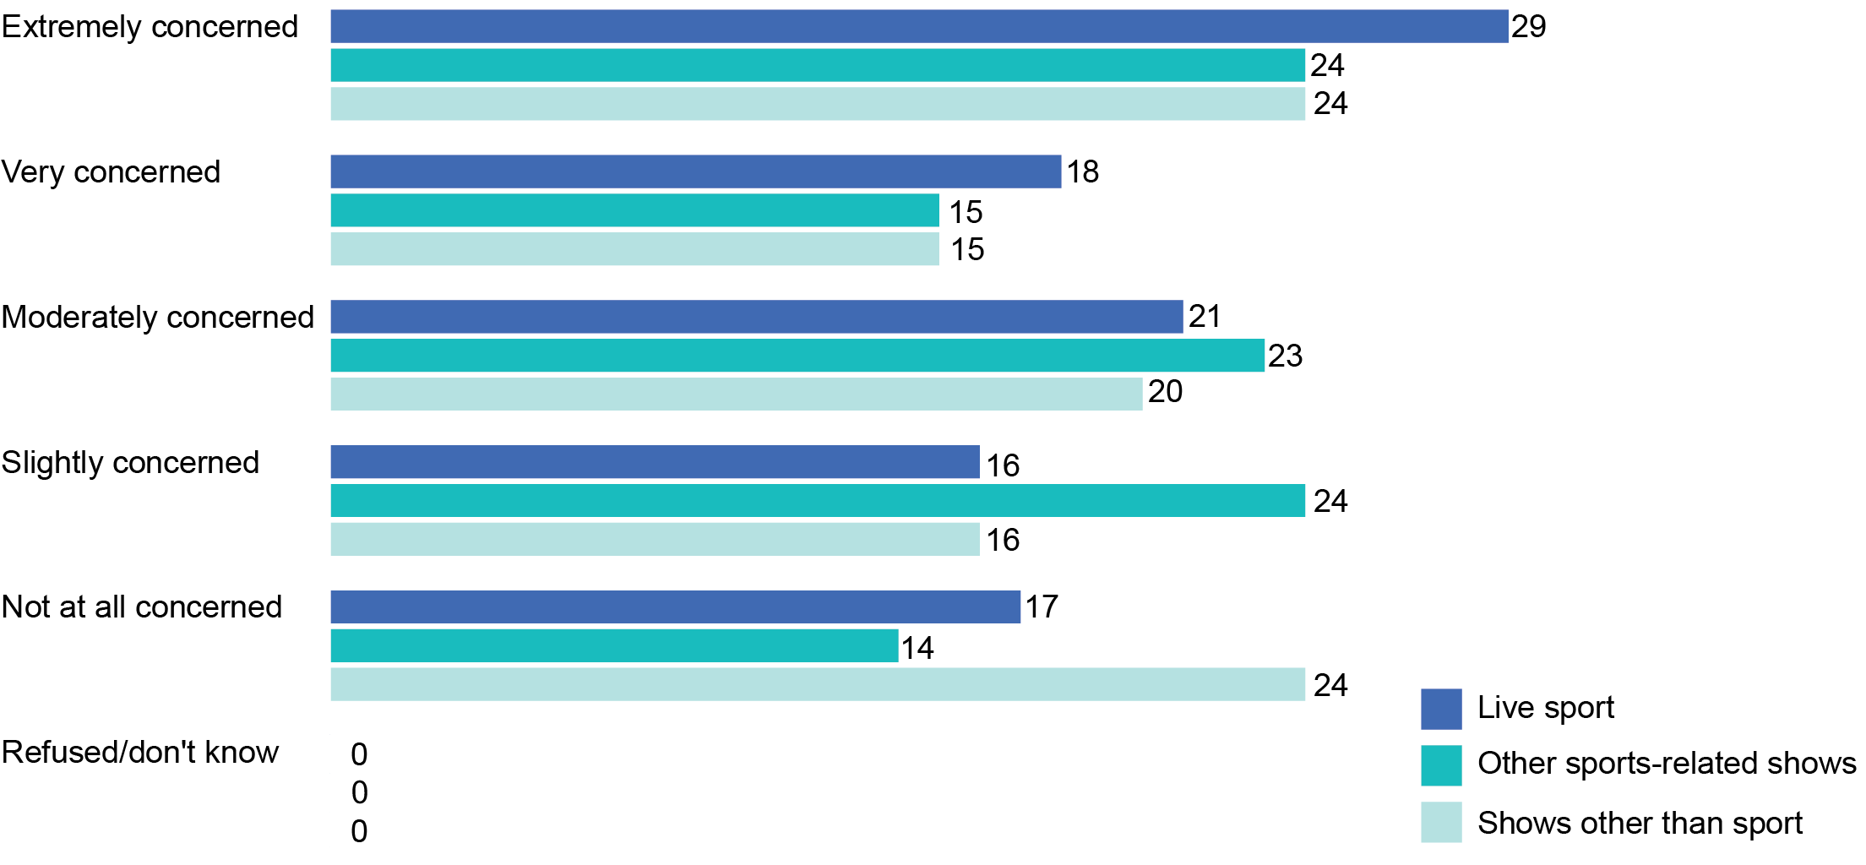

Base: Children who watch or listen to the following: Live sport (n=623), other sports-related shows (n=256); shows other than sport (n=1,355).

Note: Data based on parent weights.

### Earliest time gambling advertisements should appear in live sport

When asked to nominate an acceptable time in the evening for gambling advertising to appear during live sport, seven in 10 parents (71 per cent) opted to nominate a particular time. Twenty-one per cent said gambling should ‘never be advertised at any time’ (see Figure 14).

1. Earliest time gambling advertisements should appear in live sport (%)

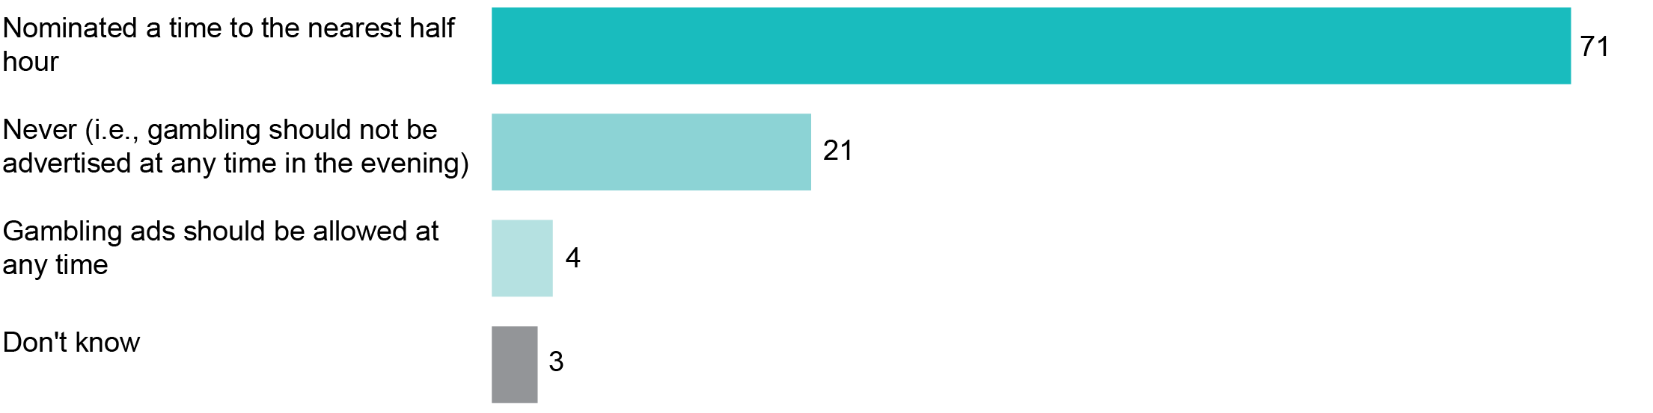

Base: All parents (n=1,507).

Among the parents who nominated acceptable times for gambling advertisements to begin appearing during live sport in the evening:

* 8.30 pm was nominated by 17 per cent
* 9.00 pm or later was nominated by 40 per cent

8.00 pm or earlier was nominated by 42 per cent (see Figure 15).

1. Earliest time gambling advertisements should appear in live sport—total (%)

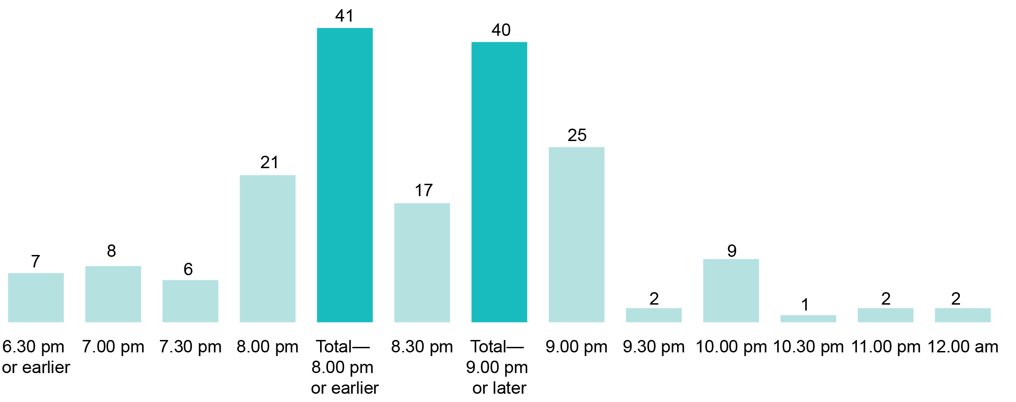

Base: Parents who specified a time to the nearest half hour (n=1,055).

Note: Excludes ‘never’, ‘any time’, and ‘don’t know’.

While there is some symmetry in the results across the parent population overall (i.e., similar proportions nominated earlier times—and later times—than the current regulations require), this symmetry was not uniform across all demographics of the parent population.

Parents of teenage children (i.e., 13–17 years) were much more likely to nominate later acceptable times (i.e., 9.00 pm or later) for gambling ads to appear than parents of younger children (see Figure 16):

* later times were nominated by 46 per cent of teenagers’ parents
* later times were nominated by 42 per cent of parents with children aged 5–12

later times were nominated by only 32 per cent of parents with children aged 0–4.

Parents of teenage children were also much less likely to nominate earlier times than the restrictions currently allow:

* earlier times were nominated by only 33 per cent of teenagers’ parents
* earlier times were nominated by 41 per cent of parents with children aged 5–12

earlier times were nominated by 53 per cent of parents with children aged 0–4.

In other words, the older their children, the later parents are likely to want gambling advertisements to appear.

1. Earliest time gambling advertisements should appear in sport—by child age (%)

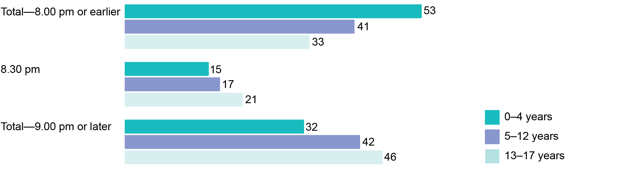

Base: Parents who specified a time to the nearest half hour (n=1,055); by age of child: 0–4 years (n=286); 5–12 years (n=481); 13–17 years (n=288).

Parents who were ‘bothered a lot’ or ‘a fair amount’ by their children being exposed to gambling advertising, were also more likely to want gambling advertisements to be delayed until 9.00 pm, or later, than parents who were ‘not bothered at all’, or ‘bothered a little’ (see Figure 17).

1. Earliest time gambling advertisements should appear in sport—by attitudes (%)

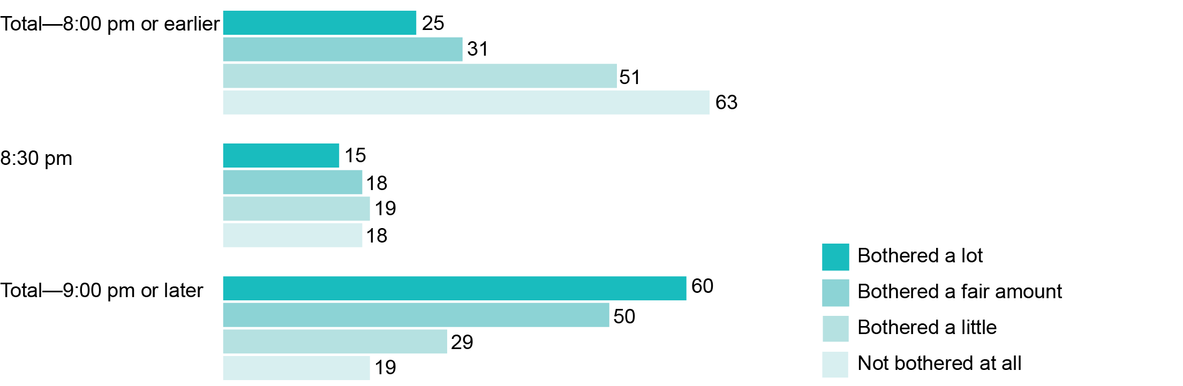

Base: Parents who specified a time to the nearest half hour (n=1,055) by attitude to child being exposed to gambling advertising: Bothered a lot (n=353); bothered a fair amount (n=158); bothered a little (n=258); not bothered at all (n=247).

The qualitative research revealed most parents felt the 8.30 pm cut-off time, as per the new broadcast restrictions, was too early and did not account for the fact that older children are allowed to stay up later to watch live sport, particularly on the weekend. Most parents in the qualitative research felt the new broadcast restrictions should be extended beyond 8.30 pm.

‘Up till 8.30 they've restricted it, so the problem is the games we watch are generally between 7.30 and 9.30. So (in the first half) you won't have gambling and then after 8.30 it's a free-for-all, so the second half you'll get gambling ads.’   
(Parent group 7, 14–17 years, Parramatta)

Most teenagers in the qualitative research also agreed with extending the 8.30 pm cut-off time to reduce the potential exposure of younger children to gambling advertising.

‘I think they should do a cut off to 9.30 pm. At 8.30 pm people are not asleep yet, and sometimes they do family BBQs that go for a long time too. My family does it. So they have the TV outside, and everyone sits around, and that includes my little cousins.’   
(Teen group 1, Parramatta)

### Why parents of older children are particularly concerned

The qualitative research helped to explain why parents are more concerned about their older children being exposed to gambling advertising. Most teenagers are allowed to stay up until weekend matches are finished and many determine their own sports viewing times and bedtimes.

‘The 14-year-old, even though he's in year 9, he will still be up until 10 o'clock, 11 o'clock.’   
(Parent group 7, 14–17 years, Parramatta)

Parents of teenagers (aged 14 to 17) also felt their children were more likely to spend time on their own and with peers than with them. This meant the potential for parents to control their teenager’s exposure to any content was limited.

‘You can stop it while they’re with you, but what about when they’re out? Friends’ places. You’ve got no control.’   
(Parent group 2, 14–17 years, Melbourne)

In effect, parents of teenagers have less control over what their children are watching and listening to, particularly online, and these older children are therefore at greater risk of exposure to gambling advertising than younger children.

## Viewing behaviours and the consumption of live sport

A key objective of the qualitative and quantitative research was to assess parents’ and children’s behaviours in relation to the consumption of live sport via both broadcast and online services. The consumption of live sport was measured across different platforms and benchmarked against the consumption of other types of content.

### Consumption of live sport compared to other program types

The research indicates that shows other than sport (i.e., dramas, reality programs, comedies, news, cartoons, etc.) capture a wider audience than live sport and sports-related shows. In the past month, non-sport programs were watched or listened to by nearly all parents (95 per cent) and by the vast majority of children (90 per cent) (see Figure 18).

1. Consumption of live sport compared to other program types (%)

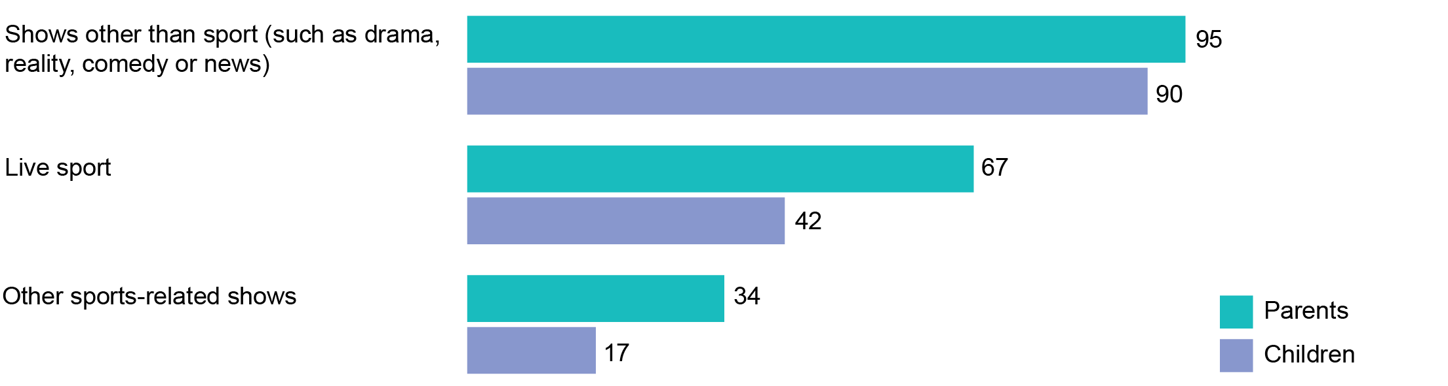

Base: All parents (n=1,507).

Two-thirds of parents (67 per cent) reported that they had personally watched or listened to live sport in the past month and one third (34 per cent) of parents said they had watched or listened to other sports-related shows in the past month.

The qualitative research showed that parents and teenagers reported a range of live sports they liked to watch or listen to. AFL and NRL were the most commonly watched sports. In regional areas, motorsports were also popular. Sports were reported to be watched predominantly at home and through free-to-air television channels.

The qualitative research also revealed that for most of the families represented in the qualitative research, watching live sports was characterised as a social activity or ‘ritual’ where family members (including extended family such as grandparents) would gather together to watch sports on Friday nights or on the weekend. Generally, members of the family would gather in the main living area to watch sports together and sport finals were highlighted as special occasions where larger groups of family members or friends would gather to watch the event, marking it with a party-like atmosphere.

‘We go to my parents’ house … and we watch the Sunday afternoon game with my whole family.’   
(Parent group 8, 9–13 years, Parramatta)

Among teenagers it also appeared to be a social occasion where they gathered with family members or friends to watch live sports.

‘If I have an option to go to my mate’s house and watch it, obviously that’s a bonus.’(Teen group 1, Parramatta)

In the focus groups, some parents commented that they only listen to live sports on the radio while in the car or when they are outside or away from home.

### Children’s viewing habits

Watching live sport and other sports-related shows was less common among children. Parents reported only 42 per cent of children had watched or listened to live sport in the past month and only 17 per cent of children had watched other sports-related shows (see Figure 18).

Within the qualitative research, some parents reported that their teenage children would not always be fully engaged with live sport matches or events, often switching between watching the television and checking webpages and social media, or chatting with friends, on their mobile phones or tablets while the game was on.

‘In my household we watch it on the TV, the whole family, but everyone with (their) iPad, my daughter would be on Facebook, the two boys will be playing games, but still watching the game. And my husband, sometimes he will be doing his emails too on an iPad too, so it's multitasking in the household.’   
(Parent group 7, 14–17 years, Parramatta)

For families with younger children (aged five to eight), parents explained that their children had shorter attention spans which meant that they were less likely to pay full attention to the television when live sport was being played. Instead, there was a tendency for younger children to dip in and out of games and matches as they entertained themselves with other activities.

### How often parents watch different program types

The research found that there were clear differences in how frequently different types of programs were watched, with parents reporting that they watch non-sport programs more frequently than live sport.

Among those parents that had watched each of the different program types in the past month, 96 per cent reported watching non-sporting programs at least weekly and 57 per cent reported that they watch live sports at least weekly (see Figure 19).

Parents who watched live sport were also far less likely to watch it daily than parents who watched shows other than sport (5 per cent versus 68 per cent).

1. Parent frequency of watching/listening to different program types (%)

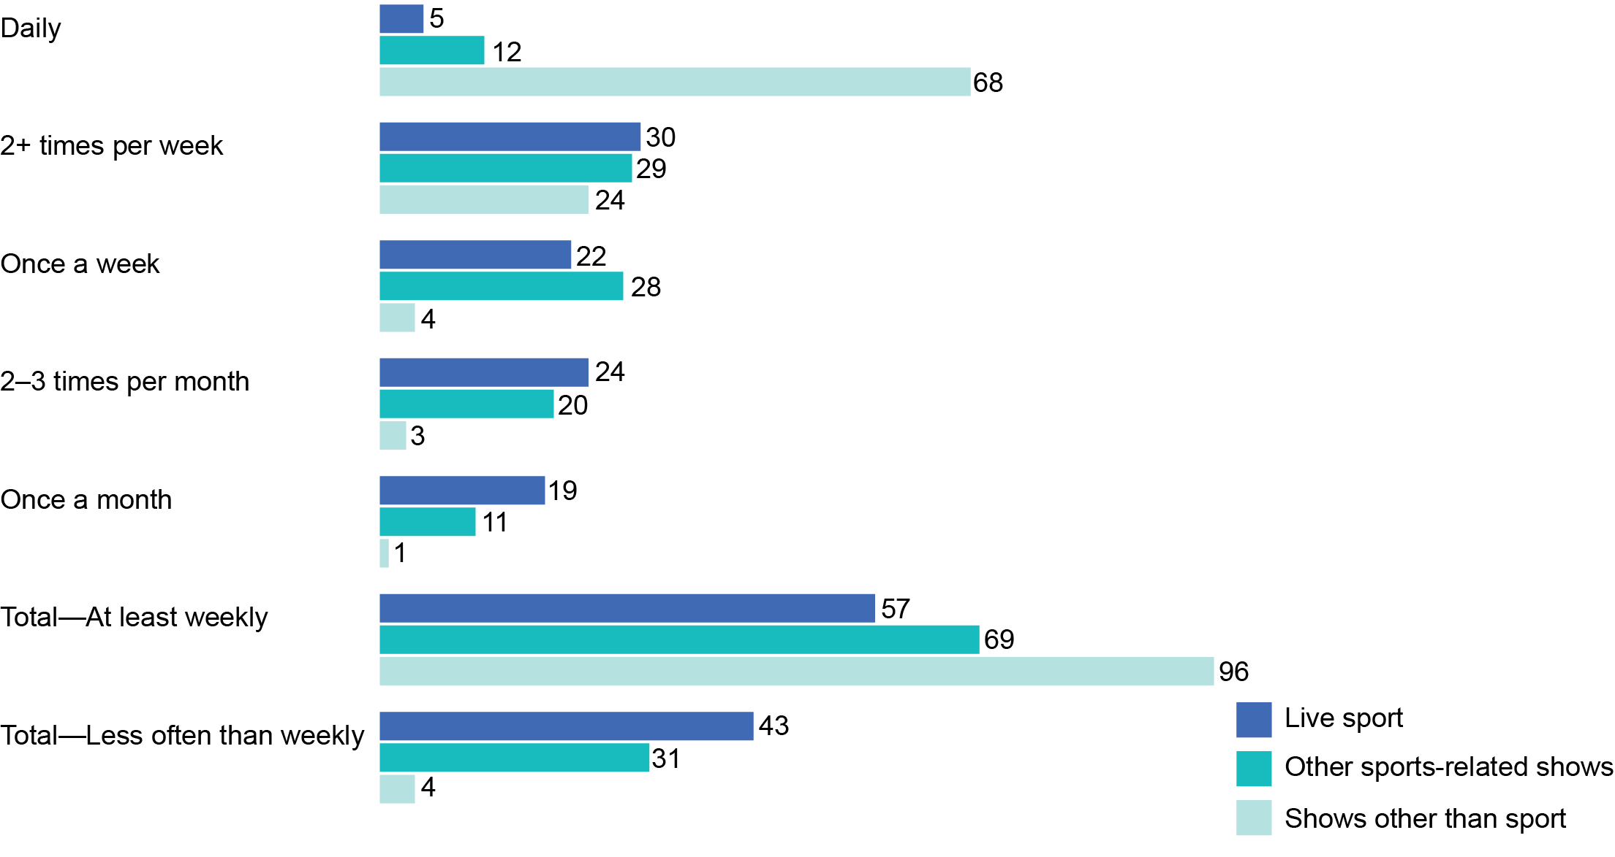

Base: Parents that watched or listened to the following in the past month: Live sport (n=1,020); other sports-related shows (n=542); shows other than sport (n=1,426).

### How often children watch different program types

Almost all children (97 per cent) watched shows other than sport at least weekly in the past month, compared to 53 per cent who watched live sport (see Figure 20).

While the child audience for other sports-related shows is smaller than the child audience for live sport, 75 per cent of the children who watch other sports-related shows reportedly watch these programs at least weekly.

1. Children’s frequency of watching different program types (%)

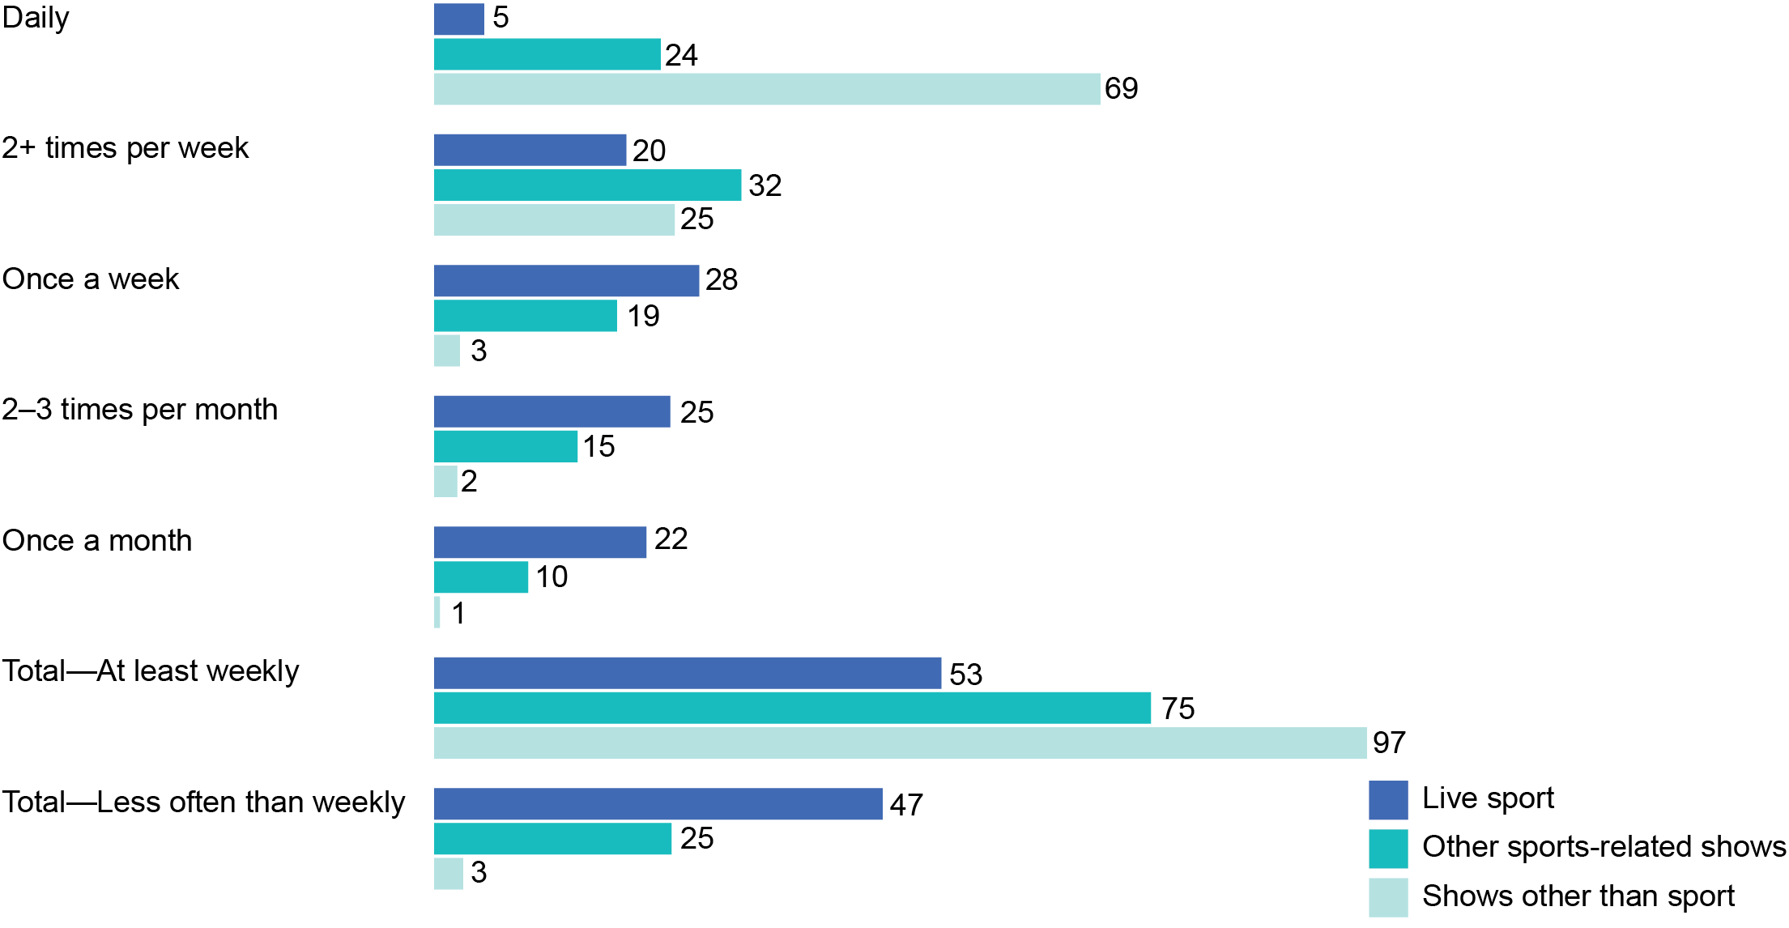

Base: Children that watched the following shows in the past month: Live sport (n=623); other sports-related shows (n=256); shows other than sport (n=1,355).

In the qualitative research, some parents mentioned that their children are exposed to sports-related shows by default, because their parents like to watch these shows. This was particularly evident for families with older children (aged nine-plus).

‘He [son] doesn’t have a choice. If he wants to watch TV with us and that’s what we’re watching, then—yeah.’   
(Parent group 6, 9–13 years, Dubbo)

The qualitative research also indicated that teenagers are more likely than younger children to watch sports-related shows, particularly if they are interested in a specific sport.

### How often children watch live sport—key demographics

Boys tend to be more frequent viewers of live sport than girls (see Figure 21). Fifty-eight per cent of boys watch sport at least weekly compared to 44 per cent of girls. This may be attributable to the types of sports broadcast and streamed online.

The research also showed that older children were more likely than younger children to be frequent viewers of live sport, with 62 per cent of teenagers aged 13 to 17 watching live sport at least weekly compared to only 51 per cent of children aged   
five to 12. This is consistent with findings from other data sources such as Roy Morgan’s Young Australians Survey (YAS), conducted among children aged six to 13 years, which shows that older children tend to be more interested in watching live sports than younger children.

1. How often children watch or listen to live sport—by gender   
   and age (%)

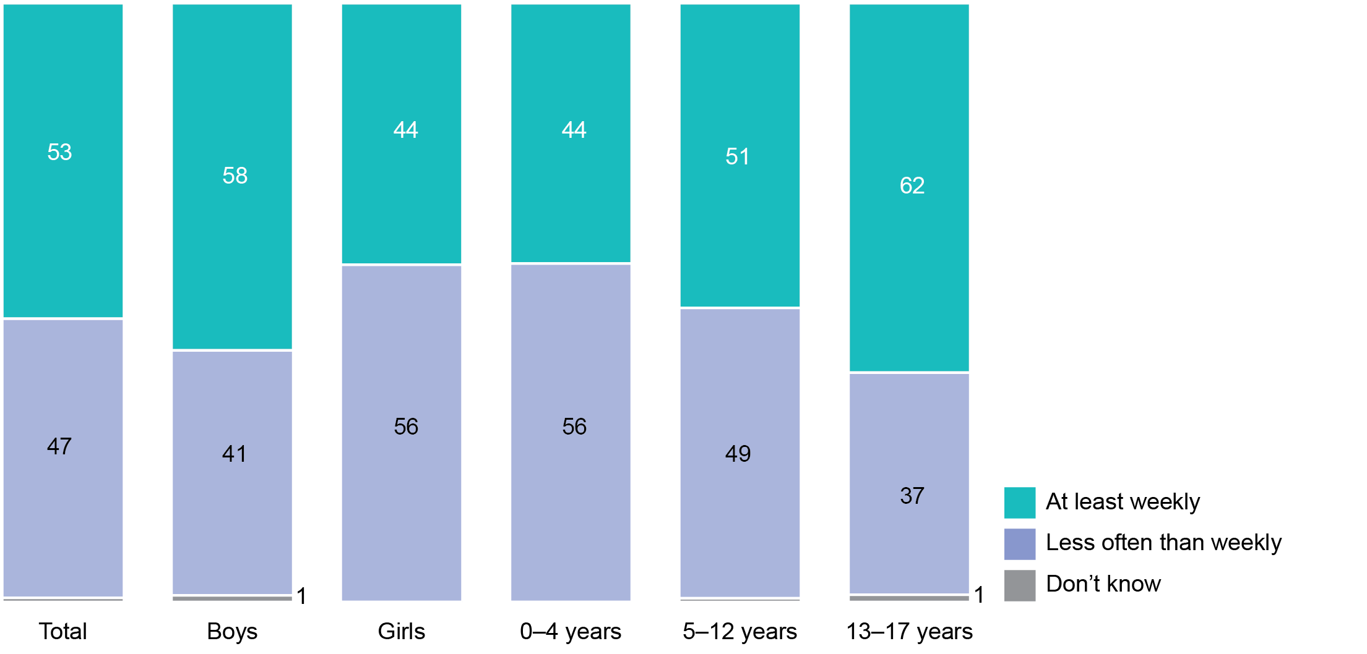

Base: Children that watched or listened to live sport in the past month; total (n=623);   
boys (n=390); girls (n=233); 0–4 years (n=106); 5–12 years (n=297); 13–17 years (n=220).

Note: Don’t know responses <1 per cent are not shown.

### How often do children watch live sport with their parents?

Children watch live sport with their parents more frequently than they watch other types of content with them (see Figure 22).

* Almost half of all children (49 per cent) watch live sport with their parents ‘some of the time’.
* A fifth (20 per cent) watch live sport with their parents ‘most of the time’.
* One-quarter of all children (25 per cent) ‘always’ watch live sport with their parents.
* Only 8 per cent of parents said that their children ‘always’ watch shows other than sport with a parent.

Only 5 per cent ‘always’ watch other sports-related shows with a parent.

1. How often children watch or listen to live sport with their parents (%)

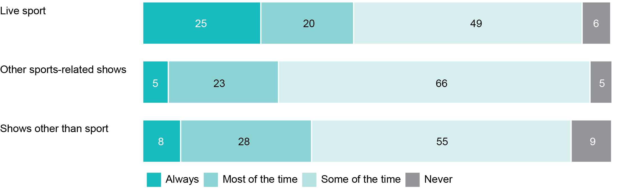

Base: Parent and child (i.e., both) who watched or listened to the following in the past month: live sport (n=564); other sports-related shows (n=171); shows other than sport (n=1,295).

Breaking this down by the gender of the parent, children are significantly more likely to ‘always’ watch live sport with their mothers than with their fathers. While one in six children (17 per cent) ‘always’ watch live sport with their fathers, around a third (32 per cent) ‘always’ watch live sport with their mothers (see Figure 23).

1. Proportion of children that ‘always’ watch or listen with their parents (%)

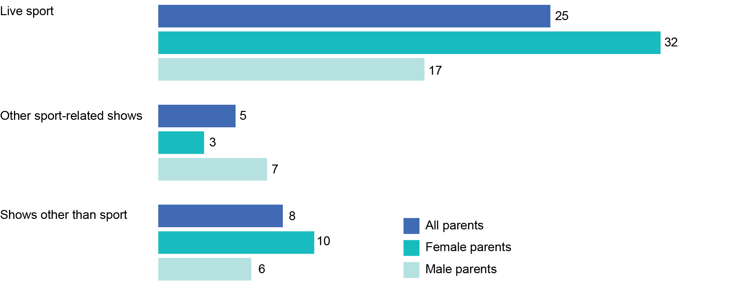

Base: Parent and child (i.e., both) who watched or listened to the following in past month: Live sport (n=564); other sports-related shows (n=171); shows other than sport (n=1,295).

### Most popular sports on television among children

Data from the YAS also provides some insight into types of sports viewed. The Olympics, AFL, the Commonwealth Games, cricket, soccer and NRL were the top six sports watched on television (see Figure 24).

YAS showed that boys aged six to 13 years are more likely than girls of that age to watch most sports including AFL, cricket, soccer and NRL (predominantly featuring male participants). However, girls aged six to 13 years are more likely than boys of the same age to watch netball, swimming and multi-sport events such as the Olympic and Commonwealth Games.

1. Top 10 sports watched on television by children aged 6–13 years (%)

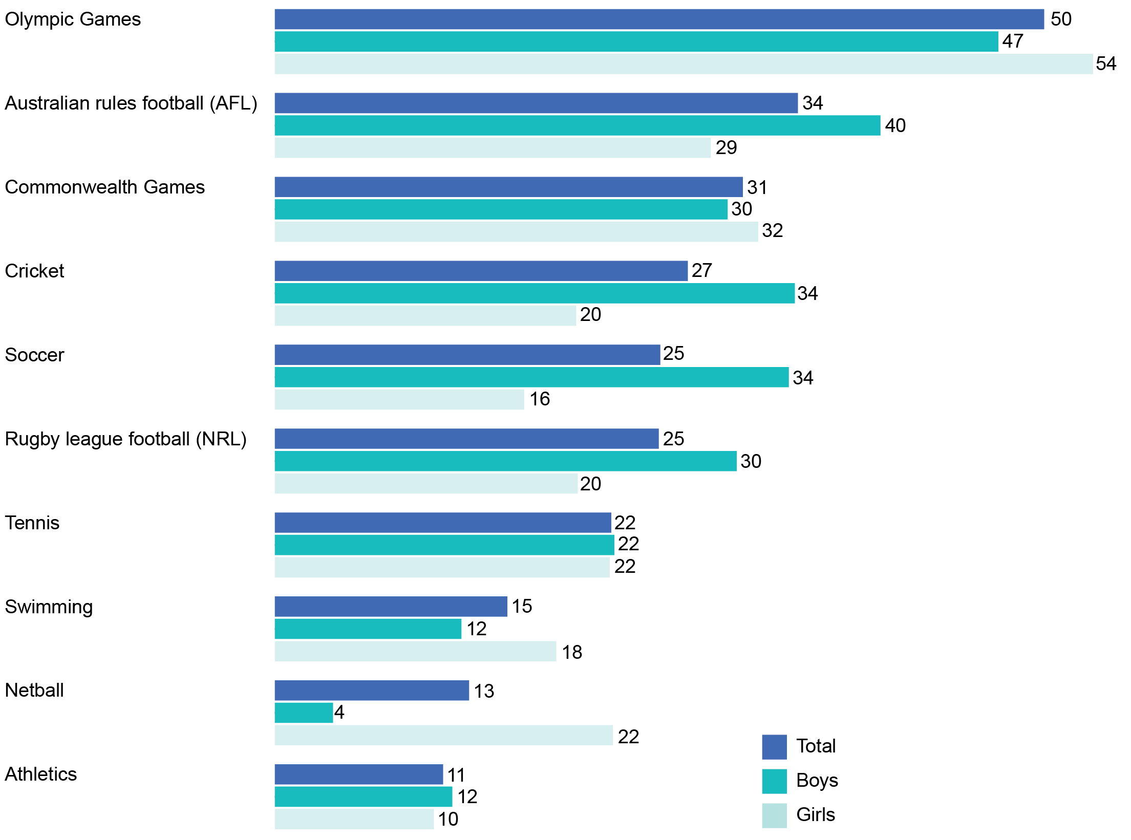

Source: Roy Morgan Young Australians Survey, July 2017–June 2018.

Base: Children aged 6–13 (n=2,527): boys (n=1,220); girls (n=1,307).

### Methods used by parents to consume different program types

Television, including both free to air and subscription television, is the most common way parents consume live sport; among parents who watched live sport in the past month, 94 per cent said they watched live sport on television. The same proportion (29 per cent) consumed live sport via radio or by streaming it online (see Figure 25).

Online streaming platforms (websites/apps) tended to be used more frequently for shows other than sport.

Among parents who watched or listened to non-sport content in the past month:

* Six in 10 (61 per cent) said that they did so by streaming non-sporting content online via a website or application

One in three (34 per cent) said they listened to non-sporting content on the radio.

The radio was on par with digital streaming for the consumption of live sport and sports-related shows:

* 29 per cent listen to live sport on the radio, with the same number of people streaming sport online

33 per cent listen to other sports-related shows on the radio and 32 per cent by online streaming.

1. Methods used by parents to consume different program types (%)

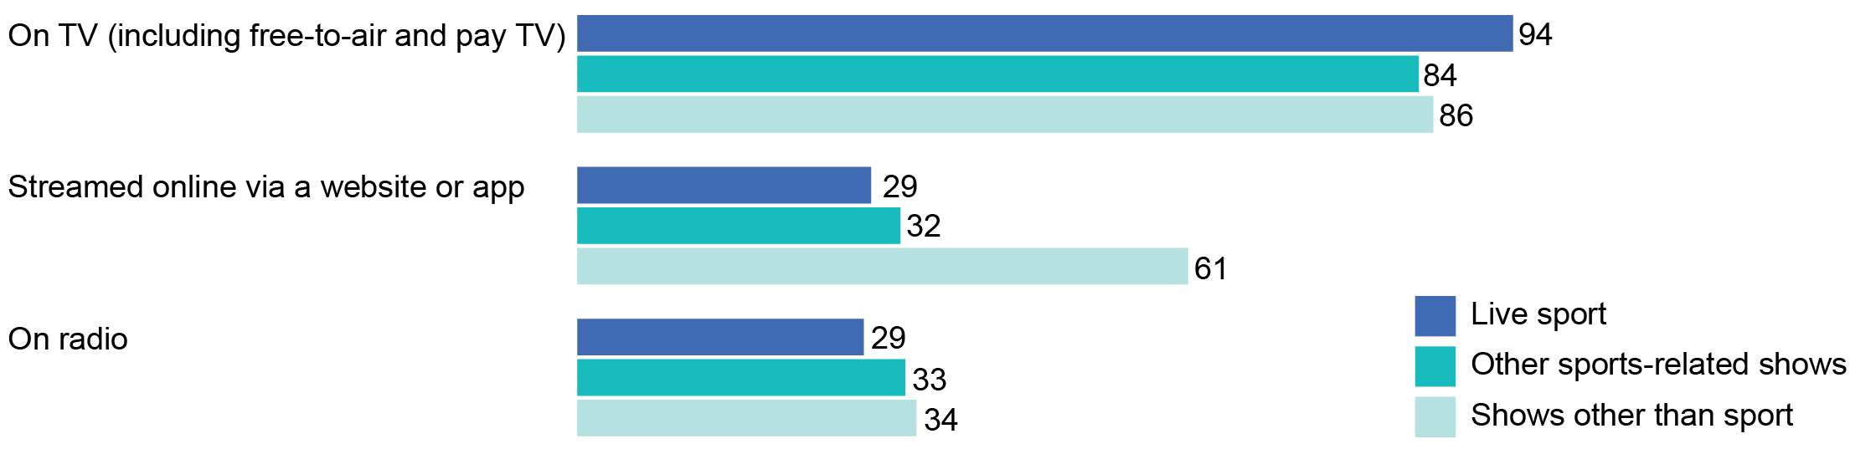

Base: Watched or listened to the following in the past month: Live sport (n=1,020); other sports-related shows (n=542); shows other than sport (n=1,426).

The qualitative research found that those who streamed live sports online were more likely to do so when:

* they were on their own rather than watching with family members or others
* out of home
* if it was broadcast at unusual times, for example, early morning soccer matches during the World Cup

if sports were not being shown on Australian free-to-air television.

Some participants referred to using betting apps as a platform for streaming live sports.

‘If I want to watch the basketball, watch … Malaysia under-19 women basketball you've just got to press 'watch' and there'll be a telecast on [the gambling company] app.’(Parent group 5, 5–8 years, Dubbo).

**Methods used by children to consume different program types**

Children were just as likely as parents to watch both sport and non-sport content on television. However, differences could be seen between children and parents in streaming of other content and in the use of radio (see Figure 26).

Ninety-five per cent of children watched live sport on television (parents—94 per cent) while only 27 per cent streamed it online (parents—29 per cent). For shows other than sport, children used online streaming (75 per cent) almost as much as television (81 per cent), while for parents, television was much more popular (86 per cent) than streaming (61 per cent).

Radio was the method used least by children to consume all of the different program types. Only 10 per cent listened to live sport and 9 per cent listened to shows other than sport on the radio, compared to 29 per cent and 34 per cent of parents respectively.

1. Methods used by children to consume different program types (%)

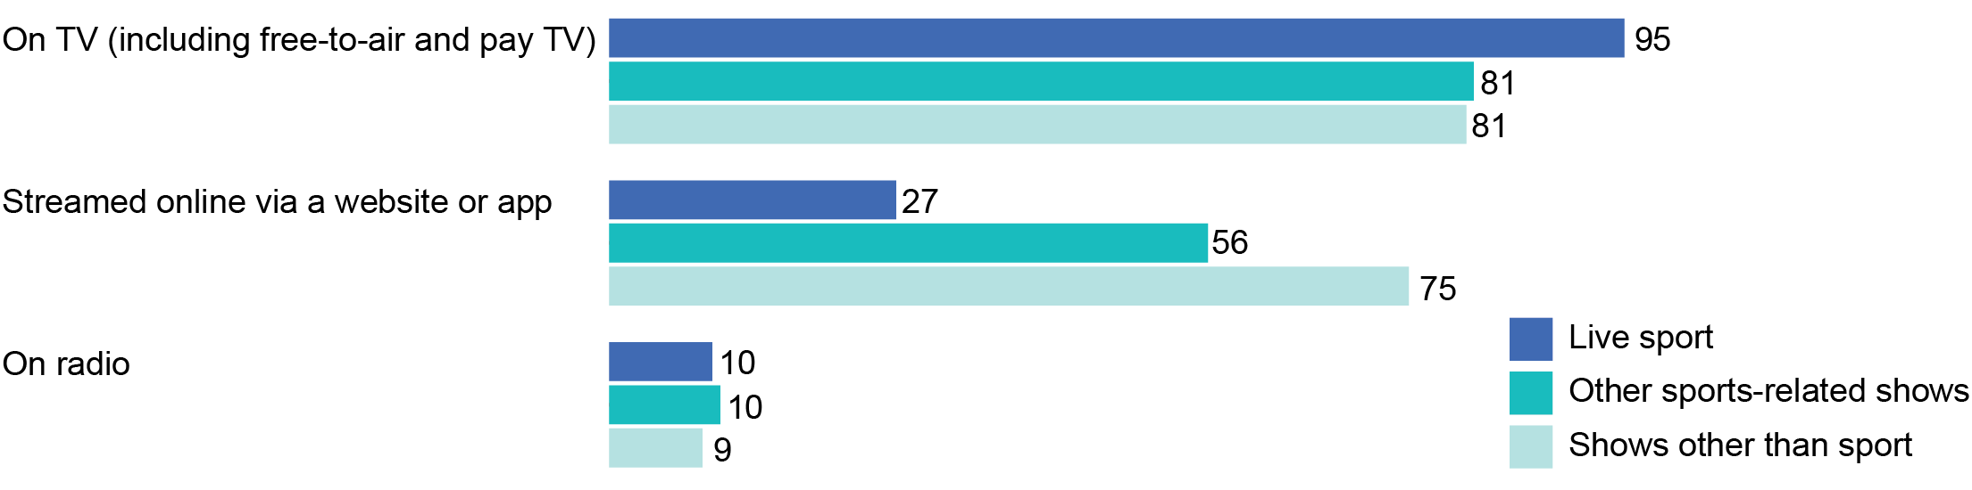

Base: Children that watched or listened to the following in the past month: live sport (n=623); other sports-related shows (n=256); shows other than sport (n=1,355).

Note: Results add to more than 100 per cent due to multiple responses.

In the qualitative research, only a few teenagers mentioned streaming live sport online, and this tended to be for sports played abroad.

‘For the soccer—because there is not a lot that's shown on Australian TV unless you pay for [subscription television service] I usually watch it online.’(Teen group 3, Melbourne)

### Online services used to stream live sport

Twenty-nine per cent of live sport viewers have used a website or app to stream live sport. The two most popular services or channels for streaming live sport for this group are the sporting organisations’ websites (63 per cent), and the broadcasters’ television or radio websites or apps (61 per cent) (see Figure 27).

Sporting-agency websites are used more heavily by parents who watch live sport weekly (69 per cent) than those who watch live sport less frequently (49 per cent). They are also more likely to be used by those who only speak English at home (69 per cent) than by those who also speak another language (46 per cent).

Video-sharing platforms are used by 40 per cent of those who stream live sport online and used more heavily by those who speak a language other than English at home (63 per cent) relative to those who do not (32 per cent).

Betting agency websites are the least popular channels used for streaming sport (10 per cent). However, betting agency website usage is significantly higher among parents who gamble weekly or monthly (55 per cent) than among those who bet less often (3 per cent) or who say they never gamble (2 per cent).

1. Online services used to stream live sport (%)

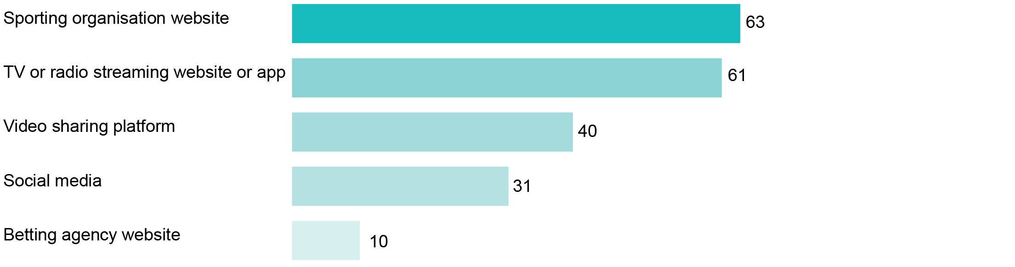

Base: Streamed live sport online in the past month (n=310).

Note: Results add to more than 100 per cent due to multiple responses.

### Methods used to restrict children from viewing content

Three-quarters of parents selected the viewing times for their children, and seven in 10 parents chose the shows that their children could watch (see Figure 28).

Parents were least likely to use ad-blocking software (24 per cent) and parental locks (29 per cent) to restrict what their children watched. The research also showed that the type of measure chosen to restrict content viewed by children differed with age.

Choosing the content watched is most common among the parents of toddlers and pre-schoolers (i.e., those aged 0–4 years). Parents of primary-school children (those aged 5–12) apply more restrictions on the content they allow their children to watch than parents of those aged zero to four and of teenagers aged 13–17 years.

1. Methods used to restrict children from viewing content (%)

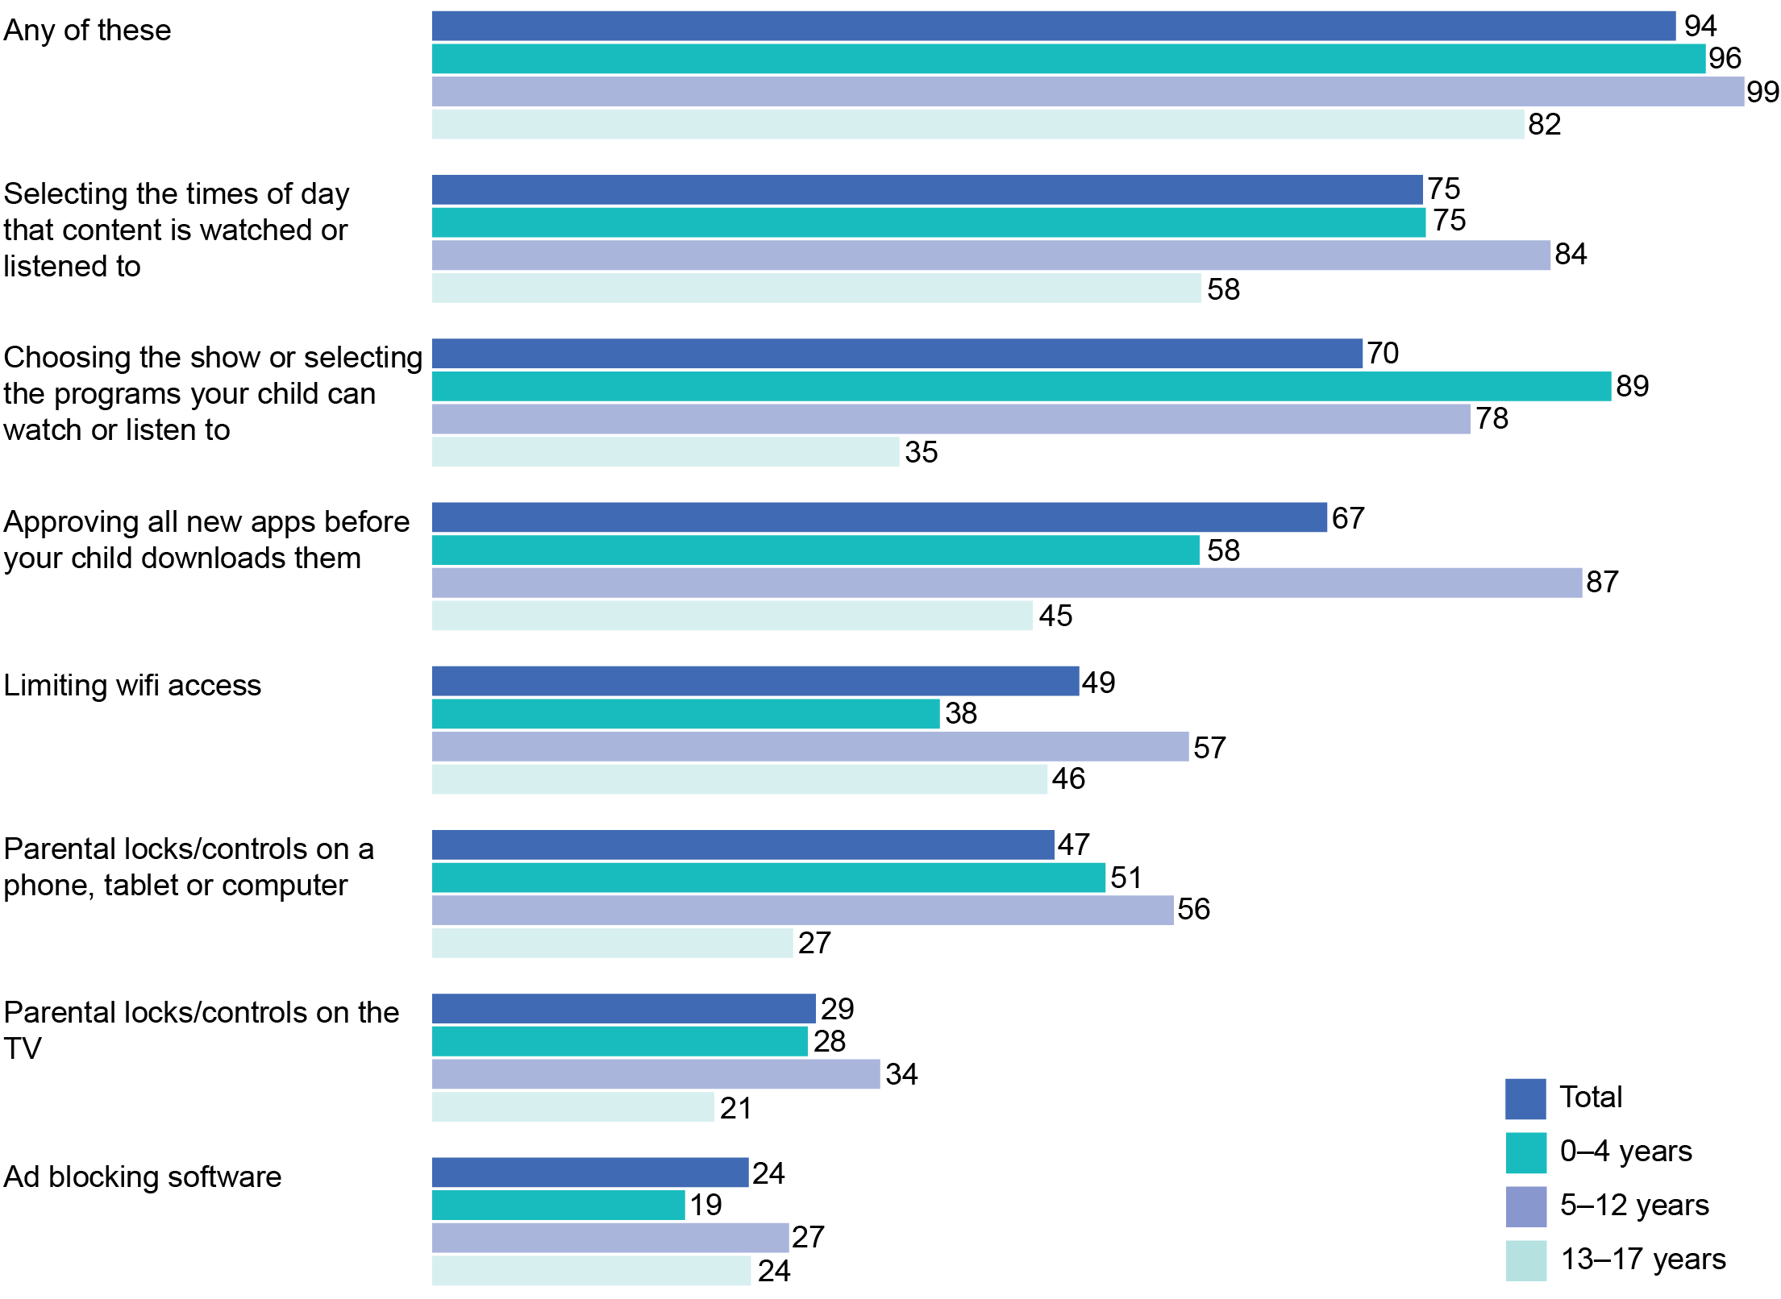

Base: All parents (n=1,507); children aged: 0–4 years (n=395); 5–12 years (n=644); 13–17 years (n=468).

In the qualitative research, similar methods of restricting children from viewing content were observed among parents but with more specific references to children’s bedtimes. Parents of children aged five to eight indicated they try to have their children in bed by around 7.30 pm to 8.00 pm during the week and by 9.00 pm at the latest on the weekends.

‘During the week we try to get him to bed by 8[pm]. But weekends, Friday night/Saturday night, 9[pm], 9.30[pm].’(Parent group 10, 5–8 years, Mandurah)

For children aged nine to 13 years, parents mentioned their children typically watched television or listened to the radio until 9.30 pm at the latest on weekdays.

## Exposure to gambling advertising

Another objective of this research was to assess parents’ and children’s exposure to gambling advertising, while watching live sport and other content via broadcast and online platforms.

### Exposure to gambling advertising in the past month

Findings from the qualitative research indicate that gambling advertising is more memorable in the live sport context than in other types of programs.

Almost nine in 10 parents (88 per cent) who watched live sport in the past month said they recalled seeing or hearing gambling advertising during the program (see Figure 29).

This was significantly higher than for non-sport content and other sports-related shows, where:

* six in 10 parents (59 per cent) who watched non-sport content in the past month recalled seeing gambling advertising while watching that type of content

three-quarters (76 per cent) of the parents who watched other sports-related shows said they saw gambling advertisements in those shows.

1. Recall of gambling advertisements in different types of content—parents (%)



Base: Watched or listened to the following on TV, radio or online: live sport (n=1,020); other sports-related shows (n=542); shows other than sport (n=1,426).

In the qualitative research, nearly all of the participants could recall being exposed—often on a daily basis—to some type of gambling advertising. Sports betting brands were top of mind and easily recalled by parents, and to a slightly lesser extent, teenagers.

‘I was watching the League the other night. In half-time, before they come through to commercial, there was about three ads—at least three—of the same [gambling company] ad.’(Parent group 6, 9–13 years, Dubbo).

When parents and teenagers in the qualitative research were asked how often they saw or heard gambling advertising, the perception was that they were exposed to gambling advertising quite regularly.

‘It seems daily. All day.’   
(Parent group 11, 9–13 years, Perth)

A few parents also made a connection between major sports events taking place and an increased amount of gambling advertising they were exposed to.

‘The World Cup was a big thing. And then they would have a lot of [gambling company] advertisements every time they had a break, half-time.’   
(Parent group 12, 5–8 years, Perth)

A few parents pointed out that the high frequency of advertisements negatively impacted their experience of watching sports to the point that the sport itself is becoming ‘gamblified’.

‘There’s so many ads now… it’s more that you should be betting on the sport, not just actually watching and enjoying the sport.’   
(Parent group 10, 5–8 years, Mandurah)

### Where gambling advertising is seen or heard

Gambling advertising was significantly more likely to be recalled on television than online or on the radio, irrespective of the program type being consumed (See Figure 30).

1. Where gambling advertisements are seen or heard by type   
   of content (%)

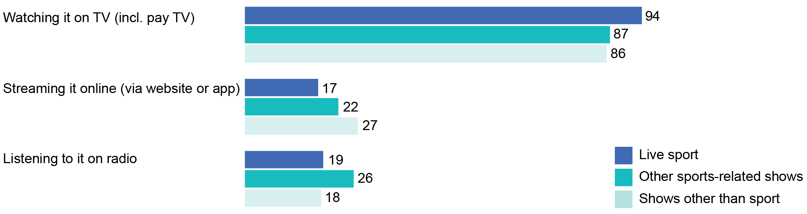

Base: Recall seeing or hearing gambling advertising while watching or listening to the following: Live sport (n=885); other sports-related shows (n=404); shows other than sport (n=851).

Note: Results add to more than 100 per cent due to multiple responses.

Among parents who recalled seeing or hearing gambling advertisements while watching live sport, almost all of them (94 per cent) reported seeing gambling advertisements while watching live sport on television.

Less than one in five (19 per cent) recalled hearing betting advertisements while listening to live sport on the radio or seeing it while streaming it online (17 per cent).

For shows other than sport, gambling advertisements were also far more likely to be recalled on television than in other media:

* 86 per cent of parents recalled gambling advertisements on TV during non-sport shows
* 27 per cent recalled gambling ads online while streaming non-sporting programs

18 per cent recalled gambling ads on radio during non-sporting programs.

In other sports-related shows:

* 87 per cent of parents recalled gambling advertising
* 22 per cent recalled gambling ads online

26 per cent recalled gambling ads on radio.

The qualitative research also found television to be the most common form of media for most participants’ exposure to gambling advertising, with the highest exposure during consumption of live sports broadcasts.

‘At half-time and three-quarter time, they give you the updated odds based on the score, that’s the live score.’   
(Parent group 12, 5–8 years, Perth)

‘Thursday, Friday nights, mainly. It's mainly night games.’   
(Parent group 5, 5–8 years, Dubbo)

Gambling advertisements on television were also deemed repetitive, by some parents.

‘And they run the same one over and over again, each ad break, so you'll see the same thing two or three times.’   
(Parent group 11, 9–13 years, Perth)

Despite the lower recall of gambling advertising on the radio, the qualitative research found radio functioned as an important alternative media platform when there was no possibility to watch sport on the television. Parents explained that they most commonly listened to the radio while travelling in the car or while they undertook household chores. It was in these situations they, and their children when they were in proximity, were exposed to gambling advertising over the radio.

For those parents who listen to sports broadcasts on the radio, the frequency of gambling advertising on the radio was reported to be high, although this was dependent on the radio station they were listening to.

Some parents said they had noticed gambling advertising and promotions online when using social media (e.g., Facebook, Twitter and Instagram) and video-sharing sites (e.g., YouTube) and assumed gambling advertising targeted them because of previous searches, websites they had visited, or ‘cookies’:

‘I don't know how it works but doesn’t that come down—if my kids, if they did use my iPad because I smash the gambling sites—but if my kid got on my app, doesn't it come from your cookies or something like that?’(Parent group 5, 5–8 years, Dubbo)

Although teenagers in the qualitative research reported seeing gambling advertising on television, they also mentioned a high volume of gambling advertising online while using social media or video-sharing platforms. Teenagers described seeing pre-roll/mid-roll video advertisements that they were required to watch in order to access content, as well as pop-up banners or advertisements as they scrolled through their feeds. This type of advertising was considered particularly prevalent across Facebook and YouTube.

‘Normally on YouTube on the computer it will pop up on the side, but on your phone, it will pop up just underneath the video for like a gambling game and on the actual video it will pop up the video the ad.’ (Teen group 6, Adelaide)

Teenagers also explained they saw gambling advertising while participating in online gaming. Free apps were highlighted as more frequently having in-app advertising and/or payment required to access an ad-free version of the app.

‘In most games, when you're on IOS devices, if you watch ads and some of them are gambling ads, you watch ads to get better at the game. Like, get in-game money.’  
(Teen group 3, Melbourne)

Sports-related websites and apps were mentioned by a few parents as another potential source of gambling advertising exposure.

‘When you’re looking at your Rugby League app and you’re seeing who’s playing, there’s an [gambling company] ad in between them, and you can click on that and go and put bets on.’   
(Parent group 6, 9–13 years, Dubbo)

### How often gambling advertising is seen or heard by parents in different types of programs

Parents recalled the frequency of exposure to gambling advertising as being substantially higher in the live sport context than in the non-sport context (See Figure 30).

Among parents who watched the different types of programs and recalled seeing any gambling advertising in those programs, gambling advertising was seen more frequently while watching live sport than other program types:

* During live sports, 51 per cent reported seeing gambling advertising ‘every time’ and 19 per cent reported seeing it some of the time.

Only 8 per cent of non-sport program viewers said they saw gambling advertisements ‘every time’ in non-sports programs and 60 per cent reported seeing it some of the time.

This supports the earlier finding that gambling advertising is recalled more frequently in the live sport context than in the non-sport context (Figure 31).

1. How often gambling advertisements are recalled in different types of content (%)

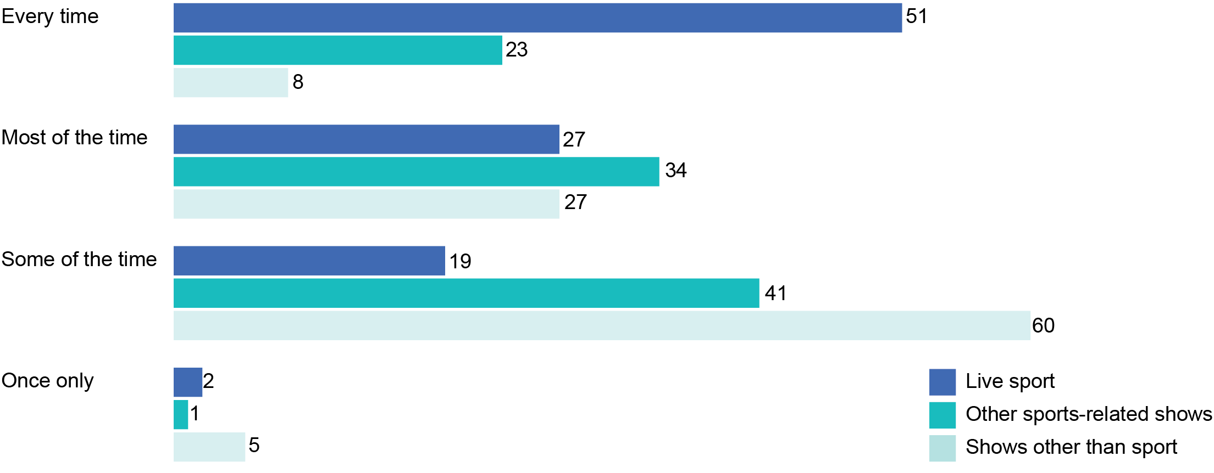

Base: Recall seeing or hearing gambling advertising while watching or listening to the following: Live sport (n=891); other sports-related shows (n=413); shows other than sport (n=854).

### How often parents are with their children when they are exposed to gambling advertising

Up to three-quarters of children watching live sport with their parents may have been exposed to gambling advertisements (see Figure 32).

Where parents recalled seeing gambling advertising during live sport:

* 12 per cent of parents said they were ‘always’ watching with their child
* 17 per cent said they were watching with their child ‘most of the time’

47 per cent watched with their child ‘some of the time’.

Four in five children may have been exposed to gambling advertising while watching non-sport programs. Among the parents who recalled seeing gambling advertising during shows other than sport:

* Two-thirds (65 per cent) said their child was with them ‘some of the time’

15 per cent said their child was with them ‘always’ or ‘most’ of the time that these gambling advertisements were seen.

1. How often parents were with their children when they were exposed to gambling advertising (%)

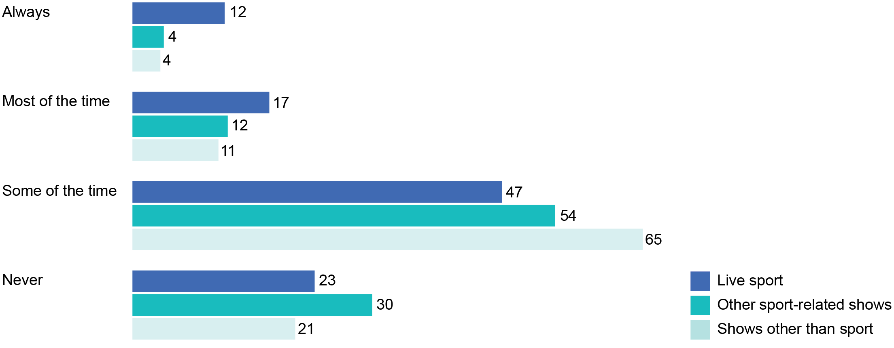

Base: Recall seeing or hearing gambling advertising while watching or listening to the following: Live sport (n=891); other sports-related shows (n=413); shows other than sport (n=854).

Note: Results based on parent weights.

The qualitative research found some parents who believed their children were seeing gambling advertising as frequently as daily.

The age of children and their cognitive development was mentioned by some parents as impacting their child’s ability to understand the message in the gambling advertisement or promotion, indicating parents are less concerned about the impact of gambling advertising on younger children.

Parents of younger children expected their children to be consuming gambling advertising in a more indirect way, as their children would not yet have the attention span to watch a full game and would be doing other activities whilst watching with family members. However, some parents indicated humorous advertising could draw the attention of children. A few parents commented on their children imitating and singing elements from the gambling advertising they had seen.

‘I think the more jingly the ad is—I reckon my kids would be able to jingle the ad before they would actually know what betting is.’(Parent group 6, 9–13 years, Dubbo)

### Gambling advertising recall by part of the live sport broadcast

Parents were most likely to see or hear gambling advertisements:

* during half-time or quarter-time (85 per cent)
* during the pre-match commentary and build-up (76 per cent)

in other breaks during play (75 per cent) (see Figure 33).

Players’ uniforms were least likely to be recalled for gambling advertisements and promotions, however almost two-thirds of parents (63 per cent) who recalled seeing or hearing gambling advertising in live sport recalled seeing it on signage around sporting grounds.

Fathers were significantly more likely than mothers to recall seeing gambling advertisements:

* during the pre-match commentary and build up (83 per cent versus 68 per cent)
* on signage around the grounds (69 per cent versus 56 per cent)

during the post-match analysis and review (52 per cent versus 38 per cent).

1. When/where in live sport broadcasts gambling advertising is recalled (%)

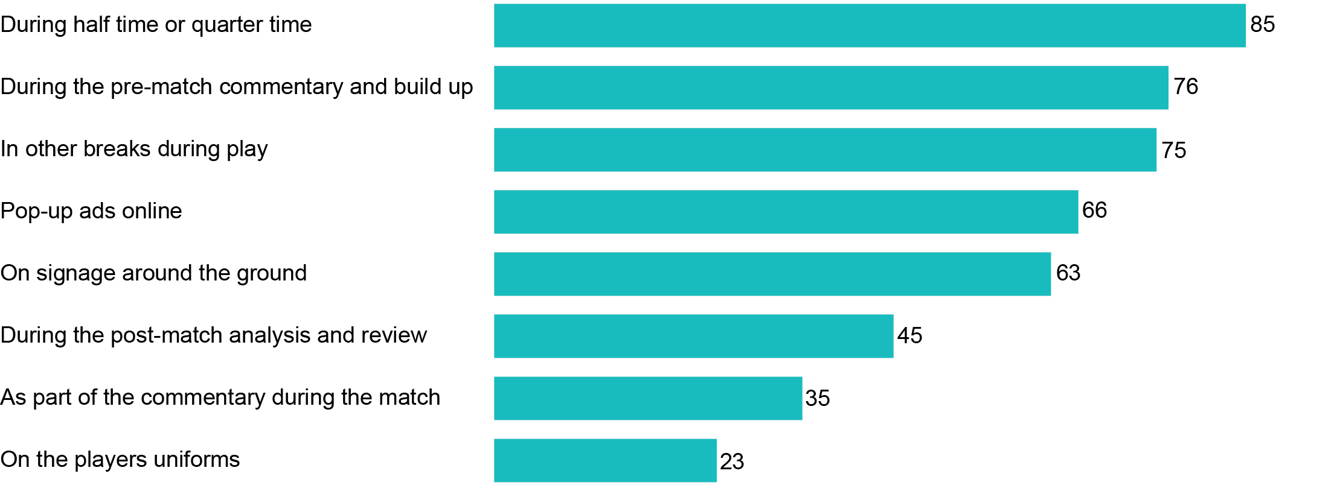

Base: Recall seeing or hearing gambling advertising while watching or listening to live sport (n=891).

Note: Results based on parent weights.

### Gambling advertising recall—time of day

The majority of parents recalled seeing gambling advertising in live sport during the afternoon and early evening (See Figure 34).

* 83 per cent of parents recalled seeing gambling advertising during live sport between 5.00 pm and 8.30 pm.
* 70 per cent of parents said they saw gambling advertising during live sport in the afternoon (between midday and 5.00 pm).
* 57 per cent of parents said they saw gambling advertisements during live sport between 8.30 pm and midnight.

13 per cent said they saw gambling advertisements during live sport between 5.00 am and midday.

Given the new restrictions apply between 5.00 am and 8.30 pm, it is possible that parents may be recalling gambling advertisements shown outside these times, in pre and post-game coverage or during non-sport programs. Comparing the AFL coverage between the 2017 and 2018 seasons on metro television, for example, the Nielsen Ad Intel data compiled by the ACMA shows that there was a 131 per cent increase in the volume of gambling advertising after 8.30 pm (see Figure 2).

1. What time of day gambling advertising is recalled in live sport (%)

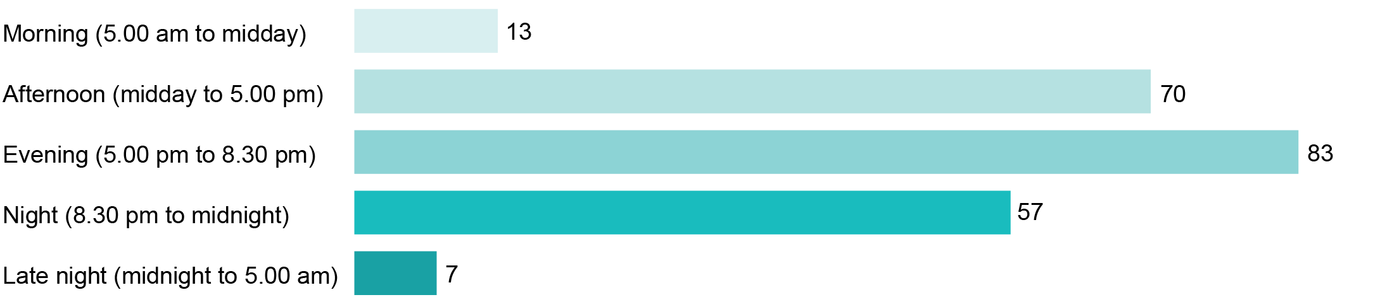

Base: Recall seeing or hearing gambling advertising in live sport (n=891).

Note: Results add to more than 100 per cent due to multiple responses.

It is worth noting that the ability of some participants to provide details about their exposure to gambling advertising may have been limited as they did not always pay conscious attention to advertisements. Similarly, participant’s recall of their exposure to gambling advertising may be related to advertising that was incidental to the broadcast or stream (e.g., through signage on the sportsground or on players’ uniforms) (see Figure 35).

For example, in the qualitative research, most parents and teenagers did not make a clear distinction between gambling advertising they had been exposed to while watching live sports content versus non-sports content, despite being asked to draw out this level of detail.

Most agreed they rarely pay conscious attention to television advertising. Ad breaks during sports broadcasts on commercial television were described as an opportunity for family members to ‘tune out’ or do something else (e.g., check phone, prepare snacks/drinks or take a refreshment break).

‘Half-time or three-quarter time or quarter-time, we’re either getting some meat pies or heating up things.’   
(Parent group 2, 14–17 years, Melbourne)

Children, too, were likely to wander off during advertisement breaks on television and were therefore less likely to be exposed to gambling advertisements.

‘The [children] push each other around or go to their room, play for a little while, come back for when the show’s back on. They don’t really watch the ads.’  
(Parent group 4, 9–13 years, Bendigo)

However, a few parents mentioned they had used gambling advertisements during family viewing as an opportunity to educate their children on the dangers, risks and traps associated with gambling.

‘Whenever I see something like that, I will always harp on it because I want to drive the point to the kids.’   
(Parent group 7, 14–17 years, Parramatta)

Other parents indicated their children’s reactions or questions about gambling advertisements could serve as an inducement to start a conversation about how to gamble responsibly or avoid it completely.

‘You’ve got to answer them and tell them the honest truth that, “It’s not what you think. Gambling isn’t a good thing”.’   
(Parent group 9, 14–17, Mandurah)

### Other sources of gambling advertising exposure

In the year to July 2018, gambling advertising expenditure increased by 26 per cent according to SMI figures published by AdNews in October 2018.[6] Surges in year-on-year gambling ad spend across all of the major media types in the year to July 2018 were led by a 121 per cent growth in newspapers, 84 per cent growth in cinema and 60 per cent growth in outdoor.

In the quantitative research, besides television and radio, most parents recalled seeing gambling advertising on other sources:

* Four in five (81 per cent) said they had seen gambling ads via one or more sources other than television and radio, including online sources.

Two-thirds of parents (66 per cent) recalled seeing gambling ads via one or more of the offline sources (i.e., outdoor, print media, merchandise or events).

Of sources other than television and radio, gambling advertising was most recalled on social media, outdoor sources, print media and online articles/blogs (See Figure 34). Based on those parents who engaged in each of these activities in the past month:

* 54 per cent saw gambling ads on social media
* 48 per cent saw these ads on outdoor billboards, bus stops and the like

46 per cent saw these ads in newspapers and magazines or while reading news, blogs or articles online.

1. Other sources of gambling advertising (%)

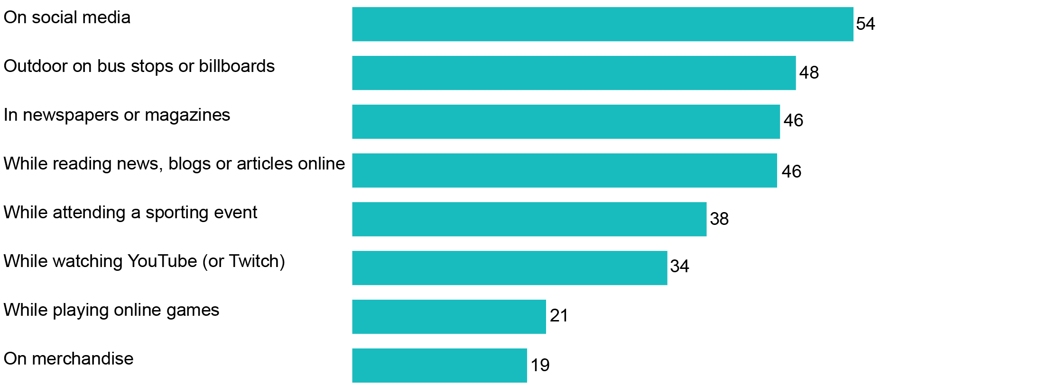

Base: Those engaged in the following activity in the past month: Played online games (n=879); travelled past outdoor billboards (n=1,411); on social media (n=1,378); outdoor (n=1,488); news, blogs, online (n=1,432); newspapers/magazines (n=1,294); YouTube (n=1,293); attending a sporting event (n=952); playing online games (n=893); merchandise (n=1,477).

In the qualitative research, some parents also mentioned gambling promotions on screens at the sportsground, or gambling brands on players’ jerseys to which they, and their children, were exposed.

‘I do see gambling ads but it’s on the outer rim of the AFL court where they have the screens.’   
(Teen group 4, Melbourne).

Other parents mentioned advertisements they had seen outside the grounds, in the form of outdoor advertising.

‘Bus stops even, they’ll have the rolling banners here and there.’   
(Parent group 8, 9–13 years, Parramatta)

## Attitudes towards gambling advertising

Another objective of the research was to explore parents’, guardians’ and carers’ attitudes towards children’s exposure to gambling advertising, both while consuming live sport and other content via broadcast and online services.

### General attitudes to gambling advertising

More than three in five parents (62 per cent) said they were bothered by gambling advertising, with almost half of this group (28 per cent) saying they were bothered ‘a lot’. Less than two in five parents (37 per cent), said they were ‘not bothered at all’ by gambling advertising (see Figure 36).

1. Attitudes towards gambling advertising—parents (%)

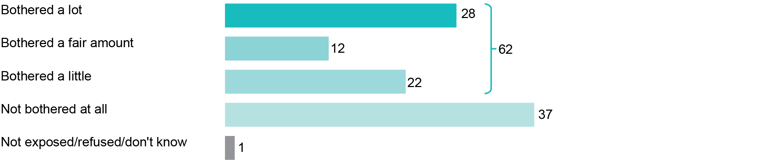

Base: All parents (n=1,507).

Across the key demographic groups:

* Older parents were more bothered than younger parents. Among parents aged 45 to 54 for example, 37 per cent said they were ‘bothered a lot’, and among parents aged 55 or more, 40 per cent said they were ‘bothered a lot’.

Parents with teenagers aged 13–17 were significantly more likely than those with younger children aged 0–4 to be ‘bothered a lot’ (34 per cent versus 21 per cent) or ‘bothered a fair amount’ (16 per cent versus 11 per cent) by gambling advertising.

Parents and teenagers in the qualitative research also described how they felt annoyed and overwhelmed by the volume of gambling advertising and promotions on both broadcasting and online platforms. This attitude was shared by almost all parents and teenagers interviewed.

‘We're being bombarded by it [gambling advertising].’   
(Parent group 11, 9–13 years, Perth)

‘It’s ridiculous. They advertise it [gambling] too much.’   
(Teen group 6, Bendigo)

Participants expressed concern about the prevalence of gambling advertising and promotions across broadcast and online platforms.

‘It's in your face all the time, it's not like it's just on TV, it's on the tablets, on your phone or on the computer. So, it's everywhere.’ (Parent group 7, 14–17 years, Parramatta)

For many parents, gambling advertising was described as inappropriate.

‘It’s just I’m annoyed that it’s on and we’re having family time and it’s on and I just think it’s inappropriate.’(Parent group 9, 14–17 years, Mandurah)

Frequent high exposure to gambling advertising was felt to be contributing to both the ‘gamblification’ of sport and the normalisation of gambling in Australian society. This was mentioned by most parents and a few teenagers during the discussions, as a genuine source of concern.

‘If children and families are viewing it [gambling advertising], it normalises gambling, and gambling can be a problem.’(Parent group 11, 9–13 years, Perth)

### Attitudes to gambling advertising involving betting odds

While 62 per cent of parents indicated they are bothered by gambling advertising in general (see Figure 36), a similar proportion (66 per cent) reported being bothered (‘a little’, ‘a fair amount’, or ‘a lot’) by advertising focused on the promotion of betting odds (see Figure 37).

A larger proportion of parents said they are bothered ‘a lot’ (32 per cent) than bothered only ‘a little’ (20 per cent) by ads involving betting odds.

1. Attitudes towards gambling advertising involving betting odds (%)



Base: All parents (n=1,507).

Some parents in the qualitative research were negative towards gambling advertising involving live odds but their concern appeared to be about gambling advertising more generally.

‘I don't like the gambling ads during the game ... I don't need to watch gambling at half-time or while the game's being played. Like, live odds, bet now, all that; it's just a bit too much.’  
(Parent group 7, 14–17 years, Parramatta)

### Attitudes to children being exposed to gambling advertising

While most parents are bothered by gambling advertising when they see it themselves (See Figure 36), they tend to be more bothered when their children are exposed to it (See Figure 38).

More than seven in 10 parents (72 per cent) said they were bothered by their child being exposed to gambling advertising. Parents were twice as likely to be ‘bothered a lot’ (39 per cent) than ‘bothered a little’ (20 per cent).

Fewer than one in four parents (23 per cent) indicated they were ‘not bothered at all’ by their child being exposed to gambling advertising.

Older parents were more likely to be ‘bothered a lot’ by children being exposed to gambling advertising. Among parents aged 45-plus, for example, 46 per cent were ‘bothered a lot’.

1. Attitudes towards children being exposed to gambling advertisements (%)

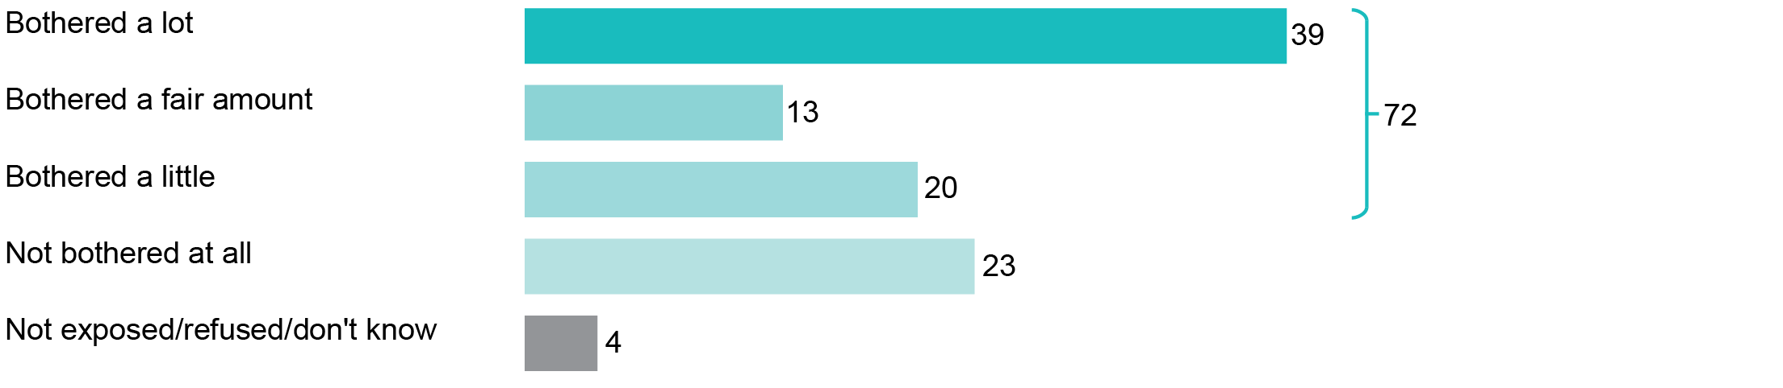

Base: All parents (n=1,507).

### Why parents are bothered by children seeing gambling advertising

The qualitative research helped to explain why parents are especially bothered by their children seeing gambling advertising. Gambling has become far more accessible since the advent of gambling apps on smartphones. Parents (and teenagers) recognise they can place a bet on a sporting event wherever they are, via their smartphones, whereas in the past, one had to physically visit a betting shop in order to place a bet, which limited the opportunities for underage gambling.

‘Everyone's got smartphones. Most kids have got smartphones. You can just get an app, have an account there and actually do it right off.’(Parent group 5, 5–8 years, Dubbo)

Parents’ concerns about the impact of gambling advertising seemed to vary according to the age of the child, the parents’ own involvement in gambling, the character of the child, and the extent to which the child had shown an interest in gambling.

Overall, most parents felt more concerned about children’s exposure to gambling advertising and promotions online because they (parents) might not be aware of it. Further, parents voiced concern about children being exposed to gambling advertising and promotions while watching a video online that was not in any way related to sports or gambling, or while playing a game through an app and having gambling-related advertisements pop-up.

‘I'm concerned because it's becoming more and more frequent on things that kids are utilising, so the tablets and things … where they perhaps have more time on their own or we're not right there beside them.’ (Parent group 5, 5–8 years, Dubbo)

There was also concern that some children may click through links to gambling sites or promotional webpages while using social media and YouTube (not related to them watching live sports). Parents also feared that some older children (age nine-plus) may be able to make payments using their parents’ credit cards.

‘They are tech-savvy and they know how it [online payment] works. They know how cards work.’   
(Parent group 6, 9–13 years, Dubbo).

Online pop-up advertisements and pre-/mid-roll advertising were described by most parents to be one of the most insidious forms of gambling advertising. They explained that children were exposed to this type of advertising while they were watching children’s programs or online content.

‘The YouTube stuff ... my girls are watching innocent [things] like makeup tutorials, and that’s not something that’s inappropriate. It’s just obviously the [gambling] ad in it is inappropriate.’   
(Parent group 9, 14–17 years, Mandurah)

One parent mentioned that sharing devices between parents and children could possibly lead to children’s exposure to gambling advertisements. Parents’ involvement in online gambling could then lead to advertisements popping up during the child’s use of the device, based on their browser history, or ‘cookies’.

‘If my kid got on my app, doesn't it come from your cookies or something like that.’   
(Parent group 5, 5–8 years, Dubbo)

Many of the parents thought gambling advertisements broadcast during prime time (typically family viewing times) and around non-sports related programming was inappropriate for children and a cause for concern.

‘We watch shows together and they [children] actually see it [gambling advertising] during the kids' shows, like Better Homes and Gardens.’   
(Parent group 11, 9–13 years, Perth)

Certain types of gambling promotions were of more concern for parents, such as promotions suggesting people would receive a refund or money back. Parents felt that children may perceive there to be no risk in this form of gambling.

‘There is a promotion on...’your money back’. So, it creates a false sense of security in that you're never going to lose.’   
(Parent group 5, 5–8 years, Dubbo)

Promotions of bonus bets were also concerning.

‘Especially when you’re adding in bonus bets and all that sort of stuff. Where it’s basically coming across like you’re getting free money anyway.’   
(Parent group 4, 9–13 years, Bendigo)

Some parents were against celebrities endorsing gambling brands or promotions as they were more likely to attract the attention of children who idolised them or their team.

‘They definitely shouldn’t have famous people on it [gambling advertisement], encouraging it.’   
(Teen group 4, Melbourne)

Humorous gambling advertisements were described as having the potential to attract the attention of children as well. Parents discussed how their children could often recall the advertisement because of the humour or jingle.

‘The funny ones. If they're doing something stupid in the ad, then they [children] remember it.’   
(Parent group 11, 9–13 years, Perth)

Parents highlighted that the perceived ‘risk-free’ gambling and humorous advertisements had the potential to attract children online. If these appeared while their child was using social media, playing games or watching sport, there was the potential for them to click through the link and be directed to a gambling website or app.

## Perceived change in volume of gambling advertising

Another key objective of the research was to explore parents’, guardians’ and carers’ perceptions of change in the amount of gambling advertising their children may have been exposed to after the introduction of the new restrictions.

When asked whether the amount of gambling advertising they had seen or heard on television or radio had changed in the past six months, more than half (55 per cent) of parents stated that it had increased (see Figure 39). Among those who noted an increase, two-thirds said it had ‘increased a lot’.

Just over one quarter (28 per cent) said there had been no change in the volume of gambling advertising. Only a small group (5 per cent) indicated they had seen a decrease.

1. Perceived change in amount of gambling advertising—generally (%)

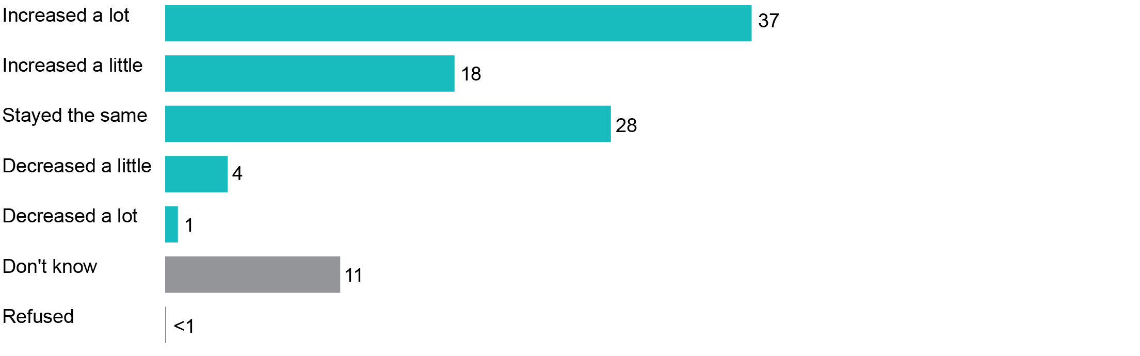

Base: All parents (n=1,507).

Note: Results do not add up to 100 per cent due to rounding.

These perceptions were also found in the qualitative research when participants were asked if they had noticed a change in the gambling advertising they had been exposed to since early 2018, the time when the new restrictions were introduced. Most parents felt they had been exposed to more gambling advertising in this time.

Some parents mentioned that the amount of gambling advertising seemed to have increased online and during online streaming of live sports. Some teenagers also said that gambling advertisements seemed to have increased online and especially on YouTube.

‘Well, it's more online, guaranteed. More online; it's actually coming more and more often.’   
(Parent group 7, 14–17 years, Parramatta)

‘It just seems there’s more. I don’t know what’s changed to make them more.’   
(Parent group 3, 14–17 years, Bendigo)

**Perceived change in volume of gambling advertising—in live sport**

Consistent with gambling advertising in general, the majority of parents also believe that the volume of gambling advertising has increased during live sport, particularly in the past six months (see Figure 40). Six in 10 (61 per cent) parents reported they had seen an increase in the amount of gambling advertising during live sport.

Of those who said that they had observed an increase, 37 per cent said that the advertising had increased a lot during live sport, while 24 per cent said it had increased a little.

1. Perceived change in amount of gambling advertising—in live sport (%)

Figure 40: Perceived change in amount of gambling advertising—
in live sport (%)


Base: Watched or listened to live sport on TV/radio (n=1,020).

Note: Results do not add up to 100 per cent due to rounding.

Just over a quarter (27 per cent) said there has been no change in the volume of gambling advertising, 8 per cent said they didn’t know and only a small group (5 per cent) said they had seen a decrease.

The number of parents who said the volume had increased (61 per cent) was again more than 10 times the number that said the volume had decreased (5 per cent).

To put these consumer perceptions in context, advertising placement data demonstrates that while gambling advertising has increased overall on television and radio, there has been strong compliance with the safe zone restrictions and a general decrease in gambling ads during all live sport.

# Appendix A—Background to the gambling advertising restrictions

The new gambling advertising restrictions applicable to broadcasters were developed under the co-regulatory scheme established by the *Broadcasting Services Act 1992* (BSA). They build on existing restrictions introduced in 2013 to prohibit promotions of betting odds during play. The codes are applicable to commercial television and radio services, subscription television and radio services and SBS.

The BSA requires broadcasting industry groups to develop codes of practice, undertake public consultation and present codes to the ACMA to be included on the Register of codes of practice. The ACMA will register a code if it is satisfied that:

* the code provides appropriate community safeguards for the matters covered
* the code is endorsed by the majority of providers of the broadcasting services in that section of the industry

members of the public have been given an adequate opportunity to comment on the code.

SBS, as a national broadcaster, is not required to submit codes to the ACMA for approval and instead notifies its amended codes to the ACMA.

Following a period of public consultation, conducted by the relevant industry groups, the new gambling advertising restrictions in the broadcasting codes of practice were included in the Register of codes of practice and became effective on 30 March 2018.

The new gambling advertising restrictions for online content services required legislative amendment. The *Communications Legislation Amendment (Online Content Services and Other Measures) Act 2018* empowered the ACMA to make Online Content Service Provider Rules(online rules) under a new Schedule 8 introduced into the BSA. In effect, Schedule 8 provides that the ACMA may:

* make online content service provider rules about gambling promotional content provided on an online content service in conjunction with live coverage of a sporting event

determine class exemptions or agree to individual exemptions for certain content service providers from all or some aspects of the online rules.

Following two rounds of public consultation, the online rules came into effect on   
28 September 2018. Prior to the introduction of the new restrictions, online platforms were not subject to any restrictions relating to the provision of gambling advertising during the coverage of live sport.

### The restrictions

The key requirement established by the new restrictions is a prohibition on gambling advertising during coverage of live sporting events between 5.00 am and 8.30 pm (including breaks in play), from five minutes before the scheduled start of play until five minutes after play concludes. The restrictions are substantially similar across broadcasting and online platforms but there are several minor differences which reflect variances in the relevant operating environments. In summary, at all times of the day:

* Gambling advertising and promotions of betting odds during play are prohibited.
* The promotion of odds by commentators and guests is prohibited from 30 minutes before play starts until 30 minutes after play concludes.

Representatives of gambling organisations appearing in a gambling advertisement must not be at, or appear to be at, the event venue.

Between the hours of 5.00 am and 8.30 pm:

* Additional restrictions prohibit gambling advertising and promotion of odds during scheduled and unscheduled breaks in play.
* This prohibition applies from five minutes before the ‘scheduled start’ of the sporting event until five minutes after the conclusion of play.

If the broadcaster/service provider does not identify the ‘scheduled start’ at least 24 hours before the event, the prohibitions apply from the start of the program that includes the live sporting event (for example, pre-game coverage).

Long-form sporting events (such as cricket) are treated as single live sporting events. This means that audiences have the benefit of the additional protections for the entire duration of the event if it takes place between 5.00 am and 8.30 pm. There are, however, limited circumstances when gambling ads may be shown, such as during breaks of extended duration where unrelated content is broadcast or streamed.

In terms of application, the restrictions on broadcasting and online platforms do not apply to incidental advertising such as signage at sporting grounds or advertising on players’ uniforms, nor do they prohibit advertisements for lotteries, lotto, keno or competitions. Broadcasts, or online streams, of live horse racing, harness racing or greyhound racing are, similarly, not subject to the restrictions.

# Appendix B—Methodology

## Qualitative research

The qualitative phase of research was conducted by the Social Research Centre (SRC) and aimed to provide an insight into:

* Behaviours of parents, guardians, carers and teenagers in the consumption of live sport, broadcast and online, and their exposure to gambling advertising while doing so.
* Attitudes of participants towards children’s exposure to gambling advertising—both in relation to live sport and other programs or content, broadcast or online—and their perceptions of changes in gambling advertising since the new restrictions were introduced.

Awareness of the regulation of gambling advertising, including the new restrictions, and perceptions about the impact of the new restrictions.

The qualitative phase of the research was also conducted to inform the development of the quantitative questionnaire. The qualitative research comprised:

* Thirteen focus groups with parents of children aged 5–17 years conducted across Victoria, New South Wales, South Australia, and Western Australia (see Table 3 for details).

Four paired interviews and two ‘affinity groups’[7] with teenagers aged from   
14–17 years, held in a mix of regional and metro locations (see Table 4 for details).

1. Parent focus group information

|  |  |  |  |
| --- | --- | --- | --- |
|  | Location | Age of children (years) | No. of attendees |
| 1 | Melbourne CBD, Vic | 5–8 | 8 |
| 2 | Melbourne CBD, Vic | 14–17 | 8 |
| 3 | Bendigo, Vic | 14–17 | 6 |
| 4 | Bendigo, Vic | 9–13 | 7 |
| 5 | Dubbo, NSW | 5–8 | 8 |
| 6 | Dubbo, NSW | 9–13 | 7 |
| 7 | Parramatta, NSW | 14–17 | 7 |
| 8 | Parramatta, NSW | 9–13 | 7 |
| 9 | Mandurah, WA | 14–17 | 3 |
| 10 | Mandurah, WA | 5–8 | 2 |
| 11 | Perth, WA | 9–13 | 5 |
| 12 | Perth, WA | 5–8 | 8 |
| 13 | Adelaide, SA | 9–13 | 6 |

1. Teenage group information

|  |  |  |  |
| --- | --- | --- | --- |
|  | Location | Type of group | Gender and age |
| 1 | Parramatta, NSW | Paired interview | M17, M17 |
| 2 | Parramatta, NSW | Paired interview | F16, F16 |
| 3 | Melbourne, Vic | Affinity group | M14, M14, M15, M15, M15 |
| 4 | Melbourne, Vic | Paired interview | F14, F14 |
| 5 | Adelaide, SA | Paired interview | M14, M15 |
| 6 | Bendigo, Vic | Affinity group | M14, M14, F15, M15, M15 |

Participants were recruited by a specialist recruitment agency and guided by a recruitment script jointly developed by SRC and ACMA researchers.

The focus group parents were invited to participate based on their and their child’s viewing and listening behaviours involving live sport as well as the ways in which they watched or listened to live sport (for example, on free-to-air television, subscription television, radio or via streaming services). Similarly, with teenager interviews and groups, teenagers were recruited to participate based on their viewing and listening behaviours involving live sport. Steps were also taken to facilitate the inclusion of people from non-English speaking backgrounds, Indigenous respondents, and people with disabilities.

Participants were made aware that their responses would be anonymised for reporting purposes, that participation was voluntary, and that they could withdraw from the research project at any time. As incentives for their participation in the research, parents received $85 cash in the focus groups, teenagers received $80 gift vouchers and parents who hosted the in-home teenage research received $100.

### Timing

The qualitative fieldwork was conducted between July and August 2018 while the AFL and NRL football competitions were in season.

### Discussion guides

Discussion guides were developed in consultation with the SRC and refined following feedback from the ACMA. The guides comprised the following broad structure:

* introductions and warm-up
* live sport viewing and listening behaviours
* exposure to gambling advertising and promotions
* attitudes to gambling advertising and promotions
* methods used to monitor and control exposure to gambling advertising
* awareness of regulation of gambling advertising and promotion

attitudes towards current approaches to regulating gambling advertising exposure.

Full ethical approval was granted by the Australian National University Human Research Ethics Committee for this project. All research was undertaken in compliance with the International Standard of ISO 20252 Market, opinion and social research, AMSRS code of practice, standards and the Market and Social Research Privacy Principles.

## Quantitative research

The quantitative phase of the research was also conducted by the SRC and undertaken via computer-assisted telephone interviewing (CATI).

### Eligible respondent definition

The sample consisted of Australians aged 18 years and over, who use a mobile phone and who parent or care for a child aged 0–17 years for at least two days per fortnight in their home.

### Sample size and approach

A total of (n=1,507) interviews was completed.

Respondents were recruited from a random digit dialling sample frame of mobile phone numbers only, sourced from *SamplePages*—a commercial sample vendor. Landlines were not sampled for this survey given the high penetration of mobile phones in the Australian population—nearly all Australian adults (96 per cent) had used a mobile phone to make a call in the last six months.[8]

### Timing

The quantitative fieldwork was conducted from 2–21 October 2018—a three-week period immediately after the AFL and NRL grand finals. These events generate the highest levels of exposure to live sport on the Australian calendar.

### Survey questionnaire

The questionnaire was developed by the SRC working in conjunction with the ACMA and incorporated insights from the qualitative research. The questionnaire covered the following topics:

1. Screening questions
2. Consumption of live sport and other types of programs—for both parents and children
3. Exposure to gambling advertising—for both parents and children
4. Attitudes towards gambling advertising in live sport and other program types
5. Perception of change in volume of gambling advertising
6. Awareness of gambling advertising restrictions
7. Demographic and profiling questions.

The average interview length was 15.8 minutes including all questions required for screening and weighting.

### Child selection methods

Some questions required respondents to focus on one child aged 0–17 years under their care (e.g., ‘In the past month, has <your child> watched or listened to live sport on TV, radio or online?’).

If the respondent had more than one child aged 0–17 years, that child was randomly selected by the survey software for the first (n=1,100) interviews.

To help boost the number of older children in the sample, where the respondent had more than one child aged 0–17 years, their oldest child under 18 years was automatically selected, for the final (n=407) interviews (see Table 3 for details).

1. Number of completed interviews, by position in family and child selection method

|  |  |  |  |
| --- | --- | --- | --- |
|  | Only child/oldest | Subsequent child | Total interviews |
| Selected at random | 710 | 390 | 1,100 |
| Selected only/oldest child | 407 | n/a | 407 |
| **Total** | **1,117** | **390** | **1,507** |

### Weighting

Two sets of weights were calculated for each respondent and incorporated into the final datasets used for the analyses.

To ensure that results from the adult-based questions are representative of the population of Australian adults, the adult data was weighted so that the final sample matched ABS estimated resident population estimates related to mobile phone ownership, age, gender and geographic distribution.

The child-related questions data was separately weighted so that the final sample was representative of ABS estimates of the population of Australian children in terms of birth order/position in family (i.e., oldest, second-oldest, youngest), child age, child gender and geographic distribution.

All survey results in this report are based on the relevant weighted data, i.e., the adult weights are used for the adult-related questions and the child weights are used for the child-related questions.

### Statistical significance

Significance testing has been conducted at the 95 per cent confidence level. This means that, when a difference is described as ‘significant’, one can be 95 per cent confident that the difference is real and not due to random sampling variation. In Figure 11, for example, arrows have been used to indicate statistically significant differences in the same way, with green arrows indicating a significantly higher estimate and red arrows indicating a significantly lower estimate.

### Privacy and ethics

This research was undertaken in accordance with the *Privacy Act 1988* and the Australian Privacy Principles contained therein, the Privacy (Market and Social Research) Code 2014, the Australian Market and Social Research Society’s Code of Professional Practice, and ISO 20252 standards.

# Appendix C—Nielsen Ad Intel overview

Nielsen Ad Intel overview slides - cover page


Nielsen Ad Intel - Australia's ad spend
Australia's most trusted and comprehensive source of ad spend for over 20 years.
We partner with leading media owners to provide unparalleled detail of Australia's advertising.
Access the most complete advertising monitoring service with data available from 1991.


Ad Intel slide graphics with the following text: 

Helping you understand:
How much advertisers are spending by media.
When, where and how many ads are placed by media.
Which creatives are being used and on which platforms.

Ad Intel slide graphics with the following text: 

Measurement across Australia's media - television, newspapers, magazines, radio, outdoor, cinema, digital, direct mail. 

Ad Intel slide graphics with the following text:

Measurement - multiple sources for the best coverage.
Ad verification includes metro TV, newspapers, magazines, digital direct mail. Nielsen independently verifies advertisements on these media types.
Data providers - Free-to-air, metro radio, outdoor, cinema, digital, Nielsen partners with media owners to receive their ad logs.
We use multiple sources of data, independently captured and sources from leading media owners to provide he most complete coverage of media in Australia.

Ad Intel slide, graphics with the following text:
How it works - Methodology
Ad rage cards are received from media owners.
Ads on select media are visually verified by Nielsen.
Ad logs are received from media owners.
Nielsen calculated and estimate of ad spend. 
Nielsen produced spend, spot and creative reports.
Extra information - spot and creative reports are only available for select media. As your Nielsen Account Manager for more information.

Ad Intel slide, graphics with the following text:
Competitive categories - see 39 major categories or dig into over 1,000 sub-categories.
Advertiser products - view ad spend at the brand (product) level.
Creative - view the actual advertising creative.
History - all our rich insights are available from 1991 onwards.
Rich details - see ad spend by advertiser, product, agency, category, state and platform.
Spot listings - see where, when and how individuals ads are delivered to consumers.
Ad information - see the format, picture, size and duration of the ad.
Access these insights through multiple platforms, including automated reports. 



1. Department of Communications and the Arts, [*Gambling advertising*](https://www.communications.gov.au/documents/gambling-advertising)fact sheet, 13 December 2019. Also see [Broadcast and Content Reform Package](https://www.communications.gov.au/what-we-do/television/broadcast-and-content-reform-package), accessed 23 August 2019.
2. P. Wallbank, ‘[Australian ad spend grew 1.9% in 2018 despite slowing half, reports SMI](https://mumbrella.com.au/australian-ad-spend-grew-1-9-in-2018-on-strong-first-half-reports-smi-563152)’, *Mumbrella*, 1 February 2019.
3. AFL home and away season rounds 3–23 in 2017 and 2018 were compared to capture periods before and after the commencement of the additional restrictions in broadcasting codes of practice.
4. G, Purnawan, ‘[Banks, energy, gambling battle bad press with major ad spend increase in 2018](http://www.adnews.com.au/banks-energy-increase-ad-spend-2018#7vs15C83MihTlbJu.99)’, *AdNews,* 8 January 2019.
5. Digital ad impressions include coverage for browser display, pre-roll video and content/native digital advertising formats across 2,000+ websites:

   * Computers—browser display, pre-roll video (incl. YouTube), content/native and skins/homepage takeovers
   * Smartphone and tablets—browser display and pre-roll video (on YouTube only).

  
6. ‘[Gambling ad spend surges 26% in year to July’](http://www.adnews.com.au/news/gambling-ad-spend-surges-26-in-year-to-july), *Ad News*, 14 October 2018.
7. An affinity group is a group formed around a shared interest or common goal, to which individuals formally or informally belong. In this case, affinity groups were conducted with teenagers who knew each other through attending the same school.
8. ACMA-commissioned survey, May 2018.