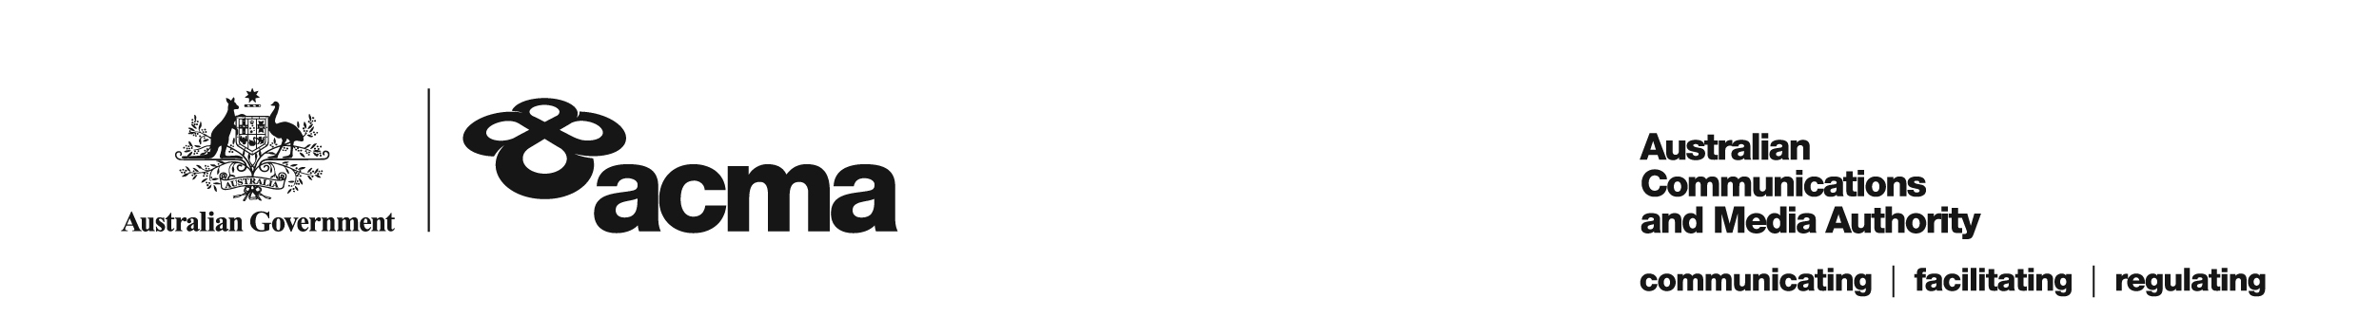**AUSTRALIAN COMMUNICATIONS AND MEDIA AUTHORITY**

**DRAFT Target Reduction Order STV-TRO-0076  
made under subsection 130ZY(3) of the *Broadcasting Services Act 1992***

**1. Interpretation**

In this instrument:

***ACMA*** means the Australian Communications and Media Authority;

***Act*** means the *Broadcasting Services Act 1992*;

***Applicant*** means FetchTV Pty Ltd (ABN 36 130 669 500);

***Application*** means the target reduction order application made on 1 April 2019 in respect of the Service;

***Service*** means TLC; and

***Specified Eligible Period*** means 1 July 2018 to 30 June 2020.

**2. Target Reduction**

Under subsection 130ZY(3) of the Act, the ACMA:

(a) having considered the written representations made by the Applicant in the Application, the supporting evidence submitted with the Application [and the submissions received during the consultation period from...] [1]; and

(b) being satisfied that a refusal to make the target reduction order would impose an unjustifiable hardship on the Applicant;

***ORDERS*** that, for each financial year included in the Specified Eligible Period, the reduced annual captioning target for the Applicant in respect of the Service will be the percentage specified opposite the relevant financial year as set out below:

2018/2019 65%

2019/2020 70%.

Dated: 20 May 2019

1. Any submissions received in response to the publication of this draft order during the 30 day consultation period will be considered by the ACMA in deciding whether to make any final order.