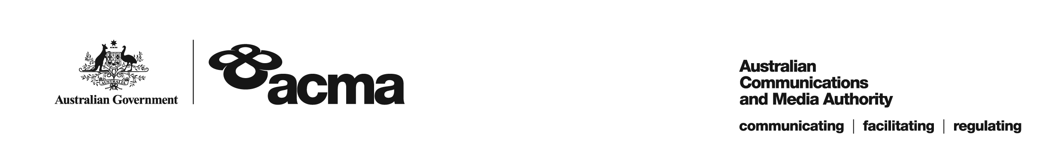**AUSTRALIAN COMMUNICATIONS AND MEDIA AUTHORITY**

**DRAFT Target Reduction Order STV-TRO-0072  
made under subsection 130ZY(3) of the *Broadcasting Services Act 1992***

**1. Interpretation**

In this instrument:

***ACMA*** means the Australian Communications and Media Authority;

***Act*** means the *Broadcasting Services Act 1992*;

***Applicant*** means Selectra Pty Limited (ABN 72 065 367 526);

***Application*** means the target reduction order application made on 29 March 2019 in respect of the Service;

***Service*** means the Aurora Community Channel; and

***Specified Eligible Period*** means 1 July 2018 to 30 June 2019.

**2. Target Reduction**

Under subsection 130ZY(3) of the Act, the ACMA:

(a) having considered the written representations made by the Applicant in the Application, the supporting evidence submitted with the Application [and the submissions received during the consultation period from...] [1]; and

(b) being satisfied that a refusal to make the target reduction order would impose an unjustifiable hardship on the Applicant;

***ORDERS*** that, for the Specified Eligible Period, the reduced annual captioning target for the Applicant in respect of the Service will be 5%.

Dated: 16 May 2019

1. Any submissions received in response to the publication of this draft order during the 30 day consultation period will be considered by the ACMA in deciding whether to make any final order.