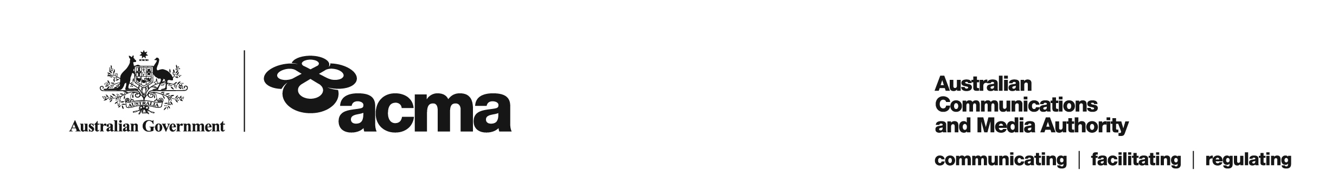**AUSTRALIAN COMMUNICATIONS AND MEDIA AUTHORITY**

**DRAFT Exemption Order STV-EO-380  
made under subsection 130ZY(3) of the *Broadcasting Services Act 1992***

**1. Interpretation**

In this instrument:

***ACMA*** means the Australian Communications and Media Authority;

***Act*** means the *Broadcasting Services Act 1992*;

***Applicant*** means FetchTV Pty Ltd (ABN 36 130 669 500);

***Application*** means the exemption order application made on 1 April 2019 in respect of the Service;

***Service*** means Horse and Country TV; and

***Specified Eligible Period*** means 1 July 2018 to 30 June 2020.

**2. Exemption**

Under subsection 130ZY(3) of the Act, the ACMA:

(a) having considered the written representations made by the Applicant in the Application, the supporting evidence submitted with the Application [and the submissions received during the consultation period from...] [1]; and

(b) being satisfied that a refusal to make the exemption order would impose an unjustifiable hardship on the Applicant;

***EXEMPTS*** the Applicant from the application of subsection 130ZV(1) of the Act in respect of the Service for the Specified Eligible Period.

Dated: 20 May 2019

1. Any submissions received in response to the publication of this draft order during the 30 day consultation period will be considered by the ACMA in deciding whether to make any final order.