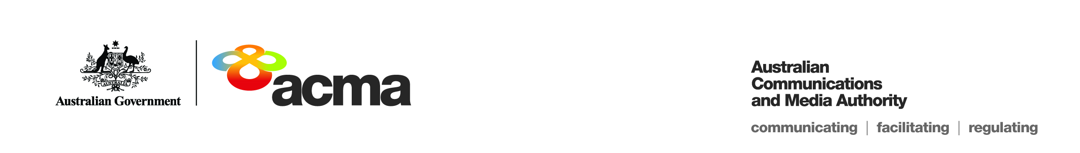**AUSTRALIAN COMMUNICATIONS AND MEDIA AUTHORITY**

**Exemption Order STV/EO-00353 granted under   
subsection 130ZY(3) of the *Broadcasting Services Act 1992***

**1. Interpretation**

In this instrument:

***ACMA*** means the Australian Communications and Media Authority;

***Act*** means the *Broadcasting Services Act 1992*;

***Applicant*** means Sky Channel Pty Ltd (ACN 009136010);

***Application*** means the exemption order application received on 29 March 2017 in respect of the Service;

***Previous Application*** means the exemption order application received on 20 December 2012 (application number 39) in respect of the Service;

***Service*** means the Sky Racing1 subscription television service provided by the Applicant; and

***Specified Eligible Period*** means 1 July 2017 to 30 June 2022.

**2. Exemption**

Under subsection 130ZY(3) of the Act, the ACMA:

1. having considered the written representations made by the Applicant in the Application and in the Previous Application, the supporting evidence submitted with the Application and with the Previous Application, and submission received within the period of 30 days from the date the draft exemption order was published; and
2. being satisfied that a refusal to make the exemption order would impose an unjustifiable hardship on the Applicant;

***EXEMPTS***the Applicant from the application of subsection 130ZV(1) of the Act in respect of the Service for the Specified Eligible Period.

Dated: 22 June 2017