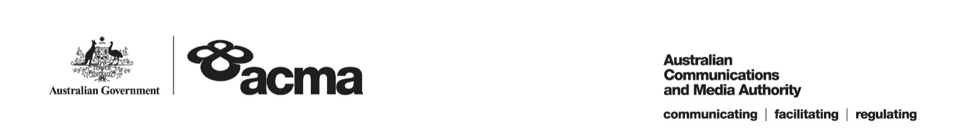**AUSTRALIAN COMMUNICATIONS AND MEDIA AUTHORITY**

**Exemption Order STV/EO-00290 made under   
subsection 130ZY(3) of the *Broadcasting Services Act 1992***

**1. Interpretation**

In this instrument:

***ACMA*** means the Australian Communications and Media Authority;

***Act*** means the *Broadcasting Services Act 1992*;

***Applicant*** means FetchTV Pty Ltd (ABN 36 130 669 500);

***Application*** means the exemption order application made on 21 February 2017 in respect of the Service;

***Previous Application*** means the exemption order application received on 24 December 2014 (application number 157), in respect of the Service;

***Service*** means Ovation; and

***Specified Eligible Period*** means 1 July 2016 to 30 June 2017.

**2. Exemption**

Under subsection 130ZY(3) of the Act, the ACMA:

(a) having considered the written representations made by the Applicant in the Application and in Previous Application, the supporting evidence submitted with the Application and in Previous Application, and the submissions received within the period of 30 days from the date the draft order was published; and

(b) being satisfied that a refusal to make the exemption order would impose an unjustifiable hardship on the Applicant;

***EXEMPTS*** the Applicant from the application of subsection 130ZV(1) of the Act in respect of the Service for the Specified Eligible Period.

Dated: 19 May 2017