**Related parties for eligible revenue reporting**

* Why do related parties need to be identified?
* What is a consolidated related party and a declared related party?
* What type of entities might be a consolidated related party or a declared related party?
* How are company interests calculated?
* What percentage of revenue and deductions of related parties is added to or deducted from the revenue of a participating person?
* How is the declared related party factor calculated?
* What if there is more than one body that owns both the participating person and a declared related party?
* What if two participating persons own more than 49 per cent of an entity and the entity is a DRP for both participating persons?
* How are related party revenues reported when the same Australian parent owns more than one participating person and the participating persons have common related parties whose revenue is reported in the consolidated financial statements of the parent entity?
* How are related parties’ revenues reported to the ACMA?
* Does the ACMA confirm related parties’?
* Where can I obtain further information?

# **Why do related parties need to be identified?**

Certain revenue of related parties of a participating person and a non-participating person may be relevant to the calculation of a participating person’s eligible revenue. It is important to identify all related parties so that the revenues of those parties can be included as part of a participating person’s eligible revenue return.

# **What is a consolidated related party and a declared related party?**

There are two types of related parties:

* consolidated related party
* declared related party (DRP).

These are defined in sections 5, 6 and 7 of the Telecommunications (Eligible Revenue) Determination 2015(ER Determination).

Consolidated related party

A consolidated related party of a participating person or a non–participating person is an entity that is not the participating person or non–participating person, the revenue of which is included in the annual consolidated financial statements of the participating person or non–participating person’s ultimate Australian parent entity. ‘Ultimate Australian parent entity’ is defined in section 5 of the ER Determination.

Declared related party

A DRP of a participating or non-participating person is defined in section 6 and 7 of the ER Determination as follows:

(1) An entity is a DRP of a participating person or non-participating person for the whole of an eligible revenue period during which the entity:

(a) is not:

(i) a participating person; or

(ii) a consolidated related party of a participating person or non-participating person; and

(b) is owned, at any time during the eligible revenue period, by a body that owns the participating person or a non-participating person at any time during the eligible revenue period; and

(c) has telecommunications sales revenue in Australia at any time during the eligible revenue period.

(2) An entity is a DRP of a participating person for any part of an eligible revenue period during which the entity:

(a) is not:

(i) a carrier; or

(ii) a consolidated related party of a participating person or a non-participating person; or

(iii) a participating carriage service provider; and

(b) is owned by a body that owns the participating person at any time during the eligible revenue period; and

(c) has telecommunications sales revenue in Australia.

(3) For subsections (1) and (2):

(a) a body owns a DRP or a participating person if the body has company interests of more than 49 per cent in the DRP or participating person; and   
(b) company interests may be traced in the same way as company interests may be traced for Part 4 of Schedule 1 to the *Broadcasting Services Act 1992*.

For more detailed information regarding DRP, please refer to Section 6, 7 and 8 of the Telecommunications (Eligible Revenue) Determination 2015.

**For example:**

‘A’ wholly (100 per cent) owns the participating person and ‘B’ and ‘C’ (that is, it has ownership interests in each entity of greater than 49 per cent).

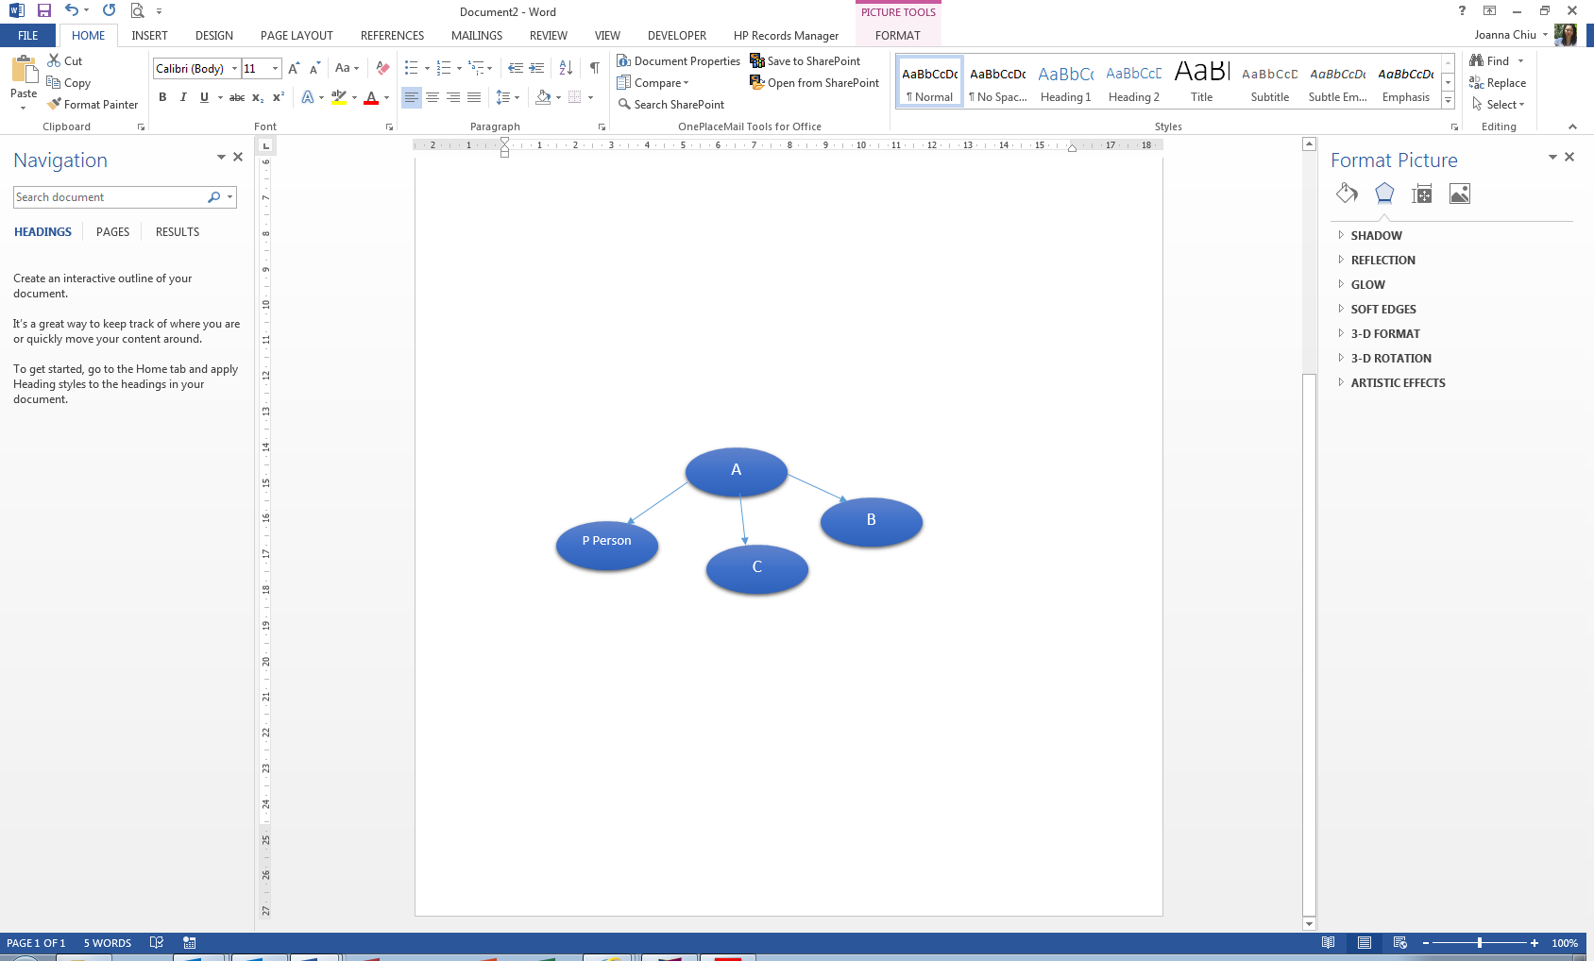

If A is the ultimate Australian parent entity and prepares an annual consolidated financial report that includes the participating person and C, then C is a consolidated related party of the participating person. As a consequence, C’s sales revenue for the eligible period is included in the calculation of the participating person’s initial sales revenue.

If B is not included in the annual consolidated financial report of A, it may be a DRP of the participating person if it meets the criteria set out in section 6 of the ER Determination.

# **What types of entities might be a consolidated related party** **or a declared related party?**

An entity is defined in section 5 of the ER Determination as anything defined as an entity in the accounting standards, made under section 334 of the *Corporations Act 2001,* as in force from time to time.

A ‘body’ is defined in section 5 of the ER Determination as a legal, administrative or fiduciary arrangement, an organisational structure, or another party (including a person) that has the capacity to allocate scarce resources in order to achieve objectives within or outside Australia.

# **How are company interests calculated?**

The ‘fractional tracing method’ is used to determine company interests. In accordance with paragraph 6(3)(b) and 7(3)(b) of the ER Determination, company interests may be traced in the same manner as in Part 4 of Schedule 1 to the *Broadcasting Services Act 1992* which sets out the fractional tracing method.

This method traces ownership interests through a chain of companies by multiplying the percentage interests that an entity holds in each company. The method can be used to identify related parties and also to work out the DRP factor (see section 8 of the ER Determination).

For example, in the diagram below, A owns the participating person and B and C. B has telecommunications sales revenue in Australia during the eligible revenue period and is 50.9 per cent owned by A. Assuming it otherwise satisfies the description in either subsection 6(1) or 6(2), it will be a DRP of the participating person for either the whole or part of the eligible revenue period. Assuming it has telecommunications sales revenue in Australia during the whole or part of the eligible revenue period, C may also be a DRP of the participating person.

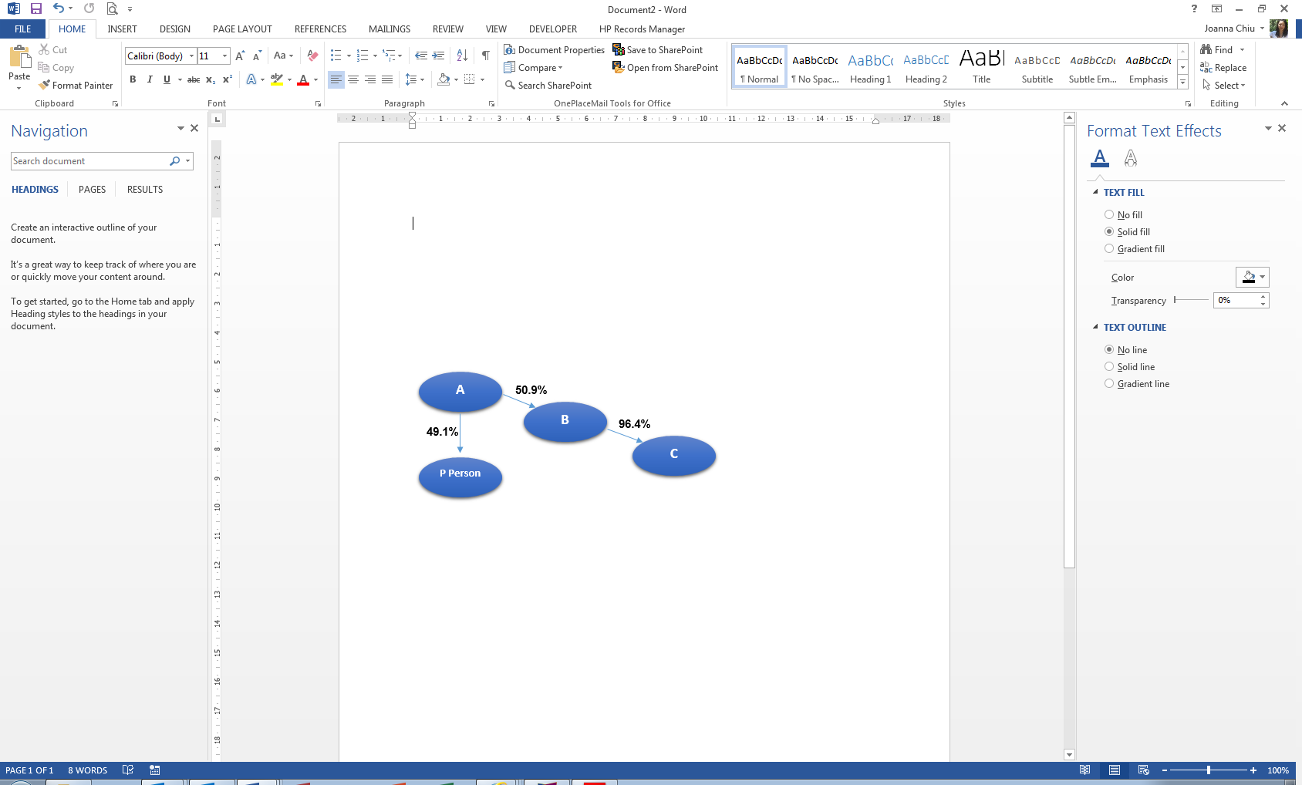

To work out A’s company interest in C, the following formula is used:

*company interest in B expressed as a percentage* ***X*** *company interest in C expressed as a percentage*

**That is, 50.9 per cent, multiplied by 96.4 per cent, equals 49.1 per cent.**

Because the ownership interest of A in C is greater than 49 per cent, C may also be a DRP of the participating person if it otherwise meets the criteria in section 6 of the ER Determination.

# **What percentage of the revenue and deductions of related parties is added to or deducted from the revenue of a participating person?**

Participating persons are required to include 100 percent of the revenues and to deduct 100 per cent of any allowable deductions in relation to consolidated related partieswhen calculating their eligible revenue for an eligible revenue period.

In the case of a DRP, the percentage of revenue and deductions to be considered in calculating a participating person’s eligible revenue is determined using the DRP factor (see section 8 of the ER Determination).

# **How is the declared related party factor calculated?**

The meaning of DRP factor is set out in section 8 of the ER Determination. It is worked out using the formula:

**participating person interest, multiplied by the party interest**

OR

**non**–**participating person interest, multiplied by the party interest**

**where:**

* The participating person or non-participating person interest is the proportion of the participating person or non-participating person that is owned by the same body that owns the DRP. Or, if there is more than one body, the body that has the greatest company interest in the participating person or non-participating person.
* The party interest is the proportion of the DRP that is owned by the same body that owns the participating person or non-participating person. Or, if there is more than one body, the body that has the greatest company interest in the DRP.

For example, A owns the participating person and B, which has been identified as a DRP of the participating person.

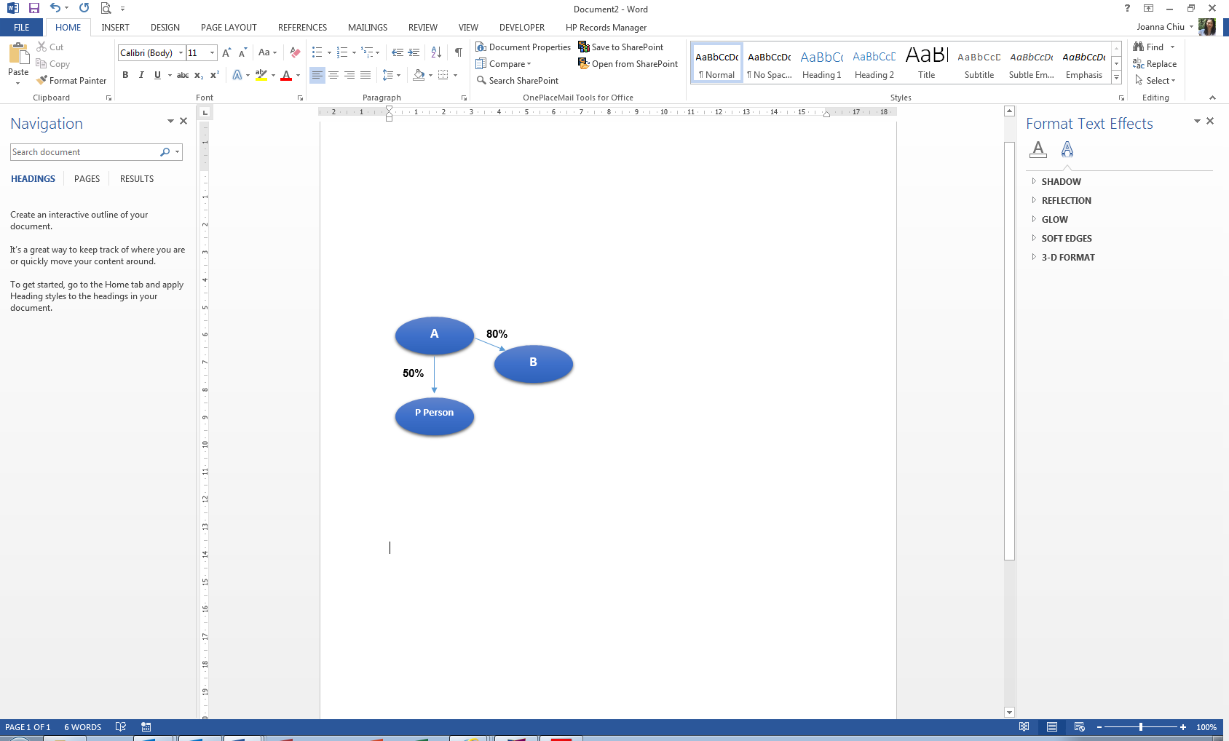

To work out the DRP factor for B, the party interest (**80 per cent**) is multiplied by the participating person interest (**50 per cent**).

**80 per cent, multiplied by 50 per cent, equals 40 per cent.**

Therefore the proportion of B’s revenue and claimed deductions that is disclosed with those of the participating person is **40 per cent** (the DRP factor).

# **What if there is more than one body that owns both the participating person and a declared related party?**

In order to determine the DRP factor, the party interest and participating person interest are calculated with reference to the body who has the greatest company interest in the DRP (to calculate party interest) or participating person (to calculate participating person interest).

In the example below, A and B are both owners of the participating person and entity C as they each have greater than 49 per cent company interests in both the participating person and entity C.

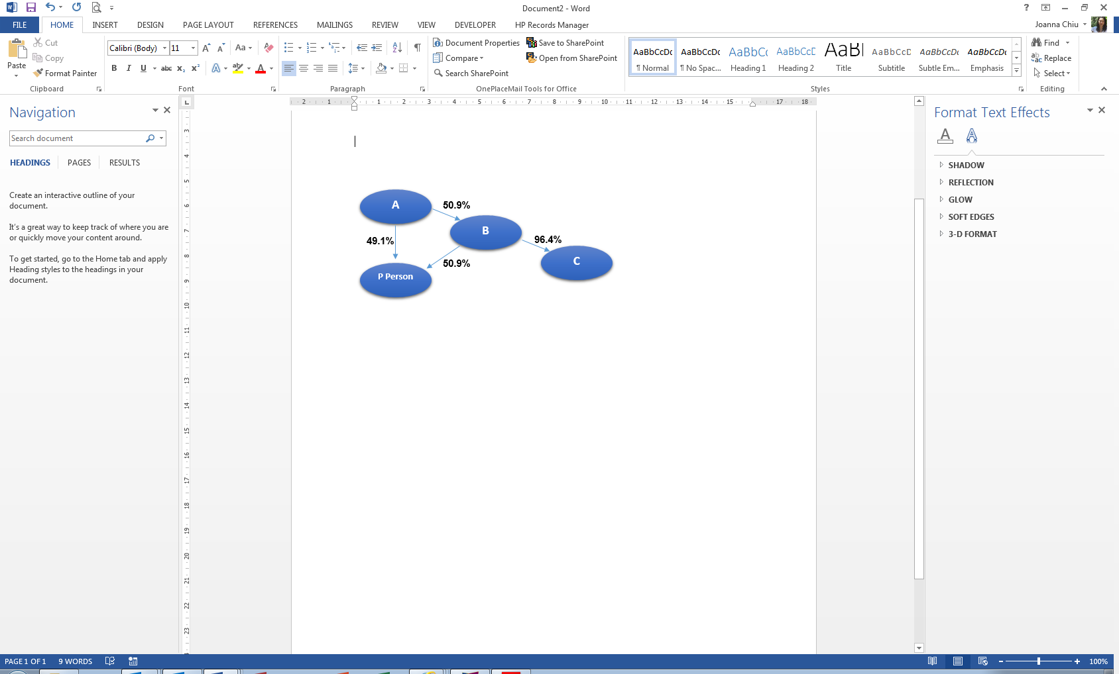

* A owns **49.1 per cent** of the participating person:
* B owns **50.9 per cent** of the participating person
* A owns **49.07 per cent** of C calculated using the fractional tracing method as follows:

**50.9 per cent, multiplied by 96.4 per cent, equals 49.07 per cent.**

* B owns **96.4 per cent** of C

C has been identified as a DRP of the participating person.

The owner who has the greatest ownership interest in C (to calculate the party interest) is entity B (with **96.4 per cent** interest). The owner who has the greatest ownership interest in the participating person (to calculate the participating person interest) is entity B (with **50.9 per cent** interest).

The DRP factor is therefore calculated as follows:

**96.4 per cent, multiplied by 50.9 per cent, equals 49.1 per cent.**

Therefore the proportion of C’s revenue and claimed deductions that is to be disclosed with those of the participating person is **49.1 per cent**.

# **What if two participating persons own more than 49 per cent of an entity and the entity is a declared related party for both participating persons?**

Each participating person must individually calculate the DRP factor for the entity that is the DRP when working out their eligible revenues, based on the ownership interest that the participating person has in the entity.

# **How are related party revenues reported when the same Australian parent owns more than one participating persons and the participating persons have common related parties who revenue is reported in the consolidated financial statements of the parent entity?**

Rather than making all of the calculations required under the ER Determination in its own right, two or more participating persons with the same ultimate Australian parent entity may make all of the calculations required under Part 3 (gross telecommunications sales revenue) and Part 4 (net telecommunications sales revenue) on a ‘group basis’ identifying and accounting for revenue and deductions as a whole (section 11 of the ER Determination). This means that sales revenues and permissible deductions of related parties which are relevant to calculating the participating person’s gross and net telecommunications sales revenue figures, are only captured once. All interests in consolidated and DRP need to be accounted for in working out the revenues and deductions applicable to those parties. In working out a participating person’s eligible revenue, where the net telecommunications sales revenue of two or more participating persons has been accounted for on a group basis, the accounts must identify how much of the net telecommunications sales revenue is attributable to each member of the group (section 36 of the ER Determination).

# **How are related parties’ revenues reported to the ACMA?**

The telecommunications revenue of related parties (whether declared or consolidated) and their deductions are combined with those of a carrier to determine whether a carrier earns under AUD $25 million in initial sales revenue, gross telecommunications sales revenue or eligible revenue for the eligible revenue period. If the carrier’s revenue is less than AUD $25 million, the carrier may meet the definition of non-participating person in the Telecommunications (Participating Persons) Determination 2015 provided it submits an eligible statutory declaration to the ACMA by 31 October following the eligible revenue period (or the ACMA is otherwise reasonably satisfied of that fact. The ACMA may seek specific information on related parties in support of the revenues declared in an eligible statutory declaration. Where the person has the same ultimate Australian parent entity as one or more other carriers the calculations required to arrive at initial sales revenue, gross telecommunications sales revenue and eligible revenue must be made on a group basis accounting for revenue and deductions as a whole.

For carriers that are a participating person and not a non-participating person, the related parties are reported online using the **DRP Financial Information tab** of the Eligible Revenue Submission form in the TELLER system.

The ACMA also requires an outline of business structure to be provided as part of an eligible revenue return. This is a diagram or description explaining the structure of the group of companies, identifying all entities that earn telecommunications sales revenue including the participating person and any DRPs.

Consolidated related parties are required to be identified in the annual consolidated financial statements of the participating person’s ultimate Australian parent entity.

# **Does the ACMA confirm related parties?**

Yes, the ACMA reviews the completeness and accuracy of related party disclosures, including undertaking reviews of company shareholdings.

# **Where can I obtain further information?**

For further information, please refer to the [Eligible Revenue Portal](http://www.acma.gov.au/Industry/Telco/Carriers-and-service-providers/Licence-fees-annual-levies-and-charges/eligible-revenue-portal-current-year) or contact our [Revenue Assurance Team](mailto:til@acma.gov.au) or phone them on (02) 6219 5355.

*Please note: The information above is intended as a guide only and should not be relied on as legal advice or regarded as a substitute for legal advice in individual cases.*