[Australian Government - Australian Communications and Media Authority](http://www.acma.gov.au/WEB/HOMEPAGE/pc=HOME)

**Apparatus License online lodgement system**Quick guide—*submitting a form for one licence*

**Steps**

1. Log into the ACMA’s online lodgement system.

2. You will be directed to the Homepage pictured below.

3. Select the form you want to submit from the ‘APSubmission Forms’ section.

4. Instructions page

5. Select the Submission Purpose.

6. Complete the Application Details

7. License Details

8. Enter Station details

9. Enter Transmitter& Receiver details

10. Legal Declaration

11. Save answers and Submit the application

Start

1. Log into the ACMA’s online lodgement system.
2. You will be directed to the Homepage pictured below.
3. Select the form you want to submit from the ‘APSubmission Forms’ section.

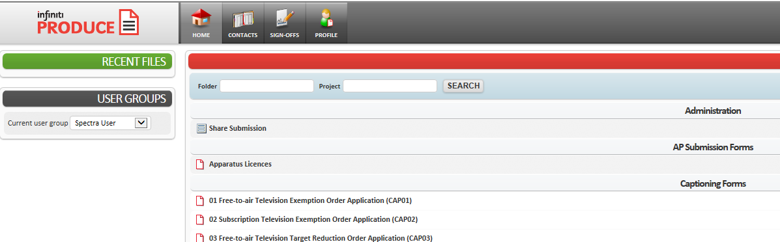

**Click the form you want to submit**

1. Once the form has been selected, you will be taken to the ‘Instructions’ page of the form. Here Instructions and Disclosure of Personal Details will be displayed.
2. Select the Submission Purpose.

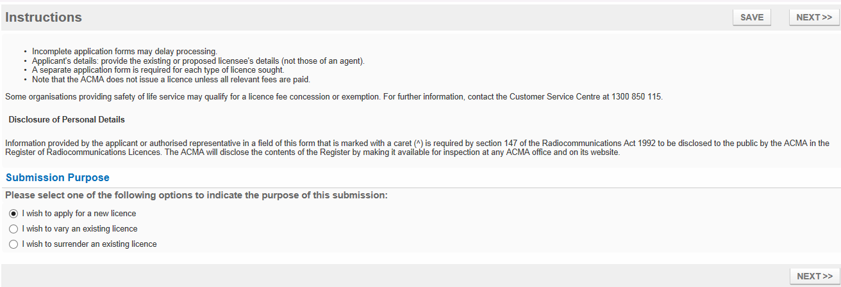

**Select I wish to apply new license**

**Click ‘Next’**

1. Complete the Application Details:

Submission Identifier: Customer reference number entered by AP for their reference for the submission

**1. Complete the application details, Help text is available with ? icon next to the field.**

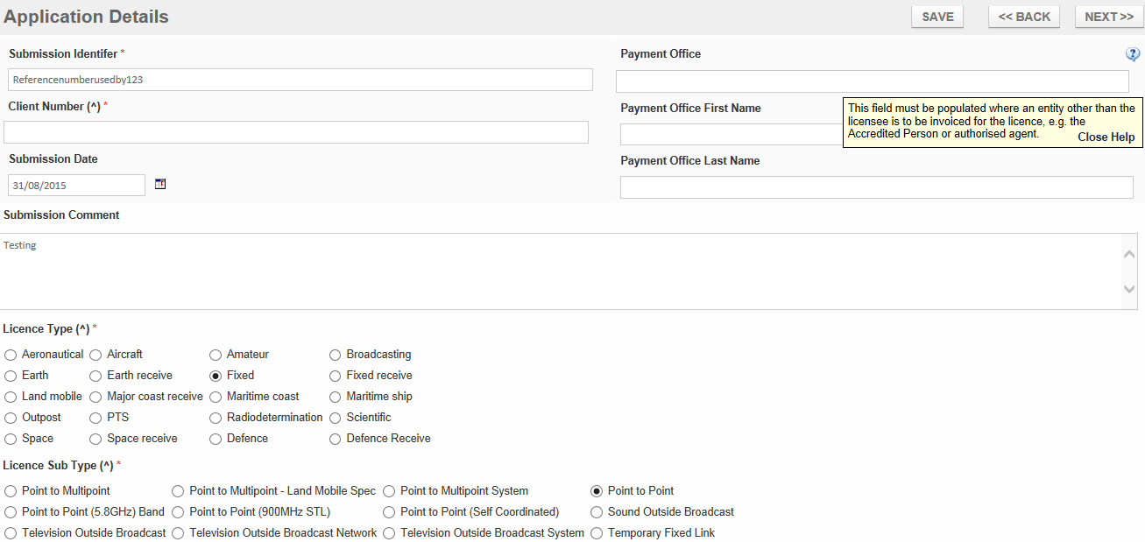

1. **Select the Service and Sub service details**

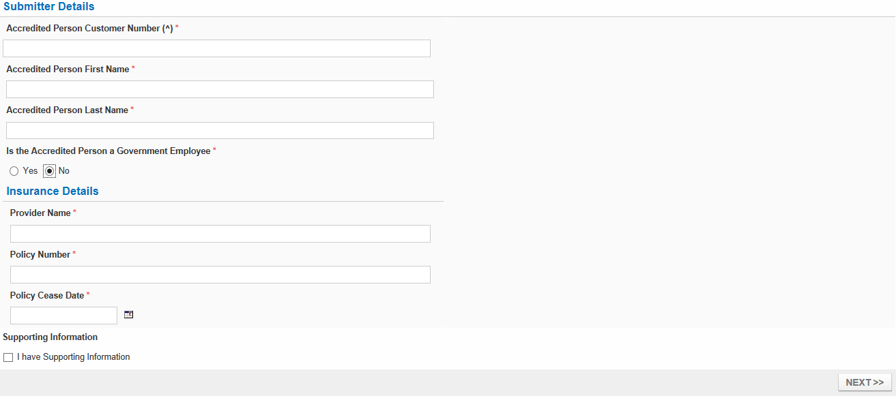

**5. Click to add any supporting document to attach**

**Click ‘Next’**

1. **If AP is not a government employee, then please provide insurance details**
2. **Enter Accredited person ID, First name and Last name**

If you have any supporting documentation to include select “I have Supporting Information”

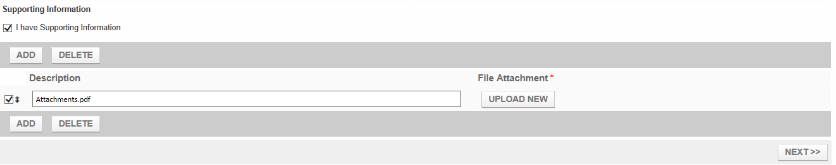

1. **Click on ADD to add multiple attachments**

**Click ‘Next’**

**Click on UPLOAD NEW to browse and up load the document**

1. License Details: Enter License details:

**Enter License details**

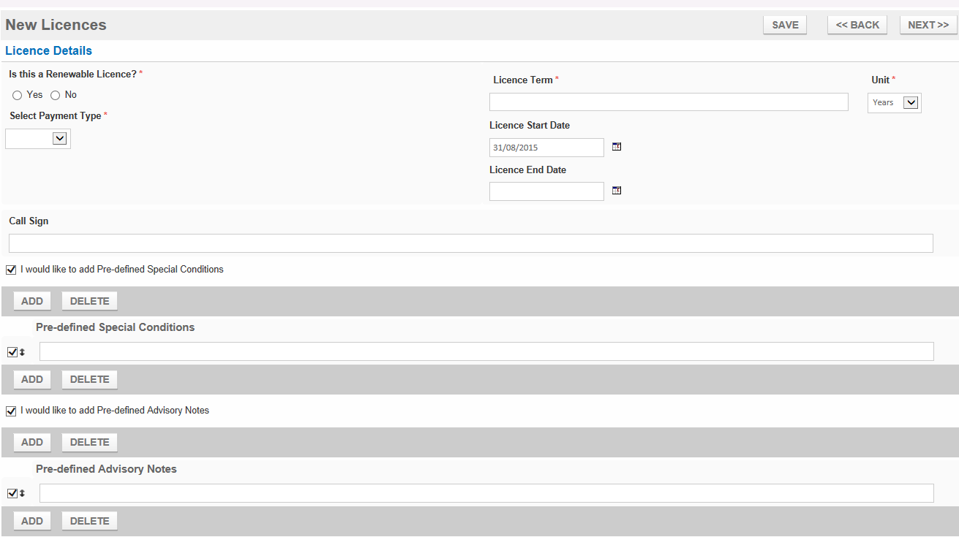

**To add Pre-defined special conditions click on ADD then enter special conditions details.**

**To add Pre-defined advisory notes click on ADD then enter advisory notes**

**To delete select the pre-defined advisory notes/special conditions then click on DELETE**

**Enter Call Sign details if applicable**

**Click ‘Next’**

1. Enter Station details:

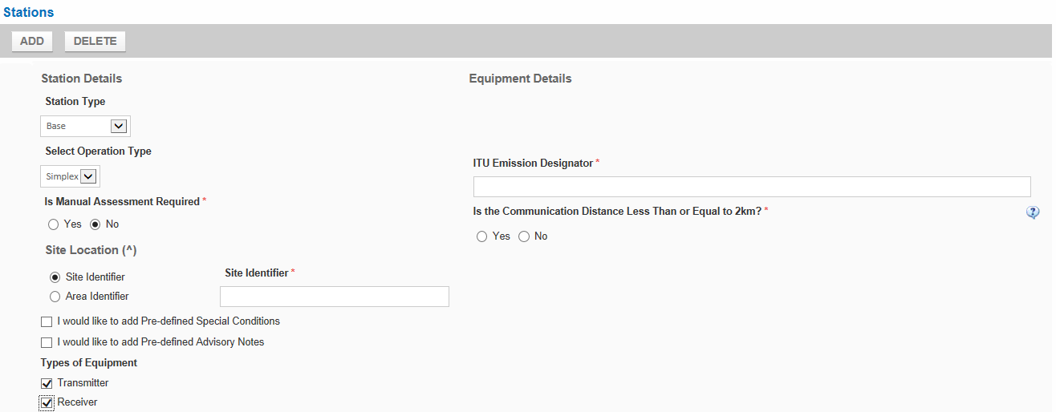

**To add special conditions/ advisory notes select the option**

**Select the type of equipment depending upon the requirement select Transmitter/Receiver or both**

**Simplex/Duplex**

**From drop down select Base or Supplementary**

**Enter Site ID or Area ID information**

1. Enter Transmitter details:

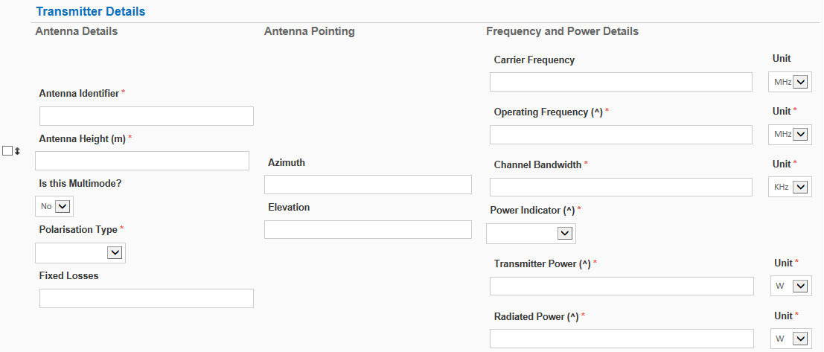

**Click ‘Next’**

Enter Receiver details:

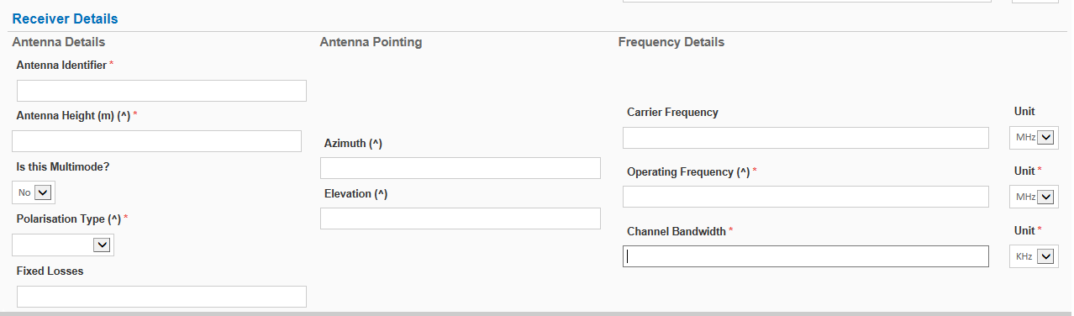

1. You will be taken to the legal declaration section.

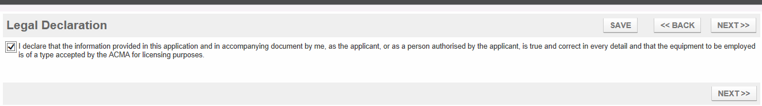

**Select the Legal declaration and click on Next button**

1. Save answers to re-use later and Submit application:

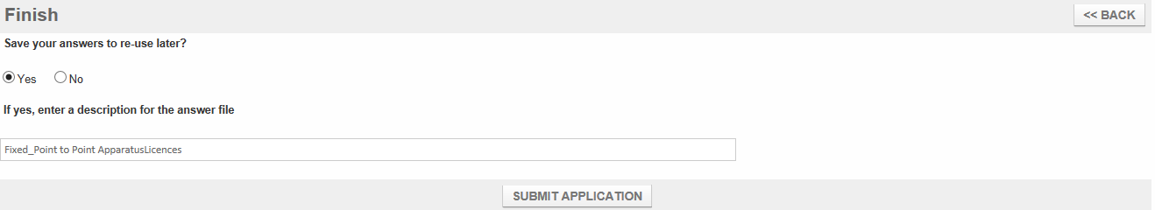

**Click to SUBMIT**

**Navigates to previous page**

**Name the application**

**To save answers**

Application has been successfully submitted: 