Investigation report no. BI-438

| Summary |  |
| --- | --- |
| **Licensee** | Tasman Community Broadcasters Association Inc. |
| **Station** | 7TAS |
| **Type of service** | Community broadcasting - radio |
| **Issue** | Encouraging community participation in the operations of the service  Having policies required by the codes |
| **Relevant legislation** | *Broadcasting Services Act 1992* (the BSA)   * Paragraph 9(2)(c)(i) of Schedule 2 [encourage community participation in the operations of the service]   *Community Radio Broadcasting Codes of Practice 2008* (the Codes)   * Code 2.1 [community participation policy] * Code 6.1 [sponsorship policy] |
| **Decision** | * No breach of paragraph 9(2)(c)(i) of Schedule 2 to the *Broadcasting Services Act 1992* [encourage community participation in the operations of the service] * Breach of Code 2.1 of the *Community Radio Broadcasting Codes of Practice 2008* [community participation policy]   + Breach of Code 6.1 of the *Community Radio Broadcasting Codes of Practice 2008* [sponsorship policy] |

Background

On 16 October 2018, the ACMA commenced an investigation under the *Broadcasting Services Act 1992* (the BSA) into the licensee of 7TAS, Tasman Community Broadcasters Association Inc, after the failure on the part of the licensee to take actions to address compliance matters raised by the ACMA following its 2017 long-term licence renewal.

**The licensee**

7TAS has held a long-term community radio broadcasting licence to represent the general community interest in the Tasman Peninsula RA1 licence area since February 2003. The expiry date of the current licence is 1 February 2023.

**Issues giving rise to andcommencement of the investigation**

On 21 March 2017, 7TAS lodged an application to renew its long-term community broadcasting licence.

On 16 June 2017, the ACMA advised 7TAS that the licence would be renewed, however, it was asked to implement certain actions to enable it to better satisfy the statutory matters for renewal. 7TAS was to complete the following actions by 1 January 2018:

* amend its constitution to include the grounds on which a membership application may be rejected, giving reasons in writing for rejecting a membership application and having appeal rights for rejected applicants
* amend its constitution to provide for:
* the two longest-serving members on the Management Committee to step down each year and not be eligible for election until the following year
* a maximum term for members on the Management Committee
* amend its constitution to make provision for the quorum at a general meeting to be double the number of members on the Management Committee plus one
* develop and adopt a community participation policy and sponsorship policy.

As 7TAS did not provide a response by the due date, on 16 January 2018, the ACMA gave 7TAS an extension to 1 February 2018 to complete the actions.

On 15 February 2018, 7TAS wrote to the ACMA outlining its views on several matters including meeting community needs, programming, volunteer numbers, management capacity and its constitution. On 2 March 2018, 7TAS was given an extension until 1 June 2018 to complete the actions.

7TAS provided a copy of its constitution on 6 June 2018, however, it had not been amended to include any of the changes suggested by the ACMA.

On 17 August 2018, the ACMA advised 7TAS that if the documents were not provided by 1 October 2018, consideration would be given to implementing formal enforcement, including the commencement of an investigation.

7TAS provided a copy of its constitution on 3 October 2018, however, it did not include changes to the matters requested by the ACMA.

7TAS’s inaction and failure to engage with the ACMA as part of the renewal process gave rise to concern that 7TAS could be in breach of the relevant licence condition and the Codes. The ACMA therefore decided to commence an investigation into 7TAS’s compliance with:

* paragraph 9(2)(c)(i) of Schedule 2 to the BSA [encourage community participation in the operations of the service]
* Codes 2.1 [community participation policy] and 6.1 [sponsorship policy] of the *Community Radio Broadcasting Codes of Practice 2008* (the Codes).

Assessment and submissions

This investigation has taken into account the following information:

* the licensee’s application for the renewal of the long-term community broadcasting licence lodged on 21 March 2017
* submissions from the licensee received on 3 October, 24 October, 27 November and 20 December 2018.

Other sources are identified in this report where relevant.

**Issue 1: Is the licensee encouraging community participation in the operations of the service?**

Relevant provisions of Schedule 2 to the *Broadcasting Services Act 1992*

Part 5 – Community broadcasting licences

**9 Conditions applicable to services provided under community broadcasting licences**

(2) Each community broadcasting licence is also subject to the following conditions:

[...]

(c) the licensee will encourage members of the community that it serves to participate in:

(i) the operations of the licensee in providing the service or services

Finding

The licensee is not in breach of sub-paragraph 9(2)(c)(i) of Schedule 2 to the BSA.

Reasons

In assessing 7TAS’s licence renewal application against the statutory matters (**Attachment A**) in 2017, the ACMA noted the following:

* 7TAS provides the only community broadcasting service in a licence area with a population of close to 4,500 people
* as a licensee representing the general community interest, 7TAS had an adequate number of members, at 140, however, it had a low number of volunteers, at 20
* 7TAS’s constitution provides for a quorum at general meetings to be 10 members present or 50% of members, whichever is lower; this creates a potential for the eight members on the Management Committee, if all were present at a general meeting, to influence decision-making
* 7TAS’s constitution does not limit the tenure of Management Committee members; this creates the potential for the operations of the service to be concentrated in the hands of the same few individuals for many years
* the 2015 and 2016 AGMs were attended by eight and 12 members, respectively; this means the 2015 AGM proceeded without a quorum.

The ACMA’s *Community Broadcasting Participation Guidelines 2010* (the Participation Guidelines) note:

[…] licensees encourage community participation in their operations when they have sound corporate governance practices, value and promote membership and volunteering, and have an effective and transparent committee structure. [page 9]

[…]

Sound corporate governance practices give communities confidence that their community broadcasting services are managed appropriately. They also enable communities to have adequate input into the decision-making that affects their services.

Examples of sound corporate governance practices include:

[…]

* measures to prevent the concentration of control in the hands of a few individuals (for example, using a range of committees, limiting the number of proxy votes a member can exercise and having a limited renewable term for individuals holding positon on committees or the board);

From the available information, it appears that the operations of the service are concentrated in the hands of a small group of members who comprise the Management Committee.

It is considered that the actions proposed by the ACMA when the licence was renewed in 2017, if implemented by 7TAS, would have enabled the licensee to have in place some measures to enable it to operate more openly and responsively.

In response to the ACMA’s advice that it had commenced an investigation into 7TAS’s compliance with the relevant licence condition, on 27 November 2018, the licensee provided another copy of its constitution. This copy showed that the licensee has included provisions for the following matters:

* a person who applies for membership becomes a member on payment of an annual membership fee
* the grounds on which a member may be expelled, giving reasons in writing for expelling a member and having appeal rights for expelled members.

It was noted that the constitution had not been amended, as had been suggested by the ACMA after the renewal, to:

* increase the quorum for general meetings to ensure that the meetings could not be controlled by the Management Committee
* make provision for the two longest-serving members on the Management Committee to step down at each annual general meeting and not be eligible for election until the following year
* make six years the maximum term for members serving on the Management Committee.

In a further response, the licensee submitted another copy of its constitution. This copy showed that the licensee has included provisions for the following matters:

* every two years, the two longest-serving members of the Management Committee shall stand down and not be eligible for re-election until the following year
* the longest term of office for members on the Management Committee shall be six years.

On the available evidence, the licensee appears to have implemented most of the ACMA’s recommendations, including open membership provisions and a rotation of membership on the management committee. It is, therefore, considered that the licensee has improved its governance to better satisfy the statutory requirement that it encourage community participation in the operations of the service.

The licensee is not in breach of the licence condition that requires it to encourage community participation in the operations of the service.

**Issue 2: Does the licensee have policies required by the Codes?**

**Relevant provisions of the Community Radio Broadcasting Codes of Practice 2008**

**2.1** Our station will make sure that people in our community who are not adequately served by

other media are encouraged and assisted to participate in providing our service. We will have

in place policies and procedures to support this commitment. We will document evidence of

our efforts to encourage community participation.

[…]

**6.1** We will have in place a written sponsorship policy that reflects the licence condition in the Act.

This includes:

1. broadcasting no more than five minutes of sponsorship announcements in one

hour, and

1. tagging each announcement to acknowledge the financial and/or in-kind support of

the sponsor.

Finding

The licensee is in breach of Codes 2.1 and 6.1.

Reasons

In assessing 7TAS’s licence renewal application against the statutory matters (**Attachment A**) in 2017, the ACMA noted that the licensee did not have all the policies required by the Codes, specifically, for community participation and sponsorship. It was noted that the licensee did not have these (and other) policies when the licence was renewed in 2012 and 7TAS was asked to address the matter at that time. These remain outstanding after many years which is indicative of the licensee’s unwillingness to implement actions to enable it to achieve compliance.

In response to the ACMA’s Preliminary Report, the licensee provided a one-page document containing its ‘Policy to encourage community participation in Tasman FM’ (Code 2.1) and ‘Policy for sponsorship’ (Code 6.1) (both at **Attachment B**).

Code 2.1 (**Attachment C**) requires licensees to have in place policies and procedures which support a commitment to ‘make sure that people in our community who are not adequately served by other media are encouraged and assisted in providing our service’. The policy supplied by the licensee includes three statements which address the issue of listener engagement, but do not outline mechanisms or commitments to encourage and assist community members to provide the service.

Code 6.1 (**Attachment C**) requires licensees to have a written policy that reflects the sponsorship licence condition in the BSA. The policy supplied by the licensee does not address the provision of the BSA.

As such, the licensee does not have the policies required by the Codes, in breach of Codes 2.1 and 6.1.

**ATTACHMENT A: Statutory matters for assessing community licence allocation and renewal applications**

**Extracts from the *Broadcasting Services Act 1992***

Section 84(2):

In deciding whether to allocate a community broadcasting licence that is a broadcasting services bands licence to an applicant or to one of a group of applicants, the ACMA is to have regard to:

(a) the extent to which the proposed service or services would meet the existing and perceived future needs of the community within the licence area of the proposed licence; and

(b) the nature and diversity of the interests of that community; and

(c) the nature and diversity of other broadcasting services (including national broadcasting services) available within that licence area; and

(d) the capacity of the applicant to provide the proposed service or services; and

(e) the undesirability of one person being in a position to exercise control of more than one community broadcasting licence that is a broadcasting services bands licence in the same licence area; and

(f) the undesirability of the Commonwealth, a state or a territory or a political party being in a position to exercise control of a community broadcasting licence.

Section 91(2A):

The ACMA may refuse to renew a community broadcasting licence that is a broadcasting services bands licence if, having regard to the matters in paragraphs 84(2)(a) to (f), it considers that it would not allocate such a licence if it were deciding whether to allocate the licence to the licensee.

**ATTACHMENT B: 7TAS policies for Codes 2.1 and 6.1**

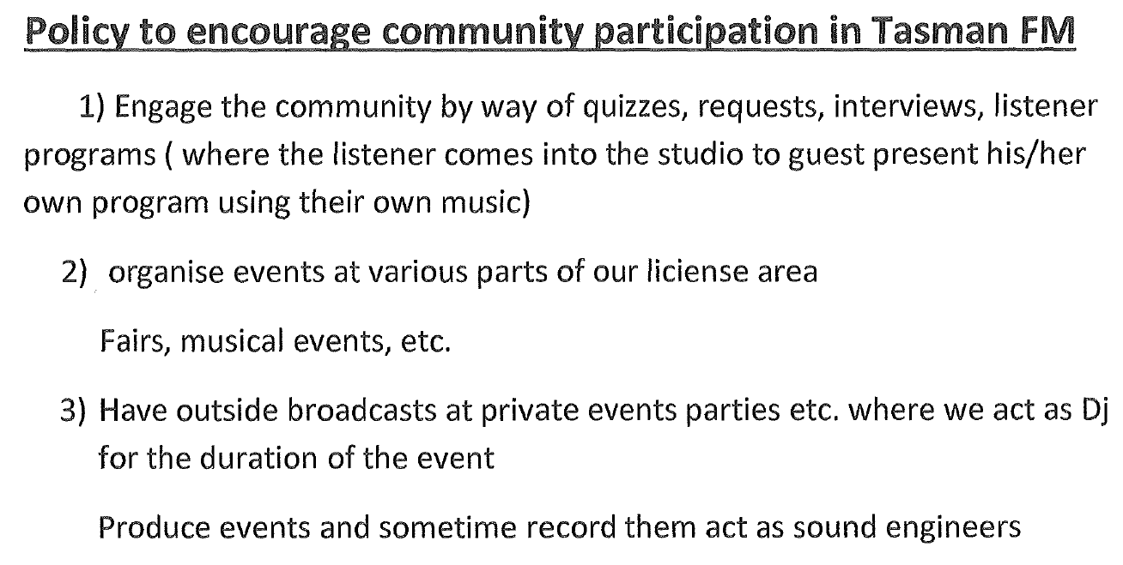

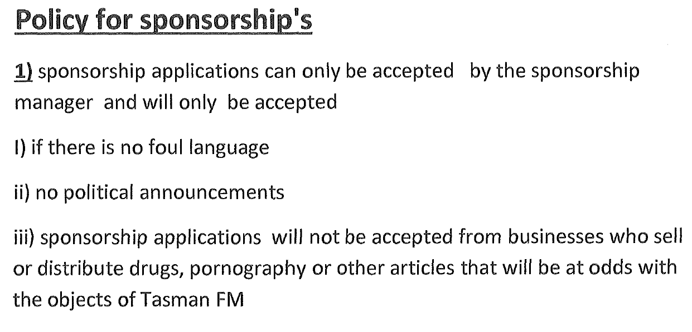

**ATTACHMENT C: Requirements specified at Codes 2 and 6**

