

*Reconnecting the Customer*—  
Tracking consumer outcomes:   
2016 update (RTC2)

DECEMBER 2016

Canberra

Red Building   
Benjamin Offices  
Chan Street   
Belconnen ACT

PO Box 78  
Belconnen ACT 2616

T +61 2 6219 5555  
F +61 2 6219 5353

Melbourne

Level 32   
Melbourne Central Tower  
360 Elizabeth Street   
Melbourne VIC

PO Box 13112  
Law Courts   
Melbourne VIC 8010

T +61 3 9963 6800  
F +61 3 9963 6899

Sydney

Level 5   
The Bay Centre  
65 Pirrama Road   
Pyrmont NSW

PO Box Q500  
Queen Victoria Building   
NSW 1230

T +61 2 9334 7700 or 1800 226 667  
F +61 2 9334 7799

Copyright notice

[Creative Commons logo](http://i.creativecommons.org/l/by/3.0/88x31.png)

<http://creativecommons.org/licenses/by/3.0/au/>

With the exception of coats of arms, logos, emblems, images, other third-party material or devices protected by a trademark, this content is licensed under the Creative Commons Australia Attribution 3.0 Licence.

We request attribution as: © Commonwealth of Australia (Australian Communications and Media Authority) 2016.

All other rights are reserved.

The Australian Communications and Media Authority has undertaken reasonable enquiries to identify material owned by third parties and secure permission for its reproduction. Permission may need to be obtained from third parties to re-use their material.

Written enquiries may be sent to:

Manager, Editorial and Design  
PO Box 13112  
Law Courts  
Melbourne VIC 8010  
Tel: 03 9963 6968  
Email: [candinfo@acma.gov.au](mailto:candinfo@acma.gov.au)

Overview 1

Background 2

ACMA research program 3

researchacma 3

About the research 3

Methodology 3

Quantitative 3

Qualitative 4

Key findings 5

Customer service interactions 6

Satisfaction with customer service 7

Complaints 7

High bills and spend management tools 8

Product information and comparing offers 11

Emerging issues 11

Unauthorised apps 11

Issues with internet streaming 11

Appendix A—Detailed findings 12

Complaints 12

Unexpectedly high bills and spend management tools 18

Product information and comparing offers 23

Emerging issues 24

# Overview

The ACMA has been tracking the impact on consumers of changes to the Telecommunications Consumer Protections (TCP) Code that occurred in 2012 and other outcomes of its *Reconnecting the Customer* (RTC) inquiry through a series of three research studies.

This RTC2 research aims to evaluate the effectiveness of the TCP Code and key emerging trends since 2012 that affect consumers’ telecommunications service experience, now that the code has been in place for a longer period of time.

The RTC2 research shows that there have been ongoing improvements in many aspects of telecommunications services since the changes to the TCP Code in 2012, but there are still some areas for improvement to be made.

It is evident from the research that consumers are better able to manage their expenditure on communications services in 2016 (compared to 2013) and, as a result, the incidence of both unexpectedly high bills and complaints have decreased (for mobile phones in particular). However, the findings suggest that while there have been positive improvements there are still opportunities for further reductions, given nearly one in four consumers is still receiving unexpectedly high bills and nearly one in three consumers has complained to their provider in the last 12 months.

The research shows that more consumers are using spend management tools such as SMS alerts and apps to monitor usage and these tools continue to be useful for consumers. Consumers are better informed about the nature and cost of the services they choose. The Critical Information Summary (CIS) is useful but more can be done to improve customers’ ability to compare plans and bundles.

There have been some positive shifts in 2016 in the quality of customer care that consumers are receiving from their telecommunications and internet service providers, but the findings suggest there is still room to improve customer service and complaints-handling. There has been no change in satisfaction, resolution rates and time frames for complaints and, although more customers are receiving a Complaint Reference Number (up from 53 to 62 per cent), this has not improved the process for many.

Other issues of relevance to consumers’ telecommunications experience identified in the RTC2 research include:

* fixed-internet faults and coverage issues
* problems with internet streaming due to slow or poor connections
* unexpectedly high bills for use of data allowances when a consumer thought he or she was using a device over Wi-Fi

unauthorised billed charges for mobile phone apps or services.

The ACMA’s role as an evidence-informed regulator is to ensure there are appropriate industry practices that minimise consumer harm and allow consumers to engage fully and safely with a competitive and technologically advanced telecommunications industry. The findings from this research challenge the industry to continue to invest in customer care to address the areas where further improvement is needed. In addition, the ACMA will consider targeted compliance measures, industry and consumer education, and enhancements to the TCP Code to ensure ongoing improvement of customer care that addresses the issues of concern to consumers.

## Background

In July 2010, the ACMA commenced its *Reconnecting the Customer* (RTC) public inquiry into customer service and complaints-handling in the telecommunications industry. The inquiry was prompted by the high and increasing number of complaints to the Telecommunications Industry Ombudsman (TIO).

The RTC inquiry concluded in September 2011, with the ACMA seeking changes to the industry’s Telecommunications Consumer Protections (TCP) Code.

In September 2012, a revised TCP Code took effect, progressively introducing changes designed to improve consumer outcomes in the following areas where harm had been identified:

* difficulty in comparing offers
* difficulty in understanding offers
* bill shock
* quality of customer service

quality of complaints-handling.

In February 2013, the ACMA undertook a national survey to help it evaluate the effectiveness of the changes to the TCP Code and other outcomes of the RTC inquiry. The results were presented in [*Reconnecting the Customer—Tracking consumer outcomes*](http://www.acma.gov.au/Industry/Telco/Reconnecting-the-customer/TCP-code/rtc-update-consumer-research)(RTC1 report),published in April 2014. Follow-up research was conducted in September 2015 to examine consumers’ use of spend management tools and the relationship with unexpectedly high bills—see [*Spend management tools and alerts*](http://www.acma.gov.au/~/media/mediacomms/Report/pdf/Spend%20management%20research%20report%20pdf.pdf)(Spend management report), published in September 2015.

# ACMA research program

## researchacma

Our research program—research**acma—**underpins the ACMA’s work and decisions as an evidence-informed regulator. It contributes to the ACMA’s strategic policy development, regulatory reviews and investigations, and helps staff better understand the agency’s role in fulfilling its strategic intent to make media and communications work for all Australians.

research**acma** has five broad areas of interest:

* market developments
* media content and culture
* social and economic participation
* citizen and consumer safeguards

regulatory best practice and development.

This research contributes to the ACMA’s social and economic participation, and citizen and consumer safeguards themes.

## About the research

In March 2016, the ACMA commissioned Colmar Brunton to conduct a third RTC survey to determine impacts on the customer experience since the initial survey, given that the measures have now been in place for a number of years.

The RTC2 research aims to further explore the effectiveness of the TCP Code 2012 and key emerging trends that affect consumers’ telecommunications service experience, in terms of the harms noted above and any new harms that have emerged.

## Methodology

The research comprised quantitative and qualitative components.

### Quantitative

The quantitative component (replicating the design of the initial survey) consisted of a survey of a stratified random sample of adult Australians who were responsible for paying a bill for a communications service. A total of n=1,891 computer assisted telephone interviews were conducted between 5 May and 14 June 2016; n=1,816 were bill-payers and n=75 non-bill-payers were included for weighting purposes (further explained below). Households were recruited through random-digit dialing using a dual-frame sample design, and included those who live in a household with a fixed-line telephone (71 per cent) and those who are mobile phone-only (29 per cent).

Detailed quotas were set based on Australian Bureau of Statistics (ABS) population data, replicating the method used for the previous studies in the series. A random selection procedure recruited eligible participants within households for the landline sample (pre-assigned gender for each household to aim for a 50/50 gender split and youngest person in the household). The mobile-only sample interviewed the main user of the mobile phone.

Weighting was conducted at the total sample level (Australians aged 18 and over). All key demographics—gender, age, area and education—were captured before screening for bill-payers to enable appropriate weighting. The combined survey data, including both the fixed-line and mobile-only samples, was then post-weighted using ABS population data on gender within age, within relevant geographic strata and on education (highest level of schooling achieved).

Statistically significant changes are identified with red and green arrows as follows:

|  | Statistically significant *increase* since RTC1 (2013) |
| --- | --- |
|  | Statistically significant *decrease* since RTC1 (2013) |

### Qualitative

The purpose of this component was to ‘drill-down’ on specific findings from the telephone survey. Twenty-two in-depth interviews were conducted with selected respondents who completed the telephone survey and agreed to be recontacted for this follow-up phase. Participants were recruited across a spread of age, gender and location (metropolitan and regional areas), as well as a mix of those in fixed-line and mobile-only households. Participants were then targeted based on responses to the quantitative survey, with key issues being complaints, customer service issues, unexpectedly and expectedly high bills, comparing offers, the Critical Information Summary (CIS), streaming issues and those who have made a complaint about unauthorised apps. Interviews were conducted by telephone and were approximately one hour in duration.

# Key findings

The impact of the TCP Code changes should be considered in the context of current consumer product holdings and usage patterns of telecommunications services.

The communications and media environment has evolved since 2013, with data from the ACMA’s [*Communications report 2015–16*](http://www.acma.gov.au/theACMA/communications-report-2015-16) showing that the majority of adult Australians are accessing the internet (91 per cent) and have a mobile phone (93 per cent). Smartphone use continues to increase, with 77 per cent of adults accessing the internet over their phones. Thirty-one per cent of Australians have made the shift to becoming mobile-phone-only households with no fixed-line telephone. There has also been strong growth in data traffic, with 2.2 million terabytes downloaded in the quarter to June 2016—more than three times the amount of data being downloaded than for the same quarter in 2013.

Table 1 provides an overview of the results from the research based on the harms identified by the RTC inquiry.

1. Overview of research results

| Harms identified by RTC inquiry | | | | | **Overall rating** | | **Key findings** | | |
| --- | --- | --- | --- | --- | --- | --- | --- | --- | --- |
|  | | **Measures to:** | | |  | |  | | |
| Decorative image only | | * improve quality of customer service | | |  | | * Fewer customers are contacting providers * No change in overall satisfaction for non-complaint issues | | |
| Decorative image | | * improve quality of complaints-handling | | |  | | * Complaints have decreased overall (due to fewer complaints about mobiles) * Fixed-internet complaints have risen * More customers are receiving a Customer Reference Number (CRN) but resolution rates/time frames remain unchanged | | |
| Decorative image only | | * reduce bill shock | | |  | | * Incidence of bill shock dropped most notably for post-paid mobile phones, but still remains highest for this service type * Size of unexpectedly high bills (UHBs) has fallen * Evidence of customers monitoring their expenditure | | |
| Decorative image only | | * reduce difficulty in *understanding* offers | | |  | | * Increase in ease of comparing offers since 2013, particularly for mobile phones and bundles * Awareness of the Critical Information Summary (CIS) has increased, but other drivers also exist * The majority continue to find the CIS useful | | |
| Decorative image only | | * reduce difficulty in *comparing* offers | | |  | |
|  | | Positive changes |  | | Mixed results | |  | No change |

## Customer service interactions

Customer contacts across all services have reduced by six percentage points to 44 per cent. While total contacts have decreased, this has been driven by fewer complaint contacts, with contacts that were not related to a complaint remaining steady (Figure 1).

Figure 1: Incidence of customer service interactions

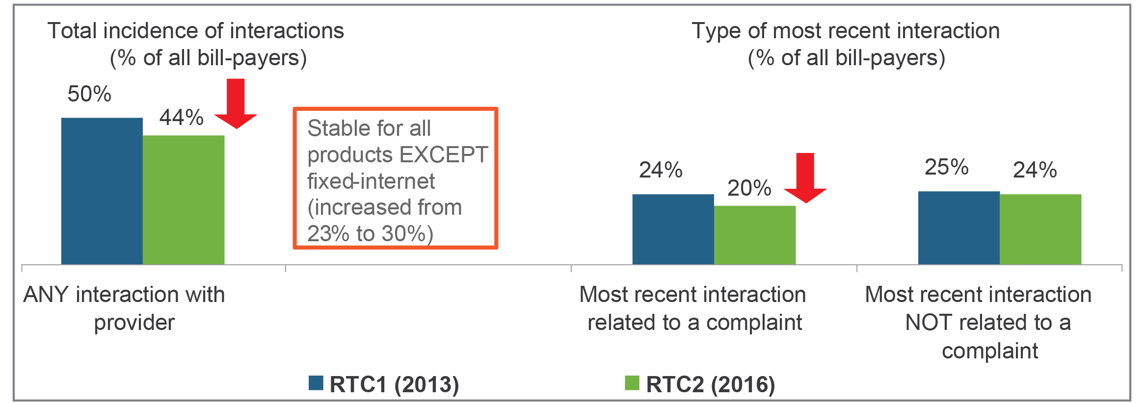

*Base: Total sample of bill-payers (RTC1 n=1,861; RTC2 n=1,816).*

There has been a slight fall in non-complaints that are resolved on first contact—from 70 per cent in RTC1 to 63 per cent in RTC2, see Figure 2.

Figure 2: Resolution of issues not related to a complaint

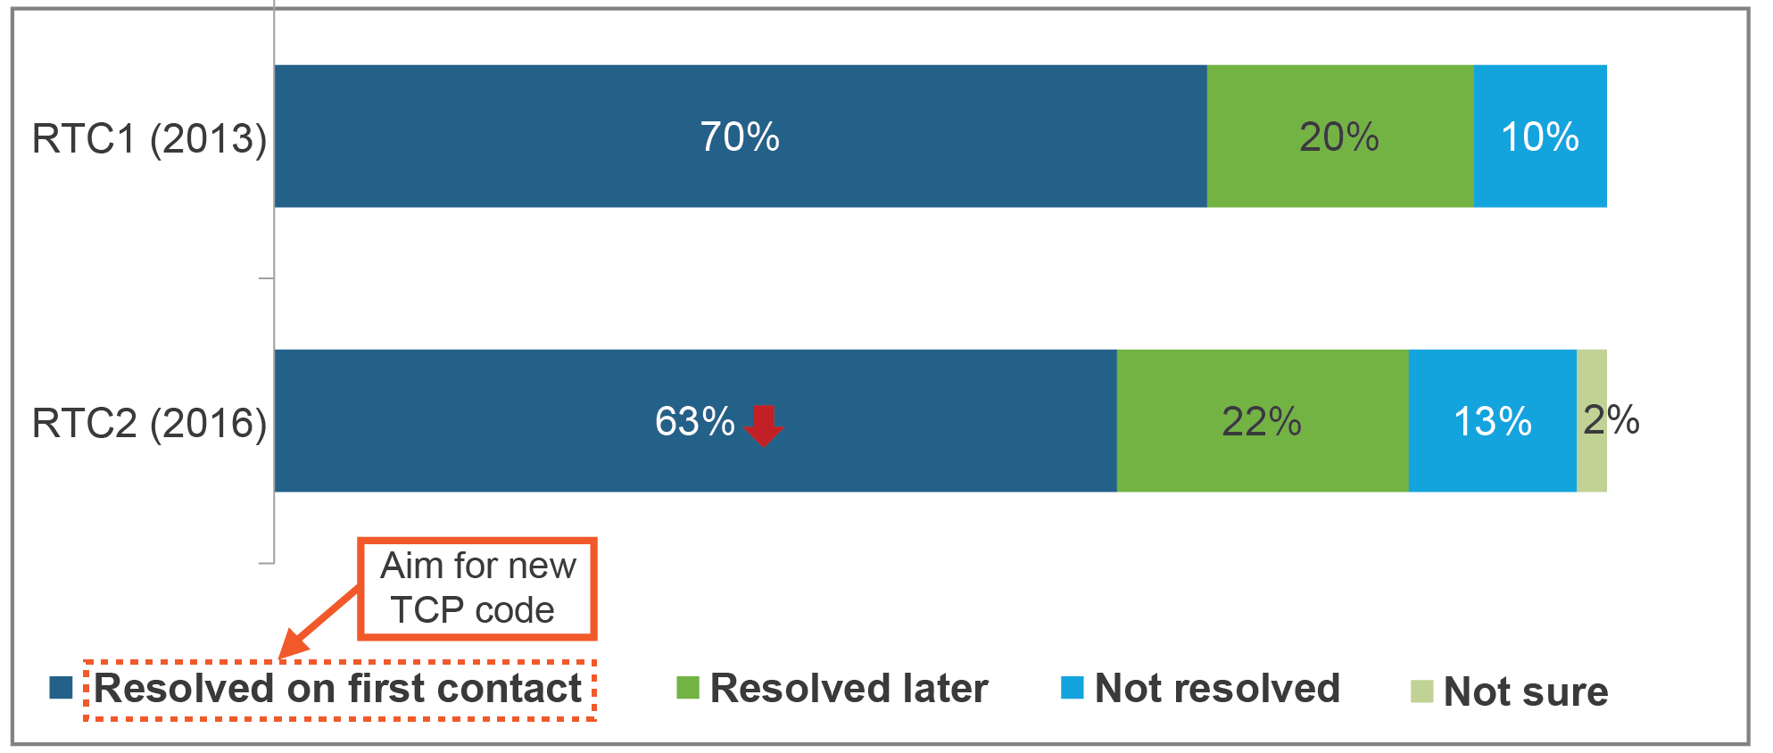

*Base: Total have contacted their service provider in the last 6 months for an issue not related to a complaint (RTC2 n=461; RTC1 n=484).*

Also remaining steady are the reasons for non-complaints and overall satisfaction for non-complaint issues.

## Satisfaction with customer service

While still fairly high, satisfaction with customer service (non-complaints) remains virtually unchanged (Figure 3).

Figure 3: Quality of customer service

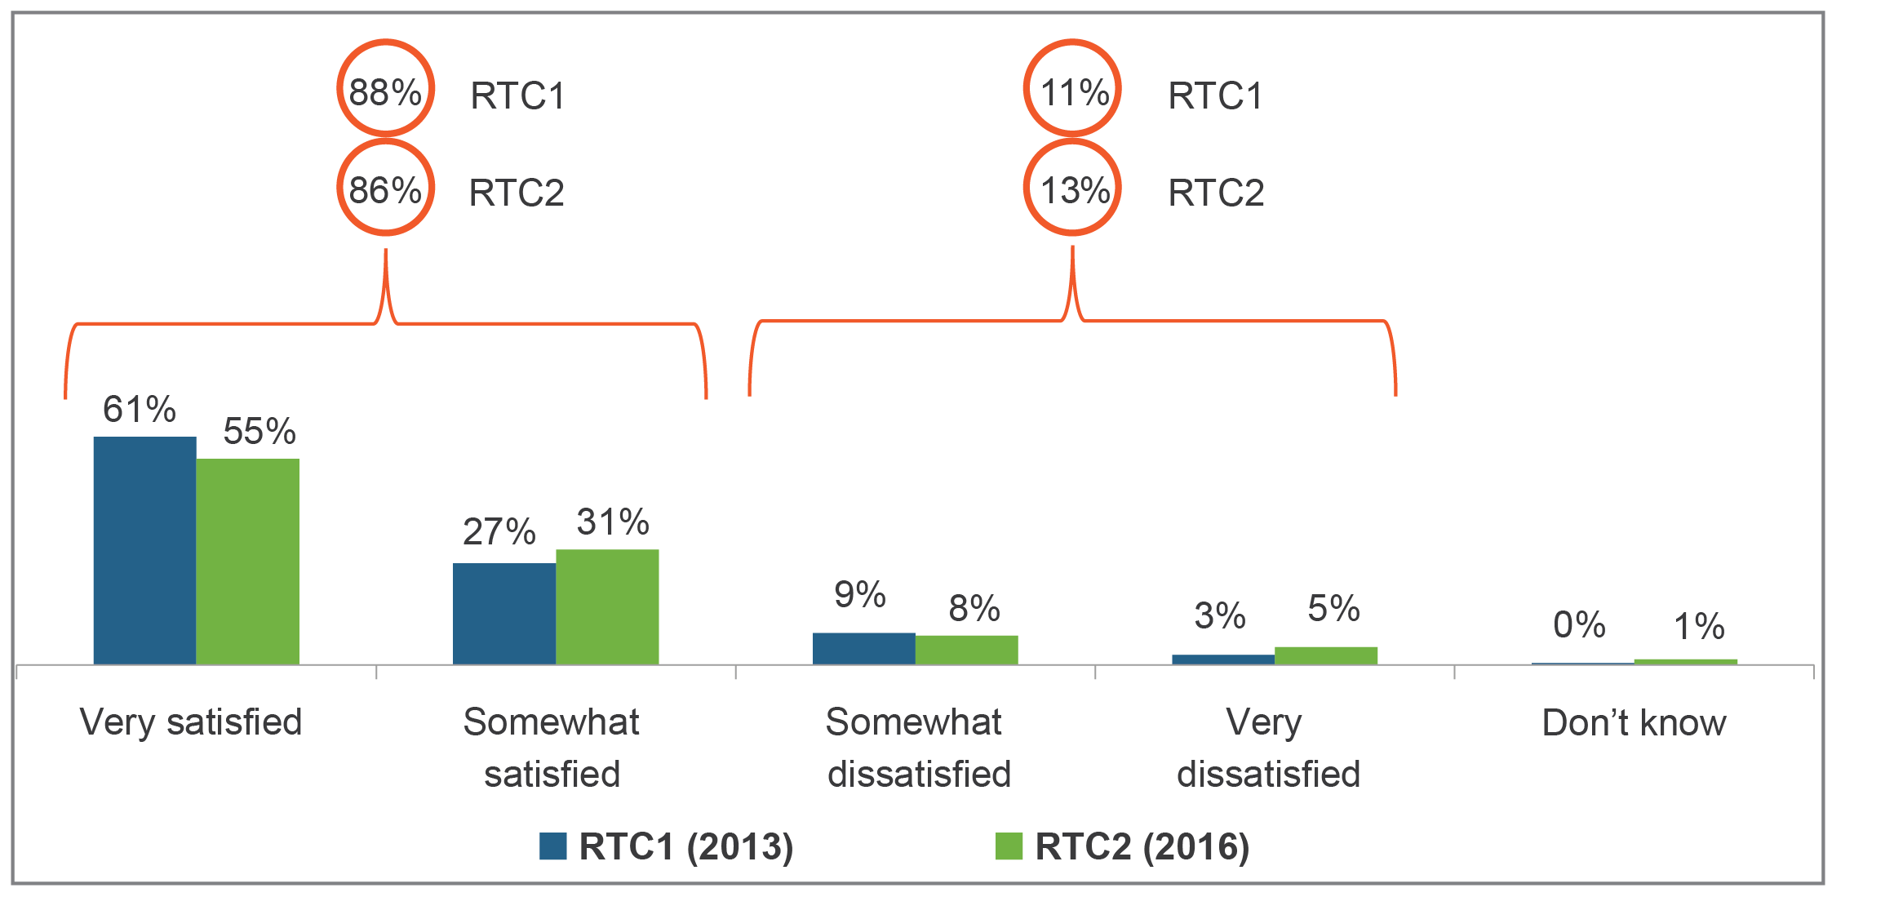

*Base: Total have contacted their service provider in the last 6 months for an issue* ***not*** *related to a complaint (RTC2 n=461; RTC1 n=484).*

## Complaints

Overall, the incidence of complaints has fallen, from 36 per cent having made a complaint in the last 12 months in 2013 to 31 per cent in 2016, see Figure 4. This is largely due to a reduction in complaints about mobile phone services, while fixed-internet complaints have increased slightly.

Figure 4: Complained to the provider—all products

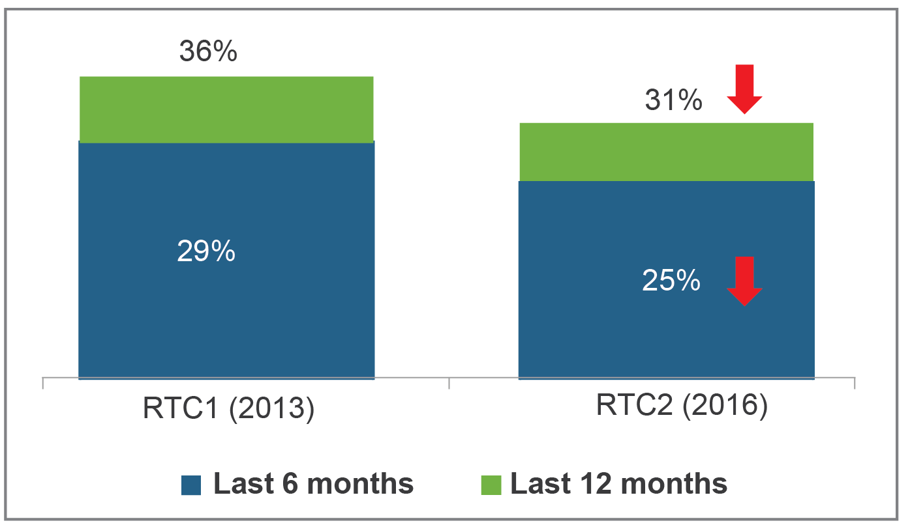

*Base: Total sample of bill-payers (RTC1 n=1,861; RTC2 n=1,816).*

For all services combined, fault and technical issues are still the dominant reason that customers complain to their service provider. There are fewer billing issues leading to complaints, and this is driven by a decline in mobile phone billing complaints. Faults and technical issues, and coverage issues have increased as reasons for fixed internet complaints.

While more complainants are receiving a Customer Relationship Number (CRN), it does not always assist the process. Complaint resolution rates and time frames remain unchanged.

Figure 5 illustrates that, for the most recent interaction, overall levels of satisfaction and dissatisfaction with customer service remains the same as three years ago, although for those dissatisfied there are slightly fewer now ‘somewhat dissatisfied’. There is a corresponding increase in those who are ‘very dissatisfied’ with their customer service experience.

Figure 5: Overall satisfaction with customer service for complaints

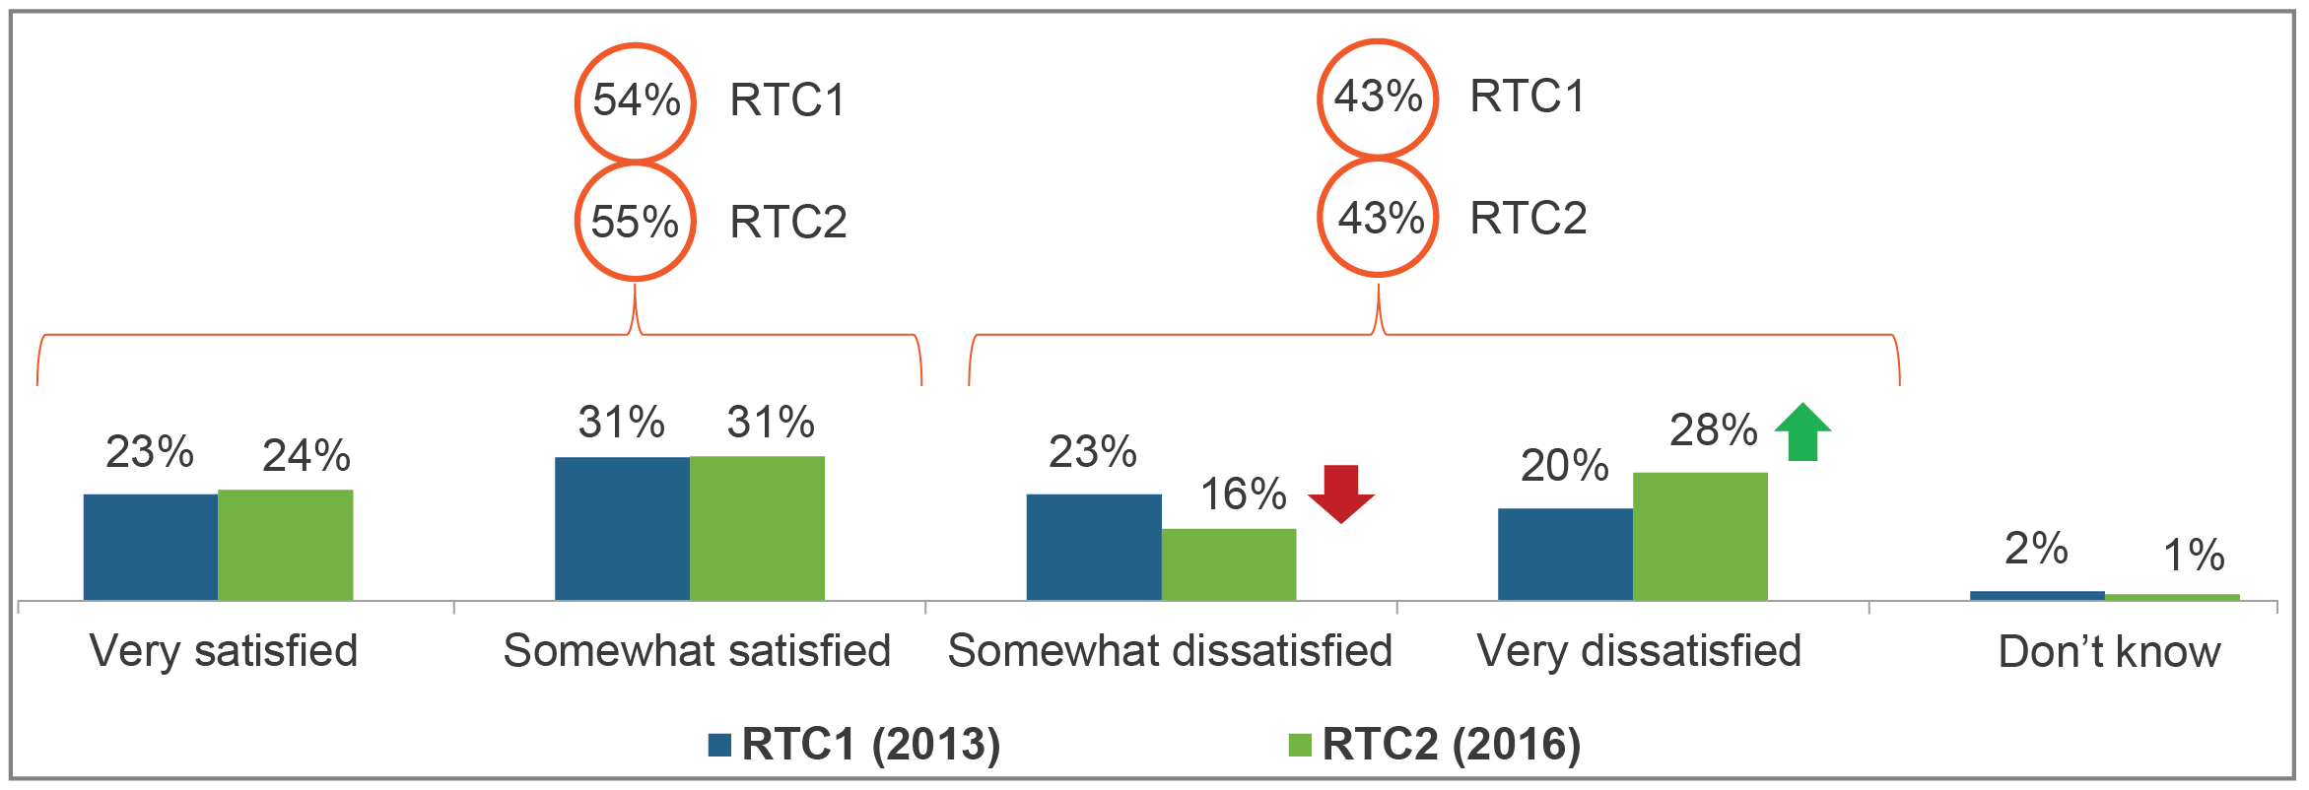

*Base: Total have contacted their service provider in the last six months for an issue related to a complaint (RTC2 n=405; RTC1 n=460).*

## High bills and spend management tools

The research shows evidence of customers actively monitoring their expenditure, with higher rates of customers receiving SMS alerts and an increase in checking usage via apps. Nine in 10 consumers still find each of these tools to be useful.

The incidence of consumers reporting unexpectedly high bills (UHBs) has decreased, most notably for post-paid mobile phones (Figure 6).

Figure 6: Incidence of unexpectedly high bills

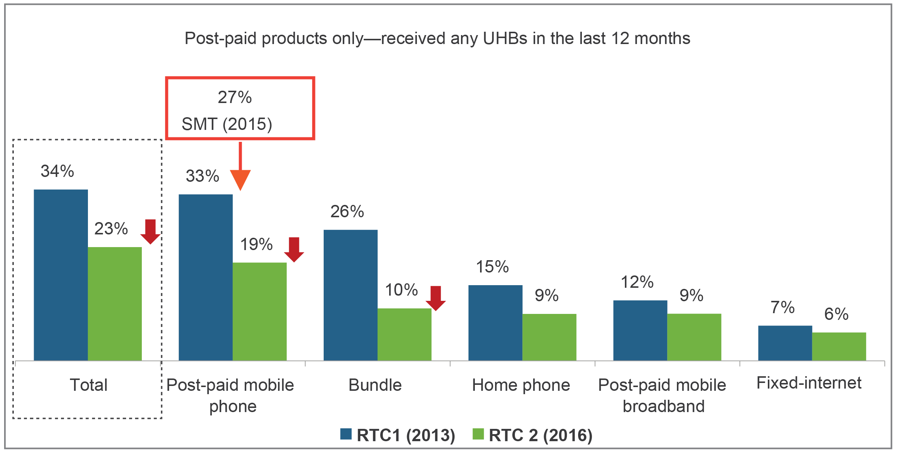

*Base: Bill-payers of post-paid services: (RTC1: Total: n=1,718; Post-paid mobile phone n=1,218; Bundle n=942; Landline telephone n=1,289; Post-paid mobile broadband n=356; Fixed internet n=1,240) (RTC2: Total: n=1,690; Post-paid mobile phone n=1,168; Bundle n=889; Landline telephone n=1,163; Post-paid mobile broadband n=289 Fixed internet n=1,290).*

When unexpectedly high bills are received, the extra amount consumers now have to pay has reduced from $94 to $60 (across all products); see Figure 7.

There is also a lower incidence of higher bills that are at least double the normal bill (53 per cent in 2013; 34 per cent in 2016).

Figure 7: Size of unexpectedly high bills

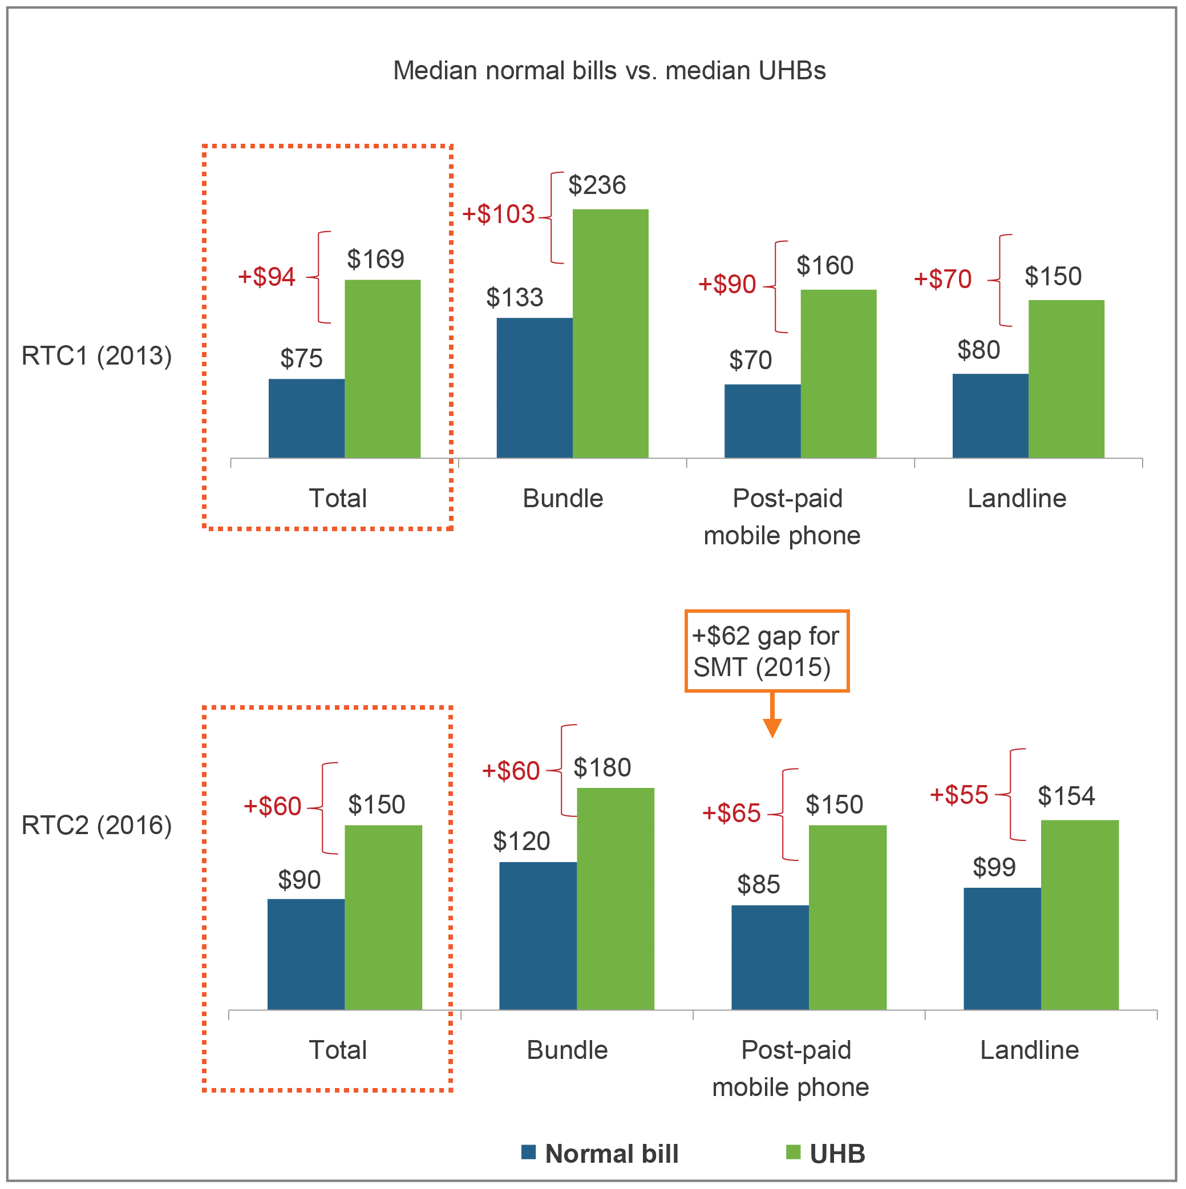

*Base: Total had high bill and gave figure for normal bill and high bill.  
*Note: ‘Don’t know’ responses excluded from the analysis. Fixed internet not shown due to small sample sizes.*

## Product information and comparing offers

There has been an increase in the ease of comparing offers since 2013, particularly for mobile phones and bundles. More consumers are also aware of the CIS—now required under the TCP code—and the majority of those who are aware do find it useful (Figure 8).

Figure 8: Awareness and usefulness of the Critical Information Summary

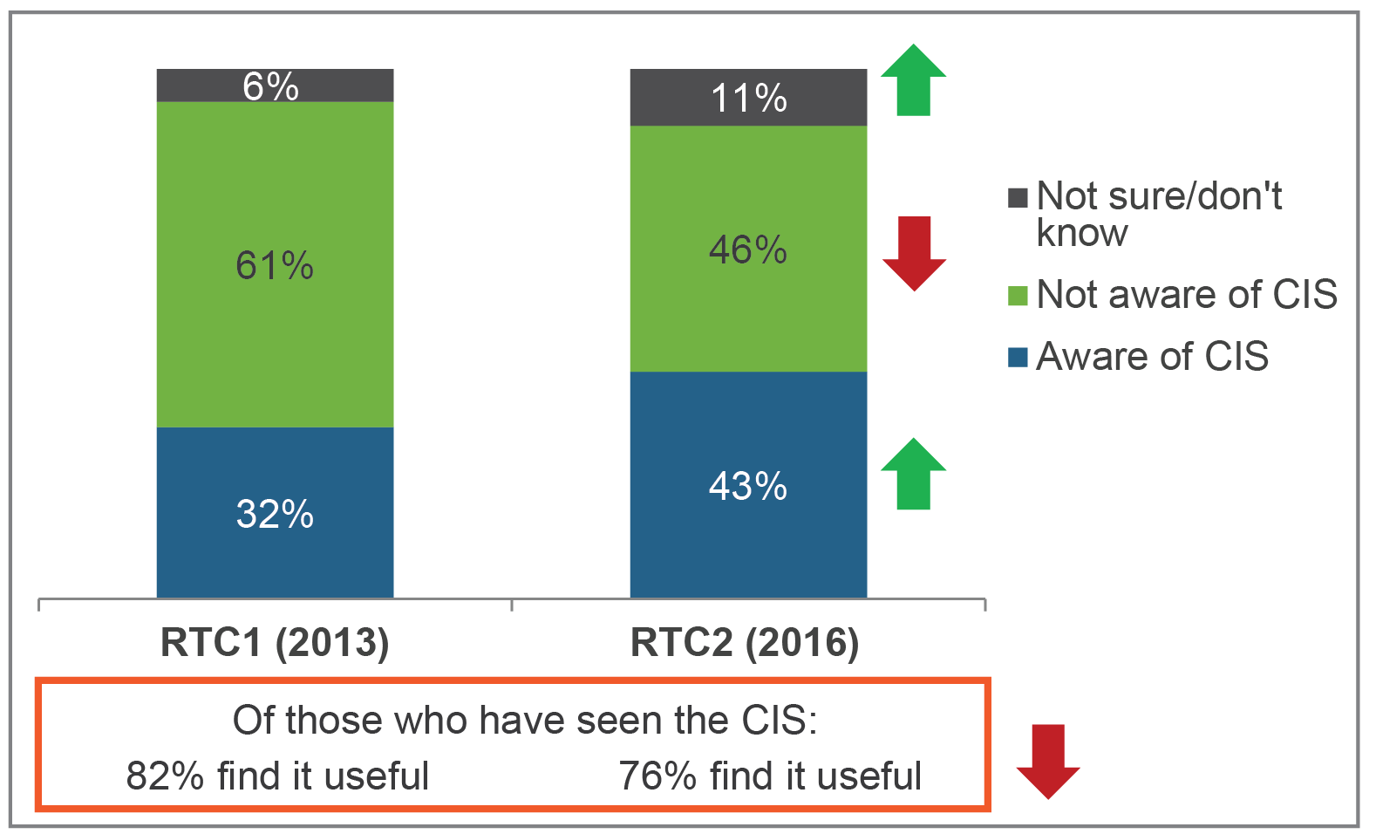

*Base: Total purchased, changed or considered changing or purchasing telecommunications services in the last 12 months (RTC1 n=1,029; RTC2 n=908). Total have seen a CIS (RTC2 n=404; RTC1 n=331).*

The research also found that consumers also rely on other sources of information such as product information on provider websites, provider ads and comparison websites.

## Emerging issues

The RTC2 study was designed identify and explore usage patterns, attitudes and issues for consumers, and investigate some new specific areas of concern that have emerged since 2013. These new topics of interest are outlined below.

### Unauthorised apps

Charges may appear on bills as a result of apps or unknown services (due to a legitimate practice known in the industry as ‘direct carrier billing’ that allows customers to pay for content such as apps or games with their mobile phone bill).

One in 10 people who made a complaint about a mobile phone service said that it was about an unauthorised mobile phone app or service appearing on their bill. While overall this represents only a small proportion (one per cent) of mobile phone bill-payers who complained about these types of unauthorised charges, our research shows many more are experiencing this new issue but not actually complaining. The impact was often quite substantial, with those affected customers reporting the issue was often not easily resolved. Since the research was conducted in May–June 2016, both Telstra and Optus have introduced double-opt-in arrangement to improve subscription processes for these types of services.

### Issues with internet streaming

Of consumers who have a service that can stream data, 14 per cent have experienced issues with it. The main concern was internet connection speeds being too slow (66 per cent), followed by experiencing drop-outs or connection difficulties (30 per cent).

# Appendix A—Detailed findings

## Complaints

Those aged 35–49 are still the most likely to have made a complaint in the last 12 months (39 per cent). There has been a decrease in complaints from those aged 25–34 (Figure 9).

Figure 9: Complaints by age group

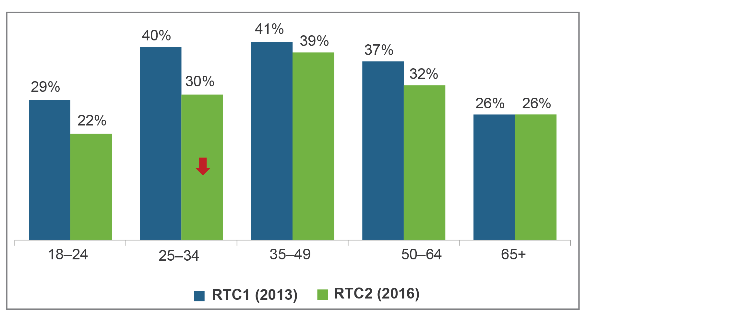

*Base: Total sample of bill-payers; RTC1 n=1,861. 18–24 n=218; 25–34 n=348; 35–49 n=504; 50–64 n=445; 65+ n=346. RTC2 n=1,816. 18–24 n=195; 25–34 n=327; 35–49 n=484; 50–64 n=445; 65+ n=365.*

The overall decline in complaints is driven by fewer mobile phone complaints.

As a proportion of all complaints, fixed-internet complaints have increased to now be the most complained-about product. However, the proportion of fixed-internet complaints for those with fixed-internet has risen only slightly (Figure 10).

Figure 10: Rate of most recent complaints for each product

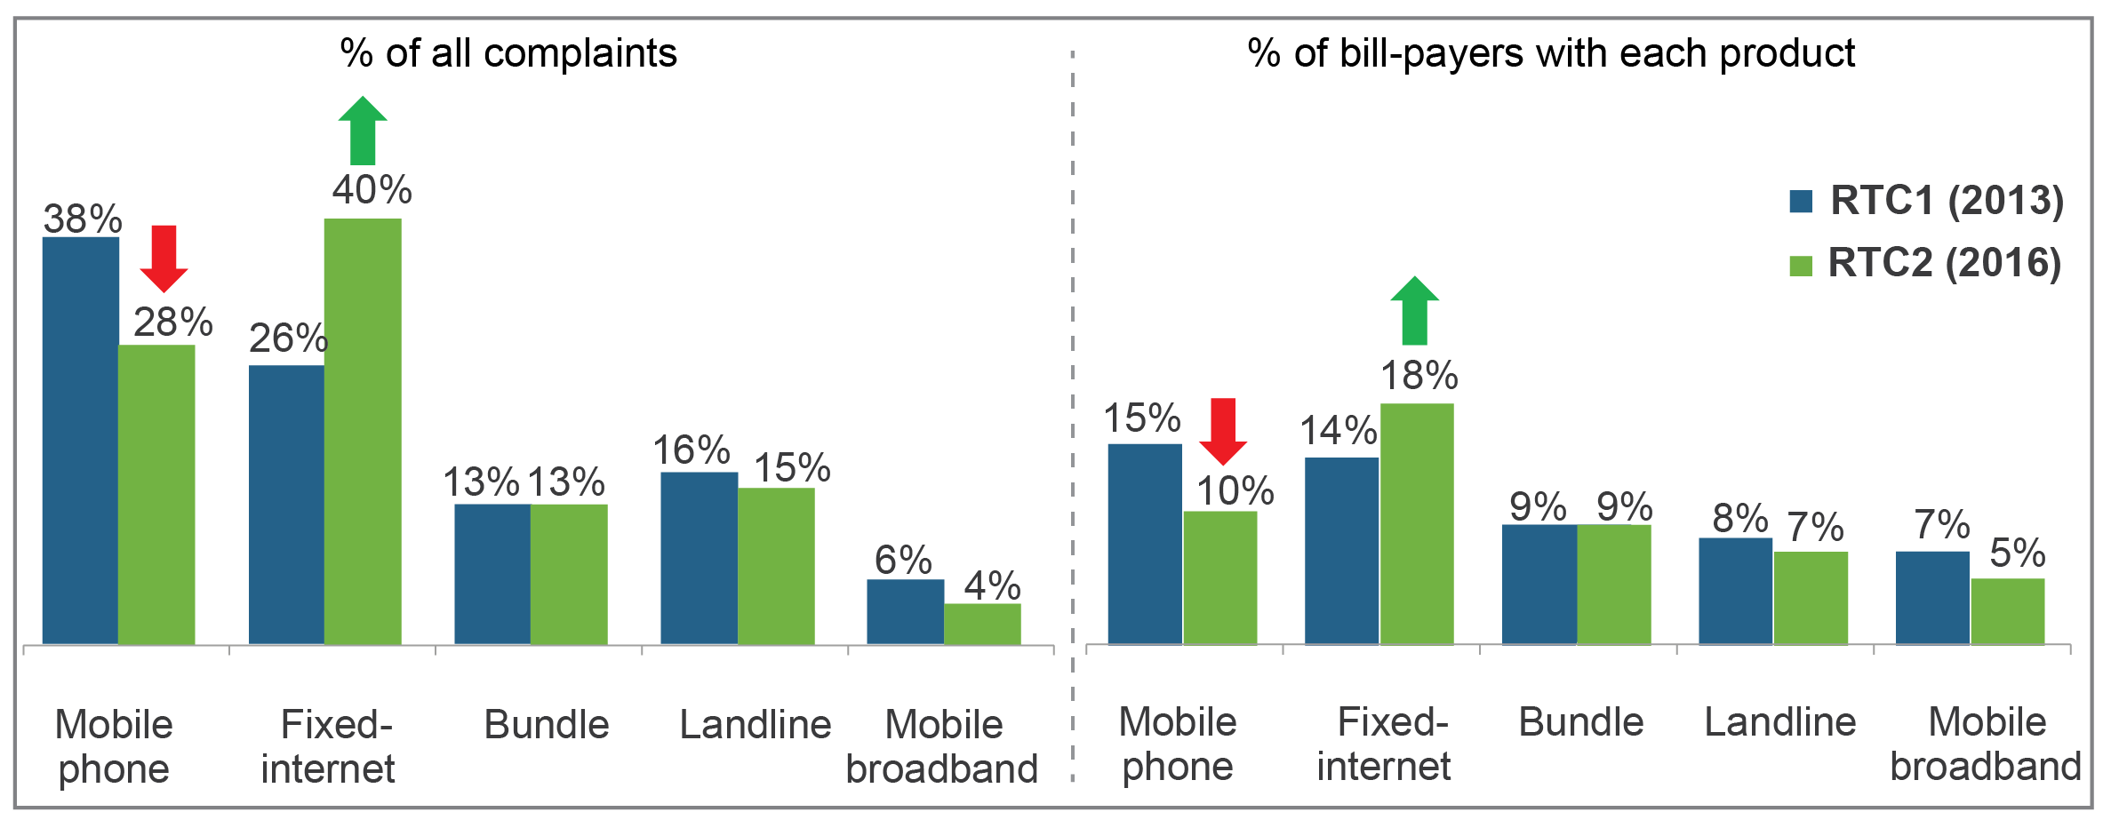

*Base: Total sample of bill-payers (RTC2 n=1,816; RTC1 n=1,861), total who are solely or jointly responsible for each product.*

Across all products, fault and technical issues continue to dominate, but billing issues have declined. The decrease in billing issues is likely to be linked to lower the incidence of UHBs and greater use of spend management tools. ‘Coverage’ issues and ‘service disconnections and suspensions’ have both increased (Figure 11).

Figure 11: Main reason for most recent complaint—all products combined

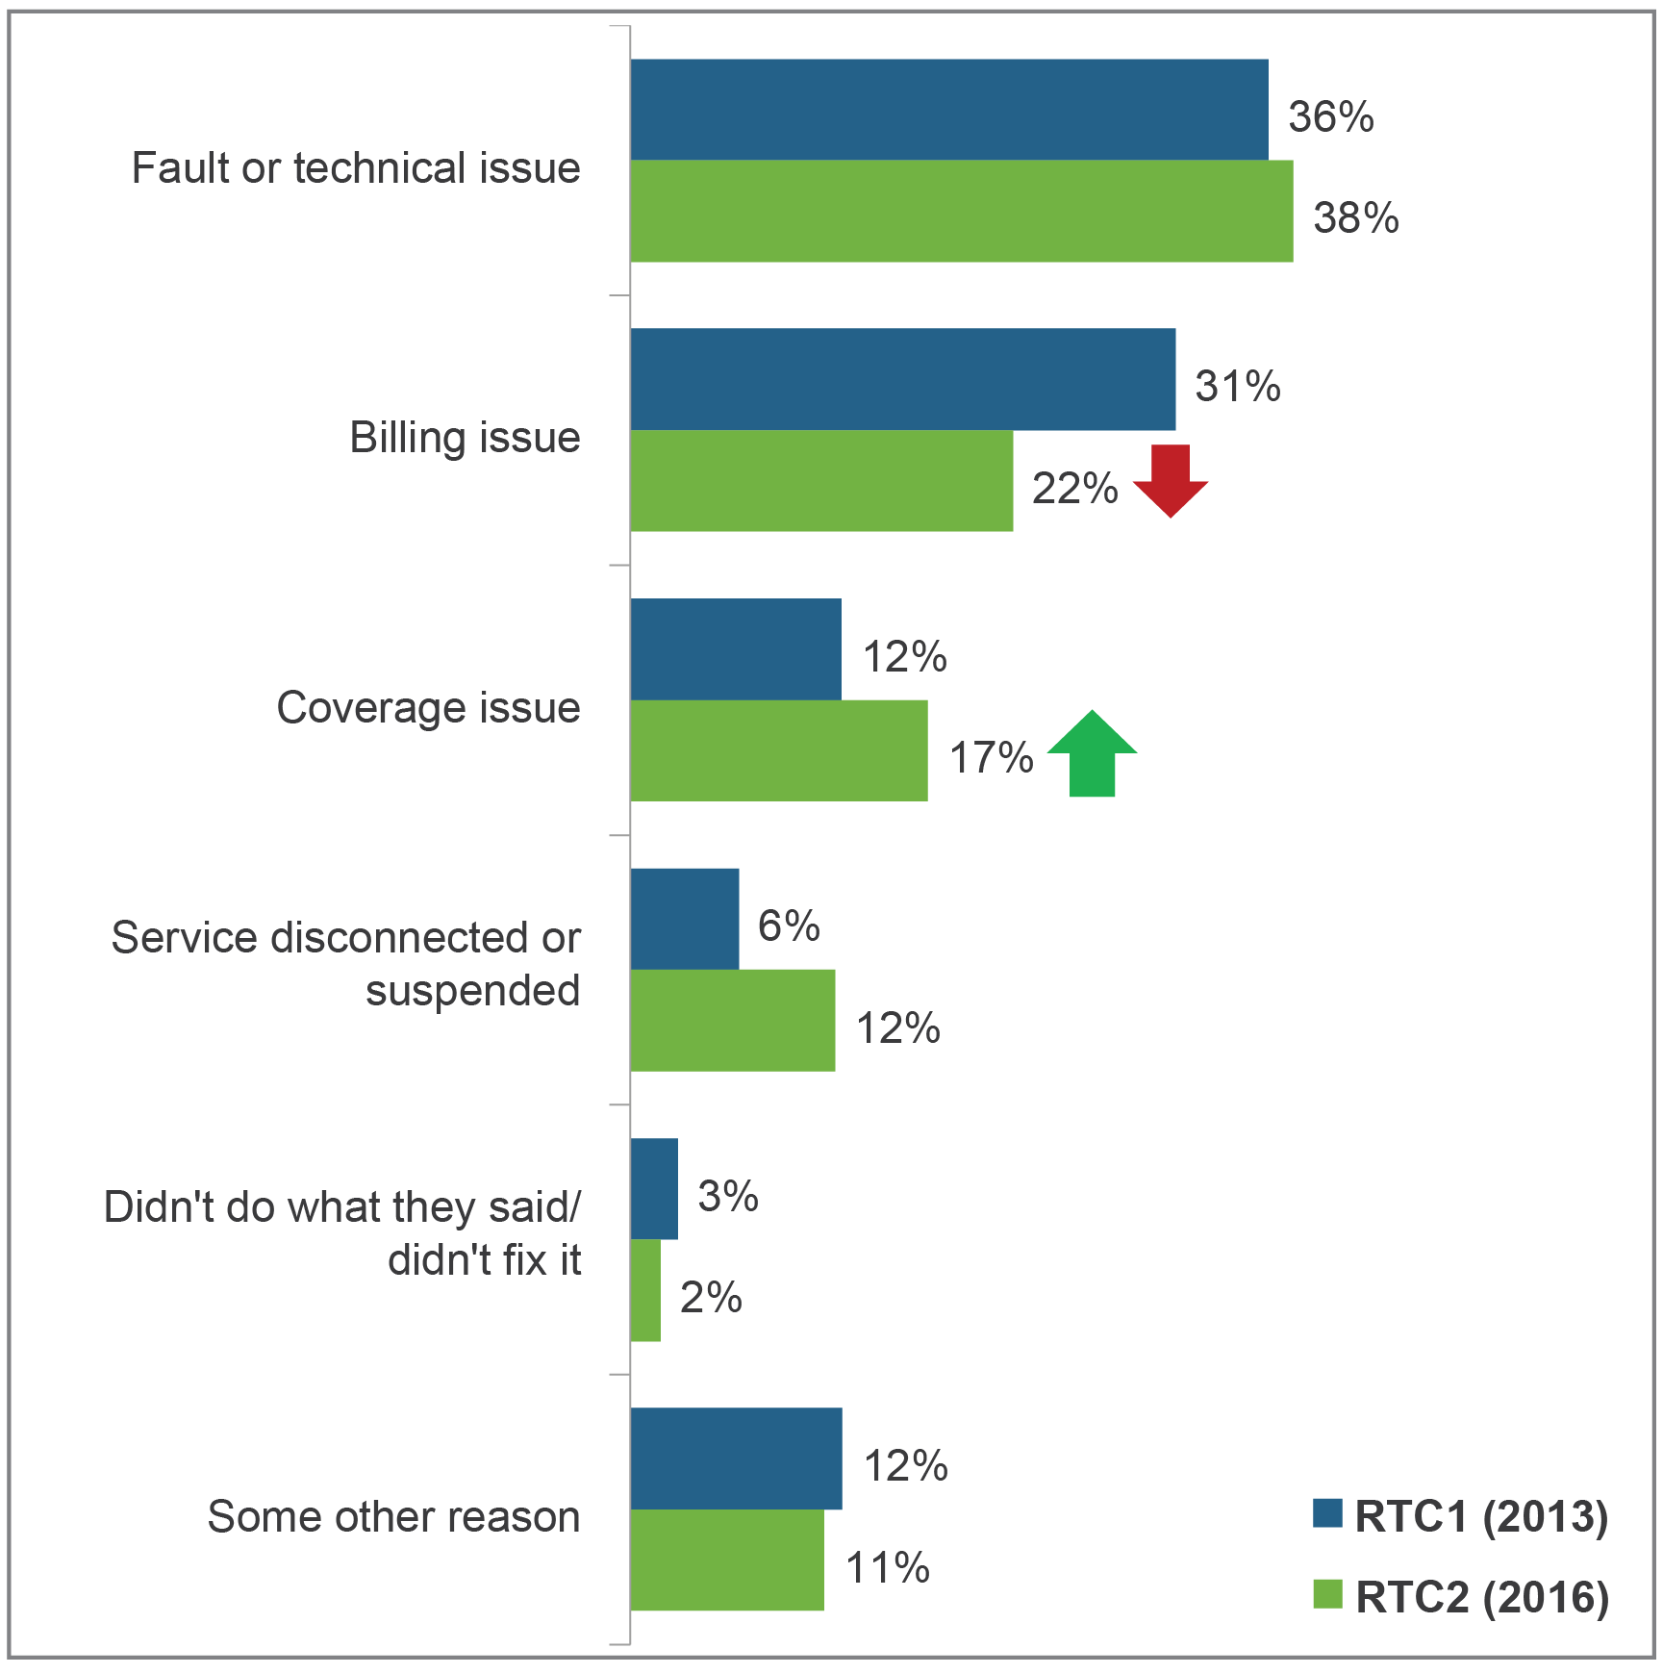

*Base: Total have made a complaint or contacted their service provider in the last 12 months for an issue related to a complaint (RTC2 n=603; RTC1 n=668).*

Billing complaints about mobiles have declined, while fixed-internet technical and fault issues and fixed-internet coverage issues have risen. There were no major changes in the main reason for complaints about bundles or home phones (Figure 12).

Figure 12: Main reason for most recent complaint, by type of service

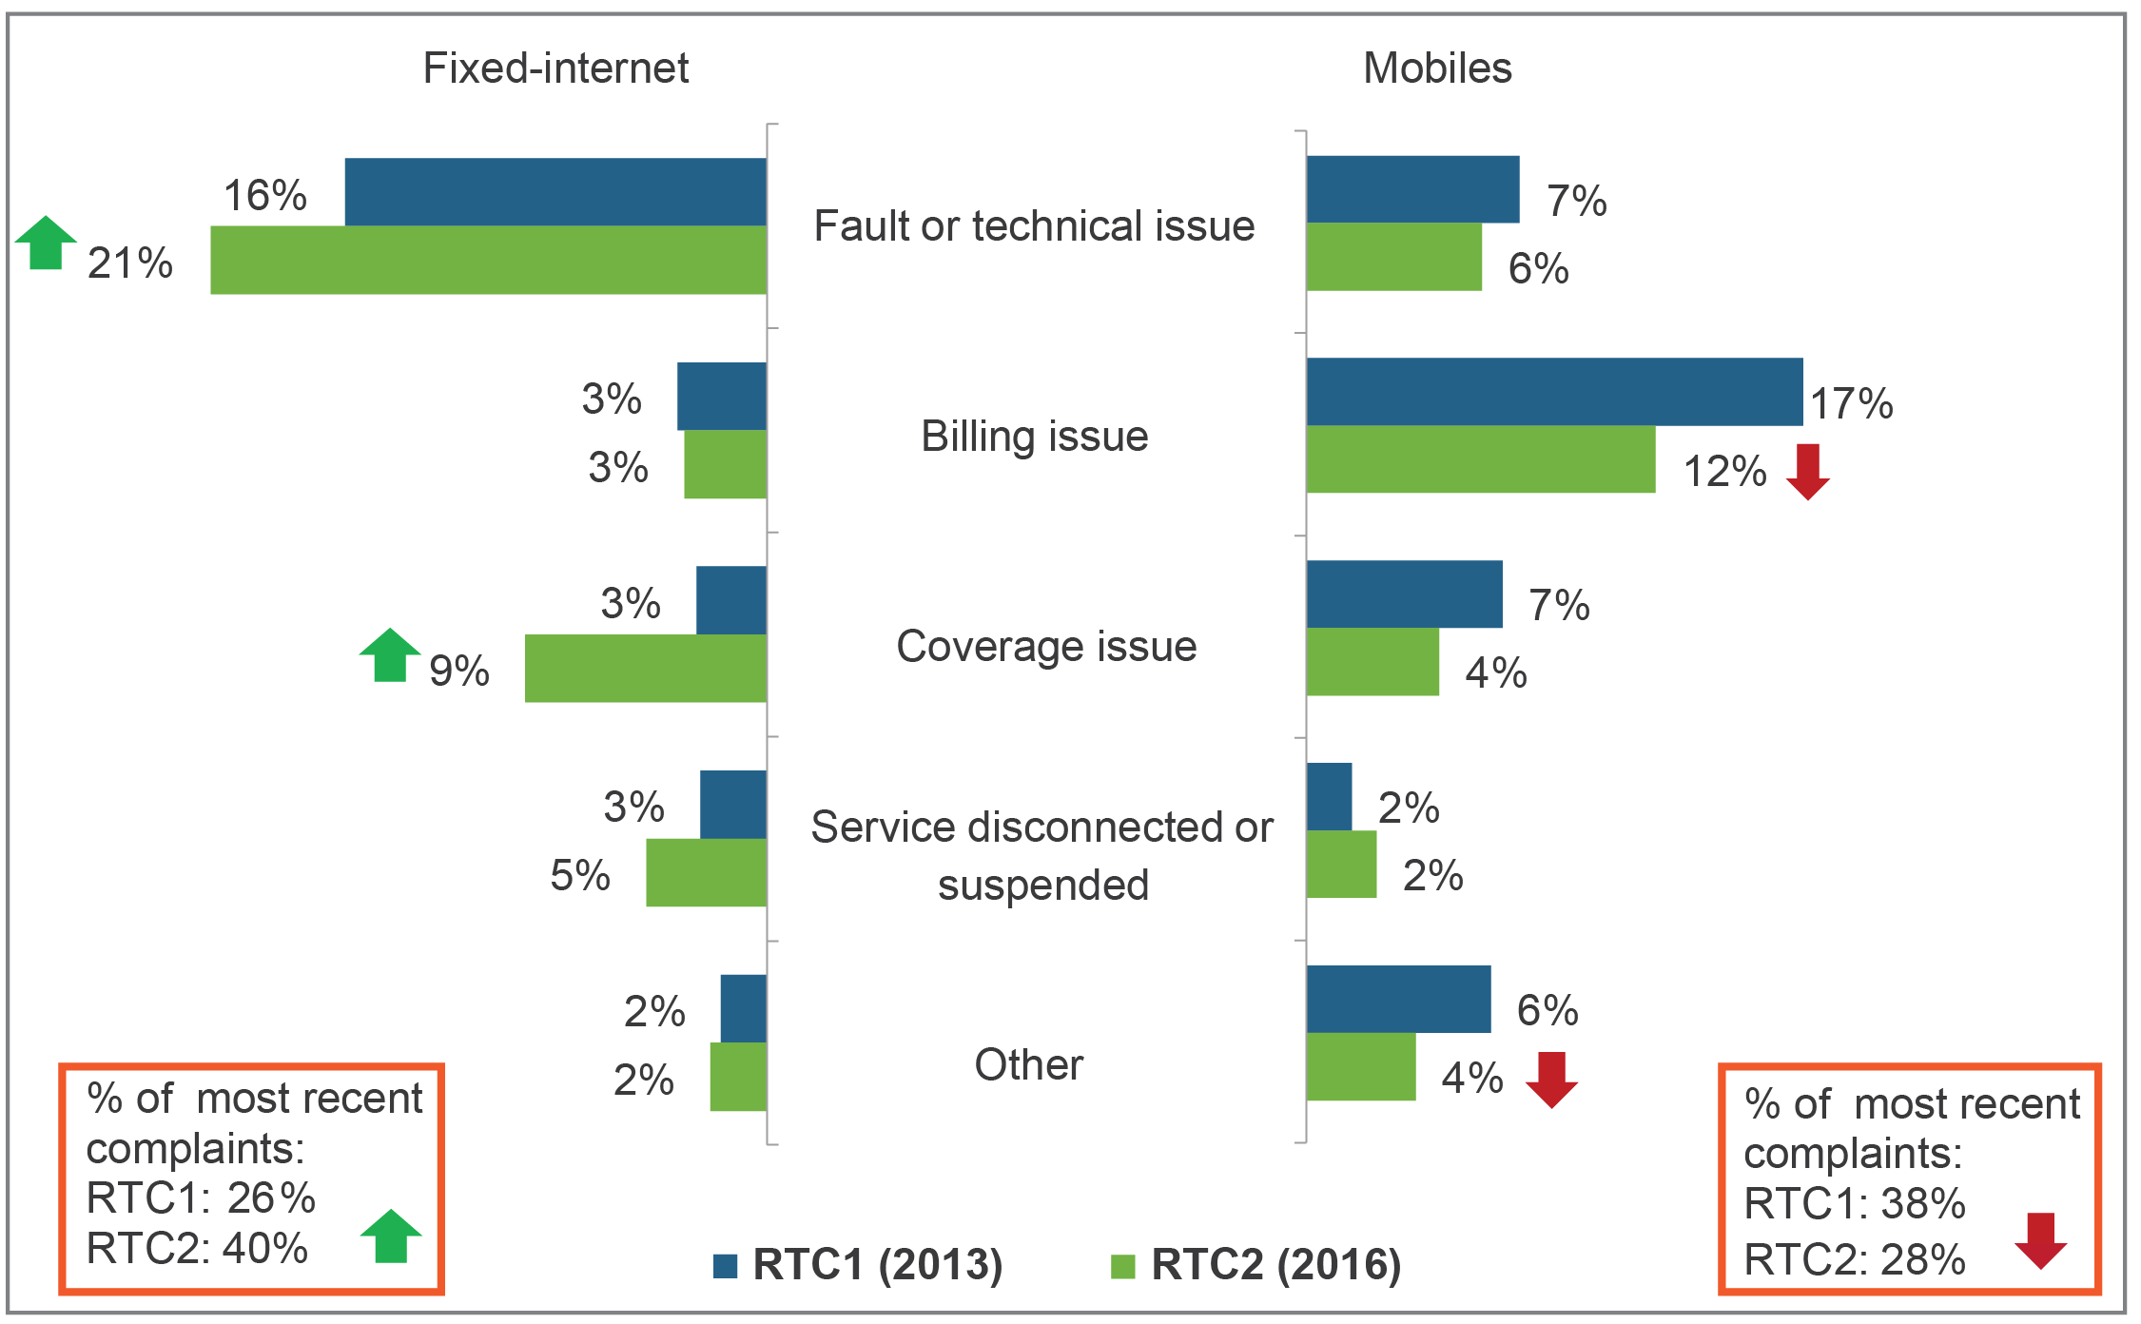

*Base: Total bill-payers who made a complaint, n=603.*

The qualitative research suggests that the rise in fixed-internet ‘coverage’ and ‘service disconnected or suspension’ issues are more likely to be fault or technical issues. Customers are not always sure how to classify the fault issues and there is some confusion as the real cause of their internet issues (among both customers and providers). These included:

* ‘ad hoc/once-off issues’—some customers deem this to be a ‘fault or technical issue’
* ‘ongoing issues/happens a lot’—some customers deem this to be a ‘coverage issue’

‘internet stops working altogether’—some customers deem this to be a ‘service disconnected or suspended issue’.

There was little change in the number of times a customer contacts their provider about their complaint, while more customers report receiving a CRN (Figure 13).

Figure 13: Complaint contacts and receipt of a CRN

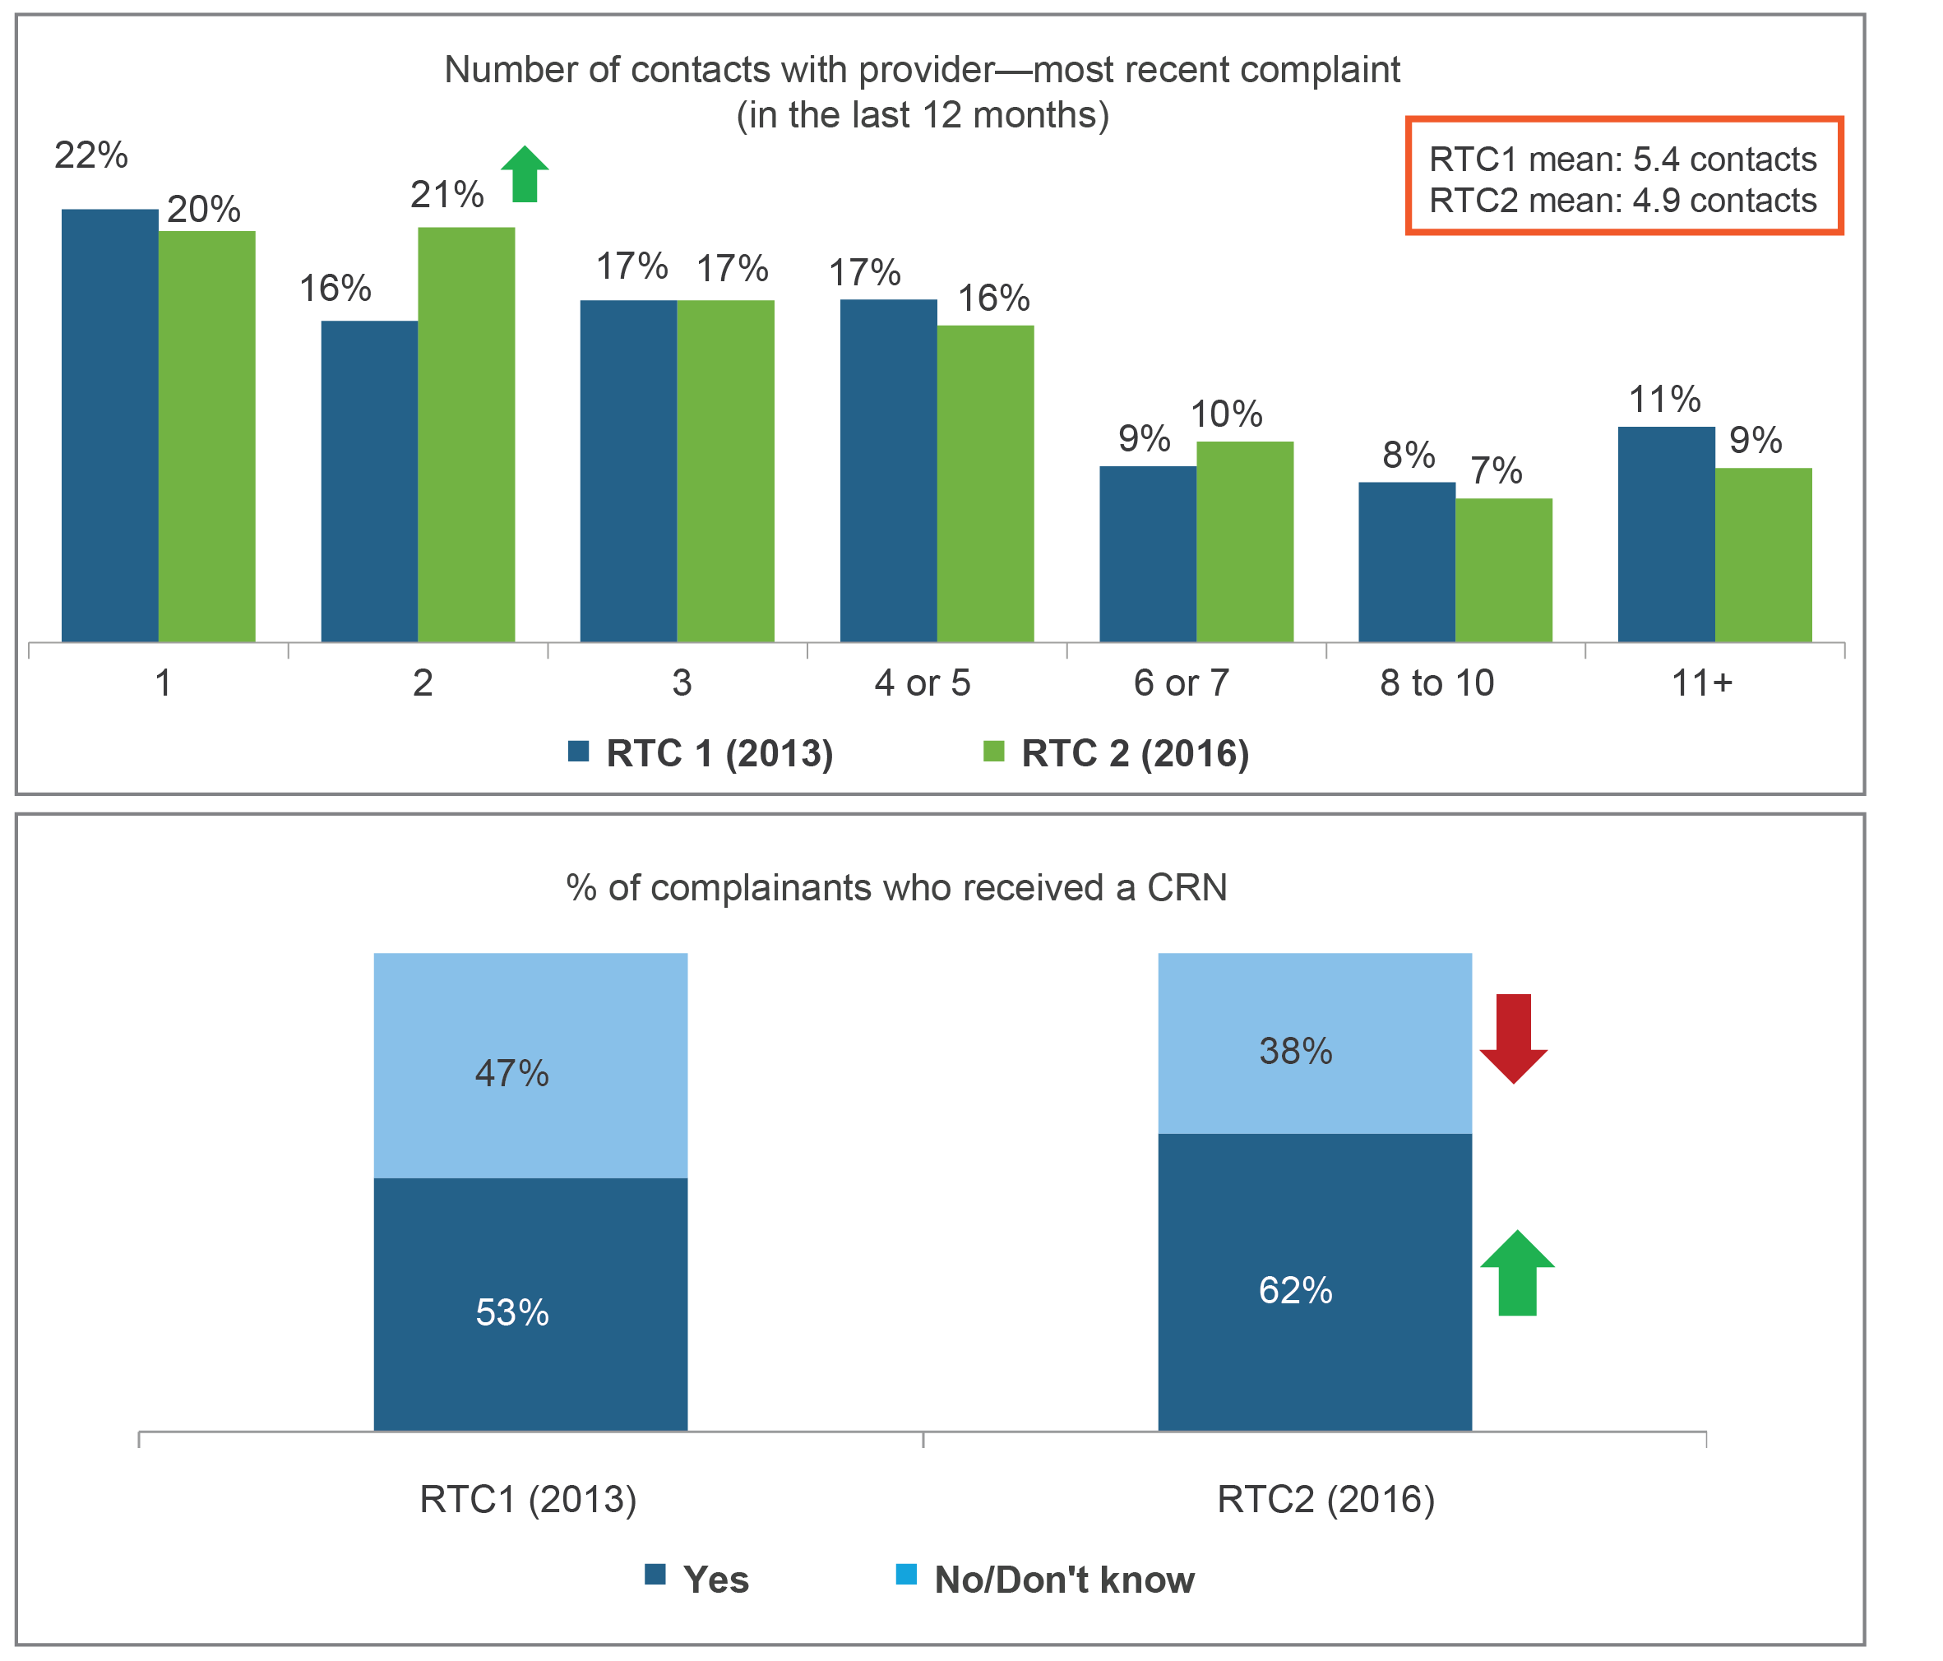

*Base: Total have made a complaint or contacted their service provider in the last 12 months for an issue related to a complaint (RTC2 n=603; RTC1 n=668)*.

The rate of resolution of complaints and time frames to resolve remain unchanged (Figure 14).

Figure 14: Resolution of complaints

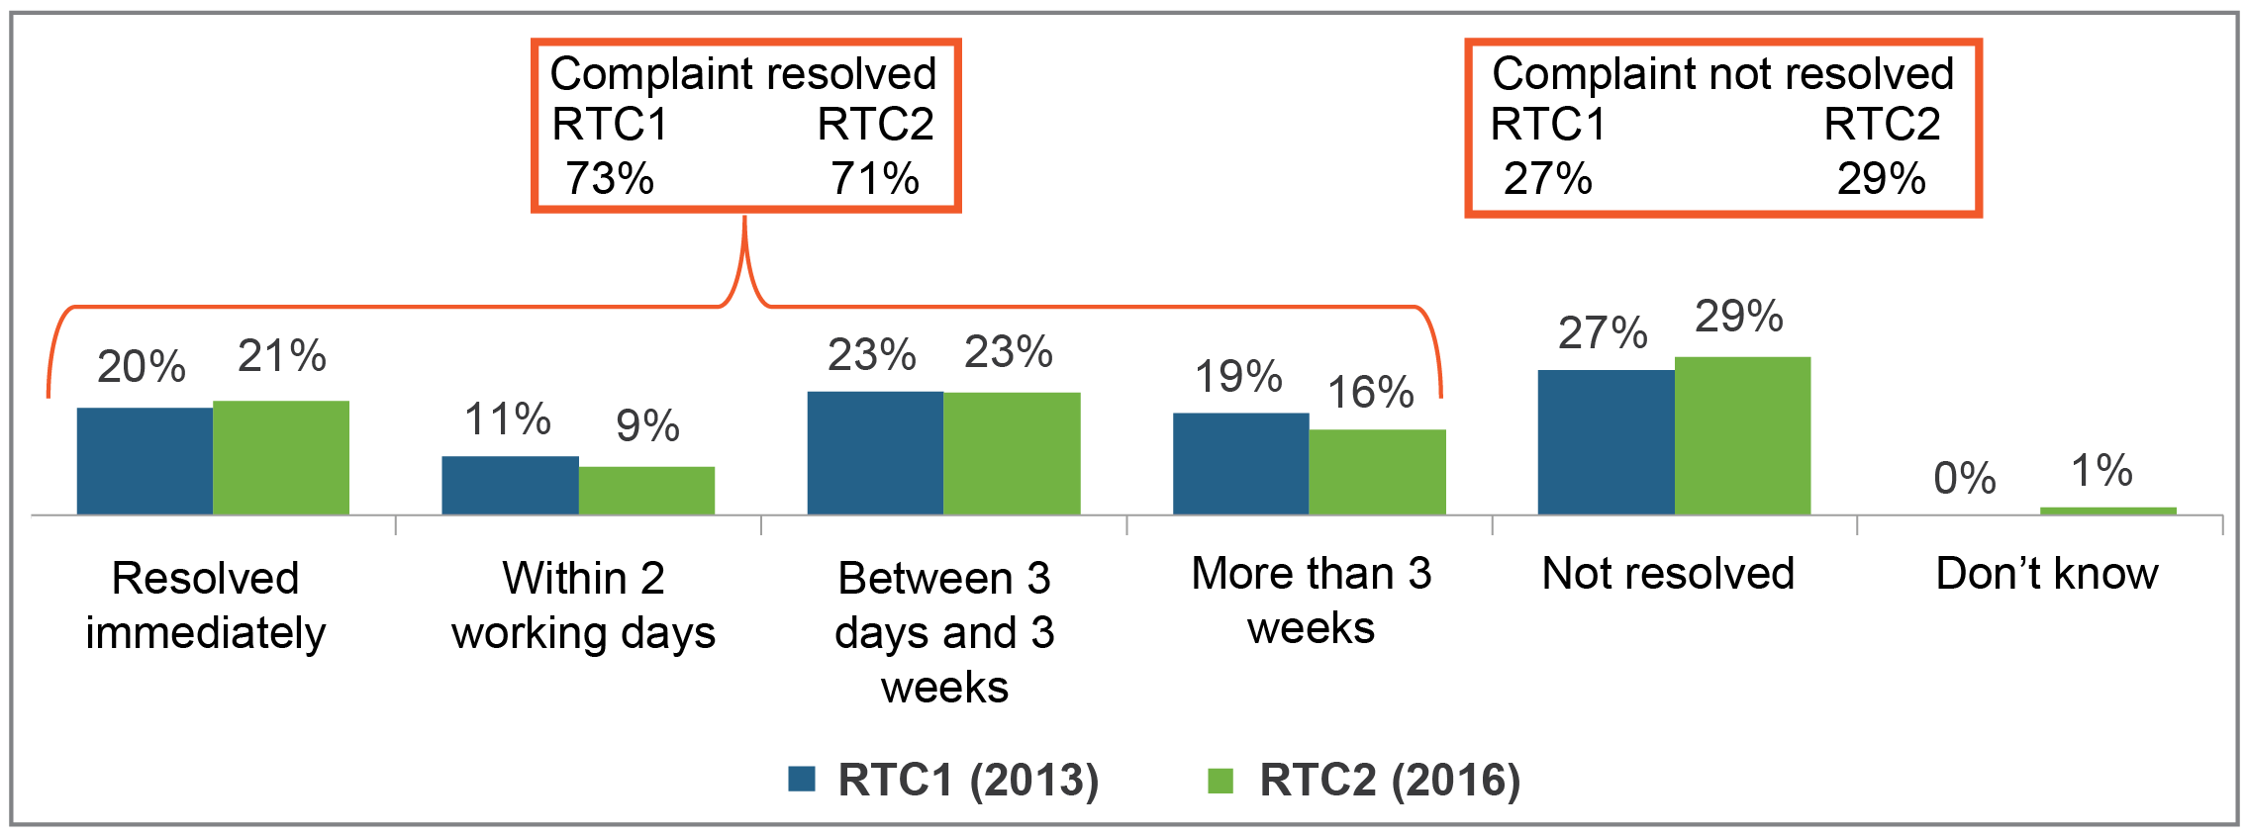

*Base: Total have made a complaint or contacted their service provider in the last 12 months for an issue related to a complaint (RTC2 n=603; RTC1 n=668).*

There has been a slight increase observed in solutions perceived as ‘not fair’ by customers. This rise is not specific to any product as there has been a small increase observed across all service types (Table 2).

1. Perceived fairness of solution

|  | **RTC1 (%)** | **RTC2**  **(%)** |
| --- | --- | --- |
| Fair | 60 | 57 |
| Not fair | 9 | green arrow indicating increase14 |
| Don’t know | 5 | 5 |
| No proposed solution | 27 | 25 |

Despite the rise in perceived ‘not fair’ solutions, fewer customers are taking action as a result, with 75 per cent of customers doing nothing other than make the complaint (up from 60 per cent for RTC1), see Table 3.

1. Actions taken in addition to making a complaint

|  | **RTC 1 (n=668)** | **RTC 2 (n=603)** |
| --- | --- | --- |
|  | (%) | (%) |
| Did nothing else (just made a complaint | 60 | green arrow indicating increase75 |
| Changed plan or offer with the same provider | 12 | Red arrow indicating decrease 8 |
| Changed provider | 9 | 7 |
| Stopped or reduced usage of the service without changing provider | 14 | Red arrow indicating decrease 3 |
| Lodged a complaint with the Telecommunications Industry Ombudsman (TIO) | 3 | 3 |
| Pursue matter with provider | – | 1 |
| Threaten to terminate contract/lodge complaint | - | 1 |
| Did something else | 9 | Red arrow indicating decrease 2 |

There was no change in satisfaction with customer service overall, although slight improvements were observed for mobile phone services.

Overall, satisfaction with the complaints-handling process at a product-specific level remained relatively unchanged (Figure 15).

Figure 15: Satisfaction with complaints-handling process

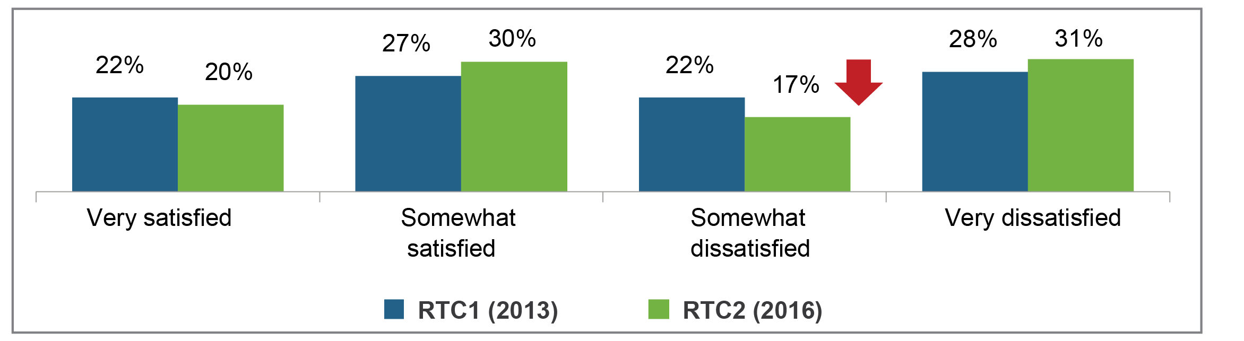

*Base: Total have made a complaint or contacted their service provider in the last 12 months for an issue related to a complaint (RTC2 n=603; RTC1 n=668).*

There has been a small rise in unresolved fixed-internet complaints since the RTC1 research (24 per cent of all fixed-internet complaints unresolved for RTC2; 31 per cent for RTC1), see Table 4.

1. Top 10 reasons for dissatisfaction with the way provider handled the complaints process

|  | **RTC 1  (n=341)** | **RTC 2  (n=290)** |
| --- | --- | --- |
|  | (%) | (%) |
| Issue not resolved/unable to resolve | 20 | 25 |
| Too long to fix/take action | 19 | 21 |
| Service not what paying for | 4 | green arrow indicating increase15 |
| Too many transfers/cannot speak to the right person/waiting on the phone too long | 17 | 14 |
| Provider showed no willingness to resolve | 8 | green arrow indicating increase14 |
| Poor communications/lack of information about problem resolution | 23 | red arrow indicating decrease13 |
| Provider didn’t do what they said they would | 10 | 13 |
| Recurring problem/ongoing problem | 3 | green arrow indicating increase10 |
| Offshore call centre/can’t understand operator | 12 | 8 |
| Poor communication/lack of information about charges or service | 8 | 8 |

## Unexpectedly high bills and spend management tools

Consumers receiving SMS usage alerts, and using apps to check usage for post-paid mobiles has increased and both continue to be useful (Figure 16).

Figure 16: Alerts and apps used for tracking post-paid mobile usage

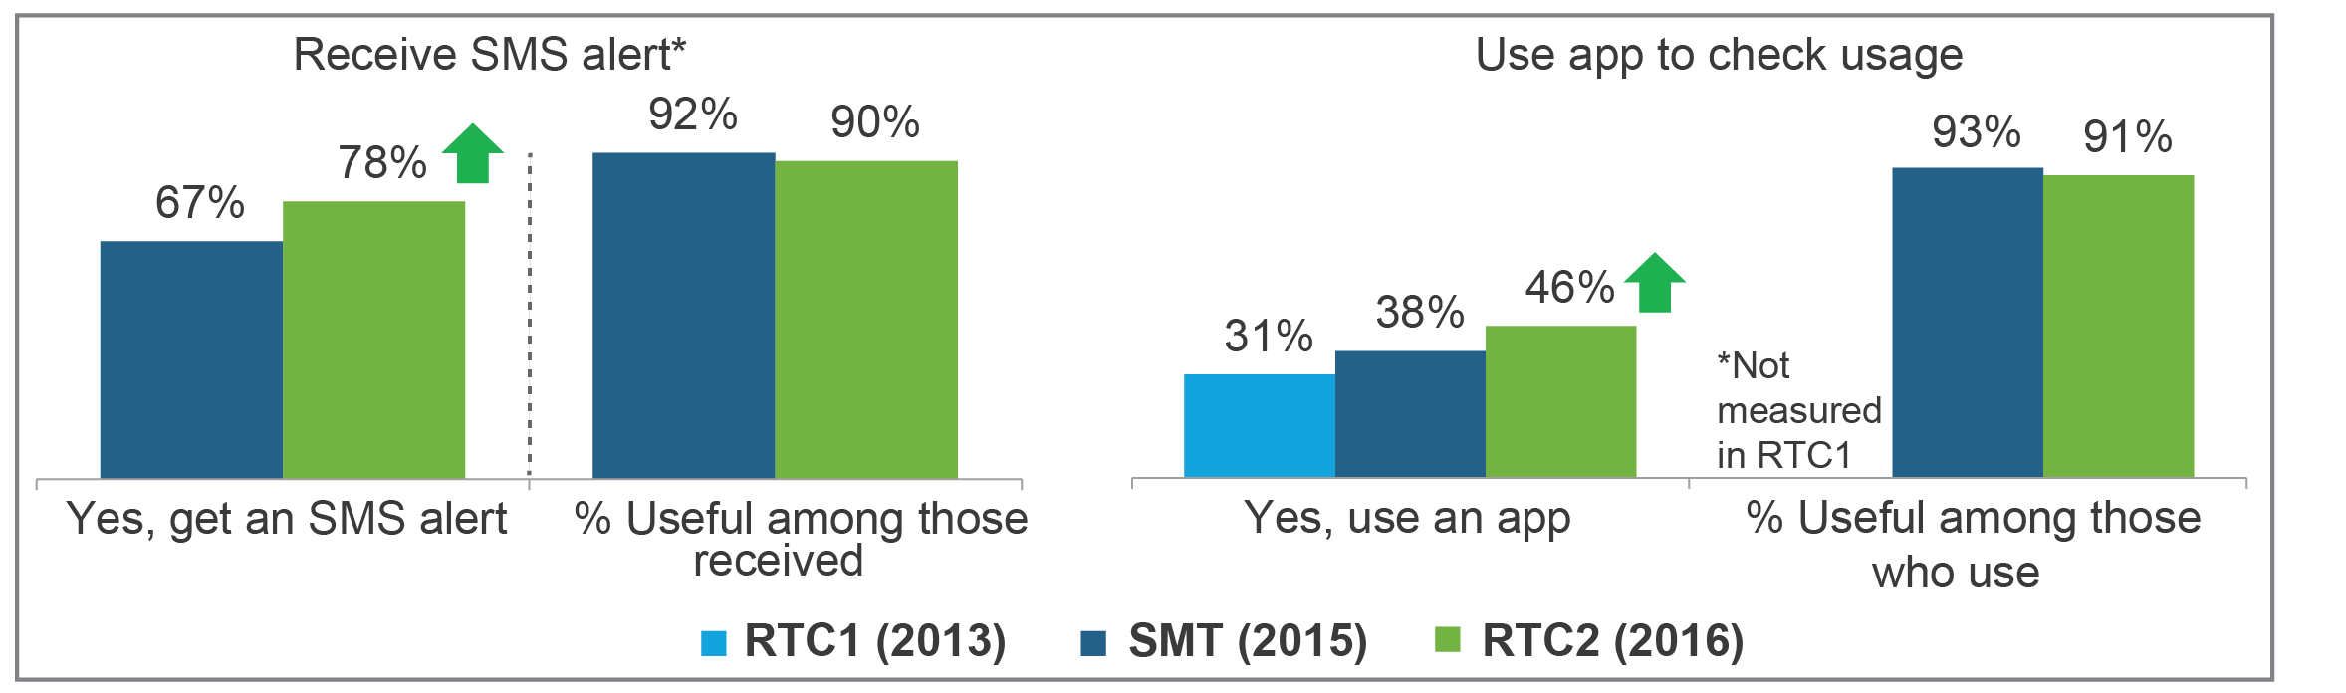

*Base: Post-paid mobile phone bill-payers (SMT n=1,020; RTC2 n=1,168), post-paid mobile phone bill-payers who indicated they received an SMS alert (SMT n=686; RTC2 n=912), post-paid mobile phone holders who use an app to check usage (SMT n=388; RTC2 n=532).*

The magnitude of high bills relative to normal bills has continued to decline over time. The number of consumers who received a bill that was at least double their normal bill has fallen (53 per cent for RTC1, 38 per cent for SMT and 34 per cent for RTC2), see Figure 17.

However, larger UHBs—that is, greater than or equal to 1.5 times and greater than $20 more than normal bill—still make up more than half of all UHBs (54 per cent for RTC1 and 59 per cent for RTC2).

Figure 17: Size of UHBs

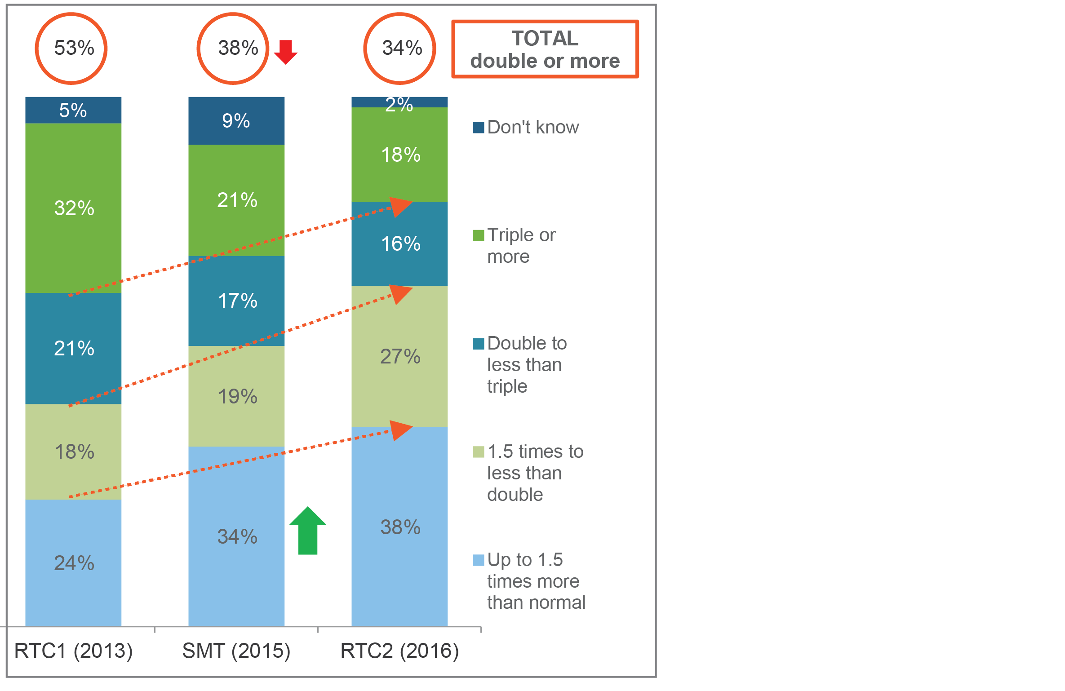

*Base: Received high bill for post-paid mobile (RTC1 n=351; SMT n=275; RTC2 n=200).*

UHBs are now less likely to be linked to difficulty in monitoring usage and spend (down from just under half to just over a third of unexpectedly high bills) and also less likely to be linked to misunderstanding of plans and charges. However, not switching to Wi-Fi has emerged for 15 per cent of cases (Figure 18).

Figure 18: Reasons for UHBs across all products

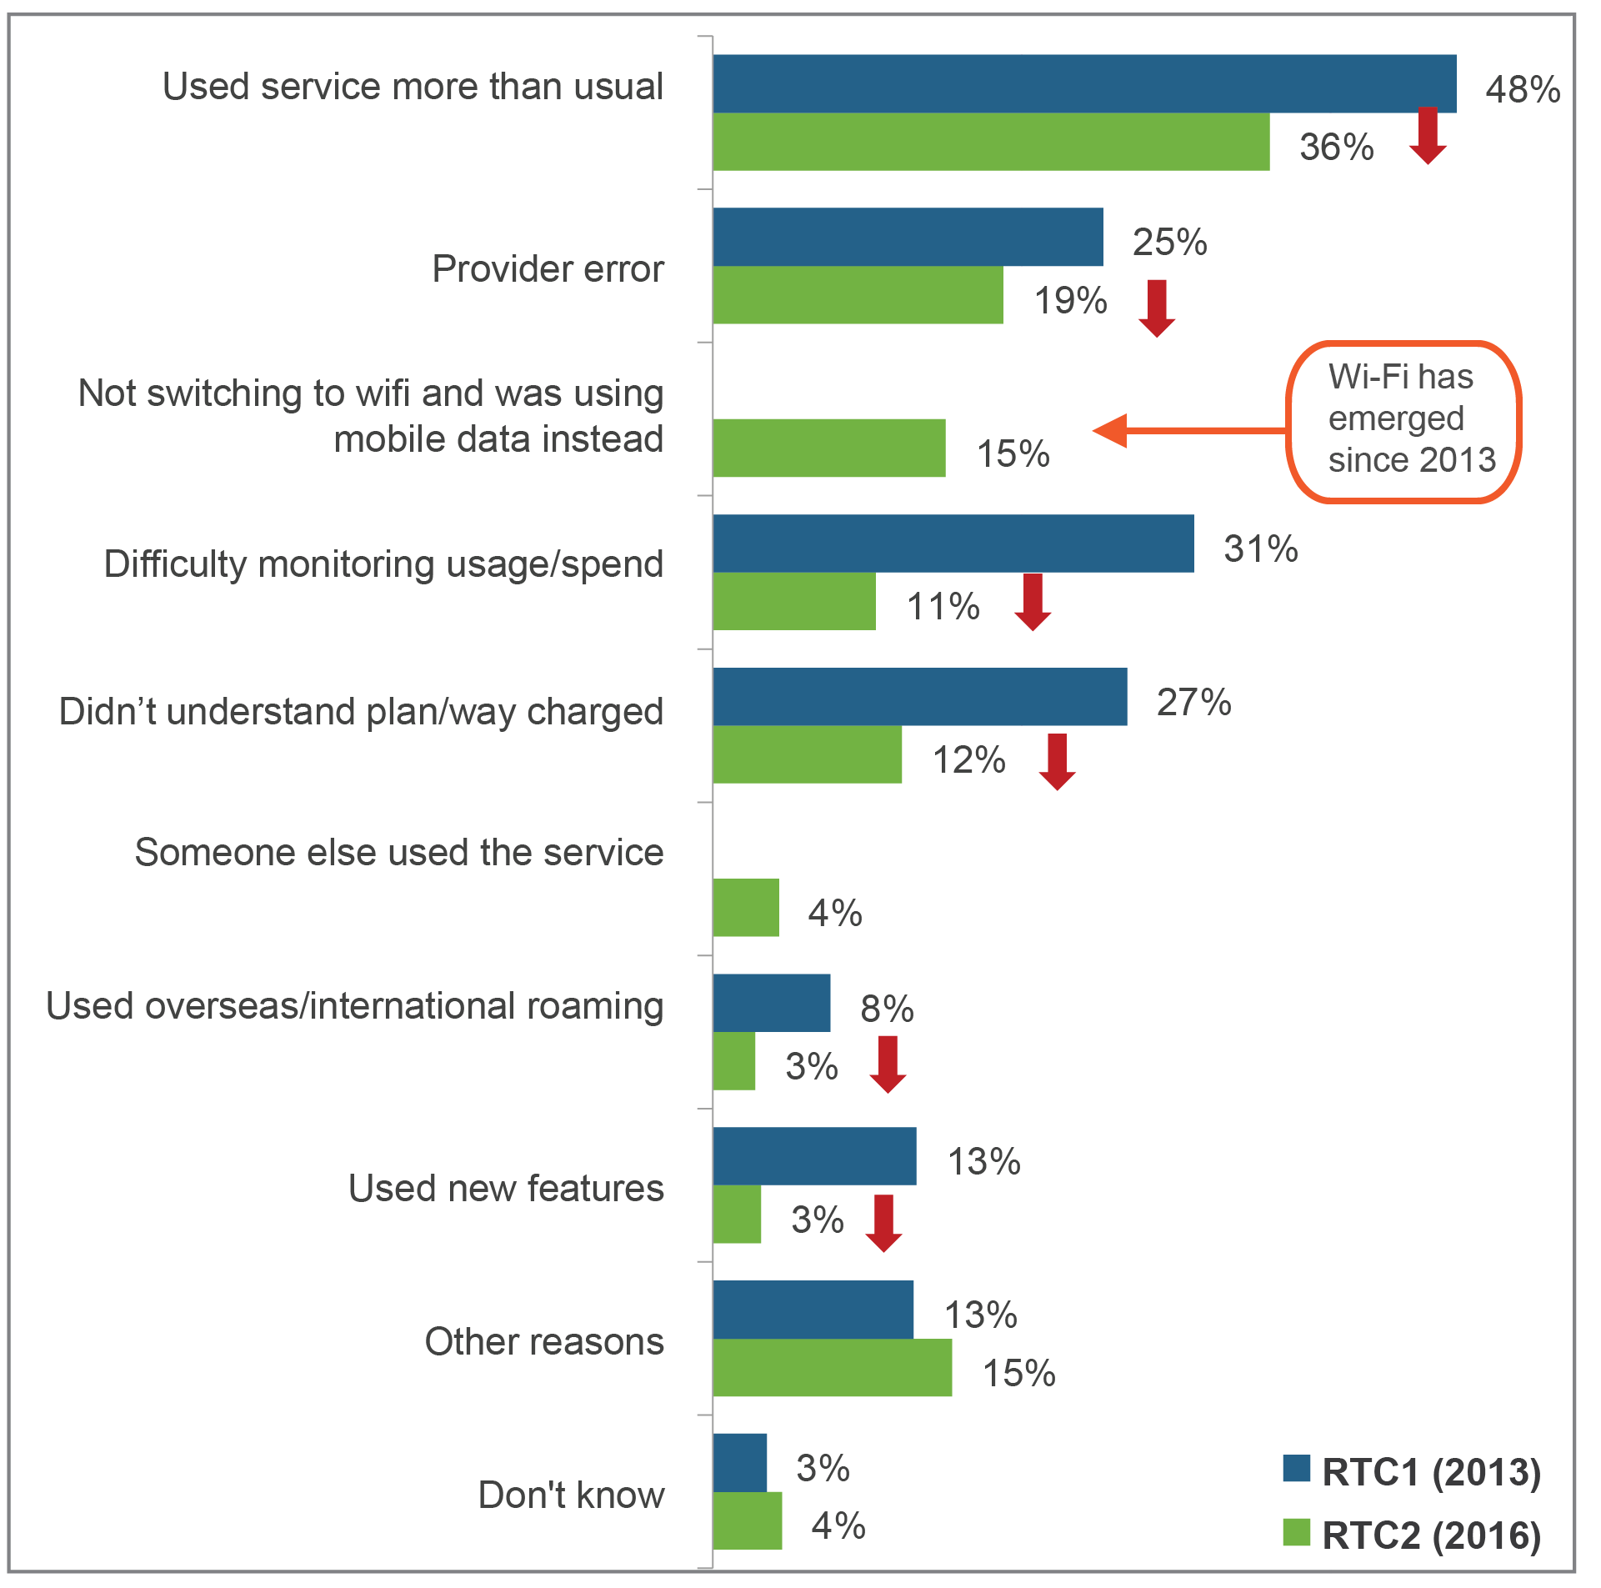

*Base: Total had higher bill in last 12 months (RTC2 n=396; RTC1 n=600).*

Using the service more than usual continues to be the main reason for post-paid mobile customers receiving UHBs. However, this has declined substantially—by 14 percentage points since the RTC1 study and 32 percentage points since SMT 2015. Currently, this reason explains almost four in 10 (39 per cent) UHBs (Table 5).

1. Reasons for UHBs—post-paid mobiles

|  | **RTC 1 (2013) n=351** | **SMT (2015) n=275** | **RTC 2 (2016) n=200** |
| --- | --- | --- | --- |
|  | (%) | (%) | (%) |
| Used the service more than you usually do | 53 | Green arrow indicating increase71 | Red arrow indicating decrease39 |
| Not switching to Wi-Fi and you were using your mobile data instead | n/a | n/a | 25 |
| Provider error | 20 | 19 | 11 |
| Didn’t understand that plan or the way you would be charged | 28 | 26 | Red arrow indicating decrease10 |
| Had difficulty in monitoring your usage and spend | 37 | 40 | Red arrow indicating decrease 9 |
| Used it overseas, on international roaming | 10 | 10 | Red arrow indicating decrease 5 |
| Someone else used the service | 1 | 11 | Red arrow indicating decrease 4 |
| Used new features | 15 | 20 | Red arrow indicating decrease 3 |

Table 6 illustrates that fewer contacts and complaints are being made as a result of UHBs.

Inaction has increased for those receiving a mobile phone UHB (likely due to automatic bumping up to next plan or ease of access to extra data packs). Spend management tools are also helping—20 per cent are now monitoring usage as the result of receiving an unexpectedly high bill).

The most common action taken after receiving a UHB continues to be contacting the service provider, though fewer seem to be taking this type of action.

1. Actions taken as a result of receipt of UHBs

|  | **Total** | | **Landline phone** | | **Mobile phone** | | | **Bundle** | |
| --- | --- | --- | --- | --- | --- | --- | --- | --- | --- |
|  | RTC 1 n=600 | RTC 2 n=396 | RTC 1 n=102 | RTC 2 n=110 | RTC 1 n=351 | SMT n=275 | RTC 2 n=231 | RTC 1  n=107 | RTC 2 n=93 |
|  | (%) | (%) | (%) | (%) | (%) | (%) | (%) | (%) | (%) |
| Contacted the customer service of the provider | 44 | red arrow indicating decrease28 | 33 | 30 | 43 | 48 | red arrow indicating decrease27 | 58 | red arrow indicating decrease34 |
| Made a complaint | 27 | red arrow indicating decrease21 | 25 | 28 | 22 | 27 | red arrow indicating decrease17 | 40 | red arrow indicating decrease26 |
| Monitor usage | – | 20 | – | 15 | – | – | 22 | – | 20 |
| Changed plan or offer with the same provider | 14 | 16 | 7 | 10 | 15 | 25 | 18 | 12 | 13 |
| Stopped or reduced use of service without changing provider | 32 | red arrow indicating decrease15 | 39 | red arrow indicating decrease11 | 35 | 43 | red arrow indicating decrease20 | 16 | 13 |
| Changed provider | 3 | 4 | 3 | 3 | 3 | 4 | 3 | 2 | 5 |
| Something else | 5 | red arrow indicating decrease1 | 5 | 3 | 5 | 5 | red arrow indicating decrease1 | 4 | red arrow indicating decrease0 |
| Did nothing | 24 | 28 | 23 | 33 | 24 | 17 | Green arrow indicating increase28 | 24 | 25 |

In some instances, customers receive a higher bill, but they expected (or suspected) it would be higher than their normal bill (EHB). In the last 12 months, 17 per cent of all bill-payers received a higher but expected bill (compared with 23 per cent of all bill-payers having received an UHB in the same period). The majority of higher but expected bills relate to mobile phone services (69 per cent of all EHBs).

Overall, those who have received a higher bill for their mobile phone, but *expected* it, report a lower level of concern than when they receive a higher bill but *did not expect* it, particularly those who use an app to check usage (Figure 19).

Figure 19: Concern over bills received

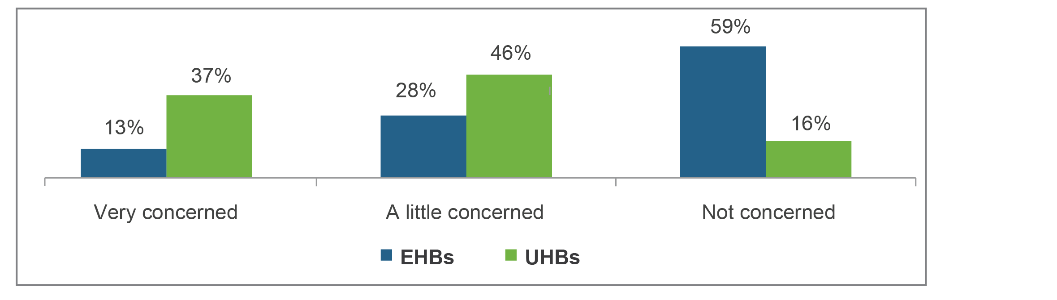

*Base: Bill-payers who received an EHB=328 or UHB (n=396).*

## Product information and comparing offers

Bill-payers have become slightly less active in seeking information about telecommunications services since 2013. This is likely to be partly linked to fewer complaints and fewer UHBs.

Those who have made a complaint are more likely to have been ‘in the market’ either buying or changing a service, or considering doing so**.** Sixty per cent of those who have complained and 64per cent of those who had a UHB were active in the market; only 42per cent of those who complained and 43 per cent of those with a UHB were not in the market looking at offers.

‘To avoid high bills’ is still a reason for a third of those who make a change, but an increase in other reasons has been observed (Figure 20).

Figure 20: Reasons given for most recent change, across all products

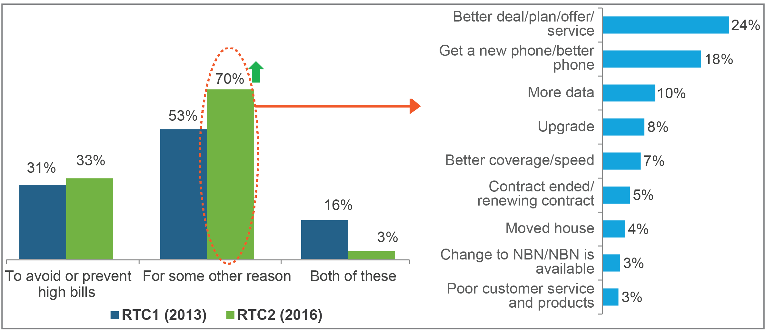

*Base: Total changed at least one service in last 12 months (RTC1 n=692; RTC2 n=628).*

The ease of comparing offers has increased since RTC1. The increase in ease is particularly evident for mobile phones and bundles (Figure 21).

Figure 21: Awareness of CIS

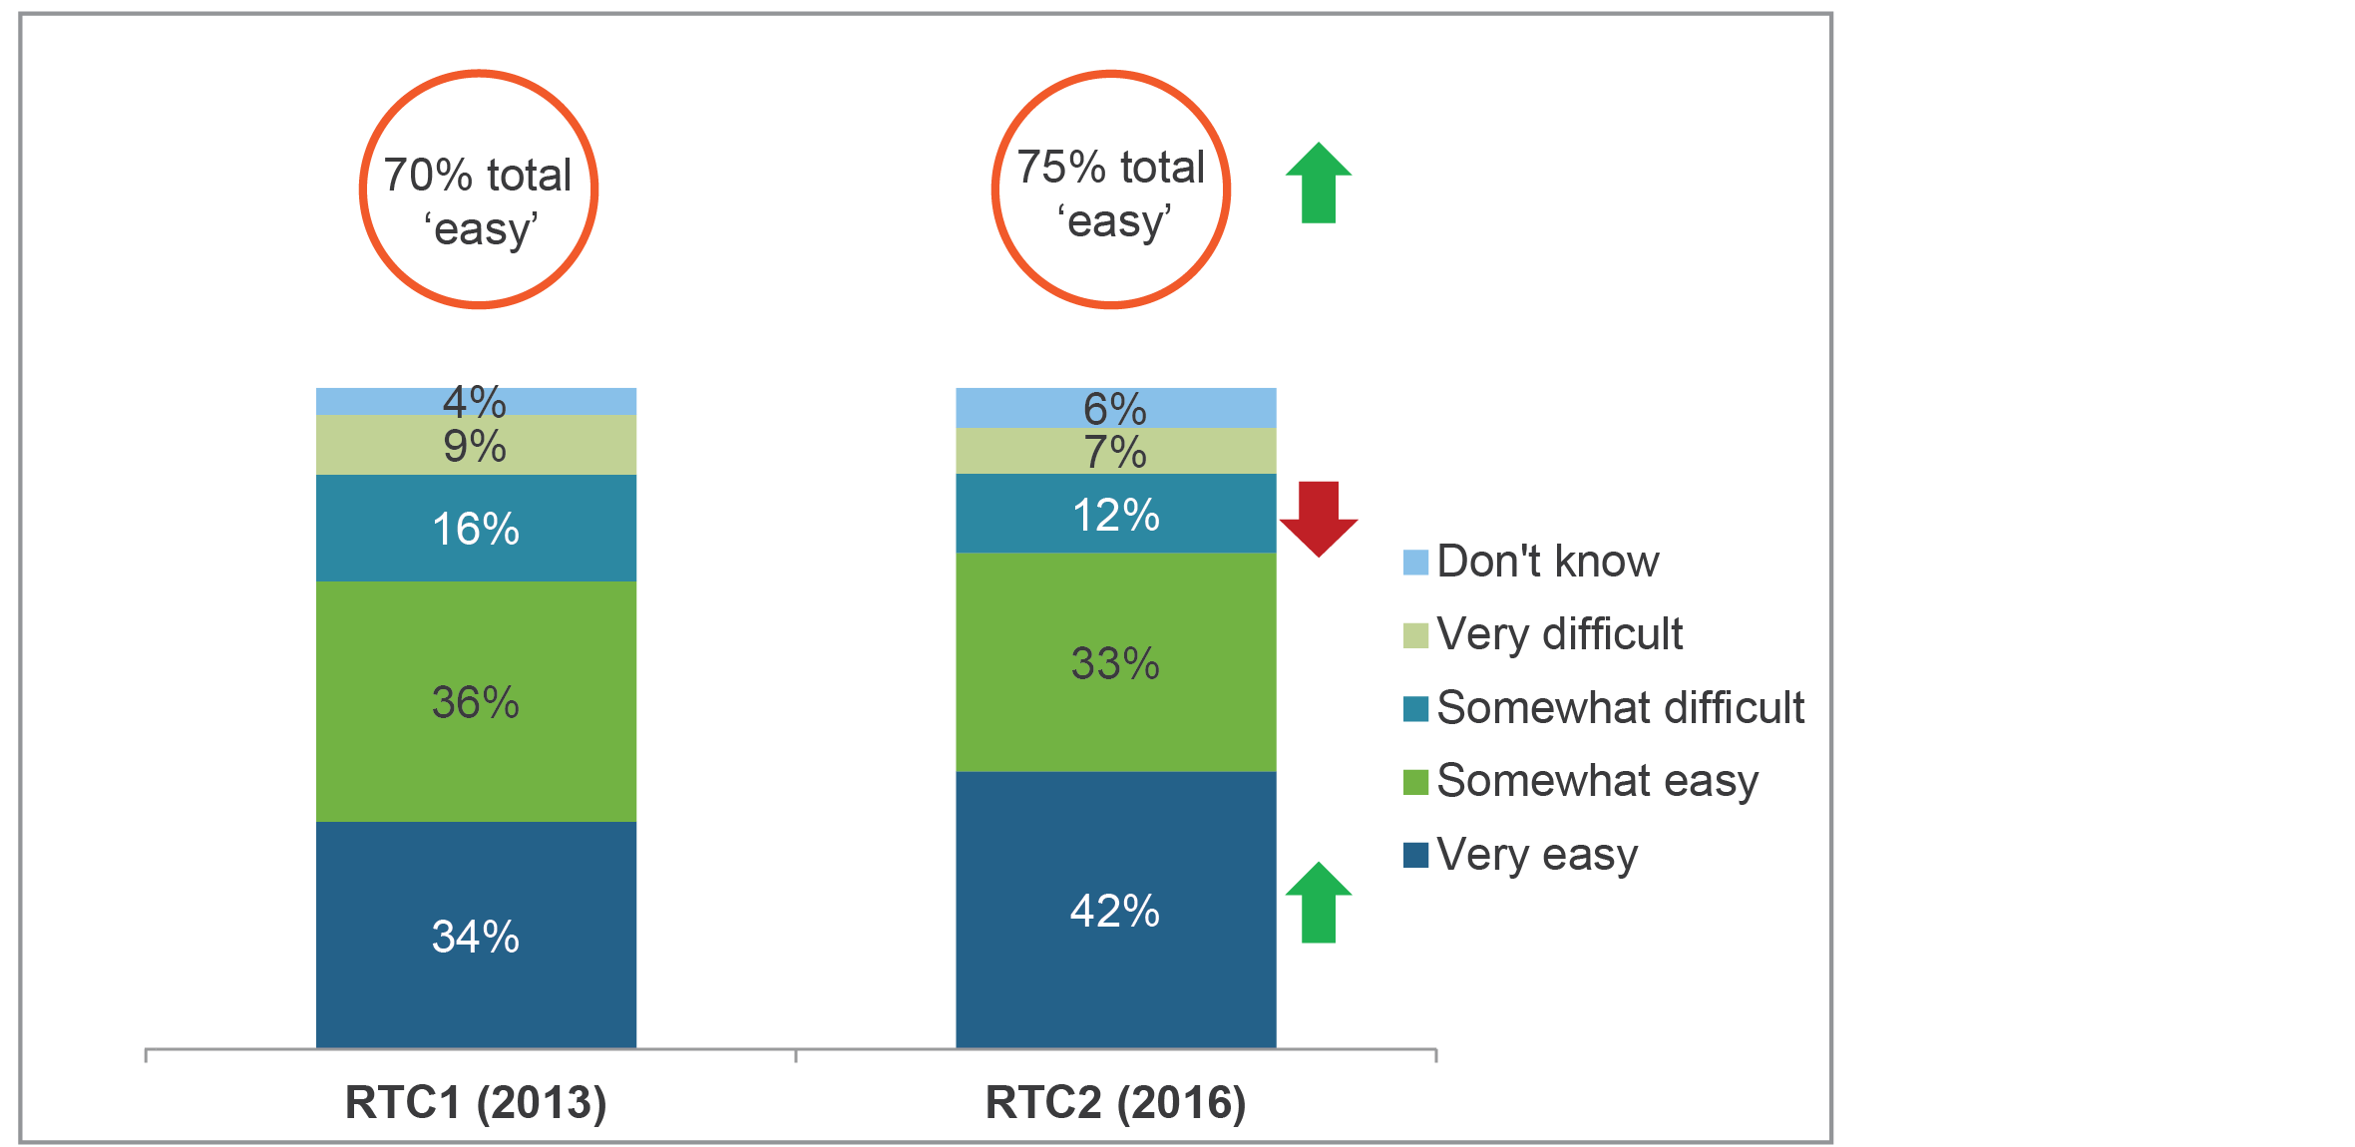

*Base: Total changed or considered changing their telecommunications services in the last 12 months (RTC1 n=1,029; RTC2 n=908)*.

## Emerging issues

Lack of standardised information is less of a factor now when consumers compare offers. However, the sheer volume of offers (and providers) now in the market means that many still find the process difficult (Figure 22).

Figure 22: Reasons for difficulty in comparing offers

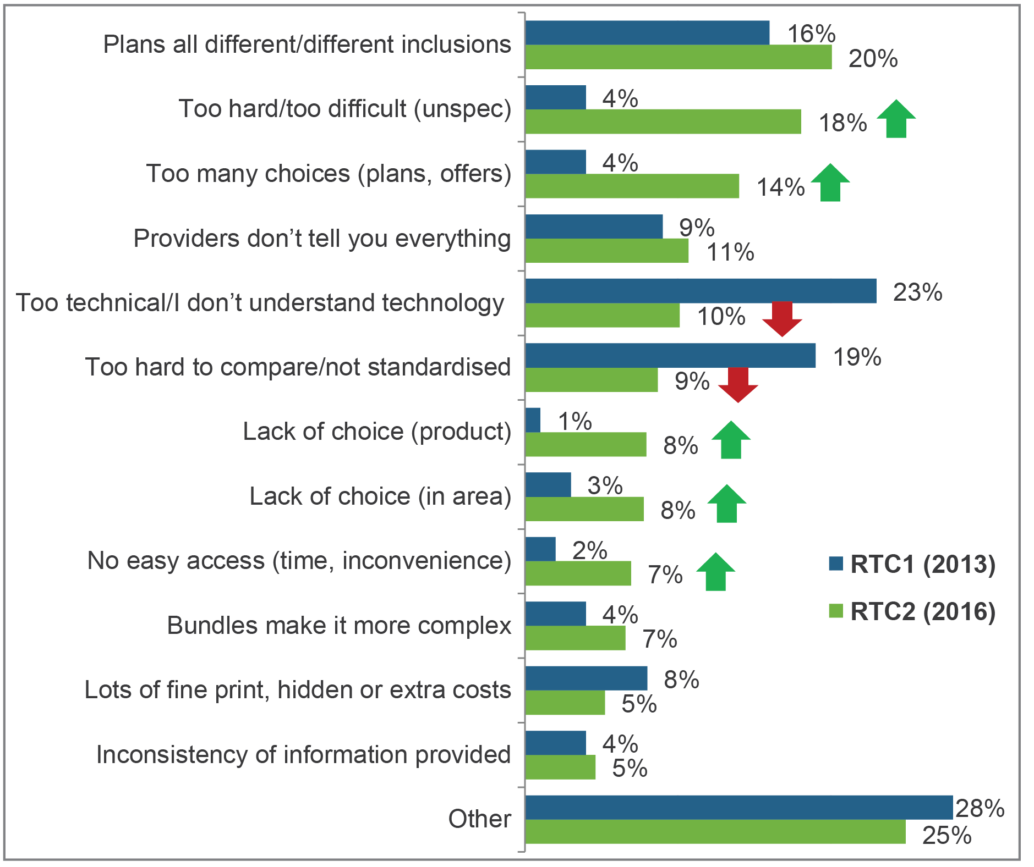

*Base: Total reported that it was difficult to evaluate or compare offers (RTC1 n=267; RTC2 n=188).*

Figure 23 shows that, of bill-payers who made a complaint about a mobile phone service, one in 10 said it was about unauthorised mobile phone apps or services (one per cent of all mobile phone bill-payers). This is just the one per cent who complained—the percentage who have *experienced* unauthorised charges but not complained is likely to be higher (but was not measured by this survey).

Figure 23: Unauthorised charges on mobile phone bill

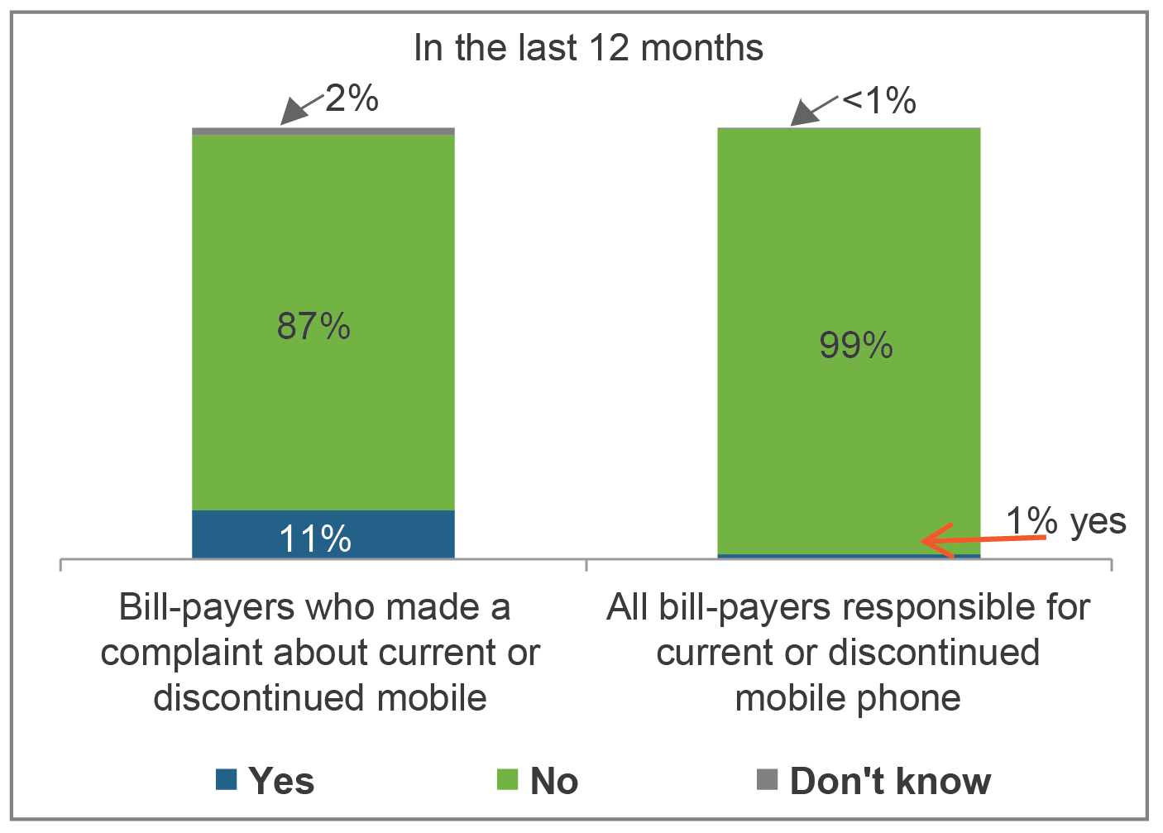

*Base: Bill-payers who made a complaint about a current or discontinued mobile (n=163), bill-payers responsible for a mobile phone (n=1,666).*

Approximately one in 10 consumers with relevant services had issues related to internet streaming, with the greatest concern about connection speed (Figure 24).

Figure 24: Issues with streaming

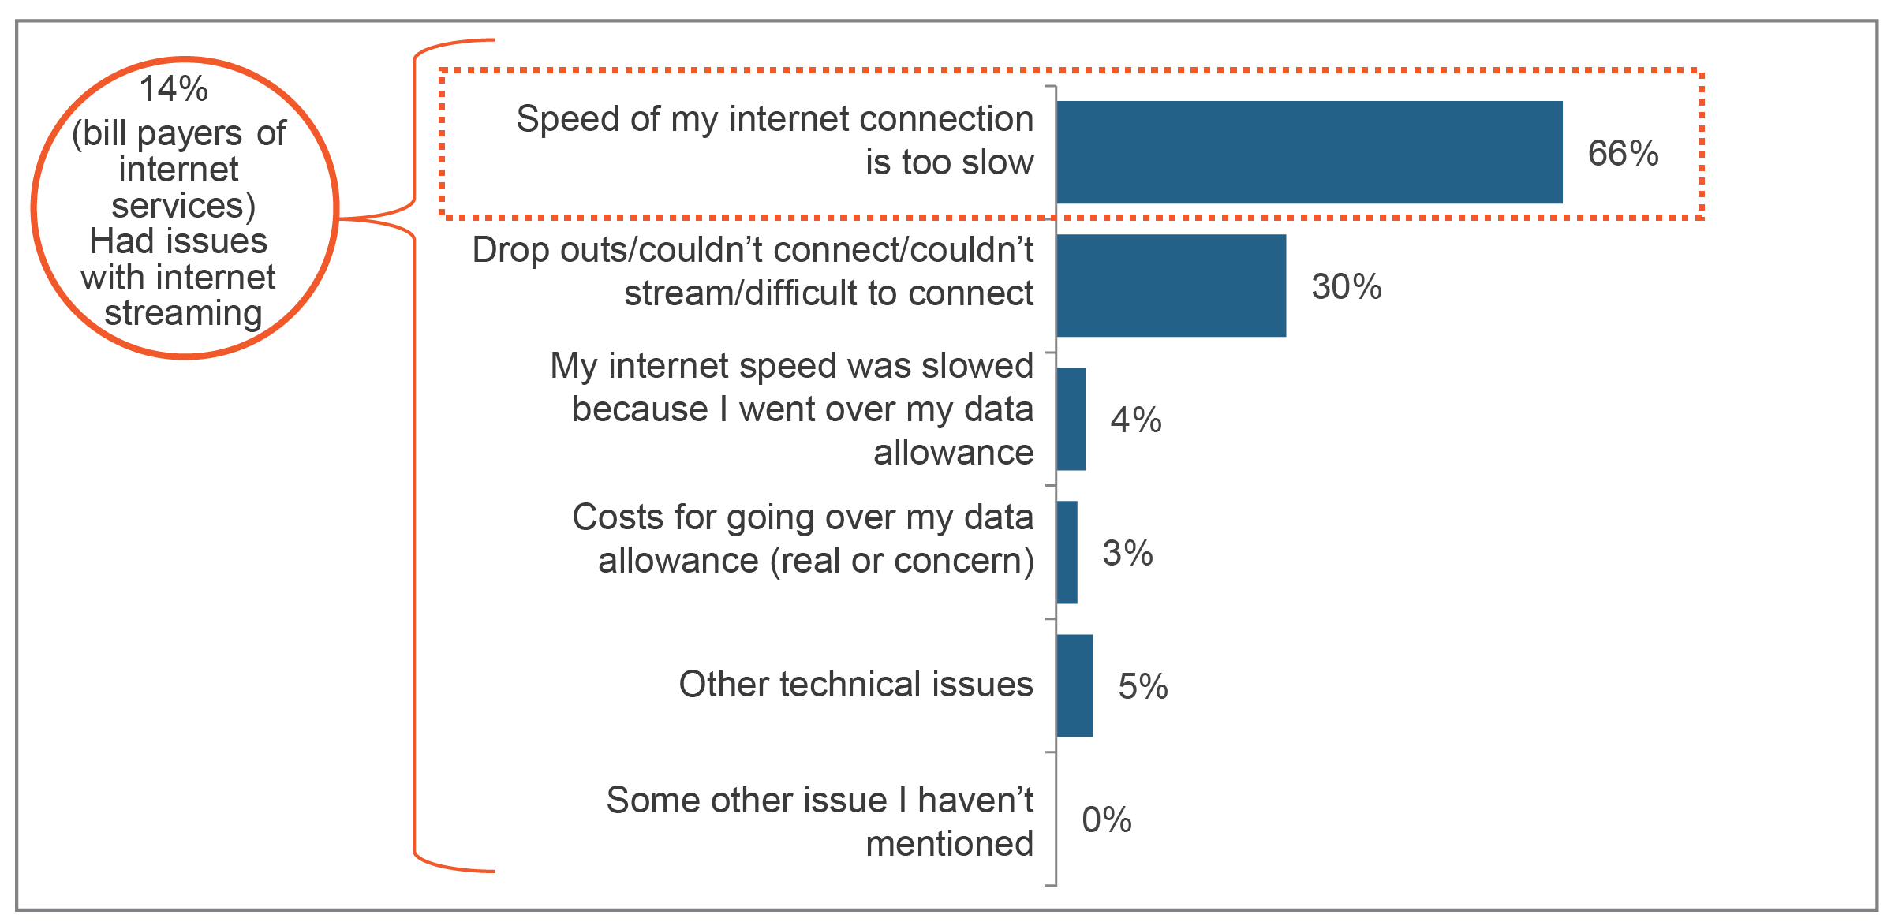

*Base: All internet at home, mobile phone or mobile broadband bill-payers who’ve experienced issues streaming TV or video services (n=261)*.