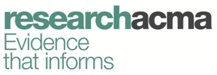

Radio in the bush

A study of radio listening in remote Western Australia

May 2017

Canberra

Red Building   
Benjamin Offices  
Chan Street   
Belconnen ACT

PO Box 78  
Belconnen ACT 2616

T +61 2 6219 5555  
F +61 2 6219 5353

Melbourne

Level 32   
Melbourne Central Tower  
360 Elizabeth Street   
Melbourne VIC

PO Box 13112  
Law Courts   
Melbourne VIC 8010

T +61 3 9963 6800  
F +61 3 9963 6899

Sydney

Level 5   
The Bay Centre  
65 Pirrama Road   
Pyrmont NSW

PO Box Q500  
Queen Victoria Building   
NSW 1230

T +61 2 9334 7700 or 1800 226 667  
F +61 2 9334 7799

Copyright notice

[Creative Commons logo](http://i.creativecommons.org/l/by/3.0/88x31.png)

<http://creativecommons.org/licenses/by/3.0/au/>

With the exception of coats of arms, logos, emblems, images, other third-party material or devices protected by a trademark, this content is licensed under the Creative Commons Australia Attribution 3.0 Licence.

We request attribution as: © Commonwealth of Australia (Australian Communications and Media Authority) 2017.

All other rights are reserved.

The Australian Communications and Media Authority has undertaken reasonable enquiries to identify material owned by third parties and secure permission for its reproduction. Permission may need to be obtained from third parties to re-use their material.

Written enquiries may be sent to:

Manager, Editorial and Design  
PO Box 13112  
Law Courts  
Melbourne VIC 8010  
Tel: 03 9963 6968  
Email: [candinfo@acma.gov.au](mailto:candinfo@acma.gov.au)

Overview 1

Background 1

ACMA research program 2

research**acma** 2

About the research 2

Methodology 2

Research parameters 3

Key findings 4

Radio listening in remote WA 4

Availability of radio stations and listening preferences 7

Radio an important source of information in an emergency 10

Radio as a source of local news in remote WA 12

Appendix A—Populations of remote and very remote WA 15

Appendix B—Research design and sample frames 16

Appendix C—Remoteness 17

Appendix D—Regional and national breakdowns by age 19

Appendix E—Data by area of remoteness 20

# Overview

This report explores radio use and listening habits in remote Western Australia (WA), regional Australia and nationally. The research was undertaken by the ACMA in 2016 to contribute to an evidence base on the role of AM radio in the contemporary communications environment.

Broadly, the research shows that AM and FM radio is popular in remote WA, with 71 per cent of adults listening to AM and 80 per cent listening to FM in the past six months, either at home or in the car. While FM listening is comparable with levels in regional Australia and nationally, AM radio listening is significantly higher in remote WA.

People in remote WA spend significantly more time listening to the radio (AM, FM and online) than the nation as a whole. The number of hours spent listening to AM radio in the bush (6.9 hours/past seven days) is double the regional and national levels.

Remote Western Australians spend more time listening to AM/FM radio in the car than at home. Large distances and dispersed towns in remote WA provide some explanation for this, coupled with the wider availability of AM transmission compared to FM, which is limited in its capability to service large areas.

A greater proportion of older remote Western Australians listen to AM radio; however, FM radio is more popular among younger adults. This pattern is similar in regional Australia and nationally.

The research shows that preferences for radio listening in remote WA are linked to availability. ABC Local Radio and Triple J are the top two most widely available and most often-listened to radio stations in remote WA. ABC Local Radio is also identified as a key information source in emergency situations and an important source of local news for people in remote WA.

## Background

The ACMA conducted research to provide information on radio listening in remote Australia. In particular, the ACMA sought to better understand the reliance Australians living in remote areas place on radio to deliver news and emergency information.

The ACMA recently published its new approach to [approving AM to FM conversions](http://www.acma.gov.au/Industry/Broadcast/Spectrum-for-broadcasting/Licence-area-plans/am-fm-conversions-and-infill-transmitters-for-commercial-radio-broadcasters) of commercial radio broadcasting stations in single licensee markets. This research illustrates the importance of AM radio coverage in remote parts of Australia. These findings informed the design of regulatory arrangements for infill transmitters to be established to ameliorate coverage loss that may occur when moving from AM to FM.

# ACMA research program

## researchacma

Our research program—research**acma—**underpins the ACMA’s work and decisions as an evidence-informed regulator. It contributes to the ACMA’s strategic policy development, regulatory reviews and investigations, and helps the ACMA better understand its role in fulfilling its strategic intent to make media and communications work for all Australians.

research**acma** has five broad areas of interest:

* market developments
* media content and culture
* social and economic participation
* citizen and consumer safeguards

regulatory best practice and development.

This research contributes to the ACMA’s market developments research theme.

## About the research

This research was conducted as part of the ACMA’s 2016 Annual Consumer Survey. In May 2016, the ACMA commissioned Omnipoll to conduct the ninth survey to monitor changes in use of telecommunications services and media. A series of questions were added to the national survey to explore AM radio use and listening habits in regional and remote areas of Australia.

## Methodology

In 2016, a total of n=351 computer-assisted telephone interviews (CATI) were conducted with a sample of Australians aged 18 years and older living in remote or very remote WA. WA was selected as an appropriate geographical area to collect data about radio use in dispersed and isolated areas, noting that remote areas cover vast and far-reaching parts of this state. The research was conducted in three distinct areas of remote WA—very remote, remote, and the urban centres of Karratha, Port Hedland, Broome and Esperance. The sample breakdowns for each area are provided on page 3, with estimated population figures listed in Appendix A.

The vast majority (92 per cent) of the sample had one usual place of residence in remote or very remote WA; the remaining eight per cent had another place of residence (six per cent in WA and two per cent outside WA). The eight per cent with another place of residence most likely represents fly-in fly-out workers.

Detailed quotas were set based on Australian Bureau of Statistics (ABS) estimated residential population (ERP) June 2015 data in order to ensure the sample was representative by each area, age and gender.

Households were recruited through random-digit dialling using a dual-frame sample design, and included those who live in a household with a fixed-line telephone (50 per cent) and those who have a mobile phone (50 per cent). A random selection procedure recruited eligible participants within households for the landline sample (last birthday). The mobile-only sample interviewed the main user of the mobile phone. The fieldwork was conducted between 24 May and 7 June 2016.

To reflect the population distribution, the results were post-weighted and projected to ABS data on age, sex and area.

For more details on the research design and sample, refer to Appendix B.

## Research parameters

### Definition of ‘remote WA’

For the purposes of this research, remote WA (n=351) includes:

* four urban centres—Karratha, Port Headland, Broome and Esperance (n=121)
* rest of remote WA (excluding the four urban centres of Karratha, Port Hedland, Broome and Esperance) (n=115)

very remote WA (n=115).[1]

This definition of remote is not the same as the ACMA’s definition of the Remote Western Australia Radio licence area.

For further information about remoteness, refer to Appendix C, Figure 11.

### Definitions of ‘regional’ and ‘national’

The two additional samples referred to in the report include national and regional Australia.

The national sample (n=2,007) is drawn from the 2016 Annual Consumer Survey recruited to complete survey two on media use; n=1,810 online and n=197 (representing those that are seldom or never online) via CATI (fixed-line telephone).

The regional sample (n=861) is a subset of the national sample described above and includes the following regions:

* Australian Capital Territory
* Regional New South Wales, excluding Sydney
* Regional Victoria, excluding Melbourne
* Regional Queensland, excluding Brisbane
* Regional South Australia, excluding Adelaide
* Regional Western Australia, excluding Perth
* Tasmania

Northern Territory.

### Radio listening in the car or at home

Radio listening is separated into two categories, with the key distinction between listening to radio in the car or at home. The complete definition for the two variables is:

* listening to radio in the car or another vehicle

listening to radio at home or elsewhere.

# Key findings

## Radio listening in remote WA

Two-thirds of remote Western Australians surveyed have a radio at home, compared to 87 per cent of regional Australians and 79 per cent nationally. The vast majority of remote Western Australians surveyed (91 per cent) had listened to the radio in the past six months, with similar listenership at regional and national levels (90 per cent each).

### AM and FM radio listening is popular in remote WA

Eight in 10 remote Western Australians surveyed listen to FM radio, which is comparable to the proportions listening regionally (82 per cent) and nationally (81 per cent). Seventy-one per cent of remote Western Australians listen to AM radio—significantly higher than regionally (46 per cent) and nationally (47 per cent). Almost a third (29 per cent) of remote Western Australians listen to the radio online, with similar proportions doing so regionally (23 per cent) and nationally (24 per cent) (Figure 1).

Fifty-nine per cent of remote Western Australians listen to both AM and FM radio; 11 per cent only listen to AM radio; and 20 per cent listen exclusively to FM radio.

1. Radio listening at home or in the car, past six months (%)

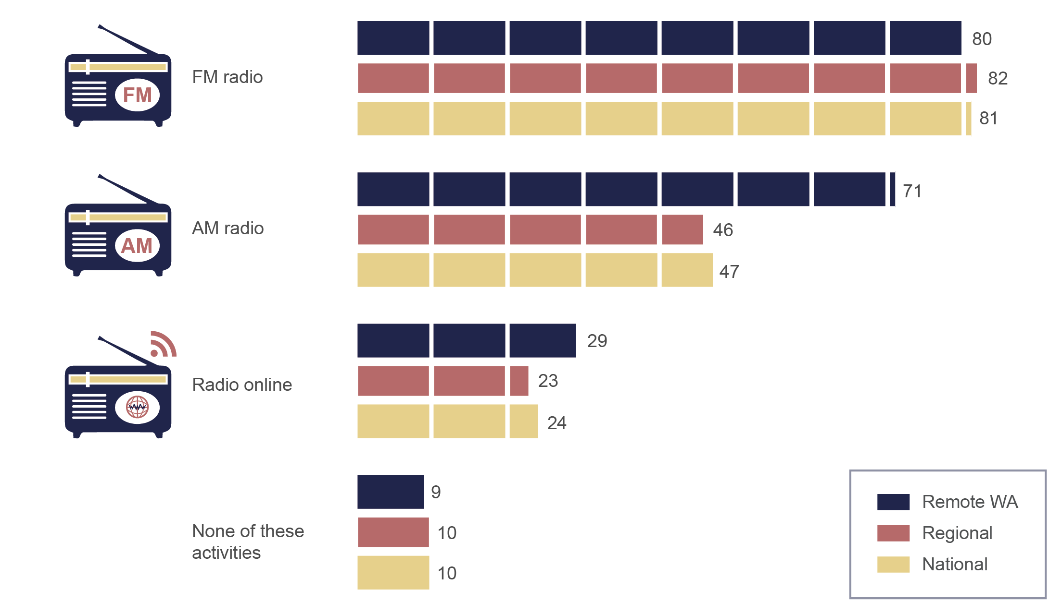

Weighted base: WA remote sample N=351, Regional Australia sample N=861, total national sample N=2,007.

Question C4 (both surveys): Which of the following have you personally done in the past six months?

### Music streaming is popular among younger adults in remote WA

Nearly a quarter (24 per cent) of remote Western Australians used an online music service such as Spotify, Pandora or iTunes radio in the past seven days, compared with 17 per cent regionally and 19 per cent nationally. Almost half (47 per cent) of those aged 18 to 34 in remote WA used an online music streaming service in the past seven days.

### Adults in remote WA are frequent radio listeners

People in remote WA spend significantly more time listening to the radio than does the nation as a whole. Eight in 10 (81 per cent) remote Western Australians listened to the radio in the past seven days, spending 13.9 hours on average, compared to 8.5 hours regionally and 8.6 nationally.

The difference is particularly pronounced for AM radio, with people in the bush spending more than double the time listening to AM radio than those regionally or nationally—6.9 hours compared to three hours (Figure 2).

1. Average time spent per radio activity, past seven days

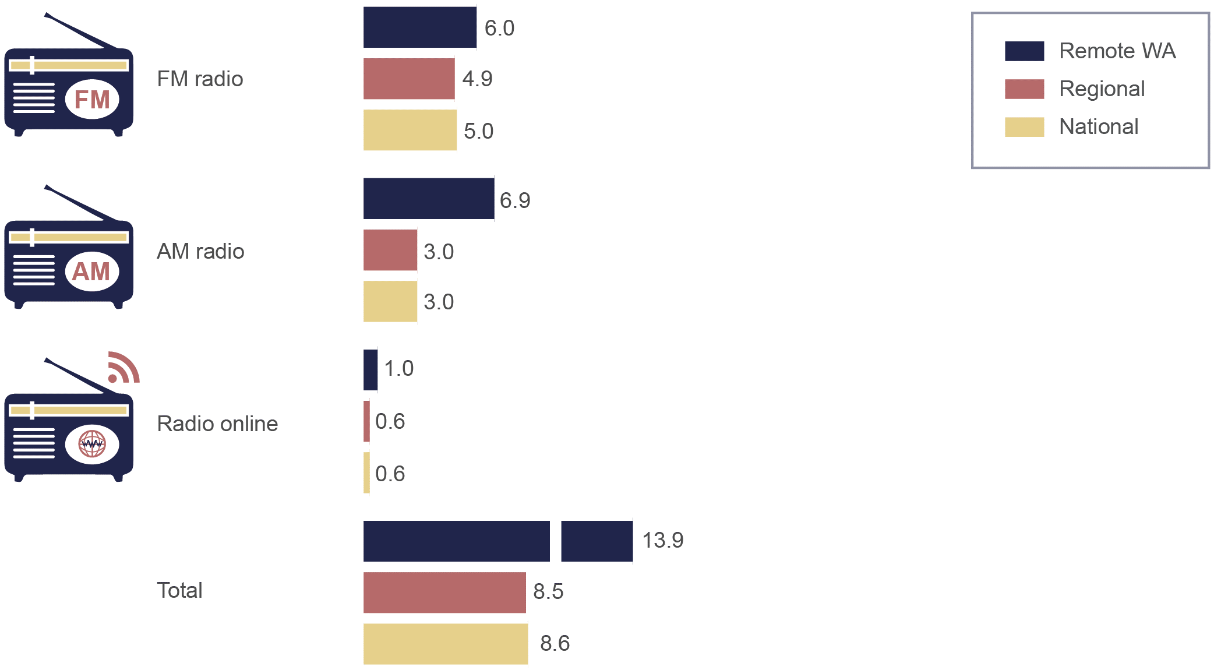

Weighted base: WA remote sample N=351 (includes those n=280 who had listened to any form of radio in the last seven days), Regional Australia sample N=861 (includes those n=724 who had listened to any form of radio in the last seven days), and the total national sample N=2,007 (includes those n=1,717 who had listened to any form of radio in the last seven days).

Question C6 (both surveys): How many hours have you spent doing each of the following in the past 7 days?

### Adults in remote WA spend most of their AM/FM radio listening time in the car

Most of the total time remote Western Australians spend listening to AM/FM radio (12.9 hours on average/past seven days) is in the car (eight hours), compared to at home (4.9 hours). The time spent listening to AM/FM radio in the car is significantly lower at regional (3.3 hours) and national (3.4 hours) levels (Figure 3).

Compared to regional Australia and nationally, the difference is particularly notable for AM radio—4.5 hours of AM radio listening occurs in the car in remote WA, compared to just under an hour (0.9) regionally and an hour (1.0) nationally. On the other hand, FM radio listening in the car is comparable, with 3.5 hours spent in remote WA compared to 2.4 hours regionally and nationally.

1. Average time spent per AM/FM radio activity and location,   
   past seven days

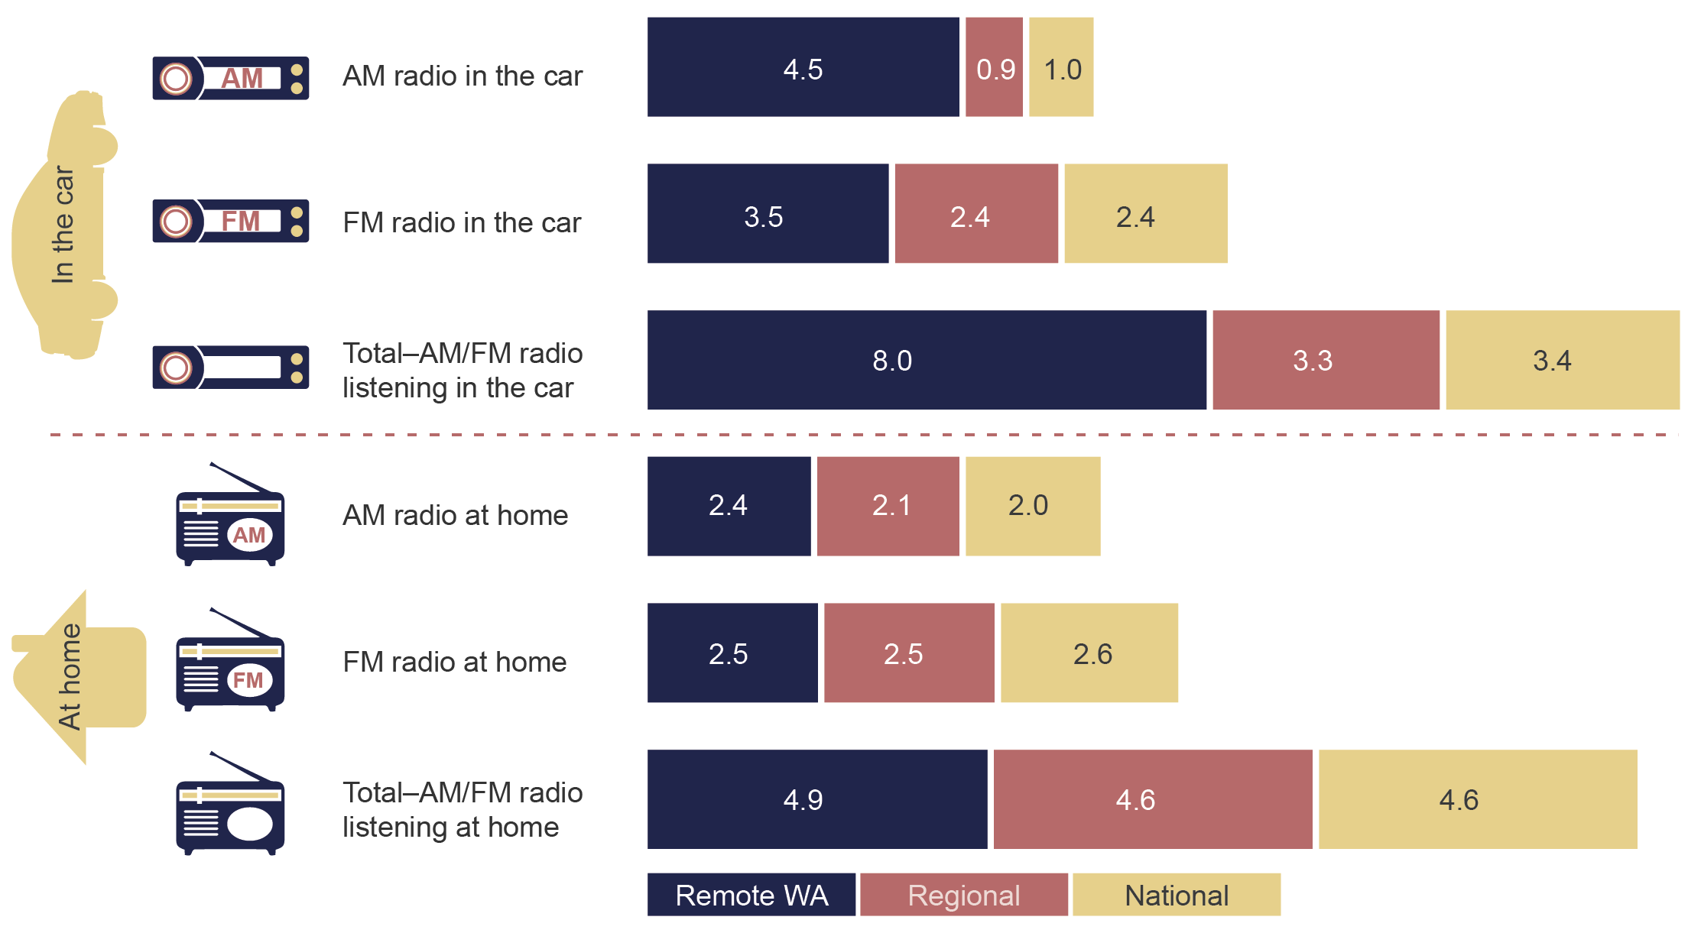

Weighted base: WA remote sample N=351 (includes those n=280 who had listened to any form of radio in the last seven days), Regional Australia sample N=861 (includes those n=724 who had listened to any form of radio in the last seven days), and the total national sample N=2,007 (includes those n=1,717 who had listened to any form of radio in the last seven days).

Question C6 (both surveys): How many hours have you spent doing each of the following in the past 7 days?

### AM radio listening increases with age; FM is popular among younger adults in remote WA

The research shows only small variations in the number of total hours spent listening to all forms of radio across different age groups in remote WA. However, listening preferences varied across the different radio platforms.

The time spent listening to AM radio increases with age in remote WA, with those aged 65 and over listening to 12.5 hours on average/past seven days. The time spent listening to FM radio is highest for those aged 35–49 (7.4 hours) and 18–34 (7.1 hours) (Figure 4).

At the national level, the time spent listening to all forms of radio combined increases significantly with age. FM radio dominates listening across all age groups nationally, with the exception of those aged 65 and over—this older age group listens to AM radio more than FM radio. A similar pattern is observed regionally. For more details on national and regional breakdowns by age, please refer to Appendix D.

1. Average number of hours spent listening, by radio activity and age for remote WA

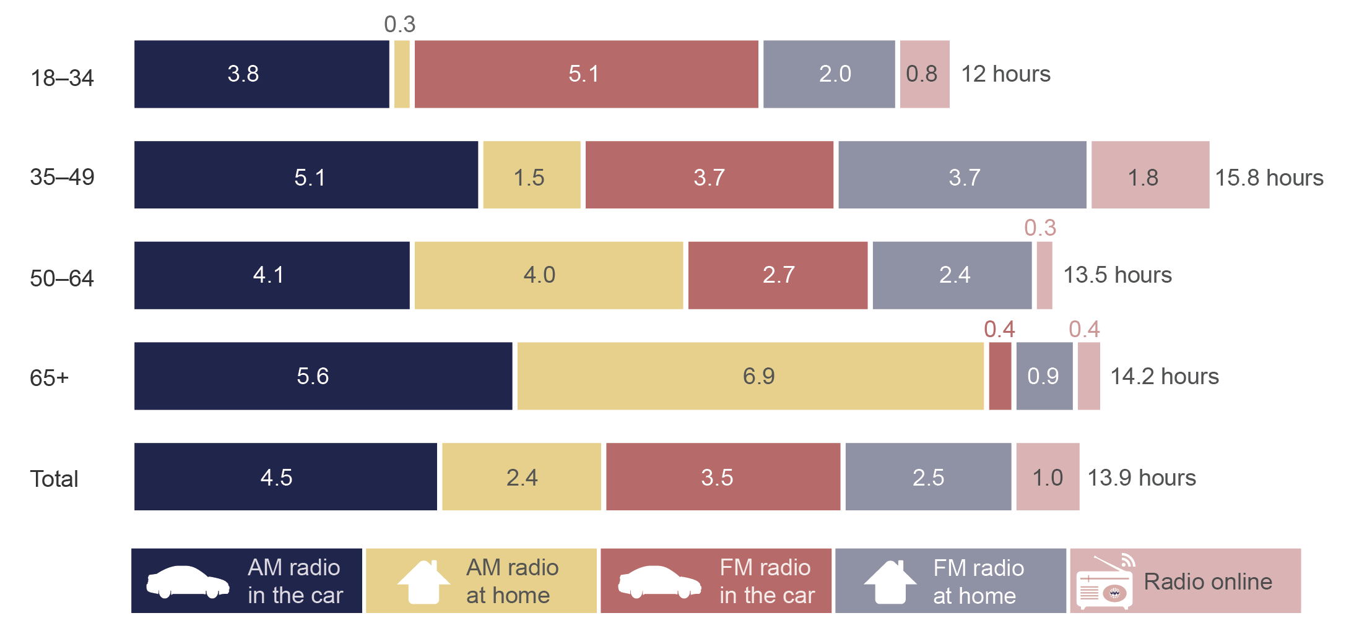

Weighted base: All respondents in remote WA (18–34 n=67, 35–49 n=133, 50–64 n=95, 65+ n=56).

Question C6 (both surveys}: How many hours have you spent doing each of the following in the past 7 days?

By area of remoteness, adults living in remote WA (excluding the four urban centres of Karratha, Port Hedland, Broome and Esperance) are spending considerably more time listening to AM radio than their counterparts in the rest of remote and very remote WA. This is particularly evident for AM radio listening in the car. For details on the area breakdowns, refer to Appendix E.

## Availability of radio stations and listening preferences

### National radio stations are reported as the most available in remote WA

Nearly three-quarters (74 per cent) of remote Western Australians reported that ABC Local Radio is available in their area. More than six in 10 reported that they have access to Triple J (63 per cent), and over half reported that ABC News Radio (56 per cent) and ABC Radio National (53 per cent) are available (Figure 5).

For a more detailed breakdown by area, please refer to Appendix E.

1. Radio stations available in remote WA (%)

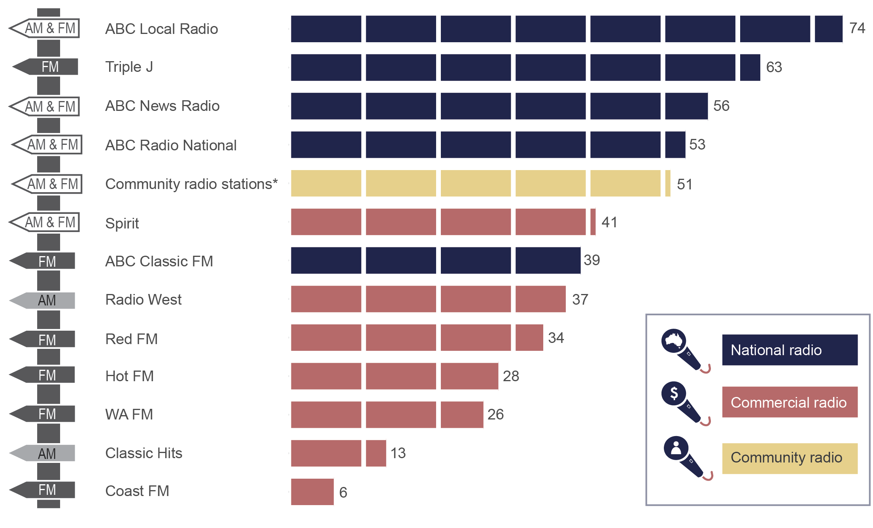

Weighted base: WA remote sample (N=351).

*Community radio station Hope FM is included in the category ‘Community radio stations’ (Hope FM was originally listed as a separate category for this question but was combined into the overall category for community radio stations).

Question C3(a): Which of the following radio stations are available where you live? (multi response)

### In remote WA, national radio stations are most often listened to

ABC Local Radio (24 per cent) and Triple J (16 per cent) are the radio stations most often listened to in remote WA (Figure 6).

1. Radio stations most often listened to (%)

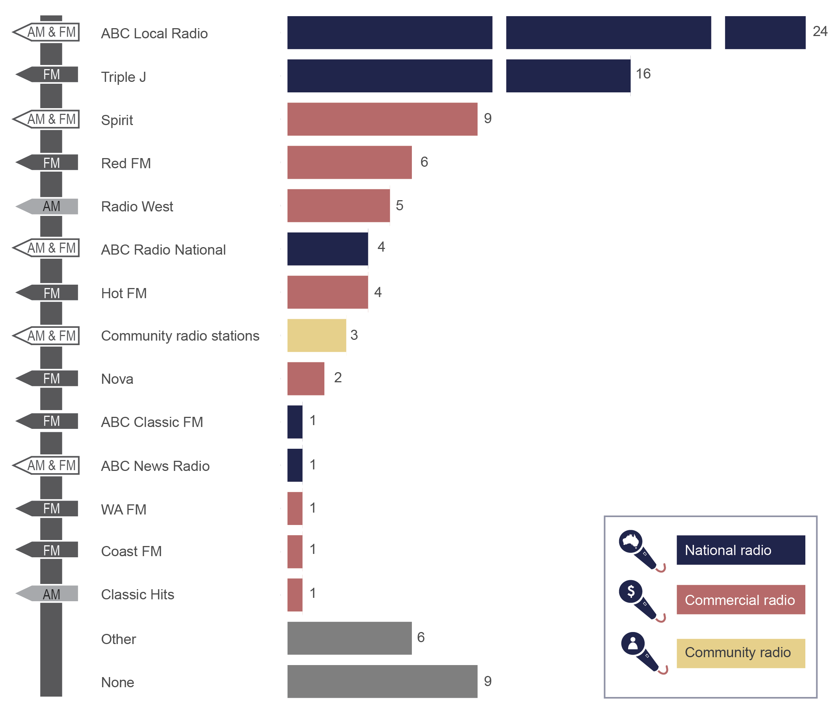

Weighted base: WA remote sample (N=351).

Question C8: And which radio station do you most often listen to? (single response)

Listeners of ABC Local Radio tend to be older, with the majority of listeners aged 45 and over (77 per cent). By area of remoteness, the highest proportion of ABC Local Radio listeners resided in ‘rest of remote WA’, which excludes the four urban centres (42 per cent), followed by the four urban centres of Karratha, Port Headland, Broome and Esperance (30 per cent) and ‘very remote WA’ (28 per cent).

Male listeners account for the majority of listeners of ABC Local Radio (69 per cent). However, to some extent, this can be attributable to the higher number of males living in remote WA—59 per cent compared to 41 per cent females.

Due to the small sample size representing Triple J listeners, it was not possible to undertake more detailed demographic analysis of Triple J audiences by area or gender.

### Preferences for radio listening in remote WA linked to availability

There is a relationship between availability of radio stations and listening preferences, with ABC Local Radio and Triple J the top two most widely available and most often-listened to radio stations in remote WA. As shown in Figure 7, for remote Western Australians, ABC Local Radio is the most listened to and most available. Triple J is the second-ranked radio station for preference and availability.

ABC News Radio, ABC Radio National, ABC Classic FM and community radio stations are available to relatively large proportions of people in remote WA, but have a lower listenership (Figure 7).

1. Radio stations—availability vs listening preference

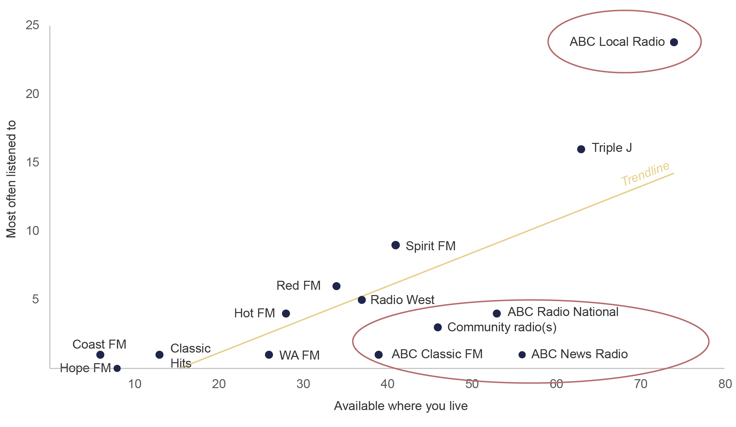

Weighted base: WA remote sample (N=351).

Question C3(a): Which of the following radio stations are available where you live? (multi response)

Question C8: And which radio station do you most often listen to? (single response)

## Radio an important source of information in an emergency

Radio is identified as an important source of information in emergency situations. Almost two-thirds (62 per cent) of remote Western Australians would turn to local ABC radio if faced with an emergency, which is nearly double the proportion for regional Australia (32 per cent).

As shown in Figure 8, the Bureau of Meteorology (74 per cent), fire and emergency services (72 per cent), local ABC radio (62 per cent) and social media (46 per cent) are the most common sources that remote Western Australians would use for up-to-date information in an emergency. For regional Australians, the most common sources would be fire and emergency services (43 per cent), commercial radio (33 per cent), the Bureau of Meteorology (32 per cent) and local ABC radio (32 per cent).

1. Sources of information people would use in emergency (%)

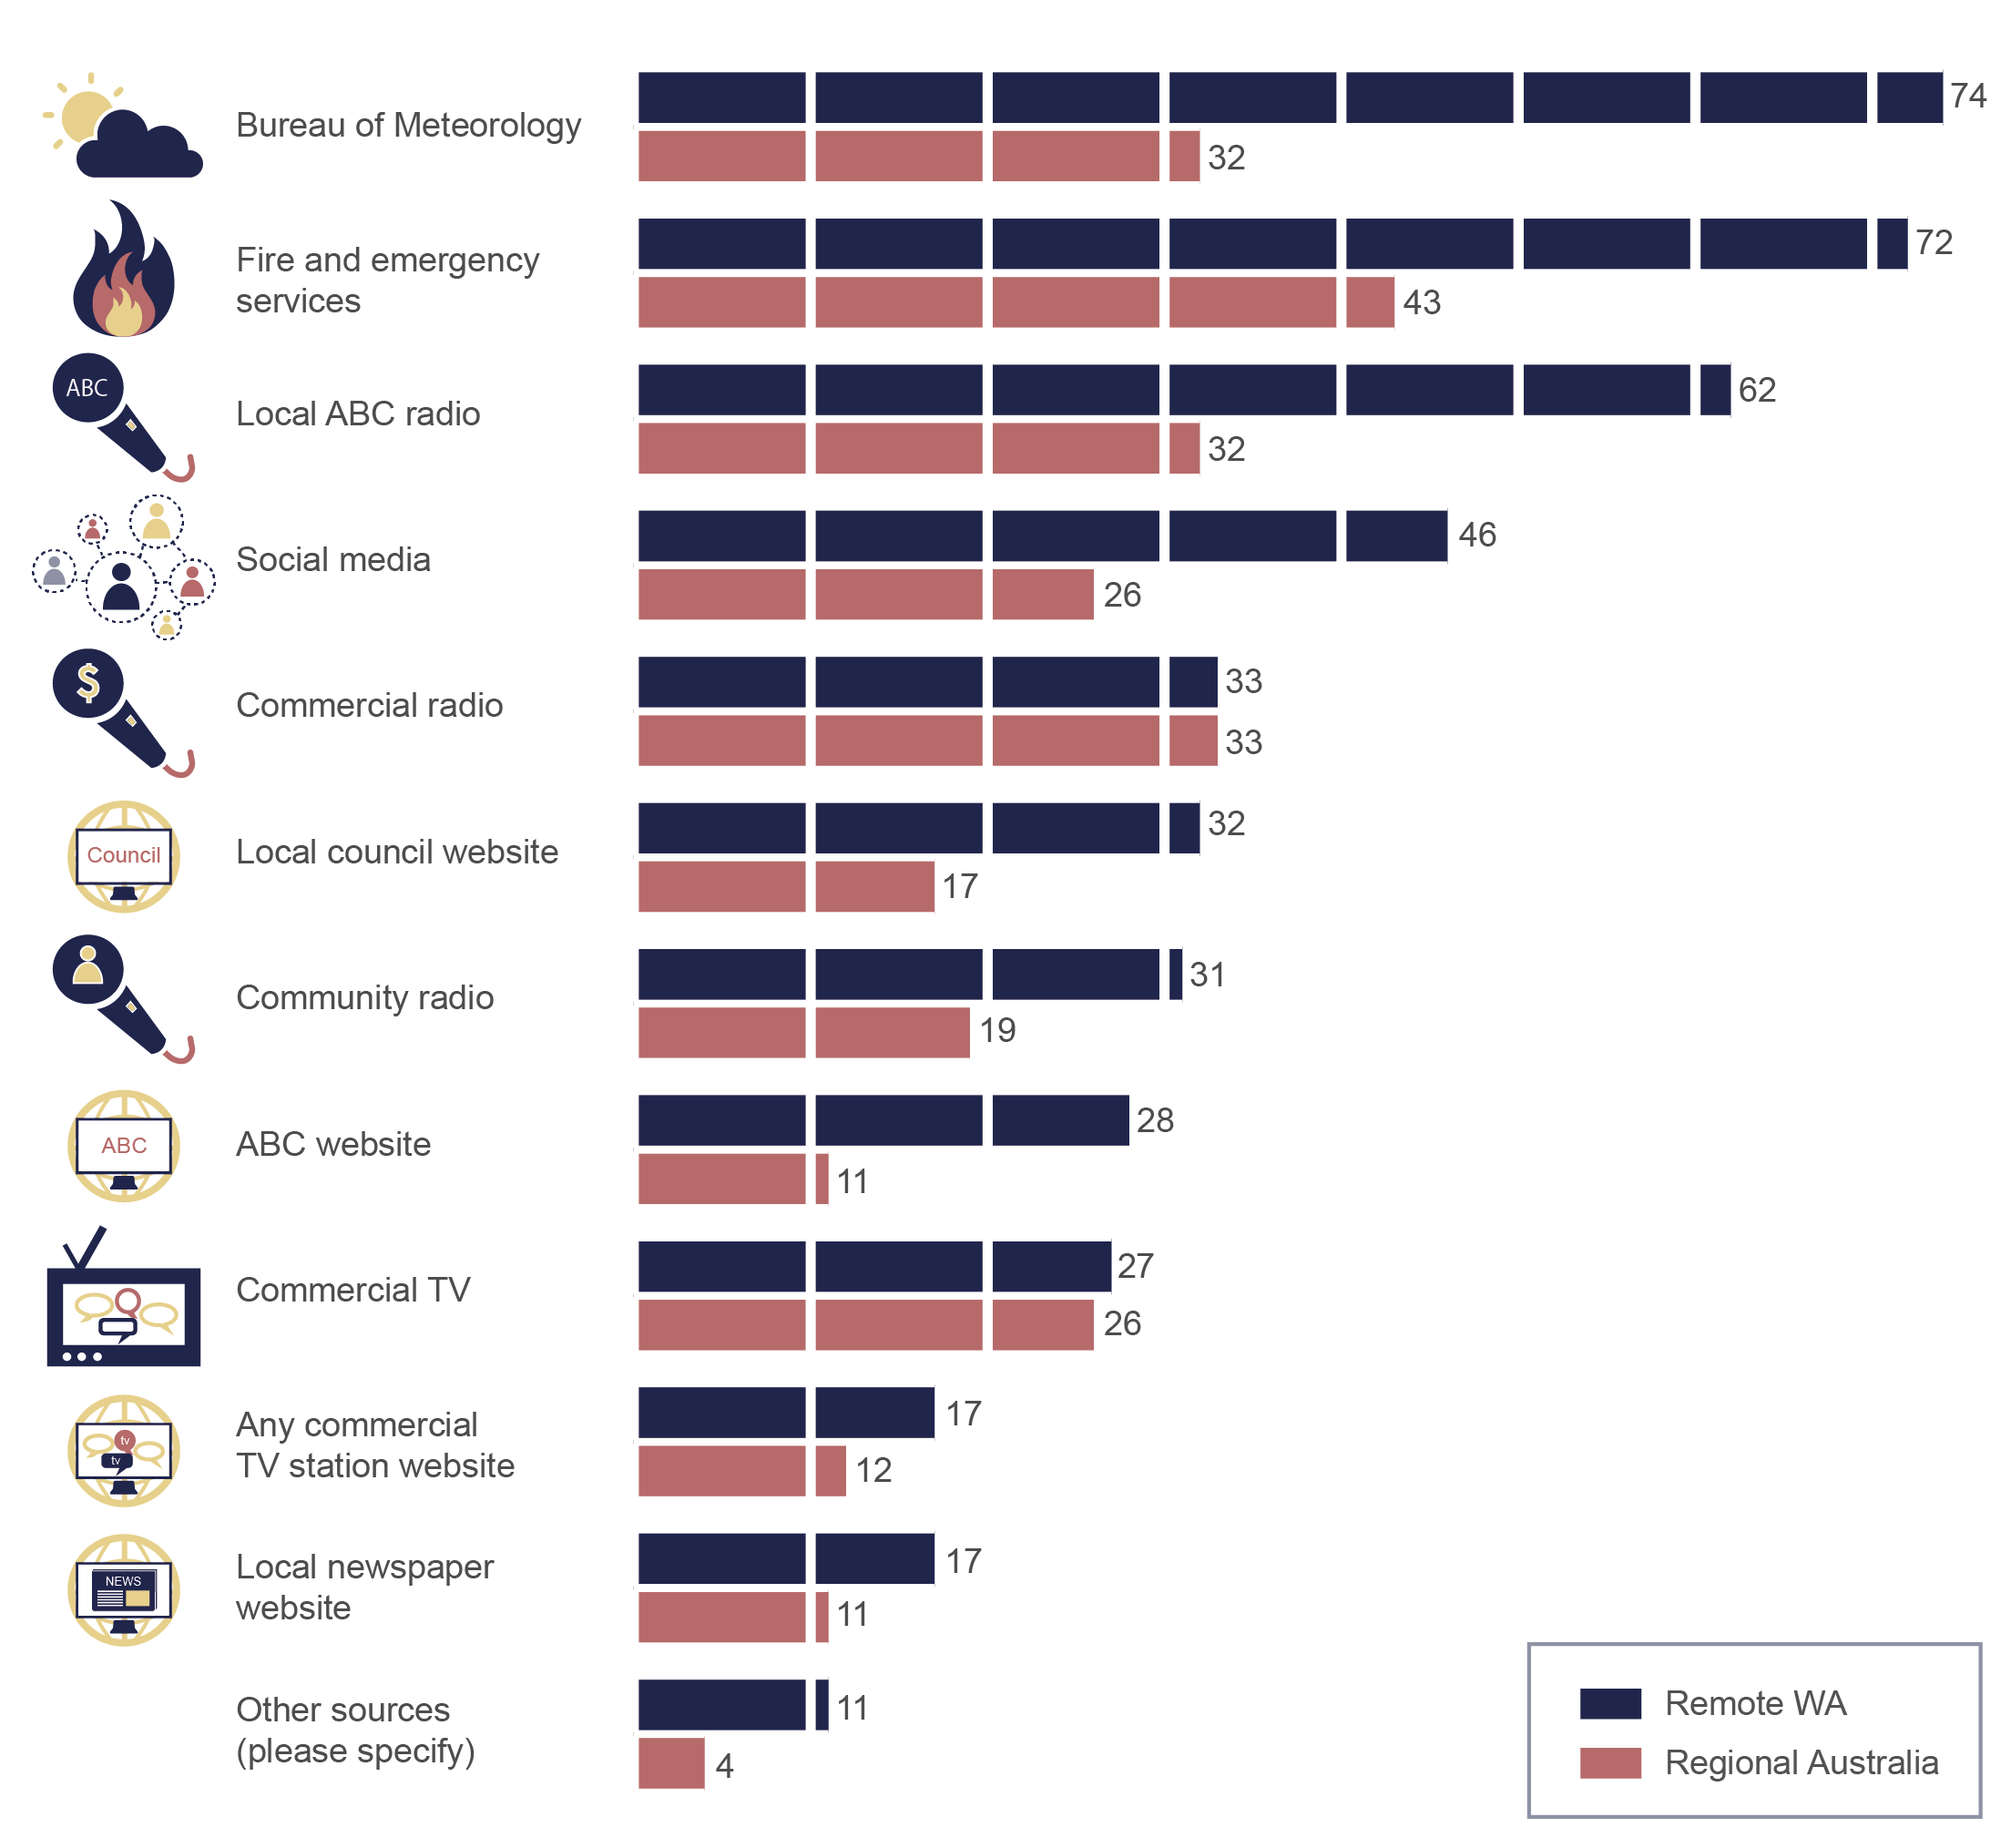

Weighted base: remote WA sample n=351, regional Australia n=861.

Question E6 (both surveys): Thinking now about being in an emergency, such as a bush fire, storm, flood or cyclone, where would you go to get up-to-date information about what to do? (multi response)

Two-thirds of remote Western Australians reported having experienced emergency situations (fire or weather event) in the last 10 years, compared with 38 per cent in regional Australia. For this group, the Bureau of Meteorology (51 per cent) was the most often reported source, followed by local ABC radio (45 per cent) (Table 1).

1. Sources used for up-to-date news during an emergency

|  | **Remote WA %** | **Regional Australia %** |
| --- | --- | --- |
| Bureau of Meteorology | **51** | **29** |
| Local ABC radio | **45** | **33** |
| Received phone calls or SMS from friends, neighbours … | **41** | 21 |
| Social media | **28** | **28** |
| Commercial TV | 26 | 19 |
| Received phone calls or SMS from fire and/or emergency services | 25 | 23 |
| Friends, neighbours came to knock at our door | 25 | 11 |
| Have contacted fire and emergency services | 22 | 10 |
| Commercial radio | 17 | **32** |
| Community radio | 16 | 16 |
| ABC website | 16 | 6 |
| Some officials (council, fire and emergency services) came to knock at our door | 14 | 8 |
| Local council website | 13 | 6 |
| Any commercial TV station website | 11 | 5 |
| Local newspaper website | 5 | 5 |
| Emergency services websites, updates online,  on apps | 5 | 2 |
| I am part of the emergency services | 4 | 0 |
| Through work, work has an emergency service | 3 | 0 |
| Use alert system, sirens | 3 | 0 |
| Use two-way radio, CB radio | 2 | 0 |
| Other | 4 | 8 |

Weighted base: respondents who had experienced an emergency in the past 10 years (remote WA sample n=233, regional Australia sample n=324).

Question E8: When you were in this emergency situation, how did you get up-to-date information about what to do? (multi response)

## Radio as a source of local news in remote WA

The ACMA has also undertaken broader research to explore consumer awareness of, use of and preferences for accessing local content and local news in regional Australia, as well as how important they perceive this content to be. Findings from the *Local content in regional Australia* report series will be published in May 2017.

### Radio is a key source of local news in remote WA

In remote WA, the local print newspaper is the number one source for local news (52 per cent), followed by social media (40 per cent), local ABC radio (38 per cent), and commercial TV (35 per cent).

Compared to regional Australia, the difference is most prominent for local ABC radio, with just 17 per cent of regional Australians using this medium to access local news. A sizeable difference in social media as a source of local news is also evident between remote WA (40 per cent) and regional Australia (25 per cent) (Figure 9).

Interestingly, remote WA, like regional Australians, mostly use the local print newspaper (52 per cent) to access local news.

1. Source of local news by area, remote WA and regional Australia (%)

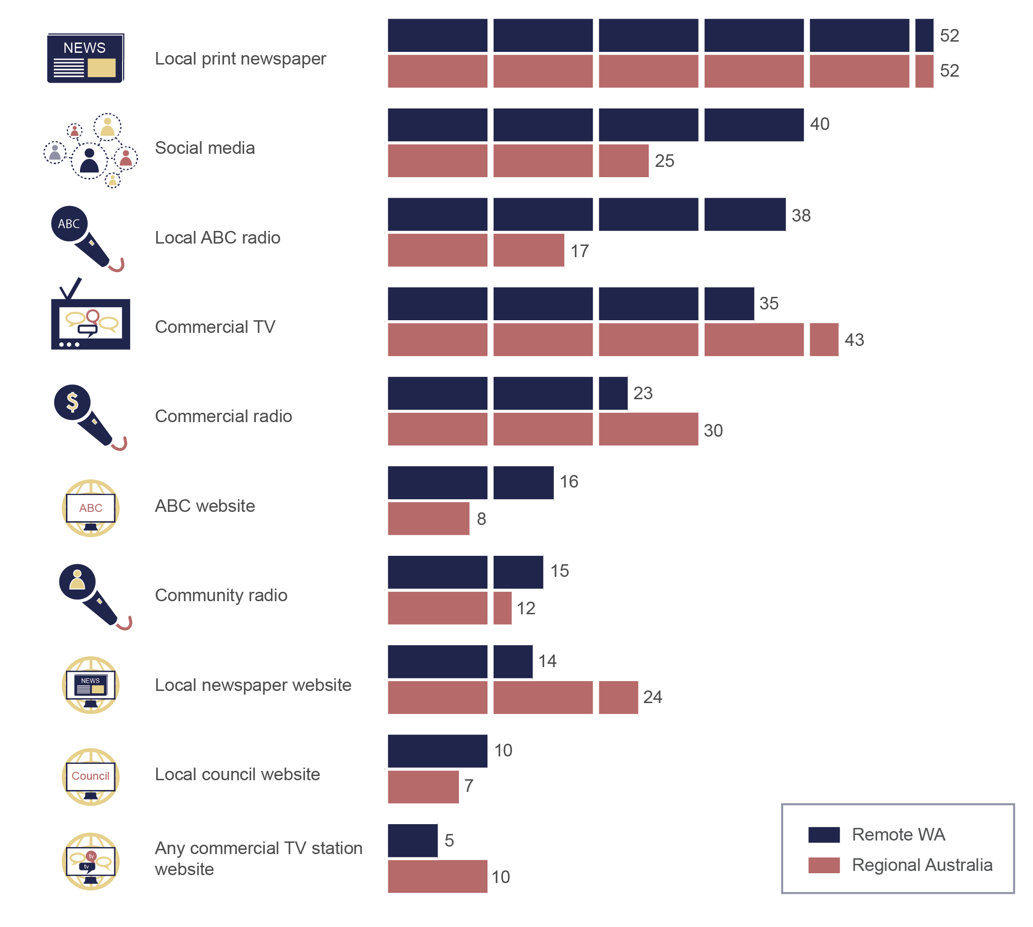

Weighted base: WA remote sample N=351, Regional Australia sample N=861.

Question E4 (both surveys): What sources do you personally use to get access to local news? (multi response)

### Radio is a preferred source of local news in remote WA

When sourcing local news, local ABC radio (21 per cent), the local print newspaper (20 per cent) and social media (19 per cent) are the top three preferred sources for people in remote WA (Figure 10). In regional Australia, the top three preferred sources include commercial television (26 per cent), the local print newspaper (21 per cent) and social media (11 per cent). Local ABC radio is the preferred source for just six per cent of regional Australians.

1. Preferred source of local news (%)

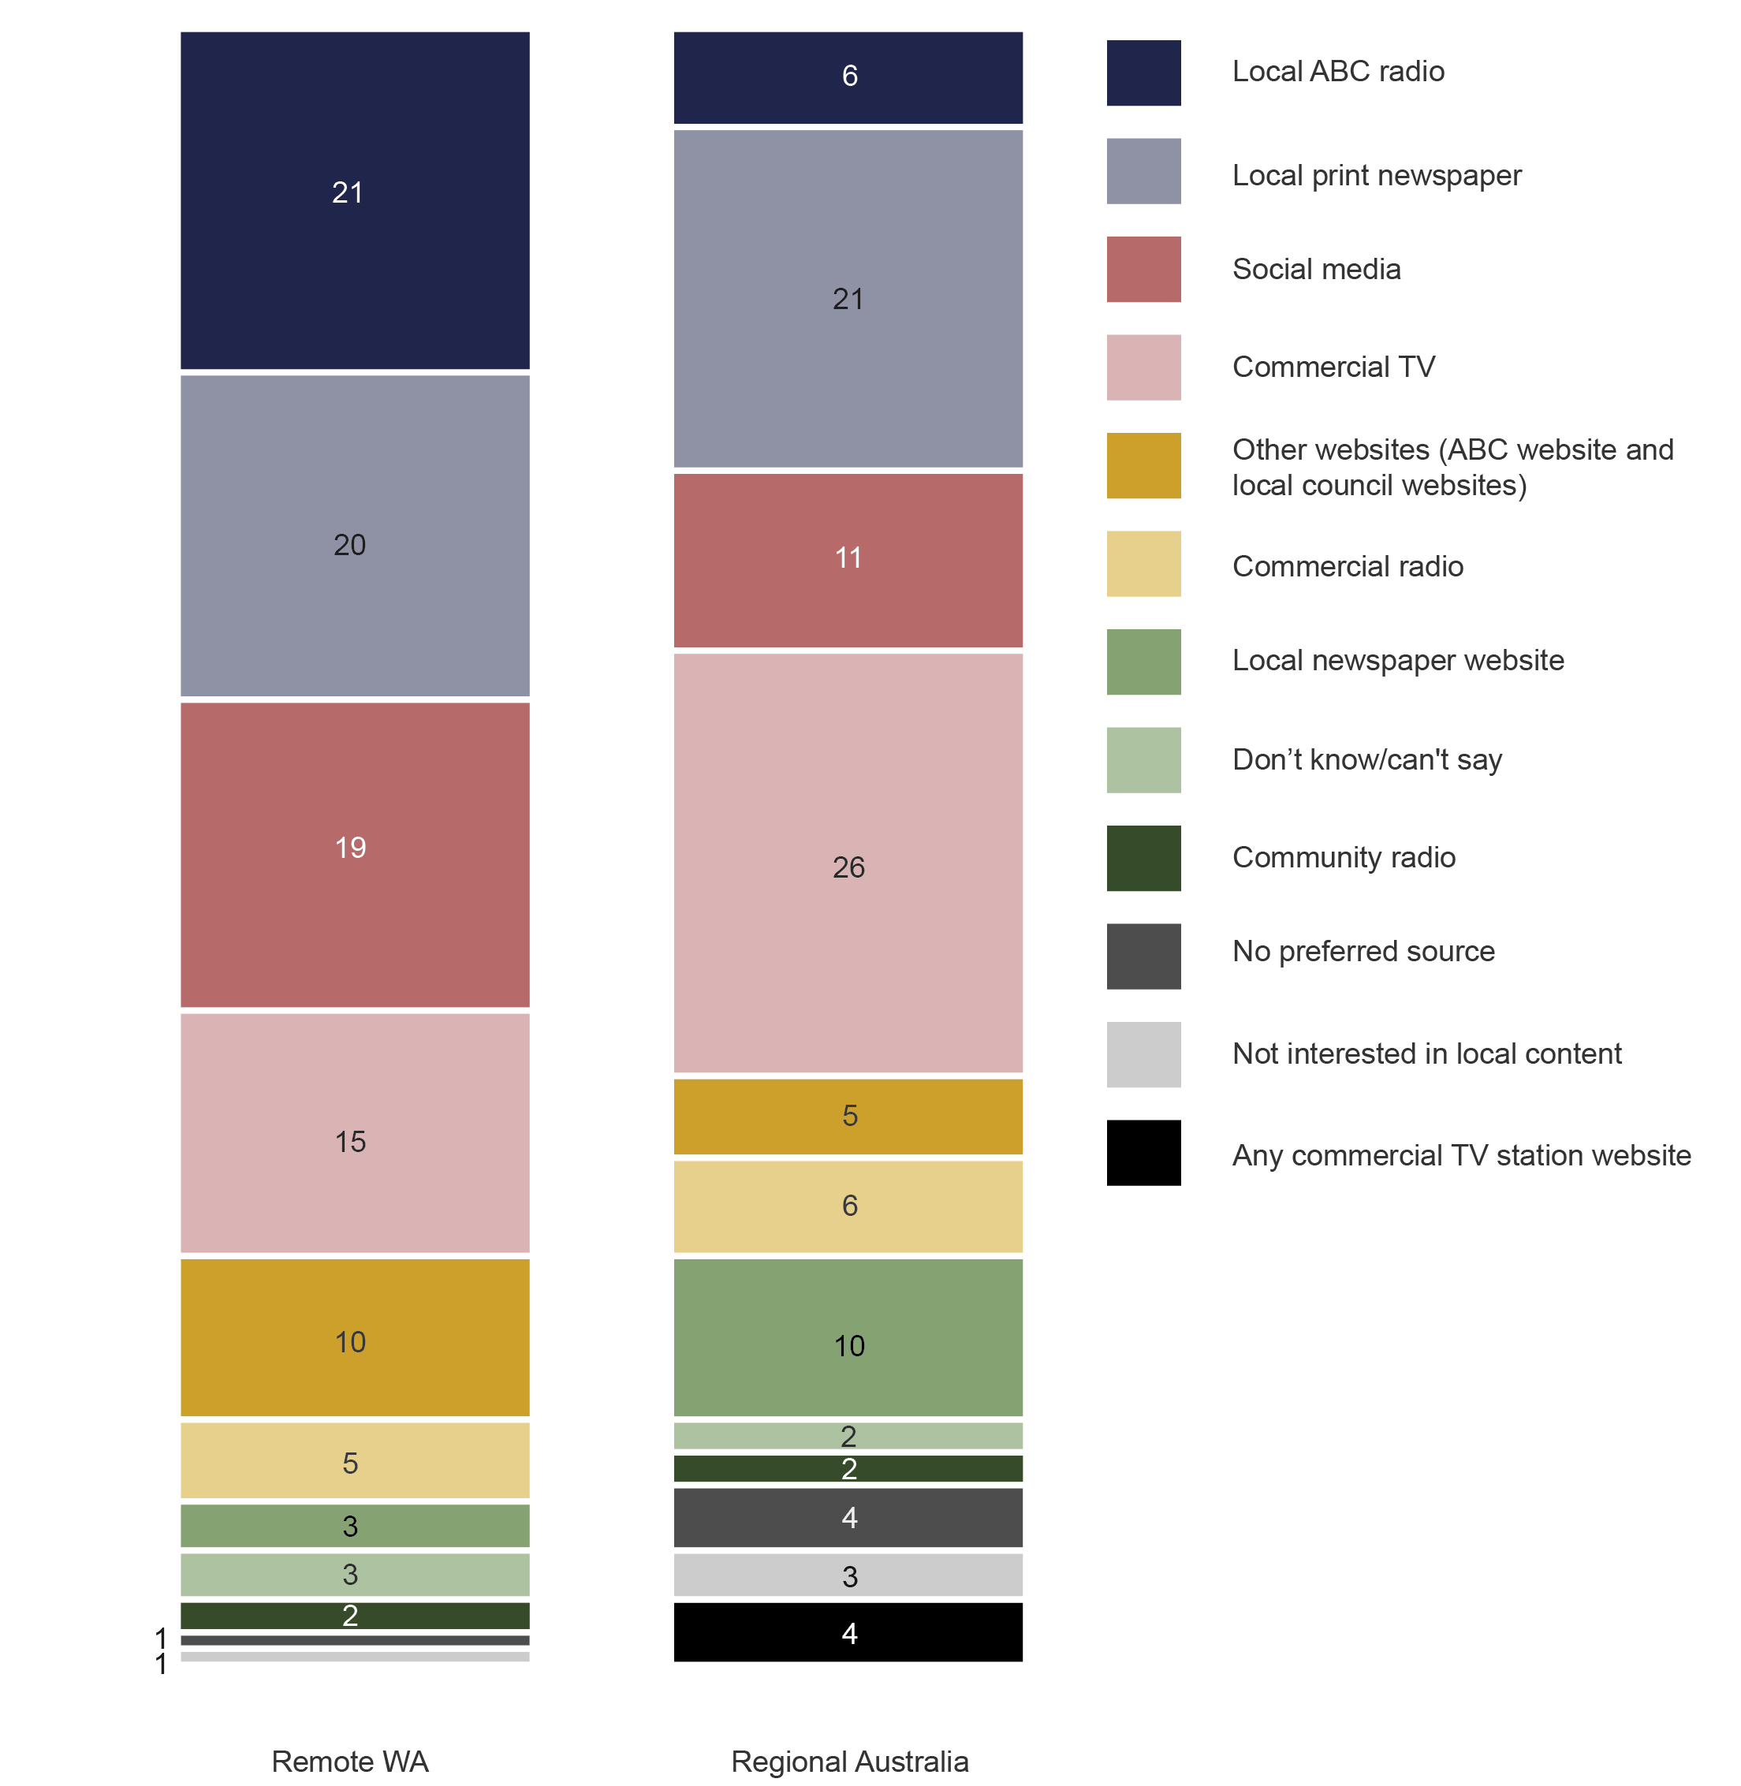

Base: WA remote sample N=351; Regional Australia N=861.

Question E5 (both surveys): Now imagine you could use any source to get access to local news. What would be your preferred source for local news?

# Appendix A— Populations of remote and very remote WA

1. Population of very remote WA

| **Age** | **Male** | **Female** | **Total** |
| --- | --- | --- | --- |
| 18–24 | 3,764 | 2,386 | **6,150** |
| 25–34 | 8,472 | 4,637 | **13,109** |
| 35–49 | 10,424 | 5,120 | **15,544** |
| 50–64 | 6,421 | 3,466 | **9,887** |
| 65+ | 3,100 | 1,934 | **5,034** |
| **Total 18+** | **32,181** | **17,543** | **49,724** |

1. Population of remote WA excluding four urban centres   
   (Broome, Karratha, Port Hedland and Esperance)

| **Age** | **Male** | **Female** | **Total** |
| --- | --- | --- | --- |
| 18–24 | 1,632 | 1,225 | **2,857** |
| 25–34 | 2,939 | 2,740 | **5,679** |
| 35–49 | 5,191 | 4,597 | **9,788** |
| 50–64 | 5,063 | 3,919 | **8,982** |
| 65+ | 3,978 | 3,176 | **7,154** |
| **Total 18+** | **18,803** | **15,657** | **34,460** |

1. Population of four urban centres of Broome, Karratha, Port Hedland and Esperance

| **Age** | **Male** | **Female** | **Total** |
| --- | --- | --- | --- |
| 18–24 | 2,586 | 2,439 | **5,025** |
| 25–34 | 5,081 | 4,646 | **9,727** |
| 35–49 | 7,411 | 5,882 | **13,293** |
| 50–64 | 4,824 | 3,545 | **8,369** |
| 65+ | 2,562 | 2,111 | **4,673** |
| **Total 18+** | **22,464** | **18,623** | **41,087** |

# Appendix B—Research design and sample frames

Survey one—communications services
Nationally representative sample of Australian adults aged 18 and over (includes metro and regional areas)
Sample size N=2,056  
n=1,855 online and n=201 representing those that are seldom or never online via CATI (fixed-line telephone) 
Please note: data from survey one not used in this publication

Survey two—media use 
Nationally representative sample of Australian adults aged 18 and over (includes metro and regional areas)
Sample size N=2,007
n=1,810 online and n=197 representing those that are seldom or never online) via CATI (fixed-line telephone)

Remote survey 
A sample boost recruited specifically in remote and very remote parts of Western Australia 
Sample size N=351
Survey was conducted via CATI (fixed-line telephone and mobile) 

Common questions were asked in survey two and remote survey

Regional Australia sample is a subset of survey two
n=861 
Regional areas are defined as follows:
ACT
Regional NSW excluding Sydney
Regional VIC excluding Melbourne
Regional QLD excluding Brisbane
Regional SA excluding Adelaide
Regional WA excluding Perth 
Tasmania
Northern Territory 

Sample distribution areas for regional 

Sample distribution areas for regional boost is as follows:
1. Four urban centres of:
Karratha (n=36)
Port Headland (n=30)
Broome (n=29)
Esperance (n=26)

2. Rest of remote WA (excluding the four urban centres above) n=115

3. Very remote WA n=115


# Appendix C—Remoteness

The concept of remoteness used in this research is based on the Australian Bureau of Statistics Australian Statistical Geography Standard (ASGS): Volume 5—Remoteness Structure.[2] The Remote and Very Remote areas of WA are coloured very light green and yellow respectively on the map shown in Figure 11.

According to [ABS 2011 Census data](http://www.censusdata.abs.gov.au/census_services/getproduct/census/2011/quickstat/RA54?opendocument&navpos=220), there are almost 61,000 people living in Very Remote WA and just over 95,000 people living in Remote WA. There is a higher male (57 per cent) to female (43 per cent) ratio across both areas, with a median age of 33 in Very Remote WA and 35 in Remote WA.

1. Remoteness structure—Western Australia

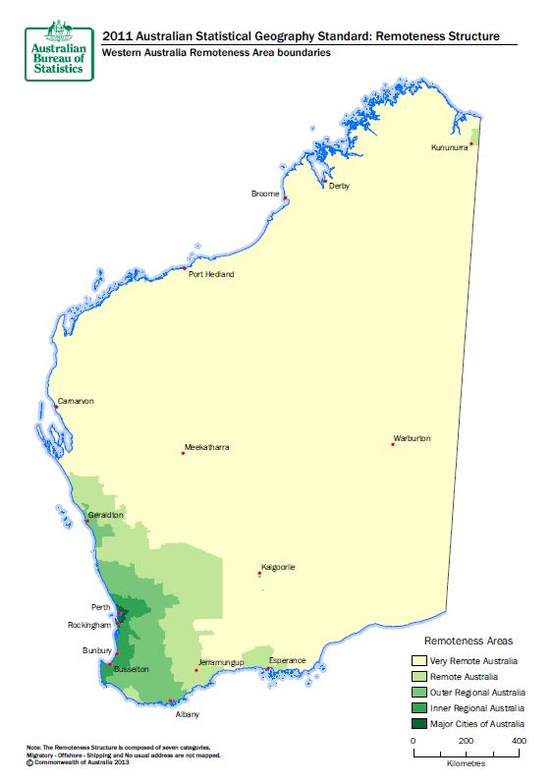

# Appendix D—Regional and national breakdowns by age

1. Average number of hours by radio activity and age, nationally

| **Radio activity** | **18–34** | **35–49** | **50–64** | **65+** |
| --- | --- | --- | --- | --- |
| AM radio in the car or another vehicle | 0.3 | 0.9 | 1.7 | 1.5 |
| AM radio at home or somewhere else (but not in a vehicle) | 0.4 | 1.2 | 2.1 | 6.0 |
| FM radio in the car or another vehicle | 2.7 | 2.6 | 2.5 | 1.3 |
| FM radio at home or somewhere else (but not in a vehicle) | 2.5 | 2.6 | 2.9 | 2.5 |
| Radio online | 0.5 | 1.0 | 0.6 | 0.3 |
| **Total hours** | **6.4** | **8.3** | **9.8** | **11.6** |

Weighted base: All respondents in remote WA (18–34 n=496, 35–49 n=472, 50–64 n=532, 65+ n=507).

Question C6: How many hours have you spent doing each of the following in the past 7 days?

1. Average number of hours by radio activity and age, regionally

| **Radio activity** | **18–34** | **35–49** | **50–64** | **65+** |
| --- | --- | --- | --- | --- |
| AM radio in the car or another vehicle | 0.1 | 0.5 | 1.7 | 1.5 |
| AM radio at home or somewhere else (but not in a vehicle) | 0.5 | 1.0 | 1.5 | 6.3 |
| FM radio in the car or another vehicle | 3.0 | 2.4 | 2.6 | 1.6 |
| FM radio at home or somewhere else (but not in a vehicle) | 2.1 | 2.5 | 2.9 | 2.5 |
| Radio online | 0.3 | 0.6 | 0.8 | 0.5 |
| **Total hours** | **6.0** | **7.0** | **9.5** | **12.4** |

Weighted base: All respondents in remote WA (18–34 n=183, 35–49 n=192, 50–64 n=238, 65+ n=248)

Question C6: How many hours have you spent doing each of the following in the past 7 days?

# Appendix E— Data by area of remoteness

1. Radio listening at home or in the car, past six months, by area of remoteness (%)

| **Radio activity** | **Four centres in remote WA** | **Rest of remote WA (excl. four centres)** | **Very remote WA** |
| --- | --- | --- | --- |
| FM radio | 84 | 72 | 81 |
| AM radio | 65 | 80 | 69 |
| Radio online | 29 | 22 | 34 |
| None of these activities | 7 | 10 | 9 |

Weighted base: All respondents in remote WA (four centres n=121, rest of remote WA n=115, very remote WA n=115).

Question C4: Which of the following have you personally done in the past six months?

1. Average number of hours by radio activity and area   
   (remote WA, regional and national)

| **Radio activity** | **Four centres in remote WA** | **Rest of remote WA (excl. four centres)** | **Very remote WA** | **Regional** | **National** |
| --- | --- | --- | --- | --- | --- |
| AM radio in the car or another vehicle | 2.7 | 8.6 | 3.2 | 0.9 | 1.0 |
| AM radio at home or somewhere else  (but not in a vehicle) | 2.0 | 2.9 | 2.4 | 2.1 | 2.0 |
| FM radio in the car or another vehicle | 2.9 | 2.0 | 5.1 | 2.4 | 2.4 |
| FM radio at home or somewhere else  (but not in a vehicle) | 3.8 | 0.8 | 2.6 | 2.5 | 2.6 |
| Radio online | 1.1 | 0.9 | 0.9 | 0.6 | 0.6 |
| **Total hours** | **12.5** | **15.2** | **14.2** | **8.5** | **8.6** |

Weighted base: All respondents in remote WA (four centres n=121, rest of remote WA n=115, very remote WA n=115), regional Australia N=861, and national sample N=2,007.

Q6: How many hours have you spent doing each of the following in the past 7 days?

1. Availability of radio stations by area of remoteness (%)

| Top four in very remote WA | |
| --- | --- |
| ABC Local Radio | 70 |
| Triple J | 69 |
| ABC News Radio | 55 |
| ABC Radio National | 47 |
| **Top four in four centres** | |
| Triple J | 71 |
| ABC Local Radio | 69 |
| Community radio(s) | 63 |
| ABC News Radio | 58 |
| **Top four in rest of remote WA** | |
| ABC Local Radio | 87 |
| ABC Radio National | 58 |
| ABC News Radio | 54 |
| Radio West | 48 |

Weighted base: All respondents in remote WA (four centres n=121, rest of remote WA n=115, very remote WA n=115).

Q3(a): Which of the following radio stations are available where you live? (multi response)

1. Radio stations most often listened to, by area of remoteness (%)

| Top four in very remote WA | |
| --- | --- |
| Triple J | 23 |
| ABC Local Radio | 17 |
| Spirit | 10 |
| Red FM | 8 |
| **Top four in four centres** | |
| ABC Local Radio | 22 |
| Triple J | 14 |
| Spirit | 10 |
| Red FM | 8 |
| **Top four in rest of remote WA** | |
| ABC Local Radio | 36 |
| Radio West | 11 |
| Spirit | 8 |
| Triple J | 8 |

Weighted base: All respondents in remote WA (four centres n=121, rest of remote WA n=115, very remote WA n=115).

Question C8: And which radio station do you most often listen to? (single response)

1. Sources of information people would use in emergency, by area of remoteness (%)

| Top four in very remote WA | |
| --- | --- |
| Fire and emergency services | 77 |
| Bureau of Meteorology | 75 |
| Local ABC radio | 61 |
| Social media | 51 |
| **Top four in four centres** | |
| Bureau of Meteorology | 82 |
| Local ABC radio | 64 |
| Fire and emergency services | 63 |
| Social media | 51 |
| **Top four in rest of remote WA** | |
| Fire and emergency services | 76 |
| Bureau of Meteorology | 64 |
| Local ABC radio | 59 |
| Commercial radio | 32 |

Weighted base: All respondents in remote WA (four centres n=121, rest of remote WA n=115, very remote WA n=115).

Question E6: Thinking now about being in an emergency, such as a bush fire, storm, flood or cyclone, where would you go to get up-to-date information about what to do? (multi response)

1. Sources used for up-to-date news in emergency, by level of remoteness (%)

| Top four in very remote WA | |
| --- | --- |
| Bureau of Meteorology | 48 |
| Local ABC radio | 47 |
| Received phone calls or SMS from friends, neighbours, etc. | 42 |
| Friends, neighbours came to knock at our door | 27 |
| **Top four in four centres** | |
| Local ABC radio | 49 |
| Received phone calls or SMS from friends, neighbours, etc. | 42 |
| Bureau of Meteorology | 37 |
| Commercial TV | 34 |
| **Top four in rest of remote WA** | |
| Received phone calls or SMS from friends, neighbours, etc. | 39 |
| Bureau of Meteorology | 36 |
| Local ABC radio | 34 |
| Received phone calls or SMS from fire and emergency services | 32 |

Weighted base: respondents who had experienced an emergency in the past 10 years (four centres n=92, rest of remote WA n=56, very remote WA n=85).

Question E8: When you were in this emergency situation, how did you get up-to-date information about what to do? (multi response)

1. Local news sources—personally used and the preferred source, by area of remoteness (%)

| Top four in very remote WA | | |
| --- | --- | --- |
|  | **Sources used** | **Preferred source** |
| Social media | 45 | 23 |
| Local print newspaper | 40 | 13 |
| Commercial TV | 38 | 19 |
| Local ABC radio | 34 | 21 |
| **Top four in four centres** | | |
| Local print newspaper | 60 | 20 |
| Social media | 44 | 16 |
| Local ABC radio | 38 | 20 |
| Commercial TV | 37 | 11 |
| **Top four in rest of remote WA** | | |
| Local print newspaper | 58 | 32 |
| Local ABC radio | 43 | 21 |
| Commercial TV | 29 | 15 |
| Social media | 28 | 17 |

Base: All respondents in remote WA (four centres n=121, rest of remote WA n=115, very remote WA n=115).

Question E4: What sources do you personally use to get access to local news? (multi response)

Question E5: Now imagine you could use any source to get access to local news. What would be your preferred source for local news?

1. ABS Census Collection Districts ARIA+ value ranges used as a nationally consistent measure of geographic remoteness. Remoteness ARIA+ values for Remote Australia is greater than 5.92 and less than or equal to 10.53, and for Very Remote Australia greater than 10.53.
2. ABS Cat 1270.0.55.005