

NBN consumer experience

Households and businesses—  
the end-to-end journey

august 2018

Canberra

Red Building   
Benjamin Offices  
Chan Street   
Belconnen ACT

PO Box 78  
Belconnen ACT 2616

T +61 2 6219 5555  
F +61 2 6219 5353

Melbourne

Level 32   
Melbourne Central Tower  
360 Elizabeth Street   
Melbourne VIC

PO Box 13112  
Law Courts   
Melbourne VIC 8010

T +61 3 9963 6800  
F +61 3 9963 6899

Sydney

Level 5   
The Bay Centre  
65 Pirrama Road   
Pyrmont NSW

PO Box Q500  
Queen Victoria Building   
NSW 1230

T +61 2 9334 7700 or 1800 226 667  
F +61 2 9334 7799

Copyright notice

[Creative Commons logo](http://i.creativecommons.org/l/by/3.0/88x31.png)

[https://creativecommons.org/licenses/by/4.0//](https://creativecommons.org/licenses/by/4.0/)

With the exception of coats of arms, logos, emblems, images, other third-party material or devices protected by a trademark, this content is made available under the terms of the Creative Commons Attribution 4.0 International (CC BY 4.0) licence.

We request attribution as © Commonwealth of Australia (Australian Communications and Media Authority) 2018.

All other rights are reserved.

The Australian Communications and Media Authority has undertaken reasonable enquiries to identify material owned by third parties and secure permission for its reproduction. Permission may need to be obtained from third parties to re-use their material.

Written enquiries may be sent to:

Manager, Editorial and Design  
PO Box 13112  
Law Courts  
Melbourne VIC 8010  
Email: [info@acma.gov.au](mailto:info@acma.gov.au)

Key findings 2

Before migration 2

During migration 2

After migration 3

Background 5

ACMA research program 5

About the research 5

Methodology 6

Quantitative survey of residential households 6

Quantitative survey of businesses 6

Statistical reliability of the quantitative results 7

Guidelines for reading this report 7

General notes 7

Detailed findings—households 10

Before migration 11

Awareness of NBN connection process 11

Medical devices and security alarms 12

Information from RSPs and NBN Co 13

Household understanding of available plans 14

Factors driving choice of plan or RSP 15

Sources of household information 16

Plan costs 17

Internet services—data allowances and download speeds 17

Speed tests 18

Choosing an RSP and keeping home phone number 19

During migration 19

Contact with RSPs and NBN Co about connecting 19

Installation of NBN 20

Technician appointments during connection 21

Service continuity during connection 21

Time without service during connection 23

Timeliness of connection and satisfaction with the process 24

After migration 26

Issues or faults since connection 26

Main issues or faults experienced by households 28

Complaints and main reasons 29

Time to resolve complaints 31

Satisfaction with complaints-handling 32

Households who did not make a complaint 33

Satisfaction with NBN phone service 35

Satisfaction with NBN internet service 37

Satisfaction with speed and comparison with previous service 39

Detailed findings: businesses 41

Before migration 42

Understanding of the connection process and plans 42

Factors driving choice of plan or RSP 43

Internet services—data allowances and download speeds 44

Keeping phone numbers when moving to NBN 45

During migration 45

Installation process 45

Service continuity during connection 46

Time without service during connection 48

Loss of service—use of interim services and impact 48

After migration 50

Satisfaction with connection and internet before and after 50

Issues or faults since connection 51

Main issues or faults experienced by businesses 53

Complaints and main reasons 54

Time to resolve complaints 56

Satisfaction with complaints handling 57

Businesses that did not make a complaint 57

Comparing the NBN connection experiences of households and businesses 60

Most important factors for choosing a plan or RSP 60

Drivers for contacting NBN Co and RSPs 60

Loss of service during connection 61

Satisfaction with connection process and with internet 62

Issues/faults and complaints 63

Appendix A— Methodology (detailed) 64

Sample design and weighting 64

Key differences between residential and business surveys 64

Questionnaire design 65

Statistical reliability 65

Limitations 66

Comparability with previous research 66

Quality assurance 67

Overview

The rollout of the National Broadband Network (NBN) has accelerated rapidly, with retail service providers (RSPs) moving millions of Australians to the new network across fixed line, fixed wireless and satellite technologies.

The NBN is a wholesale-only broadband communications network. NBN Co Limited (NBN Co)—the company building the NBN—does not directly provide services to end users. End users acquire their phone and internet services delivered over the NBN from RSPs. RSPs set service offerings and pricing and have the direct contractual relationship with their customers. There can be confusion in terminology arising from this complex supply chain. The ACMA has included definitional terms in this report to assist the reader.

As the number of consumers migrating to services delivered over the NBN has increased, so too has the number of reports of consumer problems. Reported problems include issues around connection of services and subsequent faults and performance issues.

In August 2017, the Australian Communications and Media Authority (ACMA), in coordination with the Department of Communications and the Arts (DoCA) and the Australian Competition and Consumer Commission (ACCC), announced an [increased focus](https://www.acma.gov.au/theACMA/acma-focus-on-the-nbn-customer-experience) on the problems some consumers face when migrating to and using services delivered over the NBN.

The focus of this work was to gain a clear and comprehensive set of information to achieve a better understanding of the type, incidence and causes of these problems. We began an information-gathering program of work, which included several elements:

* seeking information using our regulatory powers to obtain information from industry participants across the supply chain
* reviewing the online information provided by all RSPs offering services delivered over the NBN to customers, including information on Critical Information Summaries

conducting consumer research with households and businesses about their experience before, during and after the migration of their landline and/or internet services delivered over the NBN.

This report presents the research findings on the reported experience of both residential households (households) and small and medium-sized businesses (businesses) connecting to and using services delivered over the NBN. The research covered those who had migrated to services delivered over the NBN in the 12 months prior to the research fieldwork, that is, those who began using their new services between:

* November 2016 and December 2017 for households

January 2017 and February 2018 for businesses.

The findings reflect consumers’ reported experience with the end-to-end migration process. In some instances, consumers were asked about their experiences with individual parties in the supply chain and these are noted where appropriate.

In this report, ‘consumers’ describes both households and businesses. Detailed data is reported separately for households and businesses.

The high-level findings of this research (for households), [*NBN consumer experience: residential research snapshot*](https://www.acma.gov.au/theACMA/Library/researchacma/Snapshots-and-presentations/nbn-consumer-experience-residential-research-snapshot)*,* were published in March 2018.

## Key findings

### Before migration

Consumers who were more informed about the process and which plans would best meet their needs when connecting to services delivered over the NBN, were better prepared for migration.

While most consumers believed they understood the steps in connecting, around a third didn’t understand the different responsibilities of NBN Co and RSPs.

The research investigated the factors driving the choice of a plan or RSP for consumers. Multiple factors could be selected as important (refer to Table 3 for households and Table 6 for business).

Among all households, the factors most frequently selected as important were cost (86 per cent) and confidence in faults being fixed (80 per cent). Those with a home phone placed importance on keeping their phone number (82 per cent), while those with internet selected speed of internet connection (79 per cent) and amount of data included as important (78 per cent).

Businesses prioritised keeping their phone number (89 per cent of those with a business phone), having confidence in faults being fixed (88 per cent of all businesses) and speed of internet connection (84 per cent of those with internet).

When asked to select a single most important factor, households prioritised cost (29 per cent) and businesses prioritised keeping their phone number (36 per cent).

Three-quarters of internet households (76 per cent) were aware of the availability of different data download speeds. However, only 52 per cent of internet households knew what speed they would need, and only 55 per cent could recall what speed was included in their internet plan.

### During migration

A smooth start to the migration process can have a positive impact on the consumer experience during and after migration to services delivered over the NBN.

Consumers who had no service interruption while connecting were more likely to be satisfied with the connection process, reliability, affordability and quality of their phone and internet. They were also less likely to contact RSPs or NBN Co, experience faults and issues or make a complaint.

However, one-third (34 per cent) of households and 40 per cent of businesses indicated they experienced a period without a home phone and/or internet service during migration. Sixteen per cent of households and 14 per cent of businesses reported that they lost one or both of their services for more than one week during migration.

### After migration

Most consumers with internet (72 per cent of households and 80 per cent of businesses) rated their service about the same or better after migration (households: 41 per cent better and 31 per cent the same; businesses: 40 per cent better and 40 per cent the same). Businesses were more positive than households, with a smaller proportion considering their internet to be worse (18 per cent vs 24 per cent).

Just over half of households (52 per cent) were satisfied with their speed. Forty‑two per cent of internet households conducted speed tests to check download speeds for their service; this rose to 53 per cent for those who had made a complaint.

Higher data download speeds for internet households did not necessarily mean greater satisfaction with speed. While satisfaction was highest (62 per cent) for those on plans with the fastest speed (100 Mbps speed tier), it was lowest (44 per cent) for those on a 50 Mbps speed tier. Satisfaction for those on a 12 Mbps speed tier was 47 per cent and 55 per cent for those on a 25 Mbps speed tier.

Consumers commonly experienced issues and faults while using a service delivered over the NBN, but not all issues and faults led to complaints.

Seven in 10 consumers (71 per cent for both households and businesses) experienced at least one type of issue or fault after connection. The most frequently mentioned issue or fault was drop-outs (49 per cent). Around one-third of both households and businesses experienced speed issues and service outages.

Three in 10 households (31 per cent) and four in 10 businesses (42 per cent) had made at least one complaint to their RSP after connecting. Multiple complaints were common—the median number was three for households, and four for businesses. The most frequent reason for the most recent complaint was drop-outs (nearly twice as frequent as any other reason). Refer to Figure 16 for households and Figure 36 for business.

A key driver of satisfaction with complaints-handling was resolution time. For households, satisfaction was highest for complaints resolved within three working days. For businesses there was a slightly lower tolerance, with the rate of satisfaction dropping off after two working days. At the time the data was collected, nearly half (49 per cent) of households and 37 per cent of businesses considered their complaints unresolved.[1]

This research shows that certain key factors tended to lead to a positive consumer experience before, during and after migration to services delivered over the NBN:

* being informed about connecting made for a better prepared consumer
* having information about the factors consumers regarded as most important in a plan or RSP resulted in better choices of plans and RSPs.
* having no service interruption while connecting made for greater satisfaction, not just with the connection process but also with the overall experience of using their new services
* those satisfied with the speed of their new internet service were more likely to be satisfied with other aspects of the service, such as reliability, quality and affordability

if issues or faults arose while using their new services, having complaints to RSPs resolved promptly increased the likelihood of being satisfied with the complaints-handling process.

# Background

The NBN is a government initiative to upgrade Australia’s broadband infrastructure. The government established NBN Co to design, build and operate that upgraded broadband infrastructure as a wholesale-only, open-access network.

NBN Co provides (wholesale) services on its network to wholesalers and RSPs, who then provide (retail) telephone and fixed internet services to Australian consumers.

Most Australians who have and want to keep fixed phone or internet services need to migrate to a service delivered over the NBN provided by an RSP. Progressively, the old (or ‘legacy’) wholesale networks will be switched off in many areas of Australia.

NBN Co’s network uses a variety of technologies:

* Fibre to the Premises (FTTP)
* Fibre to the Node or Fibre to the Building (FTTN/B)
* Fibre to the Curb (FTTC)—note FTTC was not available to consumers or businesses at the time of the research
* Hybrid Fibre Coaxial (HFC)
* Fixed Wireless

Satellite (Sky Muster™).

At the time of planning this research, almost three million premises had an active NBN service.

## ACMA research program

Our research program—research**acma—**makes an important contribution to our work as an evidence-informed regulator. It informs our strategic policy development, regulatory reviews and investigations, and helps us to support a media and communications infrastructure that works for all Australians.

## About the research

In September 2017, the ACMA commissioned Colmar Brunton Pty Limited (Colmar Brunton) to conduct a survey to investigate the consumer (residential, and small and medium-sized business) experience before, during and after migration to services delivered over the NBN, across the range of network technologies being rolled out in the 12 months before the research fieldwork.

This research focused on exploring:

* the level of consumer understanding of the migration process
* positive/negative factors influencing the migration experience
* consumer experience before, during and after migration
* consumer satisfaction with their phone and/or service

any service issues experienced.

# Methodology

## Quantitative survey of residential households

A total of 1,881 residential households was interviewed between 13 November and 20 December 2017. To be included in the research, households had to have migrated to services delivered over the NBN using the technology types available at that time—FTTP, FTTN/B, HFC, Fixed Wireless and Sky Muster™ satellite—in the 12 months prior to data collection.[2]

Surveys were conducted using computer-assisted telephone interviews. Surveys were split between households with a fixed-line home phone and mobile phone, and included mobile phone-only households. The random sample was sourced from SamplePages for 12 strata[3] (defined according to states/grouped states and estimated incidence rates) within the geographic areas in scope. The respondent was the main decision-maker for the household’s internet and phone services.

The survey data has been weighted to represent dwellings connected in the previous 12 months in the areas that were surveyed and are referred to in this report as ‘households’.

Further detail of the sampling and weighting is in *Appendix A—Methodology*.

## Quantitative survey of businesses

A total of 1,153 small and medium-sized businesses with between one and 199 employees at the total business level and who were connected to services delivered over the NBN was interviewed between 24 January and 23 February 2018. For businesses with more than one location/site, data was collected just on their experiences at the location/site sampled, with key details collected about the business as a whole to provide additional context. This was done to gather information on a particular location/site of the business, and recognised that services were rolled out to individual sites of businesses separately and each could have different experiences. The survey included businesses that migrated including all the technology types currently available—FTTP, FTTN/B, HFC, Fixed Wireless and Sky Muster™ satellite—in the 12 months prior to data collection.[4]

Surveys were conducted using computer-assisted telephone interviews and included businesses with a fixed-line phone and those with a mobile phone. The sample was sourced from Dun & Bradstreet business lists, with calls made randomly within each of the 12 strata4. The respondent was the main decision-maker for the business’s internet and phone services.

The survey data has been weighted to represent small and medium-sized businesses connected in the previous 12 months in the areas that were surveyed and are referred to in this report as ‘businesses’.

Further detail of the sampling and weighting is in *Appendix A—Methodology*.

### Statistical reliability of the quantitative results

As this survey is a random sample of a defined population, standard errors based on a simple random sample apply. In addition, there is a Weight Effect (WEFF) due to the sampling and weighting design that needs to be accounted for in calculating statistical tests. The margin of error for various sample sizes and sample results (proportions of totals), with the appropriate WEFF for each survey, is shown in Table 13 in *Appendix A—Methodology*.

## Guidelines for reading this report

### General notes

* Unless otherwise stated, all percentages are based on weighted estimates.
* Base sizes are shown as the unweighted number of respondents.
* All percentages have been rounded to the nearest whole number. As a result, there may be discrepancies between sums of the component items in a table or chart and the total.
* Some of the questions invited a multiple response, so total responses may sum to more than 100 per cent.
* Some questions have been filtered depending on the respondent’s previous response (for example, a question asked only of those who made a complaint to their RSP). This is always shown as the ‘base’ on a chart or in a table. Care needs to be taken when interpreting the results, so that the data is read in the correct context.
* In some cases, ‘don’t know’ or other responses with only small levels of response are not shown—these are noted.
* If there were no respondents in a particular cell, this is indicated by a dash (–) in that cell in the table.
* A <0.5 per cent in a cell in a table of percentages indicates that while there was at least one respondent in the cell, the weighted percentage was less than 0.5.

All results shown have been tested for statistical significance at the 95 per cent confidence level.

1. Terms used in this report

| Terms used | Definition |
| --- | --- |
| complaint | An expression of dissatisfaction made to a service provider about an NBN service or its complaints-handling process, where the customer expects a response or resolution. Unless otherwise noted, complaints data relates to complaints made to a current or previous RSP. |
| disconnection date | The date where phone and/or internet services delivered over the legacy copper or HFC network are disconnected at a premise. |
| Fixed Wireless | An NBN transmission tower transmits data over radio signals to an antenna on the rooftop of a premises. |
| FTTB | Fibre to the Building  Often used to connect units in residential apartment blocks or similar types of buildings to services delivered over the NBN. A fibre-optic line is connected to a fibre node in the building’s communications room. Existing copper phone lines are then used to connect to each unit. |
| FTTN | Fibre to the Node  Fibre-optic cable is connected to the ‘nodes’ located in a street or nearby to a customer’s premises, with the existing copper network then used to connect the premises to the node. |
| FTTP | Fibre to the Premises  Fibre-optic cable is connected directly to a customer’s premises, with an NBN utility box being placed on the outside and a wall-mounted NBN connection box inside. |
| HFC | Hybrid Fibre Coaxial  The existing cable network, previously used to provide pay TV and internet, is used to connect a premise to the nearest available fibre node. |
| interim or alternative service | Businesses were asked whether they received an alternative service. This may include internet.  For example, the provision of a mobile telephone service (at the standard telephone service rates) to replace a standard telephone service or a call diversion to an existing mobile telephone service. |
| issue or fault—drop-out | When a phone or internet service disconnects unexpectedly, and temporarily stops working. |
| issue or fault—interruptions and buffering | In streaming audio or video from the internet, buffering refers to downloading a certain amount of data before starting to play the music or video. Sometimes this might happen while watching video or listening to audio, causing an interruption. |
| issue or fault—poor voice quality | Noise on the phone line, voice distortion or delay. Noise can be static, hum, crosstalk or popping. Voice distortion includes echoed voice, garbled voice or incorrect volume. |
| issue or fault—service outage | A prolonged period when the internet or phone service is not able to be used. |
| issue or fault—slow data speeds in general | Lower than expected internet speeds. |
| issue or fault—slow data speed in the evening | Lower than expected internet speeds between 7 and 11 pm. |
| NBN | National Broadband Network—the wholesale broadband network being built across Australia |
| NBN Co | The government-owned business enterprise building and delivering services on the National Broadband Network.  NBN Co delivers a wholesale-only network to RSPs and does not provide services directly to consumers surveyed in this report. |
| NBN migration process | The process involving both NBN Co and an RSP connecting a customer to services delivered over the NBN. |
| Plan | Product offerings by RSPs to consumers for phone and/or internet services delivered over the NBN. |
| RSPs | Retail Service Providers  Provide phone and internet services to consumers surveyed in the report.  An RSP is the main point of contact for their customers about services delivered over the NBN, including ordering a plan, connection of service, queries and complaints. |
| Satellite (Sky Muster™) | Predominately used for remote or rural locations and involves a satellite dish being installed at a customer’s premises. |
| Services delivered over the NBN | Connecting to and using services provided by RSPs that are delivered using the NBN network. The questionnaire phrased this to respondents as ‘connecting to the NBN’ (meaning the NBN network). |

# Detailed findings—households

Between 13 November and 20 December 2017, 1,881 residential households connected to services delivered over the NBN were interviewed by phone. The data has been weighted to represent dwellings (referred to in this report as ‘households’) that connected in the preceding 12 months in the areas that were surveyed. Households migrated using the technology types available at that time (Figure 1).

1. Services and technology type connected to households (%)

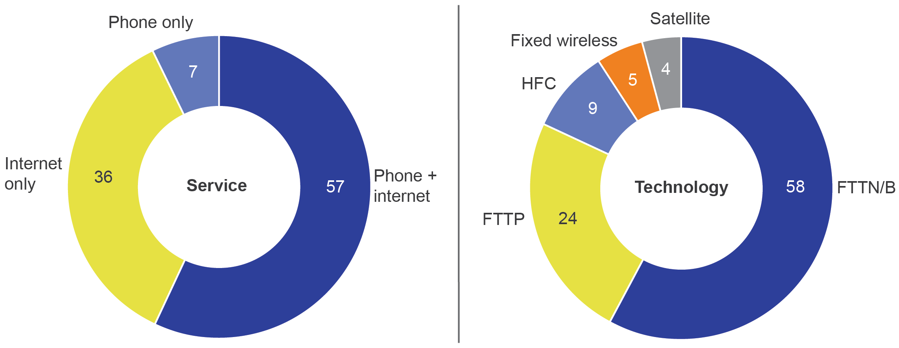

Base: Residential households connected to the NBN (n=1,881).

A8. Which of the following services has your household moved to the NBN in the last 12 months?

A12. And which type of NBN connection does your household have?

General references to households in the report relate to the total sample unless otherwise specified—they are also defined in the following ways by the services connected:

* All households connected to services delivered over the NBN or households with phone and/or internet connected—n=1,881 (total sample). This group includes those with both phone and internet, internet only and phone only connected.
* Households with internet connected or internet households—n=1,757. This group includes those with both phone and internet, and internet only.
* Households with home phone connected or phone households—n=1,412. This group includes those with both phone and internet, and phone only.
* Households with both phone and internet connected—n=1,288.
* Households with internet only connected—n=469.
* Households with phone only connected—n=124.

## Before migration

### Awareness of NBN connection process

Households were asked to report their understanding of several aspects of their move to services delivered over the NBN. At least two-thirds were aware of their household’s responsibilities when connecting (Figure 2).

1. Awareness of responsibilities before connecting (%)

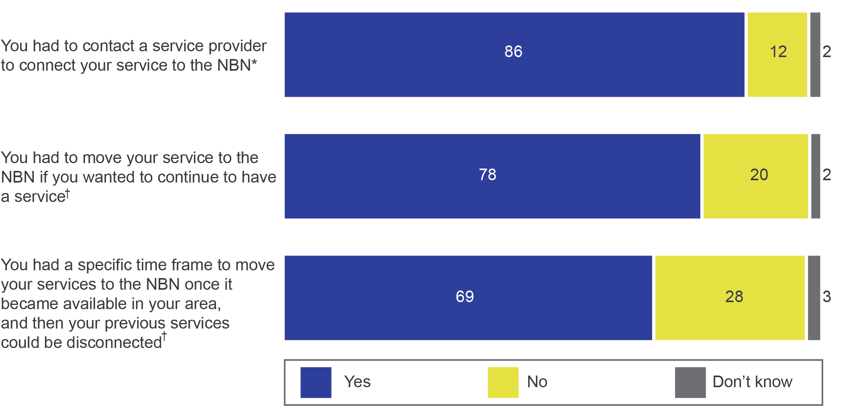

*All households connected to the NBN.

†All households connected to the NBN excluding fixed wireless and satellite customers.

Base: Residential households connected to the NBN (n=1,881), residential households connected to the NBN excluding fixed wireless and satellite customers (n=1,605).

B2a. So, now thinking about before you moved your services to the NBN, were you aware that…?

Most households connected to services delivered over the NBN by FTTP/N/B or HFC understood the need to move their home phone to a service delivered over the NBN in order to keep their home phone (79 per cent) (Figure 3).

Fewer phone households understood whether their phone would work in a power outage. Around six in 10 knew it would not work (62 per cent for those with a phone, except those on FTTP). For those with FTTP, a similar proportion (59 per cent) knew that they needed a battery backup for their phone to work in a power outage (Figure 3).

Households were asked whether they understood the steps involved in connecting and to rate this level of understanding on a scale. Overall, three-quarters (75 per cent) of all households agreed they understood the steps involved in connecting (Figure 3).

Phone-only households were less likely to agree they understood the steps involved in connecting. Understanding was also lower among older decision-makers (aged 65 or older), those with no tertiary education and those living in a household with a lower income ($40,000 or under per annum), with many of these characteristics correlating.

Around half (53 per cent) of all households agreed (‘strongly agree’—eight per cent; ‘agree’—45 per cent) they understood the different responsibilities of NBN Co and RSPs in connecting (Figure 3).

1. Understanding of NBN connection processes (%)

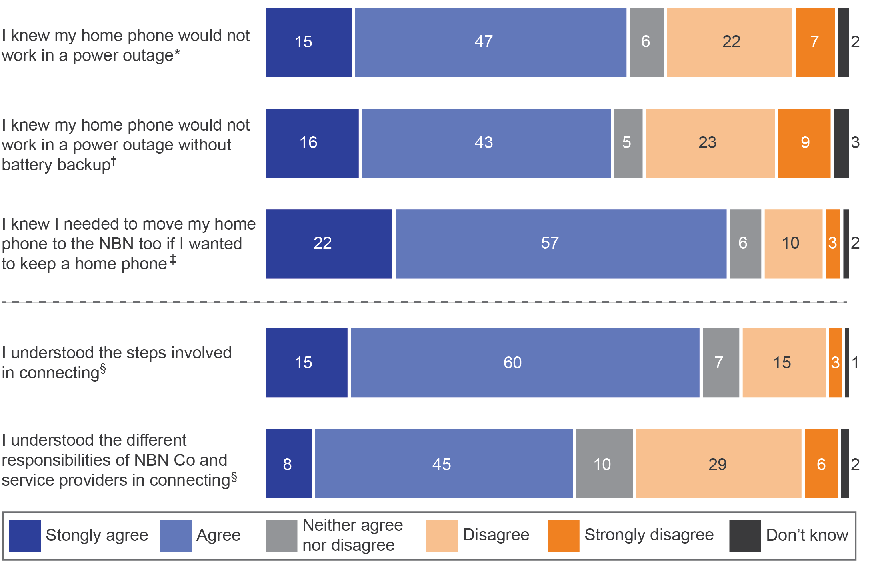

*Households with home phone (excluding FTTP) connected to the NBN.

†Households with home phone (FTTP only) connected to the NBN.

‡Households with home phone (excluding satellite and wireless) connected to the NBN.

§All households connected to the NBN.

Base: Residential households connected to the NBN (n=1,881), residential households with home phone connected to the NBN, excluding fixed wireless and satellite (n=1,266), residential households with home phone connected to the NBN, excluding FTTP (n=1,081), residential households with home phone connected to the NBN with FTTP (n=322).

B22a. I’m going to read out some statements about the NBN. Please tell me how strongly you agree or disagree with each one…? Do you strongly agree, agree, neither agree nor disagree, disagree or strongly disagree?

B22b. Ok, now I’m going to read two statements about NBN information. How strongly do you agree or disagree with the following…? Do you strongly agree, agree, neither agree nor disagree, disagree or strongly disagree?

Note: Data may not add to 100 per cent due to rounding.

Around three-quarters (74 per cent) understood the process well (‘very well’—31 per cent; ‘somewhat—43 per cent). One in five (19 per cent) understood the process ‘not very well’ and six per cent had ‘not at all’ understood.

### Medical devices and security alarms

A small proportion of households have security alarms or medical devices connected to services delivered over the NBN (security alarm or monitoring system: three per cent of households; medical alarms: two per cent).

Users of either type of device were not universally aware they should contact the provider to check compatibility for use on services delivered over the NBN.

There was only a very small group of households who used medical alarms (n=31), so results should be considered broadly indicative only. Nearly half (48 per cent) of those with a medical alarm connected to services delivered over to the NBN were aware they could register their medical device with NBN Co to help avoid a disruption to the service during the process of connecting.

### Information from RSPs and NBN Co

Half of all households recalled receiving information about how to connect from NBN Co, and two-thirds (67 per cent) recalled receiving information from RSPs (Figure 4).

1. Recall of receiving information from NBN Co or RSPs (%)

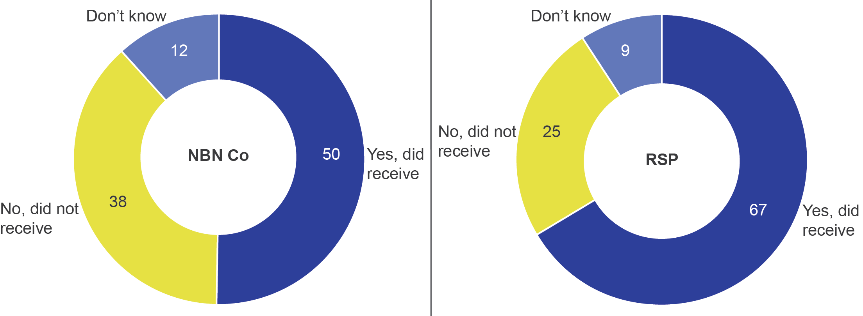

Base: Residential households connected to the NBN (n=1,881).

B4. Do you recall receiving information in the post or via email that came directly from NBN Co?

B7. Do you recall receiving information in the post or via email that came directly from service providers?

Note: Data may not add to 100 per cent due to rounding.

Around three-quarters of households who recalled receiving information from NBN Co or RSPs found it useful (74 per cent for NBN Co and 79 per cent for RSPs) (Figure 5).

1. Usefulness of information received from NBN Co or RSPs (%)

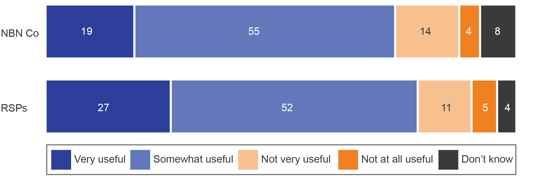

Base: Residential households who recalled receiving information from NBN Co (n=973), residential households who recalled receiving information from RSP (n=1,298).

B5. And overall, how useful or not useful was this information from NBN Co in informing your household about how to connect to the NBN?

B8. Overall, how useful or not useful was this information from service providers in informing your household about how to connect to the NBN?

Note: Data may not add to 100 per cent due to rounding.

Households who received information and rated the information ‘not very useful’ or ‘not at all useful’ did so for a range of reasons. The most frequent reason was that information received from NBN Co (35 per cent) or RSPs (31 per cent) was too confusing or unclear (Table 2).

1. Reasons information received was not useful (%)

| Reason | NBN Co | RSPs |
| --- | --- | --- |
| Too confusing, not clear | 35 | 31 |
| Too detailed, too technical | 23 | 13 |
| Not relevant | 19 | 20 |
| Didn’t arrive at the right time | 18 | 10 |
| Didn’t tell me what to do, didn’t tell me the steps involved | 15 | 20 |

Base: Residential households reporting NBN Co information as not very useful or not at all useful (n=167), residential households reporting RSP information as not very useful or not at all useful (n=214).

B6. And why wasn’t this information useful?

B9. And why wasn’t this information useful?

Note: Reasons with totals less than six per cent, ‘other’ and ‘don’t know’ responses not shown.

One-quarter (26 per cent) of household decision-makers who received information from both an RSP and NBN Co found the information from both to be useful. This group was more likely (than those who either did not recall receiving information or did not find it useful) to agree that they:

* knew to contact an RSP to connect to services delivered over the NBN
* understood the steps in connecting

understood the different responsibilities of NBN Co and RSPs in connecting.

### Household understanding of available plans

Households were asked about their understanding of a range of issues involved in choosing a plan. Around half of internet households knew what speed their household needed (52 per cent) (Figure 6). A similar proportion of all households found it easy to compare:

* what was included in different plans (49 per cent)
* plans from different RSPs (48 per cent) (Figure 6)

A third of households agreed there were too many plans to compare (32 per cent), and a quarter agreed that their household had received too much information from RSPs about signing up (25 per cent) (Figure 6).

1. Understanding and comparing plans (%)

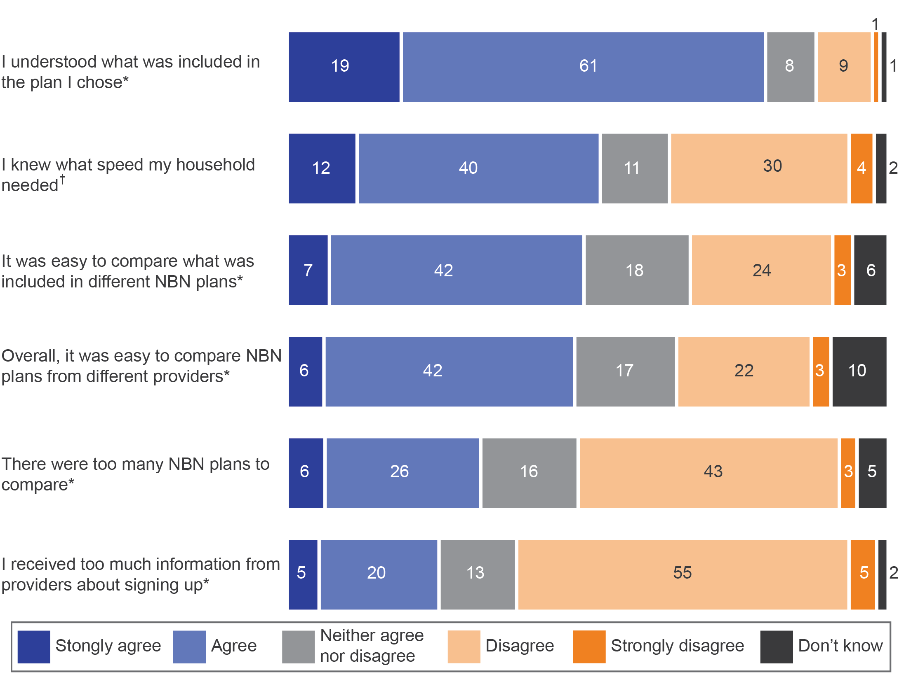

*All households connected to the NBN.

†Households with internet connected to the NBN.

Base: Residential households connected to the NBN (n=1,881), residential households with internet connected to the NBN (n=1,757).

B22a. I’m going to read out some statements about the NBN. Please tell me how strongly you agree or disagree with each one. Do you strongly agree, agree, neither agree nor disagree, disagree or strongly agree?

Note: Data may not add to 100 per cent due to rounding.

Households who recalled receiving information from NBN Co and/or RSPs and found it useful were more likely than all other households to find it easy to compare plans from different RSPs (65 per cent vs 42 per cent).

Internet households who could identify the speed in their own plan were more likely to also know what speed their household needed (67 per cent vs 33 per cent) and find it easy to compare plans (61 per cent vs 39 per cent).

Decision-makers aged under 65 found it easier than those aged 65+ to:

* compare plans from different RSPs (53 per cent vs 36 per cent)
* compare what was included in different plans (55 per cent vs 38 per cent)

know what speed their household needed (56 per cent vs 42 per cent).

### Factors driving choice of plan or RSP

The research investigated the factors driving the choice of a plan or RSP for households. Multiple factors could be selected as important and households selected a median of seven important factors.

Among all households, the two most important factors were cost (86 per cent) and confidence in faults being fixed (80 per cent). Those with a home phone placed importance on keeping their phone number (82 per cent); those with internet selected speed of internet connection (79 per cent) and amount of data included (78 per cent) as important (Table 3).

When asked to choose one factor as the most important reason for selecting a plan or RSP, cost was most frequently selected (Table 3).

1. Factors in choosing a plan or RSP (%)

|  | Important  (multiple selection) | Most important (choose one) |
| --- | --- | --- |
| Cost* | 86 | 29 |
| Speed of internet connection† | 79 | 21 |
| Keeping my phone number‡ | 82 | 14 |
| Staying with existing service provider for continuity* | 59 | 10 |
| Amount of data included† | 78 | 9 |
| Confidence in faults being fixed* | 80 | 8 |
| Keeping my email address† | 68 | 5 |
| Not being locked into a contract* | 48 | 2 |
| Positive customer reviews* | 50 | 1 |
| Getting free modem† | 54 | <0.5 |

*All households connected to the NBN.

†Households with internet connected to the NBN.

‡Households with home phone connected to the NBN.

Base: Residential households connected to the NBN (n=1,881), residential households with internet connected to the NBN (n=1,757), residential households with home phone connected to the NBN (n=1,412).

B19. I’m now going to read some factors that you might have considered when choosing your NBN service/s plan and provider. For each one could you tell me if it was important or not important to you?

B19b. Which of these was the most important for you in choosing your plan or provider?

Decision-makers aged 25 to 34 were the most likely to select cost as the most important factor in choosing their plan or RSP (41 per cent vs 27 per cent for all other age groups). Those opting for higher data download speeds (100 Mbps speed tier) were more likely to nominate speed of internet connection as the most important factor (54 per cent). Those on the lowest speed (12 Mbps speed tier) were less focused on internet speed, with 14 per cent selecting it as their most important factor.

### Sources of household information

The most useful source of information for households choosing their plan was RSPs (50 per cent). This was followed by friends/family/neighbours (17 per cent) and comparison websites (12 per cent).

For all age groups, information from RSPs was the source used more than others to decide the best plan for their household. Those aged over 35 (54 per cent) were more likely than those aged 18–34 (32 per cent) to find information from their RSP the most useful. Younger decision-makers aged 18–34 (30 per cent) were more likely than those aged 35 and over (nine per cent) to find comparison websites the most useful source of information about their plan.

### Plan costs

Households reported the usual cost of their plan each month. Among all households the monthly charges reported were:

* up to $60—22 per cent
* between $61 and $80—28 per cent
* between $81 and $100—24 per cent
* more than $100—16 per cent

could not recall the amount—10 per cent.

The groups more likely to be paying less (up to $60 month) were:

* low-income households (annual income up to $40,000)—40 per cent (vs 19 per cent of all other income groups)

those with older decision-makers (aged 65 and over)—30 per cent (vs 18 per cent for all other decision-makers).

### Internet services—data allowances and download speeds

Households with internet were asked to report their monthly data allowance, with the majority (85 per cent) able to do so. A little over four in 10 (44 per cent) households had unlimited data in their internet plan (Figure 7).

1. Awareness of household internet monthly data allowance (%)

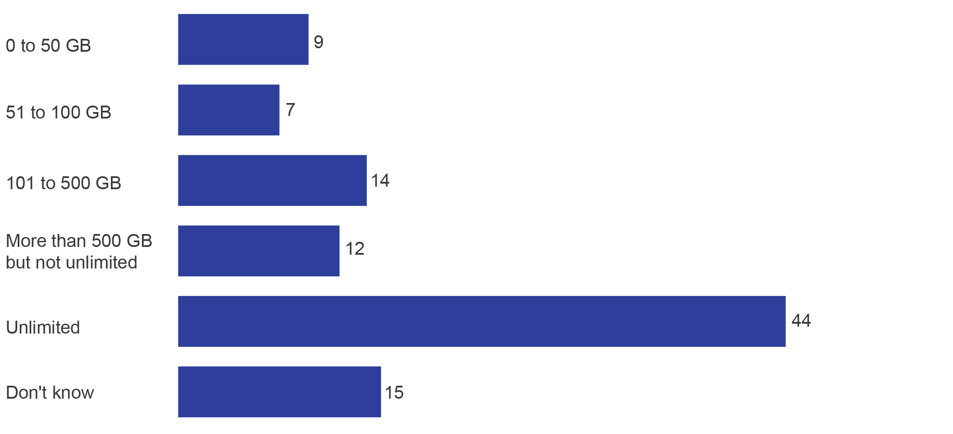

GB=gigabytes.

Base: Residential households with internet connected to the NBN (n=1,757).

B17. What is the monthly data allowance included in your NBN internet plan?

Internet households more likely to select an unlimited data allowance included those:

* with NBN internet and no home phone (52 per cent)—compared with those with both phone and internet (38 per cent)
* located in the five major capital cities[5] (51 per cent)—compared with those in other areas (38 per cent)

with children (57 per cent)—compared with those without children (40 per cent).

Internet households with decision-makers aged 65 or older were more likely to choose smaller monthly data allowances (up to 100 GB per month) (29 per cent vs 12 per cent for households with decision-makers younger than 65).

Three in four internet households (76 per cent) were aware that there were different download speed options for internet plans. This awareness was higher among those who reported they understood the process of connecting (83 per cent), compared with those who did not understand the process (55 per cent).

Internet households were also asked about the data download speed of their NBN internet service. While three-quarters (76 per cent) knew that different download speeds were available, little more than half (55 per cent) knew the speed of their household’s service, with a 25 Mbps speed tier the most common (24 per cent) (Figure 8).

1. Awareness of household data download speed tiers (%)

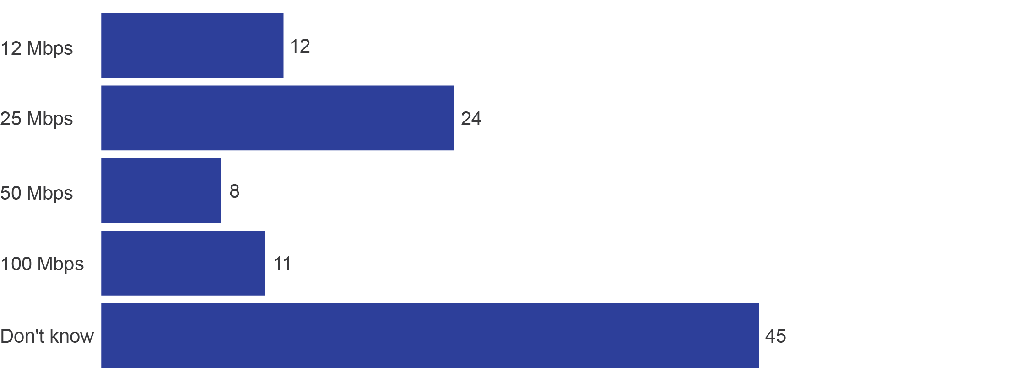

Mbps=megabits per second.

Base: Residential households with internet connected to the NBN (n=1,757).

B18b. What is the data download speed included in your NBN internet plan? Is it up to…?

Those who recalled receiving information from an RSP about moving to services delivered over the NBN were more likely to be aware of their household’s data download speed compared with those who did not recall receiving information from an RSP (61 per cent vs 44 per cent). Older decision-makers (aged 65 or older) were less likely to know the data download speed for their household (48 per cent vs 59 per cent).

Among those internet households who were not aware that there are different data download speeds, one in four (26 per cent) did know the speed of their own household’s internet plan.

### Speed tests

When asked whether they had carried out speed tests[6] since connecting, 42 per cent of internet households had done so. Those more likely to conduct speed tests included those:

* on internet plans with a 100 Mbps speed tier data download speed (77 per cent)—compared with those on lower speeds (38 per cent)
* who knew the data download speed in their own internet plan (60 per cent)—compared with those who did not know (19 per cent)
* with children in the household (50 per cent)—compared with those with no children at home (40 per cent)
* who connected from November to December 2016 (52 per cent)—compared with those who connected from October to December 2017 (35 per cent).

who made a complaint (53 per cent)—compared with those who had not complained (37 per cent).

### Choosing an RSP and keeping home phone number

For those with a home phone, when moving to a service delivered over the NBN:

* a majority (86 per cent) stayed with the same RSP
* 91 per cent were able to retain their phone number (a factor that was important to 82 per cent of households with a home phone when selecting their plan, and the most important factor for 14 per cent).

a little over two-thirds (69 per cent) were told by their RSP whether they could keep their number during the connection process.

For those who did not retain their phone number (six per cent of all phone users), approximately half of this group (45 per cent) had expected to do so. Reasons for being unable to keep a phone number when moving to a new plan included moving to a new house or to a different exchange (32 per cent); however, one quarter (26 per cent) reported that no reason was given.

## During migration

### Contact with RSPs and NBN Co about connecting

After households ordered their plan, just over four in 10 (42 per cent) contacted their RSP about the process of connection. The top three reasons for contact with RSPs were:

* installation or set-up (41 per cent)
* issues or faults (31 per cent)

activating the service for the first time (15 per cent) (Figure 9).

Among all households, one in eight (12 per cent) contacted NBN Co about connecting. Of those who contacted NBN Co, 72 per cent also contacted their RSP, while three per cent of all households contacted NBN Co about their connection without contacting their RSP. The top three reasons for contact with NBN Co were:

* installation or set-up (35 per cent)
* issues or faults (33 per cent)

delays in the connection (28 per cent) (Figure 9).

For most who contacted both NBN Co and their RSP, contact was made for the same reason/s (88 per cent).

1. Reasons for contacting RSPs and NBN Co about connection (%)

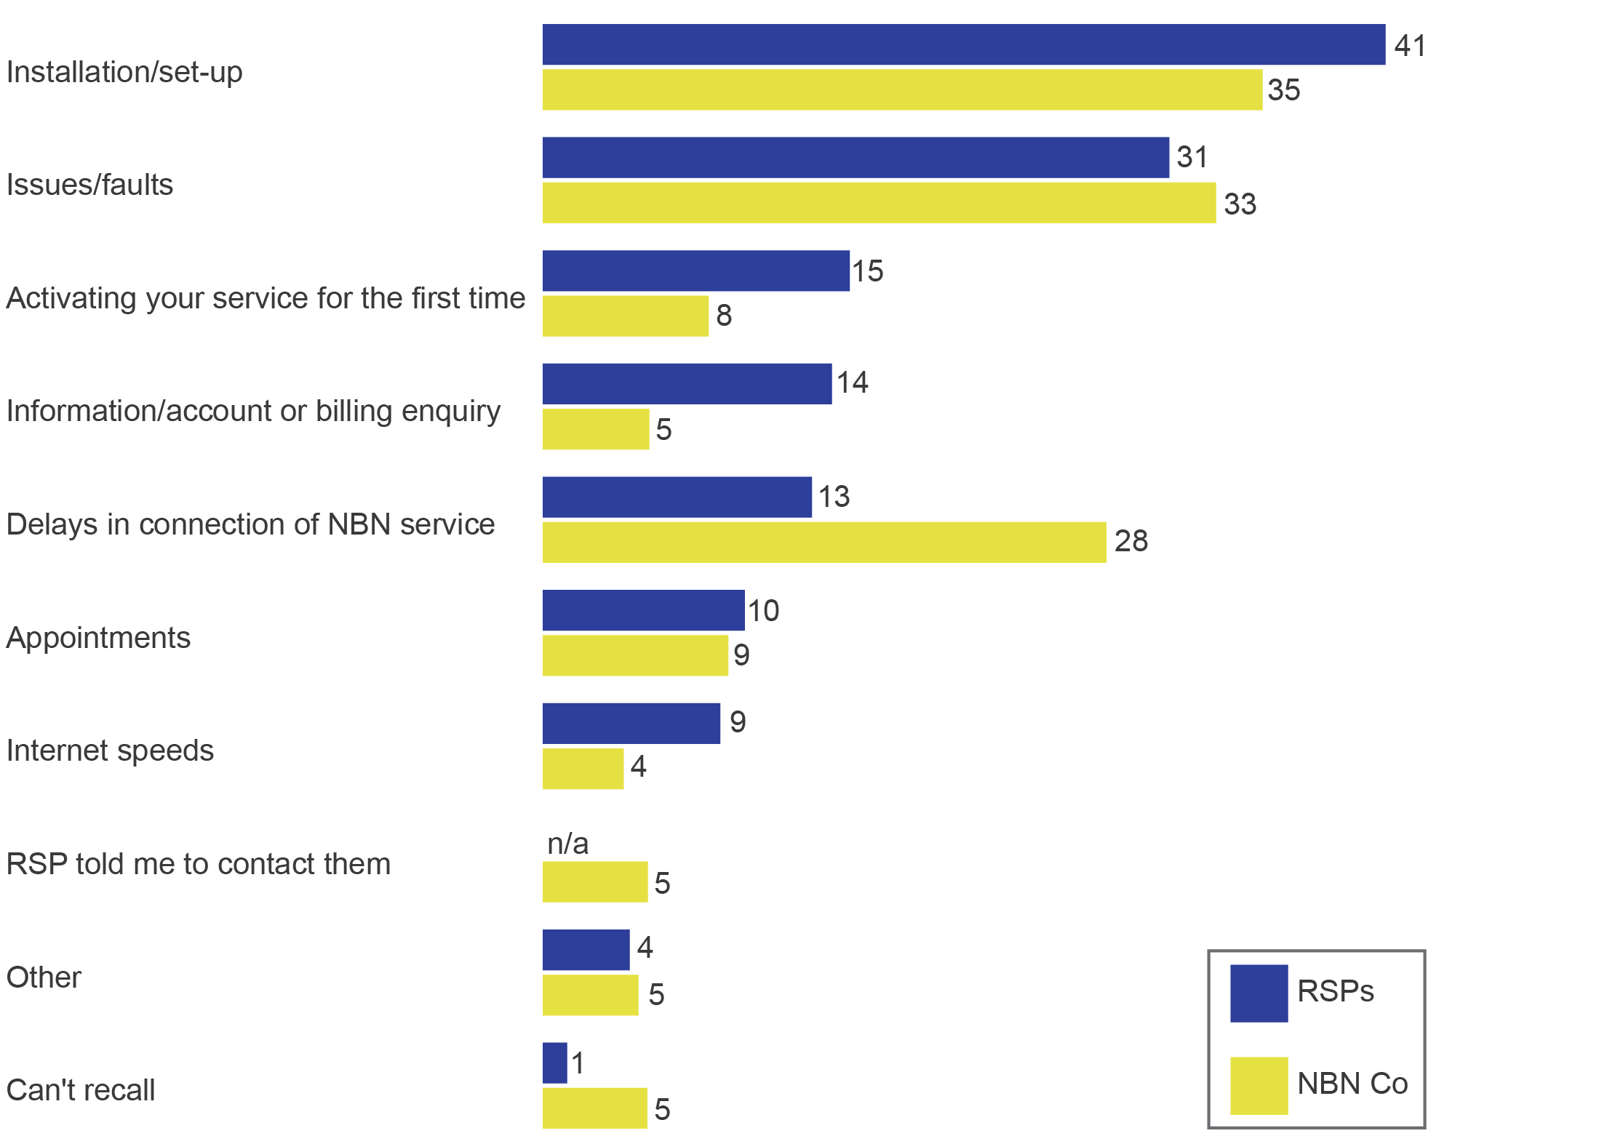

n/a=not applicable.

Base: Residential households connected to the NBN who contacted their RSP about process of connection, (n=759), residential households connected to the NBN who contacted NBN Co about process of connection, (n=250).

C8. And what were the reasons (for you contacting your provider about the process of connecting to the NBN)?

C10b. What was the reason for contacting NBN Co?

Note: Data adds to more than 100 per cent due to multiple responses.

Households with only a home phone delivered over the NBN (26 per cent) were less likely to contact their RSP during connection than those with both phone and internet (40 per cent) or internet-only (48 per cent). Older decision-makers (aged 65 or over) were less likely (31 per cent) to contact their RSP about the process of connecting than those aged under 65 (47 per cent). There is a large overlap here—83 per cent of households with only a home phone delivered on the NBN had a decision-maker aged 65 or over.

### Installation of NBN

Of the two methods of installing[7] NBN equipment during the period covered by the research, households reported that they had a:

* professional installation (53 per cent)[8]

self-installation (45 per cent).

Older decision-makers (aged 65 or over) were more likely to report that they had a professional installation than households with a younger decision-maker (63 per cent vs 49 per cent).

The majority (83 per cent) of those who opted for self-installation found it ‘very easy’ (52 per cent) or ‘somewhat easy’ (31 per cent). Nearly three in 10 households (29 per cent) who undertook self-installation required some help from their RSP to complete the task.

### Technician appointments during connection

Households were asked whether, at any point during the process of connecting, a technician had not turned up for a scheduled appointment.[9] Across all households, 11 per cent indicated this had occurred. For those who experienced a missed appointment:

* six in 10 (57 per cent) had one missed appointment
* one in five (21 per cent) had two missed appointments
* one in seven (14 per cent) had three missed appointments

seven per cent had four or more missed appointments.

Of those who had their service connected by a professional installer (a technician from their RSP), 13 per cent reported a technician missing a scheduled appointment. For those undertaking self-installation (receiving a kit from their RSP to set up the connection themselves), there was a slightly lower incidence of reporting a missed appointment (eight per cent).[10]

To reschedule the missed appointments:

* in half of cases (52 per cent), the household made contact to reschedule the appointment
* for three in 10 (30 per cent), the RSP contacted the household
* nine per cent were contacted by the technician
* six per cent reported that they were contacted by NBN Co

four per cent could not recall.

### Service continuity during connection

At the time of moving to services delivered over the NBN, some households experienced a loss of service. The survey investigated broad reasons for the loss of service but did not identify specific causes, or whether it was due to a factor within the control the RSPs, NBN Co, the household or another party.

Among all households, two-thirds (64 per cent) did not experience a loss of service during connection. One-third (34 per cent) were left without a home phone and/or internet service during connection.[11]

For internet households, 30 per cent were without internet for a period of time during the connection process. For phone households, 32 per cent were without a home phone for a period during the connection process (Figure 10).

1. Left without service during connection (%)

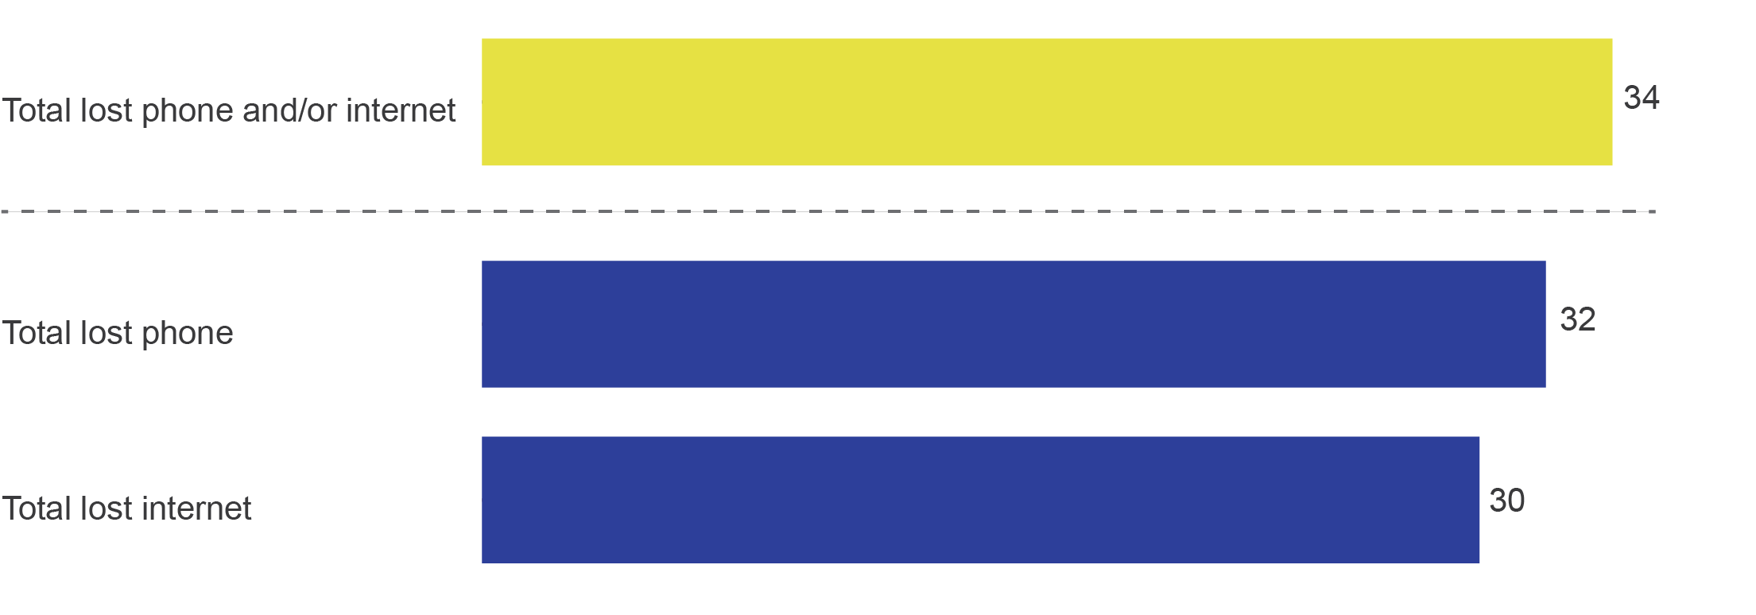

Base: Residential households connected to the NBN (n=1,881), residential households with internet connected to the NBN (n=1,757), residential households with home phone connected to the NBN (n=1,412).

C1a. Now, during the process of getting connected to the NBN, were you left without any kind of home phone or internet service at home?

Households with both phone and internet delivered over the NBN were more likely to experience a loss of service at the time of connection. Those with phone-only had the lowest rate of service loss:

* phone only—17 per cent lost their phone
* internet only—29 per cent lost their internet

both phone and internet—40 per cent lost at least one of their services (Table 4).

Those with both phone and internet were twice as likely to lose their phone service compared with phone-only households (34 per cent vs 17 per cent) (Table 4).

Households with both phone and internet connected to services delivered over the NBN were more likely to lose both of their services (25 per cent) than to lose only one service (lost just phone—nine per cent; lost just internet—six per cent) (Table 4).

1. Types of connection and loss of service (%)

|  | Both phone and internet | Internet only | Phone only |
| --- | --- | --- | --- |
| Lost just phone | 9 | n/a | 17 |
| Lost just internet | 6 | 29 | n/a |
| Lost both phone and internet | 25 | n/a | n/a |
| **Total (lost service/s)** | **40** | **29** | **17** |

n/a=not applicable

Base: Residential households with both phone and internet connected to the NBN (n=1,288), residential households with home phone only connected to the NBN (n=124), residential households with internet only connected to the NBN (n=469).

C1a. Now, during the process of getting connected to the NBN, were you left without any kind of home phone or internet service at home?

Those connected via satellite were slightly less likely to be left without service during connection (21 per cent), compared with other technology types (35 per cent).

Receipt and recall of information from NBN Co and RSPs had an impact on service continuity. Those who were left without at least one of their services during connection (29 per cent) were more likely than those who had no service continuity issues (22 per cent) to report that they had not received information from their RSP before connection.

It was not only the receipt of information, but how useful it was perceived to be that was important in relation to service continuity.

Of those who received information from NBN Co:

* for those who lost service—25 per cent did not find the information useful

for those who did not lose service—15 per cent did not find the information useful.

Of those who received information from RSPs:

* for those who lost service—23 per cent did not find the information useful

for those who did not lose service—14 per cent did not find the information useful.

The reasons given for being left without service during connection were similar whether households lost a phone or internet service. Of those left without service after their old service had been disconnected:

* a small group had missed the disconnection date in their area (two per cent without phone and one per cent without internet)
* a little over six in 10 of both groups experienced a technical issue with their NBN installation (65 per cent without phone and 63 per cent without internet)

around one-quarter (25 per cent without phone and 29 per cent without internet) said it was for ‘other’ reasons.

### Time without service during connection

The length of time households were left without a home phone and/or internet service during connection was slightly longer for those with an internet connection who lost their internet service, compared with those who had a phone service and lost their phone service (Table 5).

1. Time left without NBN service after connection (%)

|  | Without phone | Without internet |
| --- | --- | --- |
| Up to 24 hours | 20 | 17 |
| 1 to 7 days | 40 | 35 |
| 1 to 4 weeks | 30 | 34 |
| More than 1 month | 12 | 13 |

Base: Residential households who were without phone service during connection (n=472), without internet during connection (n=539).

C2. And how long were you left without any kind of home phone service once disconnected from your old service?

C3. And how long were you left without any kind of internet service at home once disconnected from your old service? Was that…?

Sixteen per cent of households reported that they lost one or both of their services for more than one week while moving to services delivered over the NBN.

Around six in 10 households who had both the internet and phone connected were without service for up to one week (59 per cent lost phone services for up to one week; 58 per cent lost internet services for up to one week) (Figure 11).

While the length of time to restore phone and internet services was similar, those households with an internet-only connection were more likely to lose their internet service for more than one week (56 per cent) than those with both a phone and internet service who lost their internet (41 per cent) (Figure 11).

1. Time without service during connection (%)

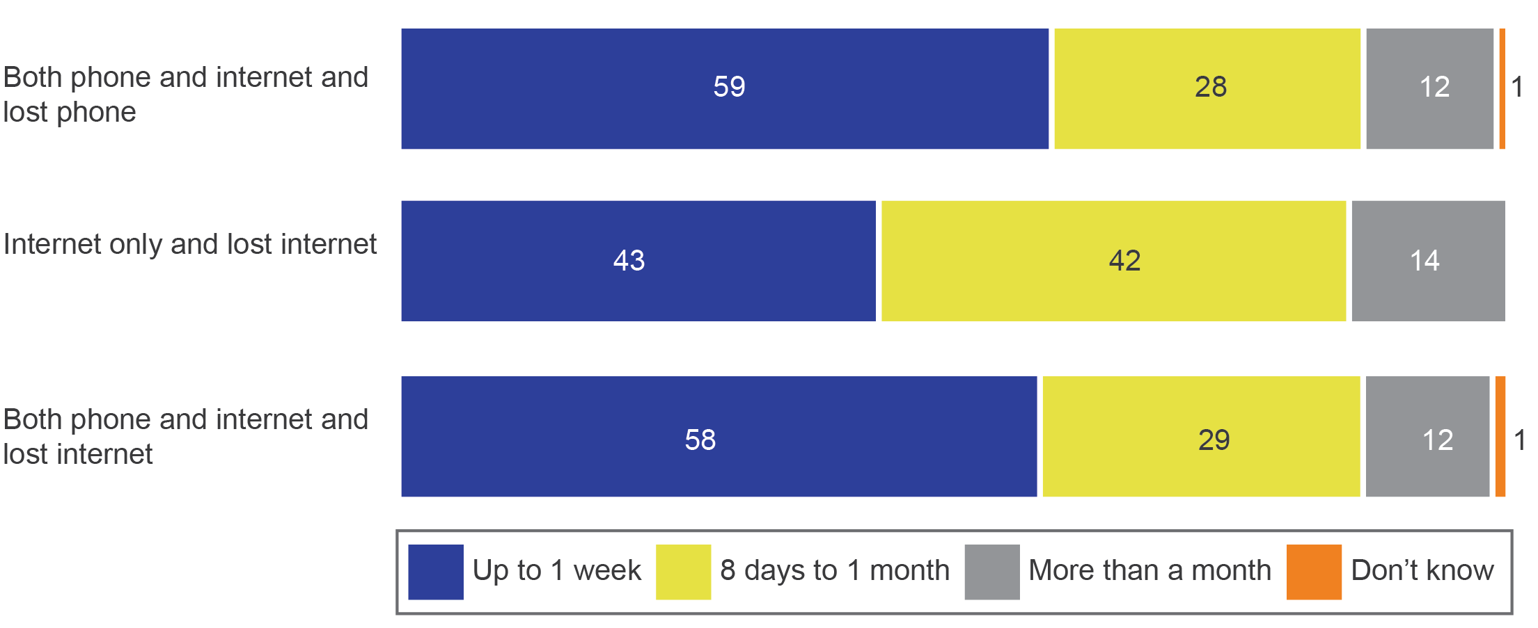

Base: Residential households connected to the NBN who lost a service: households with both phone and internet connected to the NBN and lost phone (n=440), households with both phone and internet connected to the NBN and lost internet (n=413), households with only internet connected to the NBN and lost internet (n=126).

C2. And how long were you left without any kind of home phone service once disconnected from your old service?

C3. And how long were you left without any kind of internet service at home once disconnected from your old service? Was that…?

Note: Households with phone only and lost phone are not shown due to small sample size (n=32). Data may not add up to 100 per cent due to rounding.

### Timeliness of connection and satisfaction with the process

Households were asked to consider the time between signing up to a plan and being able to use their service(s). Nearly half (46 per cent) thought the time taken was about what they expected. Around one-third (31 per cent) thought it took longer than expected and one in five (21 per cent) thought the time to connect was shorter than expected.

Households were asked to indicate their satisfaction with the process of connecting:

* two-thirds (68 per cent) were satisfied (25 per cent ‘very satisfied’ and 43 per cent ‘satisfied’)
* one in 10 was ‘neither satisfied nor dissatisfied’ (11 per cent)

one-fifth was dissatisfied (11 per cent ‘dissatisfied’ and nine per cent ‘very dissatisfied’).

Those connected with HFC (compared with all other technology types) were more likely to be ‘very dissatisfied’ with the connection process (17 per cent vs eight per cent). Those connected via satellite were more likely to be ‘very satisfied’ (40 per cent vs 25 per cent), compared with all other technologies.

There was no difference in satisfaction with the connection process in terms of when (either earlier or later in the research period) households connected to services delivered over the NBN.

Households were more likely to be satisfied with the connection process if they had received information from RSPs before connection (72 per cent vs 60 per cent). Usefulness of this information was also a key driver of satisfaction—75 per cent of those who received information and found it useful were satisfied with the connection process, compared with 53 per cent of those who received RSP information but did not find it useful (Figure 12).

Households who found the time between plan selection and using their service(s) to be shorter than expected were more likely to be satisfied with the overall connection process (86 per cent satisfied) than those who found the time longer than expected (41 per cent satisfied) (Figure 12).

1. Satisfied with the connection process and aspects of connecting (%)

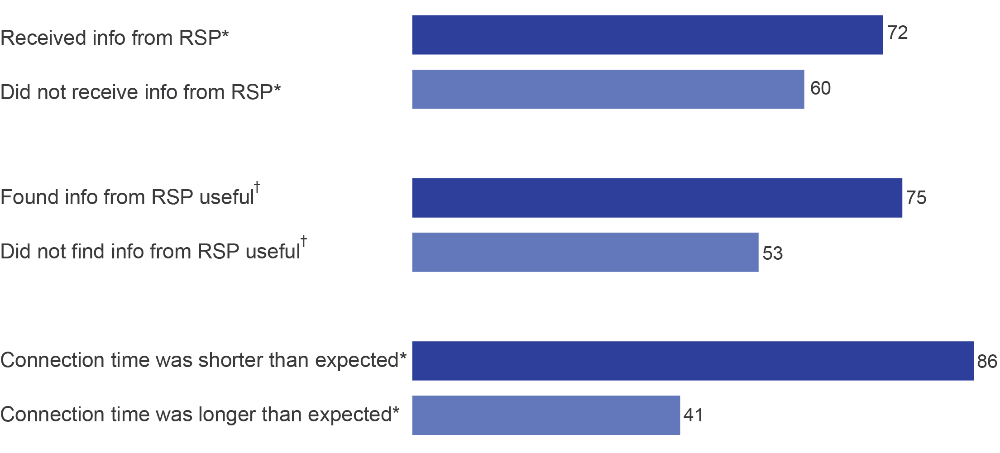

*All households connected to the NBN.

†Households connected to the NBN who received information from RSPs.

Base: Residential households connected to the NBN (n=1,881), residential households who received information from RSP (n=1,298).

C19. Overall, how satisfied or dissatisfied were you with the process of connecting to the NBN? Would you say you were…?

B7. Do you recall receiving information in the post or via email that came directly from service providers?

B8. Overall, how useful or not useful was this information from service providers in informing your household about how to connect to the NBN? Was it…?

C4. Now thinking about the time between signing up to a plan and being able to use your service, was it…?

Note: Those who recalled or did not recall receiving information from NBN Co do not show a difference in satisfaction with the connection process.

Being left without service during connection had an impact on levels of overall satisfaction with the connection process. While over three-quarters (78 per cent) of those who did not lose service during connection were satisfied, only half of those who lost service (50 per cent) were satisfied with the connection process.

The length of time spent without service during connection also had an impact on household satisfaction with the connection process. Four in five (82 per cent) of those without service for up to 24 hours were satisfied with the connection process. This figure dropped to 51 per cent for those without service for between one day and a week, and to 31 per cent for those without service for one week or more.

Nearly one-third (32 per cent) of those dissatisfied with the connection process had a technician miss a scheduled appointment. For those who were satisfied with the connection process, only five per cent had experienced a missed appointment.

## After migration

### Issues or faults since connection

Seven in 10 (71 per cent) of all households experienced an issue or fault with their service after connection, while 27 per cent did not.

The proportion of households experiencing faults and issues was lower for those connected for a shorter period of time—81 per cent for those who connected in November and December 2016, and steadily declining to 60 per cent for those who had been connected for a shorter period of time (connected in October to December 2017).

Those with internet only were more than twice as likely (75 per cent) to have experienced an issue or fault as those with only a home phone (32 per cent) (Figure 13).

1. Issues or faults since connection, by service (%)

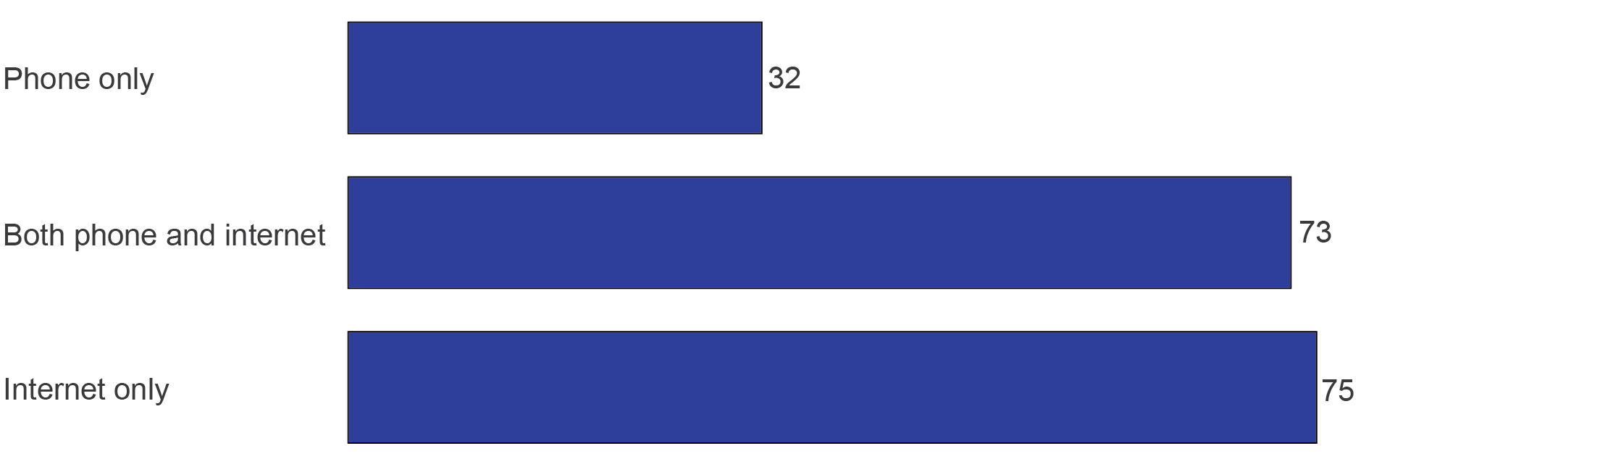

Base: Residential households with both phone and internet connected to the NBN (n=1,288), residential households with home phone only connected to the NBN (n=124), residential households with internet only connected to the NBN who experienced any type of fault or issue (n=469).

D5. Since connecting to the NBN, have you experienced any issues or faults with your NBN service/s, such as...?

The most frequently mentioned issue or fault for all households was drop-outs (49 per cent)—nearly twice the rate of service outages (28 per cent) (Figure 14).

One in six (15 per cent) of those with a home phone had experienced poor voice quality. One-third of internet households experienced slow data speeds in the evening (36 per cent), slow data speeds in general (33 per cent) and interruptions and buffering (31 per cent) (Figure 14).

Households with both a home phone and internet, or those with internet only experienced a very similar rate overall of issues and faults (73 per cent and 75 per cent, respectively). However, home phone-only households were much less likely to experience any issue or fault (32 per cent). Households with both phone and internet, or internet only, experienced similar rates of drop-outs (50 per cent and 53 per cent respectively). Those with just a home phone were less likely to experience drop-outs (15 per cent). There were similar patterns for service outages—30 per cent for both phone and internet, and 29 per cent for internet-only households. For home phone-only households, the rate was much lower at six per cent (Figure 14).

1. Issues or faults since connecting (%)

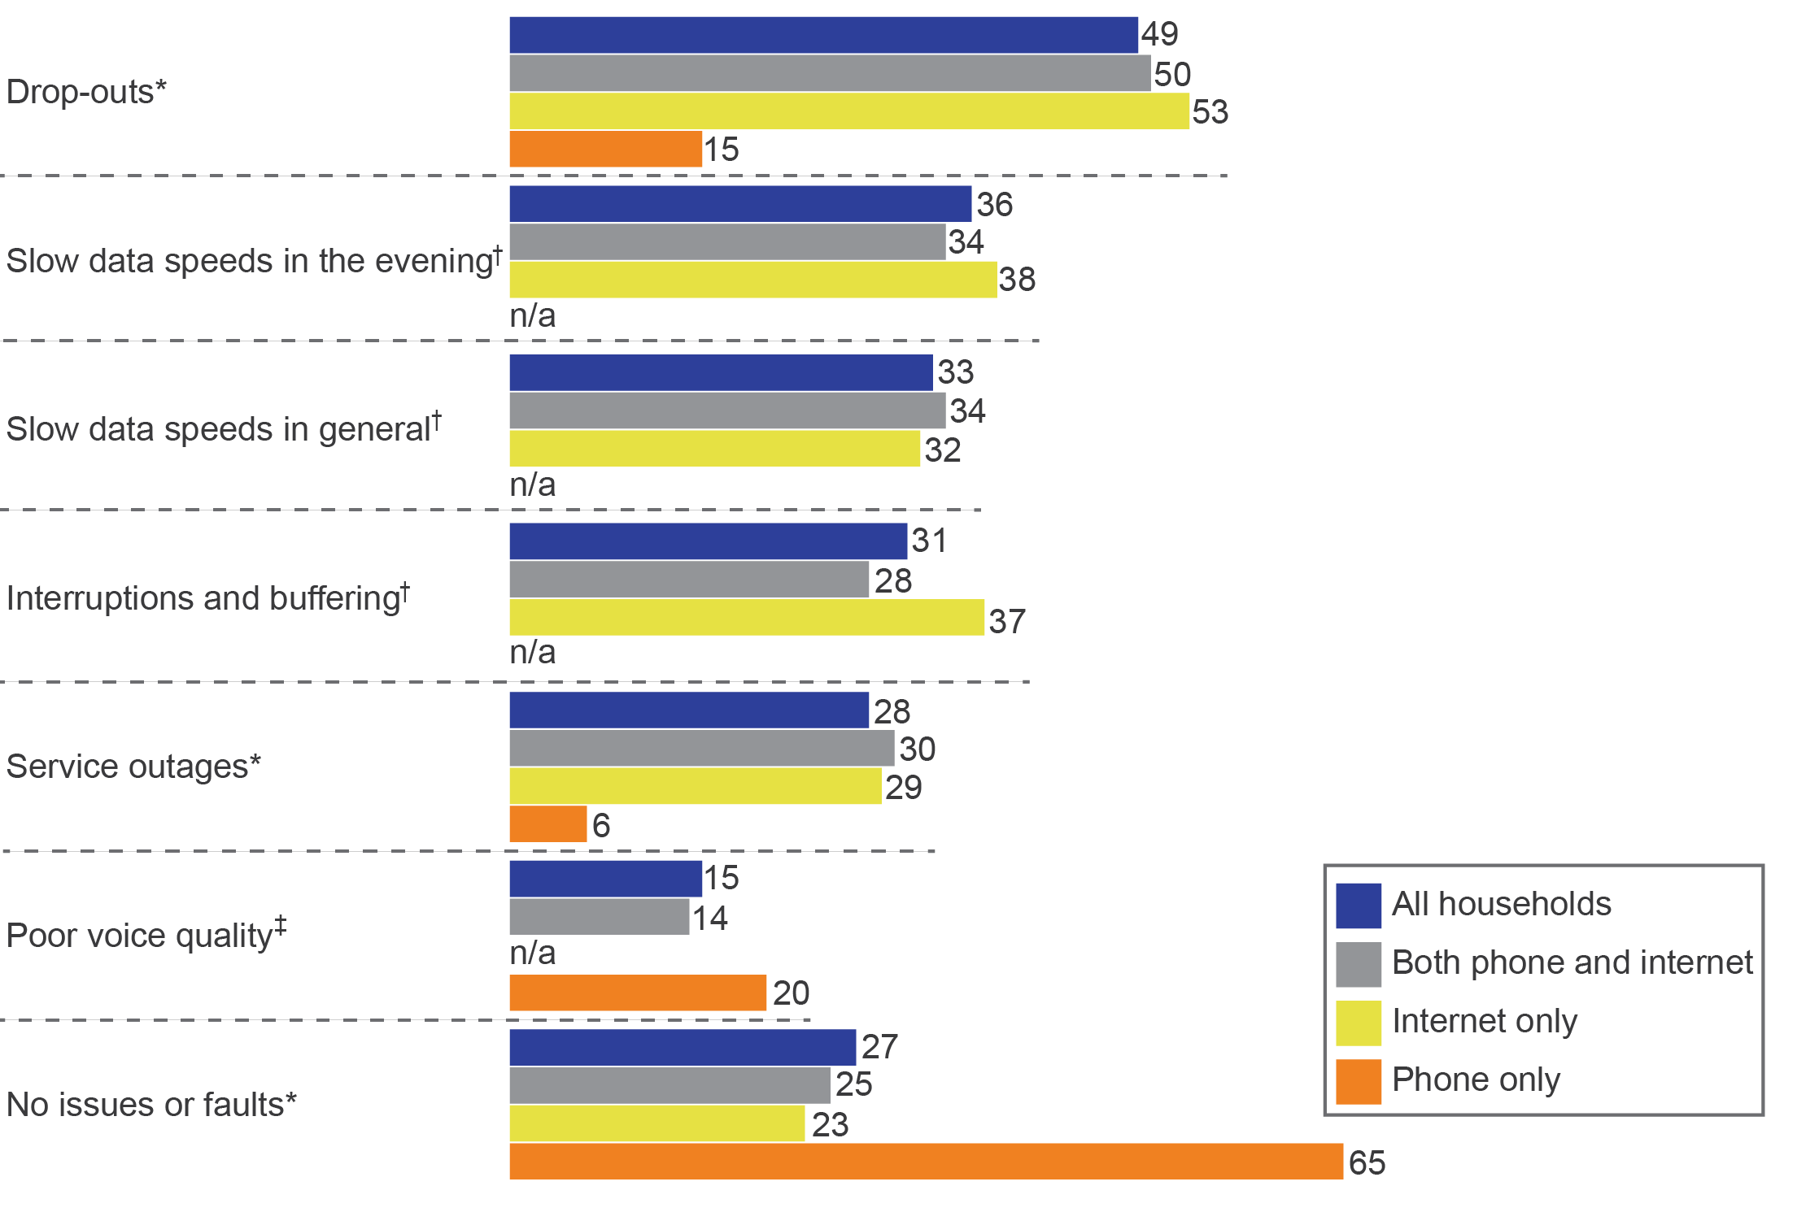

n/a=not applicable.

*All households connected to the NBN.

†Households with internet connected to the NBN.

‡Households with home phone connected to the NBN.

Base: Residential households connected to the NBN (n=1,881), residential households with both home phone and internet connected to the NBN (n=1,288), residential households with internet only connected to the NBN (n=469), residential households with phone only connected to the NBN (n=124).

D5. Since connecting to the NBN, have you experienced any issues or faults with your NBN service/s, such as…?

Note: Data does not add to 100 per cent due to multiple responses. ‘Don’t know’ data not shown (four per cent or less for all groups shown).

Of those households who had experienced issues or faults since connecting, 35 per cent experienced one, 23 per cent experienced two and 42 per cent experienced three or more. The median number of types of issues or faults experienced was two.[12]

Households left without a service during connection were more likely than those who did not lose service to have experienced:

* an issue or fault after connection (82 per cent vs 65 per cent)

three or more different types of issues or faults (45 per cent vs 22 per cent).

Among internet households who indicated they had experienced slow data speeds in the evening, two-thirds did so often (38 per cent ‘very often’ and 30 per cent ‘often’).

Internet households who had performed speed tests were more likely to have experienced issues or faults since connecting (81 per cent compared with 69 per cent who had not performed speed tests).

Households with an internet data download speed in the 100 Mbps speed tier (89 per cent) were more likely to have experienced an issue or fault than internet households on lower speeds (74 per cent). They were also more likely to experience slow data speeds in the evening than other internet households (48 per cent vs 34 per cent).

### Main issues or faults experienced by households

Drop-outs were the issue or fault most likely to be experienced and the biggest problem for households who experienced them—at 38 per cent. Slow data speeds in general were the biggest problem for 20 per cent of internet households who experienced them, followed by slow data speeds in the evening (16 per cent) (Figure 15).

1. Issue or fault that was biggest problem for households, compared to all types experienced (%)

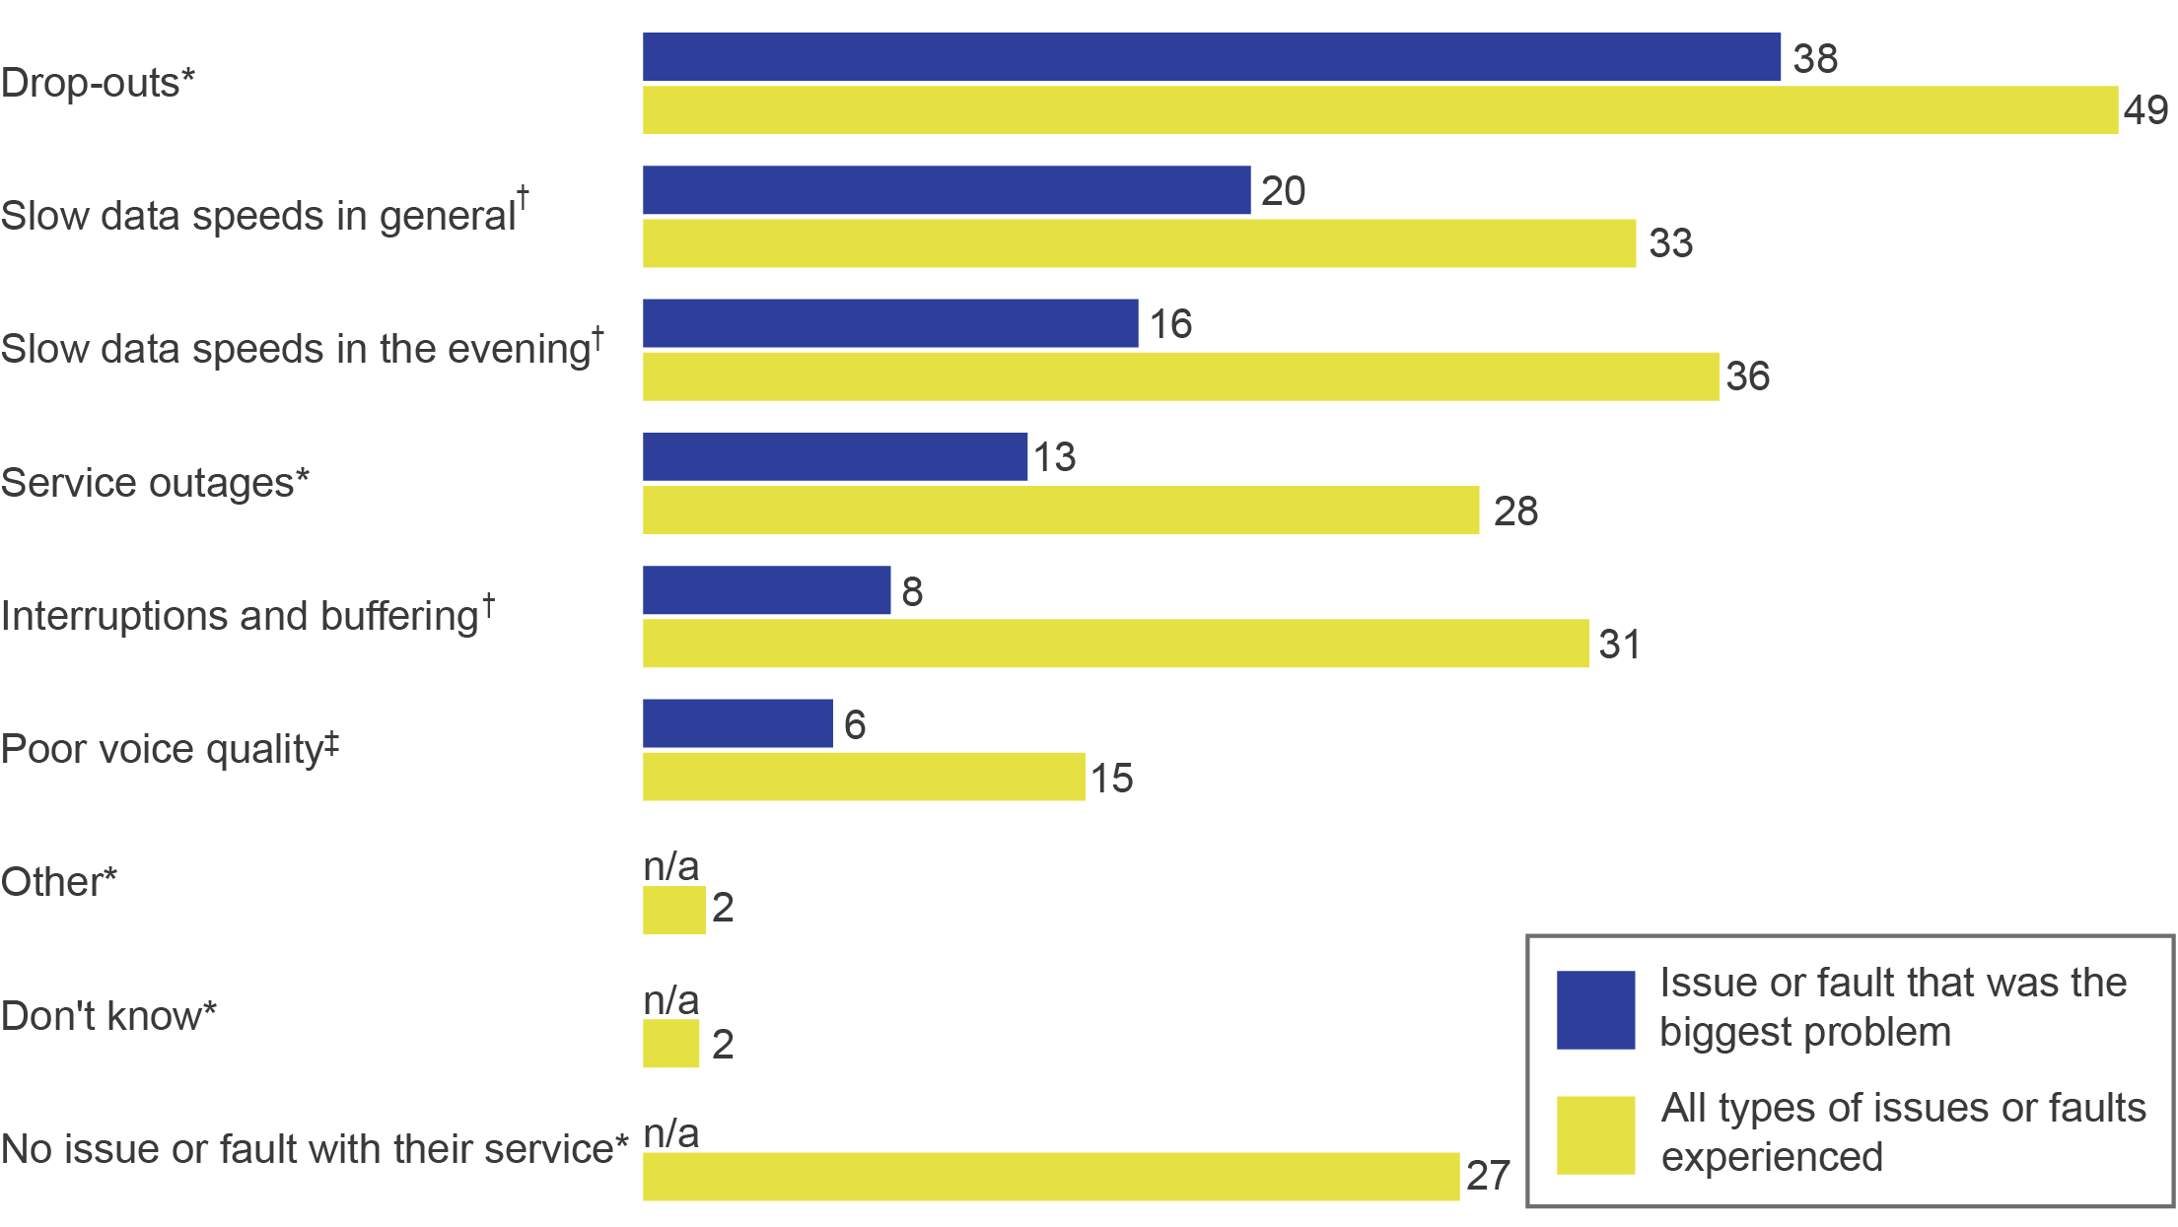

n/a=not applicable

*All households connected to the NBN.

†Households with internet connected to the NBN.

‡Households with home phone connected to the NBN.

Base: Residential households connected to the NBN (n=1,881), residential households with internet connected to the NBN (n=1,757), residential households with phone connected to the NBN (n=1,412), residential households who experienced any issue or fault (n=1,365), residential households with internet connected and experienced any issue or fault (n=1,321), residential households with home phone connected and experienced any issue or fault (n=1,015).

D5. Since connecting to the NBN, have you experienced any issues or faults with your NBN service/s, such as...?

D7a. And which issue or fault has been the biggest problem for you?

Note: Issues or faults less than two per cent not reported. Those who reported they had an issue or fault but did not know/can’t say what their issue or fault was, were not asked the biggest problem for their household.

### Complaints and main reasons

All households were asked if they had contacted their current or previous RSP to make a complaint. For consistency, all respondents were read the following definition:

A complaint is an expression of dissatisfaction made to a service provider in relation to your NBN services or their complaints-handling process, where you expect a response or a resolution.

Almost one-third of all households (31 per cent) had made at least one complaint since connecting to services delivered over the NBN. Of the households who had complained, nearly all (94 per cent) reported experiencing issues or faults since connection. Those experiencing service outages were more likely than those experiencing other types of issues or faults to complain to their RSP (57 per cent vs 45 per cent).

Those who complained without having experienced an issue or fault had done so for a range of other reasons, such as billing issues.

Households who lost service *during* connection were more likely to have made a complaint *after* connection (40 per cent) than those who did not lose service (26 per cent). Those who lost both phone and internet services (48 per cent) were more likely to complain than those who lost one service (34 per cent).

Households who were dissatisfied with the NBN connection process were twice as likely to have complained than those who were satisfied (50 per cent vs 25 per cent).

Over half (54 per cent) of those who believed their internet was either ‘slightly worse’ or ‘a lot worse’ after connection complained, compared with 24 per cent of those who indicated their internet was ‘slightly’ or ‘a lot’ better after being connected and who complained.

The presence of children in a household increased the likelihood of making a complaint, and a higher number of children in households corresponded to an increased rate of complaints.

Among all households who had made a complaint, the most frequent reason (or most recent complaint where multiple complaints were made) was drop-outs (38 per cent) (Figure 16).

1. Main reason for complaints (%)

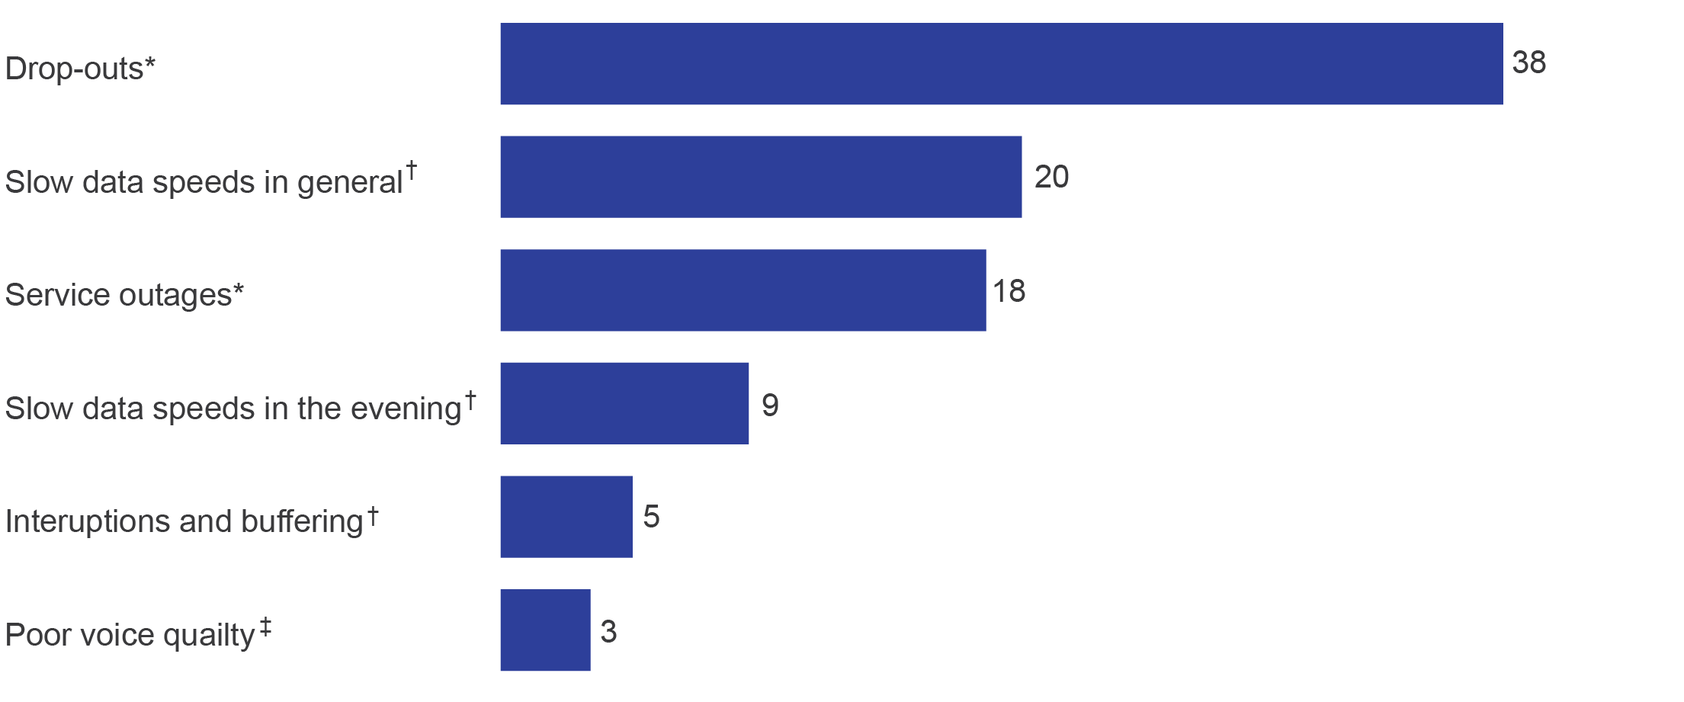

*All households connected to the NBN and complained.

†Households with internet connected to the NBN and complained.

‡Households with home phone connected to the NBN and complained.

Base: Residential households connected to the NBN who complained (n=628), residential households with internet connected and complained (n=600), residential households with home phone connected and complained (n=482).

D16. And what was the main reason for your most recent complaint?

Note: Issues/faults less than two per cent not reported. A wide range of reasons with totals less than two per cent and ‘other’ not shown.

Those who experienced a greater number of different types of issues or faults were more likely to complain. Half (50 per cent) of those who had complained experienced a median of three or more types of issues and faults, compared with 21 per cent of those who did not complain (median of one type of issue or fault). Those who did not complain (39 per cent) were more likely to have experienced no issues or faults than those who did (six per cent) (Figure 17).

1. Number of types of issues or faults experienced (%)

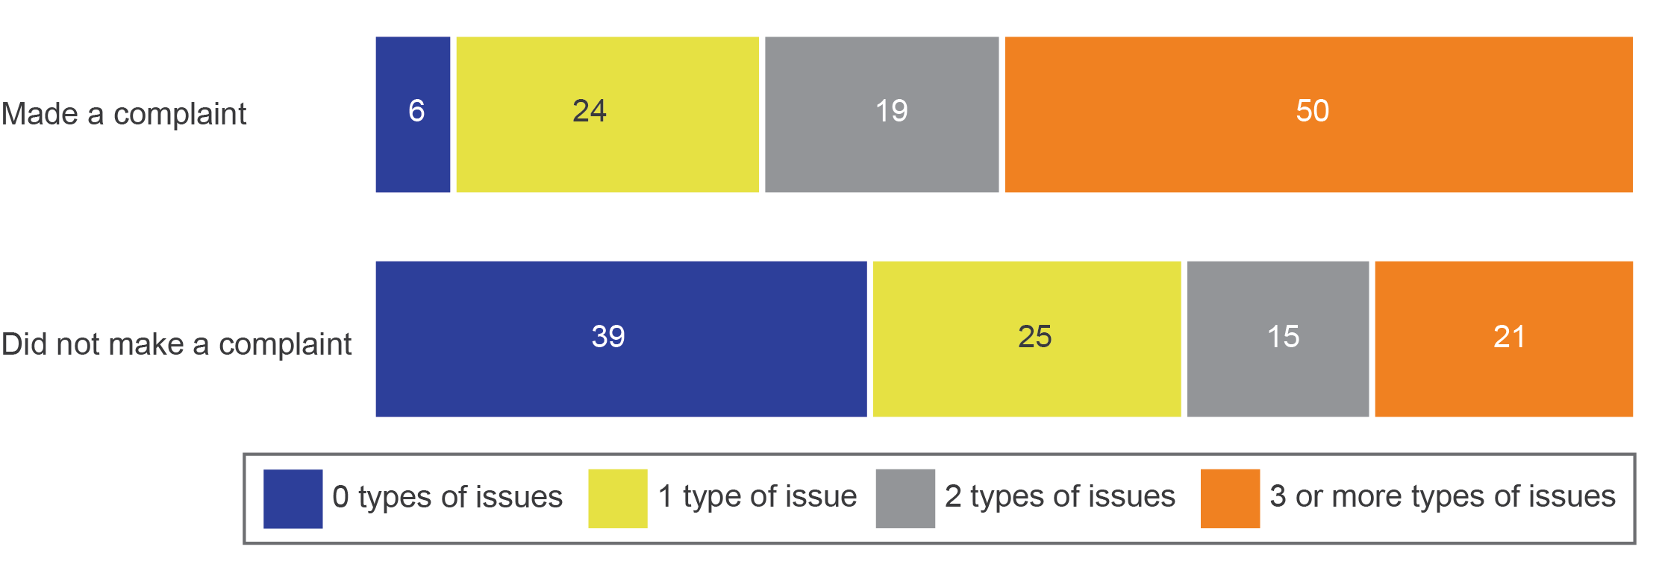

Base: Residential households connected to the NBN who complained (n=628), residential households connected to the NBN who did not complain (n=1,240).

D14b. Since connecting to the NBN, have you contacted your current and/or previous NBN service provider/s to make any kind of complaint?

Among all those households who had made a complaint after connection, the median number of complaints was three:

* one complaint—20 per cent
* two complaints—19 per cent
* three complaints—16 per cent
* four complaints—nine per cent
* five complaints—eight per cent

six or more complaints—27 per cent.[13]

While the overall incidence of complaints to RSPs was 31 per cent, there was a difference depending on when households connected. The highest rate of complaints was for households connected for longer (connected during January to March 2017—42 per cent). The rate steadily decreased to 25 per cent for those connected for the shortest period of time (connected during October to December 2017—the most recent period covered by the survey).

### Time to resolve complaints

Households were asked about the time taken to resolve their most recent complaint to their RSP. The time taken varied, with one in five complaints (20 per cent) resolved the same day the complaint was made. Nearly half of complaints (49 per cent) were unresolved at the time the data was collected (Figure 18).[14]

1. Time to resolve (among all complainants) (%)

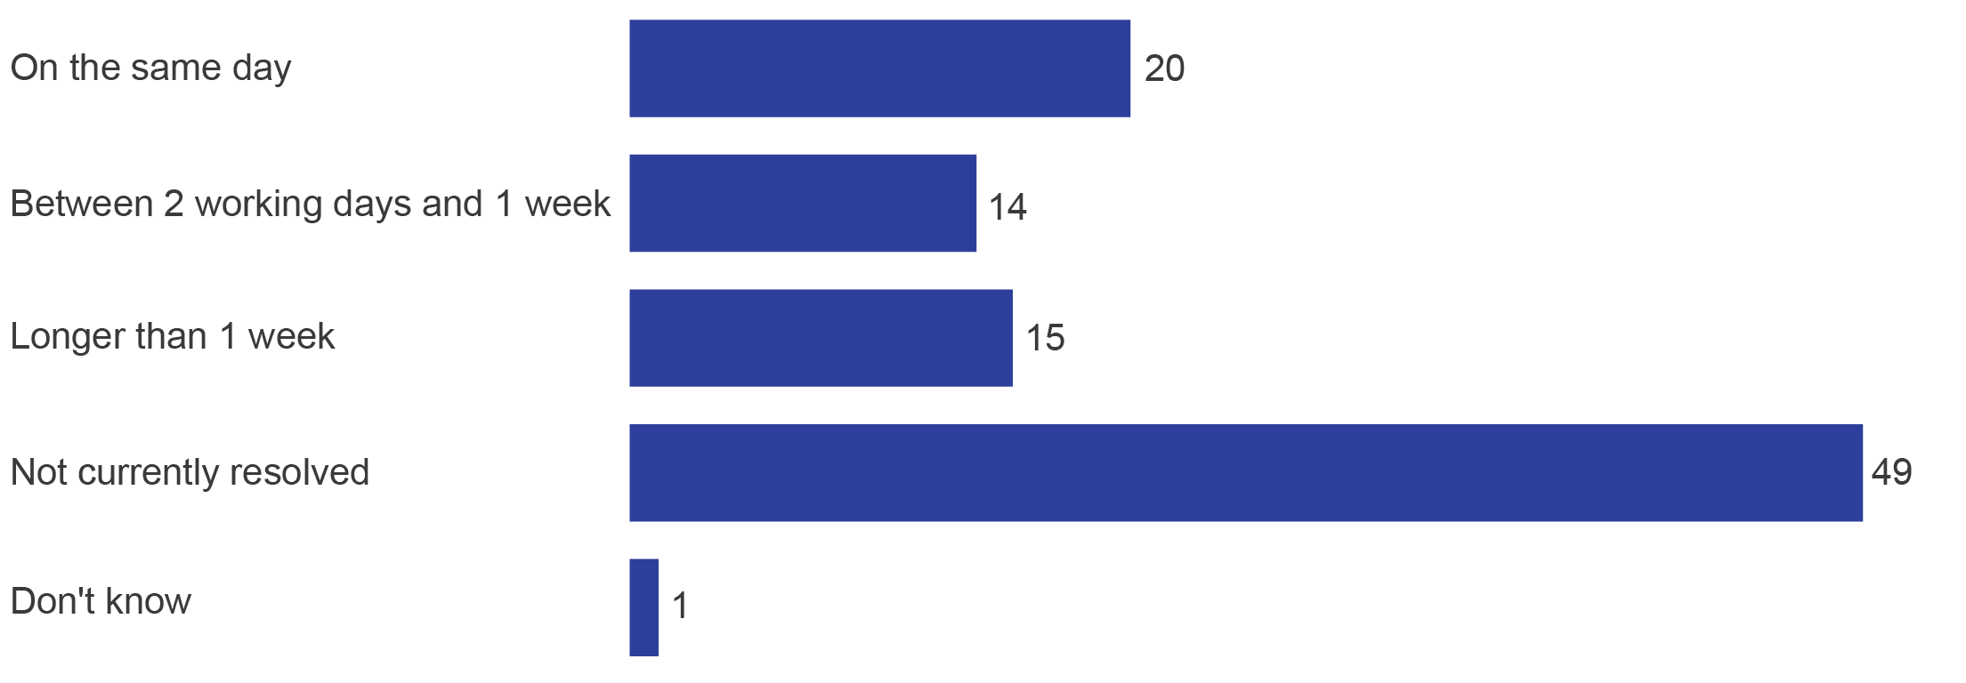

Base: Residential households connected to the NBN who complained (n=628).

D17. How long did it take to resolve the complaint? Was it resolved...?

Complaints about drop-outs were more likely to be resolved quickly compared with other types of complaints, with 26 per cent resolved on the same day the complaint was made (Figure 19).

1. Time to resolve types of complaints (among all complainants) (%)

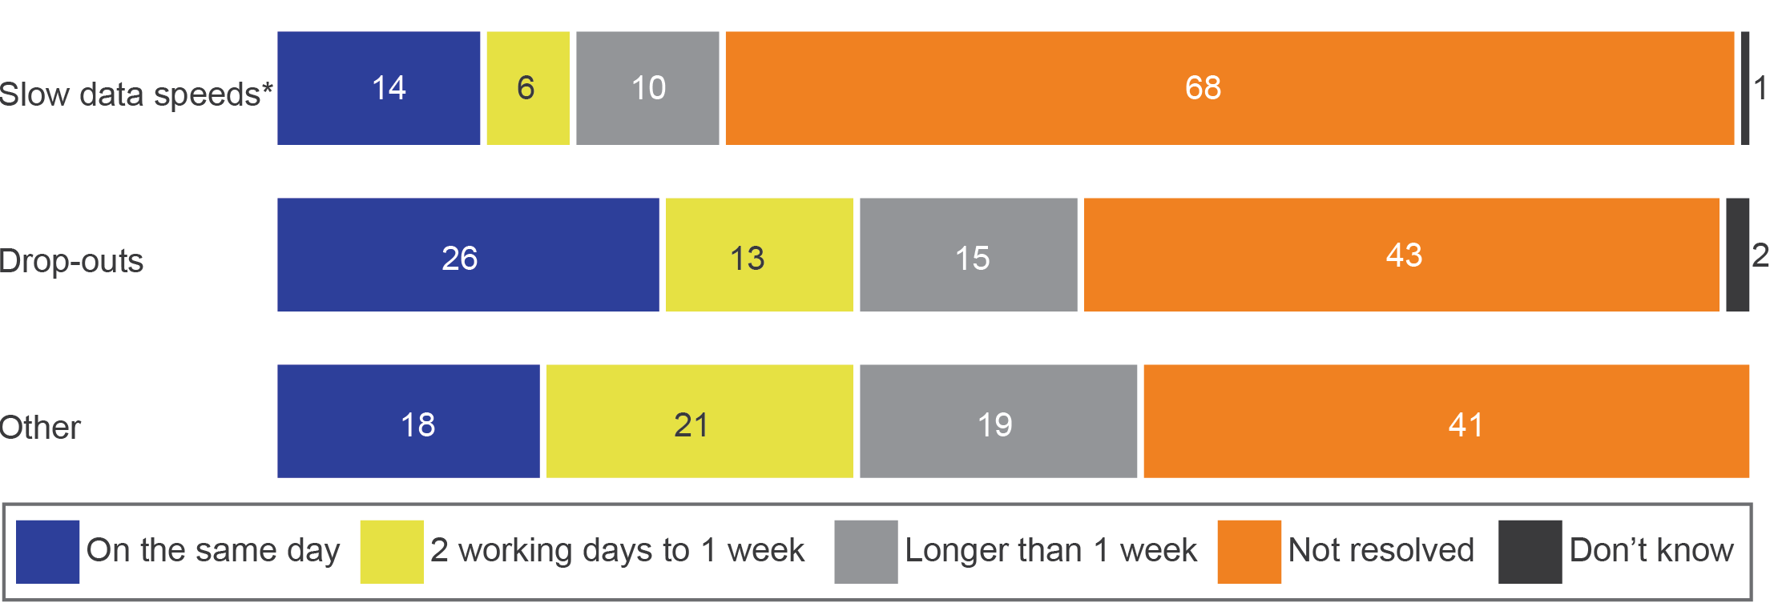

*Slow data speeds include ‘slow data speeds in the evening’ and ‘slow data speeds in general’. Households with internet connected to the NBN.

Base: Residential households with internet who made a complaint to their RSP since connecting to the NBN and most recent complaint was about slow data speeds (n=169), drop-outs (n=243) other (n=216).

D16. And what was the reason for your most recent complaint?

D17. How long did it take to resolve the complaint? Was it resolved...?

Households whose complaints had been resolved within three working days expressed a higher rate of satisfaction with their RSP’s complaints-handling process. They were more likely to be at the ‘very satisfied’ end of the scale if their complaint had been resolved within two working days (76 per cent vs 40 per cent for longer periods).

Complaints about data speeds (in the evening or in general) were more likely to be unresolved at the time of the survey than all other complaints (63 per cent vs 52 per cent).

One in five (22 per cent) of those who complained had received compensation or reimbursement as part of the complaint resolution.

Those whose complaints had taken more than a week to resolve (49 per cent) were more likely to have received reimbursement than those whose complaints were resolved in under a week (20 per cent). The reason for the complaint did not appear to have had any impact on the likelihood of receiving compensation.

### Satisfaction with complaints-handling

Households with resolved complaints were asked to rate their satisfaction with how their most recent complaint to their RSP was handled. Six in 10 (61 per cent) were satisfied and 24 per cent were dissatisfied (Figure 20).

1. Satisfaction with complaints-handling (%)

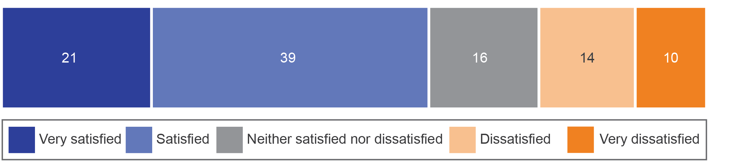

Base: Residential households connected to the NBN whose complaint was resolved at the time of survey (n=345).

D18. Overall, how satisfied or dissatisfied were you with how the complaint was handled?

Note: ‘Don’t know’ not shown due to being less than one per cent.

For those who were dissatisfied with the complaints-handling process, the most frequently mentioned reason was that ‘it took too long to fix or take action’ (58 per cent). Other reasons mentioned were ‘lack of communication or poor communication’ (48 per cent), ‘nobody would take responsibility for fixing my problem’ (39 per cent) and ‘recurring/ongoing problem’ (32 per cent).

Those who had complaints resolved on the same day (78 per cent) were more likely to be satisfied with the complaints-handling process than those who waited for one week or longer for complaint resolution (35 per cent).

Of those who made up to three complaints, 72 per cent were satisfied with the complaints-handling process. Those who had made four or more complaints were less likely to be satisfied (44 per cent).

### Households who did not make a complaint

Many households who had not made a complaint to their RSP since connecting to services delivered over the NBN still experienced issues and faults with their NBN services, though it was less common than among those who had made a complaint. Among those households who had not complained:

* 61 per cent experienced at least one type of issue or fault (vs 94 per cent who complained)

37 per cent experienced no issue or fault with their service (vs five per cent who complained).

An absence of issues or faults was a key factor in not complaining to RSPs. Nearly all (94 per cent) of those who had not experienced issues or faults since connecting had not complained to their RSP. However, for those who had experienced at least one type of issue or fault since connecting, a much lower proportion (59 per cent) had not made a complaint to their RSP (Figure 21).

1. Experiencing issues or faults and making complaints (%)

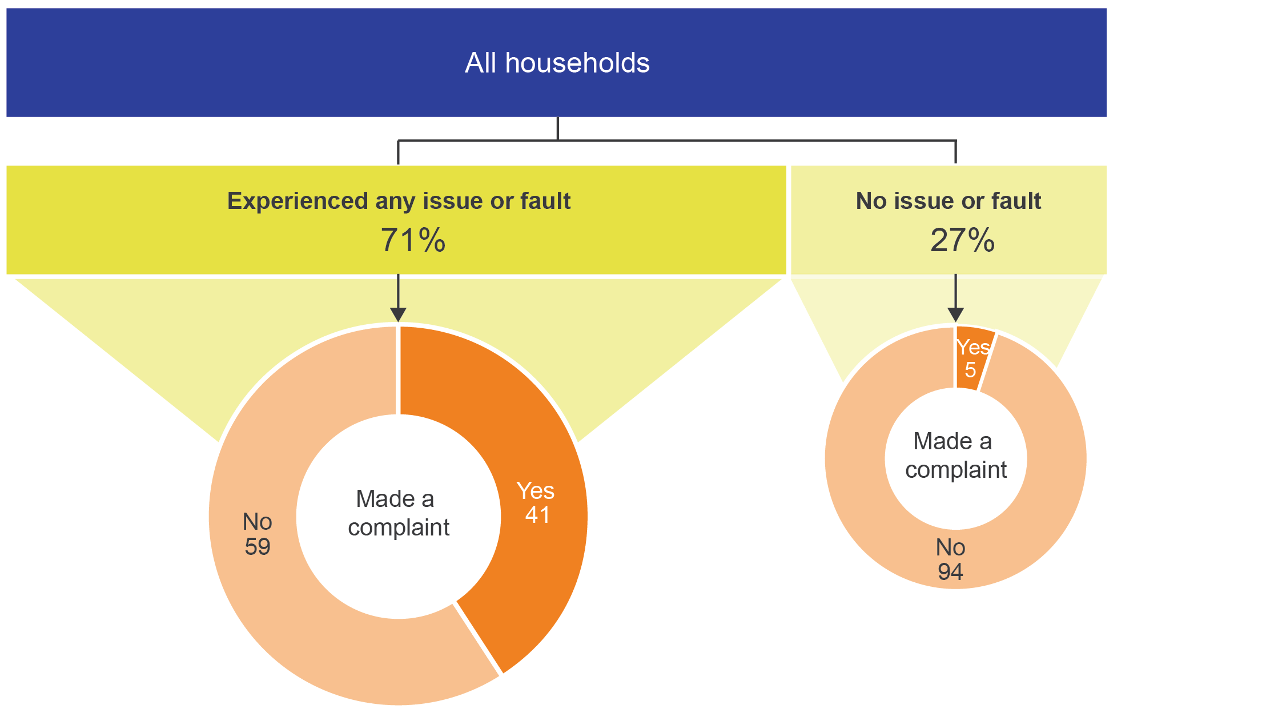

Base: Residential households connected to the NBN (n=1881), residential households connected to the NBN who experienced any issue or fault (n=1,365), residential households connected to the NBN who did not experience any issue or fault (n=491).

D5. Since connecting to the NBN, have you experienced any issues or faults with your NBN service/s, such as…?

D14b. Since connecting to the NBN, have you contacted your current and/or previous NBN service provider/s to make any kind of complaint?

Households who had not complained to their RSP had a similar pattern of issues and faults to those who had complained, though at lower rates.

Of those who did not complain, 39 per cent had experienced drop-outs (vs 71 per cent of those who complained) and 30 per cent of those with internet experienced slow data speeds in the evening (vs 48 per cent of those who complained).

The difference in the incidence of an issue or fault (between those who complained and those who did not) was largest for service outages—52 per cent of those who complained experienced service outages, and 17 per cent of those who did not complain experienced service outages.

For households who did not complain, the median number of types of issues or faults experienced was lower, at one. Those who complained without having experienced an issue or fault had done so for a range of reasons, such as billing issues.

Among those experiencing issues or faults who did not make any complaint, a minority contacted somebody about it (15 per cent). Most often, contact was made with the RSP (89 per cent) but the contact did not involve making a complaint.

For those who contacted (mainly their RSP) about their issue (but did not make a complaint), the time taken to resolve the issue was similar to the time taken to resolve complaints:

* on the same day—28 per cent
* on the second or third business day—15 per cent

unresolved at the time the data was collected—35 per cent.

Of the households who had experienced a fault or issue, and did not make a complaint, the majority (85 per cent) had not contacted anyone to seek any resolution for the fault or issue, or to take any other action (or could not recall).

### Satisfaction with NBN phone service

Households with a home phone were asked to indicate their level of satisfaction with three aspects of their service—reliability, affordability and voice quality.

Total satisfaction levels (‘very satisfied’ and ‘satisfied’) were very similar across all three measures—71 per cent for reliability, 70 per cent for affordability and 76 per cent for voice quality (Figure 22).

1. Satisfaction with aspects of NBN phone service among home phone users (%)

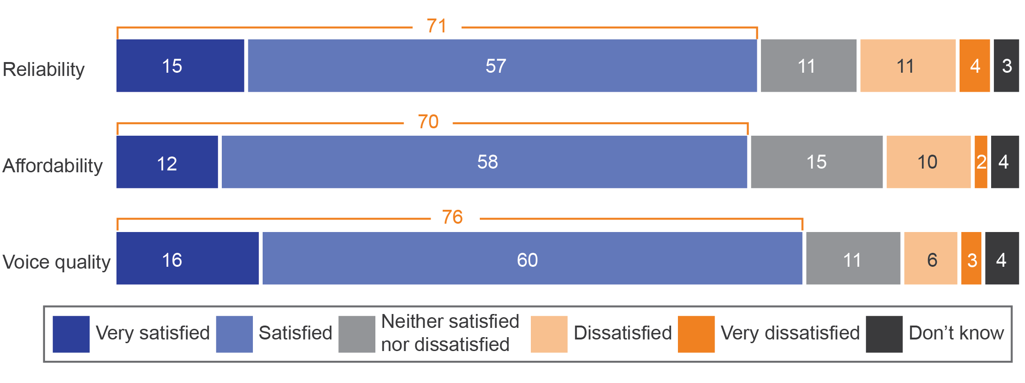

Base: Residential households with home phone connected to the NBN (n=1,412).

D23. How satisfied or dissatisfied are you with the following aspects of your NBN home phone service?

Note: Data may not add up to 100 per cent or displayed total due to rounding.

However, there were differences in satisfaction levels depending on which services the household had. Those with phone only were more satisfied with reliability (85 per cent) and voice quality (88 per cent), compared with those with both home phone and internet services (reliability 69 per cent, voice quality 75 per cent).

The occurrence (or not) of a range of events such as loss of service, an issue or fault or having made a complaint each had an impact on overall satisfaction, particularly with reliability. When there was a loss of service, or issue or fault after connection or a complaint made, overall satisfaction with phone service was lower (Figure 23).

1. Satisfaction with home phone service impacted by … (%)

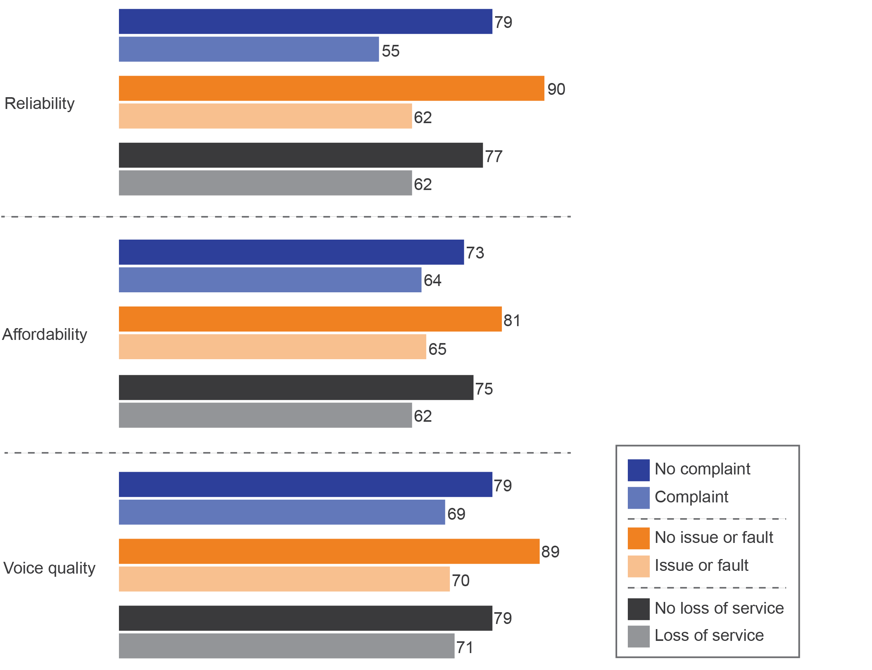

Base: Residential households connected to the NBN who lost a service (n=678) or did not lose service (n=1,163), residential households connected to the NBN who experienced any issue or fault (n=1,365) or had no issue or fault (n=491), residential households connected to the NBN who made a complaint (n=628) or did not complain (n=1,240).

D23. How satisfied or dissatisfied are you with the following aspects of your NBN home phone service? Firstly…?

C1a. Now during the process of getting connected to the NBN, was your business left without any kind or fixed line phone or internet service for three hours or more?

D5. Since connecting to the NBN; that is, from when you had a working service, have you or somebody on behalf of your business, contacted your current and/or previous NBN service provider/s to make a complaint...?

D14b. Since connecting to the NBN, have you contacted your current and/or previous NBN service provider/s to make any kind of complaint?

Households who understood what was included in the plan they chose (compared with those who did not) were more likely to be satisfied with the following aspects of their home phone:

* reliability—74 per cent vs 53 per cent
* affordability—75 per cent vs 46 per cent

voice quality—79 per cent vs 58 per cent.

For each of the three measures of satisfaction for phone households, of those who were satisfied, up to one-quarter were ‘very satisfied’ and the remainder ‘satisfied’. The data shows no difference in satisfaction between different types of connection technologies.

### Satisfaction with NBN internet service

Internet households were asked how satisfied they were with the speed of their internet service delivered over the NBN:

* half (52 per cent) were satisfied (14 per cent ‘very satisfied’ and 37 per cent ‘satisfied’)
* one in six (17 per cent) was neither satisfied nor dissatisfied

three in 10 were dissatisfied (20 per cent ‘dissatisfied’ and 10 per cent ‘very dissatisfied’).

Internet households were also asked about their satisfaction with the reliability, affordability and quality of their internet service. As with phone users, the net satisfied score was similar for all three aspects. Of those with an internet service, 62 per cent were satisfied with reliability, 69 per cent with affordability and 62 per cent with quality (Figure 24).

Household satisfaction was lowest for speed (52 per cent net satisfied) (Figure 24).

1. Satisfaction with different aspects of internet (%)

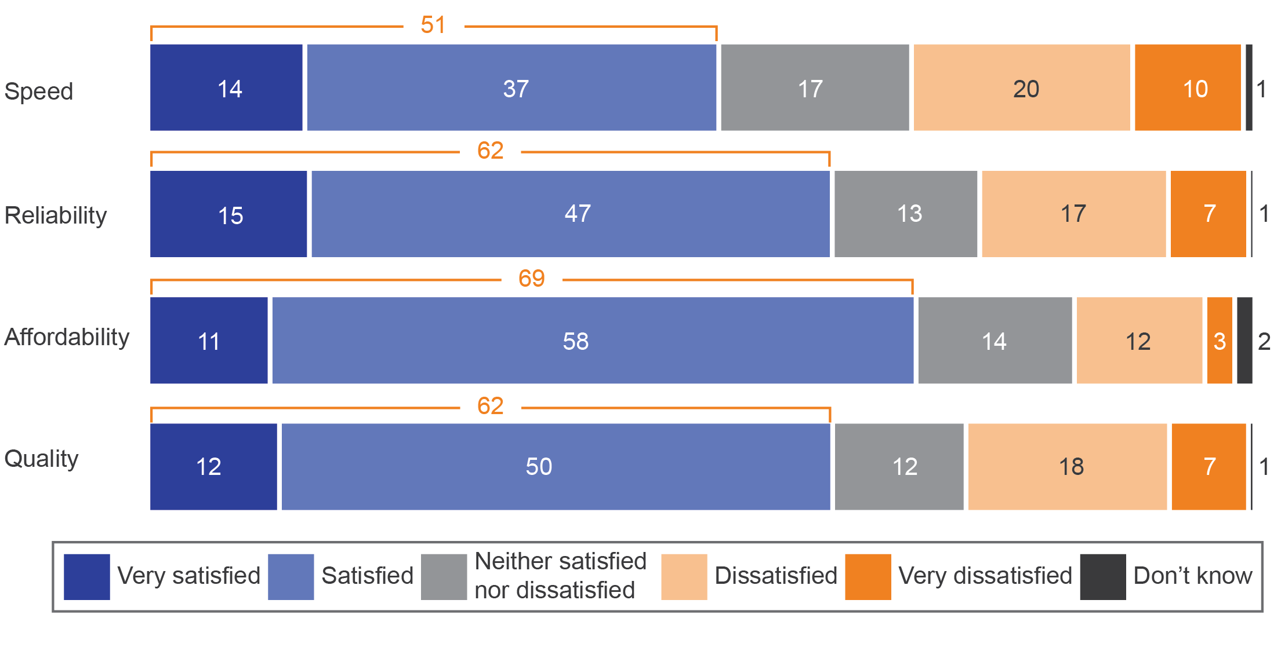

Base: Residential households with internet connected to the NBN (n= 1,757).

D4b. Now thinking about the speed of your NBN service, overall how satisfied or dissatisfied are you? Would you say...?

D25. How satisfied or dissatisfied are you with the following aspects of your NBN internet service?

Note: Data may not add up to 100 per cent due to rounding and totals may not add up due to rounding.

Overall, internet households who connected from November to December 2016 (58 per cent) were less satisfied with the affordability of their internet service than those who connected in 2017 (average of 71 per cent across the year).

In terms of reliability, satisfaction with an internet service (62 per cent) was lower than for a home phone service (71 per cent).

Experiencing a loss of service during connection or issues and faults post-connection or making a complaint after connection all had an impact on overall household satisfaction with their internet service (Figure 25).

1. Satisfaction with internet impacted by … (%)

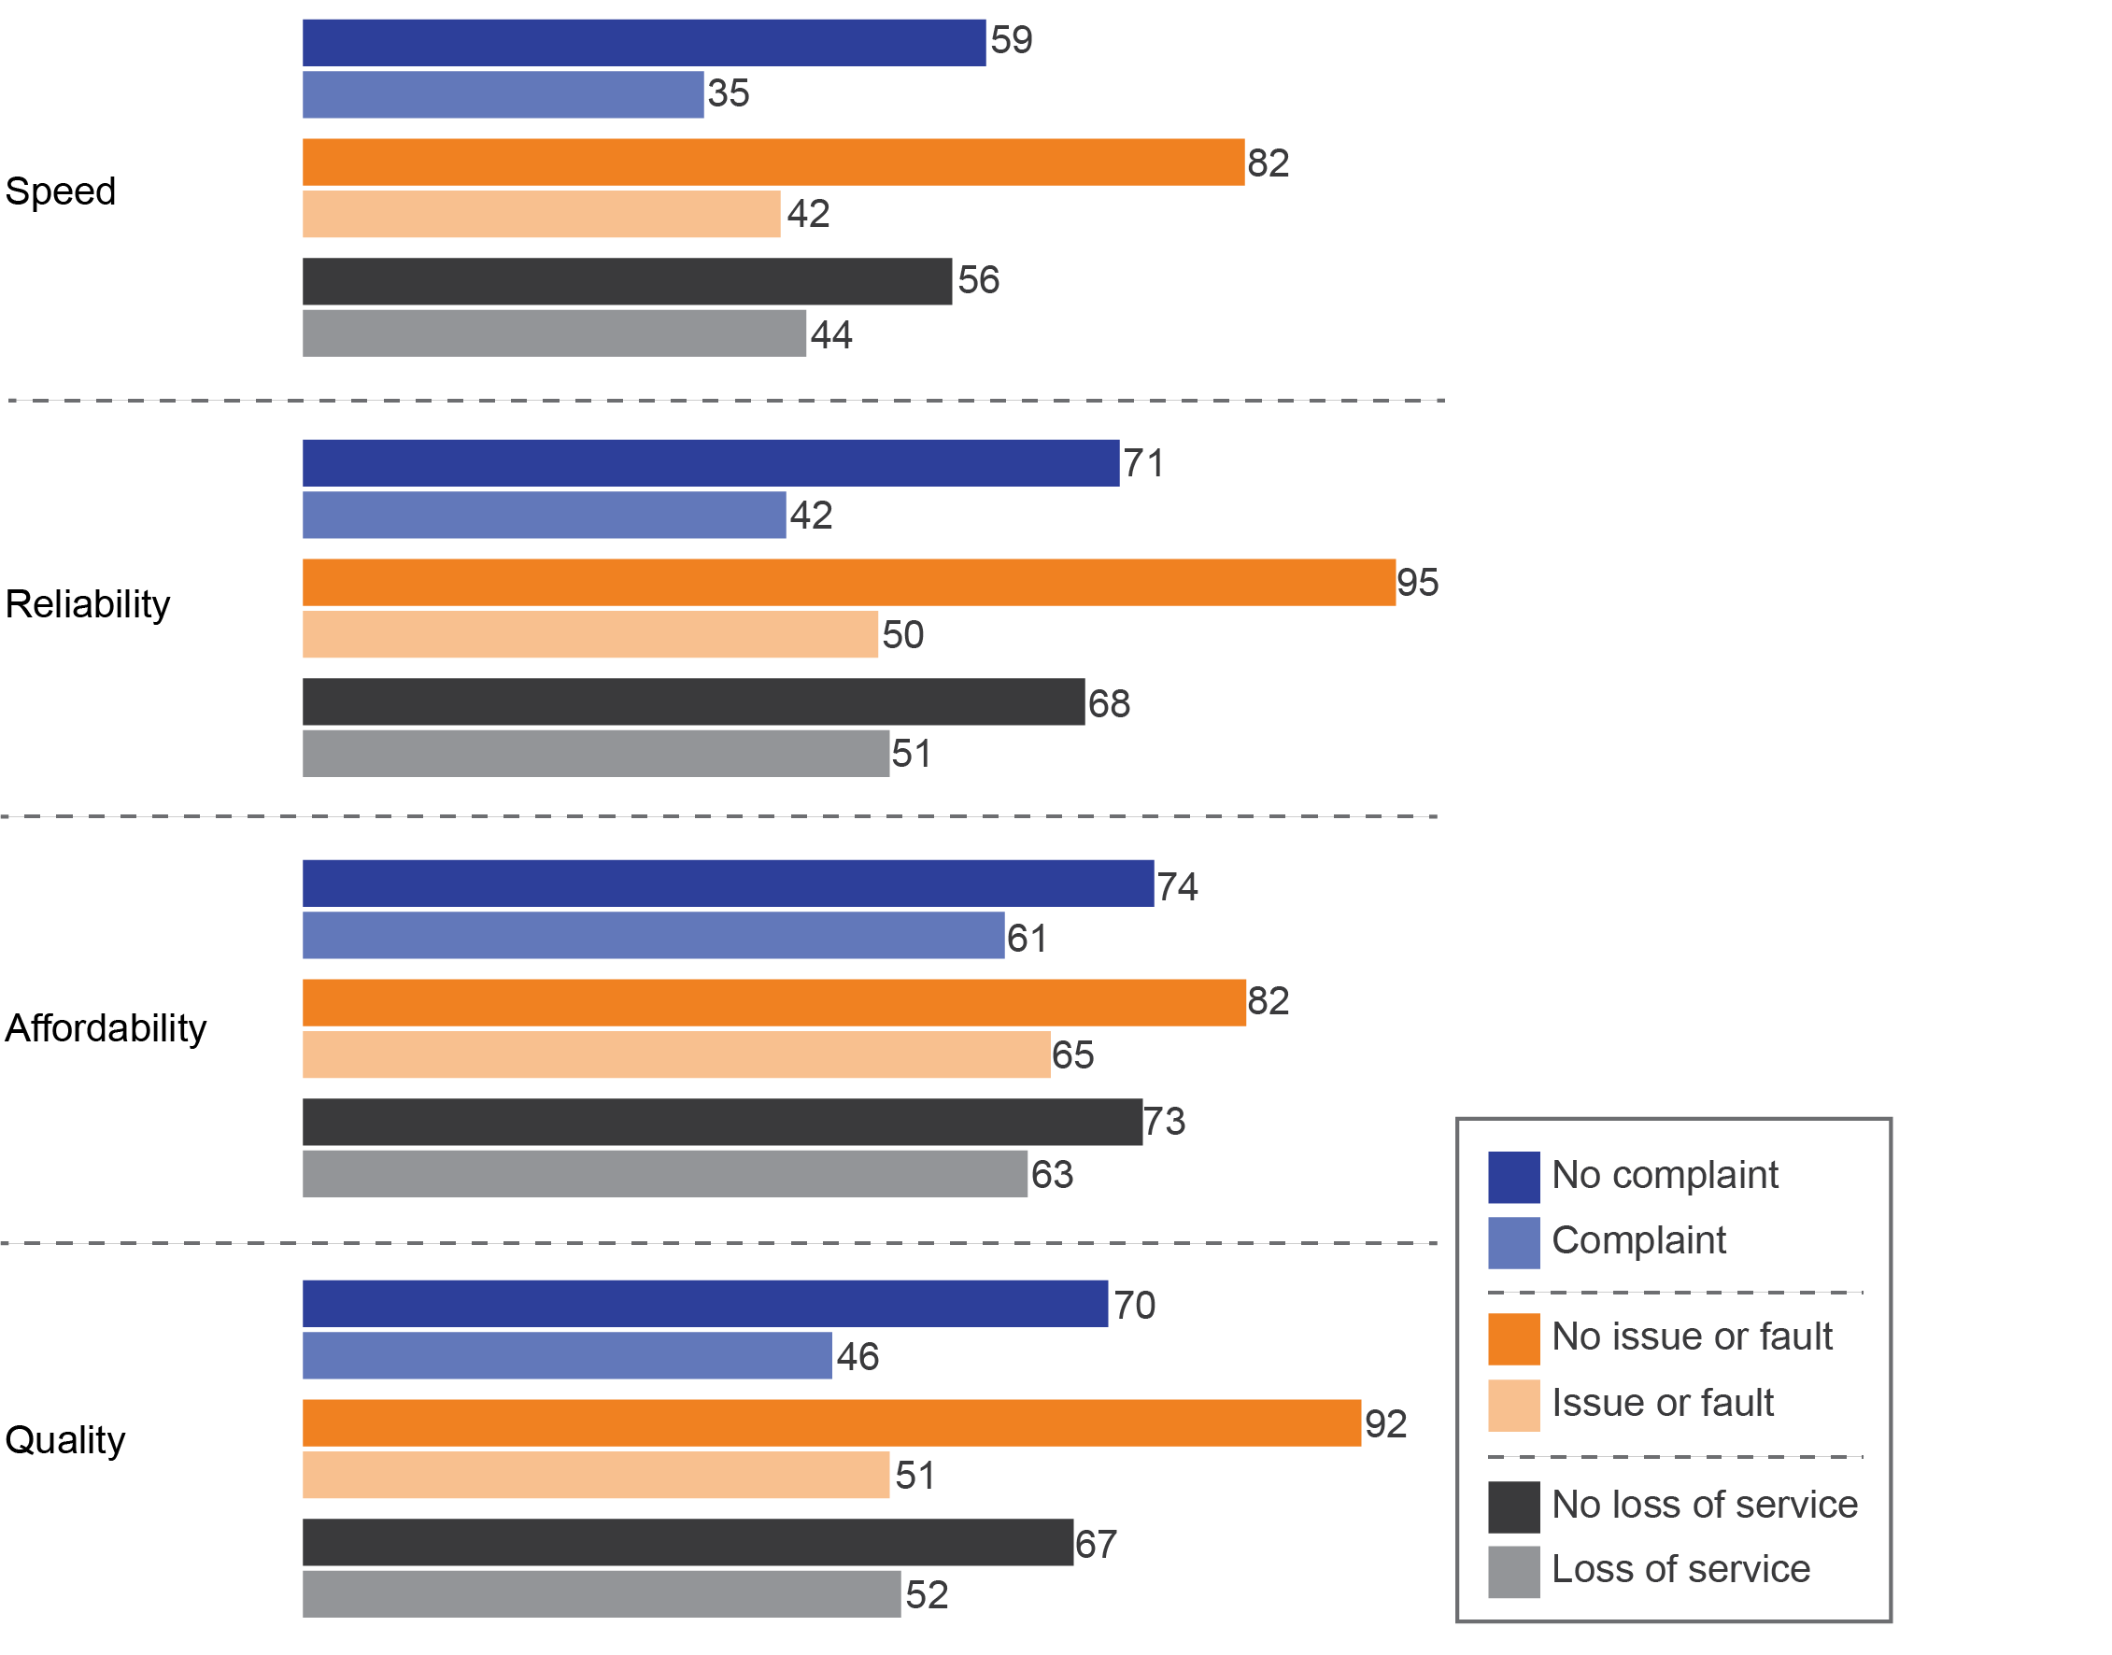

Base: Residential households connected to the NBN who lost a service (n=678) or did not lose service (n=1,163), residential households connected to the NBN who experienced any issue or fault (n=1,365) or had no issue or fault (n=491), residential households connected to the NBN who made a complaint (n=628) or did not complain (n=1,240).

D25. (Thinking now about internet services) Please indicate your level of satisfaction with the following aspects of your NBN internet service. How satisfied or dissatisfied are you with the...?

D4b. Now thinking about the speed of your NBN service, overall how satisfied or dissatisfied are you? Would you say…?

C1a. Now during the process of getting connected to the NBN, was your business left without any kind or fixed line phone or internet service for three hours or more?

D5. Since connecting to the NBN; that is, from when you had a working service, have you or somebody on behalf of your business, contacted your current and/or previous NBN service provider/s to make a complaint...?

D14b. Since connecting to the NBN, have you contacted your current and/or previous NBN service provider/s to make any kind of complaint?

Households who understood what was included in the plan they chose (compared with those who did not) were more likely to be satisfied with the following aspects of their internet:

* affordability—73 per cent vs 45 per cent
* reliability—66 per cent vs 35 per cent

quality—66 per cent vs 30 per cent.

For each of the three measures of satisfaction for internet households, of those who were satisfied, up to one-quarter were ‘very satisfied’ and the remainder ‘satisfied’. Satisfaction with reliability and quality were consistent over the time covered by the research.

Satisfaction with affordability was lower for those who connected between November and December 2016 (58 per cent satisfied) than those who connected between April and June 2017 (72 per cent satisfied) and remained stable for the remaining time covered by the research (until October to December 2017).

Satisfaction between different types of connection technologies was largely consistent, except for those connecting via HFC, who were less likely to be satisfied with reliability (53 per cent vs 63 per cent).

Internet households who were dissatisfied with reliability (compared with those who were not dissatisfied) were more likely to have complained (58 per cent vs 22 per cent) and experienced a range of issues and faults, such as:

* drops-outs (56 per cent vs 18 per cent)
* slow data speeds in the evening (63 per cent vs 23 per cent)
* slow data speeds in general (65 per cent vs 20 per cent)
* interruptions and buffering (63 per cent vs 18 per cent)

poor voice quality (26 per cent vs nine per cent).

Households who were dissatisfied with internet quality (compared with those who were not) were also more likely to have complained (57 per cent vs 24 per cent).

Those who were satisfied with the speed of their internet, or believed it was better after connection, were also more likely to be satisfied with overall reliability, quality and affordability of their internet.

Those satisfied with speed of internet after connection (compared with those who were dissatisfied) were more likely to be satisfied with:

* quality (87 per cent vs 25 per cent)
* reliability (85 per cent vs 29 per cent)

affordability (81 per cent vs 56 per cent)

Those who believed their internet was better after connection (compared with those who believed it was worse) were more likely to be satisfied with:

* reliability (84 per cent vs 21 per cent)
* quality (81 per cent vs 25 per cent)

affordability (77 per cent vs 51 per cent)

### Satisfaction with speed and comparison with previous service

Higher data download speeds for internet households did not always mean higher levels of satisfaction with speed. Satisfaction levels with speed were highest (62 per cent) for those on the fastest internet plan (100 Mbps speed tier) and lowest (44 per cent) for those on a 50 Mbps speed tier (Figure 26).

1. Satisfaction with internet by download speed tiers (%)

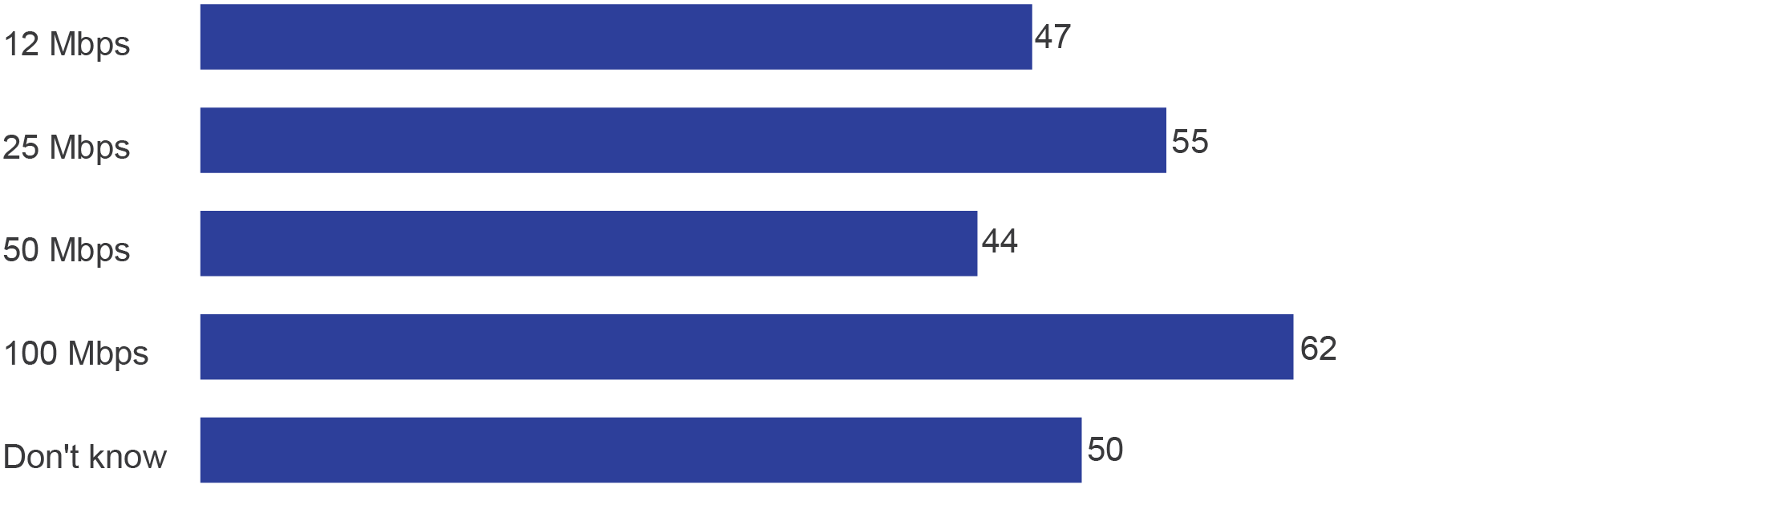

Mbps=megabits per second.

Base: Residential households with internet connected to the NBN (n=1,757).

D4b. Now thinking about the speed of your NBN service, overall how satisfied or dissatisfied are you? Would you say…?

B18b. What is the data download speed included in your NBN internet plan? Is it…?

Internet households were asked to compare their internet service before and after connecting to services delivered over the NBN. Forty-one per cent indicated their internet was better (19 per cent ‘a lot better’ and 22 per cent ‘slightly better’). For nearly one-third (31 per cent), their internet was ‘about the same’ pre- and post-connection, while one-quarter believed their internet was worse (13 per cent ‘slightly worse’ and 11 per cent ‘a lot worse’).

Internet households on a 100 Mbps speed tier plan (56 per cent) were more likely than those with slower speed internet plans (39 per cent) to say their internet was better after connection.

# Detailed findings: businesses

The survey data has been weighted to represent small and medium-sized businesses (one to 199 employees nationally, including single-site and multi-location organisations) that connected to services delivered over the NBN in the previous 12 months in the areas that were surveyed. They are referred to in this report as ‘businesses’ (Figure 27).

1. Services, technology type and plan type connected to businesses (%)

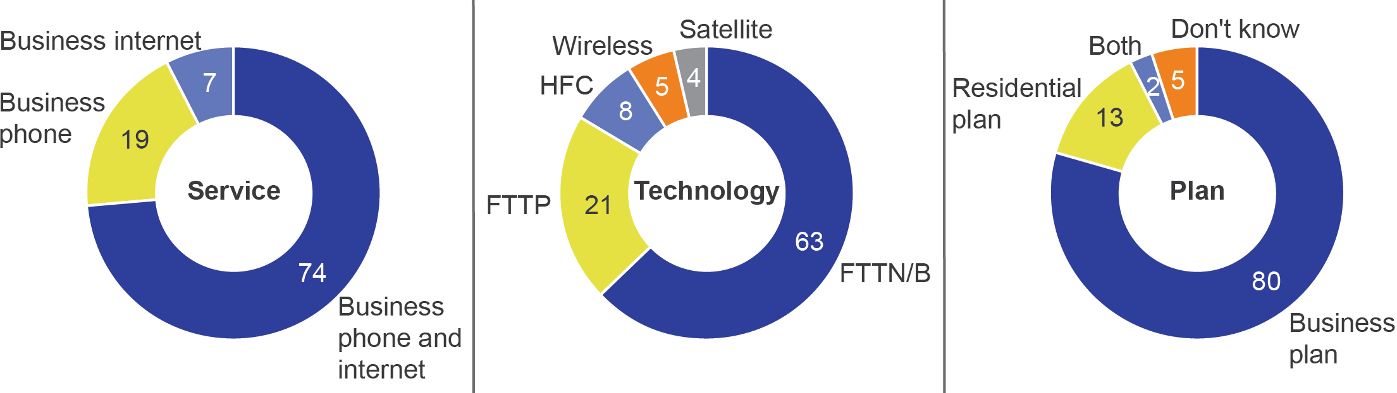

Base: Businesses connected to the NBN (n=1,153).

A10. And which services has your business connected to the NBN at this address? Firstly…?

A12. And which type of NBN connection does your household have?

B3. What kind of plan does your business use for its NBN services? Is it...?

General references to businesses in the report relate to the total sample unless otherwise specified—they are also defined in the following ways by services connected:

* All businesses connected to services delivered over the NBN or businesses with phone and/or internet connected—n=1,153 (total sample). This group includes those with both phone and internet, internet only and phone only.
* Businesses with internet connected or internet businesses—n=1,084. This group includes those with both phone and internet, and internet only.
* Businesses with phone connected or phone businesses—n=922. This group includes those with both phone and internet, and phone only.
* Businesses with both phone and internet connected—n=853.
* Business with internet only connected—n=231.

Businesses with phone only connected—n=69.

Businesses with one to four employees are more likely than those with either five to 19 employees or 20 to 199 employees to opt for a residential plan for their business.

Four in 10 (39 per cent) businesses had other services (such as an alarm, point-of-sale (POS) terminal or fax machine) connected to services delivered over the NBN, as well as their phone and/or internet.

## Before migration

### Understanding of the connection process and plans

Businesses were asked whether they agreed or disagreed with statements about services delivered over the NBN that explored their understanding of the connection process. There was a higher level of understanding of general aspects of plans—at least seven in 10 businesses understood:

* what was included in the plan they chose (78 per cent)
* that there were different download speed options to choose from (75 per cent with internet)
* the steps to prepare their business for connection (70 per cent)

the steps involved in connecting their business (69 per cent) (Figure 28).

There was a lower level of understanding about other specific aspects:

* knowing the speed their business needed (60 per cent with internet)
* understanding the different responsibilities of NBN Co and RSPs in connecting their business (55 per cent)

easily comparing what was included in different plans (47 per cent) (Figure 28).

1. Understanding of connection process and plans (%)

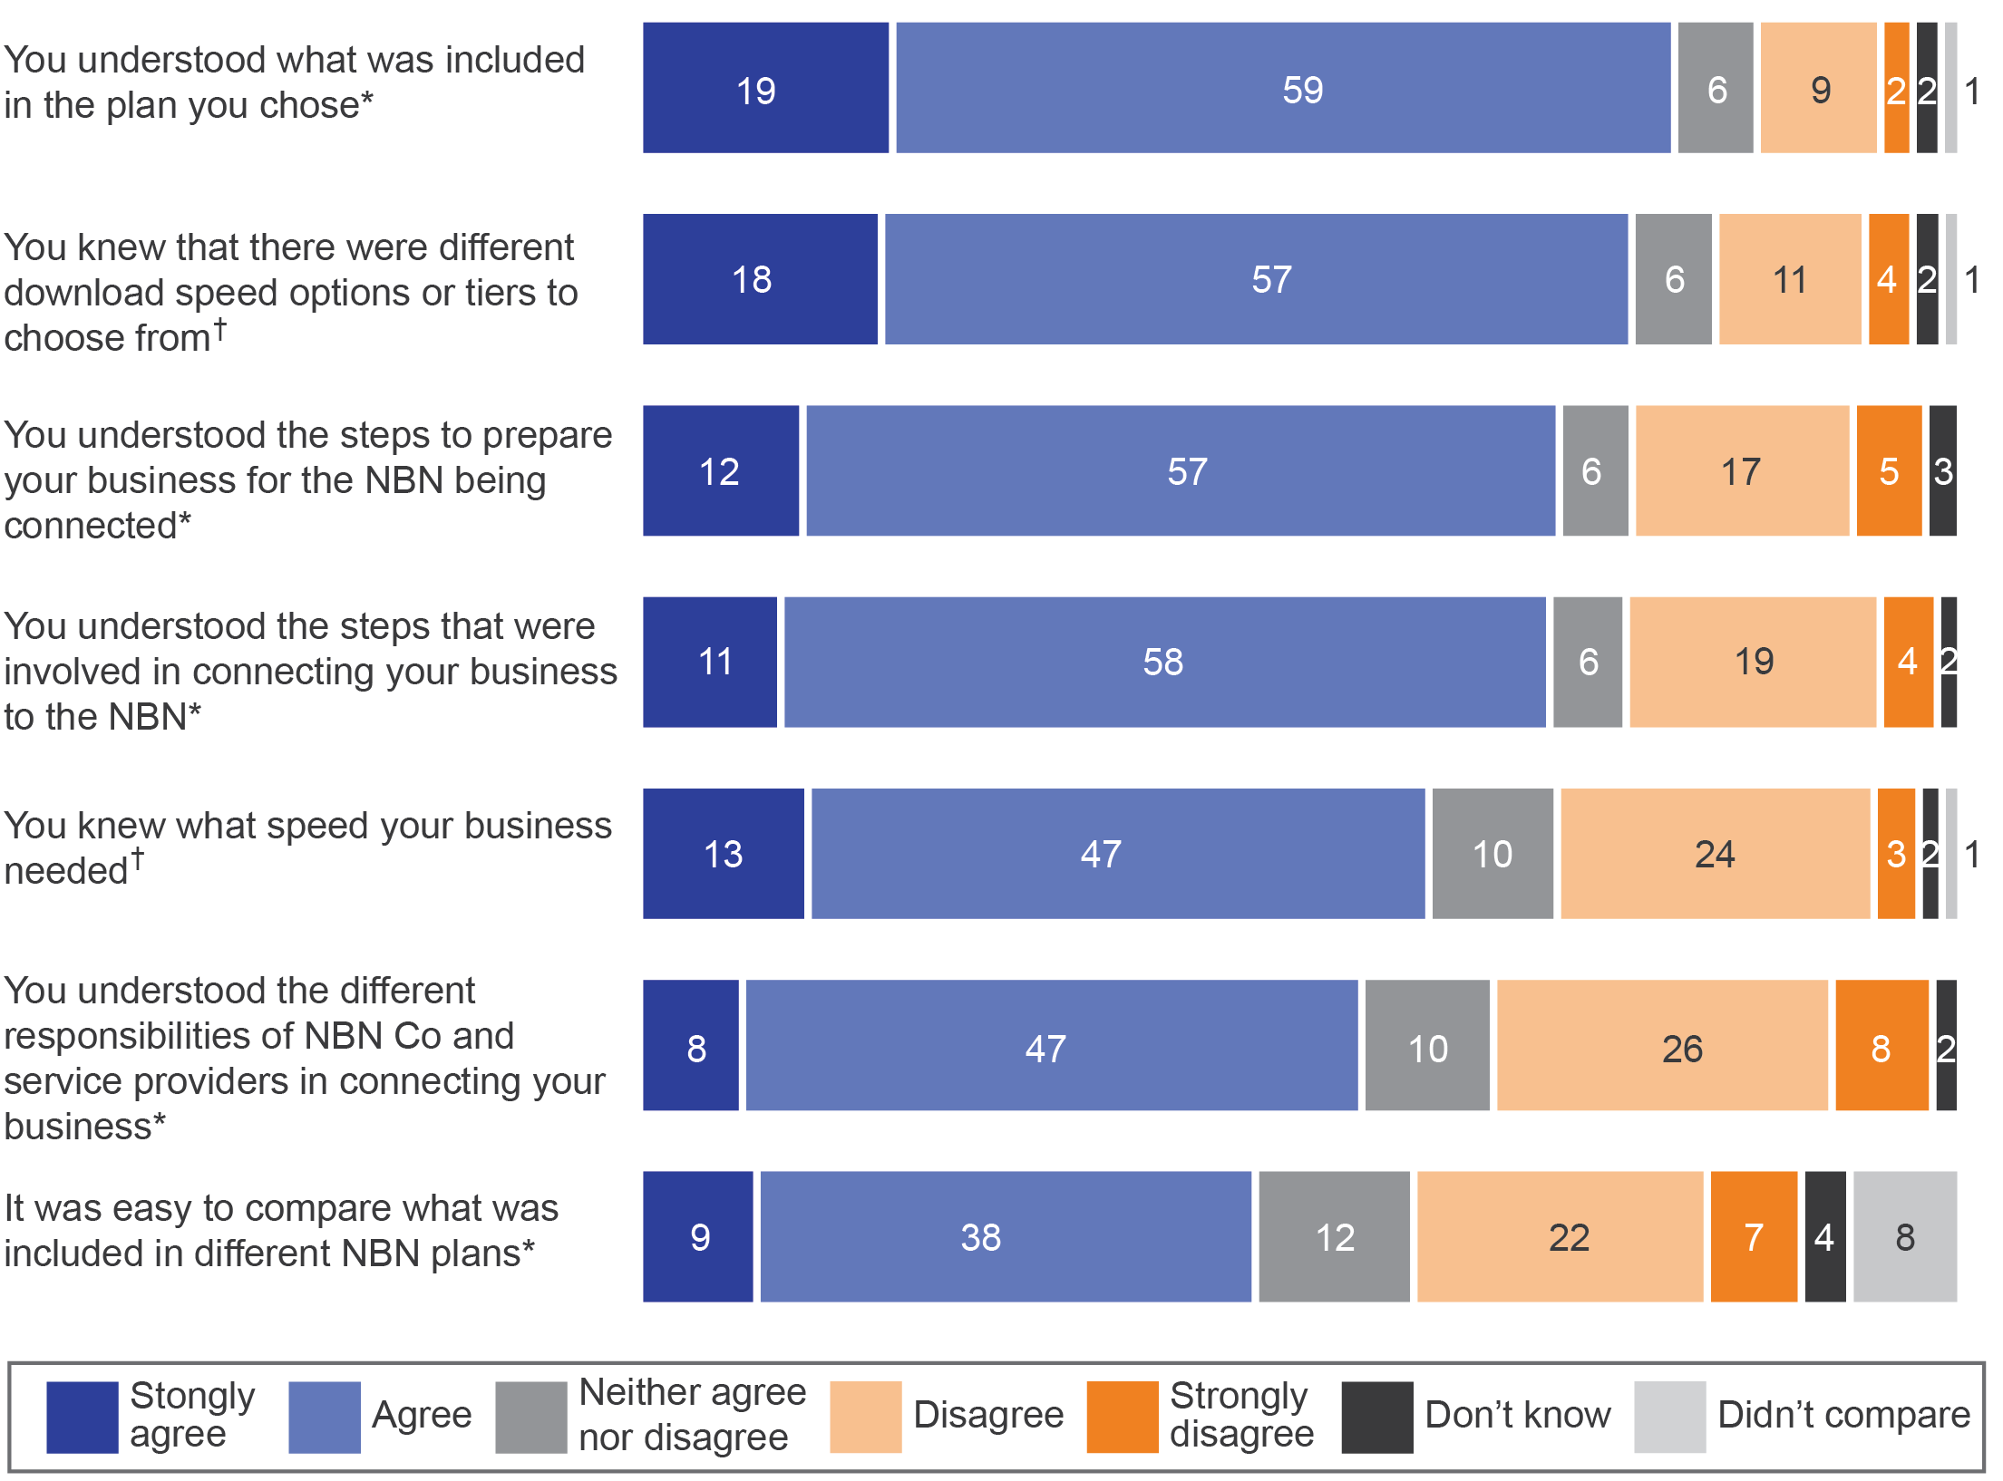

*All businesses connected to the NBN.

†Businesses with internet connected to the NBN.

Base: Businesses connected to the NBN (n=1,153), businesses with internet connected to the NBN (n=1,084).

B6. I’m going to read out some statements about the NBN. Please tell me how strongly you agree or disagree with each one.

B7. OK, now I am going to read out just three more statements about NBN information. How strongly do you agree or disagree with the following...? When choosing your NBN services, would you say that…?

Note: Data may not add to 100 per cent due to rounding. ‘Didn’t compare’ was only provided for questions in B6.

Businesses that understood the steps in connecting were more likely (compared with those who did not understand the steps) to agree that they:

* found it easy to compare plans from different RSPs (56 per cent vs 25 per cent)
* knew what speed their business needed (66 per cent vs 47 per cent)
* understood what was in the plan they chose (87 per cent vs 60 per cent)

knew there were different download speed options to choose from (82 per cent vs 60 per cent).

Businesses with an NBN residential plan were more likely (compared with those on business plans) to agree they:

* found it easy to compare what was included in different plans (64 per cent vs 44 per cent)

knew there were different download speed options to choose from (89 per cent vs 72 per cent).

For those with other services connected (POS terminal, alarm or fax machine), almost two-thirds (65 per cent) were aware they should contact the providers of such services and devices to check their compatibility before moving to services delivered over the NBN.

### Factors driving choice of plan or RSP

Businesses were asked to identify the importance of a range of factors when choosing their plan or RSP. Many factors were important to each business, with seven out of 10 the median number of important factors selected by each (Table 6).

Businesses prioritised keeping their phone number (89 per cent), confidence in faults being fixed (88 per cent) and speed of internet connection (84 per cent) (Table 6).

Twice as many businesses chose keeping their phone number over speed of internet connection as the single most important factor in choosing their plan or RSP (36 per cent vs 18 per cent).

1. Factors for businesses in choosing a plan or RSP (%)

|  | Important  (multiple selection) | Most important (choose one) |
| --- | --- | --- |
| Keeping your phone number‡ | 89 | 36 |
| Speed of internet connection† | 84 | 18 |
| Confidence in faults being fixed* | 88 | 14 |
| Cost* | 77 | 11 |
| Keeping your email address† | 80 | 8 |
| Staying with your existing service provider for continuity* | 60 | 6 |
| Amount of data included in the plan† | 69 | 3 |
| Having a designated account manager* | 37 | 2 |
| Business-specific inclusions (such as a static IP address, enhanced service levels such as fast-tracking service fault repairs)§ | 51 | 1 |
| Not being locked into a contract* | 42 | 1 |

*All businesses connected to the NBN.

†Businesses with internet connected to the NBN.

‡Businesses with phone connected to the NBN.

§Businesses that do not have only a residential NBN plan.

Base: Businesses connected to the NBN (n=1,153), businesses with internet connected to the NBN (n=1,084), businesses with phone connected to the NBN (n=922), businesses connected to the NBN who do not have a residential NBN plan (n=1,015).

B5. I’m now going to read some factors that you might have considered when choosing your business’s NBN services/plan and provider. For each one could you tell me if it was more important or less important to your business?

B5b. Which of these was the most important for your business in choosing your plan or provider?

Note: Data adds to more than 100 per cent due to multiple responses.

### Internet services—data allowances and download speeds

Businesses with internet were asked to report the data download speed in their internet plan. A little over half (55 per cent) could identify their speed, while 45 per cent were unable to confirm their plan’s data speed (Figure 29).

1. Business data download speed tiers (%)

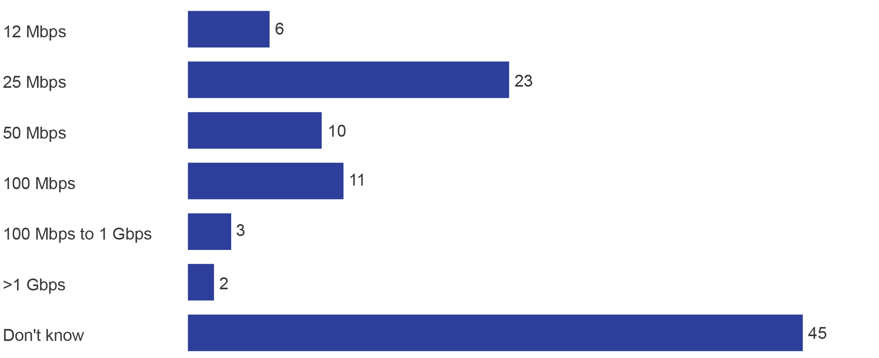

Mbps=megabits per second; Gbps=gigabits per second.

Base: Businesses with internet connected to the NBN (n=1,084).

B4. What is the data download speed included in your (business’s NBN) internet plan? Is it…?

Businesses with one to four employees at their site/location (27 per cent) were more likely to select a data download speed in the 25 Mbps speed tier than businesses with five employees or more (18 per cent), but there was little difference by business size for other internet plan speeds.[15]

Businesses on a residential plan (39 per cent) were more likely to have a 25 Mbps speed tier data download speed than those on a business plan (21 per cent).

Businesses on higher-speed internet plans (100 Mbps speed tier or more) were more likely to have selected speed of internet connection as their most important factor when choosing a plan or RSP.

### Keeping phone numbers when moving to NBN

For businesses with a phone, 94 per cent were able to keep their phone number when connecting to services delivered over the NBN.

Three-quarters of businesses with a phone (73 per cent) were advised by their RSP whether they could keep their phone number.

Due to the small sample size of those who were unable to keep their phone number when connecting, there is no further analysis for this group.

## During migration

### Installation process

After businesses ordered their plan, nearly half (47 per cent) contacted their RSP about the process of connection. The top three reasons for contact were:

* installation or set-up (40 per cent)
* issues or faults (37 per cent)

delays in connecting their service (27 per cent) (Figure 30).

Just under one quarter of businesses (23 per cent) contacted NBN Co during the process of connecting their business. Of those businesses, 72 per cent also contacted their RSP. Across all businesses, six per cent contacted NBN Co about their connection without contacting their RSP. The top three reasons for contacting NBN Co during connection were:

* issues or faults (50 per cent)
* installation or set-up (39 per cent)

delays in connecting their service (35 per cent) (Figure 30).

For most who contacted both NBN Co and their RSP, contact was made for the same reasons reason (93 per cent).

1. Reason for contacting RSP and NBN Co about connection (%)

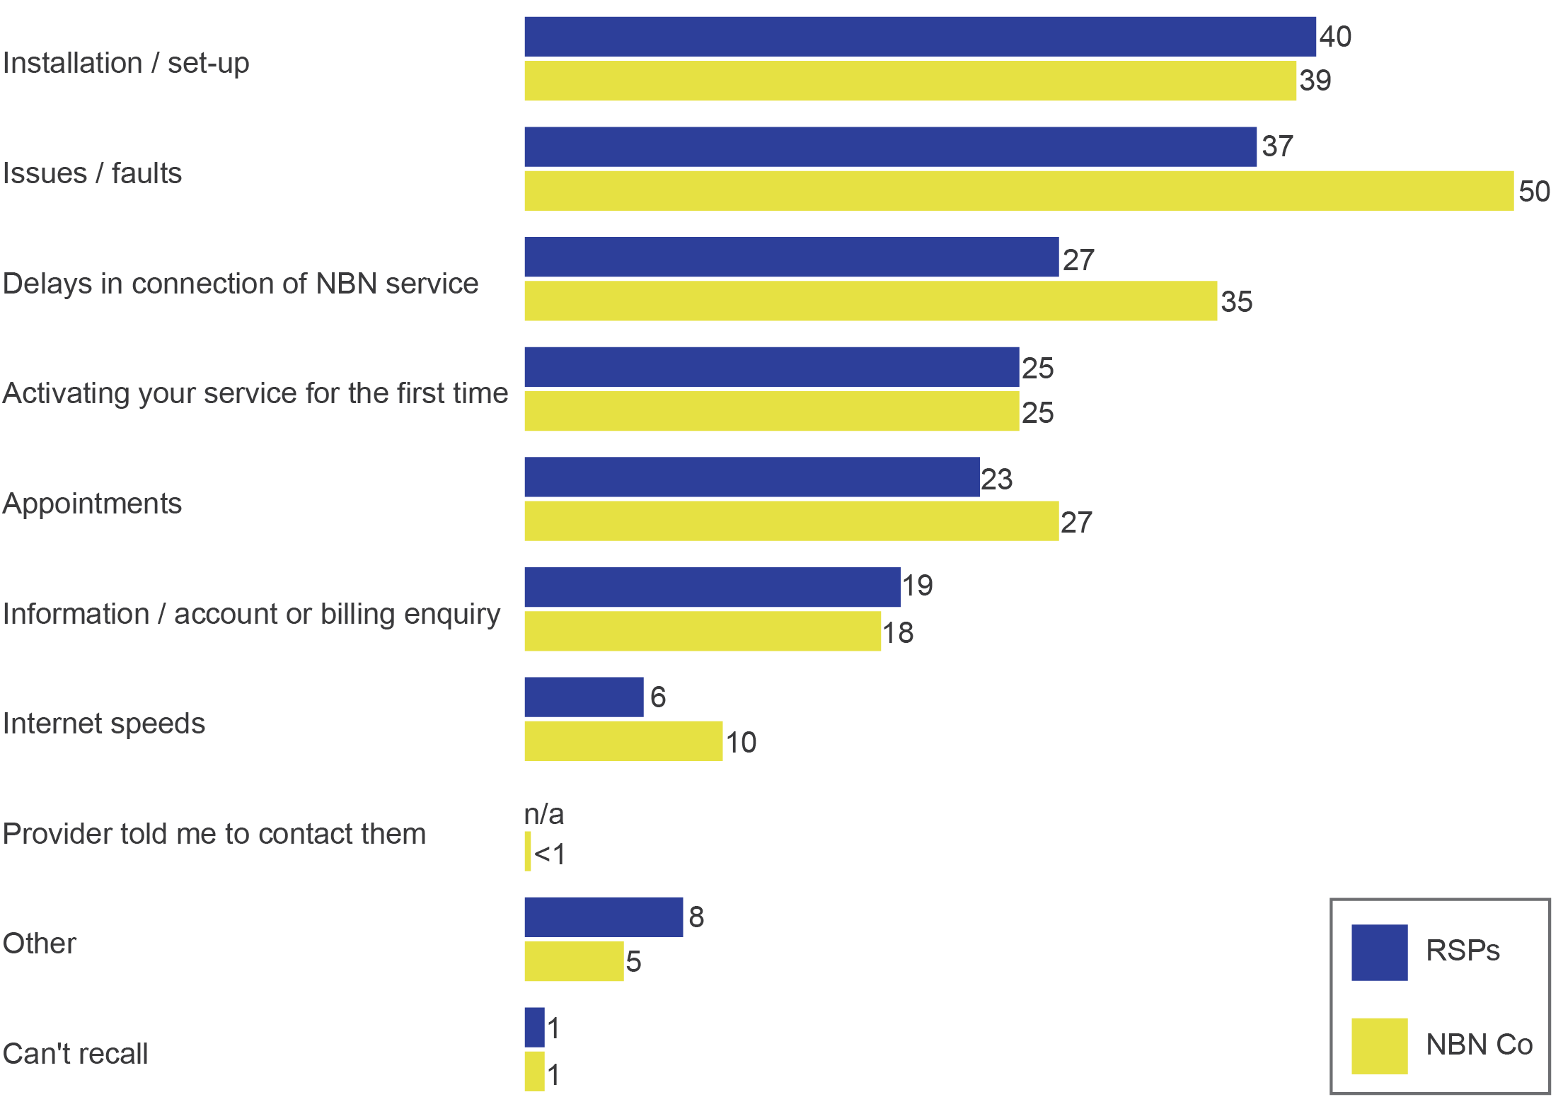

Base: Businesses that contacted RSP during connection (n=554), businesses that contacted NBN Co during connection (n=274).

C8. And what were the reasons (for you contacting your provider about the process of connecting to the NBN)?

C10a. And what were the reasons for contacting NBN Co (about connecting to the NBN)? Was it for the same issue that you contact your provider and that you just told me about?

Note: Data adds to more than 100 per cent due to multiple responses.

There tended to be a higher rate of contact with RSPs and NBN Co about the process of connecting as the number of employees increased. Nearly half (45 per cent) of businesses with one to four employees contacted their RSP during connection, compared with 67 per cent of businesses with 20 to 199 employees.

### Service continuity during connection

At the time of moving to services delivered over the NBN, some businesses experienced a loss of service. The survey investigated broad reasons for the loss of service but did not identify specific causes or whether it was due to a factor within the control the RSPs, NBN Co, the business or another party. Businesses left without service for fewer than three hours were classified as *not* being without service during connection.

Overall, 40 per cent of businesses were left without a phone and/or internet service during connection.[16] Those connecting internet had a slightly lower rate of losing their internet service (33 per cent) than those connecting their phone (40 per cent lost their phone service) (Figure 31).

1. Left without service during connection, total (%)

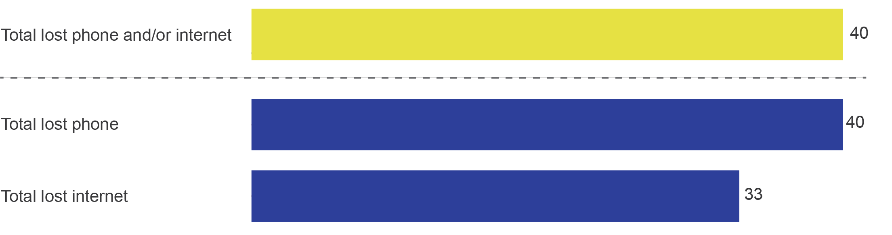

Base: All business connected to the NBN (n=1,153), businesses with phone connected to the NBN (n=922), businesses with internet connected to the NBN (n=1,084).

C1a. Now during the process of getting connected to the NBN, was your business left without any kind or fixed line phone or internet service for three hours or more?

Businesses with a phone service were more likely to experience a loss of service at the time of connection—those with only internet had the lowest rate of service loss:

* with internet only—26 per cent lost their internet
* with both phone and internet, and lost at least one service—43 per cent

with phone only—46 per cent lost their phone (these results should be considered indicative as the sample size is small, with only n=69) (Table 7).

Businesses with both phone and internet services delivered over the NBN were more likely to lose both of their services (31 per cent) than to lose only one service (lost just phone—nine per cent; lost just internet—three per cent) (Table 7).

1. Types of connection and loss of service (%)

|  | Both phone and internet | Internet only | Phone only |
| --- | --- | --- | --- |
| Lost just phone | 9 | n/a | 46 |
| Lost just internet | 3 | 26 | n/a |
| Lost both phone and internet | 31 | n/a | n/a |
| **Total (lost service/s)** | **43** | **26** | **46** |

Base: Business with both phone and internet connected to the NBN (n=853), businesses with phone only connected to the NBN (n=69), businesses with internet only connected to the NBN (n=231).

C1a. Now during the process of getting connected to the NBN, was your business left without any kind or fixed line phone or internet service for three hours or more?

Note: Results for phone only (n=69) should be considered indicative only as sample size is small.

A range of factors increased the likelihood of businesses losing service during connection:

* Businesses with other services connected (such as an alarm, POS or fax machine) were more likely to have lost service during connection than those with no other services (47 per cent vs 35 per cent).
* Those who did not understand the steps to prepare their business for connecting were more likely to have been without service during connection (61 per cent vs 33 per cent).
* Those who did not understand the steps involved in connecting were more likely to have been without service during connection (57 per cent vs 33 per cent)

Those who did not understand the different responsibilities of NBN Co and RSPs in connecting their business were more likely to have been left without service during connection (54 per cent vs 32 per cent).

Three-quarters of businesses that lost service during connection reported they had a technical issue with their installation (76 per cent of those left without phone and 78 per cent of those left without internet). A small group (two per cent of those left without phone and one per cent of those left without internet) reported they missed the disconnection date, while one in six reported that it was for ‘other’ reasons.

### Time without service during connection

The length of time businesses were left without a phone and/or internet service during connection varied. For one-quarter of each group, the time without service was up to 24 hours (Table 8). Fourteen per cent of business reported that they lost one or both of their services for more than one week while moving to services delivered over the NBN.

1. Time left without NBN service after connection (%)

|  | Without phone | Without internet |
| --- | --- | --- |
| Up to 24 hours | 27 | 26 |
| 1 to 7 days | 40 | 40 |
| 1 to 4 weeks | 23 | 20 |
| More than 1 month | 11 | 15 |

Base: Businesses left without phone during connection to the NBN (n=361), businesses left without internet during connection to the NBN (n=362).

C2. And how long was your business left without any kind of fixed phone line service once disconnected from your old service?

C3. And how long was your business left without any kind of fixed internet service once disconnected from your old service?

Note: Data may not add up to 100 per cent due to rounding. ‘Don’t know’ not shown due to being less than 0.5 per cent.

Businesses with five or more employees at their site/location (35 per cent) were more likely to have their internet service restored (after loss of service during connection) within 24 hours than businesses with one to four employees (18 per cent).

### Loss of service—use of interim services and impact

At least two thirds of businesses left without service during connection used an interim service:[17]

* 65 per cent of those without internet service during connection

73 per cent of those without phone service during connection.

Businesses that lost both phone and internet were more likely to have used an interim phone service (81 per cent) than an interim internet service (65 per cent). The survey did not collect data about whether the interim service was self-supplied or supplied by their RSP.

Among those businesses left without a phone service during connection, 61 per cent described the impact on their business as ‘major’ and 18 per cent as ‘moderate’.

For businesses that were left without an internet service during connection, just over half (57 per cent) described the impact on their business as ‘major’, and 21 per cent as ‘moderate’.

Businesses with other services connected (for example, alarm, POS, fax machine) were more likely (64 per cent) than those with no other service connected (52 per cent) to describe the impact of being without internet as ‘major’ rather than ‘moderate’.

Very few businesses that lost services indicated it had ‘no impact’ (three per cent if they lost internet service; four per cent if they lost phone service).

Businesses that lost their internet service for a short time varied in their assessment of its impact. Those with a shorter period of internet disconnection (up to 24 hours) were fairly evenly divided in describing the impact as ‘minor’, ‘moderate’ or ‘major.’ When the time without internet service exceeded one week, an increased proportion of businesses described the impact as ‘major’ (84 per cent vs 43 per cent for loss of internet service for less than one week) (Figure 32).

1. Impact of loss of internet service, by time without service (%)

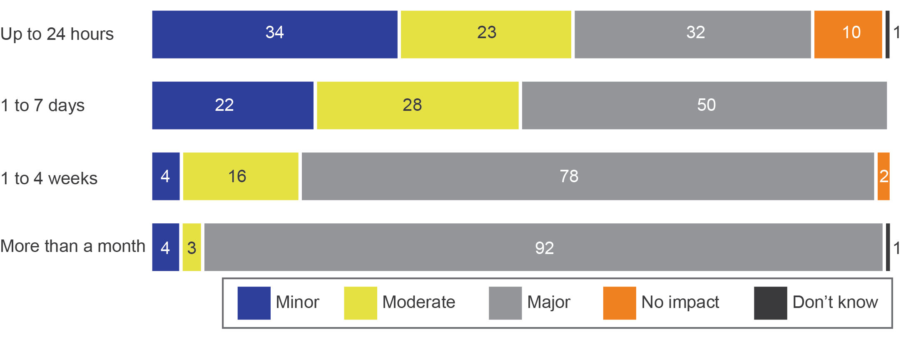

Base: Businesses that have been left without an internet service during connection (n=361).

C3. And how long was your business left without any kind of fixed line phone service once disconnected from your old service?

C3a. What impact did being left without any kind of a fixed line phone service have on your business? Was it…? None—no impact, minor impact, moderate impact, major impact, don’t know/can’t say.

Businesses without their phone service for up to 24 hours were nearly twice as likely to describe the impact as ‘major’ (39 per cent) than ‘minor’ (22 per cent). When the time without phone service exceeded one week, an increased proportion of businesses described the impact as ‘major’ (82 per cent vs 50 per cent for loss of phone service for less than one week) (Figure 33).

1. Impact of loss of phone service, by time without service (%)

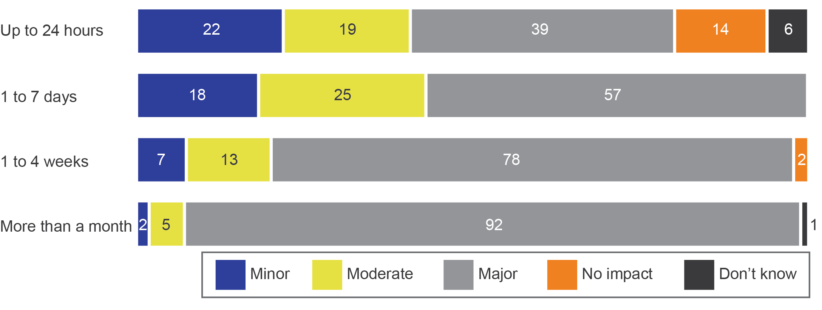

Base: Businesses that have been left without a phone service during connection (n=362).

C2. And how long was your business left without any kind of fixed line phone service once disconnected from your old service?

C2a. What impact did being left without any kind of a fixed line phone service have on your business? Was it…? None­—no impact, minor impact, moderate impact, major impact, don’t know/can’t say.

Businesses that described the loss of their internet or phone service as ‘major’ were equally likely to have been without service for up to a week and over a week (for up to one week without internet—49 per cent ‘major’; without phone—54 per cent).

However, those who described the impact as minor were much more likely to have lost internet service for up to three days or fewer (88 per cent).

## After migration

### Satisfaction with connection and internet before and after

Businesses were asked to indicate their satisfaction with the process of connecting to services delivered over the NBN. Just under half (49 per cent) were satisfied with the connection process—13 per cent ‘very satisfied’ and 36 per cent ‘satisfied’.

Among the remaining businesses, 14 per cent were ‘neither satisfied nor dissatisfied’ and a little over one-third (36 per cent) were dissatisfied with the connection process (15 per cent ‘dissatisfied’ and 21 per cent ‘very dissatisfied’).

Businesses that opted for a residential plan—rather than a business plan—were more likely to be satisfied with the connection process (65 per cent vs 46 per cent).

Those who lost service during connection were, as expected, much less likely to be satisfied with the connection process (17 per cent vs 71 per cent). One-third of those without phone and/or internet for up to 24 hours were satisfied with the connection process (35 per cent), and the level of satisfaction with connection was lower for those without service for any longer than 24 hours (10 per cent).

Businesses were asked to compare their internet service before and after connecting. Four in 10 (39 per cent) indicated it was better (16 per cent ‘a lot better’ and 23 per cent ‘slightly better). A further 40 per cent rated it as about the same pre- and post-connection. One in five (18 per cent) indicated it was worse after connecting (nine per cent ‘slightly worse’ and nine per cent ‘a lot worse’).

Businesses that were not left without service during connection were more likely (compared with those left without service) to view their internet service as better after connecting (45 per cent vs 33 per cent). Those who were satisfied with the connection process (50 per cent) were more likely than those who were not (30 per cent) to say their internet service was better after connecting to services delivered over the NBN.

Businesses were more likely to say their internet service was worse after connection if they (compared with those who did not):

* experienced slower speeds ‘often’ (42 per cent vs nine per cent)
* experienced consistently slower data speeds than expected (40 per cent vs seven per cent)
* experienced service outages (36 per cent vs eight per cent)
* experienced interruptions and buffering (36 per cent vs 11 per cent)
* experienced drop-outs (27 per cent vs six per cent)

made any complaint (31 per cent vs eight per cent).

### Issues or faults since connection

All businesses were asked if they had experienced any issues or faults with their service/s. A little over one-quarter (28 per cent) did not experience faults or issues with their service since connection.

Seven in 10 (71 per cent) businesses experienced faults or issues after connection, with drop-outs the most frequently reported issue (53 per cent).[18]

The proportion of businesses experiencing faults and issues declined for those connected for a shorter period of time—falling from 73 per cent for those who connected in 2017 (on average, with a higher rate in April to June 2017) to 53 per cent for those who had been connected for a shorter period of time (connected during January and February 2018).

Businesses with internet were most likely to indicate variable data speeds (43 per cent) as an issue or fault. Among those with a phone service, nearly one-quarter (23 per cent) experienced poor voice quality issues (Figure 34).

1. Faults or issues with service since connection (%)

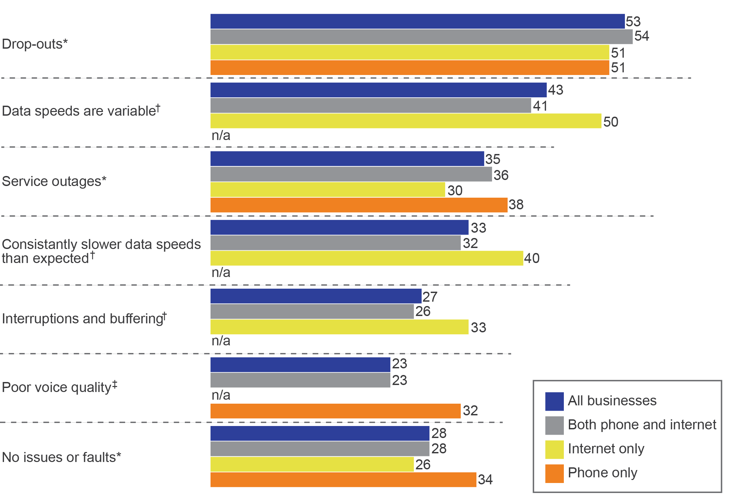

n/a=not applicable.

*All businesses connected to the NBN.

†Businesses with internet connected to the NBN.

‡Businesses with phone connected to the NBN.

Base: Businesses connected to the NBN (n=1,153), businesses with internet connected to the NBN (n=1,084), businesses with phone connected to the NBN (n=922), business with both phone and internet connected to the NBN (n=853), businesses with phone only connected to the NBN (n=69), businesses with internet only connected to the NBN (n=231).

D2. Since connecting to the NBN, have you experienced any issues or faults with your NBN services/s, such as…?

Note: Data adds to more than 100 per cent due to multiple responses. Results for phone only (n=69) should be considered indicative only as sample size is small.

Among businesses that had experienced issues or faults since connection:

* 72 per cent had experienced more than one type, with the median number being three
* 28 per cent had experienced one type
* 19 per cent had experienced two types

53 per cent experienced three or more types.

When asked to identify the biggest issue (among those who had experienced any issue or fault), businesses most frequently nominated:

* drop‑outs—41 per cent
* slower-than-expected data speeds—16 per cent
* service outages—16 per cent

variable data speeds—nine per cent.

For businesses that experienced slower speeds since connecting to services delivered over the NBN (33 per cent of all businesses with internet), six in 10 (59 per cent) noted they had occurred ‘very often’ (35 per cent) or ‘often’ (24 per cent).

Businesses that had not understood the different responsibilities of NBN Co and RSPs when connecting were more likely (81 per cent) to have experienced faults or issues than those that had understood (63 per cent).

Businesses that had lost service during connection were more likely (83 per cent) to have experienced issues and faults since connecting than those that had not (63 per cent).

Businesses that were satisfied with the connection process were less likely (62 per cent) to have experienced issues and faults than those that were dissatisfied (85 per cent). Those that indicated their internet service was worse after connection were more likely (96 per cent) to have experienced issues or faults than those that thought it was better (65 per cent).

### Main issues or faults experienced by businesses

Drop-outs were the issue or fault most likely to be experienced and the biggest problem for businesses—at 41 per cent. Businesses (where they had experienced more than one) were asked which of those issues or faults were the biggest problem. Drop-outs were the biggest problem for those that experienced them (Figure 35).

1. Issue or fault that was biggest problem for businesses, compared to all types experienced (%)

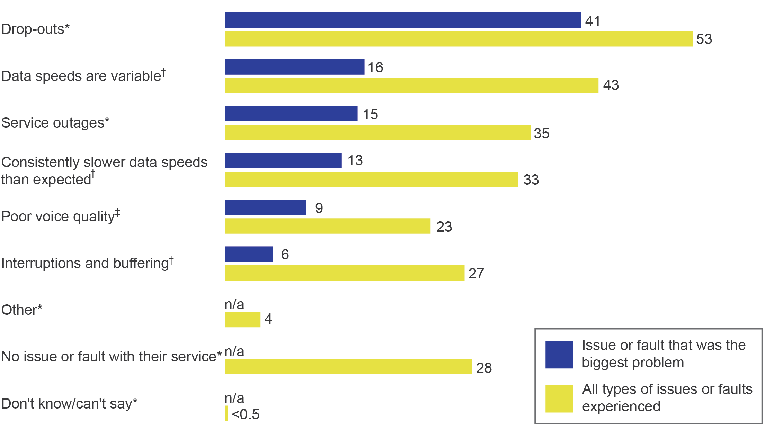

n/a=not applicable.

*All businesses connected to the NBN.

†Businesses with internet connected to the NBN.

‡Businesses with phone connected to the NBN.

Base: Businesses connected to the NBN (n=1,153), businesses with internet connected to the NBN (n=1,084), residential households with phone connected to the NBN (n=922), businesses that experienced any issue or fault (n=832), businesses with internet connected and experienced any issue or fault (n=787), businesses with phone connected and experienced any issue or fault (n=660).

D2. Since connecting to the NBN, have you experienced any issues or faults with your NBN service/s, such as…?

D3. And which issue or fault has been the biggest problem for your business?

Notes: Issues/faults less than two per cent not reported; those who reported they had an issue or fault but did not know/can’t say what their issue or fault was were not asked which was the biggest problem for their business.

### Complaints and main reasons

All businesses were asked if they had contacted their current or previous RSP to make a complaint since connecting to services delivered over the NBN, with two in five businesses (42 per cent) having done so. For consistency, all respondents were read the following definition:

A complaint is an expression of dissatisfaction made to a service provider in relation to your NBN services or their complaints-handling process, where you expect a response or a resolution.

Drop-outs were the most frequent reason for the most recent complaint (35 per cent), and twice as likely to be the reason for the most recent complaint compared with other reasons (Figure 36).

1. Main reason for complaint (%)

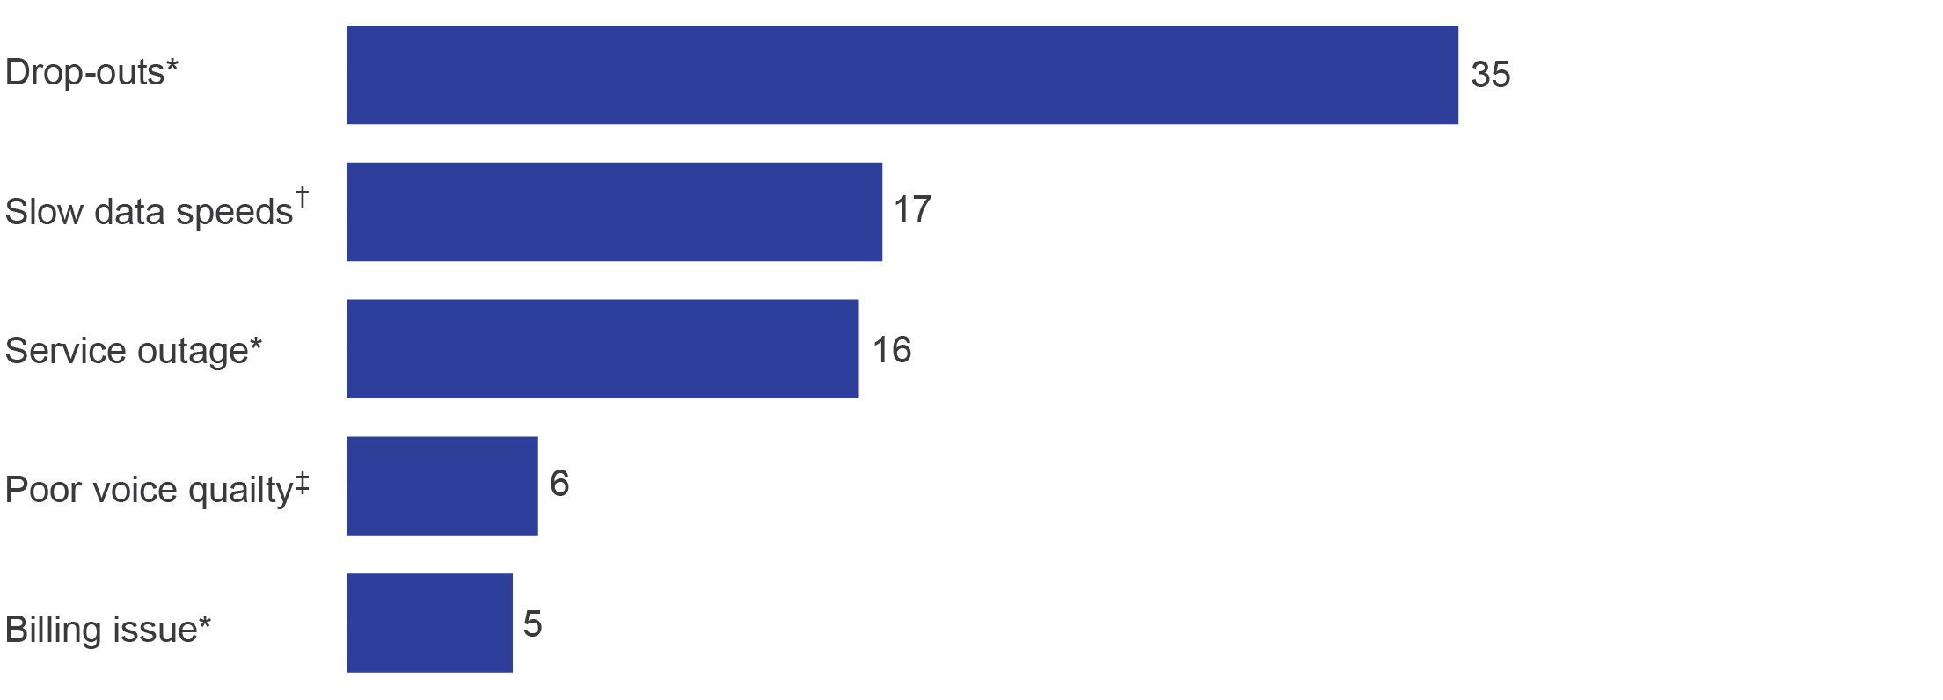

*All businesses that made a complaint.

†Businesses with internet that made a complaint.

‡Business with phone that made a complaint.

Base: Business connected to the NBN and complained (n=501), businesses with internet connected to the NBN and complained (n=404), business with phone connected to the NBN and complained (n=469).

D16. And what was the main reason for your most recent complaint?

Note: Slow data speeds are defined as ‘slow data speeds during a typical business day’. A wide range of reasons with totals less than five per cent and ‘other’ not shown.

Those who experienced a greater number of different types of issues or faults were more likely to complain:

* Two-thirds (64 per cent) of those that complained had experienced three or more issues and faults, compared with 20 per cent of those that did not complain.

Those that did not complain were more likely not to have experienced issues or faults (39 per cent vs six per cent) (Figure 37).

1. Types of issues or faults experienced—total (%)

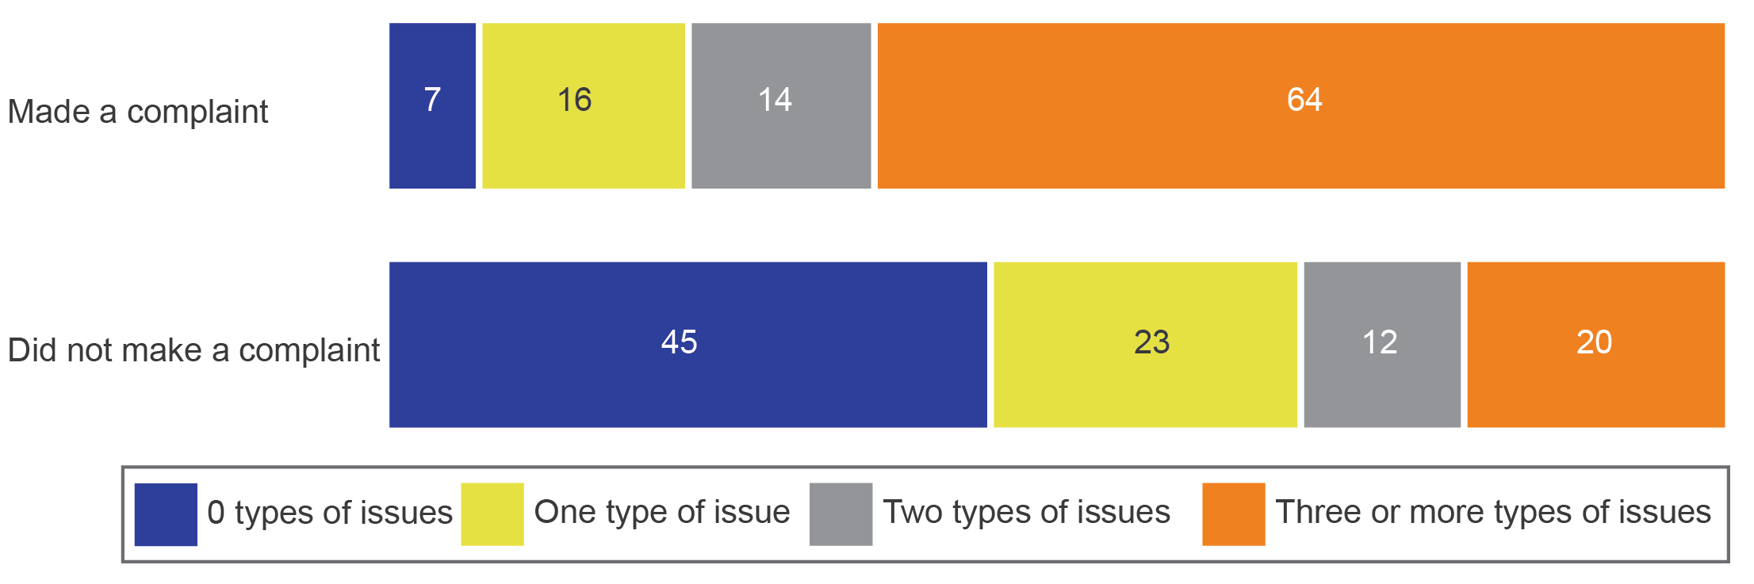

Base: Businesses connected to the NBN that complained (n=501), businesses connected to the NBN that did not complain (n=638).

D5. Since connecting to the NBN; that is, from when you had a working service, have you or somebody on behalf of your business, contacted your current and/or previous NBN service provider/s to make a complaint...?

Note: Data may not add up to 100 per cent due to rounding.

The majority (93 per cent) of businesses that made a complaint to their RSP after connection had also experienced at least one type of issue or fault since connection. Of those that complained, 87 per cent reported that they had complained about the issue or fault that was the biggest problem for their business.

Businesses that had been connected for a shorter period of time—connected in the most recent six months covered by the research (October 2017 to February 2018)—were less likely (51 per cent) to have made a complaint to their RSP than those that had been connected for a longer period of time—connected during January to September 2017 (68 per cent).

Businesses were more likely to have made a complaint to their RSP after connection if they:

* were left without service during connection (55 per cent vs 33 per cent compared with those who were not)
* had a 50 Mbps speed tier data download speed or higher (56 per cent vs 34 per cent)

did not know the steps needed to prepare their business for connection (51 per cent vs 38 per cent).

Among those businesses that had lost phone service during connection, the longer the business was without service, the more likely they were to complain to their RSP (about any issue). Of those without service for:

* 24 hours—40 per cent made any complaint
* two to seven days—57 per cent made any complaint

more than one week—66 per cent made any complaint.

Among businesses that had complained post-connection about any issue:

* 13 per cent made one complaint
* 20 per cent made two complaints

64 per cent complained three or more times.

Among businesses that complained post-connection, the most common reasons for complaints were:

* drop-outs—35 per cent
* slow data speeds during typical business hours—17 per cent
* service outages—16 per cent

poor voice quality—six per cent.

### Time to resolve complaints

Reported resolution times for complaints made by businesses varied, with one in five complaints (19 per cent) reportedly resolved on the same day (Figure 38).

1. Time to resolve (among all complainants) (%)

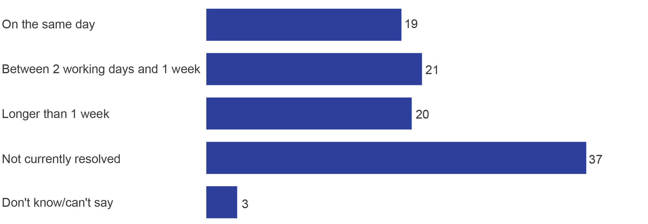

Base: Businesses connected to the NBN who complained (n=501).

D17. How long did it take to resolve the complaint? Was it resolved...?

Complaints about slow data speeds during business hours were more likely to be unresolved at the time of interview (62 per cent) (Figure 39).

1. Type of complaint and time to resolve (%)

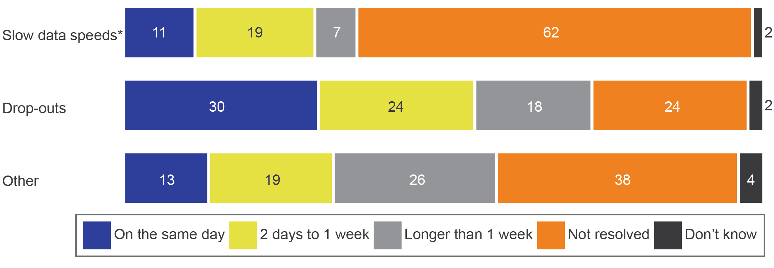

*Slow data speeds include ‘slow data speeds during business hours’.

Base: Businesses connected to the NBN that complained (n=501).

D17. How long did it take to resolve the complaint? Was it resolved...?

Note: Data may not add up to 100 per cent due to rounding.

Of businesses that complained to their RSP and had their complaint resolved, 20 per cent received reimbursement or compensation.

### Satisfaction with complaints handling

Businesses with resolved complaints were asked to rate their satisfaction with how the complaint had been handled. Thirty-nine per cent of businesses were satisfied (five per cent—‘very satisfied’ and 34 per cent—‘satisfied’) (Figure 40).

1. Satisfaction with complaints-handling (%)

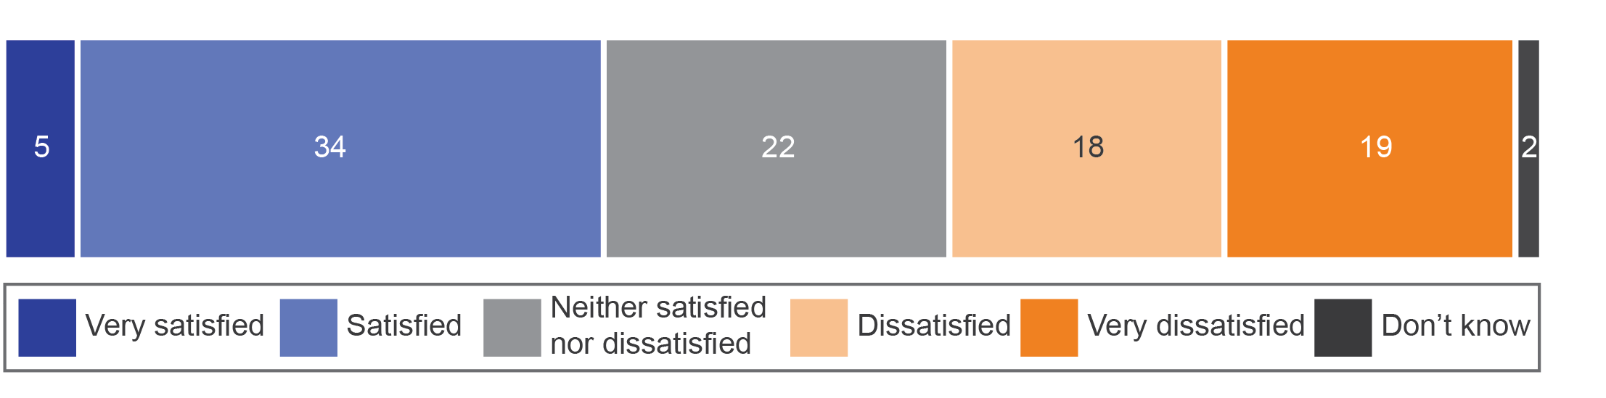

Base: Businesses connected to the NBN whose most recent complaint was resolved (n=316).

D18. Overall, how satisfied or dissatisfied were you with how the complaint was handled?

Those whose complaint was resolved on the same day (66 per cent) were more likely to be satisfied with the complaints-handling process than those whose complaints took longer to resolve (29 per cent).

Of those that had made up to three complaints, 56 per cent were satisfied with the complaints-handling process, while those that made four or more complaints were less likely to be satisfied (20 per cent).

Among those that were dissatisfied with the complaints-handling process, the most frequently mentioned reasons were:

* ‘it took long to fix or take action’—63 per cent
* ‘nobody would take responsibility for fixing the problem’—53 per cent

‘poor communication/lack of communication’—49 per cent.

### Businesses that did not make a complaint

Many businesses that had not made a complaint to their RSP since connecting to services delivered over the NBN still experienced issues and faults with their NBN services, though less frequently than those that had made a complaint. Among those businesses that *did not complain*:

* 55 per cent experienced at least one type of issue or fault (vs 93 per cent for those that did complain)

44 per cent experienced no issue or fault with their service (vs seven per cent for those that did complain).

Businesses that experienced issues or faults did not always make a complaint to their RSP, but they were more likely to complain if they had issues or faults with their service/s.

Not experiencing issues and faults doubled the chance of a business not complaining to RSPs. Of those that had not experienced any issues or faults since connecting, eight in ten (88 per cent) had not made a complaint to their RSP, compared with 44 per cent of those that had issues or faults. (Figure 41).

1. Experiencing issues or faults and making complaints (%)

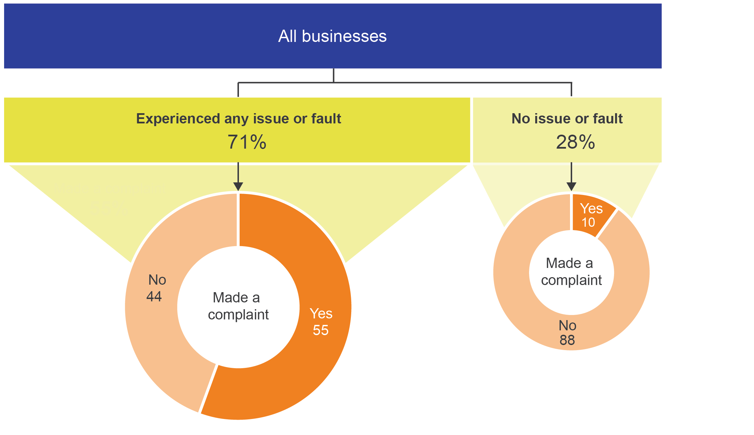

Base: Businesses connected to the NBN (n=1,153), businesses connected to the NBN that experienced any issue or fault (n=832), businesses connected to the NBN that did not experience any issue or fault (n=313).

D2. Since connecting to the NBN, have you experienced any issues or faults with your NBN service/s, such as…?

D5. Since connecting to the NBN; that is, from when you had a working service, have you or somebody on behalf of your business, contacted your current and/or previous NBN service provider/s to make a complaint...?

Businesses that had not complained to their RSP had a similar pattern of issues and faults to those that had complained, though at lower rates. Of those that did not complain, 33 per cent had experienced drop-outs (vs 82 per cent of those who complained) and 31 per cent of those with internet reported that data speeds were variable (vs 60 per cent of those who complained).

The difference in incidence of an issue or fault (between businesses that complained and did not) was largest for service outages—59 per cent of businesses that did complain experienced service outages, and 17 per cent of those that did not complain experienced service outages.

Businesses that made a complaint to their RSP experienced more types of issues and faults than businesses that had not complained. The median number of types of issues or faults experienced was higher for business that *did* make a complaint (three types of issues or faults). The median number of types of issues or faults experienced by businesses that did *not* make a complaint was one.

Among those businesses with an issue or fault, and that did not complain, a little over one-quarter (27 per cent) contacted somebody. Most often, contact was made with their RSP (89 per cent) or NBN Co (12 per cent) but the contact did not involve making a complaint. Among those who contacted somebody:

* for one in four (25 per cent), the issue was resolved on the same day
* 30 per cent were resolved on the second or third working day

for one in five (19 per cent), the issue was unresolved at the time the data was collected.

Of the businesses that experienced an issue or fault, and did not make complaint, nearly three-quarters (73 per cent) did not contact anyone to seek any resolution. The majority (88 per cent) reported that they did not take any other action. However, two per cent upgraded their telephone systems and a further two per cent reported that they changed RSP.

Those who complained without having experienced an issue or fault had done so for a range of reasons, such as billing issues (12 per cent).

# Comparing the NBN connection experiences of households and businesses

This section summarises the key differences in the findings from the household and business surveys. Comparisons are made where the same or similar questions were asked of both groups.

## Most important factors for choosing a plan or RSP

The most important factors for choosing a plan or RSP differed between household and businesses. Cost was the most important factor for households but was ranked fourth for business. Keeping their phone number was the most important factor for businesses but was third for households. For both groups, the speed of internet connection was the second most important factor. Confidence in faults being fixed was the third most important factor for businesses and sixth for households (Table 9).

## Drivers for contacting NBN Co and RSPs

While the proportion of businesses and households that contacted their RSP during connection did not differ, the reasons for contact varied. Businesses were more likely than households to contact their RSP about activating the service for the first time, delays in connection and appointments (Table 9).

Businesses were nearly twice as likely as households to contact NBN Co during the process of connecting. However, both households and businesses were much more likely to contact RSPs than NBN Co during connection (Table 9).

For businesses that contacted NBN Co during connection (compared with households who made contact), the reason for contact was more likely to be issues or faults, appointments, activating a service for the first time, an enquiry for information, or accounts or billing (Table 9).

1. Comparing most important factors in choosing a plan or RSP and contact with NBN Co and RSPs (%)

|  |  | | Households | Businesses |
| --- | --- | --- | --- | --- |
| Most important factors in selecting plan or provider | Cost*  Speed of internet†  Keeping phone number‡  Staying with provider*  Amount of data in plan†  Confidence in faults fixed*  Keeping email address† | 29  21  14  10  9  8  5 | | 11  18  36  6  3  14  8 |
| Contact RSP during connection* |  | | 42 | 47 |
| Reason for contacting RSP during connection§ | Installation/set-up*  Issues/faults*  Activating service*  Information/account/billing*  Delays*  Appointments* | | 41  31  15  14  13  10 | 40  37  25  19  27  23 |
| Contact NBN Co during connection* |  | | 12 | 23 |
| Reason for contacting NBN Co during connection|| | Installation/set-up*  Issues/faults*  Delays* | | 35  33  28 | 39  50  35 |

*Households/businesses connected to the NBN.

†Households/businesses with internet connected to the NBN.

‡Households/businesses with phone connected to the NBN.

§Residential households/businesses that contacted their RSP about the process of connecting.

||Residential households/businesses that contacted NBN Co about the process of connecting.

B19b/B5b. Which of those was the most important for your household/business in choosing your plan or provider?

Base: Residential households connected to the NBN n=1,881, businesses connected to the NBN n=1,153, residential households with internet connected to the NBN (n=1,757), businesses with internet connected to the NBN (n=1,084), residential households with home phone connected to the NBN (n=1,412), businesses with phone connected to the NBN (n=922). Residential households who contacted their RSP about the process of connecting (n=759), businesses who contacted their RSP about the process of connecting (n=554), businesses that contacted NBN Co about the process of connecting (n=274), residential households who contacted NBN Co about the process of connecting (n=250).

C7. After you ordered your NBN plan, did you contact your service provider about the actual process of connecting to the NBN for any reason?

C8. And what were the reasons (for you contacting your provider about the process of connecting to the NBN)?

C9. Did you contact NBN Co during the process of connecting to the NBN for any reason?

C10b. What was the reason for you contacting NBN Co about connecting to the NBN?

## Loss of service during connection

Overall, businesses were slightly more likely than households to be left without service during connection. Businesses and households experienced a similar incidence of losing phone service; however, businesses were more likely to report their service was reinstated within the first day or the first week, and less likely to be without service for between eight days and a month. A similar proportion of households and businesses were without service for more than month (Table 10).

1. Comparing loss of service during connection (%)

|  |  | Households | Businesses |
| --- | --- | --- | --- |
| Left without service during connection* |  | 34 | 40 |
| Proportion of those left without service during connection who had services reinstated in first week | Without phone‡  Without internet† | 59  52 | 66  65 |
| Proportion of those left without service, who were without service for more than a month | Without phone‡  Without internet† | 12  13 | 11  15 |

*All households/businesses connected to the NBN.

†Households/businesses left without internet during connection to the NBN.

‡Households/businesses left without phone during connection to the NBN.

Base: Residential households connected to the NBN (n=1,881), businesses connected to the NBN (n=1,153), residential households who were left with home phone service during connection (n=472) or without internet (n=539), businesses that were left without phone service during connection (n=361) or internet (n=362).

C1a. Now, during the process of getting connected to the NBN, were you left without any kind of home phone or internet service at home?

C2/C3. And how long were you left without any kind of home phone/internet service once disconnected from your old service?

## Satisfaction with connection process and with internet

Despite businesses and households experiencing similar levels of service interruptions during connection, businesses were less likely to be satisfied with the connection process. Once connected, however, businesses were more likely to say their internet was about the same as their previous non-NBN service. Businesses were also less likely to consider their internet to be worse (Table 11).

1. Comparing satisfaction with connection and with internet (%)

|  | Households | Businesses |
| --- | --- | --- |
| Satisfaction with connection process* | 68 | 49 |
| Comparing internet before and after connection†  Better  Same  Worse | 41  31  24 | 40  40  18 |

*All households/businesses connected to the NBN.

†Households/businesses with internet connected to the NBN.

Base: Residential households connected to the NBN (n=1,881), businesses connected to the NBN (n=1,153), residential households with internet connected to the NBN (n=1,757), businesses with internet connected to the NBN (n=1,084).

C19/C11. Overall, how satisfied or dissatisfied were you with the process of connecting to the NBN? Would you say you were…?

D1. Overall, comparing your household’s/business’s internet before and after you connected to the NBN, would you say it was now…?

## Issues/faults and complaints

After connection, businesses were more likely than households to experience service outages and poor voice quality with their services. While there was no real difference in the proportion of households and businesses experiencing issues related to data speeds (slow speeds in general or consistently slower speeds than expected), the greater incidence of some types of issues and faults may contribute to businesses being more likely to make a complaint to their RSP after connection.

In addition, businesses were less satisfied than households with how their RSP handled their complaint (despite a similar proportion receiving compensation or reimbursement as part of their complaint being resolved) (Table 12).

1. Comparing issues or faults and complaints to RSP (%)

|  | | Households | Businesses |
| --- | --- | --- | --- |
| Experienced at least one type of issue or fault since connection* | | 71 | 71 |
| Types of issues or faults | Drop-outs*  Slow data speeds in the evening†  Slow data speeds general†  Data speeds variable†  Consistent slower data speeds than expected†  Service outages*  Interruptions and buffering†  Poor voice quality‡ | 49  36  33  n/a  n/a  28  31  15 | 53  n/a  n/a  43  33  35  27  23 |
| Satisfaction with complaints-handling (resolved complaints)§ | | 61 | 39 |
| Receipt of reimbursement or compensation (resolved complaints) § | | 29 | 20 |

n/a=not applicable.

*All households/businesses connected to the NBN.

†Households/businesses with internet connected to the NBN.

‡Households/businesses with phone connected to the NBN.

§Households/businesses connected to the NBN whose most recent complaint was resolved

Base: Residential households connected to the NBN (n=1,881), residential households connected to the NBN who experienced an issue or fault (n=1,365), businesses connected to the NBN who experienced any issue or fault (n=832), residential households with internet connected to the NBN (n=1,757), businesses with internet connected to the NBN (n=1,084), residential households connected to the NBN with a resolved complaint (n=345), businesses connected to the NBN with a resolved complaint (n=304).

D5/D2. Since connecting to the NBN, have you experienced any issues or faults with your NBN service/s, such as…?

D18. Overall, how satisfied or dissatisfied were you with how the complaint was handled?

# Appendix A— Methodology (detailed)

## Sample design and weighting

The residential household survey included households who had connected to services delivered over the NBN in the previous 12 months.

The small and medium-sized business survey included businesses that had an employee count of between one and 199 employees[19] at the total business level and connected to services delivered over the NBN in the previous 12 months. The sample frame included each individual location of a business—that is, multi-location businesses had all of their locations potentially included if the locations were within the in-scope geographic areas. This reflects the NBN being rolled out at the location level (that is, locations of a business within a geographic area that was being rolled out at that time). Technologies, experiences and time periods could differ between various locations of the one total business, therefore the individual location of a business in scope was the surveyed unit.

Both the residential and business survey sample designs included geographic areas (ABS defined SA3s) if they had greater than an estimated 10 per cent of (residential/business, as appropriate for each survey) premises connected in the previous 12 months. Those areas with only a very small proportion of NBN-estimated connections in that period were excluded due to the difficulty and cost involved in trying to sample them.

The same 12 strata[20] were used for both surveys (defined according to states/grouped states and estimated incidence rates). However, the number of interviews to be achieved in each stratum varied for the residential and business surveys. The number of interviews to be achieved for each survey was based on the relative incidence rates within each stratum. Sample selection for each survey was then conducted randomly within each of the 12 strata.

A multi-stage weighting process was conducted to ensure each household’s or business’s chance of selection and response profiles were accounted for. Therefore, the data is weighted to be representative of households/small and medium-sized businesses that connected in the previous 12 months in the areas surveyed.

## Key differences between residential and business surveys

The residential survey used SamplePages as the sample source, while the business survey used Dun & Bradstreet.

Residential sampled ABS SA3s, business sampled postcodes.

Residential had a 50/50 mobile/landline split in the completed interviews to be achieved (that is, which sample type they came from within the SamplePages file—mobile phone listing or landline listing). Business sample for mobile/landline numbers was based on the number listed for the business in the Dun & Bradstreet sample file, as that was deemed the most appropriate number to call for the business.

Despite the differences that were made to conduct each survey in the most effective manner, the overall sample design for the business survey used a similar approach to that used in the residential survey design (replacing the dwelling counts by the business counts).

## Questionnaire design

Separate draft quantitative questionnaires for each survey were developed in collaboration by ACMA and Colmar Brunton. The draft questionnaires were each pre‑tested using cognitive interviews to ensure the questions and response categories made sense, were not ambiguous, flowed well, and captured the key concepts and terminology for respondents. This stage involved 27 in-depth interviews. The findings from this stage resulted in some changes to the survey scripts.

Key ACMA stakeholders were also consulted at the questionnaire design stage of the residential survey. Each survey was also pilot tested with n=41 residential and n=34 business interviews, resulting in a change of order and a few minor wording amendments.

## Statistical reliability

As this survey is a random sample of a defined population, standard errors based on a simple random sample apply. In addition, there is a Weight Effect (WEFF) due to the sampling and weighting design that needs to be accounted for in calculating statistical tests.

The WEFF was calculated to be 2.20 for the residential survey and 2.39 for the business survey. Calculations in the table below are shown at the 95 per cent confidence level; that is, there are 95 chances in 100 that a repeat survey would produce results that lie within the +/– margin of error shown for that proportion.

1. Margin of error for each total sample

|  | Residential | Business |
| --- | --- | --- |
| Actual sample size | 1,881 | 1,153 |
| Effective sample size (once sample design and weighting are taken into account) | 855 | 482 |
| WEFF | 2.20 | 2.39 |
|  |  |  |
| **Margin of error for estimates of proportions** | **Percentage points (+/–)** | |
| Maximum margin of error at 95% confidence level on total sample **(taking into account WEFF)** | 3.4 | 4.5 |
| 5% or 95% | 1.5 | 1.9 |
| 10% or 90% | 2.0 | 2.7 |
| 20% or 80% | 2.7 | 3.6 |
| 30% or 70% | 3.1 | 4.1 |
| 40% or 60% | 3.3 | 4.4 |
| 50% | 3.4 | 4.5 |

For example, for a survey result of 50 per cent based on the total sample of n=1,881 households, there are 95 chances in 100 that a repeat survey would produce results that lie within the range of 47–53 per cent. For the total sample of n=1,153 businesses, there are 95 chances in 100 that a repeat survey would produce results that lie within the range of 46–55 per cent.

When comparing a result between subgroups (for example, comparing those who have made a complaint to their RSP (n=628) with those who have not or don’t know (n=1,253), the margin of error depends on the base size of the subgroups and the percentages being compared. The margin of error, with WEFF accounted for—for example, subgroup sizes—are provided below as a guide.

|  |
| --- |
| 1. Margin of error for subgroups, ± (at 95 per cent confidence level) |
| | Actual sample size (n) | | | | | | | --- | --- | --- | --- | --- | --- | |  | n=1,881  (total sample of  residential households) | 1,200 | 800 | 500 | 200 | | **Effective sample size with WEFF (n)** | | | | | | | Survey estimate (%) | n=855 | 545 | 364 | 227 | 91 | | **Sample variance (+/–) at 95 per cent confidence level (%)** | | | | | | | 5% or 95% | 1.5 | 1.8 | 2.2 | 2.8 | 4.5 | | 10% or 90% | 2.0 | 2.5 | 3.1 | 3.9 | 6.2 | | 20% or 80% | 2.7 | 3.4 | 4.1 | 5.2 | 8.2 | | 30% or 70% | 3.1 | 3.8 | 4.7 | 6.0 | 9.4 | | 40% or 60% | 3.3 | 4.1 | 5.0 | 6.4 | 10.1 | | 50% | 3.4 | 4.2 | 5.1 | 6.5 | 10.3 | |

## Limitations

*Recall bias*—the time period that respondents were asked to recall varied depending on their connection month within the 12 months. It should be noted that ‘Don’t know/Can’t say’ responses were allowed for in the survey; however, analysis shows the proportions relative to other response options were commonly very small throughout the survey.

*Sample coverage*—those in areas with estimated less than 10 per cent connection rates to NBN were excluded due to the difficulty in finding and interviewing them.

## Comparability with previous research

The previous research on [*Migrating to the NBN—The experience of Australian consumers*](https://www.acma.gov.au/theACMA/migrating-to-the-nbn-the-experience-of-australian-consumers) was published by the ACMA in December 2016. That previous report and this new research are *not* directly comparable due to differences in research design. This is due to the need to change the design to best capture the current stage of the NBN rollout and experiences of consumers. The 2016 research remains relevant as a marker for the experience of those with FTTP connections in the early stages of the rollout.

## Quality assurance

In collaboration with the ACMA Research team, the sample frame was designed by Dr Phil Hughes from the research agency ORC International, who is highly regarded as a research expert in sampling and weighting complex government surveys.

The data presented in this summary is drawn from weighted top-line tables provided by the commissioned research agency Colmar Brunton and analysis conducted by both the ACMA research team and researchers from Colmar Brunton.

1. An unresolved complaint may relate to a recent complaint or a complaint made a longer time ago. The survey did not record the length of time an unresolved complaint remained unresolved—complaints could have been made at any time since connection.
2. The survey included only those that had connected in the previous 12 months (and using months as the base). Households interviewed in November 2017 could have connected any time from November 2016 to November 2017. Households interviewed in December 2017 could have connected from December 2016 to December 2017.
3. The sample of residential dwellings or businesses was separated into 12 groups or strata in a way that balances geography and estimated incidence (of premises connected in the previous 12 months).
4. The survey included only those that had connected in the previous 12 months (and using months as the base). Businesses interviewed in January 2018 could have connected any time from January 2017 to January 2018. Businesses interviewed in February 2018 could have connected from February 2017 to February 2018.
5. The five major Australian capital cities grouped for this analysis are Sydney, Melbourne, Brisbane, Perth and Adelaide. All other areas are grouped together as ‘other areas’.
6. A speed test measures the rate that data is being downloaded and uploaded (usually shown in megabits per second or kilobits per second) between a computer (or another connected device) and an internet server. This was only read out to all respondents who requested an explanation.
7. Installation methods available to each household depend on the technology to be installed and on certain premise-specific or consumer-specific issues.
8. Two per cent could not recall their installation method.
9. The research did not collect information about whether the technician was from an RSP, NBN Co or other, or the reason for the missed appointment.
10. For self-installation, an appointment would relate to the installation of NBN Co infrastructure.
11. The research did not explore the causes for households/businesses being left without a service during connection once disconnected from their old service, and notes that some causes can be complex.
12. The data captures which types and the number of different types of issues and faults that were experienced, but not the number of times any issue or fault occurred. For example, if a household experienced two issues and faults, it could be drop-outs and slow data speeds, which would be counted as two types of issues or faults experienced, but the survey did not collect *how many times* the household experienced a drop-out or slow data speed. The survey did collect information about *how often* slow data speeds were experienced.
13. The survey collected the total number of complaints made to a current or previous RSP. The data collected the main reason for the most recent complaint, but not how many complaints were made for that reason.
14. An unresolved complaint may relate to a recent complaint or a complaint made a longer time ago. The survey did not record how long an unresolved complaint remained so.
15. The survey collected the number of employees at the sampled site/location of the business as well as the total number of employees across the whole business for those that had more than one site/location.
16. The research did not explore the causes for households/businesses being left without a service during connection once disconnected from their old service, and notes that some causes can be complex.
17. Circumstances around who supplied or why an interim service was provided were not explored in the survey.
18. The data captures which types and the number of different types of issues and faults that were experienced, but not the number of times any issue or fault occurred. For example, if a business experienced two issues and faults, it could be drop-outs and slow data speeds, which would be counted as two types of issues or faults experienced, but the survey did not collect *how many times* a drop-out or slow data speed was experienced by the business. The survey did collect information about *how often* slow data speeds were experienced.
19. One to 199 employees is consistent with ABS standard definition of small and medium-sized businesses.
20. The sample of residential dwellings or businesses was separated into 12 groups or strata in a way that balances geography and estimated incidence (of premises connected in the previous 12 months).